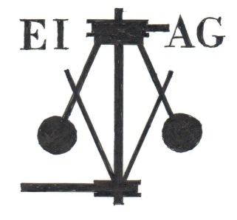
Essex Industrial Archaeology Group

NEWSLETTER

Number 3 February 2015

Welcome …

… to the third Newsletter for the Essex Industrial Archaeology Group (EIAG). As the EIAG enters its second full year, 2015 promises to be of great interest with three visits in the ESAH programme to industrial sites, the Annual Lecture in November and most significantly the Industrial Heritage Fair in October. Further details on these events appear below and in future editions of the Newsletter. This edition also features news of other events in the county with an industrial theme, a new publication on brickmaking in Essex, and news from sites and museums. If you have any comments on the Newsletter generally or the items in it, or wish to make a contribution to the next Newsletter, please contact us on our new email address - essexiag@gmail.com.

Next Visit

The next visit in the ESAH programme of industrial interest is a guided tour of

Beeleigh Mill on Saturday 25th April at 2:00 pm

Beeleigh Steam Mill, at Langford near Maldon, is a highly significant surviving example of 1840s milling technology. The virtually complete Wentworth compound beam engine remains attached to the unique iron-riveted elephant boiler. In the adjoining room is a cast iron corn mill on the circular principle favoured by millers into the C19th. Alongside the mill are the remains of the docks in which barges from the Chelmer & Blackwater Navigation could be loaded and unloaded. There will also be a guided tour of the C12th St Giles Church, Langford where refreshments will be served.

Bookings can be made with Dr Graham Gould 0208 556 1423 or DrGEGould@aol.com

Other EIAG/ESAH events in 2015

The Essex Society for Archaeology & History in its programme of visits and talks for 2015 includes the following of industrial interest as suggested by members of the EIAG:

- Saturday 4th July – Bata Reminiscence and Resource Centre, company village and factory site, East Tilbury
- Wednesday 16th September – Museum of Power, Langford, Maldon
- Saturday 14th November – EIAG Annual meeting and lecture by Keith Falconer, former Head of Industrial Archaeology at English Heritage and Chairman of the Association for Industrial Archaeology, Chelmsford Museum
The Industrial Heritage Fair on 10th October at Braintree District Museum has now been confirmed and further details of the groups which will be exhibiting, talks etc. will appear in future EIAG newsletters.

Other events in Essex

Chelmsford Annual Museum Lecture

The Recent History of The Chelmer & Blackwater Navigation
By Roy Chandler, Director of Essex Waterways Ltd

Chelmsford City Theatre
Friday 27th February 2015 at 8:00pm
Tickets: £6.00, or £5.00 for Friends of Chelmsford Museum

Full details of the lecture and how to book are at:
http://www.chelmsford.gov.uk/annual-museum-lecture

Essex Congress History Symposium – Theme is TRANSPORT

Saturday 7th March 2015
10:00 am to 4:30 pm
United Reform Church, 164 New London Road, Chelmsford

the talks will include:
The Royal Flying Corps at Stowe Maries
Buses in Essex and Beyond
A History of the Epping Ongar Railway
Cycling in Essex

More details on their website at:
http://www.essexcongress.org.uk/events.html
or contact the Assistant Secretary, Andrew Madeley
email: andrew.madeley@virgin.net tel: 020 8491 6514.

Bata Reminiscence and Resource Centre

Next Open Day
Wednesday 15th April, 2015
11a.m. - 1p.m.
and
4p.m. - 7p.m.
at
East Tilbury Library

More details on their website at:
http://www.batamemories.org.uk/MAIN/ENG/00-EN-Pages/00-EN-HOME.html

New Publication

THE BRICKMAKER’S TALE by Peter Minter

Published by Bulmer Brick and Tile Co. 2014.
112 pages. A4. Hardback. Numerous illustrations, many in colour.
£33.00 including postage and packing – cheques payable to Peter Minter.
Orders to Peter Minter at Bulmer Brick and Tile Co. Ltd., The Brickfields, Bulmer, Sudbury, Suffolk. C010 7EF

In recent years there has been a significant increase in interest in the history of brickmaking resulting in a number of publications. The latest is ‘The Brickmaker’s Tale’ by Peter Minter of Bulmer Brick and Tile Co, a well-known brickworks in north Essex. This excellent hardback is well illustrated and includes photographs of the brickworks, brickmakers and buildings where Bulmer bricks have been used. The brickworks was purchased by Lawrence Minter (Peter’s father) in 1936 when Peter was a young boy and the book contains his recollections of nearly eighty years. It includes archaeological finds, the war years, traditional brickmaking by hand, making brick moulds, kiln construction and farming of the adjacent land. The use of bricks for restoration work on many buildings in Essex and further afield are detailed and illustrated. This is an essential book for all those interested in archaeology, agriculture, brickmaking, buildings and restoration. I commend it to you.

Adrian Corder-Birch

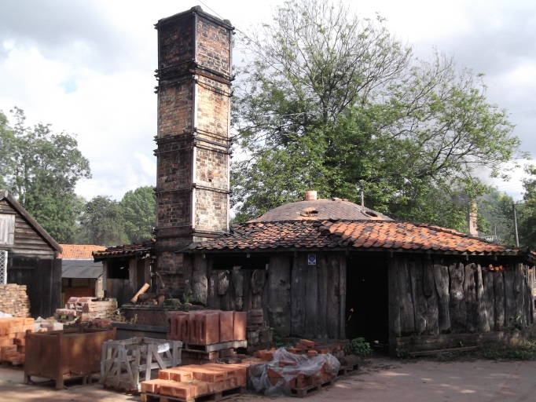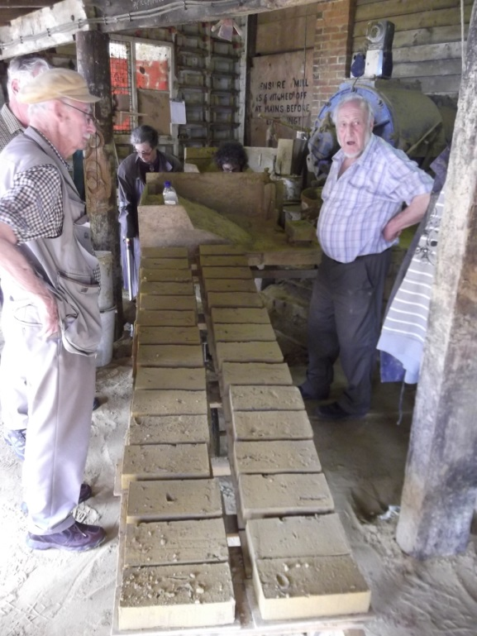

1930s downdraft kiln at Bulmer brickworks Peter Minter talking about brickmaking

News from around Essex

COLNE VALLEY RAILWAY PRESERVATION SOCIETY

EIAG is pleased to report that the Colne Valley Railway Preservation Society of Castle Hedingham has been awarded development funding of £66,000 by the Heritage Lottery Fund. This will enable the Society to prepare plans for a skills ”centre of excellence” including an interactive museum. HLF will award a further £1.65 million if it approves the plans, which will be prepared during the next two years. Early last year EIAG was one of a number of county and local organisations, which wrote letters to HLF in support of the application by the Colne Valley Railway Preservation Society. The initial funding of £66,000 indicates that HLF has endorsed the outline proposals of CVRPS and earmarked funding for the full project. The Society now has two years to apply for the project delivery funding of £1.65 million. EIAG is delighted with the progress made by the Railway Society and to have supported its application.

ROYAL GUNPOWDER MILLS, WALTHAM ABBEY

The Waltham Abbey Royal Gunpowder Mills (WARGM) are pleased to announce that their 2015 season starts on Saturday 28th March, opening times 10:00am to 5:00pm. The first special and family fun event is an Eggsplosive Easter which runs from 28th March to 12 April. Details of all WARGM events are on their website at: http://www.royalgunpowdermills.com/

The “Perfected” Kiln

Those members of EIAG who are also members of the Association for Industrial Archaeology (AIA), may have followed the items in recent issues of Industrial Archaeology News about patents granted to George Warren for improvements to the Hoffmann continuous tunnel kiln principles. When the patents were granted during the 1890s, George Warren was then a brickmaker in Exmouth. However he moved from Exmouth to Ilford and in May 1900 he announced the opening of his new Barn Hall Brick Works on the boundary of Wickford and Downham. He constructed one of his “Perfected” kilns at Barn Hall and farmed the surrounding land. It is known that another Warren’s “Perfected” kiln was built for Daniel Cornish & Co at Shenfield and Hutton Brick Works. By the end of 1904 some 35 such kilns had been built to Warren’s plans in Europe and America. Quite apart from bricks some of these kilns were used for burning limestone. If any reader has photographs or documentation relating to any Essex Brick Works please inform Adrian Corder-Birch, Rustlings, Howe Drive, Halstead CO9 2QL email: corder-birch@lineone.net Thank you.

First Wireless Factory in the World

It was reported in the first edition of the EIAG Newsletter that the Marconi wireless factory building in Hall Street, Chelmsford was the subject of a planning application to convert it to private residential and commercial uses. This planning application has been agreed by the City Council. Former Marconi employees are still in discussions over the use of some of the commercial space for a Marconi Heritage Centre – fingers crossed!

