Essex Industrial Archaeology Group
(Incorporating The Essex Mills Group)

NEWSLETTER

Number 43 January 2022

Welcome to this first edition of the
Essex Industrial Archaeology Group’s (EIAG) Newsletter for 2022.

The EIAG Committee decided at their October 2021 meeting to change the frequency and content details of the Newsletter starting with this, the January 2022 edition. This year we will, therefore, produce four editions rather than the six as in previous years. These will be produced in January, April, July and October. The other main change agreed was to publish longer articles which would give authors an opportunity to contribute both short articles as before and also ones resulting from longer research projects which are fully referenced with sources and bibliographies. We hope that members will find these changes enhance the Newsletter and your reading experience.

So this edition contains articles on industries in Chipping Ongar, Upminster Windmill, follow-up from last year’s Annual Meeting lecture, news of the new ESAH website, news from the European Route of Industrial Heritage, and a review of the new book on the Cutlers of Thaxted.

If you have any comments on the Newsletter generally or specific items in it, or wish to make a contribution to the next Newsletter, please contact us via our email address - essexiag@gmail.com. Contributions for the Newsletter should be sent by the end of the month prior to publication, please.

Programme of EIAG events 2022

The ESAH programme of visits and events for 2022 is still in preparation as this Newsletter is being produced, but the programme will be circulated to members as soon as details are finalised and we will be highlighting those which have an industrial history element here in future editions. Two events that are in the planning stage but for which we have dates are:

Industrial Heritage Fair 2022. Saturday 1st October 2022, venue is Silver End Village Hall from 10:00 am to 4:00 pm. As usual there will be various exhibition stands from industrial sites, museums and societies, talks and hopefully guided walks around the Crittall company village of Silver End.

EIAG Annual Meeting. Saturday 12th November 2022. Venue and other details still to be arranged

The clay and gas-making industries of Chipping Ongar

If nothing else, this piece will show how difficult it is to establish even the basic facts of long-departed industries in rural Essex. As far as Chipping Ongar is concerned, archaeology has revealed evidence of an ‘industrial zone’ just to the north of the medieval town enclosure of Chipping Ongar, devoted to corn processing and metal working in the early medieval period. This had dwindled and disappeared by the sixteenth century, by which time the site had reverted to agricultural use. Apart from the usual market town tradesmen, there was no further industrial activity until a brickfield was developed on a two acre site just outside the southern edge of the parish, probably in the early decades of the nineteenth century. Though a local field name suggests that bricks had been fired in clamps at an earlier date, it is likely that this took place on an ‘as and where needed’ basis, since most domestic buildings were timber-framed until well into the nineteenth century, and only relatively small numbers of bricks would have been required for building or repairing chimney stacks. However, there would have been a steady requirement for roof tiles, both for repairs and for new work, though there is no record of where these would have been made.

Though the site of the Ongar brickworks, and its excavations, can be identified from tithe and early OS maps, very little is known about how or by whom it was established. It is probable that the need for a permanent site for brick and tile making was stimulated by two factors – the increasing popularity of brick for new builds (or constructing a new frontage on existing timber framed ones), and the availability of a cheaper supply of sea coal by road from Chelmsford after the completion of the Chelmer navigation in 1797. From 1839 (at least) until his death in 1860 William Rand was the proprietor and brickmaker. The brickworks operated until just before the First World War when the site had exhausted its supply of raw material. All the buildings were demolished and the site lay derelict for decades until its development into a small housing estate in the 1980s, appropriately named Kilnfield.

In 1836 the Ongar Gas Company was formed and built its works on a quarter acre site immediately opposite the brickworks. Nothing is known about who established the company or how the necessary capital was raised to acquire the site and build the works. In order to reach the town on the other side of the Cripsey Brook, it was necessary to lay a gas main across the bridge for which the county had accepted responsibility and built a few decades earlier, and in 1836 an order was obtained at the Quarter Sessions to confirm that this pipework was “laid only on sufferance”.

The proprietor of the brickfield, William Rand, undertook the same role for the gas company, perhaps appointed because of his already established system for obtaining coal for the brickworks from Chelmsford. The day-to-day work of making coal gas was undertaken by various superintendents, though initially supplying the few pioneers consumers in the very small town would have needed only intermittent firing of the retort by one man to keep the gasholder topped up. The holder is shown as a small circular structure adjacent to a building (presumably the retort house) on the 1841 tithe map. Purification of the product was either inefficient or totally lacking, and led to complaints from consumers. The quarter acre site included a garden, presumably for the benefit of the superintendent, Thomas Evans, who was named in the tithe assessment as the occupier. An additional holder had been added by 1873 and, two decades later, a further holder had been constructed on what had been Thomas Evans’s garden, by which date the original holder by the retort house had been removed. After William Rand’s death. the local builder, Frederick Noble, became the proprietor of both the gas works and the brickfield until the flotation of the former as the Ongar Gas Company Ltd in 1884.

As well as shared use of coal, another benefit arose from the proximity of these two businesses. By the 1830s yellow stock bricks had become fashionable, as well as being much more durable than the soft reds had been made up to that date from the local clay. The addition of gas works waste (particularly ground-up clinker) to the local clay produced the hard yellow brick which was in demand. A tramway is believed to have laid across the Greensted road to connect the two sites, and to facilitate the transfer of coal and gasworks waste between them. This may have become increasingly necessary as the limitations of the restricted quarter acre site were made apparent by the increased demand for gas and the difficulties in finding space for storing coal and expanding the plant.

By the beginning of the twentieth century three disconnected developments were to alter the relationship between the two concerns. Firstly, red brick came back into fashion, and the demand for yellow bricks dwindled. Secondly the brickworks had exhausted its supply of suitable clay, abandoned its Ongar site and moved to a new rural location about a mile to the east, at Hallsford Bridge, High Ongar. Thirdly by 1900 Mr H E Jones (commonly known as “Gassy” Jones from his involvement in a number of other gasworks) had been appointed company chairman and engineer. It was probably these last two factors which required a solution to the restrictions imposed by the very small 1836 gasworks site. In 1904, land was acquired immediately to the east of Ongar bridge to provide space for a new gasholder, workshops and a show room. However, the independence of the Ongar company was short-lived, and in 1910 it was absorbed by a large merger of several small undertakings to become part of the Bishops Stortford, Harlow and Epping Gas & Electric company. Though connected by a main to Epping, the Ongar site continued to make gas until its closure in 1934, and it was not redeveloped for housing until the early 2000s when excavations released a strong, pungent and nostalgic smell of coal tar from the contaminated soil. The 1904 gasholder remained in place till its demolition in 1980. The town was not supplied with electricity till 1932, but as late as the 1970s there were several houses that were still lit entirely by gas, and being provided with free supplies of gas mantles by the supplier.

The brickworks remained in the hands of the Noble family until being absorbed by W. & C. French & Co Ltd during or after the Second World War. By then it was equipped with a continuous kiln, and continued to make bricks, tiles and pipes until the inability to compete with larger commercial manufacturers led to its closure in 1960. Its large stock of wooden brick moulds for hand-made ‘specials’ were destroyed. After clearance of the brickworks buildings, the site was adapted for the production of LECA, a lightweight expanded clay insulating aggregate made in a rotating kiln at high temperature. There was a heavy demand for aggregate at that time, and planning permission for expansion of the site was agreed in 1964, with the stipulation that no further development would be permitted. Ten years on, the two kilns were old and inefficient, and the noise levels from the gear drives, chimney fans and conveyor belts were excessive (as this author well remembers!). Dust emissions were within legal limits, as the flue gases were passed through water from a flooded pit, but the pit itself was silting up and an alternative system was needed. There were also large quantities of unfiltered dust from the screening plant, as well as from the tipping area where the finished product was stacked after firing. There were plans to build a third kiln, and to install electrostatic filters in all three stacks. The older kilns were to be taken out of action sequentially for modernisation, and all three kilns were intended to be operational within 5 years, increasing production by 50%, though extra land would then be required for clay extraction. At that date, the site employed 78 men including 11 drivers. Planning permission for this extension was refused by the local authority and, though LECA were expected to appeal against the decision, there was then a serious slump in the building industry, and the unmodernised plant continued to operate for some years before closure, having exhausted the clay on the existing site.

The former Ongar brickworks now entered its final phase of industrial use. The LECA works were cleared of plant, levelled and planted with trees, and the deep pits left from the decades of clay extraction were used for landfill. When this was completed and sealed off, the substantial hill formed was tapped for methane which was piped to a small electricity generating plant connected to the national grid, with the excess gas flared off on the summit of the mound. Leachate was passively drained off, and stored in tanks for treatment and disposal. Though the generator is still in use, it is now powered by imported LPG, as methane production from the landfill has tailed off. The other main occupants of the site are a herd of fallow deer.

Michael Leach
Sources:
ERO Quarter Sessions 1836 Q/SBb 524/4/2

ERO tithe assessment & map 1841 D/CT 262 & 262a

Institution of Gas Engineers, ND, ‘inventory of Essex gasworks’ on floppy disc

Myles, H., 1999 ‘The Utilities’ in Aspects of the History of Ongar, Ongar Millennium History Group

Ongar Civic Trust Newsletter, July 1974

OS 6” maps, surveys of 1873, 1895 and 1915

Powell, W. R., 1956 VCH Essex, iv, OUP

Ryan , P., 1999 Brick in Essex: the Clayworking Craftsmen & Gazetteer of Clayworking Sites, Chelmsford

Trade directories (Pigot & Post Office) 1832 - 1878

Young vs Hoffmann

In the discussion following Catherine Pearson’s talk at the AGM, I mentioned that there had been a court case following an accident to a young employee at Hoffmanns. I give more details of the case below.

In 1907 the Hoffmann Manufacturing Company were sued for damages on behalf of an employee, William Young, of the Bird in Hand in Chelmsford, who was injured at the age of 14 when reaching for oil to lubricate a circular saw used for cutting wire at the factory.

At the initial trial in Chelmsford the company argued that if the boy had reached for the oil with his right hand rather than his left he would have been safe. The jury found that there was negligence on the part of the company in not instructing the boy sufficiently in the use of the machine. At the trial the company wanted, using the doctrine of common employment, to raise the defence that they were not liable for the negligence of their foreman but the judge did not allow that point to be taken.

The company took the matter to the Court of Appeal, seeking a re-trial as it considered the judge to be mistaken in not allowing its defence to be argued. Counsel for the company, relying on the case of Cribb v Kynoch decided earlier in 1907, stated that “An employer is not bound personally to instruct an inexperienced and youthful workman; if he employs a competent person to instruct him, that is sufficient, even if the person to whom this duty has been delegated has been guilty of negligence in not giving proper warning as to the dangerous nature of the work”. Counsel for the injured boy argued, again relying on case law, that the doctrine of common employment could not apply to minors and that in such cases the duty to instruct the young person cannot be delegated. The appeal case heard by 3 judges, including the Master of the Rolls, Lord Cozens-Hardy. Although in his judgment the Master of the Rolls rejected the argument that the doctrine of common employment was not applicable in the case of minors, he did indicate that “the method and extent of the instruction required may vary according to the age and known disabilities of a workman” and “a boy may require more full and more careful instruction than an adult”. The other judges concurred and a re-trial was ordered. I have not found any record of such a re-trial taking place.

The 2 cases Cribb v Kynoch and Young v Hoffmann established precedents used not only in the UK but also for example in Canada. The doctrine of common employment was criticised in the case of English v Wilsons and Clyde Coal Company Ltd considered by the House of Lords in 1937 with Lord Wright in his judgment saying “The principle is stated with little regard to reality or modern ideas of economics or industrial conditions”. In this important case the Lords decided that the employer has a duty to ensure a safe system of work and that this duty could not be fully delegated to another employee. The use of the doctrine to escape liability was explicitly removed by an Act of Parliament in 1948.

Peter Wynn

Sources:
A report on the original trial was given in the Chelmsford Chronicle of 8 February 1907.

The Court of Appeal case Young v Hoffmann Manufacturing Company was reported in the

Law Reports Kings Bench Division [1907] p. 646 – 660.

English v Wilsons and Clyde Coal Company House of Lords 19 July 1937.

Section 1(1) of the Law Reform (Personal Injuries) Act, 1948.

New ESAH website and EIAG web pages
2021 saw a revamp to the ESAH website to make it more user friendly and easier to update. The new site provides access to the whole range of the society's publications, Essex Archaeology and History, Essex Journal and the newsletter. Many issues are available for download and others will follow, including more of the 19th-century transactions as these are digitised. Two EIAG officers, Paul Gilman and Paul Sainsbury, have been trained in how to upload and edit material on the website and the opportunity has been taken to refresh the EIAG pages. The EIAG section includes the EIAG newsletters, which can be downloaded, as can some of the reports from the comparative surveys of Industrial Sites and Monuments. There is information about forthcoming events and about publications, such as the Chelmsford Industrial trail. More content, such as useful web links, will be added in due course but in the meantime if members have comments on the new website they should contact the EIAG Chair in the first instance at essexiag@gmail.com.
Paul Gilman

UPMINSTER WINDMILL STEAM MILL COMPLEX
Brief Description
Upminster Windmill is a Grade II* listed smock windmill, built between 1803 and 1805. Steam power was added circa 1811. The Mill House was built circa 1838/39, with other buildings added up to the early 1900’s. An insurance document, from 1816, stated 2 timber buildings in occupation of workmen had been built on site. The site comprised of 16 buildings in total (including the windmill). The windmill last worked commercially in 1934. Production of flour decreased circa 1911/12 due to imported grain, although they still produced animal feed and dog biscuits. In 1886 the family ran a coal business to supplement their income. The mill house was vacated by around 1935. The mill house, mill cottage and mill buildings remained empty and became derelict and were demolished in 1960. The site is currently owned by London Borough of Havering and run and maintained by volunteers of The Friends of Upminster Windmill.
The Location
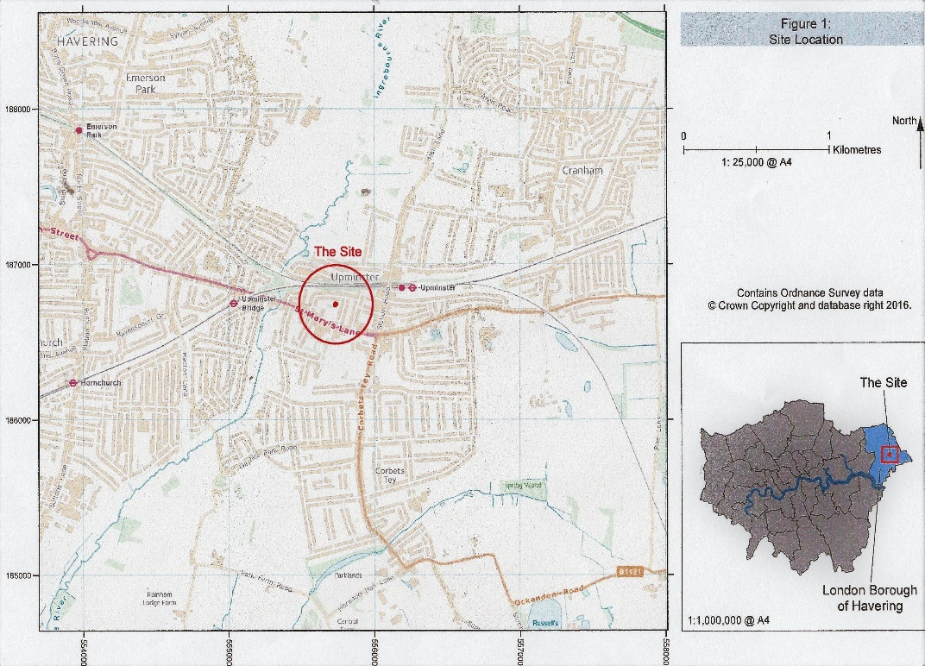
The Mills Complex was located on Mill Field, north of St Mary’s Lane in Upminster Essex NGR TQ55734 86725. (Fig 1)
Fig 1

The steam mill was added to the windmill, according to TL Wilson (the local historian of the time) circa 1811. The rateable value of the windmill increased from £37.10 to £77.10 on June 7th, 1812, which confirms the steam mill was working by then. The steam mill was driven by a Boulton and Watt Bell Crank steam engine. This was acquired from a Thames dredger and modified to operate 2 sets of mill stones for grinding corn. The only known Bolton and Watt Bell Crank engine surviving today is in the Science Museum.

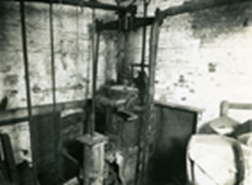
The steam engine in situ at Upminster steam mill circa 1930- 1940 (note the flywheel in the wall behind sliding doors) The engine was rated at 6hp with a running speed of 40 rpm.

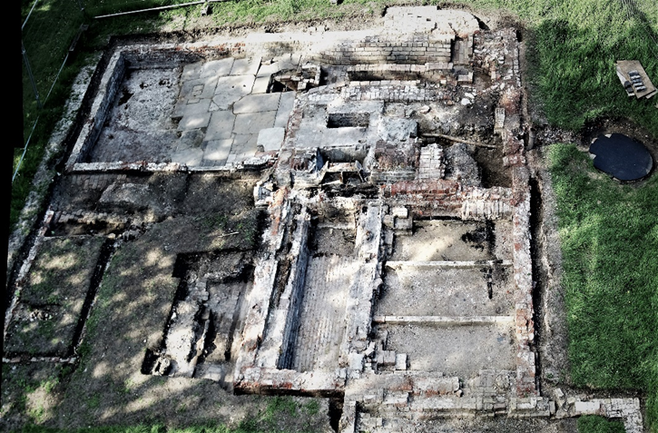

A view of the steam mill complex taken from the top of the windmill. (note the well to the right of the building, this sits where the pond was situated).

The Steam Mill consisted of four elements. These were: The Grinding Room, The Engine Room, The Boiler and Flues and The Coal Place.
The Grinding Room: This room was brick built with red brick with a shallow frog and laid with Flemish bond. The building was split internally lengthways into two halves, and lies on a north-south orientation, with the southern end adjoining the northern end of the meal room. The building was offset to the meal room and was separated from the meal room by a 2 foot (61cm) thick brick wall. The dimensions of the grinding room were 12 feet (3.66m) long x 15.5 feet (4.70m) wide. The eastern side of the grinding room had a wooden floor where the grain was stored prior to grinding. This area also had the stairs to the mezzanine floor, and two crane pads (these pads would have housed temporary cranes used for the removal of the stones for maintenance). The western side of the grinding room housed the grinding pit, where the cogs and shafts ran. Above this pit was the mezzanine floor which housed two sets of stones and grain bins.
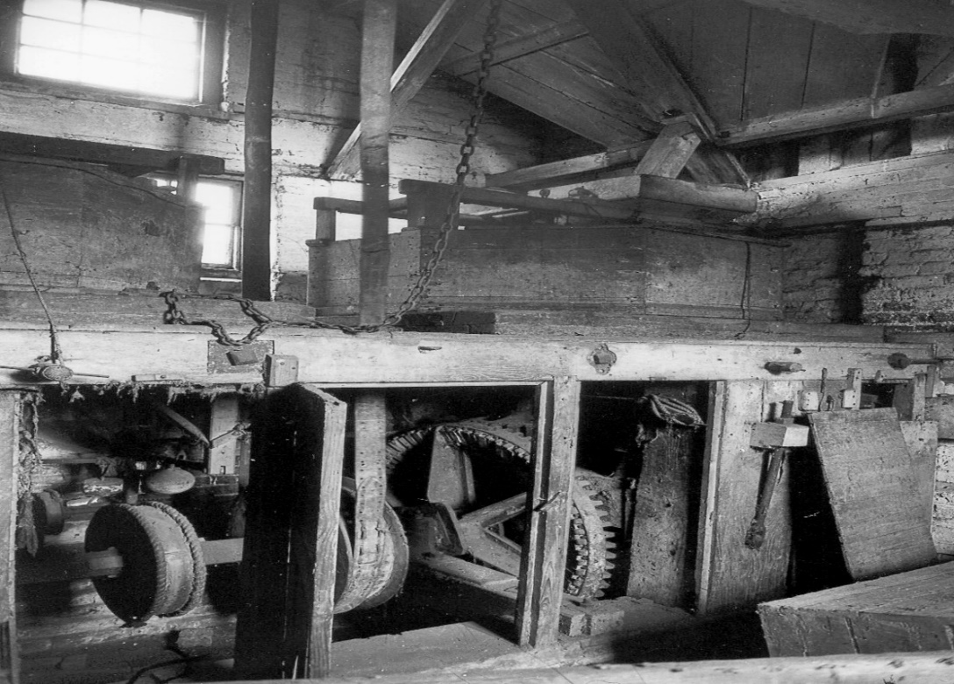
Photograph of the grinding room circa 1930-1940. This shows the machinery for driving the stones and the pit. Above the pit and machinery are the two tuns which house the grinding stones.

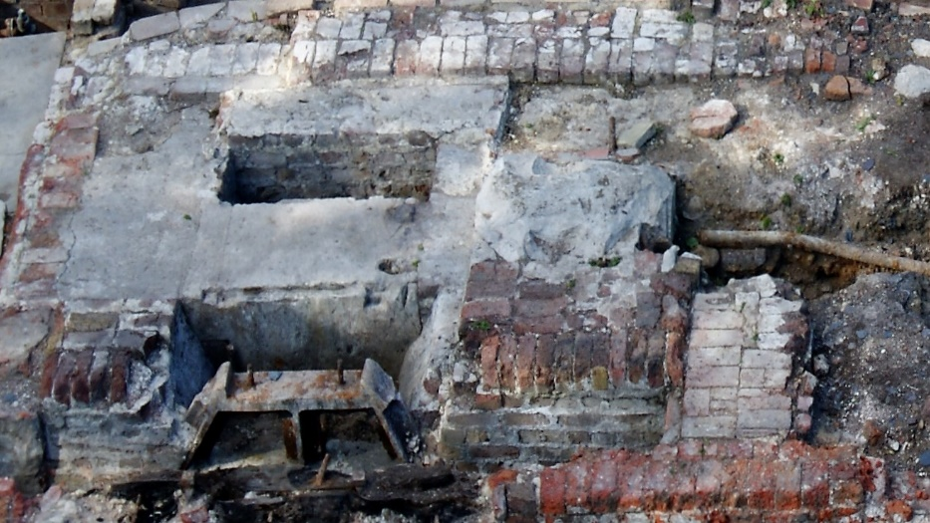
The Engine House: This building was brick built with red bricks, in Flemish bond, measuring 210mm x 103mm x 67mm. The engine house lies on a north-south orientation, with the southern end adjoining the northern side of the fly-wheel pit. The engine house was separated from the grinding room by the fly-wheel pit. This housed a 10-foot (3.05m) diameter flywheel. The engine mounting block and crank shaft pits were still in situ. The engine house shared the same building as the boiler room. The pond was 12 feet (3.66m) east of the engine room and was fed by a wooden leet from a pond east of the site.

Photograph of the engine mounting block. The two pits to the left are the crankshaft pits. The iron bearing mount in the foreground, housed the flywheel bearing. The flywheel pit is in front of the bearing mount.

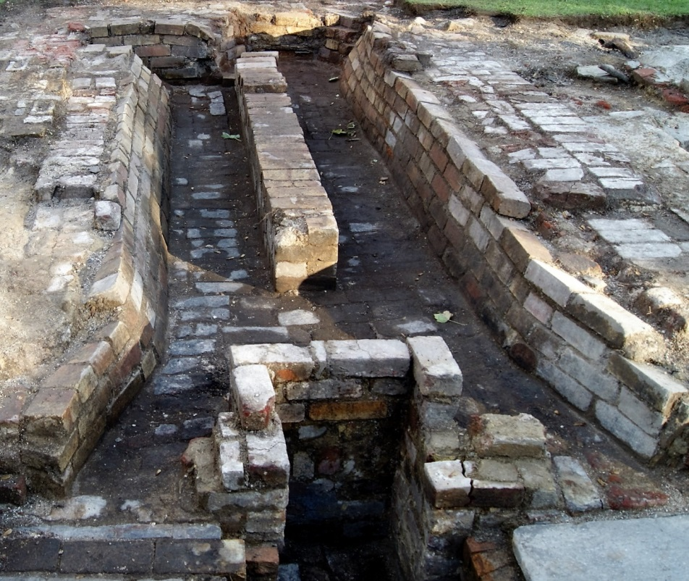
The Boiler Room: This part of the engine room housed the boiler. The flue channels and blowdown valve pit were still in situ. The area was on a north-south orientation with the southern end separated from the engine house by a low wall. At the northern end sat the base of the chimney. The early boiler was of single fire Cornish style and sat on the flue walls in an east-west orientation and was a brick set type of boiler. The dimensions of the engine house and boiler room were 13 feet (3.96m) long x 15.5 feet (4.70m) wide. The boiler was replaced at least once with the latest boiler being a Davy Paxman boiler.

Photograph of the boiler flue looking east. The pit in the foreground is the blow down valve pit. The area to the top left of the photograph is where the chimney sat. The engine mount is on the top right of the photograph, and the boiler sat over the flues on the central wall. The boiler was a brick set boiler.

The Coal Place: This building was of brick construction and sat on an east-west orientation, with the western end adjoining the eastern side of the engine house/boiler room. This adjoining wall was a full brick wall, but the centre portion was arched. This allowed the arched part of the wall to be dismantled, to remove the boiler, but allowed the remainder of the wall to support the building. The floor, on excavation, was laid to reclaimed paving slabs, but on further investigations, found the original floor was of brick. The slabs were probably used to raise the floor level after the boiler was replaced. The dimensions of the coal place were 16 feet (4.87m) long x 12.5 feet (3.80m) wide.
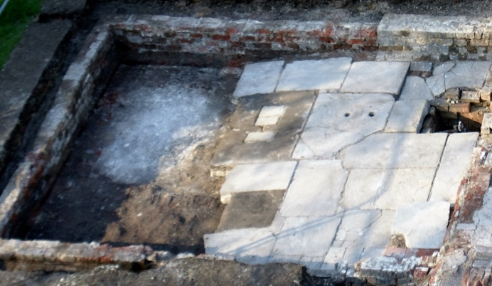
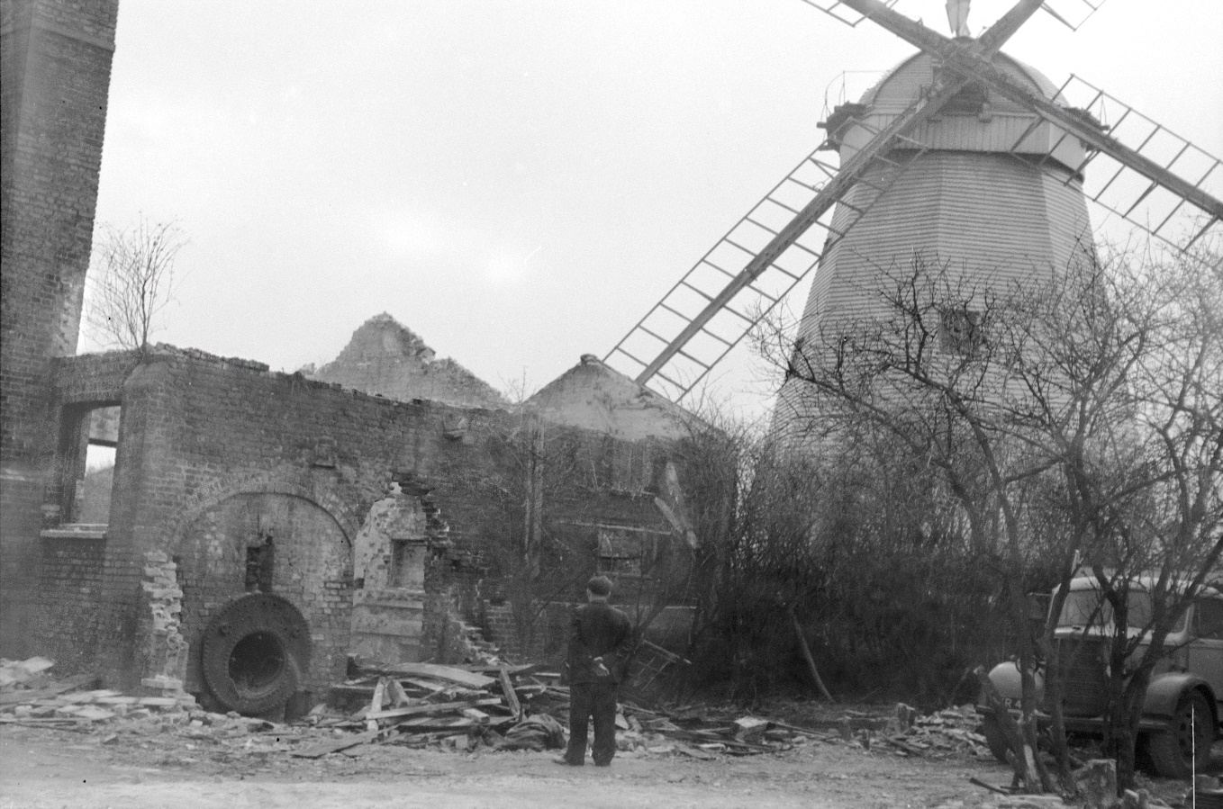
(Previous page) Photograph of the coal place. Note the blow down valve pit (complete with the valve) in the top right-hand corner. The bottom right-hand corner is the step access into the boiler and engine rooms.

Photograph of the steam plant during demolition in 1960. Where the man is standing was the Coal Place. To the left of him you can see the remains of the boiler house, boiler and Engine Room. To the left of the boiler, you can see the chimney (approx. 47 feet tall). To the right of the man and next to the windmill was the grinding room.
The Well: There had been no indication on any documents that a well existed, and no record of a well in the vicinity of Upminster Windmill on the BGS online maps, charts and borehole logs. The well lies 5 feet (1.52m) to the east of the engine room and in a direct line from the engine mounting block and is 2 feet 8 inches (0.8m) from the pond. The well was probably dug after 1869 when the rights to draw water from the pond expired. This would have required a new water supply for the steam plant. The well was of brick construction and slightly elliptical in shape. It had a course of bricks around the top. There was a cast iron pipe running from the engine mount, through the engine room eastern wall and going down into the well. The internal diameter of the well was 3 feet 6 inches (1.07m) east-west and 2 feet 10 inches (0.86m) north-south and was approx. 10 feet (3.05m) deep. The well continues to this day, to fill with water from the water table to around a depth of 7 feet (2.15m).
.

Photograph of the well, showing the water feed pipe to the engine block. The channel either side of the well rim probably held a timber framework to allow manual retrieval of water, and the triangular blocks were probably to secure some form of lid.
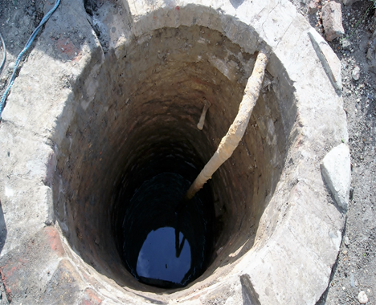
According to the International Stationary Steam Engine Society the steam mill site at Upminster Windmill is of significant importance, as stated in this correspondence:
1st March 2015
RE: Upminster Windmill 1811 steam mill foundations archaeological dig
Dear Sir, ISSES is the recognised leading specialist UK and international voluntary group specialising in the history and recording of stationary steam engines.
I can confirm that these foundations held a pre-1811 (supplied second-hand) self-contained ‘Bell-Crank’ engine manufactured by the world-famous firm of Boulton & Watt at their Soho Foundry in Smethwick in the Black Country (Staffs).This is confirmed without doubt by some extant photographs in-situ (disused) taken in 1935 by the nationally famous engine recording photographer George Watkins, whose entire life record is now held by English Heritage at Swindon as nationally important Collection. We also know that the famous mills expert Rex Wailes had an interest in the history of this machine and mill as well. Since it is known that the engine at Upminster was obtained second-hand, it is possible that this was one of these very early steamboat engines, modified for onshore use.
Bell-Crank engines are extraordinarily rare, as despite their contemporary popularity, there is only one known worldwide survivor, the one on public display in the London Science Museum Main Power Hall (ex-Nicholson’s gin distillery, Three Mills, Stratford, NE London).
The Upminster site is currently the only one known to ISSES where an original Bell-Crank engine site has been exposed to public view. It is simply, unique worldwide. The engine was significantly modified to a unique purpose design in order to be used at Upminster, as confirmed by the 1935 photographs. This again makes the site even more unique. Also, the foundations of both engine and the driven mill are exposed and there are some historic photographs of the mill machinery available.
Yours sincerely,
Chris Hodrien Technical Adviser, ISSES
The steam plant has now been reburied to preserve the archaeology, although the walls of the steam mill buildings have been outlined by sleepers to indicate their position. There is an archaeology report covering the excavations of the whole of the windmill site, on the Upminster Windmill website www.upminsterwindmill.org
Paul Sainsbury - Trustee: Upminster Windmill

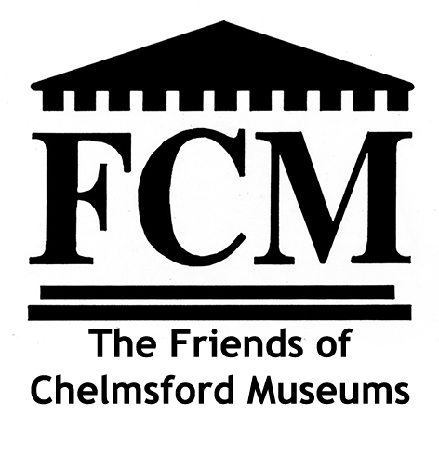
present THE ANNUAL MUSEUM LECTURE
at the Cramphorn Theatre, Chelmsford
on Friday March 11th 2022
7.45 p.m.
Chelmsford’s Industrial Past Revealed
A guide to the sites and the people
An illustrated talk by Tony Crosby 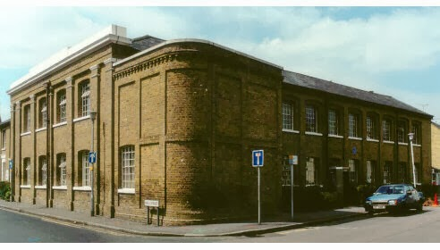
Marconi’s original factory in Hall Street, Chelmsford
Friends of Chelmsford Museums Members £6.00 Non Members £8.00
In 1987 Stanley Wood devised and wrote a Chelmsford Industrial trail pinpointing the importance of the county town’s industries, describing the places involved and the people who made them possible. In 2018 Tony Crosby and Dave Buckley revised and updated it and Tony now brings the trail to life in the Annual Museum Lecture.
EUROPEAN ROUTE OF INDUSTRIAL HERITAGE (ERIH):
REVIEW OF 2021
The ERIH newsletter for December 2021 summarised the main project activities of the year. The following provides highlights for EIAG members, for more information about past and future activities see https/www.erih.net
ERIH Work IT OUT EVENT: Despite COVID-19 and very different regional or national restrictions, this annual joint dance experience was held again. The show spanned 35 ERIH sites in 14 European countries. At exactly 3 p.m. on 12 September (Open Monument Day in Germany), teams delivered a previously rehearsed performance. This was linked by the joint choreography of the Frankfurt dance agency My Dancers to the song "Empowering Us”. There was also a live stream broadcasted at the Kulturbrauerei in Berlin, live coverage of individual sites and interviews with people from across Europe.
ERIH INDUSTRIAL HERITAGE BAROMETER SURVEY 2020/2021: In partnership with the Statistics and Surveys Unit of the Ruhr Regional Association ERIH has been collecting data on the state of industrial heritage in Europe each year since 2018. The 2020 survey was postponed because of the pandemic but this provided the opportunity to now include data from 2019 and 2020 in order to better assess the impact of the pandemic.
The results from the 73 participating sites are alarming. They were closed on half of the regular opening days due to corona. The remaining days were subject to changing hygiene requirements and restrictions. Events had to be cancelled, rental income was lost. 79 per cent of the sites responded with online offerings such as virtual museum tours or digital exhibitions.
The impact on the annual results compared to 2019 is striking with 56 per cent fewer visitors and 28 per cent less income. This could only be partially absorbed by financial aid, mostly paid from public funds, and about one third of the sites had to lay off employees. 14 per cent of the responses still assess the situation as critical and consider the sites in question to be in permanent danger.
ERIH ANNUAL CONFERENCE AND GENERAL ASSEMBLY 2021 (held at the Ghent Industrial Museum, 6-8th October): The General Assembly held prior to the official conference programme included election of the board of directors for the next three years. All board members seeking re-election were confirmed. Peter Backes from Germany and Javier Puertas Juez from Spain were elected as new members.
Jonathan Lloyd was elected an ERIIH Honorary Member for his many contributions to the project. He was a UK project partner from the beginning, representing the Iron Bridge Gorge Museums. In 2012 he became the United Kingdom and Ireland National Representative and has also presented the ERIH conferences.
The Annual Conference topic was "RESILIENCE - How industrial heritage sites accepted the pandemic challenge and survived the crisis” Current levels of contagion, with restrictions and even nationwide lockdowns, show the continued danger of the pandemic In response industrial heritage sector survival depends on jointly developing viable strategies. The results of the ERIH Industrial Heritage Barometer 2020/21 served as a major source for this conference topic.
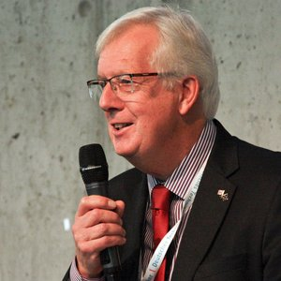Jonathan Lloyd
Following welcomes by ERIH President Prof. Dr. Meinrad Maria Grewenig and Ann Van Nieuwenhuyse, Director of the Ghent Industrial Museum, the host, provided a brief introduction to the impressive conference venue and ERIH Anchor Point.
Julia Pagel (DE) from the Network of European Museum Organisations (NEMO), gave an overview of the results of two surveys on the impact of the pandemic on European museums. The focus was on changes in museum structures and activities and on changes in visitor behaviour. More than 1,000 museums from 45 countries participated in the surveys in May 2020 and early 2021. 40% of them saw their visitor numbers plummet by at least half after the first lockdown. Income dropped sharply as a result in the case of museums in traditional tourist destinations, falling by three quarters compared to previous levels. 93 per cent of the survey respondents reacted by expanding or designing digital products and services, with social media activities and videos being the most popular ones. Among the key challenges for the future, NEMO identifies the need to find new funding options and to invest in digital tools and skills.
Dr Michael Nevell (UK), Industrial Heritage Support Officer for England, presented "Restarting Industrial Tourism in England: the Impact of COVID-19". How do they respond to the pandemic and which funding opportunities have been developed? A feature of many sites is the vital role that volunteers play in their day-to-day operation. As a result, three quarters of industrial monuments and museums remained closed after the first lockdown. Those affected also report frequent problems with burglary and vandalism. Reopening required new hygiene concepts and an appropriately adapted visitor guidance system. Ten new regional Industrial Heritage Networks (IHN) are facilitating regular online exchange between the participating sites.
After this bird's eye view, four speakers provided an insight into specific measures at ERIH member sites (the Foundation of Portuguese Railway Museums, the Bois du Cazier World Heritage Site, the Wieliczka Salt Mine Museum World Heritage Site, and the Berliner Unterwelten e.V). In the afternoon issues identified were discussed by participants in three workshops, the outcomes of which will feed into ERIH's future agenda.
ERIH COOPERATION: NINTH BERLIN FORUM ON INDUSTRIAL CULTURE 2021: The conference title was "Industrial Heritage and Sustainability – New Approaches to our Legacy". The challenges of climate change and the call for a long-term approach to the preservation and communication of industrial heritage is one of the future priorities of the ERIH network. The hybrid conference provided simultaneous translation into English for a total of 230 guests from Europe and beyond.
ERIH NATIONAL REPESENTATIVE CHANGES: A new ERIH's representative for Denmark and the other Scandinavian countries is sought following the retirement of Frank Allan Rasmussen.
Jonathan Lloyd retired as UK representative in December 2021. Rather than a single replacement the new national representatives are Dr Mike Nevell (UK), Mark Watson (Scotland), and Ruth Taylor Davies (Wales). John Rodgers will continue as the UK representative on the ERIH Board.
Dave Buckley

Book Review
The Cutlers – Thaxted’s Golden Era by Richard Till
Thaxted Society, 2021 - 72pp, 23 maps, 5 drawings
The Thaxted History Project was commissioned “to research and publish volumes on the major historical milestones” in the town’s heritage. This second volume outlines the “extraordinary impact” of the cutlery industry in the town between 1350 and 1500. The author’s research and resulting text and maps will help readers to identify where the cutlers lived and worked, and what physical evidence survives in the town to this day. The book is divided into three parts which overlap chronologically:
- Crisis and Change in Thaxted Manor (including climate change!) – setting the social, economic and land-owning context behind the start of this industry.
- The Cutlers of Thaxted 1350 - 1500- their arrival, the development, structure and process of the industry.
- The Growth and Development of the Late Medieval Town – the peak and decline of the industry.
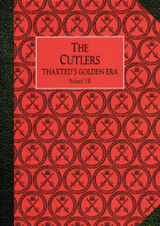
Part 1 is based on the author’s article of the same title published in Essex Archaeology and History, Vol. 8, 2017, and Part 2 on his article of the same title in The Local Historian, Vol. 48, No. 4, 2018. Part 3 completes the author’s research into the history of this industry describing its peak and then decline, and the subsequent growth of the cloth trade.
Although repeating some previously published material, this book completes the history of the cutlery industry from its rise in the C14th to its decline in the C16th. It reveals for the first time the complete story of what was at the time a major activity in the town and an industry not naturally associated with the County of Essex.
Copies are available from The Thaxted Society: https://www.thaxtedsociety.com/

Tony Crosby

