Essex Industrial Archaeology Group
(Incorporating The Essex Mills Group)

NEWSLETTER

Number 47 January 2023

Happy New Year and Welcome to this edition of the
Essex Industrial Archaeology Group’s (EIAG) Newsletter

In this edition we highlight two more new books to bring to your attention in case Christmas book tokens are waiting to be spent! There are articles on sculptures which celebrate Braintree’s industrial heritage, the iron bridge at Markshall, and one on the former PoW Camp in Hatfield Heath. Also there is follow-up on H & T C Godfrey and a look at Wethersfield brewery. Forthcoming events in the county which will be of interest I am sure are announced in posters at the final pages.

If you have any comments on the Newsletter generally or specific items in it, or wish to make a contribution to the next Newsletter, please contact us via our email address - essexiag@gmail.com.

Contributions for the Newsletter should be sent by the end of the month prior to publication (i.e. by end of March, June, September and December), please. Please submit text as a Word document and photos as separate files such as jpgs.

Programme of EIAG events 2023

East of England Region Industrial Archaeology Conference
Saturday 10th June 2023, 10:00 – 4:00 at Chelmsford Museum.
See Poster below for current details

EIAG Annual Meeting
Saturday 11th November 2023, 2:00 pm.
Further details TBC

Two recent publications
Marconi’s Wireless Telegraph Stations in Essex – The Centenary of Brentwood and Ongar Radio Stations
By Paul Hawkins and Paul Reyland. ISBN: 978-1-80369-382-8
This is the story of two radio communication stations built by Marconi in Essex, a receiving station at Brentwood and a transmitting station at Ongar, established to provide European and international wireless telegraph services. Commencing operation in 1922, with services to Berne, Paris and Madrid, telegrams were transmitted and received in Morse code at around 100 words per minute. The stations operated in the long wave band and the transmitters and receivers utilised the latest in valve technology. Services rapidly expanded to cover a number of countries in Europe and the Middle East plus Canada and the USA. Further expansion took place when new short wave wireless technology became available later in the 1920s and services were established across the globe.
The book describes development and growth of the stations, the challenges faced during WW2, post WW2 modernisation, technological changes throughout the 20th century and the eventual closure of the stations as modern satellite communication technology superseded short waves. Brentwood continued to operate until 1967 and Ongar found a new role in the maritime radio service, remaining in operation until 1985.
Both authors have professional experience in radio communications and Paul Reyland spent time working at both radio stations. The book has 130 pages and is illustrated with numerous photos, diagrams and tables, and is available from Amazon and other online sellers priced £8.99.

Radwinter to Beeleigh Abbey – A long-distance walk following a medieval route-way through the heart of Essex
By Helen Walker. ISBN:978-1-7398808-0-4
This recently published booklet is based on an historical reference documenting that in the Middle Ages corn was transported by water from the village of Radwinter (near Saffron Walden) to Beeleigh Abbey, at Maldon, via the Rivers Pant and Blackwater (actually one and the same river). In the present day it is not possible to make this journey by boat, but this entire stretch of river valley can be walked, following mainly public footpaths and minor roads. Sometimes the path goes alongside the riverbank, but often takes a route well away from the valley bottom, making for a varied journey, across meadows, fields and farmyards, through churchyards, past watermills and into some of the most attractive small towns and villages in Essex each with its own distinct character.
The main aim of this booklet is to create an enjoyable walk, but it also tries to convey something of what it must have been like to make this journey in the medieval period either by river or on foot. The booklet comprises a route narrative, sketch maps and observations on what the medieval traveller may have encountered and what can be seen in the present day. The route is 40miles long (64km) and is divided into four stages of roughly equal length. It passes two windmills and ten watermills, some complete and some in ruins. The latter part of the route follows the Witham to Maldon railway line including the trestle viaduct, and the Chelmer and Blackwater Navigation.
The booklet retails at £5 and is available from: The Art Place, Meadows shopping centre, Chelmsford; Harts Books, Saffron Walden; Between the Lines bookshop, Great Bardfield; Red Lion Books, Colchester; Brick Lane Bookshop, London. It is also available from tourist information centres at Saffron Walden, Bishop’s Stortford, Witham, and Maldon, and from the author, Helen Walker, via email at walker1956@btinternet.com.

In the October issue (#46) we asked for information regarding the presence of H & T C Godfrey of Saffron Walden. Elphin Watkin passed on the following from Mike Hibbs (Chairman of the Saffron Walden Historical Society):

‘Godfrey’s was a shop in King Street in Saffron Walden. The premises included a large yard with a number of outbuildings stretching up the hill to Church Street. The shop sold a wide range of items, including photographic and camping equipment, guns, leather items and outdoor clothing, and also prepared lengths of rope and repaired canvas and leather items. The shop was opened in the 1920’s by ‘Mr Godfrey’. He had apparently been in the Airforce during WW1, employed as a photographer, leaning out of the window of the plane. He went on to serve as Mayor of Saffron Walden. The yard and outbuildings behind the shop had at one stage been a slaughter house.’
The King Street premises were at no. 16, and they also had a shop at no. 5 Market Street which sold leather goods.
Public Artworks inspired by Braintree's Industrial Heritage
The following appeared in Newsletter Number 34 of the Newsletter of the Friends of Braintree District Museum who are thanked for allowing it to be reproduced here:
'A collection of five permanent public artworks has been installed at Meadow Rise, Townrow Avenue off London Road, Braintree, by the artist Katy Beinart to celebrate the silk weaving industry that shaped the development of Braintree. The title Hybrid refers to both the mix of patterns from different parts of the world which are held in the Archive [i.e. the Warner Textile Archive], to processes of growing plants. The sculptural works are created in the form of jacquard loom cards which translate the pattern from process to completed pattern in the fabric. Made of steel which is shot blasted to give a stabilised "corten" finish over time, as the cards weather, the finish develops fully to give an even red-brown colour. They are positioned to form a fragmented sundial so that as the light passes through the punched design, the shadows of the pattern are revealed on the path.'
Alongside the artworks there is an information panel which explains that the works were developed through community workshops held at Braintree Museum in 2019.
Are there many other artworks around the county that have been inspired by industrial heritage? The statue of Marconi in Chelmsford is one but are there many more?
Text and photo – Paul Gilman

Iron Bridge, Markshall Estate (TL8400925191)

As a regular visitor to the Markshall Estate I have often been struck by the attractive little bridge, located close to the entrance and visitor centre (see photo), so I recently tried to find more about its history. According to the Estate's website, the bridge was built by Filmer Honywood in the early 19th century. The bridge is marked as 'Iron Bridge' on the OS six-inch map, revised in 1896 and published in 1898, located about 200m south of the hall (since demolished). The Honywoods owned the estate from 1605 until 1897 and the Estate is now maintained by a charitable Trust set up by the last private owner, Thomas Phillips Price. The website adds that the bridge was extensively restored in 1992 when new cast iron work was produced at a local foundry to replace some missing sections.

The bridge carries an estate road over Robins Brook, a tributary of the River Blackwater and is Listed Grade II (National Heritage List No. 1123124.) The list entry describes it as a 'Garden bridge' dating to c.1800, of red brick with limestone copings and cast-iron railings. There are cast iron railings on each side, made of six large sections over the bridge itself, and two straight sections on the road approaches to the bridge. There are urn finials on the handrail and there are bosses of lion's head design at the centre of the sections of railing (see photo).

I have contacted the Markshall Estate to ask if they have any further information about the bridge but have yet to hear from their Archives team. In the meantime, if anyone knows any more about this bridge or if there are similar ones in Essex, I would be pleased to hear from them.

Text and photos – Paul Gilman (paul.gilman@me.com)

Prisoner of War Camp 116, Hatfield Heath
Firstly a question: is the archaeology, history and heritage of our military past a legitimate aspect of industrial archaeology? Your views would be welcome, please. However, the survey report on a former PoW Hostel in Cheshire was published in the most recent edition of Industrial Archaeology Review – Chris Wild, Accommodating Prisoners of War: A Survey of the Weston Hostel, I.A.Review, Vol. 44, No. 2, p 149-157. So I would claim that it is legitimate for this article on the history and heritage significance of the PoW Camp 116 in Hatfield Heath to be in the EIAG Newsletter!

The (then) English Heritage report of 2003 on the Twentieth Century Recording Project: Prisoner of War Camps (1939 – 1948) by Roger JC Thomas, listed 1,026 potential locations of camps in Great Britain, although this was not a true reflection of the actual situation due to inconsistencies in the numbering of the locations. Of that number the recording project identified a total of 456 sites in Great Britain of which 372 sites are in England and the Channel Islands.

Initially there was no standard design for the construction of the sites, standardisation being introduced in 1942. Some Standard design camps were built by well-known construction companies, but many were built by the prisoners themselves, living under canvas while construction progressed. The Standard design camps consisted of a guards’ compound surrounded by a single fence, and a separate prisoners’ compound surrounded by a plain outer fence and an inner barbed wire fence. The most common style of buildings used in the Standard design camps were the Ministry of War Production (MoWP) Standard Hut of 18’ 6” span for the guards’ compound, and all-timber Laing huts for the prisoners’ living accommodation.

The 2003 Recording Project adopted a then common English Heritage classification system, so each site was graded from 1 to 5 as follows:

- Complete – majority of original structures and layout remain intact.
- Near Complete – 50 – 80 % survival.
- Partial Remains – less than 50% remain.
- Removed – footprint may survive.
- Unresolved – no evidence remains or inconclusive.

Survival of sites depends on a number of factors, the most important seeming to be rural location and the continuity of use of the site for other purposes. Survival of all types is poor, but it is the Standard type which survives the best: a total of 71 in England have been identified, of which five are Class 1, and seven in Class 2.
In respect of Essex there are 10 camps identified in the Recording Project, one in Class 2, two in Class 3, and seven in Class 4. These are:

Camp No. | Location | Class | Type | Comments
78 | High Garrett Camp, Halstead Road, Braintree | 4 | German Working Camp | STANDARD type. Site occupied by a wireless mast
116 | Mill Lane Camp, Mill Lane, Hatfield Heath | 2 | German Working Camp | STANDARD type. Egg packing factory
129 | Ashford Camp, Halstead | 4 | German Working Camp | Depot with associated Nissen hut camp
180 | Radwinter North Camp, Radwinter Manor, Walden Road, Radwinter | 4 | Base Camp | Large complex of huts. Some cropmarks visible
186 | Berechurch Hall Camp, Colchester | 3 | Base Camp | Large number of huts have been demolished and replaced by modern accommodation.
236 | White House, Church Hill, Loughton | 4 |  | Site occupied by housing
266 | Hutted Camp, Bentley Farm, Old Church Hill, Langdon Hills | 4 | German Working Camp
286, 654 & 655 | Purfleet Camp, Beacon Hill, Purfleet | 4 | German Working Camp | Also Transit Camps nos. 1 & 4 at various times
607 | Hutted Camp, Ickleton Grange, Ickleton | 3 |  | Essex & Cambridgeshire
670b & 680 | Shatesbury Camp, Dovercourt, Harwich | 4 | German Working Company

PoW Camp 116 in Hatfield Heath (NGR: TL 518156) is a Standard design camp and was assessed as Class 2 – Nearly Complete – the only Essex camp in that Class. As such it is in the top 17% of the surviving Standard type of camps (71) and one of 10% of those in Class 2. This heritage significance is reflected in the fact that Camp 116 is on the Local Heritage List of Uttlesford District Council.

Construction of the camp began in 1942, originally for Italian prisoners who were considered low risk and were employed on local farms. From 1943 onwards German prisoners were also housed here, again those considered to be of low security risk. It conforms to the Standard design with the guards’ compound on the south side of the site consisting of MoWP huts and to the north the prisoners’ living huts all of which are Laing timber huts. A variety of materials was used in construction – timber or concrete for the framing, covered by either weatherboarding or hollow clay blocks, brick or concrete blocks. The prisoners’ compound consisted of the sleeping quarters, an ablution and toilet block, kitchen, canteens, chapel, hospital and office.

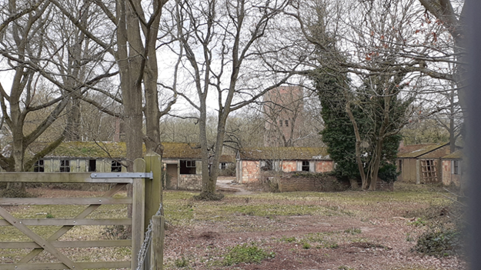
The guards’ compound consisted of offices, separate quarters for officers and soldiers, a mess, storage blocks, but the prominent feature of the guards’ compound was the standard water tower which, in the case of Camp 116, survives in good condition and little altered.

After the war the camp eventually closed in 1947. Some of the prisoners remained and married locally, and some of their families are still living in the area. The site of the camp was returned to the local farmers who owned the land with an assumption that the buildings would be demolished and the land returned to agriculture. However, the prisoner’s compound buildings were put into use as a poultry farm and still today it is the base for an egg packing factory – Greenways Eggs, Camp Farm, Hatfield Heath.

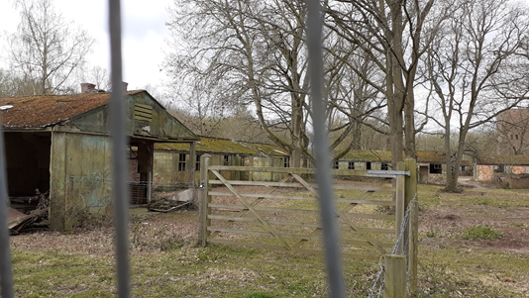
The guards’ compound, however, has not been developed at all and therefore all the buildings remain in various forms of dereliction. The site has been subject to at least four development proposals, all refused planning permission so far, the latest of which proposed ‘the demolition of 10 no. existing structures, the conversion and restoration of 8 no. existing buildings to form 8 no. holiday cottages and 1 no. dwelling, the construction of 3 no. single storey dwellings’. The single dwelling was to be the conversion and restoration of the water tower.

The Hatfield Regis Local History Society has compiled a detailed history of the camp, including oral history accounts and a report on the football match which took place on Boxing Day 1946 between remaining prisoners and the village football club. Although the prisoners won 11-0, the game is still celebrated in Hatfield Heath as part of the local folk lore. (https://hatfieldregislocalhistorysociety.weebly.com/)

Text and photos – Tony Crosby

Wethersfield Brewery

I first visited Wethersfield Brewery in February 2002 while undertaking fieldwork for the ECC Comparative Survey of Essex Breweries – for the text of that survey see the EIAG pages of the ESAH website at: https://www.esah1852.org.uk/eiag/publications-eiag/essex-breweries.
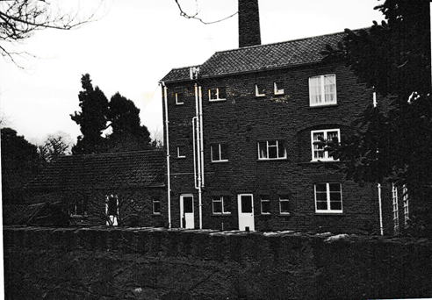
The brewery was probably built in the 1840s when Thomas Raven was recorded as the brewer and eventually also a maltster. It was sold to Greene King in 1901 and brewing continued until after WW2. The site included a malthouse (now the Village Hall), the owner’s house (now Hillfoot House), the Brewery Tavern (now a private house) and the three storey brewhouse. The b&w photo left was taken in 2002. The survey report recommended listing all four component buildings of the complex a Grade II in recognition of their significance, especially the group value. This was not implemented, but all buildings are in the village Conservation Area.

Earlier this year we visited Wethersfield and were able to see the Brewhouse as it is now since extensive restoration and adaption into a private residence. See the photo below and decide for yourselves whether this is a sympathetic restoration.

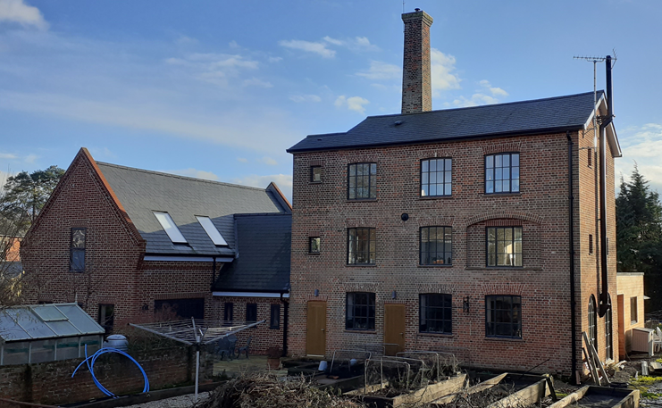

Text and photos – Tony Crosby

