THE PLACE-NAMES

OF ASHELDHAM

Recorder: James Kemble

Essex Place-names Project (Essex Society for Archaeology & History), 2013 (e-book).

www.essex.ac.uk/history/esah/essexplacenames

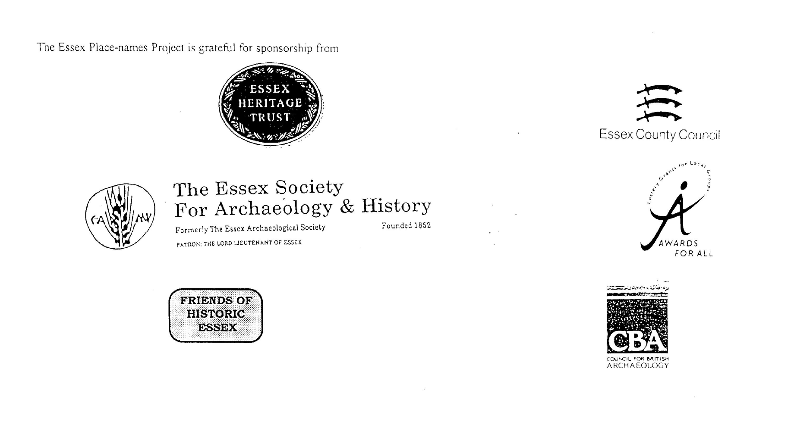

ESSEX PLACE-NAMES PROJECT.

The Essex Place-names Project is a County-wide survey to record place- and field-names from historical documents such as Tithe maps and apportionments, estate maps, sale
and auction catalogues, conveyances, terriers, deeds, rolls, inquisitions and surveys.

The second element of the Project is to investigate on-the-ground visible remains which correspond to the Place-names for actual or potential archaeological, agricultural and industrial
sites, and to record natural (topographical) and man-made features which may relate to the Place-name. This involves field-survey in rural and outside investigation in built-up areas.

It is anticipated that the Project will lead to identification of archaeological sites and lost historic buildings; it will enable analysis of indicators of early settlement, land holding, agricultural and industrial practices of the County. It will refine the more precise meaning of descriptive words and elements used by earlier settlers as they gave names appropriate to the topography of the landscape of their time.

For convenience the surveys are based on the parish, recognising that present civil parish boundaries are not necessarily identical to former ecclesiastical boundaries. Local Recorders
are supplied with templates of Record Forms to ensure consistency of recording across the County, and forward completed forms to a Central Coordinator for transfer to a county
computer database which is available to researchers on the internet at www.essex.ac.uk/history/esah/essexplacenames, and updated periodically.

This publication presents part of the information recorded from the Tithe or Estate Award and Map, and from other documents for this parish. The full record is contained on the master
database at Essex County Council (Historic Environment Section) and on the (above) website. Parish books are available to be downloaded from the website link ‘Books’ on the Home page. Please notify errors to the Project Coordinator at the Essex Record Office.

THE TITHE MAP AND APPORTIONMENT.

Since medieval times a tenth of the produce of land and stock had been paid by landholders to the church. At the Dissolution of the Monasteries, the property of many religious houses,
including the right to collect tithes, passed into lay hands. The Tithe Commutation Act which received Royal assent on 13th August 1836 abolished a rent payable in kind and
substituted rent-charges apportioned on each plot or parcel. The tithe-rent payable was assessed on the average value of wheat, barley and oats and was to fluctuate with price movements.

The commutation could be by voluntary agreement between the local owners and payers or, if agreement failed, could be compulsorily imposed by commissioners. A Valuer was to be
appointed to apportion the rent of each parcel of land and tenants could deduct that rent-charge from their rent paid to the landlord. The task fell to the Tithe Commissioners to produce a
map and an Apportionment (Award). A large-scale survey was produced for over 70% of England and Wales in the following 9 years, and about another 8% up to 1855. Most of the
parishes in Essex were surveyed. The map scales vary. The Award records ownership, tenancy and land-use, field by field and parcel by parcel (often quoting the field name) with the
ground area and rent-charge.

Land that was tithe-free tends to be less accurately mapped and contains few if any of the details recorded for those parcels subject to tithe. Rights of way and roads also tend to be
neglected. Boundaries of the tithe areas are shown as are some natural features such as streams, ponds, gardens, greens and commons. Buildings are often shown coloured red if dwellings
or grey if not. Because the Award may have been agreed only some time after the map was finished, discrepancies occur between the two. Enclosure Awards, when extant, usually date to the 18th and early 19th centuries. J.Kemble.
Reproduced by permission
of Essex County Council.

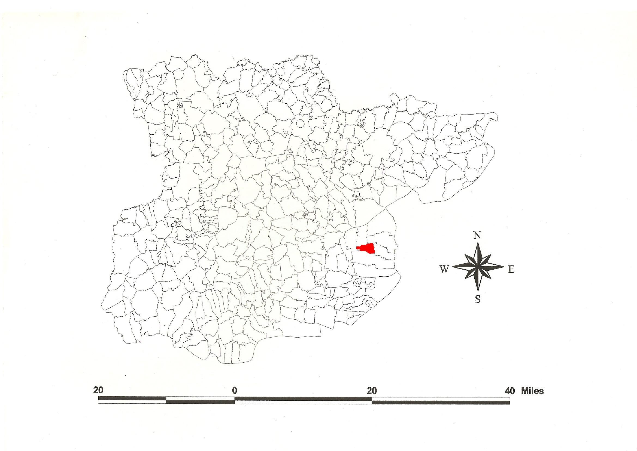
Asheldham Parish in the County of Essex.
Reproduced by permission of
Essex County Council.

The Parish of Asheldham (in Dengie alias Witbrictesherna Hundred).

The Tithe Award of Asheldham (Essex Record Office D/CT 9a), dated 1838, shows a rent-charge payable to William Whitfield, rector, of £420 including glebe of £11-10-0. The whole parish measured 1600 acres of which 1140 acres were arable, 400 acres meadow and pasture, 60 acres wood, and 40 acres glebe. The Valuer Charles Watson of Great Baddow. The Tithe Map (ERO: D/CT 9b), dated 1838, was surveyed at a scale of 20 inches to a mile and measures 115”x37”. It was countersigned by Roger Kynaston, Assistant Tithe Commissioner.

In 604x616, King Æthelbert of Kent granted land called Tillingeham to Mellitus, first bishop of London, for the minster church of St Paul; this probably also included Bradwell and Asheldham (Sawyer, 1968; Hart, 1992; Cook, 2013). In Domesday Book, 1086, Hainctuna was held by Warner from Earl Swein, which Godric had held before 1066 as a manor for half a hide and 37 acres. Ralph held Haintuna from Swein as a manor half a hide and 37 acres which a free man had held; Robert son of Wymarc had held both these lands after the arrival of King William (Morris, 1983; VCH, 1903). This translates from Old English heah ing tun, ‘high-place settlement’, lying as it does above the marshes (Kemble, 2007). Assildham, ‘[a woman] Æschild’s home’, is documented c.1130 (Reaney, 1935; Watts, 2004).

There were three manors: 1. Asheldham Hall was held by William Horkeslegh (died 1332). 2. New Hall alias Brockholes was held by Sir Geoffrey de Brockhole and passed to his daughter Joane (died 1443). 3. Bodenykes was held by John Bodenykes in 1399, and in 1537 Sir Thomas Bedingfield held it (Morant, 1768). The church dedicated to St Lawrence, who came to Britain with St Augustine and was second archbishop of Canterbury AD 606-616, has a nave and chancel whose base is Norman. A previous timber “church” and priest’s house have been detected (Drury, 1977). Asheldham Hall is timber-framed, 17th century. An Iron Age camp with extant banks and ditches lies 600 yards east of the church, the road deviating round it (Pevsner, 2007; Kemble, 2009).

The Hundred name Danesie (documented in 1185) was preceded by a charter of King Suebred of the East Saxons who granted 70 cassati (hides) in regio Deningei to the Bishop of London in 706x709 (Hart, 1971). Watts (2004) suggests this derives from a personal name Dæni + eg, ‘island’ or ‘island called after Dæni’. Reaney (1935) prefers to associate O.E. dænn, ‘woodland pasture for swine’. He allows that this area was once occupied by the Dænningas tribe. The Domesday Book (1086) name of the Hundred was Witbrictesherna, Wibrictesherna, which Reaney (1935) translates from a personal name + hyrne, ‘Whitbeorht’s corner’, referring to the topography of the peninsula. Christie (1926) places the moot at Lawling in Latchingdon which was held by ealdorman Brithnoth who was killed at the Battle of Maldon in 991 (Kemble, 2009a).

Place- and field-names from the map (ERO: D/DP P24), dated 1742, of George Wegg, jnr, and from other documents are shown against the Tithe Award names.

References:
Christie, M., 1926. Essex Hundred Moots. Trans Essex Archaeological Soc., n.s., xviii (3), 183.
Cook, B., 2013. The Place-names of Bradwell juxta Mare. www.essex.ac.uk/history/esah/essexplacenames. Then click on ‘Books’.
Drury, P., 1977. Essex Archaeology & History, 9, 95.
Hart, C., 1971. Early Charters of Essex, Leicester.
Hart, C., 1992. The Danelaw. Hambledon Press, London. p. 208.
Kemble, J., 2007. Essex Place-names, Places, Streets & People. Historical Publications, London. pp. 32, 50.
Kemble, J., 2009. Prehistoric & Roman Essex. History Press, Stroud. p.18, 20,113.
Kemble, J., 2009a. The Place-names of Latchingdon cum Lawling. www.essex.ac.uk/history/esah/essexplacenames. Then click on ‘Books’.
Morant, P., 1768. History & Antiquities of the County of Essex, i, 367.
Morris, J., 1983. Domesday Book – Essex. Phillimore.
Pevsner, N., Bettley, J., 2007. Buildings of England – Essex. Yale.
Reaney, P., 1935. Place-names of Essex. Cambridge.
Sawyer, P., 1968. Anglo-Saxon Charters. London. no 5.
Victoria County History of Essex, 1903, i, 393.
Watts, V., 2004. Dictionary of English Place-names, Cambridge.

The Tithe Award Place-names of Asheldham - by Parcel No.

Place-name | Alias | Fld No | Grd Ref | x | y | Acr | rd | pch | land use | Owner | Occupier | Farm | Other information
Near Ten acres |  | 1 | TL | 946 | 013 | 10 | 2 | 3 | arable | Cline, Margaret | Babbs, Robert | Welches | detached. Since 1888 in Steeple parish
Further Ten acres |  | 2 | TL |  |  | 10 | 3 | 14 | arable | Cline, Margaret | Babbs, Robert | Welches | detached. Since 1888 in Steeple parish
Eighteen acres |  | 3 | TL |  |  | 18 | 1 | 8 | arable | Cline, Margaret | Babbs, Robert | Welches | detached. Since 1888 in Steeple parish
Eight acres (pt) |  | 4 | TL |  |  | 5 | 0 | 12 | arable | Cline, Margaret | Babbs, Robert | Batts (pt)
Eleven acres |  | 5 | TL |  |  | 12 | 3 | 6 | arable | Cline, Margaret | Babbs, Robert | Batts (pt)
Welches Ten acres |  | 6 | TL | 948 | 016 | 13 | 0 | 5 | arable | Cline, Margaret | Babbs, Robert | Batts (pt)
Five acres |  | 7 | TL |  |  | 5 | 3 | 22 | arable | Cline, Margaret | Babbs, Robert | Batts (pt)
Asheldhams Ten acres (pt) |  | 8 | TL | 951 | 020 | 6 | 2 | 37 | arable | Cline, Margaret | Babbs, Robert | Batts (pt)
Kiln field (pt) |  | 9 | TL | 953 | 020 | 13 | 0 | 10 | arable | St Bartholomews Hospital, govrns | Bushill, William | Badnocks
Fourteen acres |  | 10 | TL |  |  | 14 | 3 | 19 | arable | St Bartholomews Hospital, govrns | Bushill, William | Badnocks
Great Hodges (pt) |  | 11 | TL | 957 | 022 | 15 | 0 | 12 | arable | St Bartholomews Hospital, govrns | Bushill, William | Badnocks
Smock field |  | 12 | TL | 958 | 020 | 18 | 0 | 15 | arable | St Bartholomews Hospital, govrns | Bushill, William | Badnocks
House pasture |  | 13 | TL |  |  | 7 | 1 | 6 | arable | St Bartholomews Hospital, govrns | Bushill, William | Badnocks
Homestead | Bodenecke, 1535, AD vi; Badnocks, 1875,OS | 14 | TL | 957 | 016 | 2 | 2 | 30 |  | St Bartholomews Hospital, govrns | Bushill, William | Badnocks | John Bodenyk, 1399,Morant
Pound pasture |  | 15 | TL |  |  | 1 | 0 | 39 | pasture | St Bartholomews Hospital, govrns | Bushill, William | Badnocks
Barn field |  | 16 | TL |  |  | 12 | 1 | 33 | pasture | St Bartholomews Hospital, govrns | Bushill, William | Badnocks
Upper Coneys |  | 17 | TL | 956 | 015 | 21 | 2 | 10 | arable | St Bartholomews Hospital, govrns | Bushill, William | Badnocks
Lower Coneys |  | 18 | TL |  |  | 20 | 3 | 15 | arable | St Bartholomews Hospital, govrns | Bushill, William | Badnocks
Chase |  | 19 | TL |  |  | 0 | 3 | 36 |  | St Bartholomews Hospital, govrns | Bushill, William | Badnocks
Cottage, garden |  | 20 | TL |  |  | 0 | 0 | 20 |  | St Bartholomews Hospital, govrns | Bushill, William | Badnocks
Upper Church Leys |  | 21 | TL | 960 | 014 | 19 | 2 | 32 | arable | St Bartholomews Hospital, govrns | Bushill, William | Badnocks
Lower Church Leys |  | 22 | TL | 961 | 018 | 25 | 0 | 22 | arable | St Bartholomews Hospital, govrns | Bushill, William | Badnocks
Fifteen acres |  | 23 | TL |  |  | 17 | 2 | 18 | arable | St Bartholomews Hospital, govrns | Bushill, William | Badnocks
Twenty five acres |  | 24 | TL |  |  | 26 | 3 | 27 | arable | St Bartholomews Hospital, govrns | Bushill, William | Badnocks
Brick Clamps |  | 25 | TL | 960 | 021 | 20 | 2 | 5 | arable | St Bartholomews Hospital, govrns | Bushill, William | Badnocks
The Mead |  | 26 | TL |  |  | 5 | 3 | 33 | pasture | St Bartholomews Hospital, govrns | Bushill, William | Badnocks
Roadway |  | 27 | TL |  |  | 0 | 2 | 8 |  | St Bartholomews Hospital, govrns | Bushill, William | Badnocks
The Grove |  | 28 | TL | 960 | 024 | 3 | 3 | 35 | wood | St Bartholomews Hospital, govrns | Bushill, William | Badnocks
The Spring |  | 29 | TL |  |  | 0 | 1 | 26 | wood | St Bartholomews Hospital, govrns | Bushill, William | Badnocks
Twelve acres |  | 30 | TL |  |  | 12 | 3 | 17 | arable | Baines, John | Vinson, George | Balls (pt)
Three acres |  | 31 | TL | 964 | 023 | 2 | 2 | 5 | arable | Baines, John | Vinson, George | Balls (pt)
Ten acres |  | 35 | TL |  |  | 11 | 1 | 0 | arable | Baines, John | Vinson, George | Balls (pt)
Twelve acres |  | 36 | TL |  |  | 15 | 0 | 0 | arable | St Bartholomews Hospital, govrns | Bushill, William | Badnocks
Nine acres |  | 37 | TL |  |  | 10 | 0 | 22 | arable | St Bartholomews Hospital, govrns | Bushill, William | Badnocks
Seven acres |  | 38 | TL |  |  | 7 | 1 | 8 |  | Smith, Thomas & Abraham | Merriott, John
Further Six acres |  | 40 | TL | 968 | 017 | 5 | 0 | 3 | arable | Smith, Thomas & Abraham | Merriott, John
Near Seven acres |  | 43 | TL |  |  | 7 | 1 | 34 | arable | Smith, Thomas & Abraham | Merriott, John
Near Five acres |  | 44 | TL |  |  | 5 | 1 | 38 | arable | Smith, Thomas & Abraham | Merriott, John
Seven acres |  | 45 | TL |  |  | 8 | 1 | 28 | arable | Gibson, Jabez | Spurgin, Richard & James | Sheep Cotes (pt)
Twelve acres (pt) |  | 47 | TL |  |  | 1 | 3 | 8 | arable | Gibson, Jabez | Spurgin, Richard & James | Sheep Cotes (pt)
Asheldham Gate |  | 48 | TL | 969 | 015 | 24 | 3 | 32 | wood | Petre, HonLord; Burchall, John Henry; Cooke, Henry, late, execs | Cooke, Henry, late, execs
Corner field |  | 49 | TL |  |  | 4 | 1 | 14 | arable | Smith, Thomas & Abraham | Merriott, John
Gatefield |  | 50 | TL | 971 | 015 | 13 | 2 | 23 | arable | Petre, HonLord; Burchall, John Henry; Cooke, Henry, late, execs | Malden, James | New Hall
Cottages, etc |  | 51 | TL |  |  | 0 | 2 | 22 |  | Miller, George | tenants | New Hall
Garden field |  | 52 | TL |  |  | 1 | 1 | 24 | gdn | Miller, George | tenants | New Hall
Two acres |  | 53 | TL |  |  | 1 | 1 | 36 | arable | Smith, Thomas & Abraham | Merriott, John
Lower field |  | 54 | TL |  |  | 1 | 3 | 37 | arable | Quihampton, Henry | Malden, James | Brook
Upper field |  | 55 | TL | 972 | 015 | 1 | 3 | 10 | arable | Quihampton, Henry | Malden, James | Brook
Copy Holds | Dors Copyhold, 1742, D/DP P24 | 56 | TL | 973 | 015 | 15 | 3 | 13 | arable | Petre, HonLord; Burchall, John Henry; Cooke, Henry, late, execs | Malden, James | New Hall
Upper field |  | 57 | TL |  |  | 3 | 3 | 33 | arable | Hay, John | Lester, John
Great Mill field |  | 58 | TL | 972 | 016 | 15 | 1 | 7 | arable | Petre, HonLord; Burchall, John Henry; Cooke, Henry, late, execs | Malden, James | New Hall
Little Mill field |  | 59 | TL | 969 | 017 | 7 | 1 | 36 | arable | Petre, HonLord; Burchall, John Henry; Cooke, Henry, late, execs | Malden, James | New Hall
Three acre field |  | 60 | TL |  |  | 3 | 0 | 30 | arable | Quihampton, Henry | Malden, James | Rushs
Four acres |  | 61 | TL |  |  | 4 | 3 | 36 | arable | Quihampton, Henry | Malden, James | Rushs
Cottage, garden |  | 62 | TL |  |  | 0 | 1 | 15 |  | Quihampton, Henry | Malden, James | Rushs
Homestead | Asheldham Grange, 1936,OS | 63 | TL | 971 | 018 | 0 | 1 | 0 |  | Quihampton, Henry | Malden, James | Rushs
Home pasture |  | 64 | TL |  |  | 1 | 2 | 30 | pasture | Quihampton, Henry | Malden, James | Rushs
Acre field |  | 65 | TL |  |  | 1 | 0 | 11 | arable | Quihampton, Henry | Malden, James | Rushs
Homestead, yard |  | 66 | TL | 971 | 018 | 0 | 2 | 22 |  | Hay, John | Lester, John
Pasture |  | 67 | TL |  |  | 1 | 1 | 20 | pasture | Hay, John | Lester, John
Little field |  | 68 | TL |  |  | 1 | 2 | 4 | arable | Hay, John | Lester, John
Six acres |  | 70 | TL |  |  | 6 | 0 | 28 | arable | Quihampton, Henry | Malden, James | Rushs
Nine acres |  | 72 | TL |  |  | 10 | 1 | 28 | arable | Dakins, Rev William Whitfield | Turner, John |  | glebe
Homestead | Vicarage, 1875,OS | 75 | TL | 970 | 022 | 0 | 0 | 23 |  | Dakins, Rev William Whitfield | Turner, John |  | glebe
Paddock |  | 76 | TL |  |  | 0 | 1 | 35 | pasture | Dakins, Rev William Whitfield | Lester, John |  | glebe
House, buildings |  | 77 | TL |  |  | 0 | 1 | 15 |  | Dakins, Rev William Whitfield | Badger, Rev James |  | glebe
Slip |  | 78 | TL |  |  | 0 | 1 | 19 | arable | Dakins, Rev William Whitfield | Lester, John |  | glebe
Four acres |  | 79 | TL |  |  | 3 | 1 | 24 | arable | Dakins, Rev William Whitfield | Turner, John |  | glebe
Three & half acres |  | 80 | TL |  |  | 5 | 0 | 30 | arable | Dakins, Rev William Whitfield | Turner, John |  | glebe
Further Catherine Brooms | Further Katherine Brooms, 1742, D/DP P24 | 83 | TL | 973 | 023 | 14 | 2 | 17 | arable | Petre, HonLord; Burchall, John Henry; Cooke, Henry, late, execs | Grice, John | Asheldham Hall
Bell House |  | 84 | TL | 974 | 024 | 0 | 3 | 15 | arable | Hay, John | Turner, John
Road field |  | 85 | TL |  |  | 4 | 1 | 24 | arable | Barnard, Charles; Mumford, Thomas | Turner, John | Mullingers
Grapnells |  | 86 | TL | 975 | 026 | 3 | 1 | 25 | arable | Hay, John | Turner, John
Cottages, gardens |  | 87 | TL |  |  | 0 | 1 | 30 |  | Turner, Matthew | Wicks & Sutton
Claypit field |  | 88 | TL | 975 | 024 | 6 | 3 | 7 | arable | Barnard, Charles; Mumford, Thomas | Turner, John | Mullingers
Homefield |  | 89 | TL |  |  | . | . | . |  | Barnard, Charles; Mumford, Thomas | Turner, John | Mullingers
Garden field |  | 90 | TL |  |  | 6 | 1 | 6 | arable | Barnard, Charles; Mumford, Thomas | Turner, John | Mullingers
Homestead, yds, gdns | Mullingers, 1875,OS | 91 | TL | 976 | 024 | 0 | 3 | 34 |  | Barnard, Charles; Mumford, Thomas | Turner, John | Mullingers
Sawpit field |  | 92 | TL | 977 | 024 | 4 | 2 | 26 | arable | Barnard, Charles; Mumford, Thomas | Turner, John | Mullingers
Barn field |  | 93 | TL |  |  | 4 | 3 | 5 | arable | Barnard, Charles; Mumford, Thomas | Turner, John | Mullingers
Pond field |  | 94 | TL |  |  | 5 | 0 | 24 | arable | Barnard, Charles; Mumford, Thomas | Turner, John | Mullingers
Pond field |  | 95 | TL | 977 | 026 | 3 | 3 | 13 | arable | Turner, John | Turner, John
Upper field |  | 96 | TL |  |  | 6 | 1 | 26 | arable | Turner, John | Turner, John
Little Meadow |  | 99 | TL |  |  | 2 | 0 | 17 | pasture | Turner, John | Turner, John
Cottage, garden |  | 100 | TL |  |  | 0 | 0 | 32 |  | Turner, John | Turner, John
Great Meadow |  | 101 | TL |  |  | 3 | 2 | 18 | arable | Turner, John | Turner, John
Lower Ventalls | Further Vantals, 1742, D/DP P24 | 102 | TL | 982 | 023 | 17 | 1 | 39 | arable | Petre, HonLord; Burchall, John Henry; Cooke, Henry, late, execs | Malden, James | New Hall
Middle Ventalls | Middle Vantals, 1742, D/DP P24 | 103 | TL | 983 | 021 | 21 | 0 | 26 | arable | Petre, HonLord; Burchall, John Henry; Cooke, Henry, late, execs | Malden, James | New Hall
Bushey Bottom |  | 104 | TL |  |  | 7 | 0 | 11 | pasture | Petre, HonLord; Burchall, John Henry; Cooke, Henry, late, execs | Malden, James | New Hall
Asheldham Hall Wood |  | 105 | TL | 980 | 022 | 7 | 3 | 16 | wood | Petre, HonLord; Burchall, John Henry; Cooke, Henry, late, execs | Petre, HonLord; Burchall, John Henry; Cooke, Henry, late, execs
Further Ventalls |  | 106 | TL |  |  | 16 | 3 | 7 | arable | Petre, HonLord; Burchall, John Henry; Cooke, Henry, late, execs | Grice, John | Asheldham Hall
Hither Catherine Brooms | Hither Katherine Brooms, 1742, D/DP P24 | 109 | TL | 974 | 020 | 17 | 0 | 2 | arable | Petre, HonLord; Burchall, John Henry; Cooke, Henry, late, execs | Grice, John | Asheldham Hall
Gravel Pit field | Stony field, 1742, D/DP P24 | 110 | TL | 976 | 016 | 25 | 1 | 8 | arable | Petre, HonLord; Burchall, John Henry; Cooke, Henry, late, execs | Grice, John | Asheldham Hall
Corner Sixteen acres |  | 113 | TL |  |  | 17 | 2 | 31 | arable | Petre, HonLord; Burchall, John Henry; Cooke, Henry, late, execs | Grice, John | Asheldham Hall
Barn field |  | 114 | TL |  |  | 17 | 2 | 33 | arable | Petre, HonLord; Burchall, John Henry; Cooke, Henry, late, execs | Grice, John | Asheldham Hall
Kitchen field |  | 115 | TL |  |  | 7 | 3 | 30 | arable | Petre, HonLord; Burchall, John Henry; Cooke, Henry, late, execs | Grice, John | Asheldham Hall
Homestead | Assildham, c1130,Bodl | 116 | TL | 979 | 013 | 3 | 1 | 26 |  | Petre, HonLord; Burchall, John Henry; Cooke, Henry, late, execs | Grice, John | Asheldham Hall | Hain(c)tuna, 1086,Domesday Book; Aintune, 1198,FeetFine
Church yard | [St Lawrence] | 117 | TL | 979 | 012 | 0 | 2 | 14 |  | Dakins, Rev William Whitfield | . |  | glebe
Pound field |  | 118 | TL | 980 | 016 | 7 | 1 | 33 | arable | Petre, HonLord; Burchall, John Henry; Cooke, Henry, late, execs | Grice, John | Asheldham Hall
Upper Bushey Piece | Little wood, 1742, D/DP P24 | 120 | TL | 981 | 020 | 2 | 3 | 24 | pasture | Petre, HonLord; Burchall, John Henry; Cooke, Henry, late, execs | Grice, John | Asheldham Hall
Lower Bushey Piece |  | 121 | TL |  |  | 1 | 1 | 32 | pasture | Petre, HonLord; Burchall, John Henry; Cooke, Henry, late, execs | Grice, John | Asheldham Hall
Holdens Spring | Walerns meadow, 1742, D/DP P24 | 122 | TL | 981 | 018 | 1 | 2 | 14 | wood | Petre, HonLord; Burchall, John Henry; Cooke, Henry, late, execs | Grice, John | Asheldham Hall
Crook field | Crook field / Lt Mays pastures, 1742, D/DP P24 | 123 | TL |  |  | 7 | 2 | 35 | arable | Petre, HonLord; Burchall, John Henry; Cooke, Henry, late, execs | Grice, John | Asheldham Hall
Hither Ventalls |  | 124 | TL | 982 | 016 | 4 | 2 | 22 |  | Petre, HonLord; Burchall, John Henry; Cooke, Henry, late, execs | Malden, James | New Hall
Hither Ventalls |  | 124a | TL |  |  | 3 | 3 | 3 | arable | Petre, HonLord; Burchall, John Henry; Cooke, Henry, late, execs | Malden, James | New Hall
Asheldham Great Wood | Asheldham Hall Wood, 1742, D/DP P24 | 125 | TL | 983 | 016 | 13 | 2 | 9 | wood | Petre, HonLord; Burchall, John Henry; Cooke, Henry, late, execs | Petre, HonLord; Burchall, John Henry; Cooke, Henry, late, execs
Spare leaves |  | 126 | TL | 984 | 015 | 11 | 3 | 17 | arable | Petre, HonLord; Burchall, John Henry; Cooke, Henry, late, execs | Malden, James | New Hall
Little Coatfield | Lt Crab field, 1742, D/DP P24 | 127 | TL |  |  | 4 | 0 | 24 | arable | Petre, HonLord; Burchall, John Henry; Cooke, Henry, late, execs | Malden, James | New Hall
Great Coatfield | Gt Crab field, 1742, D/DP P24 | 128 | TL | 982 | 014 | 8 | 3 | 33 | arable | Petre, HonLord; Burchall, John Henry; Cooke, Henry, late, execs | Malden, James | New Hall
Little pasture |  | 129 | TL |  |  | 0 | 3 | 0 | pasture | Petre, HonLord; Burchall, John Henry; Cooke, Henry, late, execs | Malden, James | New Hall
Hay yard |  | 130 | TL |  |  | 1 | 1 | 16 |  | Petre, HonLord; Burchall, John Henry; Cooke, Henry, late, execs | Malden, James | New Hall
Homestead | New(e)hall als Brockholes, 1578,Rntl | 131 | TL | 982 | 013 | 2 | 3 | 23 |  | Petre, HonLord; Burchall, John Henry; Cooke, Henry, late, execs | Malden, James | New Hall
Kitchen field |  | 132 | TL | 982 | 012 | 5 | 1 | 15 | pasture | Petre, HonLord; Burchall, John Henry; Cooke, Henry, late, execs | Malden, James | New Hall
Kitchen field |  | 133 | TL |  |  | 7 | 0 | 30 | arable | Petre, HonLord; Burchall, John Henry; Cooke, Henry, late, execs | Malden, James | New Hall
Kiln field | Kiln field, 1742, D/DP P24 | 134 | TL |  |  | 11 | 1 | 17 | arable | Petre, HonLord; Burchall, John Henry; Cooke, Henry, late, execs | Malden, James | New Hall
Brick Ground etc |  | 135 | TL | 986 | 012 | 5 | 3 | 16 | pasture | Petre, HonLord; Burchall, John Henry; Cooke, Henry, late, execs | Malden, James | New Hall
Hither Quintalls |  | 136 | TL | 985 | 010 | 19 | 0 | 19 | arable | Petre, HonLord; Burchall, John Henry; Cooke, Henry, late, execs | Malden, James | New Hall
Clay Pits | Clay pitts, 1742, D/DP P24 | 137 | TL | 983 | 010 | 14 | 1 | 25 | arable | Petre, HonLord; Burchall, John Henry; Cooke, Henry, late, execs | Malden, James | New Hall
Chaceway |  | 138 | TL |  |  | 1 | 0 | 13 |  | Petre, HonLord; Burchall, John Henry; Cooke, Henry, late, execs | Malden, James | New Hall
The Meadows |  | 139 | TL |  |  | 23 | 0 | 27 | pasture | Petre, HonLord; Burchall, John Henry; Cooke, Henry, late, execs | Malden, James | New Hall
Further Three Pits |  | 140 | TL | 981 | 009 | 17 | 1 | 8 | arable | Petre, HonLord; Burchall, John Henry; Cooke, Henry, late, execs | Malden, James | New Hall
Hither Three Pits | Three Pitts, 1742, D/DP P24 | 141 | TL | 980 | 010 | 10 | 3 | 23 | arable | Petre, HonLord; Burchall, John Henry; Cooke, Henry, late, execs | Malden, James | New Hall
Hither Church field |  | 142 | TL | 980 | 012 | 4 | 0 | 3 | pasture | Petre, HonLord; Burchall, John Henry; Cooke, Henry, late, execs | Malden, James | New Hall
Further Church field |  | 143 | TL |  |  | 4 | 1 | 26 | arable | Petre, HonLord; Burchall, John Henry; Cooke, Henry, late, execs | Malden, James | New Hall
Middle Thricles |  | 144 | TL | 979 | 010 | 6 | 2 | 3 | pasture | Petre, HonLord; Burchall, John Henry; Cooke, Henry, late, execs | Grice, John | Asheldham Hall
Lower Thricles | Lower Thricles, 1742, D/DP P24 | 145 | TL | 979 | 009 | 14 | 3 | 35 | arable | Petre, HonLord; Burchall, John Henry; Cooke, Henry, late, execs | Grice, John | Asheldham Hall
Thricles Meadow | Thricles meadow, 1742, D/DP P24 | 146 | TL | 980 | 006 | 4 | 2 | 36 | pasture | Petre, HonLord; Burchall, John Henry; Cooke, Henry, late, execs | Grice, John | Asheldham Hall
Castle Mead |  | 147 | TL | 978 | 006 | 4 | 0 | 20 | pasture | Petre, HonLord; Burchall, John Henry; Cooke, Henry, late, execs | Grice, John | Asheldham Hall
Upper Thricles | Upper Thricles, 1742, D/DP P24 | 150 | TL |  |  | 7 | 1 | 28 | arable | Petre, HonLord; Burchall, John Henry; Cooke, Henry, late, execs | Grice, John | Asheldham Hall
Hen House field |  | 152 | TL |  |  | 2 | 0 | 21 | arable | Stebbing, John | Bowerman, Abraham | Washes Farm
Church field, Gardiners |  | 153 | TL | 975 | 010 | 6 | 2 | 22 | arable | Stebbing, John | Bowerman, Abraham | Washes
Homestead | Washes, 1875,OS | 154 | TL | 974 | 010 | 0 | 3 | 17 |  | Stebbing, John | Bowerman, Abraham | Washes
Upper Park field |  | 155 | TL |  |  | 5 | 1 | 2 | arable | Stebbing, John | Bowerman, Abraham | Washes
West field |  | 156 | TL | 976 | 007 | 9 | 2 | 1 | arable | Stebbing, John | Bowerman, Abraham | Washes
Lower Park field |  | 158 | TL |  |  | 5 | 0 | 1 | arable | Stebbing, John | Bowerman, Abraham | Washes
Ash Tree field |  | 159 | TL |  |  | 3 | 3 | 8 | arable | Stebbing, John | Bowerman, Abraham | Washes
Homefield |  | 160 | TL | 974 | 008 | 5 | 0 | 20 | arable | Stebbing, John | Bowerman, Abraham | Washes
Brook field |  | 161 | TL |  |  | 4 | 2 | 35 | arable | Stebbing, John | Bowerman, Abraham | Washes
Cart Lodge field |  | 162 | TL | 973 | 010 | 4 | 0 | 15 | arable | Stebbing, John | Bowerman, Abraham | Washes
White Post field |  | 163 | TL | 973 | 011 | 4 | 3 | 3 | arable | Stebbing, John | Bowerman, Abraham | Washes
Corner Sixteen acres (pt) |  | 164 | TL |  |  | 0 | 1 | 2 | . | Stebbing, John | Bowerman, Abraham | Washes
Gravel Pit field |  | 166 | TL | 973 | 013 | 12 | 1 | 30 | arable | Stebbing, John | Bowerman, Abraham | Washes | mound within, 1875,OS
Homestead | Parochial School, 1875,OS | 167 | TL | 972 | 013 | 1 | 0 | 27 |  | Smith, Thomas & Abraham | Merriott, John
Hither Upper field |  | 168 | TL |  |  | 3 | 1 | 5 | arable | Quihampton, Henry | Malden, James | Brook
Further Brookfield |  | 169 | TL |  |  | 2 | 0 | 22 | arable | Quihampton, Henry | Malden, James | Brook
Hither Brookfield |  | 170 | TL | 972 | 010 | 2 | 1 | 26 | arable | Quihampton, Henry | Malden, James | Brook
Hither Brookfield |  | 171 | TL |  |  | 2 | 3 | 20 | pasture | Quihampton, Henry | Malden, James | Brook
Cottage, garden |  | 172 | TL |  |  | 0 | 2 | 12 |  | Quihampton, Henry | Malden, James | Brook
The Green |  | 173 | TL | 971 | 011 | 1 | 0 | 20 | pasture | Quihampton, Henry | Malden, James | Brook
Two acres |  | 174 | TL |  |  | 2 | 0 | 15 | arable | Smith, Thomas & Abraham | Merriott, John
Road field |  | 175 | TL |  |  | 1 | 2 | 26 | arable | Quihampton, Henry | Malden, James | Brook
Near Two acres |  | 176 | TL |  |  | 2 | 0 | 0 | arable | Smith, Thomas & Abraham | Merriott, John
Far Two acres |  | 177 | TL |  |  | 2 | 0 | 2 | arable | Smith, Thomas & Abraham | Merriott, John
Brook field |  | 178 | TL | 970 | 011 | 5 | 1 | 24 | arable | Smith, Thomas & Abraham | Merriott, John
Homestead | Courts, 1777,C; Coate, 1875,OS | 179 | TR | 014 | 991 | 2 | 2 | 24 |  | Petre, HonLord; Burchall, John Henry; Cooke, Henry, late, execs | Jackson, George | Coat Marsh | detached. Since 1888 in Dengie parish
Hither Mole Hills |  | 180 | TR | 013 | 993 | 22 | 0 | 6 | pasture | Petre, HonLord; Burchall, John Henry; Cooke, Henry, late, execs | Jackson, George | Coat Marsh | detached. Since 1888 in Dengie parish
Further Mole Hills |  | 181 | TR |  |  | 12 | 3 | 30 | pasture | Petre, HonLord; Burchall, John Henry; Cooke, Henry, late, execs | Jackson, George | Coat Marsh | detached. Since 1888 in Dengie parish
Middle Mole Hills |  | 182 | TR | 013 | 995 | 19 | 1 | 3 | pasture | Petre, HonLord; Burchall, John Henry; Cooke, Henry, late, execs | Jackson, George | Coat Marsh | detached. Since 1888 in Dengie parish
Upper New Marsh |  | 183 | TR | 017 | 996 | 24 | 0 | 39 | pasture | Petre, HonLord; Burchall, John Henry; Cooke, Henry, late, execs | Jackson, George | Coat Marsh | detached. Since 1888 in Dengie parish
Upper Middle Marsh |  | 184 | TR |  |  | 24 | 0 | 39 | pasture | Petre, HonLord; Burchall, John Henry; Cooke, Henry, late, execs | Jackson, George | Coat Marsh | detached. Since 1888 in Dengie parish
Long Marsh |  | 185 | TR |  |  | 36 | 2 | 17 | pasture | Petre, HonLord; Burchall, John Henry; Cooke, Henry, late, execs | Jackson, George | Coat Marsh | detached. Since 1888 in Dengie parish
Long Marsh |  | 186 | TR | 021 | 992 | 22 | 3 | 31 | pasture | Petre, HonLord; Burchall, John Henry; Cooke, Henry, late, execs | Jackson, George | Coat Marsh | detached. Since 1888 in Dengie parish
Lower Middle Marsh |  | 187 | TR |  |  | 21 | 0 | 32 | pasture | Petre, HonLord; Burchall, John Henry; Cooke, Henry, late, execs | Jackson, George | Coat Marsh | detached. Since 1888 in Dengie parish
Lower New Marsh |  | 188 | TR | 021 | 997 | 16 | 2 | 38 | pasture | Petre, HonLord; Burchall, John Henry; Cooke, Henry, late, execs | Jackson, George | Coat Marsh | detached. Since 1888 in Dengie parish
Saltings |  | 189- 189a | TR | 026 | 995 | 139 | 1 | 25 | pasture | Petre, HonLord; Burchall, John Henry; Cooke, Henry, late, execs | Jackson, George | Coat Marsh | detached. Since 1888 in Dengie parish

For abbreviations see Reaney, P., The Place-names of Essex, Cambridge, 1935; and Kemble, J., Essex Place-names, Places, Streets & People. Historical Press, p, 153.

The Tithe Award Place-names of Asheldham - by Owner.

Place-name | Alias | Fld No | Grd Ref | x | y | Acr | rd | pch | land use | Owner | Occupier | Farm | Other information
Twelve acres |  | 30 | TL |  |  | 12 | 3 | 17 | arable | Baines, John | Vinson, George | Balls (pt)
Three acres |  | 31 | TL | 964 | 023 | 2 | 2 | 5 | arable | Baines, John | Vinson, George | Balls (pt)
Ten acres |  | 35 | TL |  |  | 11 | 1 | 0 | arable | Baines, John | Vinson, George | Balls (pt)
Road field |  | 85 | TL |  |  | 4 | 1 | 24 | arable | Barnard, Charles; Mumford, Thomas | Turner, John | Mullingers
Claypit field |  | 88 | TL | 975 | 024 | 6 | 3 | 7 | arable | Barnard, Charles; Mumford, Thomas | Turner, John | Mullingers
Homefield |  | 89 | TL |  |  | . | . | . |  | Barnard, Charles; Mumford, Thomas | Turner, John | Mullingers
Garden field |  | 90 | TL |  |  | 6 | 1 | 6 | arable | Barnard, Charles; Mumford, Thomas | Turner, John | Mullingers
Homestead, yds, gdns | Mullingers, 1875,OS | 91 | TL | 976 | 024 | 0 | 3 | 34 |  | Barnard, Charles; Mumford, Thomas | Turner, John | Mullingers
Sawpit field |  | 92 | TL | 977 | 024 | 4 | 2 | 26 | arable | Barnard, Charles; Mumford, Thomas | Turner, John | Mullingers
Barn field |  | 93 | TL |  |  | 4 | 3 | 5 | arable | Barnard, Charles; Mumford, Thomas | Turner, John | Mullingers
Pond field |  | 94 | TL |  |  | 5 | 0 | 24 | arable | Barnard, Charles; Mumford, Thomas | Turner, John | Mullingers
Near Ten acres |  | 1 | TL | 946 | 013 | 10 | 2 | 3 | arable | Cline, Margaret | Babbs, Robert | Welches | detached. Since 1888 in Steeple parish
Further Ten acres |  | 2 | TL |  |  | 10 | 3 | 14 | arable | Cline, Margaret | Babbs, Robert | Welches | detached. Since 1888 in Steeple parish
Eighteen acres |  | 3 | TL |  |  | 18 | 1 | 8 | arable | Cline, Margaret | Babbs, Robert | Welches | detached. Since 1888 in Steeple parish
Eight acres (pt) |  | 4 | TL |  |  | 5 | 0 | 12 | arable | Cline, Margaret | Babbs, Robert | Batts (pt)
Eleven acres |  | 5 | TL |  |  | 12 | 3 | 6 | arable | Cline, Margaret | Babbs, Robert | Batts (pt)
Welches Ten acres |  | 6 | TL | 948 | 016 | 13 | 0 | 5 | arable | Cline, Margaret | Babbs, Robert | Batts (pt)
Five acres |  | 7 | TL |  |  | 5 | 3 | 22 | arable | Cline, Margaret | Babbs, Robert | Batts (pt)
Asheldhams Ten acres (pt) |  | 8 | TL | 951 | 020 | 6 | 2 | 37 | arable | Cline, Margaret | Babbs, Robert | Batts (pt)
Church yard | [St Lawrence] | 117 | TL | 979 | 012 | 0 | 2 | 14 |  | Dakins, Rev William Whitfield | . |  | glebe
House, buildings |  | 77 | TL |  |  | 0 | 1 | 15 |  | Dakins, Rev William Whitfield | Badger, Rev James |  | glebe
Paddock |  | 76 | TL |  |  | 0 | 1 | 35 | pasture | Dakins, Rev William Whitfield | Lester, John |  | glebe
Slip |  | 78 | TL |  |  | 0 | 1 | 19 | arable | Dakins, Rev William Whitfield | Lester, John |  | glebe
Nine acres |  | 72 | TL |  |  | 10 | 1 | 28 | arable | Dakins, Rev William Whitfield | Turner, John |  | glebe
Homestead | Vicarage, 1875,OS | 75 | TL | 970 | 022 | 0 | 0 | 23 |  | Dakins, Rev William Whitfield | Turner, John |  | glebe
Four acres |  | 79 | TL |  |  | 3 | 1 | 24 | arable | Dakins, Rev William Whitfield | Turner, John |  | glebe
Three & half acres |  | 80 | TL |  |  | 5 | 0 | 30 | arable | Dakins, Rev William Whitfield | Turner, John |  | glebe
Seven acres |  | 45 | TL |  |  | 8 | 1 | 28 | arable | Gibson, Jabez | Spurgin, Richard & James | Sheep Cotes (pt)
Twelve acres (pt) |  | 47 | TL |  |  | 1 | 3 | 8 | arable | Gibson, Jabez | Spurgin, Richard & James | Sheep Cotes (pt)
Upper field |  | 57 | TL |  |  | 3 | 3 | 33 | arable | Hay, John | Lester, John
Homestead, yard |  | 66 | TL | 971 | 018 | 0 | 2 | 22 |  | Hay, John | Lester, John
Pasture |  | 67 | TL |  |  | 1 | 1 | 20 | pasture | Hay, John | Lester, John
Little field |  | 68 | TL |  |  | 1 | 2 | 4 | arable | Hay, John | Lester, John
Bell House |  | 84 | TL | 974 | 024 | 0 | 3 | 15 | arable | Hay, John | Turner, John
Grapnells |  | 86 | TL | 975 | 026 | 3 | 1 | 25 | arable | Hay, John | Turner, John
Cottages, etc |  | 51 | TL |  |  | 0 | 2 | 22 |  | Miller, George | tenants | New Hall
Garden field |  | 52 | TL |  |  | 1 | 1 | 24 | gdn | Miller, George | tenants | New Hall
Asheldham Gate |  | 48 | TL | 969 | 015 | 24 | 3 | 32 | wood | Petre, HonLord; Burchall, John Henry; Cooke, Henry, late, execs | Cooke, Henry, late, execs
Further Catherine Brooms |  | 83 | TL | 973 | 023 | 14 | 2 | 17 | arable | Petre, HonLord; Burchall, John Henry; Cooke, Henry, late, execs | Grice, John | Asheldham Hall
Further Ventalls |  | 106 | TL |  |  | 16 | 3 | 7 | arable | Petre, HonLord; Burchall, John Henry; Cooke, Henry, late, execs | Grice, John | Asheldham Hall
Hither Catherine Brooms |  | 109 | TL | 974 | 020 | 17 | 0 | 2 | arable | Petre, HonLord; Burchall, John Henry; Cooke, Henry, late, execs | Grice, John | Asheldham Hall
Gravel Pit field | Stony field, 1742, D/DP P24 | 110 | TL | 976 | 016 | 25 | 1 | 8 | arable | Petre, HonLord; Burchall, John Henry; Cooke, Henry, late, execs | Grice, John | Asheldham Hall
Corner Sixteen acres |  | 113 | TL |  |  | 17 | 2 | 31 | arable | Petre, HonLord; Burchall, John Henry; Cooke, Henry, late, execs | Grice, John | Asheldham Hall
Barn field |  | 114 | TL |  |  | 17 | 2 | 33 | arable | Petre, HonLord; Burchall, John Henry; Cooke, Henry, late, execs | Grice, John | Asheldham Hall
Kitchen field |  | 115 | TL |  |  | 7 | 3 | 30 | arable | Petre, HonLord; Burchall, John Henry; Cooke, Henry, late, execs | Grice, John | Asheldham Hall
Homestead | Assildham, c1130,Bodl | 116 | TL | 979 | 013 | 3 | 1 | 26 |  | Petre, HonLord; Burchall, John Henry; Cooke, Henry, late, execs | Grice, John | Asheldham Hall | Hain(c)tuna, 1086,Domesday Book; Aintune, 1198,FeetFine
Pound field |  | 118 | TL | 980 | 016 | 7 | 1 | 33 | arable | Petre, HonLord; Burchall, John Henry; Cooke, Henry, late, execs | Grice, John | Asheldham Hall
Upper Bushey Piece | Little wood, 1742, D/DP P24 | 120 | TL | 981 | 020 | 2 | 3 | 24 | pasture | Petre, HonLord; Burchall, John Henry; Cooke, Henry, late, execs | Grice, John | Asheldham Hall
Lower Bushey Piece |  | 121 | TL |  |  | 1 | 1 | 32 | pasture | Petre, HonLord; Burchall, John Henry; Cooke, Henry, late, execs | Grice, John | Asheldham Hall
Holdens Spring | Walerns meadow, 1742, D/DP P24 | 122 | TL | 981 | 018 | 1 | 2 | 14 | wood | Petre, HonLord; Burchall, John Henry; Cooke, Henry, late, execs | Grice, John | Asheldham Hall
Crook field | Crook field / Lt Mays pastures, 1742, D/DP P24 | 123 | TL |  |  | 7 | 2 | 35 | arable | Petre, HonLord; Burchall, John Henry; Cooke, Henry, late, execs | Grice, John | Asheldham Hall
Middle Thricles |  | 144 | TL | 979 | 010 | 6 | 2 | 3 | pasture | Petre, HonLord; Burchall, John Henry; Cooke, Henry, late, execs | Grice, John | Asheldham Hall
Lower Thricles | Lower Thricles, 1742, D/DP P24 | 145 | TL | 979 | 009 | 14 | 3 | 35 | arable | Petre, HonLord; Burchall, John Henry; Cooke, Henry, late, execs | Grice, John | Asheldham Hall
Thricles Meadow | Thricles meadow, 1742, D/DP P24 | 146 | TL | 980 | 006 | 4 | 2 | 36 | pasture | Petre, HonLord; Burchall, John Henry; Cooke, Henry, late, execs | Grice, John | Asheldham Hall
Castle Mead |  | 147 | TL | 978 | 006 | 4 | 0 | 20 | pasture | Petre, HonLord; Burchall, John Henry; Cooke, Henry, late, execs | Grice, John | Asheldham Hall
Upper Thricles | Upper Thricles, 1742, D/DP P24 | 150 | TL |  |  | 7 | 1 | 28 | arable | Petre, HonLord; Burchall, John Henry; Cooke, Henry, late, execs | Grice, John | Asheldham Hall
Homestead | Courts, 1777,C; Coate, 1875,OS | 179 | TR | 014 | 991 | 2 | 2 | 24 |  | Petre, HonLord; Burchall, John Henry; Cooke, Henry, late, execs | Jackson, George | Coat Marsh | detached. Since 1888 in Dengie parish
Hither Mole Hills |  | 180 | TR | 013 | 993 | 22 | 0 | 6 | pasture | Petre, HonLord; Burchall, John Henry; Cooke, Henry, late, execs | Jackson, George | Coat Marsh | detached. Since 1888 in Dengie parish
Further Mole Hills |  | 181 | TR |  |  | 12 | 3 | 30 | pasture | Petre, HonLord; Burchall, John Henry; Cooke, Henry, late, execs | Jackson, George | Coat Marsh | detached. Since 1888 in Dengie parish
Middle Mole Hills |  | 182 | TR | 013 | 995 | 19 | 1 | 3 | pasture | Petre, HonLord; Burchall, John Henry; Cooke, Henry, late, execs | Jackson, George | Coat Marsh | detached. Since 1888 in Dengie parish
Upper New Marsh |  | 183 | TR | 017 | 996 | 24 | 0 | 39 | pasture | Petre, HonLord; Burchall, John Henry; Cooke, Henry, late, execs | Jackson, George | Coat Marsh | detached. Since 1888 in Dengie parish
Upper Middle Marsh |  | 184 | TR |  |  | 24 | 0 | 39 | pasture | Petre, HonLord; Burchall, John Henry; Cooke, Henry, late, execs | Jackson, George | Coat Marsh | detached. Since 1888 in Dengie parish
Long Marsh |  | 185 | TR |  |  | 36 | 2 | 17 | pasture | Petre, HonLord; Burchall, John Henry; Cooke, Henry, late, execs | Jackson, George | Coat Marsh | detached. Since 1888 in Dengie parish
Long Marsh |  | 186 | TR | 021 | 992 | 22 | 3 | 31 | pasture | Petre, HonLord; Burchall, John Henry; Cooke, Henry, late, execs | Jackson, George | Coat Marsh | detached. Since 1888 in Dengie parish
Lower Middle Marsh |  | 187 | TR |  |  | 21 | 0 | 32 | pasture | Petre, HonLord; Burchall, John Henry; Cooke, Henry, late, execs | Jackson, George | Coat Marsh | detached. Since 1888 in Dengie parish
Lower New Marsh |  | 188 | TR | 021 | 997 | 16 | 2 | 38 | pasture | Petre, HonLord; Burchall, John Henry; Cooke, Henry, late, execs | Jackson, George | Coat Marsh | detached. Since 1888 in Dengie parish
Saltings |  | 189-189a | TR | 026 | 995 | 139 | 1 | 25 | pasture | Petre, HonLord; Burchall, John Henry; Cooke, Henry, late, execs | Jackson, George | Coat Marsh | detached. Since 1888 in Dengie parish
Gatefield |  | 50 | TL | 971 | 015 | 13 | 2 | 23 | arable | Petre, HonLord; Burchall, John Henry; Cooke, Henry, late, execs | Malden, James | New Hall
Copy Holds | Dors Copyhold, 1742, D/DP P24 | 56 | TL | 973 | 015 | 15 | 3 | 13 | arable | Petre, HonLord; Burchall, John Henry; Cooke, Henry, late, execs | Malden, James | New Hall
Great Mill field |  | 58 | TL | 972 | 016 | 15 | 1 | 7 | arable | Petre, HonLord; Burchall, John Henry; Cooke, Henry, late, execs | Malden, James | New Hall
Little Mill field |  | 59 | TL | 969 | 017 | 7 | 1 | 36 | arable | Petre, HonLord; Burchall, John Henry; Cooke, Henry, late, execs | Malden, James | New Hall
Lower Ventalls |  | 102 | TL | 982 | 023 | 17 | 1 | 39 | arable | Petre, HonLord; Burchall, John Henry; Cooke, Henry, late, execs | Malden, James | New Hall
Middle Ventalls |  | 103 | TL | 983 | 021 | 21 | 0 | 26 | arable | Petre, HonLord; Burchall, John Henry; Cooke, Henry, late, execs | Malden, James | New Hall
Bushey Bottom |  | 104 | TL |  |  | 7 | 0 | 11 | pasture | Petre, HonLord; Burchall, John Henry; Cooke, Henry, late, execs | Malden, James | New Hall
Hither Ventalls |  | 124 | TL | 982 | 016 | 4 | 2 | 22 |  | Petre, HonLord; Burchall, John Henry; Cooke, Henry, late, execs | Malden, James | New Hall
Hither Ventalls |  | 124a | TL |  |  | 3 | 3 | 3 | arable | Petre, HonLord; Burchall, John Henry; Cooke, Henry, late, execs | Malden, James | New Hall
Spare leaves |  | 126 | TL | 984 | 015 | 11 | 3 | 17 | arable | Petre, HonLord; Burchall, John Henry; Cooke, Henry, late, execs | Malden, James | New Hall
Little Coatfield |  | 127 | TL |  |  | 4 | 0 | 24 | arable | Petre, HonLord; Burchall, John Henry; Cooke, Henry, late, execs | Malden, James | New Hall
Great Coat field | Gt Crab field, 1742, D/DP P24 | 128 | TL | 982 | 014 | 8 | 3 | 33 | arable | Petre, HonLord; Burchall, John Henry; Cooke, Henry, late, execs | Malden, James | New Hall
Little pasture |  | 129 | TL |  |  | 0 | 3 | 0 | pasture | Petre, HonLord; Burchall, John Henry; Cooke, Henry, late, execs | Malden, James | New Hall
Hay yard |  | 130 | TL |  |  | 1 | 1 | 16 |  | Petre, HonLord; Burchall, John Henry; Cooke, Henry, late, execs | Malden, James | New Hall
Homestead | New(e)hall als Brockholes, 1578,Rntl | 131 | TL | 982 | 013 | 2 | 3 | 23 |  | Petre, HonLord; Burchall, John Henry; Cooke, Henry, late, execs | Malden, James | New Hall
Kitchen field |  | 132 | TL | 982 | 012 | 5 | 1 | 15 | pasture | Petre, HonLord; Burchall, John Henry; Cooke, Henry, late, execs | Malden, James | New Hall
Kitchen field |  | 133 | TL |  |  | 7 | 0 | 30 | arable | Petre, HonLord; Burchall, John Henry; Cooke, Henry, late, execs | Malden, James | New Hall
Kiln field | Kiln field, 1742, D/DP P24 | 134 | TL |  |  | 11 | 1 | 17 | arable | Petre, HonLord; Burchall, John Henry; Cooke, Henry, late, execs | Malden, James | New Hall
Brick Ground etc |  | 135 | TL | 986 | 012 | 5 | 3 | 16 | pasture | Petre, HonLord; Burchall, John Henry; Cooke, Henry, late, execs | Malden, James | New Hall
Hither Quintalls |  | 136 | TL | 985 | 010 | 19 | 0 | 19 | arable | Petre, HonLord; Burchall, John Henry; Cooke, Henry, late, execs | Malden, James | New Hall
Clay Pits | Clay pitts, 1742, D/DP P24 | 137 | TL | 983 | 010 | 14 | 1 | 25 | arable | Petre, HonLord; Burchall, John Henry; Cooke, Henry, late, execs | Malden, James | New Hall
Chaceway |  | 138 | TL |  |  | 1 | 0 | 13 |  | Petre, HonLord; Burchall, John Henry; Cooke, Henry, late, execs | Malden, James | New Hall
The Meadows |  | 139 | TL |  |  | 23 | 0 | 27 | pasture | Petre, HonLord; Burchall, John Henry; Cooke, Henry, late, execs | Malden, James | New Hall
Further Three Pits |  | 140 | TL | 981 | 009 | 17 | 1 | 8 | arable | Petre, HonLord; Burchall, John Henry; Cooke, Henry, late, execs | Malden, James | New Hall
Hither Three Pits | Three Pitts, 1742, D/DP P24 | 141 | TL | 980 | 010 | 10 | 3 | 23 | arable | Petre, HonLord; Burchall, John Henry; Cooke, Henry, late, execs | Malden, James | New Hall
Hither Church field |  | 142 | TL | 980 | 012 | 4 | 0 | 3 | pasture | Petre, HonLord; Burchall, John Henry; Cooke, Henry, late, execs | Malden, James | New Hall
Further Church field |  | 143 | TL |  |  | 4 | 1 | 26 | arable | Petre, HonLord; Burchall, John Henry; Cooke, Henry, late, execs | Malden, James | New Hall
Asheldham Hall Wood |  | 105 | TL | 980 | 022 | 7 | 3 | 16 | wood | Petre, HonLord; Burchall, John Henry; Cooke, Henry, late, execs | Petre, HonLord; Burchall, John Henry; Cooke, Henry, late, execs
Asheldham Great Wood | Asheldham Hall Wood, 1742, D/DP P24 | 125 | TL | 983 | 016 | 13 | 2 | 9 | wood | Petre, HonLord; Burchall, John Henry; Cooke, Henry, late, execs | Petre, HonLord; Burchall, John Henry; Cooke, Henry, late, execs
Lower field |  | 54 | TL |  |  | 1 | 3 | 37 | arable | Quihampton, Henry | Malden, James | Brook
Upper field |  | 55 | TL | 972 | 015 | 1 | 3 | 10 | arable | Quihampton, Henry | Malden, James | Brook
Three acre field |  | 60 | TL |  |  | 3 | 0 | 30 | arable | Quihampton, Henry | Malden, James | Rushs
Four acres |  | 61 | TL |  |  | 4 | 3 | 36 | arable | Quihampton, Henry | Malden, James | Rushs
Cottage, garden |  | 62 | TL |  |  | 0 | 1 | 15 |  | Quihampton, Henry | Malden, James | Rushs
Homestead | Asheldham Grange, 1936,OS | 63 | TL | 971 | 018 | 0 | 1 | 0 |  | Quihampton, Henry | Malden, James | Rushs
Home pasture |  | 64 | TL |  |  | 1 | 2 | 30 | pasture | Quihampton, Henry | Malden, James | Rushs
Acre field |  | 65 | TL |  |  | 1 | 0 | 11 | arable | Quihampton, Henry | Malden, James | Rushs
Six acres |  | 70 | TL |  |  | 6 | 0 | 28 | arable | Quihampton, Henry | Malden, James | Rushs
Hither Upper field |  | 168 | TL |  |  | 3 | 1 | 5 | arable | Quihampton, Henry | Malden, James | Brook
Further Brookfield |  | 169 | TL |  |  | 2 | 0 | 22 | arable | Quihampton, Henry | Malden, James | Brook
Hither Brookfield |  | 170 | TL | 972 | 010 | 2 | 1 | 26 | arable | Quihampton, Henry | Malden, James | Brook
Hither Brookfield |  | 171 | TL |  |  | 2 | 3 | 20 | pasture | Quihampton, Henry | Malden, James | Brook
Cottage, garden |  | 172 | TL |  |  | 0 | 2 | 12 |  | Quihampton, Henry | Malden, James | Brook
The Green |  | 173 | TL | 971 | 011 | 1 | 0 | 20 | pasture | Quihampton, Henry | Malden, James | Brook
Road field |  | 175 | TL |  |  | 1 | 2 | 26 | arable | Quihampton, Henry | Malden, James | Brook
Seven acres |  | 38 | TL |  |  | 7 | 1 | 8 |  | Smith, Thomas & Abraham | Merriott, John
Further Six acres |  | 40 | TL | 968 | 017 | 5 | 0 | 3 | arable | Smith, Thomas & Abraham | Merriott, John
Near Seven acres |  | 43 | TL |  |  | 7 | 1 | 34 | arable | Smith, Thomas & Abraham | Merriott, John
Near Five acres |  | 44 | TL |  |  | 5 | 1 | 38 | arable | Smith, Thomas & Abraham | Merriott, John
Corner field |  | 49 | TL |  |  | 4 | 1 | 14 | arable | Smith, Thomas & Abraham | Merriott, John
Two acres |  | 53 | TL |  |  | 1 | 1 | 36 | arable | Smith, Thomas & Abraham | Merriott, John
Homestead | Parochial School, 1875,OS | 167 | TL | 972 | 013 | 1 | 0 | 27 |  | Smith, Thomas & Abraham | Merriott, John
Two acres |  | 174 | TL |  |  | 2 | 0 | 15 | arable | Smith, Thomas & Abraham | Merriott, John
Near Two acres |  | 176 | TL |  |  | 2 | 0 | 0 | arable | Smith, Thomas & Abraham | Merriott, John
Far Two acres |  | 177 | TL |  |  | 2 | 0 | 2 | arable | Smith, Thomas & Abraham | Merriott, John
Brook field |  | 178 | TL | 970 | 011 | 5 | 1 | 24 | arable | Smith, Thomas & Abraham | Merriott, John
Kiln field (pt) |  | 9 | TL | 953 | 020 | 13 | 0 | 10 | arable | St Bartholomews Hospital, govrns | Bushill, William | Badnocks
Fourteen acres |  | 10 | TL |  |  | 14 | 3 | 19 | arable | St Bartholomews Hospital, govrns | Bushill, William | Badnocks
Great Hodges (pt) |  | 11 | TL | 957 | 022 | 15 | 0 | 12 | arable | St Bartholomews Hospital, govrns | Bushill, William | Badnocks
Smock field |  | 12 | TL | 958 | 020 | 18 | 0 | 15 | arable | St Bartholomews Hospital, govrns | Bushill, William | Badnocks
House pasture |  | 13 | TL |  |  | 7 | 1 | 6 | arable | St Bartholomews Hospital, govrns | Bushill, William | Badnocks
Homestead | Bodenecke, 1535, AD vi; Badnocks, 1875,OS | 14 | TL | 957 | 016 | 2 | 2 | 30 |  | St Bartholomews Hospital, govrns | Bushill, William | Badnocks | John Bodenyk, 1399,Morant
Pound pasture |  | 15 | TL |  |  | 1 | 0 | 39 | pasture | St Bartholomews Hospital, govrns | Bushill, William | Badnocks
Barn field |  | 16 | TL |  |  | 12 | 1 | 33 | pasture | St Bartholomews Hospital, govrns | Bushill, William | Badnocks
Upper Coneys |  | 17 | TL | 956 | 015 | 21 | 2 | 10 | arable | St Bartholomews Hospital, govrns | Bushill, William | Badnocks
Lower Coneys |  | 18 | TL |  |  | 20 | 3 | 15 | arable | St Bartholomews Hospital, govrns | Bushill, William | Badnocks
Chase |  | 19 | TL |  |  | 0 | 3 | 36 |  | St Bartholomews Hospital, govrns | Bushill, William | Badnocks
Cottage, garden |  | 20 | TL |  |  | 0 | 0 | 20 |  | St Bartholomews Hospital, govrns | Bushill, William | Badnocks
Upper Church Leys |  | 21 | TL | 960 | 014 | 19 | 2 | 32 | arable | St Bartholomews Hospital, govrns | Bushill, William | Badnocks
Lower Church Leys |  | 22 | TL | 961 | 018 | 25 | 0 | 22 | arable | St Bartholomews Hospital, govrns | Bushill, William | Badnocks
Fifteen acres |  | 23 | TL |  |  | 17 | 2 | 18 | arable | St Bartholomews Hospital, govrns | Bushill, William | Badnocks
Twenty five acres |  | 24 | TL |  |  | 26 | 3 | 27 | arable | St Bartholomews Hospital, govrns | Bushill, William | Badnocks
Brick Clamps |  | 25 | TL | 960 | 021 | 20 | 2 | 5 | arable | St Bartholomews Hospital, govrns | Bushill, William | Badnocks
The Mead |  | 26 | TL |  |  | 5 | 3 | 33 | pasture | St Bartholomews Hospital, govrns | Bushill, William | Badnocks
Roadway |  | 27 | TL |  |  | 0 | 2 | 8 |  | St Bartholomews Hospital, govrns | Bushill, William | Badnocks
The Grove |  | 28 | TL | 960 | 024 | 3 | 3 | 35 | wood | St Bartholomews Hospital, govrns | Bushill, William | Badnocks
The Spring |  | 29 | TL |  |  | 0 | 1 | 26 | wood | St Bartholomews Hospital, govrns | Bushill, William | Badnocks
Twelve acres |  | 36 | TL |  |  | 15 | 0 | 0 | arable | St Bartholomews Hospital, govrns | Bushill, William | Badnocks
Nine acres |  | 37 | TL |  |  | 10 | 0 | 22 | arable | St Bartholomews Hospital, govrns | Bushill, William | Badnocks
Hen House field |  | 152 | TL |  |  | 2 | 0 | 21 | arable | Stebbing, John | Bowerman, Abraham | Washes Farm
Church field, Gardiners |  | 153 | TL | 975 | 010 | 6 | 2 | 22 | arable | Stebbing, John | Bowerman, Abraham | Washes
Homestead | Washes, 1875,OS | 154 | TL | 974 | 010 | 0 | 3 | 17 |  | Stebbing, John | Bowerman, Abraham | Washes
Upper Park field |  | 155 | TL |  |  | 5 | 1 | 2 | arable | Stebbing, John | Bowerman, Abraham | Washes
West field |  | 156 | TL | 976 | 007 | 9 | 2 | 1 | arable | Stebbing, John | Bowerman, Abraham | Washes
Lower Park field |  | 158 | TL |  |  | 5 | 0 | 1 | arable | Stebbing, John | Bowerman, Abraham | Washes
Ash Tree field |  | 159 | TL |  |  | 3 | 3 | 8 | arable | Stebbing, John | Bowerman, Abraham | Washes
Homefield |  | 160 | TL | 974 | 008 | 5 | 0 | 20 | arable | Stebbing, John | Bowerman, Abraham | Washes
Brook field |  | 161 | TL |  |  | 4 | 2 | 35 | arable | Stebbing, John | Bowerman, Abraham | Washes
Cart Lodge field |  | 162 | TL | 973 | 010 | 4 | 0 | 15 | arable | Stebbing, John | Bowerman, Abraham | Washes
White Post field |  | 163 | TL | 973 | 011 | 4 | 3 | 3 | arable | Stebbing, John | Bowerman, Abraham | Washes
Corner Sixteen acres (pt) |  | 164 | TL |  |  | 0 | 1 | 2 | . | Stebbing, John | Bowerman, Abraham | Washes
Gravel Pit field |  | 166 | TL | 973 | 013 | 12 | 1 | 30 | arable | Stebbing, John | Bowerman, Abraham | Washes | mound within, 1875,OS
Pond field |  | 95 | TL | 977 | 026 | 3 | 3 | 13 | arable | Turner, John | Turner, John
Upper field |  | 96 | TL |  |  | 6 | 1 | 26 | arable | Turner, John | Turner, John
Little Meadow |  | 99 | TL |  |  | 2 | 0 | 17 | pasture | Turner, John | Turner, John
Cottage, garden |  | 100 | TL |  |  | 0 | 0 | 32 |  | Turner, John | Turner, John
Great Meadow |  | 101 | TL |  |  | 3 | 2 | 18 | arable | Turner, John | Turner, John
Cottages, gardens |  | 87 | TL |  |  | 0 | 1 | 30 |  | Turner, Matthew | Wicks & Sutton

For abbreviations see Reaney, P., The Place-names of Essex, Cambridge, 1935; and Kemble, J., Essex Place-names, Places, Streets & People. Historical Press, p, 153.

Asheldham.

Map 1 Map 2

detached

Map 3

6 inches = 1 mile

O.S. c.1875

Sheets 63, 64

Tithe Parcel Nos. superimposed.

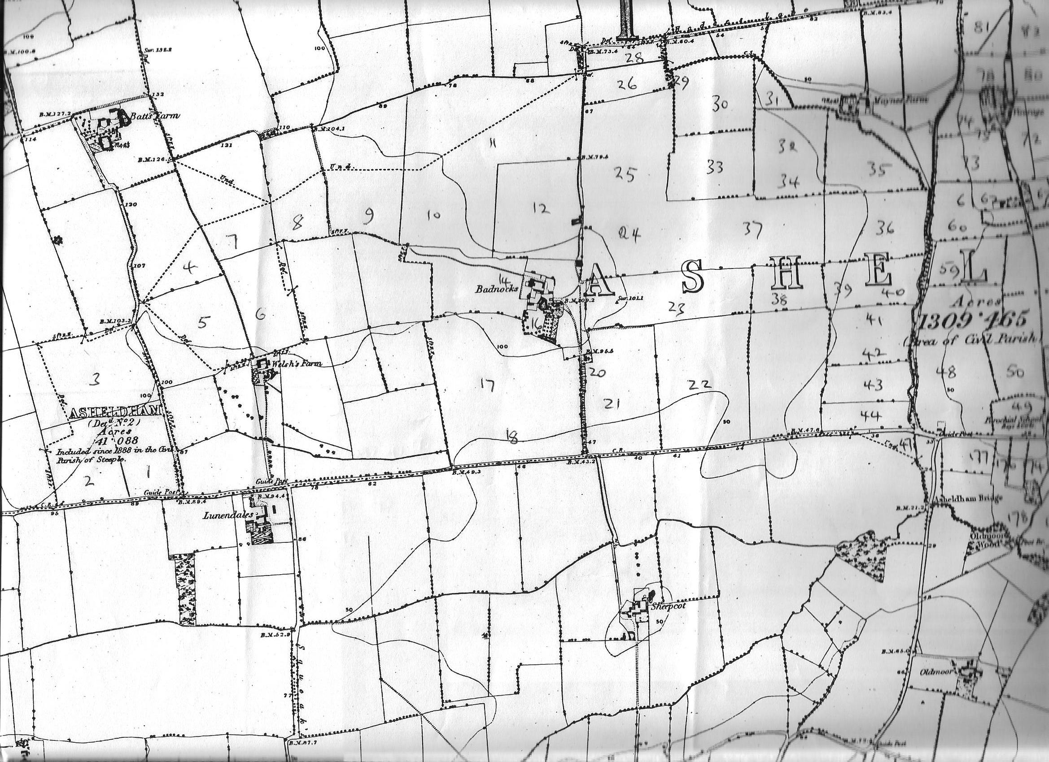
Map 1
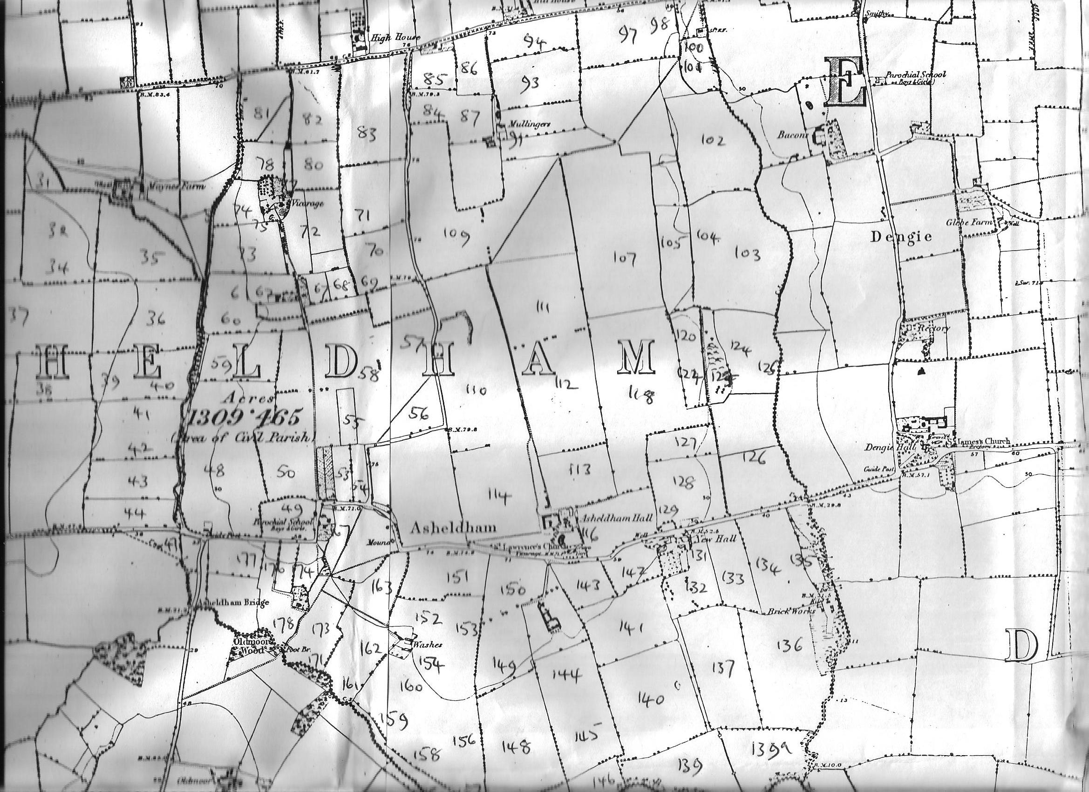
Map 2
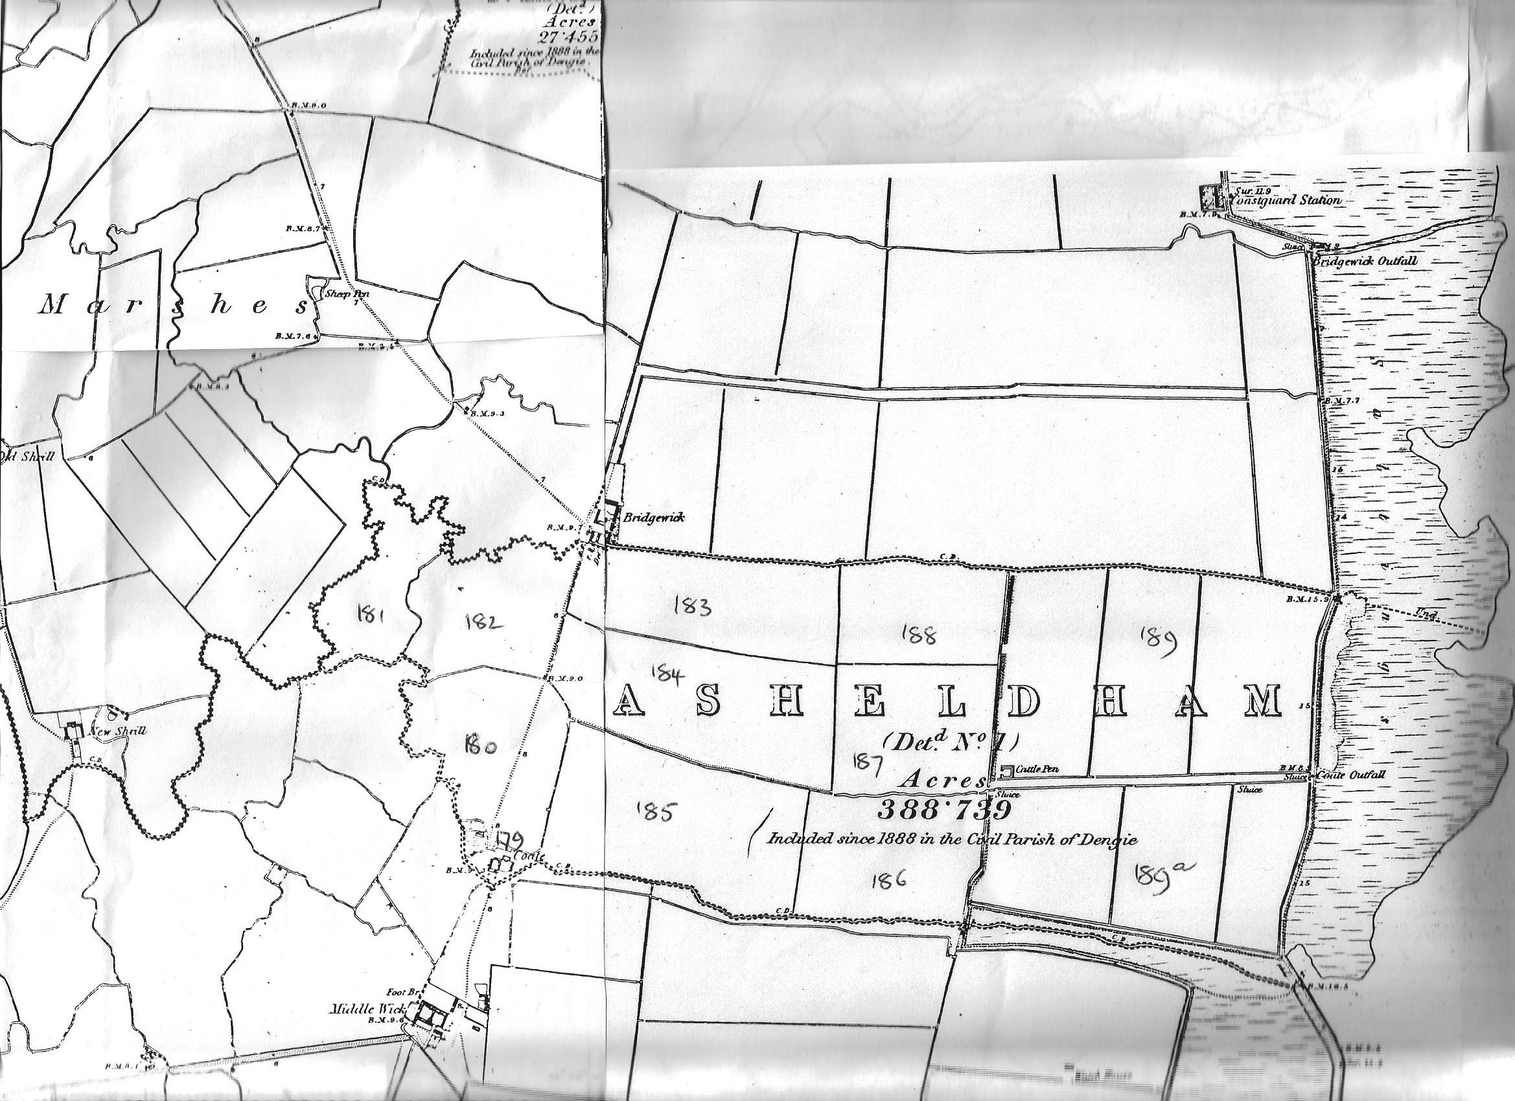
Map 3

