THE PLACE-NAMES

OF ASHINGDON

Recorder: Paul Mardon

Essex Place-names Project (Essex Society for Archaeology & History), 2011 (e-book).

www.essex.ac.uk/history/esah/essexplacenames

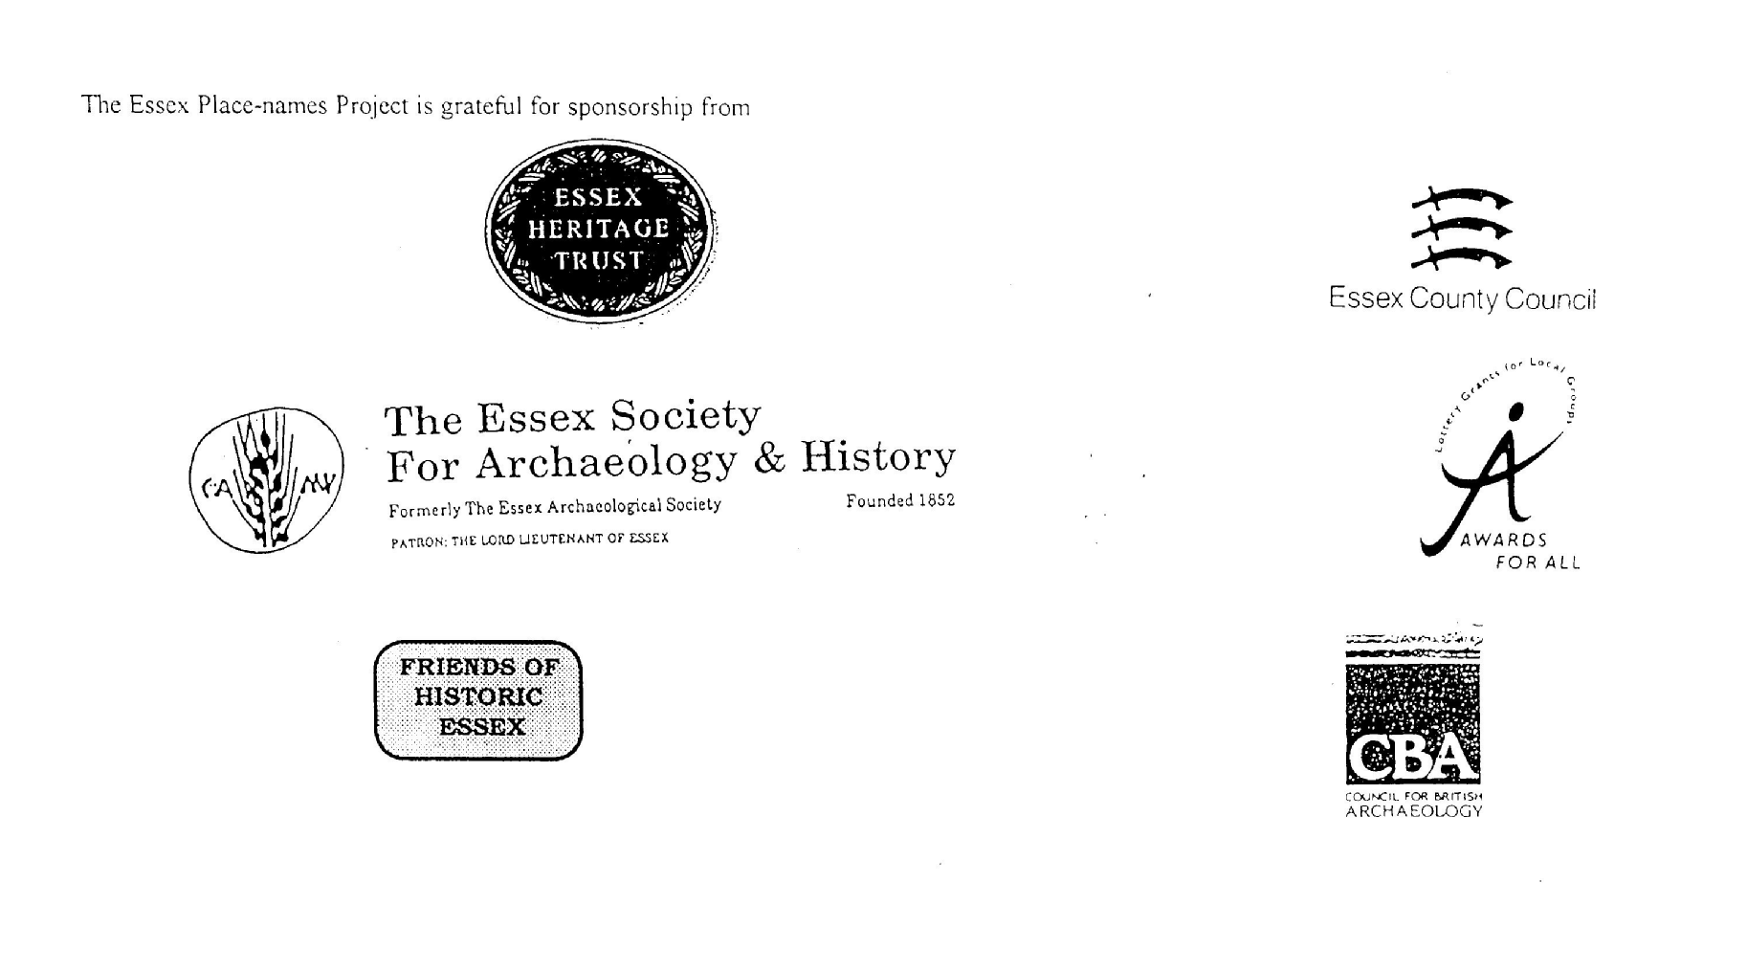

ESSEX PLACE-NAMES PROJECT.

The Essex Place-names Project is a County-wide survey to record place- and field-names from historical documents such as Tithe maps and apportionments, estate maps, sale
and auction catalogues, conveyances, terriers, deeds, rolls, inquisitions and surveys.

The second element of the Project is to investigate on-the-ground visible remains which correspond to the Place-names for actual or potential archaeological, agricultural and industrial
sites, and to record natural (topographical) and man-made features which may relate to the Place-name. This involves field-survey in rural and outside investigation in built-up areas.

It is anticipated that the Project will lead to identification of archaeological sites and lost historic buildings; it will enable analysis of indicators of early settlement, land holding, agricultural and industrial practices of the County. It will refine the more precise meaning of descriptive words and elements used by earlier settlers as they gave names appropriate to the topography of the landscape of their time.

For convenience the surveys are based on the parish, recognising that present civil parish boundaries are not necessarily identical to former ecclesiastical boundaries. Local Recorders
are supplied with templates of Record Forms to ensure consistency of recording across the County, and forward completed forms to a Central Coordinator for transfer to a county
computer database which is available to researchers on the internet at www.essex.ac.uk/history/esah/essexplacenames, and updated periodically.

This publication presents part of the information recorded from the Tithe or Estate Award and Map, and from other documents for this parish. The full record is contained on the master
database at Essex County Council (Historic Environment Section) and on the (above) website. Parish books are available from the Publications Manager, Essex Record Office, Wharf Road, Chelmsford CM2 6YT, on disc or in hard copy or may be downloaded from the website link ‘Books’ on the Home page. Please notify errors to the Project Coordinator at the Essex Record Office.

THE TITHE MAP AND APPORTIONMENT.

Since medieval times a tenth of the produce of land and stock had been paid by landholders to the church. At the Dissolution of the Monasteries, the property of many religious houses,
including the right to collect tithes, passed into lay hands. The Tithe Commutation Act which received Royal assent on 13th August 1836 abolished a rent payable in kind and
substituted rent-charges apportioned on each plot or parcel. The tithe-rent payable was assessed on the average value of wheat, barley and oats and was to fluctuate with price movements.

The commutation could be by voluntary agreement between the local owners and payers or, if agreement failed, could be compulsorily imposed by commissioners. A Valuer was to be
appointed to apportion the rent of each parcel of land and tenants could deduct that rent-charge from their rent paid to the landlord. The task fell to the Tithe Commissioners to produce a
map and an Apportionment (Award). A large-scale survey was produced for over 70% of England and Wales in the following 9 years, and about another 8% up to 1855. Most of the
parishes in Essex were surveyed. The map scales vary. The Award records ownership, tenancy and land-use, field by field and parcel by parcel (often quoting the field name) with the
ground area and rent-charge.

Land that was tithe-free tends to be less accurately mapped and contains few if any of the details recorded for those parcels subject to tithe. Rights of way and roads also tend to be
neglected. Boundaries of the tithe areas are shown as are some natural features such as streams, ponds, gardens, greens and commons. Buildings are often shown coloured red if dwellings
or grey if not. Because the Award may have been agreed only some time after the map was finished, discrepancies occur between the two. Enclosure Awards, when extant, usually date to the 18th and early 19th centuries. J.Kemble.

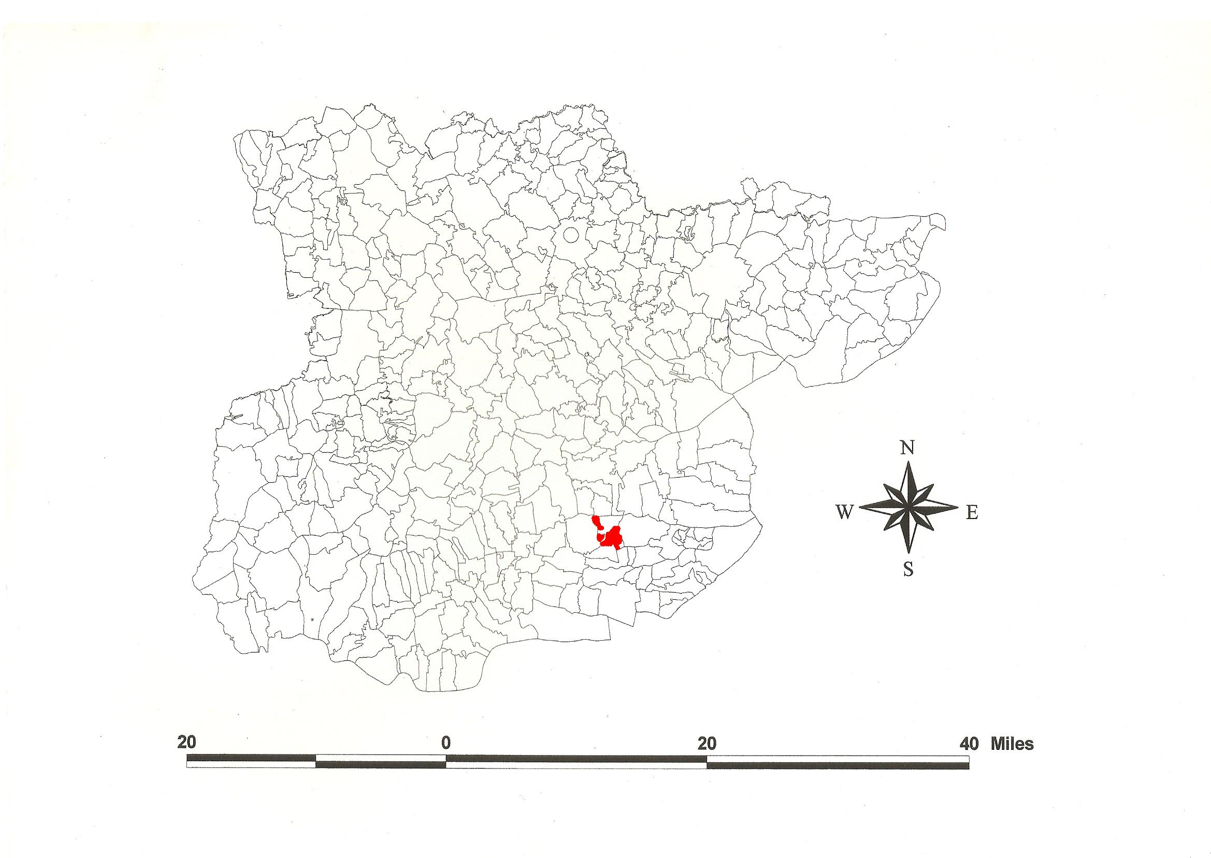
Reproduced by permission of Essex County Council.
Ashingdon Parish in the County of Essex.

Ashingdon Parish (in Rochford Hundred).

Ashingdon Tithe Award (Esex Record Office D/CT 11a), dated 1838, shows a rent-charge of £291 and £6 for glebe payable to the rector Rev John Nottidge. The whole parish measured 1165 acres of which 1020 acres were subject to tithes. 807 acres were arable, 163 acres meadow and pasture, 29 acres wood, 20 acres glebe and one acre of gardens. The Tithe Commissioners were William Blamire and J.W. Buller, the Valuer Samuel Baker of Hawkwell.

The Tithe map (ERO: D/CT 11b) was surveyed at a scale of 3 chains to an inch (26.6” to a mile) by Gilbert & Tayspill of Colchester. It is countersigned to Joseph Townsend, Assistant Tithe Commissioner.

In Domesday Book, 1086, half a hide in Nesenduna was held by Roger from Earl Swein, sheriff of Essex between 1066 and 1086, which Robert his father, Edward Confessor’s staller (son of Wymarc), had held before 1066 (Morris, 1983). Swein’s castle was at Rayleigh. Watts (2004) translates this “Assa’s or asses’ hill”. The possible association with the site of the battle fought in 1016 by Cnut and Edmund Ironside at Assandun is explored by Hart (1992) and Rodwell (1993), and summarised by Kemble (2007), Ashdon in north Essex being perhaps the more likely. Ravengar held Bachenia (Beckney) which the bishop of Bayeux (Odo, King William’s half-brother) held in 1086 for half a hide.

Laurence de Hardell (died 1285) held 50 acres from Philip Mansell by the service of one garland of roses. In 1340 Reginald Garrey held land of the Honour of Rayleigh for ½ a knight’s fee. In 1517 Richard Allen held 300 acres of pasture, and 200 acres of marsh called Beckney from the Prior of Colne. In 1285 Richard de Chamberlayn held ½ a knight’s fee from the king. In 1429 the church was temporarily united with Hawkwell but soon disunited (Morant, 1768).

The church dedicated to St Andrew is of the 14th and 15th centuries. Ashingdon Hall has two gables, 17th or 18th century, and a four-bay two-storey 19th century front (Pevsner, 2007).

The Hundred name was Rokesford c.1085-9, Roche(s)fort in Domesday Book. This is translated from O.E. hroca, or Hroces, “rooks’ or Hroc’s ford”, or ræcca, “hunting-dogs’ ford” (Reaney, 1935; Watts, 2004). Christy (1926) places the moot near the River Roach in the town of Rochford, perhaps on King’s Hill.

Place- and field-names from the Map (ERO: D/DU 300) dated 1787-1808 by J. Wise and from other documents are shown against the Tithe names

References:
Christy M., 1926. The Essex Hundred Moots. Trans Essex Archaeological Soc., ns xviii (3), 184.
Hart, C.R., 1992. The Danelaw. Hambledon. p.553.
Kemble, J., 2007. Essex Place-names, Places, Streets & People. Historical Publications. p.39.
Morant, P., 1768. History & Antiquities of the County of Essex, i, 321.
Morris, J., 1983. Domesday Book – Essex. Phillimore.
Pevsner, N., Bettley, J., 2007. Buildings of England – Essex. Yale.
Reaney, P., 1935. Place-names of Essex. Cambridge.
Rodwell, W., 1993, in Cooper, J., The Battle of Maldon. Hambledon. p.127.
Watts, V., 2004. Dictionary of English Place-names. Cambridge.

The Tithe Place-names of Ashingdon – by Parcel No.

Place-name | alias | Fld no | Grd rf | x | y | acr | rd | pch | Owner | Occupier | Farm | Other information
Twenty Acre Marsh |  | 1 | TQ | 842 | 960 | 26 | 2 | 17 | Mew, William | Mew, William | Beckney Farm
Fourteen Acre Marsh |  | 2 | TQ | 845 | 960 | 14 | 1 | 30 | Mew, William | Mew, William | Beckney Farm
Two Acre Meadow |  | 3 | TQ | 847 | 960 | 1 | 3 | 26 | Mew, William | Mew, William | Beckney Farm
Fourteen Acre Marsh |  | 4 | TQ | 842 | 956 | 18 | 1 | 2 | Mew, William | Mew, William | Beckney Farm
Thirty Two Acre Field |  | 5 | TQ | 844 | 957 | 36 | 2 | 28 | Mew, William | Mew, William | Beckney Farm
Twenty Acre Field |  | 6 | TQ | 847 | 957 | 27 | 3 | 15 | Mew, William | Mew, William | Beckney Farm
Beckney Farm Offices & Yard | Bacheneia, 1086,DB | 7 | TQ | 846 | 955 | 1 | 3 | 11 | Mew, William | Mew, William | Beckney Farm
Seventeen Acre Field |  | 8 | TQ | 844 | 953 | 19 | 3 | 3 | Mew, William | Mew, William | Beckney Farm
Eight Acre Field |  | 9 | TQ | 846 | 953 | 8 | 3 | 4 | Mew, William | Mew, William | Beckney Farm
Fourteen Acre Field |  | 10 | TQ | 848 | 953 | 15 | 0 | 16 | Mew, William | Mew, William | Beckney Farm
Cottage & Garden |  | 11 | TQ | 846 | 951 | 0 | 2 | 6 | Mew, William | Mew, William | Beckney Farm
Twenty Two Acre Field |  | 12 | TQ | 848 | 951 | 25 | 3 | 35 | Mew, William | Mew, William | Beckney Farm
Molehilly Marsh |  | 13 | TQ | 851 | 949 | 26 | 0 | 37 | Mew, William | Mew, William | Beckney Farm
Fourteen Acre Field |  | 14 | TQ | 848 | 948 | 16 | 2 | 39 | Mew, William | Mew, William | Beckney Farm
Wood | Beckney Chase, c1787,map D/DU 300 | 15 | TQ | 846 | 939 | 9 | 0 | 26 | New Parish Land, Trustees | New Parish Land, Trustees
Wood | Beckney Wood, c1787,map D/DU 300 | 16 | TQ | 848 | 940 | 21 | 3 | 35 | Mew, William | Mew, William | Beckney Farm
Ten Acre Field |  | 17 | TQ | 848 | 937 | 11 | 1 | 24 | Wollastons Charity | Keyes, James | Great Chamberlains Farm
Great Chamberlains Offices & Yard | Chambirlaynes, 1374,Ct | 18 | TQ | 849 | 936 | 1 | 1 | 36 | Wollastons Charity | Keyes, James | Great Chamberlains Farm | Roger Camerarius, Richard le Chamberleyn, tHyIII, RBE, 1326,FF
Six Acre Field |  | 19 | TQ | 850 | 937 | 7 | 1 | 7 | Wollastons Charity | Keyes, James | Great Chamberlains Farm
Tinkers Field |  | 20 | TQ | 853 | 938 | 15 | 1 | 20 | Wollastons Charity | Keyes, James | Great Chamberlains Farm
Cottage & Garden |  | 21 | TQ | 853 | 937 | 0 | 0 | 33 | Keyes,William | Bowton, Richard
Garden |  | 21a | TQ | 853 | 937 | 0 | 0 | 6 | Keyes,James | Bowton, Richard
Cartlodge Field |  | 22 | TQ | 851 | 935 | 10 | 2 | 21 | Wollastons Charity | Keyes, James | Great Chamberlains Farm
House Meadow |  | 23 | TQ | 849 | 934 | 11 | 1 | 12 | Wollastons Charity | Keyes, James | Great Chamberlains Farm
Kitchen Field |  | 24 | TQ | 848 | 934 | 9 | 3 | 28 | Wollastons Charity | Keyes, James | Great Chamberlains Farm
Cottages & Garden |  | 25 | TQ | 850 | 934 | 0 | 0 | 17 | Keyes,James | Argent,Enoch
Six acre field (pt) |  | 26 | TQ | 848 | 932 | 1 | 2 | 20 | Wollastons Charity | Keyes, James | Great Chamberlains Farm | Rest of field in Hockley Parish
Glebe |  | 27 | TQ | 857 | 942 | 9 | 1 | 26 | Nottidge,Rev John | Keyes, William
Glebe |  | 28 | TQ | 859 | 942 | 11 | 1 | 17 | Nottidge,Rev John | Keyes, William
Glebe |  | 28a | TQ | 860 | 942 | 0 | 2 | 13 | Nottidge,Rev John | Keyes, William
Thirty Acre Marsh |  | 29 | TQ | 866 | 949 | 31 | 2 | 29 | Wollastons Charity | Keyes, James | Great Chamberlains Farm
Twenty Eight Acre Marsh |  | 30 | TQ | 865 | 946 | 30 | 1 | 38 | Wollastons Charity | Keyes, James | Great Chamberlains Farm
Fiifteen Acre Field |  | 31 | TQ | 863 | 944 | 15 | 0 | 26 | Wollastons Charity | Keyes, James | Great Chamberlains Farm
Eleven Acre Field |  | 32 | TQ | 865 | 943 | 13 | 3 | 0 | Wollastons Charity | Keyes, James | Great Chamberlains Farm
Seventeen Acre Field |  | 33 | TQ | 861 | 941 | 18 | 2 | 16 | Wollastons Charity | Keyes, James | Great Chamberlains Farm
Fourteen Acre Field |  | 34 | TQ | 863 | 941 | 14 | 0 | 34 | Wollastons Charity | Keyes, James | Great Chamberlains Farm
Twelve Acre Field |  | 35 | TQ | 860 | 939 | 12 | 2 | 14 | Wollastons Charity | Keyes, James | Great Chamberlains Farm
Twelve Acre Field |  | 36 | TQ | 858 | 936 | 13 | 0 | 0 | Wollastons Charity | Keyes, James | Great Chamberlains Farm
Barn & Yard |  | 37 | TQ | 861 | 939 | 0 | 1 | 35 | Wollastons Charity | Keyes, James | Great Chamberlains Farm
Barn Field |  | 38 | TQ | 863 | 938 | 20 | 3 | 5 | Wollastons Charity | Keyes, James | Great Chamberlains Farm
Twelve Acre Field |  | 39 | TQ | 864 | 936 | 13 | 3 | 15 | Wollastons Charity | Keyes, James | Great Chamberlains Farm
Cottage & Garden |  | 40 | TQ | 864 | 935 | 0 | 0 | 38 | Wollastons Charity | Joice, Stephen; Brown, George
Orchards |  | 41 | TQ | 864 | 935 | 0 | 1 | 14 | Wollastons Charity | Keyes, James | Great Chamberlains Farm
Six Acre Field |  | 42 | TQ | 860 | 937 | 7 | 0 | 4 | Clark, RevThomas | Bright, Charles | Hill Farm
Eight Acre Field |  | 43 | TQ | 859 | 935 | 8 | 2 | 4 | Clark, RevThomas | Bright, Charles | Hill Farm
Rainbow Acre Field |  | 44 | TQ | 860 | 935 | 7 | 0 | 23 | Clark, RevThomas | Bright, Charles | Hill Farm
Road Field |  | 45 | TQ | 862 | 935 | 8 | 2 | 29 | Clark, RevThomas | Bright, Charles | Hill Farm
Eight Acre Field |  | 46 | TQ | 858 | 933 | 7 | 3 | 18 | Clark, RevThomas | Bright, Charles | Hill Farm
Barn Field |  | 47 | TQ | 859 | 933 | 7 | 3 | 25 | Clark, RevThomas | Bright, Charles | Hill Farm
Three Acre Field |  | 48 | TQ | 857 | 932 | 3 | 2 | 35 | Clark, RevThomas | Bright, Charles | Hill Farm
Hill Farm House Offices | Runcyvall,1579, ChancP; Rounsefalls, c1787,map D/DU 300 | 49 | TQ | 858 | 932 | 1 | 0 | 2 | Clark, RevThomas | Bright, Charles | Hill Farm | ?of Hospital of Our Lady of Rouncevale, Charing Cross, 1291,Tax
Further Seven Acre Field |  | 50 | TQ | 853 | 932 | 8 | 0 | 39 | Clark, RevThomas | Bright, Charles | Hill Farm
Six Acre Field |  | 51 | TQ | 855 | 931 | 6 | 0 | 5 | Clark, RevThomas | Bright, Charles | Hill Farm
Seven Acre Field |  | 52 | TQ | 857 | 931 | 7 | 2 | 10 | New Parish Land, Trustees | Bright, Charles |  | Charity Land
Fifteen Acre Field |  | 53 | TQ | 859 | 931 | 14 | 3 | 39 | Clark, RevThomas | Bright, Charles | Hill Farm
Six Acre Field | Kew Little Woodlands, c1787,map D/DU 300 | 54 | TQ | 861 | 930 | 6 | 2 | 15 | New Parish Land, Trustees | Bright, Charles |  | Charity Land
Three Acre Field |  | 55 | TQ | 861 | 928 | 3 | 3 | 7 | Clark, RevThomas | Bright, Charles | Hill Farm
Fourteen Acre Field |  | 56 | TQ | 853 | 930 | 14 | 0 | 25 | Clark, RevThomas | Bright, Charles | Hill Farm
Nine Acre Field |  | 57 | TQ | 855 | 930 | 9 | 1 | 18 | Clark, RevThomas | Bright, Charles | Hill Farm
Nine Acre Field | Kew Great Woodlands, c1787,map D/DU 300 | 58 | TQ | 857 | 929 | 8 | 3 | 32 | New Parish Land, Trustees | Bright, Charles |  | Charity Land
One Acre Field |  | 59 | TQ | 859 | 929 | 1 | 1 | 24 | Crick, John | Porter, Peter
Four Acre Field |  | 60 | TQ | 850 | 930 | 4 | 0 | 35 | Byam, Rev Richard | Dines, Reuben | Pulpits Farm | Pulpits Farm in S Fambridge Parish
Two Acre Field |  | 61 | TQ | 851 | 930 | 2 | 0 | 39 | Byam, Rev Richard | Dines, Reuben | Pulpits Farm
Five Acre Field |  | 62 | TQ | 850 | 928 | 5 | 3 | 33 | Byam, Rev Richard | Dines, Reuben | Pulpits Farm
Seven Acre Field |  | 63 | TQ | 851 | 928 | 7 | 0 | 27 | Byam, Rev Richard | Dines, Reuben | Pulpits Farm
Four Acre Field |  | 64 | TQ | 854 | 929 | 4 | 1 | 4 | Byam, Rev Richard | Dines, Reuben | Pulpits Farm
Corner Piece |  | 65 | TQ | 853 | 929 | 1 | 3 | 0 | Crick, John | Pinter, Peter
Garden |  | 66 | TQ | 852 | 929 | 0 | 0 | 9 | Crick, John | Pinter, Peter
Two Acre Field |  | 67 | TQ | 853 | 928 | 1 | 3 | 26 | Crick, John | Pinter, Peter
Three Corner Field |  | 68 | TQ | 851 | 927 | 0 | 3 | 14 | Crick, John | Pinter, Peter
North Marsh |  | 69 | TQ | 870 | 950 | 16 | 0 | 32 | Keyes,William | Keyes, William | Moons Farm
Shed Marsh |  | 70 | TQ | 869 | 948 | 19 | 2 | 32 | Keyes,William | Keyes, William | Moons Farm
Twelve Acre Marsh |  | 71 | TQ | 868 | 945 | 14 | 1 | 25 | Keyes,William | Keyes, William | Moons Farm
Long Marsh |  | 72 | TQ | 869 | 943 | 13 | 0 | 15 | Keyes,William | Keyes, William | Moons Farm
Triangle field (pt) |  | 73 | TQ | 870 | 944 | 7 | 3 | 5 | Keyes,William | Keyes, William | Moons Farm
Triangle field (pt) |  | 74 | TQ | 870 | 942 | 3 | 0 | 38 | Keyes,William | Keyes, William | Moons Farm
Kitchen Field |  | 75 | TQ | 866 | 992 | 22 | 2 | 3 | Keyes,William | Keyes, William | Moons Farm
Moons Farm House & Offices | Monys,1374,Ct; Mones,1448,MnAt | 76 | TQ | 868 | 941 | 1 | 2 | 14 | Keyes,William | Keyes, William | Moons Farm | John le Mone, 1327,SubRoll
Stack yard |  | 77 | TQ | 867 | 940 | 0 | 3 | 0 | Keyes,William | Keyes, William | Moons Farm
Stable Field |  | 78 | TQ | 868 | 940 | 9 | 0 | 38 | Keyes,William | Keyes, William | Moons Farm
Cottage Field |  | 79 | TQ | 870 | 941 | 13 | 3 | 16 | Keyes,William | Keyes, William | Moons Farm
Cottage & Garden |  | 80 | TQ | 870 | 940 | 0 | 1 | 23 | Keyes,William | Keyes, William | Moons Farm
Church Hill Field |  | 81 | TQ | 867 | 939 | 17 | 1 | 10 | Keyes,William | Keyes, William | Moons Farm
Eight Acre Field |  | 82 | TQ | 869 | 938 | 8 | 3 | 21 | Keyes,William | Keyes, William | Moons Farm
Ten Acre Field opp Cottage |  | 83 | TQ | 870 | 939 | 11 | 0 | 32 | Keyes,William | Keyes, William | Moons Farm
Six Acre Field |  | 84 | TQ | 870 | 936 | 7 | 1 | 4 | Keyes,William | Keyes, William | Moons Farm
Pond Field |  | 85 | TQ | 872 | 938 | 24 | 3 | 39 | Keyes,William | Keyes, William | Moons Farm
Canewdon Field |  | 86 | TQ | 875 | 938 | 15 | 3 | 17 | Keyes,William | Keyes, William | Moons Farm
Cottage & Garden |  | 87 | TQ | 866 | 936 | 0 | 1 | 4 | Nottidge,Rev John | Marshall; Hatley
Church Yard | [St Andrews] | 88 | TQ | 866 | 936 | 0 | 3 | 36 | Nottidge,Rev John | Marshall; Hatley
Glebe |  | 89 | TQ | 866 | 935 | 4 | 0 | 7 | Nottidge,Rev John | Keyes, William
Church Field |  | 90 | TQ | 868 | 936 | 16 | 0 | 22 | Dowler,John | Dowler, John | Ashingdon Hall & Moons Farm
Ashingdon Hall House & Offices |  | 91 | TQ | 865 | 934 | 1 | 0 | 13 | Dowler,John | Dowler, John | Ashingdon Hall & Moons Farm
Ashingdon Five Acres |  | 92 | TQ | 867 | 934 | 6 | 0 | 29 | Dowler,John | Dowler, John | Ashingdon Hall & Moons Farm
Ashingdon Twelve Acres |  | 93 | TQ | 869 | 934 | 13 | 1 | 14 | Dowler,John | Dowler, John | Ashingdon Hall & Moons Farm
Ashingdon Eight Acres |  | 94 | TQ | 871 | 934 | 9 | 1 | 29 | Dowler,John | Dowler, John | Ashingdon Hall & Moons Farm
Ashingdon Six Acres |  | 95 | TQ | 873 | 934 | 6 | 3 | 33 | Dowler,John | Dowler, John | Ashingdon Hall & Moons Farm
Road Piece |  | 96 | TQ | 865 | 933 | 0 | 1 | 32 | Dowler,John | Dowler, John | Ashingdon Hall & Moons Farm
School House & Garden |  | 97 | TQ | 866 | 932 | 0 | 0 | 29 | Dowler,John | Turner, James
Cottage Eight Acres |  | 98 | TQ | 867 | 934 | 9 | 1 | 3 | Dowler,John | Dowler, John | Ashingdon Hall & Moons Farm
Barn Yard | Moons Barn, 1875,OS | 99 | TQ | 866 | 931 | 0 | 1 | 23 | Dowler,John | Dowler, John | Ashingdon Hall & Moons Farm
Moons Barn Field |  | 100 | TQ | 867 | 932 | 12 | 3 | 8 | Dowler,John | Dowler, John | Ashingdon Hall & Moons Farm
Pond |  | 101 | TQ | 869 | 931 | 0 | 1 | 23 | Dowler,John | Dowler, John | Ashingdon Hall & Moons Farm
Moons Fourteen Acres |  | 102 | TQ | 870 | 932 | 15 | 1 | 3 | Dowler,John | Dowler, John | Ashingdon Hall & Moons Farm
Moons Lower 12 Acres |  | 103 | TQ | 872 | 932 | 12 | 3 | 34 | Dowler,John | Dowler, John | Ashingdon Hall & Moons Farm
Moons Upper 12 Acres |  | 104 | TQ | 867 | 929 | 13 | 0 | 24 | Dowler,John | Dowler, John | Ashingdon Hall & Moons Farm
18 acre field (pt) |  | 105 | TQ | 869 | 930 | 8 | 2 | 23 | Dowler,John | Dowler, John | Ashingdon Hall & Moons Farm
18 acre field (pt) |  | 106 | TQ | 871 | 930 | 9 | 1 | 3 | Dowler,John | Dowler, John | Ashingdon Hall & Moons Farm
Moons Ten Acres |  | 107 | TQ | 873 | 931 | 11 | 2 | 2 | Dowler,John | Dowler, John | Ashingdon Hall & Moons Farm
Moons Hill Field | Moons Upper Slipe, c1787,map D/DU 300 | 108 | TQ | 870 | 928 | 4 | 2 | 37 | Dowler,John | Dowler, John | Ashingdon Hall & Moons Farm
Long Pasture | Moons Lower Slipe, c1787,map D/DU 300 | 109 | TQ | 872 | 926 | 5 | 2 | 12 | Dowler,John | Dowler, John | Ashingdon Hall & Moons Farm
Little Wood Field | Golden Cross Grove, c1787,map D/DU 300 | 110 | TQ | 868 | 928 | 4 | 1 | 7 | Cockerton,William | Coolbear, Thomas
Upper Wood Field |  | 111 | TQ | 869 | 928 | 10 | 0 | 20 | Cockerton,William | Coolbear, Thomas
Grove Wood Field |  | 112 | TQ | 868 | 926 | 2 | 3 | 29 | Cockerton,William | Coolbear, Thomas
Upper Winding Field |  | 113 | TQ | 869 | 925 | 9 | 0 | 22 | Cockerton,William | Coolbear, Thomas
Winding Field |  | 114 | TQ | 869 | 924 | 7 | 3 | 22 | Cockerton,William | Coolbear, Thomas
Ashingdon Field |  | 115 | TQ | 871 | 925 | 13 | 1 | 9 | Baker, Wm; Dottin, Abel | Merryfield,Thomas | Great Brays Farm | Great Brays Farm in Rochford Parish
Ashingdon Home Meadow |  | 116 | TQ | 865 | 934 | 3 | 0 | 13 | Dowler,John | Dowler, John | Ashingdon Hall & Moons Farm
Sea Wall & Saltings |  | 117 | TQ | 843 | 961 | 5 | 1 | 2 | Mew, William | Mew, William | Beckney Fam | from TQ839961 to TQ848961
Above to Low Water Mark |  | 118 | TQ | 843 | 962 | 10 | 0 | 33 | Mew, William | Mew, William | Beckney Fam | from TQ839962 to TQ848962

For abbreviations see Reaney, P., 1935. Place-names of Essex. Cambridge; and Kemble, J., 2007. Essex Place-names, Places, Streets & People, Historical Publications, London.

The Tithe Place-names of Ashingdon – by Place-name.

Place-name | alias | Fld no | Grd rf | x | y | acr | rd | pch | Owner | Occupier | Farm | Other information
18 acre field (pt) |  | 105 | TQ | 869 | 930 | 8 | 2 | 23 | Dowler,John | Dowler, John | Ashingdon Hall & Moons Farm
18 acre field (pt) |  | 106 | TQ | 871 | 930 | 9 | 1 | 3 | Dowler,John | Dowler, John | Ashingdon Hall & Moons Farm
Above to Low Water Mark |  | 118 | TQ | 843 | 962 | 10 | 0 | 33 | Mew, William | Mew, William | Beckney Fam | from TQ839962 to TQ848962
Ashingdon Eight Acres |  | 94 | TQ | 871 | 934 | 9 | 1 | 29 | Dowler,John | Dowler, John | Ashingdon Hall & Moons Farm
Ashingdon Field |  | 115 | TQ | 871 | 925 | 13 | 1 | 9 | Baker, Wm; Dottin, Abel | Merryfield,Thomas | Great Brays Farm | Great Brays Farm in Rochford Parish
Ashingdon Five Acres |  | 92 | TQ | 867 | 934 | 6 | 0 | 29 | Dowler,John | Dowler, John | Ashingdon Hall & Moons Farm
Ashingdon Hall House & Offices |  | 91 | TQ | 865 | 934 | 1 | 0 | 13 | Dowler,John | Dowler, John | Ashingdon Hall & Moons Farm
Ashingdon Home Meadow |  | 116 | TQ | 865 | 934 | 3 | 0 | 13 | Dowler,John | Dowler, John | Ashingdon Hall & Moons Farm
Ashingdon Six Acres |  | 95 | TQ | 873 | 934 | 6 | 3 | 33 | Dowler,John | Dowler, John | Ashingdon Hall & Moons Farm
Ashingdon Twelve Acres |  | 93 | TQ | 869 | 934 | 13 | 1 | 14 | Dowler,John | Dowler, John | Ashingdon Hall & Moons Farm
Barn & Yard |  | 37 | TQ | 861 | 939 | 0 | 1 | 35 | Wollastons Charity | Keyes, James | Great Chamberlains Farm
Barn Field |  | 47 | TQ | 859 | 933 | 7 | 3 | 25 | Clark, RevThomas | Bright, Charles | Hill Farm
Barn Field |  | 38 | TQ | 863 | 938 | 20 | 3 | 5 | Wollastons Charity | Keyes, James | Great Chamberlains Farm
Barn Yard | Moons Barn, 1875,OS | 99 | TQ | 866 | 931 | 0 | 1 | 23 | Dowler,John | Dowler, John | Ashingdon Hall & Moons Farm
Beckney Farm Offices & Yard | Bacheneia, 1086,DB | 7 | TQ | 846 | 955 | 1 | 3 | 11 | Mew, William | Mew, William | Beckney Farm
Canewdon Field |  | 86 | TQ | 875 | 938 | 15 | 3 | 17 | Keyes, William | Keyes, William | Moons Farm
Cartlodge Field |  | 22 | TQ | 851 | 935 | 10 | 2 | 21 | Wollastons Charity | Keyes, James | Great Chamberlains Farm
Church Field |  | 90 | TQ | 868 | 936 | 16 | 0 | 22 | Dowler,John | Dowler, John | Ashingdon Hall & Moons Farm
Church Hill Field |  | 81 | TQ | 867 | 939 | 17 | 1 | 10 | Keyes, William | Keyes, William | Moons Farm
Church Yard | [St Andrews] | 88 | TQ | 866 | 936 | 0 | 3 | 36 | Nottidge,Rev John | Marshall; Hatley
Corner Piece |  | 65 | TQ | 853 | 929 | 1 | 3 | 0 | Crick, John | Pinter, Peter
Cottage & Garden |  | 21 | TQ | 853 | 937 | 0 | 0 | 33 | Keyes, William | Bowton, Richard
Cottage & Garden |  | 80 | TQ | 870 | 940 | 0 | 1 | 23 | Keyes, William | Keyes, William | Moons Farm
Cottage & Garden |  | 11 | TQ | 846 | 951 | 0 | 2 | 6 | Mew, William | Mew, William | Beckney Farm
Cottage & Garden |  | 87 | TQ | 866 | 936 | 0 | 1 | 4 | Nottidge,Rev John | Marshall; Hatley
Cottage & Garden |  | 40 | TQ | 864 | 935 | 0 | 0 | 38 | Wollastons Charity | Joice, Stephen; Brown, George
Cottage Eight Acres |  | 98 | TQ | 867 | 934 | 9 | 1 | 3 | Dowler,John | Dowler, John | Ashingdon Hall & Moons Farm
Cottage Field |  | 79 | TQ | 870 | 941 | 13 | 3 | 16 | Keyes, William | Keyes, William | Moons Farm
Cottages & Garden |  | 25 | TQ | 850 | 934 | 0 | 0 | 17 | Keyes, James | Argent, Enoch
Eight Acre Field |  | 43 | TQ | 859 | 935 | 8 | 2 | 4 | Clark, RevThomas | Bright, Charles | Hill Farm
Eight Acre Field |  | 46 | TQ | 858 | 933 | 7 | 3 | 18 | Clark, RevThomas | Bright, Charles | Hill Farm
Eight Acre Field |  | 82 | TQ | 869 | 938 | 8 | 3 | 21 | Keyes,William | Keyes, William | Moons Farm
Eight Acre Field |  | 9 | TQ | 846 | 953 | 8 | 3 | 4 | Mew, William | Mew, William | Beckney Farm
Eleven Acre Field |  | 32 | TQ | 865 | 943 | 13 | 3 | 0 | Wollastons Charity | Keyes, James | Great Chamberlains Farm
Fifteen Acre Field |  | 53 | TQ | 859 | 931 | 14 | 3 | 39 | Clark, Rev Thomas | Bright, Charles | Hill Farm
Fiifteen Acre Field |  | 31 | TQ | 863 | 944 | 15 | 0 | 26 | Wollastons Charity | Keyes, James | Great Chamberlains Farm
Five Acre Field |  | 62 | TQ | 850 | 928 | 5 | 3 | 33 | Byam, Rev Richard | Dines, Reuben | Pulpits Farm
Four Acre Field |  | 60 | TQ | 850 | 930 | 4 | 0 | 35 | Byam, Rev Richard | Dines, Reuben | Pulpits Farm | Pulpits Farm in S Fambridge Parish
Four Acre Field |  | 64 | TQ | 854 | 929 | 4 | 1 | 4 | Byam, Rev Richard | Dines, Reuben | Pulpits Farm
Fourteen Acre Field |  | 56 | TQ | 853 | 930 | 14 | 0 | 25 | Clark, Rev Thomas | Bright, Charles | Hill Farm
Fourteen Acre Field |  | 10 | TQ | 848 | 953 | 15 | 0 | 16 | Mew, William | Mew, William | Beckney Farm
Fourteen Acre Field |  | 14 | TQ | 848 | 948 | 16 | 2 | 39 | Mew, William | Mew, William | Beckney Farm
Fourteen Acre Field |  | 34 | TQ | 863 | 941 | 14 | 0 | 34 | Wollastons Charity | Keyes, James | Great Chamberlains Farm
Fourteen Acre Marsh |  | 2 | TQ | 845 | 960 | 14 | 1 | 30 | Mew, William | Mew, William | Beckney Farm
Fourteen Acre Marsh |  | 4 | TQ | 842 | 956 | 18 | 1 | 2 | Mew, William | Mew, William | Beckney Farm
Road Field |  | 45 | TQ | 862 | 935 | 8 | 2 | 29 | Clark, RevThomas | Bright, Charles | Hill Farm
Further Seven Acre Field |  | 50 | TQ | 853 | 932 | 8 | 0 | 39 | Clark, RevThomas | Bright, Charles | Hill Farm
Garden |  | 66 | TQ | 852 | 929 | 0 | 0 | 9 | Crick, John | Pinter, Peter
Garden |  | 21a | TQ | 853 | 937 | 0 | 0 | 6 | Keyes, James | Bowton, Richard
Glebe |  | 27 | TQ | 857 | 942 | 9 | 1 | 26 | Nottidge,Rev John | Keyes, William
Glebe |  | 28 | TQ | 859 | 942 | 11 | 1 | 17 | Nottidge,Rev John | Keyes, William
Glebe |  | 28a | TQ | 860 | 942 | 0 | 2 | 13 | Nottidge,Rev John | Keyes, William
Glebe |  | 89 | TQ | 866 | 935 | 4 | 0 | 7 | Nottidge,Rev John | Keyes, William
Great Chamberlains Offices & Yard | Chambirlaynes, 1374,Ct | 18 | TQ | 849 | 936 | 1 | 1 | 36 | Wollastons Charity | Keyes, James | Great Chamberlains Farm | Roger Camerarius, Richard le Chamberleyn, tHyIII, RBE, 1326,FF
Grove Wood Field |  | 112 | TQ | 868 | 926 | 2 | 3 | 29 | Cockerton,William | Coolbear,Thomas
Hill Farm House Offices | Runcyvall,1579, ChancP; Rounsefalls, c1787,map D/DU 300 | 49 | TQ | 858 | 932 | 1 | 0 | 2 | Clark, RevThomas | Bright, Charles | Hill Farm | ?of Hospital of Our Lady of Rouncevale, Charing Cross, 1291,Tax
House Meadow |  | 23 | TQ | 849 | 934 | 11 | 1 | 12 | Wollastons Charity | Keyes, James | Great Chamberlains Farm
Kitchen Field |  | 75 | TQ | 866 | 992 | 22 | 2 | 3 | Keyes, William | Keyes, William | Moons Farm
Kitchen Field |  | 24 | TQ | 848 | 934 | 9 | 3 | 28 | Wollastons Charity | Keyes, James | Great Chamberlains Farm
Little Wood Field | Golden Cross Grove, c1787,map D/DU 300 | 110 | TQ | 868 | 928 | 4 | 1 | 7 | Cockerton,William | Coolbear,Thomas
Long Marsh |  | 72 | TQ | 869 | 943 | 13 | 0 | 15 | Keyes, William | Keyes, William | Moons Farm
Long Pasture | Moons Lower Slipe, c1787,map D/DU 300 | 109 | TQ | 872 | 926 | 5 | 2 | 12 | Dowler,John | Dowler, John | Ashingdon Hall & Moons Farm
Molehilly Marsh |  | 13 | TQ | 851 | 949 | 26 | 0 | 37 | Mew, William | Mew, William | Beckney Farm
Moons Barn Field |  | 100 | TQ | 867 | 932 | 12 | 3 | 8 | Dowler,John | Dowler, John | Ashingdon Hall & Moons Farm
Moons Farm House & Offices | Monys,1374,Ct; Mones,1448,MnAt | 76 | TQ | 868 | 941 | 1 | 2 | 14 | Keyes,William | Keyes, William | Moons Farm | John le Mone, 1327,SubRoll
Moons Fourteen Acres |  | 102 | TQ | 870 | 932 | 15 | 1 | 3 | Dowler, John | Dowler, John | Ashingdon Hall & Moons Farm
Moons Hill Field | Moons Upper Slipe, c1787,map D/DU 300 | 108 | TQ | 870 | 928 | 4 | 2 | 37 | Dowler, John | Dowler, John | Ashingdon Hall & Moons Farm
Moons Lower 12 Acres |  | 103 | TQ | 872 | 932 | 12 | 3 | 34 | Dowler, John | Dowler, John | Ashingdon Hall & Moons Farm
Moons Ten Acres |  | 107 | TQ | 873 | 931 | 11 | 2 | 2 | Dowler, John | Dowler, John | Ashingdon Hall & Moons Farm
Moons Upper 12 Acres |  | 104 | TQ | 867 | 929 | 13 | 0 | 24 | Dowler, John | Dowler, John | Ashingdon Hall & Moons Farm
Nine Acre Field |  | 57 | TQ | 855 | 930 | 9 | 1 | 18 | Clark, RevThomas | Bright, Charles | Hill Farm
Nine Acre Field | Kew Great Woodlands, c1787,map D/DU 300 | 58 | TQ | 857 | 929 | 8 | 3 | 32 | New Parish Land, Trustees | Bright, Charles |  | Charity Land
North Marsh |  | 69 | TQ | 870 | 950 | 16 | 0 | 32 | Keyes,William | Keyes, William | Moons Farm
One Acre Field |  | 59 | TQ | 859 | 929 | 1 | 1 | 24 | Crick, John | Porter, Peter
Orchards |  | 41 | TQ | 864 | 935 | 0 | 1 | 14 | Wollastons Charity | Keyes, James | Great Chamberlains Farm
Pond |  | 101 | TQ | 869 | 931 | 0 | 1 | 23 | Dowler,John | Dowler, John | Ashingdon Hall & Moons Farm
Pond Field |  | 85 | TQ | 872 | 938 | 24 | 3 | 39 | Keyes,William | Keyes, William | Moons Farm
Rainbow Acre Field |  | 44 | TQ | 860 | 935 | 7 | 0 | 23 | Clark, RevThomas | Bright, Charles | Hill Farm
Road Piece |  | 96 | TQ | 865 | 933 | 0 | 1 | 32 | Dowler,John | Dowler, John | Ashingdon Hall & Moons Farm
School House & Garden |  | 97 | TQ | 866 | 932 | 0 | 0 | 29 | Dowler,John | Turner, James
Sea Wall & Saltings |  | 117 | TQ | 843 | 961 | 5 | 1 | 2 | Mew, William | Mew, William | Beckney Fam | from TQ839961 to 848961
Seven Acre Field |  | 63 | TQ | 851 | 928 | 7 | 0 | 27 | Byam, Rev Richard | Dines, Reuben | Pulpits Farm
Seven Acre Field |  | 52 | TQ | 857 | 931 | 7 | 2 | 10 | New Parish Land, Trustees | Bright, Charles |  | Charity Land
Seventeen Acre Field |  | 8 | TQ | 844 | 953 | 19 | 3 | 3 | Mew, William | Mew, William | Beckney Farm
Seventeen Acre Field |  | 33 | TQ | 861 | 941 | 18 | 2 | 16 | Wollastons Charity | Keyes, James | Great Chamberlains Farm
Shed Marsh |  | 70 | TQ | 869 | 948 | 19 | 2 | 32 | Keyes, William | Keyes, William | Moons Farm
Six Acre Field |  | 42 | TQ | 860 | 937 | 7 | 0 | 4 | Clark, RevThomas | Bright, Charles | Hill Farm
Six Acre Field |  | 51 | TQ | 855 | 931 | 6 | 0 | 5 | Clark, RevThomas | Bright, Charles | Hill Farm
Six Acre Field |  | 84 | TQ | 870 | 936 | 7 | 1 | 4 | Keyes, William | Keyes, William | Moons Farm
Six Acre Field | Kew Little Woodlands, c1787,map D/DU 300 | 54 | TQ | 861 | 930 | 6 | 2 | 15 | New Parish Land, Trustees | Bright, Charles |  | Charity Land
Six Acre Field |  | 19 | TQ | 850 | 937 | 7 | 1 | 7 | Wollastons Charity | Keyes, James | Great Chamberlains Farm
Six acre field (pt) |  | 26 | TQ | 848 | 932 | 1 | 2 | 20 | Wollastons Charity | Keyes, James | Great Chamberlains Farm | Rest of field in Hockley Parish
Stable Field |  | 78 | TQ | 868 | 940 | 9 | 0 | 38 | Keyes, William | Keyes, William | Moons Farm
Stack yard |  | 77 | TQ | 867 | 940 | 0 | 3 | 0 | Keyes, William | Keyes, William | Moons Farm
Ten Acre Field |  | 17 | TQ | 848 | 937 | 11 | 1 | 24 | Wollastons Charity | Keyes, James | Great Chamberlains Farm
Ten Acre Field opp Cottage |  | 83 | TQ | 870 | 939 | 11 | 0 | 32 | Keyes, William | Keyes, William | Moons Farm
Thirty Acre Marsh |  | 29 | TQ | 866 | 949 | 31 | 2 | 29 | Wollastons Charity | Keyes, James | Great Chamberlains Farm
Thirty Two Acre Field |  | 5 | TQ | 844 | 957 | 36 | 2 | 28 | Mew, William | Mew, William | Beckney Farm
Three Acre Field |  | 48 | TQ | 857 | 932 | 3 | 2 | 35 | Clark, RevThomas | Bright, Charles | Hill Farm
Three Acre Field |  | 55 | TQ | 861 | 928 | 3 | 3 | 7 | Clark, RevThomas | Bright, Charles | Hill Farm
Three Corner Field |  | 68 | TQ | 851 | 927 | 0 | 3 | 14 | Crick, John | Pinter, Peter
Tinkers Field |  | 20 | TQ | 853 | 938 | 15 | 1 | 20 | Wollastons Charity | Keyes, James | Great Chamberlains Farm
Triangle field (pt) |  | 73 | TQ | 870 | 944 | 7 | 3 | 5 | Keyes, William | Keyes, William | Moons Farm
Triangle field (pt) |  | 74 | TQ | 870 | 942 | 3 | 0 | 38 | Keyes, William | Keyes, William | Moons Farm
Twelve Acre Field |  | 35 | TQ | 860 | 939 | 12 | 2 | 14 | Wollastons Charity | Keyes, James | Great Chamberlains Farm
Twelve Acre Field |  | 36 | TQ | 858 | 936 | 13 | 0 | 0 | Wollastons Charity | Keyes, James | Great Chamberlains Farm
Twelve Acre Field |  | 39 | TQ | 864 | 936 | 13 | 3 | 15 | Wollastons Charity | Keyes, James | Great Chamberlains Farm
Twelve Acre Marsh |  | 71 | TQ | 868 | 945 | 14 | 1 | 25 | Keyes, William | Keyes, William | Moons Farm
Twenty Acre Field |  | 6 | TQ | 847 | 957 | 27 | 3 | 15 | Mew, William | Mew, William | Beckney Farm
Twenty Acre Marsh |  | 1 | TQ | 842 | 960 | 26 | 2 | 17 | Mew, William | Mew, William | Beckney Farm
Twenty Eight Acre Marsh |  | 30 | TQ | 865 | 946 | 30 | 1 | 38 | Wollastons Charity | Keyes, James | Great Chamberlains Farm
Twenty Two Acre Field |  | 12 | TQ | 848 | 951 | 25 | 3 | 35 | Mew, William | Mew, William | Beckney Farm
Two Acre Field |  | 61 | TQ | 851 | 930 | 2 | 0 | 39 | Byam, Rev Richard | Dines, Reuben | Pulpits Farm
Two Acre Field |  | 67 | TQ | 853 | 928 | 1 | 3 | 26 | Crick, John | Pinter, Peter
Two Acre Meadow |  | 3 | TQ | 847 | 960 | 1 | 3 | 26 | Mew, William | Mew, William | Beckney Farm
Upper Winding Field |  | 113 | TQ | 869 | 925 | 9 | 0 | 22 | Cockerton,William | Coolbear,Thomas
Upper Wood Field |  | 111 | TQ | 869 | 928 | 10 | 0 | 20 | Cockerton,William | Coolbear,Thomas
Winding Field |  | 114 | TQ | 869 | 924 | 7 | 3 | 22 | Cockerton,William | Coolbear,Thomas
Wood | Beckney Wood, c1787,map D/DU 300 | 16 | TQ | 848 | 940 | 21 | 3 | 35 | Mew, William | Mew, William | Beckney Farm
Wood | Beckney Chase, c1787,map D/DU 300 | 15 | TQ | 846 | 939 | 9 | 0 | 26 | New Parish Land, Trustees | New Parish Land, Trustees

For abbreviations see Reaney, P., 1935. Place-names of Essex. Cambridge; and Kemble, J., 2007. Essex Place-names, Places, Streets & People, Historical Publications, London.

Ashingdon.

Map 1.

Map 2.

6 inches = 1 mile.

O.S. c.1875.

Sheets 62, 70

Tithe parcel nos. superimposed.

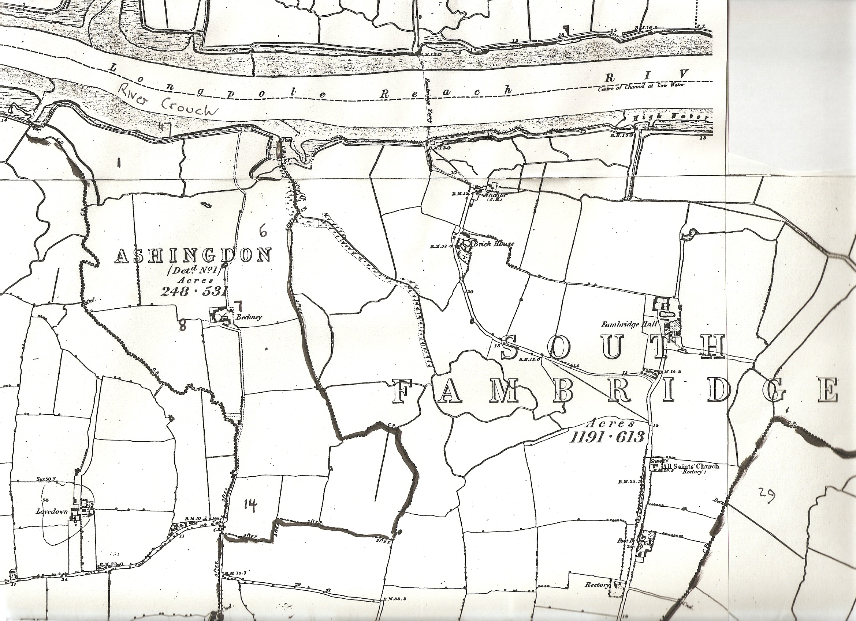
Map 1.
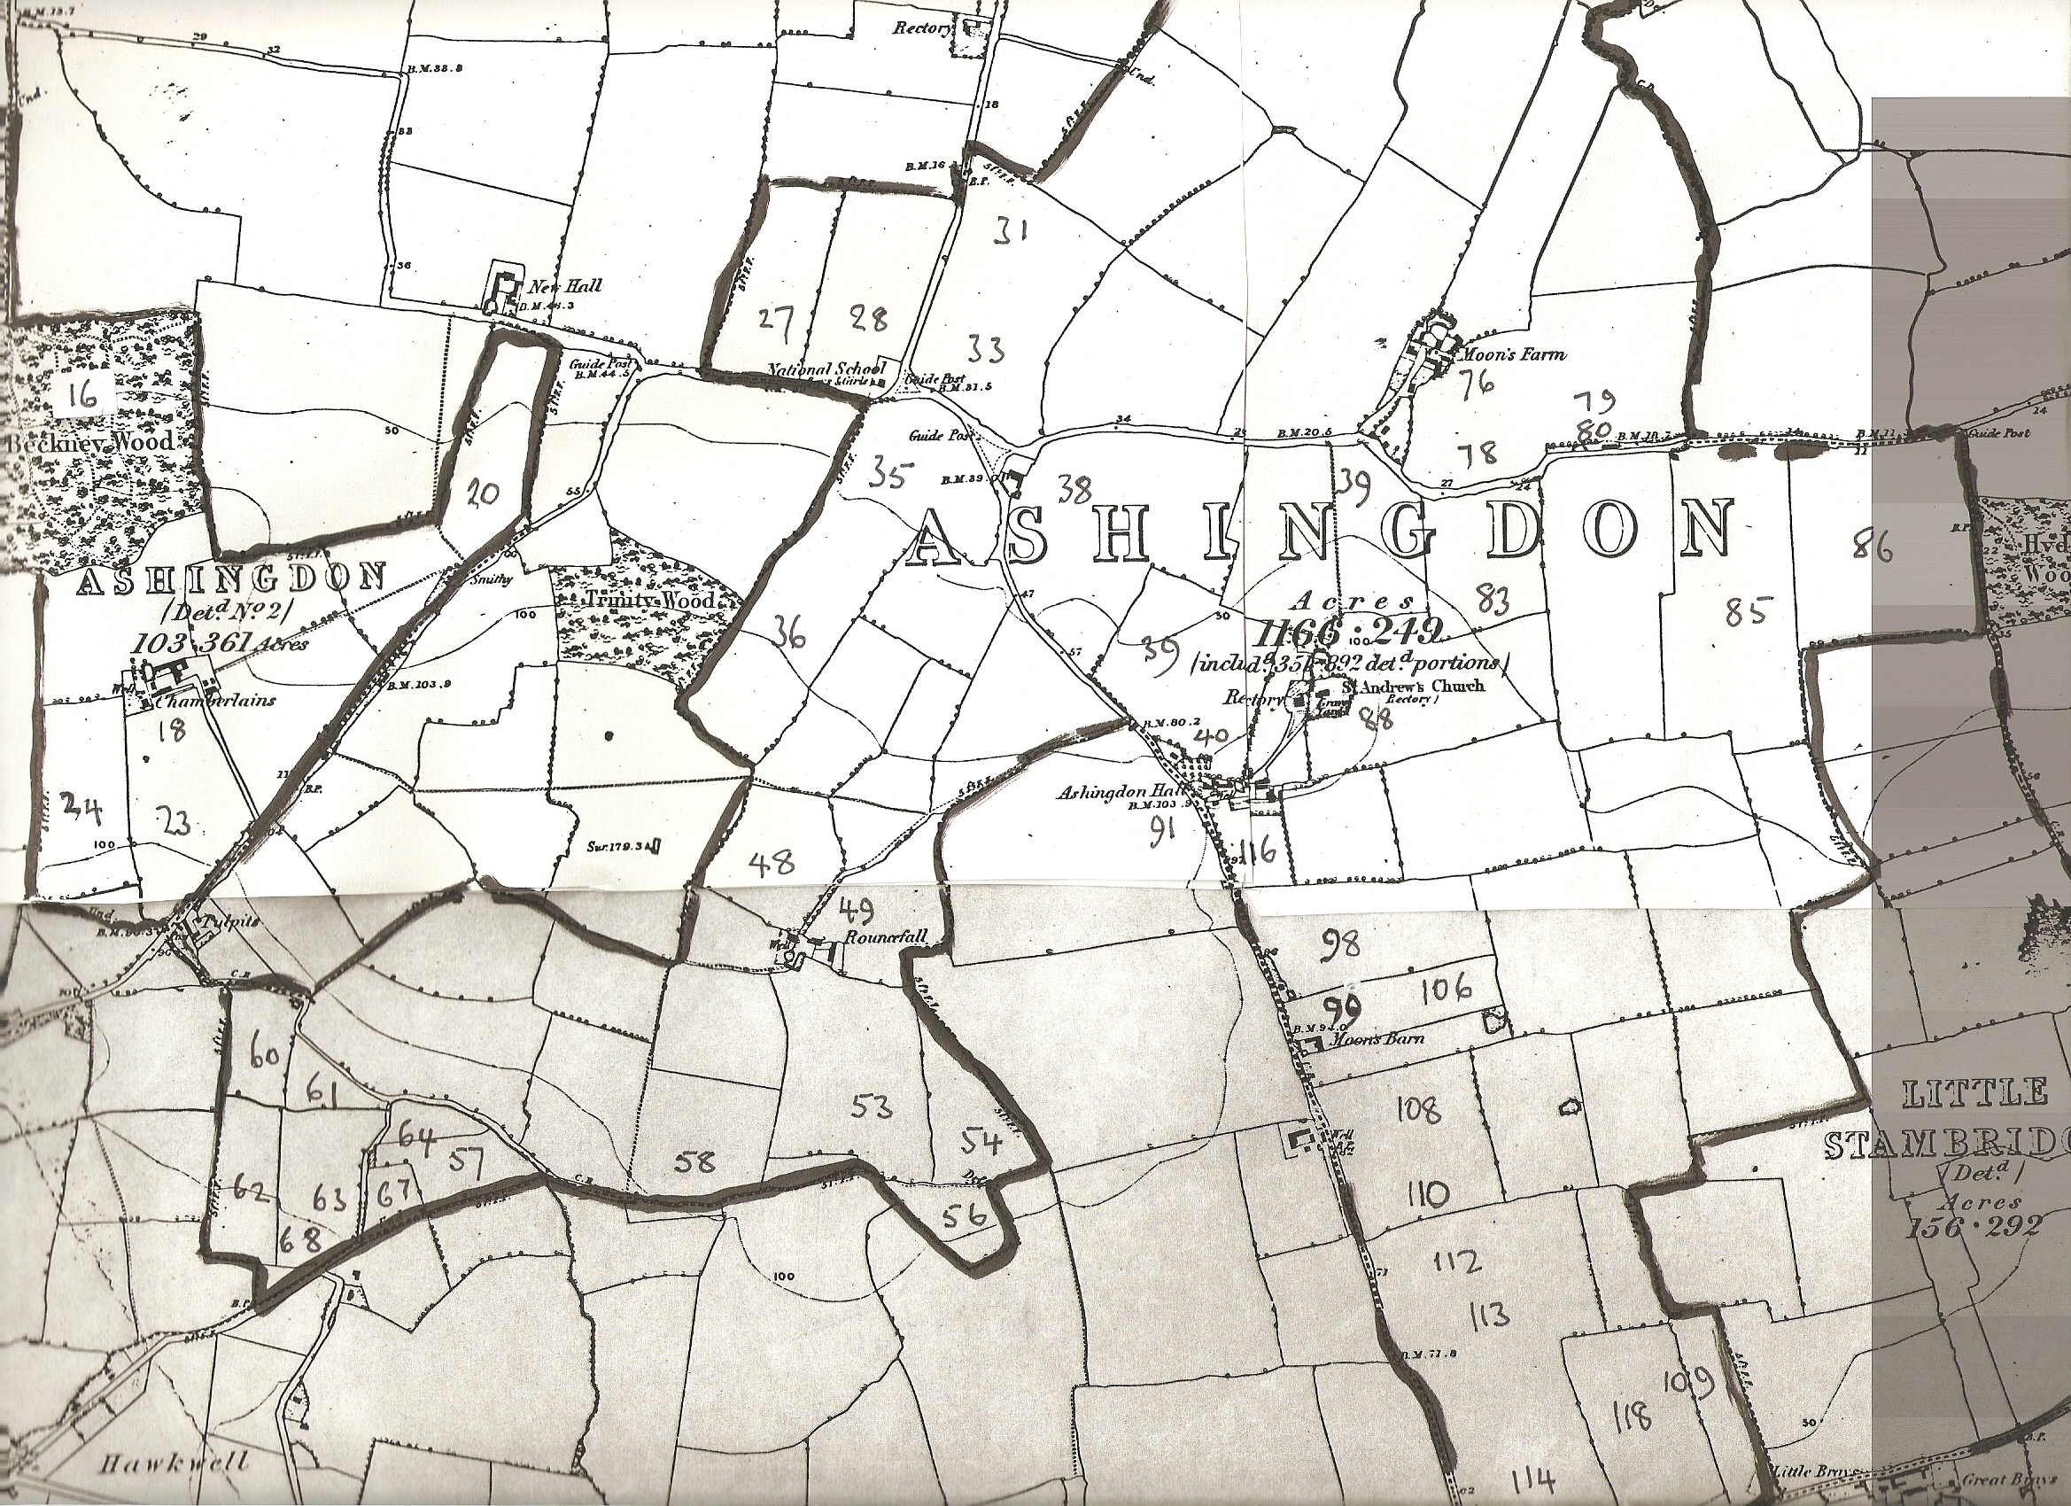
Map 2.

