THE PLACE-NAMES OF

BASILDON

Recorder: James Kemble

Essex Place-names Project (Essex Society for Archaeology & History), 2015 (e-book).

www.essex.ac.uk/history/esah/essexplacenames

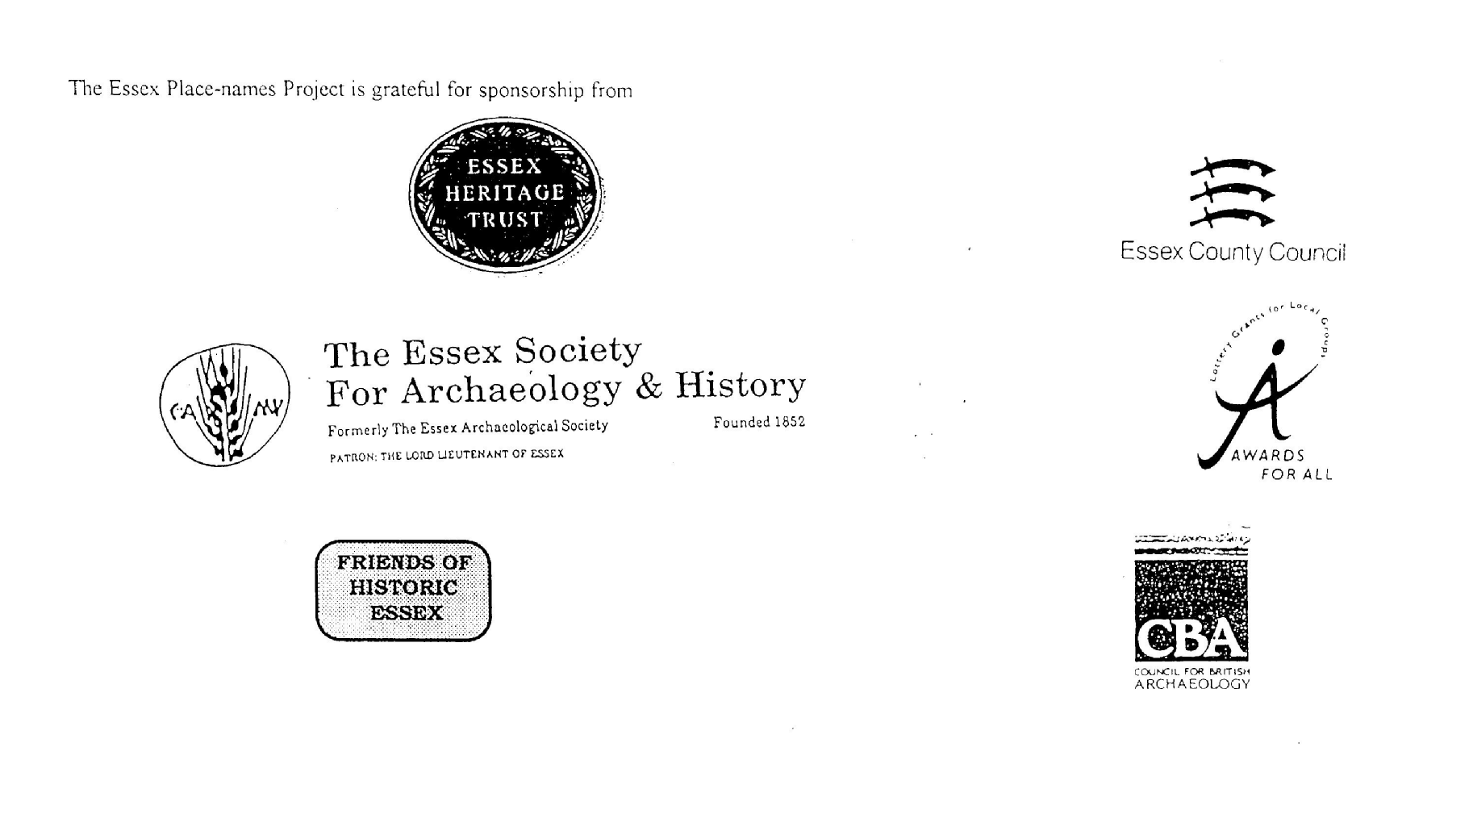

ESSEX PLACE-NAMES PROJECT.

The Essex Place-names Project is a County-wide survey to record place- and field-names from historical documents such as Tithe maps and apportionments, estate maps, sale
and auction catalogues, conveyances, terriers, deeds, rolls, inquisitions and surveys.

The second element of the Project is to investigate on-the-ground visible remains which correspond to the Place-names for actual or potential archaeological, agricultural and industrial sites, and to record natural (topographical) and man-made features which may relate to the Place-name. This involves field-survey in rural and outside investigation in built-up areas.

It is anticipated that the Project will lead to identification of archaeological sites and lost historic buildings; it will enable analysis of indicators of early settlement, land holding, agricultural and industrial practices of the County. It will refine the more precise meaning of descriptive words and elements used by earlier settlers as they gave names appropriate to the topography of the landscape of their time.

For convenience the surveys are based on the parish, recognising that present civil parish boundaries are not necessarily identical to former ecclesiastical boundaries. Local Recorders are supplied with templates of Record Forms to ensure consistency of recording across the County, and forward completed forms to a Central Coordinator for transfer to a county computer database which is available to researchers on the internet at www.essex.ac.uk/history/esah/essexplacenames, and updated periodically.

This publication presents part of the information recorded from the Tithe or Estate Award and Map, and from other documents for this parish. The full record is contained on the master database at Essex County Council (Historic Environment Section) and on the (above) website. Parish books are available to be downloaded from the website link ‘Books’ on the Home page. Please notify errors to the Project Coordinator at the Essex Record Office.

THE TITHE MAP AND APPORTIONMENT.

Since medieval times a tenth of the produce of land and stock had been paid by landholders to the church. At the Dissolution of the Monasteries, the property of many religious houses,
including the right to collect tithes, passed into lay hands. The Tithe Commutation Act which received Royal assent on 13th August 1836 abolished a rent payable in kind and
substituted rent-charges apportioned on each plot or parcel. The tithe-rent payable was assessed on the average value of wheat, barley and oats and was to fluctuate with price movements.

The commutation could be by voluntary agreement between the local owners and payers or, if agreement failed, could be compulsorily imposed by commissioners. A Valuer was to be appointed to apportion the rent of each parcel of land and tenants could deduct that rent-charge from their rent paid to the landlord. The task fell to the Tithe Commissioners to produce a map and an Apportionment (Award). A large-scale survey was produced for over 70% of England and Wales in the following 9 years, and about another 8% up to 1855. Most of the parishes in Essex were surveyed. The map scales vary. The Award records ownership, tenancy and land-use, field by field and parcel by parcel (often quoting the field name) with the ground area and rent-charge.

Land that was tithe-free tends to be less accurately mapped and contains few if any of the details recorded for those parcels subject to tithe. Rights of way and roads also tend to be neglected. Boundaries of the tithe areas are shown as are some natural features such as streams, ponds, gardens, greens and commons. Buildings are often shown coloured red if dwellingsor grey if not. Because the Award may have been agreed only some time after the map was finished, discrepancies occur between the two. Enclosure Awards, when extant, usually date to the 18th and early 19th centuries. J..Kemble.
Reproduced by permission
of Essex County Council.

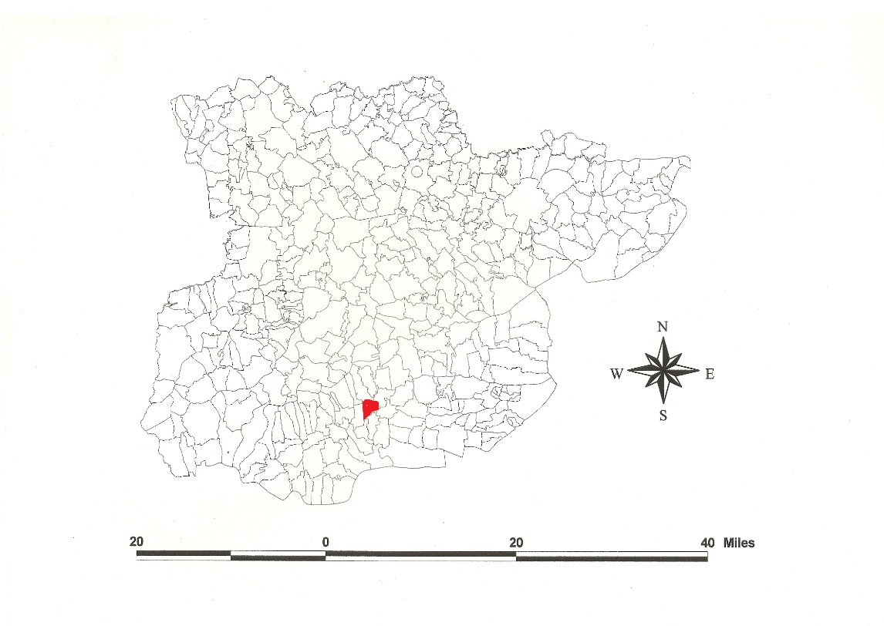
Reproduced by permission of
Essex County Council.
Basildon parish in the County of Essex

The Parish of Basildon (in Barstaple Hundred).

The Tithe Award of Basildon (Essex Record Office D/CT 22a), dated 1841, shows a rent-charge of £285 including £4 glebe payable to Edward Hodgson, rector. The whole parish measured 1346 acres all subject to tithes. 1152 acres 2 roods 31 perches were arable, 190a 2r 0p meadow and pasture, 23 acres glebe, 3 acres wood. The Tithe Commissioners were William Blamire and JW Buller, the Valuer Robert Baker of Writtle. The Tithe Map (ERO: D/CT 22b) was surveyed at a scale of 26.6” to a mile and measures 84”x46”. It was countersigned by Roger Kynaston, Assistant Tithe Commissioner.
In Domesday Book, 1086, Turold held Belesduna(m) (alias Botelers) from Earl Swein of Essex, which Leofstan had held before 1066 as a manor for 1 hide and 15 acres. W. held Berlesduna which Godith, a free [wo]man, had held before 1066 as a manor for 3 hides. Turold’s son held Berdestestapla from the Bishop of Bayeux, Odo, which a free man had held for 5½ hides and 30 acres (Morris, 1983). Watts (2004) translates this from a personal name + Old English dun, ‘Beorhtel’s hill’. For the origin of Barstable, see below (Kemble, 2007).
There were these manors: 1. Barstable Hall, in 1086 held by Turold’s son from Odo. The old town probably stood in Townfield where foundations and bones have been found by The Parsonage. By 1768 the house was deserted in favour of the new one in the valley below. Humphrey de Waldene held it of Edmund Duke of Kent, beheaded in 1330. 2. Belesdun/Botelers, in 1086 Earl Swein’s, was moated. Wido de Bartlesdun held Botelers t.Henry III of the Honour of Castle Hedingham. 3. Battleswick (alias Bartlesdon) was held by John de Vere in 1431 of the Honour of Rayleigh (Morant, 1768).
Basildon new town developed from 1949 engulfed several hamlets, Barstable, Vange, Pitsea, Chalvedon, Dunton, Felmore, Fryerns, Laindon, Langdon Hills, Lee Chapel, Nevendon and Noak Bridge. Swept away were some 5000 ‘plotlands’ which had been built after the London-Barking-Pitsea railway had been constructed in 1888. Originally conceived to house 50,000, the last (1977) revision was to 130,000. Vange is derived from early Saxon Old English fen-ge, marsh district. Pitsea, held by Wulfeva wife of Finn in 1086, was Piceseia, Pic’s low-lying land. Langdon, Langenduna, was held by Swein in 1086, langan dun, the long hill. Laindon is documented in c.998 as Ligeandune for which one man was required for ship duty against invasions, and Legenduna in Domesday Book, 1086, held by the bishop of London, the dun, hill by the Lyge stream (Kemble, 2007). (See separate Parish Place-name Books at www.essex.ac.uk/history/esah/essexplacenames. Then click on ‘Books’).
At Great Wasketts have been found socketed bronze axes dating to the Late Bronze Age (Kemble, 2009). In Barstable the church of St Basil the Great was built in 1955. Great Chalvedon Hall at Tyefields is C16 with a cross-wing. The old Basildon parish church of Holy Cross is at Fryerns (in Church Road off Whitmore Way), ragstone, restored in 1702; the nave is C14, the chancel rebuilt in 1597, and the tower C15. St Nicholas, at Church Hill Laindon, has a 15th century timber belfry, a rebuilt 12th century nave and a 15th century south porch. All Saints, Langdon Hills, now a house, has a 16th century nave and chancel, the nave roof crown-post. The remains of St Michael’s church, Pitsea Creek, is the west tower c.1500. Pitsea Hall, now Cromwell Manor, is timber-framed c.1600. In Wat Tyler Country Park are two timber-framed houses rebuilt from Coopers End Stansted Airport, Little Coopers, a 3-bay 15th century hall-house, and Blunt’s Cottage, a 16th century. All Saints, Vange, has a south nave Norman window and chancel arch (Pevsner, 2007). Here on the Vange, Pitsea and Bowers marshes south of the railway are extensive remains of red-hills (salt-working sites), medieval farmsteads and earthen dykes (Pevsner, 2007).
The Hundred name in Domesday Book is Berdestapla which Reaney (1935) translates from Old English stapol, post or pillar + beardede, ‘hairy’. Christie (1926) places the moot at or near Barstable Hall (TQ 703885) in Basildon parish.
Place- and field names from other documents are shown against the Tithe Award names.

References:
Christie, M., 1926. Essex Hundred Moots. Trans Essex Archaeological Soc., n.s., xviii (3), 182.
Hart, C., 1971. Early Charters of Essex, Leicester.
Kemble, J., 2007. Essex Place-names, Places, Streets & People. Historical Publications, London, pp 20,52.
Kemble, J., 2009. Prehistoric & Roman Essex. History Press. pp 66,114.
Morant, P., 1763. History & Antiquities of the County of Essex, i, 248
Morris, J., 1983. Domesday Book – Essex. Phillimore.
Pevsner, N., Bettley, J., 2007. Buildings of England – Essex. Yale.
Reaney, P., 1935. Place-names of Essex. Cambridge.
Watts, V., 2004. Dictionary of English Place-names. Cambridge.

The Tithe Award Place-names of Basildon - by parcel no.
www.essex.ac.uk/history/esah/essexplacenames

Place name | alias | Field No | Grid | x | y | Acr | Rd | Pch | Land use | Owner | Occupier | Other information
Corner field | [at Hardings Elms Rd, 1999,Atlas/OS] | 1 | TQ | 706 | 914 | 13 | 2 | 20 | arable | Walmsley, Michael & Harriet, wife | Gibbons, William
Eight acres |  | 2 | TQ | 707 | 914 | 9 | 1 | 27 | arable | Walmsley, Michael & Harriet, wife | Gibbons, William
Ten acres | [at Oak Road, 1999,Atlas/OS] | 4 | TQ | 712 | 915 | 10 | 3 | 9 | arable | Baker, Jane | Lowe, Edmund
Nine acres | [at Oak Road, 1999,Atlas/OS] | 6 | TQ | 715 | 915 | 9 | 2 | 31 | arable | Baker, Jane | Lowe, Edmund
Wood field | [at Oak Road, 1999,Atlas/OS] | 7 | TQ | 717 | 916 | 12 | 2 | 35 | arable | Baker, Jane | Lowe, Edmund
Wood | Nuttons Wood, 1999,Atlas/OS] | 8 | TQ | 718 | 917 | 4 | 1 | 2 | wood | Francis, John George | Francis, John George
Meadow |  | 9 | TQ | 719 | 917 | 2 | 2 | 33 | pasture | Greenwood, John | Greenwood, John
Cottage, gdn |  | 10 | TQ | 720 | 917 | 0 | 0 | 13 |  | Horsnail, James | Horsnail, John
Two cttgs, gdns |  | 11 | TQ | 720 | 917 |  |  |  |  | Greenwood, John | Barker, Barnaby; Tate, Wm
Three acres |  | 12 | TQ | 720 | 916 | 3 | 3 | 34 |  | Francis, John George | Archer, Daniel
Further field | [at Gardiners Lane North, 1999,Atlas/OS] | 13 | TQ | 720 | 915 | 10 | 3 | 17 | arable | Walmsley, Michael & Harriet, wife | Gibbons, William
Hill field |  | 14 | TQ | 717 | 914 | 11 | 0 | 25 | arable | Walmsley, Michael & Harriet, wife | Gibbons, William
Long Eleven acres |  | 15 | TQ | 715 | 914 | 12 | 0 | 2 | arable | Baker, Jane | Lowe, Edmund
Long field |  | 16 | TQ | 715 | 913 | 5 | 2 | 27 | arable | Walmsley, Michael & Harriet, wife | Gibbons, William
Ten acres |  | 17 | TQ | 713 | 913 | 13 | 0 | 3 | arable | Walmsley, Michael & Harriet, wife | Gibbons, William
Pea field |  | 18 | TQ | 710 | 913 | 2 | 2 | 37 | arable | Walmsley, Michael & Harriet, wife | Gibbons, William
Stable field |  | 19 | TQ | 709 | 913 | 3 | 0 | 6 | pasture | Walmsley, Michael & Harriet, wife | Gibbons, William
Barn field |  | 20 | TQ | 707 | 913 | 12 | 0 | 4 | arable | Walmsley, Michael & Harriet, wife | Gibbons, William
Road field |  | 21 | TQ | 707 | 912 | 9 | 0 | 38 | arable | Walmsley, Michael & Harriet, wife | Gibbons, William
Horsing Blocks | [at Honeypot Lane, 1875,OS] | 22 | TQ | 708 | 909 | 8 | 0 | 30 | arable | Walmsley, Michael & Harriet, wife | Gibbons, William
Home mead |  | 23 | TQ | 710 | 910 | 6 | 0 | 39 | pasture | Walmsley, Michael & Harriet, wife | Gibbons, William
Homestead, paddock | Somers in Botyllesden, 1507,Ipm; Summers, 1777,C | 24 | TQ | 709 | 911 | 3 | 0 | 28 | pasture | Walmsley, Michael & Harriet, wife | Gibbons, William
Fifteen acres |  | 25 | TQ | 713 | 911 | 18 | 1 | 0 | arable | Francis, John George | Daniel, Archer
Lower Westgates |  | 26 | TQ | 715 | 911 | 13 | 1 | 11 | arable | Francis, John George | Daniel, Archer
Upper Westgates |  | 27 | TQ | 717 | 912 | 13 | 1 | 30 | arable | Francis, John George | Daniel, Archer
Barn mead |  | 28 | TQ | 720 | 913 | 9 | 1 | 23 | pasture | Francis, John George | Daniel, Archer
Homestead | Wasket(t)slond, 1578, Srvy; Whisketts, 1643, Add; Great Wasketts, 1875,OS | 29 | TQ | 719 | 912 | 4 | 1 | 34 |  | Francis, John George | Daniel, Archer
Kitchen mead | [at Gardiners Lane North, 1999,Atlas/OS] | 30 | TQ | 720 | 910 | 14 | 3 | 28 | pasture | Francis, John George | Daniel, Archer | Elyas Waskett of Writtle, 1274,RH
The Twentyone acres |  | 31 | TQ | 716 | 910 | 23 | 0 | 20 | arable | Francis, John George | Daniel, Archer
The Fourteen acres |  | 33 | TQ | 710 | 908 | 16 | 0 | 12 | arable | Francis, John George | Daniel, Archer
Asplands |  | 34 | TQ | 709 | 907 | 7 | 1 | 21 | arable | Walmsley, Michael & Harriet, wife | Gibbons, William
Colliers |  | 35 | TQ | 709 | 905 | 14 | 0 | 1 | arable | Walmsley, Michael & Harriet, wife | Gibbons, William
Second Little Salmons |  | 36 | TQ | 719 | 904 | 2 | 1 | 0 | arable | Soames, William | Hunt, George
Black Land |  | 37 | TQ | 711 | 905 | 10 | 3 | 20 | arable | Hodgson, Rev Edward | Hunt, George | glebe
Eighteen acres |  | 38 | TQ | 714 | 906 | 18 | 2 | 35 | arable | Prentice, Golden Nehemiah | Raynham, James
Twelve acres |  | 40 | TQ | 717 | 907 | 13 | 2 | 0 | arable | Prentice, Golden Nehemiah | Raynham, James
The Fourteen acres | [at Gardiners Lane North, 1999,Atlas/OS] | 41 | TQ | 720 | 908 | 16 | 0 | 1 | arable | Prentice, Golden Nehemiah | Raynham, James
Spring field |  | 42 | TQ | 720 | 905 | 17 | 2 | 13 | arable | Prentice, Golden Nehemiah | Raynham, James
Kitchen field | [at Oak Road, 1999,Atlas/OS] | 43 | TQ | 717 | 904 | 16 | 2 | 38 | arable | Prentice, Golden Nehemiah | Raynham, James
Calves Hoppit |  | 44 | TQ | 715 | 904 | 5 | 3 | 28 | arable | Prentice, Golden Nehemiah | Raynham, James
Homestead | Onyandesmed, 1452,Ct; Onyfaunts, 1484,M; Oliphants, 1875,OS | 45 | TQ | 715 | 904 | 1 | 3 | 12 |  | Prentice, Golden Nehemiah | Raynham, James | Juliana Honywand, 1249,FF; Richard Oniwant, 1327,SR
Two cttgs, gdns |  | 46 | TQ | 715 | 903 | 0 | 1 | 22 |  | Prentice, Golden Nehemiah | Raynham, James
Barley mead |  | 47 | TQ | 714 | 904 | 12 | 1 | 31 | arable | Prentice, Golden Nehemiah | Raynham, James
Nether Black Land | Rectory, 1875,OS | 48 | TQ | 713 | 903 | 12 | 3 | 17 | arable | Hodgson, Rev Edward | Hunt, George | Glebe
Salmons field |  | 49 | TQ | 710 | 902 | 13 | 2 | 12 | arable | Offin, Abraham | Hunt, George
Upper Parsonage field |  | 50 | TQ | 710 | 900 | 16 | 1 | 37 | arable | Prentice, Golden Nehemiah | Raynham, James | Juliana Honywand, 1249,FF; Richard Oniwant, 1327,SR
Church Hills |  | 51 | TQ | 712 | 900 | 13 | 2 | 25 | arable | Prentice, Golden Nehemiah | Raynham, James
Middle Path field |  | 52 | TQ | 714 | 901 | 14 | 3 | 0 | pasture | Prentice, Golden Nehemiah | Raynham, James
Town field |  | 53 | TQ | 716 | 901 | 15 | 0 | 14 | arable | Prentice, Golden Nehemiah | Raynham, James | foundations & bones found, 1768,Morant
Well field |  | 54 | TQ | 718 | 901 | 18 | 2 | 4 |  | Prentice, Golden Nehemiah | Raynham, James
Slip |  | 55 | TQ | 720 | 904 | 1 | 1 | 10 | arable | Prentice, Golden Nehemiah | Raynham, James
Further Eight acres |  | 56 | TQ | 720 | 903 | 9 | 1 | 0 | arable | Francis, John George | Bell,George
Pond Eight Acres |  | 57 | TQ | 720 | 901 | 9 | 0 | 27 | arable | Francis, John George | Bell,George
Four Acres |  | 59 | TQ | 721 | 901 | 4 | 0 | 15 | arable | Francis, John George | Bell,George
Little meadow |  | 60 | TQ | 712 | 901 | 6 | 0 | 34 | pasture | Francis, John George | Bell,George
Homestead | ffreryn, 1469,MnAt; Frerne,1563,Deed; Fryerns, 1875,OS | 61 | TQ | 712 | 900 | 1 | 0 | 12 |  | Francis, John George | Bell,George | ? of Knights Hospitalller, M i, 250
Broken Backs |  | 62 | TQ | 721 | 899 | 7 | 3 | 24 | arable | Francis, John George | Bell,George
Broken Backs |  | 63 | TQ | 720 | 899 | 7 | 2 | 9 | arable | Francis, John George | Bell,George
Fourteen acres |  | 64 | TQ | 717 | 899 | 15 | 2 | 36 | arable | Prentice, Golden Nehemiah | Raynham, James
Church mead |  | 65 | TQ | 715 | 898 | 14 | 1 | 22 | arable | Prentice, Golden Nehemiah | Raynham, James
Church, yard | Chapel of Ease, 1875,OS | 66 | TQ | 714 | 898 | 0 | 1 | 26 |  | Prentice, Golden Nehemiah | Raynham, James
Church Hills | [at Church Road, 1999,Atlas/OS] | 67 | TQ | 713 | 898 | 7 | 3 | 27 | arable | Prentice, Golden Nehemiah | Raynham, James
Granary, stables |  | 69 | TQ | 713 | 896 | 1 | 2 | 1 |  | Prentice, Golden Nehemiah | Raynham, James
Pightle |  | 70 | TQ | 715 | 896 | 1 | 1 | 7 | pasture | Prentice, Golden Nehemiah | Raynham, James
Homestead | Moat House, site of Botelers, 1875,OS | 71 | TQ | 715 | 896 | 2 | 0 | 12 |  | Prentice, Golden Nehemiah | Raynham, James
Yards, stack yds |  | 72 | TQ | 714 | 896 | 1 | 0 | 10 | pasture | Prentice, Golden Nehemiah | Raynham, James
Two cttgs, gdns |  | 73 | TQ | 714 | 896 | 0 | 0 | 33 |  | Prentice, Golden Nehemiah | Raynham, James
Stack Yard meadow |  | 74 | TQ | 714 | 896 | 1 | 1 | 14 | pasture | Prentice, Golden Nehemiah | Raynham, James
Calves Hoppit |  | 75 | TQ | 715 | 896 | 1 | 3 | 7 | pasture | Prentice, Golden Nehemiah | Raynham, James
Moat field |  | 76 | TQ | 717 | 896 | 14 | 0 | 33 | arable | Prentice, Golden Nehemiah | Raynham, James
Eleven acres |  | 77 | TQ | 720 | 896 | 13 | 1 | 21 | arable | Francis, John George | Bell,George
Nine acre mead |  | 78 | TQ | 723 | 896 | 9 | 0 | 12 | pasture | Francis, John George | Bell,George
Nevendon field |  | 79 | TQ | 722 | 895 | 3 | 1 | 35 | arable | Prentice, Golden Nehemiah | Raynham, James
Eleven acres |  | 80 | TQ | 720 | 895 | 13 | 2 | 29 | arable | Prentice, Golden Nehemiah | Raynham, James
Thistley field |  | 81 | TQ | 718 | 895 | 14 | 0 | 5 | arable | Prentice, Golden Nehemiah | Raynham, James
Fair Mead |  | 82 | TQ | 715 | 895 | 10 | 2 | 11 | arable | Prentice, Golden Nehemiah | Raynham, James
Upper Stoney Hills | [at Church Road, 1999,Atlas/OS] | 83 | TQ | 713 | 894 | 10 | 1 | 7 | arable | Prentice, Golden Nehemiah | Raynham, James
Great Stoney Hills |  | 84 | TQ | 713 | 892 | 7 | 0 | 17 | arable | Prentice, Golden Nehemiah | Raynham, James
Cottage, gdn | Fair House, 1875,OS | 85 | TQ | 714 | 893 | 0 | 1 | 17 |  | Morrin, Thomas | Roberts, William
Hoppit |  | 86 | TQ | 714 | 893 | 1 | 2 | 34 | pasture | Morrin, Thomas | Roberts, William
Five acres |  | 88 | TQ | 715 | 894 | 5 | 0 | 33 | arable | Morrin, Thomas | Roberts, William
Six acres |  | 89 | TQ | 718 | 894 | 6 | 2 | 10 | arable | Morrin, Thomas | Roberts, William
Five acres |  | 90 | TQ | 720 | 894 | 4 | 3 | 18 | arable | Morrin, Thomas | Roberts, William
Fifteen acres |  | 91 | TQ | 720 | 893 | 17 | 0 | 6 | arable | Prentice, Golden Nehemiah | Raynham, James
Fourteen acres |  | 92 | TQ | 718 | 892 | 14 | 3 | 19 | arable | Prentice, Golden Nehemiah | Raynham, James
Great Lants |  | 93 | TQ | 716 | 890 | 18 | 2 | 20 | arable | Prentice, Golden Nehemiah | Raynham, James
Hoppit |  | 94 | TQ | 714 | 891 | 0 | 3 | 21 | pasture | Prentice, Golden Nehemiah | Raynham, James
Little field | [at Church Road, 1999,Atlas/OS] | 95 | TQ | 714 | 890 | 1 | 3 | 21 | arable | Prentice, Golden Nehemiah | Raynham, James
Six acres |  | 96 | TQ | 715 | 889 | 7 | 0 | 22 | arable | Prentice, Golden Nehemiah | Raynham, James
Homestead | Fairhouse Farm, 1875,OS | 97 | TQ | 715 | 887 | 1 | 0 | 2 |  | Prentice, Golden Nehemiah | Raynham, James
Furze mead |  | 98 | TQ | 715 | 887 | 4 | 0 | 24 | pasture | Prentice, Golden Nehemiah | Raynham, James
Furze mead | [at Church Road, 1999,Atlas/OS] | 99 | TQ | 716 | 886 | 7 | 0 | 23 | pasture | Prentice, Golden Nehemiah | Raynham, James
Fifteen acres |  | 100 | TQ | 717 | 886 | 15 | 0 | 9 | arable | Prentice, Golden Nehemiah | Raynham, James
Ten acres |  | 101 | TQ | 719 | 890 | 11 | 0 | 38 | arable | Freman, John | Hills, James
Thirteen acres |  | 102 | TQ | 719 | 887 | 6 | 2 | 16 | arable | Morrin, Thomas | Roberts, William
No name |  | 103 | TQ | 720 | 890 | 6 | 2 | 16 | arable | Freman, John | Hills, James
No name |  | 105 | TQ | 721 | 891 | 3 | 1 | 27 | arable | Freman, John | Hills, James
Basildon field (pt) |  | 107 | TQ | 723 | 889 | 4 | 0 | 14 | arable | Tooke, William | Abrey, Daniel
Rainbow field | [at Timberlog Lane, 1875,OS] | 108 | TQ | 722 | 887 | 3 | 0 | 1 | arable | Shaw, George | Brown, John
Wood |  | 109 | TQ | 721 | 886 | 3 | 1 | 3 | wood | Shaw, George | Shaw, George
Ten acres |  | 110 | TQ | 720 | 886 | 11 | 1 | 23 | arable | Morrin, Thomas | Roberts, William
Bell field | [at Clay Hill Rd/Church Rd junction, 1999,Atlas/OS] | 112 | TQ | 716 | 885 | 10 | 2 | 4 | arable | Prentice, Golden Nehemiah | Pocklington, John
The Five acres | [at Church Road, 1999,Atlas/OS] | 113 | TQ | 716 | 884 | 5 | 3 | 15 | arable | Prentice, Golden Nehemiah | Pocklington, John
Five acres |  | 114 | TQ | 717 | 883 | 5 | 3 | 31 | arable | Smith, Sir Chas Joshua, execs | Hockley, John
Bull field | [at Timberlog Lane, 1875,OS] | 115 | TQ | 720 | 885 | 10 | 1 | 18 | arable | Morrin, Thomas | Roberts, William
Bull field | [at Timberlog Lane, 1875,OS] | 116 | TQ | 720 | 884 | 11 | 1 | 37 | arable | Morrin, Thomas | Roberts, William
Bull field | [at Clay Hill Road, 1999,Atlas/OS] | 117 | TQ | 721 | 883 | 5 | 1 | 22 | arable | Smith, Sir Chas Joshua, execs | Hockley, John
Cottage, gdn |  | 118 | TQ | 720 | 883 | 0 | 1 | 22 |  | Bont, Samuel | Bont, Samuel
Parish House |  | 119 | TQ | 721 | 883 | 0 | 0 | 14 |  | Basildon Parish Property, trustees | Marshall, Wm; Rickett, Elisa; Adkins,George; Swan,George
Cottage, gdn |  | 120 | TQ | 721 | 883 | 0 | 0 | 23 |  | Forster, Susan | Forster, Susan
Cottage, gdn |  | 121 | TQ | 721 | 883 | 0 | 0 | 19 |  | Sach, Joseph | Sach, Joseph
Basildon Bull hs, gdn |  | 122 | TQ | 722 | 883 | 0 | 0 | 31 |  | Miles, Sarah | Hyness,John; Levitt,Wm
Pips Hill | [at Honeypot Lane, 1875,OS; Pipps Hill Rd North, 1999,Atlas/OS] | 123 | TQ | 706 | 906 | 15 | 1 | 35 | arable | Walmsley, Michael & Harriet, wife | Gibbons, William
First Little Salmons | [at Honeypot Lane, 1875,OS; Pipps Hill Rd North, 1999,Atlas/OS] | 124 | TQ | 706 | 905 | 2 | 3 | 15 | arable | Soames, William | Hunt, George
Salmons |  | 125 | TQ | 707 | 902 | 17 | 1 | 30 | arable | Soames, William | Hunt, George
Hoppit |  | 126 | TQ | 706 | 901 | 1 | 0 | 11 | arable | Hodgson, Rev Edward | Hunt, George | glebe
Lower Parsonage field |  | 127 | TQ | 707 | 899 | 11 | 1 | 30 | arable | Prentice, Golden Nehemiah | Raynham, James
Great Parsonage field |  | 128 | TQ | 708 | 899 | 17 | 3 | 14 | arable | Prentice, Golden Nehemiah | Raynham, James
Eight acres | [at Honeypot Lane, 1875,OS; Waterfront Walk, 1999,Atlas/OS] | 130 | TQ | 708 | 896 | 11 | 1 | 13 | arable | Prentice, Golden Nehemiah | Raynham, James
Tory field |  | 131 | TQ | 709 | 895 | 15 | 1 | 28 | arable | Prentice, Golden Nehemiah | Raynham, James
Lower Stoney Hills |  | 133 | TQ | 709 | 894 | 10 | 3 | 22 | arable | Prentice, Golden Nehemiah | Raynham, James
Curd Field |  | 134 | TQ | 709 | 893 | 7 | 1 | 3 | arable | Slater, Anna Maria | Moss, Benjamin
Ten acre mead |  | 136 | TQ | 706 | 893 | 10 | 0 | 7 | pasture | Slater, Anna Maria | Moss, Benjamin
Seventeen acres |  | 137 | TQ | 705 | 893 | 17 | 1 | 25 | arable | Slater, Anna Maria | Moss, Benjamin
Pewit field |  | 138 | TQ | 703 | 892 | 11 | 0 | 17 | arable | Slater, Anna Maria | Moss, Benjamin
Five Rood field |  | 139 | TQ | 702 | 893 | 1 | 2 | 36 | arable | Slater, Anna Maria | Moss, Benjamin
Gate field |  | 141 | TQ | 701 | 889 | 9 | 3 | 7 | arable | Slater, Anna Maria | Moss, Benjamin
Fourteen acres |  | 142 | TQ | 702 | 890 | 16 | 0 | 31 | arable | Slater, Anna Maria | Moss, Benjamin
Sallow Pond field |  | 143 | TQ | 705 | 890 | 9 | 3 | 30 | arable | Slater, Anna Maria | Moss, Benjamin
Honey Pot Six acres |  | 144 | TQ | 707 | 891 | 8 | 0 | 38 | arable | Slater, Anna Maria | Moss, Benjamin
No name |  | 145 | TQ | 709 | 892 | 0 | 3 | 21 |  | Hodgson, Rev Edward | Hunt, George | glebe
Four acres |  | 146 | TQ | 709 | 892 | 4 | 1 | 34 | arable | Boudel, Thomas | Moss, Benjamin
Garden field |  | 147 | TQ | 710 | 891 | 4 | 3 | 9 | arable | Boudel, Thomas | Moss, Benjamin
Homestead | Sawyers, 1875,OS | 148 | TQ | 711 | 891 | 0 | 2 | 3 |  | Boudel, Thomas | Moss, Benjamin
Barn field |  | 149 | TQ | 712 | 891 | 3 | 2 | 14 | arable | Boudel, Thomas | Moss, Benjamin
Stack Yard field |  | 150 | TQ | 712 | 891 | 4 | 0 | 14 | arable | Boudel, Thomas | Moss, Benjamin
Further Stoney Hills | [at Church Road, 1999,Atlas/OS] | 151 | TQ | 714 | 889 | 9 | 1 | 17 | arable | Prentice, Golden Nehemiah | Raynham, James
Stoney Hills |  | 152 | TQ | 713 | 889 | 9 | 2 | 31 | arable | Slater, Anna Maria | Moss, Benjamin
Driftway |  | 153 | TQ | 710 | 890 | 0 | 1 | 28 | pasture | Slater, Anna Maria | Moss, Benjamin
Upper Sawyers |  | 154 | TQ | 710 | 888 | 15 | 0 | 1 | arable | Morrin, Thomas | Clark, George
Lower Sawyers |  | 155 | TQ | 708 | 888 | 11 | 3 | 3 | arable | Morrin, Thomas | Clark, George
Nine acres |  | 157 | TQ | 707 | 887 | 10 | 1 | 5 | arable | Morrin, Thomas | Clark, George
Barn field |  | 158 | TQ | 704 | 887 | 6 | 3 | 22 | arable | Slater, Anna Maria | Moss, Benjamin
Homestead | Berdestesapla, 1086,DB; Barstable Hall, 1875,OS | 159 | TQ | 703 | 885 | 6 | 3 | 22 | arable | Slater, Anna Maria | Moss, Benjamin
Three acre mead |  | 160 | TQ | 704 | 886 | 2 | 2 | 10 | pasture | Slater, Anna Maria | Moss, Benjamin
Hoppit |  | 161 | TQ | 702 | 887 | 1 | 2 | 10 | pasture | Slater, Anna Maria | Moss, Benjamin
Sixteen acres |  | 163 | TQ | 700 | 885 | 20 | 1 | 38 | arable | Slater, Anna Maria | Moss, Benjamin
Cartlodge field |  | 164 | TQ | 702 | 885 | 5 | 1 | 30 | pasture | Slater, Anna Maria | Moss, Benjamin
Four acre mead |  | 165 | TQ | 704 | 885 | 4 | 0 | 32 | pasture | Slater, Anna Maria | Moss, Benjamin
Twelve acres |  | 166 | TQ | 707 | 885 | 14 | 1 | 17 | arable | Morrin, Thomas | Clark, George
Hilly Mead |  | 167 | TQ | 709 | 886 | 9 | 3 | 10 | pasture | Morrin, Thomas | Clark, George
Six acre mead |  | 168 | TQ | 711 | 886 | 5 | 3 | 20 | pasture | Morrin, Thomas | Clark, George
Mud Mead |  | 169 | TQ | 713 | 887 | 8 | 3 | 33 | pasture | Morrin, Thomas | Clark, George
Kitchen field |  | 170 | TQ | 714 | 885 | 17 | 2 | 34 | arable | Morrin, Thomas | Clark, George
Orchard |  | 171 | TQ | 712 | 884 | 0 | 3 | 39 | pasture | Morrin, Thomas | Clark, George
Stable field |  | 172 | TQ | 712 | 884 | 3 | 2 | 4 | pasture | Morrin, Thomas | Clark, George
Homestead, Hoppit | Belesduna(m), 1086, DB; Basildon Hall, 1875,OS | 173 | TQ | 711 | 885 | 2 | 3 | 17 | pasture | Morrin, Thomas | Clark, George
Chaseway |  | 174 | TQ | 710 | 885 | 1 | 1 | 2 | pasture | Morrin, Thomas | Clark, George
Pea Hill |  | 175 | TQ | 710 | 884 | 11 | 1 | 6 | arable | Morrin, Thomas | Clark, George
Slipe |  | 176 | TQ | 709 | 883 | 2 | 2 | 19 | pasture | Morrin, Thomas | Clark, George
Great Field |  | 177 | TQ | 707 | 884 | 23 | 1 | 20 | arable | Morrin, Thomas | Clark, George
Half Moon Field |  | 178 | TQ | 704 | 884 | 8 | 2 | 3 | arable | Slater, Anna Maria | Moss, Benjamin
Fourteen acres | [at corner of Waldegrave & Codenham Straight, 1999,Atlas/OS] | 180 | TQ | 706 | 880 | 16 | 3 | 0 | arable | Morrin, Thomas | Clark, George
Swan Mead |  | 181 | TQ | 708 | 881 | 5 | 3 | 9 | pasture | Morrin, Thomas | Peasgood, John
Middle Hall Hill | [at Clay Hill Road, 1999,Atlas/OS] | 182 | TQ | 710 | 881 | 14 | 0 | 21 | arable | Morrin, Thomas | Peasgood, John
Hurdle Hoppit |  | 183 | TQ | 711 | 883 | 3 | 0 | 3 | pasture | Morrin, Thomas | Peasgood, John
Moat Hoppit | Middle Hall, 1777,C | 184 | TQ | 711 | 882 | 3 | 0 | 25 | pasture | Morrin, Thomas | Peasgood, John
Barn, Small Pieces |  | 184a | TQ | 711 | 882 | 1 | 0 | 12 | pasture | Morrin, Thomas | Peasgood, John
Driftway |  | 185 | TQ | 712 | 881 | 0 | 1 | 2 | pasture | Morrin, Thomas | Peasgood, John
Pound field | [at Clay Hill Rd/Church Rd junction, 1999,Atlas/OS] | 186 | TQ | 714 | 882 | 24 | 0 | 30 | arable | Morrin, Thomas | Peasgood, John
Cottage, gdn | [at Clay Hill Road, 1999,Atlas/OS] | 187 | TQ | 714 | 881 | 0 | 0 | 14 |  | Morrin, Thomas | Angier, John
Corner field |  | 189 | TQ | 708 | 878 | 2 | 3 | 7 | pasture | Prentice, Golden Nehemiah | Pocklington, John
Hoppit |  | 190 | TQ | 707 | 878 | 2 | 2 | 16 | pasture | Prentice, Golden Nehemiah | Pocklington, John
Homestead, Hoppit | Broom Bottoms, 1875,OS | 191 | TQ | 707 | 878 | 0 | 1 | 31 |  | Prentice, Golden Nehemiah | Pocklington, John
Barn field | [at corner of Waldegrave & Codenham Straight, 1999,Atlas/OS] | 192 | TQ | 705 | 878 | 3 | 3 | 30 | arable | Prentice, Golden Nehemiah | Pocklington, John
Barkers Piece |  | 193 | TQ | 707 | 877 | 6 | 3 | 10 | pasture | Morrin, Thomas | Brett, Samuel
Six acres | [at Waldegrave, 1999,Atlas/OS] | 194 | TQ | 705 | 876 | 6 | 2 | 36 | arable | Prentice, Golden Nehemiah | Pocklington, John
Five acres |  | 195 | TQ | 706 | 876 | 4 | 3 | 6 | arable | Prentice, Golden Nehemiah | Pocklington, John
Further Five Acres |  | 196 | TQ | 704 | 875 | 5 | 2 | 34 | arable | Prentice, Golden Nehemiah | Pocklington, John
Rainbow field |  | 197 | TQ | 704 | 876 | 3 | 1 | 12 | arable | Prentice, Golden Nehemiah | Pocklington, John
Barn mead, yd (pt) |  | 198 | TQ | 727 | 903 | 1 | 1 | 37 | pasture | Offin, Abraham | Offin, Abraham | detached. Since 1883 in Nevendon parish
Basildon Seven acres |  | 199 | TQ | 730 | 903 | 7 | 2 | 8 | arable | Deering, William | Deering, William | detached. Since 1883 in Nevendon parish
Slip |  | 200 | TQ | 731 | 903 | 0 | 3 | 3 | pasture | Deering, William | Deering, William | detached. Since 1883 in Nevendon parish
Basildon Mead |  | 201 | TQ | 732 | 903 | 5 | 2 | 18 | arable | Deering, William | Deering, William | detached. Since 1883 in Nevendon parish
Basildon Further Seven acres |  | 202 | TQ | 933 | 902 | 7 | 1 | 12 | arable | Deering, William | Deering, William | detached. Since 1883 in Nevendon parish
Cottage, gdn (Half a) |  | 203 | TQ | 933 | 902 | 0 | 0 | 8 |  | Wood, William | Murrey, William

For abbreviations see Reaney, P., The Place-names of Essex, Cambridge, 1935; and Kemble, J., Essex Place-names, Places, Streets & People. Historical Press, 2007, p, 153.

The Tithe Award Place-names of Basildon - by Owner.
www.essex.ac.uk/history/esah/essexplacenames

Place name | alias | Field No | Grid | x | y | Acr | Rd | Pch | Land use | Owner | Occupier | Other information
Long Eleven acres |  | 15 | TQ | 715 | 914 | 12 | 0 | 2 | arable | Baker, Jane | Lowe, Edmund
Ten acres | [at Oak Road, 1999,Atlas/OS] | 4 | TQ | 712 | 915 | 10 | 3 | 9 | arable | Baker, Jane | Lowe, Edmund
Nine acres | [at Oak Road, 1999,Atlas/OS] | 6 | TQ | 715 | 915 | 9 | 2 | 31 | arable | Baker, Jane | Lowe, Edmund
Wood field | [at Oak Road, 1999,Atlas/OS] | 7 | TQ | 717 | 916 | 12 | 2 | 35 | arable | Baker, Jane | Lowe, Edmund
Parish House |  | 119 | TQ | 721 | 883 | 0 | 0 | 14 |  | Basildon Parish Property, trustees | Marshall, Wm; Rickett, Elisa; Adkins,George; Swan,George
Cottage, gdn |  | 118 | TQ | 720 | 883 | 0 | 1 | 22 |  | Bont, Samuel | Bont, Samuel
Four acres |  | 146 | TQ | 709 | 892 | 4 | 1 | 34 | arable | Boudel, Thomas | Moss, Benjamin
Garden field |  | 147 | TQ | 710 | 891 | 4 | 3 | 9 | arable | Boudel, Thomas | Moss, Benjamin
Homestead | Sawyers, 1875,OS | 148 | TQ | 711 | 891 | 0 | 2 | 3 |  | Boudel, Thomas | Moss, Benjamin
Barn field |  | 149 | TQ | 712 | 891 | 3 | 2 | 14 | arable | Boudel, Thomas | Moss, Benjamin
Stack Yard field |  | 150 | TQ | 712 | 891 | 4 | 0 | 14 | arable | Boudel, Thomas | Moss, Benjamin
Basildon Seven acres |  | 199 | TQ | 730 | 903 | 7 | 2 | 8 | arable | Deering, William | Deering, William | detached. Since 1883 in Nevendon parish
Slip |  | 200 | TQ | 731 | 903 | 0 | 3 | 3 | pasture | Deering, William | Deering, William | detached. Since 1883 in Nevendon parish
Basildon Mead |  | 201 | TQ | 732 | 903 | 5 | 2 | 18 | arable | Deering, William | Deering, William | detached. Since 1883 in Nevendon parish
Basildon Further Seven acres |  | 202 | TQ | 933 | 902 | 7 | 1 | 12 | arable | Deering, William | Deering, William | detached. Since 1883 in Nevendon parish
Cottage, gdn |  | 120 | TQ | 721 | 883 | 0 | 0 | 23 |  | Forster, Susan | Forster, Susan
Three acres |  | 12 | TQ | 720 | 916 | 3 | 3 | 34 |  | Francis, John George | Archer, Daniel
Further Eight acres |  | 56 | TQ | 720 | 903 | 9 | 1 | 0 | arable | Francis, John George | Bell,George
Pond Eight Acres |  | 57 | TQ | 720 | 901 | 9 | 0 | 27 | arable | Francis, John George | Bell,George
Four Acres |  | 59 | TQ | 721 | 901 | 4 | 0 | 15 | arable | Francis, John George | Bell,George
Little meadow |  | 60 | TQ | 712 | 901 | 6 | 0 | 34 | pasture | Francis, John George | Bell,George
Homestead | ffreryn, 1469,MnAt; Frerne,1563,Deed; Fryerns, 1875,OS | 61 | TQ | 712 | 900 | 1 | 0 | 12 |  | Francis, John George | Bell,George | ? of Knights Hospitalller, M i, 250
Broken Backs |  | 62 | TQ | 721 | 899 | 7 | 3 | 24 | arable | Francis, John George | Bell,George
Broken Backs |  | 63 | TQ | 720 | 899 | 7 | 2 | 9 | arable | Francis, John George | Bell,George
Eleven acres |  | 77 | TQ | 720 | 896 | 13 | 1 | 21 | arable | Francis, John George | Bell,George
Nine acre mead |  | 78 | TQ | 723 | 896 | 9 | 0 | 12 | pasture | Francis, John George | Bell,George
Fifteen acres |  | 25 | TQ | 713 | 911 | 18 | 1 | 0 | arable | Francis, John George | Daniel, Archer
Lower Westgates |  | 26 | TQ | 715 | 911 | 13 | 1 | 11 | arable | Francis, John George | Daniel, Archer
Upper Westgates |  | 27 | TQ | 717 | 912 | 13 | 1 | 30 | arable | Francis, John George | Daniel, Archer
Barn mead |  | 28 | TQ | 720 | 913 | 9 | 1 | 23 | pasture | Francis, John George | Daniel, Archer
Homestead | Wasket(t)slond, 1578, Srvy; Whisketts, 1643, Add; Great Wasketts, 1875,OS | 29 | TQ | 719 | 912 | 4 | 1 | 34 |  | Francis, John George | Daniel, Archer
Kitchen mead | [at Gardiners Lane North, 1999,Atlas/OS] | 30 | TQ | 720 | 910 | 14 | 3 | 28 | pasture | Francis, John George | Daniel, Archer | Elyas Waskett of Writtle, 1274,RH
The Twentyone acres |  | 31 | TQ | 716 | 910 | 23 | 0 | 20 | arable | Francis, John George | Daniel, Archer
The Fourteen acres |  | 33 | TQ | 710 | 908 | 16 | 0 | 12 | arable | Francis, John George | Daniel, Archer
Wood | Nuttons Wood, 1999,Atlas/OS] | 8 | TQ | 718 | 917 | 4 | 1 | 2 | wood | Francis, John George | Francis, John George
Ten acres |  | 101 | TQ | 719 | 890 | 11 | 0 | 38 | arable | Freman, John | Hills, James
No name |  | 103 | TQ | 720 | 890 | 6 | 2 | 16 | arable | Freman, John | Hills, James
No name |  | 105 | TQ | 721 | 891 | 3 | 1 | 27 | arable | Freman, John | Hills, James
Two cttgs, gdns |  | 11 | TQ | 720 | 917 |  |  |  |  | Greenwood, John | Barker, Barnaby; Tate, Wm
Meadow |  | 9 | TQ | 719 | 917 | 2 | 2 | 33 | pasture | Greenwood, John | Greenwood, John
Hoppit |  | 126 | TQ | 706 | 901 | 1 | 0 | 11 | arable | Hodgson, Rev Edward | Hunt, George | glebe
No name |  | 145 | TQ | 709 | 892 | 0 | 3 | 21 |  | Hodgson, Rev Edward | Hunt, George | glebe
Black Land |  | 37 | TQ | 711 | 905 | 10 | 3 | 20 | arable | Hodgson, Rev Edward | Hunt, George | glebe
Nether Black Land | Rectory, 1875,OS | 48 | TQ | 713 | 903 | 12 | 3 | 17 | arable | Hodgson, Rev Edward | Hunt, George | Glebe
Cottage, gdn |  | 10 | TQ | 720 | 917 | 0 | 0 | 13 |  | Horsnail, James | Horsnail, John
Basildon Bull hs, gdn |  | 122 | TQ | 722 | 883 | 0 | 0 | 31 |  | Miles, Sarah | Hyness,John; Levitt,Wm
Cottage, gdn | [at Clay Hill Road, 1999,Atlas/OS] | 187 | TQ | 714 | 881 | 0 | 0 | 14 |  | Morrin, Thomas | Angier, John
Barkers Piece |  | 193 | TQ | 707 | 877 | 6 | 3 | 10 | pasture | Morrin, Thomas | Brett, Samuel
Upper Sawyers |  | 154 | TQ | 710 | 888 | 15 | 0 | 1 | arable | Morrin, Thomas | Clark, George
Lower Sawyers |  | 155 | TQ | 708 | 888 | 11 | 3 | 3 | arable | Morrin, Thomas | Clark, George
Nine acres |  | 157 | TQ | 707 | 887 | 10 | 1 | 5 | arable | Morrin, Thomas | Clark, George
Twelve acres |  | 166 | TQ | 707 | 885 | 14 | 1 | 17 | arable | Morrin, Thomas | Clark, George
Hilly Mead |  | 167 | TQ | 709 | 886 | 9 | 3 | 10 | pasture | Morrin, Thomas | Clark, George
Six acre mead |  | 168 | TQ | 711 | 886 | 5 | 3 | 20 | pasture | Morrin, Thomas | Clark, George
Mud Mead |  | 169 | TQ | 713 | 887 | 8 | 3 | 33 | pasture | Morrin, Thomas | Clark, George
Kitchen field |  | 170 | TQ | 714 | 885 | 17 | 2 | 34 | arable | Morrin, Thomas | Clark, George
Orchard |  | 171 | TQ | 712 | 884 | 0 | 3 | 39 | pasture | Morrin, Thomas | Clark, George
Stable field |  | 172 | TQ | 712 | 884 | 3 | 2 | 4 | pasture | Morrin, Thomas | Clark, George
Homestead, Hoppit | Belesduna(m), 1086, DB; Basildon Hall, 1875,OS | 173 | TQ | 711 | 885 | 2 | 3 | 17 | pasture | Morrin, Thomas | Clark, George
Chaseway |  | 174 | TQ | 710 | 885 | 1 | 1 | 2 | pasture | Morrin, Thomas | Clark, George
Pea Hill |  | 175 | TQ | 710 | 884 | 11 | 1 | 6 | arable | Morrin, Thomas | Clark, George
Slipe |  | 176 | TQ | 709 | 883 | 2 | 2 | 19 | pasture | Morrin, Thomas | Clark, George
Great Field |  | 177 | TQ | 707 | 884 | 23 | 1 | 20 | arable | Morrin, Thomas | Clark, George
Fourteen acres | [at corner of Waldegrave & Codenham Straight, 1999,Atlas/OS] | 180 | TQ | 706 | 880 | 16 | 3 | 0 | arable | Morrin, Thomas | Clark, George
Swan Mead |  | 181 | TQ | 708 | 881 | 5 | 3 | 9 | pasture | Morrin, Thomas | Peasgood, John
Middle Hall Hill | [at Clay Hill Road, 1999,Atlas/OS] | 182 | TQ | 710 | 881 | 14 | 0 | 21 | arable | Morrin, Thomas | Peasgood, John
Hurdle Hoppit |  | 183 | TQ | 711 | 883 | 3 | 0 | 3 | pasture | Morrin, Thomas | Peasgood, John
Moat Hoppit | Middle Hall, 1777,C | 184 | TQ | 711 | 882 | 3 | 0 | 25 | pasture | Morrin, Thomas | Peasgood, John
Barn, Small Pieces |  | 184a | TQ | 711 | 882 | 1 | 0 | 12 | pasture | Morrin, Thomas | Peasgood, John
Driftway |  | 185 | TQ | 712 | 881 | 0 | 1 | 2 | pasture | Morrin, Thomas | Peasgood, John
Pound field | [at Clay Hill Rd/Church Rd junction, 1999,Atlas/OS] | 186 | TQ | 714 | 882 | 24 | 0 | 30 | arable | Morrin, Thomas | Peasgood, John
Thirteen acres |  | 102 | TQ | 719 | 887 | 6 | 2 | 16 | arable | Morrin, Thomas | Roberts, William
Ten acres |  | 110 | TQ | 720 | 886 | 11 | 1 | 23 | arable | Morrin, Thomas | Roberts, William
Bull field | [at Timberlog Lane, 1875,OS] | 115 | TQ | 720 | 885 | 10 | 1 | 18 | arable | Morrin, Thomas | Roberts, William
Bull field | [at Timberlog Lane, 1875,OS] | 116 | TQ | 720 | 884 | 11 | 1 | 37 | arable | Morrin, Thomas | Roberts, William
Cottage, gdn | Fair House, 1875,OS | 85 | TQ | 714 | 893 | 0 | 1 | 17 |  | Morrin, Thomas | Roberts, William
Hoppit |  | 86 | TQ | 714 | 893 | 1 | 2 | 34 | pasture | Morrin, Thomas | Roberts, William
Five acres |  | 88 | TQ | 715 | 894 | 5 | 0 | 33 | arable | Morrin, Thomas | Roberts, William
Six acres |  | 89 | TQ | 718 | 894 | 6 | 2 | 10 | arable | Morrin, Thomas | Roberts, William
Five acres |  | 90 | TQ | 720 | 894 | 4 | 3 | 18 | arable | Morrin, Thomas | Roberts, William
Salmons field |  | 49 | TQ | 710 | 902 | 13 | 2 | 12 | arable | Offin, Abraham | Hunt, George
Barn mead, yd (pt) |  | 198 | TQ | 727 | 903 | 1 | 1 | 37 | pasture | Offin, Abraham | Offin, Abraham | detached. Since 1883 in Nevendon parish
Bell field | [at Clay Hill Rd/Church Rd junction, 1999,Atlas/OS] | 112 | TQ | 716 | 885 | 10 | 2 | 4 | arable | Prentice, Golden Nehemiah | Pocklington, John
The Five acres | [at Church Road, 1999,Atlas/OS] | 113 | TQ | 716 | 884 | 5 | 3 | 15 | arable | Prentice, Golden Nehemiah | Pocklington, John
Corner field |  | 189 | TQ | 708 | 878 | 2 | 3 | 7 | pasture | Prentice, Golden Nehemiah | Pocklington, John
Hoppit |  | 190 | TQ | 707 | 878 | 2 | 2 | 16 | pasture | Prentice, Golden Nehemiah | Pocklington, John
Homestead, Hoppit | Broom Bottoms, 1875,OS | 191 | TQ | 707 | 878 | 0 | 1 | 31 |  | Prentice, Golden Nehemiah | Pocklington, John
Barn field | [at corner of Waldegrave & Codenham Straight, 1999,Atlas/OS] | 192 | TQ | 705 | 878 | 3 | 3 | 30 | arable | Prentice, Golden Nehemiah | Pocklington, John
Six acres | [at Waldegrave, 1999,Atlas/OS] | 194 | TQ | 705 | 876 | 6 | 2 | 36 | arable | Prentice, Golden Nehemiah | Pocklington, John
Five acres |  | 195 | TQ | 706 | 876 | 4 | 3 | 6 | arable | Prentice, Golden Nehemiah | Pocklington, John
Further Five Acres |  | 196 | TQ | 704 | 875 | 5 | 2 | 34 | arable | Prentice, Golden Nehemiah | Pocklington, John
Rainbow field |  | 197 | TQ | 704 | 876 | 3 | 1 | 12 | arable | Prentice, Golden Nehemiah | Pocklington, John
Fifteen acres |  | 100 | TQ | 717 | 886 | 15 | 0 | 9 | arable | Prentice, Golden Nehemiah | Raynham, James
Lower Parsonage field |  | 127 | TQ | 707 | 899 | 11 | 1 | 30 | arable | Prentice, Golden Nehemiah | Raynham, James
Great Parsonage field |  | 128 | TQ | 708 | 899 | 17 | 3 | 14 | arable | Prentice, Golden Nehemiah | Raynham, James
Eight acres | [at Honeypot Lane, 1875,OS; Waterfront Walk, 1999,Atlas/OS] | 130 | TQ | 708 | 896 | 11 | 1 | 13 | arable | Prentice, Golden Nehemiah | Raynham, James
Tory field |  | 131 | TQ | 709 | 895 | 15 | 1 | 28 | arable | Prentice, Golden Nehemiah | Raynham, James
Lower Stoney Hills |  | 133 | TQ | 709 | 894 | 10 | 3 | 22 | arable | Prentice, Golden Nehemiah | Raynham, James
Further Stoney Hills | [at Church Road, 1999,Atlas/OS] | 151 | TQ | 714 | 889 | 9 | 1 | 17 | arable | Prentice, Golden Nehemiah | Raynham, James
Eighteen acres |  | 38 | TQ | 714 | 906 | 18 | 2 | 35 | arable | Prentice, Golden Nehemiah | Raynham, James
Twelve acres |  | 40 | TQ | 717 | 907 | 13 | 2 | 0 | arable | Prentice, Golden Nehemiah | Raynham, James
The Fourteen acres | [at Gardiners Lane North, 1999,Atlas/OS] | 41 | TQ | 720 | 908 | 16 | 0 | 1 | arable | Prentice, Golden Nehemiah | Raynham, James
Spring field |  | 42 | TQ | 720 | 905 | 17 | 2 | 13 | arable | Prentice, Golden Nehemiah | Raynham, James
Kitchen field | [at Oak Road, 1999,Atlas/OS] | 43 | TQ | 717 | 904 | 16 | 2 | 38 | arable | Prentice, Golden Nehemiah | Raynham, James
Calves Hoppit |  | 44 | TQ | 715 | 904 | 5 | 3 | 28 | arable | Prentice, Golden Nehemiah | Raynham, James
Homestead | Onyandesmed, 1452,Ct; Onyfaunts, 1484,M; Oliphants, 1875,OS | 45 | TQ | 715 | 904 | 1 | 3 | 12 |  | Prentice, Golden Nehemiah | Raynham, James | Juliana Honywand, 1249,FF; Richard Oniwant, 1327,SR
Two cttgs, gdns |  | 46 | TQ | 715 | 903 | 0 | 1 | 22 |  | Prentice, Golden Nehemiah | Raynham, James
Barley mead |  | 47 | TQ | 714 | 904 | 12 | 1 | 31 | arable | Prentice, Golden Nehemiah | Raynham, James
Upper Parsonage field |  | 50 | TQ | 710 | 900 | 16 | 1 | 37 | arable | Prentice, Golden Nehemiah | Raynham, James | Juliana Honywand, 1249,FF; Richard Oniwant, 1327,SR
Church Hills |  | 51 | TQ | 712 | 900 | 13 | 2 | 25 | arable | Prentice, Golden Nehemiah | Raynham, James
Middle Path field |  | 52 | TQ | 714 | 901 | 14 | 3 | 0 | pasture | Prentice, Golden Nehemiah | Raynham, James
Town field |  | 53 | TQ | 716 | 901 | 15 | 0 | 14 | arable | Prentice, Golden Nehemiah | Raynham, James | foundations & bones found, 1768,Morant
Well field |  | 54 | TQ | 718 | 901 | 18 | 2 | 4 |  | Prentice, Golden Nehemiah | Raynham, James
Slip |  | 55 | TQ | 720 | 904 | 1 | 1 | 10 | arable | Prentice, Golden Nehemiah | Raynham, James
Fourteen acres |  | 64 | TQ | 717 | 899 | 15 | 2 | 36 | arable | Prentice, Golden Nehemiah | Raynham, James
Church mead |  | 65 | TQ | 715 | 898 | 14 | 1 | 22 | arable | Prentice, Golden Nehemiah | Raynham, James
Church, yard | Chapel of Ease, 1875,OS | 66 | TQ | 714 | 898 | 0 | 1 | 26 |  | Prentice, Golden Nehemiah | Raynham, James
Church Hills | [at Church Road, 1999,Atlas/OS] | 67 | TQ | 713 | 898 | 7 | 3 | 27 | arable | Prentice, Golden Nehemiah | Raynham, James
Granary, stables |  | 69 | TQ | 713 | 896 | 1 | 2 | 1 |  | Prentice, Golden Nehemiah | Raynham, James
Pightle |  | 70 | TQ | 715 | 896 | 1 | 1 | 7 | pasture | Prentice, Golden Nehemiah | Raynham, James
Homestead | Moat House, site of Botelers, 1875,OS | 71 | TQ | 715 | 896 | 2 | 0 | 12 |  | Prentice, Golden Nehemiah | Raynham, James
Yards, stack yds |  | 72 | TQ | 714 | 896 | 1 | 0 | 10 | pasture | Prentice, Golden Nehemiah | Raynham, James
Two cttgs, gdns |  | 73 | TQ | 714 | 896 | 0 | 0 | 33 |  | Prentice, Golden Nehemiah | Raynham, James
Stack Yard meadow |  | 74 | TQ | 714 | 896 | 1 | 1 | 14 | pasture | Prentice, Golden Nehemiah | Raynham, James
Calves Hoppit |  | 75 | TQ | 715 | 896 | 1 | 3 | 7 | pasture | Prentice, Golden Nehemiah | Raynham, James
Moat field |  | 76 | TQ | 717 | 896 | 14 | 0 | 33 | arable | Prentice, Golden Nehemiah | Raynham, James
Nevendon field |  | 79 | TQ | 722 | 895 | 3 | 1 | 35 | arable | Prentice, Golden Nehemiah | Raynham, James
Eleven acres |  | 80 | TQ | 720 | 895 | 13 | 2 | 29 | arable | Prentice, Golden Nehemiah | Raynham, James
Thistley field |  | 81 | TQ | 718 | 895 | 14 | 0 | 5 | arable | Prentice, Golden Nehemiah | Raynham, James
Fair Mead |  | 82 | TQ | 715 | 895 | 10 | 2 | 11 | arable | Prentice, Golden Nehemiah | Raynham, James
Upper Stoney Hills | [at Church Road, 1999,Atlas/OS] | 83 | TQ | 713 | 894 | 10 | 1 | 7 | arable | Prentice, Golden Nehemiah | Raynham, James
Great Stoney Hills |  | 84 | TQ | 713 | 892 | 7 | 0 | 17 | arable | Prentice, Golden Nehemiah | Raynham, James
Fifteen acres |  | 91 | TQ | 720 | 893 | 17 | 0 | 6 | arable | Prentice, Golden Nehemiah | Raynham, James
Fourteen acres |  | 92 | TQ | 718 | 892 | 14 | 3 | 19 | arable | Prentice, Golden Nehemiah | Raynham, James
Great Lants |  | 93 | TQ | 716 | 890 | 18 | 2 | 20 | arable | Prentice, Golden Nehemiah | Raynham, James
Hoppit |  | 94 | TQ | 714 | 891 | 0 | 3 | 21 | pasture | Prentice, Golden Nehemiah | Raynham, James
Little field | [at Church Road, 1999,Atlas/OS] | 95 | TQ | 714 | 890 | 1 | 3 | 21 | arable | Prentice, Golden Nehemiah | Raynham, James
Six acres |  | 96 | TQ | 715 | 889 | 7 | 0 | 22 | arable | Prentice, Golden Nehemiah | Raynham, James
Homestead | Fairhouse Farm, 1875,OS | 97 | TQ | 715 | 887 | 1 | 0 | 2 |  | Prentice, Golden Nehemiah | Raynham, James
Furze mead |  | 98 | TQ | 715 | 887 | 4 | 0 | 24 | pasture | Prentice, Golden Nehemiah | Raynham, James
Furze mead | [at Church Road, 1999,Atlas/OS] | 99 | TQ | 716 | 886 | 7 | 0 | 23 | pasture | Prentice, Golden Nehemiah | Raynham, James
Cottage, gdn |  | 121 | TQ | 721 | 883 | 0 | 0 | 19 |  | Sach, Joseph | Sach, Joseph
Rainbow field | [at Timberlog Lane, 1875,OS] | 108 | TQ | 722 | 887 | 3 | 0 | 1 | arable | Shaw, George | Brown, John
Wood |  | 109 | TQ | 721 | 886 | 3 | 1 | 3 | wood | Shaw, George | Shaw, George
Curd Field |  | 134 | TQ | 709 | 893 | 7 | 1 | 3 | arable | Slater, Anna Maria | Moss, Benjamin
Ten acre mead |  | 136 | TQ | 706 | 893 | 10 | 0 | 7 | pasture | Slater, Anna Maria | Moss, Benjamin
Seventeen acres |  | 137 | TQ | 705 | 893 | 17 | 1 | 25 | arable | Slater, Anna Maria | Moss, Benjamin
Pewit field |  | 138 | TQ | 703 | 892 | 11 | 0 | 17 | arable | Slater, Anna Maria | Moss, Benjamin
Five Rood field |  | 139 | TQ | 702 | 893 | 1 | 2 | 36 | arable | Slater, Anna Maria | Moss, Benjamin
Gate field |  | 141 | TQ | 701 | 889 | 9 | 3 | 7 | arable | Slater, Anna Maria | Moss, Benjamin
Fourteen acres |  | 142 | TQ | 702 | 890 | 16 | 0 | 31 | arable | Slater, Anna Maria | Moss, Benjamin
Sallow Pond field |  | 143 | TQ | 705 | 890 | 9 | 3 | 30 | arable | Slater, Anna Maria | Moss, Benjamin
Honey Pot Six acres |  | 144 | TQ | 707 | 891 | 8 | 0 | 38 | arable | Slater, Anna Maria | Moss, Benjamin
Stoney Hills |  | 152 | TQ | 713 | 889 | 9 | 2 | 31 | arable | Slater, Anna Maria | Moss, Benjamin
Driftway |  | 153 | TQ | 710 | 890 | 0 | 1 | 28 | pasture | Slater, Anna Maria | Moss, Benjamin
Barn field |  | 158 | TQ | 704 | 887 | 6 | 3 | 22 | arable | Slater, Anna Maria | Moss, Benjamin
Homestead | Berdestesapla, 1086,DB; Barstable Hall, 1875,OS | 159 | TQ | 703 | 885 | 6 | 3 | 22 | arable | Slater, Anna Maria | Moss, Benjamin
Three acre mead |  | 160 | TQ | 704 | 886 | 2 | 2 | 10 | pasture | Slater, Anna Maria | Moss, Benjamin
Hoppit |  | 161 | TQ | 702 | 887 | 1 | 2 | 10 | pasture | Slater, Anna Maria | Moss, Benjamin
Sixteen acres |  | 163 | TQ | 700 | 885 | 20 | 1 | 38 | arable | Slater, Anna Maria | Moss, Benjamin
Cartlodge field |  | 164 | TQ | 702 | 885 | 5 | 1 | 30 | pasture | Slater, Anna Maria | Moss, Benjamin
Four acre mead |  | 165 | TQ | 704 | 885 | 4 | 0 | 32 | pasture | Slater, Anna Maria | Moss, Benjamin
Half Moon Field |  | 178 | TQ | 704 | 884 | 8 | 2 | 3 | arable | Slater, Anna Maria | Moss, Benjamin
Five acres |  | 114 | TQ | 717 | 883 | 5 | 3 | 31 | arable | Smith, Sir Chas Joshua, execs | Hockley, John
Bull field | [at Clay Hill Road, 1999,Atlas/OS] | 117 | TQ | 721 | 883 | 5 | 1 | 22 | arable | Smith, Sir Chas Joshua, execs | Hockley, John
First Little Salmons | [at Honeypot Lane, 1875,OS; Pipps Hill Rd North, 1999,Atlas/OS] | 124 | TQ | 706 | 905 | 2 | 3 | 15 | arable | Soames, William | Hunt, George
Salmons |  | 125 | TQ | 707 | 902 | 17 | 1 | 30 | arable | Soames, William | Hunt, George
Second Little Salmons |  | 36 | TQ | 719 | 904 | 2 | 1 | 0 | arable | Soames, William | Hunt, George
Basildon field (pt) |  | 107 | TQ | 723 | 889 | 4 | 0 | 14 | arable | Tooke, William | Abrey, Daniel
Corner field | [at Hardings Elms Rd, 1999,Atlas/OS] | 1 | TQ | 706 | 914 | 13 | 2 | 20 | arable | Walmsley, Michael & Harriet, wife | Gibbons, William
Pips Hill | [at Honeypot Lane, 1875,OS; Pipps Hill Rd North, 1999,Atlas/OS] | 123 | TQ | 706 | 906 | 15 | 1 | 35 | arable | Walmsley, Michael & Harriet, wife | Gibbons, William
Further field | [at Gardiners Lane North, 1999,Atlas/OS] | 13 | TQ | 720 | 915 | 10 | 3 | 17 | arable | Walmsley, Michael & Harriet, wife | Gibbons, William
Hill field |  | 14 | TQ | 717 | 914 | 11 | 0 | 25 | arable | Walmsley, Michael & Harriet, wife | Gibbons, William
Long field |  | 16 | TQ | 715 | 913 | 5 | 2 | 27 | arable | Walmsley, Michael & Harriet, wife | Gibbons, William
Ten acres |  | 17 | TQ | 713 | 913 | 13 | 0 | 3 | arable | Walmsley, Michael & Harriet, wife | Gibbons, William
Pea field |  | 18 | TQ | 710 | 913 | 2 | 2 | 37 | arable | Walmsley, Michael & Harriet, wife | Gibbons, William
Stable field |  | 19 | TQ | 709 | 913 | 3 | 0 | 6 | pasture | Walmsley, Michael & Harriet, wife | Gibbons, William
Eight acres |  | 2 | TQ | 707 | 914 | 9 | 1 | 27 | arable | Walmsley, Michael & Harriet, wife | Gibbons, William
Barn field |  | 20 | TQ | 707 | 913 | 12 | 0 | 4 | arable | Walmsley, Michael & Harriet, wife | Gibbons, William
Road field |  | 21 | TQ | 707 | 912 | 9 | 0 | 38 | arable | Walmsley, Michael & Harriet, wife | Gibbons, William
Horsing Blocks | [at Honeypot Lane, 1875,OS] | 22 | TQ | 708 | 909 | 8 | 0 | 30 | arable | Walmsley, Michael & Harriet, wife | Gibbons, William
Home mead |  | 23 | TQ | 710 | 910 | 6 | 0 | 39 | pasture | Walmsley, Michael & Harriet, wife | Gibbons, William
Homestead, paddock | Somers in Botyllesden, 1507,Ipm; Summers, 1777,C | 24 | TQ | 709 | 911 | 3 | 0 | 28 | pasture | Walmsley, Michael & Harriet, wife | Gibbons, William
Asplands |  | 34 | TQ | 709 | 907 | 7 | 1 | 21 | arable | Walmsley, Michael & Harriet, wife | Gibbons, William
Colliers |  | 35 | TQ | 709 | 905 | 14 | 0 | 1 | arable | Walmsley, Michael & Harriet, wife | Gibbons, William
Cottage, gdn (Half a) |  | 203 | TQ | 933 | 902 | 0 | 0 | 8 |  | Wood, William | Murrey, William

For abbreviations see Reaney, P., The Place-names of Essex, Cambridge, 1935; and Kemble, J., Essex Place-names, Places, Streets & People. Historical Press, 2007, p, 153.

Basildon

Map 1

Map 2



6 inches = 1 mile

O.S. c.1875

Sheets 68, 69, 76

Tithe Parcel Nos. superimposed.

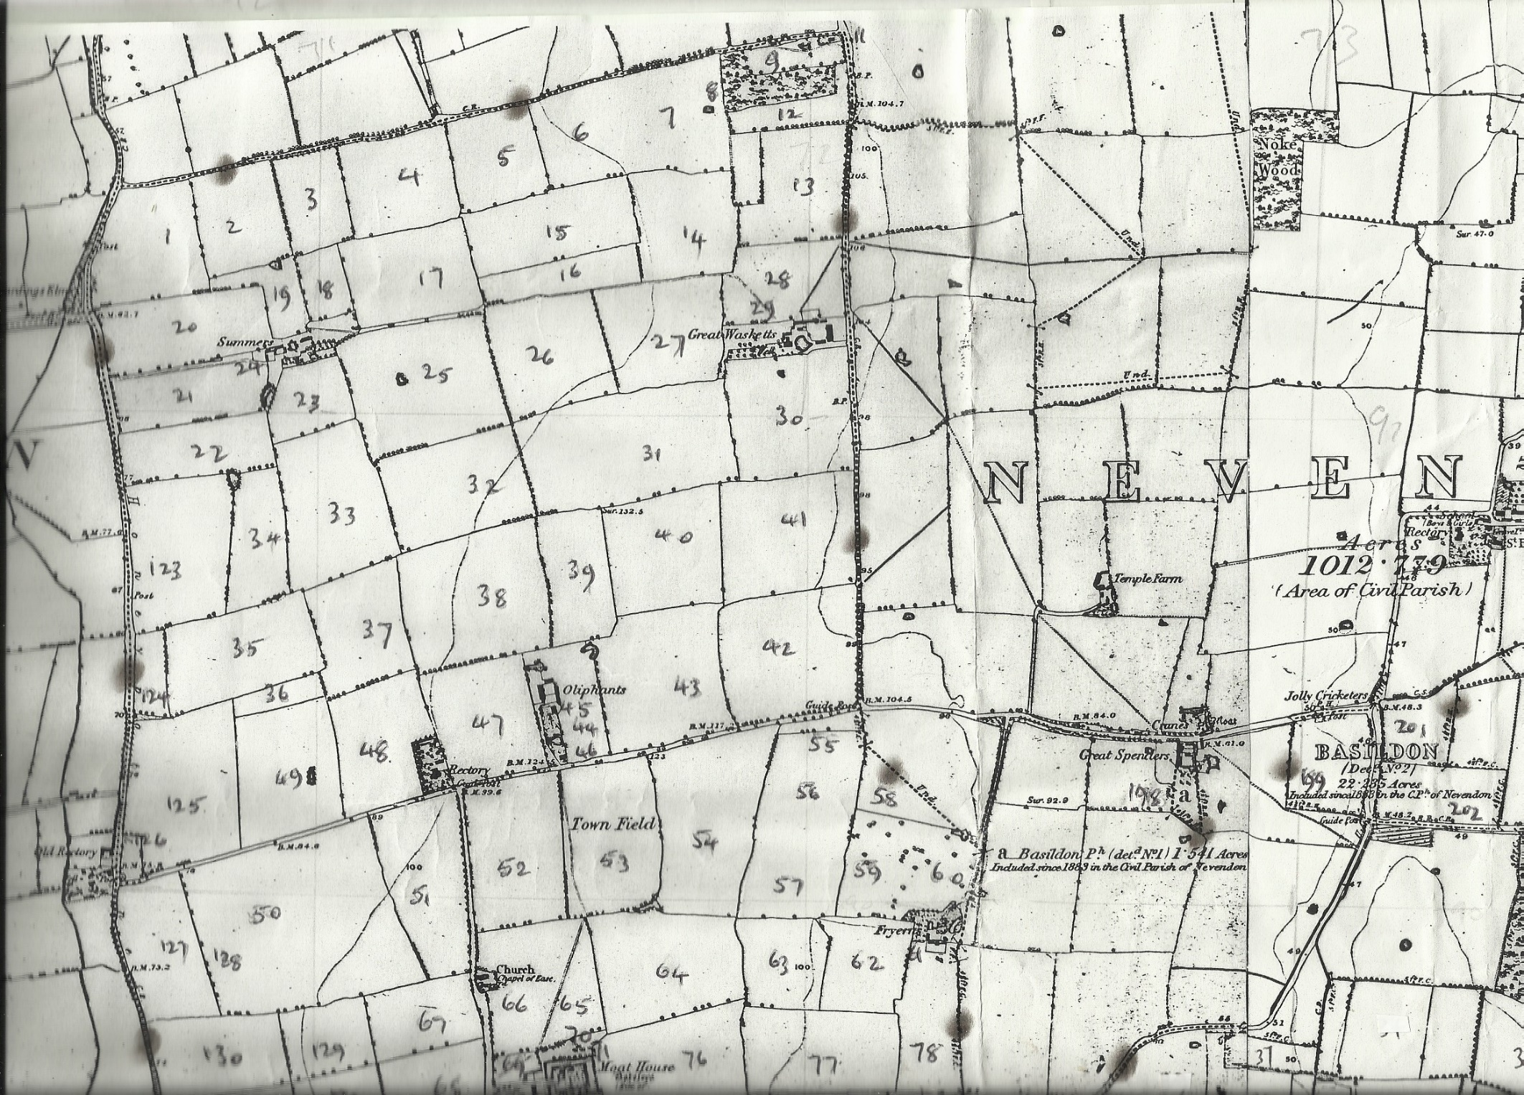
Map 1
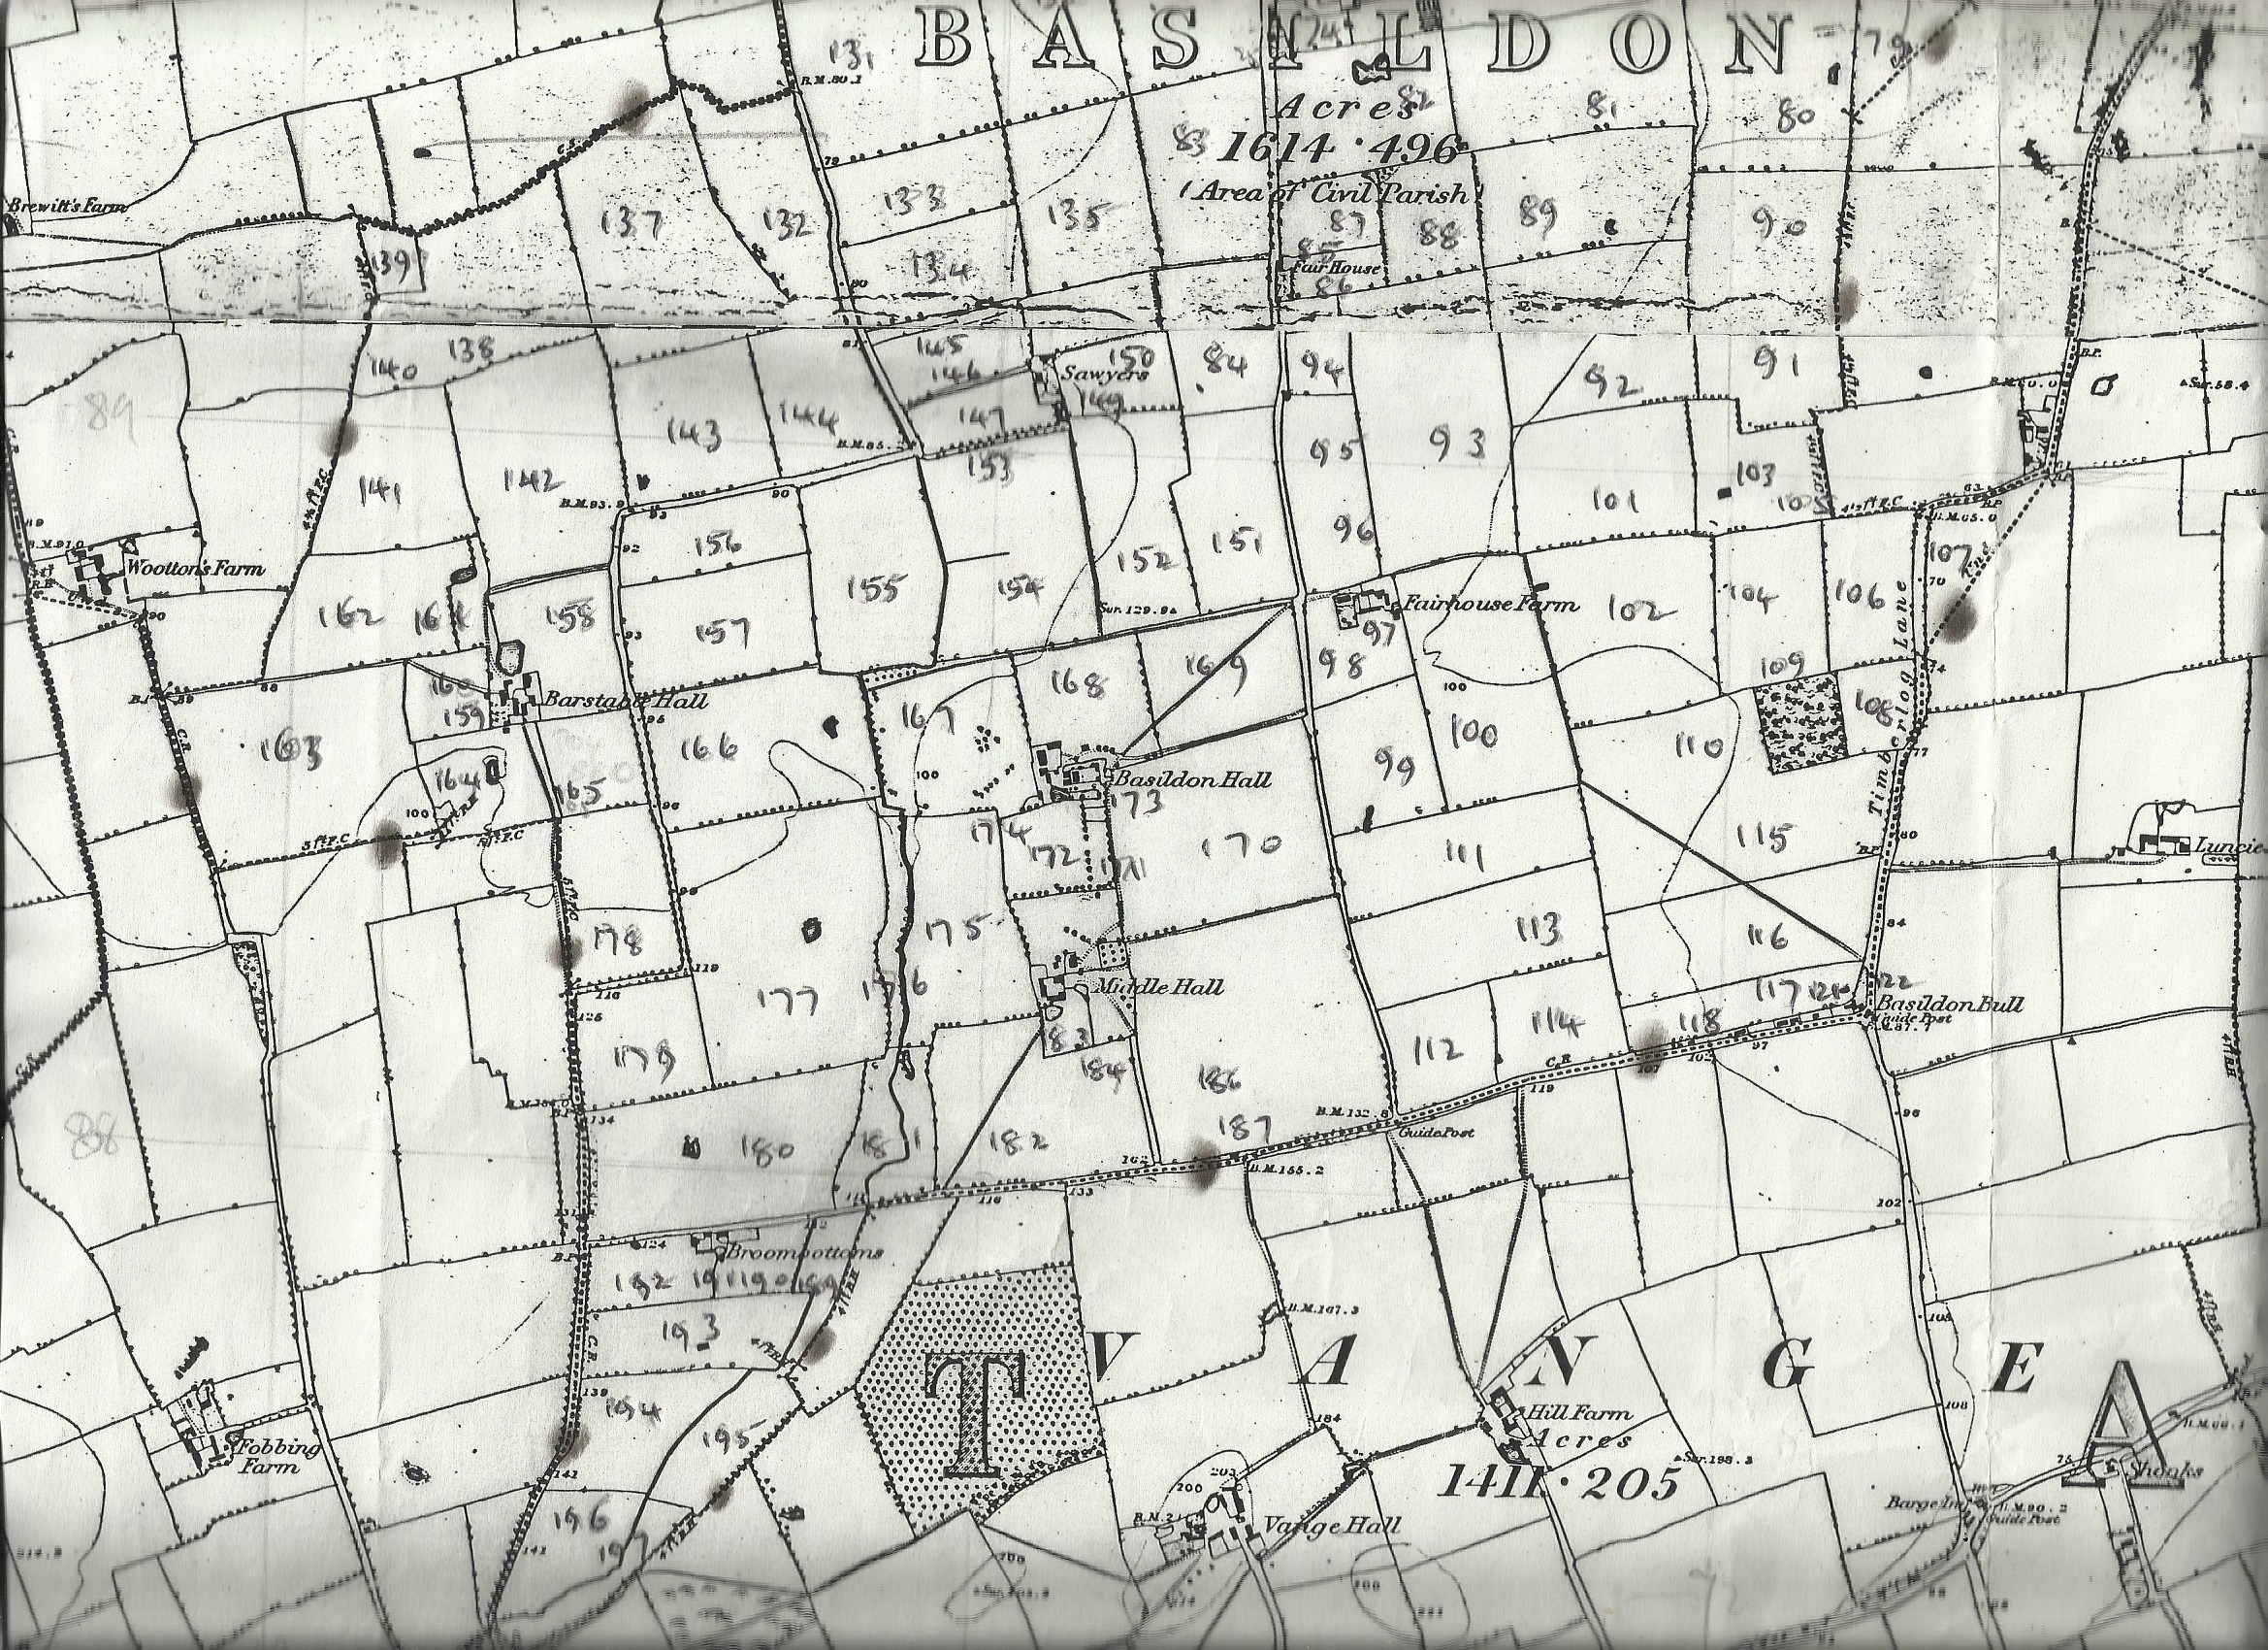
Map 2

