THE PLACE-NAMES OF

BERDEN

Recorder: James Kemble

Essex Place-names Project (Essex Society for Archaeology & History), 2016 (e-book).

www.essex.ac.uk/history/esah/essexplacenames

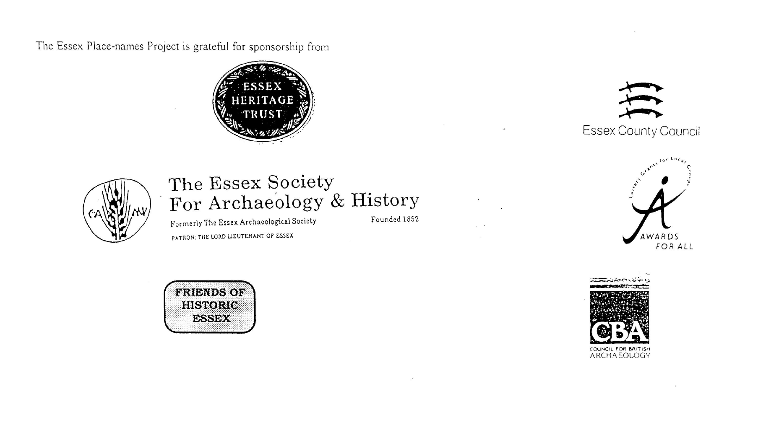

ESSEX PLACE-NAMES PROJECT.

The Essex Place-names Project is a County-wide survey to record place- and field-names from historical documents such as Tithe maps and apportionments, estate maps, sale
and auction catalogues, conveyances, terriers, deeds, rolls, inquisitions and surveys.

The second element of the Project is to investigate on-the-ground visible remains which correspond to the Place-names for actual or potential archaeological, agricultural and industrial sites, and to record natural (topographical) and man-made features which may relate to the Place-name. This involves field-survey in rural and outside investigation in built-up areas.

It is anticipated that the Project will lead to identification of archaeological sites and lost historic buildings; it will enable analysis of indicators of early settlement, land holding, agricultural and industrial practices of the County. It will refine the more precise meaning of descriptive words and elements used by earlier settlers as they gave names appropriate to the topography of the landscape of their time.

For convenience the surveys are based on the parish, recognising that present civil parish boundaries are not necessarily identical to former ecclesiastical boundaries. Local Recorders are supplied with templates of Record Forms to ensure consistency of recording across the County, and forward completed forms to a Central Coordinator for transfer to a county computer database which is available to researchers on the internet at www.essex.ac.uk/history/esah/essexplacenames, and updated periodically.

This publication presents part of the information recorded from the Tithe or Estate Award and Map, and from other documents for this parish. The full record is contained on the master database at Essex County Council (Historic Environment Section) and on the (above) website. Parish books are available to be downloaded from the website link ‘Books’ on the Home page. Please notify errors to the Project Coordinator at the Essex Record Office.

THE TITHE MAP AND APPORTIONMENT.

Since medieval times a tenth of the produce of land and stock had been paid by landholders to the church. At the Dissolution of the Monasteries, the property of many religious houses,
including the right to collect tithes, passed into lay hands. The Tithe Commutation Act which received Royal assent on 13th August 1836 abolished a rent payable in kind and
substituted rent-charges apportioned on each plot or parcel. The tithe-rent payable was assessed on the average value of wheat, barley and oats and was to fluctuate with price movements.

The commutation could be by voluntary agreement between the local owners and payers or, if agreement failed, could be compulsorily imposed by commissioners. A Valuer was to be appointed to apportion the rent of each parcel of land and tenants could deduct that rent-charge from their rent paid to the landlord. The task fell to the Tithe Commissioners to produce a map and an Apportionment (Award). A large-scale survey was produced for over 70% of England and Wales in the following 9 years, and about another 8% up to 1855. Most of the parishes in Essex were surveyed. The map scales vary. The Award records ownership, tenancy and land-use, field by field and parcel by parcel (often quoting the field name) with the ground area and rent-charge.

Land that was tithe-free tends to be less accurately mapped and contains few if any of the details recorded for those parcels subject to tithe. Rights of way and roads also tend to be neglected. Boundaries of the tithe areas are shown as are some natural features such as streams, ponds, gardens, greens and commons. Buildings are often shown coloured red if dwellingsor grey if not. Because the Award may have been agreed only some time after the map was finished, discrepancies occur between the two. Enclosure Awards, when extant, usually date to the 18th and early 19th centuries. J..Kemble.
Reproduced by permission
of Essex County Council.

Berden parish in the County of Essex

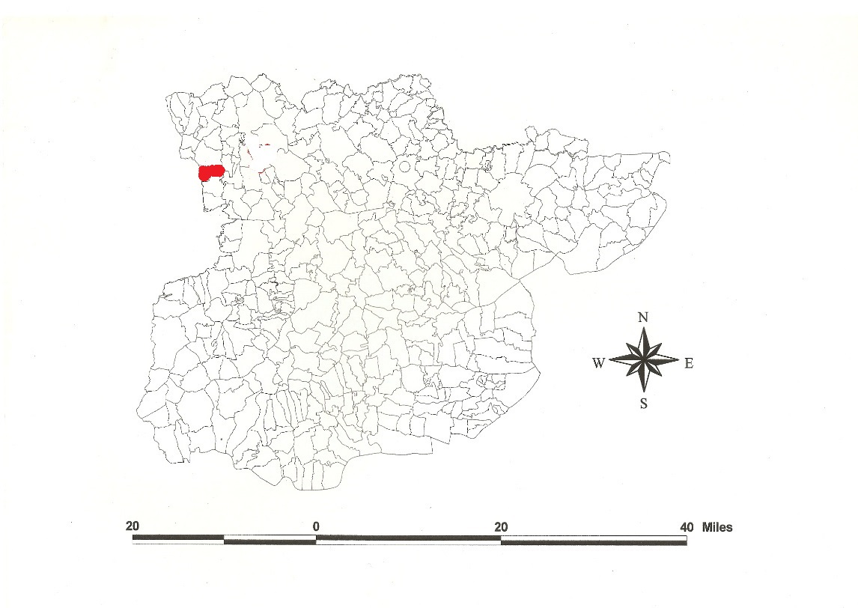
Reproduced by permission of
Essex County Council.

The Parish of Berden (in Clavering Half-Hundred) .

The Tithe Award of Berden (Essex Record Office D/CT 31a), dated 1838, shows a rent-charge of £360 payable to the Governors of Christs Hospital Bridewell. The whole parish measured 1730 acres of which 1510 acres were subject to tithes. 1223 acres were arable, 166a meadow and pasture, 32a orchards and gardens, 89a woods, and Priory Farm, formerly of Walden Abbey, tithe free, was 130 acres. The Tithe Commissioners were William Blamire and JW Buller, the Apportioner J Martin Nockolds of Stansted.

The Tithe Map (ERO: D/CT 31b), dated 1839, was surveyed by Nockolds and Son at a scale of 13.3” to a mile and measures 26”x38”. It was countersigned by Roger Kynaston, Assistant Tithe Commissioner.

In Domesday Book, 1086, Alfred held Berdane for 2 hides from Earl Swein which Godman, a freeman of Robert [son of Wymarc, father of Swein], had held before 1066.
In 1087 William confirmed Berden to Westminster Abbey; this is Old English bær denu, ‘woodland-pasture valley for swine’ (Hart, 1971; Kemble, 2007, 2008)

The Hall was held soon after the Conquest by the de Rochfords. John de Rochford held 3½ knights’ fees of the Honour of Rayleigh from Henry de Essex t.Henry II. Edward III in 1340 granted Rochford (and presumably Berden) to William de Bohun who gave it to the Abbey of Walden in 1343. In 1528 Henry VIII granted it to Sir Thomas Audley. By purchase it came to Thomas Sutton in 1597. Thomas Ramsey alienated to the Mayor & Citizens of London & Christs Hospital Bridewell.

The church dedicated to St Nicholas has a Norman nave and a C15 tower. Berden Hall, brick, is of two stories with gables and wings, timber-framed, probably C16. ‘The Priory’ was built in C16 on the site of the C12 hospice. The Augustinian house was founded in 1214, a patron the abbot of Walden. Well House with its granary are C17. A moated mound, ‘The Crump’ (Old English crumb ‘crooked, bent’), in Blakings Lane (TL470300), 10 feet high, lies in the garden of two thatched cottages 500 yards southeast of a ploughed-out ringwork (TL466293) (Pevsner, 2007). The Estate Map (ERO: T/M 222/1) of 1783 shows that lands in Waxted Field, High Field, Noke Field, Nopnall Field, Slamsted Field and Sowden Hills were being farmed in strips.

The Hundred name in Domesday Book is Clauelinga which is translated ‘place where clover grows’ (Reaney, 1935). Swein may have been responsible for taking Clavering Half-hundred out of the large Hundred of Uttlesford which was formerly divided in to East and West; part may have been in Hertfordshire. Christy (1926) suggests the moot was at Berden.

Place- and field names from the Map (ERO: T/M 215/1) dated c.1600, the Estate Map (ERO: T/M 222/1) dated 1783, from the Enclosure Map (Q/RDC 29b) dated 1841, and from other documents are shown against the Tithe Award names.

References:
Christie, M., 1926. Essex Hundred Moots. Trans Essex Archaeological Soc., n.s., xviii (3), 182.
Hart, C., 1971. Early Charters of Essex. Leicester.
Kemble, J., 2007. Essex Place-names, Places, Streets & People. Historical Publications, London, p 53, 54.
Kemble, J., 2008. Saxon Estates of Westminster Abbey. Essex Archaeology & History, 39, 152.
Morant, P., 1763. History & Antiquities of the County of Essex,.
Morris, J., 1983. Domesday Book – Essex. Phillimore. ii, 615.
Pevsner, N., Bettley, J., 2007. Buildings of England – Essex. Yale.
Reaney, P., 1935. Place-names of Essex. Cambridge.

The Tithe Award Place-names Berden - by parcel no.
www.essex.ac.uk/history/esah/essexplacenames

Place name | alias | Fld No | Grd | x | y | Acr | Rd | Pch | Land Use | Owner | Occupier | Farm | Other information
Great Stockings (pt) |  | 1 | TL | 455 | 306 | 10 | 0 | 3 | arable | Christs Hospital | Seabrook, Thomas
Four acres Cranhams | Further Cranham, 1783,T/M 222/1 | 2 | TL | 458 | 305 | 5 | 1 | 22 | arable | Christs Hospital | Seabrook, Thomas
Fifteen acre Pelhams |  | 3 | TL | 460 | 305 | 7 | 0 | 16 | arable | Christs Hospital | Seabrook, Thomas
Seventeen acre Cranham | Hither Cranham, 1783, T/M 222/1 | 4 | TL | 462 | 304 | 7 | 5 | 19 | arable | Christs Hospital | Seabrook, Thomas
Parsonage Wood (pt) |  | 5 | TL | 465 | 304 | 0 | 1 | 22 | grass | Christs Hospital | Seabrook, Thomas
Priory Wood | Hornbeam Grove, 1783,T/M 222/1 | 6 | TL | 463 | 303 | 16 | 5 | 17 | grass | Christs Hospital | Seabrook, Thomas
Great Grass Croft | Grass croft, 1783,T/M 222/1 | 7 | TL | 466 | 302 | 9 | 3 | 33 | grass | Christs Hospital | Seabrook, Thomas
Orchard |  | 8 | TL | 464 | 303 | 0 | 3 | 22 | Grass | Christs Hospital | Seabrook, Thomas
Priory Farm Homestead | The Priory, 1875,OS | 9 | TL | 463 | 303 | 2 | 1 | 23 |  | Christs Hospital | Seabrook, Thomas
Dove house close |  | 10 | TL | 461 | 302 | 2 | 1 | 38 | Grass | Christs Hospital | Seabrook, Thomas
Masons |  | 11 | TL | 461 | 303 | 7 | 3 | 16 | Arable | Beard, John, jnr | Beard, John, jnr
Bottom Place |  | 12 | TL | 461 | 304 | 0 | 3 | 35 | Grass | Beard, Susannah | Beard, Susannah
Little Masons |  | 13 | TL | 459 | 304 | 2 | 0 | 8 | Arable | Beard, Susannah | Beard, Susannah
Barn close |  | 14 | TL | 458 | 303 | 3 | 1 | 17 | arble,grs | Beard, Susannah | Beard, Susannah
Orchard |  | 15 | TL | 458 | 303 | 1 | 0 | 22 | Grass | Beard, Susannah | Beard, Susannah
Three acres |  | 16 | TL | 461 | 304 | 3 | 1 | 33 | arable | Beard, Susannah | Beard, Susannah
Cranham pasture |  | 17 | TL | 460 | 304 | 1 | 0 | 3 | grass | Beard, Susannah | Beard, Susannah
Orchard |  | 18 | TL | 459 | 304 | 0 | 2 | 22 | grass | Beard, Susannah | Beard, Susannah
Farm Homestead. Dews Green | Douse Green, 1777,C | 19 | TL | 458 | 303 | 0 | 2 | 33 |  | Beard, Susannah | Beard, Susannah
Brooks moat |  | 20 | TL | 458 | 304 | 1 | 1 | 38 | grass | Beard, Susannah | Beard, Susannah
Allotment in Stockings Common |  | 21 | TL | 457 | 304 | 1 | 1 | 2 | arable | Beard, Susannah | Beard, Susannah
Allotment in Stockings Common |  | 22 | TL | 457 | 304 | 0 | 3 | 17 | arable | Beard, John, jnr | Beard, Susannah
Stockings | Stokings, 1600, T/M 215/1 | 23 | TL | 457 | 305 | 1 | 3 | 35 | arable | Beard, John, jnr | Beard, John, jnr
Stocking mead | Little Stockings, 1783,T/M 222/1 | 24 | TL | 456 | 305 | 8 | 3 | 29 | grass | Christs Hospital | Seabrook, Thomas
Roadway to Dills |  | 25 | TL | 456 | 305 | 0 | 0 | 55 |  | Christs Hospital | Seabrook, Thomas
Little Stockings |  | 26 | TL | 456 | 305 | 6 | 2 | 7 | arable | Beard, Susannah | Beard, Susannah
Ploughed field |  | 28 | TL | 456 | 304 | 2 | 3 | 4 | arable | Barlee's Charity | Chipperfield, Elizabeth
Orchard | Harrolds, 1875,OS | 32 | TL | 456 | 303 | 2 | 0 | 13 | grass | Barlee's Charity | Chipperfield, Elizabeth
Great Wingsby |  | 33 | TL | 457 | 302 | 6 | 2 | 31 | arable | Sworder, Thomas | Chipperfield,Thomas
Allotment in Waxted Common |  | 35 | TL | 458 | 300 | 8 | 2 | 33 | arable | Sworder, Thomas | Chipperfield,Thomas
Allotment in Waxted Common | Waxted feild, 1600,T/M 215/1 | 36 | TL | 458 | 297 | 14 | 2 | 5 | arable | Christs Hospital | Seabrook, Thomas
Allotment in Waxted Common | Waxted field, 1783, T/M 222/1 | 37 | TL | 458 | 296 | 19 | 1 | 13 | arable | Sworder, Thomas | Chipperfield,Thomas
Allotment in Waxted Common |  | 38 | TL | 457 | 296 | 2 | 3 | 25 | arable | Trigg, Robert | Trigg, Robert
Pelham Croft |  | 39 | TL | 458 | 295 | 2 | 2 | 20 | arable | Trigg, Robert | Trigg, Robert
Pelham Croft |  | 40 | TL | 460 | 296 | 1 | 1 | 19 | arable | Trigg, Robert | Trigg, Robert
Pelham Croft Common Allotment |  | 41 | TL | 460 | 296 | 1 | 0 | 22 | arable | Trigg, Robert | Trigg, Robert
Haxted mead |  | 42 | TL | 459 | 296 | 2 | 3 | 33 | grass | Sworder, Thomas | Chipperfield,Thomas
Great Arnolds | Arnoldleys, 1471,IpmR | 43 | TL | 461 | 296 | 3 | 1 | 12 | arable | Sworder, Thomas | Chipperfield,Thomas
Arnolds mead |  | 44 | TL | 461 | 297 | 4 | 2 | 17 | grass | Sworder, Thomas | Chipperfield,Thomas
Arnolds Wood | Arnold's Spring, 1875,OS | 45 | TL | 461 | 298 | 3 | 0 | 38 | wood | Sworder, Thomas | Chipperfield,Thomas |  | John Arnold of Clavering, 1373,FeetFine
Little Arnolds |  | 46 | TL | 462 | 299 | 1 | 1 | 20 | arable | Sworder, Thomas | Chipperfield,Thomas
Lucern field | [at Waxtead Knoll, 1875,OS] | 47 | TL | 461 | 300 | 0 | 3 | 34 | arable | Christs Hospital | Seabrook, Thomas
Coles field | The Beard, 1783,T/M 222/1 | 49 | TL | 462 | 300 | 3 | 3 | 5 | arable | Beard, Susannah | Beard, Susannah
Rose mead | Rose mead, 1783,T/M 222/1 | 50 | TL | 463 | 299 | 3 | 1 | 37 | grass | Christs Hospital | Seabrook, Thomas
Redhead |  | 51 | TL | 464 | 300 | 1 | 1 | 33 | arable | Orger, Samuel | King, John
The Orchard |  | 52 | TL | 464 | 299 | 1 | 3 | 11 | grass | Orger, Samuel | King, John
Long field | [at Rose Lane, 1875,OS] | 53 | TL | 463 | 298 | 1 | 3 | 26 | arable | Orger, Samuel | King, John
Carters |  | 54 | TL | 463 | 297 | 9 | 1 | 8 | arable | King, John | King, John
Gores |  | 55 | TL | 465 | 297 | 2 | 3 | 34 | arable | Beard, John, jnr | Beard, John, jnr
Pightle |  | 58 | TL | 465 | 297 | 0 | 1 | 18 | grass | Beard, John, jnr | Beard, John, jnr
House, barn, yd | Redhill, 1875,OS | 59 | TL | 465 | 298 | 0 | 1 | 6 |  | King, John | King, John
The croft |  | 60 | TL | 466 | 298 | 0 | 2 | 24 | grass | King, John | King, John
Orchard |  | 61 | TL | 466 | 298 | 0 | 1 | 11 | grass | King, John | King, John
Grass Parkers |  | 64 | TL | 467 | 298 | 3 | 2 | 18 | grass | Gee, William | Chipperfield, George
Ploughed Parkers |  | 65 | TL | 468 | 298 | 6 | 2 | 11 | arable | Sworder, Thomas | Chipperfield,Thomas
Dawley Common allotmt, Dawley Field |  | 66 | TL | 466 | 300 | 3 | 0 | 22 | arable | Sworder, Thomas | Chipperfield,Thomas
Dawley pasture |  | 67 | TL | 468 | 300 | 0 | 1 | 18 | grass | Beard, John, jnr | Beard, John, jnr
Dawley |  | 68 | TL | 468 | 300 | 0 | 3 | 5 | grass | King, John | King, John
Hawkins |  | 69 | TL | 467 | 301 | 5 | 0 | 10 | arable | Christs Hospital | Seabrook, Thomas
Great Nailings | Great Naylings, 1841,Q/RDC 29b | 70 | TL | 468 | 301 | 5 | 2 | 38 | arable | Seabrook Thomas | Seabrook, Thomas
Little Nailings |  | 71 | TL | 468 | 303 | 1 | 2 | 16 | arable | Seabrook Thomas | Seabrook, Thomas
Little Gass Croft |  | 72 | TL | 467 | 303 | 1 | 0 | 28 | grass | Christs Hospital | Seabrook, Thomas
Killey Corner Common Allotmts |  | 73 | TL | 466 | 304 | 5 | 3 | 8 | arable | Christs Hospital | Seabrook, Thomas
Killey | Kills Corner, 1738,T/M 222/1 | 74 | TL | 468 | 304 | 7 | 3 | 25 | arable | Christs Hospital | Seabrook, Thomas
Allotment in Hill Common |  | 75 | TL | 469 | 303 | 2 | 3 | 0 | arable | Christs Hospital | Seabrook, Thomas
Allotment in Hill Common |  | 76 | TL | 469 | 302 | 3 | 1 | 32 | Arable | Rayment, William | Rayment, William
New Croft Common Allotmt |  | 77 | TL | 469 | 301 | 2 | 2 | 19 | arble,grs | Rayment, William | Rayment, William
New Croft pasture |  | 78 | TL | 469 | 300 | 3 | 0 | 22 | grass | Rayment, William | Rayment, William
Tare Croft | [at Bonneting Lane, 1875,OS] | 79 | TL | 469 | 300 | 0 | 3 | 16 | grass | Sworder, Thomas | Chipperfield,Thomas
Hoppit |  | 80 | TL | 469 | 299 | 0 | 3 | 27 | arable | Beard, John, jnr | Beard, John, snr
Orchard |  | 81 | TL | 468 | 299 | 1 | 1 | 22 | grass | Sworder, Thomas | Chipperfield,Thomas
Homestead | Martins, 1875,OS | 82 | TL | 468 | 297 | 0 | 2 | 39 |  | Sworder, Thomas | Chipperfield,Thomas
Homestead |  | 83 | TL | 468 | 297 | 0 | 1 | 11 |  | Beard, John, jnr | Beard, John, snr
Orchard |  | 84 | TL | 468 | 297 | 1 | 0 | 34 | grass | Beard, John, jnr | Beard, John, snr
Orchard |  | 85 | TL | 469 | 298 | 0 | 1 | 20 | grass | Rayment, William | Rayment, William
Garden |  | 86 | TL | 469 | 298 | 0 | 1 | 4 |  | Rayment, William | Rayment, William
Farm Homestead |  | 87 | TL | 469 | 297 | 0 | 2 | 30 |  | Rayment, William | Rayment, William
House, barn, yd, gdn |  | 88 | TL | 469 | 297 | 0 | 1 | 2 |  | Seabrook Thomas | Sibley, Daniel
Potatoe ground |  | 89 | TL | 469 | 297 | 0 | 2 | 38 | arable | Seabrook Thomas | Sibley, Daniel
No name |  | 90 | TL | 470 | 297 | 1 | 1 | 32 | arable | Seabrook Thomas | Chipperfield,Thomas
Pightle |  | 91 | TL | 470 | 297 | 0 | 1 | 34 | grass | Seabrook Thomas | Sibley, Daniel
Twenty acres |  | 92 | TL | 471 | 300 | 10 | 3 | 7 | arable | Calvert, Nicholson, esq | Hodges, Isaac
Orchard field |  | 93 | TL | 470 | 299 | 1 | 2 | 37 | grass | Rayment, William | Rayment, William
Leys Common Allotment |  | 94 | TL | 470 | 300 | 1 | 3 | 18 | arable | Rayment, William | Rayment, William
Bottom Leys Allotment |  | 95 | TL | 470 | 301 | 1 | 2 | 32 | grass | Rayment, William | Rayment, William
Twenty acres |  | 96 | TL | 473 | 301 | 10 | 1 | 7 | arble,grs | Christs Hospital | Seabrook, Thomas
The Harp |  | 97 | TL | 474 | 299 | 1 | 0 | 12 | grass | Christs Hospital | Seabrook, Thomas
Cross Gardens, 6 acres, Tare Croft |  | 99 | TL | 475 | 301 | 8 | 3 | 7 | arable | Christs Hospital | Seabrook, Thomas
Allotment in Mill field |  | 100 | TL | 476 | 301 | 6 | 1 | 12 | arable | Christs Hospital | Seabrook, Thomas
Allotment in Mill field |  | 101 | TL | 477 | 300 | 6 | 2 | 15 | arable | Christs Hospital | Seabrook, Thomas
Allotment, Mill House | Berden windmill (corn), 1875,OS | 102 | TL | 478 | 301 | 2 | 2 | 35 | arable | Perry, Joseph | Harvey, John
Allotment, Mill House |  | 103 | TL | 478 | 301 | 0 | 3 | 16 | arable | Perry, Joseph | Harvey, John
Nine acres |  | 104 | TL | 480 | 300 | 8 | 1 | 38 | arable | Christs Hospital | Seabrook, Thomas
Bean acre | Bean Acre, 1841, Q/RDC 29b | 106 | TL | 481 | 300 | 2 | 1 | 25 | arable | Seabrook Thomas | Seabrook Thomas
Bean acre Common Allotmts |  | 107 | TL | 481 | 299 | 3 | 1 | 32 | arable | Seabrook Thomas | Seabrook Thomas
Hand post field | Hand Post field, 1841, Q/RDC 29b | 108 | TL | 481 | 299 | 2 | 1 | 4 | arable | Sworder, Thomas | Chipperfield,Thomas
Long mead |  | 109 | TL | 482 | 298 | 2 | 1 | 34 | grass | Sworder, Thomas | Chipperfield,Thomas
Great mead |  | 110 | TL | 483 | 300 | 7 | 2 | 10 | grass | Calvert, Nicholson, esq | Hodges, Isaac
Allotment in High Field | [at Drover Lane, 1875,OS] | 111 | TL | 484 | 300 | 11 | 1 | 30 | arable | Sworder, Thomas | Chipperfield,Thomas
Allotment in High Field | High field, 1783,T/M 222/1 | 112 | TL | 486 | 302 | 51 | 1 | 28 | arable | Christs Hospital | Seabrook, Thomas
Allotment in High Field | Poor's Land, 1875,OS | 113 | TL | 491 | 305 | 11 | 2 | 4 | arable | Berden Poor | Rayment, William
Allotment in High Field |  | 114 | TL | 493 | 305 | 3 | 3 | 19 | arable | Calvert, Nicholson, esq | Hodges, Isaac
High Field Croft | High Feilde, 1600,T/M 215/1 | 115 | TL | 493 | 303 | 17 | 2 | 30 | arable | Calvert, Nicholson, esq | Hodges, Isaac
Allotment in High Field |  | 116 | TL | 494 | 300 | 12 | 1 | 22 | arable | Calvert, Nicholson, esq | Hodges, Isaac
Allotment in High Field | High field, 1783,T/M 222/1 | 117 | TL | 489 | 298 | 69 | 3 | 15 | arable | Sworder, Thomas | Chipperfield, Elizabeth
Lower Middle mead |  | 118 | TL | 484 | 296 | 2 | 3 | 30 | grass | Calvert, Nicholson, esq | Hodges, Isaac
Upper Middle mead |  | 119 | TL | 484 | 295 | 3 | 0 | 16 | grass | Calvert, Nicholson, esq | Hodges, Isaac
Hop Ground |  | 120 | TL | 483 | 296 | 7 | 2 | 35 | arable | Calvert, Nicholson, esq | Hodges, Isaac
Mill field croft |  | 121 | TL | 480 | 296 | 4 | 3 | 30 | arable | Seabrook, Thomas | Seabrook, Thomas
Allotment in Mill field | [at Cole's Green, 1875,OS] | 123 | TL | 476 | 296 | 4 | 2 | 30 | arable | Seabrook, Thomas | Chipperfield, Elizabeth
Allotmt in Mill Field, Old Enclosure | Mill, 1600, T/M 215/1 | 124 | TL | 476 | 297 | 19 | 0 | 39 | arble,grs | Seabrook, Thomas | Seabrook, Thomas
Allotmt in Mill Field, Old Enclosure |  | 125 | TL | 475 | 297 | 9 | 0 | 6 | arable | Kirk, Samuel & wife | Rayment, William
Millfield Common |  | 126 | TL | 476 | 294 | 4 | 2 | 36 | arable | Kirk, Samuel & wife | Rayment, William
Chapmans Croft |  | 127 | TL | 476 | 294 | 1 | 1 | 26 | grass | Kirk, Samuel & wife | Rayment, William
Homestead | Little London, 1777,C, 1875,OS | 131 | TL | 475 | 294 | 0 | 1 | 31 |  | Kirk, Samuel & wife | Rayment, William
Orchard |  | 133 | TL | 475 | 295 | 1 | 3 | 15 | grass | Kirk, Samuel & wife | Rayment, William
Goose croft |  | 134 | TL | 473 | 295 | 3 | 1 | 33 | arable | Kirk, Samuel & wife | Rayment, William
Goose croft |  | 135 | TL | 472 | 295 | 1 | 3 | 3 | grass | Kirk, Samuel & wife | Rayment, William
Hoppit | [at Easingwell Lane, 1783,T/M 222/1] | 137 | TL | 474 | 294 | 0 | 2 | 15 | grass | Sworder, Thomas | Chipperfield, Elizabeth
Broad croft |  | 138 | TL | 474 | 295 | 6 | 0 | 16 | arable | Sworder, Thomas | Chipperfield, Elizabeth
Broad croft |  | 139 | TL | 470 | 293 | 49 | 0 | 17 | arable | Calvert, Nicholson, esq | Hodges, Isaac
Broad croft |  | 140 | TL | 472 | 297 | 40 | 3 | 38 | arable | Calvert, Nicholson, esq | Hodges, Isaac
Broad croft |  | 141 | TL | 471 | 296 | 12 | 0 | 35 | arable | Calvert, Nicholson, esq | Hodges, Isaac
Close |  | 142 | TL | 471 | 297 | 0 | 2 | 39 | grass | Sworder, Thomas | Sibley, Daniel
Blacksmiths shop, gdn |  | 144 | TL | 470 | 297 | 0 | 1 | 14 |  | Sworder, Thomas | Sibley, Daniel
Vicarage field |  | 151 | TL | 418 | 296 | 3 | 3 | 22 | arable | Christs Hospital | Seabrook, Thomas
Vicarage field | Vicarage Close, 1841, Q/RDC 29b | 152 | TL | 468 | 297 | 1 | 1 | 39 | arable | Beard, Susannah | Beard, John, jnr
House, gdn |  | 153 | TL | 468 | 297 | 0 | 1 | 1 |  | Beard, John, jnr | Beard, John, jnr
Orchard |  | 154 | TL | 468 | 297 | 1 | 0 | 35 | grass | Beard, John, jnr | Beard, John, jnr
Turners |  | 155 | TL | 467 | 296 | 3 | 1 | 30 | grass | Christs Hospital | Seabrook, Thomas
Stack Yard |  | 157 | TL | 468 | 296 | 0 | 3 | 31 |  | Calvert, Nicholson, esq | Hodges, Isaac
No name |  | 158 | TL | 468 | 296 | 0 | 1 | 38 | grass | Calvert, Nicholson, esq | Hodges, Isaac
Orchard |  | 159 | TL | 467 | 295 | 1 | 1 | 32 | grass | Calvert, Nicholson, esq | Hodges, Isaac
Berden Hall Farm | Berdane, 1086,DB; Berden, 1087,Telligraphus | 160 | TL | 467 | 295 | 2 | 0 | 27 |  | Calvert, Nicholson, esq | Hodges, Isaac
Berden Hall Farm | Bereden, 1267,Ch; Byerden, 1387,Wldn | 161 | TL | 467 | 295 | 1 | 2 | 34 |  | Calvert, Nicholson, esq | Hodges, Isaac
Cottage, gdn |  | 162 | TL | 467 | 294 | 0 | 0 | 9 |  | Calvert, Nicholson, esq | Hodges, Isaac
Coal Ground |  | 163 | TL | 467 | 294 | 1 | 1 | 5 | grass | Calvert, Nicholson, esq | Hodges, Isaac
Chaseway |  | 164 | TL | 467 | 294 | 0 | 2 | 33 |  | Calvert, Nicholson, esq | Hodges, Isaac
Pale Ground |  | 165 | TL | 467 | 294 | 3 | 0 | 28 | grass | Calvert, Nicholson, esq | Hodges, Isaac
Kitchen Ley | Blacke feild, 1600, T/M 215/1 | 166 | TL | 466 | 295 | 6 | 2 | 37 | grass | Calvert, Nicholson, esq | Hodges, Isaac
Great Nutsfield |  | 167 | TL | 463 | 295 | 57 | 2 | 39 | arable | Calvert, Nicholson, esq | Hodges, Isaac
Little Nutsfield |  | 168 | TL | 460 | 294 | 32 | 0 | 17 | arable | Calvert, Nicholson, esq | Hodges, Isaac
Reedings Ley |  | 169 | TL | 460 | 292 | 19 | 2 | 2 | arable | Calvert, Nicholson, esq | Hodges, Isaac
The Fen |  | 170 | TL | 458 | 290 | 0 | 1 | 35 | arable | Calvert, Nicholson, esq | Hodges, Isaac
Corn Reedings |  | 171 | TL | 462 | 291 | 20 | 1 | 32 | arable | Calvert, Nicholson, esq | Hodges, Isaac
Ethers Wood |  | 172 | TL | 464 | 292 | 6 | 0 | 31 | wood | Calvert, Nicholson, esq | Hodges, Isaac
New Mead |  | 173 | TL | 464 | 290 | 9 | 2 | 4 | grass | Calvert, Nicholson, esq | Hodges, Isaac
Cumber Hills |  | 174 | TL | 466 | 292 | 16 | 2 | 27 | grass | Calvert, Nicholson, esq | Hodges, Isaac
Plantation |  | 175 | TL | 466 | 292 | 0 | 1 | 22 | plntn | Calvert, Nicholson, esq | Hodges, Isaac |  | Tumulus, 1875,OS
The Lawn |  | 176 | TL | 467 | 292 | 8 | 2 | 15 | grass | Calvert, Nicholson, esq | Hodges, Isaac
The Lawn |  | 177 | TL | 467 | 294 | 0 | 2 | 31 | grass | Calvert, Nicholson, esq | Hodges, Isaac
Great Lawn Croft |  | 178 | TL | 467 | 290 | 15 | 0 | 2 | Arable | Calvert, Nicholson, esq | Hodges, Isaac
Little Lawn Croft |  | 179 | TL | 468 | 290 | 3 | 0 | 0 | arble,wd | Calvert, Nicholson, esq | Hodges, Isaac
Garden |  | 180 | TL | 468 | 289 | 0 | 1 | 18 |  | Calvert, Nicholson, esq | Hodges, Isaac
Orchard |  | 181 | TL | 468 | 289 | 0 | 1 | 27 | Grass | Bush, John | Rand, George
Homestead | Stocks, 1875,OS | 182 | TL | 469 | 289 | 0 | 1 | 32 |  | Bush, John | Rand, George
The Mount |  | 183 | TL | 470 | 290 | 1 | 2 | 32 | Grass | Bush, John | Rand, George
Home field |  | 184 | TL | 469 | 289 | 3 | 3 | 9 | Arable | Bush, John | Rand, George
Eazing Wells |  | 185 | TL | 469 | 293 | 2 | 3 | 4 | Arable | Calvert, Nicholson, esq | Hodges, Isaac
Severals Homestead |  | 186 | TL | 472 | 292 | 22 | 2 | 2 | Arable | Calvert, Nicholson, esq | Hodges, Isaac
Ploughed Croft |  | 187 | TL | 474 | 293 | 5 | 3 | 28 | Arable | Sworder, Thomas | Chipperfield, Elizabeth
Rooks Farm |  | 188 | TL | 475 | 293 | 0 | 3 | 35 |  | Sworder, Thomas | Chipperfield, Elizabeth |  | John le Rook, 1327-32, SR
The Orchard |  | 189 | TL | 475 | 293 | 1 | 3 | 19 | grass | Sworder, Thomas | Chipperfield, Elizabeth
Barn pasture & hoppit |  | 191 | TL | 476 | 294 | 4 | 0 | 25 | grass | Sworder, Thomas | Chipperfield, Elizabeth
Long pasture | [at Sawpit Lane, 1875,OS] | 194 | TL | 476 | 293 | 1 | 3 | 10 | grass | Kirk, Samuel & wife | Rayment, William
Cocks Croft |  | 195 | TL | 476 | 293 | 0 | 2 | 22 | arable | Hodges, Isaac | Hodges, Isaac
Pightle |  | 197 | TL | 476 | 293 | 0 | 0 | 32 | grass | Kirk, Samuel & wife | Rayment, William
Coles Green Croft |  | 199 | TL | 478 | 295 | 4 | 1 | 12 | arable | Sworder, Thomas | Chipperfield, Elizabeth |  | John Cole, 1273,Ipm
Allotmt in Nopnall Common |  | 200 | TL | 478 | 294 | 2 | 1 | 22 | arable | Sworder, Thomas | Chipperfield, Elizabeth
Allotmt in Nopnall Common |  | 201 | TL | 478 | 293 | 0 | 3 | 35 | arable | Trigg, Robert | Trigg, Robert
Allotmt in Nopnall Common |  | 202 | TL | 479 | 293 | 24 | 0 | 33 | arable | Kirk, Samuel & wife | Rayment, William
Sheep Croft |  | 203 | TL | 482 | 293 | 10 | 2 | 36 | arable | Kirk, Samuel & wife | Rayment, William
Level Ditch Common Allotmt | Level Ditch, 1783,T/M 222/1 | 204 | TL | 484 | 294 | 14 | 1 | 14 | arable | Calvert, Nicholson, esq | Hodges, Isaac
Hanchetts Croft | Woodside Cottage, 1875,OS | 205 | TL | 484 | 293 | 7 | 3 | 10 | arable | Christs Hospital | Haydon, Nathaniel | Brick House
Calverts Croft |  | 206 | TL | 484 | 293 | 1 | 1 | 33 | arable | Sworder, Thomas | Chipperfield, Elizabeth
Little Broome |  | 207 | TL | 485 | 293 | 0 | 3 | 35 | arable | Calvert, Nicholson, esq | Hodges, Isaac
Bullens Grove Ley |  | 208 | TL | 484 | 294 | 3 | 3 | 32 | arable | Calvert, Nicholson, esq | Hodges, Isaac
Garden |  | 209 | TL | 485 | 293 | 0 | 2 | 3 |  | Calvert, Nicholson, esq | Hodges, Isaac
Pot Ash Barn |  | 210 | TL | 486 | 293 | 0 | 2 | 8 |  | Calvert, Nicholson, esq | Hodges, Isaac
Pot Ash mead |  | 211 | TL | 486 | 294 | 6 | 1 | 28 | grass | Calvert, Nicholson, esq | Hodges, Isaac
Allotment in Noak Field | Nocke feilde, 1600,T/M 215/1 | 212 | TL | 487 | 295 | 11 | 2 | 31 | arable | Kirk, Samuel & wife | Rayment, William
Allotment in Peak Field |  | 213 | TL | 487 | 296 | 4 | 1 | 33 | arable | Calvert, Nicholson, esq | Hodges, Isaac
Peak Ley | Potash Farm, 1875,OS | 214 | TL | 487 | 294 | 8 | 0 | 7 | arable | Calvert, Nicholson, esq | Hodges, Isaac
Alan Croft |  | 215 | TL | 490 | 296 | 4 | 2 | 30 | arable | Calvert, Nicholson, esq | Hodges, Isaac
Allotmt in Noak field & Crofts Common | Noak field, 1783,T/M 222/1 | 216 | TL | 492 | 296 | 45 | 3 | 31 | arable | Calvert, Nicholson, esq | Hodges, Isaac
Lions croft |  | 217 | TL | 494 | 295 | 2 | 0 | 28 | arable | Calvert, Nicholson, esq | Hodges, Isaac
Southern Common, allotment | Sowden Hills, 1783,T/M 222/1 | 218 | TL | 492 | 294 | 59 | 3 | 17 | arable | Calvert, Nicholson, esq | Hodges, Isaac
Southern Croft |  | 219 | TL | 493 | 292 | 4 | 5 | 2 | arable | Calvert, Nicholson, esq | Hodges, Isaac
Collalders |  | 220 | TL | 492 | 288 | 6 | 2 | 26 | arable | Calvert, Nicholson, esq | Hodges, Isaac
Lamberts Mead |  | 221 | TL | 491 | 289 | 3 | 1 | 11 | grass | Gosling, Robert, esq | Mumford, Elizabeth
Dump meadow |  | 222 | TL | 489 | 291 | 3 | 3 | 9 | grass | Calvert, Nicholson, esq | Hodges, Isaac
Long Ley |  | 223 | TL | 489 | 292 | 7 | 1 | 17 | arable | Calvert, Nicholson, esq | Hodges, Isaac
Littley mead |  | 224 | TL | 488 | 293 | 3 | 1 | 2 | grass | Calvert, Nicholson, esq | Hodges, Isaac
Allotmt in Littley Common |  | 225 | TL | 487 | 292 | 10 | 1 | 24 | arable | Calvert, Nicholson, esq | Hodges, Isaac
Littley Dews |  | 226 | TL | 488 | 290 | 4 | 3 | 15 | arable | Calvert, Nicholson, esq | Hodges, Isaac
Little Brooms |  | 227 | TL | 487 | 290 | 2 | 0 | 8 | arable | Calvert, Nicholson, esq | Hodges, Isaac
Great Brooms |  | 228 | TL | 486 | 291 | 6 | 0 | 33 | arable | Calvert, Nicholson, esq | Hodges, Isaac
Littley Ley |  | 229 | TL | 486 | 292 | 7 | 2 | 34 | arable | Calvert, Nicholson, esq | Hodges, Isaac
Allotmt in Littley Common | Littley field, 1783,T/M 222/1 | 230 | TL | 485 | 293 | 2 | 1 | 18 | arable | Sworder, Thomas | Chipperfield, Elizabeth
Sand Croft Spring |  | 231 | TL | 486 | 293 | 1 | 2 | 15 | wood | Sworder, Thomas | Chipperfield, Elizabeth
Allotmt in Nopnall Common |  | 233 | TL | 484 | 293 | 14 | 3 | 5 | arable | Christs Hospital | Haydon, Nathaniel | BrickHouse
Rookery |  | 234 | TL | 484 | 290 | 12 | 3 | 14 | arable | Calvert, Nicholson, esq | Hodges, Isaac
Rookill | Rookell, 1841, Q/RDC 28b | 235 | TL | 481 | 291 | 9 | 0 | 10 | arable | Gosling, Robert, esq | Mumford, Elizabeth
Rookill Spring |  | 236 | TL | 480 | 291 | 0 | 1 | 37 | wood | Gosling, Robert, esq | Mumford, Elizabeth
Sibleys (pt) |  | 237 | TL | 478 | 290 | 5 | 0 | 17 | arable | Gosling, Robert, esq | Mumford, Elizabeth
Allotmt in Nopnall Common |  | 238 | TL | 478 | 291 | 8 | 2 | 15 | arable | Gosling, Robert, esq | Mumford, Elizabeth
Cooks Croft |  | 239 | TL | 477 | 292 | 4 | 3 | 21 | arable | Gosling, Robert, esq | Mumford, Elizabeth
Lamberts Ley |  | 240 | TL | 477 | 290 | 16 | 1 | 11 | arable | Gosling, Robert, esq | Mumford, Elizabeth
Allotmt in Slamsted Common | Slamsted, 1504,Will | 241 | TL | 476 | 291 | 2 | 2 | 6 | arable | Gosling, Robert, esq | Mumford, Elizabeth
Allotmt in Slamsted Common |  | 242 | TL | 475 | 291 | 13 | 2 | 26 | arable | Sworder, Thomas | Chipperfield, Elizabeth
Allotmt in Slamsted Common late part of Brick House Farm taken in exchange for land in Manewdon |  | 242a | TL | 475 | 291 | 1 | 0 | 33 | arable | Sworder, Thomas | Chipperfield, Elizabeth
Allotmt in Slamsted Common, Old inclosures |  | 243 | TL | 475 | 290 | 10 | 3 | 34 | arable | Bush, John | Rand, George
Allotmt in Slamsted Common late part of Brick House Farm taken in exchange for land in Manewdon |  | 243a | TL | 475 | 290 | 1 | 3 | 22 | Arable | Bush, John | Rand, George
Reedings |  | 244 | TL | 474 | 287 | 5 | 3 | 33 | Arable | Calvert, Nicholson, esq | Sworder, Thomas
Long Field |  | 245 | TL | 472 | 286 | 29 | 2 | 3 | Arable | Calvert, Nicholson, esq | Sworder, Thomas
Hills Croft | [at Blaking's Lane, 1875,OS] | 246 | TL | 470 | 287 | 13 | 0 | 30 | Arable | Calvert, Nicholson, esq | Hodges, Isaac |  | moated mound, Pevsner, 2007, p133
The Mead |  | 247 | TL | 470 | 284 | 5 | 2 | 30 | arble,grs | Christs Hospital | Haydon, Nathaniel | BrickHouse
Cart Shed field |  | 248 | TL | 469 | 282 | 4 | 1 | 37 | arable | Christs Hospital | Haydon, Nathaniel | BrickHouse
Aldwick |  | 249 | TL | 468 | 281 | 21 | 1 | 32 | arable | Calvert, Nicholson, esq | Sworder, Thomas
Hare pasture |  | 250 | TL | 471 | 282 | 2 | 1 | 0 | grass | Calvert, Nicholson, esq | Sworder, Thomas
Aldwick Mead |  | 251 | TL | 471 | 281 | 3 | 3 | 26 | grass | Calvert, Nicholson, esq | Sworder, Thomas
Mullingers |  | 252 | TL | 468 | 280 | 4 | 3 | 2 | grass | Christs Hospital | Haydon, Nathaniel | BrickHouse
Eight acres |  | 253 | TL | 467 | 283 | 10 | 3 | 18 | arable | Christs Hospital | Haydon, Nathaniel | BrickHouse
Tree pasture |  | 254 | TL | 467 | 284 | 3 | 0 | 32 | grass | Christs Hospital | Haydon, Nathaniel | BrickHouse
Orchard |  | 255 | TL | 467 | 284 | 0 | 2 | 6 | grass | Christs Hospital | Haydon, Nathaniel | BrickHouse
Brick House Farm | Brick House, 1875,OS | 256 | TL | 468 | 284 | 1 | 1 | 17 |  | Christs Hospital | Haydon, Nathaniel | BrickHouse
Cart Shed pasture |  | 257 | TL | 469 | 284 | 0 | 3 | 30 | grass | Christs Hospital | Haydon, Nathaniel | BrickHouse
Forks pightle |  | 259 | TL | 469 | 285 | 0 | 3 | 18 | grass | Christs Hospital | Haydon, Nathaniel | BrickHouse
Cottage, barn, yd |  | 260 | TL | 469 | 285 | 0 | 1 | 6 |  | Barker, William | Tant, Samuel
Orchard |  | 261 | TL | 469 | 285 | 0 | 0 | 29 | grass | Barker, William | Tant, Samuel
Close |  | 262 | TL | 467 | 284 | 0 | 3 | 9 | grass | Barker, William | Tant, Samuel
Home field |  | 263 | TL | 467 | 285 | 1 | 3 | 0 | arable | Barker, William | Tant, Samuel
Orchard |  | 264 | TL | 467 | 285 | 0 | 1 | 22 | grass | Christs Hospital | Haydon, Nathaniel | BrickHouse
Close | Poor's House, Thomson's Charity, 1875,OS | 265 | TL | 467 | 285 | 0 | 1 | 17 | grass | Barker, William | Tant, Samuel
Short Croft | Short croft/Witch croft, 1783,T/M 222/1 | 267 | TL | 467 | 286 | 5 | 0 | 15 | arable | Christs Hospital | Haydon, Nathaniel | BrickHouse
Swingstead | Swinstead. Southouse's Charity, 1875,OS | 268 | TL | 467 | 287 | 1 | 2 | 26 | arable | Manewdon Poor | Tand, Job Harvey
Amber Croft |  | 269 | TL | 467 | 288 | 4 | 0 | 35 | arable | Christs Hospital | Haydon, Nathaniel | BrickHouse
Smith field |  | 270 | TL | 466 | 287 | 11 | 0 | 37 | arable | Calvert, Nicholson, esq | Hodges, Isaac
Croft |  | 271 | TL | 466 | 288 | 1 | 0 | 23 | grass | Brett, Sarah | Brett, Sarah
Croft |  | 272 | TL | 466 | 288 | 0 | 2 | 23 | grass | Brett, Sarah | Brett, Sarah
Cottage,Barn,gdn, close |  | 273 | TL | 466 | 288 | 0 | 2 | 11 |  | Brett, Sarah | Brett, Sarah
Edmunds |  | 274 | TL | 465 | 287 | 3 | 0 | 39 | arable | Bush, John | Rand, George
Clover field |  | 275 | TL | 464 | 287 | 3 | 0 | 36 | arable | Brett, George | Rand, George
Hunts |  | 276 | TL | 464 | 286 | 1 | 3 | 10 | arable | Bush, John | Rand, George
Pightle | Park Green, 1777,C | 278 | TL | 464 | 285 | 0 | 3 | 34 |  | Harvey, Joshua | Harvey, Joshua
Croft |  | 281 | TL | 464 | 285 | 0 | 2 | 29 | grass | Harvey, Joshua | Harvey, Joshua
Orchard |  | 282 | TL | 464 | 285 | 0 | 1 | 12 | grass | Harvey, Joshua | Harvey, Joshua
Cottage, gdn |  | 283 | TL | 464 | 285 | 0 | 0 | 36 |  | Harvey, Joshua | Harvey, Joshua
Further Smith field |  | 286 | TL | 464 | 284 | 23 | 2 | 18 | arable | Calvert, Nicholson, esq | Hodges, Isaac
Rands field |  | 287 | TL | 482 | 284 | 5 | 0 | 9 | arable | Christs Hospital | Haydon, Nathaniel | BrickHouse
Berden Park, Hunt Wood | Berden Park, 1783,T/M 222/1 | 288 | TL | 460 | 284 | 76 | 1 | 3 | wood | Calvert, Nicholson, esq | Hodges, Isaac
Kings Croft | Kings Croft, 1783,T/M 222/1 | 289 | TL | 458 | 283 | 5 | 0 | 9 | arable | Christs Hospital | Haydon, Nathaniel | BrickHouse
Barn field | Barn field, 1783,T/M 222/1 | 290 | TL | 460 | 283 | 11 | 0 | 22 | arable | Christs Hospital | Haydon, Nathaniel | BrickHouse
Cross Croft |  | 291 | TL | 459 | 281 | 7 | 0 | 33 | arable | Christs Hospital | Haydon, Nathaniel | BrickHouse
Triggs Barn Pightle |  | 292 | TL | 461 | 282 | 1 | 2 | 14 | grass | Christs Hospital | Haydon, Nathaniel | BrickHouse
Upper field | Upper field, 1783,T/M 222/1 | 293 | TL | 462 | 283 | 8 | 2 | 23 | arable | Christs Hospital | Haydon, Nathaniel | BrickHouse
Red Field | Red field, 1783,T/M 222/1 | 294 | TL | 464 | 284 | 9 | 2 | 14 | arable | Christs Hospital | Haydon, Nathaniel | BrickHouse
Forks field |  | 295 | TL | 466 | 285 | 11 | 3 | 23 | arable | Christs Hospital | Haydon, Nathaniel | BrickHouse
Clap gate mead |  | 296 | TL | 466 | 284 | 2 | 1 | 35 | grass | Christs Hospital | Haydon, Nathaniel | BrickHouse
Turnip ground |  | 297 | TL | 466 | 283 | 1 | 2 | 0 | grass | Christs Hospital | Haydon, Nathaniel | BrickHouse
Hop ground mead |  | 298 | TL | 466 | 282 | 7 | 1 | 31 | grass | Calvert, Nicholson, esq | Sworder, Thomas
Grove |  | 299 | TL | 465 | 281 | 0 | 1 | 32 | wood | Calvert, Nicholson, esq | Sworder, Thomas
Rush Plat |  | 300 | TL | 465 | 281 | 2 | 1 | 20 | grass | Christs Hospital | Haydon, Nathaniel | BrickHouse
Boywells |  | 301 | TL | 464 | 281 | 4 | 2 | 22 | arable | Christs Hospital | Haydon, Nathaniel | BrickHouse
Black field | Black field, 1783,T/M 222/1 | 302 | TL | 465 | 282 | 5 | 3 | 35 | arable | Christs Hospital | Haydon, Nathaniel | BrickHouse
Great leys | Great Ley, 1783,T/M 222/1 | 303 | TL | 464 | 282 | 8 | 3 | 35 | grass | Christs Hospital | Haydon, Nathaniel | BrickHouse
Poor Allen Common Allotment | Allens field, 1783,T/M 222/1 | 304 | TL | 462 | 281 | 14 | 1 | 22 | arable | Christs Hospital | Haydon, Nathaniel | BrickHouse

For abbreviations see Reaney, P., The Place-names of Essex, Cambridge, 1935; and Kemble, J., Essex Place-names, Places, Streets & People. Historical Press, 2007, p. 153.

The Tithe Award Place-names of Berden - by Owner.
www.essex.ac.uk/history/esah/essexplacenames

Place name | alias | Fld No | Grd | x | y | Acr | Rd | Pch | Land Use | Owner | Occupier | Farm | Other information
Cottage, barn, yd |  | 260 | TL | 469 | 285 | 0 | 1 | 6 |  | Barker, William | Tant, Samuel
Orchard |  | 261 | TL | 469 | 285 | 0 | 0 | 29 | grass | Barker, William | Tant, Samuel
Close |  | 262 | TL | 467 | 284 | 0 | 3 | 9 | grass | Barker, William | Tant, Samuel
Home field |  | 263 | TL | 467 | 285 | 1 | 3 | 0 | arable | Barker, William | Tant, Samuel
Close | Poor's House, Thomson's Charity, 1875,OS | 265 | TL | 467 | 285 | 0 | 1 | 17 | grass | Barker, William | Tant, Samuel
Ploughed field |  | 28 | TL | 456 | 304 | 2 | 3 | 4 | arable | Barlee's Charity | Chipperfield, Elizabeth
Orchard | Harrolds, 1875,OS | 32 | TL | 456 | 303 | 2 | 0 | 13 | grass | Barlee's Charity | Chipperfield, Elizabeth
Masons |  | 11 | TL | 461 | 303 | 7 | 3 | 16 | Arable | Beard, John, jnr | Beard, John, jnr
House, gdn |  | 153 | TL | 468 | 297 | 0 | 1 | 1 |  | Beard, John, jnr | Beard, John, jnr
Orchard |  | 154 | TL | 468 | 297 | 1 | 0 | 35 | grass | Beard, John, jnr | Beard, John, jnr
Stockings | Stokings, 1600, T/M 215/1 | 23 | TL | 457 | 305 | 1 | 3 | 35 | arable | Beard, John, jnr | Beard, John, jnr
Gores |  | 55 | TL | 465 | 297 | 2 | 3 | 34 | arable | Beard, John, jnr | Beard, John, jnr
Pightle |  | 58 | TL | 465 | 297 | 0 | 1 | 18 | grass | Beard, John, jnr | Beard, John, jnr
Dawley pasture |  | 67 | TL | 468 | 300 | 0 | 1 | 18 | grass | Beard, John, jnr | Beard, John, jnr
Hoppit |  | 80 | TL | 469 | 299 | 0 | 3 | 27 | arable | Beard, John, jnr | Beard, John, snr
Homestead |  | 83 | TL | 468 | 297 | 0 | 1 | 11 |  | Beard, John, jnr | Beard, John, snr
Orchard |  | 84 | TL | 468 | 297 | 1 | 0 | 34 | grass | Beard, John, jnr | Beard, John, snr
Allotment in Stockings Common |  | 22 | TL | 457 | 304 | 0 | 3 | 17 | arable | Beard, John, jnr | Beard, Susannah
Vicarage field | Vicarage Close, 1841, Q/RDC 29b | 152 | TL | 468 | 297 | 1 | 1 | 39 | arable | Beard, Susannah | Beard, John, jnr
Bottom Place |  | 12 | TL | 461 | 304 | 0 | 3 | 35 | Grass | Beard, Susannah | Beard, Susannah
Little Masons |  | 13 | TL | 459 | 304 | 2 | 0 | 8 | Arable | Beard, Susannah | Beard, Susannah
Barn close |  | 14 | TL | 458 | 303 | 3 | 1 | 17 | arble,grs | Beard, Susannah | Beard, Susannah
Orchard |  | 15 | TL | 458 | 303 | 1 | 0 | 22 | Grass | Beard, Susannah | Beard, Susannah
Three acres |  | 16 | TL | 461 | 304 | 3 | 1 | 33 | arable | Beard, Susannah | Beard, Susannah
Cranham pasture |  | 17 | TL | 460 | 304 | 1 | 0 | 3 | grass | Beard, Susannah | Beard, Susannah
Orchard |  | 18 | TL | 459 | 304 | 0 | 2 | 22 | grass | Beard, Susannah | Beard, Susannah
Farm Homestead. Dews Green | Douse Green, 1777,C | 19 | TL | 458 | 303 | 0 | 2 | 33 |  | Beard, Susannah | Beard, Susannah
Brooks moat |  | 20 | TL | 458 | 304 | 1 | 1 | 38 | grass | Beard, Susannah | Beard, Susannah
Allotment in Stockings Common |  | 21 | TL | 457 | 304 | 1 | 1 | 2 | arable | Beard, Susannah | Beard, Susannah
Little Stockings |  | 26 | TL | 456 | 305 | 6 | 2 | 7 | arable | Beard, Susannah | Beard, Susannah
Coles field | The Beard, 1783,T/M 222/1 | 49 | TL | 462 | 300 | 3 | 3 | 5 | arable | Beard, Susannah | Beard, Susannah
Allotment in High Field | Poor's Land, 1875,OS | 113 | TL | 491 | 305 | 11 | 2 | 4 | arable | Berden Poor | Rayment, William
Clover field |  | 275 | TL | 464 | 287 | 3 | 0 | 36 | arable | Brett, George | Rand, George
Croft |  | 271 | TL | 466 | 288 | 1 | 0 | 23 | grass | Brett, Sarah | Brett, Sarah
Croft |  | 272 | TL | 466 | 288 | 0 | 2 | 23 | grass | Brett, Sarah | Brett, Sarah
Cottage, barn, gdn, close |  | 273 | TL | 466 | 288 | 0 | 2 | 11 |  | Brett, Sarah | Brett, Sarah
Orchard |  | 181 | TL | 468 | 289 | 0 | 1 | 27 | Grass | Bush, John | Rand, George
Homestead | Stocks, 1875,OS | 182 | TL | 469 | 289 | 0 | 1 | 32 |  | Bush, John | Rand, George
The Mount |  | 183 | TL | 470 | 290 | 1 | 2 | 32 | Grass | Bush, John | Rand, George
Home field |  | 184 | TL | 469 | 289 | 3 | 3 | 9 | Arable | Bush, John | Rand, George
Allotmt in Slamsted Common, Old inclosures |  | 243 | TL | 475 | 290 | 10 | 3 | 34 | arable | Bush, John | Rand, George
Allotmt in Slamsted Common late part of Brick House Farm taken in exchange for land in Manewdon |  | 243a | TL | 475 | 290 | 1 | 3 | 22 | Arable | Bush, John | Rand, George
Edmunds |  | 274 | TL | 465 | 287 | 3 | 0 | 39 | arable | Bush, John | Rand, George
Hunts |  | 276 | TL | 464 | 286 | 1 | 3 | 10 | arable | Bush, John | Rand, George
Great mead |  | 110 | TL | 483 | 300 | 7 | 2 | 10 | grass | Calvert, Nicholson, esq | Hodges, Isaac
Allotment in High Field |  | 114 | TL | 493 | 305 | 3 | 3 | 19 | arable | Calvert, Nicholson, esq | Hodges, Isaac
High Field Croft | High Feilde, 1600,T/M 215/1 | 115 | TL | 493 | 303 | 17 | 2 | 30 | arable | Calvert, Nicholson, esq | Hodges, Isaac
Allotment in High Field |  | 116 | TL | 494 | 300 | 12 | 1 | 22 | arable | Calvert, Nicholson, esq | Hodges, Isaac
Lower Middle mead |  | 118 | TL | 484 | 296 | 2 | 3 | 30 | grass | Calvert, Nicholson, esq | Hodges, Isaac
Upper Middle mead |  | 119 | TL | 484 | 295 | 3 | 0 | 16 | grass | Calvert, Nicholson, esq | Hodges, Isaac
Hop Ground |  | 120 | TL | 483 | 296 | 7 | 2 | 35 | arable | Calvert, Nicholson, esq | Hodges, Isaac
Broad croft |  | 139 | TL | 470 | 293 | 49 | 0 | 17 | arable | Calvert, Nicholson, esq | Hodges, Isaac
Broad croft |  | 140 | TL | 472 | 297 | 40 | 3 | 38 | arable | Calvert, Nicholson, esq | Hodges, Isaac
Broad croft |  | 141 | TL | 471 | 296 | 12 | 0 | 35 | arable | Calvert, Nicholson, esq | Hodges, Isaac
Stack Yard |  | 157 | TL | 468 | 296 | 0 | 3 | 31 |  | Calvert, Nicholson, esq | Hodges, Isaac
No name |  | 158 | TL | 468 | 296 | 0 | 1 | 38 | grass | Calvert, Nicholson, esq | Hodges, Isaac
Orchard |  | 159 | TL | 467 | 295 | 1 | 1 | 32 | grass | Calvert, Nicholson, esq | Hodges, Isaac
Berden Hall Farm | Berdane, 1086,DB; Berden, 1087,Telligraphus | 160 | TL | 467 | 295 | 2 | 0 | 27 |  | Calvert, Nicholson, esq | Hodges, Isaac
Berden Hall Farm | Bereden, 1267,Ch; Byerden, 1387,Wldn | 161 | TL | 467 | 295 | 1 | 2 | 34 |  | Calvert, Nicholson, esq | Hodges, Isaac
Cottage, gdn |  | 162 | TL | 467 | 294 | 0 | 0 | 9 |  | Calvert, Nicholson, esq | Hodges, Isaac
Coal Ground |  | 163 | TL | 467 | 294 | 1 | 1 | 5 | grass | Calvert, Nicholson, esq | Hodges, Isaac
Chaseway |  | 164 | TL | 467 | 294 | 0 | 2 | 33 |  | Calvert, Nicholson, esq | Hodges, Isaac
Pale Ground |  | 165 | TL | 467 | 294 | 3 | 0 | 28 | grass | Calvert, Nicholson, esq | Hodges, Isaac
Kitchen Ley | Blacke feild, 1600, T/M 215/1 | 166 | TL | 466 | 295 | 6 | 2 | 37 | grass | Calvert, Nicholson, esq | Hodges, Isaac
Great Nutsfield |  | 167 | TL | 463 | 295 | 57 | 2 | 39 | arable | Calvert, Nicholson, esq | Hodges, Isaac
Little Nutsfield |  | 168 | TL | 460 | 294 | 32 | 0 | 17 | arable | Calvert, Nicholson, esq | Hodges, Isaac
Reedings Ley |  | 169 | TL | 460 | 292 | 19 | 2 | 2 | arable | Calvert, Nicholson, esq | Hodges, Isaac
The Fen |  | 170 | TL | 458 | 290 | 0 | 1 | 35 | arable | Calvert, Nicholson, esq | Hodges, Isaac
Corn Reedings |  | 171 | TL | 462 | 291 | 20 | 1 | 32 | arable | Calvert, Nicholson, esq | Hodges, Isaac
Ethers Wood |  | 172 | TL | 464 | 292 | 6 | 0 | 31 | wood | Calvert, Nicholson, esq | Hodges, Isaac
New Mead |  | 173 | TL | 464 | 290 | 9 | 2 | 4 | grass | Calvert, Nicholson, esq | Hodges, Isaac
Cumber Hills |  | 174 | TL | 466 | 292 | 16 | 2 | 27 | grass | Calvert, Nicholson, esq | Hodges, Isaac
Plantation |  | 175 | TL | 466 | 292 | 0 | 1 | 22 | plntn | Calvert, Nicholson, esq | Hodges, Isaac |  | Tumulus, 1875,OS
The Lawn |  | 176 | TL | 467 | 292 | 8 | 2 | 15 | grass | Calvert, Nicholson, esq | Hodges, Isaac
The Lawn |  | 177 | TL | 467 | 294 | 0 | 2 | 31 | grass | Calvert, Nicholson, esq | Hodges, Isaac
Great Lawn Croft |  | 178 | TL | 467 | 290 | 15 | 0 | 2 | Arable | Calvert, Nicholson, esq | Hodges, Isaac
Little Lawn Croft |  | 179 | TL | 468 | 290 | 3 | 0 | 0 | arble,wd | Calvert, Nicholson, esq | Hodges, Isaac
Garden |  | 180 | TL | 468 | 289 | 0 | 1 | 18 |  | Calvert, Nicholson, esq | Hodges, Isaac
Eazing Wells |  | 185 | TL | 469 | 293 | 2 | 3 | 4 | Arable | Calvert, Nicholson, esq | Hodges, Isaac
Severals Homestead |  | 186 | TL | 472 | 292 | 22 | 2 | 2 | Arable | Calvert, Nicholson, esq | Hodges, Isaac
Level Ditch Common Allotmt | Level Ditch, 1783,T/M 222/1 | 204 | TL | 484 | 294 | 14 | 1 | 14 | arable | Calvert, Nicholson, esq | Hodges, Isaac
Little Broome |  | 207 | TL | 485 | 293 | 0 | 3 | 35 | arable | Calvert, Nicholson, esq | Hodges, Isaac
Bullens Grove Ley |  | 208 | TL | 484 | 294 | 3 | 3 | 32 | arable | Calvert, Nicholson, esq | Hodges, Isaac
Garden |  | 209 | TL | 485 | 293 | 0 | 2 | 3 |  | Calvert, Nicholson, esq | Hodges, Isaac
Pot Ash Barn |  | 210 | TL | 486 | 293 | 0 | 2 | 8 |  | Calvert, Nicholson, esq | Hodges, Isaac
Pot Ash mead |  | 211 | TL | 486 | 294 | 6 | 1 | 28 | grass | Calvert, Nicholson, esq | Hodges, Isaac
Allotment in Peak Field |  | 213 | TL | 487 | 296 | 4 | 1 | 33 | arable | Calvert, Nicholson, esq | Hodges, Isaac
Peak Ley | Potash Farm, 1875,OS | 214 | TL | 487 | 294 | 8 | 0 | 7 | arable | Calvert, Nicholson, esq | Hodges, Isaac
Alan Croft |  | 215 | TL | 490 | 296 | 4 | 2 | 30 | arable | Calvert, Nicholson, esq | Hodges, Isaac
Allotmt in Noak field & Crofts Common | Noak field, 1783,T/M 222/1 | 216 | TL | 492 | 296 | 45 | 3 | 31 | arable | Calvert, Nicholson, esq | Hodges, Isaac
Lions croft |  | 217 | TL | 494 | 295 | 2 | 0 | 28 | arable | Calvert, Nicholson, esq | Hodges, Isaac
Southern Common, allotment | Sowden Hills, 1783,T/M 222/1 | 218 | TL | 492 | 294 | 59 | 3 | 17 | arable | Calvert, Nicholson, esq | Hodges, Isaac
Southern Croft |  | 219 | TL | 493 | 292 | 4 | 5 | 2 | arable | Calvert, Nicholson, esq | Hodges, Isaac
Collalders |  | 220 | TL | 492 | 288 | 6 | 2 | 26 | arable | Calvert, Nicholson, esq | Hodges, Isaac
Dump meadow |  | 222 | TL | 489 | 291 | 3 | 3 | 9 | grass | Calvert, Nicholson, esq | Hodges, Isaac
Long Ley |  | 223 | TL | 489 | 292 | 7 | 1 | 17 | arable | Calvert, Nicholson, esq | Hodges, Isaac
Littley mead |  | 224 | TL | 488 | 293 | 3 | 1 | 2 | grass | Calvert, Nicholson, esq | Hodges, Isaac
Allotmt in Littley Common |  | 225 | TL | 487 | 292 | 10 | 1 | 24 | arable | Calvert, Nicholson, esq | Hodges, Isaac
Littley Dews |  | 226 | TL | 488 | 290 | 4 | 3 | 15 | arable | Calvert, Nicholson, esq | Hodges, Isaac
Little Brooms |  | 227 | TL | 487 | 290 | 2 | 0 | 8 | arable | Calvert, Nicholson, esq | Hodges, Isaac
Great Brooms |  | 228 | TL | 486 | 291 | 6 | 0 | 33 | arable | Calvert, Nicholson, esq | Hodges, Isaac
Littley Ley |  | 229 | TL | 486 | 292 | 7 | 2 | 34 | arable | Calvert, Nicholson, esq | Hodges, Isaac
Rookery |  | 234 | TL | 484 | 290 | 12 | 3 | 14 | arable | Calvert, Nicholson, esq | Hodges, Isaac
Hills Croft | [at Blaking's Lane, 1875,OS] | 246 | TL | 470 | 287 | 13 | 0 | 30 | Arable | Calvert, Nicholson, esq | Hodges, Isaac |  | moated mound, Pevsner, 2007, p133
Smith field |  | 270 | TL | 466 | 287 | 11 | 0 | 37 | arable | Calvert, Nicholson, esq | Hodges, Isaac
Further Smith field |  | 286 | TL | 464 | 284 | 23 | 2 | 18 | arable | Calvert, Nicholson, esq | Hodges, Isaac
Berden Park, Hunt Wood | Berden Park, 1783,T/M 222/1 | 288 | TL | 460 | 284 | 76 | 1 | 3 | wood | Calvert, Nicholson, esq | Hodges, Isaac
Twenty acres |  | 92 | TL | 471 | 300 | 10 | 3 | 7 | arable | Calvert, Nicholson, esq | Hodges, Isaac
Reedings |  | 244 | TL | 474 | 287 | 5 | 3 | 33 | Arable | Calvert, Nicholson, esq | Sworder, Thomas
Long Field |  | 245 | TL | 472 | 286 | 29 | 2 | 3 | Arable | Calvert, Nicholson, esq | Sworder, Thomas
Aldwick |  | 249 | TL | 468 | 281 | 21 | 1 | 32 | arable | Calvert, Nicholson, esq | Sworder, Thomas
Hare pasture |  | 250 | TL | 471 | 282 | 2 | 1 | 0 | grass | Calvert, Nicholson, esq | Sworder, Thomas
Aldwick Mead |  | 251 | TL | 471 | 281 | 3 | 3 | 26 | grass | Calvert, Nicholson, esq | Sworder, Thomas
Hop ground mead |  | 298 | TL | 466 | 282 | 7 | 1 | 31 | grass | Calvert, Nicholson, esq | Sworder, Thomas
Grove |  | 299 | TL | 465 | 281 | 0 | 1 | 32 | wood | Calvert, Nicholson, esq | Sworder, Thomas
Hanchetts Croft | Woodside Cottage, 1875,OS | 205 | TL | 484 | 293 | 7 | 3 | 10 | arable | Christs Hospital | Haydon, Nathaniel | Brick House
Allotmt in Nopnall Common |  | 233 | TL | 484 | 293 | 14 | 3 | 5 | arable | Christs Hospital | Haydon, Nathaniel | BrickHouse
The Mead |  | 247 | TL | 470 | 284 | 5 | 2 | 30 | arble,grs | Christs Hospital | Haydon, Nathaniel | BrickHouse
Cart Shed field |  | 248 | TL | 469 | 282 | 4 | 1 | 37 | arable | Christs Hospital | Haydon, Nathaniel | BrickHouse
Mullingers |  | 252 | TL | 468 | 280 | 4 | 3 | 2 | grass | Christs Hospital | Haydon, Nathaniel | BrickHouse
Eight acres |  | 253 | TL | 467 | 283 | 10 | 3 | 18 | arable | Christs Hospital | Haydon, Nathaniel | BrickHouse
Tree pasture |  | 254 | TL | 467 | 284 | 3 | 0 | 32 | grass | Christs Hospital | Haydon, Nathaniel | BrickHouse
Orchard |  | 255 | TL | 467 | 284 | 0 | 2 | 6 | grass | Christs Hospital | Haydon, Nathaniel | BrickHouse
Brick House Farm | Brick House, 1875,OS | 256 | TL | 468 | 284 | 1 | 1 | 17 |  | Christs Hospital | Haydon, Nathaniel | BrickHouse
Cart Shed pasture |  | 257 | TL | 469 | 284 | 0 | 3 | 30 | grass | Christs Hospital | Haydon, Nathaniel | BrickHouse
Forks pightle |  | 259 | TL | 469 | 285 | 0 | 3 | 18 | grass | Christs Hospital | Haydon, Nathaniel | BrickHouse
Orchard |  | 264 | TL | 467 | 285 | 0 | 1 | 22 | grass | Christs Hospital | Haydon, Nathaniel | BrickHouse
Short Croft | Short croft/Witch croft, 1783,T/M 222/1 | 267 | TL | 467 | 286 | 5 | 0 | 15 | arable | Christs Hospital | Haydon, Nathaniel | BrickHouse
Amber Croft |  | 269 | TL | 467 | 288 | 4 | 0 | 35 | arable | Christs Hospital | Haydon, Nathaniel | BrickHouse
Rands field |  | 287 | TL | 482 | 284 | 5 | 0 | 9 | arable | Christs Hospital | Haydon, Nathaniel | BrickHouse
Kings Croft | Kings Croft, 1783,T/M 222/1 | 289 | TL | 458 | 283 | 5 | 0 | 9 | arable | Christs Hospital | Haydon, Nathaniel | BrickHouse
Barn field | Barn field, 1783,T/M 222/1 | 290 | TL | 460 | 283 | 11 | 0 | 22 | arable | Christs Hospital | Haydon, Nathaniel | BrickHouse
Cross Croft |  | 291 | TL | 459 | 281 | 7 | 0 | 33 | arable | Christs Hospital | Haydon, Nathaniel | BrickHouse
Triggs Barn Pightle |  | 292 | TL | 461 | 282 | 1 | 2 | 14 | grass | Christs Hospital | Haydon, Nathaniel | BrickHouse
Upper field | Upper field, 1783,T/M 222/1 | 293 | TL | 462 | 283 | 8 | 2 | 23 | arable | Christs Hospital | Haydon, Nathaniel | BrickHouse
Red Field | Red field, 1783,T/M 222/1 | 294 | TL | 464 | 284 | 9 | 2 | 14 | arable | Christs Hospital | Haydon, Nathaniel | BrickHouse
Forks field |  | 295 | TL | 466 | 285 | 11 | 3 | 23 | arable | Christs Hospital | Haydon, Nathaniel | BrickHouse
Clap gate mead |  | 296 | TL | 466 | 284 | 2 | 1 | 35 | grass | Christs Hospital | Haydon, Nathaniel | BrickHouse
Turnip ground |  | 297 | TL | 466 | 283 | 1 | 2 | 0 | grass | Christs Hospital | Haydon, Nathaniel | BrickHouse
Rush Plat |  | 300 | TL | 465 | 281 | 2 | 1 | 20 | grass | Christs Hospital | Haydon, Nathaniel | BrickHouse
Boywells |  | 301 | TL | 464 | 281 | 4 | 2 | 22 | arable | Christs Hospital | Haydon, Nathaniel | BrickHouse
Black field | Black field, 1783,T/M 222/1 | 302 | TL | 465 | 282 | 5 | 3 | 35 | arable | Christs Hospital | Haydon, Nathaniel | BrickHouse
Great leys | Great Ley, 1783,T/M 222/1 | 303 | TL | 464 | 282 | 8 | 3 | 35 | grass | Christs Hospital | Haydon, Nathaniel | BrickHouse
Poor Allen Common Allotment | Allens field, 1783,T/M 222/1 | 304 | TL | 462 | 281 | 14 | 1 | 22 | arable | Christs Hospital | Haydon, Nathaniel | BrickHouse
Great Stockings (pt) |  | 1 | TL | 455 | 306 | 10 | 0 | 3 | arable | Christs Hospital | Seabrook, Thomas
Dove house close |  | 10 | TL | 461 | 302 | 2 | 1 | 38 | Grass | Christs Hospital | Seabrook, Thomas
Allotment in Mill field |  | 100 | TL | 476 | 301 | 6 | 1 | 12 | arable | Christs Hospital | Seabrook, Thomas
Allotment in Mill field |  | 101 | TL | 477 | 300 | 6 | 2 | 15 | arable | Christs Hospital | Seabrook, Thomas
Nine acres |  | 104 | TL | 480 | 300 | 8 | 1 | 38 | arable | Christs Hospital | Seabrook, Thomas
Allotment in High Field | High field, 1783,T/M 222/1 | 112 | TL | 486 | 302 | 51 | 1 | 28 | arable | Christs Hospital | Seabrook, Thomas
Vicarage field |  | 151 | TL | 418 | 296 | 3 | 3 | 22 | arable | Christs Hospital | Seabrook, Thomas
Turners |  | 155 | TL | 467 | 296 | 3 | 1 | 30 | grass | Christs Hospital | Seabrook, Thomas
Four acres Cranhams | Further Cranham, 1783,T/M 222/1 | 2 | TL | 458 | 305 | 5 | 1 | 22 | arable | Christs Hospital | Seabrook, Thomas
Stocking mead | Little Stockings, 1783,T/M 222/1 | 24 | TL | 456 | 305 | 8 | 3 | 29 | grass | Christs Hospital | Seabrook, Thomas
Roadway to Dills |  | 25 | TL | 456 | 305 | 0 | 0 | 55 |  | Christs Hospital | Seabrook, Thomas
Fifteen acre Pelhams |  | 3 | TL | 460 | 305 | 7 | 0 | 16 | arable | Christs Hospital | Seabrook, Thomas
Allotment in Waxted Common | Waxted feild, 1600,T/M 215/1 | 36 | TL | 458 | 297 | 14 | 2 | 5 | arable | Christs Hospital | Seabrook, Thomas
Seventeen acre Cranham | Hither Cranham, 1783, T/M 222/1 | 4 | TL | 462 | 304 | 7 | 5 | 19 | arable | Christs Hospital | Seabrook, Thomas
Lucern field | [at Waxtead Knoll, 1875,OS] | 47 | TL | 461 | 300 | 0 | 3 | 34 | arable | Christs Hospital | Seabrook, Thomas
Parsonage Wood (pt) |  | 5 | TL | 465 | 304 | 0 | 1 | 22 | grass | Christs Hospital | Seabrook, Thomas
Rose mead | Rose mead, 1783,T/M 222/1 | 50 | TL | 463 | 299 | 3 | 1 | 37 | grass | Christs Hospital | Seabrook, Thomas
Priory Wood | Hornbeam Grove, 1783,T/M 222/1 | 6 | TL | 463 | 303 | 16 | 5 | 17 | grass | Christs Hospital | Seabrook, Thomas
Hawkins |  | 69 | TL | 467 | 301 | 5 | 0 | 10 | arable | Christs Hospital | Seabrook, Thomas
Great Grass Croft | Grass croft, 1783,T/M 222/1 | 7 | TL | 466 | 302 | 9 | 3 | 33 | grass | Christs Hospital | Seabrook, Thomas
Little Gass Croft |  | 72 | TL | 467 | 303 | 1 | 0 | 28 | grass | Christs Hospital | Seabrook, Thomas
Killey Corner Common Allotmts |  | 73 | TL | 466 | 304 | 5 | 3 | 8 | arable | Christs Hospital | Seabrook, Thomas
Killey | Kills Corner, 1738,T/M 222/1 | 74 | TL | 468 | 304 | 7 | 3 | 25 | arable | Christs Hospital | Seabrook, Thomas
Allotment in Hill Common |  | 75 | TL | 469 | 303 | 2 | 3 | 0 | arable | Christs Hospital | Seabrook, Thomas
Orchard |  | 8 | TL | 464 | 303 | 0 | 3 | 22 | Grass | Christs Hospital | Seabrook, Thomas
Priory Farm Homestead | The Priory, 1875,OS | 9 | TL | 463 | 303 | 2 | 1 | 23 |  | Christs Hospital | Seabrook, Thomas
Twenty acres |  | 96 | TL | 473 | 301 | 10 | 1 | 7 | arble,grs | Christs Hospital | Seabrook, Thomas
The Harp |  | 97 | TL | 474 | 299 | 1 | 0 | 12 | grass | Christs Hospital | Seabrook, Thomas
Cross Gardens, 6 acres, Tare Croft |  | 99 | TL | 475 | 301 | 8 | 3 | 7 | arable | Christs Hospital | Seabrook, Thomas
Grass Parkers |  | 64 | TL | 467 | 298 | 3 | 2 | 18 | grass | Gee, William | Chipperfield, George
Lamberts Mead |  | 221 | TL | 491 | 289 | 3 | 1 | 11 | grass | Gosling, Robert, esq | Mumford, Elizabeth
Rookill | Rookell, 1841, Q/RDC 28b | 235 | TL | 481 | 291 | 9 | 0 | 10 | arable | Gosling, Robert, esq | Mumford, Elizabeth
Rookill Spring |  | 236 | TL | 480 | 291 | 0 | 1 | 37 | wood | Gosling, Robert, esq | Mumford, Elizabeth
Sibleys (pt) |  | 237 | TL | 478 | 290 | 5 | 0 | 17 | arable | Gosling, Robert, esq | Mumford, Elizabeth
Allotmt in Nopnall Common |  | 238 | TL | 478 | 291 | 8 | 2 | 15 | arable | Gosling, Robert, esq | Mumford, Elizabeth
Cooks Croft |  | 239 | TL | 477 | 292 | 4 | 3 | 21 | arable | Gosling, Robert, esq | Mumford, Elizabeth
Lamberts Ley |  | 240 | TL | 477 | 290 | 16 | 1 | 11 | arable | Gosling, Robert, esq | Mumford, Elizabeth
Allotmt in Slamsted Common | Slamsted, 1504,Will | 241 | TL | 476 | 291 | 2 | 2 | 6 | arable | Gosling, Robert, esq | Mumford, Elizabeth
Pightle | Park Green, 1777,C | 278 | TL | 464 | 285 | 0 | 3 | 34 |  | Harvey, Joshua | Harvey, Joshua
Croft |  | 281 | TL | 464 | 285 | 0 | 2 | 29 | grass | Harvey, Joshua | Harvey, Joshua
Orchard |  | 282 | TL | 464 | 285 | 0 | 1 | 12 | grass | Harvey, Joshua | Harvey, Joshua
Cottage, gdn |  | 283 | TL | 464 | 285 | 0 | 0 | 36 |  | Harvey, Joshua | Harvey, Joshua
Cocks Croft |  | 195 | TL | 476 | 293 | 0 | 2 | 22 | arable | Hodges, Isaac | Hodges, Isaac
Carters |  | 54 | TL | 463 | 297 | 9 | 1 | 8 | arable | King, John | King, John
House, barn, yd | Redhill, 1875,OS | 59 | TL | 465 | 298 | 0 | 1 | 6 |  | King, John | King, John
The croft |  | 60 | TL | 466 | 298 | 0 | 2 | 24 | grass | King, John | King, John
Orchard |  | 61 | TL | 466 | 298 | 0 | 1 | 11 | grass | King, John | King, John
Dawley |  | 68 | TL | 468 | 300 | 0 | 3 | 5 | grass | King, John | King, John
Allotmt in Mill Field, Old Enclosure |  | 125 | TL | 475 | 297 | 9 | 0 | 6 | arable | Kirk, Samuel & wife | Rayment, William
Millfield Common |  | 126 | TL | 476 | 294 | 4 | 2 | 36 | arable | Kirk, Samuel & wife | Rayment, William
Chapmans Croft |  | 127 | TL | 476 | 294 | 1 | 1 | 26 | grass | Kirk, Samuel & wife | Rayment, William
Homestead | Little London, 1777,C, 1875,OS | 131 | TL | 475 | 294 | 0 | 1 | 31 |  | Kirk, Samuel & wife | Rayment, William
Orchard |  | 133 | TL | 475 | 295 | 1 | 3 | 15 | grass | Kirk, Samuel & wife | Rayment, William
Goose croft |  | 134 | TL | 473 | 295 | 3 | 1 | 33 | arable | Kirk, Samuel & wife | Rayment, William
Goose croft |  | 135 | TL | 472 | 295 | 1 | 3 | 3 | grass | Kirk, Samuel & wife | Rayment, William
Long pasture | [at Sawpit Lane, 1875,OS] | 194 | TL | 476 | 293 | 1 | 3 | 10 | grass | Kirk, Samuel & wife | Rayment, William
Pightle |  | 197 | TL | 476 | 293 | 0 | 0 | 32 | grass | Kirk, Samuel & wife | Rayment, William
Allotmt in Nopnall Common |  | 202 | TL | 479 | 293 | 24 | 0 | 33 | arable | Kirk, Samuel & wife | Rayment, William
Sheep Croft |  | 203 | TL | 482 | 293 | 10 | 2 | 36 | arable | Kirk, Samuel & wife | Rayment, William
Allotment in Noak Field | Nocke feilde, 1600,T/M 215/1 | 212 | TL | 487 | 295 | 11 | 2 | 31 | arable | Kirk, Samuel & wife | Rayment, William
Swingstead | Swinstead. Southouse's Charity, 1875,OS | 268 | TL | 467 | 287 | 1 | 2 | 26 | arable | Manewdon Poor | Tand, Job Harvey
Redhead |  | 51 | TL | 464 | 300 | 1 | 1 | 33 | arable | Orger, Samuel | King, John
The Orchard |  | 52 | TL | 464 | 299 | 1 | 3 | 11 | grass | Orger, Samuel | King, John
Long field | [at Rose Lane, 1875,OS] | 53 | TL | 463 | 298 | 1 | 3 | 26 | arable | Orger, Samuel | King, John
Allotment, Mill House | Berden windmill (corn), 1875,OS | 102 | TL | 478 | 301 | 2 | 2 | 35 | arable | Perry, Joseph | Harvey, John
Allotment, Mill House |  | 103 | TL | 478 | 301 | 0 | 3 | 16 | arable | Perry, Joseph | Harvey, John
Allotment in Hill Common |  | 76 | TL | 469 | 302 | 3 | 1 | 32 | Arable | Rayment, William | Rayment, William
New Croft Common Allotmt |  | 77 | TL | 469 | 301 | 2 | 2 | 19 | arble,grs | Rayment, William | Rayment, William
New Croft pasture |  | 78 | TL | 469 | 300 | 3 | 0 | 22 | grass | Rayment, William | Rayment, William
Orchard |  | 85 | TL | 469 | 298 | 0 | 1 | 20 | grass | Rayment, William | Rayment, William
Garden |  | 86 | TL | 469 | 298 | 0 | 1 | 4 |  | Rayment, William | Rayment, William
Farm Homestead |  | 87 | TL | 469 | 297 | 0 | 2 | 30 |  | Rayment, William | Rayment, William
Orchard field |  | 93 | TL | 470 | 299 | 1 | 2 | 37 | grass | Rayment, William | Rayment, William
Leys Common Allotment |  | 94 | TL | 470 | 300 | 1 | 3 | 18 | arable | Rayment, William | Rayment, William
Bottom Leys Allotment |  | 95 | TL | 470 | 301 | 1 | 2 | 32 | grass | Rayment, William | Rayment, William
No name |  | 90 | TL | 470 | 297 | 1 | 1 | 32 | arable | Seabrook Thomas | Chipperfield,Thomas
Bean acre | Bean Acre, 1841, Q/RDC 29b | 106 | TL | 481 | 300 | 2 | 1 | 25 | arable | Seabrook Thomas | Seabrook Thomas
Bean acre Common Allotmts |  | 107 | TL | 481 | 299 | 3 | 1 | 32 | arable | Seabrook Thomas | Seabrook Thomas
Great Nailings | Great Naylings, 1841,Q/RDC 29b | 70 | TL | 468 | 301 | 5 | 2 | 38 | arable | Seabrook Thomas | Seabrook, Thomas
Little Nailings |  | 71 | TL | 468 | 303 | 1 | 2 | 16 | arable | Seabrook Thomas | Seabrook, Thomas
House, barn, yd, gdn |  | 88 | TL | 469 | 297 | 0 | 1 | 2 |  | Seabrook Thomas | Sibley, Daniel
Potatoe ground |  | 89 | TL | 469 | 297 | 0 | 2 | 38 | arable | Seabrook Thomas | Sibley, Daniel
Pightle |  | 91 | TL | 470 | 297 | 0 | 1 | 34 | grass | Seabrook Thomas | Sibley, Daniel
Allotment in Mill field | [at Cole's Green, 1875,OS] | 123 | TL | 476 | 296 | 4 | 2 | 30 | arable | Seabrook, Thomas | Chipperfield, Elizabeth
Mill field croft |  | 121 | TL | 480 | 296 | 4 | 3 | 30 | arable | Seabrook, Thomas | Seabrook, Thomas
Allotmt in Mill Field, Old Enclosure | Mill, 1600, T/M 215/1 | 124 | TL | 476 | 297 | 19 | 0 | 39 | arble,grs | Seabrook, Thomas | Seabrook, Thomas
Allotment in High Field | High field, 1783,T/M 222/1 | 117 | TL | 489 | 298 | 69 | 3 | 15 | arable | Sworder, Thomas | Chipperfield, Elizabeth
Hoppit | [at Easingwell Lane, 1783,T/M 222/1] | 137 | TL | 474 | 294 | 0 | 2 | 15 | grass | Sworder, Thomas | Chipperfield, Elizabeth
Broad croft |  | 138 | TL | 474 | 295 | 6 | 0 | 16 | arable | Sworder, Thomas | Chipperfield, Elizabeth
Ploughed Croft |  | 187 | TL | 474 | 293 | 5 | 3 | 28 | Arable | Sworder, Thomas | Chipperfield, Elizabeth
Rooks Farm |  | 188 | TL | 475 | 293 | 0 | 3 | 35 |  | Sworder, Thomas | Chipperfield, Elizabeth |  | John le Rook, 1327-32, SR
The Orchard |  | 189 | TL | 475 | 293 | 1 | 3 | 19 | grass | Sworder, Thomas | Chipperfield, Elizabeth
Barn pasture & hoppit |  | 191 | TL | 476 | 294 | 4 | 0 | 25 | grass | Sworder, Thomas | Chipperfield, Elizabeth
Coles Green Croft |  | 199 | TL | 478 | 295 | 4 | 1 | 12 | arable | Sworder, Thomas | Chipperfield, Elizabeth |  | John Cole, 1273,Ipm
Allotmt in Nopnall Common |  | 200 | TL | 478 | 294 | 2 | 1 | 22 | arable | Sworder, Thomas | Chipperfield, Elizabeth
Calverts Croft |  | 206 | TL | 484 | 293 | 1 | 1 | 33 | arable | Sworder, Thomas | Chipperfield, Elizabeth
Allotmt in Littley Common | Littley field, 1783,T/M 222/1 | 230 | TL | 485 | 293 | 2 | 1 | 18 | arable | Sworder, Thomas | Chipperfield, Elizabeth
Sand Croft Spring |  | 231 | TL | 486 | 293 | 1 | 2 | 15 | wood | Sworder, Thomas | Chipperfield, Elizabeth
Allotmt in Slamsted Common |  | 242 | TL | 475 | 291 | 13 | 2 | 26 | arable | Sworder, Thomas | Chipperfield, Elizabeth
Allotmt in Slamsted Common late part of Brick House Farm taken in exchange for land in Manewdon |  | 242a | TL | 475 | 291 | 1 | 0 | 33 | arable | Sworder, Thomas | Chipperfield, Elizabeth
Hand post field | Hand Post field, 1841, Q/RDC 29b | 108 | TL | 481 | 299 | 2 | 1 | 4 | arable | Sworder, Thomas | Chipperfield,Thomas
Long mead |  | 109 | TL | 482 | 298 | 2 | 1 | 34 | grass | Sworder, Thomas | Chipperfield,Thomas
Allotment in High Field | [at Drover Lane, 1875,OS] | 111 | TL | 484 | 300 | 11 | 1 | 30 | arable | Sworder, Thomas | Chipperfield,Thomas
Great Wingsby |  | 33 | TL | 457 | 302 | 6 | 2 | 31 | arable | Sworder, Thomas | Chipperfield,Thomas
Allotment in Waxted Common |  | 35 | TL | 458 | 300 | 8 | 2 | 33 | arable | Sworder, Thomas | Chipperfield,Thomas
Allotment in Waxted Common | Waxted field, 1783, T/M 222/1 | 37 | TL | 458 | 296 | 19 | 1 | 13 | arable | Sworder, Thomas | Chipperfield,Thomas
Haxted mead |  | 42 | TL | 459 | 296 | 2 | 3 | 33 | grass | Sworder, Thomas | Chipperfield,Thomas
Great Arnolds | Arnoldleys, 1471,IpmR | 43 | TL | 461 | 296 | 3 | 1 | 12 | arable | Sworder, Thomas | Chipperfield,Thomas
Arnolds mead |  | 44 | TL | 461 | 297 | 4 | 2 | 17 | grass | Sworder, Thomas | Chipperfield,Thomas
Arnolds Wood | Arnold's Spring, 1875,OS | 45 | TL | 461 | 298 | 3 | 0 | 38 | wood | Sworder, Thomas | Chipperfield,Thomas |  | John Arnold of Clavering, 1373,FeetFine
Little Arnolds |  | 46 | TL | 462 | 299 | 1 | 1 | 20 | arable | Sworder, Thomas | Chipperfield,Thomas
Ploughed Parkers |  | 65 | TL | 468 | 298 | 6 | 2 | 11 | arable | Sworder, Thomas | Chipperfield,Thomas
Dawley Common allotmt, Dawley Field |  | 66 | TL | 466 | 300 | 3 | 0 | 22 | arable | Sworder, Thomas | Chipperfield,Thomas
Tare Croft | [at Bonneting Lane, 1875,OS] | 79 | TL | 469 | 300 | 0 | 3 | 16 | grass | Sworder, Thomas | Chipperfield,Thomas
Orchard |  | 81 | TL | 468 | 299 | 1 | 1 | 22 | grass | Sworder, Thomas | Chipperfield,Thomas
Homestead | Martins, 1875,OS | 82 | TL | 468 | 297 | 0 | 2 | 39 |  | Sworder, Thomas | Chipperfield,Thomas
Close |  | 142 | TL | 471 | 297 | 0 | 2 | 39 | grass | Sworder, Thomas | Sibley, Daniel
Blacksmiths shop, gdn |  | 144 | TL | 470 | 297 | 0 | 1 | 14 |  | Sworder, Thomas | Sibley, Daniel
Allotmt in Nopnall Common |  | 201 | TL | 478 | 293 | 0 | 3 | 35 | arable | Trigg, Robert | Trigg, Robert
Allotment in Waxted Common |  | 38 | TL | 457 | 296 | 2 | 3 | 25 | arable | Trigg, Robert | Trigg, Robert
Pelham Croft |  | 39 | TL | 458 | 295 | 2 | 2 | 20 | arable | Trigg, Robert | Trigg, Robert
Pelham Croft |  | 40 | TL | 460 | 296 | 1 | 1 | 19 | arable | Trigg, Robert | Trigg, Robert
Pelham Croft Common Allotment |  | 41 | TL | 460 | 296 | 1 | 0 | 22 | arable | Trigg, Robert | Trigg, Robert

For abbreviations see Reaney, P., The Place-names of Essex, Cambridge, 1935; and Kemble, J., Essex Place-names, Places, Streets & People. Historical Press, 2007, p, 153.

Berden

Map 1

Map 2

Map 3



6 inches = 1 mile

O.S. c.1875

Sheet 13

Tithe Parcel Nos. superimposed.

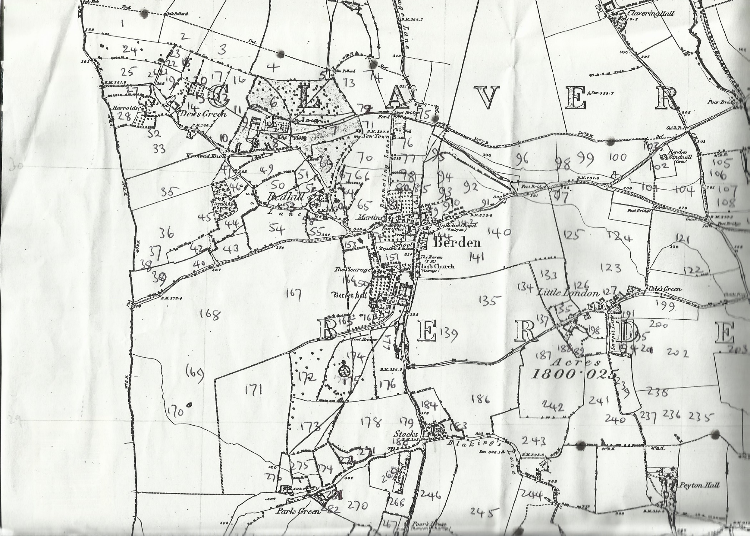
Map 1
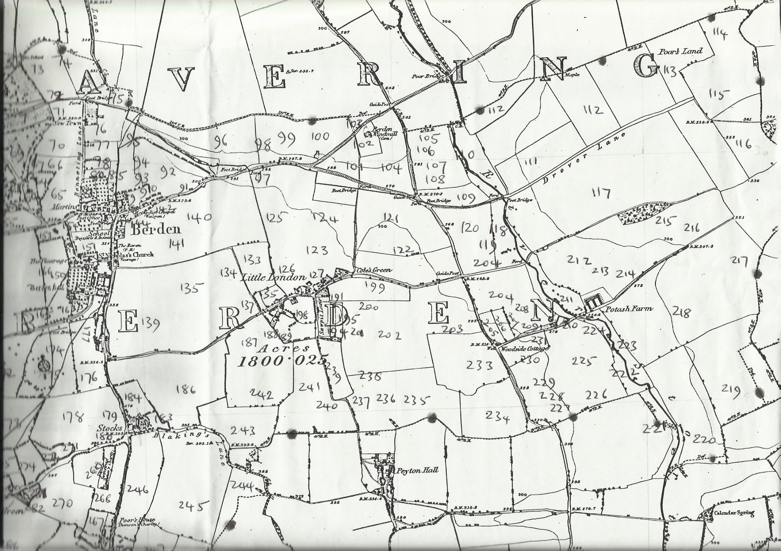
Map 2
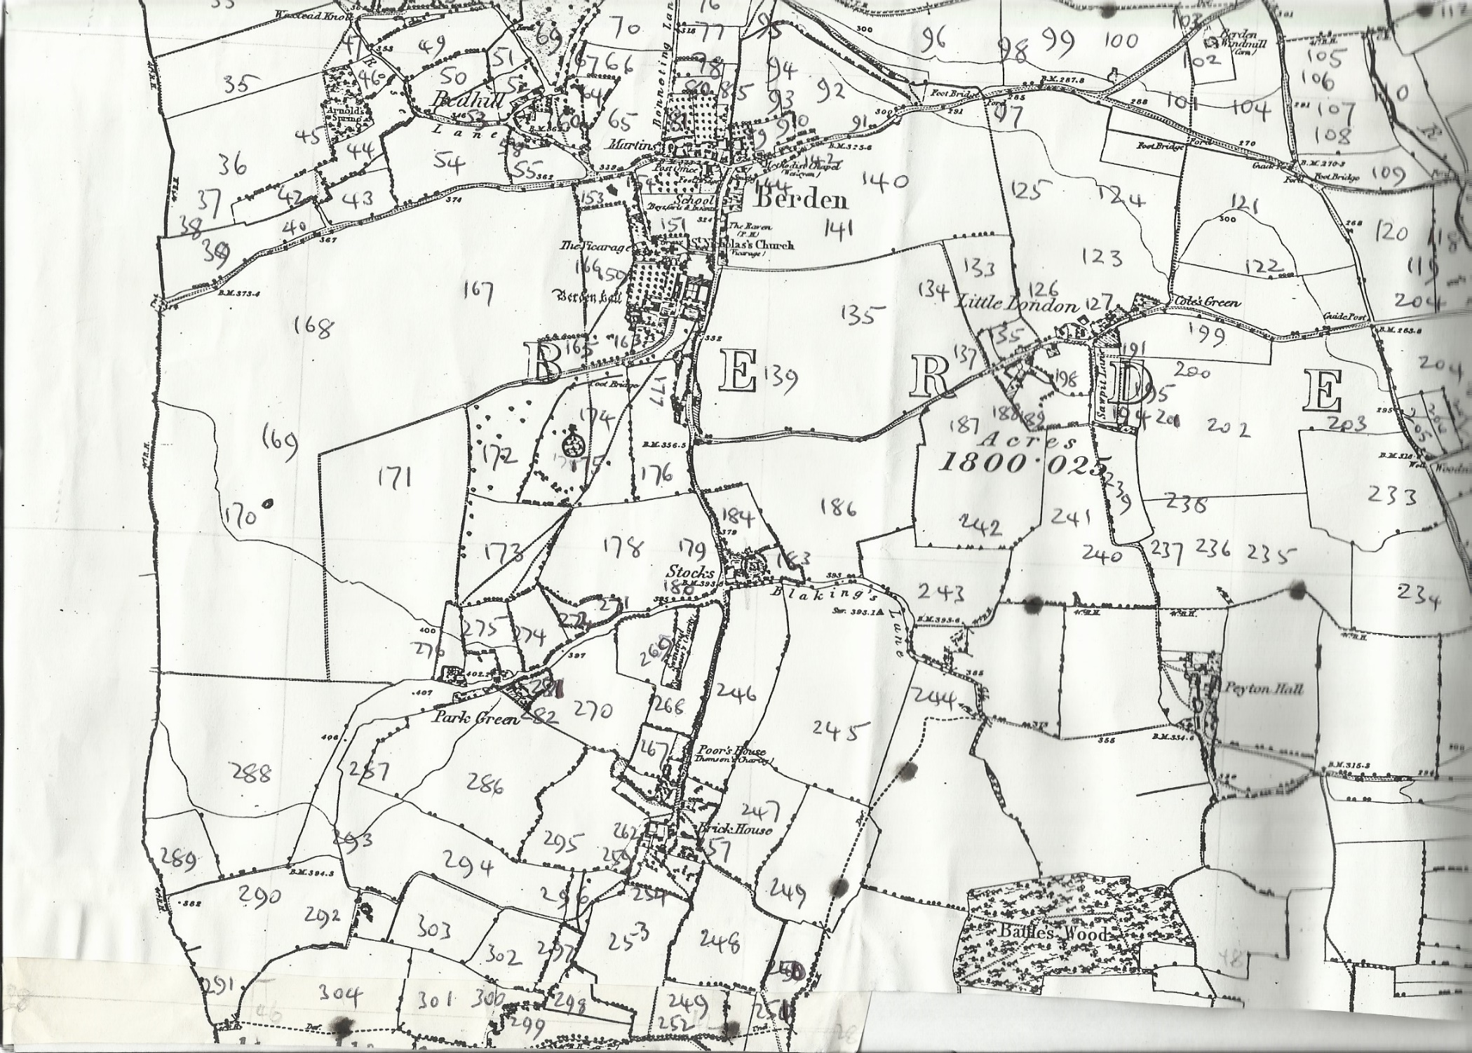
Map 3

