THE PLACE-NAMES

OF BERNERS RODING

Recorder: James Kemble

Essex Place-names Project (Essex Society for Archaeology & History)

Essex Record Office e-book, 2010. (1st hard-copy edition 2005).

www.essex.ac.uk/history/esah/essexplacenames

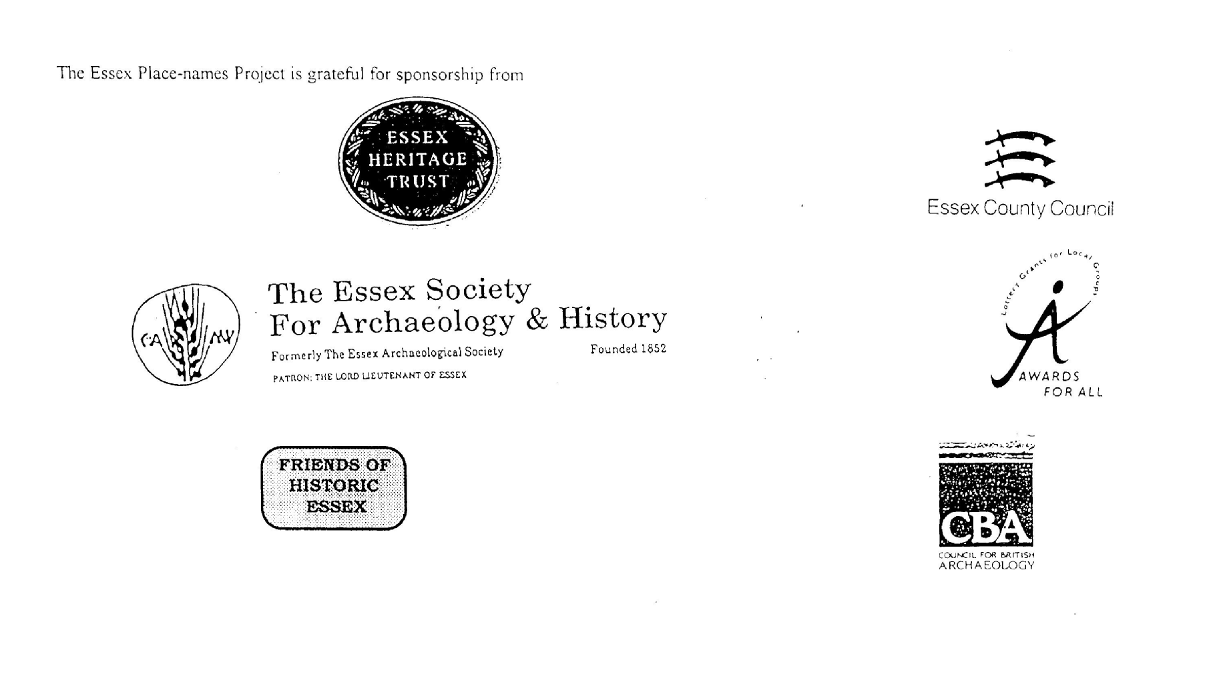

ESSEX PLACE-NAMES PROJECT.

The Essex Place-names Project is a County-wide survey to record place- and field-names from historical documents such as Tithe maps and apportionments, estate maps, sale and auction catalogues, conveyances, terriers, deeds, rolls, inquisitions and surveys.

The second element of the Project is to investigate on-the-ground visible remains which correspond to the Place-names for actual or potential archaeological, agricultural and industrial
sites, and to record natural (topographical) and man-made features which may relate to the Place-name. This involves field-survey in rural and outside investigation in built-up areas.

It is anticipated that the Project will lead to identification of archaeological sites and lost historic buildings; it will enable analysis of indicators of early settlement, land holding, agricultural and industrial practices of the County. It will refine the more precise meaning of descriptive words and elements used by earlier settlers as they gave names appropriate to the topography of the landscape of their time.

For convenience the surveys are based on the parish, recognising that present civil parish boundaries are not necessarily identical to former ecclesiastical boundaries. Local Recorders
are supplied with templates of Record Forms to ensure consistency of recording across the County, and forward completed forms to a Central Coordinator for transfer to a county
computer database which is available at the Essex Record Office to researchers.

This publication presents part of the information recorded from the Tithe or Estate Award and Map, (and from other documents for this parish.) The full record is contained on the master database in the Essex Record Office, Wharf Road, Chelmsford CM2 6YT and the website www.essex.ac.uk/history/esah/essexplacenames. Parish books are available from the ERO on disc or in hard copy or may be downloaded from the website. Please notify errors to the Project Coordinator at the Essex Record Office.

THE TITHE MAP AND APPORTIONMENT.

Since medieval times a tenth of the produce of land and stock had been paid by landholders to the church. At the Dissolution of the Monasteries, the property of many religious houses,
including the right to collect tithes, passed into lay hands. The Tithe Commutation Act which received Royal assent on 13th August 1836 abolished a rent payable in kind and
substituted rent-charges apportioned on each plot or parcel. The tithe-rent payable was assessed on the average value of wheat, barley and oats and was to fluctuate with price movements.

The commutation could be by voluntary agreement between the local owners and payers or, if agreement failed, could be compulsorily imposed by commissioners. A Valuer was to be
appointed to apportion the rent of each parcel of land and tenants could deduct that rent-charge from their rent paid to the landlord. The task fell to the Tithe Commissioners to produce a map and an Apportionment (Award). A large-scale survey was produced for over 70% of England and Wales in the following 9 years, and about another 8% up to 1855. Most of the
parishes in Essex were surveyed. The map scales vary. The Award records ownership, tenancy and land-use, field by field and parcel by parcel (often quoting the field name) with the
ground area and rent-charge.

Land that was tithe-free tends to be less accurately mapped and contains few if any of the details recorded for those parcels subject to tithe. Rights of way and roads also tend to be
neglected. Boundaries of the tithe areas are shown as are some natural features such as streams, ponds, gardens, greens and commons. Buildings are often shown coloured red if dwellings or grey if not. Because the Award may have been agreed only some time after the map was finished, discrepancies occur between the two. Enclosure Awards, when extant, usually date to the 18th and early 19th centuries. J.Kemble.
Reproduced by permission
of Essex County Council.

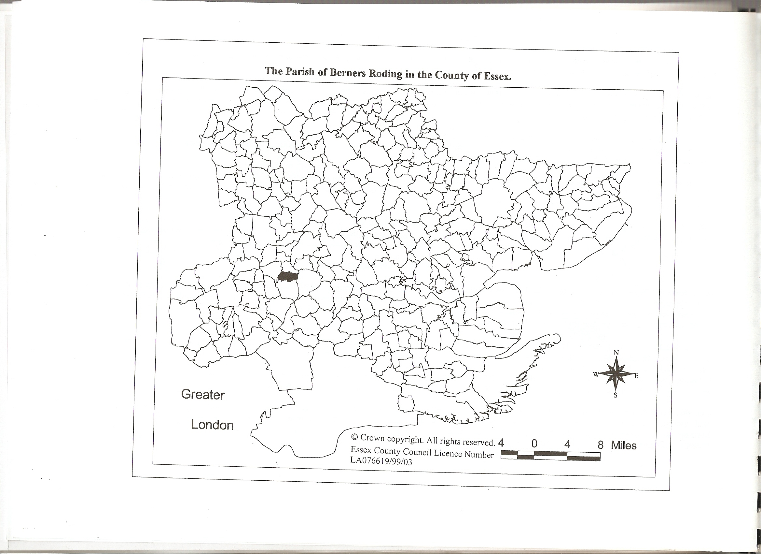

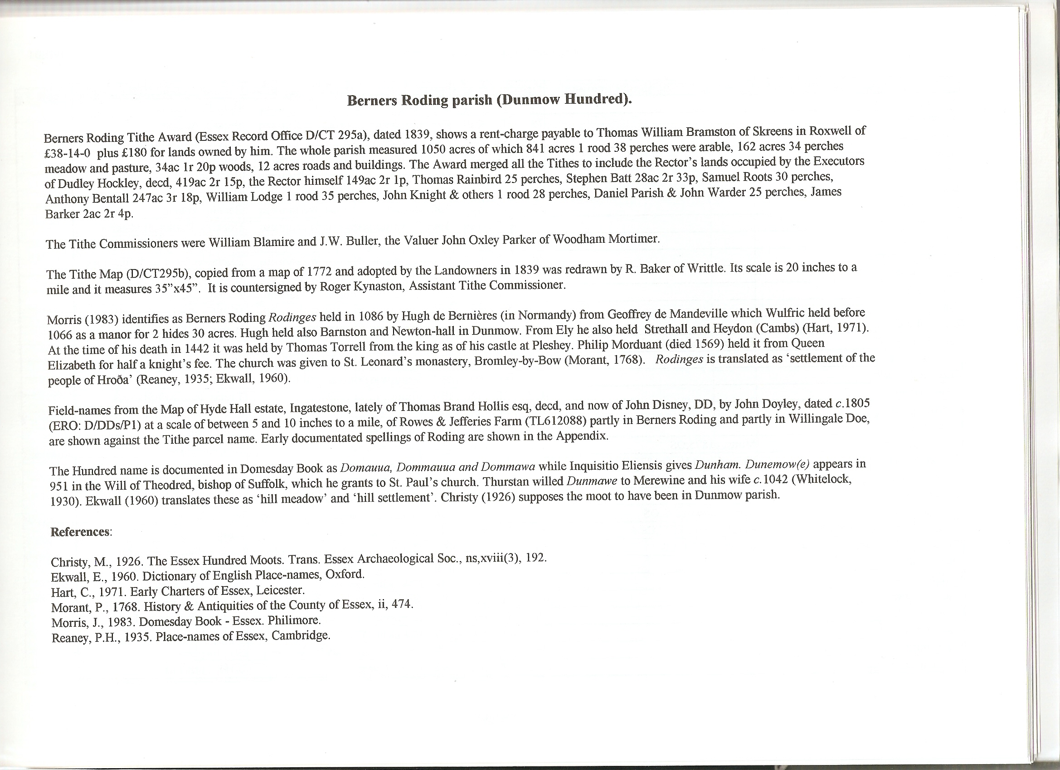

The Tithe Award Place-names of Berners Roding – by Parcel No.

Place-name | Alias | Fld No | Gd Rf | x | y | Acr | rd | pch | Land use | Owner | Occupier | Name of farm | Other information
Colsens Comb |  | 1 | TL | 592 | 103 | 4 | 1 | 20 | past | Bramston, Thomas William esq | Hockley, Dudley, decd,execs
Spring |  | 2 | TL | 593 | 105 | 2 | 2 | 4 | past | Bramston, Thomas William esq | Barker, James
Milldown |  | 3 | TL | 595 | 105 | 12 | 3 | 0 | arbl | Bramston, Thomas William esq | Hockley, Dudley, decd,execs
Milldown |  | 3 | TL | 595 | 104 | 6 | 1 | 31 | past | Bramston, Thomas William esq | Hockley, Dudley, decd,execs
Comewell Mead |  | 4 | TL | 600 | 594 | 11 | 1 | 13 | past | Bramston, Thomas William esq | Hockley, Dudley, decd,execs
Beech field |  | 5 | TL | 602 | 106 | 11 | 0 | 12 | arbl | Bramston, Thomas William esq | Hockley, Dudley, decd,execs
Slough Mead |  | 8 | TL | 604 | 105 | 4 | 3 | 11 | past | Bramston, Thomas William esq | Bentall, Anthony
Peartree field |  | 12 | TL | 605 | 104 | 8 | 0 | 29 | past | Bramston, Thomas William esq | Bentall, Anthony
Six Acres |  | 13 | TL | 605 | 103 | 5 | 3 | 12 | past | Bramston, Thomas William esq | Bentall, Anthony
Long field |  | 14 | TL | 606 | 103 | 6 | 1 | 25 | arbl | Bramston, Thomas William esq | Bentall, Anthony
Little Wood field |  | 15 | TL | 607 | 104 | 3 | 1 | 37 | arbl | Bramston, Thomas William esq | Bentall, Anthony
Great Wood field |  | 16 | TL | 607 | 102 | 6 | 1 | 8 | arbl | Bramston, Thomas William esq | Bentall, Anthony
Lawn Wood | Berners Wood, c1875,OS | 17 | TL | 608 | 101 | 25 | 2 | 36 | wd | Bramston, Thomas William esq | Bramston, Thomas William esq
Burnt Park |  | 18 | TL | 612 | 102 | 18 | 3 | 35 | arbl | Bramston, Thomas William esq | Bentall, Anthony
Lawn Park |  | 19 | TL | 611 | 100 | 22 | 1 | 5 | arbl | Bramston, Thomas William esq | Bentall, Anthony
Mountneys Spring | Hardy's Plantation, c1875,OS | 20 | TL | 615 | 103 | 6 | 0 | 30 | wd | Bramston, Thomas William esq | Bramston, Thomas William esq
Hardy's Park |  | 21 | TL | 616 | 102 | 6 | 3 | 18 | arbl | Bramston, Thomas William esq | Batt, Stephen
Great Park |  | 22 | TL | 615 | 100 | 20 | 2 | 33 | arbl | Bramston, Thomas William esq | Bentall, Anthony
Further Great Park |  | 22a | TL | 616 | 100 | 16 | 3 | 24 | arbl | Bramston, Thomas William esq | Bentall, Anthony
Spring |  | 23 | TL | 617 | 099 | 2 | 0 | 19 | wd | Bramston, Thomas William esq | Bramston, Thomas William esq
Ravens field |  | 24 | TL | 619 | 101 | 5 | 3 | 33 | arbl | Bramston, Thomas William esq | Batt, Stephen
Eight Acres |  | 25 | TL | 619 | 100 | 8 | 1 | 11 | arbl | Bramston, Thomas William esq | Batt, Stephen
Spring (pt) |  | 26 | TL | 619 | 099 | 0 | 3 | 0 | wd | Bramston, Thomas William esq | Bramston, Thomas William esq
Barn field |  | 27 | TL | 618 | 098 | 7 | 2 | 11 | arbl | Bramston, Thomas William esq | Batt, Stephen
Spring (pt) |  | 28 | TL | 619 | 095 | 0 | 1 | 20 | wd | Bramston, Thomas William esq | Bramston, Thomas William esq
Little Mountneys |  | 29 | TL | 618 | 095 | 7 | 1 | 13 | arbl | Bramston, Thomas William esq | Bramston, Thomas William esq
Long Park |  | 30 | TL | 615 | 097 | 24 | 1 | 24 | arbl | Bramston, Thomas William esq | Bentall, Anthony
Cottage, garden | Gingerbread Hall, c1875,OS | 30a | TL | 618 | 098 | 0 | 0 | 30 |  | Bramston, Thomas William esq | Roots, Samuel
Park field |  | 31 | TL | 610 | 097 | 8 | 0 | 20 | arbl | Bramston, Thomas William esq | Bentall, Anthony
Land Way |  | 32 | TL | 608 | 098 | 1 | 1 | 33 | wd | Bramston, Thomas William esq | Bramston, Thomas William esq
Little Park field |  | 33 | TL | 608 | 098 | 5 | 1 | 14 | arbl | Bramston, Thomas William esq | Bentall, Anthony
Old House field |  | 34 | TL | 607 | 100 | 6 | 3 | 7 | arbl | Bramston, Thomas William esq | Bentall, Anthony
Cottage, garden |  | 35 | TL | 606 | 099 | 0 | 1 | 35 |  | Bramston, Thomas William esq | Lodge, William
Home field |  | 36 | TL | 606 | 100 | 3 | 0 | 21 | arbl | Bramston, Thomas William esq | Bentall, Anthony
Homestead | Parsonage, 1777,C | 37 | TL | 606 | 099 | 1 | 0 | 24 |  | Bramston, Thomas William esq | Bentall, Anthony
Barn Mead |  | 38 | TL | 605 | 100 | 4 | 1 | 18 | past | Bramston, Thomas William esq | Bentall, Anthony
Grays Lane Comewell |  | 39 | TL | 603 | 103 | 14 | 1 | 2 | past | Bramston, Thomas William esq | Hockley, Dudley, decd,execs
Dove house Hoppet |  | 40 | TL | 603 | 100 | 3 | 2 | 9 | past | Bramston, Thomas William esq | Hockley, Dudley, decd,execs
Orchard |  | 40a | TL | 603 | 101 | 0 | 2 | 36 |  | Bramston, Thomas William esq | Hockley, Dudley, decd,execs
Homestead | Berners, 1420, Feudal Aids | 41 | TL | 602 | 100 | 2 | 2 | 21 |  | Bramston, Thomas William esq | Hockley, Dudley, decd,execs |  | Hugh deBerners, 1086,DB
Church and yard | Bernese church, 1503,EASxxi | 42 | TL | 602 | 100 | 0 | 1 | 24 |  | . | .
Lay Comewell |  | 44 | TL | 601 | 100 | 9 | 2 | 22 | past | Bramston, Thomas William esq | Hockley, Dudley, decd,execs
Dool Comewell |  | 45 | TL | 601 | 103 | 17 | 3 | 15 | arbl | Bramston, Thomas William esq | Hockley, Dudley, decd,execs
Great Comewell |  | 46 | TL | 598 | 101 | 27 | 1 | 27 | arbl | Bramston, Thomas William esq | Hockley, Dudley, decd,execs
Further Comewell |  | 47 | TL | 594 | 101 | 20 | 2 | 20 | arbl | Bramston, Thomas William esq | Hockley, Dudley, decd,execs
Cross Croft |  | 48 | TL | 593 | 100 | 1 | 2 | 31 | arbl | Bramston, Thomas William esq | Hockley, Dudley, decd,execs
Mill field |  | 49 | TL | 592 | 102 | 10 | 1 | 14 | arbl | Bramston, Thomas William esq | Hockley, Dudley, decd,execs
Beauchamp Mead |  | 51 | TL | 588 | 100 | 2 | 0 | 24 | past | Bramston, Thomas William esq | Hockley, Dudley, decd,execs
Great Mead |  | 52 | TL | 589 | 099 | 6 | 3 | 2 | past | Bramston, Thomas William esq | Hockley, Dudley, decd,execs
River Lay |  | 53 | TL | 591 | 098 | 60 | 3 | 18 | arbl | Bramston, Thomas William esq | Hockley, Dudley, decd,execs
Barn field |  | 54 | TL | 593 | 098 | 3 | 2 | 6 | arbl | Bramston, Thomas William esq | Hockley, Dudley, decd,execs
Cottage, garden | Larners,1777,C&A | 55 | TL | 594 | 097 | 0 | 1 | 28 |  | Bramston, Thomas William esq | Knight,John; Monk,John | Flarns, c1875,OS | William Flawyn, 1327,SR
Springs Croft |  | 56 | TL | 593 | 096 | 2 | 2 | 0 | arbl | Bramston, Thomas William esq | Hockley, Dudley, decd,execs
Stable field |  | 57 | TL | 594 | 097 | 8 | 2 | 2 | arbl | Bramston, Thomas William esq | Hockley, Dudley,decd,execs
Springs Mead |  | 58 | TL | 589 | 095 | 2 | 0 | 25 | past | Horsnail, Samuel | Horsnail, Samuel
Further Bandlay |  | 59 | TL | 595 | 097 | 28 | 0 | 33 | arbl | Bramston, Thomas William esq | Hockley, Dudley, decd,execs
Further Bandlay |  | 59 | TL | 595 | 095 | 4 | 3 | 18 | past | Bramston, Thomas William esq | Hockley, Dudley, decd,execs
Peartree Bandlay |  | 60 | TL | 599 | 098 | 30 | 1 | 7 | arbl | Bramston, Thomas William esq | Hockley, Dudley, decd,execs
Brockleshotts |  | 61 | TL | 599 | 094 | 9 | 2 | 30 | past | Bramston, Thomas William esq | Hockley, Dudley, decd,execs
Tare Croft |  | 62 | TL | 601 | 099 | 2 | 1 | 30 | past | Bramston, Thomas William esq | Hockley, Dudley, decd,execs
Little Bandlay |  | 63 | TL | 602 | 098 | 22 | 1 | 12 | past | Bramston, Thomas William esq | Hockley, Dudley, decd,execs
Tolly Croft |  | 64 | TL | 603 | 099 | 2 | 3 | 17 | past | Bramston, Thomas William esq | Hockley, Dudley, decd,execs
Cottage, garden |  | 65 | TL | 604 | 099 | 0 | 0 | 25 |  | Bramston, Thomas William esq | Rainbird, Thomas
Games Land |  | 66 | TL | 605 | 098 | 21 | 3 | 17 | arbl | Bramston, Thomas William esq | Hockley, Dudley, decd,execs
Peartree field |  | 67 | TL | 604 | 096 | 5 | 1 | 1 | arbl | Bramston, Thomas William esq | Bentall, Anthony
Orchard field |  | 68 | TL | 605 | 096 | 3 | 2 | 25 | arbl | Bramston, Thomas William esq | Bentall, Anthony
Long field |  | 69 | TL | 605 | 095 | 3 | 3 | 35 | arbl | Bramston, Thomas William esq | Bentall, Anthony
The Pasture |  | 70 | TL | 607 | 095 | 0 | 3 | 36 | past | Bramston, Thomas William esq | Bentall, Anthony
Hoppit |  | 71 | TL | 607 | 096 | 1 | 0 | 35 | past | Bramston, Thomas William esq | Bentall, Anthony
Cottage, garden | Dacre Farm, c1875,OS | 71a | TL | 607 | 096 | 0 | 0 | 25 |  | Bramston, Thomas William esq | Parish, Daniel
Great Barn field |  | 72 | TL | 608 | 096 | 7 | 2 | 20 | arbl | Bramston, Thomas William esq | Bentall, Anthony
Great Kitchen field |  | 73 | TL | 608 | 095 | 3 | 2 | 28 | arbl | Bramston, Thomas William esq | Bentall, Anthony
Little Barn field |  | 74 | TL | 609 | 095 | 5 | 2 | 24 | arbl | Bramston, Thomas William esq | Bentall, Anthony
Little Kitchen field |  | 75 | TL | 609 | 094 | 3 | 1 | 5 | arbl | Bramston, Thomas William esq | Bentall, Anthony
The Plantation |  | 78 | TL | 610 | 095 | 0 | 1 | 16 | wd | Bramston, Thomas William esq | Bentall, Anthony
Aly Pasture |  | 79 | TL | 610 | 094 | 2 | 2 | 36 | past | Bramston, Thomas William esq | Bentall, Anthony
Roaches Park |  | 80 | TL | 611 | 094 | 25 | 2 | 22 | arbl | Bramston, Thomas William esq | Bramston, Thomas William esq
Aly field |  | 80 | TL | 611 | 094 | 8 | 2 | 30 | arbl | Bramston, Thomas William esq | Bentall, Anthony
Bushey Park |  | 81 | TL | 615 | 093 | 30 | 1 | 9 | arbl | Bramston, Thomas William esq | Bramston, Thomas William esq
Great Mountneys |  | 82 | TL | 618 | 093 | 8 | 2 | 3 | arbl | Bramston, Thomas William esq | Bramston, Thomas William esq
Hither Great Mountneys |  | 83 | TL | 618 | 092 | 3 | 2 | 39 | past | Bramston, Thomas William esq | Bramston, Thomas William esq
Bernish Croft (pt) |  | 84 | TL | 617 | 092 | 5 | 2 | 14 | arbl | Bramston, Thomas William esq | Bramston, Thomas William esq
Thistledowns |  | 85 | TL | 617 | 093 | 2 | 1 | 10 | past | Bramston, Thomas William esq | Bramston, Thomas William esq
Further Thistledowns |  | 89 | TL | 616 | 092 | 5 | 0 | 4 | past | Bramston, Thomas William esq | Bramston, Thomas William esq
Slipe field (pt) | Thistledown, 1805(D/DDs/P1) | 90 | TL | 615 | 090 | 4 | 1 | 7 | arbl | Bramston, Thomas William esq | Bramston, Thomas William esq | Rowes & Jefferies, 1805(D/DDs/P1)
Middle Thistledowns |  | 91 | TL | 613 | 091 | 6 | 0 | 10 | past | Bramston, Thomas William esq | Bramston, Thomas William esq
Middle field (pt) | Eight Acres, 1805(D/DDs/P1) | 92 | TL | 613 | 090 | 2 | 3 | 32 | past | Bramston, Thomas William esq | Bramston, Thomas William esq | Rowes & Jefferies, 1805(D/DDs/P1)
Home Pasture (pt) | The Ley, 1805 (D/DDs/P1) | 93 | TL | 611 | 090 | 2 | 2 | 12 | past | Bramston, Thomas William esq | Bramston, Thomas William esq | Rowes & Jefferies, 1805(D/DDs/P1)
Rows field |  | 94 | TL | 611 | 092 | 5 | 1 | 8 | past | Bramston, Thomas William esq | Bramston, Thomas William esq
Long field (pt) | Long field, 1805(D/DDs/P1) | 95 | TL | 610 | 090 | 1 | 1 | 8 | past | Bramston, Thomas William esq | Bramston, Thomas William esq | Rowes & Jefferies, 1805(D/DDs/P1)
Dodge Shoes |  | 96 | TL | 608 | 089 | 5 | 3 | 38 | arbl | Bramston, Rev John | Taylor, Joseph, decd,execs
Goggles | Bernish field, 1805(D/DDs/P1) | 97 | TL | 609 | 090 | 1 | 3 | 32 | arbl | Bramston, Thomas William esq | Bramston, Thomas William esq | Rowes & Jefferies, 1805(D/DDs/P1)
Peartree field |  | 98 | TL | 608 | 090 | 3 | 3 | 37 | arbl | Bramston, Rev John | Taylor, Joseph, decd,execs
Low field |  | 99 | TL | 608 | 091 | 12 | 3 | 18 | arbl | Bramston, Rev John | Taylor, Joseph, decd,execs
Hazletons |  | 102 | TL | 606 | 093 | 8 | 3 | 10 | arbl | Bramston, Thomas William esq | Bentall, Anthony
Home field |  | 105 | TL | 606 | 091 | 9 | 0 | 24 | arbl | Bramston, Rev John | Taylor, Joseph, decd,execs
Cottage, garden | Horsell-down, 1777,C | 106 | TL | 606 | 092 | 0 | 2 | 2 |  | Bramston, Rev John | Twain, Joseph; Blow, James | Asfeldens,c1875,OS
Rye Grass field |  | 107 | TL | 606 | 091 | 1 | 3 | 29 | arbl | Bramston, Rev John | Taylor, Joseph, decd,execs
Riddens |  | 110 | TL | 605 | 088 | 12 | 1 | 4 | arbl | Bramston, Rev John | Taylor, Joseph, decd,execs
Further Riddens |  | 112 | TL | 604 | 088 | 12 | 0 | 14 | arbl | Bramston, Rev John | Taylor, Joseph, decd,execs
Wood field |  | 115 | TL | 604 | 090 | 8 | 0 | 30 | arbl | Bramston, Rev John | Taylor, Joseph, decd,execs
Ashweldowns |  | 116 | TL | 605 | 092 | 4 | 1 | 3 | arbl | Bramston, Rev John | Taylor, Joseph, decd,execs
Tare Croft |  | 117 | TL | 605 | 094 | 2 | 1 | 31 | arbl | Bramston, Thomas William esq | Bentall, Anthony
White Root field |  | 118 | TL | 604 | 094 | 8 | 3 | 39 | arbl | Bramston, Thomas William esq | Bentall, Anthony
Wood field |  | 119 | TL | 604 | 092 | 9 | 2 | 23 | arbl | Bramston, Thomas William esq | Bentall, Anthony
Hither Burshotts |  | 120 | TL | 601 | 091 | 16 | 0 | 11 | arbl | Bramston, Thomas William esq | Hockley, Dudley, decd,execs
Pepper field |  | 121 | TL | 602 | 091 | 3 | 2 | 37 | arbl | Bramston, Thomas William esq | Bentall, Anthony
Conduit field |  | 122 | TL | 601 | 090 | 3 | 3 | 16 | arbl | Bramston, Rev John | Taylor, Joseph, decd,execs
Hither Riddens |  | 124 | TL | 601 | 088 | 14 | 0 | 31 | arbl | Bramston, Rev John | Taylor, Joseph, decd,execs
Eight Acres |  | 125 | TL | 599 | 088 | 9 | 1 | 20 | arbl | Bramston, Rev John | Taylor, Joseph, decd,execs
Old House field |  | 126 | TL | 600 | 089 | 12 | 1 | 24 | arbl | Brocket, Staines Brocket esq | Barnard, James
Further Burshotts |  | 128 | TL | 599 | 092 | 8 | 0 | 30 | arbl | Bramston, Thomas William esq | Hockley, Dudley, decd,execs
Burshotts |  | 130 | TL | 601 | 094 | 16 | 3 | 23 | arbl | Bramston, Thomas William esq | Hockley, Dudley, decd,execs
Fouchings Hoppett |  | 132 | TL | 598 | 092 | 1 | 0 | 37 | arbl | Dodd, Cornelius | Dodd, Cornelius
Well field |  | 133 | TL | 596 | 092 | 18 | 0 | 2 | arbl | Brocket, Staines Brocket esq | Barnard, James
Cottage, garden |  | 134 | TL | 595 | 090 | 0 | 0 | 30 |  | Stock, Edward | Oakley, William; Lanes, John; Childs, James
Garden |  | 135 | TL | 595 | 090 | 0 | 0 | 20 |  | Stock, Edward | Childs, James
New field |  | 136 | TL | 596 | 093 | 14 | 3 | 2 | arbl | Bramston, Thomas William esq | Hockley, Dudley, decd, execs
Barn field |  | 137 | TL | 593 | 094 | 13 | 3 | 24 | arbl | Brocket, Staines Brocket esq | Barnard, James
Homestead | Elms,1777,C&A | 138 | TL | 593 | 093 | 2 | 0 | 17 |  | Brocket, Staines Brocket esq | Barnard, James
Orchard Pasture |  | 139 | TL | 593 | 093 | 1 | 1 | 28 | past | Brocket, Staines Brocket esq | Barnard, James
Home Pasture |  | 140 | TL | 593 | 093 | 1 | 2 | 34 | past | Brocket, Staines Brocket esq | Barnard, James
Hutleys Land |  | 141 | TL | 593 | 091 | 4 | 3 | 26 | arbl | Horsnail, Samuel | Horsnail, Samuel
Little Bean Acre |  | 142 | TL | 592 | 091 | 3 | 3 | 37 | arbl | Brocket, Staines Brocket esq | Barnard, James
Shelly Bridge field |  | 143 | TL | 591 | 089 | 5 | 0 | 18 | arbl | Brocket, Staines Brocket esq | Barnard, James
Cottage, garden |  | 144 | TL | 591 | 088 | 0 | 2 | 23 |  | Judd, John | Judd, John
Hither French's (pt) |  | 145 | TL | 590 | 089 | 1 | 2 | 11 | arbl | Brocket, Staines Brocket esq | Barnard, James
River Mead |  | 146 | TL | 591 | 092 | 2 | 3 | 29 | past | Bush, William | Bush, William
Motts |  | 147 | TL | 592 | 092 | 4 | 0 | 37 | arbl | Bush, William | Bush, William
Motts |  | 147 | TL | 592 | 092 | 0 | 1 | 19 | past | Bush, William | Bush, William
Cottage, garden | Motts, c1875,OS | 148 | TL | 592 | 092 | 0 | 1 | 8 |  | Bush, William | Harrington, Isaac; Hatchman, John
River field |  | 150 | TL | 592 | 094 | 7 | 3 | 5 | arbl | Brocket, Staines Brocket esq | Barnard, James
The Mead |  | 151 | TL | 590 | 094 | 1 | 1 | 18 | past | Brocket, Staines Brocket esq | Barnard, James
Little Mead | Rowes or Bernish Mead, 1805 (D/DDs/P1) | 152 | TL | 590 | 101 | 3 | 0 | 20 | past | Bramston, Thomas William esq | Hockley, Dudley, decd,execs | Rowes & Jefferies, 1805 (D/DDs/P1)

For abbreviations see Reaney, P., Place-names of Essex, Cambridge 1935; and Kemble, J., Essex Place-names, Places, Streets & People, Historical Publications, London 2007.

The Tithe Award Place-names of Berners Roding – by Place-name.

Place-name | Alias | Fld No | Gd Rf | x | y | Acr | rd | pch | Land use | Owner | Occupier | Name of farm | Other information
Aly field |  | 80 | TL | 611 | 094 | 8 | 2 | 30 | arbl | Bramston, Thomas William esq | Bentall, Anthony
Aly Pasture |  | 79 | TL | 610 | 094 | 2 | 2 | 36 | past | Bramston, Thomas William esq | Bentall, Anthony
Ashweldowns |  | 116 | TL | 605 | 092 | 4 | 1 | 3 | arbl | Bramston, Rev John | Taylor, Joseph, decd,execs
Barn field |  | 27 | TL | 618 | 098 | 7 | 2 | 11 | arbl | Bramston, Thomas William esq | Batt, Stephen
Barn field |  | 54 | TL | 593 | 098 | 3 | 2 | 6 | arbl | Bramston, Thomas William esq | Hockley, Dudley, decd,execs
Barn field |  | 137 | TL | 593 | 094 | 13 | 3 | 24 | arbl | Brocket, Staines Brocket esq | Barnard, James
Barn Mead |  | 38 | TL | 605 | 100 | 4 | 1 | 18 | past | Bramston, Thomas William esq | Bentall, Anthony
Beauchamp Mead |  | 51 | TL | 588 | 100 | 2 | 0 | 24 | past | Bramston, Thomas William esq | Hockley, Dudley, decd,execs
Beech field |  | 5 | TL | 602 | 106 | 11 | 0 | 12 | arbl | Bramston, Thomas William esq | Hockley, Dudley, decd,execs
Bernish Croft (pt) |  | 84 | TL | 617 | 092 | 5 | 2 | 14 | arbl | Bramston, Thomas William esq | Bramston, Thomas William esq
Brockleshotts |  | 61 | TL | 599 | 094 | 9 | 2 | 30 | past | Bramston, Thomas William esq | Hockley, Dudley, decd,execs
Burnt Park |  | 18 | TL | 612 | 102 | 18 | 3 | 35 | arbl | Bramston, Thomas William esq | Bentall, Anthony
Burshotts |  | 130 | TL | 601 | 094 | 16 | 3 | 23 | arbl | Bramston, Thomas William esq | Hockley, Dudley, decd,execs
Bushey Park |  | 81 | TL | 615 | 093 | 30 | 1 | 9 | arbl | Bramston, Thomas William esq | Bramston, Thomas William esq
Church and yard | Bernese church, 1503,EASxxi | 42 | TL | 602 | 100 | 0 | 1 | 24 |  | . | .
Colsens Comb |  | 1 | TL | 592 | 103 | 4 | 1 | 20 | past | Bramston, Thomas William esq | Hockley, Dudley, decd,execs
Comewell Mead |  | 4 | TL | 600 | 594 | 11 | 1 | 13 | past | Bramston, Thomas William esq | Hockley, Dudley, decd,execs
Conduit field |  | 122 | TL | 601 | 090 | 3 | 3 | 16 | arbl | Bramston, Rev John | Taylor, Joseph, decd,execs
Cottage, garden | Horsell-down, 1777,C | 106 | TL | 606 | 092 | 0 | 2 | 2 |  | Bramston, Rev John | Twain, Joseph; Blow, James | Asfeldens,c1875,OS
Cottage, garden | Larners,1777,C&A | 55 | TL | 594 | 097 | 0 | 1 | 28 |  | Bramston, Thomas William esq | Knight,John; Monk,John | Flarns, c1875,OS | William Flawyn, 1327,SR
Cottage, garden |  | 35 | TL | 606 | 099 | 0 | 1 | 35 |  | Bramston, Thomas William esq | Lodge, William
Cottage, garden | Dacre Farm, c1875,OS | 71a | TL | 607 | 096 | 0 | 0 | 25 |  | Bramston, Thomas William esq | Parish, Daniel
Cottage, garden |  | 65 | TL | 604 | 099 | 0 | 0 | 25 |  | Bramston, Thomas William esq | Rainbird, Thomas
Cottage, garden | Gingerbread Hall, c1875,OS | 30a | TL | 618 | 098 | 0 | 0 | 30 |  | Bramston, Thomas William esq | Roots, Samuel
Cottage, garden | Motts, c1875,OS | 148 | TL | 592 | 092 | 0 | 1 | 8 |  | Bush, William | Harrington, Isaac; Hatchman, John
Cottage, garden |  | 144 | TL | 591 | 088 | 0 | 2 | 23 |  | Judd, John | Judd, John
Cottage, garden |  | 134 | TL | 595 | 090 | 0 | 0 | 30 |  | Stock, Edward | Oakley, William; Lanes, John; Childs, James
Cross Croft |  | 48 | TL | 593 | 100 | 1 | 2 | 31 | arbl | Bramston, Thomas William esq | Hockley, Dudley, decd,execs
Dodge Shoes |  | 96 | TL | 608 | 089 | 5 | 3 | 38 | arbl | Bramston, Rev John | Taylor, Joseph, decd,execs
Dool Comewell |  | 45 | TL | 601 | 103 | 17 | 3 | 15 | arbl | Bramston, Thomas William esq | Hockley, Dudley, decd,execs
Dove house Hoppet |  | 40 | TL | 603 | 100 | 3 | 2 | 9 | past | Bramston, Thomas William esq | Hockley, Dudley, decd,execs
Eight Acres |  | 125 | TL | 599 | 088 | 9 | 1 | 20 | arbl | Bramston, Rev John | Taylor, Joseph, decd,execs
Eight Acres |  | 25 | TL | 619 | 100 | 8 | 1 | 11 | arbl | Bramston, Thomas William esq | Batt, Stephen
Fouchings Hoppett |  | 132 | TL | 598 | 092 | 1 | 0 | 37 | arbl | Dodd, Cornelius | Dodd, Cornelius
Further Bandlay |  | 59 | TL | 595 | 097 | 28 | 0 | 33 | arbl | Bramston, Thomas William esq | Hockley, Dudley, decd,execs
Further Bandlay |  | 59 | TL | 595 | 095 | 4 | 3 | 18 | past | Bramston, Thomas William esq | Hockley, Dudley, decd,execs
Further Burshotts |  | 128 | TL | 599 | 092 | 8 | 0 | 30 | arbl | Bramston, Thomas William esq | Hockley, Dudley, decd,execs
Further Comewell |  | 47 | TL | 594 | 101 | 20 | 2 | 20 | arbl | Bramston, Thomas William esq | Hockley, Dudley, decd,execs
Further Great Park |  | 22a | TL | 616 | 100 | 16 | 3 | 24 | arbl | Bramston, Thomas William esq | Bentall, Anthony
Further Riddens |  | 112 | TL | 604 | 088 | 12 | 0 | 14 | arbl | Bramston, Rev John | Taylor, Joseph, decd,execs
Further Thistledowns |  | 89 | TL | 616 | 092 | 5 | 0 | 4 | past | Bramston, Thomas William esq | Bramston, Thomas William esq
Games Land |  | 66 | TL | 605 | 098 | 21 | 3 | 17 | arbl | Bramston, Thomas William esq | Hockley, Dudley, decd,execs
Garden |  | 135 | TL | 595 | 090 | 0 | 0 | 20 |  | Stock, Edward | Childs, James
Goggles | Bernish field, 1805(D/DDs/P1) | 97 | TL | 609 | 090 | 1 | 3 | 32 | arbl | Bramston, Thomas William esq | Bramston, Thomas William esq | Rowes & Jefferies, 1805(D/DDs/P1)
Grays Lane Comewell |  | 39 | TL | 603 | 103 | 14 | 1 | 2 | past | Bramston, Thomas William esq | Hockley, Dudley, decd,execs
Great Barn field |  | 72 | TL | 608 | 096 | 7 | 2 | 20 | arbl | Bramston, Thomas William esq | Bentall, Anthony
Great Comewell |  | 46 | TL | 598 | 101 | 27 | 1 | 27 | arbl | Bramston, Thomas William esq | Hockley, Dudley, decd,execs
Great Kitchen field |  | 73 | TL | 608 | 095 | 3 | 2 | 28 | arbl | Bramston, Thomas William esq | Bentall, Anthony
Great Mead |  | 52 | TL | 589 | 099 | 6 | 3 | 2 | past | Bramston, Thomas William esq | Hockley, Dudley, decd,execs
Great Mountneys |  | 82 | TL | 618 | 093 | 8 | 2 | 3 | arbl | Bramston, Thomas William esq | Bramston, Thomas William esq
Great Park |  | 22 | TL | 615 | 100 | 20 | 2 | 33 | arbl | Bramston, Thomas William esq | Bentall, Anthony
Great Wood field |  | 16 | TL | 607 | 102 | 6 | 1 | 8 | arbl | Bramston, Thomas William esq | Bentall, Anthony
Hardy's Park |  | 21 | TL | 616 | 102 | 6 | 3 | 18 | arbl | Bramston, Thomas William esq | Batt, Stephen
Hazletons |  | 102 | TL | 606 | 093 | 8 | 3 | 10 | arbl | Bramston, Thomas William esq | Bentall, Anthony
Hither Burshotts |  | 120 | TL | 601 | 091 | 16 | 0 | 11 | arbl | Bramston, Thomas William esq | Hockley, Dudley, decd,execs
Hither French's (pt) |  | 145 | TL | 590 | 089 | 1 | 2 | 11 | arbl | Brocket, Staines Brocket esq | Barnard, James
Hither Great Mountneys |  | 83 | TL | 618 | 092 | 3 | 2 | 39 | past | Bramston, Thomas William esq | Bramston, Thomas William esq
Hither Riddens |  | 124 | TL | 601 | 088 | 14 | 0 | 31 | arbl | Bramston, Rev John | Taylor, Joseph, decd,execs
Home field |  | 105 | TL | 606 | 091 | 9 | 0 | 24 | arbl | Bramston, Rev John | Taylor, Joseph, decd,execs
Home field |  | 36 | TL | 606 | 100 | 3 | 0 | 21 | arbl | Bramston, Thomas William esq | Bentall, Anthony
Home Pasture |  | 140 | TL | 593 | 093 | 1 | 2 | 34 | past | Brocket, Staines Brocket esq | Barnard, James
Home Pasture (pt) | The Ley, 1805 (D/DDs/P1) | 93 | TL | 611 | 090 | 2 | 2 | 12 | past | Bramston, Thomas William esq | Bramston, Thomas William esq | Rowes & Jefferies, 1805(D/DDs/P1)
Homestead | Parsonage, 1777,C | 37 | TL | 606 | 099 | 1 | 0 | 24 |  | Bramston, Thomas William esq | Bentall, Anthony
Homestead | Berners, 1420, Feudal Aids | 41 | TL | 602 | 100 | 2 | 2 | 21 |  | Bramston, Thomas William esq | Hockley, Dudley, decd,execs |  | Hugh deBerners, 1086,DB
Homestead | Elms,1777,C&A | 138 | TL | 593 | 093 | 2 | 0 | 17 |  | Brocket, Staines Brocket esq | Barnard, James
Hoppit |  | 71 | TL | 607 | 096 | 1 | 0 | 35 | past | Bramston, Thomas William esq | Bentall, Anthony
Hutleys Land |  | 141 | TL | 593 | 091 | 4 | 3 | 26 | arbl | Horsnail, Samuel | Horsnail, Samuel
Land Way |  | 32 | TL | 608 | 098 | 1 | 1 | 33 | wd | Bramston, Thomas William esq | Bramston, Thomas William esq
Lawn Park |  | 19 | TL | 611 | 100 | 22 | 1 | 5 | arbl | Bramston, Thomas William esq | Bentall, Anthony
Lawn Wood | Berners Wood, c1875,OS | 17 | TL | 608 | 101 | 25 | 2 | 36 | wd | Bramston, Thomas William esq | Bramston, Thomas William esq
Lay Comewell |  | 44 | TL | 601 | 100 | 9 | 2 | 22 | past | Bramston, Thomas William esq | Hockley, Dudley, decd,execs
Little Bandlay |  | 63 | TL | 602 | 098 | 22 | 1 | 12 | past | Bramston, Thomas William esq | Hockley, Dudley, decd,execs
Little Barn field |  | 74 | TL | 609 | 095 | 5 | 2 | 24 | arbl | Bramston, Thomas William esq | Bentall, Anthony
Little Bean Acre |  | 142 | TL | 592 | 091 | 3 | 3 | 37 | arbl | Brocket, Staines Brocket esq | Barnard, James
Little Kitchen field |  | 75 | TL | 609 | 094 | 3 | 1 | 5 | arbl | Bramston, Thomas William esq | Bentall, Anthony
Little Mead | Rowes or Bernish Mead, 1805 (D/DDs/P1) | 152 | TL | 590 | 101 | 3 | 0 | 20 | past | Bramston, Thomas William esq | Hockley, Dudley, decd,execs | Rowes & Jefferies, 1805 (D/DDs/P1)
Little Mountneys |  | 29 | TL | 618 | 095 | 7 | 1 | 13 | arbl | Bramston, Thomas William esq | Bramston, Thomas William esq
Little Park field |  | 33 | TL | 608 | 098 | 5 | 1 | 14 | arbl | Bramston, Thomas William esq | Bentall, Anthony
Little Wood field |  | 15 | TL | 607 | 104 | 3 | 1 | 37 | arbl | Bramston, Thomas William esq | Bentall, Anthony
Long field |  | 14 | TL | 606 | 103 | 6 | 1 | 25 | arbl | Bramston, Thomas William esq | Bentall, Anthony
Long field |  | 69 | TL | 605 | 095 | 3 | 3 | 35 | arbl | Bramston, Thomas William esq | Bentall, Anthony
Long field (pt) | Long field, 1805(D/DDs/P1) | 95 | TL | 610 | 090 | 1 | 1 | 8 | past | Bramston, Thomas William esq | Bramston, Thomas William esq | Rowes & Jefferies, 1805(D/DDs/P1)
Long Park |  | 30 | TL | 615 | 097 | 24 | 1 | 24 | arbl | Bramston, Thomas William esq | Bentall, Anthony
Low field |  | 99 | TL | 608 | 091 | 12 | 3 | 18 | arbl | Bramston, Rev John | Taylor, Joseph, decd,execs
Middle field (pt) | Eight Acres, 1805(D/DDs/P1) | 92 | TL | 613 | 090 | 2 | 3 | 32 | past | Bramston, Thomas William esq | Bramston, Thomas William esq | Rowes & Jefferies, 1805(D/DDs/P1)
Middle Thistledowns |  | 91 | TL | 613 | 091 | 6 | 0 | 10 | past | Bramston, Thomas William esq | Bramston, Thomas William esq
Mill field |  | 49 | TL | 592 | 102 | 10 | 1 | 14 | arbl | Bramston, Thomas William esq | Hockley, Dudley, decd,execs
Milldown |  | 3 | TL | 595 | 105 | 12 | 3 | 0 | arbl | Bramston, Thomas William esq | Hockley, Dudley, decd,execs
Milldown |  | 3 | TL | 595 | 104 | 6 | 1 | 31 | past | Bramston, Thomas William esq | Hockley, Dudley, decd,execs
Motts |  | 147 | TL | 592 | 092 | 4 | 0 | 37 | arbl | Bush, William | Bush, William
Motts |  | 147 | TL | 592 | 092 | 0 | 1 | 19 | past | Bush, William | Bush, William
Mountneys Spring | Hardy's Plantation, c1875,OS | 20 | TL | 615 | 103 | 6 | 0 | 30 | wd | Bramston, Thomas William esq | Bramston, Thomas William esq
New field |  | 136 | TL | 596 | 093 | 14 | 3 | 2 | arbl | Bramston, Thomas William esq | Hockley, Dudley, decd, execs
Old House field |  | 34 | TL | 607 | 100 | 6 | 3 | 7 | arbl | Bramston, Thomas William esq | Bentall, Anthony
Old House field |  | 126 | TL | 600 | 089 | 12 | 1 | 24 | arbl | Brocket, Staines Brocket esq | Barnard, James
Orchard |  | 40a | TL | 603 | 101 | 0 | 2 | 36 |  | Bramston, Thomas William esq | Hockley, Dudley, decd,execs
Orchard field |  | 68 | TL | 605 | 096 | 3 | 2 | 25 | arbl | Bramston, Thomas William esq | Bentall, Anthony
Orchard Pasture |  | 139 | TL | 593 | 093 | 1 | 1 | 28 | past | Brocket, Staines Brocket esq | Barnard, James
Park field |  | 31 | TL | 610 | 097 | 8 | 0 | 20 | arbl | Bramston, Thomas William esq | Bentall, Anthony
Peartree Bandlay |  | 60 | TL | 599 | 098 | 30 | 1 | 7 | arbl | Bramston, Thomas William esq | Hockley, Dudley, decd,execs
Peartree field |  | 98 | TL | 608 | 090 | 3 | 3 | 37 | arbl | Bramston, Rev John | Taylor, Joseph, decd,execs
Peartree field |  | 12 | TL | 605 | 104 | 8 | 0 | 29 | past | Bramston, Thomas William esq | Bentall, Anthony
Peartree field |  | 67 | TL | 604 | 096 | 5 | 1 | 1 | arbl | Bramston, Thomas William esq | Bentall, Anthony
Pepper field |  | 121 | TL | 602 | 091 | 3 | 2 | 37 | arbl | Bramston, Thomas William esq | Bentall, Anthony
Ravens field |  | 24 | TL | 619 | 101 | 5 | 3 | 33 | arbl | Bramston, Thomas William esq | Batt, Stephen
Riddens |  | 110 | TL | 605 | 088 | 12 | 1 | 4 | arbl | Bramston, Rev John | Taylor, Joseph, decd,execs
River field |  | 150 | TL | 592 | 094 | 7 | 3 | 5 | arbl | Brocket, Staines Brocket esq | Barnard, James
River Lay |  | 53 | TL | 591 | 098 | 60 | 3 | 18 | arbl | Bramston, Thomas William esq | Hockley, Dudley, decd,execs
River Mead |  | 146 | TL | 591 | 092 | 2 | 3 | 29 | past | Bush, William | Bush, William
Roaches Park |  | 80 | TL | 611 | 094 | 25 | 2 | 22 | arbl | Bramston, Thomas William esq | Bramston, Thomas William esq
Rows field |  | 94 | TL | 611 | 092 | 5 | 1 | 8 | past | Bramston, Thomas William esq | Bramston, Thomas William esq
Rye Grass field |  | 107 | TL | 606 | 091 | 1 | 3 | 29 | arbl | Bramston, Rev John | Taylor, Joseph, decd,execs
Shelly Bridge field |  | 143 | TL | 591 | 089 | 5 | 0 | 18 | arbl | Brocket, Staines Brocket esq | Barnard, James
Six Acres |  | 13 | TL | 605 | 103 | 5 | 3 | 12 | past | Bramston, Thomas William esq | Bentall, Anthony
Slipe field (pt) | Thistledown, 1805(D/DDs/P1) | 90 | TL | 615 | 090 | 4 | 1 | 7 | arbl | Bramston, Thomas William esq | Bramston, Thomas William esq | Rowes & Jefferies, 1805(D/DDs/P1)
Slough Mead |  | 8 | TL | 604 | 105 | 4 | 3 | 11 | past | Bramston, Thomas William esq | Bentall, Anthony
Spring |  | 2 | TL | 593 | 105 | 2 | 2 | 4 | past | Bramston, Thomas William esq | Barker, James
Spring |  | 23 | TL | 617 | 099 | 2 | 0 | 19 | wd | Bramston, Thomas William esq | Bramston, Thomas William esq
Spring (pt) |  | 26 | TL | 619 | 099 | 0 | 3 | 0 | wd | Bramston, Thomas William esq | Bramston, Thomas William esq
Spring (pt) |  | 28 | TL | 619 | 095 | 0 | 1 | 20 | wd | Bramston, Thomas William esq | Bramston, Thomas William esq
Springs Croft |  | 56 | TL | 593 | 096 | 2 | 2 | 0 | arbl | Bramston, Thomas William esq | Hockley, Dudley, decd,execs
Springs Mead |  | 58 | TL | 589 | 095 | 2 | 0 | 25 | past | Horsnail, Samuel | Horsnail, Samuel
Stable field |  | 57 | TL | 594 | 097 | 8 | 2 | 2 | arbl | Bramston, Thomas William esq | Hockley, Dudley,decd,execs
Tare Croft |  | 117 | TL | 605 | 094 | 2 | 1 | 31 | arbl | Bramston, Thomas William esq | Bentall, Anthony
Tare Croft |  | 62 | TL | 601 | 099 | 2 | 1 | 30 | past | Bramston, Thomas William esq | Hockley, Dudley, decd,execs
The Mead |  | 151 | TL | 590 | 094 | 1 | 1 | 18 | past | Brocket, Staines Brocket esq | Barnard, James
The Pasture |  | 70 | TL | 607 | 095 | 0 | 3 | 36 | past | Bramston, Thomas William esq | Bentall, Anthony
The Plantation |  | 78 | TL | 610 | 095 | 0 | 1 | 16 | wd | Bramston, Thomas William esq | Bentall, Anthony
Thistledowns |  | 85 | TL | 617 | 093 | 2 | 1 | 10 | past | Bramston, Thomas William esq | Bramston, Thomas William esq
Tolly Croft |  | 64 | TL | 603 | 099 | 2 | 3 | 17 | past | Bramston, Thomas William esq | Hockley, Dudley, decd,execs
Well field |  | 133 | TL | 596 | 092 | 18 | 0 | 2 | arbl | Brocket, Staines Brocket esq | Barnard, James
White Root field |  | 118 | TL | 604 | 094 | 8 | 3 | 39 | arbl | Bramston, Thomas William esq | Bentall, Anthony
Wood field |  | 115 | TL | 604 | 090 | 8 | 0 | 30 | arbl | Bramston, Rev John | Taylor, Joseph, decd,execs
Wood field |  | 119 | TL | 604 | 092 | 9 | 2 | 23 | arbl | Bramston, Thomas William esq | Bentall, Anthony

For abbreviations see Reaney, P., Place-names of Essex, Cambridge 1935; and Kemble, J., Essex Place-names, Places, Streets & People, Historical Publications, London 2007.

The Tithe Award Place-names of Berners Roding – by Owner.

Place-name | Alias | Fld No | Gd Rf | x | y | Acr | rd | pch | Land use | Owner | Occupier | Name of farm | Other information
Church and yard | Bernese church, 1503,EASxxi | 42 | TL | 602 | 100 | 0 | 1 | 24 |  | . | .
Dodge Shoes |  | 96 | TL | 608 | 089 | 5 | 3 | 38 | arbl | Bramston, Rev John | Taylor, Joseph, decd,execs
Peartree field |  | 98 | TL | 608 | 090 | 3 | 3 | 37 | arbl | Bramston, Rev John | Taylor, Joseph, decd,execs
Low field |  | 99 | TL | 608 | 091 | 12 | 3 | 18 | arbl | Bramston, Rev John | Taylor, Joseph, decd,execs
Home field |  | 105 | TL | 606 | 091 | 9 | 0 | 24 | arbl | Bramston, Rev John | Taylor, Joseph, decd,execs
Rye Grass field |  | 107 | TL | 606 | 091 | 1 | 3 | 29 | arbl | Bramston, Rev John | Taylor, Joseph, decd,execs
Riddens |  | 110 | TL | 605 | 088 | 12 | 1 | 4 | arbl | Bramston, Rev John | Taylor, Joseph, decd,execs
Further Riddens |  | 112 | TL | 604 | 088 | 12 | 0 | 14 | arbl | Bramston, Rev John | Taylor, Joseph, decd,execs
Wood field |  | 115 | TL | 604 | 090 | 8 | 0 | 30 | arbl | Bramston, Rev John | Taylor, Joseph, decd,execs
Ashweldowns |  | 116 | TL | 605 | 092 | 4 | 1 | 3 | arbl | Bramston, Rev John | Taylor, Joseph, decd,execs
Conduit field |  | 122 | TL | 601 | 090 | 3 | 3 | 16 | arbl | Bramston, Rev John | Taylor, Joseph, decd,execs
Hither Riddens |  | 124 | TL | 601 | 088 | 14 | 0 | 31 | arbl | Bramston, Rev John | Taylor, Joseph, decd,execs
Eight Acres |  | 125 | TL | 599 | 088 | 9 | 1 | 20 | arbl | Bramston, Rev John | Taylor, Joseph, decd,execs
Cottage, garden | Horsell-down, 1777,C | 106 | TL | 606 | 092 | 0 | 2 | 2 |  | Bramston, Rev John | Twain, Joseph; Blow, James | Asfeldens,c1875,OS
Spring |  | 2 | TL | 593 | 105 | 2 | 2 | 4 | past | Bramston, Thomas William esq | Barker, James
Hardy's Park |  | 21 | TL | 616 | 102 | 6 | 3 | 18 | arbl | Bramston, Thomas William esq | Batt, Stephen
Ravens field |  | 24 | TL | 619 | 101 | 5 | 3 | 33 | arbl | Bramston, Thomas William esq | Batt, Stephen
Eight Acres |  | 25 | TL | 619 | 100 | 8 | 1 | 11 | arbl | Bramston, Thomas William esq | Batt, Stephen
Barn field |  | 27 | TL | 618 | 098 | 7 | 2 | 11 | arbl | Bramston, Thomas William esq | Batt, Stephen
Slough Mead |  | 8 | TL | 604 | 105 | 4 | 3 | 11 | past | Bramston, Thomas William esq | Bentall, Anthony
Peartree field |  | 12 | TL | 605 | 104 | 8 | 0 | 29 | past | Bramston, Thomas William esq | Bentall, Anthony
Six Acres |  | 13 | TL | 605 | 103 | 5 | 3 | 12 | past | Bramston, Thomas William esq | Bentall, Anthony
Long field |  | 14 | TL | 606 | 103 | 6 | 1 | 25 | arbl | Bramston, Thomas William esq | Bentall, Anthony
Little Wood field |  | 15 | TL | 607 | 104 | 3 | 1 | 37 | arbl | Bramston, Thomas William esq | Bentall, Anthony
Great Wood field |  | 16 | TL | 607 | 102 | 6 | 1 | 8 | arbl | Bramston, Thomas William esq | Bentall, Anthony
Burnt Park |  | 18 | TL | 612 | 102 | 18 | 3 | 35 | arbl | Bramston, Thomas William esq | Bentall, Anthony
Lawn Park |  | 19 | TL | 611 | 100 | 22 | 1 | 5 | arbl | Bramston, Thomas William esq | Bentall, Anthony
Great Park |  | 22 | TL | 615 | 100 | 20 | 2 | 33 | arbl | Bramston, Thomas William esq | Bentall, Anthony
Further Great Park |  | 22a | TL | 616 | 100 | 16 | 3 | 24 | arbl | Bramston, Thomas William esq | Bentall, Anthony
Long Park |  | 30 | TL | 615 | 097 | 24 | 1 | 24 | arbl | Bramston, Thomas William esq | Bentall, Anthony
Park field |  | 31 | TL | 610 | 097 | 8 | 0 | 20 | arbl | Bramston, Thomas William esq | Bentall, Anthony
Little Park field |  | 33 | TL | 608 | 098 | 5 | 1 | 14 | arbl | Bramston, Thomas William esq | Bentall, Anthony
Old House field |  | 34 | TL | 607 | 100 | 6 | 3 | 7 | arbl | Bramston, Thomas William esq | Bentall, Anthony
Home field |  | 36 | TL | 606 | 100 | 3 | 0 | 21 | arbl | Bramston, Thomas William esq | Bentall, Anthony
Homestead | Parsonage, 1777,C | 37 | TL | 606 | 099 | 1 | 0 | 24 |  | Bramston, Thomas William esq | Bentall, Anthony
Barn Mead |  | 38 | TL | 605 | 100 | 4 | 1 | 18 | past | Bramston, Thomas William esq | Bentall, Anthony
Peartree field |  | 67 | TL | 604 | 096 | 5 | 1 | 1 | arbl | Bramston, Thomas William esq | Bentall, Anthony
Orchard field |  | 68 | TL | 605 | 096 | 3 | 2 | 25 | arbl | Bramston, Thomas William esq | Bentall, Anthony
Long field |  | 69 | TL | 605 | 095 | 3 | 3 | 35 | arbl | Bramston, Thomas William esq | Bentall, Anthony
The Pasture |  | 70 | TL | 607 | 095 | 0 | 3 | 36 | past | Bramston, Thomas William esq | Bentall, Anthony
Hoppit |  | 71 | TL | 607 | 096 | 1 | 0 | 35 | past | Bramston, Thomas William esq | Bentall, Anthony
Great Barn field |  | 72 | TL | 608 | 096 | 7 | 2 | 20 | arbl | Bramston, Thomas William esq | Bentall, Anthony
Great Kitchen field |  | 73 | TL | 608 | 095 | 3 | 2 | 28 | arbl | Bramston, Thomas William esq | Bentall, Anthony
Little Barn field |  | 74 | TL | 609 | 095 | 5 | 2 | 24 | arbl | Bramston, Thomas William esq | Bentall, Anthony
Little Kitchen field |  | 75 | TL | 609 | 094 | 3 | 1 | 5 | arbl | Bramston, Thomas William esq | Bentall, Anthony
The Plantation |  | 78 | TL | 610 | 095 | 0 | 1 | 16 | wd | Bramston, Thomas William esq | Bentall, Anthony
Aly Pasture |  | 79 | TL | 610 | 094 | 2 | 2 | 36 | past | Bramston, Thomas William esq | Bentall, Anthony
Aly field |  | 80 | TL | 611 | 094 | 8 | 2 | 30 | arbl | Bramston, Thomas William esq | Bentall, Anthony
Hazletons |  | 102 | TL | 606 | 093 | 8 | 3 | 10 | arbl | Bramston, Thomas William esq | Bentall, Anthony
Tare Croft |  | 117 | TL | 605 | 094 | 2 | 1 | 31 | arbl | Bramston, Thomas William esq | Bentall, Anthony
White Root field |  | 118 | TL | 604 | 094 | 8 | 3 | 39 | arbl | Bramston, Thomas William esq | Bentall, Anthony
Wood field |  | 119 | TL | 604 | 092 | 9 | 2 | 23 | arbl | Bramston, Thomas William esq | Bentall, Anthony
Pepper field |  | 121 | TL | 602 | 091 | 3 | 2 | 37 | arbl | Bramston, Thomas William esq | Bentall, Anthony
Lawn Wood | Berners Wood, c1875,OS | 17 | TL | 608 | 101 | 25 | 2 | 36 | wd | Bramston, Thomas William esq | Bramston, Thomas William esq
Mountneys Spring | Hardy's Plantation, c1875,OS | 20 | TL | 615 | 103 | 6 | 0 | 30 | wd | Bramston, Thomas William esq | Bramston, Thomas William esq
Spring |  | 23 | TL | 617 | 099 | 2 | 0 | 19 | wd | Bramston, Thomas William esq | Bramston, Thomas William esq
Spring (pt) |  | 26 | TL | 619 | 099 | 0 | 3 | 0 | wd | Bramston, Thomas William esq | Bramston, Thomas William esq
Spring (pt) |  | 28 | TL | 619 | 095 | 0 | 1 | 20 | wd | Bramston, Thomas William esq | Bramston, Thomas William esq
Little Mountneys |  | 29 | TL | 618 | 095 | 7 | 1 | 13 | arbl | Bramston, Thomas William esq | Bramston, Thomas William esq
Land Way |  | 32 | TL | 608 | 098 | 1 | 1 | 33 | wd | Bramston, Thomas William esq | Bramston, Thomas William esq
Roaches Park |  | 80 | TL | 611 | 094 | 25 | 2 | 22 | arbl | Bramston, Thomas William esq | Bramston, Thomas William esq
Bushey Park |  | 81 | TL | 615 | 093 | 30 | 1 | 9 | arbl | Bramston, Thomas William esq | Bramston, Thomas William esq
Great Mountneys |  | 82 | TL | 618 | 093 | 8 | 2 | 3 | arbl | Bramston, Thomas William esq | Bramston, Thomas William esq
Hither Great Mountneys |  | 83 | TL | 618 | 092 | 3 | 2 | 39 | past | Bramston, Thomas William esq | Bramston, Thomas William esq
Bernish Croft (pt) |  | 84 | TL | 617 | 092 | 5 | 2 | 14 | arbl | Bramston, Thomas William esq | Bramston, Thomas William esq
Thistledowns |  | 85 | TL | 617 | 093 | 2 | 1 | 10 | past | Bramston, Thomas William esq | Bramston, Thomas William esq
Further Thistledowns |  | 89 | TL | 616 | 092 | 5 | 0 | 4 | past | Bramston, Thomas William esq | Bramston, Thomas William esq
Slipe field (pt) | Thistledown, 1805(D/DDs/P1) | 90 | TL | 615 | 090 | 4 | 1 | 7 | arbl | Bramston, Thomas William esq | Bramston, Thomas William esq | Rowes & Jefferies, 1805(D/DDs/P1)
Middle Thistledowns |  | 91 | TL | 613 | 091 | 6 | 0 | 10 | past | Bramston, Thomas William esq | Bramston, Thomas William esq
Middle field (pt) | Eight Acres, 1805(D/DDs/P1) | 92 | TL | 613 | 090 | 2 | 3 | 32 | past | Bramston, Thomas William esq | Bramston, Thomas William esq | Rowes & Jefferies, 1805(D/DDs/P1)
Home Pasture (pt) | The Ley, 1805 (D/DDs/P1) | 93 | TL | 611 | 090 | 2 | 2 | 12 | past | Bramston, Thomas William esq | Bramston, Thomas William esq | Rowes & Jefferies, 1805(D/DDs/P1)
Rows field |  | 94 | TL | 611 | 092 | 5 | 1 | 8 | past | Bramston, Thomas William esq | Bramston, Thomas William esq
Long field (pt) | Long field, 1805(D/DDs/P1) | 95 | TL | 610 | 090 | 1 | 1 | 8 | past | Bramston, Thomas William esq | Bramston, Thomas William esq | Rowes & Jefferies, 1805(D/DDs/P1)
Goggles | Bernish field, 1805(D/DDs/P1) | 97 | TL | 609 | 090 | 1 | 3 | 32 | arbl | Bramston, Thomas William esq | Bramston, Thomas William esq | Rowes & Jefferies, 1805(D/DDs/P1)
New field |  | 136 | TL | 596 | 093 | 14 | 3 | 2 | arbl | Bramston, Thomas William esq | Hockley, Dudley, decd, execs
Colsens Comb |  | 1 | TL | 592 | 103 | 4 | 1 | 20 | past | Bramston, Thomas William esq | Hockley, Dudley, decd,execs
Milldown |  | 3 | TL | 595 | 105 | 12 | 3 | 0 | arbl | Bramston, Thomas William esq | Hockley, Dudley, decd,execs
Milldown |  | 3 | TL | 595 | 104 | 6 | 1 | 31 | past | Bramston, Thomas William esq | Hockley, Dudley, decd,execs
Comewell Mead |  | 4 | TL | 600 | 594 | 11 | 1 | 13 | past | Bramston, Thomas William esq | Hockley, Dudley, decd,execs
Beech field |  | 5 | TL | 602 | 106 | 11 | 0 | 12 | arbl | Bramston, Thomas William esq | Hockley, Dudley, decd,execs
Grays Lane Comewell |  | 39 | TL | 603 | 103 | 14 | 1 | 2 | past | Bramston, Thomas William esq | Hockley, Dudley, decd,execs
Dove house Hoppet |  | 40 | TL | 603 | 100 | 3 | 2 | 9 | past | Bramston, Thomas William esq | Hockley, Dudley, decd,execs
Orchard |  | 40a | TL | 603 | 101 | 0 | 2 | 36 |  | Bramston, Thomas William esq | Hockley, Dudley, decd,execs
Homestead | Berners, 1420, Feudal Aids | 41 | TL | 602 | 100 | 2 | 2 | 21 |  | Bramston, Thomas William esq | Hockley, Dudley, decd,execs |  | Hugh deBerners, 1086,DB
Lay Comewell |  | 44 | TL | 601 | 100 | 9 | 2 | 22 | past | Bramston, Thomas William esq | Hockley, Dudley, decd,execs
Dool Comewell |  | 45 | TL | 601 | 103 | 17 | 3 | 15 | arbl | Bramston, Thomas William esq | Hockley, Dudley, decd,execs
Great Comewell |  | 46 | TL | 598 | 101 | 27 | 1 | 27 | arbl | Bramston, Thomas William esq | Hockley, Dudley, decd,execs
Further Comewell |  | 47 | TL | 594 | 101 | 20 | 2 | 20 | arbl | Bramston, Thomas William esq | Hockley, Dudley, decd,execs
Cross Croft |  | 48 | TL | 593 | 100 | 1 | 2 | 31 | arbl | Bramston, Thomas William esq | Hockley, Dudley, decd,execs
Mill field |  | 49 | TL | 592 | 102 | 10 | 1 | 14 | arbl | Bramston, Thomas William esq | Hockley, Dudley, decd,execs
Beauchamp Mead |  | 51 | TL | 588 | 100 | 2 | 0 | 24 | past | Bramston, Thomas William esq | Hockley, Dudley, decd,execs
Great Mead |  | 52 | TL | 589 | 099 | 6 | 3 | 2 | past | Bramston, Thomas William esq | Hockley, Dudley, decd,execs
River Lay |  | 53 | TL | 591 | 098 | 60 | 3 | 18 | arbl | Bramston, Thomas William esq | Hockley, Dudley, decd,execs
Barn field |  | 54 | TL | 593 | 098 | 3 | 2 | 6 | arbl | Bramston, Thomas William esq | Hockley, Dudley, decd,execs
Springs Croft |  | 56 | TL | 593 | 096 | 2 | 2 | 0 | arbl | Bramston, Thomas William esq | Hockley, Dudley, decd,execs
Further Bandlay |  | 59 | TL | 595 | 097 | 28 | 0 | 33 | arbl | Bramston, Thomas William esq | Hockley, Dudley, decd,execs
Further Bandlay |  | 59 | TL | 595 | 095 | 4 | 3 | 18 | past | Bramston, Thomas William esq | Hockley, Dudley, decd,execs
Peartree Bandlay |  | 60 | TL | 599 | 098 | 30 | 1 | 7 | arbl | Bramston, Thomas William esq | Hockley, Dudley, decd,execs
Brockleshotts |  | 61 | TL | 599 | 094 | 9 | 2 | 30 | past | Bramston, Thomas William esq | Hockley, Dudley, decd,execs
Tare Croft |  | 62 | TL | 601 | 099 | 2 | 1 | 30 | past | Bramston, Thomas William esq | Hockley, Dudley, decd,execs
Little Bandlay |  | 63 | TL | 602 | 098 | 22 | 1 | 12 | past | Bramston, Thomas William esq | Hockley, Dudley, decd,execs
Tolly Croft |  | 64 | TL | 603 | 099 | 2 | 3 | 17 | past | Bramston, Thomas William esq | Hockley, Dudley, decd,execs
Games Land |  | 66 | TL | 605 | 098 | 21 | 3 | 17 | arbl | Bramston, Thomas William esq | Hockley, Dudley, decd,execs
Hither Burshotts |  | 120 | TL | 601 | 091 | 16 | 0 | 11 | arbl | Bramston, Thomas William esq | Hockley, Dudley, decd,execs
Further Burshotts |  | 128 | TL | 599 | 092 | 8 | 0 | 30 | arbl | Bramston, Thomas William esq | Hockley, Dudley, decd,execs
Burshotts |  | 130 | TL | 601 | 094 | 16 | 3 | 23 | arbl | Bramston, Thomas William esq | Hockley, Dudley, decd,execs
Little Mead | Rowes or Bernish Mead, 1805 (D/DDs/P1) | 152 | TL | 590 | 101 | 3 | 0 | 20 | past | Bramston, Thomas William esq | Hockley, Dudley, decd,execs | Rowes & Jefferies, 1805 (D/DDs/P1)
Stable field |  | 57 | TL | 594 | 097 | 8 | 2 | 2 | arbl | Bramston, Thomas William esq | Hockley, Dudley,decd,execs
Cottage, garden | Larners,1777,C&A | 55 | TL | 594 | 097 | 0 | 1 | 28 |  | Bramston, Thomas William esq | Knight,John; Monk,John | Flarns, c1875,OS | William Flawyn, 1327,SR
Cottage, garden |  | 35 | TL | 606 | 099 | 0 | 1 | 35 |  | Bramston, Thomas William esq | Lodge, William
Cottage, garden | Dacre Farm, c1875,OS | 71a | TL | 607 | 096 | 0 | 0 | 25 |  | Bramston, Thomas William esq | Parish, Daniel
Cottage, garden |  | 65 | TL | 604 | 099 | 0 | 0 | 25 |  | Bramston, Thomas William esq | Rainbird, Thomas
Cottage, garden | Gingerbread Hall, c1875,OS | 30a | TL | 618 | 098 | 0 | 0 | 30 |  | Bramston, Thomas William esq | Roots, Samuel
Old House field |  | 126 | TL | 600 | 089 | 12 | 1 | 24 | arbl | Brocket, Staines Brocket esq | Barnard, James
Well field |  | 133 | TL | 596 | 092 | 18 | 0 | 2 | arbl | Brocket, Staines Brocket esq | Barnard, James
Barn field |  | 137 | TL | 593 | 094 | 13 | 3 | 24 | arbl | Brocket, Staines Brocket esq | Barnard, James
Homestead | Elms,1777,C&A | 138 | TL | 593 | 093 | 2 | 0 | 17 |  | Brocket, Staines Brocket esq | Barnard, James
Orchard Pasture |  | 139 | TL | 593 | 093 | 1 | 1 | 28 | past | Brocket, Staines Brocket esq | Barnard, James
Home Pasture |  | 140 | TL | 593 | 093 | 1 | 2 | 34 | past | Brocket, Staines Brocket esq | Barnard, James
Little Bean Acre |  | 142 | TL | 592 | 091 | 3 | 3 | 37 | arbl | Brocket, Staines Brocket esq | Barnard, James
Shelly Bridge field |  | 143 | TL | 591 | 089 | 5 | 0 | 18 | arbl | Brocket, Staines Brocket esq | Barnard, James
Hither French's (pt) |  | 145 | TL | 590 | 089 | 1 | 2 | 11 | arbl | Brocket, Staines Brocket esq | Barnard, James
River field |  | 150 | TL | 592 | 094 | 7 | 3 | 5 | arbl | Brocket, Staines Brocket esq | Barnard, James
The Mead |  | 151 | TL | 590 | 094 | 1 | 1 | 18 | past | Brocket, Staines Brocket esq | Barnard, James
River Mead |  | 146 | TL | 591 | 092 | 2 | 3 | 29 | past | Bush, William | Bush, William
Motts |  | 147 | TL | 592 | 092 | 4 | 0 | 37 | arbl | Bush, William | Bush, William
Motts |  | 147 | TL | 592 | 092 | 0 | 1 | 19 | past | Bush, William | Bush, William
Cottage, garden | Motts, c1875,OS | 148 | TL | 592 | 092 | 0 | 1 | 8 |  | Bush, William | Harrington, Isaac; Hatchman, John
Fouchings Hoppett |  | 132 | TL | 598 | 092 | 1 | 0 | 37 | arbl | Dodd, Cornelius | Dodd, Cornelius
Springs Mead |  | 58 | TL | 589 | 095 | 2 | 0 | 25 | past | Horsnail, Samuel | Horsnail, Samuel
Hutleys Land |  | 141 | TL | 593 | 091 | 4 | 3 | 26 | arbl | Horsnail, Samuel | Horsnail, Samuel
Cottage, garden |  | 144 | TL | 591 | 088 | 0 | 2 | 23 |  | Judd, John | Judd, John
Garden |  | 135 | TL | 595 | 090 | 0 | 0 | 20 |  | Stock, Edward | Childs, James
Cottage, garden |  | 134 | TL | 595 | 090 | 0 | 0 | 30 |  | Stock, Edward | Oakley, William; Lanes, John; Childs, James

For abbreviations see Reaney, P., Place-names of Essex, Cambridge 1935; and Kemble, J., Essex Place-names, Places, Streets & People, Historical Publications, London 2007.

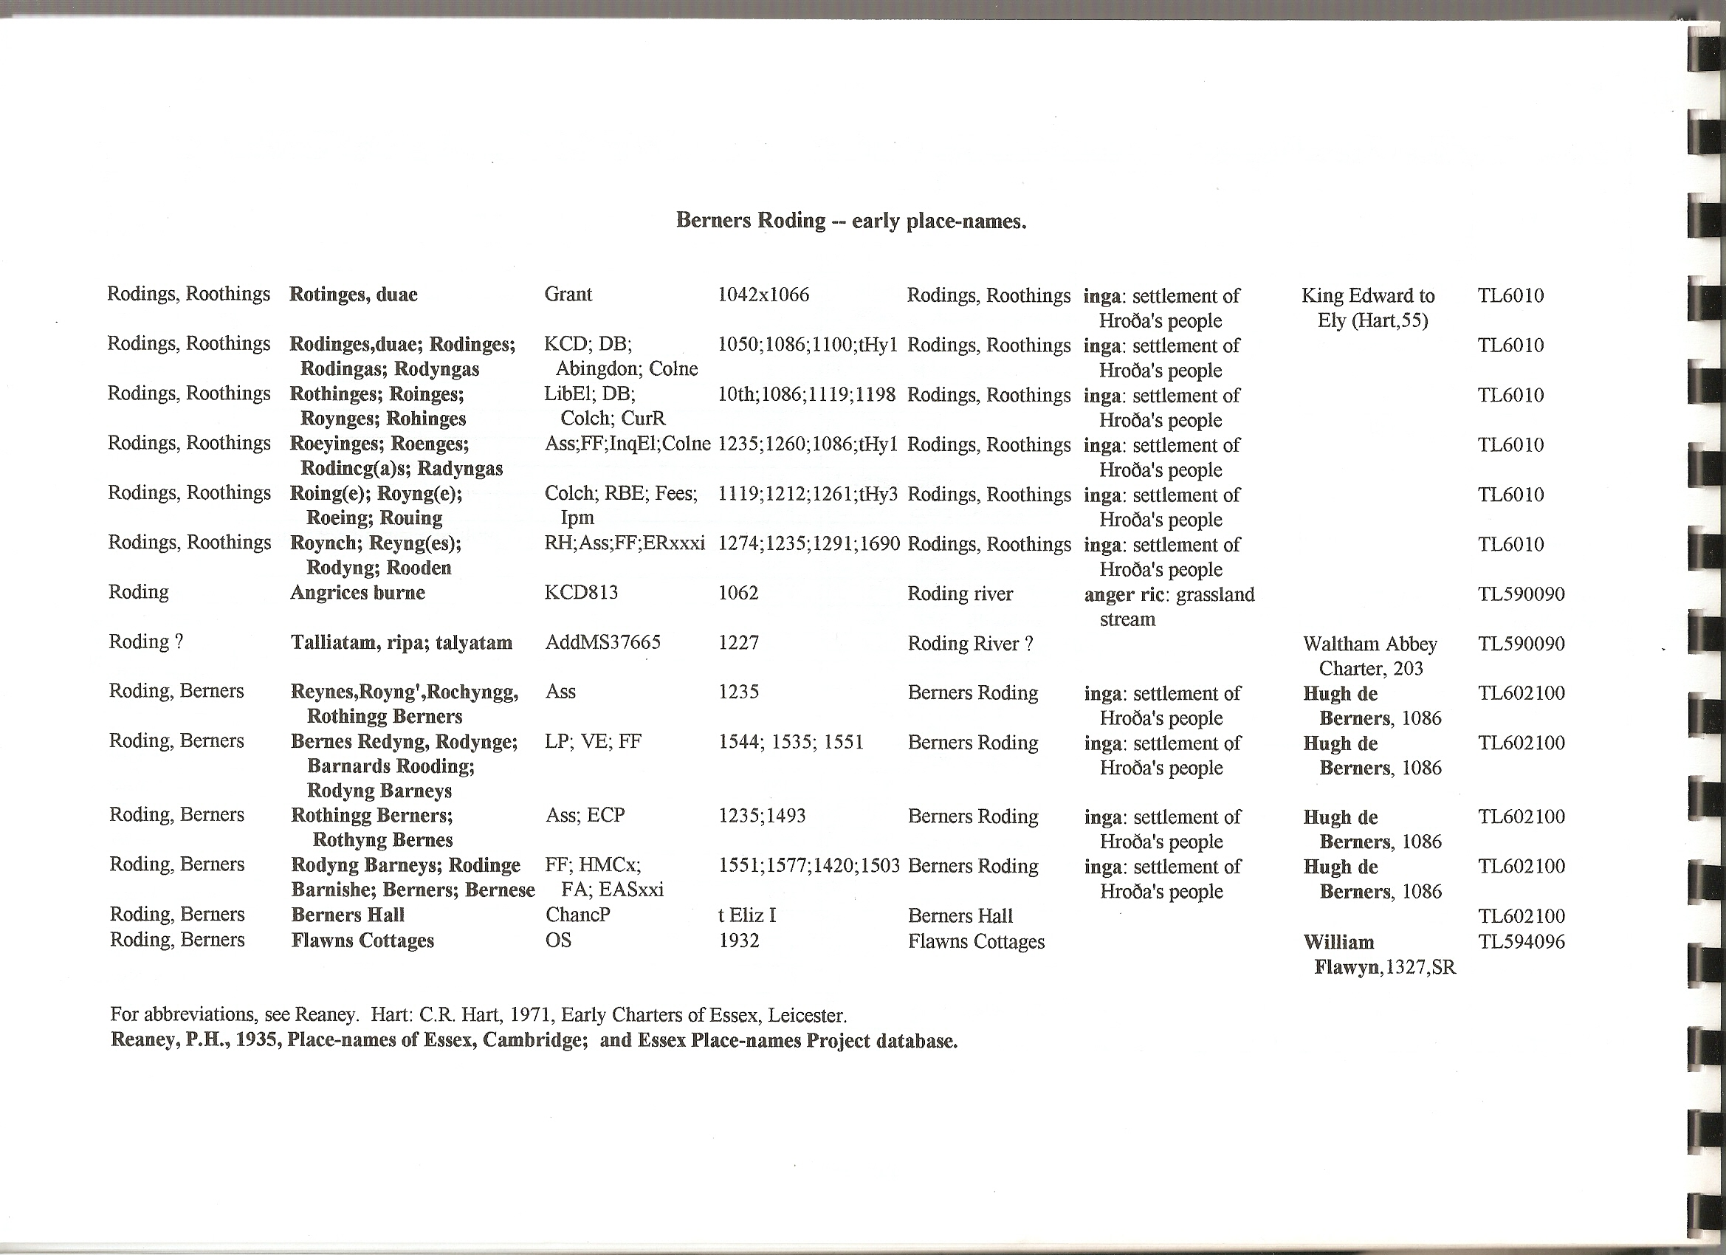
6” Ordnance Survey map, c.1875, with Tithe parcel nos. superimposed:-
