THE PLACE-NAMES

OF CHICKNEY

Recorder: James Kemble

Essex Place-names Project (Essex Society for Archaeology & History)

Essex Record Office e-book, 2nd edition, 2010. (1st edition in hard copy 2004).

www.essex.ac.uk/history/esah/essexplacenames

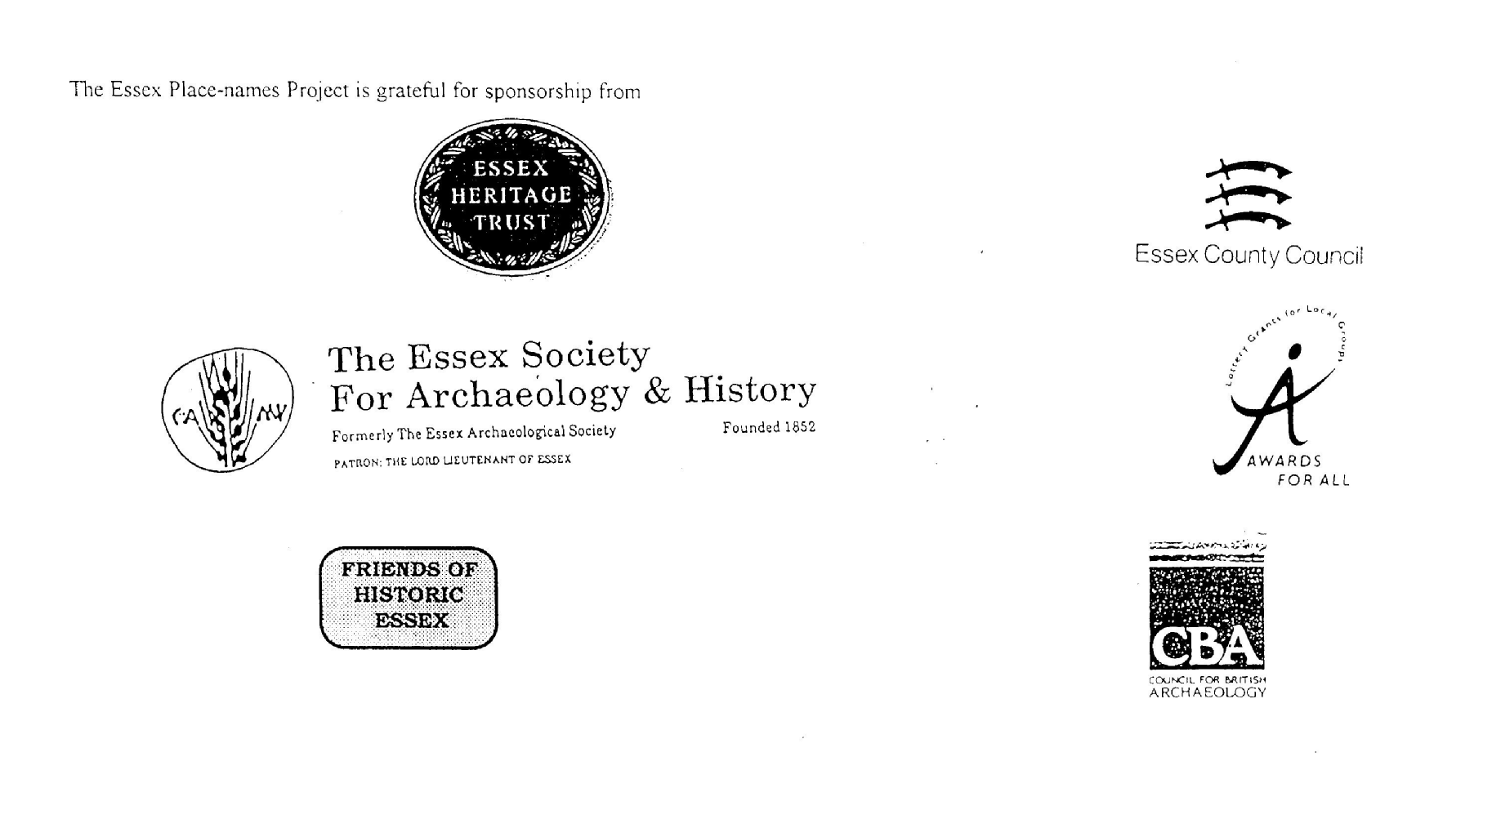

ESSEX PLACE-NAMES PROJECT.

The Essex Place-names Project is a County-wide survey to record place- and field-names from historical documents such as Tithe maps and apportionments, estate maps, sale and auction catalogues, conveyances, terriers, deeds, rolls, inquisitions and surveys.

The second element of the Project is to investigate on-the-ground visible remains which correspond to the Place-names for actual or potential archaeological, agricultural and industrial
sites, and to record natural (topographical) and man-made features which may relate to the Place-name. This involves field-survey in rural and outside investigation in built-up areas.

It is anticipated that the Project will lead to identification of archaeological sites and lost historic buildings; it will enable analysis of indicators of early settlement, land holding, agricultural and industrial practices of the County. It will refine the more precise meaning of descriptive words and elements used by earlier settlers as they gave names appropriate to the topography of the landscape of their time.

For convenience the surveys are based on the parish, recognising that present civil parish boundaries are not necessarily identical to former ecclesiastical boundaries. Local Recorders
are supplied with templates of Record Forms to ensure consistency of recording across the County, and forward completed forms to a Central Coordinator for transfer to a county
computer database which is available at the Essex Record Office to researchers.

This publication presents part of the information recorded from the Tithe or Estate Award and Map, (and from other documents for this parish.) The full record is contained on the master database in the Essex Record Office, Wharf Road, Chelmsford CM2 6YT and the website www.essex.ac.uk/history/esah/essexplacenames. Parish books are available from the ERO on disc or in hard copy or may be downloaded from the website. Please notify errors to the Project Coordinator at the Essex Record Office.

THE TITHE MAP AND APPORTIONMENT.

Since medieval times a tenth of the produce of land and stock had been paid by landholders to the church. At the Dissolution of the Monasteries, the property of many religious houses,
including the right to collect tithes, passed into lay hands. The Tithe Commutation Act which received Royal assent on 13th August 1836 abolished a rent payable in kind and
substituted rent-charges apportioned on each plot or parcel. The tithe-rent payable was assessed on the average value of wheat, barley and oats and was to fluctuate with price movements.

The commutation could be by voluntary agreement between the local owners and payers or, if agreement failed, could be compulsorily imposed by commissioners. A Valuer was to be
appointed to apportion the rent of each parcel of land and tenants could deduct that rent-charge from their rent paid to the landlord. The task fell to the Tithe Commissioners to produce a map and an Apportionment (Award). A large-scale survey was produced for over 70% of England and Wales in the following 9 years, and about another 8% up to 1855. Most of the
parishes in Essex were surveyed. The map scales vary. The Award records ownership, tenancy and land-use, field by field and parcel by parcel (often quoting the field name) with the
ground area and rent-charge.

Land that was tithe-free tends to be less accurately mapped and contains few if any of the details recorded for those parcels subject to tithe. Rights of way and roads also tend to be
neglected. Boundaries of the tithe areas are shown as are some natural features such as streams, ponds, gardens, greens and commons. Buildings are often shown coloured red if dwellings or grey if not. Because the Award may have been agreed only some time after the map was finished, discrepancies occur between the two. Enclosure Awards, when extant, usually date to the 18th and early 19th centuries. J.Kemble.
Reproduced by permission
of Essex County Council.

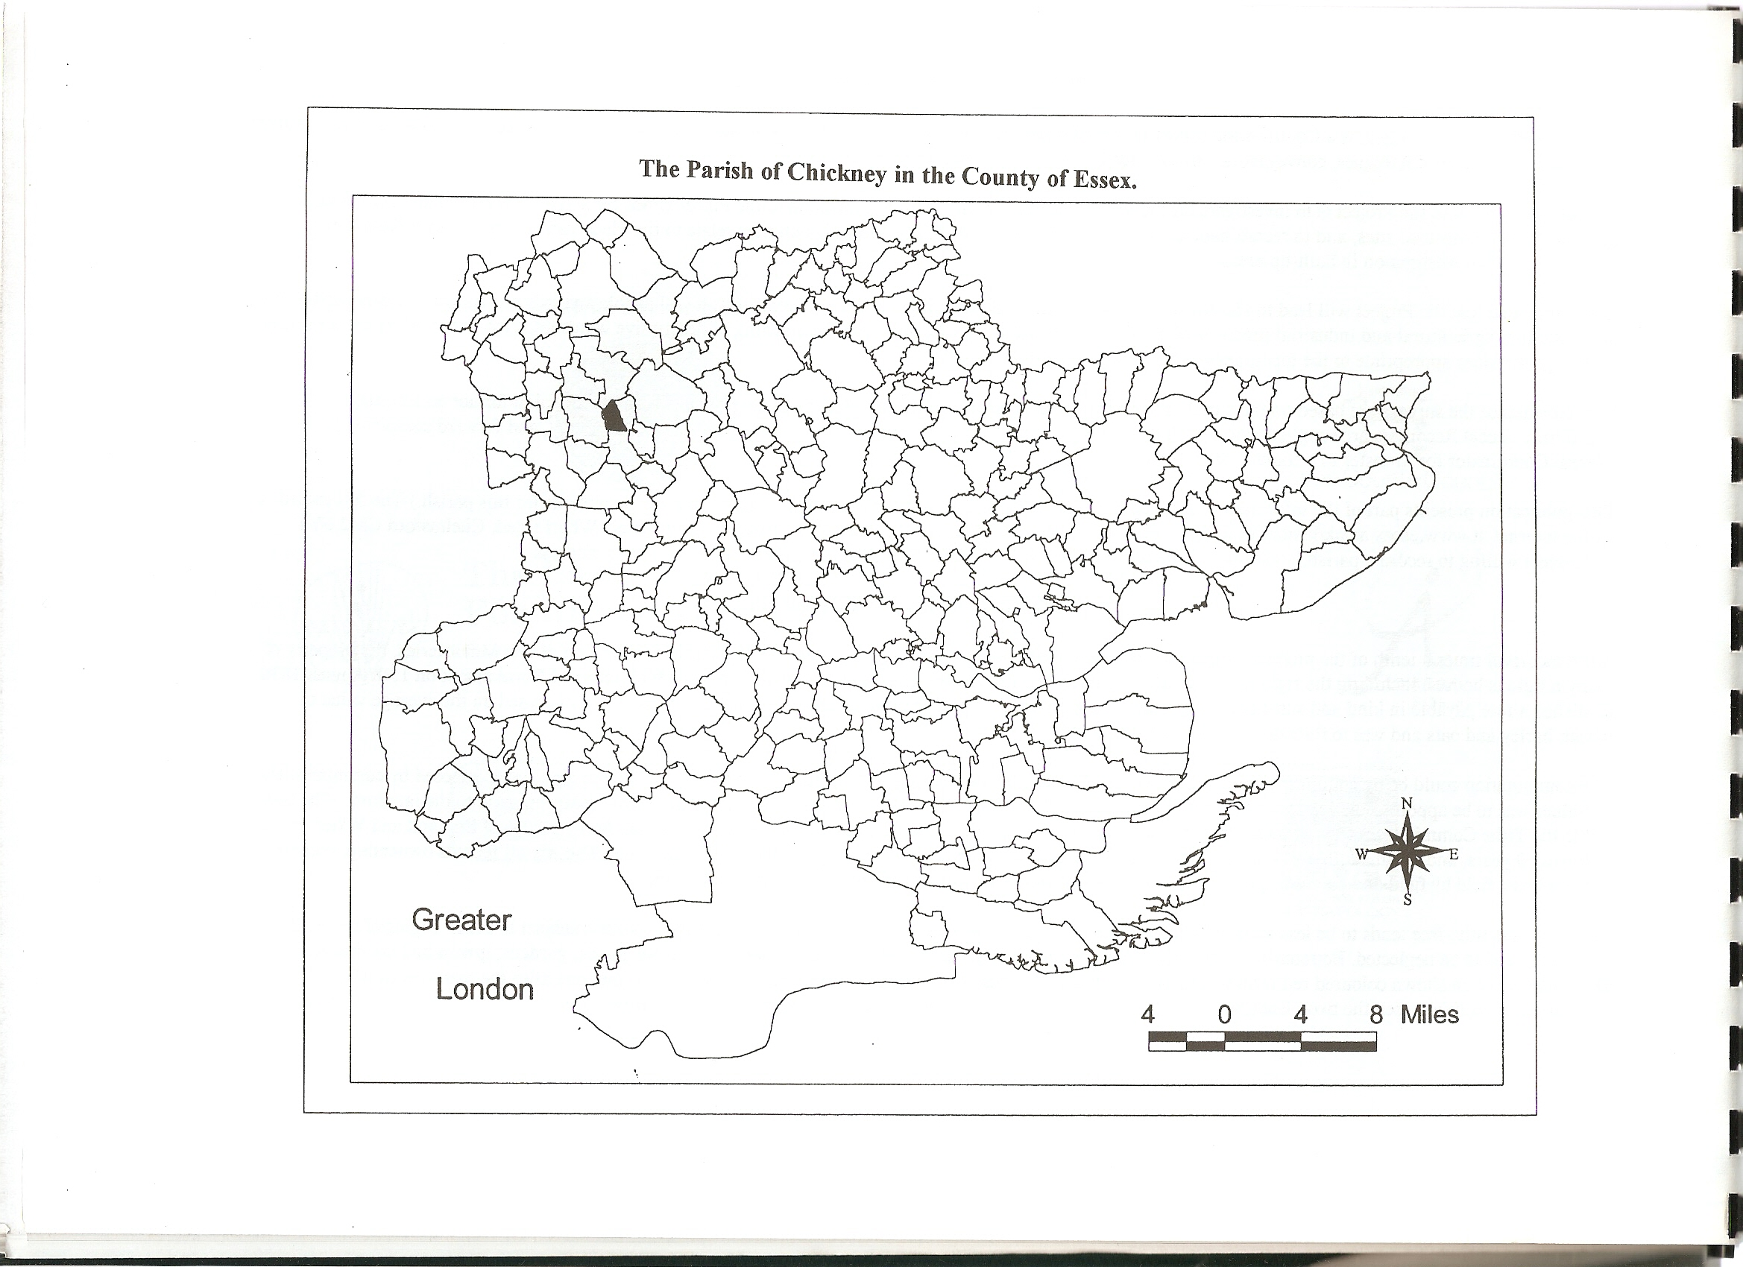
Reproduced by permission of Essex County Council.
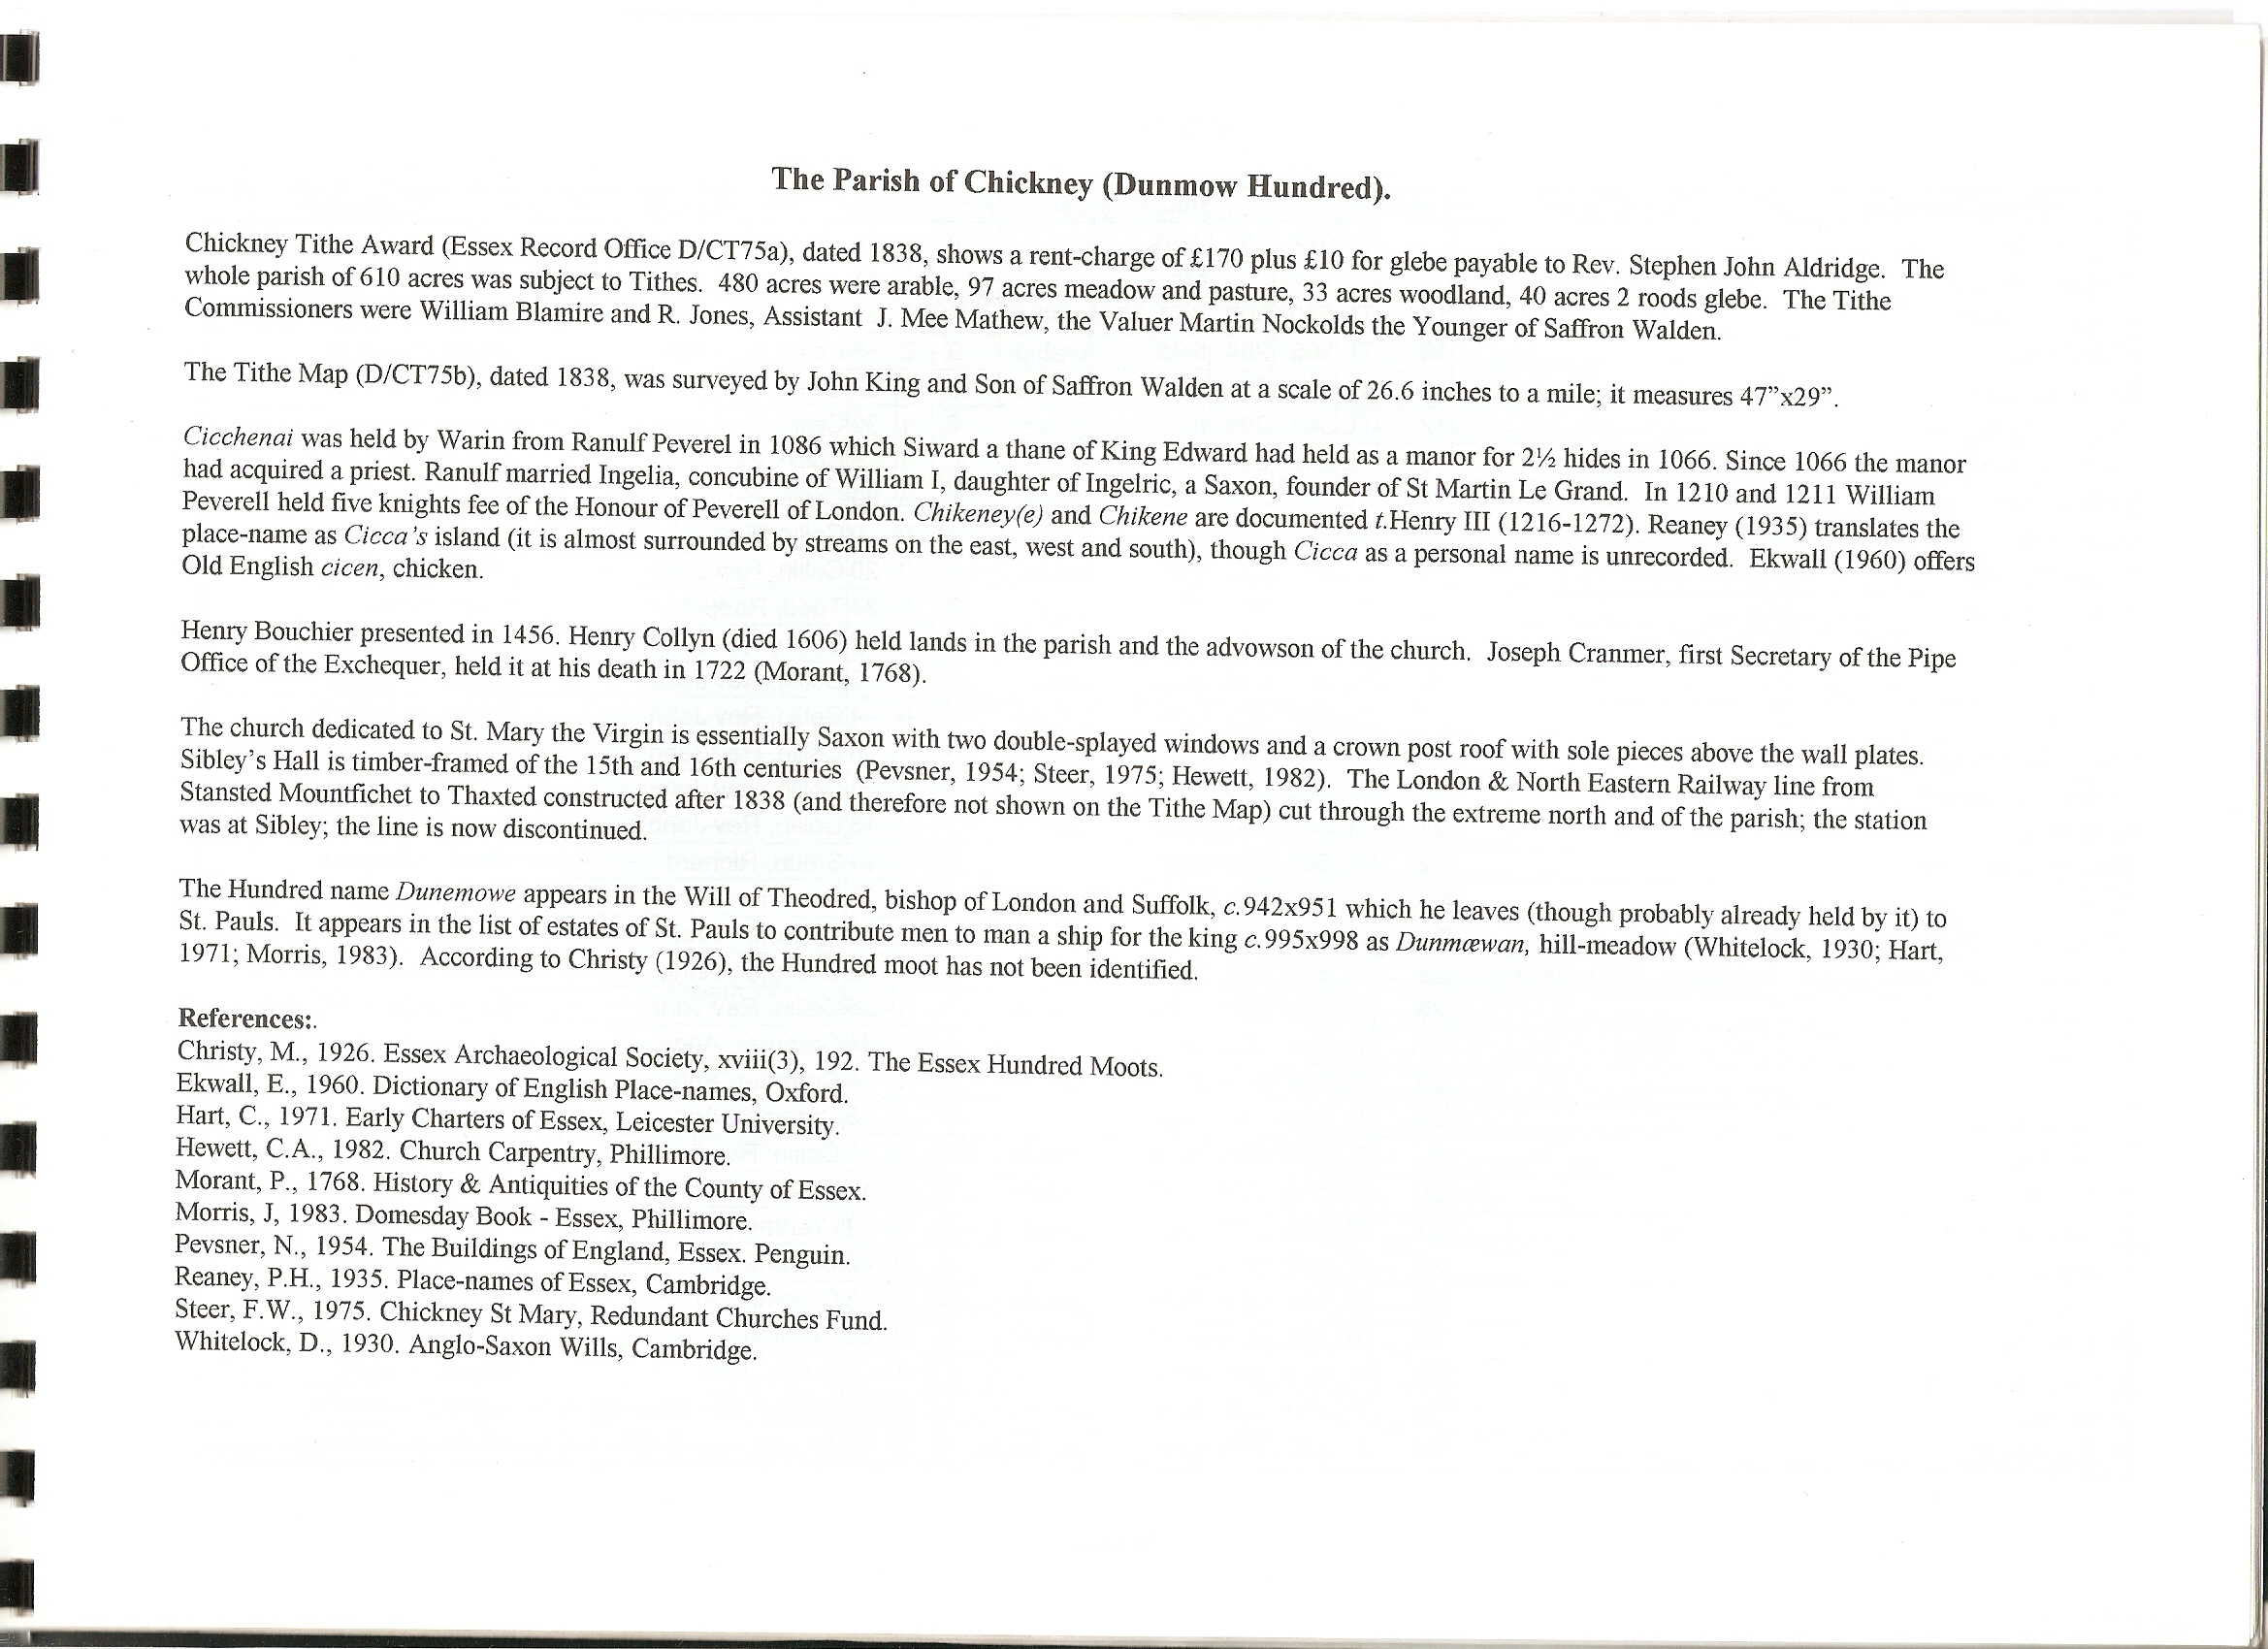

The Tithe Award Place-names of Chickney – by Parcel No.

Place-name | Alias | Fld No | Gd Ref | x | y | Place Type | Acr | rd | pch | Land use | Owner | Occupier | Name of farm | Other information
Church yard | [ St Mary’s] |  | TL | 572 | 281 | chch | 0 | 2 | 12
Roads, waste etc |  |  |  |  |  | rds | 11 | 3 | 11
Chickney Croft |  | 1 | TL | 570 | 300 | field | 5 | 3 | 29 | arable | Collin, Rev John | Andrews, William
Old Ley |  | 2 | TL | 568 | 300 | field | 7 | 0 | 4 | arable | Collin, Rev John | Andrews, William
Borders field |  | 3 | TL | 569 | 298 | field | 11 | 3 | 0 | arable | Collin, Rev John | Andrews, William
The Stow |  | 4 | TL | 566 | 298 | field | 8 | 2 | 15 | grass | Collin, Rev John | Joyce, Thomas
Sibley's Farm homestead |  | 5 | TL | 566 | 296 | hmstd | 1 | 1 | 24 |  | Collin, Rev John | Joyce, Thomas |  | John Sibily,1319, SubsidyRoll(PRO)
Purse field |  | 6 | TL | 568 | 296 | field | 11 | 2 | 20 | arable | Collin, Rev John | Joyce, Thomas
Barn Ley Pasture |  | 7 | TL | 567 | 296 | field | 6 | 0 | 0 | grass | Collin, Rev John | Joyce, Thomas
Barn Ley Pasture |  | 8 | TL | 566 | 295 | field | 5 | 2 | 3 | grass | Collin, Rev John | Joyce, Thomas
Gate Ley |  | 9 | TL | 564 | 296 | field | 11 | 2 | 22 | grass | Collin, Rev John | Joyce, Thomas
The Grove |  | 10 | TL | 566 | 294 | field | 9 | 2 | 36 | arable | Collin, Rev John | Joyce, Thomas
Great Stoney field |  | 11 | TL | 564 | 294 | field | 10 | 1 | 33 | arable | Collin, Rev John | Joyce, Thomas
Pasture by Camp |  | 12 | TL | 563 | 294 | field | 2 | 1 | 39 | grass | Collin, Rev John | Joyce, Thomas
Cottage, garden | Burnt House, 1875,OS | 13 | TL | 563 | 294 | bldg | 0 | 1 | 5 |  | Collin, Rev John | Camp, Joshua; Barker, John
Little Stoney field |  | 14 | TL | 563 | 295 | field | 5 | 3 | 29 | arable | Collin, Rev John | Joyce, Thomas
Park field |  | 15 | TL | 563 | 294 | field | 4 | 0 | 0 | arable | Collin, Rev John | Joyce, Thomas
Hither Pasture |  | 16 | TL | 562 | 295 | field | 1 | 0 | 20 | arable | Collin, Rev John | Joyce, Thomas
Chickney field |  | 17 | TL | 560 | 294 | field | 9 | 0 | 27 | arable | Todd, Radcliffe | Bush, James
Garden |  | 18 | TL | 562 | 294 | gdn | 0 | 0 | 12 |  | Collin, Rev John | Camp, Joshua; Barker, John
Grove |  | 19 | TL | 561 | 294 | wood | 0 | 1 | 3 | wood | Collin, Rev John | Joyce, Thomas
Three Cornered Pasture |  | 20 | TL | 562 | 294 | field | 1 | 1 | 26 | grass | Collin, Rev John | Joyce, Thomas
Three Cornered Pasture |  | 20 | TL | 562 | 294 | wood | 0 | 1 | 0 | wood | Collin, Rev John | Joyce, Thomas
Nine Acres |  | 21 | TL | 562 | 292 | field | 17 | 3 | 15 | arable | Collin, Rev John | Joyce, Thomas
Cottage & orchard |  | 22 | TL | 561 | 292 | cttg | 0 | 1 | 24 |  | Smith, Richard | Smith, Abraham
Slipe |  | 23 | TL | 561 | 291 | field | 0 | 0 | 25 | grass | Cranmer, Anne | Chipperfield, Thomas
Orchard Pightle |  | 24 | TL | 561 | 291 | field | 0 | 2 | 29 | grass | Cranmer, Anne | Chipperfield, Thomas
Springate Farm Homestead | Springate, 1610, Newcourt | 25 | TL | 561 | 290 | hmstd | 0 | 2 | 12 |  | Cranmer, Anne | Chipperfield, Thomas
Chickney field |  | 26 | TL | 559 | 290 | field | 11 | 1 | 26 | arable | Collin, Rev John | Chipperfield, Thomas
Garden |  | 27 | TL | 559 | 288 | gdn | 0 | 0 | 34 |  | Cranmer, Anne | Gunn, James; Prior, George
Basters Pasture |  | 28 | TL | 558 | 288 | field | 2 | 1 | 14 | grass | Cranmer, Anne | Clark, James
Cottage & garden |  | 29 | TL | 559 | 288 | cttg | 0 | 1 | 5 |  | Cranmer, Anne | Gunn, James; Prior, George
Barn field |  | 30 | TL | 560 | 288 | field | 7 | 2 | 16 | arable | Cranmer, Anne | Chipperfield, Thomas
Cartshed Pightle |  | 31 | TL | 562 | 290 | field | 3 | 1 | 3 | grass | Cranmer, Anne | Chipperfield, Thomas
Garden |  | 32 | TL | 562 | 289 | gdn | 0 | 0 | 22 | grass | Cranmer, Anne | Chipperfield, Thomas
Lacies |  | 33 | TL | 563 | 288 | field | 4 | 0 | 3 | arable | Cranmer, Anne | Chipperfield, Thomas
Five Acres |  | 34 | TL | 563 | 289 | field | 5 | 0 | 25 | arable | Cranmer, Anne | Chipperfield, Thomas
Cottage & garden |  | 35 | TL | 563 | 290 | cttg | 0 | 1 | 4 |  | Smith, John | Clark, Richard; unoccupied
Acre field |  | 36 | TL | 563 | 289 | field | 1 | 0 | 20 | arable | Aldrich, Rev Stephen John | Nottage, Thomas |  | glebe
Parsonage Yard |  | 37 | TL | 563 | 288 | field | 1 | 2 | 39 | arable | Aldrich, Rev Stephen John | Nottage, Thomas |  | glebe. Moated
Cranes Yard |  | 38 | TL | 564 | 288 | field | 1 | 2 | 1 | grass | Cranmer, Anne | Chipperfield, Thomas
Seven Acres |  | 39 | TL | 564 | 290 | field | 6 | 3 | 1 | arable | Cranmer, Anne | Chipperfield, Thomas
Little field |  | 40 | TL | 565 | 289 | field | 2 | 2 | 24 | arable | Cranmer, Anne | Chipperfield, Thomas
Great Harwoods |  | 41 | TL | 565 | 290 | field | 10 | 3 | 11 | arable | Aldrich, Rev Stephen John | Nottage, Thomas |  | glebe
Grove |  | 42 | TL | 567 | 291 | wood | 0 | 1 | 37 | wood | Collin, Rev John | Joyce, Thomas
Dukes field |  | 43 | TL | 567 | 292 | field | 17 | 3 | 9 | arable | Collin, Rev John | Joyce, Thomas
Hoppett |  | 44 | TL | 568 | 293 | field | 1 | 0 | 0 | grass | Collin, Rev John | Joyce, Thomas
Ploughed Barn Ley |  | 45 | TL | 569 | 295 | field | 10 | 0 | 0 | arable | Collin, Rev John | Joyce, Thomas
Grove |  | 46 | TL | 569 | 293 | wood | 0 | 1 | 23 | wood | Collin, Rev John | Joyce, Thomas
Long Mead |  | 47 | TL | 569 | 292 | field | 12 | 2 | 39 | grass | Collin, Rev John | Joyce, Thomas
Newlands |  | 48 | TL | 568 | 289 | field | 14 | 2 | 4 | arable | Collin, Rev John | Joyce, Thomas
Grove |  | 49 | TL | 566 | 288 | wood | 0 | 3 | 27 | wood | Collin, Rev John | Joyce, Thomas
Great Newgate |  | 50 | TL | 566 | 287 | field | 11 | 1 | 4 | arable | Cranmer, Anne | Chipperfield, Thomas
Three Corners |  | 51 | TL | 565 | 288 | field | 5 | 0 | 28 | arable | Cranmer, Anne | Chipperfield, Thomas
Moat field |  | 52 | TL | 564 | 286 | field | 6 | 0 | 0 | arable | Aldrich, Rev Stephen John | Nottage, Thomas |  | glebe
Broad field |  | 53 | TL | 563 | 286 | field | 5 | 0 | 30 | arable | Aldrich, Rev Stephen John | Nottage, Thomas |  | glebe
Woodstalls |  | 54 | TL | 562 | 287 | field | 6 | 2 | 18 | arable | Cranmer, Anne | Clark, James
Bean field |  | 55 | TL | 560 | 287 | field | 2 | 3 | 6 | arable | Cranmer, Anne | Clark, James
Bean field |  | 55 | TL | 560 | 287 | field | 2 | 0 | 13 | grass | Cranmer, Anne | Clark, James
Seven Acres | Duds Wood (pt), 1777,C | 56 | TL | 562 | 285 | field | 8 | 2 | 28 | arable | Cranmer, Anne | Clark, James
Spring Gate Grove | Duds Wood (pt), 1777,C | 57 | TL | 563 | 286 | wood | 8 | 1 | 18 | wood | Cranmer, Anne | Cranmer, Anne |  | Willis’s Spring, 1875,OS
White Lands | Duds Wood (pt), 1777,C | 58 | TL | 563 | 285 | field | 13 | 2 | 5 | arable | Cranmer, Anne | Clark, James
Stoney field |  | 59 | TL | 564 | 285 | field | 11 | 2 | 25 | arable | Aldrich, Rev Stephen John | Nottage, Thomas |  | glebe
Old Ley |  | 60 | TL | 564 | 286 | field | 6 | 2 | 32 | arable | Aldrich, Rev Stephen John | Nottage, Thomas |  | glebe
Strawberry Ley |  | 61 | TL | 567 | 286 | field | 14 | 1 | 25 | arable | Cranmer, Anne | Clark, James
Strawberry field |  | 62 | TL | 570 | 287 | field | 25 | 1 | 12 | arable | Cranmer, Anne | Clark, James
Crayborn Mead |  | 63 | TL | 571 | 288 | field | 1 | 0 | 6 | grass | Aldrich, Rev Stephen John | Clark, James |  | glebe
Hoe Mead |  | 64 | TL | 573 | 285 | field | 7 | 1 | 24 | grass | Cranmer, Anne | Clark, James
Rush Mead |  | 65 | TL | 573 | 284 | field | 0 | 2 | 11 | grass | Aldrich, Rev Stephen John | Clark, James |  | glebe
Slugs Acre |  | 66 | TL | 575 | 284 | field | 1 | 2 | 25 | grass | Cranmer, Anne | Clark, James
Mill field |  | 67 | TL | 572 | 284 | field | 28 | 2 | 19 | arable | Cranmer, Anne | Clark, James
Long Mead |  | 68 | TL | 567 | 285 | field | 4 | 2 | 29 | arable | Cranmer, Anne | Clark, James
Stoney field |  | 69 | TL | 566 | 285 | field | 7 | 2 | 3 | arable | Cranmer, Anne | Clark, James
Bush field |  | 70 | TL | 568 | 283 | field | 20 | 0 | 26 | arable | Cranmer, Anne | Clark, James
Bush field Spring | Bush Spring, 1875, OS | 71 | TL | 566 | 283 | wood | 3 | 1 | 20 | wood | Cranmer, Anne | Clark, James
Hungerdown |  | 72 | TL | 565 | 283 | field | 12 | 3 | 16 | arable | Cranmer, Anne | Clark, James
Bottoms Pasture |  | 73 | TL | 563 | 282 | field | 6 | 0 | 0 | grass | Cranmer, Anne | Clark, James
Grove | Duds Wood (pt), 1777,C | 74 | TL | 562 | 284 | wood | 2 | 0 | 0 | wood | Aldrich, Rev Stephen John | Clark, James |  | glebe
Rounds Park | Duds Wood (pt), 1777,C | 75 | TL | 561 | 282 | field | 8 | 2 | 28 | arable | Cranmer, Anne | Clark, James
Salings | Duds Wood (pt), 1777,C | 76 | TL | 562 | 282 | field | 14 | 2 | 31 | arable | Cranmer, Anne | Clark, James
Grove | Duds Wood (pt), 1777,C | 77 | TL | 560 | 282 | wood | 0 | 1 | 17 | wood | Cranmer, Anne | Clark, James
Hoeling Wood | Duds Wood (pt), 1777,C | 78 | TL | 562 | 281 | wood | 7 | 0 | 27 | wood | Cranmer, Anne | Clark, James |  | Hawland Wood, 1875,OS
Hoeling Wood | Duds Wood (pt), 1777,C | 79 | TL | 564 | 280 | wood | 12 | 1 | 28 | wood | Cranmer, Anne | Cranmer, Anne
The Bottoms |  | 80 | TL | 565 | 280 | field | 13 | 3 | 27 | arable | Cranmer, Anne | Clark, James
Great Hazells |  | 81 | TL | 566 | 278 | field | 13 | 3 | 16 | arable | Cranmer, Anne | Clark, James
Sharmans |  | 82 | TL | 567 | 279 | field | 4 | 1 | 7 | arable | Cranmer, Anne | Clark, James
Garden |  | 83 | TL | 568 | 278 | gdn | 0 | 0 | 20 |  | Cranmer, Anne | Gunn, Thomas; Bartropp, William
Poll Shot |  | 84 | TL | 569 | 280 | field | 11 | 0 | 22 | arable | Cranmer, Anne | Clark, James
Poll Shot Mead |  | 85 | TL | 569 | 281 | field | 5 | 0 | 4 | grass | Cranmer, Anne | Clark, James
Church field |  | 86 | TL | 572 | 283 | field | 4 | 3 | 35 | grass | Cranmer, Anne | Clark, James
Church field |  | 87 | TL | 572 | 282 | field | 10 | 3 | 28 | arable | Cranmer, Anne | Clark, James
Chaseway |  | 88 | TL | 571 | 281 |  | 0 | 1 | 37 |  | Cranmer, Anne | Clark, James
Cottage & garden |  | 89 | TL | 572 | 281 | cttg | 0 | 1 | 0 |  | Cranmer, Anne | Gunn, Thomas; Bartropp, William
Stow |  | 91 | TL | 573 | 280 | field | 7 | 3 | 4 | grass | Cranmer, Anne | Clark, James
The Moors |  | 92 | TL | 574 | 282 | field | 8 | 2 | 30 | grass | Cranmer, Anne | Clark, James
Chickney Hall Homestead | Chicchenai, 1086,DB | 93 | TL | 573 | 279 | hmstd | 3 | 0 | 33 |  | Cranmer, Anne | Clark, James
Dovehouse Pightle |  | 94 | TL | 573 | 278 | field | 3 | 0 | 28 | grass | Cranmer, Anne | Clark, James
Broad field |  | 95 | TL | 570 | 278 | field | 36 | 2 | 15 | arable | Cranmer, Anne | Clark, James
Horse Pasture |  | 96 | TL | 572 | 277 | field | 6 | 1 | 29 | grass | Cranmer, Anne | Clark, James
Cow Pasture |  | 97 | TL | 574 | 277 | field | 14 | 3 | 17 | grass | Cranmer, Anne | Clark, James

For abbreviations see Reaney, P., Place-names of Essex, Cambridge 1935; and Kemble, J., Essex Place-names, Places, Streets & People, Historical Publications, London 2007.

The Tithe Award Place-names of Chickney – by Place-name.

Place-name | Alias | Fld No | Gd Ref | x | y | Place Type | Acr | rd | pch | Land use | Owner | Occupier | Name of farm | Other information
Acre field |  | 36 | TL | 563 | 289 | field | 1 | 0 | 20 | arable | Aldrich, Rev Stephen John | Nottage, Thomas |  | glebe
Barn field |  | 30 | TL | 560 | 288 | field | 7 | 2 | 16 | arable | Cranmer, Anne | Chipperfield, Thomas
Barn Ley Pasture |  | 7 | TL | 567 | 296 | field | 6 | 0 | 0 | grass | Collin, Rev John | Joyce, Thomas
Barn Ley Pasture |  | 8 | TL | 566 | 295 | field | 5 | 2 | 3 | grass | Collin, Rev John | Joyce, Thomas
Basters Pasture |  | 28 | TL | 558 | 288 | field | 2 | 1 | 14 | grass | Cranmer, Anne | Clark, James
Bean field |  | 55 | TL | 560 | 287 | field | 2 | 3 | 6 | arable | Cranmer, Anne | Clark, James
Bean field |  | 55 | TL | 560 | 287 | field | 2 | 0 | 13 | grass | Cranmer, Anne | Clark, James
Borders field |  | 3 | TL | 569 | 298 | field | 11 | 3 | 0 | arable | Collin, Rev John | Andrews, William
Bottoms Pasture |  | 73 | TL | 563 | 282 | field | 6 | 0 | 0 | grass | Cranmer, Anne | Clark, James
Broad field |  | 53 | TL | 563 | 286 | field | 5 | 0 | 30 | arable | Aldrich, Rev Stephen John | Nottage, Thomas |  | glebe
Broad field |  | 95 | TL | 570 | 278 | field | 36 | 2 | 15 | arable | Cranmer, Anne | Clark, James
Bush field |  | 70 | TL | 568 | 283 | field | 20 | 0 | 26 | arable | Cranmer, Anne | Clark, James
Bush field Spring | Bush Spring, 1875, OS | 71 | TL | 566 | 283 | wood | 3 | 1 | 20 | wood | Cranmer, Anne | Clark, James
Cartshed Pightle |  | 31 | TL | 562 | 290 | field | 3 | 1 | 3 | grass | Cranmer, Anne | Chipperfield, Thomas
Chaseway |  | 88 | TL | 571 | 281 |  | 0 | 1 | 37 |  | Cranmer, Anne | Clark, James
Chickney Croft |  | 1 | TL | 570 | 300 | field | 5 | 3 | 29 | arable | Collin, Rev John | Andrews, William
Chickney field |  | 26 | TL | 559 | 290 | field | 11 | 1 | 26 | arable | Collin, Rev John | Chipperfield, Thomas
Chickney field |  | 17 | TL | 560 | 294 | field | 9 | 0 | 27 | arable | Todd, Radcliffe | Bush, James
Chickney Hall Homestead | Chicchenai, 1086,DB | 93 | TL | 573 | 279 | hmstd | 3 | 0 | 33 |  | Cranmer, Anne | Clark, James
Church field |  | 86 | TL | 572 | 283 | field | 4 | 3 | 35 | grass | Cranmer, Anne | Clark, James
Church field |  | 87 | TL | 572 | 282 | field | 10 | 3 | 28 | arable | Cranmer, Anne | Clark, James
Church yard | [ St Mary’s] |  | TL | 572 | 281 | chch | 0 | 2 | 12
Cottage & garden |  | 29 | TL | 559 | 288 | cttg | 0 | 1 | 5 |  | Cranmer, Anne | Gunn, James; Prior, George
Cottage & garden |  | 89 | TL | 572 | 281 | cttg | 0 | 1 | 0 |  | Cranmer, Anne | Gunn, Thomas; Bartropp, William
Cottage & garden |  | 35 | TL | 563 | 290 | cttg | 0 | 1 | 4 |  | Smith, John | Clark, Richard; unoccupied
Cottage & orchard |  | 22 | TL | 561 | 292 | cttg | 0 | 1 | 24 |  | Smith, Richard | Smith, Abraham
Cottage, garden | Burnt House, 1875,OS | 13 | TL | 563 | 294 | bldg | 0 | 1 | 5 |  | Collin, Rev John | Camp, Joshua; Barker, John
Cow Pasture |  | 97 | TL | 574 | 277 | field | 14 | 3 | 17 | grass | Cranmer, Anne | Clark, James
Cranes Yard |  | 38 | TL | 564 | 288 | field | 1 | 2 | 1 | grass | Cranmer, Anne | Chipperfield, Thomas
Crayborn Mead |  | 63 | TL | 571 | 288 | field | 1 | 0 | 6 | grass | Aldrich, Rev Stephen John | Clark, James |  | glebe
Dovehouse Pightle |  | 94 | TL | 573 | 278 | field | 3 | 0 | 28 | grass | Cranmer, Anne | Clark, James
Dukes field |  | 43 | TL | 567 | 292 | field | 17 | 3 | 9 | arable | Collin, Rev John | Joyce, Thomas
Five Acres |  | 34 | TL | 563 | 289 | field | 5 | 0 | 25 | arable | Cranmer, Anne | Chipperfield, Thomas
Garden |  | 18 | TL | 562 | 294 | gdn | 0 | 0 | 12 |  | Collin, Rev John | Camp, Joshua; Barker, John
Garden |  | 32 | TL | 562 | 289 | gdn | 0 | 0 | 22 | grass | Cranmer, Anne | Chipperfield, Thomas
Garden |  | 27 | TL | 559 | 288 | gdn | 0 | 0 | 34 |  | Cranmer, Anne | Gunn, James; Prior, George
Garden |  | 83 | TL | 568 | 278 | gdn | 0 | 0 | 20 |  | Cranmer, Anne | Gunn, Thomas; Bartropp, William
Gate Ley |  | 9 | TL | 564 | 296 | field | 11 | 2 | 22 | grass | Collin, Rev John | Joyce, Thomas
Great Harwoods |  | 41 | TL | 565 | 290 | field | 10 | 3 | 11 | arable | Aldrich, Rev Stephen John | Nottage, Thomas |  | glebe
Great Hazells |  | 81 | TL | 566 | 278 | field | 13 | 3 | 16 | arable | Cranmer, Anne | Clark, James
Great Newgate |  | 50 | TL | 566 | 287 | field | 11 | 1 | 4 | arable | Cranmer, Anne | Chipperfield, Thomas
Great Stoney field |  | 11 | TL | 564 | 294 | field | 10 | 1 | 33 | arable | Collin, Rev John | Joyce, Thomas
Grove | Duds Wood (pt), 1777,C | 74 | TL | 562 | 284 | wood | 2 | 0 | 0 | wood | Aldrich, Rev Stephen John | Clark, James |  | glebe
Grove |  | 19 | TL | 561 | 294 | wood | 0 | 1 | 3 | wood | Collin, Rev John | Joyce, Thomas
Grove |  | 42 | TL | 567 | 291 | wood | 0 | 1 | 37 | wood | Collin, Rev John | Joyce, Thomas
Grove |  | 46 | TL | 569 | 293 | wood | 0 | 1 | 23 | wood | Collin, Rev John | Joyce, Thomas
Grove |  | 49 | TL | 566 | 288 | wood | 0 | 3 | 27 | wood | Collin, Rev John | Joyce, Thomas
Grove | Duds Wood (pt), 1777,C | 77 | TL | 560 | 282 | wood | 0 | 1 | 17 | wood | Cranmer, Anne | Clark, James
Hither Pasture |  | 16 | TL | 562 | 295 | field | 1 | 0 | 20 | arable | Collin, Rev John | Joyce, Thomas
Hoe Mead |  | 64 | TL | 573 | 285 | field | 7 | 1 | 24 | grass | Cranmer, Anne | Clark, James
Hoeling Wood | Duds Wood (pt), 1777,C | 78 | TL | 562 | 281 | wood | 7 | 0 | 27 | wood | Cranmer, Anne | Clark, James |  | Hawland Wood, 1875,OS
Hoeling Wood | Duds Wood (pt), 1777,C | 79 | TL | 564 | 280 | wood | 12 | 1 | 28 | wood | Cranmer, Anne | Cranmer, Anne
Hoppett |  | 44 | TL | 568 | 293 | field | 1 | 0 | 0 | grass | Collin, Rev John | Joyce, Thomas
Horse Pasture |  | 96 | TL | 572 | 277 | field | 6 | 1 | 29 | grass | Cranmer, Anne | Clark, James
Hungerdown |  | 72 | TL | 565 | 283 | field | 12 | 3 | 16 | arable | Cranmer, Anne | Clark, James
Lacies |  | 33 | TL | 563 | 288 | field | 4 | 0 | 3 | arable | Cranmer, Anne | Chipperfield, Thomas
Little field |  | 40 | TL | 565 | 289 | field | 2 | 2 | 24 | arable | Cranmer, Anne | Chipperfield, Thomas
Little Stoney field |  | 14 | TL | 563 | 295 | field | 5 | 3 | 29 | arable | Collin, Rev John | Joyce, Thomas
Long Mead |  | 47 | TL | 569 | 292 | field | 12 | 2 | 39 | grass | Collin, Rev John | Joyce, Thomas
Long Mead |  | 68 | TL | 567 | 285 | field | 4 | 2 | 29 | arable | Cranmer, Anne | Clark, James
Mill field |  | 67 | TL | 572 | 284 | field | 28 | 2 | 19 | arable | Cranmer, Anne | Clark, James
Moat field |  | 52 | TL | 564 | 286 | field | 6 | 0 | 0 | arable | Aldrich, Rev Stephen John | Nottage, Thomas |  | glebe
Newlands |  | 48 | TL | 568 | 289 | field | 14 | 2 | 4 | arable | Collin, Rev John | Joyce, Thomas
Nine Acres |  | 21 | TL | 562 | 292 | field | 17 | 3 | 15 | arable | Collin, Rev John | Joyce, Thomas
Old Ley |  | 60 | TL | 564 | 286 | field | 6 | 2 | 32 | arable | Aldrich, Rev Stephen John | Nottage, Thomas |  | glebe
Old Ley |  | 2 | TL | 568 | 300 | field | 7 | 0 | 4 | arable | Collin, Rev John | Andrews, William
Orchard Pightle |  | 24 | TL | 561 | 291 | field | 0 | 2 | 29 | grass | Cranmer, Anne | Chipperfield, Thomas
Park field |  | 15 | TL | 563 | 294 | field | 4 | 0 | 0 | arable | Collin, Rev John | Joyce, Thomas
Parsonage Yard |  | 37 | TL | 563 | 288 | field | 1 | 2 | 39 | arable | Aldrich, Rev Stephen John | Nottage, Thomas |  | glebe. Moated
Pasture by Camp |  | 12 | TL | 563 | 294 | field | 2 | 1 | 39 | grass | Collin, Rev John | Joyce, Thomas
Ploughed Barn Ley |  | 45 | TL | 569 | 295 | field | 10 | 0 | 0 | arable | Collin, Rev John | Joyce, Thomas
Poll Shot |  | 84 | TL | 569 | 280 | field | 11 | 0 | 22 | arable | Cranmer, Anne | Clark, James
Poll Shot Mead |  | 85 | TL | 569 | 281 | field | 5 | 0 | 4 | grass | Cranmer, Anne | Clark, James
Purse field |  | 6 | TL | 568 | 296 | field | 11 | 2 | 20 | arable | Collin, Rev John | Joyce, Thomas
Roads, waste etc |  |  |  |  |  | rds | 11 | 3 | 11
Rounds Park | Duds Wood (pt), 1777,C | 75 | TL | 561 | 282 | field | 8 | 2 | 28 | arable | Cranmer, Anne | Clark, James
Rush Mead |  | 65 | TL | 573 | 284 | field | 0 | 2 | 11 | grass | Aldrich, Rev Stephen John | Clark, James |  | glebe
Salings | Duds Wood (pt), 1777,C | 76 | TL | 562 | 282 | field | 14 | 2 | 31 | arable | Cranmer, Anne | Clark, James
Seven Acres |  | 39 | TL | 564 | 290 | field | 6 | 3 | 1 | arable | Cranmer, Anne | Chipperfield, Thomas
Seven Acres | Duds Wood (pt), 1777,C | 56 | TL | 562 | 285 | field | 8 | 2 | 28 | arable | Cranmer, Anne | Clark, James
Sharmans |  | 82 | TL | 567 | 279 | field | 4 | 1 | 7 | arable | Cranmer, Anne | Clark, James
Sibley's Farm homestead |  | 5 | TL | 566 | 296 | hmstd | 1 | 1 | 24 |  | Collin, Rev John | Joyce, Thomas |  | John Sibily,1319, SubsidyRoll(PRO)
Slipe |  | 23 | TL | 561 | 291 | field | 0 | 0 | 25 | grass | Cranmer, Anne | Chipperfield, Thomas
Slugs Acre |  | 66 | TL | 575 | 284 | field | 1 | 2 | 25 | grass | Cranmer, Anne | Clark, James
Spring Gate Grove | Duds Wood (pt), 1777,C | 57 | TL | 563 | 286 | wood | 8 | 1 | 18 | wood | Cranmer, Anne | Cranmer, Anne |  | Willis’s Spring, 1875,OS
Springate Farm Homestead | Springate, 1610, Newcourt | 25 | TL | 561 | 290 | hmstd | 0 | 2 | 12 |  | Cranmer, Anne | Chipperfield, Thomas
Stoney field |  | 59 | TL | 564 | 285 | field | 11 | 2 | 25 | arable | Aldrich, Rev Stephen John | Nottage, Thomas |  | glebe
Stoney field |  | 69 | TL | 566 | 285 | field | 7 | 2 | 3 | arable | Cranmer, Anne | Clark, James
Stow |  | 91 | TL | 573 | 280 | field | 7 | 3 | 4 | grass | Cranmer, Anne | Clark, James
Strawberry field |  | 62 | TL | 570 | 287 | field | 25 | 1 | 12 | arable | Cranmer, Anne | Clark, James
Strawberry Ley |  | 61 | TL | 567 | 286 | field | 14 | 1 | 25 | arable | Cranmer, Anne | Clark, James
The Bottoms |  | 80 | TL | 565 | 280 | field | 13 | 3 | 27 | arable | Cranmer, Anne | Clark, James
The Grove |  | 10 | TL | 566 | 294 | field | 9 | 2 | 36 | arable | Collin, Rev John | Joyce, Thomas
The Moors |  | 92 | TL | 574 | 282 | field | 8 | 2 | 30 | grass | Cranmer, Anne | Clark, James
The Stow |  | 4 | TL | 566 | 298 | field | 8 | 2 | 15 | grass | Collin, Rev John | Joyce, Thomas
Three Cornered Pasture |  | 20 | TL | 562 | 294 | field | 1 | 1 | 26 | grass | Collin, Rev John | Joyce, Thomas
Three Cornered Pasture |  | 20 | TL | 562 | 294 | wood | 0 | 1 | 0 | wood | Collin, Rev John | Joyce, Thomas
Three Corners |  | 51 | TL | 565 | 288 | field | 5 | 0 | 28 | arable | Cranmer, Anne | Chipperfield, Thomas
White Lands | Duds Wood (pt), 1777,C | 58 | TL | 563 | 285 | field | 13 | 2 | 5 | arable | Cranmer, Anne | Clark, James
Woodstalls |  | 54 | TL | 562 | 287 | field | 6 | 2 | 18 | arable | Cranmer, Anne | Clark, James

For abbreviations see Reaney, P., Place-names of Essex, Cambridge 1935; and Kemble, J., Essex Place-names, Places, Streets & People, Historical Publications, London 2007.

The Tithe Award Place-names of Chickney – by Owner.

Place-name | Alias | Fld No | Gd Ref | x | y | Place Type | Acr | rd | pch | Land use | Owner | Occupier | Name of farm | Other information
Church yard | [ St Mary’s] |  | TL | 572 | 281 | chch | 0 | 2 | 12
Roads, waste etc |  |  |  |  |  | rds | 11 | 3 | 11
Crayborn Mead |  | 63 | TL | 571 | 288 | field | 1 | 0 | 6 | grass | Aldrich, Rev Stephen John | Clark, James |  | glebe
Rush Mead |  | 65 | TL | 573 | 284 | field | 0 | 2 | 11 | grass | Aldrich, Rev Stephen John | Clark, James |  | glebe
Grove | Duds Wood (pt), 1777,C | 74 | TL | 562 | 284 | wood | 2 | 0 | 0 | wood | Aldrich, Rev Stephen John | Clark, James |  | glebe
Acre field |  | 36 | TL | 563 | 289 | field | 1 | 0 | 20 | arable | Aldrich, Rev Stephen John | Nottage, Thomas |  | glebe
Parsonage Yard |  | 37 | TL | 563 | 288 | field | 1 | 2 | 39 | arable | Aldrich, Rev Stephen John | Nottage, Thomas |  | glebe. Moated
Great Harwoods |  | 41 | TL | 565 | 290 | field | 10 | 3 | 11 | arable | Aldrich, Rev Stephen John | Nottage, Thomas |  | glebe
Moat field |  | 52 | TL | 564 | 286 | field | 6 | 0 | 0 | arable | Aldrich, Rev Stephen John | Nottage, Thomas |  | glebe
Broad field |  | 53 | TL | 563 | 286 | field | 5 | 0 | 30 | arable | Aldrich, Rev Stephen John | Nottage, Thomas |  | glebe
Stoney field |  | 59 | TL | 564 | 285 | field | 11 | 2 | 25 | arable | Aldrich, Rev Stephen John | Nottage, Thomas |  | glebe
Old Ley |  | 60 | TL | 564 | 286 | field | 6 | 2 | 32 | arable | Aldrich, Rev Stephen John | Nottage, Thomas |  | glebe
Chickney Croft |  | 1 | TL | 570 | 300 | field | 5 | 3 | 29 | arable | Collin, Rev John | Andrews, William
Old Ley |  | 2 | TL | 568 | 300 | field | 7 | 0 | 4 | arable | Collin, Rev John | Andrews, William
Borders field |  | 3 | TL | 569 | 298 | field | 11 | 3 | 0 | arable | Collin, Rev John | Andrews, William
Cottage, garden | Burnt House, 1875,OS | 13 | TL | 563 | 294 | bldg | 0 | 1 | 5 |  | Collin, Rev John | Camp, Joshua; Barker, John
Garden |  | 18 | TL | 562 | 294 | gdn | 0 | 0 | 12 |  | Collin, Rev John | Camp, Joshua; Barker, John
Chickney field |  | 26 | TL | 559 | 290 | field | 11 | 1 | 26 | arable | Collin, Rev John | Chipperfield, Thomas
The Stow |  | 4 | TL | 566 | 298 | field | 8 | 2 | 15 | grass | Collin, Rev John | Joyce, Thomas
Sibley's Farm homestead |  | 5 | TL | 566 | 296 | hmstd | 1 | 1 | 24 |  | Collin, Rev John | Joyce, Thomas |  | John Sibily,1319, SubsidyRoll(PRO)
Purse field |  | 6 | TL | 568 | 296 | field | 11 | 2 | 20 | arable | Collin, Rev John | Joyce, Thomas
Barn Ley Pasture |  | 7 | TL | 567 | 296 | field | 6 | 0 | 0 | grass | Collin, Rev John | Joyce, Thomas
Barn Ley Pasture |  | 8 | TL | 566 | 295 | field | 5 | 2 | 3 | grass | Collin, Rev John | Joyce, Thomas
Gate Ley |  | 9 | TL | 564 | 296 | field | 11 | 2 | 22 | grass | Collin, Rev John | Joyce, Thomas
The Grove |  | 10 | TL | 566 | 294 | field | 9 | 2 | 36 | arable | Collin, Rev John | Joyce, Thomas
Great Stoney field |  | 11 | TL | 564 | 294 | field | 10 | 1 | 33 | arable | Collin, Rev John | Joyce, Thomas
Pasture by Camp |  | 12 | TL | 563 | 294 | field | 2 | 1 | 39 | grass | Collin, Rev John | Joyce, Thomas
Little Stoney field |  | 14 | TL | 563 | 295 | field | 5 | 3 | 29 | arable | Collin, Rev John | Joyce, Thomas
Park field |  | 15 | TL | 563 | 294 | field | 4 | 0 | 0 | arable | Collin, Rev John | Joyce, Thomas
Hither Pasture |  | 16 | TL | 562 | 295 | field | 1 | 0 | 20 | arable | Collin, Rev John | Joyce, Thomas
Grove |  | 19 | TL | 561 | 294 | wood | 0 | 1 | 3 | wood | Collin, Rev John | Joyce, Thomas
Three Cornered Pasture |  | 20 | TL | 562 | 294 | field | 1 | 1 | 26 | grass | Collin, Rev John | Joyce, Thomas
Three Cornered Pasture |  | 20 | TL | 562 | 294 | wood | 0 | 1 | 0 | wood | Collin, Rev John | Joyce, Thomas
Nine Acres |  | 21 | TL | 562 | 292 | field | 17 | 3 | 15 | arable | Collin, Rev John | Joyce, Thomas
Grove |  | 42 | TL | 567 | 291 | wood | 0 | 1 | 37 | wood | Collin, Rev John | Joyce, Thomas
Dukes field |  | 43 | TL | 567 | 292 | field | 17 | 3 | 9 | arable | Collin, Rev John | Joyce, Thomas
Hoppett |  | 44 | TL | 568 | 293 | field | 1 | 0 | 0 | grass | Collin, Rev John | Joyce, Thomas
Ploughed Barn Ley |  | 45 | TL | 569 | 295 | field | 10 | 0 | 0 | arable | Collin, Rev John | Joyce, Thomas
Grove |  | 46 | TL | 569 | 293 | wood | 0 | 1 | 23 | wood | Collin, Rev John | Joyce, Thomas
Long Mead |  | 47 | TL | 569 | 292 | field | 12 | 2 | 39 | grass | Collin, Rev John | Joyce, Thomas
Newlands |  | 48 | TL | 568 | 289 | field | 14 | 2 | 4 | arable | Collin, Rev John | Joyce, Thomas
Grove |  | 49 | TL | 566 | 288 | wood | 0 | 3 | 27 | wood | Collin, Rev John | Joyce, Thomas
Slipe |  | 23 | TL | 561 | 291 | field | 0 | 0 | 25 | grass | Cranmer, Anne | Chipperfield, Thomas
Orchard Pightle |  | 24 | TL | 561 | 291 | field | 0 | 2 | 29 | grass | Cranmer, Anne | Chipperfield, Thomas
Springate Farm Homestead | Springate, 1610, Newcourt | 25 | TL | 561 | 290 | hmstd | 0 | 2 | 12 |  | Cranmer, Anne | Chipperfield, Thomas
Barn field |  | 30 | TL | 560 | 288 | field | 7 | 2 | 16 | arable | Cranmer, Anne | Chipperfield, Thomas
Cartshed Pightle |  | 31 | TL | 562 | 290 | field | 3 | 1 | 3 | grass | Cranmer, Anne | Chipperfield, Thomas
Garden |  | 32 | TL | 562 | 289 | gdn | 0 | 0 | 22 | grass | Cranmer, Anne | Chipperfield, Thomas
Lacies |  | 33 | TL | 563 | 288 | field | 4 | 0 | 3 | arable | Cranmer, Anne | Chipperfield, Thomas
Five Acres |  | 34 | TL | 563 | 289 | field | 5 | 0 | 25 | arable | Cranmer, Anne | Chipperfield, Thomas
Cranes Yard |  | 38 | TL | 564 | 288 | field | 1 | 2 | 1 | grass | Cranmer, Anne | Chipperfield, Thomas
Seven Acres |  | 39 | TL | 564 | 290 | field | 6 | 3 | 1 | arable | Cranmer, Anne | Chipperfield, Thomas
Little field |  | 40 | TL | 565 | 289 | field | 2 | 2 | 24 | arable | Cranmer, Anne | Chipperfield, Thomas
Great Newgate |  | 50 | TL | 566 | 287 | field | 11 | 1 | 4 | arable | Cranmer, Anne | Chipperfield, Thomas
Three Corners |  | 51 | TL | 565 | 288 | field | 5 | 0 | 28 | arable | Cranmer, Anne | Chipperfield, Thomas
Basters Pasture |  | 28 | TL | 558 | 288 | field | 2 | 1 | 14 | grass | Cranmer, Anne | Clark, James
Woodstalls |  | 54 | TL | 562 | 287 | field | 6 | 2 | 18 | arable | Cranmer, Anne | Clark, James
Bean field |  | 55 | TL | 560 | 287 | field | 2 | 3 | 6 | arable | Cranmer, Anne | Clark, James
Bean field |  | 55 | TL | 560 | 287 | field | 2 | 0 | 13 | grass | Cranmer, Anne | Clark, James
Seven Acres | Duds Wood (pt), 1777,C | 56 | TL | 562 | 285 | field | 8 | 2 | 28 | arable | Cranmer, Anne | Clark, James
White Lands | Duds Wood (pt), 1777,C | 58 | TL | 563 | 285 | field | 13 | 2 | 5 | arable | Cranmer, Anne | Clark, James
Strawberry Ley |  | 61 | TL | 567 | 286 | field | 14 | 1 | 25 | arable | Cranmer, Anne | Clark, James
Strawberry field |  | 62 | TL | 570 | 287 | field | 25 | 1 | 12 | arable | Cranmer, Anne | Clark, James
Hoe Mead |  | 64 | TL | 573 | 285 | field | 7 | 1 | 24 | grass | Cranmer, Anne | Clark, James
Slugs Acre |  | 66 | TL | 575 | 284 | field | 1 | 2 | 25 | grass | Cranmer, Anne | Clark, James
Mill field |  | 67 | TL | 572 | 284 | field | 28 | 2 | 19 | arable | Cranmer, Anne | Clark, James
Long Mead |  | 68 | TL | 567 | 285 | field | 4 | 2 | 29 | arable | Cranmer, Anne | Clark, James
Stoney field |  | 69 | TL | 566 | 285 | field | 7 | 2 | 3 | arable | Cranmer, Anne | Clark, James
Bush field |  | 70 | TL | 568 | 283 | field | 20 | 0 | 26 | arable | Cranmer, Anne | Clark, James
Bush field Spring | Bush Spring, 1875, OS | 71 | TL | 566 | 283 | wood | 3 | 1 | 20 | wood | Cranmer, Anne | Clark, James
Hungerdown |  | 72 | TL | 565 | 283 | field | 12 | 3 | 16 | arable | Cranmer, Anne | Clark, James
Bottoms Pasture |  | 73 | TL | 563 | 282 | field | 6 | 0 | 0 | grass | Cranmer, Anne | Clark, James
Rounds Park | Duds Wood (pt), 1777,C | 75 | TL | 561 | 282 | field | 8 | 2 | 28 | arable | Cranmer, Anne | Clark, James
Salings | Duds Wood (pt), 1777,C | 76 | TL | 562 | 282 | field | 14 | 2 | 31 | arable | Cranmer, Anne | Clark, James
Grove | Duds Wood (pt), 1777,C | 77 | TL | 560 | 282 | wood | 0 | 1 | 17 | wood | Cranmer, Anne | Clark, James
Hoeling Wood | Duds Wood (pt), 1777,C | 78 | TL | 562 | 281 | wood | 7 | 0 | 27 | wood | Cranmer, Anne | Clark, James |  | Hawland Wood, 1875,OS
The Bottoms |  | 80 | TL | 565 | 280 | field | 13 | 3 | 27 | arable | Cranmer, Anne | Clark, James
Great Hazells |  | 81 | TL | 566 | 278 | field | 13 | 3 | 16 | arable | Cranmer, Anne | Clark, James
Sharmans |  | 82 | TL | 567 | 279 | field | 4 | 1 | 7 | arable | Cranmer, Anne | Clark, James
Poll Shot |  | 84 | TL | 569 | 280 | field | 11 | 0 | 22 | arable | Cranmer, Anne | Clark, James
Poll Shot Mead |  | 85 | TL | 569 | 281 | field | 5 | 0 | 4 | grass | Cranmer, Anne | Clark, James
Church field |  | 86 | TL | 572 | 283 | field | 4 | 3 | 35 | grass | Cranmer, Anne | Clark, James
Church field |  | 87 | TL | 572 | 282 | field | 10 | 3 | 28 | arable | Cranmer, Anne | Clark, James
Chaseway |  | 88 | TL | 571 | 281 |  | 0 | 1 | 37 |  | Cranmer, Anne | Clark, James
Stow |  | 91 | TL | 573 | 280 | field | 7 | 3 | 4 | grass | Cranmer, Anne | Clark, James
The Moors |  | 92 | TL | 574 | 282 | field | 8 | 2 | 30 | grass | Cranmer, Anne | Clark, James
Chickney Hall Homestead | Chicchenai, 1086,DB | 93 | TL | 573 | 279 | hmstd | 3 | 0 | 33 |  | Cranmer, Anne | Clark, James
Dovehouse Pightle |  | 94 | TL | 573 | 278 | field | 3 | 0 | 28 | grass | Cranmer, Anne | Clark, James
Broad field |  | 95 | TL | 570 | 278 | field | 36 | 2 | 15 | arable | Cranmer, Anne | Clark, James
Horse Pasture |  | 96 | TL | 572 | 277 | field | 6 | 1 | 29 | grass | Cranmer, Anne | Clark, James
Cow Pasture |  | 97 | TL | 574 | 277 | field | 14 | 3 | 17 | grass | Cranmer, Anne | Clark, James
Spring Gate Grove | Duds Wood (pt), 1777,C | 57 | TL | 563 | 286 | wood | 8 | 1 | 18 | wood | Cranmer, Anne | Cranmer, Anne |  | Willis’s Spring, 1875,OS
Hoeling Wood | Duds Wood (pt), 1777,C | 79 | TL | 564 | 280 | wood | 12 | 1 | 28 | wood | Cranmer, Anne | Cranmer, Anne
Garden |  | 27 | TL | 559 | 288 | gdn | 0 | 0 | 34 |  | Cranmer, Anne | Gunn, James; Prior, George
Cottage & garden |  | 29 | TL | 559 | 288 | cttg | 0 | 1 | 5 |  | Cranmer, Anne | Gunn, James; Prior, George
Garden |  | 83 | TL | 568 | 278 | gdn | 0 | 0 | 20 |  | Cranmer, Anne | Gunn, Thomas; Bartropp, William
Cottage & garden |  | 89 | TL | 572 | 281 | cttg | 0 | 1 | 0 |  | Cranmer, Anne | Gunn, Thomas; Bartropp, William
Cottage & garden |  | 35 | TL | 563 | 290 | cttg | 0 | 1 | 4 |  | Smith, John | Clark, Richard; unoccupied
Cottage & orchard |  | 22 | TL | 561 | 292 | cttg | 0 | 1 | 24 |  | Smith, Richard | Smith, Abraham
Chickney field |  | 17 | TL | 560 | 294 | field | 9 | 0 | 27 | arable | Todd, Radcliffe | Bush, James

For abbreviations see Reaney, P., Place-names of Essex, Cambridge 1935; and Kemble, J., Essex Place-names, Places, Streets & People, Historical Publications, London 2007.

