THE PLACE-NAMES

OF CHIGNALL

Recorder: James Kemble

Essex Place-names Project (Essex Society for Archaeology & History), 2013 (e-book).

www.essex.ac.uk/history/esah/essexplacenames

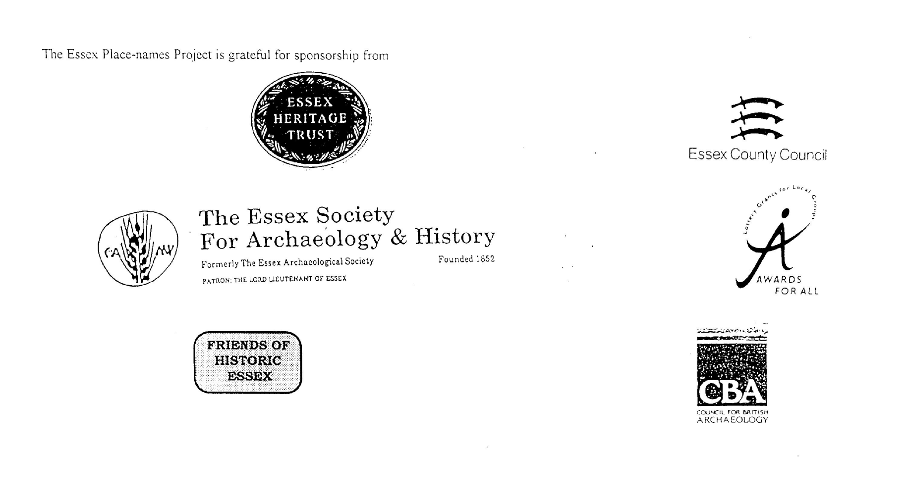

ESSEX PLACE-NAMES PROJECT.

The Essex Place-names Project is a County-wide survey to record place- and field-names from historical documents such as Tithe maps and apportionments, estate maps, sale
and auction catalogues, conveyances, terriers, deeds, rolls, inquisitions and surveys.

The second element of the Project is to investigate on-the-ground visible remains which correspond to the Place-names for actual or potential archaeological, agricultural and industrial
sites, and to record natural (topographical) and man-made features which may relate to the Place-name. This involves field-survey in rural and outside investigation in built-up areas.

It is anticipated that the Project will lead to identification of archaeological sites and lost historic buildings; it will enable analysis of indicators of early settlement, land holding, agricultural and industrial practices of the County. It will refine the more precise meaning of descriptive words and elements used by earlier settlers as they gave names appropriate to the topography of the landscape of their time.

For convenience the surveys are based on the parish, recognising that present civil parish boundaries are not necessarily identical to former ecclesiastical boundaries. Local Recorders
are supplied with templates of Record Forms to ensure consistency of recording across the County, and forward completed forms to a Central Coordinator for transfer to a county
computer database which is available to researchers on the internet at www.essex.ac.uk/history/esah/essexplacenames, and updated periodically.

This publication presents part of the information recorded from the Tithe or Estate Award and Map, and from other documents for this parish. The full record is contained on the master
database at Essex County Council (Historic Environment Section) and on the (above) website. Parish books are available to be downloaded from the website link ‘Books’ on the Home page. Please notify errors to the Project Coordinator at the Essex Record Office.

THE TITHE MAP AND APPORTIONMENT.

Since medieval times a tenth of the produce of land and stock had been paid by landholders to the church. At the Dissolution of the Monasteries, the property of many religious houses,
including the right to collect tithes, passed into lay hands. The Tithe Commutation Act which received Royal assent on 13th August 1836 abolished a rent payable in kind and
substituted rent-charges apportioned on each plot or parcel. The tithe-rent payable was assessed on the average value of wheat, barley and oats and was to fluctuate with price movements.

The commutation could be by voluntary agreement between the local owners and payers or, if agreement failed, could be compulsorily imposed by commissioners. A Valuer was to be
appointed to apportion the rent of each parcel of land and tenants could deduct that rent-charge from their rent paid to the landlord. The task fell to the Tithe Commissioners to produce a
map and an Apportionment (Award). A large-scale survey was produced for over 70% of England and Wales in the following 9 years, and about another 8% up to 1855. Most of the
parishes in Essex were surveyed. The map scales vary. The Award records ownership, tenancy and land-use, field by field and parcel by parcel (often quoting the field name) with the
ground area and rent-charge.

Land that was tithe-free tends to be less accurately mapped and contains few if any of the details recorded for those parcels subject to tithe. Rights of way and roads also tend to be
neglected. Boundaries of the tithe areas are shown as are some natural features such as streams, ponds, gardens, greens and commons. Buildings are often shown coloured red if dwellings
or grey if not. Because the Award may have been agreed only some time after the map was finished, discrepancies occur between the two. Enclosure Awards, when extant, usually date to the 18th and early 19th centuries. J.Kemble.

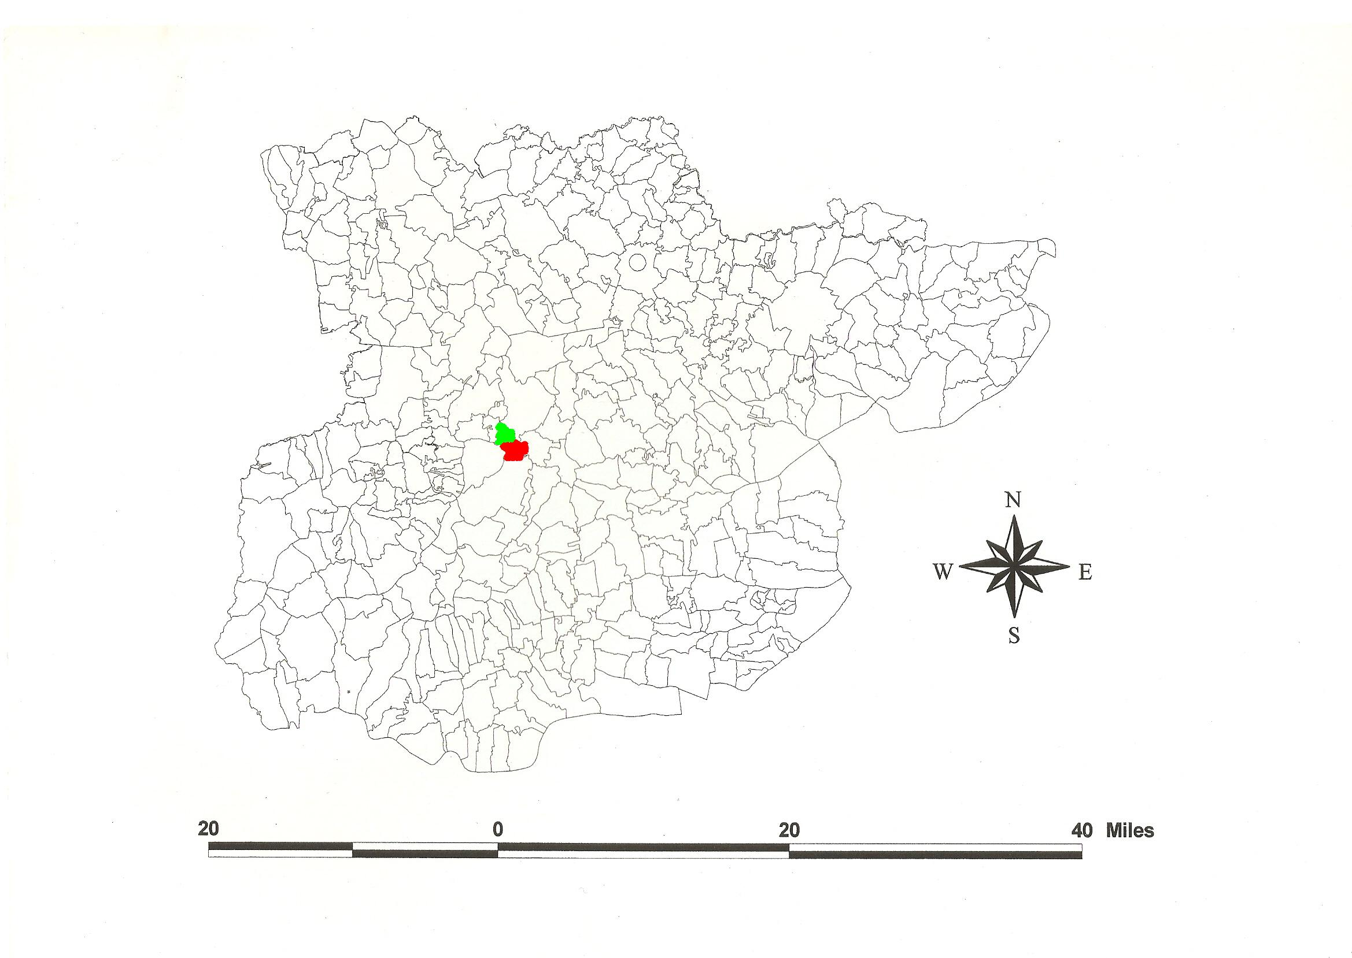
Chignall Smealy and Chignall St James Parishes in the County of Essex.
Reproduced by permission of
Essex County Council.

The Parish of Chignall (in ChelmsfordHundred).
The Tithe Award of Little Chignall, Chignall Smealy (ERO: D/CT 77a), dated 1847, shows a rent charge of £118-17-0 payable to Rev. James Hardwicke Dyer, and to the Rector of Great Waltham £2-12-0. The whole parish measured 378 acres of which 317 acres were arable, 57a meadow and pasture, 4a wood, and 6a glebe. The Tithe Commissioners were William Blamire and R. Jones, the Assistant F. J. Tatham and the Valuer Robert Baker of Writtle. The Tithe map (ERO: D/CT 77b) was surveyed at a scale of 26.6” to a mile and measures 50”x43”. It was countersigned by G.H. Whalley, Assistant Tithe Commissioner. .

The Tithe Award of Great Chignal, Chignall St James (Essex Record Office D/P 291//27/1), dated 1845, shows a rent-charge of £272 including glebe. The whole parish measured 909 acres 2 roods 18 perches of which 734a 2r 3p were arable, 162a 3r 16p meadow and pasture, 12a 39p roads and waste, and 36a 9p glebe. The Tithe Commissioners were J.W. Buller and R. Jones, the Assistant T.J. Tatham of Bedford Place, Russell Square, London, and the Valuer Robert Baker of Writtle. The Tithe map (ERO: D/P 291/27/2) was surveyed at a scale of 1 inch to 4 chains (18 inches to a mile) and measures 50”x43”. .

In Domesday Book, 1086, three men held Cingehala(m) before 1066 for one hide and 15 acres; then Richard held it from Geoffrey de Mandeville as a manor for the same. Godwin the deacon held Cingehala(m) as a manor before 1066 for 1½ hides less 5 acres; then Richard Garnet held it from Geoffrey for the same. In the same ville Wulfwin held 45 acres before 1066; then Ralph held it as a manor from Geoffrey for the same; Leofson held in 1066 one virgate and in 1086 the same from Geofffrey. Leofric held and holds 30 acres from Geoffrey. Leofwin held and holds 15 acres. Alstan had always held 10 acres. Saewin the priest held 15 acres; in 1086 Richard held them from Geoffrey. Edsi had held 15 acres, and Richard held them in 1086. Ansketel held Cinguehalla(m) from Robert Gernon which Dot had held as a manor for two hides; this became the manor of Chignall Zoyn in Chignall St. James (Morris, 1983). The last originates from Jordan del Zuin (Reaney, 1935). Chignall St James was Great Chignall; Chignall Smealy (O.E. smeðe leah = ‘smooth clearing’) was Little Chignall. Watts (2004) translates Cingehala from a personal name Cicca or Old English cicen + halh, ‘Cicca’s or chicken nook [separated land]’.

Chignall Smealey: 1. The Hall was ¼ mile southeast of the church, moated. 2. Dryves Hall: 12 Henry II, John Trenchfuill held 4 knights’ fees of Geoffrey de Mandeville. Thereafter it was with the family of Dyve. Sir John de Philibert, knight, presented in 1331 and held court here in 1322. 3. Beremans was once part of Chignall Trenchfoyl before the 15th century; it came to the families of Armenter and Rolf (Morant, 1768).

Chignall St Mary & St James and Zoyn: There were these manors: 1. Chignall Hall, half a mile northwest of the church was held by the Tany family. Richard de Tani was sheriff of Essex in 1260-1. By marriage it came to John de Drokenford (died 1341). 2. Hawes alais Hittot’s, a mile from the church on the left of the road to Chelmsford. 24 Edward I, Joane de Briazon granted to John de Hotot one messuage, 80 acres of arable etc. The manor of Zoyn was in the east of of the parish adjacent to Broomfield. In 1638 it was with William Peacock esq. The ‘supposed site’ of St Mary’s church is shown on the Ordnance Survey map of c.1875 about 2/3rds of a mile northwest from St James’, adjacent to the National School.

Here is a three-range Roman villa (with probable bath-house) whose estate workers’ 3rd/4th century cemetery has been excavated (Kemble, 2009). The church of St James has a 13th/14th century nave and chancel with a rood turret. Brickbarns Farm is 17th century timber-framed. Broomwood was built in Elizabethan style in 1912-13 for Miller Christy, the historian. Chobbings Farm, 14th century, has a timber-framed chimney stack. The church of St Nicholas in Chignall Smealy is of brick, 16th century. Part of Writtle was transferred to Chignall in 1888 (Kemble, 2007) when the civil parish of Chignall was formed in 1888 by the amalgamation of Chignall St James and Smealy (Pevsner, 2007).

In Domesday Book, 1086, the Hundred name is Celmeresforda, -fort. The river name Chelmer is a back-formation from the town name. The Hundred was formerly divided into North and South (Fowler, 1922). Christy (1926) suggests the moot was near the fording place.

Place- and field-names from other documents are shown against the Tithe Award parcel numbers.

References:

Christy, M., 1926. Essex Hundred Moots. Trans Essex Arch. Society, ns, xviii (3), p.184.
Fowler, R.C., 1922. Essex Hundreds. Trans Essex Archaeological Society, ns, xvi, p.183.
Kemble, J., 2007. Essex Place-names, Places, Streets & People. Historical Publications.
pp. 10, 46.
Kemble, 2009. Prehistoric & Roman Essex. History Press, Stroud. pp. 106, 122.
Morant, P., 1768. History & Antiquities of the County of Essex, ii, 79 and 81.
Morris, J., 1983. Domesday Book - Essex. Phillimore.
Pevsner, N., Bettley, J., 2007. Buildings of England - Essex. Yale.
Reaney, P., 1935. Place-names of Essex. Cambridge.
Watts, V., 2004. Dictionary of English Place-names. Cambridge.

The Tithe Award Place-names of Chignall Smealy - by Parcel Number.

Place-name | Alias | Fld No | Gd Ref | x | y | Acr | rd | Pch | Land use | Owner | Occupier | Other information
Clobs |  | 1 | TL | 662 | 132 | 10 | 3 | 11 | arable | Wallis, Rev Thomas | Lucking, Wilson
Upper Dringe |  | 2 | TL | 663 | 130 | 10 | 3 | 30 | arable | Laurie, John | Buttle, Richard
Walnut Tree field |  | 3 | TL | 661 | 130 | 6 | 0 | 20 | arable | Wallis, Rev Thomas | Lucking, Wilson
Middle field |  | 4 | TL | 660 | 129 | 4 | 1 | 38 | arable | Wallis, Rev Thomas | Lucking, Wilson
Downs |  | 5 | TL | 659 | 128 | 8 | 0 | 28 | arable | Wallis, Rev Thomas | Lucking, Wilson
Upper 9 Acre Downs |  | 6 | TL | 662 | 128 | 9 | 3 | 38 | arable | Laurie, John | Buttle, Richard
Four Acres |  | 7 | TL | 663 | 128 | 4 | 0 | 31 | arable | Milne, Rev JG | Buttle, Richard
7 Acre Dringe |  | 8 | TL | 664 | 127 | 8 | 0 | 11 | arable | Laurie, John | Buttle, Richard
5 Acre Dringe |  | 9 | TL | 665 | 128 | 5 | 2 | 27 | arable | Laurie, John | Buttle, Richard
Arable field |  | 10 | TL | 664 | 126 | 1 | 3 | 28 | arable | Tufnell, John Jolliffe | Lucking, Wilson
Lads field |  | 11 | TL | 664 | 124 | 11 | 2 | 11 | arable | Milne, Rev JG | Buttle, Richard
8 Acre Downs |  | 12 | TL | 662 | 125 | 9 | 0 | 6 | arable | Laurie, John | Buttle, Richard
11 Acre Downs |  | 13 | TL | 660 | 125 | 11 | 1 | 8 | arable | Laurie, John | Buttle, Richard
Upper Downs |  | 14 | TL | 658 | 126 | 6 | 3 | 36 | arable | Buckle, George | Buckle, George
Lower Downs |  | 15 | TL | 659 | 125 | 7 | 2 | 18 | arable | Buckle, George | Buckle, George
Prickney Mead |  | 16 | TL | 658 | 125 | 0 | 1 | 16 | pasture | Fuller, Edward | Fuller, Edward
Prickney field |  | 17 | TL | 658 | 124 | 2 | 3 | 24 | arable | Fuller, Edward | Fuller, Edward
Prickney field |  | 18 | TL | 659 | 124 | 1 | 3 | 8 | pasture | Fuller, Edward | Fuller, Edward
Long Mead |  | 19 | TL | 660 | 123 | 3 | 3 | 9 | pasture | Laurie, John | Buttle, Richard
Lower 9 Acre Downs |  | 20 | TL | 651 | 123 | 9 | 3 | 29 | arable | Laurie, John | Buttle, Richard
Lower 8 Acre Downs |  | 21 | TL | 652 | 123 | 8 | 3 | 24 | arable | Laurie, John | Buttle, Richard
Stable field |  | 22 | TL | 651 | 122 | 1 | 2 | 2 | pasture | Laurie, John | Buttle, Richard
Long Croft |  | 23 | TL | 651 | 123 | 3 | 0 | 5 | arable | Milne, Rev JG | Buttle, Richard
Premises |  | 24 | TL | 654 | 122 | 0 | 1 | 28 |  | Laurie, John | Buttle, Richard
Hubbards Yard | Hubbardes, 1571,FF | 25 | TL | 654 | 122 | 0 | 1 | 26 | pasture | Milne, Rev JG | Buttle, Richard
House, garden | Beremans, 1537,FF; Bereman's Farm, 1875,OS | 26 | TL | 654 | 122 | 0 | 2 | 29 |  | Laurie, John | Buttle, Richard | John Bereman, tenant, 1768,Morant
Orchard |  | 27 | TL | 654 | 122 | 0 | 3 | 18 | ochd | Laurie, John | Buttle, Richard
The Ley |  | 28 | TL | 654 | 122 | 2 | 2 | 10 | pasture | Laurie, John | Buttle, Richard
Little Bearmans |  | 29 | TL | 655 | 123 | 1 | 3 | 36 | arable | Lawton, Rev JT | Harrington, Wm | glebe
Little Bearmans |  | 30 | TL | 656 | 123 | 2 | 3 | 28 | arable | Laurie, John | Buttle, Richard
Bower field |  | 31 | TL | 667 | 120 | 12 | 1 | 21 | arable | Laurie, John | Buttle, Richard
Hubbards Pasture |  | 32 | TL | 665 | 120 | 3 | 3 | 32 | pasture | Milne, Rev JG | Pratt, Richard
Moat |  | 33 | TL | 666 | 119 | 0 | 1 | 14 |  | Milne, Rev JG | Pratt, Richard
Island |  | 34 | TL | 666 | 119 | 0 | 2 | 31 | pasture | Milne, Rev JG | Pratt, Richard
Cottages, gardens |  | 35 | TL | 665 | 119 | 0 | 1 | 11 |  | Spurgin, George | Marshall, John; Petts, Wm
Middle Mead |  | 36 | TL | 666 | 119 | 4 | 0 | 3 | pasture | Milne, Rev JG | Pratt, Richard
Long Meadow |  | 37 | TL | 668 | 118 | 3 | 2 | 14 | pasture | Milne, Rev JG | Pratt, Richard
Shortlands |  | 38 | TL | 670 | 118 | 11 | 3 | 3 | arable | Milne, Rev JG | Pratt, Richard
Shortlands |  | 39 | TL | 672 | 117 | 6 | 1 | 35 | arable | Austen, Col Thomas | Barker, Wm
Roswells Orchard |  | 40 | TL | 671 | 118 | 2 | 0 | 0 | pasture | Austen, Col Thomas | Barker, Wm
Glebe Meads |  | 41 | TL | 670 | 118 | 1 | 0 | 6 | pasture | Lawton, Rev JT | Harrington, Wm | glebe
Glebe Meads |  | 42 | TL | 670 | 118 | 2 | 0 | 24 | pasture | Lawton, Rev JT | Harrington, Wm | glebe
Little Church field |  | 43 | TL | 669 | 117 | 1 | 2 | 20 | arable | Lawton, Rev JT | Harrington, Wm | glebe
Garden |  | 44 | TL | 668 | 117 | 0 | 1 | 26 |  | Lawton, Rev JT | Everitt, Samuel; Johnson, John
Garden |  | 45 | TL | 668 | 117 | 0 | 0 | 7 |  | Bramston, Thomas Wm | Harrington, Wm
Cottage, garden |  | 46 | TL | 668 | 117 | 0 | 0 | 28 |  | Lawton, Rev JT | Everitt, Samuel; Johnson, John | glebe
Church & yard | [St Nicholas's] | 47 | TL | 668 | 117 | 0 | 1 | 3 |  | . | .
Barn & yard |  | 48 | TL | 668 | 117 | 0 | 0 | 22 |  | Lawton, Rev JT | Harrington, Wm | glebe
Orchard |  | 49 | TL | 668 | 117 | 0 | 0 | 26 | ochd | Dawson, Sarah | Harrington, Wm
Wheat Sheaf Inn, premises |  | 50 | TL | 668 | 117 | 0 | 0 | 29 | inn | Dawson, Sarah | Harrington, Wm
Orchard |  | 51 | TL | 668 | 118 | 0 | 3 | 33 | ochd | Dawson, Sarah | Harrington, Wm
Perry House field |  | 52 | TL | 667 | 118 | 7 | 0 | 5 | arable | Dawson, Sarah | Harrington, Wm
Great Hoddocks (pt) |  | 53 | TL | 667 | 117 | 8 | 3 | 36 | arable | Milne, Rev JG | Pratt, Richard
Hoddocks Wood |  | 54 | TL | 665 | 117 | 3 | 0 | 15 | wood | Laurie, John | Buttle, Richard
Little Hoddocks |  | 55 | TL | 665 | 118 | 2 | 0 | 36 | arable | Milne, Rev JG | Pratt, Richard
Bigs |  | 56 | TL | 664 | 118 | 6 | 2 | 19 | arable | Laurie, John | Buttle, Richard
Squider Croft |  | 57 | TL | 664 | 120 | 3 | 1 | 17 | arable | Milne, Rev JG | Buttle, Richard
Hither Readings |  | 58 | TL | 662 | 120 | 10 | 3 | 35 | arable | Laurie, John | Buttle, Richard
Lower 4 Acres |  | 59 | TL | 663 | 118 | 4 | 1 | 27 | arable | McLean, Dr | Drake, John
Chapel Field |  | 60 | TL | 661 | 118 | 7 | 1 | 16 | arable | McLean, Dr | Drake, John
Chapel |  | 62 | TL | 661 | 119 | 0 | 0 | 35 |  | Dissenting Society, trustees | Dissenting Society, trustees
Readings Piece |  | 63 | TL | 661 | 120 | 1 | 0 | 16 | arable | Lawton, Rev JT | Harrington, Wm | glebe
Chapel field |  | 64 | TL | 660 | 120 | 5 | 0 | 6 | arable | Laurie, John | Buttle, Richard
Old House field |  | 65 | TL | 659 | 119 | 3 | 3 | 6 | arable | McLean, Dr | Drake, John
Long field |  | 66 | TL | 657 | 116 | 7 | 0 | 27 | arable | McLean, Dr | Drake, John | detached.
Arable field |  | 67 | TL | 658 | 115 | 6 | 1 | 3 | arable | Bramston, Thomas Wm | Hart, Frederick | detached.
Spring |  | 68 | TL | 657 | 115 | 0 | 1 | 10 | wood | McLean, Dr | Drake, John
Further Wood field |  | 69 | TL | 657 | 114 | 7 | 2 | 12 | arable | McLean, Dr | Drake, John
Wood Mead |  | 70 | TL | 659 | 114 | 1 | 2 | 12 | pasture | McLean, Dr | Drake, John
Little Langleys |  | 71 | TL | 661 | 113 | 10 | 2 | 16 | arable | McLean, Dr | Drake, John
Lady Works (pt) |  | 72 | TL | 662 | 113 | 0 | 2 | 19 | arable | McLean, Dr | Drake, John
Barn Mead (pt) |  | 73 | TL | 663 | 113 | 0 | 3 | 18 | arable | McLean, Dr | Drake, John
Barn Mead (pt) |  | 74 | TL | 664 | 114 | 0 | 1 | 20 | pasture | McLean, Dr | Drake, John
Great Langleys |  | 75 | TL | 664 | 112 | 14 | 1 | 10 | arable | McLean, Dr | Drake, John
Chessons Mead |  | 76 | TL | 665 | 113 | 1 | 3 | 27 | pasture | McLean, Dr | Drake, John
Orchard |  | 77 | TL | 664 | 114 | 0 | 1 | 0 | ochd | McLean, Dr | Drake, John
Homestead | Langley's Farm, 1875,OS | 78 | TL | 664 | 114 | 0 | 2 | 26 |  | McLean, Dr | Drake, John | John Langelye, 1381, SubRoll
Cottage, gdn, smithy |  | 79 | TL | 665 | 113 | 0 | 0 | 20 |  | Chesson, John | Chesson, John
Three Acres |  | 80 | TL | 665 | 114 | 3 | 0 | 28 | arable | Chesson, John | Chesson, John
Cottages, gardens |  | 81 | TL | 665 | 113 | 0 | 1 | 2 |  | Austen, Col Thomas | Burr, Mary; Savell, John
Little field |  | 82 | TL | 666 | 113 | 2 | 2 | 16 | arable | Austen, Col Thomas | Barker, Wm
Four Acres |  | 83 | TL | 666 | 114 | 4 | 2 | 2 | arable | Austen, Col Thomas | Barker, Wm
Church field |  | 84 | TL | 669 | 115 | 9 | 1 | 22 | arable | Austen, Col Thomas | Barker, Wm
Dovehouse Croft |  | 85 | TL | 670 | 116 | 7 | 0 | 21 | arable | Austen, Col Thomas | Barker, Wm
Little Grove |  | 86 | TL | 672 | 115 | 5 | 1 | 18 | pasture | Austen, Col Thomas | Barker, Wm
Homestead | Dyves Hall al. Chygnall Hall al. Trenchefoyle, 1564,FF; Dryes hall, 1875,OS | 87 | TL | 672 | 116 | 1 | 0 | 38 |  | Austen, Col Thomas | Barker, Wm | Robert de Dyve, 1279, FeetFine
Garden |  | 88 | TL | 672 | 116 | 0 | 1 | 19 |  | Austen, Col Thomas | Barker, Wm
Moat |  | 89 | TL | 672 | 116 | 0 | 1 | 32 |  | Austen, Col Thomas | Barker, Wm
Hoppit |  | 90 | TL | 672 | 116 | 0 | 2 | 0 | pasture | Austen, Col Thomas | Barker, Wm
Sheds Pasture etc |  | 91 | TL | 672 | 116 | 0 | 2 | 12 | pasture | Austen, Col Thomas | Barker, Wm
Stackyard |  | 92 | TL | 672 | 117 | 0 | 2 | 19 |  | Austen, Col Thomas | Barker, Wm
Garden |  | 93 | TL | 672 | 117 | 0 | 0 | 24 |  | Austen, Col Thomas | Barker, Wm
Patches |  | 94 | TL | 673 | 115 | 12 | 1 | 29 | arable | Austen, Col Thomas | Barker, Wm
Mill field |  | 95 | TL | 674 | 115 | 2 | 1 | 12 | arable | Austen, Col Thomas | Barker, Wm
Big field |  | 96 | TL | 675 | 114 | 1 | 3 | 15 | arable | McLean, Dr | Drake, John
Garden |  | 97 | TL | 675 | 114 | 0 | 0 | 30 |  | McLean, Dr | King, James
Cottage & hoppit |  | 98 | TL | 675 | 114 | 0 | 0 | 37 | pasture | McLean, Dr | Drake, John; King, James
Barn field |  | 99 | TL | 674 | 113 | 3 | 3 | 31 | arable | McLean, Dr | Drake, John
Brights Mead |  | 100 | TL | 674 | 112 | 2 | 2 | 5 | pasture | McLean, Dr | Drake, John
Little Pasture |  | 101 | TL | 674 | 110 | 0 | 2 | 25 | pasture | McLean, Dr | Drake, John
Long Mead |  | 102 | TL | 673 | 113 | 7 | 2 | 11 | pasture | Austen, Col Thomas | Barker, Wm
Palmers Mead |  | 103 | TL | 672 | 112 | 1 | 3 | 11 | pasture | Austen, Col Thomas | Barker, Wm
Great Grove |  | 104 | TL | 672 | 114 | 7 | 2 | 36 | arable | Austen, Col Thomas | Barker, Wm
Stable field |  | 105 | TL | 670 | 114 | 7 | 1 | 21 | arable | Austen, Col Thomas | Barker, Wm
Kitchen field |  | 106 | TL | 671 | 113 | 1 | 0 | 37 | arable | Austen, Col Thomas | Barker, Wm
Spring field |  | 107 | TL | 669 | 113 | 3 | 3 | 5 | arable | Austen, Col Thomas | Barker, Wm
Four Acres |  | 108 | TL | 668 | 113 | 4 | 1 | 28 | arable | Austen, Col Thomas | Barker, Wm
Little Wrights |  | 109 | TL | 667 | 112 | 1 | 3 | 8 | arable | McLean, Dr | Drake, John
Old Lands |  | 110 | TL | 666 | 111 | 5 | 2 | 19 | arable | Milne, Rev JG | Buckle, George
Arable field |  | 111 | TL | 665 | 110 | 2 | 2 | 20 | arable | Gandy, Ann | Gandy, Ann
Great Wrights |  | 112 | TL | 666 | 110 | 8 | 1 | 27 | arable | McLean, Dr | Drake, John
Rowleys |  | 113 | TL | 670 | 109 | 14 | 2 | 7 | arable | Austen, Col Thomas | Barker, Wm
Straights |  | 114 | TL | 673 | 108 | 5 | 3 | 8 | arable | Austen, Col Thomas | Barker, Wm
Lawfords Mead |  | 115 | TL | 676 | 109 | 3 | 0 | 18 | pasture | Wallis, Rev Thomas | Lucking, Wilson
Cartlodge Mead |  | 116 | TL | 676 | 108 | 2 | 1 | 31 | pasture | Falls, William Stuart | Parnell, James
Garden |  | 117 | TL | 676 | 107 | 0 | 0 | 10 |  | Falls, William Stuart | Parnell, James
Premises (pt) | Grays, 1777,C | 118 | TL | 677 | 107 | 0 | 0 | 27 |  | Falls, William Stuart | Parnell, James

For abbreviations see Reaney, P., Place-names of Essex, Cambridge 1935; and Kemble, J., Essex Place-names Places, Streets & People. Historical Publications, 2007, p153.

The Tithe Award Place-names of Chignall Smealy - by Owner.

Place-name | Alias | Fld No | Gd Ref | x | y | Acr | rd | Pch | Land use | Owner | Occupier | Other information
Long Mead |  | 102 | TL | 673 | 113 | 7 | 2 | 11 | pasture | Austen, Col Thomas | Barker, Wm
Palmers Mead |  | 103 | TL | 672 | 112 | 1 | 3 | 11 | pasture | Austen, Col Thomas | Barker, Wm
Great Grove |  | 104 | TL | 672 | 114 | 7 | 2 | 36 | arable | Austen, Col Thomas | Barker, Wm
Stable field |  | 105 | TL | 670 | 114 | 7 | 1 | 21 | arable | Austen, Col Thomas | Barker, Wm
Kitchen field |  | 106 | TL | 671 | 113 | 1 | 0 | 37 | arable | Austen, Col Thomas | Barker, Wm
Spring field |  | 107 | TL | 669 | 113 | 3 | 3 | 5 | arable | Austen, Col Thomas | Barker, Wm
Four Acres |  | 108 | TL | 668 | 113 | 4 | 1 | 28 | arable | Austen, Col Thomas | Barker, Wm
Rowleys |  | 113 | TL | 670 | 109 | 14 | 2 | 7 | arable | Austen, Col Thomas | Barker, Wm
Straights |  | 114 | TL | 673 | 108 | 5 | 3 | 8 | arable | Austen, Col Thomas | Barker, Wm
Shortlands |  | 39 | TL | 672 | 117 | 6 | 1 | 35 | arable | Austen, Col Thomas | Barker, Wm
Roswells Orchard |  | 40 | TL | 671 | 118 | 2 | 0 | 0 | pasture | Austen, Col Thomas | Barker, Wm
Little field |  | 82 | TL | 666 | 113 | 2 | 2 | 16 | arable | Austen, Col Thomas | Barker, Wm
Four Acres |  | 83 | TL | 666 | 114 | 4 | 2 | 2 | arable | Austen, Col Thomas | Barker, Wm
Church field |  | 84 | TL | 669 | 115 | 9 | 1 | 22 | arable | Austen, Col Thomas | Barker, Wm
Dovehouse Croft |  | 85 | TL | 670 | 116 | 7 | 0 | 21 | arable | Austen, Col Thomas | Barker, Wm
Little Grove |  | 86 | TL | 672 | 115 | 5 | 1 | 18 | pasture | Austen, Col Thomas | Barker, Wm
Homestead | Dyves Hall al. Chygnall Hall al. Trenchefoyle, 1564,FF; Dryes hall, 1875,OS | 87 | TL | 672 | 116 | 1 | 0 | 38 |  | Austen, Col Thomas | Barker, Wm | Robert de Dyve, 1279, FeetFine
Garden |  | 88 | TL | 672 | 116 | 0 | 1 | 19 |  | Austen, Col Thomas | Barker, Wm
Moat |  | 89 | TL | 672 | 116 | 0 | 1 | 32 |  | Austen, Col Thomas | Barker, Wm
Hoppit |  | 90 | TL | 672 | 116 | 0 | 2 | 0 | pasture | Austen, Col Thomas | Barker, Wm
Sheds Pasture etc |  | 91 | TL | 672 | 116 | 0 | 2 | 12 | pasture | Austen, Col Thomas | Barker, Wm
Stackyard |  | 92 | TL | 672 | 117 | 0 | 2 | 19 |  | Austen, Col Thomas | Barker, Wm
Garden |  | 93 | TL | 672 | 117 | 0 | 0 | 24 |  | Austen, Col Thomas | Barker, Wm
Patches |  | 94 | TL | 673 | 115 | 12 | 1 | 29 | arable | Austen, Col Thomas | Barker, Wm
Mill field |  | 95 | TL | 674 | 115 | 2 | 1 | 12 | arable | Austen, Col Thomas | Barker, Wm
Cottages, gardens |  | 81 | TL | 665 | 113 | 0 | 1 | 2 |  | Austen, Col Thomas | Burr, Mary; Savell, John
Garden |  | 45 | TL | 668 | 117 | 0 | 0 | 7 |  | Bramston, Thomas Wm | Harrington, Wm
Arable field |  | 67 | TL | 658 | 115 | 6 | 1 | 3 | arable | Bramston, Thomas Wm | Hart, Frederick | detached.
Upper Downs |  | 14 | TL | 658 | 126 | 6 | 3 | 36 | arable | Buckle, George | Buckle, George
Lower Downs |  | 15 | TL | 659 | 125 | 7 | 2 | 18 | arable | Buckle, George | Buckle, George
Cottage, gdn, smithy |  | 79 | TL | 665 | 113 | 0 | 0 | 20 |  | Chesson, John | Chesson, John
Three Acres |  | 80 | TL | 665 | 114 | 3 | 0 | 28 | arable | Chesson, John | Chesson, John
Orchard |  | 49 | TL | 668 | 117 | 0 | 0 | 26 | ochd | Dawson, Sarah | Harrington, Wm
Wheat Sheaf Inn, premises |  | 50 | TL | 668 | 117 | 0 | 0 | 29 | inn | Dawson, Sarah | Harrington, Wm
Orchard |  | 51 | TL | 668 | 118 | 0 | 3 | 33 | ochd | Dawson, Sarah | Harrington, Wm
Perry House field |  | 52 | TL | 667 | 118 | 7 | 0 | 5 | arable | Dawson, Sarah | Harrington, Wm
Chapel |  | 62 | TL | 661 | 119 | 0 | 0 | 35 |  | Dissenting Society, trustees | Dissenting Society, trustees
Cartlodge Mead |  | 116 | TL | 676 | 108 | 2 | 1 | 31 | pasture | Falls, William Stuart | Parnell, James
Garden |  | 117 | TL | 676 | 107 | 0 | 0 | 10 |  | Falls, William Stuart | Parnell, James
Premises (pt) | Grays, 1777,C | 118 | TL | 677 | 107 | 0 | 0 | 27 |  | Falls, William Stuart | Parnell, James
Prickney Mead |  | 16 | TL | 658 | 125 | 0 | 1 | 16 | pasture | Fuller, Edward | Fuller, Edward
Prickney field |  | 17 | TL | 658 | 124 | 2 | 3 | 24 | arable | Fuller, Edward | Fuller, Edward
Prickney field |  | 18 | TL | 659 | 124 | 1 | 3 | 8 | pasture | Fuller, Edward | Fuller, Edward
Arable field |  | 111 | TL | 665 | 110 | 2 | 2 | 20 | arable | Gandy, Ann | Gandy, Ann
8 Acre Downs |  | 12 | TL | 662 | 125 | 9 | 0 | 6 | arable | Laurie, John | Buttle, Richard
11 Acre Downs |  | 13 | TL | 660 | 125 | 11 | 1 | 8 | arable | Laurie, John | Buttle, Richard
Long Mead |  | 19 | TL | 660 | 123 | 3 | 3 | 9 | pasture | Laurie, John | Buttle, Richard
Upper Dringe |  | 2 | TL | 663 | 130 | 10 | 3 | 30 | arable | Laurie, John | Buttle, Richard
Lower 9 Acre Downs |  | 20 | TL | 651 | 123 | 9 | 3 | 29 | arable | Laurie, John | Buttle, Richard
Lower 8 Acre Downs |  | 21 | TL | 652 | 123 | 8 | 3 | 24 | arable | Laurie, John | Buttle, Richard
Stable field |  | 22 | TL | 651 | 122 | 1 | 2 | 2 | pasture | Laurie, John | Buttle, Richard
Premises |  | 24 | TL | 654 | 122 | 0 | 1 | 28 |  | Laurie, John | Buttle, Richard
House, garden | Beremans, 1537,FF; Bereman's Farm, 1875,OS | 26 | TL | 654 | 122 | 0 | 2 | 29 |  | Laurie, John | Buttle, Richard | John Bereman, tenant, 1768,Morant
Orchard |  | 27 | TL | 654 | 122 | 0 | 3 | 18 | ochd | Laurie, John | Buttle, Richard
The Ley |  | 28 | TL | 654 | 122 | 2 | 2 | 10 | pasture | Laurie, John | Buttle, Richard
Little Bearmans |  | 30 | TL | 656 | 123 | 2 | 3 | 28 | arable | Laurie, John | Buttle, Richard
Bower field |  | 31 | TL | 667 | 120 | 12 | 1 | 21 | arable | Laurie, John | Buttle, Richard
Hoddocks Wood |  | 54 | TL | 665 | 117 | 3 | 0 | 15 | wood | Laurie, John | Buttle, Richard
Bigs |  | 56 | TL | 664 | 118 | 6 | 2 | 19 | arable | Laurie, John | Buttle, Richard
Hither Readings |  | 58 | TL | 662 | 120 | 10 | 3 | 35 | arable | Laurie, John | Buttle, Richard
Upper 9 Acre Downs |  | 6 | TL | 662 | 128 | 9 | 3 | 38 | arable | Laurie, John | Buttle, Richard
Chapel field |  | 64 | TL | 660 | 120 | 5 | 0 | 6 | arable | Laurie, John | Buttle, Richard
7 Acre Dringe |  | 8 | TL | 664 | 127 | 8 | 0 | 11 | arable | Laurie, John | Buttle, Richard
5 Acre Dringe |  | 9 | TL | 665 | 128 | 5 | 2 | 27 | arable | Laurie, John | Buttle, Richard
Garden |  | 44 | TL | 668 | 117 | 0 | 1 | 26 |  | Lawton, Rev JT | Everitt, Samuel; Johnson, John
Cottage, garden |  | 46 | TL | 668 | 117 | 0 | 0 | 28 |  | Lawton, Rev JT | Everitt, Samuel; Johnson, John | glebe
Little Bearmans |  | 29 | TL | 655 | 123 | 1 | 3 | 36 | arable | Lawton, Rev JT | Harrington, Wm | glebe
Glebe Meads |  | 41 | TL | 670 | 118 | 1 | 0 | 6 | pasture | Lawton, Rev JT | Harrington, Wm | glebe
Glebe Meads |  | 42 | TL | 670 | 118 | 2 | 0 | 24 | pasture | Lawton, Rev JT | Harrington, Wm | glebe
Little Church field |  | 43 | TL | 669 | 117 | 1 | 2 | 20 | arable | Lawton, Rev JT | Harrington, Wm | glebe
Barn & yard |  | 48 | TL | 668 | 117 | 0 | 0 | 22 |  | Lawton, Rev JT | Harrington, Wm | glebe
Readings Piece |  | 63 | TL | 661 | 120 | 1 | 0 | 16 | arable | Lawton, Rev JT | Harrington, Wm | glebe
Brights Mead |  | 100 | TL | 674 | 112 | 2 | 2 | 5 | pasture | McLean, Dr | Drake, John
Little Pasture |  | 101 | TL | 674 | 110 | 0 | 2 | 25 | pasture | McLean, Dr | Drake, John
Little Wrights |  | 109 | TL | 667 | 112 | 1 | 3 | 8 | arable | McLean, Dr | Drake, John
Great Wrights |  | 112 | TL | 666 | 110 | 8 | 1 | 27 | arable | McLean, Dr | Drake, John
Lower 4 Acres |  | 59 | TL | 663 | 118 | 4 | 1 | 27 | arable | McLean, Dr | Drake, John
Chapel Field |  | 60 | TL | 661 | 118 | 7 | 1 | 16 | arable | McLean, Dr | Drake, John
Old House field |  | 65 | TL | 659 | 119 | 3 | 3 | 6 | arable | McLean, Dr | Drake, John
Long field |  | 66 | TL | 657 | 116 | 7 | 0 | 27 | arable | McLean, Dr | Drake, John | detached.
Spring |  | 68 | TL | 657 | 115 | 0 | 1 | 10 | wood | McLean, Dr | Drake, John
Further Wood field |  | 69 | TL | 657 | 114 | 7 | 2 | 12 | arable | McLean, Dr | Drake, John
Wood Mead |  | 70 | TL | 659 | 114 | 1 | 2 | 12 | pasture | McLean, Dr | Drake, John
Little Langleys |  | 71 | TL | 661 | 113 | 10 | 2 | 16 | arable | McLean, Dr | Drake, John
Lady Works (pt) |  | 72 | TL | 662 | 113 | 0 | 2 | 19 | arable | McLean, Dr | Drake, John
Barn Mead (pt) |  | 73 | TL | 663 | 113 | 0 | 3 | 18 | arable | McLean, Dr | Drake, John
Barn Mead (pt) |  | 74 | TL | 664 | 114 | 0 | 1 | 20 | pasture | McLean, Dr | Drake, John
Great Langleys |  | 75 | TL | 664 | 112 | 14 | 1 | 10 | arable | McLean, Dr | Drake, John
Chessons Mead |  | 76 | TL | 665 | 113 | 1 | 3 | 27 | pasture | McLean, Dr | Drake, John
Orchard |  | 77 | TL | 664 | 114 | 0 | 1 | 0 | ochd | McLean, Dr | Drake, John
Homestead | Langley's Farm, 1875,OS | 78 | TL | 664 | 114 | 0 | 2 | 26 |  | McLean, Dr | Drake, John | John Langelye, 1381, SubRoll
Big field |  | 96 | TL | 675 | 114 | 1 | 3 | 15 | arable | McLean, Dr | Drake, John
Barn field |  | 99 | TL | 674 | 113 | 3 | 3 | 31 | arable | McLean, Dr | Drake, John
Cottage & hoppit |  | 98 | TL | 675 | 114 | 0 | 0 | 37 | pasture | McLean, Dr | Drake, John; King, James
Garden |  | 97 | TL | 675 | 114 | 0 | 0 | 30 |  | McLean, Dr | King, James
Old Lands |  | 110 | TL | 666 | 111 | 5 | 2 | 19 | arable | Milne, Rev JG | Buckle, George
Lads field |  | 11 | TL | 664 | 124 | 11 | 2 | 11 | arable | Milne, Rev JG | Buttle, Richard
Long Croft |  | 23 | TL | 651 | 123 | 3 | 0 | 5 | arable | Milne, Rev JG | Buttle, Richard
Hubbards Yard | Hubbardes, 1571,FF | 25 | TL | 654 | 122 | 0 | 1 | 26 | pasture | Milne, Rev JG | Buttle, Richard
Squider Croft |  | 57 | TL | 664 | 120 | 3 | 1 | 17 | arable | Milne, Rev JG | Buttle, Richard
Four Acres |  | 7 | TL | 663 | 128 | 4 | 0 | 31 | arable | Milne, Rev JG | Buttle, Richard
Hubbards Pasture |  | 32 | TL | 665 | 120 | 3 | 3 | 32 | pasture | Milne, Rev JG | Pratt, Richard
Moat |  | 33 | TL | 666 | 119 | 0 | 1 | 14 |  | Milne, Rev JG | Pratt, Richard
Island |  | 34 | TL | 666 | 119 | 0 | 2 | 31 | pasture | Milne, Rev JG | Pratt, Richard
Middle Mead |  | 36 | TL | 666 | 119 | 4 | 0 | 3 | pasture | Milne, Rev JG | Pratt, Richard
Long Meadow |  | 37 | TL | 668 | 118 | 3 | 2 | 14 | pasture | Milne, Rev JG | Pratt, Richard
Shortlands |  | 38 | TL | 670 | 118 | 11 | 3 | 3 | arable | Milne, Rev JG | Pratt, Richard
Great Hoddocks (pt) |  | 53 | TL | 667 | 117 | 8 | 3 | 36 | arable | Milne, Rev JG | Pratt, Richard
Little Hoddocks |  | 55 | TL | 665 | 118 | 2 | 0 | 36 | arable | Milne, Rev JG | Pratt, Richard
Cottages, gardens |  | 35 | TL | 665 | 119 | 0 | 1 | 11 |  | Spurgin, George | Marshall, John; Petts, Wm
Arable field |  | 10 | TL | 664 | 126 | 1 | 3 | 28 | arable | Tufnell, John Jolliffe | Lucking, Wilson
Clobs |  | 1 | TL | 662 | 132 | 10 | 3 | 11 | arable | Wallis, Rev Thomas | Lucking, Wilson
Lawfords Mead |  | 115 | TL | 676 | 109 | 3 | 0 | 18 | pasture | Wallis, Rev Thomas | Lucking, Wilson
Walnut Tree field |  | 3 | TL | 661 | 130 | 6 | 0 | 20 | arable | Wallis, Rev Thomas | Lucking, Wilson
Middle field |  | 4 | TL | 660 | 129 | 4 | 1 | 38 | arable | Wallis, Rev Thomas | Lucking, Wilson
Downs |  | 5 | TL | 659 | 128 | 8 | 0 | 28 | arable | Wallis, Rev Thomas | Lucking, Wilson
Church & yard | [St Nicholas's] | 47 | TL | 668 | 117 | 0 | 1 | 3 |  | . | .

For abbreviations see Reaney, P., Place-names of Essex, Cambridge 1935; and Kemble, J., Essex Place-names Places, Streets & People. Historical Publications, 2007, p153.

The Tithe Award Place-names of Chignall St James - by Parcel Number.

Place-name | Alias | Fld No | Grd Rf | x | y | Acr | rd | pch | land use | Owner | Occupier | Other information
Fourteen acres (pt) |  | 1 | TL | 666 | 120 | 7 | 3 | 10 | arable | Wallace, Mary Ann | Fitch, Samuel | detached.
Further Fourteen Acres |  | 2 | TL | 661 | 116 | 4 | 0 | 35 | arable | McLean, John | Drake, Wm | detached.
Middle Fourteen Acres |  | 3 | TL | 662 | 116 | 5 | 0 | 25 | arable | McLean, John | Drake, Wm | detached.
Near Fourteen Acres |  | 4 | TL | 663 | 116 | 4 | 2 | 9 | arable | McLean, John | Drake, Wm | detached.
Twenty acres |  | 5 | TL | 664 | 115 | 4 | 3 | 27 | arable | Puller, Charles | Cousins, Charles | detached.
Fourteen acres (pt) |  | 6 | TL | 665 | 115 | 4 | 2 | 31 | arable | Wallace, Mary Ann | Fitch, Samuel | detached.
Eight acres (pt) |  | 7 | TL | 667 | 114 | 9 | 3 | 9 | arable | Austen, Thomas | Barker, Joseph | detached.
Thirteen acres |  | 8 | TL | 659 | 110 | 15 | 0 | 36 | arable | Bramston, Thomas Wm | Richardson, George
No name |  | 9 | TL | 660 | 110 | 2 | 2 | 36 | arable | Gandy, Anne | Gandy, Anne
No name |  | 10 | TL | 661 | 110 | 2 | 1 | 20 | arable | Gandy, Anne | Gandy, Anne
No name |  | 11 | TL | 661 | 110 | 1 | 2 | 0 | arable | Gandy, Anne | Gandy, Anne
No name |  | 11a | TL | 661 | 110 | 0 | 3 | 0 | pasture | Gandy, Anne | Gandy, Anne
Homestead | Howlett's Hall, 1875,OS | 12 | TL | 660 | 109 | 0 | 3 | 25 |  | Gandy, Anne | Gandy, Anne
Colemans Piece |  | 13 | TL | 660 | 109 | 3 | 1 | 20 | arable | Bramston, Thomas Wm | Richardson, George
No name |  | 14 | TL | 660 | 108 | 0 | 3 | 27 | pasture | Gandy, Anne | Gandy, Anne
No name |  | 15 | TL | 659 | 108 | 2 | 3 | 3 | arable | Gandy, Anne | Gandy, Anne
Nine acres |  | 16 | TL | 657 | 108 | 11 | 2 | 19 | arable | Bramston, Thomas Wm | Richardson, George
Lower wool setters |  | 17 | TL | 658 | 108 | 15 | 0 | 33 | arable | Bramston, Thomas Wm | Richardson, George
Five acre mead |  | 18 | TL | 656 | 107 | 5 | 1 | 28 | pasture | Bramston, Thomas Wm | Richardson, George
Bushy clover |  | 19 | TL | 659 | 107 | 8 | 2 | 37 | pasture | Bramston, Thomas Wm | Richardson, George
Hop garden piece |  | 20 | TL | 661 | 105 | 4 | 0 | 5 | pasture | Bramston, Thomas Wm | Richardson, George
Great banks |  | 21 | TL | 662 | 107 | 25 | 3 | 8 | arable | Bramston, Thomas Wm | Richardson, George
Little banks |  | 22 | TL | 662 | 105 | 18 | 0 | 16 | arable | Bramston, Thomas Wm | Richardson, George
Warren pasture |  | 23 | TL | 662 | 102 | 13 | 2 | 23 | pasture | Bramston, Thomas Wm | Richardson, George
Homestead | Chicknell Hall, 1777,C; Chignall Hall, 1875,OS | 24 | TL | 663 | 103 | 2 | 1 | 32 |  | Bramston, Thomas Wm | Richardson, George
Chase |  | 25 | TL | 663 | 103 | 0 | 2 | 24 |  | Bramston, Thomas Wm | Richardson, George
Upper chapel fields | Chapel Field, 1875,OS | 26 | TL | 663 | 102 | 11 | 1 | 38 | arable | Bramston, Thomas Wm | Richardson, George
Lower chapel fields |  | 27 | TL | 663 | 101 | 5 | 3 | 26 | arable | Bramston, Thomas Wm | Richardson, George
Two acre hoppit |  | 28 | TL | 665 | 100 | 2 | 1 | 0 | pasture | Bramston, Thomas Wm | Richardson, George
Little Humphreys |  | 29 | TL | 666 | 100 | 5 | 2 | 10 | arable | Crush, William | Crush, William
Broad Mead |  | 30 | TL | 666 | 099 | 5 | 1 | 24 | pasture | Crush, William | Crush, William
Hoppit |  | 30a | TL | 666 | 099 | 1 | 2 | 25 | pasture | Crush, William | Crush, William
Humphreys pasture |  | 31 | TL | 665 | 101 | 7 | 2 | 32 | pasture | Crush, William | Crush, William
Homestead | Stevens, 1777,C; Steven's Farm, 1875,OS | 32 | TL | 668 | 010 | 1 | 3 | 36 |  | Crush, William | Crush, William | William Stevene, 1338,Cl
No name |  | 33 | TL | 664 | 108 | 1 | 0 | 16 | arable | Gandy, Anne | Gandy, Anne
Tenements |  | 34 | TL | 664 | 107 | 0 | 0 | 33 |  | Greenwood, James | Perry, Wm; another
Tenements | [supposed site of St Mary's church, 1875,OS] | 35 | TL | 665 | 107 | 0 | 3 | 13 |  | Milne, Rev JG | Curtis, James; others | glebe
Empty Purse field |  | 36 | TL | 666 | 107 | 12 | 0 | 34 | arable | Bramston, Thomas Wm | Richardson, George
St Marys |  | 37 | TL | 664 | 105 | 7 | 0 | 30 | arable | Bramston, Thomas Wm | Richardson, George
The Shunbles |  | 38 | TL | 668 | 104 | 11 | 0 | 13 | arable | Crush, William | Crush, William
Upper Grimsley |  | 39 | TL | 669 | 106 | 21 | 1 | 4 | arable | Bramston, Thomas Wm | Richardson, George
Lower Grimsley |  | 40 | TL | 668 | 103 | 21 | 0 | 25 | arable | Bramston, Thomas Wm | Richardson, George
Chase |  | 41 | TL | 670 | 100 | 0 | 2 | 32 |  | Bramston, Thomas Wm | Richardson, George
Two acres |  | 42 | TL | 670 | 102 | 2 | 1 | 6 | arable | Bramston, Thomas Wm | Richardson, George
Nine acres |  | 43 | TL | 670 | 105 | 10 | 3 | 30 | arable | Bramston, Thomas Wm | Richardson, George
Gandys field |  | 44 | TL |  |  | 2 | 1 | 19 | arable | Bramston, Thomas Wm | Richardson, George
Tenements |  | 45 | TL |  |  | 0 | 1 | 7 |  | Bramston, Thomas Wm | Sewell, Samuel; others
Cartshed & pasture |  | 46 | TL | 671 | 106 | 0 | 2 | 9 | pasture | Bramston, Thomas Wm | Richardson, George
Hall field |  | 47 | TL | 673 | 106 | 11 | 3 | 1 | arable | Bramston, Thomas Wm | Richardson, George
Hall field |  | 48 | TL | 674 | 107 | 4 | 2 | 17 | arable | Austen, Thomas | Barker, Joseph
Hadcroft |  | 49 | TL | 676 | 104 | 12 | 2 | 20 | arable | Falls, Mrs, late, execs | Parnell, James
Six acres |  | 50 | TL | 673 | 103 | 5 | 3 | 19 | arable | Bramston, Thomas Wm | Richardson, George
Eight acres |  | 51 | TL | 672 | 102 | 8 | 3 | 20 | arable | Bramston, Thomas Wm | Richardson, George
The sixteen acres |  | 52 | TL |  |  | 15 | 1 | 3 | arable | Crush, William | Crush, William
Little Stoney Croft |  | 53 | TL |  |  | 4 | 2 | 4 | arable | Bramston, Thomas Wm | Richardson, George
Gravel Pit Pasture |  | 54 | TL | 659 | 098 | 3 | 1 | 2 | pasture | Crush, William | Crush, William
Tenements |  | 55 | TL | 659 | 098 | 0 | 1 | 24 |  | Crush, William | Tyler, James; others
Beldhams |  | 56 | TL | 670 | 098 | 4 | 3 | 23 | arable | Crush, William | Crush, William
No name |  | 57 | TL |  |  | 1 | 3 | 30 | . | Smith, Mr | Child, Zachariah
Public House, garden |  | 58 | TL | 671 | 097 | 1 | 1 | 3 | inn | Smith, Mr | Child, Zachariah
No name |  | 59 | TL | 673 | 097 | 3 | 0 | 5 | . | Smith, Mr | Child, Zachariah
The Orchard |  | 60 | TL | 673 | 098 | 1 | 2 | 15 | arable | Milne, Rev JG | Milne, Rev JG | glebe
No name |  | 61 | TL | 674 | 098 | 3 | 2 | 28 | arable | Smith, Mr | Child, Zachariah
Little Hooks |  | 62 | TL |  |  | 0 | 3 | 22 | arable | Milne, Rev JG | Milne, Rev JG | glebe
Great Stoney Croft |  | 63 | TL | 672 | 100 | 13 | 3 | 34 | arable | Bramston, Thomas Wm | Richardson, George
Stoney Croft |  | 64 | TL |  |  | 3 | 2 | 2 | arable | Milne, Rev JG | Harrington, Susan | glebe
Great Hooks |  | 65 | TL |  |  | 4 | 1 | 35 | arable | Milne, Rev JG | Harrington, Susan | glebe
Pondwood Oak |  | 66 | TL | 665 | 101 | 16 | 2 | 4 | arable | Bramston, Thomas Wm | Richardson, George
Garden & pond |  | 67 | TL |  |  | 0 | 1 | 26 |  | Milne, Rev JG | Milne, Rev JG | glebe
Nine acres |  | 68 | TL | 675 | 099 | 10 | 0 | 18 | arable | Milne, Rev JG | Harrington, Susan | glebe
Chase |  | 69 | TL | 675 | 099 | 0 | 3 | 34 |  | Bramston, Thomas Wm | Richardson, George
Wood Oaks |  | 70 | TL | 677 | 100 | 12 | 2 | 1 | arable | Bramston, Thomas Wm | Richardson, George
Dannescroft |  | 71 | TL | 677 | 101 | 3 | 0 | 37 | arable | Falls, Mrs, late, execs | Parnell, James
Beadles Mead (pt) | cp. Bedillshall, 1571,Ct | 72 | TL | 679 | 101 | 0 | 3 | 25 | pasture | Falls, Mrs, late, execs | Parnell, James
Clodfield (pt) |  | 73 | TL | 672 | 106 | 3 | 2 | 14 | arable | Stewart, Lady Frances | Cowlin, Mark | detached.
Wood field |  | 74 | TL |  |  | 18 | 1 | 33 | arable | Bramston, Thomas Wm | Richardson, George
No name |  | 75 | TL |  |  | 2 | 0 | 28 | pasture | Harrington, Susan | Harrington, Susan
Half acre |  | 76 | TL |  |  | 0 | 3 | 0 | pasture | Strutt, Wm Goodday | Harrington, Susan
Orchard in front |  | 77 | TL |  |  | 0 | 1 | 16 | arable | Milne, Rev JG | Milne, Rev JG | glebe
Barn field |  | 78 | TL | 675 | 098 | 4 | 1 | 4 | arable | Milne, Rev JG | Harrington, Susan | glebe
No name |  | 79 | TL | 675 | 097 | 2 | 0 | 7 | arable | Smith, Mr | Child, Zachariah
Allotments |  | 80 | TL | 675 | 097 | 3 | 1 | 16 |  | Charity Land | The Poor
Public House, garden |  | 81 | TL | 675 | 097 | 0 | 1 | 18 |  | Strutt, Wm Goodday | Crow, SS
Little Piece at Crows |  | 82 | TL | 675 | 095 | 0 | 1 | 0 | pasture | Strutt, Wm Goodday | Harrington, Susan
Cottages |  | 83 | TL | 675 | 095 | 0 | 1 | 9 |  | Strutt, Wm Goodday | Harrington, Susan
Lucerne field |  | 84 | TL | 676 | 095 | 3 | 1 | 28 | arable | Strutt, Wm Goodday | Harrington, Susan | Land growing Purple Medick (fodder)
Meadow field |  | 85 | TL |  |  | 3 | 1 | 28 | arable | Strutt, Wm Goodday | Harrington, Susan
The Six acres |  | 86 | TL | 677 | 097 | 7 | 0 | 13 | arable | Milne, Rev JG | Harrington, Susan | glebe
Greatwood field |  | 87 | TL | 679 | 099 | 11 | 1 | 27 | arable | Strutt, Wm Goodday | Harrington, Susan
Home field |  | 88 | TL | 676 | 095 | 7 | 0 | 14 | arable | Strutt, Wm Goodday | Harrington, Susan
Little Wood field |  | 89 | TL | 678 | 095 | 4 | 2 | 0 | arable | Strutt, Wm Goodday | Harrington, Susan
Long Mead |  | 90 | TL | 679 | 095 | 3 | 1 | 16 | pasture | Strutt, Wm Goodday | Harrington, Susan
Little Spring field |  | 91 | TL | 680 | 096 | 2 | 1 | 26 | arable | Strutt, Wm Goodday | Harrington, Susan
Great Spring field |  | 92 | TL | 680 | 095 | 6 | 3 | 22 | arable | Strutt, Wm Goodday | Harrington, Susan
Shortlands |  | 93 | TL | 680 | 093 | 8 | 3 | 28 | arable | Strutt, Wm Goodday | Harrington, Susan
The Eight acres |  | 94 | TL | 679 | 094 | 10 | 3 | 2 | arable | Strutt, Wm Goodday | Harrington, Susan
Shed Mead |  | 95 | TL | 679 | 093 | 4 | 1 | 35 | pasture | Strutt, Wm Goodday | Harrington, Susan
Hop Garden |  | 96 | TL | 679 | 092 | 3 | 3 | 15 | pasture | Strutt, Wm Goodday | Harrington, Susan
The Pieces |  | 97 | TL | 679 | 091 | 3 | 3 | 22 | arable | Hanbury, Osgood | Josling, John
Shortlands |  | 98 | TL | 681 | 091 | 6 | 1 | 25 | arable | Hanbury, Osgood | Josling, John
No name |  | 99 | TL | 681 | 093 | 4 | 2 | 0 | arable | Marriage, Henry | Marriage, Henry
No name (pt) |  | 100 | TL | 681 | 094 | 5 | 0 | 15 | arable | Marriage, Henry | Marriage, Henry
Thatch barn field |  | 101 | TL | 682 | 092 | 11 | 0 | 24 | arable | Hanbury, Osgood | Josling, John
Great Chobbings (pt) |  | 102 | TL | 683 | 093 | 0 | 3 | 15 | pasture | Marriage, Henry | Marriage, Henry
No name |  | 103 | TL | 684 | 093 | 1 | 1 | 0 | pasture | Marriage, Henry | Marriage, Henry
Gravel Ley |  | 104 | TL | 683 | 091 | 11 | 1 | 11 | arable | Hanbury, Osgood | Josling, John
Hoppit |  | 105 | TL | 682 | 091 | 2 | 1 | 20 | pasture | Hanbury, Osgood | Josling, John
Beldham Mead |  | 106 | TL | 666 | 096 | 11 | 3 | 23 | pasture | Bramston, Thomas Wm | Richardson, George
Tenements |  | 107 | TL | 670 | 096 | 0 | 0 | 27 |  | Fewell, Thomas | Fewell, Thomas
Tenements |  | 108 | TL | 670 | 096 | 0 | 0 | 31 |  | Woodgate, George | Fairchild; others
Tenements |  | 109 | TL | 670 | 097 | 0 | 1 | 2 |  | Crush, William | Hewitt, John; others
Tenements |  | 109a | TL | 670 | 097 | 0 | 1 | 18 |  | Child, John | Child, John; others
Church & yard | [St James's] | 110 | TL | 670 | 097 | 0 | 2 | 16 |  | . | .
Church field |  | 111 | TL | 670 | 097 | 9 | 1 | 20 | arable | Strutt, Wm Goodday | Harrington, Susan
Rectory pasture |  | 112 | TL | 672 | 098 | 1 | 2 | 0 | pasture | Milne, Rev JG | Milne, Rev JG | glebe
Homestead |  | 113 | TL | 673 | 098 | 1 | 0 | 5 |  | Milne, Rev JG | Milne, Rev JG | glebe
Sand field |  | 114 | TL | 673 | 097 | 9 | 3 | 37 | arable | Strutt, Wm Goodday | Harrington, Susan
Tenements |  | 115 | TL | 674 | 096 | 0 | 0 | 8 |  | Coleman, John | Coleman, John
Nine acres |  | 116 | TL | 673 | 095 | 12 | 1 | 2 | arable | Strutt, Wm Goodday | Harrington, Susan
Upper Church field |  | 117 | TL | 671 | 094 | 11 | 3 | 28 | arable | Crush, William | Crush, William
Lower Church field |  | 118 | TL | 670 | 095 | 8 | 2 | 1 | arable | Crush, William | Crush, William
Bitters |  | 119 | TL | 669 | 094 | 18 | 3 | 30 | arable | Crush, William | Crush, William
The Park |  | 120 | TL | 667 | 093 | 10 | 1 | 13 | arable | Crush, William | Crush, William
Bushy Bottom |  | 121 | TL | 665 | 094 | 2 | 2 | 35 | arable | Crush, William | Crush, William
Long mead (pt) |  | 122 | TL | 664 | 092 | 4 | 3 | 32 | pasture | Crush, William | Crush, William
Barn field |  | 123 | TL | 665 | 092 | 5 | 0 | 0 | arable | Crush, William | Crush, William
Homestead | Painge-mill Farm, 1777,C; Pengymill, 1875,OS | 124 | TL | 665 | 090 | 1 | 0 | 5 |  | Crush, William | Crush, William
Paingle Hoppit |  | 125 | TL | 665 | 090 | 2 | 2 | 25 | pasture | Crush, William | Crush, William
Stackyard hoppit |  | 126 | TL |  |  | 1 | 3 | 15 | pasture | Crush, William | Crush, William
Homefield |  | 127 | TL |  |  | 7 | 2 | 22 | arable | Crush, William | Crush, William
The Eight acres |  | 128 | TL |  |  | 13 | 1 | 8 | arable | Crush, William | Crush, William
Wood meadow |  | 129 | TL | 668 | 090 | 3 | 2 | 5 | pasture | Crush, William | Crush, William
Hance [illegible] |  | 130 | TL | 669 | 091 | 4 | 2 | 8 | arable | Crush, William | Crush, William
Hoys |  | 131 | TL | 670 | 092 | 4 | 2 | 8 | arable | Crush, William | Crush, William
Chase |  | 132 | TL |  |  | 0 | 1 | 30 |  | Crush, William | Crush, William
Hollys (pt) |  | 133 | TL | 672 | 092 | 18 | 1 | 7 | arable | Crush, William | Crush, William
Ridden |  | 134 | TL | 674 | 093 | 11 | 0 | 18 | arable | Crush, William | Crush, William
Kitchen field |  | 135 | TL | 675 | 093 | 4 | 3 | 37 | arable | Strutt, Wm Goodday | Harrington, Susan
Hoppit |  | 136 | TL | 676 | 095 | 1 | 0 | 0 | pasture | Strutt, Wm Goodday | Harrington, Susan
Homestead | Brettons, 1768,M; Britton's Hall, 1875,OS | 137 | TL | 676 | 095 | 1 | 2 | 15 |  | Strutt, Wm Goodday | Harrington, Susan | Maud Bretoun, 1327,SubRoll
Clockticker |  | 138 | TL | 676 | 094 | 9 | 1 | 26 | arable | Strutt, Wm Goodday | Harrington, Susan
Near Broad field |  | 139 | TL | 676 | 092 | 14 | 1 | 10 | arable | Crush, William | Crush, William
Puttocks Lees (pt) |  | 140 | TL | 674 | 091 | 4 | 3 | 37a | arable | Crush, William | Crush, William
Further Broad field |  | 141 | TL |  |  | 7 | 3 | 12 | arable | Crush, William | Crush, William
Common field (pt) |  | 142 | TL | 677 | 091 | 4 | 3 | 10 | arable | Strutt, Wm Goodday | Harrington, Susan
Lowlands (pt) |  | 143 | TL | 679 | 090 | 4 | 2 | 27 | pasture | Strutt, Wm Goodday | Harrington, Susan
Acre Mead |  | 144 | TL | 680 | 090 | 1 | 1 | 23 | pasture | Hanbury, Osgood | Josling, John
Crown mead (pt) |  | 145 | TL | 680 | 090 | 0 | 3 | 30 | pasture | Strutt, Wm Goodday | Harrington, Susan
Spainsmead |  | 146 | TL | 681 | 090 | 6 | 1 | 6 | pasture | Hanbury, Osgood | Josling, John
Tenements |  | 146a | TL | 682 | 090 | 0 | 0 | 20 |  | Josling, John | Coleman, John; another
Homestead | Brickbarns Farm, 1875,OS | 147 | TL | 682 | 090 | 1 | 0 | 27 |  | Hanbury, Osgood | Josling, John
Brick field (pt) |  | 148 | TL | 683 | 090 | 1 | 2 | 18 | arable | Hanbury, Osgood | Josling, John
No name |  | 149 | TL | 684 | 093 | 1 | 0 | 22 | arable | Marriage, Henry | Howard, Robert
Homestead | Bluehouse Farm, 1875,OS | 150 | TL | 685 | 095 | 0 | 1 | 20 |  | Marriage, Henry | Howard, Robert
Kitchen field |  | 151 | TL | 685 | 095 | 0 | 2 | 0 | pasture | Marriage, Henry | Howard, Robert
Pond field |  | 152 | TL | 685 | 095 | 0 | 2 | 30 | pasture | Marriage, Henry | Howard, Robert
No name |  | 153 | TL | 685 | 095 | 4 | 1 | 10 | arable | Marriage, Henry | Marriage, Henry
No name |  | 154 | TL | 686 | 095 | 2 | 0 | 30 | arable | Clapham, George | Howard, Robert
No name |  | 155 | TL | 687 | 095 | 1 | 1 | 15 | arable | Marriage, Henry | Marriage, Henry
Bluehouse field (pt) |  | 156 | TL | 687 | 095 | 2 | 0 | 26 | arable | Marriage, Henry | Marriage, Henry | detached.
Moses field (pt) |  | 157 | TL | 688 | 095 | 0 | 1 | 33 | pasture | Tyrell, Sir John Tyssen | Tylney, Sarah | detached.
The Marsh |  | 158 | TL | 682 | 087 | 0 | 1 | 34 | pasture | Tyrell, Sir John Tyssen | Tylney, Sarah | detached.
The Marsh |  | 159 | TL | 683 | 087 | 0 | 3 | 34 | pasture | Tyrell, Sir John Tyssen | Tylney, Sarah | detached.
Homestead | Crow's Farm, 1875,OS | 160 | TL | 683 | 087 | 0 | 1 | 25 |  | Tyrell, Sir John Tyssen | Tylney, Sarah | detached.
Four acres |  | 161 | TL | 684 | 085 | 4 | 3 | 27 | arable | Tyrell, Sir John Tyssen | Tylney, Sarah | detached.
Broomfield Field (pt) |  | 162 | TL | 684 | 084 | 2 | 2 | 10 | arable | Tyrell, Sir John Tyssen | Tylney, Sarah | detached.

For abbreviations see Reaney, P., Place-names of Essex, Cambridge 1935; and Kemble, J., Essex Place-names Places, Streets & People. Historical Publications, 2007, p153.

The Tithe Award Place-names of Chignall St James - by Owner.

Place-name | Alias | Fld No | Grd Rf | x | y | Acr | rd | pch | land use | Owner | Occupier | Other information
Hall field |  | 48 | TL | 674 | 107 | 4 | 2 | 17 | arable | Austen, Thomas | Barker, Joseph
Eight acres (pt) |  | 7 | TL | 667 | 114 | 9 | 3 | 9 | arable | Austen, Thomas | Barker, Joseph | detached.
Beldham Mead |  | 106 | TL | 666 | 096 | 11 | 3 | 23 | pasture | Bramston, Thomas Wm | Richardson, George
Colemans Piece |  | 13 | TL | 660 | 109 | 3 | 1 | 20 | arable | Bramston, Thomas Wm | Richardson, George
Nine acres |  | 16 | TL | 657 | 108 | 11 | 2 | 19 | arable | Bramston, Thomas Wm | Richardson, George
Lower wool setters |  | 17 | TL | 658 | 108 | 15 | 0 | 33 | arable | Bramston, Thomas Wm | Richardson, George
Five acre mead |  | 18 | TL | 656 | 107 | 5 | 1 | 28 | pasture | Bramston, Thomas Wm | Richardson, George
Bushy clover |  | 19 | TL | 659 | 107 | 8 | 2 | 37 | pasture | Bramston, Thomas Wm | Richardson, George
Hop garden piece |  | 20 | TL | 661 | 105 | 4 | 0 | 5 | pasture | Bramston, Thomas Wm | Richardson, George
Great banks |  | 21 | TL | 662 | 107 | 25 | 3 | 8 | arable | Bramston, Thomas Wm | Richardson, George
Little banks |  | 22 | TL | 662 | 105 | 18 | 0 | 16 | arable | Bramston, Thomas Wm | Richardson, George
Warren pasture |  | 23 | TL | 662 | 102 | 13 | 2 | 23 | pasture | Bramston, Thomas Wm | Richardson, George
Homestead | Chicknell Hall, 1777,C; Chignall Hall, 1875,OS | 24 | TL | 663 | 103 | 2 | 1 | 32 |  | Bramston, Thomas Wm | Richardson, George
Chase |  | 25 | TL | 663 | 103 | 0 | 2 | 24 |  | Bramston, Thomas Wm | Richardson, George
Upper chapel fields | Chapel Field, 1875,OS | 26 | TL | 663 | 102 | 11 | 1 | 38 | arable | Bramston, Thomas Wm | Richardson, George
Lower chapel fields |  | 27 | TL | 663 | 101 | 5 | 3 | 26 | arable | Bramston, Thomas Wm | Richardson, George
Two acre hoppit |  | 28 | TL | 665 | 100 | 2 | 1 | 0 | pasture | Bramston, Thomas Wm | Richardson, George
Empty Purse field |  | 36 | TL | 666 | 107 | 12 | 0 | 34 | arable | Bramston, Thomas Wm | Richardson, George
St Marys |  | 37 | TL | 664 | 105 | 7 | 0 | 30 | arable | Bramston, Thomas Wm | Richardson, George
Upper Grimsley |  | 39 | TL | 669 | 106 | 21 | 1 | 4 | arable | Bramston, Thomas Wm | Richardson, George
Lower Grimsley |  | 40 | TL | 668 | 103 | 21 | 0 | 25 | arable | Bramston, Thomas Wm | Richardson, George
Chase |  | 41 | TL | 670 | 100 | 0 | 2 | 32 |  | Bramston, Thomas Wm | Richardson, George
Two acres |  | 42 | TL | 670 | 102 | 2 | 1 | 6 | arable | Bramston, Thomas Wm | Richardson, George
Nine acres |  | 43 | TL | 670 | 105 | 10 | 3 | 30 | arable | Bramston, Thomas Wm | Richardson, George
Gandys field |  | 44 | TL |  |  | 2 | 1 | 19 | arable | Bramston, Thomas Wm | Richardson, George
Cartshed & pasture |  | 46 | TL | 671 | 106 | 0 | 2 | 9 | pasture | Bramston, Thomas Wm | Richardson, George
Hall field |  | 47 | TL | 673 | 106 | 11 | 3 | 1 | arable | Bramston, Thomas Wm | Richardson, George
Six acres |  | 50 | TL | 673 | 103 | 5 | 3 | 19 | arable | Bramston, Thomas Wm | Richardson, George
Eight acres |  | 51 | TL | 672 | 102 | 8 | 3 | 20 | arable | Bramston, Thomas Wm | Richardson, George
Little Stoney Croft |  | 53 | TL |  |  | 4 | 2 | 4 | arable | Bramston, Thomas Wm | Richardson, George
Great Stoney Croft |  | 63 | TL | 672 | 100 | 13 | 3 | 34 | arable | Bramston, Thomas Wm | Richardson, George
Pondwood Oak |  | 66 | TL | 665 | 101 | 16 | 2 | 4 | arable | Bramston, Thomas Wm | Richardson, George
Chase |  | 69 | TL | 675 | 099 | 0 | 3 | 34 |  | Bramston, Thomas Wm | Richardson, George
Wood Oaks |  | 70 | TL | 677 | 100 | 12 | 2 | 1 | arable | Bramston, Thomas Wm | Richardson, George
Wood field |  | 74 | TL |  |  | 18 | 1 | 33 | arable | Bramston, Thomas Wm | Richardson, George
Thirteen acres |  | 8 | TL | 659 | 110 | 15 | 0 | 36 | arable | Bramston, Thomas Wm | Richardson, George
Tenements |  | 45 | TL |  |  | 0 | 1 | 7 |  | Bramston, Thomas Wm | Sewell, Samuel; others
Allotments |  | 80 | TL | 675 | 097 | 3 | 1 | 16 |  | Charity Land | The Poor
Tenements |  | 109a | TL | 670 | 097 | 0 | 1 | 18 |  | Child, John | Child, John; others
No name |  | 154 | TL | 686 | 095 | 2 | 0 | 30 | arable | Clapham, George | Howard, Robert
Tenements |  | 115 | TL | 674 | 096 | 0 | 0 | 8 |  | Coleman, John | Coleman, John
Upper Church field |  | 117 | TL | 671 | 094 | 11 | 3 | 28 | arable | Crush, William | Crush, William
Lower Church field |  | 118 | TL | 670 | 095 | 8 | 2 | 1 | arable | Crush, William | Crush, William
Bitters |  | 119 | TL | 669 | 094 | 18 | 3 | 30 | arable | Crush, William | Crush, William
The Park |  | 120 | TL | 667 | 093 | 10 | 1 | 13 | arable | Crush, William | Crush, William
Bushy Bottom |  | 121 | TL | 665 | 094 | 2 | 2 | 35 | arable | Crush, William | Crush, William
Long mead (pt) |  | 122 | TL | 664 | 092 | 4 | 3 | 32 | pasture | Crush, William | Crush, William
Barn field |  | 123 | TL | 665 | 092 | 5 | 0 | 0 | arable | Crush, William | Crush, William
Homestead | Painge-mill Farm, 1777,C; Pengymill, 1875,OS | 124 | TL | 665 | 090 | 1 | 0 | 5 |  | Crush, William | Crush, William
Paingle Hoppit |  | 125 | TL | 665 | 090 | 2 | 2 | 25 | pasture | Crush, William | Crush, William
Stackyard hoppit |  | 126 | TL |  |  | 1 | 3 | 15 | pasture | Crush, William | Crush, William
Homefield |  | 127 | TL |  |  | 7 | 2 | 22 | arable | Crush, William | Crush, William
The Eight acres |  | 128 | TL |  |  | 13 | 1 | 8 | arable | Crush, William | Crush, William
Wood meadow |  | 129 | TL | 668 | 090 | 3 | 2 | 5 | pasture | Crush, William | Crush, William
Hance [illegible] |  | 130 | TL | 669 | 091 | 4 | 2 | 8 | arable | Crush, William | Crush, William
Hoys |  | 131 | TL | 670 | 092 | 4 | 2 | 8 | arable | Crush, William | Crush, William
Chase |  | 132 | TL |  |  | 0 | 1 | 30 |  | Crush, William | Crush, William
Hollys (pt) |  | 133 | TL | 672 | 092 | 18 | 1 | 7 | arable | Crush, William | Crush, William
Ridden |  | 134 | TL | 674 | 093 | 11 | 0 | 18 | arable | Crush, William | Crush, William
Near Broad field |  | 139 | TL | 676 | 092 | 14 | 1 | 10 | arable | Crush, William | Crush, William
Puttocks Lees (pt) |  | 140 | TL | 674 | 091 | 4 | 3 | 37a | arable | Crush, William | Crush, William
Further Broad field |  | 141 | TL |  |  | 7 | 3 | 12 | arable | Crush, William | Crush, William
Little Humphreys |  | 29 | TL | 666 | 100 | 5 | 2 | 10 | arable | Crush, William | Crush, William
Broad Mead |  | 30 | TL | 666 | 099 | 5 | 1 | 24 | pasture | Crush, William | Crush, William
Hoppit |  | 30a | TL | 666 | 099 | 1 | 2 | 25 | pasture | Crush, William | Crush, William
Humphreys pasture |  | 31 | TL | 665 | 101 | 7 | 2 | 32 | pasture | Crush, William | Crush, William
Homestead | Stevens, 1777,C; Steven's Farm, 1875,OS | 32 | TL | 668 | 010 | 1 | 3 | 36 |  | Crush, William | Crush, William | William Stevene, 1338,Cl
The Shunbles |  | 38 | TL | 668 | 104 | 11 | 0 | 13 | arable | Crush, William | Crush, William
The sixteen acres |  | 52 | TL |  |  | 15 | 1 | 3 | arable | Crush, William | Crush, William
Gravel Pit Pasture |  | 54 | TL | 659 | 098 | 3 | 1 | 2 | pasture | Crush, William | Crush, William
Beldhams |  | 56 | TL | 670 | 098 | 4 | 3 | 23 | arable | Crush, William | Crush, William
Tenements |  | 109 | TL | 670 | 097 | 0 | 1 | 2 |  | Crush, William | Hewitt, John; others
Tenements |  | 55 | TL | 659 | 098 | 0 | 1 | 24 |  | Crush, William | Tyler, James; others
Hadcroft |  | 49 | TL | 676 | 104 | 12 | 2 | 20 | arable | Falls, Mrs, late, execs | Parnell, James
Dannescroft |  | 71 | TL | 677 | 101 | 3 | 0 | 37 | arable | Falls, Mrs, late, execs | Parnell, James
Beadles Mead (pt) | cp. Bedillshall, 1571,Ct | 72 | TL | 679 | 101 | 0 | 3 | 25 | pasture | Falls, Mrs, late, execs | Parnell, James
Tenements |  | 107 | TL | 670 | 096 | 0 | 0 | 27 |  | Fewell, Thomas | Fewell, Thomas
No name |  | 10 | TL | 661 | 110 | 2 | 1 | 20 | arable | Gandy, Anne | Gandy, Anne
No name |  | 11 | TL | 661 | 110 | 1 | 2 | 0 | arable | Gandy, Anne | Gandy, Anne
No name |  | 11a | TL | 661 | 110 | 0 | 3 | 0 | pasture | Gandy, Anne | Gandy, Anne
Homestead | Howlett's Hall, 1875,OS | 12 | TL | 660 | 109 | 0 | 3 | 25 |  | Gandy, Anne | Gandy, Anne
No name |  | 14 | TL | 660 | 108 | 0 | 3 | 27 | pasture | Gandy, Anne | Gandy, Anne
No name |  | 15 | TL | 659 | 108 | 2 | 3 | 3 | arable | Gandy, Anne | Gandy, Anne
No name |  | 33 | TL | 664 | 108 | 1 | 0 | 16 | arable | Gandy, Anne | Gandy, Anne
No name |  | 9 | TL | 660 | 110 | 2 | 2 | 36 | arable | Gandy, Anne | Gandy, Anne
Tenements |  | 34 | TL | 664 | 107 | 0 | 0 | 33 |  | Greenwood, James | Perry, Wm; another
Thatch barn field |  | 101 | TL | 682 | 092 | 11 | 0 | 24 | arable | Hanbury, Osgood | Josling, John
Gravel Ley |  | 104 | TL | 683 | 091 | 11 | 1 | 11 | arable | Hanbury, Osgood | Josling, John
Hoppit |  | 105 | TL | 682 | 091 | 2 | 1 | 20 | pasture | Hanbury, Osgood | Josling, John
Acre Mead |  | 144 | TL | 680 | 090 | 1 | 1 | 23 | pasture | Hanbury, Osgood | Josling, John
Spainsmead |  | 146 | TL | 681 | 090 | 6 | 1 | 6 | pasture | Hanbury, Osgood | Josling, John
Homestead | Brickbarns Farm, 1875,OS | 147 | TL | 682 | 090 | 1 | 0 | 27 |  | Hanbury, Osgood | Josling, John
Brick field (pt) |  | 148 | TL | 683 | 090 | 1 | 2 | 18 | arable | Hanbury, Osgood | Josling, John
The Pieces |  | 97 | TL | 679 | 091 | 3 | 3 | 22 | arable | Hanbury, Osgood | Josling, John
Shortlands |  | 98 | TL | 681 | 091 | 6 | 1 | 25 | arable | Hanbury, Osgood | Josling, John
No name |  | 75 | TL |  |  | 2 | 0 | 28 | pasture | Harrington, Susan | Harrington, Susan
Tenements |  | 146a | TL | 682 | 090 | 0 | 0 | 20 |  | Josling, John | Coleman, John; another
No name |  | 149 | TL | 684 | 093 | 1 | 0 | 22 | arable | Marriage, Henry | Howard, Robert
Homestead | Bluehouse Farm, 1875,OS | 150 | TL | 685 | 095 | 0 | 1 | 20 |  | Marriage, Henry | Howard, Robert
Kitchen field |  | 151 | TL | 685 | 095 | 0 | 2 | 0 | pasture | Marriage, Henry | Howard, Robert
Pond field |  | 152 | TL | 685 | 095 | 0 | 2 | 30 | pasture | Marriage, Henry | Howard, Robert
No name (pt) |  | 100 | TL | 681 | 094 | 5 | 0 | 15 | arable | Marriage, Henry | Marriage, Henry
Great Chobbings (pt) |  | 102 | TL | 683 | 093 | 0 | 3 | 15 | pasture | Marriage, Henry | Marriage, Henry
No name |  | 103 | TL | 684 | 093 | 1 | 1 | 0 | pasture | Marriage, Henry | Marriage, Henry
No name |  | 153 | TL | 685 | 095 | 4 | 1 | 10 | arable | Marriage, Henry | Marriage, Henry
No name |  | 155 | TL | 687 | 095 | 1 | 1 | 15 | arable | Marriage, Henry | Marriage, Henry
Bluehouse field (pt) |  | 156 | TL | 687 | 095 | 2 | 0 | 26 | arable | Marriage, Henry | Marriage, Henry | detached.
No name |  | 99 | TL | 681 | 093 | 4 | 2 | 0 | arable | Marriage, Henry | Marriage, Henry
Further Fourteen Acres |  | 2 | TL | 661 | 116 | 4 | 0 | 35 | arable | McLean, John | Drake, Wm | detached.
Middle Fourteen Acres |  | 3 | TL | 662 | 116 | 5 | 0 | 25 | arable | McLean, John | Drake, Wm | detached.
Near Fourteen Acres |  | 4 | TL | 663 | 116 | 4 | 2 | 9 | arable | McLean, John | Drake, Wm | detached.
Tenements | [supposed site of St Mary's church, 1875,OS] | 35 | TL | 665 | 107 | 0 | 3 | 13 |  | Milne, Rev JG | Curtis, James; others | glebe
Stoney Croft |  | 64 | TL |  |  | 3 | 2 | 2 | arable | Milne, Rev JG | Harrington, Susan | glebe
Great Hooks |  | 65 | TL |  |  | 4 | 1 | 35 | arable | Milne, Rev JG | Harrington, Susan | glebe
Nine acres |  | 68 | TL | 675 | 099 | 10 | 0 | 18 | arable | Milne, Rev JG | Harrington, Susan | glebe
Barn field |  | 78 | TL | 675 | 098 | 4 | 1 | 4 | arable | Milne, Rev JG | Harrington, Susan | glebe
The Six acres |  | 86 | TL | 677 | 097 | 7 | 0 | 13 | arable | Milne, Rev JG | Harrington, Susan | glebe
Rectory pasture |  | 112 | TL | 672 | 098 | 1 | 2 | 0 | pasture | Milne, Rev JG | Milne, Rev JG | glebe
Homestead |  | 113 | TL | 673 | 098 | 1 | 0 | 5 |  | Milne, Rev JG | Milne, Rev JG | glebe
The Orchard |  | 60 | TL | 673 | 098 | 1 | 2 | 15 | arable | Milne, Rev JG | Milne, Rev JG | glebe
Little Hooks |  | 62 | TL |  |  | 0 | 3 | 22 | arable | Milne, Rev JG | Milne, Rev JG | glebe
Garden & pond |  | 67 | TL |  |  | 0 | 1 | 26 |  | Milne, Rev JG | Milne, Rev JG | glebe
Orchard in front |  | 77 | TL |  |  | 0 | 1 | 16 | arable | Milne, Rev JG | Milne, Rev JG | glebe
Twenty acres |  | 5 | TL | 664 | 115 | 4 | 3 | 27 | arable | Puller, Charles | Cousins, Charles | detached.
No name |  | 57 | TL |  |  | 1 | 3 | 30 | . | Smith, Mr | Child, Zachariah
Public House, garden |  | 58 | TL | 671 | 097 | 1 | 1 | 3 | inn | Smith, Mr | Child, Zachariah
No name |  | 59 | TL | 673 | 097 | 3 | 0 | 5 | . | Smith, Mr | Child, Zachariah
No name |  | 61 | TL | 674 | 098 | 3 | 2 | 28 | arable | Smith, Mr | Child, Zachariah
No name |  | 79 | TL | 675 | 097 | 2 | 0 | 7 | arable | Smith, Mr | Child, Zachariah
Clodfield (pt) |  | 73 | TL | 672 | 106 | 3 | 2 | 14 | arable | Stewart, Lady Frances | Cowlin, Mark | detached.
Public House, garden |  | 81 | TL | 675 | 097 | 0 | 1 | 18 |  | Strutt, Wm Goodday | Crow, SS
Church field |  | 111 | TL | 670 | 097 | 9 | 1 | 20 | arable | Strutt, Wm Goodday | Harrington, Susan
Sand field |  | 114 | TL | 673 | 097 | 9 | 3 | 37 | arable | Strutt, Wm Goodday | Harrington, Susan
Nine acres |  | 116 | TL | 673 | 095 | 12 | 1 | 2 | arable | Strutt, Wm Goodday | Harrington, Susan
Kitchen field |  | 135 | TL | 675 | 093 | 4 | 3 | 37 | arable | Strutt, Wm Goodday | Harrington, Susan
Hoppit |  | 136 | TL | 676 | 095 | 1 | 0 | 0 | pasture | Strutt, Wm Goodday | Harrington, Susan
Homestead | Brettons, 1768,M; Britton's Hall, 1875,OS | 137 | TL | 676 | 095 | 1 | 2 | 15 |  | Strutt, Wm Goodday | Harrington, Susan | Maud Bretoun, 1327,SubRoll
Clockticker |  | 138 | TL | 676 | 094 | 9 | 1 | 26 | arable | Strutt, Wm Goodday | Harrington, Susan
Common field (pt) |  | 142 | TL | 677 | 091 | 4 | 3 | 10 | arable | Strutt, Wm Goodday | Harrington, Susan
Lowlands (pt) |  | 143 | TL | 679 | 090 | 4 | 2 | 27 | pasture | Strutt, Wm Goodday | Harrington, Susan
Crown mead (pt) |  | 145 | TL | 680 | 090 | 0 | 3 | 30 | pasture | Strutt, Wm Goodday | Harrington, Susan
Half acre |  | 76 | TL |  |  | 0 | 3 | 0 | pasture | Strutt, Wm Goodday | Harrington, Susan
Little Piece at Crows |  | 82 | TL | 675 | 095 | 0 | 1 | 0 | pasture | Strutt, Wm Goodday | Harrington, Susan
Cottages |  | 83 | TL | 675 | 095 | 0 | 1 | 9 |  | Strutt, Wm Goodday | Harrington, Susan
Lucerne field |  | 84 | TL | 676 | 095 | 3 | 1 | 28 | arable | Strutt, Wm Goodday | Harrington, Susan | Land growing Purple Medick (fodder)
Meadow field |  | 85 | TL |  |  | 3 | 1 | 28 | arable | Strutt, Wm Goodday | Harrington, Susan
Greatwood field |  | 87 | TL | 679 | 099 | 11 | 1 | 27 | arable | Strutt, Wm Goodday | Harrington, Susan
Home field |  | 88 | TL | 676 | 095 | 7 | 0 | 14 | arable | Strutt, Wm Goodday | Harrington, Susan
Little Wood field |  | 89 | TL | 678 | 095 | 4 | 2 | 0 | arable | Strutt, Wm Goodday | Harrington, Susan
Long Mead |  | 90 | TL | 679 | 095 | 3 | 1 | 16 | pasture | Strutt, Wm Goodday | Harrington, Susan
Little Spring field |  | 91 | TL | 680 | 096 | 2 | 1 | 26 | arable | Strutt, Wm Goodday | Harrington, Susan
Great Spring field |  | 92 | TL | 680 | 095 | 6 | 3 | 22 | arable | Strutt, Wm Goodday | Harrington, Susan
Shortlands |  | 93 | TL | 680 | 093 | 8 | 3 | 28 | arable | Strutt, Wm Goodday | Harrington, Susan
The Eight acres |  | 94 | TL | 679 | 094 | 10 | 3 | 2 | arable | Strutt, Wm Goodday | Harrington, Susan
Shed Mead |  | 95 | TL | 679 | 093 | 4 | 1 | 35 | pasture | Strutt, Wm Goodday | Harrington, Susan
Hop Garden |  | 96 | TL | 679 | 092 | 3 | 3 | 15 | pasture | Strutt, Wm Goodday | Harrington, Susan
Moses field (pt) |  | 157 | TL | 688 | 095 | 0 | 1 | 33 | pasture | Tyrell, Sir John Tyssen | Tylney, Sarah | detached.
The Marsh |  | 158 | TL | 682 | 087 | 0 | 1 | 34 | pasture | Tyrell, Sir John Tyssen | Tylney, Sarah | detached.
The Marsh |  | 159 | TL | 683 | 087 | 0 | 3 | 34 | pasture | Tyrell, Sir John Tyssen | Tylney, Sarah | detached.
Homestead | Crow's Farm, 1875,OS | 160 | TL | 683 | 087 | 0 | 1 | 25 |  | Tyrell, Sir John Tyssen | Tylney, Sarah | detached.
Four acres |  | 161 | TL | 684 | 085 | 4 | 3 | 27 | arable | Tyrell, Sir John Tyssen | Tylney, Sarah | detached.
Broomfield Field (pt) |  | 162 | TL | 684 | 084 | 2 | 2 | 10 | arable | Tyrell, Sir John Tyssen | Tylney, Sarah | detached.
Fourteen acres (pt) |  | 1 | TL | 666 | 120 | 7 | 3 | 10 | arable | Wallace, Mary Ann | Fitch, Samuel | detached.
Fourteen acres (pt) |  | 6 | TL | 665 | 115 | 4 | 2 | 31 | arable | Wallace, Mary Ann | Fitch, Samuel | detached.
Tenements |  | 108 | TL | 670 | 096 | 0 | 0 | 31 |  | Woodgate, George | Fairchild; others
Church & yard | [St James's] | 110 | TL | 670 | 097 | 0 | 2 | 16 |  | . | .

For abbreviations see Reaney, P., Place-names of Essex, Cambridge 1935; and Kemble, J., Essex Place-names Places, Streets & People. Historical Publications, 2007, p153.

Chignall

Maps 1 and 2: Chignall Smealy
Map 1 Maps 3 and 4: Chignall St. James

Map 2

Map 3

Map 4

6 inches = 1 mile

O.S. c. 1875

Sheet 43

Tithe parcel nos. superimposed

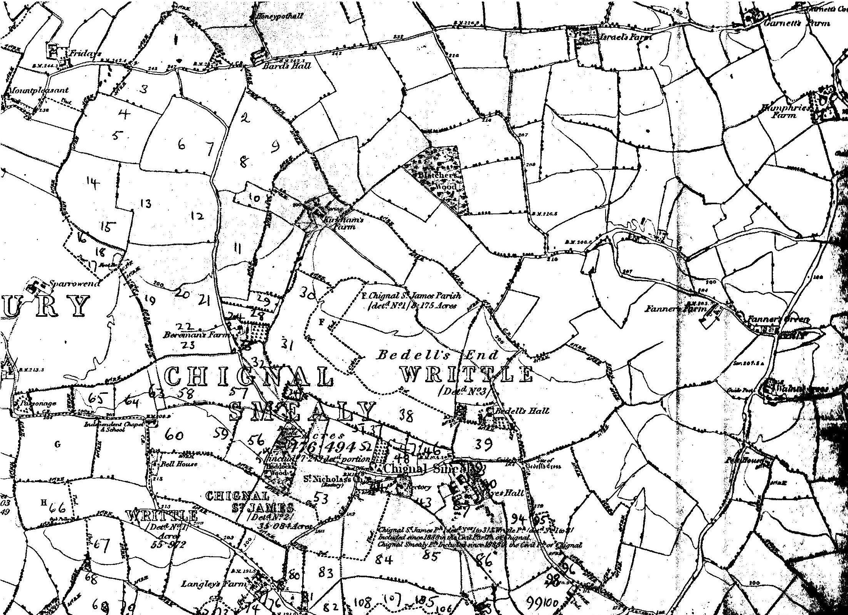
Map 1
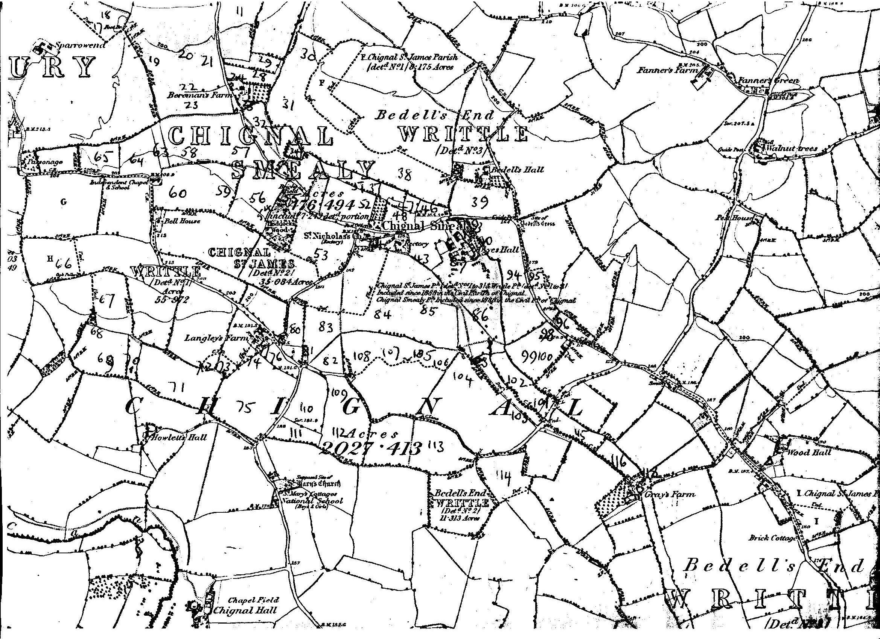
Map 2.

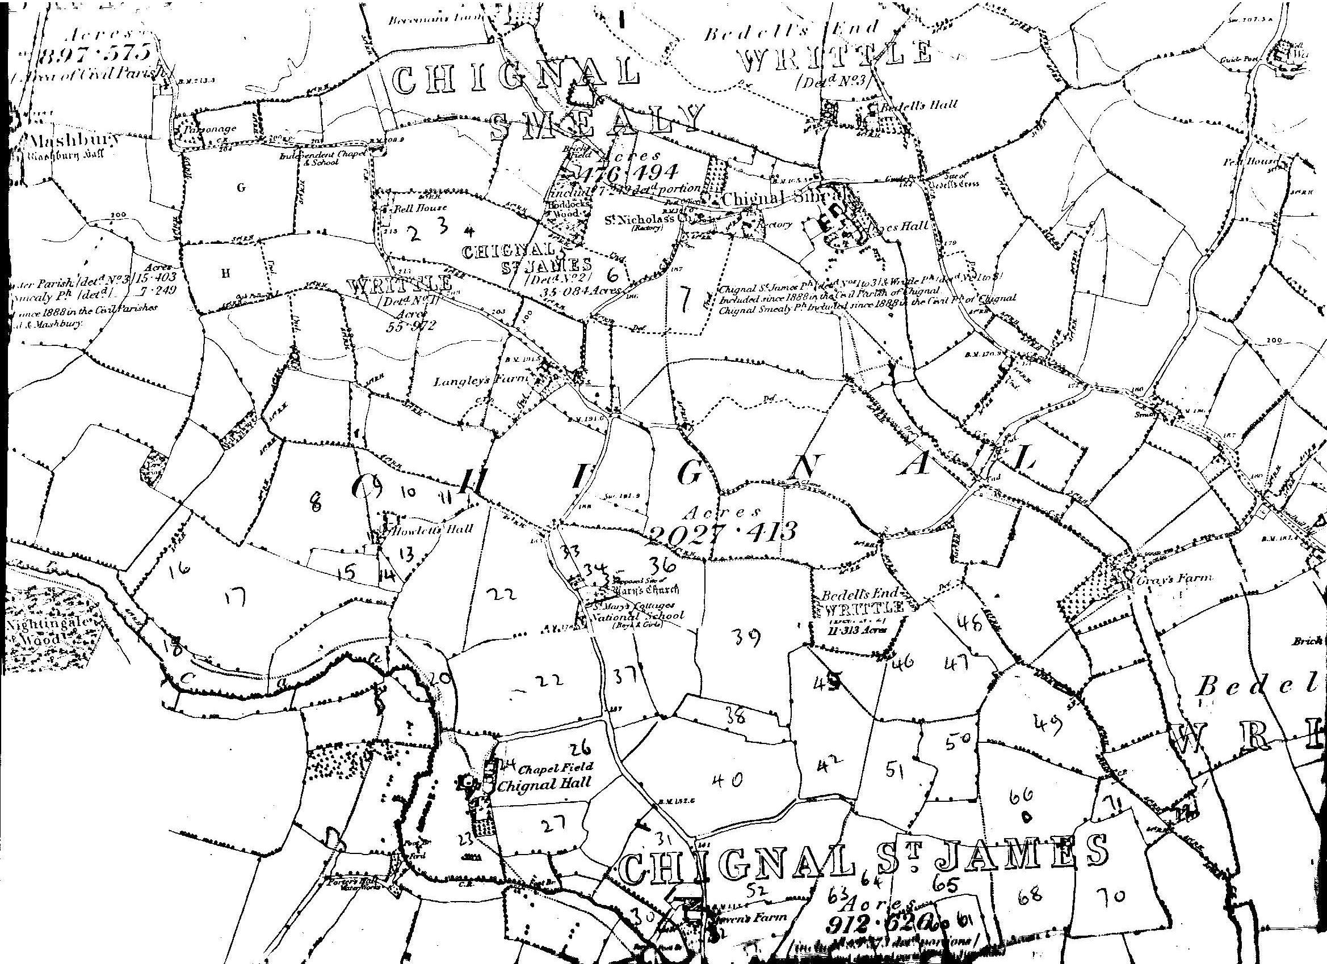
Map 3
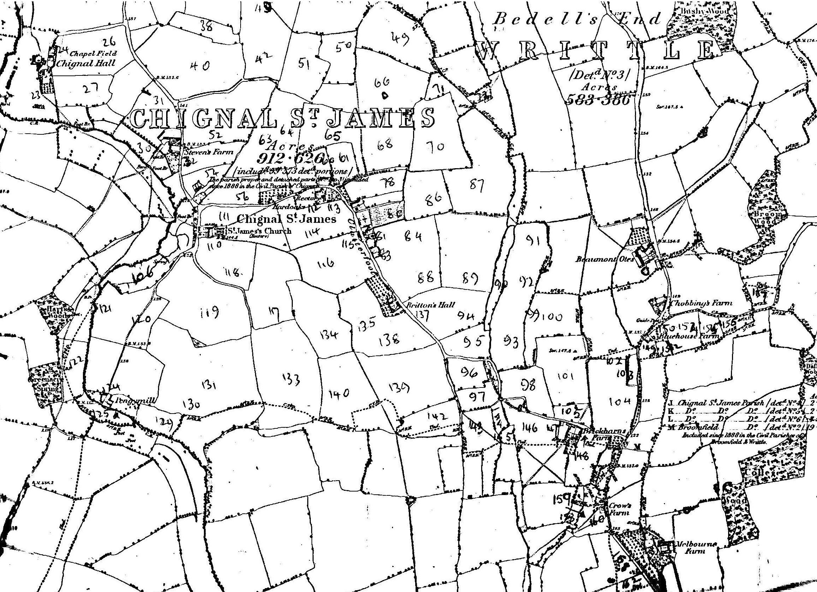
Map 4

