THE PLACE-NAMES

OF CREEKSEA

Recorder: James Kemble

Essex Place-names Project (Essex Society for Archaeology & History)

Essex Record Office e-book, 2nd edition, 2010. (1st edition in hard copy 2004).

www.essex.ac.uk/history/esah/essexplacenames

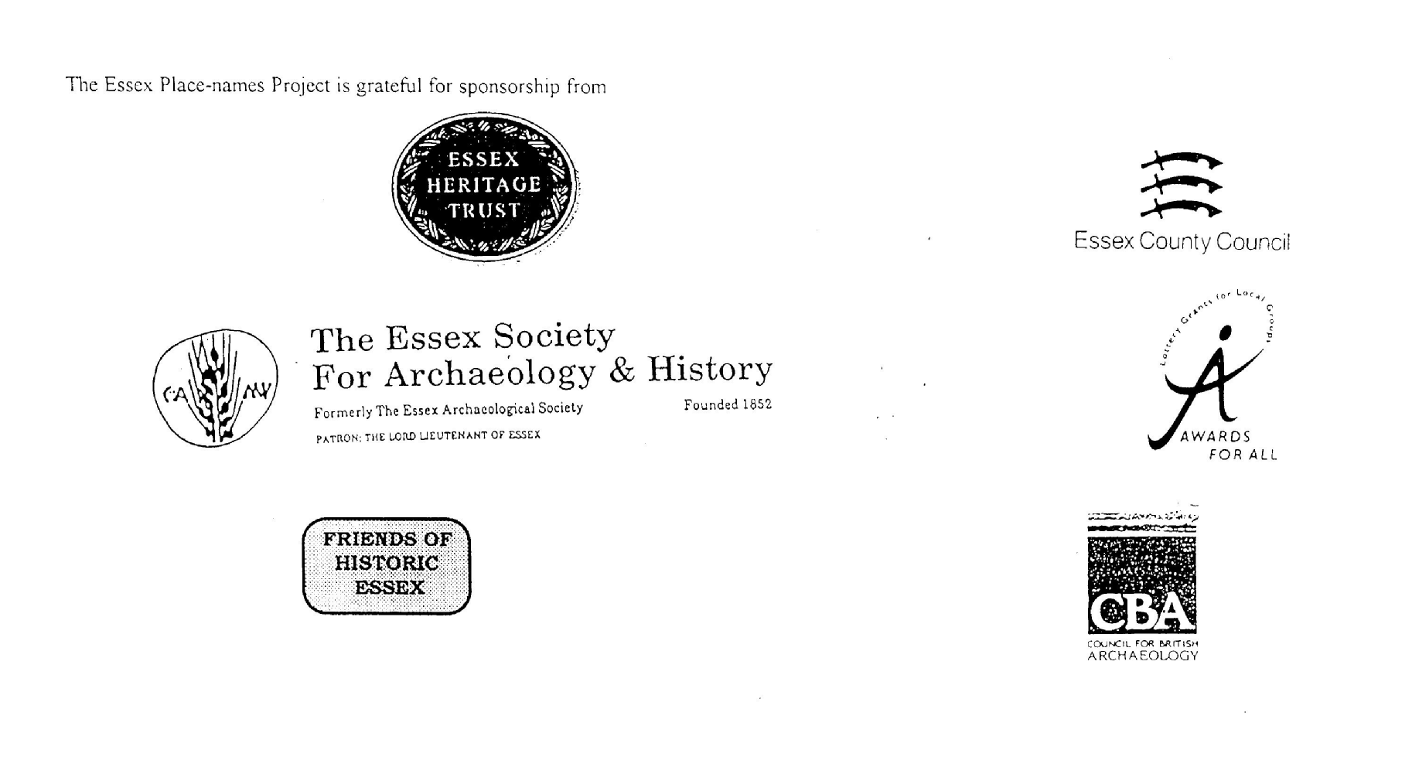

ESSEX PLACE-NAMES PROJECT.

The Essex Place-names Project is a County-wide survey to record place- and field-names from historical documents such as Tithe maps and apportionments, estate maps, sale and auction catalogues, conveyances, terriers, deeds, rolls, inquisitions and surveys.

The second element of the Project is to investigate on-the-ground visible remains which correspond to the Place-names for actual or potential archaeological, agricultural and industrial
sites, and to record natural (topographical) and man-made features which may relate to the Place-name. This involves field-survey in rural and outside investigation in built-up areas.

It is anticipated that the Project will lead to identification of archaeological sites and lost historic buildings; it will enable analysis of indicators of early settlement, land holding, agricultural and industrial practices of the County. It will refine the more precise meaning of descriptive words and elements used by earlier settlers as they gave names appropriate to the topography of the landscape of their time.

For convenience the surveys are based on the parish, recognising that present civil parish boundaries are not necessarily identical to former ecclesiastical boundaries. Local Recorders
are supplied with templates of Record Forms to ensure consistency of recording across the County, and forward completed forms to a Central Coordinator for transfer to a county
computer database which is available at the Essex Record Office to researchers.

This publication presents part of the information recorded from the Tithe or Estate Award and Map, (and from other documents for this parish.) The full record is contained on the master database in the Essex Record Office, Wharf Road, Chelmsford CM2 6YT and the website www.essex.ac.uk/history/esah/essexplacenames. Parish books are available from the ERO on disc or in hard copy or may be downloaded from the website. Please notify errors to the Project Coordinator at the Essex Record Office.

THE TITHE MAP AND APPORTIONMENT.

Since medieval times a tenth of the produce of land and stock had been paid by landholders to the church. At the Dissolution of the Monasteries, the property of many religious houses,
including the right to collect tithes, passed into lay hands. The Tithe Commutation Act which received Royal assent on 13th August 1836 abolished a rent payable in kind and
substituted rent-charges apportioned on each plot or parcel. The tithe-rent payable was assessed on the average value of wheat, barley and oats and was to fluctuate with price movements.

The commutation could be by voluntary agreement between the local owners and payers or, if agreement failed, could be compulsorily imposed by commissioners. A Valuer was to be
appointed to apportion the rent of each parcel of land and tenants could deduct that rent-charge from their rent paid to the landlord. The task fell to the Tithe Commissioners to produce a map and an Apportionment (Award). A large-scale survey was produced for over 70% of England and Wales in the following 9 years, and about another 8% up to 1855. Most of the
parishes in Essex were surveyed. The map scales vary. The Award records ownership, tenancy and land-use, field by field and parcel by parcel (often quoting the field name) with the
ground area and rent-charge.

Land that was tithe-free tends to be less accurately mapped and contains few if any of the details recorded for those parcels subject to tithe. Rights of way and roads also tend to be
neglected. Boundaries of the tithe areas are shown as are some natural features such as streams, ponds, gardens, greens and commons. Buildings are often shown coloured red if dwellings or grey if not. Because the Award may have been agreed only some time after the map was finished, discrepancies occur between the two. Enclosure Awards, when extant, usually date to the 18th and early 19th centuries. J.Kemble.
Reproduced by permission
of Essex County Council.

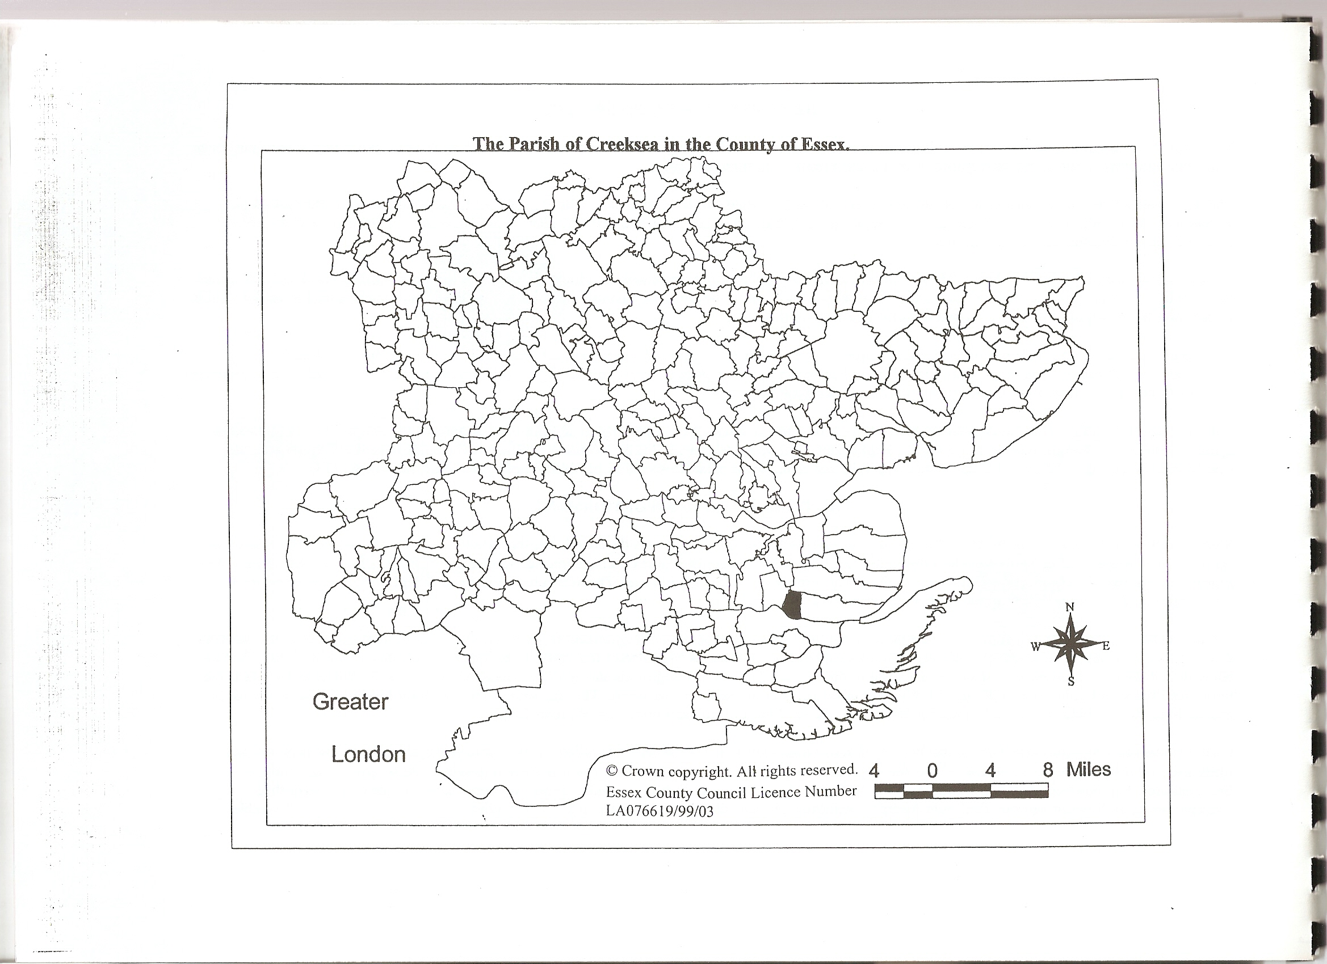

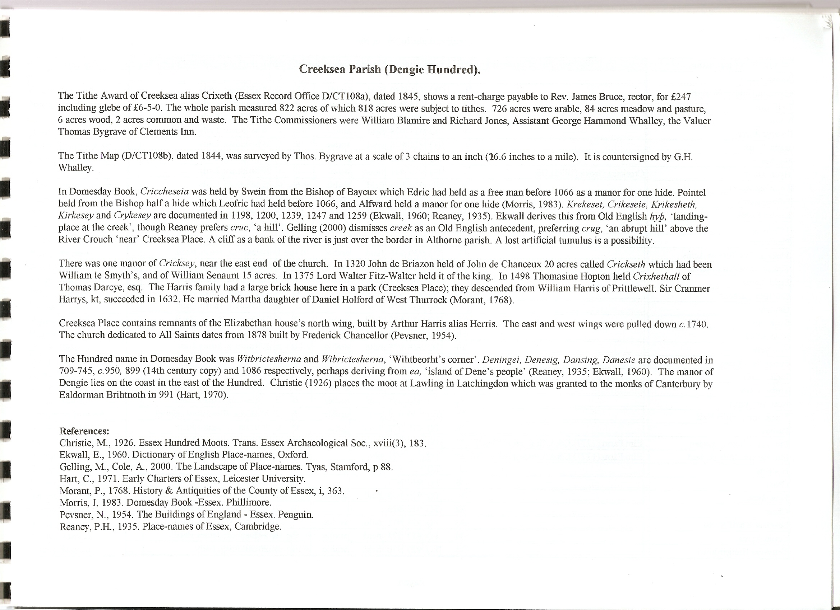

The Tithe Award Place-names of Creeksea – by Parcel No.

Place-name | Alias | Fld No | Gd Ref | x | y | Place Type | Acr | rd | pch | Land use | Owner | Occupier | Other information
Creeksea field or Mangapp |  | 1 | TQ | 936 | 980 | field | 11 | 1 | 1 | arable | Mildmay, Lady | Orwell, Peacock
Driftway |  | 2 | TQ | 935 | 980 | field | 0 | 1 | 29 | grass | Mildmay, Lady | Baker, Charles, exec
Road |  | 3 | TQ | 935 | 979 | rd | 0 | 1 | 34 |  | Mildmay, Lady | Baker, Charles, exec
Twelve Acres |  | 4 | TQ | 933 | 978 | field | 13 | 1 | 6 | arable | Mildmay, Lady | Baker, Charles, exec
Eight Acres |  | 5 | TQ | 932 | 978 | field | 9 | 1 | 35 | arable | Mildmay, Lady | Baker, Charles, exec
Six Acres |  | 6 | TQ | 932 | 981 | field | 7 | 0 | 29 | arable | Mildmay, Lady | Baker, Charles, exec
Hyde wood | Creeksea Grove (1875),OS | 7 | TQ | 933 | 981 | wood | 6 | 1 | 29 | wood | Mildmay, Lady | Mildmay, Lady
Long Six Acres |  | 8 | TQ | 935 | 981 | field | 6 | 0 | 35 | arable | Mildmay, Lady | Baker, Charles, exec
Fifteen Acres |  | 9 | TQ | 935 | 984 | field | 16 | 3 | 20 | arable | Mildmay, Lady | Baker, Charles, exec
Eleven Acres |  | 10 | TQ | 933 | 984 | field | 13 | 0 | 3 | arable | Mildmay, Lady | Baker, Charles, exec
Ten Acres |  | 11 | TQ | 932 | 984 | field | 11 | 2 | 7 | arable | Mildmay, Lady | Baker, Charles, exec
Plantation |  | 12 | TQ | 932 | 986 | wood | 0 | 0 | 26 | wood | Danbuz, James Basil | Kemp, Samuel
Tinkers Hole Eleven Acres |  | 13 | TQ | 930 | 985 | field | 11 | 1 | 20 | arable | Danbuz, James Basil | Kemp, Samuel
Tinkers Hole Nine Acres |  | 14 | TQ | 930 | 983 | field | 10 | 1 | 1 | arable | Danbuz, James Basil | Kemp, Samuel
Eight Acres |  | 15 | TQ | 930 | 981 | field | 9 | 2 | 0 | arable | Danbuz, James Basil | Kemp, Samuel
Cottages, gardens |  | 16 | TQ | 931 | 981 | cttgs | 0 | 0 | 25 |  | Danbuz, James Basil | Kemp, Samuel
Garden |  | 17 | TQ | 931 | 979 | gdn | 0 | 0 | 7 |  | Danbuz, James Basil | Kemp, Samuel
Six Acres |  | 18 | TQ | 930 | 979 | field | 7 | 0 | 16 | arable | Danbuz, James Basil | Kemp, Samuel
Nine Acres |  | 19 | TQ | 928 | 980 | field | 10 | 1 | 33 | arable | Danbuz, James Basil | Kemp, Samuel
Ten Acres |  | 20 | TQ | 928 | 978 | field | 11 | 1 | 23 | arable | Danbuz, James Basil | Kemp, Samuel
Further Six Acres |  | 21 | TQ | 928 | 976 | field | 7 | 1 | 9 | arable | Danbuz, James Basil | Kemp, Samuel
Eight Acres |  | 22 | TQ | 928 | 974 | field | 8 | 1 | 38 | arable | Danbuz, James Basil | Kemp, Samuel
Three Acres |  | 23 | TQ | 929 | 974 | field | 3 | 0 | 32 | arable | Danbuz, James Basil | Kemp, Samuel
Near Six Acres |  | 24 | TQ | 929 | 975 | field | 6 | 2 | 9 | arable | Danbuz, James Basil | Kemp, Samuel
Three Acres and a Half |  | 25 | TQ | 929 | 977 | field | 3 | 2 | 35 | arable | Bruce, Rev James | Dunmore, Edward | glebe
Pasture |  | 26 | TQ | 930 | 978 | field | 0 | 2 | 28 | grass | Danbuz, James Basil | Kemp, Samuel
Elm Farm House, garden | Elm Farm (1777),C&A; Crosses (1875),OS | 27 | TQ | 930 | 977 | bldg | 0 | 1 | 12 |  | Danbuz, James Basil | Kemp, Samuel
Elm Farm buildings, yard | Elm Farm (1777),C&A; Crosses (1875),OS | 28 | TQ | 930 | 977 | bldgs | 0 | 3 | 14 |  | Danbuz, James Basil | Kemp, Samuel
Hoppett |  | 29 | TQ | 929 | 976 | field | 0 | 3 | 20 | grass | Danbuz, James Basil | Kemp, Samuel
Chase |  | 30 | TQ | 930 | 977 |  | 0 | 1 | 30 |  | Danbuz, James Basil | Kemp, Samuel
Four Acres |  | 31 | TQ | 929 | 975 | field | 4 | 1 | 12 | arable | Bruce, Rev James | Dunmore, Edward | glebe
Chase |  | 32 | TQ | 928 | 973 |  | 1 | 2 | 35 |  | Danbuz, James Basil | Kemp, Samuel
Seven & a half Acres |  | 33 | TQ | 928 | 971 | field | 7 | 3 | 15 | arable | Danbuz, James Basil | Kemp, Samuel
Seven Acres |  | 34 | TQ | 927 | 971 | field | 7 | 1 | 34 | arable | Danbuz, James Basil | Kemp, Samuel
Ten Acre Hungerdown |  | 35 | TQ | 927 | 970 | field | 10 | 0 | 26 | arable | Mildmay, Lady | Kemp, Samuel
Eight Acre Hungerdown |  | 36 | TQ | 927 | 968 | field | 8 | 2 | 26 | arable | Mildmay, Lady | Kemp, Samuel
Fifteen Acre Marsh |  | 37 | TQ | 927 | 967 | field | 16 | 1 | 39 | arable | Danbuz, James Basil | Kemp, Samuel
Grove |  | 38 | TQ | 926 | 967 | wood | 0 | 1 | 36 | wood | Danbuz, James Basil | Kemp, Samuel
Cliff field |  | 39 | TQ | 926 | 967 | field | 4 | 0 | 27 | arable | Gardner, Richard | Gardner, Richard
Saltings, seawall |  | 40 | TQ | 927 | 965 | sltngs | 2 | 3 | 13 | grass | Danbuz, James Basil | Kemp, Samuel | 40, 41 are together
Saltings, seawall |  | 41 | TQ | 927 | 965 | sltngs | 2 | 3 | 13 | grass | Danbuz, James Basil | Kemp, Samuel | 40, 41 are together
Kill Hill |  | 42 | TQ | 928 | 965 | field | 13 | 1 | 12 | arable | Danbuz, James Basil | Kemp, Samuel
Six Acre Sea field |  | 43 | TQ | 928 | 967 | field | 6 | 1 | 7 | arable | Danbuz, James Basil | Kemp, Samuel
Nine Acre Hungerdown |  | 44 | TQ | 928 | 969 | field | 9 | 0 | 20 | arable | Mildmay, Lady | Kemp, Samuel
Owls Hole |  | 45 | TQ | 929 | 968 | field | 7 | 1 | 28 | arable | Danbuz, James Basil | Kemp, Samuel
Barn field |  | 46 | TQ | 930 | 967 | field | 9 | 0 | 2 | arable | Danbuz, James Basil | Kemp, Samuel
Front Nine Acres |  | 47 | TQ | 932 | 967 | field | 9 | 2 | 31 | arable | Danbuz, James Basil | Kemp, Samuel
Six Acre Ferry field |  | 48 | TQ | 931 | 964 | field | 6 | 3 | 8 | arable | Danbuz, James Basil | Kemp, Samuel
Four Acres |  | 49 | TQ | 930 | 964 | field | 4 | 0 | 20 | arable | Danbuz, James Basil | Kemp, Samuel
Six Acres |  | 50 | TQ | 929 | 964 | field | 6 | 1 | 18 | arable | Danbuz, James Basil | Kemp, Samuel
Seven & a half Acres |  | 51 | TQ | 928 | 964 | field | 7 | 3 | 2 | arable | Danbuz, James Basil | Kemp, Samuel
Cliff, The |  | 52 | TQ | 927 | 964 | wood | 2 | 0 | 13 | wood | Danbuz, James Basil | Kemp, Samuel
Saltings, seawall |  | 53 | TQ | 928 | 962 | sltngs | 4 | 0 | 36 | grass | Danbuz, James Basil | Kemp, Samuel | 53,54 are together
Saltings, seawall |  | 54 | TQ | 928 | 962 | sltngs | 4 | 0 | 36 | grass | Danbuz, James Basil | Kemp, Samuel | 53,54 are together
Saltings, The |  | 55 | TQ | 926 | 963 | sltngs | 8 | 2 | 4 | grass | Danbuz, James Basil | Kemp, Samuel
Grass Marsh |  | 56 | TQ | 929 | 962 | field | 10 | 3 | 9 | grass | Danbuz, James Basil | Kemp, Samuel
Saltings, seawall | Oyster Beds (1875),OS | 57 | TQ | 929 | 961 | sltngs | 2 | 3 | 18 | grass | Clark, George | Clark, George
Cliff field |  | 58 | TQ | 931 | 960 | field | 6 | 2 | 7 | arable | Clark, George | Clark, George
Middle Six Acres |  | 59 | TQ | 931 | 961 | field | 6 | 1 | 21 | arable | Clark, George | Clark, George
Acre field |  | 60 | TQ | 932 | 962 | field | 1 | 0 | 4 | arable | Mildmay, Lady | Baker, Charles, exec
Upper Six Acres |  | 61 | TQ | 931 | 962 | field | 5 | 3 | 1 | arable | Clark, George | Clark, George
Eleven Acre Ferry field |  | 62 | TQ | 933 | 964 | field | 12 | 1 | 37 | arable | Danbuz, James Basil | Kemp, Samuel
Further Nine Acres |  | 63 | TQ | 934 | 966 | field | 10 | 1 | 15 | arable | Danbuz, James Basil | Kemp, Samuel
Front Pasture |  | 64 | TQ | 933 | 969 | field | 3 | 3 | 12 | grass | Danbuz, James Basil | Kemp, Samuel
Creeksea Hall Homestead | Cricksey Hall (1777),C&A | 65 | TQ | 933 | 969 | hmstd | 2 | 1 | 1 |  | Danbuz, James Basil | Kemp, Samuel
Church Pasture |  | 66 | TQ | 931 | 968 | field | 1 | 1 | 8 | grass | Danbuz, James Basil | Kemp, Samuel
Church, churchyard | [All Saints] | 67 | TQ | 931 | 968 | chch | 0 | 2 | 21
Church field |  | 68 | TQ | 930 | 969 | field | 3 | 1 | 22 | arable | Danbuz, James Basil | Kemp, Samuel
Back Pasture |  | 69 | TQ | 931 | 969 | field | 4 | 0 | 30 | grass | Danbuz, James Basil | Kemp, Samuel
Cottage, garden |  | 70 | TQ | 933 | 970 | cttg | 0 | 0 | 38 |  | Danbuz, James Basil | Kemp, Samuel
Top Pasture |  | 71 | TQ | 932 | 971 | field | 2 | 0 | 14 | grass | Danbuz, James Basil | Kemp, Samuel
Cowhouse field |  | 72 | TQ | 931 | 971 | field | 9 | 2 | 14 | arable | Danbuz, James Basil | Kemp, Samuel
Hilly Ten Acres |  | 73 | TQ | 929 | 970 | field | 10 | 2 | 23 | arable | Danbuz, James Basil | Kemp, Samuel
Eleven Acre Longfield |  | 74 | TQ | 929 | 972 | field | 10 | 1 | 33 | arable | Danbuz, James Basil | Kemp, Samuel
Twelve Acres |  | 75 | TQ | 931 | 973 | field | 13 | 2 | 14 | arable | Danbuz, James Basil | Kemp, Samuel
Prouts Eight Acres |  | 76 | TQ | 932 | 975 | field | 9 | 0 | 0 | arable | Danbuz, James Basil | Kemp, Samuel
Three Acres |  | 77 | TQ | 930 | 977 | field | 3 | 0 | 8 | arable | Bruce, Rev James | Dunmore, Edward | glebe
Five Acres |  | 78 | TQ | 931 | 977 | field | 2 | 2 | 35 | arable | Bruce, Rev James | Dunmore, Edward | glebe
Barn, yard |  | 79 | TQ | 932 | 977 | bldg | 0 | 0 | 22 |  | Bruce, Rev James | Dunmore, Edward | glebe
Hoppett |  | 80 | TQ | 932 | 977 | field | 0 | 3 | 31 | grass | Bruce, Rev James | Dunmore, Edward | glebe
Cottage, garden |  | 81 | TQ | 932 | 977 | cttg | 0 | 0 | 33 |  | Bruce, Rev James | Dunmore, Edward | glebe
Two & a half Acres |  | 82 | TQ | 932 | 977 | field | 2 | 3 | 34 | arable | Bruce, Rev James | Dunmore, Edward | glebe
Further Three Acres |  | 83 | TQ | 933 | 977 | field | 3 | 0 | 6 | arable | Bruce, Rev James | Dunmore, Edward | glebe
Cottages, gardens |  | 84 | TQ | 933 | 977 | cttgs | 0 | 0 | 26 |  | Mildmay, Lady | Baker, Charles, exec
Cottages, gardens |  | 85 | TQ | 934 | 977 | cttgs | 0 | 0 | 24 |  | Miller; others | Gill; others
Cottages, gardens |  | 86 | TQ | 934 | 977 | cttgs | 0 | 0 | 6 |  | Miller; others | Gill; others
Cottages, gardens |  | 87 | TQ | 935 | 977 | cttgs | 0 | 0 | 19 |  | Wackerill; others | Rolfe, James
Cottage, garden | Ostend (1875), OS | 88 | TQ | 936 | 977 | cttg | 0 | 0 | 5 |  | Brown, James | Brown, James
Cottages, gardens | Ostend (1875), OS | 89 | TQ | 936 | 977 | cttgs | 0 | 0 | 10 |  | Dale, William | Dale,Wm; others
Five Acre Lions |  | 90 | TQ | 935 | 976 | field | 5 | 0 | 2 | arable | Danbuz, James Basil | Kemp, Samuel
Four Acre Lions |  | 91 | TQ | 934 | 976 | field | 5 | 1 | 19 | arable | Danbuz, James Basil | Kemp, Samuel
Further Eight Acres |  | 92 | TQ | 934 | 974 | field | 9 | 1 | 18 | arable | Danbuz, James Basil | Kemp, Samuel
Five Acre Mustards |  | 93 | TQ | 937 | 974 | field | 5 | 1 | 36 | arable | Burnham Charity | Kemp, Samuel
Near Eight Acres |  | 94 | TQ | 935 | 973 | field | 9 | 0 | 17 | arable | Danbuz, James Basil | Kemp, Samuel
Home Eight Acres |  | 95 | TQ | 934 | 970 | field | 8 | 2 | 26 | arable | Danbuz, James Basil | Kemp, Samuel
Middle Eight Acres |  | 96 | TQ | 935 | 970 | field | 8 | 0 | 7 | arable | Danbuz, James Basil | Kemp, Samuel
Seven Acre Mustards |  | 97 | TQ | 936 | 970 | field | 7 | 1 | 11 | arable | Burnham Charity | Kemp, Samuel
Little Mustards |  | 98 | TQ | 937 | 970 | field | 0 | 2 | 21 | arable | Burnham Charity | Kemp, Samuel
Creeksea Lodge homestead | Lodge Farm (1875),OS | 99 | TQ | 938 | 970 | hmstd | 1 | 1 | 3 |  | Price, Mrs | Croxon, Sarah
Back Pasture |  | 100 | TQ | 938 | 971 | field | 3 | 0 | 28 | grass | Price, Mrs | Croxon, Sarah
Near Four Acres |  | 101 | TQ | 939 | 970 | field | 4 | 1 | 4 | arable | Price, Mrs | Croxon, Sarah
Further Four Acres |  | 102 | TQ | 940 | 970 | field | 4 | 0 | 2 | arable | Price, Mrs | Croxon, Sarah
Seven Acres |  | 103 | TQ | 939 | 969 | field | 7 | 0 | 15 | arable | Price, Mrs | Croxon, Sarah
Two Acres |  | 104 | TQ | 938 | 968 | field | 2 | 1 | 18 | arable | Price, Mrs | Croxon, Sarah
Front Pasture |  | 105 | TQ | 938 | 969 | field | 3 | 2 | 27 | grass | Price, Mrs | Croxon, Sarah
Cottage, garden |  | 106 | TQ | 938 | 967 | cttg | 0 | 1 | 2 |  | Mildmay, Lady | Baker, Charles, exec
Five Acres |  | 107 | TQ | 938 | 967 | field | 5 | 0 | 36 | arable | Mildmay, Lady | Baker, Charles, exec
Six Acres |  | 108 | TQ | 937 | 967 | field | 7 | 3 | 6 | arable | Mildmay, Lady | Baker, Charles, exec
Eighteen Acres |  | 109 | TQ | 936 | 967 | field | 18 | 2 | 38 | arable | Mildmay, Lady | Baker, Charles, exec
Horsepond field |  | 110 | TQ | 935 | 964 | field | 9 | 0 | 8 | arable | Mildmay, Lady | Baker, Charles, exec
Pightle |  | 111 | TQ | 936 | 964 | field | 3 | 1 | 39 | grass | Mildmay, Lady | Baker, Charles, exec
Eight Acres |  | 112 | TQ | 936 | 965 | field | 8 | 2 | 13 | arable | Mildmay, Lady | Baker, Charles, exec
Thirteen Acres |  | 113 | TQ | 939 | 967 | field | 13 | 2 | 24 | arable | Mildmay, Lady | Baker, Charles, exec
Twelve Acres |  | 114 | TQ | 940 | 965 | field | 13 | 0 | 32 | arable | Mildmay, Lady | Baker, Charles, exec
Nine Acres |  | 115 | TQ | 940 | 963 | field | 10 | 2 | 33 | arable | Mildmay, Lady | Baker, Charles, exec
Ten Acres |  | 116 | TQ | 940 | 961 | field | 11 | 2 | 6 | arable | Mildmay, Lady | Baker, Charles, exec
Barn field |  | 117 | TQ | 938 | 962 | field | 10 | 0 | 39 | arable | Mildmay, Lady | Baker, Charles, exec
Gravel Pit field |  | 118 | TQ | 938 | 961 | field | 6 | 3 | 0 | arable | Mildmay, Lady | Baker, Charles, exec
Furze field |  | 119 | TQ | 937 | 960 | field | 4 | 2 | 8 | grass | Mildmay, Lady | Baker, Charles, exec
Garden field |  | 120 | TQ | 935 | 962 | field | 7 | 0 | 17 | arable | Mildmay, Lady | Baker, Charles, exec
Pightle |  | 121 | TQ | 934 | 962 | field | 0 | 2 | 18 | grass | Mildmay, Lady | Baker, Charles, exec
Creeksea Place Farmhouse, garden | Cricksey Place (1777),C&A | 122 | TQ | 935 | 962 | bldg | 0 | 2 | 27 |  | Mildmay, Lady | Baker, Charles, exec
Creeksea Place Farm buildings | Cricksey Place (1777),C&A | 123 | TQ | 935 | 962 | bldgs | 2 | 1 | 5 |  | Mildmay, Lady | Baker, Charles, exec
Pightle |  | 124 | TQ | 935 | 963 | field | 2 | 1 | 16 | grass | Mildmay, Lady | Baker, Charles, exec
Home Pasture |  | 125 | TQ | 934 | 962 | field | 2 | 1 | 11 | grass | Mildmay, Lady | Baker, Charles, exec
Garden piece |  | 126 | TQ | 934 | 962 | field | 0 | 1 | 34 | arable | Mildmay, Lady | Baker, Charles, exec
Garden |  | 127 | TQ | 934 | 962 | gdn | 0 | 0 | 23 |  | Mildmay, Lady | Baker, Charles, exec
Ozier Ground |  | 128 | TQ | 934 | 962 | field | 0 | 2 | 22 | grass | Mildmay, Lady | Baker, Charles, exec
Rushy Piece |  | 129 | TQ | 933 | 962 | field | 8 | 3 | 27 | grass | Mildmay, Lady | Baker, Charles, exec
Grove |  | 130 | TQ | 933 | 961 | wood | 1 | 1 | 35 | wood | Mildmay, Lady | Baker, Charles, exec
Two Acres |  | 131 | TQ | 932 | 961 | field | 1 | 3 | 20 | arable | Clark, George | Clark, George
Little Pasture |  | 132 | TQ | 933 | 962 | field | 1 | 3 | 35 | arable | Mildmay, Lady | Baker, Charles, exec
Little Pasture |  | 133 | TQ | 932 | 960 | field | 3 | 0 | 9 | arable | Mildmay, Lady | Baker, Charles, exec
Ferry field |  | 134 | TQ | 934 | 960 | field | 7 | 2 | 4 | arable | Mildmay, Lady | Baker, Charles, exec
Grove | The Grove (1875),OS | 135 | TQ | 934 | 958 | wood | 3 | 0 | 30 | wood | Mildmay, Lady | Baker, Charles, exec
Lower Furze field |  | 136 | TQ | 936 | 958 | field | 4 | 3 | 16 | grass | Mildmay, Lady | Baker, Charles, exec
Brick Dock Marsh |  | 137 | TQ | 939 | 957 | field | 12 | 0 | 30 | arable | Mildmay, Lady | Baker, Charles, exec
Canaway Marsh |  | 138 | TQ | 939 | 959 | field | 7 | 0 | 36 | arable | Mildmay, Lady | Baker, Charles, exec
Six Acre Marsh |  | 139 | TQ | 940 | 960 | field | 5 | 2 | 33 | arable | Mildmay, Lady | Baker, Charles, exec
Twelve Acre Marsh |  | 140 | TQ | 943 | 960 | field | 15 | 1 | 24 | arable | Mildmay, Lady | Baker, Henry
Seven Acre Marsh |  | 141 | TQ | 942 | 958 | field | 7 | 1 | 10 | arable | Mildmay, Lady | Baker, Henry
Five Acre Marsh |  | 142 | TQ | 941 | 968 | field | 5 | 0 | 13 | arable | Mildmay, Lady | Baker, Charles, exec
Saltings, seawall |  | 143 | TQ | 942 | 967 | sltngs | 2 | 1 | 7 | grass | Mildmay, Lady | Baker, Henry
Saltings, seawall |  | 144 | TQ | 940 | 967 | sltngs | 4 | 2 | 8 | arable | Mildmay, Lady | Baker, Charles, exec
Saltings, seawall |  | 145 | TQ | 936 | 966 | sltngs | 7 | 0 | 28 | grass | Clark, George | Clark, George
Burnham field |  | 146 | TQ | 935 | 967 | field | 6 | 1 | 31 | arable | Clark, George | Clark, George
Home field |  | 147 | TQ | 934 | 967 | field | 1 | 1 | 32 | arable | Clark, George | Clark, George
House,bldgs,yard,gdn |  | 148 | TQ | 934 | 967 | bldgs | 0 | 2 | 28 |  | Clark, George | Clark, George
Home field |  | 149 | TQ | 933 | 967 | field | 5 | 1 | 38 | arable | Clark, George | Clark, George
Cottages, gardens |  | 150 | TQ | 933 | 968 | cttgs | 0 | 0 | 34 |  | Clark, George | Clark, George
Public House,premises |  | 151 | TQ | 933 | 968 | bldg | 0 | 0 | 27 |  | Clark, George | Clark, George
Greyhound Pasture |  | 152 | TQ | 932 | 968 | field | 0 | 3 | 17 | grass | Clark, George | Clark, George
Home field |  | 153 | TQ | 933 | 968 | field | 1 | 0 | 7 | grass | Clark, George | Clark, George
Saltings | Lime kiln (1875),OS | 154 | TQ | 933 | 968 | sltngs | 1 | 3 | 36 | grass | Clark, George | Clark, George
Lions Croft or Cantonhooks |  | 155 | TQ | 923 | 959 | field | 12 | 0 | 21 | grass | Campion, William Thon | Lester, Labon | detached
Saltings, seawall |  | 156 | TQ | 924 | 960 | sltngs | 4 | 0 | 8 | grass | Campion, William Thon | Lester, Labon | detached
Roads, waste |  |  |  |  |  |  | 7 | 1 | 35

For abbreviations see Reaney, P., Place-names of Essex, Cambridge 1935; and Kemble, J., Essex Place-names, Places, Streets & People, Historical Publications, London 2007.

The Tithe Award Place-names of Creeksea – by Place-name.

Place-name | Alias | Fld No | Gd Ref | x | y | Place Type | Acr | rd | pch | Land use | Owner | Occupier | Other information
Acre field |  | 60 | TQ | 932 | 962 | field | 1 | 0 | 4 | arable | Mildmay, Lady | Baker, Charles, exec
Back Pasture |  | 69 | TQ | 931 | 969 | field | 4 | 0 | 30 | grass | Danbuz, James Basil | Kemp, Samuel
Back Pasture |  | 100 | TQ | 938 | 971 | field | 3 | 0 | 28 | grass | Price, Mrs | Croxon, Sarah
Barn field |  | 46 | TQ | 930 | 967 | field | 9 | 0 | 2 | arable | Danbuz, James Basil | Kemp, Samuel
Barn field |  | 117 | TQ | 938 | 962 | field | 10 | 0 | 39 | arable | Mildmay, Lady | Baker, Charles, exec
Barn, yard |  | 79 | TQ | 932 | 977 | bldg | 0 | 0 | 22 |  | Bruce, Rev James | Dunmore, Edward | glebe
Brick Dock Marsh |  | 137 | TQ | 939 | 957 | field | 12 | 0 | 30 | arable | Mildmay, Lady | Baker, Charles, exec
Burnham field |  | 146 | TQ | 935 | 967 | field | 6 | 1 | 31 | arable | Clark, George | Clark, George
Canaway Marsh |  | 138 | TQ | 939 | 959 | field | 7 | 0 | 36 | arable | Mildmay, Lady | Baker, Charles, exec
Chase |  | 30 | TQ | 930 | 977 |  | 0 | 1 | 30 |  | Danbuz, James Basil | Kemp, Samuel
Chase |  | 32 | TQ | 928 | 973 |  | 1 | 2 | 35 |  | Danbuz, James Basil | Kemp, Samuel
Church field |  | 68 | TQ | 930 | 969 | field | 3 | 1 | 22 | arable | Danbuz, James Basil | Kemp, Samuel
Church Pasture |  | 66 | TQ | 931 | 968 | field | 1 | 1 | 8 | grass | Danbuz, James Basil | Kemp, Samuel
Church, churchyard | [All Saints] | 67 | TQ | 931 | 968 | chch | 0 | 2 | 21
Cliff field |  | 58 | TQ | 931 | 960 | field | 6 | 2 | 7 | arable | Clark, George | Clark, George
Cliff field |  | 39 | TQ | 926 | 967 | field | 4 | 0 | 27 | arable | Gardner, Richard | Gardner, Richard
Cliff, The |  | 52 | TQ | 927 | 964 | wood | 2 | 0 | 13 | wood | Danbuz, James Basil | Kemp, Samuel
Cottage, garden | Ostend (1875), OS | 88 | TQ | 936 | 977 | cttg | 0 | 0 | 5 |  | Brown, James | Brown, James
Cottage, garden |  | 81 | TQ | 932 | 977 | cttg | 0 | 0 | 33 |  | Bruce, Rev James | Dunmore, Edward | glebe
Cottage, garden |  | 70 | TQ | 933 | 970 | cttg | 0 | 0 | 38 |  | Danbuz, James Basil | Kemp, Samuel
Cottage, garden |  | 106 | TQ | 938 | 967 | cttg | 0 | 1 | 2 |  | Mildmay, Lady | Baker, Charles, exec
Cottages, gardens |  | 150 | TQ | 933 | 968 | cttgs | 0 | 0 | 34 |  | Clark, George | Clark, George
Cottages, gardens | Ostend (1875), OS | 89 | TQ | 936 | 977 | cttgs | 0 | 0 | 10 |  | Dale, William | Dale,Wm; others
Cottages, gardens |  | 16 | TQ | 931 | 981 | cttgs | 0 | 0 | 25 |  | Danbuz, James Basil | Kemp, Samuel
Cottages, gardens |  | 84 | TQ | 933 | 977 | cttgs | 0 | 0 | 26 |  | Mildmay, Lady | Baker, Charles, exec
Cottages, gardens |  | 85 | TQ | 934 | 977 | cttgs | 0 | 0 | 24 |  | Miller; others | Gill; others
Cottages, gardens |  | 86 | TQ | 934 | 977 | cttgs | 0 | 0 | 6 |  | Miller; others | Gill; others
Cottages, gardens |  | 87 | TQ | 935 | 977 | cttgs | 0 | 0 | 19 |  | Wackerill; others | Rolfe, James
Cowhouse field |  | 72 | TQ | 931 | 971 | field | 9 | 2 | 14 | arable | Danbuz, James Basil | Kemp, Samuel
Creeksea field or Mangapp |  | 1 | TQ | 936 | 980 | field | 11 | 1 | 1 | arable | Mildmay, Lady | Orwell, Peacock
Creeksea Hall Homestead | Cricksey Hall (1777),C&A | 65 | TQ | 933 | 969 | hmstd | 2 | 1 | 1 |  | Danbuz, James Basil | Kemp, Samuel
Creeksea Lodge homestead | Lodge Farm (1875),OS | 99 | TQ | 938 | 970 | hmstd | 1 | 1 | 3 |  | Price, Mrs | Croxon, Sarah
Creeksea Place Farm buildings | Cricksey Place (1777),C&A | 123 | TQ | 935 | 962 | bldgs | 2 | 1 | 5 |  | Mildmay, Lady | Baker, Charles, exec
Creeksea Place Farmhouse, garden | Cricksey Place (1777),C&A | 122 | TQ | 935 | 962 | bldg | 0 | 2 | 27 |  | Mildmay, Lady | Baker, Charles, exec
Driftway |  | 2 | TQ | 935 | 980 | field | 0 | 1 | 29 | grass | Mildmay, Lady | Baker, Charles, exec
Eight Acre Hungerdown |  | 36 | TQ | 927 | 968 | field | 8 | 2 | 26 | arable | Mildmay, Lady | Kemp, Samuel
Eight Acres |  | 15 | TQ | 930 | 981 | field | 9 | 2 | 0 | arable | Danbuz, James Basil | Kemp, Samuel
Eight Acres |  | 22 | TQ | 928 | 974 | field | 8 | 1 | 38 | arable | Danbuz, James Basil | Kemp, Samuel
Eight Acres |  | 5 | TQ | 932 | 978 | field | 9 | 1 | 35 | arable | Mildmay, Lady | Baker, Charles, exec
Eight Acres |  | 112 | TQ | 936 | 965 | field | 8 | 2 | 13 | arable | Mildmay, Lady | Baker, Charles, exec
Eighteen Acres |  | 109 | TQ | 936 | 967 | field | 18 | 2 | 38 | arable | Mildmay, Lady | Baker, Charles, exec
Eleven Acre Ferry field |  | 62 | TQ | 933 | 964 | field | 12 | 1 | 37 | arable | Danbuz, James Basil | Kemp, Samuel
Eleven Acre Longfield |  | 74 | TQ | 929 | 972 | field | 10 | 1 | 33 | arable | Danbuz, James Basil | Kemp, Samuel
Eleven Acres |  | 10 | TQ | 933 | 984 | field | 13 | 0 | 3 | arable | Mildmay, Lady | Baker, Charles, exec
Elm Farm buildings, yard | Elm Farm (1777),C&A; Crosses (1875),OS | 28 | TQ | 930 | 977 | bldgs | 0 | 3 | 14 |  | Danbuz, James Basil | Kemp, Samuel
Elm Farm House, garden | Elm Farm (1777),C&A; Crosses (1875),OS | 27 | TQ | 930 | 977 | bldg | 0 | 1 | 12 |  | Danbuz, James Basil | Kemp, Samuel
Ferry field |  | 134 | TQ | 934 | 960 | field | 7 | 2 | 4 | arable | Mildmay, Lady | Baker, Charles, exec
Fifteen Acre Marsh |  | 37 | TQ | 927 | 967 | field | 16 | 1 | 39 | arable | Danbuz, James Basil | Kemp, Samuel
Fifteen Acres |  | 9 | TQ | 935 | 984 | field | 16 | 3 | 20 | arable | Mildmay, Lady | Baker, Charles, exec
Five Acre Lions |  | 90 | TQ | 935 | 976 | field | 5 | 0 | 2 | arable | Danbuz, James Basil | Kemp, Samuel
Five Acre Marsh |  | 142 | TQ | 941 | 968 | field | 5 | 0 | 13 | arable | Mildmay, Lady | Baker, Charles, exec
Five Acre Mustards |  | 93 | TQ | 937 | 974 | field | 5 | 1 | 36 | arable | Burnham Charity | Kemp, Samuel
Five Acres |  | 78 | TQ | 931 | 977 | field | 2 | 2 | 35 | arable | Bruce, Rev James | Dunmore, Edward | glebe
Five Acres |  | 107 | TQ | 938 | 967 | field | 5 | 0 | 36 | arable | Mildmay, Lady | Baker, Charles, exec
Four Acre Lions |  | 91 | TQ | 934 | 976 | field | 5 | 1 | 19 | arable | Danbuz, James Basil | Kemp, Samuel
Four Acres |  | 31 | TQ | 929 | 975 | field | 4 | 1 | 12 | arable | Bruce, Rev James | Dunmore, Edward | glebe
Four Acres |  | 49 | TQ | 930 | 964 | field | 4 | 0 | 20 | arable | Danbuz, James Basil | Kemp, Samuel
Front Nine Acres |  | 47 | TQ | 932 | 967 | field | 9 | 2 | 31 | arable | Danbuz, James Basil | Kemp, Samuel
Front Pasture |  | 64 | TQ | 933 | 969 | field | 3 | 3 | 12 | grass | Danbuz, James Basil | Kemp, Samuel
Front Pasture |  | 105 | TQ | 938 | 969 | field | 3 | 2 | 27 | grass | Price, Mrs | Croxon, Sarah
Further Eight Acres |  | 92 | TQ | 934 | 974 | field | 9 | 1 | 18 | arable | Danbuz, James Basil | Kemp, Samuel
Further Four Acres |  | 102 | TQ | 940 | 970 | field | 4 | 0 | 2 | arable | Price, Mrs | Croxon, Sarah
Further Nine Acres |  | 63 | TQ | 934 | 966 | field | 10 | 1 | 15 | arable | Danbuz, James Basil | Kemp, Samuel
Further Six Acres |  | 21 | TQ | 928 | 976 | field | 7 | 1 | 9 | arable | Danbuz, James Basil | Kemp, Samuel
Further Three Acres |  | 83 | TQ | 933 | 977 | field | 3 | 0 | 6 | arable | Bruce, Rev James | Dunmore, Edward | glebe
Furze field |  | 119 | TQ | 937 | 960 | field | 4 | 2 | 8 | grass | Mildmay, Lady | Baker, Charles, exec
Garden |  | 17 | TQ | 931 | 979 | gdn | 0 | 0 | 7 |  | Danbuz, James Basil | Kemp, Samuel
Garden |  | 127 | TQ | 934 | 962 | gdn | 0 | 0 | 23 |  | Mildmay, Lady | Baker, Charles, exec
Garden field |  | 120 | TQ | 935 | 962 | field | 7 | 0 | 17 | arable | Mildmay, Lady | Baker, Charles, exec
Garden piece |  | 126 | TQ | 934 | 962 | field | 0 | 1 | 34 | arable | Mildmay, Lady | Baker, Charles, exec
Grass Marsh |  | 56 | TQ | 929 | 962 | field | 10 | 3 | 9 | grass | Danbuz, James Basil | Kemp, Samuel
Gravel Pit field |  | 118 | TQ | 938 | 961 | field | 6 | 3 | 0 | arable | Mildmay, Lady | Baker, Charles, exec
Greyhound Pasture |  | 152 | TQ | 932 | 968 | field | 0 | 3 | 17 | grass | Clark, George | Clark, George
Grove |  | 38 | TQ | 926 | 967 | wood | 0 | 1 | 36 | wood | Danbuz, James Basil | Kemp, Samuel
Grove |  | 130 | TQ | 933 | 961 | wood | 1 | 1 | 35 | wood | Mildmay, Lady | Baker, Charles, exec
Grove | The Grove (1875),OS | 135 | TQ | 934 | 958 | wood | 3 | 0 | 30 | wood | Mildmay, Lady | Baker, Charles, exec
Hilly Ten Acres |  | 73 | TQ | 929 | 970 | field | 10 | 2 | 23 | arable | Danbuz, James Basil | Kemp, Samuel
Home Eight Acres |  | 95 | TQ | 934 | 970 | field | 8 | 2 | 26 | arable | Danbuz, James Basil | Kemp, Samuel
Home field |  | 147 | TQ | 934 | 967 | field | 1 | 1 | 32 | arable | Clark, George | Clark, George
Home field |  | 149 | TQ | 933 | 967 | field | 5 | 1 | 38 | arable | Clark, George | Clark, George
Home field |  | 153 | TQ | 933 | 968 | field | 1 | 0 | 7 | grass | Clark, George | Clark, George
Home Pasture |  | 125 | TQ | 934 | 962 | field | 2 | 1 | 11 | grass | Mildmay, Lady | Baker, Charles, exec
Hoppett |  | 80 | TQ | 932 | 977 | field | 0 | 3 | 31 | grass | Bruce, Rev James | Dunmore, Edward | glebe
Hoppett |  | 29 | TQ | 929 | 976 | field | 0 | 3 | 20 | grass | Danbuz, James Basil | Kemp, Samuel
Horsepond field |  | 110 | TQ | 935 | 964 | field | 9 | 0 | 8 | arable | Mildmay, Lady | Baker, Charles, exec
House,bldgs,yard,gdn |  | 148 | TQ | 934 | 967 | bldgs | 0 | 2 | 28 |  | Clark, George | Clark, George
Hyde wood | Creeksea Grove (1875),OS | 7 | TQ | 933 | 981 | wood | 6 | 1 | 29 | wood | Mildmay, Lady | Mildmay, Lady
Kill Hill |  | 42 | TQ | 928 | 965 | field | 13 | 1 | 12 | arable | Danbuz, James Basil | Kemp, Samuel
Lions Croft or Cantonhooks |  | 155 | TQ | 923 | 959 | field | 12 | 0 | 21 | grass | Campion, William Thon | Lester, Labon | detached
Little Mustards |  | 98 | TQ | 937 | 970 | field | 0 | 2 | 21 | arable | Burnham Charity | Kemp, Samuel
Little Pasture |  | 132 | TQ | 933 | 962 | field | 1 | 3 | 35 | arable | Mildmay, Lady | Baker, Charles, exec
Little Pasture |  | 133 | TQ | 932 | 960 | field | 3 | 0 | 9 | arable | Mildmay, Lady | Baker, Charles, exec
Long Six Acres |  | 8 | TQ | 935 | 981 | field | 6 | 0 | 35 | arable | Mildmay, Lady | Baker, Charles, exec
Lower Furze field |  | 136 | TQ | 936 | 958 | field | 4 | 3 | 16 | grass | Mildmay, Lady | Baker, Charles, exec
Middle Eight Acres |  | 96 | TQ | 935 | 970 | field | 8 | 0 | 7 | arable | Danbuz, James Basil | Kemp, Samuel
Middle Six Acres |  | 59 | TQ | 931 | 961 | field | 6 | 1 | 21 | arable | Clark, George | Clark, George
Near Eight Acres |  | 94 | TQ | 935 | 973 | field | 9 | 0 | 17 | arable | Danbuz, James Basil | Kemp, Samuel
Near Four Acres |  | 101 | TQ | 939 | 970 | field | 4 | 1 | 4 | arable | Price, Mrs | Croxon, Sarah
Near Six Acres |  | 24 | TQ | 929 | 975 | field | 6 | 2 | 9 | arable | Danbuz, James Basil | Kemp, Samuel
Nine Acre Hungerdown |  | 44 | TQ | 928 | 969 | field | 9 | 0 | 20 | arable | Mildmay, Lady | Kemp, Samuel
Nine Acres |  | 19 | TQ | 928 | 980 | field | 10 | 1 | 33 | arable | Danbuz, James Basil | Kemp, Samuel
Nine Acres |  | 115 | TQ | 940 | 963 | field | 10 | 2 | 33 | arable | Mildmay, Lady | Baker, Charles, exec
Owls Hole |  | 45 | TQ | 929 | 968 | field | 7 | 1 | 28 | arable | Danbuz, James Basil | Kemp, Samuel
Ozier Ground |  | 128 | TQ | 934 | 962 | field | 0 | 2 | 22 | grass | Mildmay, Lady | Baker, Charles, exec
Pasture |  | 26 | TQ | 930 | 978 | field | 0 | 2 | 28 | grass | Danbuz, James Basil | Kemp, Samuel
Pightle |  | 111 | TQ | 936 | 964 | field | 3 | 1 | 39 | grass | Mildmay, Lady | Baker, Charles, exec
Pightle |  | 121 | TQ | 934 | 962 | field | 0 | 2 | 18 | grass | Mildmay, Lady | Baker, Charles, exec
Pightle |  | 124 | TQ | 935 | 963 | field | 2 | 1 | 16 | grass | Mildmay, Lady | Baker, Charles, exec
Plantation |  | 12 | TQ | 932 | 986 | wood | 0 | 0 | 26 | wood | Danbuz, James Basil | Kemp, Samuel
Prouts Eight Acres |  | 76 | TQ | 932 | 975 | field | 9 | 0 | 0 | arable | Danbuz, James Basil | Kemp, Samuel
Public House,premises |  | 151 | TQ | 933 | 968 | bldg | 0 | 0 | 27 |  | Clark, George | Clark, George
Road |  | 3 | TQ | 935 | 979 | rd | 0 | 1 | 34 |  | Mildmay, Lady | Baker, Charles, exec
Roads, waste |  |  |  |  |  |  | 7 | 1 | 35
Rushy Piece |  | 129 | TQ | 933 | 962 | field | 8 | 3 | 27 | grass | Mildmay, Lady | Baker, Charles, exec
Saltings | Lime kiln (1875),OS | 154 | TQ | 933 | 968 | sltngs | 1 | 3 | 36 | grass | Clark, George | Clark, George
Saltings, seawall |  | 156 | TQ | 924 | 960 | sltngs | 4 | 0 | 8 | grass | Campion, William Thon | Lester, Labon | detached
Saltings, seawall | Oyster Beds (1875),OS | 57 | TQ | 929 | 961 | sltngs | 2 | 3 | 18 | grass | Clark, George | Clark, George
Saltings, seawall |  | 145 | TQ | 936 | 966 | sltngs | 7 | 0 | 28 | grass | Clark, George | Clark, George
Saltings, seawall |  | 40 | TQ | 927 | 965 | sltngs | 2 | 3 | 13 | grass | Danbuz, James Basil | Kemp, Samuel | 40, 41 are together
Saltings, seawall |  | 41 | TQ | 927 | 965 | sltngs | 2 | 3 | 13 | grass | Danbuz, James Basil | Kemp, Samuel | 40, 41 are together
Saltings, seawall |  | 53 | TQ | 928 | 962 | sltngs | 4 | 0 | 36 | grass | Danbuz, James Basil | Kemp, Samuel | 53,54 are together
Saltings, seawall |  | 54 | TQ | 928 | 962 | sltngs | 4 | 0 | 36 | grass | Danbuz, James Basil | Kemp, Samuel | 53,54 are together
Saltings, seawall |  | 144 | TQ | 940 | 967 | sltngs | 4 | 2 | 8 | arable | Mildmay, Lady | Baker, Charles, exec
Saltings, seawall |  | 143 | TQ | 942 | 967 | sltngs | 2 | 1 | 7 | grass | Mildmay, Lady | Baker, Henry
Saltings, The |  | 55 | TQ | 926 | 963 | sltngs | 8 | 2 | 4 | grass | Danbuz, James Basil | Kemp, Samuel
Seven & a half Acres |  | 33 | TQ | 928 | 971 | field | 7 | 3 | 15 | arable | Danbuz, James Basil | Kemp, Samuel
Seven & a half Acres |  | 51 | TQ | 928 | 964 | field | 7 | 3 | 2 | arable | Danbuz, James Basil | Kemp, Samuel
Seven Acre Marsh |  | 141 | TQ | 942 | 958 | field | 7 | 1 | 10 | arable | Mildmay, Lady | Baker, Henry
Seven Acre Mustards |  | 97 | TQ | 936 | 970 | field | 7 | 1 | 11 | arable | Burnham Charity | Kemp, Samuel
Seven Acres |  | 34 | TQ | 927 | 971 | field | 7 | 1 | 34 | arable | Danbuz, James Basil | Kemp, Samuel
Seven Acres |  | 103 | TQ | 939 | 969 | field | 7 | 0 | 15 | arable | Price, Mrs | Croxon, Sarah
Six Acre Ferry field |  | 48 | TQ | 931 | 964 | field | 6 | 3 | 8 | arable | Danbuz, James Basil | Kemp, Samuel
Six Acre Marsh |  | 139 | TQ | 940 | 960 | field | 5 | 2 | 33 | arable | Mildmay, Lady | Baker, Charles, exec
Six Acre Sea field |  | 43 | TQ | 928 | 967 | field | 6 | 1 | 7 | arable | Danbuz, James Basil | Kemp, Samuel
Six Acres |  | 18 | TQ | 930 | 979 | field | 7 | 0 | 16 | arable | Danbuz, James Basil | Kemp, Samuel
Six Acres |  | 50 | TQ | 929 | 964 | field | 6 | 1 | 18 | arable | Danbuz, James Basil | Kemp, Samuel
Six Acres |  | 6 | TQ | 932 | 981 | field | 7 | 0 | 29 | arable | Mildmay, Lady | Baker, Charles, exec
Six Acres |  | 108 | TQ | 937 | 967 | field | 7 | 3 | 6 | arable | Mildmay, Lady | Baker, Charles, exec
Ten Acre Hungerdown |  | 35 | TQ | 927 | 970 | field | 10 | 0 | 26 | arable | Mildmay, Lady | Kemp, Samuel
Ten Acres |  | 20 | TQ | 928 | 978 | field | 11 | 1 | 23 | arable | Danbuz, James Basil | Kemp, Samuel
Ten Acres |  | 11 | TQ | 932 | 984 | field | 11 | 2 | 7 | arable | Mildmay, Lady | Baker, Charles, exec
Ten Acres |  | 116 | TQ | 940 | 961 | field | 11 | 2 | 6 | arable | Mildmay, Lady | Baker, Charles, exec
Thirteen Acres |  | 113 | TQ | 939 | 967 | field | 13 | 2 | 24 | arable | Mildmay, Lady | Baker, Charles, exec
Three Acres |  | 77 | TQ | 930 | 977 | field | 3 | 0 | 8 | arable | Bruce, Rev James | Dunmore, Edward | glebe
Three Acres |  | 23 | TQ | 929 | 974 | field | 3 | 0 | 32 | arable | Danbuz, James Basil | Kemp, Samuel
Three Acres and a Half |  | 25 | TQ | 929 | 977 | field | 3 | 2 | 35 | arable | Bruce, Rev James | Dunmore, Edward | glebe
Tinkers Hole Eleven Acres |  | 13 | TQ | 930 | 985 | field | 11 | 1 | 20 | arable | Danbuz, James Basil | Kemp, Samuel
Tinkers Hole Nine Acres |  | 14 | TQ | 930 | 983 | field | 10 | 1 | 1 | arable | Danbuz, James Basil | Kemp, Samuel
Top Pasture |  | 71 | TQ | 932 | 971 | field | 2 | 0 | 14 | grass | Danbuz, James Basil | Kemp, Samuel
Twelve Acre Marsh |  | 140 | TQ | 943 | 960 | field | 15 | 1 | 24 | arable | Mildmay, Lady | Baker, Henry
Twelve Acres |  | 75 | TQ | 931 | 973 | field | 13 | 2 | 14 | arable | Danbuz, James Basil | Kemp, Samuel
Twelve Acres |  | 4 | TQ | 933 | 978 | field | 13 | 1 | 6 | arable | Mildmay, Lady | Baker, Charles, exec
Twelve Acres |  | 114 | TQ | 940 | 965 | field | 13 | 0 | 32 | arable | Mildmay, Lady | Baker, Charles, exec
Two & a half Acres |  | 82 | TQ | 932 | 977 | field | 2 | 3 | 34 | arable | Bruce, Rev James | Dunmore, Edward | glebe
Two Acres |  | 131 | TQ | 932 | 961 | field | 1 | 3 | 20 | arable | Clark, George | Clark, George
Two Acres |  | 104 | TQ | 938 | 968 | field | 2 | 1 | 18 | arable | Price, Mrs | Croxon, Sarah
Upper Six Acres |  | 61 | TQ | 931 | 962 | field | 5 | 3 | 1 | arable | Clark, George | Clark, George

For abbreviations see Reaney, P., Place-names of Essex, Cambridge 1935; and Kemble, J., Essex Place-names, Places, Streets & People, Historical Publications, London 2007.

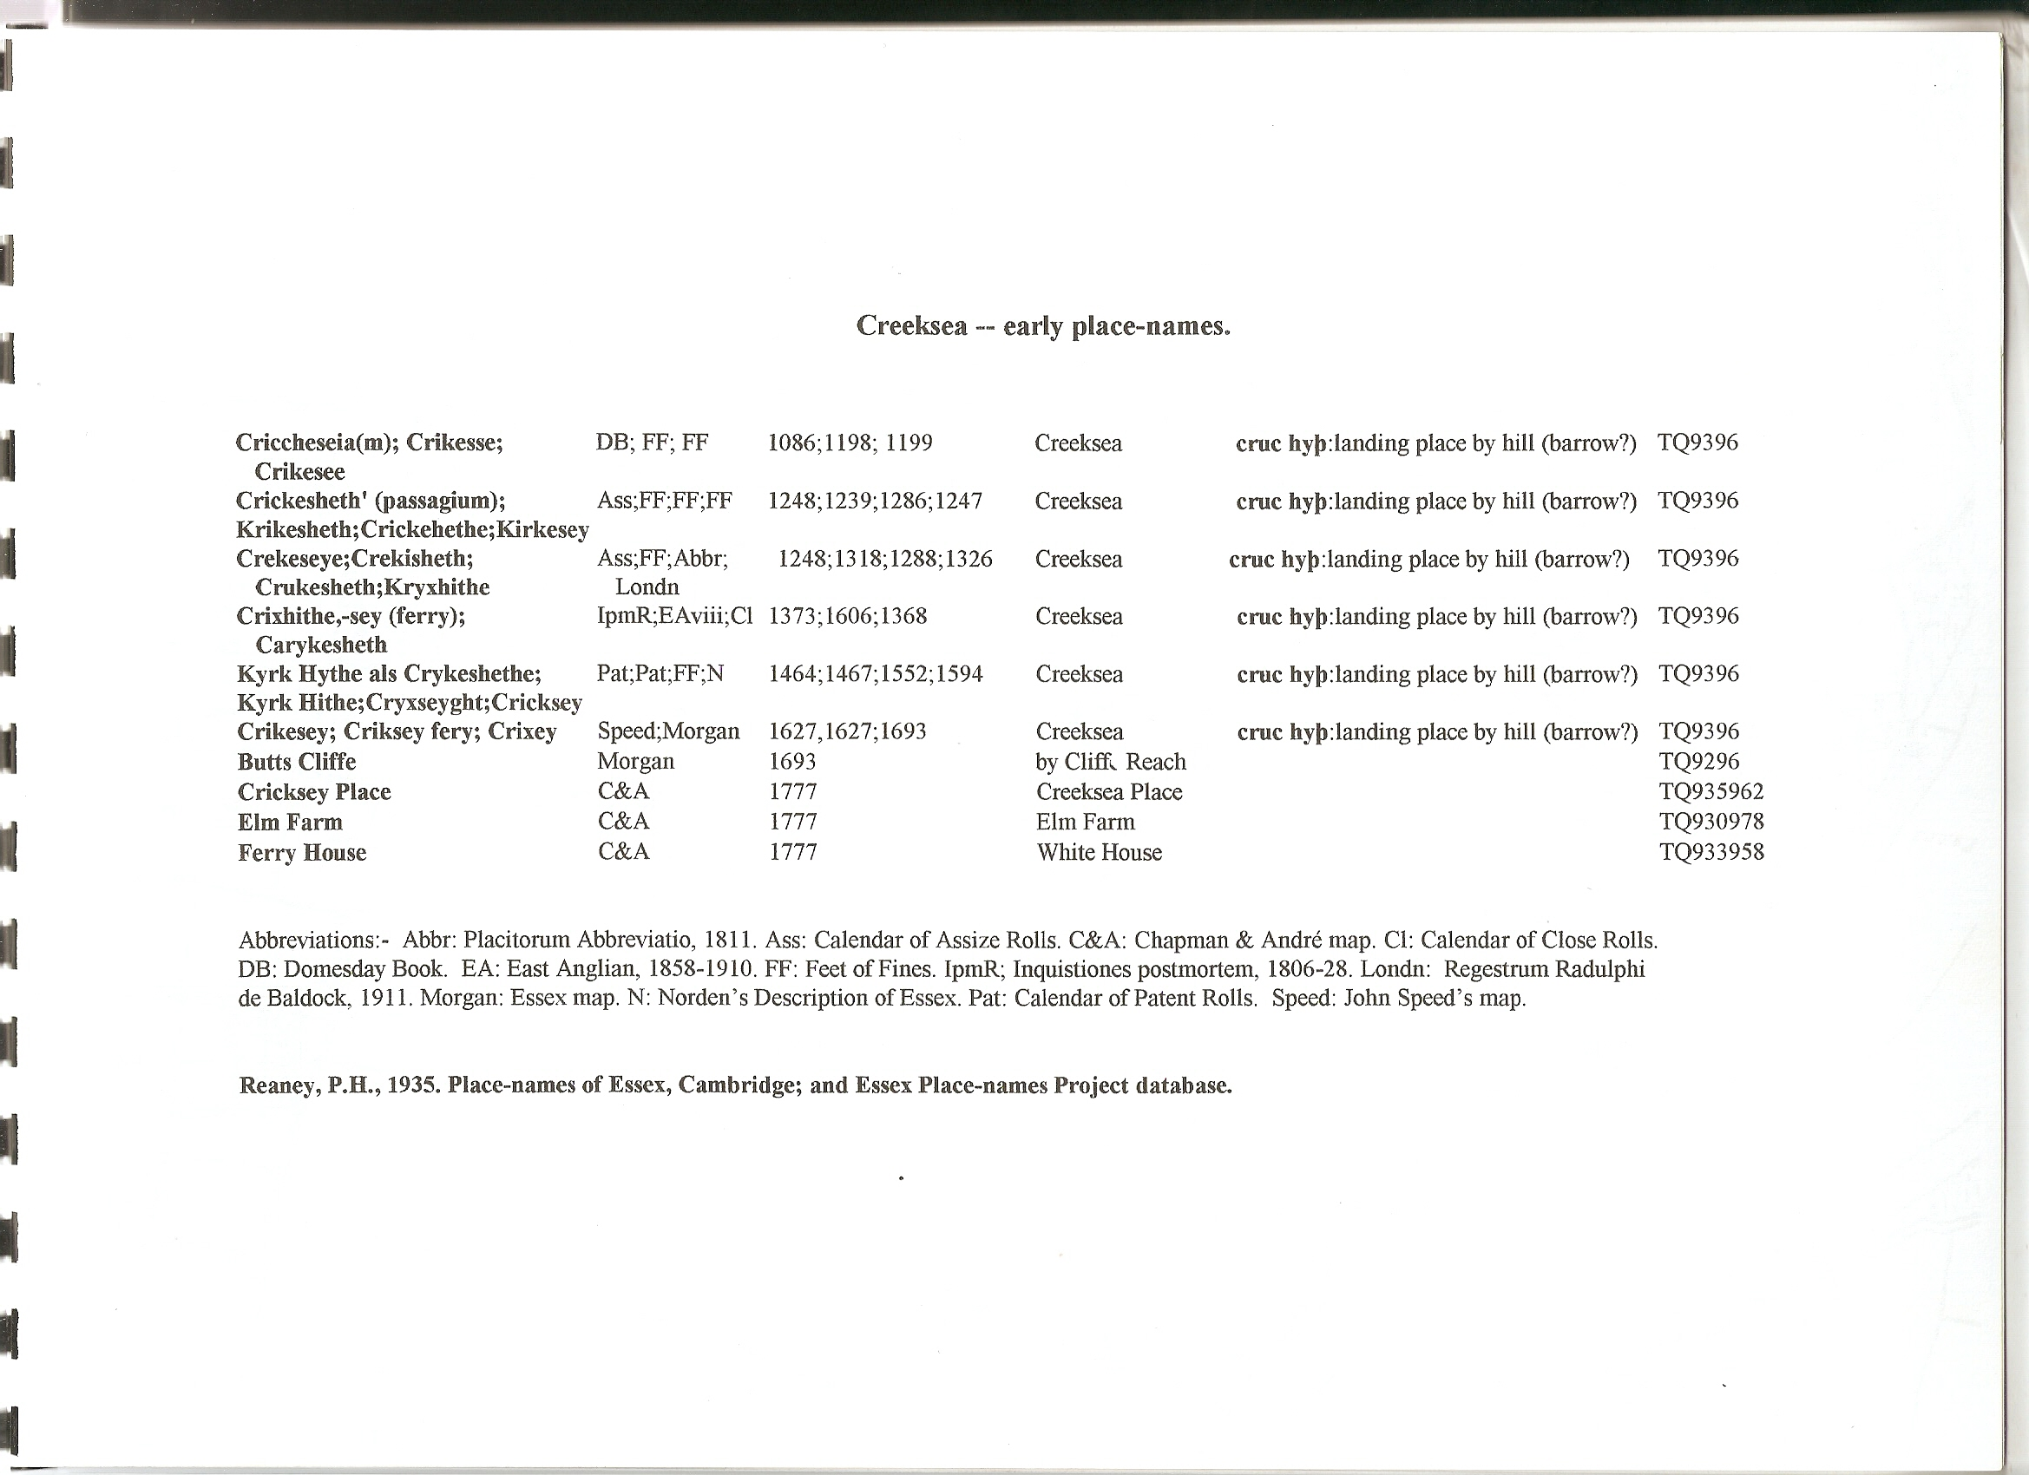

Ordnance Survey, c.1875, 6” = 1 mile. Tithe Parcel Nos. superimposed :--
