THE PLACE-NAMES OF

(GREAT) ILFORD

Recorder: James Kemble

Essex Place-names Project (Essex Society for Archaeology & History), 2015 (e-book).

www.essex.ac.uk/history/esah/essexplacenames

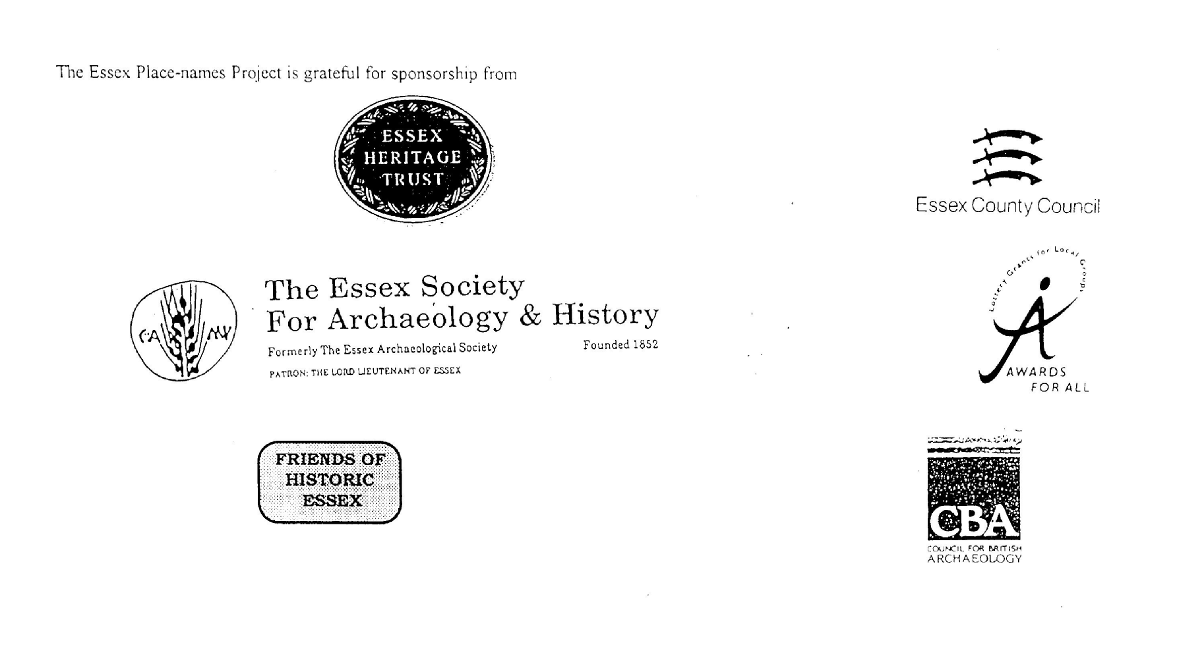

ESSEX PLACE-NAMES PROJECT.

The Essex Place-names Project is a County-wide survey to record place- and field-names from historical documents such as Tithe maps and apportionments, estate maps, sale
and auction catalogues, conveyances, terriers, deeds, rolls, inquisitions and surveys.

The second element of the Project is to investigate on-the-ground visible remains which correspond to the Place-names for actual or potential archaeological, agricultural and industrial sites, and to record natural (topographical) and man-made features which may relate to the Place-name. This involves field-survey in rural and outside investigation in built-up areas.

It is anticipated that the Project will lead to identification of archaeological sites and lost historic buildings; it will enable analysis of indicators of early settlement, land holding, agricultural and industrial practices of the County. It will refine the more precise meaning of descriptive words and elements used by earlier settlers as they gave names appropriate to the topography of the landscape of their time.

For convenience the surveys are based on the parish, recognising that present civil parish boundaries are not necessarily identical to former ecclesiastical boundaries. Local Recorders are supplied with templates of Record Forms to ensure consistency of recording across the County, and forward completed forms to a Central Coordinator for transfer to a county computer database which is available to researchers on the internet at www.essex.ac.uk/history/esah/essexplacenames, and updated periodically.

This publication presents part of the information recorded from the Tithe or Estate Award and Map, and from other documents for this parish. The full record is contained on the master database at Essex County Council (Historic Environment Section) and on the (above) website. Parish books are available to be downloaded from the website link ‘Books’ on the Home page. Please notify errors to the Project Coordinator at the Essex Record Office.

THE TITHE MAP AND APPORTIONMENT.

Since medieval times a tenth of the produce of land and stock had been paid by landholders to the church. At the Dissolution of the Monasteries, the property of many religious houses,
including the right to collect tithes, passed into lay hands. The Tithe Commutation Act which received Royal assent on 13th August 1836 abolished a rent payable in kind and
substituted rent-charges apportioned on each plot or parcel. The tithe-rent payable was assessed on the average value of wheat, barley and oats and was to fluctuate with price movements.

The commutation could be by voluntary agreement between the local owners and payers or, if agreement failed, could be compulsorily imposed by commissioners. A Valuer was to be appointed to apportion the rent of each parcel of land and tenants could deduct that rent-charge from their rent paid to the landlord. The task fell to the Tithe Commissioners to produce a map and an Apportionment (Award). A large-scale survey was produced for over 70% of England and Wales in the following 9 years, and about another 8% up to 1855. Most of the parishes in Essex were surveyed. The map scales vary. The Award records ownership, tenancy and land-use, field by field and parcel by parcel (often quoting the field name) with the ground area and rent-charge.

Land that was tithe-free tends to be less accurately mapped and contains few if any of the details recorded for those parcels subject to tithe. Rights of way and roads also tend to be neglected. Boundaries of the tithe areas are shown as are some natural features such as streams, ponds, gardens, greens and commons. Buildings are often shown coloured red if dwellingsor grey if not. Because the Award may have been agreed only some time after the map was finished, discrepancies occur between the two. Enclosure Awards, when extant, usually date to the 18th and early 19th centuries. J..Kemble.
Reproduced by permission
of Essex County Council.

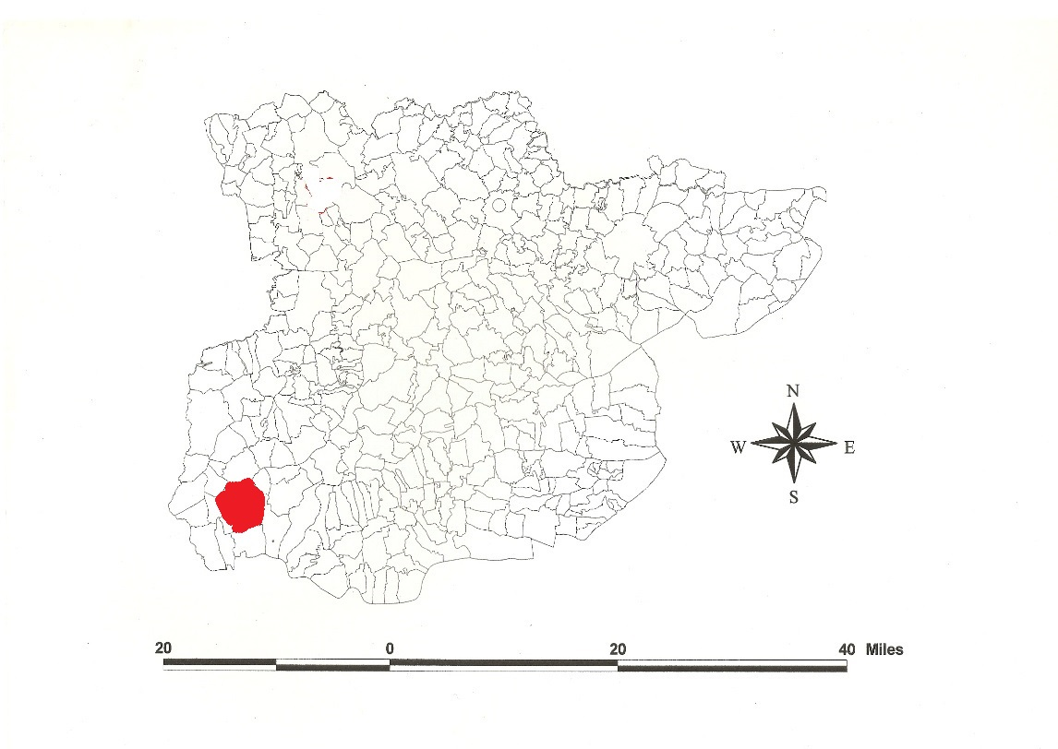
Reproduced by permission of
Essex County Council.
Great Ilford parish formerly in the County of Essex

The Parish of Great Ilford (in Becontree Hundred).

In 675x678 Oedilred granted Abbess Æthelburga 75 ‘manentes’ for Barking Abbey called Ricingahaam (Rainham), Budinhaam (Barking), Daeccanhaam (Dagenham) and Angenlabeshaam with open country in woodland Widmundesfelt (Wyfields in Great Ilford (Hart, 1971). In Domesday Book, 1086, Jocelyn Lorimer held Ilefort with a mill and fishery which two free men had held before 1066 as a manor for 3 hides less 30 acres. St Mary’s Barking held Berchingas for 30 hides; this included Barking, Ilford and Dagenham (Powell, 1984/5). Illeford magna is documented in 1254 (Reaney, 1935). This is the ‘ford through river Hile’; this British river-name derives from Celtic sil, ‘trickling’, from C16 called Roding river (Morris, 1983; Kemble, 2007).

Wolstonian Stage (200,000 years BP) bones of mammoth and giant ox have been found at Uphall Road. Excavations at Buttsbury Road have shown Mesolithic flint tools and Bronze Age stock enclosures. Uphall Camp is an Iron Age enclosure on the east bank of the River Roding (Kemble, 2009). In 1140 Abbess Adeliza of Barking Abbey founded a leper hospital, St Mary’s spitel, at the top of Ilford Hill of which the C14 chancel of the chapel survives.

After the Suppression of Barking Abbey, Elizabeth I granted St Marys Hospital to Thomas Fanshaw, Remembrancer of the Exchequer. The manor of Withfield, half a mile north, came to Lord Audley who sold it to Robert Cowper. Cranbrook belonged to Sir Henry Palavicini (died 1615) and afterwards to Sir William Boreman (Morant, 1768; VCH, 1966).

Until 1830, (Great) Ilford was a hamlet of Barking (Lockwood, 2006), while Little Ilford was a separate parish (Kemble, 2010). It now forms part of the borough of Redbridge which is named from the bridge (shown on Roque’s map of 1746 but replaced in 1925), formerly called Hocklee’s Bridge, 1650, by which the road from Stratford to Romford crossed the River Roding. Valentines House is late Stuart or early Georgian. St Mary’s church was built in 1831 (Weinreb, 1983). Mossford Lodge was occupied by Dr Thomas Barnado after 1873 who developed a Girl’s Village Home. Great Gearies was rebuilt c.1900, the former house c.1840. Clayhall, mentioned in 1203, was a free tenement of Barking Abbey (VCH, 1966).

The Hundred name in Domesday Book is Beuentreu which Reaney (1935) translates from a personal name + Old English treow, ‘Beohha’s tree’, or beacen treow, ‘beacon tree’. Christie (1926) places the moot on Becontree Heath. In 1465 the Liberty of Havering atte Bower was taken out of the eastern part of the Hundred.

The following table shows place- and field names.

References:
Christie, M., 1926. Essex Hundred Moots. Trans Essex Archaeological Soc., n.s., xviii (3), 172.
Hart, C., 1971. Early Charters of Essex. Leicester.
Kemble, J., 2007. Essex Place-names, Places, Streets & People. Historical Publications, London, pp 8, 70, 140, 142.
Kemble, J., 2009. Prehistoric & Roman Essex. History Press. pp 81, 140.
Kemble, J., 2010. The Place-names of Little Ilford. www.essex.ac.uk/history/esah/essexplacenames. Then click on ‘Books’.
Kemble, J., 2014. ‘New’ Anglo-Saxon Charters of Barking Abbey. Essex Archaeology & History, 4th series, iv,
Lockwood, H., 2006. Barking Tithe. Essex Record Office.
Morant, P., 1763. History & Antiquities of the County of Essex, i, p7.
Morris, J., 1983. Domesday Book – Essex. Phillimore.
Pevsner, N., Bettley, J., 2007. Buildings of England – Essex. Yale.
Powell, W.R., Essex Domesday Topography. Essex Archaeology & History, 16, 41.
Reaney, P., 1935. Place-names of Essex. Cambridge.
Victoria County History, 1966, vol 5, pp 184, 249.
Weinreb, B., Hibbert, C., 1983. The London Encyclopaedia. London.

The Place-names of (Great) Ilford
www.essex.ac.uk/history/esah/essexplacenames

Reference | Document | Date of Document | Place name | Alias |  | Grid Ref | x | y | Other information | Origin
Re,97 | DB; P; Cl; FeetFine | 1086;1171;1226; 1234 | Ilefort; Yleford; Illeford; Hil(l)eford | Ilford |  | TQ | 435 | 865 | Ilford was pt of Barking till 1830 | ford: ford at River Hyle (Roding)
Re,97 | For; EASxvi; FF; ECP | 1300;1391;1458; 1475 | Hyleford; Jilford; New-, Michill Ilford | Ilford |  | TQ | 435 | 865 | Ilford was pt of Barking till 1830 | ford: ford at River Hyle (Roding)
Re,97 | Tax; FF; FeetFine | 1291;1552;1293 | Illesford; El(le)ford(e); Ileford | Ilford |  | TQ | 435 | 865 | Ilford was pt of Barking till 1830 | ford: ford at River Hyle (Roding)
Re,97 | Ass; ECP; Ass | 1272;1459;1254 | Yleford parua; Lilford; Illeford Magna | Ilford, Little/Great |  | TQ | 435 | 865 | Ilford was pt of Barking till 1830 | ford: ford at River Hyle (Roding)
Re,98;Map | ERxxxii; ECP; Speed | 1456;1486;1627 | Albrorhhatchcrosse; Al(d)borough-, Abrey Hatch(e) | Abery House, Aldborough Hatch |  | TQ | 453 | 893 | John, Stephen Albo(u)rgh,1327,SR | burh: manor haec:gate
Map | Chapman & Andre | 1777 | Aldersbrook | Aldersbrook Lane, OS 1875 |  | TQ | 425 | 865 |  | broc: stream
Re,101 | TEAS xi | 1538 | Barkingside | Barking Side, OS 1875 |  | TQ | 440 | 897 | on edge of old parish of Barking
Re,101 | LRMB; Rntal | 1609;1545;1586 | Barley-,Barlow(e) lane,streete; Barl(e)y marsh(e) | Barley Lane |  | TQ | 465 | 885 | Abbess Dorothy Barley
 | Lockwood |  | Barones Reden |  |  | TQ | 448 | 870 | now railway | ryden: clearing
Re,101 | LRMB; ChapmanAndre | 1609;1777 | Beehive,le; Gt,Lt Bee Hive | Beehive Lane |  | TQ | 427 | 885
Re,100 | For; Shawcross | 1369;1452;1660 | Beneytesmor; Castell; St Bennett's Castle | Bennett's Castle |  |  |  |  | Adam Beneyt, 1327,SR
 | Lockwood |  | Brittains als Goslings Lane | Cameron Road |  | TQ | 453 | 873
Re,100 | M; LRMB; Chapman & Andre | 1548;1609;1777 | Bontyngs; Buntons; Buntinges bridge; Bunters Bridge | Bridge Bridge, OS 1875 |  | TQ | 445 | 886 | Beatrice Bunton,a 1609,LRMB
 | Lockwood |  | Bushfield als Combefield (?) | Buckingham Road |  | TQ | 446 | 867
Re,101 | FeetFine, 0rd Srvy | 1542; 1875 | Careswell; Carswell | Carswell |  | TQ | 418 | 916 |  | caerse wielle: watercress stream
Re,100 |  |  | Castle Rising Farm | Castle Rising Farm |  | TQ | 444 | 875 | Clement de Risinges (Nflk),1248,Ass
Re,100 | LRMB | 1609 | Cattes lane | Cat Lane; Grove Road |  |  |  |  | Nicholas le Cat, 1285,Ass
Re,101 | LRMB | 1609 | Chase lane voc Bushe lane | Chase Lane, OS 1875 |  | TQ | 448 | 888
Re,98 | FF; For; ADvi; Pat | 1203;1239;1424;  1449 | Claie,la; Claya,La; Berkyngcley; Clayhall | Clayhall |  | TQ | 430 | 900
Re,98 | Ct; EASxi | 1270;1566 | Clayberye, le; Cleyberye | Claybury Farm |  | TQ | 435 | 915 |  | burh: manor
Re,101 | LRMB | 1609 | Cockleyland | Cocklease Lane |  |  |  |  |  | land: land
 | Lockwood |  | Coombecrofft | Pelham Road |  | TQ | 448 | 866 |  | cumb: valley
Re,6; OS | Lysons iv; Chapman Andre | 1650;1777 | Cranbrook-rill; Cranbrook Wash | Cranbrook Park, OS 1875 |  | TQ | 448 | 893 |  | broc, cran: crane stream
Re,98 | FF; Ass; EssVis | 1233;1248;1552 | Cranebroc; Cranbroke besyde Ilford | Cranbrook Farm, OS 1875 |  | TQ | 430 | 874 |  | cran broc: crane stream
 | Tithe Award | 1847 | Cricklewood, (Reden) | Cricklefield |  | TQ | 448 | 867 | see Cricklewode, in Barking | cruc?: hill/mound
Re,101 | LRMB | 1609 | Crowches | Crouches
Re,101 | ERxxxii; M | 1456;1542 | Dun(e)shall | Downshall Park |  | TQ | 436 | 906
 | Lockwood |  | Dunshall Ridden |  |  | TQ | 449 | 871 | now railway | ryden: clearing
Re,98 | Smith | 1738 | Fair Lop Tree | Fairlop Plain, OS 1875 |  | TQ | 455 | 905
Re,101 | FF; LRMB | 1561;1609 | Farnehall; ffernehall (greene) | Fernhall |  | TQ | 416 | 890 |  | grene: grassy
Re,100 | MinAct | t Hy8 | ffulwell(hacche) | Fulwell Hatch, OS 1875 |  | TQ | 440 | 905 | William de ffolewell, 1332,SR | ful wielle: dirty stream
 | Lockwood |  | Fursey field | New Road (c1841) |  | TQ | 453 | 868 |  | fyrs: furze
Re,100 | For; Pat; LP; LRMB | 1291;1464;1323;  1609 | Gantesgrave; Cantesgroue; Gauntes Hethe; Gauntstubbing | Gantshill |  | TQ | 432 | 884 | Richard le gant, 1285,Ass | grafa,stubbing: grove,clearing
Re,99 | Ct; EA,os,i | 1348-1490;1689 | Gays(e)ham(e)s (Hall); Gessams Hall | Gayshamhall |  | TQ | 436 | 896 |  | ham: Gaeg's farm
Re,98 | Ass; ERxv; HMCvii | 1248;tHy3;tHy3 | Geyesham; Gaysham; Caysham | Gayshamhall |  | TQ | 436 | 896 |  | ham: Gaeg's farm
Re,99 | ERxxxii | 1456 | Goodmaistrete; Goodmayes | Goodmayes |  | TQ | 465 | 870 | John Godemay, 1319,SR
Re,101 | LRMB | 1609 | Greene streete als Greenelane | Green Lane |  | TQ | 460 | 869 |  | grene: grassy
Re,100 |  |  | Grove Farm | Grove Farm |  |  |  |  | Richard atte Grove,1376,FF
Re,100 | Ord Survey |  | Hatch Lane | Hatch Lane |  |  |  |  | Richard atte Hacche,1327,SR | haecc: gate
Re,100 |  |  | Hedgemans | Hedgemans |  | TQ | 440 | 896 | John Hegman, 1305,HPD
Re,101 | LRMB | 1609 | Highfeldes | Highfield Farm |  |  |  |  |  | feld: open country
Re,101 | Harl | 1538 | Highland hilles | Highland Farm |  | TQ | 425 | 880 | William Webber esq, 1777,C | hyll: hill
Re,99 | Tasker; ChapmanAndre | 1650;1777 | Hocklee's Bridge; Red Bridge | Red Bridge |  | TQ | 415 | 884
Re,99 | Misc; BPR; LRMB; Tsker | 1360;1361;1609;  1900 | Hokkeleys; Bederes garden; hockley(s); Hockles | Redbridge House |  |  |  |  | Hugh de hockele(gh), 1332,SR
Re,100 | Ord Survey |  | Horns Road | Horns Road |  | TQ | 445 | 891 | Richard Horne, 1547,Shawcross
Re,101 | IpmR; Pat; TA | 1397;1462;1840 | Hospital,le; Spitell Grove,le; Spittle Wood | Hospital Hill (Wood) |  |  |  |  |  | spitel: hospital
Re,99 | LRMB | 1609 | le vij Kinges Wateringes | Seven Kings Watering Stoop
Re,101 | LRMB | 1609 | Leestreete; Laystreete | Ley Street |  |  |  |  |  | leah: wood/clearing
 | Lockwood |  | Levesons Grove | Lombard Avenue |  | TQ | 452 | 871 |  | grafa: grove
Re,100 | Ord Srvy | 1875 | Great Gearies | Great, Little Gearies |  | TQ | 438 | 891 | John Gery,1327,SR
 | Lockwood |  | Longcroft | Kent View Gardens |  | TQ | 452 | 867 |  | croft: small enclosed field
Re,99 | Pat; ERxxxii | 1319;1368;1456 | Loxford(ebury), -strete, -bridge, -gate; | Loxford Hall |  | TQ | 444 | 852 |  | ford: Locc's ford or R.Loxa
Re,99;Map | Pat; Speed | 1319; 1627 | Loxford(ebury); Loxford | Loxford |  | TQ | 444 | 852 |  | lox?: pool (Celtic)
Re,101 | For; ERxxxii | 1369;1456 | Lytel Ylleford heth'; Litelheth | Little Heath, OS 1875 |  | TQ | 465 | 890 |  | haeð; heath
Re,101 | Chapman& Andre | 1777 | Mossfoot Green | Mossford Green, OS 1875 |  | TQ | 440 | 903
Re,101 | Harl | 1538 | Myllers Ho(o)pe | Hope Farm |  |  |  |  |  | hop: land enclosed in marsh
Re,101 | Ct; M; N | 1348;1573;1594 | Newbury; Newber(r)y | Newbury park; Gt Newbury |  | TQ | 455 | 886 |  | burh: manor
Re,101;Map | Ct; M; Speed | 1348;1573;1627 | Newbury; Newber(r)y; Newbury | Great Newbury, OS 1875 |  | TQ | 455 | 886 |  | burh: manor
Re,99 | Pat; For; ERxxxii; LRMB | 1303;1369;1456;  1609 | Padenhale; Patenhale; Padnale; Padnalls corner | Padnall Hall, OS 1875 |  | TQ | 478 | 893 |  | halh: Padda's corner
 | Lockwood |  | Pit field | St Marys Road |  | TQ | 445 | 866
Re,100 | MinAct | 1321 | Ravenynges | Ravenings |  |  |  |  | Simon Ravening, 1248,FF
 | Lockwood |  | Ravening als Conduit field | Winchester Road |  | TQ | 445 | 864
Re,100 | OrdSurvey |  | Sams Green | Sams Green |  |  |  |  | Gilbert le Sam, 1332,SR
 | Lockwood |  | Searles Croft | Gordon Fields |  | TQ | 447 | 865
Re,99 | Ass; ERxxxii | 1285;1456 | Sevekyngg(es); Sevyn Kynges | Seven Kings |  | TQ | 455 | 875 |  | Seofecingas?:settlement of Seofeca's people
Re,99; OS |  |  | Seven Kings Water | Seven Kings Water |  | TQ | 462 | 885 |  | ing?:settlement of Seofecanwyrð's people
Re,101 | For | 1323 | Shakemans Croft | Shackmans Farm |  | TQ | 422 | 886 |  | croft:small enclosed field
Re,100 | Ipm; LP; LRMB | 1496;1545;1609 | Stone Hallys; Stonehall; Stonelles als Stonehalles | Stonehall Farm |  | TQ | 423 | 882 | Roger Stonhale, 1327,SR
Re,99 | LRMB; Shawcross | 1609;1794 | Stulpe in London hie way,le; The Stoup | Stoop Bridge, Lane |  |  |  |  |  | stoop: boundary-post
Re,101 | Chapman & Andre | 1777 | Swithins | St Swithins |  | TQ | 418 | 896
Re,101 | LRMB | 1609 | terra Ward | Wards Lane |  | TQ | 450 | 877
Re,98 | Tasker | 1765 | The Mausoleum | Ilford -, Barking -, Cranbrook castle |  | TQ | 430 | 874
Re,100 | Ct; Chapman & Andre | 1590;1777 | Thom at woodes hill; Tomswood | Tomswood Farm, - Hill,OS 1875 |  | TQ | 436 | 915 | William Tom, 1245,HPD
Re,101 | MinAct | 1539 | Uphall | Uphall, OS 1875 |  | TQ | 438 | 850
Re,101 | Shawcross | 1665 | Valentines | Valentines |  | TQ | 435 | 880 | Charles Raymond esq, 1777,C
Re,99 | LRMB | 1609 | Wanford Lane; Wansteddforde meade | Redbridge Lane |  | TQ | 420 | 885
Re,100 | Ass; ECP; M; P; LRMB | 1254;1486;1542;  tHy8 | Wanghou; Wangeo; Wang(e)y(hall);  Wayngehall | Wangeyhall Farm |  | TQ | 477 | 878 |  | Hoh : promontory
Re,99 | LRMB | 1609 | Wanstedland | Wanstead Lane |  | TQ | 425 | 881
Re,99 | LRMB | 1609 | Waterlane | Roding Lane |  | TQ | 417 | 895
Re,100 | LRMB | 1609 | Whites | White's Farm, OS 1875 |  | TQ | 452 | 885 | John le White, 1285,Ass
Re,100 | P; Brtn; FF; ChncP; LRMB | 1191;1224;1543;tJasI | Witefeld';Withfeud;With(e)feld(s);Wyfields;Whitfeilds | Wyfields;ffulkes streete |  | TQ | 435 | 875 | Thomas ffuke, 1272,Ass | withig feld: willow open country
Re,101 | EA,os,i; ChapmanAndre | 1587; 1777 | Wo(o)fen(ne)s; Woulffennes peece,peice; Fence Piece | Fencepiece farm |  | TQ | 443 | 920
Hart,4 | Grant | c.687 | Widmundesfelt | Wyfields |  | TQ | 435 | 875 | OEdilred to Abbess Æthelburga, Barking Abbey (Hart,4) | wiðig feld: open country with willows

Record Office | Reference | Date of document | Place name | alias | Grd ref | x | y | Acr | rd | pch | Land use
ERO | D/DK P1 | c1625 | Dunn's Mead | cp. Downspring, 1777,C | TQ | 436 | 906 | 5 | 1 | 12 | field
ERO | D/DK P1 | c1625 | The Wood |  | TQ |  |  | 10 | 2 | 12 | wood
ERO | D/DK P1 | c1625 | Home field |  | TQ |  |  | 13 | 3 | 1 | field
ERO | D/DK P1 | c1625 | The ffryth |  | TQ |  |  | 15 | 3 | 1 | wood
ERO | D/DK P1 | c1625 | Hilly field |  | TQ |  |  | 9 | 1 | 24 | field

Re = PH Reaney, followed by page number. Hart = CR Hart, Early Charters of Essex, Leicester, 1971.
For abbreviations see Reaney, P.H., The Place-names of Essex, Cambridge, 1935; and Kemble, J., Essex Place-names, Places, Streets & People. Historical Press, 2007, p, 153.

