THE PLACE-NAMES OF

HARWICH St. NICHOLAS

Recorder: James Kemble

Essex Place-names Project (Essex Society for Archaeology & History)

Essex Record Office e-book, 2nd edition, 2010. (1st edition in hard copy 2004).

www.essex.ac.uk/history/esah/essexplacenames

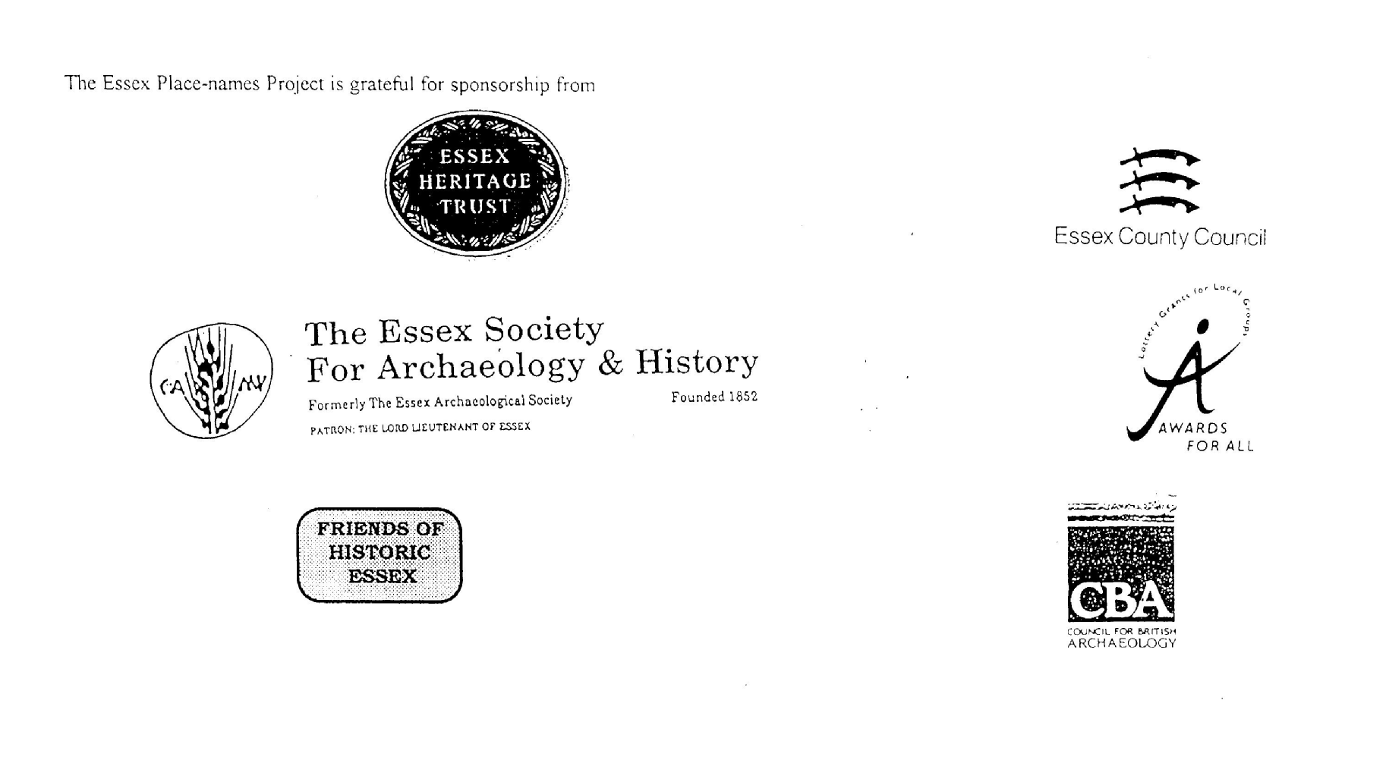

ESSEX PLACE-NAMES PROJECT.

The Essex Place-names Project is a County-wide survey to record place- and field-names from historical documents such as Tithe maps and apportionments, estate maps, sale and
auction catalogues, conveyances, terriers, deeds, rolls, inquisitions and surveys.

The second element of the Project is to investigate on-the-ground visible remains which correspond to the Place-names for actual or potential archaeological, agricultural and industrial
sites, and to record natural (topographical) and man-made features which may relate to the Place-name. This involves field-survey in rural and outside investigation in built-up areas.

It is anticipated that the Project will lead to identification of archaeological sites and lost historic buildings; it will enable analysis of indicators of early settlement, land holding, agricultural and industrial practices of the County. It will refine the more precise meaning of descriptive words and elements used by earlier settlers as they gave names appropriate to the topography of the landscape of their time.

For convenience the surveys are based on the parish, recognizing that present civil parish boundaries are not necessarily identical to former ecclesiastical boundaries. Local Recorders
are supplied with templates of Record Forms to ensure consistency of recording across the County, and forward completed forms to a Central Coordinator for transfer to a county
computer database which is available at the Essex Record Office to researchers.

This publication presents part of the information recorded from the Tithe or Estate Award and Map, (and from other documents for this parish.) The full record is contained on the master database in the Essex Record Office, Wharf Road, Chelmsford CM2 6YT and the website www.essex.ac.uk/history/esah/essexplacenames. Parish books are available from the ERO on disc or in hard copy or may be downloaded from the website. Please notify errors to the Project Coordinator at the Essex Record Office.

THE TITHE MAP AND APPORTIONMENT.

Since medieval times a tenth of the produce of land and stock had been paid by landholders to the church. At the Dissolution of the Monasteries, the property of many religious houses,
including the right to collect tithes, passed into lay hands. The Tithe Commutation Act which received Royal assent on 13th August 1836 abolished a rent payable in kind and
substituted rent-charges apportioned on each plot or parcel. The tithe-rent payable was assessed on the average value of wheat, barley and oats and was to fluctuate with price movements.

The commutation could be by voluntary agreement between the local owners and payers or, if agreement failed, could be compulsorily imposed by commissioners. A Valuer was to be
appointed to apportion the rent of each parcel of land and tenants could deduct that rent-charge from their rent paid to the landlord. The task fell to the Tithe Commissioners to produce a map and an Apportionment (Award). A large-scale survey was produced for over 70% of England and Wales in the following 9 years, and about another 8% up to 1855. Most of the
parishes in Essex were surveyed. The map scales vary. The Award records ownership, tenancy and land-use, field by field and parcel by parcel (often quoting the field name) with the
ground area and rent-charge.

Land that was tithe-free tends to be less accurately mapped and contains few if any of the details recorded for those parcels subject to tithe. Rights of way and roads also tend to be
neglected. Boundaries of the tithe areas are shown as are some natural features such as streams, ponds, gardens, greens and commons. Buildings are often shown coloured red if dwellings or grey if not. Because the Award may have been agreed only some time after the map was finished, discrepancies occur between the two. Enclosure Awards, when extant, usually date to the 18th and early 19th centuries. J.Kemble.
Reproduced by permission
of Essex County Council.

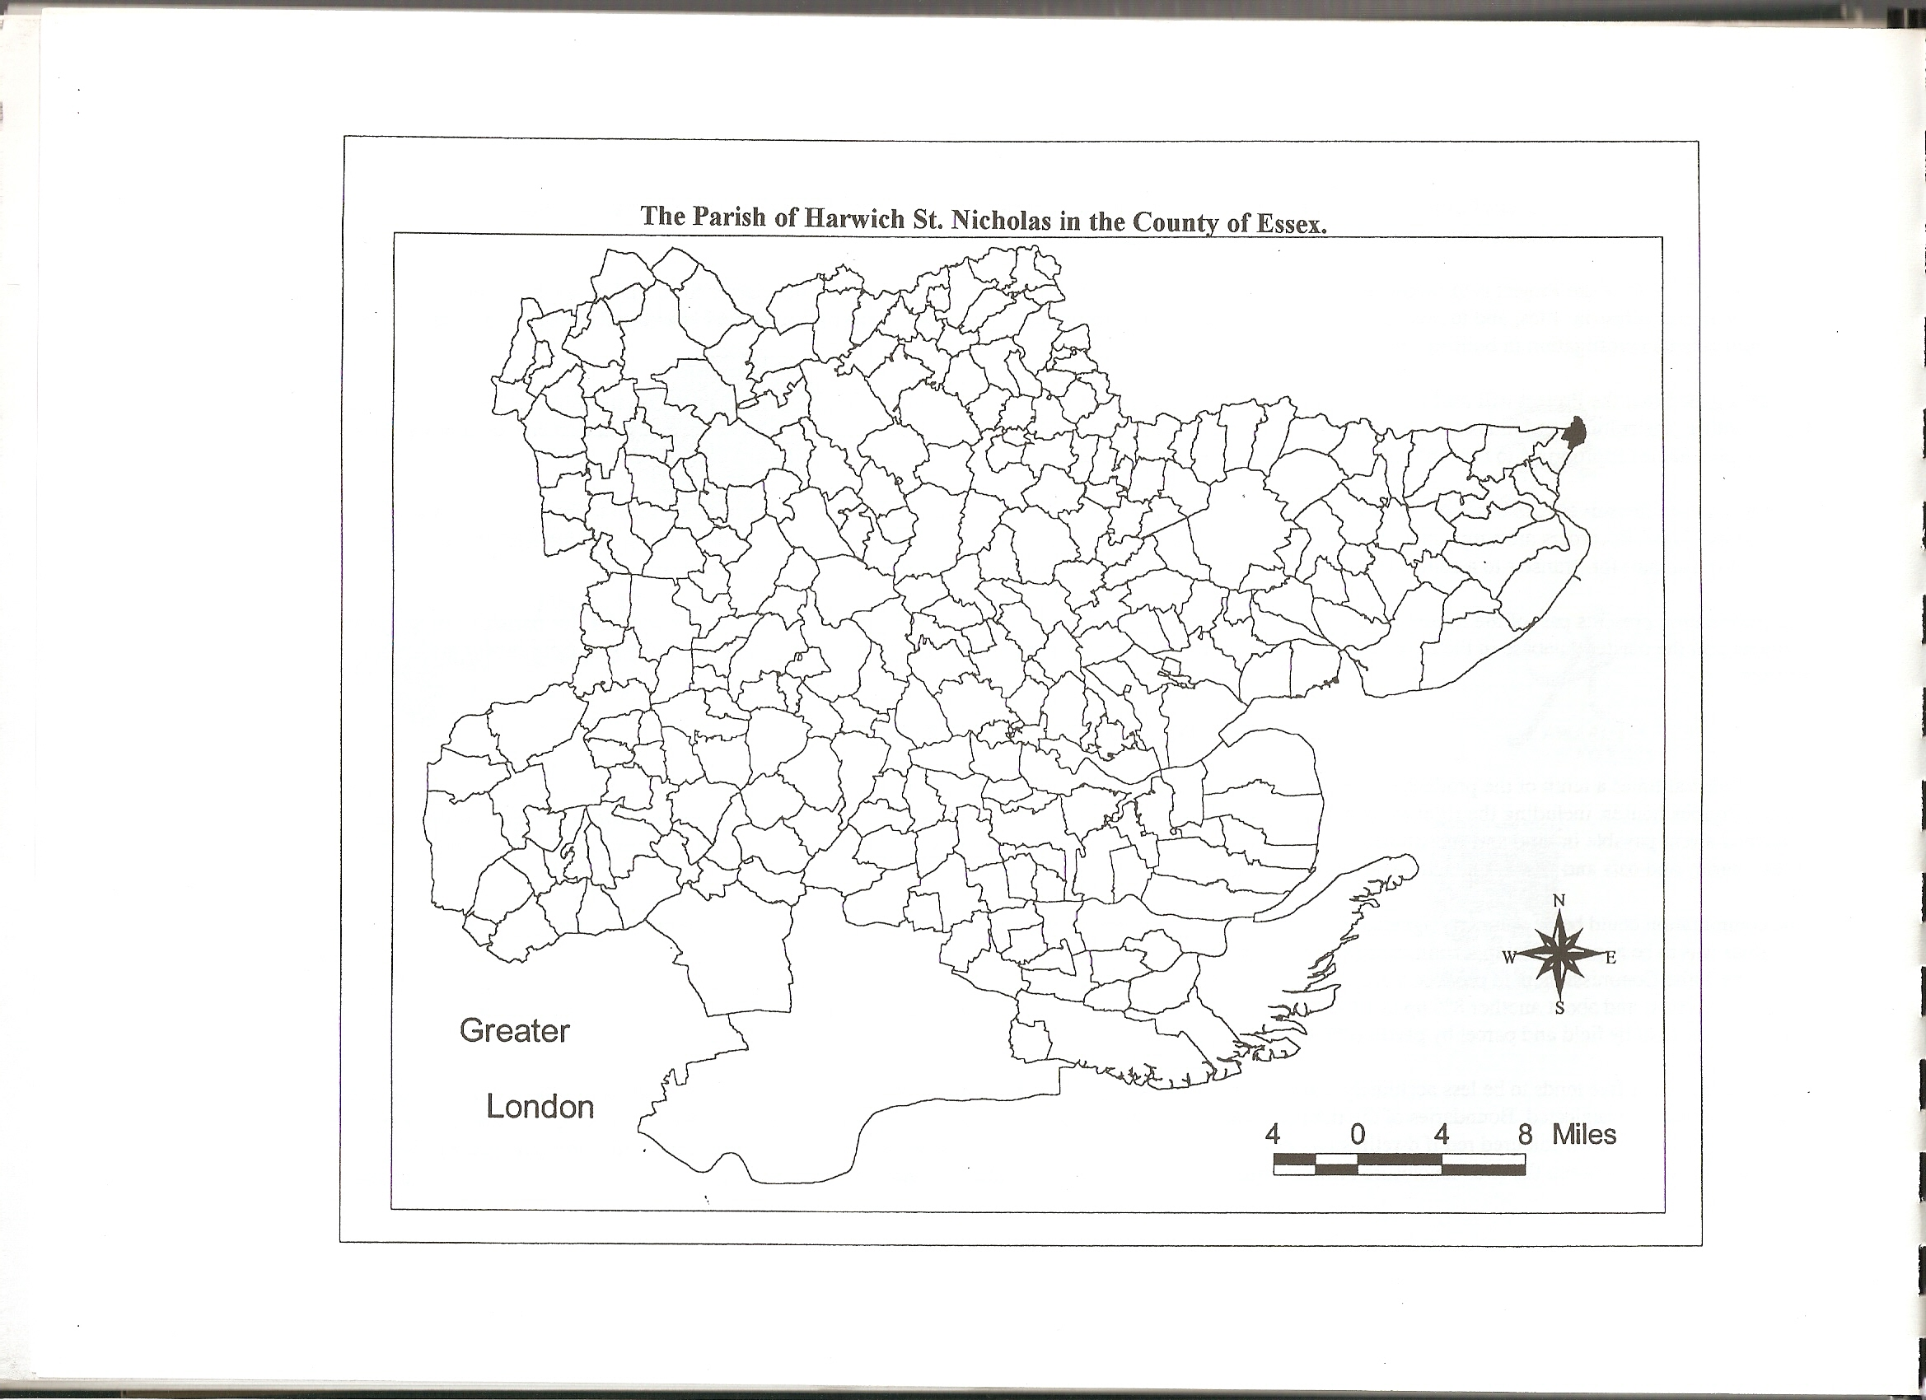
Reproduced by permission of
Essex County Council.

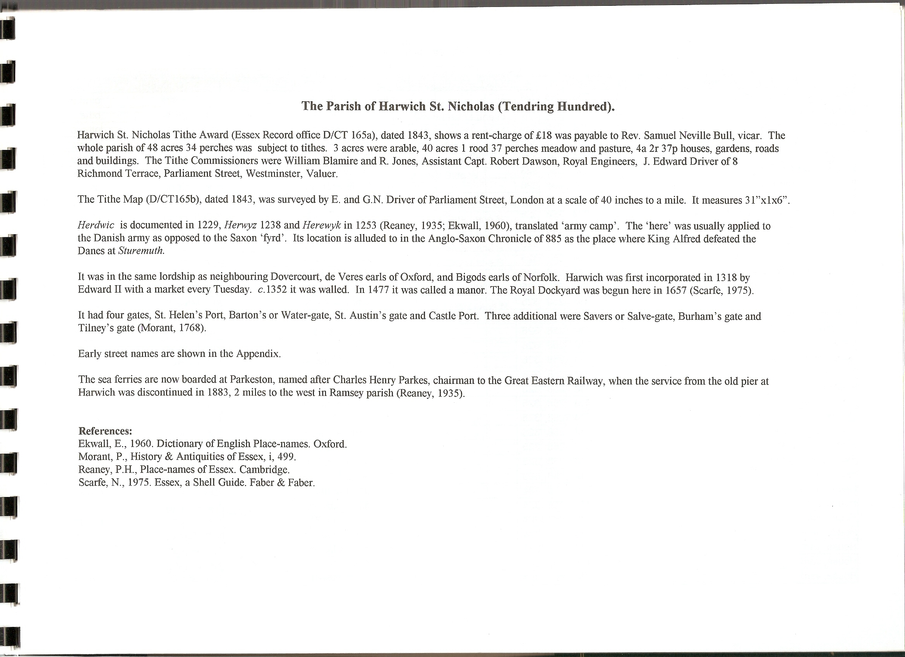

The Tithe Award Place-names of Harwich St. Nicholas – by Parcel No.

Place-name | Alias | Fld No | Gd Ref | x | y | Place Type | Acr | rd | pch | Land use | Owner | Occupier | Man-made features next to field | Other information
Five houses, yds, buildings |  | 1 | TM | 259 | 326 |  | 0 | 0 | 13 |  | Her Majesty | Her Majesty; others | White Hart Lane N
Buildings and yard |  | 2 | TM | 259 | 326 |  | 0 | 0 | 8 |  | Her Majesty | Her Majesty; others | White Hart Lane N
House, yard, kitchin |  | 3 | TM | 259 | 326 |  | 0 | 0 | 2 |  | Her Majesty | Her Majesty; others | White Hart Lane N
Buildings, yard |  | 4 | TM | 258 | 326 |  | 0 | 0 | 6 |  | Her Majesty | Her Majesty; others | White Hart Lane N
Garden |  | 5 | TM | 258 | 326 |  | 0 | 0 | 20 | gdn | Her Majesty | Her Majesty; others | Back Side W
Cottage, yard, buildings |  | 6 | TM | 258 | 326 |  | 0 | 0 | 3 |  | Her Majesty | Her Majesty; others | Back Side W
House, yard,garden |  | 7 | TM | 258 | 326 |  | 0 | 0 | 24 |  | Her Majesty | Her Majesty; others | Back Side W
Two houses,yards |  | 8 | TM | 258 | 326 |  | 0 | 0 | 5 |  | Her Majesty | Her Majesty; others
Cottage,yard, road from Bath side |  | 9 | TM | 258 | 326 |  | 0 | 0 | 7 |  | Her Majesty | Her Majesty; others
House, garden |  | 10 | TM | 258 | 325 |  | 0 | 0 | 3 |  | Her Majesty | Her Majesty; others | Back Side Lane S
Two houses,yards, buildings |  | 11 | TM | 258 | 325 |  | 0 | 0 | 4 |  | Her Majesty | Her Majesty; others | Back Side Lane S
Two houses,yards, buildings |  | 12 | TM | 258 | 325 |  | 0 | 0 | 4 |  | Her Majesty | Her Majesty; others | Back Side Lane S
Two houses,yards, buildings |  | 13 | TM | 258 | 325 |  | 0 | 0 | 5 |  | Her Majesty | Her Majesty; others | Back Side Lane S
Garden, pond, building |  | 14 | TM | 259 | 325 |  | 0 | 1 | 5 | gdn | Her Majesty | Her Majesty; others
Yard |  | 15 | TM | 259 | 325 |  | 0 | 0 | 5 |  | Her Majesty | Her Majesty; others | Back Side W
Buoy House, buildings,yard |  | 16 | TM | 257 | 326 |  | 0 | 0 | 16 |  | Her Majesty | Her Majesty; others | White Hart Lane N
Coachhouse, stabling |  | 17 | TM | 258 | 326 |  | 0 | 0 | 8 |  | Her Majesty | Her Majesty; others
Open Ground |  | 18 | TM | 258 | 326 |  | 0 | 1 | 0 |  | Her Majesty | Her Majesty; others
Saving House, yard |  | 19 | TM | 258 | 326 |  | 0 | 0 | 5 |  | Her Majesty | Her Majesty; others
Two houses, passage |  | 20 | TM | 258 | 325 |  | 0 | 0 | 6 |  | Her Majesty | Her Majesty; others
Warehouse, yard |  | 21 | TM | 258 | 325 |  | 0 | 0 | 13 |  | Her Majesty | Her Majesty; others
Open Ground |  | 22 | TM | 258 | 325 |  | 0 | 1 | 8 |  | Her Majesty | Her Majesty; others
Bath side or 3 Gun Battery |  | 22a | TM | 258 | 325 |  | 0 | 1 | 3 |  | Board of Ordnance | Board of Ordnance; others
Two houses, yards |  | 23 | TM | 258 | 325 |  | 0 | 0 | 4 |  | Her Majesty | Her Majesty; others | Back Side W
Two houses, yards |  | 24 | TM | 258 | 325 |  | 0 | 0 | 4 |  | Her Majesty | Her Majesty; others | Back Side W
Two houses, yards |  | 25 | TM | 258 | 325 |  | 0 | 0 | 4 |  | Her Majesty | Her Majesty; others | Back Side W
House, yard |  | 26 | TM | 258 | 325 |  | 0 | 0 | 3 |  | Her Majesty | Her Majesty; others | Back Side W
House, yard |  | 27 | TM | 258 | 324 |  | 0 | 0 | 4 |  | Her Majesty | Her Majesty; others | Back Side W
House, yard |  | 28 | TM | 258 | 324 |  | 0 | 0 | 4 |  | Her Majesty | Her Majesty; others | Back Side W
House, yard |  | 29 | TM | 257 | 324 |  | 0 | 0 | 3 |  | Her Majesty | Her Majesty; others
House, yard |  | 30 | TM | 257 | 324 |  | 0 | 0 | 2 |  | Her Majesty | Her Majesty; others
House, yard |  | 31 | TM | 257 | 324 |  | 0 | 0 | 4 |  | Her Majesty | Her Majesty; others
House, yard |  | 32 | TM | 257 | 324 |  | 0 | 0 | 4 |  | Her Majesty | Her Majesty; others
House, yard |  | 33 | TM | 257 | 324 |  | 0 | 0 | 3 |  | Her Majesty | Her Majesty; others
House, yard |  | 34 | TM | 257 | 324 |  | 0 | 0 | 4 |  | Her Majesty | Her Majesty; others
House, yard |  | 35 | TM | 257 | 324 |  | 0 | 0 | 4 |  | Her Majesty | Her Majesty; others
House, yard |  | 36 | TM | 257 | 324 |  | 0 | 0 | 2 |  | Her Majesty | Her Majesty; others
House, yard |  | 37 | TM | 257 | 324 |  | 0 | 0 | 8 |  | Her Majesty | Her Majesty; others
House, yard |  | 38 | TM | 257 | 324 |  | 0 | 0 | 2 |  | Her Majesty | Her Majesty; others
House, yard |  | 39 | TM | 257 | 324 |  | 0 | 0 | 2 |  | Her Majesty | Her Majesty; others
Meadow |  | 40 | TM | 258 | 324 | field | 1 | 0 | 25 | mdw | Her Majesty | Her Majesty; others | Back Side W
Meadow |  | 41 | TM | 258 | 325 | field | 1 | 0 | 4 | mdw | Her Majesty | Her Majesty; others
Garden |  | 42 | TM | 258 | 326 |  | 0 | 2 | 0 | gdn | Her Majesty | Her Majesty; others
Paddock, sheds |  | 43 | TM | 258 | 326 | field | 0 | 0 | 29 | pstre | Her Majesty | Her Majesty; others | White Hart Lane N
Meadow |  | 44 | TM | 258 | 325 | field | 1 | 0 | 32 | mdw | Her Majesty | Her Majesty; others | White Hart Lane N
Yard, sheds |  | 45 | TM | 258 | 326 |  | 0 | 0 | 6 |  | Her Majesty | Her Majesty; others | White Hart Lane N
Yard, sheds |  | 46 | TM | 258 | 326 |  | 0 | 0 | 9 |  | Her Majesty | Her Majesty; others | White Hart Lane N
Meadow, sheds, piggery |  | 47 | TM | 259 | 326 | field | 0 | 3 | 24 | mdw | Her Majesty | Her Majesty; others
Garden |  | 48 | TM | 259 | 326 |  | 0 | 2 | 11 | gdn | Her Majesty | Her Majesty; others
Sheds, yards |  | 49 | TM | 260 | 325 |  | 0 | 0 | 11 |  | Her Majesty | Her Majesty; others | New Road E
Yard,shed,stable |  | 50 | TM | 260 | 325 |  | 0 | 0 | 10 |  | Her Majesty | Her Majesty; others
Yard, sheds |  | 51 | TM | 260 | 325 |  | 0 | 0 | 3 |  | Her Majesty | Her Majesty; others
Cottage, yard |  | 52 | TM | 260 | 325 |  | 0 | 0 | 8 |  | Her Majesty | Her Majesty; others
Cottage, yard |  | 53 | TM | 260 | 325 |  | 0 | 0 | 3 |  | Her Majesty | Her Majesty; others
Cottage, yard |  | 54 | TM | 260 | 325 |  | 0 | 0 | 6 |  | Her Majesty | Her Majesty; others
Cottage, yard |  | 55 | TM | 260 | 325 |  | 0 | 0 | 8 |  | Her Majesty | Her Majesty; others
Garden |  | 56 | TM | 260 | 325 |  | 0 | 0 | 16 | gdn | Her Majesty | Her Majesty; others
Meadow |  | 57 | TM | 259 | 325 |  | 0 | 2 | 34 | mdw | Her Majesty | Her Majesty; others
Meadow |  | 58 | TM | 259 | 324 |  | 2 | 0 | 18 | mdw | Her Majesty | Her Majesty; others
Open space, sheds, cottage |  | 59 | TM | 259 | 324 |  | 0 | 2 | 8 |  | Her Majesty | Her Majesty; others
Roadway |  | 59a | TM | 259 | 324 |  | 0 | 1 | 32 |  | Her Majesty | Her Majesty; others
Arable piece.Slaughter House |  | 60 | TM | 260 | 324 | Field | 0 | 1 | 14 | arable | Her Majesty | Her Majesty; others
Arable piece |  | 61 | TM | 260 | 324 | field | 1 | 0 | 0 | arable | Her Majesty | Her Majesty; others
Piece between Railing & No 61 |  | 62 | TM | 261 | 324 |  | 0 | 0 | 32 |  | Her Majesty | Her Majesty; others
Meadow |  | 63 | TM | 260 | 323 | field | 1 | 3 | 22 | mdw | Her Majesty | Her Majesty; others | Dovercourt par. E
Old Rope Walk |  | 64 | TM | 260 | 323 | field | 0 | 2 | 13 | pstre | Her Majesty | Her Majesty; others
Arable in No 64 |  | 65 | TM | 260 | 323 | field | 0 | 0 | 28 | arable | Her Majesty | Her Majesty; others
Meadow |  | 66 | TM | 260 | 323 | field | 0 | 2 | 36 | mdw | Her Majesty | Her Majesty; others
Arable piece |  | 67 | TM | 259 | 323 | field | 1 | 0 | 24 | arable | Her Majesty | Her Majesty; others
Meadow |  | 68 | TM | 258 | 323 | field | 2 | 0 | 0 | mdw | Her Majesty | Her Majesty; others
Arable piece |  | 69 | TM | 257 | 323 | field | 0 | 2 | 0 | arable | Her Majesty | Her Majesty; others
Meadow, sheds |  | 70 | TM | 257 | 323 | field | 1 | 0 | 32 | mdw | Her Majesty | Her Majesty; others
Meadow |  | 71 | TM | 260 | 323 | field | 1 | 0 | 32 | mdw | Her Majesty | Her Majesty; others
Arable |  | 72 | TM | 260 | 322 | field | 1 | 3 | 24 | arable | Her Majesty | Her Majesty; others | Dovercourt par. E
Meadow |  | 73 | TM | 259 | 322 | field | 1 | 2 | 35 | mdw | Her Majesty | Her Majesty; others | Dovercourt par. S
Meadow |  | 74 | TM | 259 | 322 | field | 2 | 3 | 8 | mdw | Her Majesty | Her Majesty; others | Dovercourt par. S
Footpath,bank, shore from White Hart Lane |  | 75 | TM | 258 | 326 |  | 5 | 0 | 27 |  | Her Majesty | Her Majesty; others
Carpenters yard |  | 76 | TM | 261 | 326 |  | 0 | 2 | 0 |  | Board of Ordnance | Board of Ordnance; others
Open Ground, pt of Esplanade |  | 77 | TM | 263 | 327 |  | 1 | 2 | 16 |  | Her Majesty | Her Majesty; others
Ordnance House, Light, buildings, garden |  | 78 | TM | 263 | 326 |  | 1 | 0 | 5 | gdn | Board of Ordnance | Board of Ordnance; others
Meadow, pt of Esplanade, Lower Light |  | 79 | TM | 263 | 325 | field | 4 | 2 | 5 | mdw | Board of Ordnance | Board of Ordnance; others
Piece in front of Ordnance Depot |  | 80 | TM | 262 | 325 |  | 1 | 0 | 10 |  | Board of Ordnance | Board of Ordnance; others
Ordnance Depot, garden, magazine |  | 81 | TM | 262 | 325 |  | 1 | 0 | 5 | gdn | Board of Ordnance | Board of Ordnance; others
Meadow, Town pond |  | 82 | TM | 261 | 325 | Field | 1 | 0 | 4 | mdw | Board of Ordnance | Board of Ordnance; others | New Road W
Glacis (part of) |  | 83 | TM | 263 | 323 | Field | 9 | 1 | 0 | mdw | Board of Ordnance | Board of Ordnance; others | Dovercourt par. W
Circular Redoubt, The |  | 84 | TM | 263 | 323 |  | 1 | 0 | 15 |  | Board of Ordnance | Board of Ordnance; others
Meadow |  | 85 | TM | 262 | 322 | field | 0 | 3 | 30 | mdw | Board of Ordnance | Board of Ordnance; others | Dovercourt par. S

See also Reaney, P., Place-names of Essex, Cambridge, 1935; and Kemble, J., Essex Place-names, Places, Streets & People, Historical Publications, London 2007.

