THE PLACE-NAMES

OF HEYBRIDGE

Recorder: James Kemble

Essex Place-names Project (Essex Society for Archaeology & History), 2014 (e-book).

www.essex.ac.uk/history/esah/essexplacenames

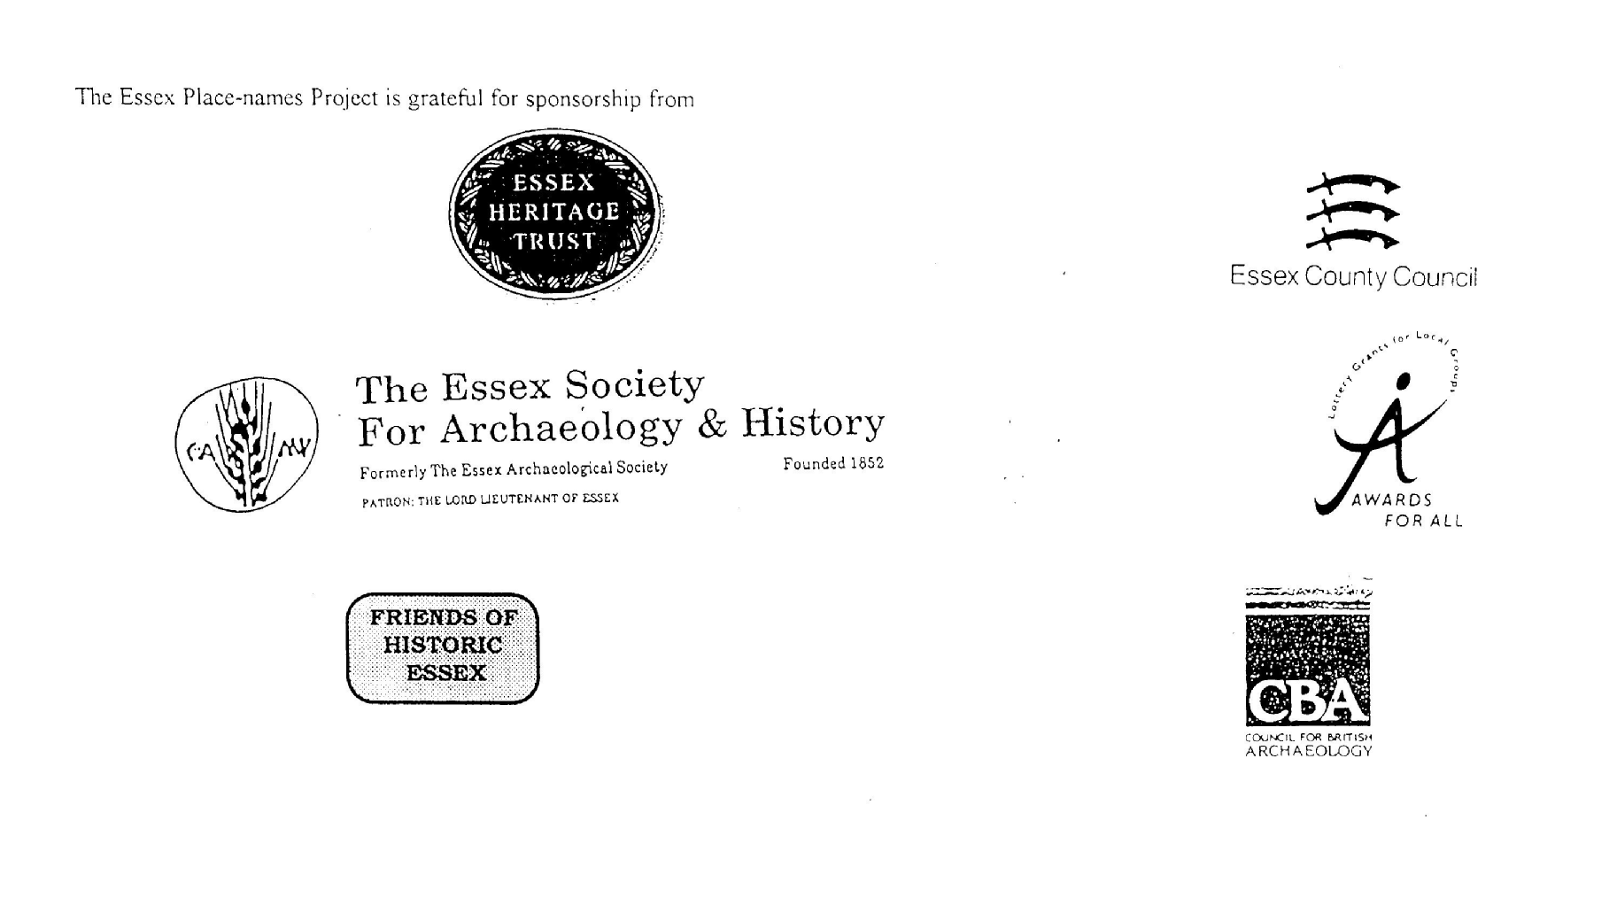

ESSEX PLACE-NAMES PROJECT.

The Essex Place-names Project is a County-wide survey to record place- and field-names from historical documents such as Tithe maps and apportionments, estate maps, sale
and auction catalogues, conveyances, terriers, deeds, rolls, inquisitions and surveys.

The second element of the Project is to investigate on-the-ground visible remains which correspond to the Place-names for actual or potential archaeological, agricultural and industrial
sites, and to record natural (topographical) and man-made features which may relate to the Place-name. This involves field-survey in rural and outside investigation in built-up areas.

It is anticipated that the Project will lead to identification of archaeological sites and lost historic buildings; it will enable analysis of indicators of early settlement, land holding, agricultural and industrial practices of the County. It will refine the more precise meaning of descriptive words and elements used by earlier settlers as they gave names appropriate to the topography of the landscape of their time.

For convenience the surveys are based on the parish, recognising that present civil parish boundaries are not necessarily identical to former ecclesiastical boundaries. Local Recorders
are supplied with templates of Record Forms to ensure consistency of recording across the County, and forward completed forms to a Central Coordinator for transfer to a county
computer database which is available to researchers on the internet at www.essex.ac.uk/history/esah/essexplacenames, and updated periodically.

This publication presents part of the information recorded from the Tithe or Estate Award and Map, and from other documents for this parish. The full record is contained on the master
database at Essex County Council (Historic Environment Section) and on the (above) website. Parish books are available to be downloaded from the website link ‘Books’ on the Home page. Please notify errors to the Project Coordinator at the Essex Record Office.

THE TITHE MAP AND APPORTIONMENT.

Since medieval times a tenth of the produce of land and stock had been paid by landholders to the church. At the Dissolution of the Monasteries, the property of many religious houses,
including the right to collect tithes, passed into lay hands. The Tithe Commutation Act which received Royal assent on 13th August 1836 abolished a rent payable in kind and
substituted rent-charges apportioned on each plot or parcel. The tithe-rent payable was assessed on the average value of wheat, barley and oats and was to fluctuate with price movements.

The commutation could be by voluntary agreement between the local owners and payers or, if agreement failed, could be compulsorily imposed by commissioners. A Valuer was to be
appointed to apportion the rent of each parcel of land and tenants could deduct that rent-charge from their rent paid to the landlord. The task fell to the Tithe Commissioners to produce a
map and an Apportionment (Award). A large-scale survey was produced for over 70% of England and Wales in the following 9 years, and about another 8% up to 1855. Most of the
parishes in Essex were surveyed. The map scales vary. The Award records ownership, tenancy and land-use, field by field and parcel by parcel (often quoting the field name) with the
ground area and rent-charge.

Land that was tithe-free tends to be less accurately mapped and contains few if any of the details recorded for those parcels subject to tithe. Rights of way and roads also tend to be
neglected. Boundaries of the tithe areas are shown as are some natural features such as streams, ponds, gardens, greens and commons. Buildings are often shown coloured red if dwellings
or grey if not. Because the Award may have been agreed only some time after the map was finished, discrepancies occur between the two. Enclosure Awards, when extant, usually date to the 18th and early 19th centuries. J.Kemble.
Reproduced by permission
of Essex County Council.

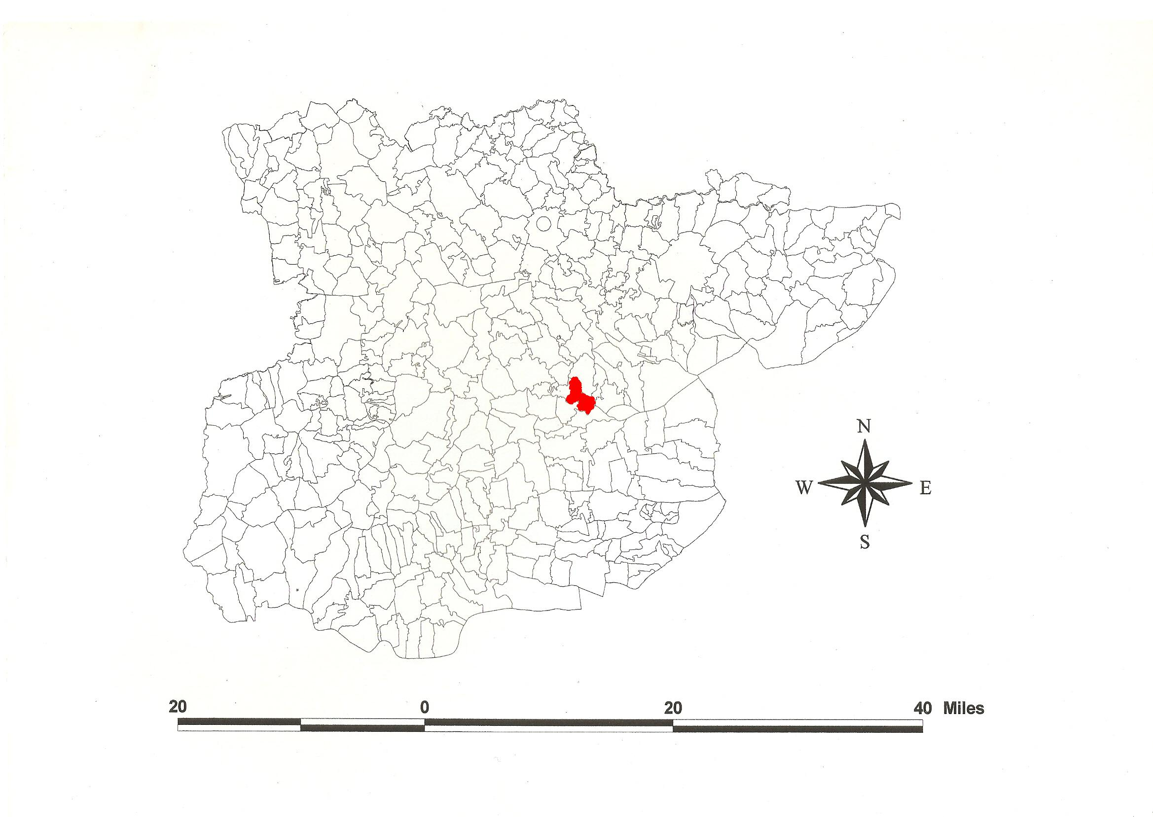
Heybridge Parish in the County of Essex.
Reproduced by permission of
Essex County Council.

The Parish of Heybridge (in Thurstable Hundred).

The Tithe Award of Heybridge (Essex Record Office D/CT 179a), dated 1843, shows a rent-charge payable for Great Tithes to the appropriator Dean and Chapter of St Pauls of £464-18-3 including glebe (to whom Oliver Hering of Southampton was lessee), and £203-0-7 to the vicar. The whole parish measured 2012 acres 3 roods 15 perches of which 180a 2r 38p were arable, 456a 3r 2p meadow and pasture, 104a 3r 21 wood, 63a 2r 0p homesteads and gardens, 74a 2r 22p roads and waste, 42a 2r 26p vicarial glebe. The Tithe Commissioners were William Blamire and J.W. Buller, the Assistant James Tatham and the Valuers William Downes of Dedham and James Beadel of Chelmsford.

The Tithe Map (ERO: D/CT 179b) was surveyed at a scale of 13.3” to a mile and measures 46”x38”. It is badly defaced especially in the west and southwest.

In 946x951 Ælfgar, ealdorman, willed an estate at Tidwoldingtone alias Tidweldington to Ælfwold. In a spurious charter, King Æthelstan confirmed 8 hides at Tidwoldintune to St Pauls in ?961x971. [This estate did not come to St Pauls until after Ælfgar’s daughter Ælfflæd’s death in c.1002]. In Domesday Book, 1086, St Pauls held Tidwoldituna for 8 hides a manor with a salt-house and a mill, but Ralph Baynard held half a hide which Aelmer had held from St Pauls for customary dues (recorded under Langford) (Hart, 1971; Morris, 1983). This is Tidweald’s tun, ‘settlement’. The name, now lost, appears not to have been in use after the 13th century. Heaghbregge, ‘high bridge’, presumably one over River Blackwater, is documented c.1220 (Reaney, 1935; Kemble, 2007).

There was one manor, Heybridge Hall, 1 mile east of the church, held by St Pauls, leased to Richard Freshwater (died 1617). It passed to his son John (Morant, 1768).

At Elms Farm, north of the Maldon bypass roundabout, has been excavated an Iron Age village which later developed into a Romano-British settlement with a shrine (Wickenden, 1986; Kemble, 2009). The church of St Andrew has a mainly Norman chancel and nave. Heybridge Hall with a C14 open hall was destroyed by fire in 1997 (Carrick, 1980). Beside the Chelmer & Blackwater Navigation, opened in 1797, William Bentall’s huge mid-19th century warehouse is extant (Pevsner, 2007; Gould, 2002).

The Hundred name Thur(e)stapel(l), -stapl(e) is documented in 1066-87 (Reaney, 1935). This probably derives from Old English thunres-stapol, Thu[no]r’s pillar, possibly a personal name Thur, not necessarily the Norse god (Bronnenkant, 1981). Christy (1926) suggested the moot was 200 yards southwest of Tolleshunt Major church at a tumulus, latterly used as a mill-mound, though high ground in Great Totham is a possibility.

References:

Bronnenkant, L., 1981. Thurstable Revisited. Jnl English Place-name Society, 15, 9
Carrick, D., Richards, P., et al., 1980. Heybridge Hall. Essex Archaeology & History, 12, 89.
Christie, M., 1926. Essex Hundred Moots. Trans Essex Archaeological Soc., n.s., xviii (3), 182.
Gould, S., Kemble, J., 2002. The Chelmer & Blackwater Navigation, a Survey. Essex County Council [in ERO].
Hart, C., 1971. Early Charters of Essex, Leicester.
Kemble, J., 2007. Essex Place-names, Places, Streets & People. Historical Publications, London, p69.
Kemble, J., 2009. Prehistoric & Roman Essex. History Press, Stroud, p145.
Morant, P., 1768. History & Antiquities of the County of Essex, i, 379
Morris, J., 1983. Domesday Book – Essex. Phillimore.
Pevsner, N., Bettley, J., 2007. Buildings of England – Essex. Yale. p578.
Reaney, P., 1935. Place-names of Essex. Cambridge.
Wickenden, N., 1986. Heybridge. Essex Archaeology & History, 17, 6.

The Tithe Award Place-names of Heybridge - by parcel no.

Place-name | Alias | Fld No | Grd Ref | x | y | Acr | rd | pch |  | Land use | Owner | Occupier | Other information
Wood | Captain(s) Wood, 1777,C, 1875,OS | 1 | TL | 853 | 108 | 44 | 0 | 12 |  | wood | St Pauls, Dean & Chapter | Hering, Oliver
.. |  | 2 | TL | 850 | 108 | 3 | 1 | 3 |  | arable | Bourne, William | Cottee, Mark, execs
Cottage | Gun Farm, 1777,C | 3 | TL | 849 | 107 | 0 | 3 | 33 |  |  | Bourne, William | Thomasin, John
.. |  | 6 | TL | 849 | 104 | 4 | 1 | 2 |  | arable | Bourne, William | Cottee, Mark, execs
.. |  | 7 | TL | 850 | 105 | 8 | 1 | 3 |  | arable | St Pauls, Dean & Chapter | Wade, William
 |  | 10 | TL | 851 | 104 | 5 | 3 | 18 |  | arable | St Pauls, Dean & Chapter | Wade, William
.. |  | 11 | TL |  |  | 14 | 2 | 10 |  | arable | Sadel, John | Sadel, John
.. |  | 14 | TL | 856 | 108 | 1 | 3 | 20 |  | arable | St Pauls, Dean & Chapter | Sadd, John
Homestead | Brodegrene, 1470,Bodl; Broad Street Green Farm, 1875,OS | 16 | TL | 855 | 104 | 0 | 3 | 31 |  |  | Sadel, John | Sadel, John
Cottage |  | 19 | TL |  |  | 0 | 1 | 0 |  |  | Sadel, John | Webb, George
.. |  | 22 | TL |  |  | 0 | 0 | 22 |  | grass | Shaen, Samuel | Hazell, Thomas
Homestead |  | 23 | TL |  |  | 0 | 3 | 22 |  |  | Hazell, Thomas | Hazell, Thomas
.. |  | 24 | TL |  |  | 0 | 2 | 11 |  |  | Pattison, Wm Henry | Eve, Charles
.. |  | 25 | TL | 857 | 107 | 1 | 2 | 1 |  | arable | Honeywood, William | Clarke, Robert
Wood |  | 27 | TL |  |  | 0 | 2 | 39 |  | wood | Honeywood, William | Honeywood, William
Wood |  | 27a | TL |  |  | 0 | 2 | 23 |  | wood | Crane, Robert P, clerk | Crane, Robert P, clerk | glebe
Wood |  | 28 | TL | 860 | 103 | 1 | 0 | 8 |  | wood | Westcomb
.. |  | 29 | TL |  |  | 2 | 3 | 33 |  | arable | Pitt, Mary | Moss, Shuttleworth
Homestead | Binley Farm, 1875,OS | 31 | TL | 860 | 100 | 0 | 1 | 6 |  |  | Pitt, Mary | Moss, Shuttleworth
Cottage |  | 34a | TL | 860 | 099 | 0 | 1 | 0 |  |  | Westcomb | Kemp, Thomas
Cottage, yd etc | Nortlands Farm, 1875,OS | 35 | TL | 860 | 097 | 0 | 2 | 3 |  |  | Heybridge Churchwardens | Wheeler, Richard; Whitmore, Henry
Inn, gdn | Crown Inn, 1875,OS | 36 | TL | 860 | 097 | 0 | 3 | 12 |  |  | Whitmore, Henry | Whitmore, Henry
.. |  | 37 | TL | 860 | 097 | 2 | 2 | 19 |  | arable | Carter, Sarah | Carter, James
.. |  | 38 | TL | 859 | 097 | 2 | 3 | 8 |  | grass | Clarke, Robert | Clarke, Robert
.. |  | 40 | TL | 858 | 097 | 4 | 0 | 19 |  | arable | Clarke, Robert | Clarke, Robert
Wood | Middle Wood, 1875,OS | 45 | TL | 853 | 100 | 16 | 0 | 8 |  | wood | St Pauls, Dean & Chapter | Hering, Oliver
Wood |  | 46 | TL | 852 | 100 | 2 | 0 | 21 |  | wood | St Pauls, Dean & Chapter | Hering, Oliver
 |  | 47 | TL | 850 | 101 | 4 | 2 | 11 |  | arable | St Pauls, Dean & Chapter | Wade, William
 |  | 50 | TL | 852 | 099 | 13 | 2 | 31 |  | arable | St Pauls, Dean & Chapter | Wade, William
Wood |  | 51 | TL | 854 | 098 | 0 | 2 | 37 |  | wood | Clarke, Robert | Clarke, Robert
.. |  | 52 | TL |  |  | 3 | 2 | 24 |  | arable | Shaen, Samuel | Clark, Thomas
Yards, Chase |  | 55 | TL | 858 | 096 | 1 | 0 | 39 |  |  | Clarke, Robert | Clarke, Robert
.. |  | 56 | TL | 860 | 095 | 7 | 3 | 13 |  | arable | Clarke, Robert | Clarke, Robert
Homestead | Plumtons, tEdwVI, Rntl; Plumptons Farm, 1875,OS | 57 | TL | 859 | 096 | 0 | 1 | 32 |  |  | Clarke, Robert | Clarke, Robert
.. | [at Broad Street Green, 1875,OS] | 59 | TL | 858 | 095 | 5 | 2 | 37 |  | arable | Clarke, Robert | Clarke, Robert
.. |  | 60 | TL | 857 | 095 | 5 | 1 |  |  | arable | Clarke, Robert | Clarke, Robert
Homestead | Furzeland's Farm, 1875,OS | 66 | TL | 850 | 098 | 0 | 3 | 18 |  |  | St Pauls, Dean & Chapter | Wade, William
.. |  | 69 | TL |  |  | 3 | 1 | 0 |  | arable | Holloway, Jeremiah jnr | Moss, william
Homestead |  | 71a | TL |  |  | 0 | 0 | 25 |  |  | Holloway, Jeremiah jnr | Moss, william
Homestead | Hollwells, tEdw VI, Rntl; Howell's Farm, 1875,OS | 73 | TL | 850 | 095 | 0 | 1 | 34 |  |  | Shaen, Samuel | Clark, Thomas
.. |  | 75 | TL |  |  | 8 | 0 | 31 |  | arable | Shaen, Samuel | Clark, Thomas
.. |  | 80 | TL | 851 | 090 | 11 | 0 | 0 |  | arable | St Pauls, Dean & Chapter | Wade, William
.. |  | 81 | TL | 854 | 092 | 6 | 2 | 27 |  | arable | Clarke, Robert | Clarke, Robert
Wood | Heybridge Wood, 1875,OS | 82 | TL | 856 | 090 | 36 | 2 | 31 |  | wood | St Pauls, Dean & Chapter | Hering, Oliver
.. |  | 84 | TL | 860 | 093 | 7 | 2 | 37 |  | arable | Clarke, Robert | Clarke, Robert
Cottage, yd |  | 85 | TL |  |  | 0 | 1 | 23 |  |  | Ramsey, Elizabeth | Warren, Joseph; another
.. |  | 86 | TL | 861 | 093 | 1 | 1 | 5 |  | arable | Heybridge Churchwardens | Francis, Wm
.. |  | 87 | TL |  |  | 2 | 2 | 0 |  | arable | Honeywood, William | May, Alfred
.. |  | 91 | TL |  |  | 5 | 3 | 5 |  | arable | Crane, Robert P, clerk | Yell, Charles | glebe
Road,cottage | Black Cottages,1898,OS | 93a | TL | 860 | 088 | 0 | 1 | 37 |  |  | Francis, Sarah Ann | Francis, Sarah Ann; others
.. |  | 94 | TL |  |  | 5 | 3 | 1 |  | arable | Francis, Sarah Ann | Francis, Sarah Ann
.. |  | 100 | TL |  |  | 5 | 2 | 0 |  | arable | Westcomb | Wood, John jnr
.. |  | 106 | TL | 856 | 088 | 6 | 0 | 37 |  | arable | St Pauls, Dean & Chapter | Holloway, Jeremiah
Homestead | Grapnell's Farm, 1875,OS | 107 | TL | 854 | 087 | 0 | 1 | 20 |  |  | St Pauls, Dean & Chapter | Holloway, Jeremiah | Walter Grapinel, 1255,Ass
.. |  | 108 | TL | 852 | 089 | 11 | 0 | 15 |  | arable | St Pauls, Dean & Chapter | Holloway, Jeremiah
.. |  | 111 | TL | 848 | 089 | 4 | 2 | 21 |  | arable | St Pauls, Dean & Chapter | Wade, William
.. |  | 115 | TL |  |  | 8 | 3 | 36 |  | arable | St Pauls, Dean & Chapter | Holloway, Jeremiah
.. |  | 116 | TL |  |  | 6 | 2 | 14 |  | arable | Sadel, John | Sadel, John
.. |  | 120 | TL |  |  | 7 | 2 | 3 |  | arable | Francis, Sarah Ann | Francis, Sarah Ann
.. |  | 121 | TL | 860 | 085 | 6 | 0 | 32 |  | arable | Heybridge Churchwardens | Francis, Wm
Garden |  | 121a | TL |  |  | 0 | 0 | 37 |  |  | Crane, Robert P, clerk | Nash, James | glebe
.. |  | 124 | TL | 858 | 083 | 9 | 3 | 18 |  | arable | St Pauls, Dean & Chapter | Holloway, Jeremiah | moat
Homestead | Moat Cottage, 1898,OS | 126 | TL | 858 | 083 | 0 | 3 | 19 |  |  | Francis, Sarah Ann | Francis, Sarah Ann
.. |  | 128 | TL |  |  | 4 | 1 | 37 |  | grass | Francis, Sarah Ann | Francis, Sarah Ann
.. |  | 129 | TL | 855 | 083 | 3 | 1 | 34 |  | grass | Bentall, Edward Hammond | Bentall, Edward Hammond
.. |  | 130 | TL | 854 | 083 | 1 | 1 | 4 |  | grass | Arthy, Mr | Taylor
Cottages |  | 130 | TL |  |  | 0 | 1 | 7 |  |  | Holloway, Jeremiah jnr | Finch, Wm; others
Garden |  | 131 | TL | 854 | 084 | 0 | 1 | 16 |  |  | Arthy, Mr | Taylor
.. |  | 132 | TL | 853 | 085 | 1 | 0 | 10 |  | grass | Arthy, Mr | Taylor
.. |  | 133 | TL | 853 | 085 | 1 | 0 | 23 |  | grass | Arthy, Mr | Taylor
Garden |  | 135 | TL | 852 | 085 | 1 | 3 | 2 |  |  | Belsham, Daniel | Sibley, Henry; Wrake, Miss; Garland, Wm
Homestead, shop |  | 136 | TL | 852 | 082 | 0 | 1 | 30 |  |  | Arthy, Mr | Taylor
Cottages |  | 137 | TL |  |  | 0 | 0 | 16 |  |  | Overseers of Poor | Bures, Thos; Allwright, Mary
Cottages |  | 138 | TL | 852 | 083 | 0 | 1 | 18 |  |  | Belsham, Daniel | Wrake, Miss; Garland, Wm
House, shop |  | 139 | TL |  |  | 0 | 3 | 7 |  |  | Holloway, Jeremiah jnr | Holloway, Jeremiah jnr
Malting |  | 140 | TL | 853 | 083 | 0 | 0 | 32 |  |  | Belsham, Daniel | Belsham, Daniel
.. |  | 141 | TL | 852 | 084 | 2 | 2 | 7 |  | arable | Belsham, Daniel | Belsham, Daniel
Homestead | B(o)uhern(e), 1285,Ass; 1290,Ass; Boucherne Farm, 1875,OS | 142 | TL | 852 | 084 | 1 | 2 | 8 |  |  | Belsham, Daniel | Belsham, Daniel
Cottages |  | 145 | TL | 852 | 084 | 0 | 1 | 3 |  |  | Belsham, Isaac | Webber, Robt; Juniper, Joseph; Worraker, Thos; others
Buildings |  | 146 | TL |  |  | 0 | 0 | 24 |  |  | Chelmer Company | Chelmer Company
Homestead |  | 147 | TL | 850 | 085 | 0 | 2 | 5 |  |  | Belsham, Isaac | Belsham, Isaac
Cottages |  | 148 | TL |  |  | 0 | 0 | 13 |  |  | Belsham, Isaac | Felton, Shadrach; others
Cottages |  | 149 | TL |  |  | 0 | 0 | 8 |  |  | Cross, Stephen | Lewis, Robert; another
.. |  | 152 | TL |  |  | 1 | 1 | 0 |  | grass | St Pauls, Dean & Chapter | Belsham, Daniel
.. |  | 155 | TL |  |  | 9 | 2 | 23 |  | arable | Belsham, Daniel | Belsham, Daniel
Cottage |  | 157a | TL |  |  | 0 | 0 | 21 |  |  | Baldwin, Thomas | Collis, James; Baldwin,Thos
.. |  | 160 | TL | 848 | 082 | 9 | 0 | 31 |  | arable | Belsham, Daniel | Belsham, Daniel
.. |  | 162 | TL | 849 | 080 | 28 | 0 | 11 |  | grass | St Pauls, Dean & Chapter | Parke, Robert | cut by railway, 1875,OS
.. |  | 163 | TL | 850 | 078 | 15 | 3 | 3 |  | grass | St Pauls, Dean & Chapter | Parke, Robert | cut by railway, 1875,OS
.. |  | 168 | TL | 841 | 078 | 16 | 3 | 18 |  | grass | St Pauls, Dean & Chapter | Parke, Robert
.. |  | 169 | TL |  |  | 4 | 3 | 5 |  | grass | Francis, Sarah Ann | Francis, Sarah Ann
Saltings |  | 170 | TL | 847 | 075 | 2 | 3 | 39 |  | s | St Pauls, Dean & Chapter | Parke, Robert
.. | Maldon Iron Works, 1875,OS | 171 | TL | 849 | 076 | 9 | 0 | 13 |  | grass | St Pauls, Dean & Chapter | Beale, John
Saltings |  | 171a | TL | 849 | 076 | 1 | 0 | 0 |  | s | St Pauls, Dean & Chapter | Beale, John
.. |  | 173 | TL | 851 | 078 | 2 | 0 | 34 |  | grass | St Pauls, Dean & Chapter | Ward, George
Mill etc |  | 176 | TL | 853 | 081 | 1 | 1 | 39 |  |  | St Pauls, Dean & Chapter | Ward, George
Yard,wharf |  | 180 | TL | 853 | 082 | 1 | 2 | 6 |  |  | Bentall, William | Bentall, Edward Hammond
Cottages |  | 180 | TL |  |  | 0 | 1 | 4 |  |  | Norwich Union Fire Office | Goss, Joseph; others
Anchor |  | 181 | TL |  |  | 0 | 0 | 13 |  |  | Holloway, Jeremiah jnr | Rayner, Joseph
Cottages |  | 182 | TL |  |  | 0 | 0 | 35 |  |  | Marraiage, James | Lord, Mary; others
Inn,yd, wharf |  | 183 | TL | 853 | 082 | 0 | 2 | 27 |  |  | Wells & Perry | Keys, Wm
Yard |  | 184 | TL | 853 | 082 | 0 | 0 | 35 |  |  | Bright, Edward | Bright, Edward & Edward jnr
Cottages |  | 185 | TL |  |  | 0 | 0 | 18 |  |  | Holloway, Jeremiah jnr | Tring, George; others
Shop, gdn, Chapel |  | 187 | TL | 855 | 081 | 0 | 1 | 35 |  |  | Cross, Stephen | Cross, Stephen
House |  | 188 | TL |  |  | 0 | 0 | 27 |  |  | Lambirth, Henry, late, execs | Sadler, Robert
Wharf |  | 189a | TL | 856 | 081 | 0 | 2 | 28 |  |  | Belsham, Daniel | Belsham, Daniel
Cottages |  | 190 | TL |  |  | 0 | 0 | 31 |  |  | Whipps | Clover, John; others
Vicarage |  | 191 | TL |  |  | 0 | 2 | 2 |  |  | Crane, Robert P, clerk | Crane, Robert P, clerk | glebe
House |  | 193 | TL |  |  | 0 | 1 | 24 |  |  | Francis, Sarah Ann | Webb, Joseph
Wharf |  | 194 | TL | 855 | 082 | 1 | 0 | 20 |  |  | Coates, George | Coates, George
Cottages |  | 195 | TL |  |  | 0 | 0 | 15 |  |  | Russell, William | Rayland, Chas; Frost, James
Waste |  | 196a | TL |  |  | 0 | 0 | 4 |  |  | Francis, Sarah Ann | Francis, Sarah Ann
Homestead | Glebe Farm, 1898,OS | 198 | TL | 861 | 085 | 0 | 2 | 32 |  |  | Crane, Robert P, clerk | Yell, Charles | glebe
.. |  | 200 | TL |  |  | 7 | 0 | 16 |  | arable | Grimwood,Jeffrey,late,execs | Bateman, edward
Homestead | Pratts,1777,C; Drapers Fm,1875,OS | 204a | TL | 867 | 082 | 0 | 2 | 30 |  |  | Butler, Thomas | Wade, Henry
.. |  | 205 | TL | 866 | 083 | 8 | 2 | 9 |  | arable | Butler, Thomas | Wade, Henry
.. |  | 210 | TL |  |  | 4 | 1 | 0 |  | arable | Grimwood,Jeffrey,late,execs | Bateman, edward
Homestead | Jacob's Farm, 1875,OS | 212 | TL | 862 | 080 | 1 | 0 | 2 |  |  | Grimwood,Jeffrey,late,execs | Bateman, edward
.. |  | 214 | TL |  |  | 3 | 0 | 35 |  | arable | Grimwood,Jeffrey,late,execs | Bateman, edward
.. |  | 215 | TL | 865 | 079 | 6 | 2 | 16 |  | arable | Butler, Thomas | Wade, Henry
.. |  | 216 | TL |  |  | 7 | 2 | 14 |  | arable | Grimwood,Jeffrey,late,execs | Wakeling, William
.. |  | 216a | TL |  |  | 2 | 2 | 0 |  | arable | Grimwood,Jeffrey,late,execs | Wilson, John
Homestead |  | 217 | TL |  |  | 0 | 0 | 32 |  |  | Grimwood,Jeffrey,late,execs | Wilson, John
.. |  | 220 | TL | 868 | 084 | 4 | 3 | 18 |  | arable | Butler, Thomas | Wade, Henry
.. |  | 222 | TL | 869 | 085 | 6 | 3 | 2 |  | arable | Butler, Thomas | Wade, Henry
.. |  | 225 | TL | 870 | 084 | 15 | 3 | 18 |  | arable | Brooke, James Moffatt | Holmes, Thomas
.. | Chigborough, 1875,OS | 230 | TL | 873 | 080 | 12 | 0 | 29 |  | arable | Brooke, James Moffatt | Holmes, Thomas
Waste |  | 230a | TL | 873 | 080 | 0 | 0 | 11 |  |  | Coape, Henry | Coape, Henry
Homestead | Halles, 1521,Harl; Hall Farm, 1875,OS | 234 | TL | 871 | 080 | 1 | 1 | 24 |  |  | Brooke, James Moffatt | Holmes, Thomas | Robert Hall, 1521,Harl
Homestead |  | 234a | TL | 871 | 080 | 0 | 3 | 3 |  |  | Brooke, James Moffatt | Brooke, James Moffatt
.. |  | 235 | TL | 871 | 080 | 1 | 3 | 3 |  | arable | Brooke, James Moffatt | Holmes, Thomas
Cottages |  | 238a | TL | 868 | 080 | 0 | 0 | 32 |  |  | Butler, Thomas | Harvey, Robt; Cole, Isaac
.. |  | 239 | TL | 868 | 080 | 13 | 2 | 0 |  | arable | Brooke, James Moffatt | Holmes, Thomas
.. |  | 240 | TL | 868 | 078 | 2 | 3 | 13 |  | grass | Coape, Henry | Hall, Charles
Malting, cottages | Salt Court (Malthouse), 1875,OS | 240b | TL | 869 | 078 | 1 | 0 | 20 |  |  | Coape, Henry | Rush, Hayward; Cross, John; Worraker, John & Robt; Everett, Wm
Homestead | Caunterberyes, 1553,LP; Canterbury Farm, 1875,OS | 243 | TL | 867 | 076 | 0 | 3 | 27 |  |  | Grimwood,Jeffrey,late,execs | Wakeling, William | Thomas Caunterbury, 1381,SR
Homestead | Middle Farm, 1875,OS | 245 | TL | 874 | 078 | 0 | 1 | 0 |  |  | Grimwood,Jeffrey,late,execs | Wakeling, William
.. |  | 248 | TL | 858 | 080 | 3 | 1 | 5 |  | arable | Bentall, William | Bentall, Edward Hammond
Homestead |  | 249 | TL | 858 | 080 | 0 | 1 | 22 |  |  | Bentall, William | Bentall, Edward Hammond
Cottages |  | 249a | TL | 858 | 080 | 0 | 1 | 0 |  |  | Bentall, William | Paul, Joseph; Morrell, James
Cottages, gdns, shop |  | 251 | TL |  |  | 0 | 1 | 13 |  |  | Handance, Henry; Wright, Wm | Humphrey, John; others
.. |  | 256 | TL | 862 | 075 | 19 | 3 | 33 |  | arable | St Pauls, Dean & Chapter | Parke, Robert
.. |  | 258 | TL |  |  | 7 | 2 | 27 |  | arable | Grimwood,Jeffrey,late,execs | Wakeling, William
.. |  | 260 | TL | 868 | 072 | 16 | 1 | 35 |  | arable | St Pauls, Dean & Chapter | Parke, Robert
Cottages etc |  | 264 | TL | 870 | 070 | 1 | 2 | 18 |  |  | Chelmer Company | Chelmer Co; Blatch, Robt; Clarke, Hy; Woodcroft, John; Clarke, Jas; Montague, Danl; Chaney, Wm; Going, Richd; Mayhew, Saml; Montague, Danl
Cottages etc |  | 265 | TL | 870 | 070 | 0 | 1 | 10 |  |  | Chelmer Company | Going, Richard; Parke, John; Huby, Wm; Rudland, Geo; Hardy, Jas; Saxby, Saml; Chaney, Robt; Smith, Hannah; Clarke, John
Cottage, Ground |  | 266 | TL |  |  | 0 | 0 | 17 |  |  | Tovee, Edward | Tovee, Edward
Saltworks shop, grass |  | 267 | TL | 870 | 069 | 2 | 3 | 5 |  |  | Chelmer Company | Toree, Edw; Worraker, Thos; Porter, Jas
Cottages, Outhouse |  | 267a | TL | 870 | 069 | 0 | 0 | 35 |  |  | Chelmer Company | Rudland, John; Berridge, Jas; Coates, George
Wharf |  | 268 | TL | 870 | 069 | 0 | 1 | 23 |  |  | Chelmer Company | Chelmer Company
.. |  | 270 | TL | 866 | 070 | 11 | 0 | 11 |  | arable | St Pauls, Dean & Chapter | Parke, Robert
Cottage |  | 271a | TL | 865 | 068 | 0 | 0 | 17 |  |  | St Pauls, Dean & Chapter | Poole, Morgan
Wall |  | 275 | TL | 862 | 070 | 1 | 3 | 32 |  |  | St Pauls, Dean & Chapter | Parke, Robert
Homestead | Tidwoldingtone, c950,Will; Tidwoldituna,1086,DB; Heybridge Hall,1875,OS | 280 | TL | 858 | 077 | 3 | 0 | 26 |  |  | St Pauls, Dean & Chapter | Parke, Robert | Owner Rev Mr Hering, 1777,C
Saltings |  | 281 | TL | 859 | 070 | 64 | 1 | 13 |  | sltg | St Pauls, Dean & Chapter | Parke, Robert
.. |  | 282 | TL | 859 | 070 | 1 | 2 | 30 |  | grass | St Pauls, Dean & Chapter | Parke, Robert
Cottage |  | 284 | TL |  |  | 0 | 0 | 37 |  |  | Parke, Robert | Parke, John
Cottages |  | 285 | TL |  |  | 0 | 1 | 39 |  |  | Handance, Henry; Wright, Wm | Clarke, John; others
Wharf |  | 287 | TL |  |  | 1 | 3 | 15 |  |  | Parke, Robert | Prentice
Cottages |  | 288 | TL |  |  | 0 | 0 | 28 |  |  | Parke, Robert | Smith, Susannah; another
Cottages |  | 291 | TL |  |  | 0 | 0 | 30 |  |  | Moore, Sarah | Garland, Wm; another
Cottages |  | 292 | TL |  |  | 0 | 0 | 10 |  |  | Wood, Mary | Ryland, Chas; another
Malting, pasture |  | 293 | TL | 858 | 078 | 1 | 0 | 26 |  |  | Holloway, Jeremiah jnr | Holloway, Jeremiah jnr
Cottages |  | 294 | TL | 858 | 078 | 0 | 0 | 8 |  |  | Clarke, John | Baynes, Mary; Wood, John
Cottages |  | 295 | TL | 858 | 078 | 0 | 0 | 35 |  |  | Clarke, Stephen | Wood, John; Chaney, Wm
Cottages, gdn |  | 296 | TL |  |  | 0 | 0 | 36 |  |  | Marraiage, James | Keys, John; others
Cottages, Chapel |  | 298 | TL | 857 | 077 | 0 | 0 | 30 |  |  | Everard, Edward | Everard, Edward
Cottages, shop, gdn |  | 301 | TL |  |  | 0 | 0 | 22 |  |  | Everard, Edward | Everard, Edward; others
Cottage, shop |  | 302 | TL |  |  | 0 | 0 | 22 |  |  | Montague, Daniel; Rudland, George | Harvey, Wm; others
.. |  | 303 | TL |  |  | 0 | 2 | 39 |  | grass | Dixon, Benjamin | Everard, Henry
House |  | 305 | TL | 856 | 078 | 0 | 0 | 20 |  |  | Coates, George | Hall, Joseph
Houses |  | 306 | TL | 856 | 078 | 0 | 0 | 9 |  |  | Boyton, Thomas | Ince, Wm; another
Houses |  | 309 | TL | 856 | 078 | 0 | 0 | 12 |  |  | Chaney, William | Harvey, Edw; Wrake, John; Crowland, James
Cottages |  | 310 | TL | 856 | 078 | 0 | 0 | 7 |  |  | Bentall, William | Taylor, Jonathan
Houses |  | 311 | TL | 856 | 078 | 0 | 0 | 15 |  |  | Boyton, Thomas | Boyton, Thos; Reeder, Wm; Jeffries, John; Dale, Mark; Drake, Geo; Buckle, Wm
House |  | 314 | TL | 855 | 082 | 0 | 0 | 18 |  |  | Waring, Walter | Brickmore, Stephen jnr
Church & yd | [St Andrews] | 315 | TL | 855 | 082 | 0 | 2 | 24 |  |  | Crane, Robert P, clerk | Crane, Robert P, clerk | glebe
Houses |  | 316 | TL | 856 | 078 | 0 | 0 | 10 |  |  | Boyton, Thomas | Joslin, George; another
Houses |  | 317 | TL | 856 | 078 | 0 | 0 | 2 |  |  | Boyton, Thomas | White, Chas; Hearne, Mary
Cottages |  | 318 | TL |  |  | 0 | 0 | 9 |  |  | Stevens, Mary | Muller, Henry; another
House |  | 320 | TL | 856 | 078 | 0 | 0 | 1 |  |  | Creek, John | Clarke, Henry; Belcher, Henry
Cottages |  | 323 | TL |  |  | 0 | 0 | 10 |  |  | Mogg, John | Crowland, James; another
Cottage |  | 324 | TL |  |  | 0 | 1 | 1 |  |  | Lennard, Thomas Barrett | Prentis, Joseph
Cottage |  | 325 | TL |  |  | 0 | 1 | 2 |  |  | Handance, Henry; Wright, Wm | Hamm, Henry
Inn |  | 330 | TL | 856 | 078 | 0 | 0 | 26 |  | inn | Tovee, Edward | Tovee, Edward
House |  | 331 | TL | 856 | 078 | 0 | 0 | 12 |  |  | Chelmer Company | Balls, Thomas
House |  | 332 | TL | 856 | 078 | 0 | 0 | 5 |  |  | Chelmer Company | Woodcraft, widow
Waste |  | 333 | TL | 856 | 078 | 0 | 0 | 23 |  |  | Chelmer Company | Chelmer Company
Shop |  | 333a | TL | 856 | 078 | 0 | 0 | 1 |  |  | Chelmer Company | Wright, Sampson
.. |  | 334 | TL |  |  | 2 | 1 | 11 |  | grass | Belsham, Isaac; Sadd, John | Going, Richard
Cottages |  | 335 | TL |  |  | 0 | 1 | 23 |  |  | Belsham, Isaac; Sadd, John | Josling, Thos; Russell, Thos; Crawley, Wm; Firmin, James; Blatch, John
Cottages |  | 336 | TL |  |  | 0 | 0 | 17 |  |  | Clarke, James | Beadle, Thomas; Chaney, Thomas
Cottages |  | 337 | TL |  |  | 0 | 0 | 34 |  |  | Chaney, John | Chaney, John & Robt;Hardy, Henry; Hansell, John; Playle, Wm
Chapel |  | 338 | TL | 871 | 071 | 0 | 0 | 6 |  |  | Sadel, John | Sadel, John
Cottages | [at Heybridge Basin, 1875,OS] | 343 | TL | 871 | 070 | 0 | 0 | 36 |  |  | Pettit, Richard | Barbrook, James; others
Cottages |  | 344 | TL |  |  | 0 | 0 | 37 |  |  | Going, Joseph | Rix, Robert; others
.. |  | 344 | TL |  |  | 6 | 1 | 32 |  | grass | Parke, Robert | Going, Joseph
.. |  | 346 | TL | 872 | 74 | 13 | 0 | 0 |  | grass | St Pauls, Dean & Chapter | Wakeling, William
.. |  | 347 | TL |  |  | 28 | 2 | 5 |  | grass | Mercurial Salt Company | Wakeling, Wm
Saltworks |  | 347a | TL | 872 | 075 | 2 | 0 | 8 |  |  | Mercurial Salt Company | Mercurial Salt Company
Soil |  | 348 | TL | 871 | 075 | 0 | 3 | 24 |  |  | Surveyors of Highways | Surveyors of Highways | tumulus in field, 1875,OS
.. |  | 350 | TL | 871 | 078 | 5 | 1 | 27 |  | grass | Brooke, James Moffatt | Holmes, Thomas
.. |  | 351 | TL | 872 | 078 | 2 | 0 | 32 |  | grass | Brooke, James Moffatt | Brooke, James Moffatt
Cottages |  | 352 | TL | 873 | 078 | 0 | 2 | 8 |  |  | Brooke, James Moffatt | Kitchin, Wm; Joslin, Wm; Ridgewell, Geo; Worraker, Sarah; Barber, Thos; Robinson, Sarah
Cottage |  | 353 | TL | 873 | 078 | 0 | 0 | 18 |  |  | Brooke, James Moffatt | Holmes, Thomas
.. |  | 354 | TL |  |  | 3 | 2 | 30 |  | grass | Brooke, James Moffatt | Holmes, Thomas
Cottage |  | 355 | TL |  |  | 0 | 0 | 13 |  |  | Grimwood,Jeffrey,late,execs | Sheldrick, Wm; others
Cottage |  | 357 | TL |  |  | 0 | 0 | 38 |  |  | Pettit, Richard | Sawkin, James
Cottage |  | 357a | TL |  |  | 0 | 0 | 22 |  |  | Birdseye, William | Wright, Wm
Cottage |  | 358 | TL |  |  | 0 | 0 | 9 |  |  | Wood, James | Davey, John; another
Cottages |  | 358a | TL |  |  | 0 | 0 | 9 |  |  | Holloway, Jeremiah jnr | Reader, Thomas; another
Cottage |  | 359 | TL |  |  | 0 | 0 | 36 |  |  | Grimwood,Jeffrey,late,execs | Hudson, Thomas; others
.. |  | 360 | TL |  |  | 1 | 0 | 30 |  | arable | Francis, Sarah Ann | Francis, Sarah Ann
Cottage |  | 361 | TL |  |  | 0 | 3 | 3 |  |  | Holmstead | Mays, Wm; another
Cottages |  | 362 | TL |  |  | 0 | 1 | 4 |  |  | Walford | Collis, Wm; another
House, yd |  | 364 | TL |  |  | 0 | 0 | 25 |  |  | Benefit Society Maldon Union | Warren, Joseph jnr
Foundry |  | 365 | TL |  |  | 0 | 0 | 25 |  |  | Belsham, Isaac | Warren, Joseph jnr
.. |  | 368 | TL |  |  | 1 | 0 | 18 |  | arable | Argent, Emeretta | Whitmore, Henry
Arable |  | 369 | TL |  |  | 1 | 0 | 22 |  | arable | Bourne, William | Sadd, John
.. | [at Totham Bull] | 370 | TL | 855 | 121 | 9 | 1 | 0 |  | arable | Argent, Emeretta | Argent, Emeretta | Detached. Since 1883 in Gt Totham parish
School, Cottage | [at Totham Bull] | 371 | TL | 855 | 121 | 0 | 0 | 23 |  |  | Gower, Flook, Rev Clerk | Joliffe, Richard | Detached. Since 1883 in Gt Totham parish
Cottages | [at Totham Bull] | 372 | TL | 855 | 121 | 0 | 0 | 19 |  |  | Taylor, George | Green, John | Detached. Since 1883 in Gt Totham parish
Garden | [at Totham Bull] | 372a | TL | 855 | 121 | 0 | 1 | 6 |  |  | Argent, Emeretta | Rushen, James; another | Detached. Since 1883 in Gt Totham parish
Cottage | [at Totham Bull] | 373 | TL | 855 | 121 | 0 | 1 | 4 |  |  | Argent, Emeretta | Knight, Mary; another | Detached. Since 1883 in Gt Totham parish

For abbreviations see Reaney, P., The Place-names of Essex, Cambridge, 1935; and Kemble, J., Essex Place-names, Places, Streets & People. Historical Press, p, 153.

The Tithe Award Place-names of Heybridge - by Owner.

Place-name | Alias | Fld No | Grd Ref | x | y | Acr | rd | pch |  | Land use | Owner | Occupier | Other information
.. | [at Totham Bull] | 370 | TL | 855 | 122 | 9 | 1 | 0 |  | arable | Argent, Emeretta | Argent, Emeretta | Detached. Since 1883 in Gt Totham parish
Cottage | [at Totham Bull] | 373 | TL | 855 | 122 | 0 | 1 | 4 |  |  | Argent, Emeretta | Knight, Mary; another | Detached. Since 1883 in Gt Totham parish
Garden | [at Totham Bull] | 372a | TL | 855 | 122 | 0 | 1 | 6 |  |  | Argent, Emeretta | Rushen, James; another | Detached. Since 1883 in Gt Totham parish
.. |  | 368 | TL |  |  | 1 | 0 | 18 |  | arable | Argent, Emeretta | Whitmore, Henry
.. |  | 130 | TL | 854 | 083 | 1 | 1 | 4 |  | grass | Arthy, Mr | Taylor
Garden |  | 131 | TL | 854 | 084 | 0 | 1 | 16 |  |  | Arthy, Mr | Taylor
.. |  | 132 | TL | 853 | 085 | 1 | 0 | 10 |  | grass | Arthy, Mr | Taylor
.. |  | 133 | TL | 853 | 085 | 1 | 0 | 23 |  | grass | Arthy, Mr | Taylor
Homestead, shop |  | 136 | TL | 852 | 082 | 0 | 1 | 30 |  |  | Arthy, Mr | Taylor
Cottage |  | 157a | TL |  |  | 0 | 0 | 21 |  |  | Baldwin, Thomas | Collis, James; Baldwin,Thos
Malting |  | 140 | TL | 853 | 083 | 0 | 0 | 32 |  |  | Belsham, Daniel | Belsham, Daniel
.. |  | 141 | TL | 852 | 084 | 2 | 2 | 7 |  | arable | Belsham, Daniel | Belsham, Daniel
Homestead | B(o)uhern(e), 1285,Ass; 1290,Ass; Boucherne Farm, 1875,OS | 142 | TL | 852 | 084 | 1 | 2 | 8 |  |  | Belsham, Daniel | Belsham, Daniel
.. |  | 155 | TL |  |  | 9 | 2 | 23 |  | arable | Belsham, Daniel | Belsham, Daniel
.. |  | 160 | TL | 848 | 082 | 9 | 0 | 31 |  | arable | Belsham, Daniel | Belsham, Daniel
Wharf |  | 189a | TL | 856 | 081 | 0 | 2 | 28 |  |  | Belsham, Daniel | Belsham, Daniel
Garden |  | 135 | TL | 852 | 085 | 1 | 3 | 2 |  |  | Belsham, Daniel | Sibley, Henry; Wrake, Miss; Garland, Wm
Cottages |  | 138 | TL | 852 | 083 | 0 | 1 | 18 |  |  | Belsham, Daniel | Wrake, Miss; Garland, Wm
Homestead |  | 147 | TL | 850 | 085 | 0 | 2 | 5 |  |  | Belsham, Isaac | Belsham, Isaac
Cottages |  | 148 | TL |  |  | 0 | 0 | 13 |  |  | Belsham, Isaac | Felton, Shadrach; others
Foundry |  | 365 | TL |  |  | 0 | 0 | 25 |  |  | Belsham, Isaac | Warren, Joseph jnr
Cottages |  | 145 | TL | 852 | 084 | 0 | 1 | 3 |  |  | Belsham, Isaac | Webber, Robt; Juniper, Joseph; Worraker, Thos; others
.. |  | 334 | TL |  |  | 2 | 1 | 11 |  | grass | Belsham, Isaac; Sadd, John | Going, Richard
Cottages |  | 335 | TL |  |  | 0 | 1 | 23 |  |  | Belsham, Isaac; Sadd, John | Josling, Thos; Russell, Thos; Crawley, Wm; Firmin, James; Blatch, John
House, yd |  | 364 | TL |  |  | 0 | 0 | 25 |  |  | Benefit Society Maldon Union | Warren, Joseph jnr
.. |  | 129 | TL | 855 | 083 | 3 | 1 | 34 |  | grass | Bentall, Edward Hammond | Bentall, Edward Hammond
Yard,wharf |  | 180 | TL | 853 | 082 | 1 | 2 | 6 |  |  | Bentall, William | Bentall, Edward Hammond
.. |  | 248 | TL | 858 | 080 | 3 | 1 | 5 |  | arable | Bentall, William | Bentall, Edward Hammond
Homestead |  | 249 | TL | 858 | 080 | 0 | 1 | 22 |  |  | Bentall, William | Bentall, Edward Hammond
Cottages |  | 249a | TL | 858 | 080 | 0 | 1 | 0 |  |  | Bentall, William | Paul, Joseph; Morrell, James
Cottages |  | 310 | TL | 856 | 078 | 0 | 0 | 7 |  |  | Bentall, William | Taylor, Jonathan
Cottage |  | 357a | TL |  |  | 0 | 0 | 22 |  |  | Birdseye, William | Wright, Wm
.. |  | 2 | TL | 850 | 108 | 3 | 1 | 3 |  | arable | Bourne, William | Cottee, Mark, execs
.. |  | 6 | TL | 849 | 104 | 4 | 1 | 2 |  | arable | Bourne, William | Cottee, Mark, execs
Arable |  | 369 | TL |  |  | 1 | 0 | 22 |  | arable | Bourne, William | Sadd, John
Cottage | Gun Farm, 1777,C | 3 | TL | 849 | 107 | 0 | 3 | 33 |  |  | Bourne, William | Thomasin, John
Houses |  | 311 | TL | 856 | 078 | 0 | 0 | 15 |  |  | Boyton, Thomas | Boyton, Thos; Reeder, Wm; Jeffries, John; Dale, Mark; Drake, Geo; Buckle, Wm
Houses |  | 306 | TL | 856 | 078 | 0 | 0 | 9 |  |  | Boyton, Thomas | Ince, Wm; another
Houses |  | 316 | TL | 856 | 078 | 0 | 0 | 10 |  |  | Boyton, Thomas | Joslin, George; another
Houses |  | 317 | TL | 856 | 078 | 0 | 0 | 2 |  |  | Boyton, Thomas | White, Chas; Hearne, Mary
Yard |  | 184 | TL | 853 | 082 | 0 | 0 | 35 |  |  | Bright, Edward | Bright, Edward & Edward jnr
Homestead |  | 234a | TL | 871 | 080 | 0 | 3 | 3 |  |  | Brooke, James Moffatt | Brooke, James Moffatt
.. |  | 351 | TL | 872 | 078 | 2 | 0 | 32 |  | grass | Brooke, James Moffatt | Brooke, James Moffatt
.. |  | 225 | TL | 870 | 084 | 15 | 3 | 18 |  | arable | Brooke, James Moffatt | Holmes, Thomas
.. | Chigborough, 1875,OS | 230 | TL | 873 | 080 | 12 | 0 | 29 |  | arable | Brooke, James Moffatt | Holmes, Thomas
Homestead | Halles, 1521,Harl; Hall Farm, 1875,OS | 234 | TL | 871 | 080 | 1 | 1 | 24 |  |  | Brooke, James Moffatt | Holmes, Thomas | Robert Hall, 1521,Harl
.. |  | 235 | TL | 871 | 080 | 1 | 3 | 3 |  | arable | Brooke, James Moffatt | Holmes, Thomas
.. |  | 239 | TL | 868 | 080 | 13 | 2 | 0 |  | arable | Brooke, James Moffatt | Holmes, Thomas
.. |  | 350 | TL | 871 | 078 | 5 | 1 | 27 |  | grass | Brooke, James Moffatt | Holmes, Thomas
Cottage |  | 353 | TL | 873 | 078 | 0 | 0 | 18 |  |  | Brooke, James Moffatt | Holmes, Thomas
.. |  | 354 | TL |  |  | 3 | 2 | 30 |  | grass | Brooke, James Moffatt | Holmes, Thomas
Cottages |  | 352 | TL | 873 | 078 | 0 | 2 | 8 |  |  | Brooke, James Moffatt | Kitchin, Wm; Joslin, Wm; Ridgewell, Geo; Worraker, Sarah; Barber, Thos; Robinson, Sarah
Cottages |  | 238a | TL | 868 | 080 | 0 | 0 | 32 |  |  | Butler, Thomas | Harvey, Robt; Cole, Isaac
Homestead | Pratts,1777,C; Drapers Fm,1875,OS | 204a | TL | 867 | 082 | 0 | 2 | 30 |  |  | Butler, Thomas | Wade, Henry
.. |  | 205 | TL | 866 | 083 | 8 | 2 | 9 |  | arable | Butler, Thomas | Wade, Henry
.. |  | 215 | TL | 865 | 079 | 6 | 2 | 16 |  | arable | Butler, Thomas | Wade, Henry
.. |  | 220 | TL | 868 | 084 | 4 | 3 | 18 |  | arable | Butler, Thomas | Wade, Henry
.. |  | 222 | TL | 869 | 085 | 6 | 3 | 2 |  | arable | Butler, Thomas | Wade, Henry
.. |  | 37 | TL | 860 | 097 | 2 | 2 | 19 |  | arable | Carter, Sarah | Carter, James
Cottages |  | 337 | TL |  |  | 0 | 0 | 34 |  |  | Chaney, John | Chaney, John & Robt;Hardy, Henry; Hansell, John; Playle, Wm
Houses |  | 309 | TL | 856 | 078 | 0 | 0 | 12 |  |  | Chaney, William | Harvey, Edw; Wrake, John; Crowland, James
House |  | 331 | TL | 856 | 078 | 0 | 0 | 12 |  |  | Chelmer Company | Balls, Thomas
Cottages etc |  | 264 | TL | 870 | 070 | 1 | 2 | 18 |  |  | Chelmer Company | Chelmer Co; Blatch, Robt; Clarke, Hy; Woodcroft, John; Clarke, Jas; Montague, Danl; Chaney, Wm; Going, Richd; Mayhew, Saml; Montague, Danl
Buildings |  | 146 | TL |  |  | 0 | 0 | 24 |  |  | Chelmer Company | Chelmer Company
Wharf |  | 268 | TL | 870 | 069 | 0 | 1 | 23 |  |  | Chelmer Company | Chelmer Company
Waste |  | 333 | TL | 856 | 078 | 0 | 0 | 23 |  |  | Chelmer Company | Chelmer Company
Cottages etc |  | 265 | TL | 870 | 070 | 0 | 1 | 10 |  |  | Chelmer Company | Going, Richard; Parke, John; Huby, Wm; Rudland, Geo; Hardy, Jas; Saxby, Saml; Chaney, Robt; Smith, Hannah; Clarke, John
Cottages, Outhouse |  | 267a | TL | 870 | 069 | 0 | 0 | 35 |  |  | Chelmer Company | Rudland, John; Berridge, Jas; Coates, George
Saltworks shop, grass |  | 267 | TL | 870 | 069 | 2 | 3 | 5 |  |  | Chelmer Company | Toree, Edw; Worraker, Thos; Porter, Jas
House |  | 332 | TL | 856 | 078 | 0 | 0 | 5 |  |  | Chelmer Company | Woodcraft, widow
Shop |  | 333a | TL | 856 | 078 | 0 | 0 | 1 |  |  | Chelmer Company | Wright, Sampson
Cottages |  | 336 | TL |  |  | 0 | 0 | 17 |  |  | Clarke, James | Beadle, Thomas; Chaney, Thomas
Cottages |  | 294 | TL | 858 | 078 | 0 | 0 | 8 |  |  | Clarke, John | Baynes, Mary; Wood, John
.. |  | 38 | TL | 859 | 097 | 2 | 3 | 8 |  | grass | Clarke, Robert | Clarke, Robert
.. |  | 40 | TL | 858 | 097 | 4 | 0 | 19 |  | arable | Clarke, Robert | Clarke, Robert
Wood |  | 51 | TL | 854 | 098 | 0 | 2 | 37 |  | wood | Clarke, Robert | Clarke, Robert
Yards, Chase |  | 55 | TL | 858 | 096 | 1 | 0 | 39 |  |  | Clarke, Robert | Clarke, Robert
.. |  | 56 | TL | 860 | 095 | 7 | 3 | 13 |  | arable | Clarke, Robert | Clarke, Robert
Homestead | Plumtons, tEdwVI, Rntl; Plumptons Farm, 1875,OS | 57 | TL | 859 | 096 | 0 | 1 | 32 |  |  | Clarke, Robert | Clarke, Robert
.. | [at Broad Street Green, 1875,OS] | 59 | TL | 858 | 095 | 5 | 2 | 37 |  | arable | Clarke, Robert | Clarke, Robert
.. |  | 60 | TL | 857 | 095 | 5 | 1 |  |  | arable | Clarke, Robert | Clarke, Robert
.. |  | 81 | TL | 854 | 092 | 6 | 2 | 27 |  | arable | Clarke, Robert | Clarke, Robert
.. |  | 84 | TL | 860 | 093 | 7 | 2 | 37 |  | arable | Clarke, Robert | Clarke, Robert
Cottages |  | 295 | TL | 858 | 078 | 0 | 0 | 35 |  |  | Clarke, Stephen | Wood, John; Chaney, Wm
Waste |  | 230a | TL | 873 | 080 | 0 | 0 | 11 |  |  | Coape, Henry | Coape, Henry
.. |  | 240 | TL | 868 | 078 | 2 | 3 | 13 |  | grass | Coape, Henry | Hall, Charles
Malting, cottages | Salt Court (Malthouse), 1875,OS | 240b | TL | 869 | 078 | 1 | 0 | 20 |  |  | Coape, Henry | Rush, Hayward; Cross, John; Worraker, John & Robt; Everett, Wm
Wharf |  | 194 | TL | 855 | 082 | 1 | 0 | 20 |  |  | Coates, George | Coates, George
House |  | 305 | TL | 856 | 078 | 0 | 0 | 20 |  |  | Coates, George | Hall, Joseph
Vicarage |  | 191 | TL |  |  | 0 | 2 | 2 |  |  | Crane, Robert P, clerk | Crane, Robert P, clerk | glebe
Wood |  | 27a | TL |  |  | 0 | 2 | 23 |  | wood | Crane, Robert P, clerk | Crane, Robert P, clerk | glebe
Church & yd | [St Andrews] | 315 | TL | 855 | 082 | 0 | 2 | 24 |  |  | Crane, Robert P, clerk | Crane, Robert P, clerk | glebe
Garden |  | 121a | TL |  |  | 0 | 0 | 37 |  |  | Crane, Robert P, clerk | Nash, James | glebe
Homestead | Glebe Farm, 1898,OS | 198 | TL | 861 | 085 | 0 | 2 | 32 |  |  | Crane, Robert P, clerk | Yell, Charles | glebe
.. |  | 91 | TL |  |  | 5 | 3 | 5 |  | arable | Crane, Robert P, clerk | Yell, Charles | glebe
House |  | 320 | TL | 856 | 078 | 0 | 0 | 1 |  |  | Creek, John | Clarke, Henry; Belcher, Henry
Shop, gdn, Chapel |  | 187 | TL | 855 | 081 | 0 | 1 | 35 |  |  | Cross, Stephen | Cross, Stephen
Cottages |  | 149 | TL |  |  | 0 | 0 | 8 |  |  | Cross, Stephen | Lewis, Robert; another
.. |  | 303 | TL |  |  | 0 | 2 | 39 |  | grass | Dixon, Benjamin | Everard, Henry
Cottages, Chapel |  | 298 | TL | 857 | 077 | 0 | 0 | 30 |  |  | Everard, Edward | Everard, Edward
Cottages, shop, gdn |  | 301 | TL |  |  | 0 | 0 | 22 |  |  | Everard, Edward | Everard, Edward; others
.. |  | 120 | TL |  |  | 7 | 2 | 3 |  | arable | Francis, Sarah Ann | Francis, Sarah Ann
Homestead | Moat Cottage, 1898,OS | 126 | TL | 858 | 083 | 0 | 3 | 19 |  |  | Francis, Sarah Ann | Francis, Sarah Ann | moat
.. |  | 128 | TL |  |  | 4 | 1 | 37 |  | grass | Francis, Sarah Ann | Francis, Sarah Ann
.. |  | 169 | TL |  |  | 4 | 3 | 5 |  | grass | Francis, Sarah Ann | Francis, Sarah Ann
Waste |  | 196a | TL |  |  | 0 | 0 | 4 |  |  | Francis, Sarah Ann | Francis, Sarah Ann
.. |  | 360 | TL |  |  | 1 | 0 | 30 |  | arable | Francis, Sarah Ann | Francis, Sarah Ann
.. |  | 94 | TL |  |  | 5 | 3 | 1 |  | arable | Francis, Sarah Ann | Francis, Sarah Ann
Road,cottage | Black Cottages, 1898,OS | 93a | TL | 860 | 088 | 0 | 1 | 37 |  |  | Francis, Sarah Ann | Francis, Sarah Ann; others
House |  | 193 | TL |  |  | 0 | 1 | 24 |  |  | Francis, Sarah Ann | Webb, Joseph
Cottages |  | 344 | TL |  |  | 0 | 0 | 37 |  |  | Going, Joseph | Rix, Robert; others
School, Cottage | [at Totham Bull] | 371 | TL | 855 | 122 | 0 | 0 | 23 |  |  | Gower, Flook, Rev Clerk | Joliffe, Richard | Detached. Since 1883 in Gt Totham parish
.. |  | 200 | TL |  |  | 7 | 0 | 16 |  | arable | Grimwood,Jeffrey,late,execs | Bateman, edward
.. |  | 210 | TL |  |  | 4 | 1 | 0 |  | arable | Grimwood,Jeffrey,late,execs | Bateman, edward
Homestead | Jacob's Farm, 1875,OS | 212 | TL | 862 | 080 | 1 | 0 | 2 |  |  | Grimwood,Jeffrey,late,execs | Bateman, edward
.. |  | 214 | TL |  |  | 3 | 0 | 35 |  | arable | Grimwood,Jeffrey,late,execs | Bateman, edward
Cottage |  | 359 | TL |  |  | 0 | 0 | 36 |  |  | Grimwood,Jeffrey,late,execs | Hudson, Thomas; others
Cottage |  | 355 | TL |  |  | 0 | 0 | 13 |  |  | Grimwood,Jeffrey,late,execs | Sheldrick, Wm; others
.. |  | 216 | TL |  |  | 7 | 2 | 14 |  | arable | Grimwood,Jeffrey,late,execs | Wakeling, William
Homestead | Caunterberyes, 1553,LP; Canterbury Farm, 1875,OS | 243 | TL | 867 | 076 | 0 | 3 | 27 |  |  | Grimwood,Jeffrey,late,execs | Wakeling, William | Thomas Caunterbury, 1381,SR
Homestead | Middle Farm, 1875,OS | 245 | TL | 874 | 078 | 0 | 1 | 0 |  |  | Grimwood,Jeffrey,late,execs | Wakeling, William
.. |  | 258 | TL |  |  | 7 | 2 | 27 |  | arable | Grimwood,Jeffrey,late,execs | Wakeling, William
.. |  | 216a | TL |  |  | 2 | 2 | 0 |  | arable | Grimwood,Jeffrey,late,execs | Wilson, John
Homestead |  | 217 | TL |  |  | 0 | 0 | 32 |  |  | Grimwood,Jeffrey,late,execs | Wilson, John
Cottages |  | 285 | TL |  |  | 0 | 1 | 39 |  |  | Handance, Henry; Wright, Wm | Clarke, John; others
Cottage |  | 325 | TL |  |  | 0 | 1 | 2 |  |  | Handance, Henry; Wright, Wm | Hamm, Henry
Cottages, gdns, shop |  | 251 | TL |  |  | 0 | 1 | 13 |  |  | Handance, Henry; Wright, Wm | Humphrey, John; others
Homestead |  | 23 | TL |  |  | 0 | 3 | 22 |  |  | Hazell, Thomas | Hazell, Thomas
.. |  | 121 | TL | 860 | 085 | 6 | 0 | 32 |  | arable | Heybridge Churchwardens | Francis, Wm
.. |  | 86 | TL | 861 | 093 | 1 | 1 | 5 |  | arable | Heybridge Churchwardens | Francis, Wm
Cottage, yd etc | Nortlands Farm, 1875,OS | 35 | TL | 860 | 097 | 0 | 2 | 3 |  |  | Heybridge Churchwardens | Wheeler, Richard; Whitmore, Henry
Cottages |  | 130 | TL |  |  | 0 | 1 | 7 |  |  | Holloway, Jeremiah jnr | Finch, Wm; others
House, shop |  | 139 | TL |  |  | 0 | 3 | 7 |  |  | Holloway, Jeremiah jnr | Holloway, Jeremiah jnr
Malting, pasture |  | 293 | TL | 858 | 078 | 1 | 0 | 26 |  |  | Holloway, Jeremiah jnr | Holloway, Jeremiah jnr
.. |  | 69 | TL |  |  | 3 | 1 | 0 |  | arable | Holloway, Jeremiah jnr | Moss, william
Homestead |  | 71a | TL |  |  | 0 | 0 | 25 |  |  | Holloway, Jeremiah jnr | Moss, william
Anchor |  | 181 | TL |  |  | 0 | 0 | 13 |  |  | Holloway, Jeremiah jnr | Rayner, Joseph
Cottages |  | 358a | TL |  |  | 0 | 0 | 9 |  |  | Holloway, Jeremiah jnr | Reader, Thomas; another
Cottages |  | 185 | TL |  |  | 0 | 0 | 18 |  |  | Holloway, Jeremiah jnr | Tring, George; others
Cottage |  | 361 | TL |  |  | 0 | 3 | 3 |  |  | Holmstead | Mays, Wm; another
.. |  | 25 | TL | 857 | 107 | 1 | 2 | 1 |  | arable | Honeywood, William | Clarke, Robert
Wood |  | 27 | TL |  |  | 0 | 2 | 39 |  | wood | Honeywood, William | Honeywood, William
.. |  | 87 | TL |  |  | 2 | 2 | 0 |  | arable | Honeywood, William | May, Alfred
House |  | 188 | TL |  |  | 0 | 0 | 27 |  |  | Lambirth, Henry, late, execs | Sadler, Robert
Cottage |  | 324 | TL |  |  | 0 | 1 | 1 |  |  | Lennard, Thomas Barrett | Prentis, Joseph
Cottages, gdn |  | 296 | TL |  |  | 0 | 0 | 36 |  |  | Marraiage, James | Keys, John; others
Cottages |  | 182 | TL |  |  | 0 | 0 | 35 |  |  | Marraiage, James | Lord, Mary; others
Saltworks |  | 347a | TL | 872 | 075 | 2 | 0 | 8 |  |  | Mercurial Salt Company | Mercurial Salt Company
.. |  | 347 | TL |  |  | 28 | 2 | 5 |  | grass | Mercurial Salt Company | Wakeling, Wm
Cottages |  | 323 | TL |  |  | 0 | 0 | 10 |  |  | Mogg, John | Crowland, James; another
Cottage, shop |  | 302 | TL |  |  | 0 | 0 | 22 |  |  | Montague, Daniel; Rudland, George | Harvey, Wm; others
Cottages |  | 291 | TL |  |  | 0 | 0 | 30 |  |  | Moore, Sarah | Garland, Wm; another
Cottages |  | 180 | TL |  |  | 0 | 1 | 4 |  |  | Norwich Union Fire Office | Goss, Joseph; others
Cottages |  | 137 | TL |  |  | 0 | 0 | 16 |  |  | Overseers of Poor | Bures, Thos; Allwright, Mary
.. |  | 344 | TL |  |  | 6 | 1 | 32 |  | grass | Parke, Robert | Going, Joseph
Cottage |  | 284 | TL |  |  | 0 | 0 | 37 |  |  | Parke, Robert | Parke, John
Wharf |  | 287 | TL |  |  | 1 | 3 | 15 |  |  | Parke, Robert | Prentice
Cottages |  | 288 | TL |  |  | 0 | 0 | 28 |  |  | Parke, Robert | Smith, Susannah; another
.. |  | 24 | TL |  |  | 0 | 2 | 11 |  |  | Pattison, Wm Henry | Eve, Charles
Cottages | [at Heybridge Basin, 1875,OS] | 343 | TL | 871 | 070 | 0 | 0 | 36 |  |  | Pettit, Richard | Barbrook, James; others
Cottage |  | 357 | TL |  |  | 0 | 0 | 38 |  |  | Pettit, Richard | Sawkin, James
.. |  | 29 | TL |  |  | 2 | 3 | 33 |  | arable | Pitt, Mary | Moss, Shuttleworth
Homestead | Binley Farm, 1875,OS | 31 | TL | 860 | 100 | 0 | 1 | 6 |  |  | Pitt, Mary | Moss, Shuttleworth
Cottage, yd |  | 85 | TL |  |  | 0 | 1 | 23 |  |  | Ramsey, Elizabeth | Warren, Joseph; another
Cottages |  | 195 | TL |  |  | 0 | 0 | 15 |  |  | Russell, William | Rayland, Chas; Frost, James
.. |  | 11 | TL |  |  | 14 | 2 | 10 |  | arable | Sadel, John | Sadel, John
.. |  | 116 | TL |  |  | 6 | 2 | 14 |  | arable | Sadel, John | Sadel, John
Homestead | Brodegrene, 1470,Bodl; Broad Street Green Farm, 1875,OS | 16 | TL | 855 | 104 | 0 | 3 | 31 |  |  | Sadel, John | Sadel, John
Chapel |  | 338 | TL | 871 | 071 | 0 | 0 | 6 |  |  | Sadel, John | Sadel, John
Cottage |  | 19 | TL |  |  | 0 | 1 | 0 |  |  | Sadel, John | Webb, George
.. |  | 52 | TL |  |  | 3 | 2 | 24 |  | arable | Shaen, Samuel | Clark, Thomas
Homestead | Hollwells, tEdw VI, Rntl; Howell's Farm, 1875,OS | 73 | TL | 850 | 095 | 0 | 1 | 34 |  |  | Shaen, Samuel | Clark, Thomas
.. |  | 75 | TL |  |  | 8 | 0 | 31 |  | arable | Shaen, Samuel | Clark, Thomas
.. |  | 22 | TL |  |  | 0 | 0 | 22 |  | grass | Shaen, Samuel | Hazell, Thomas
Homestead | Tidwoldingtone, c950,Will; Tidwoldituna,1086,DB; Heybridge Hall,1875,OS | 280 | TL | 858 | 077 | 3 | 0 | 26 |  |  | St Pauls, Dean & Chapter | Parke, Robert | Owner Rev Mr Hering, 1777,C
.. | Maldon Iron Works, 1875,OS | 171 | TL | 849 | 076 | 9 | 0 | 13 |  | grass | St Pauls, Dean & Chapter | Beale, John
Saltings |  | 171a | TL | 849 | 076 | 1 | 0 | 0 |  | s | St Pauls, Dean & Chapter | Beale, John
.. |  | 152 | TL |  |  | 1 | 1 | 0 |  | grass | St Pauls, Dean & Chapter | Belsham, Daniel
Wood | Captain(s) Wood, 1777,C, 1875,OS | 1 | TL | 853 | 108 | 44 | 0 | 12 |  | wood | St Pauls, Dean & Chapter | Hering, Oliver
Wood | Middle Wood, 1875,OS | 45 | TL | 853 | 100 | 16 | 0 | 8 |  | wood | St Pauls, Dean & Chapter | Hering, Oliver
Wood |  | 46 | TL | 852 | 100 | 2 | 0 | 21 |  | wood | St Pauls, Dean & Chapter | Hering, Oliver
Wood | Heybridge Wood, 1875,OS | 82 | TL | 856 | 090 | 36 | 2 | 31 |  | wood | St Pauls, Dean & Chapter | Hering, Oliver
.. |  | 106 | TL | 856 | 088 | 6 | 0 | 37 |  | arable | St Pauls, Dean & Chapter | Holloway, Jeremiah
Homestead | Grapnell's Farm, 1875,OS | 107 | TL | 854 | 087 | 0 | 1 | 20 |  |  | St Pauls, Dean & Chapter | Holloway, Jeremiah | Walter Grapinel, 1255,Ass
.. |  | 108 | TL | 852 | 089 | 11 | 0 | 15 |  | arable | St Pauls, Dean & Chapter | Holloway, Jeremiah
.. |  | 115 | TL |  |  | 8 | 3 | 36 |  | arable | St Pauls, Dean & Chapter | Holloway, Jeremiah
.. |  | 124 | TL | 858 | 083 | 9 | 3 | 18 |  | arable | St Pauls, Dean & Chapter | Holloway, Jeremiah
.. |  | 162 | TL | 849 | 080 | 28 | 0 | 11 |  | grass | St Pauls, Dean & Chapter | Parke, Robert | cut by railway, 1875,OS
.. |  | 163 | TL | 850 | 078 | 15 | 3 | 3 |  | grass | St Pauls, Dean & Chapter | Parke, Robert | cut by railway, 1875,OS
.. |  | 168 | TL | 841 | 078 | 16 | 3 | 18 |  | grass | St Pauls, Dean & Chapter | Parke, Robert
Saltings |  | 170 | TL | 847 | 075 | 2 | 3 | 39 |  | s | St Pauls, Dean & Chapter | Parke, Robert
.. |  | 256 | TL | 862 | 075 | 19 | 3 | 33 |  | arable | St Pauls, Dean & Chapter | Parke, Robert
.. |  | 260 | TL | 868 | 072 | 16 | 1 | 35 |  | arable | St Pauls, Dean & Chapter | Parke, Robert
.. |  | 270 | TL | 866 | 070 | 11 | 0 | 11 |  | arable | St Pauls, Dean & Chapter | Parke, Robert
Wall |  | 275 | TL | 862 | 070 | 1 | 3 | 32 |  |  | St Pauls, Dean & Chapter | Parke, Robert
Saltings |  | 281 | TL | 859 | 070 | 64 | 1 | 13 |  | sltg | St Pauls, Dean & Chapter | Parke, Robert
.. |  | 282 | TL | 859 | 070 | 1 | 2 | 30 |  | grass | St Pauls, Dean & Chapter | Parke, Robert
Cottage |  | 271a | TL | 865 | 068 | 0 | 0 | 17 |  |  | St Pauls, Dean & Chapter | Poole, Morgan
.. |  | 14 | TL | 856 | 108 | 1 | 3 | 20 |  | arable | St Pauls, Dean & Chapter | Sadd, John
 |  | 10 | TL | 851 | 104 | 5 | 3 | 18 |  | arable | St Pauls, Dean & Chapter | Wade, William
.. |  | 111 | TL | 848 | 089 | 4 | 2 | 21 |  | arable | St Pauls, Dean & Chapter | Wade, William
 |  | 47 | TL | 850 | 101 | 4 | 2 | 11 |  | arable | St Pauls, Dean & Chapter | Wade, William
 |  | 50 | TL | 852 | 099 | 13 | 2 | 31 |  | arable | St Pauls, Dean & Chapter | Wade, William
Homestead | Furzeland's Farm, 1875,OS | 66 | TL | 850 | 098 | 0 | 3 | 18 |  |  | St Pauls, Dean & Chapter | Wade, William
.. |  | 7 | TL | 850 | 105 | 8 | 1 | 3 |  | arable | St Pauls, Dean & Chapter | Wade, William
.. |  | 80 | TL | 851 | 090 | 11 | 0 | 0 |  | arable | St Pauls, Dean & Chapter | Wade, William
.. |  | 346 | TL | 872 | 74 | 13 | 0 | 0 |  | grass | St Pauls, Dean & Chapter | Wakeling, William
.. |  | 173 | TL | 851 | 078 | 2 | 0 | 34 |  | grass | St Pauls, Dean & Chapter | Ward, George
Mill etc |  | 176 | TL | 853 | 081 | 1 | 1 | 39 |  |  | St Pauls, Dean & Chapter | Ward, George
Cottages |  | 318 | TL |  |  | 0 | 0 | 9 |  |  | Stevens, Mary | Muller, Henry; another
Soil |  | 348 | TL | 871 | 075 | 0 | 3 | 24 |  |  | Surveyors of Highways | Surveyors of Highways | tumulus in field, 1875,OS
Cottages | [at Totham Bull] | 372 | TL | 855 | 122 | 0 | 0 | 19 |  |  | Taylor, George | Green, John | Detached. Since 1883 in Gt Totham parish
Cottage, Ground |  | 266 | TL |  |  | 0 | 0 | 17 |  |  | Tovee, Edward | Tovee, Edward
Inn |  | 330 | TL | 856 | 078 | 0 | 0 | 26 |  | inn | Tovee, Edward | Tovee, Edward
Cottages |  | 362 | TL |  |  | 0 | 1 | 4 |  |  | Walford | Collis, Wm; another
House |  | 314 | TL | 855 | 082 | 0 | 0 | 18 |  |  | Waring, Walter | Brickmore, Stephen jnr
Inn,yd, wharf |  | 183 | TL | 853 | 082 | 0 | 2 | 27 |  |  | Wells & Perry | Keys, Wm
Wood |  | 28 | TL | 860 | 103 | 1 | 0 | 8 |  | wood | Westcomb
Cottage |  | 34a | TL | 860 | 099 | 0 | 1 | 0 |  |  | Westcomb | Kemp, Thomas
.. |  | 100 | TL |  |  | 5 | 2 | 0 |  | arable | Westcomb | Wood, John jnr
Cottages |  | 190 | TL |  |  | 0 | 0 | 31 |  |  | Whipps | Clover, John; others
Inn, gdn | Crown Inn, 1875,OS | 36 | TL | 860 | 097 | 0 | 3 | 12 |  |  | Whitmore, Henry | Whitmore, Henry
Cottage |  | 358 | TL |  |  | 0 | 0 | 9 |  |  | Wood, James | Davey, John; another
Cottages |  | 292 | TL |  |  | 0 | 0 | 10 |  |  | Wood, Mary | Ryland, Chas; another

For abbreviations see Reaney, P., The Place-names of Essex, Cambridge, 1935; and Kemble, J., Essex Place-names, Places, Streets & People. Historical Press, p, 153.

Heybridge

Map 1

Map 2

Map 3

6 inches = 1 mile

O.S. c.1875

Sheets 45, 54

Tithe Parcel Nos. superimposed.

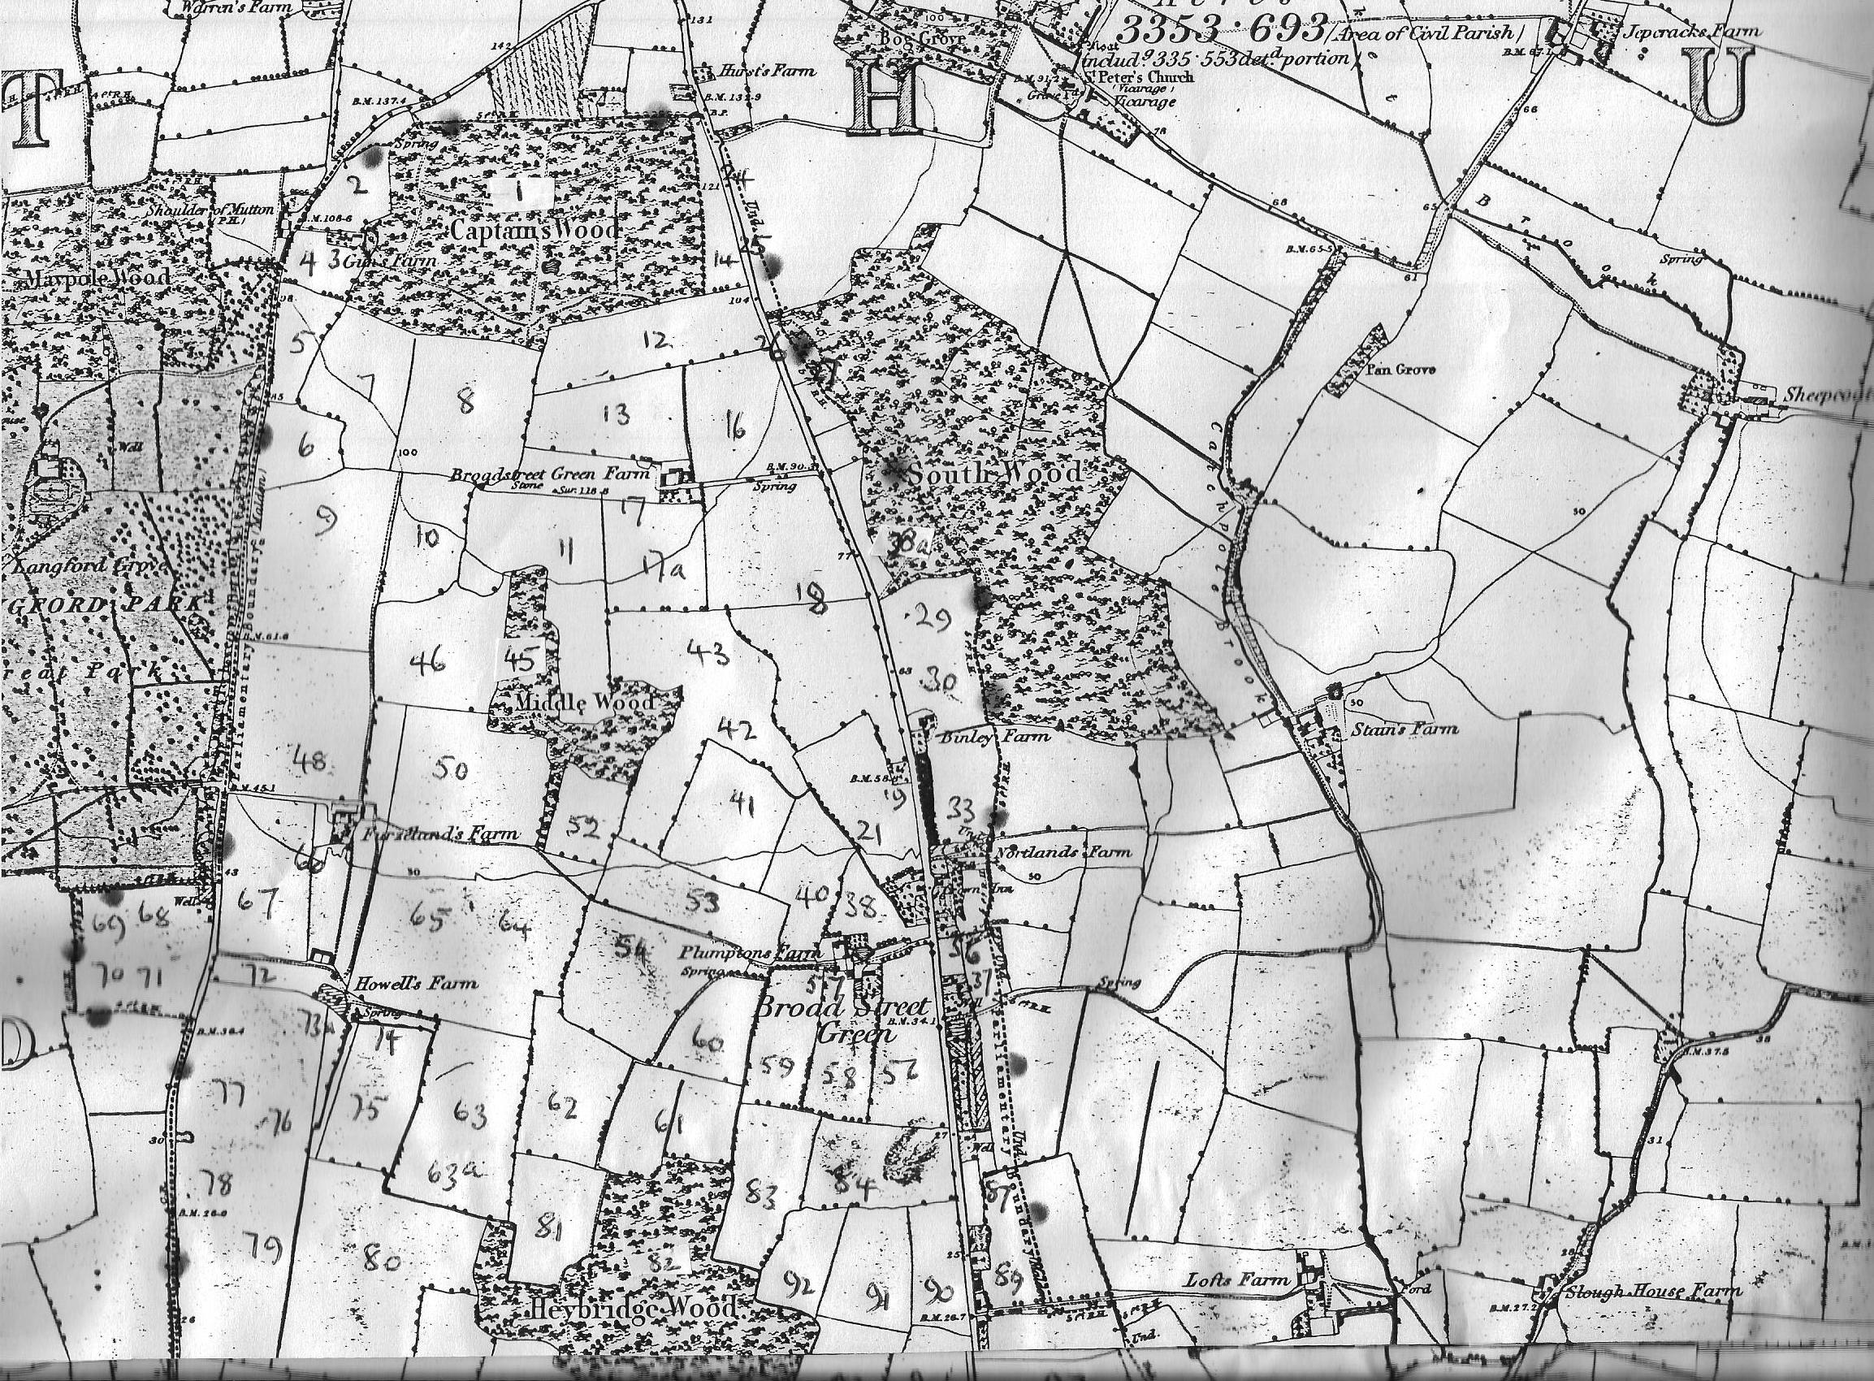
Map 1
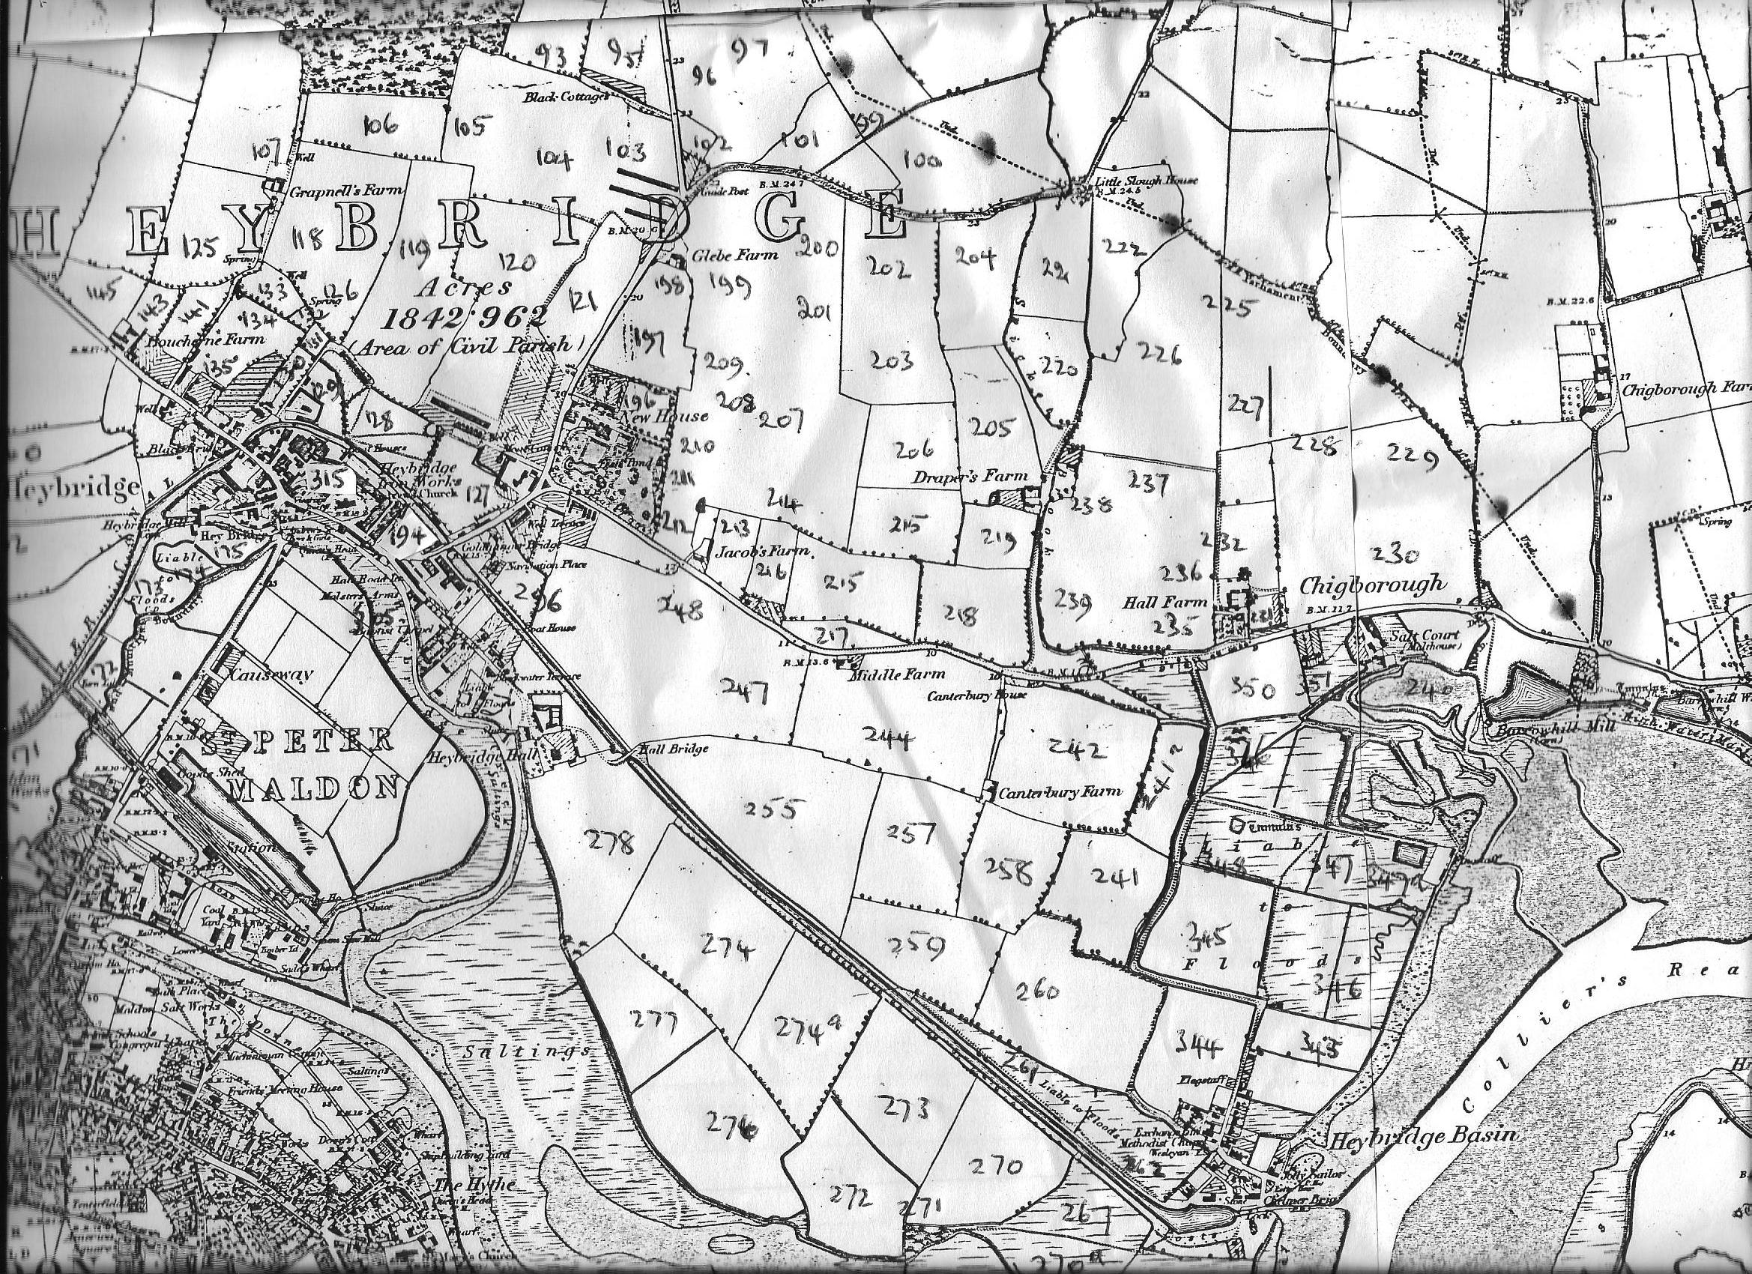
Map 2
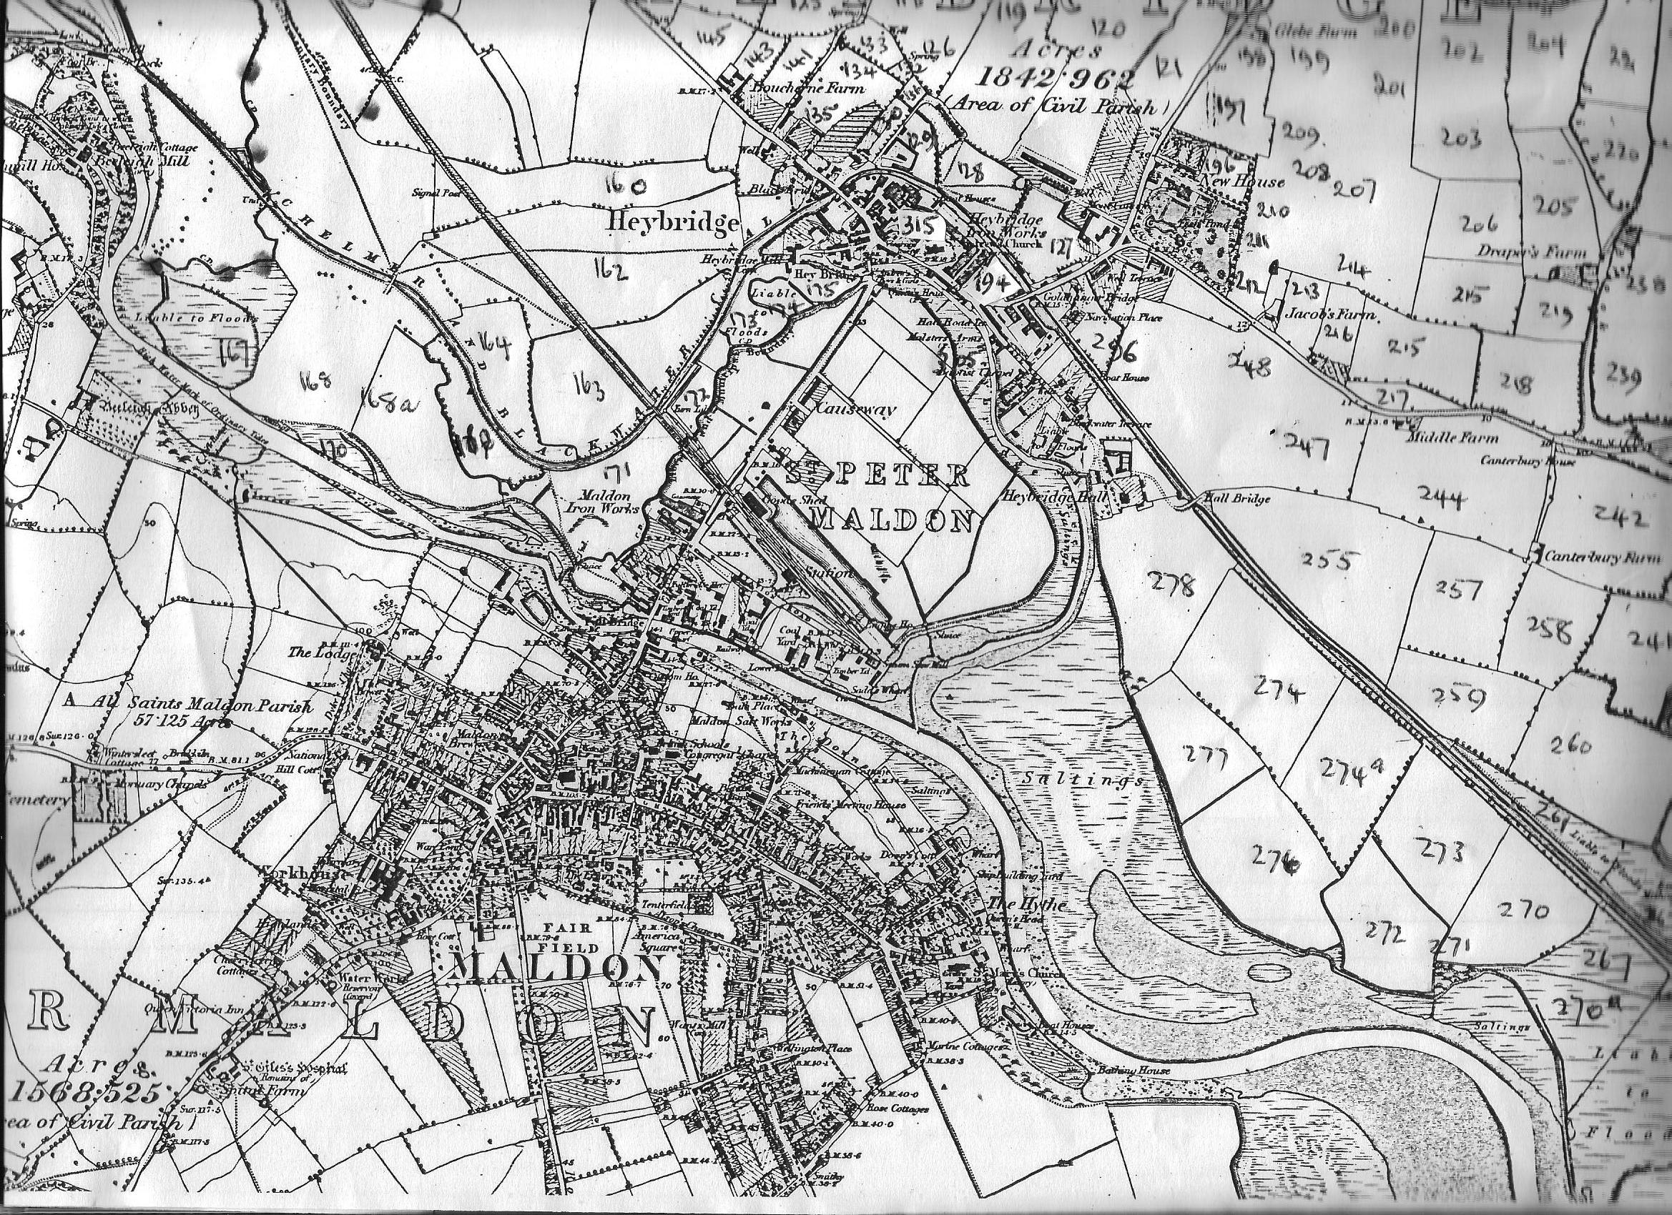
Map 3

