THE PLACE-NAMES

OF LAYER BRETON

Recorder: James Kemble

Essex Place-names Project (Essex Society for Archaeology & History), 2011 (e-book).

www.essex.ac.uk/history/esah/essexplacenames

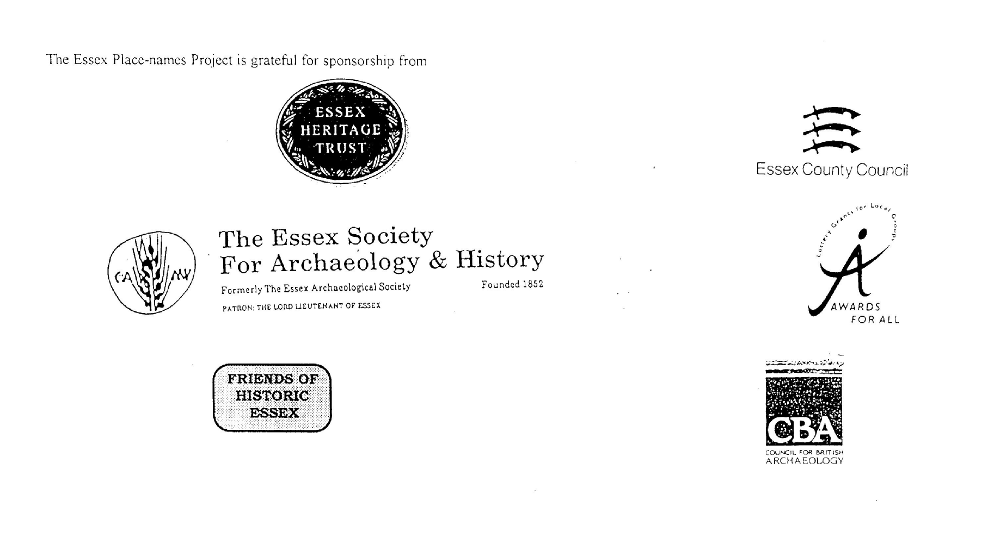

ESSEX PLACE-NAMES PROJECT.

The Essex Place-names Project is a County-wide survey to record place- and field-names from historical documents such as Tithe maps and apportionments, estate maps, sale
and auction catalogues, conveyances, terriers, deeds, rolls, inquisitions and surveys.

The second element of the Project is to investigate on-the-ground visible remains which correspond to the Place-names for actual or potential archaeological, agricultural and industrial
sites, and to record natural (topographical) and man-made features which may relate to the Place-name. This involves field-survey in rural and outside investigation in built-up areas.

It is anticipated that the Project will lead to identification of archaeological sites and lost historic buildings; it will enable analysis of indicators of early settlement, land holding, agricultural and industrial practices of the County. It will refine the more precise meaning of descriptive words and elements used by earlier settlers as they gave names appropriate to the topography of the landscape of their time.

For convenience the surveys are based on the parish, recognising that present civil parish boundaries are not necessarily identical to former ecclesiastical boundaries. Local Recorders
are supplied with templates of Record Forms to ensure consistency of recording across the County, and forward completed forms to a Central Coordinator for transfer to a county
computer database which is available to researchers on the internet at www.essex.ac.uk/history/esah/essexplacenames, and updated periodically.

This publication presents part of the information recorded from the Tithe or Estate Award and Map, and from other documents for this parish. The full record is contained on the master
database at Essex County Council (Historic Environment Section) and on the (above) website. Parish books are available from the Publications Manager, Essex Record Office, Wharf Road, Chelmsford CM2 6YT, on disc or in hard copy or may be downloaded from the website link ‘Books’ on the Home page. Please notify errors to the Project Coordinator at the Essex Record Office.

THE TITHE MAP AND APPORTIONMENT.

Since medieval times a tenth of the produce of land and stock had been paid by landholders to the church. At the Dissolution of the Monasteries, the property of many religious houses,
including the right to collect tithes, passed into lay hands. The Tithe Commutation Act which received Royal assent on 13th August 1836 abolished a rent payable in kind and
substituted rent-charges apportioned on each plot or parcel. The tithe-rent payable was assessed on the average value of wheat, barley and oats and was to fluctuate with price movements.

The commutation could be by voluntary agreement between the local owners and payers or, if agreement failed, could be compulsorily imposed by commissioners. A Valuer was to be
appointed to apportion the rent of each parcel of land and tenants could deduct that rent-charge from their rent paid to the landlord. The task fell to the Tithe Commissioners to produce a
map and an Apportionment (Award). A large-scale survey was produced for over 70% of England and Wales in the following 9 years, and about another 8% up to 1855. Most of the
parishes in Essex were surveyed. The map scales vary. The Award records ownership, tenancy and land-use, field by field and parcel by parcel (often quoting the field name) with the
ground area and rent-charge.

Land that was tithe-free tends to be less accurately mapped and contains few if any of the details recorded for those parcels subject to tithe. Rights of way and roads also tend to be
neglected. Boundaries of the tithe areas are shown as are some natural features such as streams, ponds, gardens, greens and commons. Buildings are often shown coloured red if dwellings
or grey if not. Because the Award may have been agreed only some time after the map was finished, discrepancies occur between the two. Enclosure Awards, when extant, usually date to the 18th and early 19th centuries. J.Kemble.
Reproduced by permission
of Essex County Council.

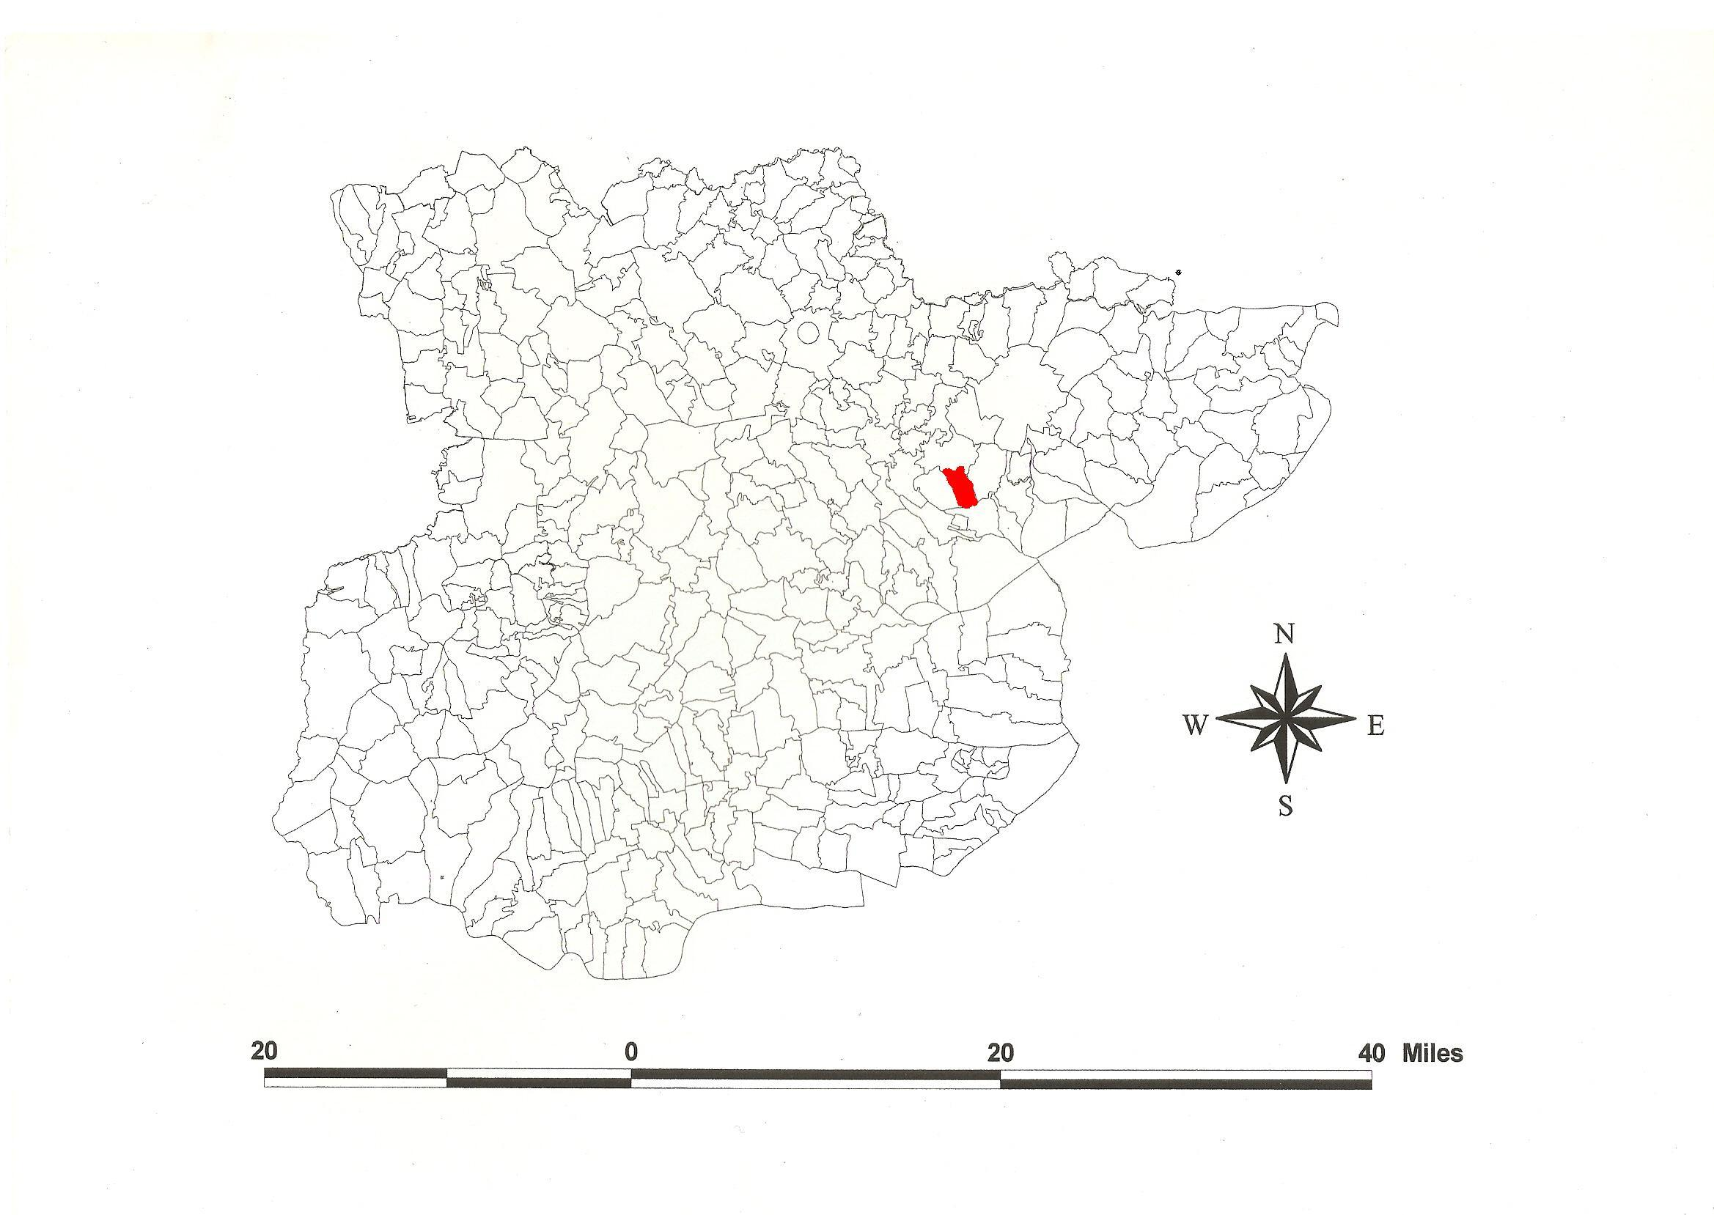
Layer Breton Parish in the County of Essex.
Reproduced by permission
of Essex County Council.

The Parish of Layer Breton (in Winstree Hundred).

The Tithe Award of Layer Breton (Essex Record Office D/CT 213a),dated 1842, shows a rent-charge payable to the rector of £302-16-5 including glebe of £12-16-5. The whole parish measured 932 acres 1 rood 27 perches of which 799a 1r 5p were arable, 95a 1r 32p meadow and pasture, 37a 2r 30p heath and 37a 3r 4p glebe. The Tithe Commissioners were William Blamire and J.W. Buller, the Assistant Commissioner Thomas James Tatham, the Valuer J. William Kendall of Alresford.

The Tithe Map (ERO: D/CT 213b) was surveyed in 1849 by Gibert & Tayspill of Colchester at a scale of 26.6” to a mile and measures 60”x29”. It was countersigned by F.O. Martin, Assistant Tithe Commissioner.

In Domesday Book, 1086, Legra was held by Sasselin which 2 free men held before 1066 as a manor for 8 hides (VCH, 1903; Morris, 1983). Legere Britonis is documented in 1238 and Le Britun in 1248. Breton derives from the family of Brito’ which held it until c.1430. Ralph son of Lewis Brito the Breton granted two parts of the tithes in Layer to St Johns Abbey Colchester c.1300 (Morant, 1763; Reaney, 1935; Ekwall, 1960; Kemble, 2007). Watts (2004) derives Layer from a river name possibly of Celtic origin (cp. Loire) referring to the stream Layer Brook which runs now into the Abberton reservoir, part of which occupies the south of the parish.

The church dedicated to St Mary was built on The Heath in 1922-3, its predecessor immediately east of the Hall demolished in 1915. The Hall is of 3 bays, with Georgian brick. Shalom Hall, formerly the rectory, was built c.1840 (Pevsner, 2007). St Catherine College Farm became the property of St Catherine’s College Cambridge in 1506 (Reaney, 1935).

Place- and field-names from the map (ERO: T/M 250) dated 1767 of Edward Morley snr by R. Dyer, and from other documents are shown against the Tithe names.

The Hundred name in Domesday Book is Wensistreu, ‘Wynsige’s tree’, which was probably at the moot called Mustouwe (c.1330) near Duke’s Farm in Layer Marney (Reaney, 1935).
Without onomastic evidence, Christie (1926) places the moot near Peldon church.

References:

Christy, M., 1926. Essex Hundred Moots. Trans Essex Archaeological Society, xviii(3), 182.
Ekwall, E., 1960. Dictionary of English Place-names. Oxford.
Kemble, J., 2007. Essex Place-names, Places, Streets & People. Historical Publications.
Morant., P., 1963. History & Antiquities of the County of Essex, i, 409.
Morris, J., 1983. Domesday Book - Essex. Phillimore.
Pevsner, N., Bettley, J., 2007. Buildings of England - Essex. Yale.
Reaney, P., 1935. Place-names of Essex. Cambridge.
Victoria County History of Essex, 1903, i, 556.
Watts, V., 2004. Dictionary of English Place-names. Cambridge.

The Tithe Award Place-names of Layer Breton - by Parcel No.

Place-name | Alias | Fld No | Grd Ref | x | y | Acr | rd | pch | land use | Owner | Occupier | Name of Farm | Other information
Homestead | Garhouse Farm, 1875,OS | 1 | TL | 954 | 158 | 1 | 1 | 10 |  | Sutton, Rev Robert W | Wheeler, William | Gar House
Garden field |  | 2 | TL | 954 | 159 | 8 | 1 | 34 | arble | Sutton, Rev Robert W | Wheeler, William | Gar House
Ten Acres |  | 3 | TL | 956 | 160 | 11 | 0 | 3 | arble | Sutton, Rev Robert W | Wheeler, William | Gar House
Six Acres |  | 4 | TL | 955 | 161 | 6 | 3 | 38 | arble | Sutton, Rev Robert W | Wheeler, William | Gar House
Hither 8 Acres | Middle Field Hill, 1875,OS | 5 | TL | 952 | 160 | 9 | 1 | 15 | arble | Sutton, Rev Robert W | Wheeler, William | Gar House
Seven Acres | Middle Field Hill, 1875,OS | 6 | TL | 949 | 160 | 7 | 1 | 9 | arble | Colchester Free Grammar School | Wheeler, William
Second 4 Acres |  | 7 | TL | 948 | 162 | 4 | 1 | 12 | arble | Colchester Free Grammar School | Wheeler, William
First 4 Acres |  | 8 | TL | 948 | 163 | 4 | 2 | 3 |  | Colchester Free Grammar School | Wheeler, William
Highfield | Highfield, 1673,Rntl | 9 | TL | 945 | 161 | 20 | 1 | 38 | arble | Gripper, Edward | Gripper, Edward
Upper Ley |  | 10 | TL | 944 | 163 | 15 | 1 | 18 | arble | Gripper, Edward | Gripper, Edward
Lower Ley |  | 11 | TL | 944 | 165 | 14 | 2 | 25 | arble | Gripper, Edward | Gripper, Edward
Stable field |  | 12 | TL | 946 | 165 | 16 | 1 | 19 | arble | Gripper, Edward | Gripper, Edward
Eight Acres |  | 13 | TL | 947 | 164 | 8 | 3 | 5 | arble | Gripper, Edward | Gripper, Edward
Black Lands |  | 14 | TL | 950 | 164 | 25 | 0 | 38 | arble | Gripper, Edward | Gripper, Edward
White Lands |  | 15 | TL | 950 | 161 | 10 | 0 | 5 | arble | Gripper, Edward | Gripper, Edward
Upper Peldon Croft |  | 16 | TL | 954 | 162 | 14 | 3 | 3 | arble | Gripper, Edward | Gripper, Edward
Lower Peldon Croft |  | 17 | TL | 953 | 165 | 10 | 3 | 25 | arble | Gripper, Edward | Gripper, Edward
Chase |  | 18 | TL | 956 | 163 | 0 | 3 | 2 | grass | Sutton, Rev Robert W | Wheeler, William | Gar House
Further 8 Acres |  | 19 | TL | 955 | 164 | 8 | 3 | 3 | arble | Sutton, Rev Robert W | Wheeler, William | Gar House
The Hill |  | 20 | TL | 956 | 165 | 9 | 1 | 0 | arble | Sutton, Rev Robert W | Wheeler, William | Gar House
Meadow |  | 21 | TL | 955 | 167 | 3 | 2 | 13 | grass | Gripper, Edward | Gripper, Edward
Island Piece |  | 22 | TL | 953 | 167 | 3 | 3 | 26 | grass | Gripper, Edward | Gripper, Edward
Fifteen Acres |  | 23 | TL | 953 | 166 | 15 | 2 | 25 | arble | Gripper, Edward | Gripper, Edward
Stone Lands (pt) |  | 24 | TL | 950 | 164 | 10 | 0 | 19 | arble | Gripper, Edward | Gripper, Edward
Stone Lands (pt) |  | 24a | TL | 950 | 164 | 1 | 0 | 11 | grass | Gripper, Edward | Gripper, Edward
Long Meadow |  | 25 | TL | 950 | 167 | 5 | 0 | 39 | grass | Gripper, Edward | Gripper, Edward
Acre Meadow |  | 26 | TL | 955 | 166 | 8 | 0 | 14 | grass | Gripper, Edward | Gripper, Edward
Further Rye Shots |  | 27 | TL | 954 | 170 | 15 | 3 | 4 | arble | Gripper, Edward | Gripper, Edward
Hither Rye Shots |  | 28 | TL | 952 | 170 | 17 | 3 | 24 | arble | Gripper, Edward | Gripper, Edward
Further Church field |  | 29 | TL | 950 | 170 | 17 | 2 | 21 | arble | Gripper, Edward | Gripper, Edward
Hither Church field |  | 30 | TL | 948 | 170 | 16 | 2 | 19 | arble | Gripper, Edward | Gripper, Edward
Lower Kitchen field |  | 31 | TL | 946 | 168 | 10 | 1 | 9 | arble | Gripper, Edward | Gripper, Edward
Farming Premises |  | 32 | TL | 948 | 166 | 0 | 3 | 7 |  | Gripper, Edward | Gripper, Edward
Bridge field |  | 33 | TL | 946 | 166 | 9 | 1 | 32 | arble | Gripper, Edward | Gripper, Edward
Calves Croft (pt) |  | 34 | TL | 944 | 166 | 13 | 3 | 29 | arble | Gripper, Edward | Gripper, Edward
Calves Croft (pt) |  | 34a | TL | 944 | 167 | 1 | 3 | 27 | grass | Gripper, Edward | Gripper, Edward
Down Field (pt) |  | 35 | TL | 943 | 169 | 30 | 2 | 2 | arble | Gripper, Edward | Gripper, Edward
Down Field (pt) |  | 35a | TL | 943 | 168 | 1 | 0 | 38 | grass | Gripper, Edward | Gripper, Edward
Home Meadow |  | 36 | TL | 146 | 171 | 12 | 2 | 7 | grass | Gripper, Edward | Gripper, Edward
Upper Kitchen field |  | 37 | TL | 947 | 170 | 7 | 3 | 17 | arble | Gripper, Edward | Gripper, Edward
The Hall & premises | Layer Breton hall, 1777,C | 38 | TL | 946 | 172 | 2 | 3 | 27 |  | Gripper, Edward | Gripper, Edward
Pightle |  | 39 | TL | 947 | 172 | 0 | 1 | 30 | grass | Sutton, Rev Robert W | Wheeler, William |  | Glebe
Church & yard | [St Mary's] | 40 | TL | 947 | 172 | 0 | 2 | 33 | grass | Sutton, Rev Robert W | Wheeler, William |  | glebe
Pightle |  | 41 | TL | 947 | 172 | 2 | 2 | 38 | arble | Gripper, Edward | Gripper, Edward | White House Fm
Moat Piece | Whitehouse Grove, 1875,OS | 42 | TL | 948 | 172 | 0 | 2 | 9 | wood | Gripper, Edward | Gripper, Edward | White House Fm
Church field |  | 43 | TL | 947 | 173 | 5 | 1 | 25 | arble | Gripper, Edward | Gripper, Edward | White House Fm
Barn field |  | 44 | TL | 950 | 173 | 10 | 1 | 10 | arble | Gripper, Edward | Gripper, Edward | White House Fm
The Hyde |  | 45 | TL | 952 | 173 | 9 | 1 | 14 | arble | Gripper, Edward | Gripper, Edward | White House Fm
Lower Hyde |  | 46 | TL | 954 | 173 | 11 | 1 | 7 | arble | Western, Lord | Grimwood, John
Upper Hyde |  | 47 | TL | 953 | 175 | 11 | 2 | 12 | arble | Western, Lord | Grimwood, John
Great Stoney Hills (pt) |  | 48 | TL | 952 | 176 | 5 | 1 | 2 | arble | Round, Rev James | Wheeler, William
Long Meadow (pt) |  | 49 | TL | 951 | 175 | 7 | 1 | 10 | arble | Round, Rev James | Wheeler, William
Long field |  | 50 | TL | 950 | 176 | 8 | 1 | 6 | arble | Gripper, Edward | Gripper, Edward | White House Fm
High field |  | 51 | TL | 950 | 175 | 9 | 1 | 6 | arble | Gripper, Edward | Gripper, Edward | White House Fm
Middle field | Midil-, Middlefeld, 1499,EAS xiii | 52 | TL | 948 | 176 | 5 | 1 | 18 | arble | Gripper, Edward | Gripper, Edward | White House Fm
Four acres |  | 53 | TL | 947 | 176 | 4 | 1 | 23 | arble | Gripper, Edward | Gripper, Edward | White House Fm
Low field |  | 54 | TL | 948 | 173 | 5 | 1 | 2 | arble | Gripper, Edward | Gripper, Edward | White House Fm
White House field |  | 55 | TL | 945 | 173 | 8 | 0 | 35 | grass | Gripper, Edward | Gripper, Edward | White House Fm
Lady Lands | Ladyland(acre), 1499, EAS xiii | 56 | TL | 944 | 173 | 5 | 1 | 0 | arble | Gripper, Edward | Gripper, Edward
Great Burnt House field |  | 57 | TL | 943 | 172 | 8 | 3 | 31 | arble | Rebow, General Francis Slater | Barritt, Lydia
Eleven acres |  | 58 | TL | 942 | 171 | 11 | 0 | 32 | arble | Rebow, General Francis Slater | Barritt, Lydia
Knut Lands |  | 59 | TL | 941 | 173 | 7 | 3 | 6 | arble | Sutton, Rev Robert W | Wheeler, William |  | Glebe
Small Profits |  | 60 | TL | 943 | 174 | 2 | 0 | 18 | arble | Sutton, Rev Robert W | Wheeler, William |  | Glebe
Pear Tree field | cf. Periton, 1499,EAS xiii | 61 | TL | 944 | 175 | 5 | 3 | 29 | arble | Catherine Hall (Cambridge) | Wheeler, William
Three Acres by Chase |  | 62 | TL | 943 | 175 | 2 | 3 | 19 | arble | Catherine Hall (Cambridge) | Wheeler, William
Cupid's Corner |  | 63 | TL | 942 | 175 | 1 | 3 | 6 | arble | Sutton, Rev Robert W | Wheeler, William |  | Glebe
Further Three acres |  | 64 | TL | 941 | 175 | 3 | 2 | 30 | arble | Catherine Hall (Cambridge) | Wheeler, William
The Hope |  | 65 | TL | 941 | 176 | 3 | 3 | 14 | arble | Catherine Hall (Cambridge) | Wheeler, William
The Hope |  | 66 | TL | 941 | 177 | 4 | 1 | 13 | arble | Rebow, General Francis Slater | Barritt, Lydia
Meadow |  | 67 | TL | 943 | 177 | 2 | 2 | 35 | grass | Catherine Hall (Cambridge) | Wheeler, William
Lower Meadow |  | 68 | TL | 944 | 176 | 2 | 1 | 25 | grass | Catherine Hall (Cambridge) | Wheeler, William
The Meadow |  | 69 | TL | 944 | 175 | 4 | 1 | 22 | grass | Rebow, General Francis Slater | Barritt, Lydia
Six acres |  | 70 | TL | 944 | 174 | 6 | 3 | 33 | arble | Rebow, General Francis Slater | Barritt, Lydia
Little Burnt House field |  | 71 | TL | 943 | 174 | 2 | 2 | 23 | arble | Rebow, General Francis Slater | Barritt, Lydia
Five acres |  | 72 | TL | 944 | 174 | 6 | 1 | 0 | arble | Rebow, General Francis Slater | Barritt, Lydia
Pasture |  | 73 | TL | 947 | 174 | 1 | 2 | 5 | grass | Rebow, General Francis Slater | Barritt, Lydia
Homestead | Washings, 1875,OS | 74 | TL | 947 | 175 | 0 | 3 | 16 |  | Rebow, General Francis Slater | Barritt, Lydia |  | William Wascelin, 1214,FeetFine
Pasture |  | 75 | TL | 947 | 175 | 1 | 2 | 33 | grass | Rebow, General Francis Slater | Barritt, Lydia
Four acres |  | 76 | TL | 946 | 175 | 4 | 2 | 38 | grass | Sutton, Rev Robert W | Wheeler, William |  | Glebe
3 Acre Mead |  | 77 | TL | 946 | 176 | 2 | 2 | 10 | grass | Sutton, Rev Robert W | Wheeler, William |  | Glebe
Homestead | Glebe Farm, 1875,OS | 78 | TL | 946 | 177 | 0 | 2 | 27 |  | Sutton, Rev Robert W | Wheeler, William |  | Glebe
Cots,gdns, stable, yard |  | 79 | TL | 946 | 177 | 0 | 2 | 26 |  | Sutton, Rev Robert W | Abbot; Root; others |  | Glebe
Parsonage, Home, premises |  | 80 | TL | 947 | 177 | 2 | 0 | 34 |  | Sutton, Rev Robert W | Sutton, Rev Robert W |  | Glebe
Barn Meadow |  | 81 | TL | 947 | 177 | 1 | 2 | 26 | grass | Sutton, Rev Robert W | Wheeler, William |  | Glebe
Cot, garden | Parochial School, 1875,OS | 82 | TL | 947 | 176 | 0 | 0 | 36 |  | Sutton, Rev Robert W | Bullock; Firmin |  | Glebe
Cartlodge field |  | 83 | TL | 948 | 177 | 4 | 2 | 1 | arble | Gripper, Edward | Gripper, Edward
Pasture |  | 84 | TL | 948 | 176 | 2 | 2 | 9 | grass | Gripper, Edward | Gripper, Edward
Stack Field |  | 85 | TL | 950 | 177 | 9 | 3 | 38 | arble | Gripper, Edward | Gripper, Edward
Dovehouse field |  | 86 | TL | 950 | 179 | 9 | 0 | 33 | arble | Gripper, Edward | Gripper, Edward
Homestead | White House, 1777,C | 87 | TL | 948 | 178 | 3 | 0 | 17 |  | Gripper, Edward | Gripper, Edward
The Rookery |  | 88 | TL | 948 | 180 | 3 | 3 | 27 | grass | Gripper, Edward | Gripper, Edward
Little Greenfield |  | 89 | TL | 948 | 182 | 5 | 3 | 22 | arble | Gripper, Edward | Gripper, Edward
Great Greenfield |  | 90 | TL | 946 | 181 | 8 | 1 | 13 | arble | Gripper, Edward | Gripper, Edward
Little Stack House field |  | 91 | TL | 947 | 179 | 4 | 2 | 32 | arble | Gripper, Edward | Gripper, Edward
Hill Field |  | 92 | TL | 945 | 180 | 8 | 0 | 32 | arble | Gripper, Edward | Gripper, Edward
Great Stockhouse field (pt) |  | 93 | TL | 945 | 177 | 9 | 1 | 5 | arble | Gripper, Edward | Gripper, Edward
Great Stockhouse field (pt) |  | 93a | TL | 945 | 176 | 1 | 0 | 14 | grass | Gripper, Edward | Gripper, Edward
Barn field |  | 94 | TL | 944 | 178 | 7 | 0 | 5 | arble | Catherine Hall (Cambridge) | Wheeler, William
Doyley field |  | 95 | TL | 943 | 178 | 2 | 0 | 34 | grass | Catherine Hall (Cambridge) | Wheeler, William
Homestead | Catherine Hall Farm, 1875,OS | 96 | TL | 943 | 178 | 0 | 1 | 34 |  | Catherine Hall (Cambridge) | Wheeler, William
Four acres |  | 97 | TL | 943 | 179 | 4 | 1 | 3 | arble | Catherine Hall (Cambridge) | Wheeler, William
No name |  | 98 | TL | 942 | 179 | 0 | 1 | 2 | grass | Nayland Bridge Land | Quilter, James
Homestead | Nayling Bridge Farm, 1875,OS | 99 | TL | 942 | 178 | 0 | 2 | 26 |  | Nayland Bridge Land | Quilter, James
No name |  | 100 | TL | 942 | 177 | 2 | 1 | 8 | arble | Nayland Bridge Land | Quilter, James
No name |  | 101 | TL | 940 | 177 | 3 | 1 | 20 | arble | Nayland Bridge Land | Quilter, James
No name |  | 102 | TL | 940 | 178 | 3 | 2 | 18 | arble | Nayland Bridge Land | Quilter, James
No name |  | 103 | TL | 940 | 179 | 3 | 2 | 33 | arble | Nayland Bridge Land | Quilter, James
No name |  | 104 | TL | 940 | 180 | 3 | 2 | 34 | arble | Nayland Bridge Land | Quilter, James
Cots, gardens |  | 105 | TL | 942 | 180 | 0 | 1 | 5 |  | Barritt, Lydia | Bullock & Poor
Homestead | Peppes,1542,LP; Phip's Farm,1875,OS | 106 | TL | 942 | 180 | 0 | 1 | 12 |  | Barritt, Lydia | Pulpett, Anna |  | John Peps, 1319,SubRoll
No name |  | 107 | TL | 943 | 180 | 1 | 0 | 15 | arble | Barritt, Lydia | Pulpett, Anna
No name |  | 108 | TL | 943 | 181 | 2 | 1 | 4 | arble | Barritt, Lydia | Pulpett, Anna
No name |  | 109 | TL | 944 | 180 | 2 | 0 | 35 | arble | Barritt, Lydia | Pulpett, Anna
No name |  | 110 | TL | 943 | 181 | 2 | 0 | 19 | arble | Barritt, Lydia | Pulpett, Anna
No name |  | 111 | TL | 940 | 181 | 1 | 3 | 35 | arble | Barritt, Lydia | Pulpett, Anna
No name |  | 112 | TL | 939 | 181 | 2 | 1 | 13 | . | Barritt, Lydia | Pulpett, Anna
Ambit |  | 113 | TL | 939 | 182 | 1 | 0 | 22 | arble | Sutton, Rev Robert W | Wheeler, William |  | Glebe
Breech |  | 114 | TL | 941 | 182 | 5 | 3 | 8 | arble | Sutton, Rev Robert W | Wheeler, William |  | Glebe
Little Highfield |  | 115 | TL | 938 | 183 | 2 | 3 | 7 | arble | Sutton, Rev Robert W | Wheeler, William |  | Glebe
Great Highfield |  | 116 | TL | 940 | 183 | 4 | 3 | 12 | arble | Sutton, Rev Robert W | Wheeler, William |  | Glebe
No name |  | 117 | TL | 943 | 183 | 6 | 1 | 23 | arble | Burkitt, George | Powell, Thomas
Allotments |  | 118 | TL | 944 | 184 | 5 | 0 | 34 | arble | Gripper, Edward | Gripper, Edward
Heathfield |  | 119 | TL | 944 | 182 | 9 | 0 | 23 | arble | Gripper, Edward | Gripper, Edward
Cots, gardens |  | 120 | TL | 945 | 183 | 0 | 1 | 32 |  | Gripper, Edward | Smith; Finch
Garden |  | 121 | TL | 945 | 183 | 0 | 0 | 25 | . | Gripper, Edward | Cole, John
Cots, gardens |  | 122 | TL | 945 | 184 | 0 | 1 | 31 |  | Gripper, Edward | Cole; Cole; Smith
Cots, gardens |  | 123 | TL | 945 | 184 | 0 | 0 | 32 |  | Tiffin, Jonathan | Hutley; Cole
Cots, gardens |  | 124 | TL | 945 | 185 | 0 | 0 | 28 |  | Ayling, Ann, trustees | Abbot, Thomas
Cots, gardens |  | 125 | TL | 945 | 185 | 0 | 0 | 28 |  | Anthony, William | Quilter; Roe;others
Cots, gardens |  | 126 | TL | 945 | 185 | 0 | 1 | 14 |  | Burkitt, George | Roe; Webb;others
House, premises | Layer Breton Lodge, 1875,OS | 127 | TL | 945 | 184 | 1 | 2 | 28 |  | Burkitt, George | Burkitt, George
Cots, gardens |  | 128 | TL | 945 | 184 | 0 | 0 | 25 |  | Barrett, Lydia | Goody & South
Cots, gardens |  | 129 | TL | 945 | 184 | 0 | 1 | 26 |  | Gripper, Edward | Kemp & Potter
Meeting & premises | Friends' Meeting house, 1875,OS | 130 | TL | 946 | 183 | 0 | 1 | 16 |  | Quakers Society | .
No name |  | 131 | TL | 946 | 183 | 3 | 2 | 30 | arble | Burkitt, George | Powell, Thomas
No name |  | 132 | TL | 948 | 183 | 3 | 2 | 32 | arble | Burkitt, George | Powell, Thomas
Bretton Meadow |  | 133 | TL | 949 | 181 | 6 | 1 | 24 | arble | Round, Rev James | Wheeler, William
Birch Meadow (pt) |  | 134 | TL | 950 | 182 | 2 | 1 | 31 | arble | Round, Rev James | Wheeler, William
Green field | grene field, 1581,Harl | 135 | TL | 949 | 183 | 4 | 2 | 27 | arble | Scale, Rev Bernard | Powell, Thomas
Further field (pt) | Farther field, 1767, T/M 250 | 136 | TL | 950 | 184 | 1 | 1 | 2 | arble | Scale, Rev Bernard | Powell, Thomas
Middle field | Midil-, Middlefeld, 1499,EAS xiii | 137 | TL | 949 | 185 | 4 | 2 | 35 | arble | Scale, Rev Bernard | Powell, Thomas
Lower 9 acres |  | 138 | TL | 948 | 185 | 4 | 2 | 20 | arble | Scale, Rev Bernard | Powell, Thomas
Heath field | Heath field, 1767,T/M 250 | 139 | TL | 948 | 186 | 3 | 2 | 38 | arble | Scale, Rev Bernard | Powell, Thomas
Upper 9 acres |  | 140 | TL | 947 | 186 | 5 | 1 | 6 | arble | Scale, Rev Bernard | Powell, Thomas
No name |  | 141 | TL | 947 | 185 | 5 | 0 | 12 | arble | Burkitt, George | Powell, Thomas
No name |  | 142 | TL | 946 | 185 | 4 | 0 | 15 | arble | Burkitt, George | Powell, Thomas
Homestead |  | 143 | TL | 945 | 185 | 0 | 3 | 11 |  | Burkitt, George | Powell, Thomas
No name |  | 144 | TL | 945 | 185 | 0 | 2 | 26 | grass | Burkitt, George | Powell, Thomas
Cot, garden |  | 145 | TL | 944 | 186 | 0 | 0 | 13 |  | Tiffen, Charles | Harvey, Robert
No name |  | 146 | TL | 944 | 186 | 1 | 2 | 8 | grass | Tiffen, Charles | Tiffen, Charles
No name |  | 147 | TL | 944 | 185 | 0 | 2 | 18 | grass | Tiffen, Charles | Tiffen, Charles
Cots, gardens |  | 148 | TL | 944 | 185 | 0 | 1 | 22 |  | Digby, Martha | Cole & Wagstaff
Cots, gardens |  | 149 | TL | 944 | 185 | 0 | 0 | 26 |  | Wheeler, William | Reef & Higham
Cartlodge field |  | 150 | TL | 943 | 186 | 6 | 0 | 31 | arble | Scale, Rev Bernard | Powell, Thomas
Cots, gardens |  | 151 | TL | 944 | 186 | 0 | 1 | 19 |  | Scale, Rev Bernard | Powell, Thomas
Three acres |  | 152 | TL | 943 | 186 | 3 | 2 | 2 | arble | Scale, Rev Bernard | Powell, Thomas
Long field |  | 153 | TL | 942 | 186 | 5 | 1 | 14 | arble | Scale, Rev Bernard | Powell, Thomas
Shatters |  | 154 | TL | 942 | 185 | 4 | 0 | 14 | arble | Scale, Rev Bernard | Powell, Thomas
Bottom field |  | 155 | TL | 939 | 185 | 6 | 0 | 2 | arble | Scale, Rev Bernard | Powell, Thomas
Lower field |  | 156 | TL | 938 | 186 | 7 | 2 | 26 | arble | Scale, Rev Bernard | Powell, Thomas
Wood field |  | 157 | TL | 940 | 186 | 4 | 3 | 13 | arble | Scale, Rev Bernard | Powell, Thomas
Meat field |  | 158 | TL | 942 | 187 | 7 | 0 | 14 | arble | Scale, Rev Bernard | Powell, Thomas
Homestead | Stamp's Farm, 1875,OS | 159 | TL | 943 | 187 | 1 | 3 | 18 | arble | Scale, Rev Bernard | Powell, Thomas |  | Henry Stampe, 1451,MnAt
Pightle |  | 160 | TL | 943 | 187 | 0 | 3 | 19 | grass | Scale, Rev Bernard | Powell, Thomas
Cot, garden |  | 161 | TL | 943 | 187 | 0 | 0 | 24 |  | Scale, Rev Bernard | Powell, Thomas
House, cots, gardens |  | 162 | TL | 943 | 187 | 0 | 2 | 18 |  | Wade, William | Wade, William; others
Cots, gardens |  | 163 | TL | 944 | 188 | 0 | 0 | 39 |  | Little, Nathaniel | Lay & Cole
Public House, premises |  | 164 | TL | 945 | 188 | 0 | 2 | 25 | inn | Holloway, Edward | Holloway, Edward
Meeting House, burial ground | Independent Chapel, 1875,OS | 165 | TL | 946 | 188 | 0 | 1 | 38 |  | Independent Meeting | Merchant, William
Cots, gardens |  | 166 | TL | 946 | 188 | 0 | 0 | 35 |  | Nicholson, Isaac | Barnby & Pepper
Cots, gardens |  | 167 | TL | 947 | 188 | 0 | 0 | 30 |  | Brewer, Henry U. | Brewer, Henry U.
Meeting field |  | 168 | TL | 947 | 189 | 6 | 3 | 17 | arble | Gripper, Edward | Gripper, Edward
Heath field |  | 169 | TL | 948 | 188 | 6 | 3 | 15 | arble | Gripper, Edward | Gripper, Edward
Garden |  | 170 | TL | 949 | 189 | 0 | 1 | 17 | arble | Gripper, Edward | Gripper, Edward
Birch field |  | 171 | TL | 949 | 190 | 6 | 3 | 18 | arble | Gripper, Edward | Gripper, Edward
Spring field |  | 172 | TL | 947 | 190 | 5 | 1 | 36 | arble | Gripper, Edward | Gripper, Edward
Layer Breton Heath | Layrebretten heath, 1581,Harl | 173 | TL | 947 | 186 | 32 | 1 | 29 |  | . | .

For abbreviations see Reaney, P., 1935. Place-names of Essex, Cambridge; and Kemble, J., 2009. Essex Place-names, Places, Streets & People, Historical Publications.

The Tithe Award Place-names of Layer Breton - by Place-name.

Place-name | Alias | Fld No | Grd Ref | x | y | Acr | rd | pch | land use | Owner | Occupier | Name of Farm | Other information
3 Acre Mead |  | 77 | TL | 946 | 176 | 2 | 2 | 10 | grass | Sutton, Rev Robert W | Wheeler, William |  | Glebe
Acre Meadow |  | 26 | TL | 955 | 166 | 8 | 0 | 14 | grass | Gripper, Edward | Gripper, Edward
Allotments |  | 118 | TL | 944 | 184 | 5 | 0 | 34 | arble | Gripper, Edward | Gripper, Edward
Ambit |  | 113 | TL | 939 | 182 | 1 | 0 | 22 | arble | Sutton, Rev Robert W | Wheeler, William |  | Glebe
Barn field |  | 94 | TL | 944 | 178 | 7 | 0 | 5 | arble | Catherine Hall (Cambridge) | Wheeler, William
Barn field |  | 44 | TL | 950 | 173 | 10 | 1 | 10 | arble | Gripper, Edward | Gripper, Edward | White House Fm
Barn Meadow |  | 81 | TL | 947 | 177 | 1 | 2 | 26 | grass | Sutton, Rev Robert W | Wheeler, William |  | Glebe
Birch field |  | 171 | TL | 949 | 190 | 6 | 3 | 18 | arble | Gripper, Edward | Gripper, Edward
Birch Meadow (pt) |  | 134 | TL | 950 | 182 | 2 | 1 | 31 | arble | Round, Rev James | Wheeler, William
Black Lands |  | 14 | TL | 950 | 164 | 25 | 0 | 38 | arble | Gripper, Edward | Gripper, Edward
Bottom field |  | 155 | TL | 939 | 185 | 6 | 0 | 2 | arble | Scale, Rev Bernard | Powell, Thomas
Breech |  | 114 | TL | 941 | 182 | 5 | 3 | 8 | arble | Sutton, Rev Robert W | Wheeler, William |  | Glebe
Bretton Meadow |  | 133 | TL | 949 | 181 | 6 | 1 | 24 | arble | Round, Rev James | Wheeler, William
Bridge field |  | 33 | TL | 946 | 166 | 9 | 1 | 32 | arble | Gripper, Edward | Gripper, Edward
Calves Croft (pt) |  | 34 | TL | 944 | 166 | 13 | 3 | 29 | arble | Gripper, Edward | Gripper, Edward
Calves Croft (pt) |  | 34a | TL | 944 | 167 | 1 | 3 | 27 | grass | Gripper, Edward | Gripper, Edward
Cartlodge field |  | 83 | TL | 948 | 177 | 4 | 2 | 1 | arble | Gripper, Edward | Gripper, Edward
Cartlodge field |  | 150 | TL | 943 | 186 | 6 | 0 | 31 | arble | Scale, Rev Bernard | Powell, Thomas
Chase |  | 18 | TL | 956 | 163 | 0 | 3 | 2 | grass | Sutton, Rev Robert W | Wheeler, William | Gar House
Church & yard | [St Mary's] | 40 | TL | 947 | 172 | 0 | 2 | 33 | grass | Sutton, Rev Robert W | Wheeler, William |  | glebe
Church field |  | 43 | TL | 947 | 173 | 5 | 1 | 25 | arble | Gripper, Edward | Gripper, Edward | White House Fm
Cot, garden |  | 161 | TL | 943 | 187 | 0 | 0 | 24 |  | Scale, Rev Bernard | Powell, Thomas
Cot, garden | Parochial School, 1875,OS | 82 | TL | 947 | 176 | 0 | 0 | 36 |  | Sutton, Rev Robert W | Bullock; Firmin |  | Glebe
Cot, garden |  | 145 | TL | 944 | 186 | 0 | 0 | 13 |  | Tiffen, Charles | Harvey, Robert
Cots, gardens |  | 125 | TL | 945 | 185 | 0 | 0 | 28 |  | Anthony, William | Quilter; Roe;others
Cots, gardens |  | 124 | TL | 945 | 185 | 0 | 0 | 28 |  | Ayling, Ann, trustees | Abbot, Thomas
Cots, gardens |  | 128 | TL | 945 | 184 | 0 | 0 | 25 |  | Barrett, Lydia | Goody & South
Cots, gardens |  | 105 | TL | 942 | 180 | 0 | 1 | 5 |  | Barritt, Lydia | Bullock & Poor
Cots, gardens |  | 167 | TL | 947 | 188 | 0 | 0 | 30 |  | Brewer, Henry U. | Brewer, Henry U.
Cots, gardens |  | 126 | TL | 945 | 185 | 0 | 1 | 14 |  | Burkitt, George | Roe; Webb;others
Cots, gardens |  | 148 | TL | 944 | 185 | 0 | 1 | 22 |  | Digby, Martha | Cole & Wagstaff
Cots, gardens |  | 122 | TL | 945 | 184 | 0 | 1 | 31 |  | Gripper, Edward | Cole; Cole; Smith
Cots, gardens |  | 129 | TL | 945 | 184 | 0 | 1 | 26 |  | Gripper, Edward | Kemp & Potter
Cots, gardens |  | 120 | TL | 945 | 183 | 0 | 1 | 32 |  | Gripper, Edward | Smith; Finch
Cots, gardens |  | 163 | TL | 944 | 188 | 0 | 0 | 39 |  | Little, Nathaniel | Lay & Cole
Cots, gardens |  | 166 | TL | 946 | 188 | 0 | 0 | 35 |  | Nicholson, Isaac | Barnby & Pepper
Cots, gardens |  | 151 | TL | 944 | 186 | 0 | 1 | 19 |  | Scale, Rev Bernard | Powell, Thomas
Cots, gardens |  | 123 | TL | 945 | 184 | 0 | 0 | 32 |  | Tiffin, Jonathan | Hutley; Cole
Cots, gardens |  | 149 | TL | 944 | 185 | 0 | 0 | 26 |  | Wheeler, William | Reef & Higham
Cots,gdns, stable, yard |  | 79 | TL | 946 | 177 | 0 | 2 | 26 |  | Sutton, Rev Robert W | Abbot; Root; others |  | Glebe
Cupid's Corner |  | 63 | TL | 942 | 175 | 1 | 3 | 6 | arble | Sutton, Rev Robert W | Wheeler, William |  | Glebe
Dovehouse field |  | 86 | TL | 950 | 179 | 9 | 0 | 33 | arble | Gripper, Edward | Gripper, Edward
Down Field (pt) |  | 35 | TL | 943 | 169 | 30 | 2 | 2 | arble | Gripper, Edward | Gripper, Edward
Down Field (pt) |  | 35a | TL | 943 | 168 | 1 | 0 | 38 | grass | Gripper, Edward | Gripper, Edward
Doyley field |  | 95 | TL | 943 | 178 | 2 | 0 | 34 | grass | Catherine Hall (Cambridge) | Wheeler, William
Eight Acres |  | 13 | TL | 947 | 164 | 8 | 3 | 5 | arble | Gripper, Edward | Gripper, Edward
Eleven acres |  | 58 | TL | 942 | 171 | 11 | 0 | 32 | arble | Rebow, General Francis Slater | Barritt, Lydia
Farming Premises |  | 32 | TL | 948 | 166 | 0 | 3 | 7 |  | Gripper, Edward | Gripper, Edward
Fifteen Acres |  | 23 | TL | 953 | 166 | 15 | 2 | 25 | arble | Gripper, Edward | Gripper, Edward
First 4 Acres |  | 8 | TL | 948 | 163 | 4 | 2 | 3 |  | Colchester Free Grammar School | Wheeler, William
Five acres |  | 72 | TL | 944 | 174 | 6 | 1 | 0 | arble | Rebow, General Francis Slater | Barritt, Lydia
Four acres |  | 97 | TL | 943 | 179 | 4 | 1 | 3 | arble | Catherine Hall (Cambridge) | Wheeler, William
Four acres |  | 53 | TL | 947 | 176 | 4 | 1 | 23 | arble | Gripper, Edward | Gripper, Edward | White House Fm
Four acres |  | 76 | TL | 946 | 175 | 4 | 2 | 38 | grass | Sutton, Rev Robert W | Wheeler, William |  | Glebe
Further 8 Acres |  | 19 | TL | 955 | 164 | 8 | 3 | 3 | arble | Sutton, Rev Robert W | Wheeler, William | Gar House
Further Church field |  | 29 | TL | 950 | 170 | 17 | 2 | 21 | arble | Gripper, Edward | Gripper, Edward
Further field (pt) | Farther field, 1767, T/M 250 | 136 | TL | 950 | 184 | 1 | 1 | 2 | arble | Scale, Rev Bernard | Powell, Thomas
Further Rye Shots |  | 27 | TL | 954 | 170 | 15 | 3 | 4 | arble | Gripper, Edward | Gripper, Edward
Further Three acres |  | 64 | TL | 941 | 175 | 3 | 2 | 30 | arble | Catherine Hall (Cambridge) | Wheeler, William
Garden |  | 121 | TL | 945 | 183 | 0 | 0 | 25 | . | Gripper, Edward | Cole, John
Garden |  | 170 | TL | 949 | 189 | 0 | 1 | 17 | arble | Gripper, Edward | Gripper, Edward
Garden field |  | 2 | TL | 954 | 159 | 8 | 1 | 34 | arble | Sutton, Rev Robert W | Wheeler, William | Gar House
Great Burnt House field |  | 57 | TL | 943 | 172 | 8 | 3 | 31 | arble | Rebow, General Francis Slater | Barritt, Lydia
Great Greenfield |  | 90 | TL | 946 | 181 | 8 | 1 | 13 | arble | Gripper, Edward | Gripper, Edward
Great Highfield |  | 116 | TL | 940 | 183 | 4 | 3 | 12 | arble | Sutton, Rev Robert W | Wheeler, William |  | Glebe
Great Stockhouse field (pt) |  | 93 | TL | 945 | 177 | 9 | 1 | 5 | arble | Gripper, Edward | Gripper, Edward
Great Stockhouse field (pt) |  | 93a | TL | 945 | 176 | 1 | 0 | 14 | grass | Gripper, Edward | Gripper, Edward
Great Stoney Hills (pt) |  | 48 | TL | 952 | 176 | 5 | 1 | 2 | arble | Round, Rev James | Wheeler, William
Green field | grene field, 1581,Harl | 135 | TL | 949 | 183 | 4 | 2 | 27 | arble | Scale, Rev Bernard | Powell, Thomas
Heath field |  | 169 | TL | 948 | 188 | 6 | 3 | 15 | arble | Gripper, Edward | Gripper, Edward
Heath field | Heath field, 1767,T/M 250 | 139 | TL | 948 | 186 | 3 | 2 | 38 | arble | Scale, Rev Bernard | Powell, Thomas
Heathfield |  | 119 | TL | 944 | 182 | 9 | 0 | 23 | arble | Gripper, Edward | Gripper, Edward
High field |  | 51 | TL | 950 | 175 | 9 | 1 | 6 | arble | Gripper, Edward | Gripper, Edward | White House Fm
Highfield | Highfield, 1673,Rntl | 9 | TL | 945 | 161 | 20 | 1 | 38 | arble | Gripper, Edward | Gripper, Edward
Hill Field |  | 92 | TL | 945 | 180 | 8 | 0 | 32 | arble | Gripper, Edward | Gripper, Edward
Hither 8 Acres | Middle Field Hill, 1875,OS | 5 | TL | 952 | 160 | 9 | 1 | 15 | arble | Sutton, Rev Robert W | Wheeler, William | Gar House
Hither Church field |  | 30 | TL | 948 | 170 | 16 | 2 | 19 | arble | Gripper, Edward | Gripper, Edward
Hither Rye Shots |  | 28 | TL | 952 | 170 | 17 | 3 | 24 | arble | Gripper, Edward | Gripper, Edward
Home Meadow |  | 36 | TL | 146 | 171 | 12 | 2 | 7 | grass | Gripper, Edward | Gripper, Edward
Homestead | Peppes,1542,LP; Phip's Farm,1875,OS | 106 | TL | 942 | 180 | 0 | 1 | 12 |  | Barritt, Lydia | Pulpett, Anna |  | John Peps, 1319,SubRoll
Homestead |  | 143 | TL | 945 | 185 | 0 | 3 | 11 |  | Burkitt, George | Powell, Thomas
Homestead | Catherine Hall Farm, 1875,OS | 96 | TL | 943 | 178 | 0 | 1 | 34 |  | Catherine Hall (Cambridge) | Wheeler, William
Homestead | White House, 1777,C | 87 | TL | 948 | 178 | 3 | 0 | 17 |  | Gripper, Edward | Gripper, Edward
Homestead | Nayling Bridge Farm, 1875,OS | 99 | TL | 942 | 178 | 0 | 2 | 26 |  | Nayland Bridge Land | Quilter, James
Homestead | Washings, 1875,OS | 74 | TL | 947 | 175 | 0 | 3 | 16 |  | Rebow, General Francis Slater | Barritt, Lydia |  | William Wascelin, 1214,FeetFine
Homestead | Stamp's Farm, 1875,OS | 159 | TL | 943 | 187 | 1 | 3 | 18 | arble | Scale, Rev Bernard | Powell, Thomas |  | Henry Stampe, 1451,MnAt
Homestead | Garhouse Farm, 1875,OS | 1 | TL | 954 | 158 | 1 | 1 | 10 |  | Sutton, Rev Robert W | Wheeler, William | Gar House
Homestead | Glebe Farm, 1875,OS | 78 | TL | 946 | 177 | 0 | 2 | 27 |  | Sutton, Rev Robert W | Wheeler, William |  | Glebe
House, cots, gardens |  | 162 | TL | 943 | 187 | 0 | 2 | 18 |  | Wade, William | Wade, William; others
House, premises | Layer Breton Lodge, 1875,OS | 127 | TL | 945 | 184 | 1 | 2 | 28 |  | Burkitt, George | Burkitt, George
Island Piece |  | 22 | TL | 953 | 167 | 3 | 3 | 26 | grass | Gripper, Edward | Gripper, Edward
Knut Lands |  | 59 | TL | 941 | 173 | 7 | 3 | 6 | arble | Sutton, Rev Robert W | Wheeler, William |  | Glebe
Lady Lands | Ladyland(acre), 1499, EAS xiii | 56 | TL | 944 | 173 | 5 | 1 | 0 | arble | Gripper, Edward | Gripper, Edward
Layer Breton Heath | Layrebretten heath, 1581,Harl | 173 | TL | 947 | 186 | 32 | 1 | 29 |  | . | .
Little Burnt House field |  | 71 | TL | 943 | 174 | 2 | 2 | 23 | arble | Rebow, General Francis Slater | Barritt, Lydia
Little Greenfield |  | 89 | TL | 948 | 182 | 5 | 3 | 22 | arble | Gripper, Edward | Gripper, Edward
Little Highfield |  | 115 | TL | 938 | 183 | 2 | 3 | 7 | arble | Sutton, Rev Robert W | Wheeler, William |  | Glebe
Little Stack House field |  | 91 | TL | 947 | 179 | 4 | 2 | 32 | arble | Gripper, Edward | Gripper, Edward
Long field |  | 50 | TL | 950 | 176 | 8 | 1 | 6 | arble | Gripper, Edward | Gripper, Edward | White House Fm
Long field |  | 153 | TL | 942 | 186 | 5 | 1 | 14 | arble | Scale, Rev Bernard | Powell, Thomas
Long Meadow |  | 25 | TL | 950 | 167 | 5 | 0 | 39 | grass | Gripper, Edward | Gripper, Edward
Long Meadow (pt) |  | 49 | TL | 951 | 175 | 7 | 1 | 10 | arble | Round, Rev James | Wheeler, William
Low field |  | 54 | TL | 948 | 173 | 5 | 1 | 2 | arble | Gripper, Edward | Gripper, Edward | White House Fm
Lower 9 acres |  | 138 | TL | 948 | 185 | 4 | 2 | 20 | arble | Scale, Rev Bernard | Powell, Thomas
Lower field |  | 156 | TL | 938 | 186 | 7 | 2 | 26 | arble | Scale, Rev Bernard | Powell, Thomas
Lower Hyde |  | 46 | TL | 954 | 173 | 11 | 1 | 7 | arble | Western, Lord | Grimwood, John
Lower Kitchen field |  | 31 | TL | 946 | 168 | 10 | 1 | 9 | arble | Gripper, Edward | Gripper, Edward
Lower Ley |  | 11 | TL | 944 | 165 | 14 | 2 | 25 | arble | Gripper, Edward | Gripper, Edward
Lower Meadow |  | 68 | TL | 944 | 176 | 2 | 1 | 25 | grass | Catherine Hall (Cambridge) | Wheeler, William
Lower Peldon Croft |  | 17 | TL | 953 | 165 | 10 | 3 | 25 | arble | Gripper, Edward | Gripper, Edward
Meadow |  | 67 | TL | 943 | 177 | 2 | 2 | 35 | grass | Catherine Hall (Cambridge) | Wheeler, William
Meadow |  | 21 | TL | 955 | 167 | 3 | 2 | 13 | grass | Gripper, Edward | Gripper, Edward
Meat field |  | 158 | TL | 942 | 187 | 7 | 0 | 14 | arble | Scale, Rev Bernard | Powell, Thomas
Meeting & premises | Friends' Meeting house, 1875,OS | 130 | TL | 946 | 183 | 0 | 1 | 16 |  | Quakers Society | .
Meeting field |  | 168 | TL | 947 | 189 | 6 | 3 | 17 | arble | Gripper, Edward | Gripper, Edward
Meeting House, burial ground | Independent Chapel, 1875,OS | 165 | TL | 946 | 188 | 0 | 1 | 38 |  | Independent Meeting | Merchant, William
Middle field | Midil-, Middlefeld, 1499,EAS xiii | 52 | TL | 948 | 176 | 5 | 1 | 18 | arble | Gripper, Edward | Gripper, Edward | White House Fm
Middle field | Midil-, Middlefeld, 1499,EAS xiii | 137 | TL | 949 | 185 | 4 | 2 | 35 | arble | Scale, Rev Bernard | Powell, Thomas
Moat Piece | Whitehouse Grove, 1875,OS | 42 | TL | 948 | 172 | 0 | 2 | 9 | wood | Gripper, Edward | Gripper, Edward | White House Fm
No name |  | 107 | TL | 943 | 180 | 1 | 0 | 15 | arble | Barritt, Lydia | Pulpett, Anna
No name |  | 108 | TL | 943 | 181 | 2 | 1 | 4 | arble | Barritt, Lydia | Pulpett, Anna
No name |  | 109 | TL | 944 | 180 | 2 | 0 | 35 | arble | Barritt, Lydia | Pulpett, Anna
No name |  | 110 | TL | 943 | 181 | 2 | 0 | 19 | arble | Barritt, Lydia | Pulpett, Anna
No name |  | 111 | TL | 940 | 181 | 1 | 3 | 35 | arble | Barritt, Lydia | Pulpett, Anna
No name |  | 112 | TL | 939 | 181 | 2 | 1 | 13 | . | Barritt, Lydia | Pulpett, Anna
No name |  | 117 | TL | 943 | 183 | 6 | 1 | 23 | arble | Burkitt, George | Powell, Thomas
No name |  | 131 | TL | 946 | 183 | 3 | 2 | 30 | arble | Burkitt, George | Powell, Thomas
No name |  | 132 | TL | 948 | 183 | 3 | 2 | 32 | arble | Burkitt, George | Powell, Thomas
No name |  | 141 | TL | 947 | 185 | 5 | 0 | 12 | arble | Burkitt, George | Powell, Thomas
No name |  | 142 | TL | 946 | 185 | 4 | 0 | 15 | arble | Burkitt, George | Powell, Thomas
No name |  | 144 | TL | 945 | 185 | 0 | 2 | 26 | grass | Burkitt, George | Powell, Thomas
No name |  | 98 | TL | 942 | 179 | 0 | 1 | 2 | grass | Nayland Bridge Land | Quilter, James
No name |  | 100 | TL | 942 | 177 | 2 | 1 | 8 | arble | Nayland Bridge Land | Quilter, James
No name |  | 101 | TL | 940 | 177 | 3 | 1 | 20 | arble | Nayland Bridge Land | Quilter, James
No name |  | 102 | TL | 940 | 178 | 3 | 2 | 18 | arble | Nayland Bridge Land | Quilter, James
No name |  | 103 | TL | 940 | 179 | 3 | 2 | 33 | arble | Nayland Bridge Land | Quilter, James
No name |  | 104 | TL | 940 | 180 | 3 | 2 | 34 | arble | Nayland Bridge Land | Quilter, James
No name |  | 146 | TL | 944 | 186 | 1 | 2 | 8 | grass | Tiffen, Charles | Tiffen, Charles
No name |  | 147 | TL | 944 | 185 | 0 | 2 | 18 | grass | Tiffen, Charles | Tiffen, Charles
Parsonage, Home, premises |  | 80 | TL | 947 | 177 | 2 | 0 | 34 |  | Sutton, Rev Robert W | Sutton, Rev Robert W |  | Glebe
Pasture |  | 84 | TL | 948 | 176 | 2 | 2 | 9 | grass | Gripper, Edward | Gripper, Edward
Pasture |  | 73 | TL | 947 | 174 | 1 | 2 | 5 | grass | Rebow, General Francis Slater | Barritt, Lydia
Pasture |  | 75 | TL | 947 | 175 | 1 | 2 | 33 | grass | Rebow, General Francis Slater | Barritt, Lydia
Pear Tree field | cf. Periton, 1499,EAS xiii | 61 | TL | 944 | 175 | 5 | 3 | 29 | arble | Catherine Hall (Cambridge) | Wheeler, William
Pightle |  | 41 | TL | 947 | 172 | 2 | 2 | 38 | arble | Gripper, Edward | Gripper, Edward | White House Fm
Pightle |  | 160 | TL | 943 | 187 | 0 | 3 | 19 | grass | Scale, Rev Bernard | Powell, Thomas
Pightle |  | 39 | TL | 947 | 172 | 0 | 1 | 30 | grass | Sutton, Rev Robert W | Wheeler, William |  | Glebe
Public House, premises |  | 164 | TL | 945 | 188 | 0 | 2 | 25 | inn | Holloway, Edward | Holloway, Edward
Second 4 Acres |  | 7 | TL | 948 | 162 | 4 | 1 | 12 | arble | Colchester Free Grammar School | Wheeler, William
Seven Acres | Middle Field Hill, 1875,OS | 6 | TL | 949 | 160 | 7 | 1 | 9 | arble | Colchester Free Grammar School | Wheeler, William
Shatters |  | 154 | TL | 942 | 185 | 4 | 0 | 14 | arble | Scale, Rev Bernard | Powell, Thomas
Six acres |  | 70 | TL | 944 | 174 | 6 | 3 | 33 | arble | Rebow, General Francis Slater | Barritt, Lydia
Six Acres |  | 4 | TL | 955 | 161 | 6 | 3 | 38 | arble | Sutton, Rev Robert W | Wheeler, William | Gar House
Small Profits |  | 60 | TL | 943 | 174 | 2 | 0 | 18 | arble | Sutton, Rev Robert W | Wheeler, William |  | Glebe
Spring field |  | 172 | TL | 947 | 190 | 5 | 1 | 36 | arble | Gripper, Edward | Gripper, Edward
Stable field |  | 12 | TL | 946 | 165 | 16 | 1 | 19 | arble | Gripper, Edward | Gripper, Edward
Stack Field |  | 85 | TL | 950 | 177 | 9 | 3 | 38 | arble | Gripper, Edward | Gripper, Edward
Stone Lands (pt) |  | 24 | TL | 950 | 164 | 10 | 0 | 19 | arble | Gripper, Edward | Gripper, Edward
Stone Lands (pt) |  | 24a | TL | 950 | 164 | 1 | 0 | 11 | grass | Gripper, Edward | Gripper, Edward
Ten Acres |  | 3 | TL | 956 | 160 | 11 | 0 | 3 | arble | Sutton, Rev Robert W | Wheeler, William | Gar House
The Hall & premises | Layer Breton hall, 1777,C | 38 | TL | 946 | 172 | 2 | 3 | 27 |  | Gripper, Edward | Gripper, Edward
The Hill |  | 20 | TL | 956 | 165 | 9 | 1 | 0 | arble | Sutton, Rev Robert W | Wheeler, William | Gar House
The Hope |  | 65 | TL | 941 | 176 | 3 | 3 | 14 | arble | Catherine Hall (Cambridge) | Wheeler, William
The Hope |  | 66 | TL | 941 | 177 | 4 | 1 | 13 | arble | Rebow, General Francis Slater | Barritt, Lydia
The Hyde |  | 45 | TL | 952 | 173 | 9 | 1 | 14 | arble | Gripper, Edward | Gripper, Edward | White House Fm
The Meadow |  | 69 | TL | 944 | 175 | 4 | 1 | 22 | grass | Rebow, General Francis Slater | Barritt, Lydia
The Rookery |  | 88 | TL | 948 | 180 | 3 | 3 | 27 | grass | Gripper, Edward | Gripper, Edward
Three acres |  | 152 | TL | 943 | 186 | 3 | 2 | 2 | arble | Scale, Rev Bernard | Powell, Thomas
Three Acres by Chase |  | 62 | TL | 943 | 175 | 2 | 3 | 19 | arble | Catherine Hall (Cambridge) | Wheeler, William
Upper 9 acres |  | 140 | TL | 947 | 186 | 5 | 1 | 6 | arble | Scale, Rev Bernard | Powell, Thomas
Upper Hyde |  | 47 | TL | 953 | 175 | 11 | 2 | 12 | arble | Western, Lord | Grimwood, John
Upper Kitchen field |  | 37 | TL | 947 | 170 | 7 | 3 | 17 | arble | Gripper, Edward | Gripper, Edward
Upper Ley |  | 10 | TL | 944 | 163 | 15 | 1 | 18 | arble | Gripper, Edward | Gripper, Edward
Upper Peldon Croft |  | 16 | TL | 954 | 162 | 14 | 3 | 3 | arble | Gripper, Edward | Gripper, Edward
White House field |  | 55 | TL | 945 | 173 | 8 | 0 | 35 | grass | Gripper, Edward | Gripper, Edward | White House Fm
White Lands |  | 15 | TL | 950 | 161 | 10 | 0 | 5 | arble | Gripper, Edward | Gripper, Edward
Wood field |  | 157 | TL | 940 | 186 | 4 | 3 | 13 | arble | Scale, Rev Bernard | Powell, Thomas

For abbreviations see Reaney, P., 1935. Place-names of Essex, Cambridge; and Kemble, J., 2007. Essex Place-names, Places, Streets & People, Historical Publications.

Layer Breton.

Map 1

Map 2

6 inches = 1 mile

O.S., c.1875

Sheet 36

Tithe parcel numbers superimposed.

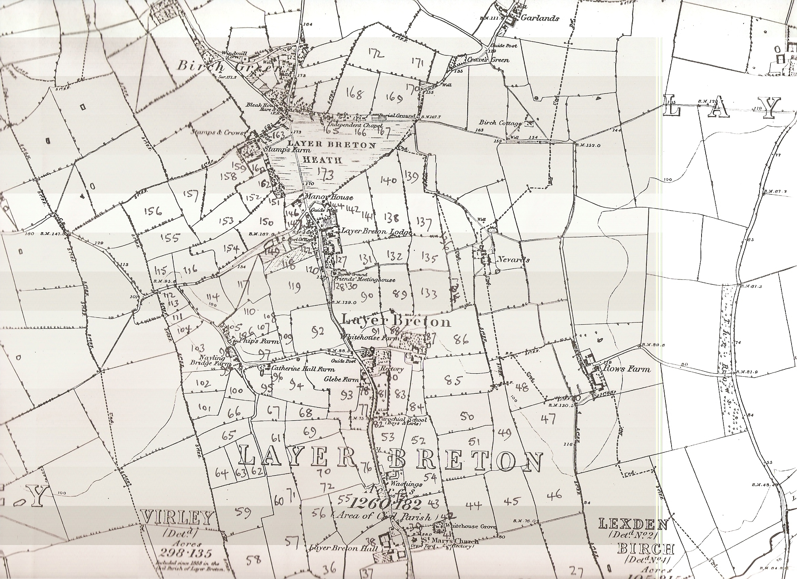
Map 1.
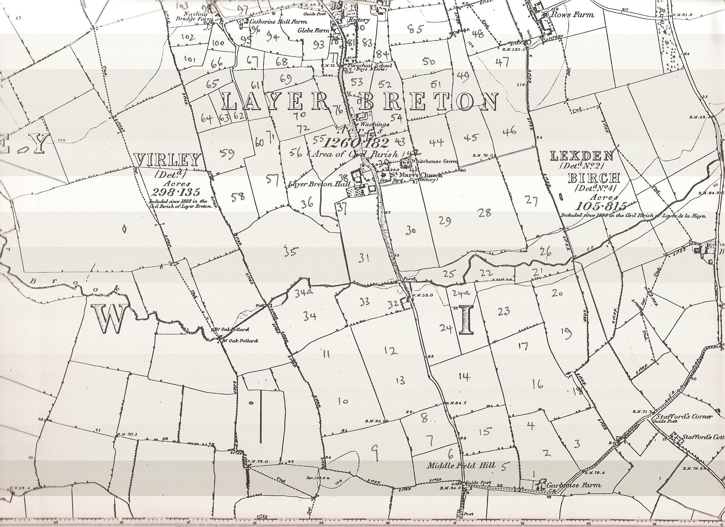
Map 2.

