THE PLACE-NAMES

OF LITTLE CHESTERFORD

Recorder: W.K. Kilford

Essex Place-names Project (Essex Society for Archaeology & History)

Essex Record Office e-book, 2010. (1st hard-copy edition 2001).

www.essex.ac.uk/history/esah/essexplacenames

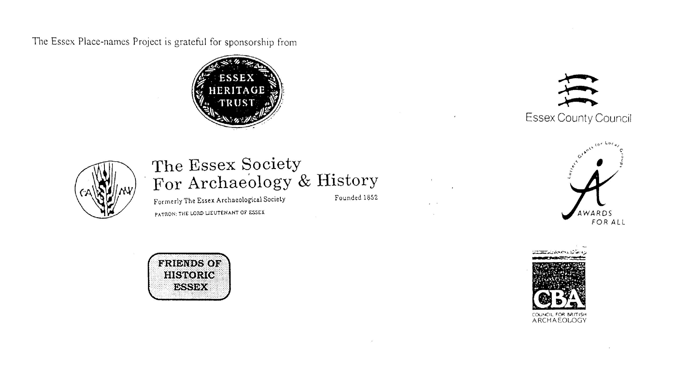

ESSEX PLACE-NAMES PROJECT.

The Essex Place-names Project is a County-wide survey to record place- and field-names from historical documents such as Tithe maps and apportionments, estate maps, sale and auction catalogues, conveyances, terriers, deeds, rolls, inquisitions and surveys.

The second element of the Project is to investigate on-the-ground visible remains which correspond to the Place-names for actual or potential archaeological, agricultural and industrial
sites, and to record natural (topographical) and man-made features which may relate to the Place-name. This involves field-survey in rural and outside investigation in built-up areas.

It is anticipated that the Project will lead to identification of archaeological sites and lost historic buildings; it will enable analysis of indicators of early settlement, land holding, agricultural and industrial practices of the County. It will refine the more precise meaning of descriptive words and elements used by earlier settlers as they gave names appropriate to the topography of the landscape of their time.

For convenience the surveys are based on the parish, recognising that present civil parish boundaries are not necessarily identical to former ecclesiastical boundaries. Local Recorders
are supplied with templates of Record Forms to ensure consistency of recording across the County, and forward completed forms to a Central Coordinator for transfer to a county
computer database which is available at the Essex Record Office to researchers.

This publication presents part of the information recorded from the Tithe or Estate Award and Map, (and from other documents for this parish.) The full record is contained on the master database in the Essex Record Office, Wharf Road, Chelmsford CM2 6YT and the website www.essex.ac.uk/history/esah/essexplacenames. Parish books are available from the ERO on disc or in hard copy or may be downloaded from the website. Please notify errors to the Project Coordinator at the Essex Record Office.

THE TITHE MAP AND APPORTIONMENT.

Since medieval times a tenth of the produce of land and stock had been paid by landholders to the church. At the Dissolution of the Monasteries, the property of many religious houses,
including the right to collect tithes, passed into lay hands. The Tithe Commutation Act which received Royal assent on 13th August 1836 abolished a rent payable in kind and
substituted rent-charges apportioned on each plot or parcel. The tithe-rent payable was assessed on the average value of wheat, barley and oats and was to fluctuate with price movements.

The commutation could be by voluntary agreement between the local owners and payers or, if agreement failed, could be compulsorily imposed by commissioners. A Valuer was to be
appointed to apportion the rent of each parcel of land and tenants could deduct that rent-charge from their rent paid to the landlord. The task fell to the Tithe Commissioners to produce a map and an Apportionment (Award). A large-scale survey was produced for over 70% of England and Wales in the following 9 years, and about another 8% up to 1855. Most of the
parishes in Essex were surveyed. The map scales vary. The Award records ownership, tenancy and land-use, field by field and parcel by parcel (often quoting the field name) with the
ground area and rent-charge.

Land that was tithe-free tends to be less accurately mapped and contains few if any of the details recorded for those parcels subject to tithe. Rights of way and roads also tend to be
neglected. Boundaries of the tithe areas are shown as are some natural features such as streams, ponds, gardens, greens and commons. Buildings are often shown coloured red if dwellings or grey if not. Because the Award may have been agreed only some time after the map was finished, discrepancies occur between the two. Enclosure Awards, when extant, usually date to the 18th and early 19th centuries. J.Kemble.
Reproduced by permission
of Essex County Council.

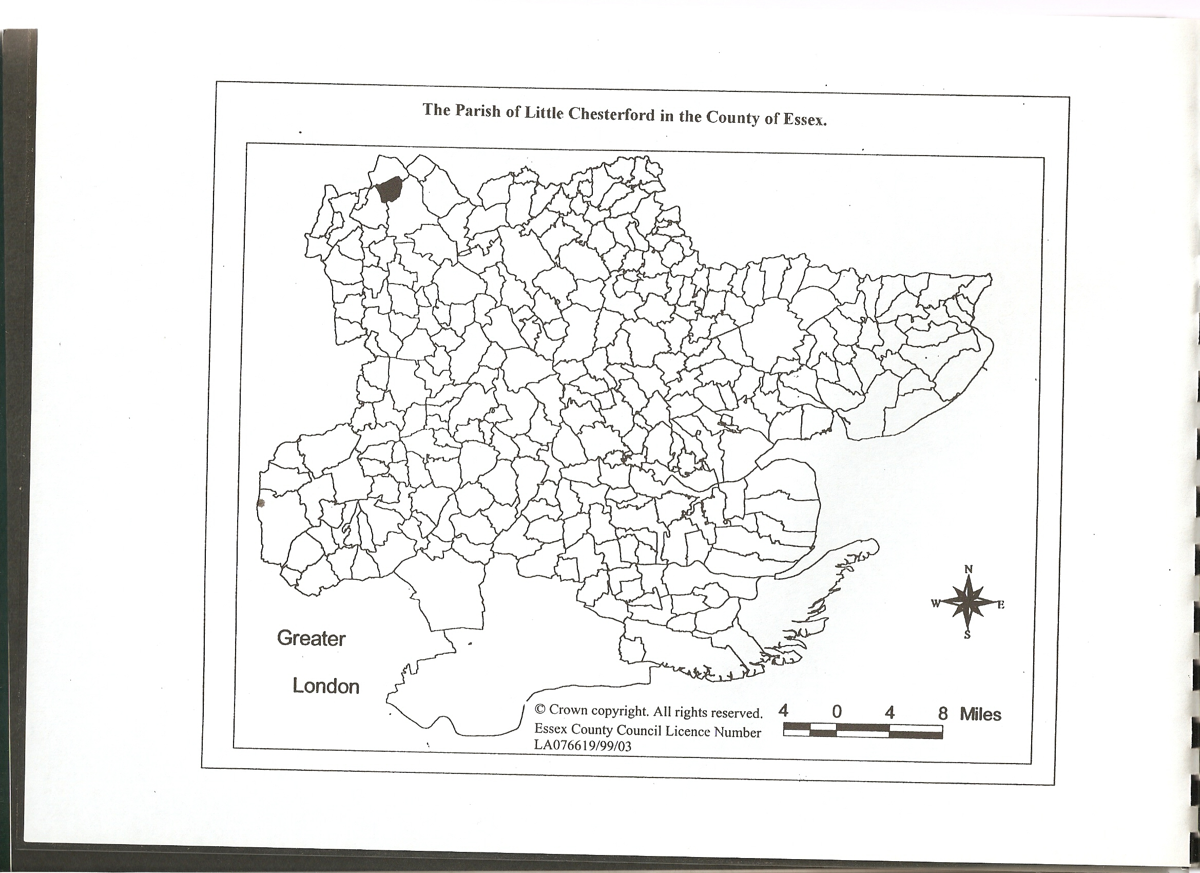

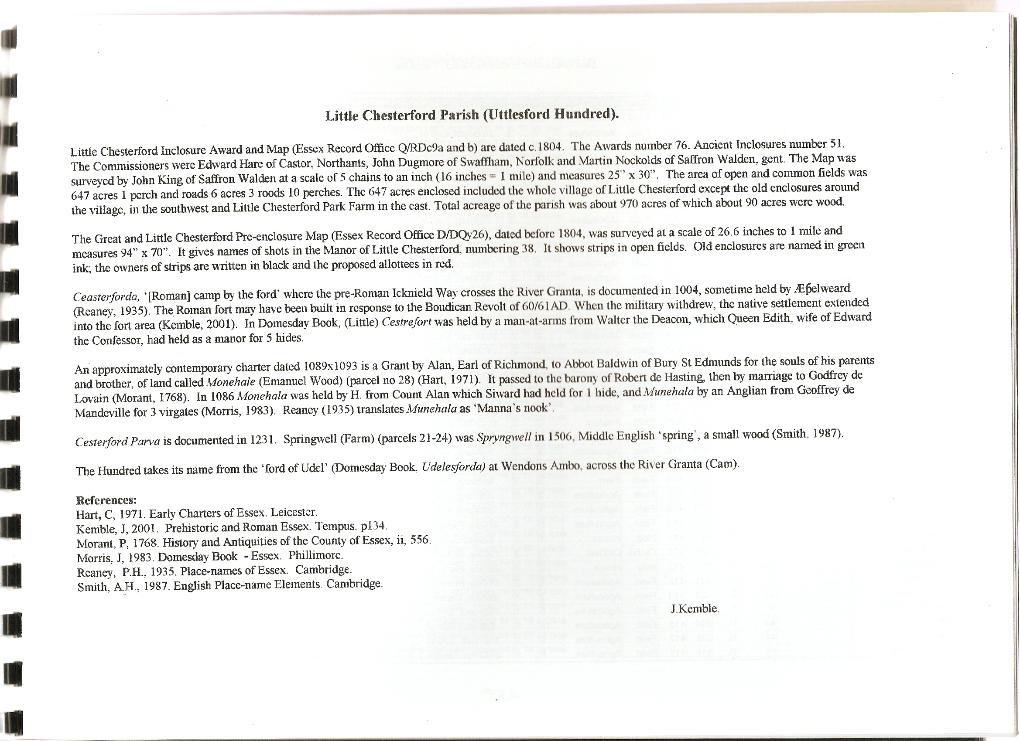

The Enclosure Award Place-names, c.1810, of Little Chesterford – by Parcel No.

Place-name | Alias | Fld No | Gd Ref | x | y | Acr | rd | pch | Land use | Owner | Name of farm | Any other information
Eke |  | 1 | TL | 529 | 428 | 25 | 2 | 21 | Arable | Bristol, Earl of | Home | Anciently inclosed before the 1801 Act. Items 14 to 18 as now.
Parkfield |  | 2 | TL | 529 | 423 | 9 | 3 | 18 | Agricult | Bristol, Earl of | Home | Anciently inclosed before the 1801 Act. Items 14 to 18 as now.
Woodfield |  | 3, 4 | TL | 532 | 422 | 10 | 2 | 11 | Agricult | Bristol, Earl of | Home | Anciently inclosed before the 1801 Act. Items 14 to 18 as now.
Foreside |  | 5 | TL | 532 | 424 | 10 | 1 | 12 | Agricult | Bristol, Earl of |  | Anciently inclosed before the 1801 Act. Items 14 to 18 as now.
North Hill |  | 6 | TL | 531 | 424 | 8 | 1 | 39 | Agricult | Bristol, Earl of | Home | Anciently inclosed before the 1801 Act. Items 14 to 18 as now.
Bush Springwell |  | 7 | TL | 534 | 425 | 15 | 1 | 29 | Agricult | Bristol, Earl of | Home | Anciently inclosed before the 1801 Act. Items 14 to 18 as now.
Bassingbourne Wood |  | 8 | TL | 534 | 427 | 9 | 0 | 15 | Wood | Bristol, Earl of | Home | Roger de Bassyngburne, 1285,Ass
Stockinglay |  | 9 | TL | 538 | 427 | 7 | 0 | 0 | Agricult | Bristol, Earl of | Home | Anciently inclosed before the 1801 Act. Items 14 to 18 as now.
No name given |  | 10 | TL | 537 | 426 | 7 | 3 | 20 | Agricult | Bristol, Earl of | Home | Anciently inclosed before the 1801 Act. Items 14 to 18 as now.
Further Stocking |  | 11 | TL | 538 | 426 | 6 | 3 | 30 | Agricult | Bristol, Earl of | Home | Anciently inclosed before the 1801 Act. Items 14 to 18 as now.
Hither Stocking |  | 12 | TL | 537 | 425 | 8 | 1 | 26 | Agricult | Bristol, Earl of | Home | Anciently inclosed before the 1801 Act. Items 14 to 18 as now.
No name given |  | 15 | TL | 535 | 474 | 3 | 2 | 4 | Agricult | Bristol, Earl of |  | Anciently inclosed before the 1801 Act. Items 14 to 18 as now.
Lt Chesterford Park, mess'ge, house, barns |  | 16 | TL | 534 | 422 | 2 | 2 | 37 | House | Bristol, Earl of |  | Anciently inclosed before the 1801 Act. Items 14 to 18 as now.
No name given |  | 17 | TL | 535 | 422 | 0 | 0 | 0 | Agricult | Bristol, Earl of |  | Anciently inclosed before the 1801 Act. Items 14 to 18 as now.
Little Lay |  | 18 | TL | 536 | 421 | 6 | 2 | 7 | Agricult | Bristol, Earl of | Home | Anciently inclosed before the 1801 Act. Items 14 to 18 as now.
Twenty Acre Ley |  | 21 | TL | 536 | 416 | 18 | 2 | 4 | Agricult | Griffin, Richard Aldworth (Lord Braybrooke) | Springwell | Anciently inclosed before the 1801 Act. Items 14 to 18 as now.
Ploughed Twenty Acre Lay |  | 22 | TL | 535 | 413 | 18 | 1 | 6 | Arable | Griffin, Richard Aldworth (Lord Braybrooke) | Springwell | Anciently inclosed before the 1801 Act. Items 14 to 18 as now.
No name given |  | 23 | TL | 534 | 411 | 1 | 2 | 24 | Agricult | Griffin, Richard Aldworth (Lord Braybrooke) | Springwell | Anciently inclosed before the 1801 Act. Items 14 to 18 as now.
Fox Burrows |  | 24 | TL | 531 | 411 | 86 | 3 | 7 | Agricult | Griffin, Richard Aldworth (LordBraybrooke) | Springwell | Anciently inclosed before the 1801 Act. Items 14 to 18 as now.
Four Acre Grove |  | 25 | TL | 530 | 414 | 4 | 2 | 39 | Wood | Bristol, Earl of | Rectory | Anciently inclosed before the 1801 Act. This woodland still known as Four Acre Grove. Items 14 to 18 as now.
Manhall Hill |  | 26 | TL | 530 | 416 | 21 | 2 | 24 | Agricult | Bristol, Earl of | Rectory | Anciently inclosed before the 1801 Act. Items 14 to 18 as now.
Oak Pasture |  | 13, 14 | TL | 537 | 423 | 22 | 1 | 10 | Agricult | Bristol, Earl of | Home | Anciently inclosed before the 1801 Act. Items 14 to 18 as now.
No name given |  | 27 | TL | 529 | 417 | 0 | 0 | 0 |  | Bristol, Earl of | Rectory | Anciently inclosed before the 1801 Act. Items 14 to 18 as now.
Manhall Wood [Munehala, 1086,DB] | Emanuel Wood, 1875,OS | 28 |  |  |  | 74 | 1 | 10 | Wood | Bristol, Earl of | Home | Anciently inclosed before the 1801 Act. Items 14 to 18 as now. The remnants of woodland known as Emanual Wood.
Long Eight Acres |  | 29 | TL | 528 | 418 | 8 | 2 | 15 | Agricult | Bristol, Earl of | Rectory | Anciently inclosed before the 1801 Act. Items 14 to 18 as now.
Fordingworth Mill Mead |  | 30 | TL | 519 | 406 | 3 | 0 | 11 | Pasture | Griffin, Richard Aldworth (LordBraybrooke) |  | Anciently inclosed before the 1801 Act. Items 14 to 18 as now.
No name given |  | 31 | TL | 517 | 408 | 6 | 0 | 25 | Agricult | Strong, William |  | Anciently inclosed before the 1801 Act. Items 14 to 18 as now.
Four Acre Mead |  | 32 | TL | 516 | 410 | 3 | 2 | 1 | Agricult | Strong, William |  | Anciently inclosed before the 1801 Act. Items 14 to 18 as now.
Walnut Tree Pasture |  | 33 | TL | 520 | 409 | 3 | 3 | 25 | Agricult | Strong, William | Springwell | Anciently inclosed before the 1801 Act. Items 14 to 18 as now.
Homestead | Spryngwell, 1506,Will | 34 | TL | 520 | 410 | 3 | 2 | 8 | Farm | Strong, William | Springwell | Anciently inclosed before the 1801 Act. Items 14 to 18 as now.
Old Moor |  | 35 | TL | 518 | 412 | 3 | 2 | 8 | Agricult | Strong, William |  | Anciently inclosed before the 1801 Act. Items 14 to 18 as now.
Old Orchard |  | 36 | TL | 519 | 412 | 1 | 1 | 0 | Agricult | Strong, William | Springwell | Anciently inclosed before the 1801 Act. Items 14 to 18 as now.
Crangles |  | 37 | TL | 517 | 413 | 0 | 3 | 37 | Agricult | Day, Richard | Bordeaux | Anciently inclosed before the 1801 Act. Items 14 to 18 as now.
No name given |  | 38 | TL | 521 | 411 | 1 | 0 | 8 | House | Kent, Daniel |  | Anciently inclosed before the 1801 Act. Items 14 to 18 as now.
Great Lay |  | 19, 20 | TL | 537 | 419 | 13 | 2 | 39 | Agricult | Bristol, Earl of | Home | Anciently inclosed before the 1801 Act. Items 14 to 18 as now.
The Orchard |  | 39 | TL | 520 | 411 | 0 | 3 | 13 | Orchard | Day, Richard |  | Anciently inclosed before the 1801 Act. Items 14 to 18 as now.
No name given |  | 39a | TL | 520 | 412 | 0 | 0 | 22 | House | Day, Richard |  | Anciently inclosed before the 1801 Act. Items 14 to 18 as now.
Home Close |  | 40 | TL | 521 | 412 | 2 | 2 | 24 | Agricult | Day, Richard |  | Anciently inclosed before the 1801 Act. Items 14 to 18 as now.
No name given |  | 41 | TL | 520 | 413 | 3 | 1 | 35 | Agricult | Kent, Daniel |  | Anciently inclosed before the 1801 Act. Items 14 to 18 as now.
Crows Hill Meadow |  | 42 | TL | 516 | 416 | 5 | 1 | 18 | Agricult | Bristol, Earl of | Bordeaux | Anciently inclosed before the 1801 Act. Items 14 to 18 as now.
Great Field |  | 43 | TL | 518 | 416 | 15 | 0 | 0 | Agricult | Bristol, Earl of | Bordeaux | Anciently inclosed before the 1801 Act. Items 14 to 18 as now.
Holley Croft |  | 44 | TL | 516 | 417 | 4 | 2 | 30 | Agricult | Bristol, Earl of | Bordeaux | Anciently inclosed before the 1801 Act. Items 14 to 18 as now.
Backside Close |  | 45 | TL | 518 | 417 | 8 | 0 | 39 | Agricult | Crisp, Joseph | Bordeaux | Anciently inclosed before the 1801 Act. Items 14 to 18 as now.
No name given |  | 46 | TL | 519 | 418 | 0 | 1 | 37 | House | Rider, Charles |  | Anciently inclosed before the 1801 Act. Items 14 to 18 as now.
No name given |  | 47 | TL | 518 | 418 | 0 | 1 | 33 | House | Searle, Thomas |  | Anciently inclosed before the 1801 Act. Items 14 to 18 as now.
No name given |  | 48 | TL | 517 | 418 | 0 | 1 | 26 | Agricult | Turnwell, Richard |  | Anciently inclosed before the 1801 Act. Items 14 to 18 as now.
No name given |  | 49 | TL | 517 | 417 | 0 | 2 | 10 | House | Crisp, Joseph |  | Anciently inclosed before the 1801 Act. Items 14 to 18 as now.
No name given |  | 50 | TL | 517 | 417 | 0 | 0 | 30 | House | Burrows, James |  | Anciently inclosed before the 1801 Act. Items 14 to 18 as now.
No name given |  | 50a | TL | 516 | 417 | 0 | 0 | 6 | House | Rider, Charles |  | Anciently inclosed before the 1801 Act. Items 14 to 18 as now.
No name given |  | 51 | TL | 516 | 417 | 0 | 0 | 22 | House | Welsh, Thomas |  | Anciently inclosed before the 1801 Act. Items 14 to 18 as now.
No name given |  | 52 | TL | 516 | 417 | 0 | 1 | 0 | House | Sheldrake, William |  | Anciently inclosed before the 1801 Act. Items 14 to 18 as now.
No name given |  | 53 | TL | 516 | 417 | 0 | 1 | 6 | House | Seaman, William |  | Anciently inclosed before the 1801 Act. Items 14 to 18 as now.
No name given |  | 54 | TL | 515 | 176 | 0 | 2 | 22 | House | Day, Richard |  | Sold to Charles Rider before 1810. Anciently inclosed before the 1801 Act. Items 14 to 18 as now.
No name given |  | 55 | TL | 515 | 418 | 1 | 2 | 15 | Farm | Bristol, Earl of |  | Anciently inclosed before the 1801 Act. Items 14 to 18 as now.
No name given |  | 56 | TL | 514 | 417 | 1 | 0 | 19 | Agricult | Bristol, Earl of |  | Anciently inclosed before the 1801 Act. Items 14 to 18 as now.
No name given |  | 57 | TL | 514 | 418 | 3 | 0 | 31 | Agricult | Bristol, Earl of |  | Anciently inclosed before the 1801 Act. Items 14 to 18 as now.
No name given |  | 58 | TL | 515 | 418 | 0 | 3 | 19 | Agricult | Marris, Allington |  | Anciently inclosed before the 1801 Act. Items 14 to 18 as now.
No name given |  | 59 | TL | 515 | 418 | 0 | 0 | 12 | House | Marris, Allington |  | Anciently inclosed before the 1801 Act. Items 14 to 18 as now.
No name given |  | 60 | TL | 515 | 418 | 0 | 0 | 35 | House | Strong, William |  | Anciently inclosed before the 1801 Act. Items 14 to 18 as now.
No name given |  | 61 | TL | 513 | 418 | 0 | 1 | 12 | House | King, James |  | Anciently inclosed before the 1801 Act. Items 14 to 18 as now.
Rectory House |  | 62 | TL | 515 | 418 | 0 | 3 | 32 | Farm | Macklin, Rev Wm |  | Anciently inclosed before the 1801 Act. Items 14 to 18 as now.
No name given |  | 63 | TL | 515 | 418 | 0 | 2 | 39 | Agricult | Strong, William |  | Anciently inclosed before the 1801 Act. Items 14 to 18 as now.
No name given |  | 64 | TL | 516 | 418 | 0 | 1 | 26 | House | Sheldrake, William |  | Anciently inclosed before the 1801 Act. Items 14 to 18 as now.
No name given |  | 65 | TL | 517 | 418 | 0 | 2 | 37 |  | Kent, John |  | Anciently inclosed before the 1801 Act. Items 14 to 18 as now.
No name given |  | 66 | TL | 517 | 418 | 0 | 1 | 5 | House | Kent, John |  | Anciently inclosed before the 1801 Act. Items 14 to 18 as now.
No name given |  | 67 | TL | 517 | 419 | 1 | 2 | 27 | House | Seaman, William |  | Anciently inclosed before the 1801 Act. Items 14 to 18 as now.
No name given |  | 68 | TL | 517 | 418 | 0 | 1 | 11 | House | Turnwell, Richard |  | Anciently inclosed before the 1801 Act. Items 14 to 18 as now.
No name given |  | 69 | TL | 518 | 418 | 0 | 1 | 11 | House | Rider, Shadrack |  | Anciently inclosed before the 1801 Act. Items 14 to 18 as now.
The Crown Public House |  | 70 | TL | 518 | 418 | 0 | 0 | 27 | House | King, James |  | Anciently inclosed before the 1801 Act. Items 14 to 18 as now.
The Crown Public House |  | 71 | TL | 518 | 420 | 0 | 2 | 36 | Agricult | King, James |  | Anciently inclosed before the 1801 Act. Items 14 to 18 as now.
No name given |  | 72 | TL | 517 | 419 | 0 | 3 | 9 | Agricult | Seaman, William |  | Anciently inclosed before the 1801 Act. Items 14 to 18 as now.
No name given |  | 73 | TL | 517 | 419 | 1 | 2 | 10 | Agricult | Turnwell, Richard |  | Anciently inclosed before the 1801 Act. Items 14 to 18 as now.
No name given |  | 74 | TL | 517 | 419 | 1 | 2 | 15 | Agricult | Kent, John |  | Anciently inclosed before the 1801 Act. Items 14 to 18 as now.
No name given |  | 75 | TL | 516 | 419 | 1 | 0 | 0 | Agricult | Marris, Allington |  | Anciently inclosed before the 1801 Act. Items 14 to 18 as now.
Shepherds Croft |  | 76 | TL | 515 | 419 | 1 | 1 | 31 | Agricult | Day, Richard | Bordeaux | Sold to Charles Rider before 1810. Anciently inclosed before the 1801 Act. Items 14 to 18 as now.
No name given |  | 78 | TL | 515 | 419 | 0 | 1 | 18 | House | Bristol, Earl of |  | Anciently inclosed before the 1801 Act. Items 14 to 18 as now.

For abbreviations see Reaney, P., Place-names of Essex, Cambridge 1935; and Kemble, J., Essex Place-names, Places, Streets & People, Historical Publications, London 2007.

The Enclosure Award Place-names, c.1810, of Little Chesterford – by Owner.

Place-name | Alias | Fld No | Gd Ref | x | y | Acr | rd | pch | Land use | Owner | Name of farm | Any other information
Eke |  | 1 | TL | 529 | 428 | 25 | 2 | 21 | Arable | Bristol, Earl of | Home | Anciently inclosed before the 1801 Act. Items 14 to 18 as now.
Parkfield |  | 2 | TL | 529 | 423 | 9 | 3 | 18 | Agricult | Bristol, Earl of | Home | Anciently inclosed before the 1801 Act. Items 14 to 18 as now.
Woodfield |  | 3, 4 | TL | 532 | 422 | 10 | 2 | 11 | Agricult | Bristol, Earl of | Home | Anciently inclosed before the 1801 Act. Items 14 to 18 as now.
Foreside |  | 5 | TL | 532 | 424 | 10 | 1 | 12 | Agricult | Bristol, Earl of |  | Anciently inclosed before the 1801 Act. Items 14 to 18 as now.
North Hill |  | 6 | TL | 531 | 424 | 8 | 1 | 39 | Agricult | Bristol, Earl of | Home | Anciently inclosed before the 1801 Act. Items 14 to 18 as now.
Bush Springwell |  | 7 | TL | 534 | 425 | 15 | 1 | 29 | Agricult | Bristol, Earl of | Home | Anciently inclosed before the 1801 Act. Items 14 to 18 as now.
Bassingbourne Wood |  | 8 | TL | 534 | 427 | 9 | 0 | 15 | Wood | Bristol, Earl of | Home | Roger de Bassyngburne, 1285,Ass
Stockinglay |  | 9 | TL | 538 | 427 | 7 | 0 | 0 | Agricult | Bristol, Earl of | Home | Anciently inclosed before the 1801 Act. Items 14 to 18 as now.
No name given |  | 10 | TL | 537 | 426 | 7 | 3 | 20 | Agricult | Bristol, Earl of | Home | Anciently inclosed before the 1801 Act. Items 14 to 18 as now.
Further Stocking |  | 11 | TL | 538 | 426 | 6 | 3 | 30 | Agricult | Bristol, Earl of | Home | Anciently inclosed before the 1801 Act. Items 14 to 18 as now.
Hither Stocking |  | 12 | TL | 537 | 425 | 8 | 1 | 26 | Agricult | Bristol, Earl of | Home | Anciently inclosed before the 1801 Act. Items 14 to 18 as now.
Oak Pasture |  | 13, 14 | TL | 537 | 423 | 22 | 1 | 10 | Agricult | Bristol, Earl of | Home | Anciently inclosed before the 1801 Act. Items 14 to 18 as now.
No name given |  | 15 | TL | 535 | 474 | 3 | 2 | 4 | Agricult | Bristol, Earl of |  | Anciently inclosed before the 1801 Act. Items 14 to 18 as now.
Lt Chesterford Park, mess'ge, house, barns |  | 16 | TL | 534 | 422 | 2 | 2 | 37 | House | Bristol, Earl of |  | Anciently inclosed before the 1801 Act. Items 14 to 18 as now.
No name given |  | 17 | TL | 535 | 422 | 0 | 0 | 0 | Agricult | Bristol, Earl of |  | Anciently inclosed before the 1801 Act. Items 14 to 18 as now.
Little Lay |  | 18 | TL | 536 | 421 | 6 | 2 | 7 | Agricult | Bristol, Earl of | Home | Anciently inclosed before the 1801 Act. Items 14 to 18 as now.
Great Lay |  | 19, 20 | TL | 537 | 419 | 13 | 2 | 39 | Agricult | Bristol, Earl of | Home | Anciently inclosed before the 1801 Act. Items 14 to 18 as now.
Four Acre Grove |  | 25 | TL | 530 | 414 | 4 | 2 | 39 | Wood | Bristol, Earl of | Rectory | Anciently inclosed before the 1801 Act. This woodland still known as Four Acre Grove. Items 14 to 18 as now.
Manhall Hill |  | 26 | TL | 530 | 416 | 21 | 2 | 24 | Agricult | Bristol, Earl of | Rectory | Anciently inclosed before the 1801 Act. Items 14 to 18 as now.
No name given |  | 27 | TL | 529 | 417 | 0 | 0 | 0 |  | Bristol, Earl of | Rectory | Anciently inclosed before the 1801 Act. Items 14 to 18 as now.
Manhall Wood [Munehala, 1086,DB] | Emanuel Wood, 1875,OS | 28 |  |  |  | 74 | 1 | 10 | Wood | Bristol, Earl of | Home | Anciently inclosed before the 1801 Act. Items 14 to 18 as now. The remnants of woodland known as Emanual Wood.
Long Eight Acres |  | 29 | TL | 528 | 418 | 8 | 2 | 15 | Agricult | Bristol, Earl of | Rectory | Anciently inclosed before the 1801 Act. Items 14 to 18 as now.
Crows Hill Meadow |  | 42 | TL | 516 | 416 | 5 | 1 | 18 | Agricult | Bristol, Earl of | Bordeaux | Anciently inclosed before the 1801 Act. Items 14 to 18 as now.
Great Field |  | 43 | TL | 518 | 416 | 15 | 0 | 0 | Agricult | Bristol, Earl of | Bordeaux | Anciently inclosed before the 1801 Act. Items 14 to 18 as now.
Holley Croft |  | 44 | TL | 516 | 417 | 4 | 2 | 30 | Agricult | Bristol, Earl of | Bordeaux | Anciently inclosed before the 1801 Act. Items 14 to 18 as now.
No name given |  | 55 | TL | 515 | 418 | 1 | 2 | 15 | Farm | Bristol, Earl of |  | Anciently inclosed before the 1801 Act. Items 14 to 18 as now.
No name given |  | 56 | TL | 514 | 417 | 1 | 0 | 19 | Agricult | Bristol, Earl of |  | Anciently inclosed before the 1801 Act. Items 14 to 18 as now.
No name given |  | 57 | TL | 514 | 418 | 3 | 0 | 31 | Agricult | Bristol, Earl of |  | Anciently inclosed before the 1801 Act. Items 14 to 18 as now.
No name given |  | 78 | TL | 515 | 419 | 0 | 1 | 18 | House | Bristol, Earl of |  | Anciently inclosed before the 1801 Act. Items 14 to 18 as now.
Rectory House |  | 62 | TL | 515 | 418 | 0 | 3 | 32 | Farm | Macklin, Rev Wm |  | Anciently inclosed before the 1801 Act. Items 14 to 18 as now.
Twenty Acre Ley |  | 21 | TL | 536 | 416 | 18 | 2 | 4 | Agricult | Griffin, Richard Aldworth (Lord Braybrooke) | Springwell | Anciently inclosed before the 1801 Act. Items 14 to 18 as now.
Ploughed Twenty Acre Lay |  | 22 | TL | 535 | 413 | 18 | 1 | 6 | Arable | Griffin, Richard Aldworth (Lord Braybrooke) | Springwell | Anciently inclosed before the 1801 Act. Items 14 to 18 as now.
No name given |  | 23 | TL | 534 | 411 | 1 | 2 | 24 | Agricult | Griffin, Richard Aldworth (Lord Braybrooke) | Springwell | Anciently inclosed before the 1801 Act. Items 14 to 18 as now.
Fox Burrows |  | 24 | TL | 531 | 411 | 86 | 3 | 7 | Agricult | Griffin, Richard Aldworth (LordBraybrooke) | Springwell | Anciently inclosed before the 1801 Act. Items 14 to 18 as now.
Fordingworth Mill Mead |  | 30 | TL | 519 | 406 | 3 | 0 | 11 | Pasture | Griffin, Richard Aldworth (LordBraybrooke) |  | Anciently inclosed before the 1801 Act. Items 14 to 18 as now.
No name given |  | 50 | TL | 517 | 417 | 0 | 0 | 30 | House | Burrows, James |  | Anciently inclosed before the 1801 Act. Items 14 to 18 as now.
No name given |  | 49 | TL | 517 | 417 | 0 | 2 | 10 | House | Crisp, Joseph |  | Anciently inclosed before the 1801 Act. Items 14 to 18 as now.
Backside Close |  | 45 | TL | 518 | 417 | 8 | 0 | 39 | Agricult | Crisp, Joseph | Bordeaux | Anciently inclosed before the 1801 Act. Items 14 to 18 as now.
Crangles |  | 37 | TL | 517 | 413 | 0 | 3 | 37 | Agricult | Day, Richard | Bordeaux | Anciently inclosed before the 1801 Act. Items 14 to 18 as now.
The Orchard |  | 39 | TL | 520 | 411 | 0 | 3 | 13 | Orchard | Day, Richard |  | Anciently inclosed before the 1801 Act. Items 14 to 18 as now.
Home Close |  | 40 | TL | 521 | 412 | 2 | 2 | 24 | Agricult | Day, Richard |  | Anciently inclosed before the 1801 Act. Items 14 to 18 as now.
No name given |  | 39a | TL | 520 | 412 | 0 | 0 | 22 | House | Day, Richard |  | Anciently inclosed before the 1801 Act. Items 14 to 18 as now.
Shepherds Croft |  | 76 | TL | 515 | 419 | 1 | 1 | 31 | Agricult | Day, Richard | Bordeaux | Sold to Charles Rider before 1810. Anciently inclosed before the 1801 Act. Items 14 to 18 as now.
No name given |  | 54 | TL | 515 | 176 | 0 | 2 | 22 | House | Day, Richard |  | Sold to Charles Rider before 1810. Anciently inclosed before the 1801 Act. Items 14 to 18 as now.
No name given |  | 65 | TL | 517 | 418 | 0 | 2 | 37 |  | Kent, John |  | Anciently inclosed before the 1801 Act. Items 14 to 18 as now.
No name given |  | 66 | TL | 517 | 418 | 0 | 1 | 5 | House | Kent, John |  | Anciently inclosed before the 1801 Act. Items 14 to 18 as now.
No name given |  | 74 | TL | 517 | 419 | 1 | 2 | 15 | Agricult | Kent, John |  | Anciently inclosed before the 1801 Act. Items 14 to 18 as now.
No name given |  | 38 | TL | 521 | 411 | 1 | 0 | 8 | House | Kent, Daniel |  | Anciently inclosed before the 1801 Act. Items 14 to 18 as now.
No name given |  | 41 | TL | 520 | 413 | 3 | 1 | 35 | Agricult | Kent, Daniel |  | Anciently inclosed before the 1801 Act. Items 14 to 18 as now.
No name given |  | 61 | TL | 513 | 418 | 0 | 1 | 12 | House | King, James |  | Anciently inclosed before the 1801 Act. Items 14 to 18 as now.
The Crown Public House |  | 70 | TL | 518 | 418 | 0 | 0 | 27 | House | King, James |  | Anciently inclosed before the 1801 Act. Items 14 to 18 as now.
The Crown Public House |  | 71 | TL | 518 | 420 | 0 | 2 | 36 | Agricult | King, James |  | Anciently inclosed before the 1801 Act. Items 14 to 18 as now.
No name given |  | 58 | TL | 515 | 418 | 0 | 3 | 19 | Agricult | Marris, Allington |  | Anciently inclosed before the 1801 Act. Items 14 to 18 as now.
No name given |  | 59 | TL | 515 | 418 | 0 | 0 | 12 | House | Marris, Allington |  | Anciently inclosed before the 1801 Act. Items 14 to 18 as now.
No name given |  | 75 | TL | 516 | 419 | 1 | 0 | 0 | Agricult | Marris, Allington |  | Anciently inclosed before the 1801 Act. Items 14 to 18 as now.
No name given |  | 46 | TL | 519 | 418 | 0 | 1 | 37 | House | Rider, Charles |  | Anciently inclosed before the 1801 Act. Items 14 to 18 as now.
No name given |  | 50a | TL | 516 | 417 | 0 | 0 | 6 | House | Rider, Charles |  | Anciently inclosed before the 1801 Act. Items 14 to 18 as now.
No name given |  | 69 | TL | 518 | 418 | 0 | 1 | 11 | House | Rider, Shadrack |  | Anciently inclosed before the 1801 Act. Items 14 to 18 as now.
No name given |  | 53 | TL | 516 | 417 | 0 | 1 | 6 | House | Seaman, William |  | Anciently inclosed before the 1801 Act. Items 14 to 18 as now.
No name given |  | 67 | TL | 517 | 419 | 1 | 2 | 27 | House | Seaman, William |  | Anciently inclosed before the 1801 Act. Items 14 to 18 as now.
No name given |  | 72 | TL | 517 | 419 | 0 | 3 | 9 | Agricult | Seaman, William |  | Anciently inclosed before the 1801 Act. Items 14 to 18 as now.
No name given |  | 52 | TL | 516 | 417 | 0 | 1 | 0 | House | Sheldrake, William |  | Anciently inclosed before the 1801 Act. Items 14 to 18 as now.
No name given |  | 64 | TL | 516 | 418 | 0 | 1 | 26 | House | Sheldrake, William |  | Anciently inclosed before the 1801 Act. Items 14 to 18 as now.
No name given |  | 47 | TL | 518 | 418 | 0 | 1 | 33 | House | Searle, Thomas |  | Anciently inclosed before the 1801 Act. Items 14 to 18 as now.
No name given |  | 31 | TL | 517 | 408 | 6 | 0 | 25 | Agricult | Strong, William |  | Anciently inclosed before the 1801 Act. Items 14 to 18 as now.
Four Acre Mead |  | 32 | TL | 516 | 410 | 3 | 2 | 1 | Agricult | Strong, William |  | Anciently inclosed before the 1801 Act. Items 14 to 18 as now.
Walnut Tree Pasture |  | 33 | TL | 520 | 409 | 3 | 3 | 25 | Agricult | Strong, William | Springwell | Anciently inclosed before the 1801 Act. Items 14 to 18 as now.
Homestead | Spryngwell, 1506,Will | 34 | TL | 520 | 410 | 3 | 2 | 8 | Farm | Strong, William | Springwell | Anciently inclosed before the 1801 Act. Items 14 to 18 as now.
Old Moor |  | 35 | TL | 518 | 412 | 3 | 2 | 8 | Agricult | Strong, William |  | Anciently inclosed before the 1801 Act. Items 14 to 18 as now.
Old Orchard |  | 36 | TL | 519 | 412 | 1 | 1 | 0 | Agricult | Strong, William | Springwell | Anciently inclosed before the 1801 Act. Items 14 to 18 as now.
No name given |  | 60 | TL | 515 | 418 | 0 | 0 | 35 | House | Strong, William |  | Anciently inclosed before the 1801 Act. Items 14 to 18 as now.
No name given |  | 63 | TL | 515 | 418 | 0 | 2 | 39 | Agricult | Strong, William |  | Anciently inclosed before the 1801 Act. Items 14 to 18 as now.
No name given |  | 48 | TL | 517 | 418 | 0 | 1 | 26 | Agricult | Turnwell, Richard |  | Anciently inclosed before the 1801 Act. Items 14 to 18 as now.
No name given |  | 68 | TL | 517 | 418 | 0 | 1 | 11 | House | Turnwell, Richard |  | Anciently inclosed before the 1801 Act. Items 14 to 18 as now.
No name given |  | 73 | TL | 517 | 419 | 1 | 2 | 10 | Agricult | Turnwell, Richard |  | Anciently inclosed before the 1801 Act. Items 14 to 18 as now.
No name given |  | 51 | TL | 516 | 417 | 0 | 0 | 22 | House | Welsh, Thomas |  | Anciently inclosed before the 1801 Act. Items 14 to 18 as now.

For abbreviations see Reaney, P., Place-names of Essex, Cambridge 1935; and Kemble, J., Essex Place-names, Places, Streets & People, Historical Publications, London 2007.

The Ancient Inclosure Place-names, c.1810, of Little Chesterford – by Owner.

Place-name | Alias | Fld No | Gd Ref | x | x |  | Acr | rd | pch | Land Use | Owner | Name of Farm | Other Information
Public stone, gravel and mortar pit |  | 0 | TL | 514 | 423 |  | 2 | 0 | 0 | pit | The Parish | Bordeaux | Pit lies in Millfield and includes access road.
No name given |  | 0 | TL | 518 | 423 | Field | 0 | 1 | 29 | Agricult | Bristol, Earl of | Bordeaux | Land lies in Millfield. Items 14 to 18 as now.
No name given |  | 0 | TL | 512 | 407 | Field | 0 | 0 | 24 | Agricult | Braybrooke, Lord | Springwell | Land lies in Springwell field. Items 14 to 18 as now.
No name given |  | 0 | TL | 518 | 422 | Field | 9 | 0 | 2 | Agricult | Macklin, William (rector) |  | Land lies in Mill field. Items 14 to 18 as now.
No name given |  | 0 | TL | 521 | 421 | Field | 25 | 1 | 6 | Agricult | Macklin, William (rector) | Rectory | Land lies in Great field. Items 14 to 18 as now.
No name given |  | 0 | TL | 525 | 425 | Field | 155 | 2 | 23 | Agricult | Macklin, William (rector) | Rectory | Land lies in Manhall field. Items 14 to 18 as now.
No name given |  | 0 | TL | 519 | 424 | Field | 11 | 3 | 29 | Agricult | Macklin, William (rector) | Rectory | Land lies in Great field. Items 14 to 18 as now.
No name given |  | 0 | TL | 523 | 421 | Field | 16 | 2 | 0 | Agricult | Macklin, William (rector) | Rectory | Land lies in Manhall field. Items 14 to 18 as now.
No name given |  | 0 | TL | 515 | 423 | Field | 53 | 1 | 28 | Agricult | Bristol, Earl of | Bordeaux | Land lies in Mill field. Items 14 to 18 as now.
No name given |  | 0 | TL | 521 | 427 | Field | 60 | 3 | 22 | Agricult | Bristol, Earl of | Rectory | Land lies in Burnham Bottom. Items 14 to 18 as now.
No name given |  | 0 | TL | 526 | 417 | Field | 52 | 1 | 20 | Agricult | Bristol, Earl of | Bordeaux | Land lies in Manhall Field. Items 14 to 18 as now.
No name given |  | 0 | TL | 516 | 412 | Field | 8 | 3 | 32 | Agricult | Bristol, Earl of | Bordeaux | Land lies in Common Meadows. Items 14 to 18 as now.
No name given |  | 0 | TL | 515 | 417 | Road | 0 | 0 | 28 | Rd | Bristol, Earl of |  | Items 14 to 18 as now.
No name given |  | 0 | TL | 518 | 426 | Field | 4 | 0 | 26 | Agricult | Bristol, Earl of | Rectory | Land lies in Barham Bottom. Items 14 to 18 as now.
No name given |  | 0 | TL | 517 | 426 | Field | 0 | 3 | 4 | Agricult | Bristol, Earl of | Rectory | Land lies in Barham Bottom. Items 14 to 18 as now.
No name given |  | 0 | TL | 520 | 407 | Field | 1 | 1 | 16 | Agricult | Braybrooke, Richard | Springwell | Land lies in Springwell field. Items 14 to 18 as now.
No name given |  | 0 | TL | 522 | 407 | Field | 6 | 0 | 39 | Agricult | Braybrooke, Richard | Springwell | Land lies in Springwell field. Items 14 to 18 as now.
No name given |  | 0 | TL | 519 | 420 | Field | 0 | 0 | 34 | Agricult | Burrows, James |  | Land lies in the Nook in Millfield. Items 14 to 18asnow.
No name given |  | 0 | TL | 522 | 414 | Field | 21 | 3 | 34 | Agricult | Crisp, Joseph | Bordeaux | Land lies in Springwell & Manhall fields.14 to18asnow
No name given |  | 0 | TL | 521 | 425 | Field | 9 | 0 | 39 | Agricult | Crisp, Joseph | Bordeaux | Land lies in Manhall field. Items 14 to 18 as now.
The Pightle |  | 0 | TL | 515 | 419 | Field | 0 | 1 | 10 | Agricult | Crisp, Joseph |  | Items 14 to 18 as now.
No name given |  | 0 | TL | 519 | 413 | Field | 10 | 1 | 19 | Agricult | Day, Richard | Bordeaux | Land lies in Little field. Items 14 to 18 as now.
No name given |  | 0 | TL | 519 | 415 | Field | 1 | 2 | 5 | Agricult | Day, Richard | Bordeaux | Land lies in Little field. Items 14 to 18 as now.
No name given |  | 0 | TL | 526 | 413 | Field | 32 | 2 | 19 | Agricult | Day, Richard | Bordeaux | Land lies in Springwell field. Items 14 to 18 as now.
No name given |  | 0 | TL | 520 | 412 | Field | 0 | 1 | 14 | Agricult | Day, Richard | Bordeaux | Land lies in Little fileld and is copyhold of the manor of Brooke Walden. Items 14 to 18 as now.
No name given |  | 0 | TL | 520 | 412 | Field | 0 | 1 | 22 |  | Gibson, Atkinson Francis |  | Land lies in Burton Close in Springwell field. Items 14 to 18 as now.
No name given |  | 0 | TL | 524 | 418 | Field | 12 | 2 | 30 | Agricult | Kent, John | Rectory | Land lies in Manhall field. Items 14 to 18 as now.
No name given |  | 0 | TL | 524 | 412 | Field | 8 | 2 | 20 | Agricult | Kent, David | Bordeaux | Land lies in Springwell field. Items 14 to 18 as now.
No name given |  | 0 | TL | 522 | 412 | Field | 0 | 3 | 22 | Agricult | Kent, David | Bordeaux | Land lies in Springwell field and is copyhold of the manor of Brook Walden. Items 14 to 18 as now.
No name given |  | 0 | TL | 528 | 417 | Field | 9 | 2 | 36 | Agricult | King, James | Bordeaux | Land lies in Manhall field. Items 14 to 18 as now.
No name given |  | 0 | TL | 519 | 419 |  | 0 | 0 | 7 |  | King, James |  | Land lies in The Nook in Millfield. Items 14 to 18asnow
No name given |  | 0 | TL | 519 | 418 | Field | 0 | 3 | 6 | Agricult | Marris, Allington | Bordeaux | Land lies in Manhall field. Items 14 to 18 as now.
No name given |  | 0 | TL | 520 | 418 | Field | 8 | 1 | 14 | Agricult | Marris, Allington | Bordeaux | Land lies in Manhall field. Items 14 to 18 as now.
No name given |  | 0 | TL | 519 | 419 | Field | 0 | 0 | 26 | Agricult | Rider, Charles |  | Land lies in The Nook in Millfield. Items 14 to 18asnow
No name given |  | 0 | TL | 519 | 419 | Field | 0 | 0 | 26 | Agricult | Rider, Charles |  | Land lies in The Nook in Millfield. Items 14 to 18asnow
No name given |  | 0 | TL | 519 | 419 | Field | 0 | 0 | 30 | Agricult | Rider, Sarah |  | Land lies in The Nook in Millfield. Items 14 to 18asnow
No name given |  | 0 | TL | 517 | 419 | Field | 0 | 3 | 13 | Agricult | Seaman, William and Mary |  | Land lies in Millfield. Items 14 to 18 as now.
No name given |  | 0 | TL | 518 | 421 | Field | 0 | 2 | 29 | Agricult | Seaman, William & Mary |  | Land lies in Millfield. Items 14 to 18 as now.
No name given |  | 0 | TL | 519 | 419 | Field | 0 | 0 | 27 | Agricult | Searle, Thomas |  | Land lies in The Nook in Millfield. Items 14 to 18asnow
No name given |  | 0 | TL | 518 | 420 | Field | 0 | 2 | 16 | Agricult | Sheldrake, Sarah |  | Land lies in The Nook in Millfield. Items 14 to 18asnow
No name given |  | 0 | TL | 518 | 420 | Field | 1 | 2 | 10 | Agricult | Sheldrake, Sarah |  | Land lies in The Nook in Millfield. Items 14 to 18asnow
No name given |  | 0 | TL | 525 | 408 | Field | 75 | 1 | 38 | Agricult | Strong, William | Springwell | Land lies in Springwell field. Items 14 to 18 as now.
No name given |  | 0 | TL | 518 | 410 | Field | 4 | 1 | 11 | Agricult | Strong, William |  | Land lies in common meadow. Items 14 to 18 as now.
No name given |  | 0 | TL | 520 | 411 | Field | 0 | 1 | 38 | Agricult | Strong, William |  | Land lies on green at Springwell. Items 14 to 18 as now.
No name given |  | 0 | TL | 519 | 408 | Field | 0 | 2 | 36 | Agricult | Strong, William | Springwell | Land lies in Millhurst. Items 14 to 18 as now.
No name given |  | 0 | TL | 520 | 408 | Field | 4 | 0 | 27 | Agricult | Strong, William | Springwell | Land lies in Millhurst and is copyhold of the Manor of Brooke Walden. Items 14 to 18 as now.
No name given |  | 0 | TL | 523 | 408 | Field | 11 | 1 | 35 | Agricult | Strong, William | Springwell | Land lies in Springwell field. Items 14 to 18 as now.
No name given |  | 0 | TL | 521 | 427 | Field | 10 | 1 | 8 | Agricult | Turnwell, Richard | Bordeaux | Land lies in Manhall field. Items 14 to 18 as now.
No name given |  | 0 | TL | 517 | 427 | Field | 5 | 0 | 14 | Agricult | Trustees of the poor | Rectory | Land lies in Barnham Bottom. Items 14 to 18 as now.
No name given |  | 0 | TL | 519 | 419 | Field | 0 | 0 | 35 | Agricult | Welsh, Thomas |  | Land lies in The Nook in Millfield. Items 14 to 18asnow
No name given |  | 0 | TL | 520 | 413 | Field | 0 | 1 | 22 | Agricult | Wright, George |  | Land lies in Burton Close in Springwell field in the copyhold of the manor of Brooke walden.14 to 18asnow

The Pre-Enclosure Shot Place-names, ante 1804, of Little Chesterford – by Parcel No.

Place-name | Alias | No | Gd | x | y | Use | Owner | Occupier 1 | Occupier 2 | Farm | Other Information
Claybread Shot |  | 1 | TL | 515 | 425 | Agricult | Lt Chesterford Manor | Marris; Day | Kent, John | Bordeaux | Shot lies in Millfield. Items 14 to 18 as now. Item 5 No. Roman equivalent appears on map.
Twelve Acre Shot |  | 2 | TL | 517 | 423 | Agricult | Lt Chesterford Manor | Pettit | Marris; Day | Bordeaux | Shot lies in Millfield. Items 14 to 18 as now. Item 5 No. Roman equivalent appears on map.
Charley Shot |  | 3 | TL | 515 | 422 | Agricult | Lt Chesterford Manor | Day; Marris | Kent, John | Bordeaux | Shot lies in Millfield. Items 14 to 18 as now. Item 5 No. Roman equivalent appears on map.
The Nook |  | 4 | TL | 518 | 420 | Agricult | Lt Chesterford Manor | Crisp | King; Marris |  | Shot lies in Millfield. Items 14 to 18 as now. Item 5 No. Roman equivalent appears on map.
Barram Bottom Shot |  | 5 | TL | 518 | 427 | Agricult | Lt Chesterford Manor | Pettit | Crisp; Marris | Rectory | Shot lies in Greatfield. Items 14 to 18 as now. Item 5 No. Roman equivalent appears on map.
Rynish Shot |  | 6 | TL | 524 | 427 | Agricult | Lt Chesterford Manor | Gardiner | Marris;Pettit | Rectory | Shot lies in Greatfield. Items 14 to 18 as now. Item 5 No. Roman equivalent appears on map.
Caterpillar Shot |  | 7 | TL | 524 | 429 | Agricult | Lt Chesterford Manor | Marris | Turnwell, King | Rectory | Shot lies in Greatfield. Items 14 to 18 as now. Item 5 No. Roman equivalent appears on map.
Wheel Shot |  | 8 | TL | 526 | 430 | Agricult | Lt Chesterford Manor | Crisp | Pettit; Glebe | Rectory | Shot lies in Greatfield. Items 14 to 18 as now. Item 5 No. Roman equivalent appears on map.
No name given |  | 9 | TL | 528 | 431 | Agricult | Lt Chesterford Manor | Day |  | Rectory | Shot lies in Great field. Items 14 to 18 as now. Item 5 No. Roman equivalent appears on map.
Honey Hill Shot |  | 10 | TL | 528 | 428 | Agricult | Lt Chesterford Manor | Turnwell | Crisp; Day | Rectory | Shot lies in Great field. Items 14 to 18 as now. Item 5 No. Roman equivalent appears on map.
No name given |  | 11 | TL | 526 | 427 | Agricult | Lt Chesterford Manor | Turnwell | Crisp; Gardiner | Rectory | Shot lies in Great field. Items 14 to 18 as now. Item 5 No. Roman equivalent appears on map.
Polds Shot |  | 12 | TL | 524 | 423 | Agricult | Lt Chesterford Manor | Glebe | Day; King | Rectory | Shot lies in Great field. Items 14 to 18 as now. Item 5 No. Roman equivalent appears on map.
Deep Bank Shot |  | 13 | TL | 529 | 426 | Agricult | Lt Chesterford Manor | Crisp | Pettit; Simmonds | Rectory | Shot lies in Great field. Items 14 to 18 as now. Item 5 No. Roman equivalent appears on map.
Slade Shot |  | 14 | TL | 529 | 426 | Agricult | Lt Chesterford Manor | Day; Simmonds | Sheldrake; Simmons | Rectory | Shot lies in Great field. Items 14 to 18 as now. Item 5 No. Roman equivalent appears on map.
Balls Folley Shot |  | 15 | TL | 522 | 423 | Agricult | Lt Chesterford Manor | Turnwell | Day; Pettit | Rectory | Shot lies in Great field. Items 14 to 18 as now. Item 5 No. Roman equivalent appears on map.
No name given |  | 16 | TL | 520 | 422 | Agricult | Lt Chesterford Manor | Day; Crisp | Turnwell | Rectory | Shot lies in Great field. Items 14 to 18 as now. Item 5 No. Roman equivalent appears on map.
Poplar Mere Shot |  | 17 | TL | 522 | 421 | Agricult | Lt Chesterford Manor | Day; Pettit | Crisp | Rectory | Shot lies in Great field. Items 14 to 18 as now. Item 5 No. Roman equivalent appears on map.
Tare Close Shot |  | 18 | TL | 523 | 420 | Agricult | Lt Chesterford Manor | Gardiner | Pettit; Day | Rectory | Shot lies in Great field. Items 14 to 18 as now. Item 5 No. Roman equivalent appears on map.
Park Lane Shot |  | 19 | TL | 522 | 420 | Agricult | Lt Chesterford Manor | Simmons | Turnwell; Day | Rectory | Shot lies in Great field. Items 14 to 18 as now. Item 5 No. Roman equivalent appears on map.
Road Shot |  | 20 | TL | 520 | 417 | Agricult | Lt Chesterford Manor | Pettit; King | Turnwell | Bordeaux | Shot lies in Manhall field. Items 14 to 18 as now. Item 5 No. Roman equivalent on map.
Frank Hales Acre Shot |  | 21 | TL | 522 | 418 | Agricult | Lt Chesterford Manor | Sheldrake | Pettit; Simmonds | Bordeaux | Shot lies in Manhall field. Items 14 to 18 as now. Item 5 No. Roman equivalent on map.
Chalk Pit Shot |  | 22 | TL | 523 | 419 | Agricult | Lt Chesterford Manor | Marris | Day; Pettit | Rectory | Shot lies in Manhall field. Items 14 to 18 as now. Item 5 No. Roman equivalent on map.
Tobacco Acre Shot |  | 23 | TL | 525 | 420 | Agricult | Lt Chesterford Manor | Pettit | Crisp; Day | Rectory | Shot lies in Manhall field. Items 14 to 18 as now. Item 5 No. Roman equivalent on map.
Punch Bowl Shot |  | 24 | TL | 526 | 417 | Agricult | Lt Chesterford Manor |  |  | Rectory | Shot lies in Manhall field. Items 14 to 18 as now. Item 5 No. Roman equivalent on map.
Charlock Balk Shot |  | 25 | TL | 523 | 415 | Agricult | Lt Chesterford Manor | Marris | Day; Kent | Bordeaux | Shot lies in Manhall field. Items 14 to 18 as now. Item 5 No. Roman equivalent on map.
Little Field |  | 26 | TL | 519 | 412 | Agricult | Lt Chesterford Manor | Pettit | Kent | Bordeaux | Shot lies in Manhall field. Items 14 to 18 as now. Item 5 No. Roman equivalent on map.
Backside Shot |  | 27 | TL | 521 | 413 | Agricult | Lt Chesterford Manor | Kent, D | Pettit; Crisp | Bordeaux | Shot lies in Manhall field. Items 14 to 18 as now. Item 5 No. Roman equivalent on map.
Upper Nine Acre Shot |  | 28 | TL | 523 | 415 | Agricult | Lt Chesterford Manor | Marris | Pettit, Crisp | Bordeaux | Shot lies in Manhall field. Items 14 to 18 as now. Item 5 No. Roman equivalent on map.
Charlock Balk Shot |  | 29 | TL | 526 | 413 | Agricult | Lt Chesterford Manor | Pettit | Crisp; Kent, D | Rectory | Shot lies in Manhall field. Items 14 to 18 as now. Item 5 No. Roman equivalent on map.
Manhall Hill Shot | Monehale, c.1090, Charter | 30 | TL | 528 | 415 | Agricult | Lt Chesterford Manor | Pettit; Day | Kent, D |  | Shot lies in Manhall field. Items 14 to 18 as now. Item 5 No. Roman equivalent on map.
Fox Burrow Shot |  | 31 | TL | 527 | 412 | Agricult | Lt Chesterford Manor | Pettit | Day; Crisp | Bordeaux | Shot lies in Manhall field. Items 14 to 18 as now. Item 5 No. Roman equivalent on map.
Fox Burrow Shot |  | 32 | TL | 525 | 412 | Agricult | Lt Chesterford Manor | Pettit | Kent, D; Crisp | Bordeaux | Shot lies in Manhall field. Items 14 to 18 as now. Item 5 No. Roman equivalent on map.
Sparrock High Way Shot |  | 33 | TL | 525 | 410 | Agricult | Lt Chesterford Manor | Day | Pettit; Kent,D | Springwell | Shot lies in Springwell field. Items 14 to 18 as now. Item 5 No. Roman equivalent on map.
Old Acre Shot |  | 34 | TL | 529 | 409 | Agricult | Lt Chesterford Manor | Day | Pettit; Kent,D | Springwell | Shot lies in Springwell field. Items 14 to 18 as now. Item 5 No. Roman equivalent on map.
No name given |  | 35 | TL | 526 | 408 | Agricult | Lt Chesterford Manor | Pettit; King | Kent, D | Springwell | Shot lies in Springwell field. Items 14 to 18 as now. Item 5 No. Roman equivalent on map.
Half Acre Lane Shot - Headlands |  | 36 | TL | 523 | 409 | Agricult | Lt Chesterford Manor | Pettit | Day | Springwell | Shot lies in Springwell field. Items 14 to 18 as now. Item 5 No. Roman equivalent on map.
Half Acre Lane Shot |  | 37 | TL | 523 | 408 | Agricult | Lt Chesterford Manor | Kent, D |  | Springwell | Shot lies in Springwell field. Items 14 to 18 as now. Item 5 No. Roman equivalent on map.
Cartshed Shot |  | 38 | TL | 522 | 409 | Agricult | Lt Chesterford Manor | Kent, D | Pettit; Day | Springwell | Shot lies in Springwell field. 14 to 18 as now.


