THE PLACE-NAMES

OF LITTLE (and Great) HENNY

Recorder: James Kemble

Essex Place-names Project (Essex Society for Archaeology & History)

Essex Record Office e-book, 2010. (1st hard-copy edition 2003).

www.essex.ac.uk/history/esah/essexplacenames

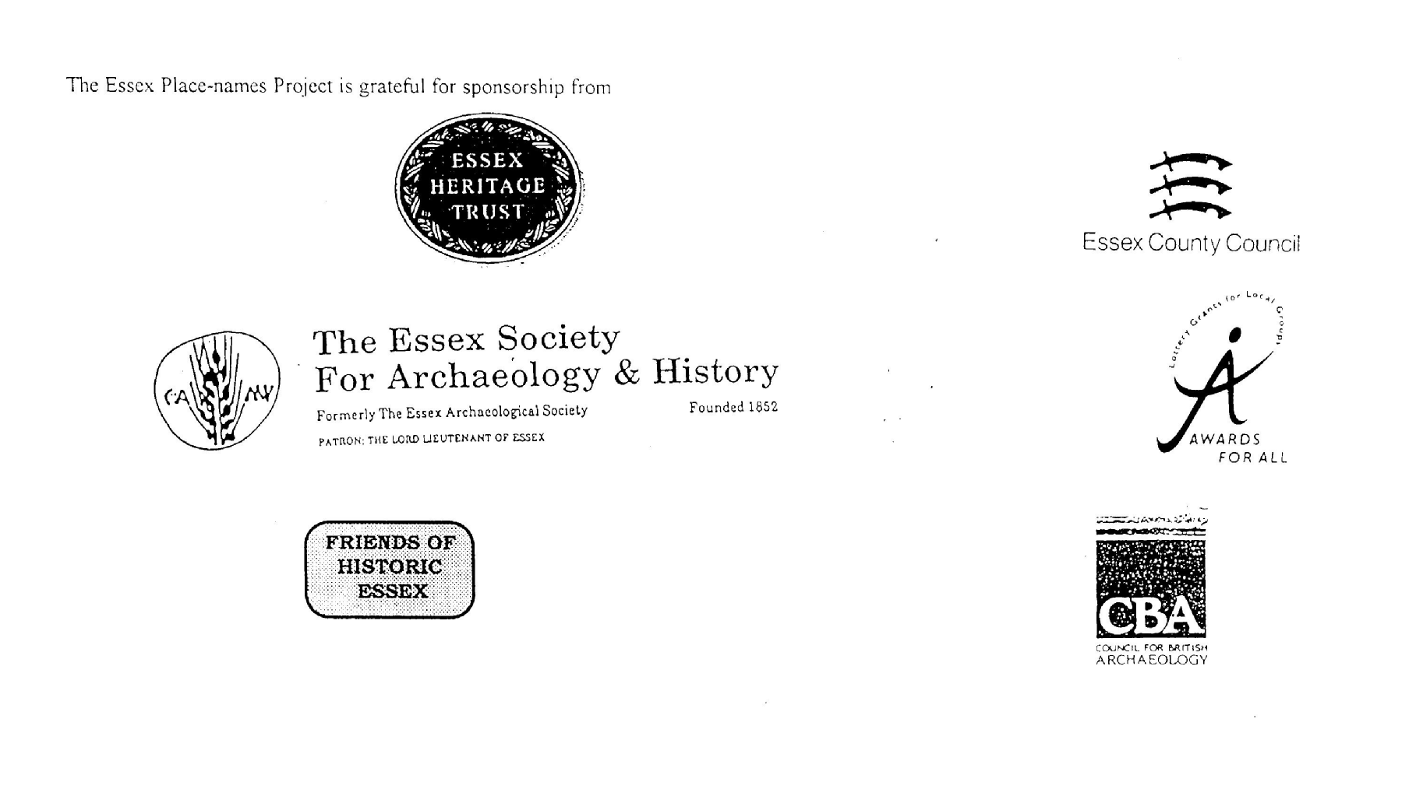

ESSEX PLACE-NAMES PROJECT.

The Essex Place-names Project is a County-wide survey to record place- and field-names from historical documents such as Tithe maps and apportionments, estate maps, sale and auction catalogues, conveyances, terriers, deeds, rolls, inquisitions and surveys.

The second element of the Project is to investigate on-the-ground visible remains which correspond to the Place-names for actual or potential archaeological, agricultural and industrial
sites, and to record natural (topographical) and man-made features which may relate to the Place-name. This involves field-survey in rural and outside investigation in built-up areas.

It is anticipated that the Project will lead to identification of archaeological sites and lost historic buildings; it will enable analysis of indicators of early settlement, land holding, agricultural and industrial practices of the County. It will refine the more precise meaning of descriptive words and elements used by earlier settlers as they gave names appropriate to the topography of the landscape of their time.

For convenience the surveys are based on the parish, recognising that present civil parish boundaries are not necessarily identical to former ecclesiastical boundaries. Local Recorders
are supplied with templates of Record Forms to ensure consistency of recording across the County, and forward completed forms to a Central Coordinator for transfer to a county
computer database which is available at the Essex Record Office to researchers.

This publication presents part of the information recorded from the Tithe or Estate Award and Map, (and from other documents for this parish.) The full record is contained on the master database in the Essex Record Office, Wharf Road, Chelmsford CM2 6YT and the website www.essex.ac.uk/history/esah/essexplacenames. Parish books are available from the ERO on disc or in hard copy or may be downloaded from the website. Please notify errors to the Project Coordinator at the Essex Record Office.

THE TITHE MAP AND APPORTIONMENT.

Since medieval times a tenth of the produce of land and stock had been paid by landholders to the church. At the Dissolution of the Monasteries, the property of many religious houses,
including the right to collect tithes, passed into lay hands. The Tithe Commutation Act which received Royal assent on 13th August 1836 abolished a rent payable in kind and
substituted rent-charges apportioned on each plot or parcel. The tithe-rent payable was assessed on the average value of wheat, barley and oats and was to fluctuate with price movements.

The commutation could be by voluntary agreement between the local owners and payers or, if agreement failed, could be compulsorily imposed by commissioners. A Valuer was to be
appointed to apportion the rent of each parcel of land and tenants could deduct that rent-charge from their rent paid to the landlord. The task fell to the Tithe Commissioners to produce a map and an Apportionment (Award). A large-scale survey was produced for over 70% of England and Wales in the following 9 years, and about another 8% up to 1855. Most of the
parishes in Essex were surveyed. The map scales vary. The Award records ownership, tenancy and land-use, field by field and parcel by parcel (often quoting the field name) with the
ground area and rent-charge.

Land that was tithe-free tends to be less accurately mapped and contains few if any of the details recorded for those parcels subject to tithe. Rights of way and roads also tend to be
neglected. Boundaries of the tithe areas are shown as are some natural features such as streams, ponds, gardens, greens and commons. Buildings are often shown coloured red if dwellings or grey if not. Because the Award may have been agreed only some time after the map was finished, discrepancies occur between the two. Enclosure Awards, when extant, usually date to the 18th and early 19th centuries. J.Kemble.
Reproduced by permission
of Essex County Council.

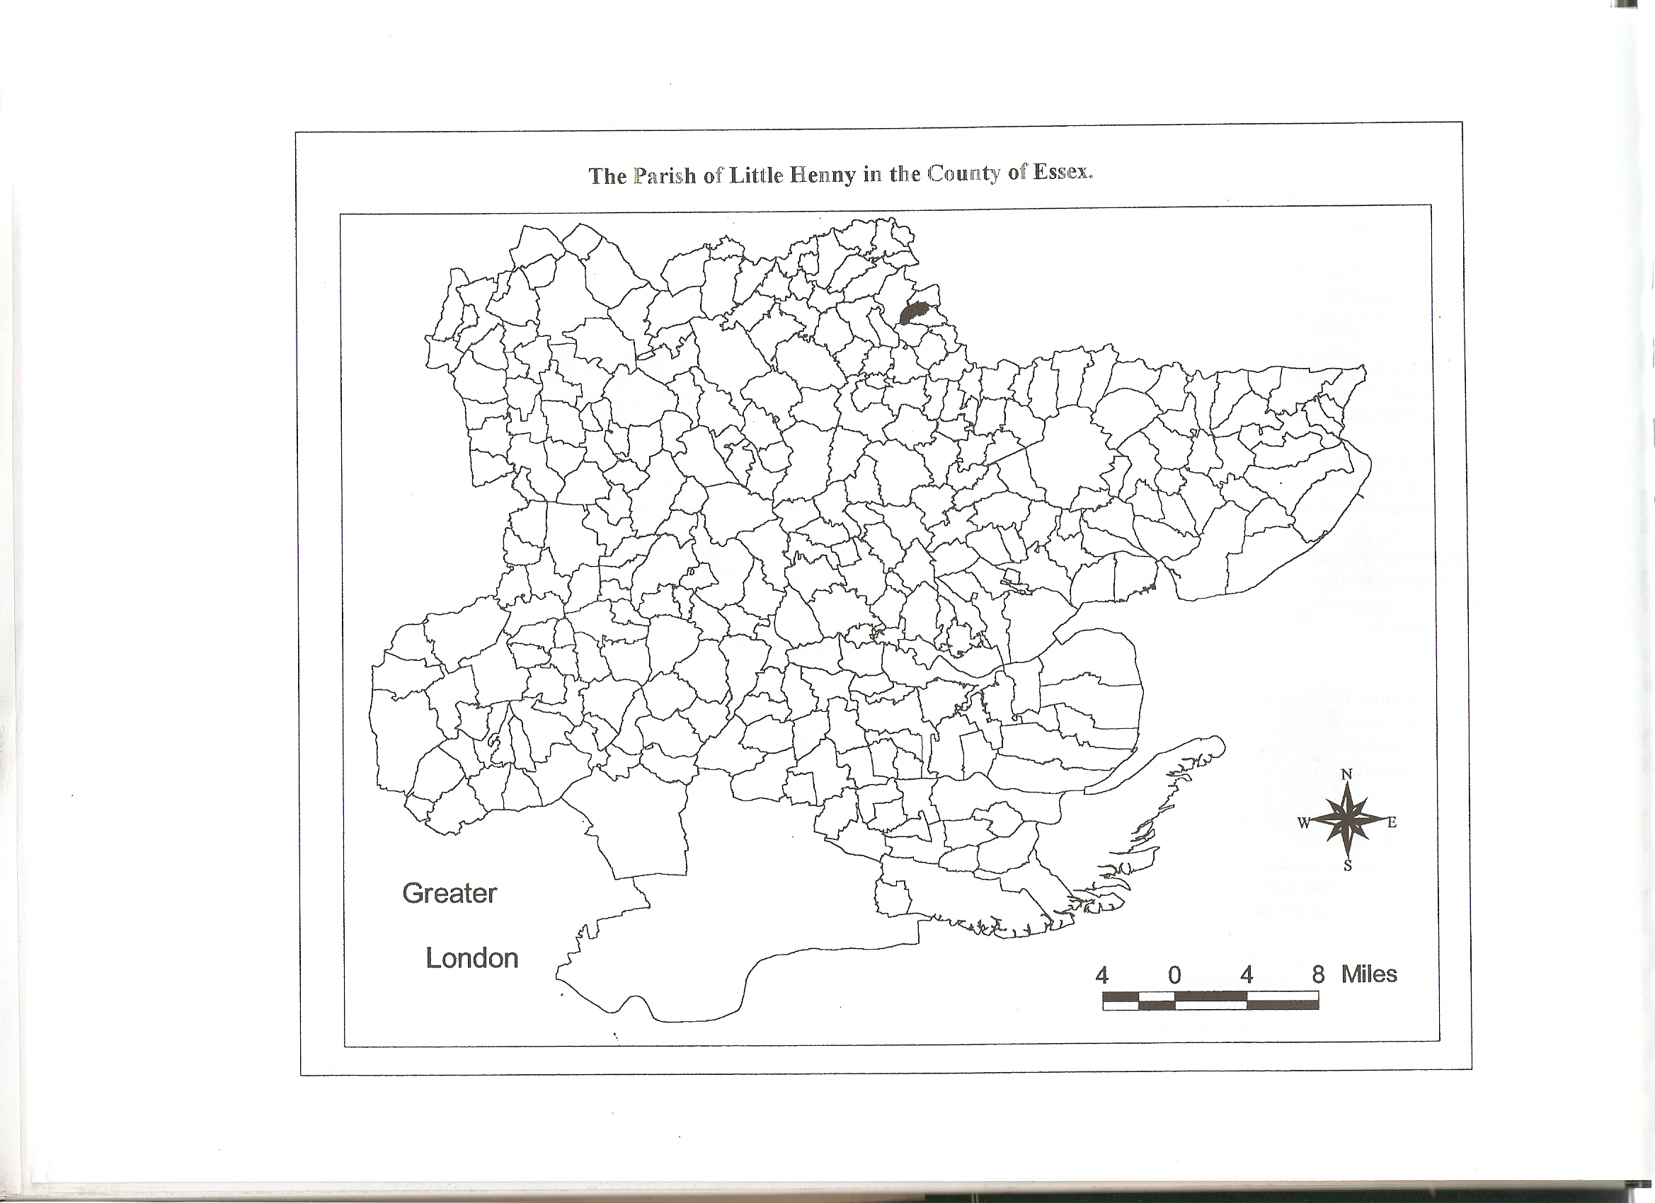
Reproduced by permission of Essex County Council.
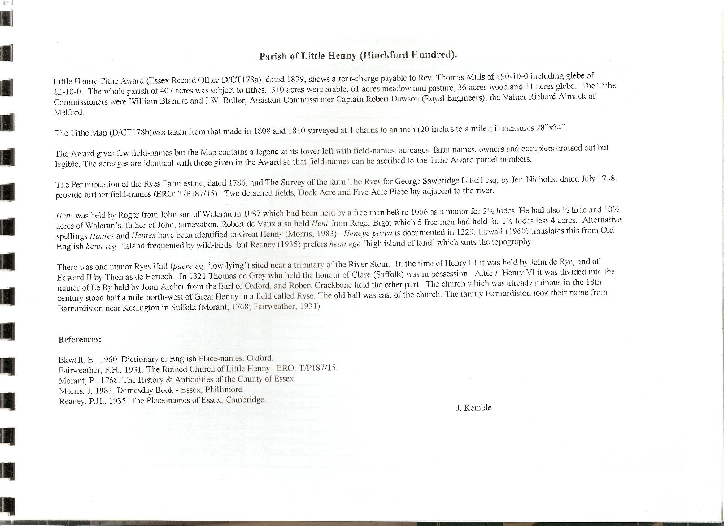
The Tithe Map (1808/10) and Award (1839) Place-names of Little Henny – by Parcel No.

Map Place-name | Award Name | Alias | Fld No | Gd Ref | x | y | Acr | rd | pch | Land use | Owner | Occupier | Name of farm | Other information
Waste in Road, 1808/10 |  | Waste, 1839 |  |  |  |  | 1 | 2 | 6
none | Piece in Common Meadow, 1839 | Dock Acre, 1738, T/P 187/15 |  |  |  |  |  |  |  |  |  |  |  | detached (by R. Stour)
none | Piece in Common Meadow, 1839 | Five Acre Piece, 1738, T/P 187/15 |  |  |  |  |  |  |  |  |  |  |  | detached (by R. Stour)
Woodhouse field (pt), 1808/10 | Gentrys Farm land, 1839 |  | 1 | TL | 848 | 373 | 7 | 3 | 8 | arble | Howe, Earl | Hazell, James
Stackyard, 1808/10 | Gentrys Farm land, 1839 |  | 2 | TL | 849 | 375 | 0 | 1 | 10 | yds,farm | Howe, Earl | Hazell, James
Stackyard field, 1808/10 | Gentrys Farm land, 1839 |  | 3 | TL | 850 | 374 | 9 | 1 | 10 | arble | Howe, Earl | Hazell, James
Thistley Field, 1808/10 | Gentrys Farm land, 1839 |  | 4 | TL | 850 | 372 | 6 | 3 | 9 | arble | Howe, Earl | Hazell, James
Rush Lay, 1808/10 | Gentrys Farm land, 1839 |  | 5 | TL | 850 | 371 | 4 | 2 | 15 | arble | Howe, Earl | Hazell, James
Horse Pasture, 1808/10 | Gentrys Farm land, 1839 |  | 6 | TL | 851 | 371 | 4 | 2 | 26 | arble | Howe, Earl | Hazell, James
Cottage Pond Field, 1808/10 | Gentrys Farm land, 1839 |  | 7 | TL | 852 | 373 | 6 | 1 | 28 | arble | Howe, Earl | Hazell, James
Henny Field, 1808/10 | Gentrys Farm land, 1839 |  | 8 | TL | 854 | 373 | 8 | 2 | 6 | arble | Howe, Earl | Hazell, James
Church Field, 1808/10 | Gentrys Farm land, 1839 |  | 9 | TL | 854 | 375 | 8 | 1 | 28 | arble | Howe, Earl | Hazell, James
Langbridge Bottom (pt), 1808/10 | Gentrys Farm land, 1839 |  | 10 | TL | 857 | 377 | 1 | 2 | 38 | arble | Howe, Earl | Hazell, James
Grove (pt), 1808/10 | Gentrys Farm land, 1839 |  | 11 | TL | 857 | 377 | 0 | 0 | 36 | arble | Howe, Earl | Hazell, James
Langbridge Lay, 1808/10 | Gentrys Farm land, 1839 |  | 12 | TL | 856 | 377 | 9 | 1 | 24 | arble | Howe, Earl | Hazell, James
Langbridge Field, 1808/10 | Gentrys Farm land, 1839 |  | 13 | TL | 853 | 377 | 6 | 3 | 7 | arble | Howe, Earl | Hazell, James
Langbridge Grove, 1808/10 | Milkhouse Wood, 1839 |  | 14 | TL | 852 | 379 | 5 | 2 | 10 | wd | Howe, Earl | Howe, Earl
Broom Pasture, 1808/10 | Gentrys Farm land, 1839 |  | 15 | TL | 854 | 380 | 5 | 0 | 14 | arble | Howe, Earl | Hazell, James
Milkhouse Wood (pt), 1808/10 | Milkhouse Wood, 1839 |  | 16 | TL | 851 | 378 | 12 | 2 | 8 | wd | Howe, Earl | Howe, Earl
Milkhouse Field (pt), 1808/10 | Gentrys Farm land, 1839 |  | 17 | TL | 850 | 376 | 11 | 3 | 24 | arble | Howe, Earl | Hazell, James
Barn Meadow, 1808/10 | Gentrys Farm land, 1839 |  | 18 | TL | 849 | 375 | 0 | 3 | 24 | pstre | Howe, Earl | Hazell, James
Farm, Yards, 1808/10 | Gentrys Farm land, 1839 | Gentries, 1508, Rntl | 19 | TL | 850 | 375 | 0 | 3 | 2 | farm | Howe, Earl | Hazell, James |  | Richard Gentri, 1348,FF
Garden (pt), 1808/10 | Cottage, 1839 |  | 20 | TL | 850 | 370 | 0 | 1 | 0
Cottage and Garden, 1808/10 | Cottage, 1839 |  | 21 | TL | 852 | 372 | 0 | 0 | 38 | gdns
Plantation, 1808/10 | Ryes Lodge, The, 1839 |  | 22a | TL | 857 | 385 | 0 | 3 | 36 | plnt | Barnardiston, Elizabeth Joanna | Barnardiston, Elizabeth Joanna | Tye Farm (pt),1808/10
Pottus Lay, 1808/10 | Ryes Hall Lands, The, 1839 |  | 22 | TL | 855 | 385 | 8 | 2 | 26 | arble | Barnardiston, Nathaniel Clarke, esq | Barnardiston, Nathaniel Clarke | Tye Farm (pt),1808/10
Seven Acres, 1808/10 | Ryes Hall Lands, The, 1839 |  | 23 | TL | 854 | 384 | 5 | 3 | 13 | arble | Barnardiston, Nathaniel Clarke, esq | Barnardiston, Nathaniel Clarke | Tye Farm (pt),1808/10
Glebe Field, 1808/10 | Glege, 1839 |  | 24 | TL | 855 | 382 | 11 | 0 | 24 | arble | Mills, Thomas, Rev | Barnardiston, Nathaniel Clarke | Little Henny Glebe
Bush Pasture, 1808/10 | Ryes Hall Lands, The, 1839 |  | 25 | TL | 853 | 382 | 9 | 0 | 14 | arble | Barnardiston, Nathaniel Clarke, esq | Barnardiston, Nathaniel Clarke | Tye Farm (pt),1808/10
Wood field (pt), 1808/10 | Tye Farm (pt), 1839 |  | 26 | TL | 852 | 382 | 2 | 2 | 36 | arble | Barnardiston, Nathaniel Clarke, esq | Viall, John | Tye Farm (pt),1808/10
Ten Acres, 1808/10 | Ryes Hall Lands, The, 1839 |  | 27 | TL | 853 | 385 | 10 | 3 | 13 | arble | Barnardiston, Nathaniel Clarke, esq | Barnardiston, Nathaniel Clarke | Tye Farm (pt),1808/10
High Croft Wood (pt), 1808/10 | Middleton Lands, The (pt), 1839 |  | 28 | TL | 852 | 384 | 1 | 1 | 0 | arble | Meyrick, William Henry, Col | Meyrick, William Henry, Col
12 Acres College Wood (pt), 1808/10 | Middleton Lands, The (pt), 1839 |  | 29 | TL | 853 | 390 | 1 | 3 | 10 | arble | Meyrick, William Henry, Col | Meyrick, William Henry, Col
22 Acres College Wood (pt), 1808/10 | Middleton Lands, The (pt), 1839 |  | 30 | TL | 853 | 389 | 9 | 0 | 21 | arble | Meyrick, William Henry, Col | Meyrick, William Henry, Col
College Wood by Foxholes | Middleton Lands, The (pt), 1839 |  | 31 | TL | 861 | 390 | 5 | 0 | 30 | arble | Meyrick, William Henry, Col | Meyrick, William Henry, Col
Pond field (pt), 1808/10 | Tye Farm (pt), 1839 |  | 32 | TL | 854 | 388 | 5 | 2 | 8 | arble | Barnardiston, Nathaniel Clarke, esq | Viall, John | Lodge Farm, 1808/10
Long Field, 1808/10 | Ryes Hall Lands, The, 1839 |  | 33 | TL | 856 | 386 | 4 | 2 | 11 | arble | Barnardiston, Nathaniel Clarke, esq | Barnardiston, Nathaniel Clarke | Lodge Farm, 1808/10
No name, 1808/10 | Ryes Lodge, The, 1839 |  | 34a | TL | 857 | 385 | 0 | 2 | 11 | plnt | Barnardiston, Elizabeth Joanna | Barnardiston, Elizabeth Joanna | Lodge Farm, 1808/10
Farm Yards, 1808/10 | Ryes Hall Lands, The, 1839 |  | 34 | TL | 858 | 386 | 0 | 1 | 15 |  | Barnardiston, Nathaniel Clarke, esq | Barnardiston, Nathaniel Clarke | Lodge Farm, 1808/10
Argus field (pt), 1808/10 | Ryes Hall Lands, The, 1839 |  | 35 | TL | 858 | 386 | 4 | 1 | 28 | arble | Barnardiston, Nathaniel Clarke, esq | Barnardiston, Nathaniel Clarke | Lodge Farm, 1808/10
No name, 1808/10 | Ryes Hall Lands, The, 1839 |  | 35a | TL | 858 | 386 | 0 | 0 | 37 | arble | Barnardiston, Nathaniel Clarke, esq | Barnardiston, Nathaniel Clarke | Lodge Farm, 1808/10
Drying Ground, 1808/10 | Ryes Hall Lands, The, 1839 |  | 36 | TL | 858 | 386 | 0 | 1 | 37 |  | Barnardiston, Nathaniel Clarke, esq | Barnardiston, Nathaniel Clarke | Lodge Farm, 1808/10
Cottage and Yard, 1808/10 | Cottage, 1839 |  | 37 | TL | 858 | 386 | 0 | 0 | 20
Tommasis, 1808/10 | Sheepcote, 1839 |  | 38 | TL | 864 | 392 | 1 | 1 | 37 | arble | Jones, William Brazier | Viall, John |  | detached
Lower East field, 1808/10 | Ryes Hall Lands, The, 1839 | Further East field, 1738 T/P 187/15 | 39 | TL | 871 | 388 | 13 | 0 | 14 | arble | Barnardiston, Nathaniel Clarke, esq | Barnardiston, Nathaniel Clarke | The Ryes, 1808/10
Upper East field, 1808/10 | Ryes Hall Lands, The, 1839 | East Field (1738), T/P 187/15 | 40 | TL | 869 | 388 | 6 | 3 | 13 | arble | Barnardiston, Nathaniel Clarke, esq | Barnardiston, Nathaniel Clarke | The Ryes, 1808/10
Meadow, 1808/10 | Ryes Hall Lands, The, 1839 | Long Meadow, 1738  T/P 187/15 | 41 | TL | 870 | 386 | 7 | 2 | 4 | arble | Barnardiston, Nathaniel Clarke, esq | Barnardiston, Nathaniel Clarke | The Ryes, 1808/10
Little Meadow, 1808/10 | Ryes Hall Lands, The, 1839 | Meadow (1738), T/P 187/15 | 42 | TL | 867 | 387 | 2 | 0 | 1 | pstre | Barnardiston, Nathaniel Clarke, esq | Barnardiston, Nathaniel Clarke | The Ryes, 1808/10
Further Ox Pasture, 1808/10 | Ryes Hall Lands, The, 1839 | Ox Pasture (1738), T/P 187/15 | 43 | TL | 868 | 387 | 4 | 1 | 2 | arble | Barnardiston, Nathaniel Clarke, esq | Barnardiston, Nathaniel Clarke | The Ryes, 1808/10
First Ox Pasture, 1808/10 | Ryes Hall Lands, The, 1839 | Ox Pasture (1738), T/P 187/15 | 44 | TL | 866 | 387 | 2 | 3 | 38 | arble | Barnardiston, Nathaniel Clarke, esq | Barnardiston, Nathaniel Clarke | The Ryes, 1808/10
Little Coneyfear, 1808/10 | Ryes Hall Lands, The, 1839 | Little Coneyfear(1738), T/P 187/15 | 45 | TL | 868 | 388 | 4 | 3 | 2 | arble | Barnardiston, Nathaniel Clarke, esq | Barnardiston, Nathaniel Clarke | The Ryes, 1808/10
Great Coneyfear, 1808/10 | Ryes Hall Lands, The, 1839 | Great Coneyfear (1738), T/P 187/15 | 46 | TL | 868 | 389 | 8 | 2 | 5 | arble | Barnardiston, Nathaniel Clarke, esq | Barnardiston, Nathaniel Clarke | The Ryes, 1808/10
Lime field, 1808/10 | Ryes Hall Lands, The, 1839 | Lime Field (1738), T/P 187/15 | 47 | TL | 864 | 389 | 1 | 0 | 24 | arble | Barnardiston, Nathaniel Clarke, esq | Barnardiston, Nathaniel Clarke | The Ryes, 1808/10
Lime Pasture, 1808/10 | Ryes Hall Lands, The, 1839 |  | 48 | TL | 862 | 388 | 12 | 1 | 20 | pstre | Barnardiston, Nathaniel Clarke, esq | Barnardiston, Nathaniel Clarke | The Ryes, 1808/10
Old Osier Ground, 1808/10 | Ryes Hall Lands, The, 1839 | Old Osier Ground, 1738, T/P 187/15 | 49 | TL | 865 | 386 | 1 | 1 | 11 | pstre | Barnardiston, Nathaniel Clarke, esq | Barnardiston, Nathaniel Clarke | The Ryes, 1808/10
Slugs Hill, 1808/10 | Ryes Lodge, The, 1839 | Slugs Hill (1738), T/P 187/15 | 50 | TL | 863 | 386 | 2 | 1 | 35 | pstre | Barnardiston, Elizabeth Joanna | Barnardiston, Elizabeth Joanna | The Ryes, 1808/10
Plantation in Slugs Hill, 1808/10 | Ryes Lodge, The, 1839 | Slugs Hill (1738), T/P 187/15 | 51 | TL | 864 | 386 | 0 | 1 | 22 | plnt | Barnardiston, Elizabeth Joanna | Barnardiston, Elizabeth Joanna | The Ryes, 1808/10
Hop Ground Piece, 1808/10 | Ryes Hall Lands, The, 1839 | Marsh (1738), T/P 187/15 | 52 | TL | 864 | 386 | 1 | 0 | 36 | pstre | Barnardiston, Nathaniel Clarke, esq | Barnardiston, Nathaniel Clarke | The Ryes, 1808/10
First Marsh, 1808/10 | Ryes Hall Lands, The, 1839 | Marsh (1738), T/P 187/15 | 53 | TL | 864 | 386 | 1 | 3 | 16 | pstre | Barnardiston, Nathaniel Clarke, esq | Barnardiston, Nathaniel Clarke | The Ryes, 1808/10
Further Marsh, 1808/10 | Ryes Hall Lands, The, 1839 | Marsh (1738), T/P 187/15 | 54 | TL | 866 | 386 | 3 | 2 | 5 | pstre | Barnardiston, Nathaniel Clarke, esq | Barnardiston, Nathaniel Clarke | The Ryes, 1808/10
Pond Lay, 1808/10 | Ryes Hall Lands, The, 1839 | Holyday Croft (1738), T/P 187/15 | 55 | TL | 867 | 385 | 8 | 0 | 27 | arble | Barnardiston, Nathaniel Clarke, esq | Barnardiston, Nathaniel Clarke | The Ryes, 1808/10
Five Acres Lay, 1808/10 | Ryes Hall Lands, The, 1839 | Holyday Croft (1738), T/P 187/15 | 56 | TL | 868 | 385 | 5 | 1 | 15 | arble | Barnardiston, Nathaniel Clarke, esq | Barnardiston, Nathaniel Clarke | The Ryes, 1808/10
Lower WoodCroft, 1808/10 | Ryes Hall Lands, The, 1839 | Holyday Croft (1738), T/P 187/15 | 57 | TL | 868 | 384 | 4 | 1 | 22 | arble | Barnardiston, Nathaniel Clarke, esq | Barnardiston, Nathaniel Clarke | The Ryes, 1808/10
Wood Croft, 1808/10 | Ryes Hall Lands, The, 1839 | Holyday Croft (1738), T/P 187/15 | 58 | TL | 867 | 384 | 4 | 3 | 22 | arble | Barnardiston, Nathaniel Clarke, esq | Barnardiston, Nathaniel Clarke | The Ryes, 1808/10
Holyday Croft, 1808/10 | Ryes Hall Lands, The, 1839 | Holyday Croft (1738), T/P 187/15 | 59 | TL | 866 | 385 | 4 | 0 | 5 | arble | Barnardiston, Nathaniel Clarke, esq | Barnardiston, Nathaniel Clarke | The Ryes, 1808/10
Church Pasture. 1808/10 | Ryes Hall Lands, The, 1839 | Church Pasture, 1738 | 60 | TL | 864 | 385 | 2 | 2 | 12 | pstre | Barnardiston, Nathaniel Clarke, esq | Barnardiston, Nathaniel Clarke | The Ryes, 1808/10
Farm, Yards, 1808/10 | Ryes Hall Lands, The, 1839 | Ryes, 1562, Ct | 61 | TL | 864 | 385 | 2 | 0 | 20 |  | Barnardiston, Nathaniel Clarke, esq | Barnardiston, Nathaniel Clarke | The Ryes, 1808/10 | John de Ry, 1269,FF
Home Pasture, 1808/10 | Ryes Hall Lands, The, 1839 | Horse Pasture/Osier Ground, 1738 | 62 | TL | 863 | 385 | 5 | 1 | 4 | pstre | Barnardiston, Nathaniel Clarke, esq | Barnardiston, Nathaniel Clarke | The Ryes, 1808/10
Coopers Field Wood, 1808/10 | Ryes Lodge, The, 1839 | Coopers Field Wood (1738), T/P 187/15 | 63 | TL | 865 | 382 | 5 | 0 | 32 | wd | Barnardiston, Elizabeth Joanna | Barnardiston, Elizabeth Joanna | The Ryes, 1808/10
Great Parsonage field, 1808/10 | Ryes Hall Lands, The, 1839 | Parsonage field/Acre Piece,1738, T/P 187/15 | 64 | TL | 863 | 382 | 24 | 1 | 14 | arble | Barnardiston, Nathaniel Clarke, esq | Barnardiston, Nathaniel Clarke | The Ryes, 1808/10
Little Parsonage field, 1808/10 | Ryes Hall Lands, The, 1839 | Little Parsonage field, 1738, T/P 187/15 | 65 | TL | 860 | 381 | 7 | 0 | 6 | arble | Barnardiston, Nathaniel Clarke, esq | Barnardiston, Nathaniel Clarke | The Ryes, 1808/10
Three Corners, 1808/10 | Ryes Hall Lands, The, 1839 | Three Cornered Field, 1738, T/P 187/15 | 66 | TL | 858 | 382 | 4 | 0 | 10 | arble | Barnardiston, Nathaniel Clarke, esq | Barnardiston, Nathaniel Clarke | The Ryes, 1808/10
Wood field, 1808/10 | Ryes Hall Lands, The, 1839 |  | 67 | TL | 858 | 383 | 4 | 1 | 30 | arble | Barnardiston, Nathaniel Clarke, esq | Barnardiston, Nathaniel Clarke | The Ryes, 1808/10
Castle field, 1808/10 | Ryes Hall Lands, The, 1839 | Castle Field(1738), T/P 187/15 | 68 | TL | 860 | 384 | 19 | 3 | 22 | pstre | Barnardiston, Nathaniel Clarke, esq | Barnardiston, Nathaniel Clarke | The Ryes, 1808/10
Planted dec in Castle field, 1808/10 | Ryes Lodge, The, 1839 |  | 69 | TL | 858 | 384 | 2 | 1 | 34 | plnt | Barnardiston, Elizabeth Joanna | Barnardiston, Elizabeth Joanna | The Ryes, 1808/10
Garden Close, 1808/10 | Ryes Lodge, The, 1839 |  | 70 | TL | 858 | 385 | 1 | 1 | 25 | pstre | Barnardiston, Elizabeth Joanna | Barnardiston, Elizabeth Joanna | The Ryes, 1808/10
Kitchen Garden, 1808/10 | Ryes Lodge, The, 1839 | Six Rood Field (1738),T/P 187/15 | 71 | TL | 859 | 385 | 1 | 0 | 30 | gdn | Barnardiston, Elizabeth Joanna | Barnardiston, Elizabeth Joanna | The Ryes, 1808/10
Kitchen Garden, 1808/10 | Ryes Lodge, The, 1839 | Six Rood Field (1738),T/P 187/15 | 72 | TL | 859 | 385 | 0 | 2 | 0 | gdn | Barnardiston, Elizabeth Joanna | Barnardiston, Elizabeth Joanna | The Ryes, 1808/10
Plantation, 1808/10 | Ryes Lodge, The, 1839 |  | 73 | TL | 859 | 385 | 1 | 2 | 22 | plnt | Barnardiston, Elizabeth Joanna | Barnardiston, Elizabeth Joanna | The Ryes, 1808/10
Home Wood, 1808/10 | Ryes Lodge, The, 1839 | Chappell Wood (1738),T/P 187/15 | 74 | TL | 860 | 387 | 7 | 2 | 28 | wd | Barnardiston, Elizabeth Joanna | Barnardiston, Elizabeth Joanna | The Ryes, 1808/10
Mansion, yards etc, 1808/10 | Ryes Lodge, The, 1839 | Chappell Field (1738),T/P 187/15 | 75 | TL | 860 | 385 | 1 | 1 | 14 |  | Barnardiston, Elizabeth Joanna | Barnardiston, Elizabeth Joanna | The Ryes, 1808/10
The Lawn, 1808/10 | Ryes Lodge, The, 1839 |  | 76 | TL | 861 | 386 | 8 | 2 | 19 | pstre | Barnardiston, Elizabeth Joanna | Barnardiston, Elizabeth Joanna | The Ryes, 1808/10
Planted in The Lawn, 1808/10 | Ryes Lodge, The, 1839 |  | 77 | TL | 860 | 385 | 0 | 3 | 17 | plnt | Barnardiston, Elizabeth Joanna | Barnardiston, Elizabeth Joanna | The Ryes, 1808/10
Drift to the Farm, 1808/10 | Ryes Hall Lands, The, 1839 |  | 78 | TL | 860 | 385 | 0 | 1 | 32 |  | Barnardiston, Nathaniel Clarke, esq | Barnardiston, Nathaniel Clarke | The Ryes, 1808/10

For abbreviations see Reaney, P., Place-names of Essex, Cambridge 1935; and Kemble, J., Essex Place-names, Places, Streets & People, Historical Publications, London 2007.

The Tithe Map (1808/10) and Award (1839) Place-names of Little Henny – by Place-name.

Map Place-name | Award name | Alias | Fld No | Gd Ref | x | y | Acr | rd | pch | Land use | Owner | Occupier | Name of farm | Other information
12 Acres College Wood (pt), 1808/10 | Middleton Lands, The (pt), 1839 |  | 29 | TL | 853 | 390 | 1 | 3 | 10 | arble | Meyrick, William Henry, Col | Meyrick, William Henry, Col
22 Acres College Wood (pt), 1808/10 | Middleton Lands, The (pt), 1839 |  | 30 | TL | 853 | 389 | 9 | 0 | 21 | arble | Meyrick, William Henry, Col | Meyrick, William Henry, Col
Argus field (pt), 1808/10 | Ryes Hall Lands, The, 1839 |  | 35 | TL | 858 | 386 | 4 | 1 | 28 | arble | Barnardiston, Nathaniel Clarke, esq | Barnardiston, Nathaniel Clarke | Lodge Farm, 1808/10
Barn Meadow, 1808/10 | Gentrys Farm land, 1839 |  | 18 | TL | 849 | 375 | 0 | 3 | 24 | pstre | Howe, Earl | Hazell, James
Broom Pasture, 1808/10 | Gentrys Farm land, 1839 |  | 15 | TL | 854 | 380 | 5 | 0 | 14 | arble | Howe, Earl | Hazell, James
Bush Pasture, 1808/10 | Ryes Hall Lands, The, 1839 |  | 25 | TL | 853 | 382 | 9 | 0 | 14 | arble | Barnardiston, Nathaniel Clarke, esq | Barnardiston, Nathaniel Clarke | Tye Farm (pt),1808/10
Castle field, 1808/10 | Ryes Hall Lands, The, 1839 | Castle Field(1738), T/P 187/15 | 68 | TL | 860 | 384 | 19 | 3 | 22 | pstre | Barnardiston, Nathaniel Clarke, esq | Barnardiston, Nathaniel Clarke | The Ryes, 1808/10
Church Field, 1808/10 | Gentrys Farm land, 1839 |  | 9 | TL | 854 | 375 | 8 | 1 | 28 | arble | Howe, Earl | Hazell, James
Church Pasture, 1808/10 | Ryes Hall Lands, The, 1839 | Church Pasture, 1738, T/P 187/15 | 60 | TL | 864 | 385 | 2 | 2 | 12 | pstre | Barnardiston, Nathaniel Clarke, esq | Barnardiston, Nathaniel Clarke | The Ryes, 1808/10
College Wood by Foxholes | Middleton Lands, The (pt), 1839 |  | 31 | TL | 861 | 390 | 5 | 0 | 30 | arble | Meyrick, William Henry, Col | Meyrick, William Henry, Col
Coopers Field Wood, 1808/10 | Ryes Lodge, The, 1839 | Coopers Field Wood (1738), T/P 187/15 | 63 | TL | 865 | 382 | 5 | 0 | 32 | wd | Barnardiston, Elizabeth Joanna | Barnardiston, Elizabeth Joanna | The Ryes, 1808/10
Cottage and Garden, 1808/10 | Cottage, 1839 |  | 21 | TL | 852 | 372 | 0 | 0 | 38 | gdns
Cottage and Yard, 1808/10 | Cottage, 1839 |  | 37 | TL | 858 | 386 | 0 | 0 | 20
Cottage Pond Field, 1808/10 | Gentrys Farm land, 1839 |  | 7 | TL | 852 | 373 | 6 | 1 | 28 | arble | Howe, Earl | Hazell, James
Drift to the Farm, 1808/10 | Ryes Hall Lands, The, 1839 |  | 78 | TL | 860 | 385 | 0 | 1 | 32 |  | Barnardiston, Nathaniel Clarke, esq | Barnardiston, Nathaniel Clarke | The Ryes, 1808/10
Drying Ground, 1808/10 | Ryes Hall Lands, The, 1839 |  | 36 | TL | 858 | 386 | 0 | 1 | 37 |  | Barnardiston, Nathaniel Clarke, esq | Barnardiston, Nathaniel Clarke | Lodge Farm, 1808/10
Farm, Yards, 1808/10 | Ryes Hall Lands, The, 1839 |  | 34 | TL | 858 | 386 | 0 | 1 | 15 |  | Barnardiston, Nathaniel Clarke, esq | Barnardiston, Nathaniel Clarke | Lodge Farm, 1808/10
Farm, Yards, 1808/10 | Ryes Hall Lands, The, 1839 | Ryes, 1562, Ct | 61 | TL | 864 | 385 | 2 | 0 | 20 |  | Barnardiston, Nathaniel Clarke, esq | Barnardiston, Nathaniel Clarke | The Ryes, 1808/10 | John de Ry, 1269,FF
Farm, Yards, 1808/10 | Gentrys Farm land, 1839 | Gentries, 1508, Rntl | 19 | TL | 850 | 375 | 0 | 3 | 2 | farm | Howe, Earl | Hazell, James |  | Richard Gentri, 1348,FF
First Marsh, 1808/10 | Ryes Hall Lands, The, 1839 | Marsh (1738), T/P 187/15 | 53 | TL | 864 | 386 | 1 | 3 | 16 | pstre | Barnardiston, Nathaniel Clarke, esq | Barnardiston, Nathaniel Clarke | The Ryes, 1808/10
First Ox Pasture, 1808/10 | Ryes Hall Lands, The, 1839 | Ox Pasture (1738), T/P 187/15 | 44 | TL | 866 | 387 | 2 | 3 | 38 | arble | Barnardiston, Nathaniel Clarke, esq | Barnardiston, Nathaniel Clarke | The Ryes, 1808/10
Five Acres Lay, 1808/10 | Ryes Hall Lands, The, 1839 | Holyday Croft (1738), T/P 187/15 | 56 | TL | 868 | 385 | 5 | 1 | 15 | arble | Barnardiston, Nathaniel Clarke, esq | Barnardiston, Nathaniel Clarke | The Ryes, 1808/10
Further Marsh, 1808/10 | Ryes Hall Lands, The, 1839 | Marsh (1738), T/P 187/15 | 54 | TL | 866 | 386 | 3 | 2 | 5 | pstre | Barnardiston, Nathaniel Clarke, esq | Barnardiston, Nathaniel Clarke | The Ryes, 1808/10
Further Ox Pasture, 1808/10 | Ryes Hall Lands, The, 1839 | Ox Pasture (1738), T/P 187/15 | 43 | TL | 868 | 387 | 4 | 1 | 2 | arble | Barnardiston, Nathaniel Clarke, esq | Barnardiston, Nathaniel Clarke | The Ryes, 1808/10
Garden (pt), 1808/10 | Cottage, 1839 |  | 20 | TL | 850 | 370 | 0 | 1 | 0
Garden Close, 1808/10 | Ryes Lodge, The, 1839 |  | 70 | TL | 858 | 385 | 1 | 1 | 25 | pstre | Barnardiston, Elizabeth Joanna | Barnardiston, Elizabeth Joanna | The Ryes, 1808/10
Glebe Field, 1808/10 | Glege, 1839 |  | 24 | TL | 855 | 382 | 11 | 0 | 24 | arble | Mills, Thomas, Rev | Barnardiston, Nathaniel Clarke | Little Henny Glebe
Great Coneyfear, 1808/10 | Ryes Hall Lands, The, 1839 | Great Coneyfear (1738), T/P 187/15 | 46 | TL | 868 | 389 | 8 | 2 | 5 | arble | Barnardiston, Nathaniel Clarke, esq | Barnardiston, Nathaniel Clarke | The Ryes, 1808/10
Great Parsonage field, 1808/10 | Ryes Hall Lands, The, 1839 | Parsonage field/Acre Piece, 1738 | 64 | TL | 863 | 382 | 24 | 1 | 14 | arble | Barnardiston, Nathaniel Clarke, esq | Barnardiston, Nathaniel Clarke | The Ryes, 1808/10
Grove (pt), 1808/10 | Gentrys Farm land, 1839 |  | 11 | TL | 857 | 377 | 0 | 0 | 36 | arble | Howe, Earl | Hazell, James
Henny Field, 1808/10 | Gentrys Farm land, 1839 |  | 8 | TL | 854 | 373 | 8 | 2 | 6 | arble | Howe, Earl | Hazell, James
High Croft Wood (pt), 1808/10 | Middleton Lands, The (pt), 1839 |  | 28 | TL | 852 | 384 | 1 | 1 | 0 | arble | Meyrick, William Henry, Col | Meyrick, William Henry, Col
Holyday Croft, 1808/10 | Ryes Hall Lands, The, 1839 | Holyday Croft (1738), T/P 187/15 | 59 | TL | 866 | 385 | 4 | 0 | 5 | arble | Barnardiston, Nathaniel Clarke, esq | Barnardiston, Nathaniel Clarke | The Ryes, 1808/10
Home Pasture, 1808/10 | Ryes Hall Lands, The, 1839 | Horse Pasture/Osier Ground, 1738 | 62 | TL | 863 | 385 | 5 | 1 | 4 | pstre | Barnardiston, Nathaniel Clarke, esq | Barnardiston, Nathaniel Clarke | The Ryes, 1808/10
Home Wood, 1808/10 | Ryes Lodge, The, 1839 | Chappell Wood (1738),T/P 187/15 | 74 | TL | 860 | 387 | 7 | 2 | 28 | wd | Barnardiston, Elizabeth Joanna | Barnardiston, Elizabeth Joanna | The Ryes, 1808/10
Hop Ground Piece, 1808/10 | Ryes Hall Lands, The, 1839 | Marsh (1738), T/P 187/15 | 52 | TL | 864 | 386 | 1 | 0 | 36 | pstre | Barnardiston, Nathaniel Clarke, esq | Barnardiston, Nathaniel Clarke | The Ryes, 1808/10
Horse Pasture, 1808/10 | Gentrys Farm land, 1839 |  | 6 | TL | 851 | 371 | 4 | 2 | 26 | arble | Howe, Earl | Hazell, James
Kitchen Garden, 1808/10 | Ryes Lodge, The, 1839 | Six Rood Field (1738),T/P 187/15 | 71 | TL | 859 | 385 | 1 | 0 | 30 | gdn | Barnardiston, Elizabeth Joanna | Barnardiston, Elizabeth Joanna | The Ryes, 1808/10
Kitchen Garden, 1808/10 | Ryes Lodge, The, 1839 | Six Rood Field (1738),T/P 187/15 | 72 | TL | 859 | 385 | 0 | 2 | 0 | gdn | Barnardiston, Elizabeth Joanna | Barnardiston, Elizabeth Joanna | The Ryes, 1808/10
Langbridge Bottom (pt), 1808/10 | Gentrys Farm land, 1839 |  | 10 | TL | 857 | 377 | 1 | 2 | 38 | arble | Howe, Earl | Hazell, James
Langbridge Field, 1808/10 | Gentrys Farm land, 1839 |  | 13 | TL | 853 | 377 | 6 | 3 | 7 | arble | Howe, Earl | Hazell, James
Langbridge Grove, 1808/10 | Milkhouse Wood, 1839 |  | 14 | TL | 852 | 379 | 5 | 2 | 10 | wd | Howe, Earl | Howe, Earl
Langbridge Lay, 1808/10 | Gentrys Farm land, 1839 |  | 12 | TL | 856 | 377 | 9 | 1 | 24 | arble | Howe, Earl | Hazell, James
Lime field, 1808/10 | Ryes Hall Lands, The, 1839 | Lime Field (1738), T/P 187/15 | 47 | TL | 864 | 389 | 1 | 0 | 24 | arble | Barnardiston, Nathaniel Clarke, esq | Barnardiston, Nathaniel Clarke | The Ryes, 1808/10
Lime Pasture, 1808/10 | Ryes Hall Lands, The, 1839 |  | 48 | TL | 862 | 388 | 12 | 1 | 20 | pstre | Barnardiston, Nathaniel Clarke, esq | Barnardiston, Nathaniel Clarke | The Ryes, 1808/10
Little Coneyfear, 1808/10 | Ryes Hall Lands, The, 1839 | Little Coneyfear(1738), T/P 187/15 | 45 | TL | 868 | 388 | 4 | 3 | 2 | arble | Barnardiston, Nathaniel Clarke, esq | Barnardiston, Nathaniel Clarke | The Ryes, 1808/10
Little Meadow, 1808/10 | Ryes Hall Lands, The, 1839 | Meadow (1738), T/P 187/15 | 42 | TL | 867 | 387 | 2 | 0 | 1 | pstre | Barnardiston, Nathaniel Clarke, esq | Barnardiston, Nathaniel Clarke | The Ryes, 1808/10
Little Parsonage field, 1808/10 | Ryes Hall Lands, The, 1839 | Little Parsonage field, 1738, T/P 187/15 | 65 | TL | 860 | 381 | 7 | 0 | 6 | arble | Barnardiston, Nathaniel Clarke, esq | Barnardiston, Nathaniel Clarke | The Ryes, 1808/10
Long Field, 1808/10 | Ryes Hall Lands, The, 1839 |  | 33 | TL | 856 | 386 | 4 | 2 | 11 | arble | Barnardiston, Nathaniel Clarke, esq | Barnardiston, Nathaniel Clarke | Lodge Farm, 1808/10
Lower East field, 1808/10 | Ryes Hall Lands, The, 1839 | Further East field, 1738 T/P 187/15 | 39 | TL | 871 | 388 | 13 | 0 | 14 | arble | Barnardiston, Nathaniel Clarke, esq | Barnardiston, Nathaniel Clarke | The Ryes, 1808/10
Lower WoodCroft, 1808/10 | Ryes Hall Lands, The, 1839 | Holyday Croft (1738), T/P 187/15 | 57 | TL | 868 | 384 | 4 | 1 | 22 | arble | Barnardiston, Nathaniel Clarke, esq | Barnardiston, Nathaniel Clarke | The Ryes, 1808/10
Mansion, yards etc, 1808/10 | Ryes Lodge, The, 1839 | Chappell Field (1738),T/P 187/15 | 75 | TL | 860 | 385 | 1 | 1 | 14 |  | Barnardiston, Elizabeth Joanna | Barnardiston, Elizabeth Joanna | The Ryes, 1808/10
Meadow, 1808/10 | Ryes Hall Lands, The, 1839 | Long Meadow, 1738  T/P 187/15 | 41 | TL | 870 | 386 | 7 | 2 | 4 | arble | Barnardiston, Nathaniel Clarke, esq | Barnardiston, Nathaniel Clarke | The Ryes, 1808/10
Milkhouse Field (pt), 1808/10 | Gentrys Farm land, 1839 |  | 17 | TL | 850 | 376 | 11 | 3 | 24 | arble | Howe, Earl | Hazell, James
Milkhouse Wood (pt), 1808/10 | Milkhouse Wood, 1839 |  | 16 | TL | 851 | 378 | 12 | 2 | 8 | wd | Howe, Earl | Howe, Earl
No name, 1808/10 | Ryes Lodge, The, 1839 |  | 34a | TL | 857 | 385 | 0 | 2 | 11 | plnt | Barnardiston, Elizabeth Joanna | Barnardiston, Elizabeth Joanna | Lodge Farm, 1808/10
No name, 1808/10 | Ryes Hall Lands, The, 1839 |  | 35a | TL | 858 | 386 | 0 | 0 | 37 | arble | Barnardiston, Nathaniel Clarke, esq | Barnardiston, Nathaniel Clarke | Lodge Farm, 1808/10
none | Piece in Common Meadow, 1839 | Dock Acre, 1738, T/P 187/15 |  |  |  |  |  |  |  |  |  |  |  | detached (by R. Stour)
none | Piece in Common Meadow, 1839 | Five Acre Piece, 1738, T/P 187/15 |  |  |  |  |  |  |  |  |  |  |  | detached (by R. Stour)
Old Osier Ground, 1808/10 | Ryes Hall Lands, The, 1839 | Old Osier Ground, 1738, T/P 187/15 | 49 | TL | 865 | 386 | 1 | 1 | 11 | pstre | Barnardiston, Nathaniel Clarke, esq | Barnardiston, Nathaniel Clarke | The Ryes, 1808/10
Plantation in Slugs Hill, 1808/10 | Ryes Lodge, The, 1839 | Slugs Hill (1738), T/P 187/15 | 51 | TL | 864 | 386 | 0 | 1 | 22 | plnt | Barnardiston, Elizabeth Joanna | Barnardiston, Elizabeth Joanna | The Ryes, 1808/10
Plantation, 1808/10 | Ryes Lodge, The, 1839 |  | 22a | TL | 857 | 385 | 0 | 3 | 36 | plnt | Barnardiston, Elizabeth Joanna | Barnardiston, Elizabeth Joanna | Tye Farm (pt),1808/10
Plantation, 1808/10 | Ryes Lodge, The, 1839 |  | 73 | TL | 859 | 385 | 1 | 2 | 22 | plnt | Barnardiston, Elizabeth Joanna | Barnardiston, Elizabeth Joanna | The Ryes, 1808/10
Planted dec in Castle field, 1808/10 | Ryes Lodge, The, 1839 |  | 69 | TL | 858 | 384 | 2 | 1 | 34 | plnt | Barnardiston, Elizabeth Joanna | Barnardiston, Elizabeth Joanna | The Ryes, 1808/10
Planted in The Lawn, 1808/10 | Ryes Lodge, The, 1839 |  | 77 | TL | 860 | 385 | 0 | 3 | 17 | plnt | Barnardiston, Elizabeth Joanna | Barnardiston, Elizabeth Joanna | The Ryes, 1808/10
Pond field (pt), 1808/10 | Tye Farm (pt), 1839 |  | 32 | TL | 854 | 388 | 5 | 2 | 8 | arble | Barnardiston, Nathaniel Clarke, esq | Viall, John | Lodge Farm, 1808/10
Pond Lay, 1808/10 | Ryes Hall Lands, The, 1839 | Holyday Croft (1738), T/P 187/15 | 55 | TL | 867 | 385 | 8 | 0 | 27 | arble | Barnardiston, Nathaniel Clarke, esq | Barnardiston, Nathaniel Clarke | The Ryes, 1808/10
Pottus Lay, 1808/10 | Ryes Hall Lands, The, 1839 |  | 22 | TL | 855 | 385 | 8 | 2 | 26 | arble | Barnardiston, Nathaniel Clarke, esq | Barnardiston, Nathaniel Clarke | Tye Farm (pt),1808/10
Rush Lay, 1808/10 | Gentrys Farm land, 1839 |  | 5 | TL | 850 | 371 | 4 | 2 | 15 | arble | Howe, Earl | Hazell, James
Seven Acres, 1808/10 | Ryes Hall Lands, The, 1839 |  | 23 | TL | 854 | 384 | 5 | 3 | 13 | arble | Barnardiston, Nathaniel Clarke, esq | Barnardiston, Nathaniel Clarke | Tye Farm (pt),1808/10
Slugs Hill, 1808/10 | Ryes Lodge, The, 1839 | Slugs Hill (1738), T/P 187/15 | 50 | TL | 863 | 386 | 2 | 1 | 35 | pstre | Barnardiston, Elizabeth Joanna | Barnardiston, Elizabeth Joanna | The Ryes, 1808/10
Stackyard field, 1808/10 | Gentrys Farm land, 1839 |  | 3 | TL | 850 | 374 | 9 | 1 | 10 | arble | Howe, Earl | Hazell, James
Stackyard, 1808/10 | Gentrys Farm land, 1839 |  | 2 | TL | 849 | 375 | 0 | 1 | 10 | yds,farm | Howe, Earl | Hazell, James
Ten Acres, 1808/10 | Ryes Hall Lands, The, 1839 |  | 27 | TL | 853 | 385 | 10 | 3 | 13 | arble | Barnardiston, Nathaniel Clarke, esq | Barnardiston, Nathaniel Clarke | Tye Farm (pt),1808/10
The Lawn, 1808/10 | Ryes Lodge, The, 1839 |  | 76 | TL | 861 | 386 | 8 | 2 | 19 | pstre | Barnardiston, Elizabeth Joanna | Barnardiston, Elizabeth Joanna | The Ryes, 1808/10
Thistley Field, 1808/10 | Gentrys Farm land, 1839 |  | 4 | TL | 850 | 372 | 6 | 3 | 9 | arble | Howe, Earl | Hazell, James
Three Corners, 1808/10 | Ryes Hall Lands, The, 1839 | Three Cornered Field, 1738, T/P 187/15 | 66 | TL | 858 | 382 | 4 | 0 | 10 | arble | Barnardiston, Nathaniel Clarke, esq | Barnardiston, Nathaniel Clarke | The Ryes, 1808/10
Tommasis, 1808/10 | Sheepcote, 1839 |  | 38 | TL | 864 | 392 | 1 | 1 | 37 | arble | Jones, William Brazier | Viall, John |  | detached
Upper East field, 1808/10 | Ryes Hall Lands, The, 1839 | East Field (1738), T/P 187/15 | 40 | TL | 869 | 388 | 6 | 3 | 13 | arble | Barnardiston, Nathaniel Clarke, esq | Barnardiston, Nathaniel Clarke | The Ryes, 1808/10
Waste in Road, 1808/10 | Waste, 1839 |  |  |  |  |  | 1 | 2 | 6
Wood Croft, 1808/10 | Ryes Hall Lands, The, 1839 | Holyday Croft (1738), T/P 187/15 | 58 | TL | 867 | 384 | 4 | 3 | 22 | arble | Barnardiston, Nathaniel Clarke, esq | Barnardiston, Nathaniel Clarke | The Ryes, 1808/10
Wood field (pt), 1808/10 | Tye Farm (pt), 1839 |  | 26 | TL | 852 | 382 | 2 | 2 | 36 | arble | Barnardiston, Nathaniel Clarke, esq | Viall, John | Tye Farm (pt),1808/10
Wood field, 1808/10 | Ryes Hall Lands, The, 1839 |  | 67 | TL | 858 | 383 | 4 | 1 | 30 | arble | Barnardiston, Nathaniel Clarke, esq | Barnardiston, Nathaniel Clarke | The Ryes, 1808/10
Woodhouse field (pt), 1808/10 | Gentrys Farm land, 1839 |  | 1 | TL | 848 | 373 | 7 | 3 | 8 | arble | Howe, Earl | Hazell, James

For abbreviations see Reaney, P., Place-names of Essex, Cambridge 1935; and Kemble, J., Essex Place-names, Places, Streets & People, Historical Publications, London 2007.

The Perambulation, 1786, Place-names of Great & Little Henny (ERO: T/P 187/15).

Parish | Parish | Place-name | Estate | Grid Ref | x | y
Little Henny | Great Henny | White Thorn NE side of Great Coneyfear | Ryes farm estate | TL | 868 | 389
Little Henny | Great Henny | Lime field | Ryes farm estate | TL | 864 | 389
Little Henny | Great Henny | Foxholes | Ryes farm estate
Little Henny | Great Henny | Bowers & Lowers dale | Ryes farm estate
Little Henny | Great Henny | Thomas Croft (detached) | Ryes farm estate | TL | 864 | 392
Little Henny | Great Henny | College Wood Foxholes | Ryes farm estate | TL | 861 | 390
Little Henny | Great Henny | Broom Pasture | Ryes farm estate | TL | 854 | 380
Little Henny | Great Henny | Argus Croft | Ryes farm estate | TL | 858 | 386
Little Henny | Great Henny | Newmans field | Ryes farm estate
Little Henny | Great Henny | Brewsters field | Ryes farm estate
Little Henny | Great Henny | Long field | Ryes farm estate | TL | 856 | 386
Little Henny | Great Henny | Raymonds Further field | Ryes farm estate
Little Henny | Great Henny | College Wood field | Ryes farm estate
Little Henny | Great Henny | Pungs Wood field | Ryes farm estate
Little Henny | Great Henny | Chase to High Wood croft | Ryes farm estate
Little Henny | Great Henny | Wood field | Ryes farm estate
Little Henny | Great Henny | Bushey Pasture | Ryes farm estate | TL | 853 | 382
Little Henny | Great Henny | Gentrys wood | Ryes farm estate | TL | 851 | 381
Little Henny | Great Henny | Milk House field | Ryes farm estate | TL | 850 | 376
Little Henny | Great Henny | Odys field | Ryes farm estate
Little Henny | Great Henny | Hounds Brook | Ryes farm estate
Little Henny | Great Henny | Rush lay | Ryes farm estate | TL | 850 | 371
Little Henny | Great Henny | Hop Ground | Ryes farm estate | TL | 864 | 386
Little Henny | Great Henny | Great or Longbridge Lay | Ryes farm estate | TL | 856 | 377
Little Henny | Great Henny | Great Lay | Ryes farm estate
Little Henny | Great Henny | Broom field | Ryes farm estate
Little Henny | Great Henny | Henny Lay (glebe) | Ryes farm estate | TL | 851 | 373
Little Henny | Great Henny | Pitfield Green (road) | Ryes farm estate
Little Henny | Great Henny | Parsonage field | Ryes farm estate | TL | 863 | 382
Little Henny | Great Henny | Cooper field wood | Ryes farm estate | TL | 865 | 382
Little Henny | Great Henny | Two acre Holiday croft | Ryes farm estate | TL | 866 | 385
Little Henny | Great Henny | Seven Acre Holiday croft | Ryes farm estate | TL | 869 | 385
Little Henny | Great Henny | Long Meadow | Ryes farm estate | TL | 870 | 386
Little Henny | Great Henny | Dairy field | Ryes farm estate
Little Henny | Great Henny | Lower East field | Ryes farm estate | TL | 871 | 388
Little Henny | Great Henny | Upper East field | Ryes farm estate | TL | 869 | 388
Little Henny | Great Henny | Little ConeyFear | Ryes farm estate | TL | 868 | 388
Little Henny | Great Henny | Great ConeyFear | Ryes farm estate | TL | 868 | 389

