THE PLACE-NAMES

OF LITTLE OAKLEY

Recorder: James Kemble

Essex Place-names Project (Essex Society for Archaeology & History), 2011 (e-book).

www.essex.ac.uk/history/esah/essexplacenames

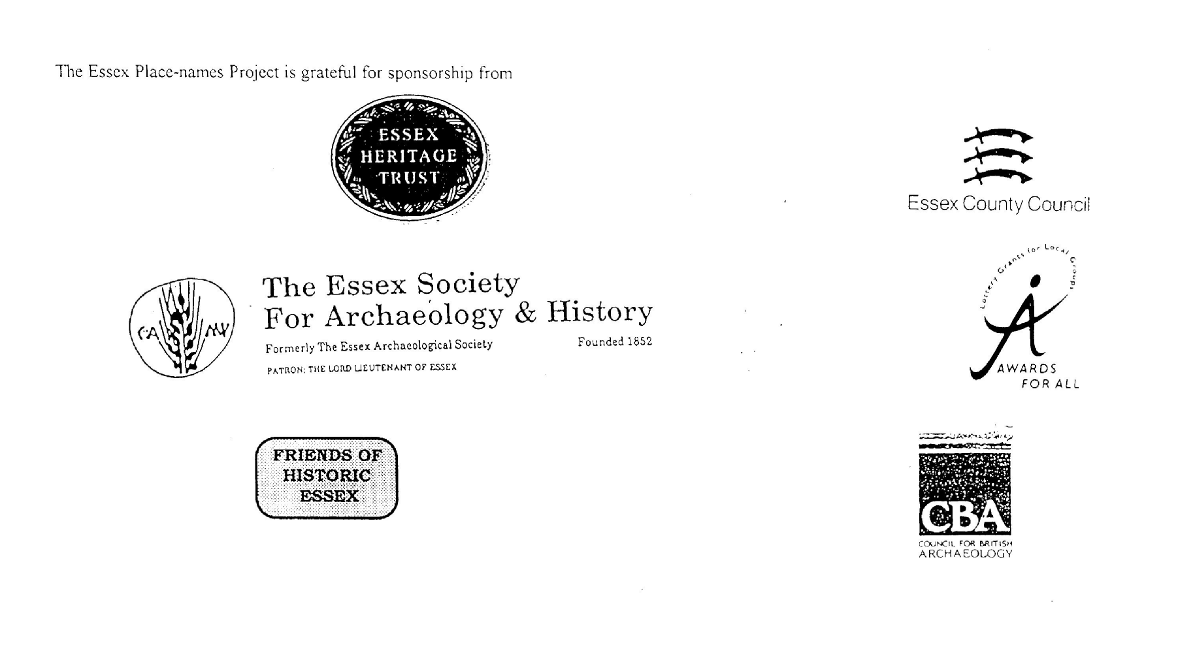

ESSEX PLACE-NAMES PROJECT.

The Essex Place-names Project is a County-wide survey to record place- and field-names from historical documents such as Tithe maps and apportionments, estate maps, sale
and auction catalogues, conveyances, terriers, deeds, rolls, inquisitions and surveys.

The second element of the Project is to investigate on-the-ground visible remains which correspond to the Place-names for actual or potential archaeological, agricultural and industrial
sites, and to record natural (topographical) and man-made features which may relate to the Place-name. This involves field-survey in rural and outside investigation in built-up areas.

It is anticipated that the Project will lead to identification of archaeological sites and lost historic buildings; it will enable analysis of indicators of early settlement, land holding, agricultural and industrial practices of the County. It will refine the more precise meaning of descriptive words and elements used by earlier settlers as they gave names appropriate to the topography of the landscape of their time.

For convenience the surveys are based on the parish, recognising that present civil parish boundaries are not necessarily identical to former ecclesiastical boundaries. Local Recorders
are supplied with templates of Record Forms to ensure consistency of recording across the County, and forward completed forms to a Central Coordinator for transfer to a county
computer database which is available to researchers on the internet at www.essex.ac.uk/history/esah/essexplacenames, and updated periodically.

This publication presents part of the information recorded from the Tithe or Estate Award and Map, and from other documents for this parish. The full record is contained on the master
database at Essex County Council (Historic Environment Section) and on the (above) website. Parish books are available from the Publications Manager, Essex Record Office, Wharf Road, Chelmsford CM2 6YT, on disc or in hard copy or may be downloaded from the website link ‘Books’ on the Home page. Please notify errors to the Project Coordinator at the Essex Record Office.

THE TITHE MAP AND APPORTIONMENT.

Since medieval times a tenth of the produce of land and stock had been paid by landholders to the church. At the Dissolution of the Monasteries, the property of many religious houses,
including the right to collect tithes, passed into lay hands. The Tithe Commutation Act which received Royal assent on 13th August 1836 abolished a rent payable in kind and
substituted rent-charges apportioned on each plot or parcel. The tithe-rent payable was assessed on the average value of wheat, barley and oats and was to fluctuate with price movements.

The commutation could be by voluntary agreement between the local owners and payers or, if agreement failed, could be compulsorily imposed by commissioners. A Valuer was to be
appointed to apportion the rent of each parcel of land and tenants could deduct that rent-charge from their rent paid to the landlord. The task fell to the Tithe Commissioners to produce a
map and an Apportionment (Award). A large-scale survey was produced for over 70% of England and Wales in the following 9 years, and about another 8% up to 1855. Most of the
parishes in Essex were surveyed. The map scales vary. The Award records ownership, tenancy and land-use, field by field and parcel by parcel (often quoting the field name) with the
ground area and rent-charge.

Land that was tithe-free tends to be less accurately mapped and contains few if any of the details recorded for those parcels subject to tithe. Rights of way and roads also tend to be
neglected. Boundaries of the tithe areas are shown as are some natural features such as streams, ponds, gardens, greens and commons. Buildings are often shown coloured red if dwellings
or grey if not. Because the Award may have been agreed only some time after the map was finished, discrepancies occur between the two. Enclosure Awards, when extant, usually date to the 18th and early 19th centuries. J.Kemble.
Reproduced by permission
of Essex County Council.

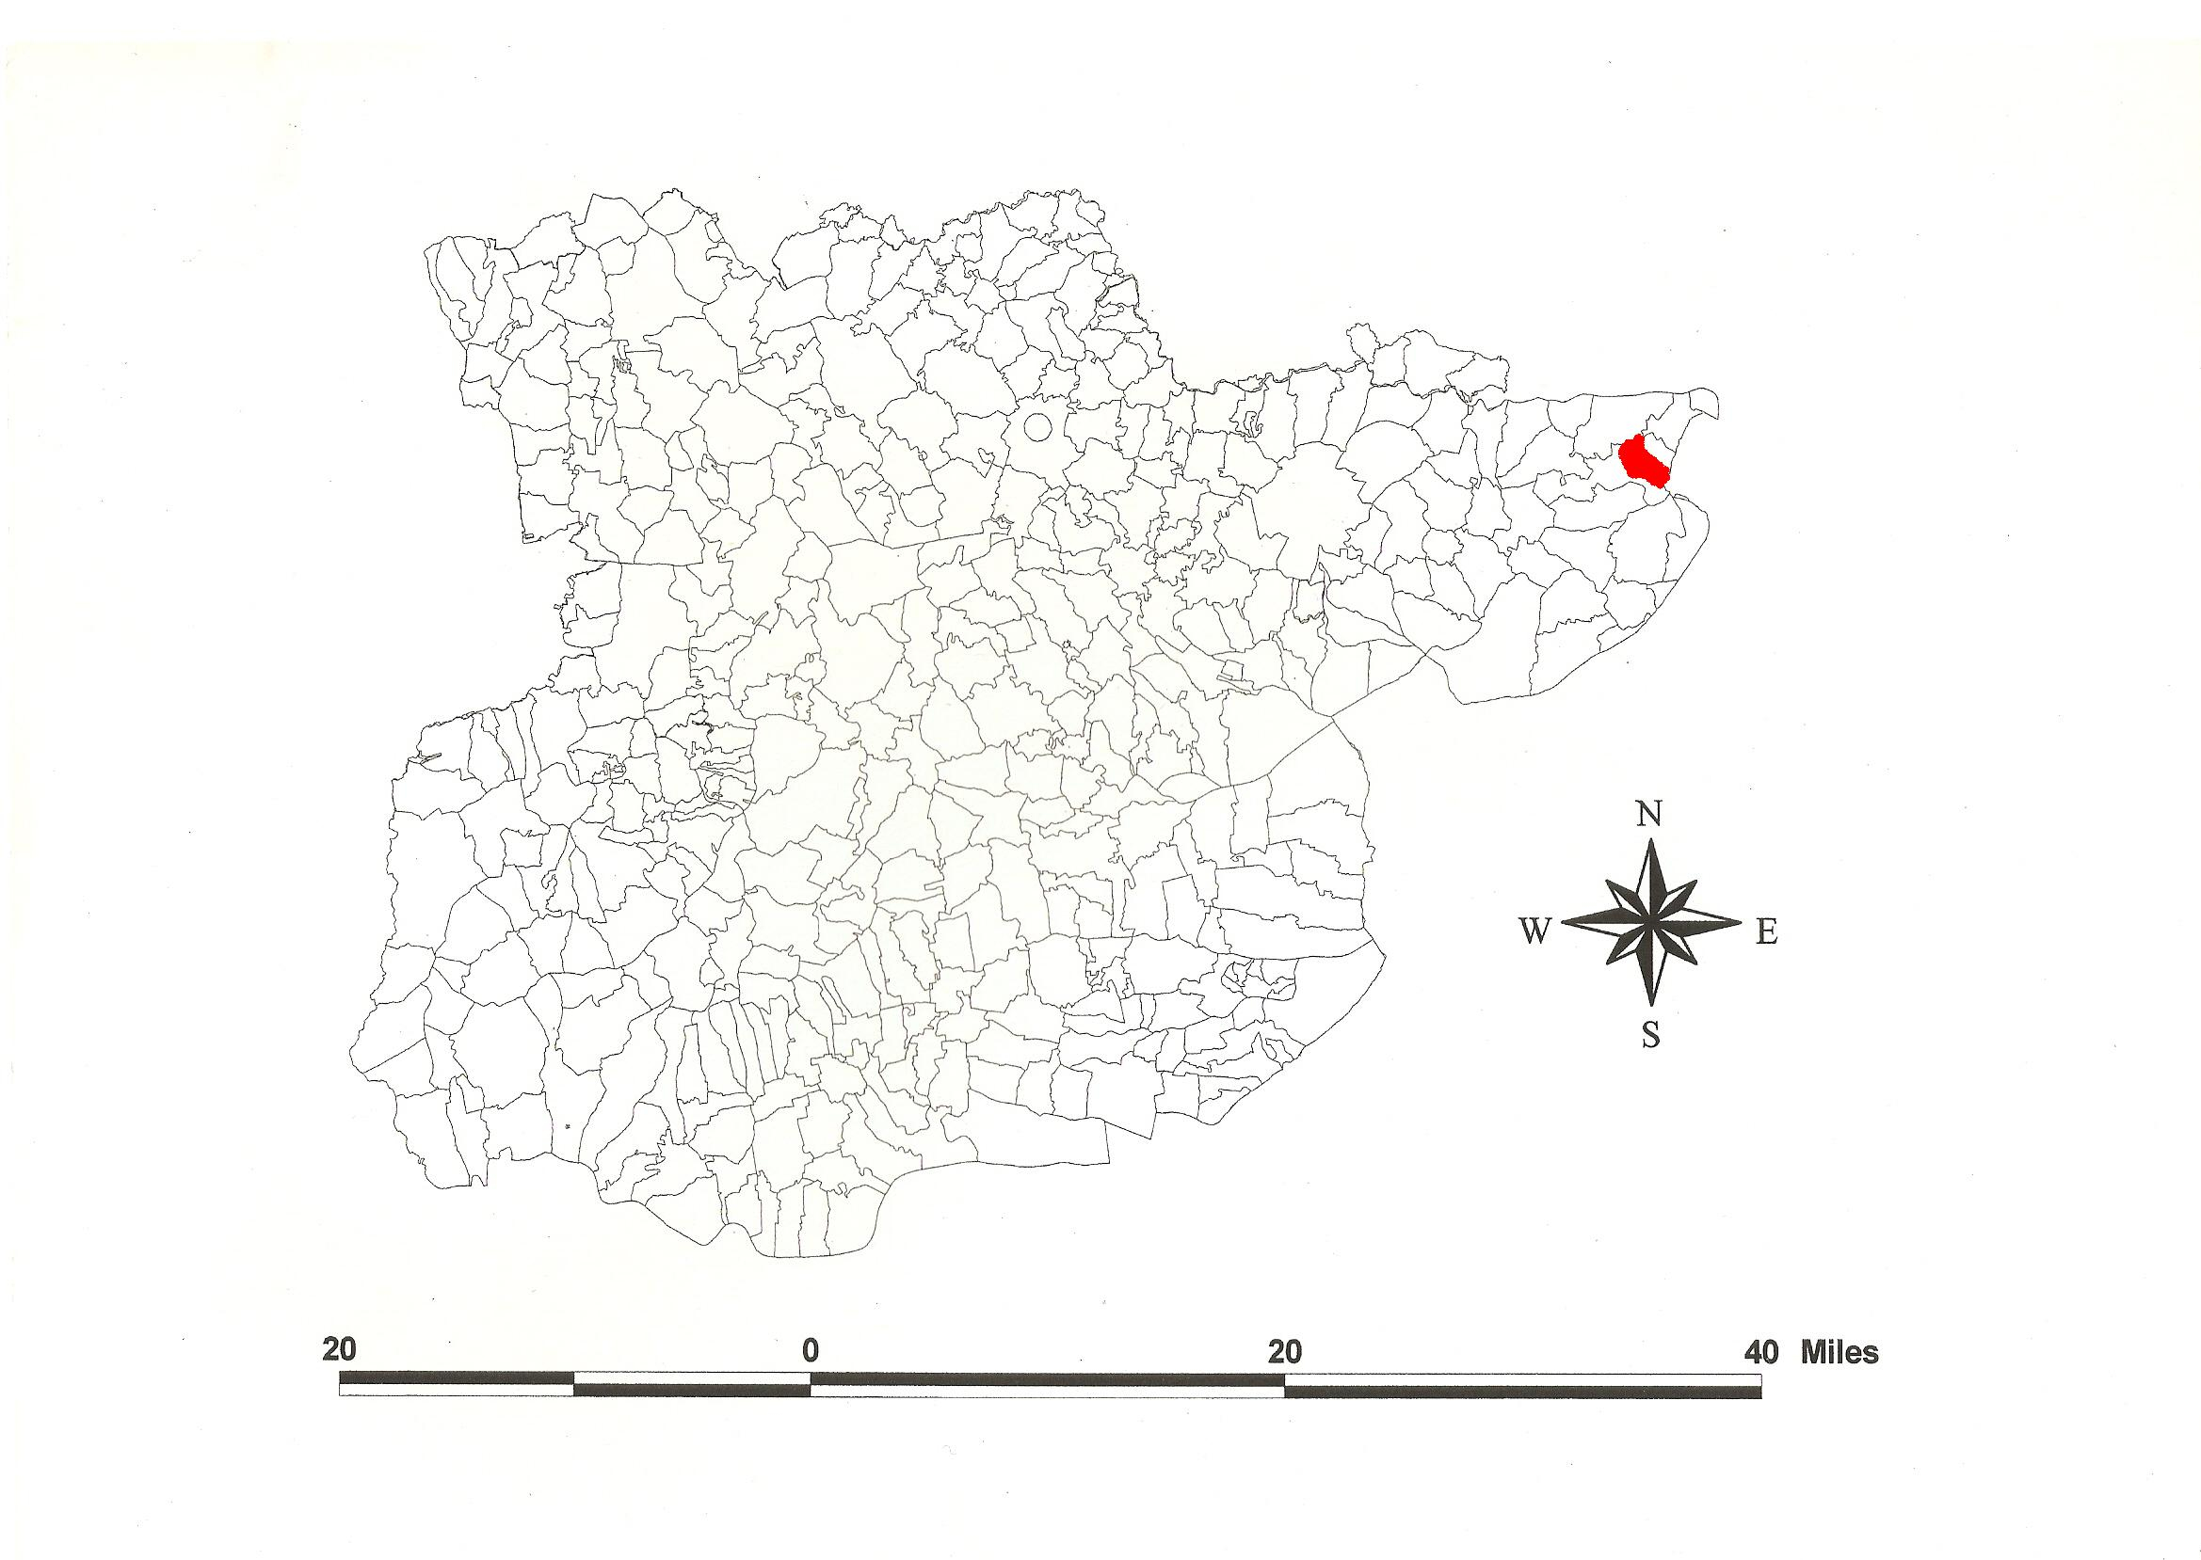
Reproduced by permission of
Essex County Council.
Little Oakley Parish in the County of Essex.

Little Oakley Parish (in Tendring Hundred).

Little Oakley Tithe Award (Essex Record Office D/CT 259a), dated 1839, shows a rent-charge of £428-15-3 payable to the rector including glebe. The whole parish measured 1028 acres 2 roods 35 perches of which 821a 2r 21p were arable, 162a 2r 30p meadow and pasture, 15a 0r 33p wood, 29a 0r 31p waste and roads, and 29a 3r 17p glebe. The Tithe Commissioners were William Blamire and J.W. Buller, the Assistant Thomas J. Tatham, the Valuer John Woodsmith of 33 Fitzroy Square, Middlesex.

The Tithe Map (ERO: D/CT 259b), dated 1838, was surveyed by John Bull of 16 Tavistock Street, Covent Garden, at a scale of 26.6” to a mile and measures 54”x42”. It was countersigned by Robert Dawson, Captain Royal Engineers, Assistant Tithe Commissioner.

In Domesday Book, 1086, Germund held Ade(m) [Acle(m)] from Ralph Baynard, sheriff of Essex at a date between 1066 and 1086, which Ednoth had held as a manor for 5½ hides with a fishery before 1066 (Morris, 1983). Acle parva is documented in 1330 (Reaney, 1935). This is O.E. ac leah, ‘oak-tree clearing or wood’ (Kemble, 2007).

Ralph Baynard’s grandson William was deprived of his estates which were granted to Robert fitz-Gilbert. In 1259 Richard Filoll held the manor of Acle from Robert fitz-Walter. Sir John Filliol (died 1332) held Little Oakley of the heirs of Robert fitz-Walter. Elizabeth and John de Vere and their heirs presented from 1448 until 1550. William Leathes, appointed Resident of the Austrian Netherlands, held the manor in 1716 (Morant, 1768). The parish, abutting the North Sea, is separated from Dovercourt by a neck of Ramsey parish (Kemble, 2011).

A Roman villa has been excavated south of Foulton Hall (Barford, 2002). The church dedicated to St Mary overlooking the marshes, since 1976 a residence, has a Norman nave and a west tower of c.1500. The chancel is of c.1330. Little Oakley Hall, 3 bays, has gabled cross-wings (Pevsner, 2007).

The name of the Hundred may originate from that region in Lower Saxony Tündern, or from the Danish place-name Tønder north of Angeln on the west coast of Jutland, perhaps denoting tinder or burnt woodland, of the people called the Tyndringas who migrated to Britain (Coates, 2005). The moot was probably at Tendring (Hundred) Heath at the junction of four roads shown on Chapman & André’ s map (VCH, 1903).

Place- and field-names from the map of Oak Hall (ERO: D/DRw P1), dated 1798, of Sir William Rowley, bart, by William Cole at a scale of 20” to a mile measuring 24”x37” are shown against the Tithe names.

References:
Barford, P.M., 2002. Excavations at Little Oakley. East Anglian Archaeology, 28.
Coates, R., 2005. A Tendring Hundred Miscellany. Jnl of English Place-name Soc, 37, 37.
Kemble, J., 2007. Essex Place-names, Places, Streets & People. Historical Publications, London.
Kemble, J., 2011. The Place-names of Dovercourt. www.essex.ac.uk/history/esah/essexplacenames/books
Morant P., 1768. History & Antiquities of the County of Essex. i. 490.
Morris, J., 1983. Domesday Book – Essex. Phillimore.
Pevsner, N., Bettley, J., 2007. Buildings of England – Essex. Yale.
Reaney, P., 1935. Place-names of Essex. Cambridge.
Victoria County History of Essex, 1903. i, 406.

The Tithe Place-names of Little Oakley – by Parcel No.

Place-name | Alias | Fld No | Gd Ref | x | y | Acr | rd | pch | land use | Owner | Occupier | Other information
Cottage, garden | at Saltwater Bridge, Tithe map | 1 | TM | 206 | 290 | 0 | 0 | 28 |  | Boldry, John | Boldry, John | Tithe exempt
Garden |  | 2 | TM | 206 | 290 | 0 | 1 | 14 |  | Sewell, Russell | Mason, George
Brick Kiln, yard | Brickkiln Cottages, 1875,OS | 3 | TM | 206 | 290 | 0 | 3 | 11 |  | Sewell, Russell | Sewell, Russell
Gardens |  | 4 | TM | 207 | 290 | 0 | 1 | 10 |  | Sewell, Russell | Mason, George; Deex, Abram; Merchant, Richard | Tithe exempt
Kiln field |  | 5 | TM | 208 | 291 | 9 | 3 | 13 | arable | Sewell, Russell | Sewell, Russell
Crosspath field |  | 6 | TM | 210 | 292 | 11 | 2 | 38 | arable | Sewell, Russell | Sewell, Russell
Five tenements, gardens |  | 7,8 | TM | 210 | 291 | 0 | 3 | 35 |  | Sewell, Russell | Bull, John;Harris, Robert;Cook, John;Grant, Joseph;Fosgate, Jonas | Tithe exempt
Cottage, garden |  | 9 | TM | 211 | 291 | 0 | 1 | 18 |  | Bull, John | Bull, John
Cottage, garden |  | 10 | TM | 211 | 291 | 0 | 1 | 18 |  | Bull, widow | Felgate, John
The five acres |  | 11 | TM | 210 | 290 | 5 | 2 | 9 | arable | Sewell, Russell | Sewell, Russell
Nursery field |  | 12 | TM | 211 | 288 | 3 | 2 | 22 | arable | Norman, Edward | Bullimer, John
Orchard field |  | 13 | TM | 212 | 290 | 8 | 3 | 36 | arable | Norman, Edward | Bullimer, John
Kitchen field |  | 14 | TM | 213 | 290 | 7 | 1 | 33 | arable | Norman, Edward | Bullimer, John
Farm house, garden etc | Whitehouse Farm, 1875,OS | 15 | TM | 213 | 292 | 0 | 2 | 16 |  | Norman, Edward | Bullimer, John
Rickyard, barn, sheds etc |  | 16 | TM | 212 | 292 | 0 | 2 | 16 |  | Norman, Edward | Bullimer, John
Stable pightle |  | 17 | TM | 213 | 292 | 1 | 0 | 22 | psture | Norman, Edward | Bullimer, John
Lane |  | 18 | TM | 211 | 293 | 0 | 1 | 3 | waste | Norman, Edward | Bullimer, John
Stable field |  | 19 | TM | 211 | 293 | 4 | 2 | 15 | arable | Norman, Edward | Bullimer, John
West Bottom |  | 20 | TM | 210 | 295 | 1 | 3 | 4 | psture | Norman, Edward | Bullimer, John
Lower sand pit |  | 21 | TM | 211 | 294 | 4 | 1 | 39 | arable | Norman, Edward | Bullimer, John
Upper sand pit |  | 22 | TM | 212 | 292 | 7 | 1 | 33 | arable | Norman, Edward | Bullimer, John
Cottage, garden |  | 23 | TM | 213 | 292 | 0 | 2 | 23 |  | Cockerill, Robert | English, Benjamin
Old Barn field |  | 24 | TM | 214 | 291 | 5 | 2 | 31 | arable | Norman, Edward | Bullimer, John
Molly Gardens |  | 25 | TM | 214 | 290 | 6 | 3 | 15 | arable | Norman, Edward | Bullimer, John
White Way & Pond field |  | 26 | TM | 215 | 290 | 11 | 2 | 10 | arable | Burmester, Rev George (glebe) | Burmester, Rev George
Cross field |  | 27 | TM | 216 | 290 | 5 | 1 | 18 | arable | Norman, Edward | Bullimer, John
Shoulder of mutton field |  | 28 | TM | 214 | 292 | 2 | 3 | 30 | arable | Norman, Edward | Bullimer, John
The Rectory House, gdns, Farm, Rickyards | Rectory, 1875,OS | 29 | TM | 214 | 294 | 1 | 3 | 37 |  | Burmester, Rev George (glebe) | Burmester, Rev George
Plantation |  | 30 | TM | 215 | 294 | 0 | 1 | 37 | plntn | Burmester, Rev George (glebe) | Burmester, Rev George
Pasture |  | 31 | TM | 214 | 294 | 0 | 1 | 5 | psture | Burmester, Rev George (glebe) | Burmester, Rev George
Pasture by Garden |  | 32 | TM | 214 | 294 | 1 | 1 | 4 | psture | Burmester, Rev George (glebe) | Burmester, Rev George
Three tenements, gardens |  | 33 | TM | 214 | 293 | 0 | 1 | 34 |  | Gammon, David | Fosgate, widow; Smith, Samuel; Holden, John jnr | tithe exempt
Two tenements, gardens |  | 34 | TM | 214 | 293 | 0 | 1 | 30 |  | Gammon, David | Fosgate, John; Grey, Mark | tithe exempt
Little Orchard field |  | 35 | TM | 213 | 294 | 4 | 3 | 19 | arable | Norman, Edward | Bullimer, John
Carrott or Dog Kennel field |  | 36 | TM | 214 | 295 | 6 | 3 | 32 | arable | Burmester, Rev George (glebe) | Burmester, Rev George
Swampy |  | 37 | TM | 212 | 215 | 5 | 2 | 12 | arable | Norman, Edward | Bullimer, John
East Bottom |  | 38 | TM | 212 | 296 | 1 | 0 | 39 | psture | Norman, Edward | Bullimer, John
Marsh (part) |  | 39 | TM | 211 | 296 | 3 | 1 | 34 | psture | Simpson, George, execs | Wrinch, Eldridge Leonard
Field (pt of adjoining [39]) |  | 40 | TM | 209 | 296 | 1 | 0 | 32 | arable | Simpson, George, execs | Wrinch, Eldridge Leonard
Marsh (part) |  | 41 | TM | 212 | 297 | 0 | 2 | 22 | psture | Garland, Nathaniel | Garland, Nathaniel
Marsh (part) |  | 42 | TM | 212 | 297 | 1 | 0 | 38 | mdw | Burmester, Rev George (glebe) | Burmester, Rev George
The Grove |  | 43 | TM | 212 | 297 | 0 | 3 | 31 | plntn | Burmester, Rev George (glebe) | Burmester, Rev George
Great Mill or Hilly field |  | 44 | TM | 213 | 296 | 5 | 2 | 20 | arable | Burmester, Rev George (glebe) | Burmester, Rev George
Reed Land Piece |  | 45 | TM | 213 | 298 | 0 | 3 | 11 | mdw | Cooper, Edward | Wrinch, Eldridge Leonard
Two tenements, gardens |  | 46 | TM | 213 | 298 | 0 | 2 | 21 |  | Garland, Nathaniel | Allison & Pudney, widows
Garden |  | 47 | TM | 213 | 298 | 0 | 0 | 20 |  | Garland, Nathaniel | Garland, Nathaniel
Two cottages, gardens |  | 48,49 | TM | 213 | 297 | 0 | 0 | 32 |  | Cooper, Edward | Wrinch, Eldridge Leonard | Tithe exempt
Johnson's field |  | 50,51 | TM | 214 | 296 | 4 | 2 | 9 | arable | Cooper, Edward | Wrinch, Eldridge Leonard
The twelve acres |  | 52 | TM | 215 | 295 | 13 | 0 | 23 | arable | Norman, Edward | Wrinch, Eldridge Leonard
The ten acres |  | 53 | TM | 215 | 294 | 11 | 1 | 21 | arable | Norman, Edward | Wrinch, Eldridge Leonard
Three tenements, gardens |  | 54 | TM | 216 | 294 | 0 | 1 | 20 |  | Norman, Edward | Gross, Robert; Cole, Bark; Flurry, R | Tithe exempt
The two acres |  | 55 | TM | 216 | 293 | 2 | 0 | 2 | arable | Woodruffe, Eliza | Sewell, Russell
Two tenements, gardens |  | 56 | TM | 216 | 293 | 0 | 0 | 24 |  | Woodruffe, Eliza | Foots, Stephen; Garrard, Thomas | Tithe exempt
Cross path field |  | 57 | TM | 217 | 293 | 8 | 2 | 24 | arable | Hempson, John | Hempson, John
Kings Land |  | 58 | TM | 218 | 293 | 6 | 2 | 17 | arable | Woodruffe, Eliza | South, John
Glovers |  | 59 | TM | 217 | 294 | 7 | 2 | 11 | arable | Norman, Edward | Wrinch, Eldridge Leonard
Gravel pit field |  | 60 | TM | 217 | 295 | 11 | 2 | 27 | arable | Norman, Edward | Wrinch, Eldridge Leonard
Spring field |  | 61 | TM | 215 | 297 | 9 | 2 | 36 | arable | Norman, Edward | Wrinch, Eldridge Leonard
Long Lands |  | 62 | TM | 217 | 297 | 10 | 2 | 23 | arable | Norman, Edward | Wrinch, Eldridge Leonard
Upper Ten acres |  | 63 | TM | 220 | 296 | 11 | 2 | 13 | arable | Norman, Edward | Cooper, Edward
Garden |  | 64 | TM | 219 | 294 | 2 | 0 | 23 |  | Norman, Edward | Wrinch, Eldridge underlet to Holden, John
Farm yards, bldgs | Vine Cottages, 1875,OS | 65 | TM | 220 | 293 | 0 | 1 | 0 |  | Norman, Edward | Cooper, Edward
Dwelling House, garden | Vine Cottages, 1875,OS | 66 | TM | 220 | 293 | 0 | 0 | 26 |  | Norman, Edward | Wrinch, Eldridge Leonard
Two tenements, gardens | Vine Cottages, 1875,OS | 67 | TM | 220 | 293 | 0 | 2 | 6 |  | Sherman, widow | Gilbert, John; Brown, Dl
Cottage, garden |  | 68 | TM | 221 | 293 | 0 | 0 | 32 |  | Norman, Edward | Wilson, Samuel | Tithe exempt
Lower Ten acres |  | 69 | TM | 220 | 294 | 10 | 2 | 20 | arable | Norman, Edward | Cooper, Edward
Cottage, garden ground |  | 70 | TM | 221 | 295 | 5 | 1 | 3 |  | Randfield, William | Holden, John
The Six acres |  | 71 | TM | 222 | 295 | 5 | 3 | 11 | arable | Woodruffe, Eliza | Cooper, Edward
The five acres |  | 72 | TM | 220 | 297 | 5 | 0 | 8 | arable | Woodruffe, Eliza | Cooper, Edward
Little North field |  | 73 | TM | 220 | 298 | 4 | 0 | 17 | arable | Palmer, Peter | Palmer, Peter
Great North field |  | 74 | TM | 218 | 300 | 6 | 1 | 22 | arable | Palmer, Peter | Palmer, Peter
Red Barn field | at May House Lane, Tithe Map [E] | 75 | TM | 220 | 300 | 11 | 1 | 20 | arable | Woodruffe, Eliza | Cooper, Edward
Lane |  | 76 | TM | 221 | 299 | 0 | 1 | 3 |  | Palmer, Peter | Palmer, Peter
The ten acres |  | 77 | TM | 222 | 298 | 10 | 2 | 13 | arable | Woodruffe, Eliza | Cooper, Edward
Barn field |  | 78 | TM | 223 | 296 | 5 | 0 | 16 | arable | Woodruffe, Eliza | Cooper, Edward
Cart Lodge field |  | 79 | TM | 224 | 295 | 0 | 3 | 14 | arable | Palmer, Peter | Palmer, Peter
Barns etc |  | 80 | TM | 224 | 294 | 0 | 1 | 15 |  | Woodruffe, Eliza | Cooper, Edward
Dwelling House, garden | Little Oakley Lodge, 1875,OS | 80a | TM | 224 | 294 | 0 | 2 | 37 |  | Woodruffe, Eliza | Woodruffe, Eliza
Foulton Hall, garden (pt) | Foulton Hall, 1777,C | 81 | TM | 224 | 293 | 0 | 2 | 21 |  | Garland, Nathaniel | South, John
The Eight acres |  | 82 | TM | 223 | 292 | 8 | 1 | 4 | arable | Woodruffe, Eliza | South, John
Further Eight acres |  | 83 | TM | 221 | 292 | 8 | 1 | 16 | arable | Woodruffe, Eliza | South, John
Three cottages, gardens |  | 84 | TM | 221 | 293 | 0 | 2 | 15 |  | Woodruffe, Eliza | Wilso, James; Partridge, William | Tithe exempt
The five acres |  | 85 | TM | 221 | 291 | 5 | 3 | 7 | arable | Woodruffe, Eliza | South, John
The five acres |  | 86 | TM | 220 | 291 | 6 | 1 | 1 | arable | Norman, Edward | Wrinch, Eldridge Leonard
The Six acres |  | 87 | TM | 220 | 290 | 6 | 2 | 38 | arable | Norman, Edward | Wrinch, Eldridge Leonard
Two tenements, gardens |  | 88 | TM | 218 | 292 | 0 | 0 | 19 |  | Shearman, Thomas | Grimsey, Rachel | Tithe exempt
Cherry tree field |  | 89 | TM | 218 | 290 | 8 | 2 | 31 | arable | Norman, Edward | Wrinch, Eldridge Leonard
Four tenements, gardens |  | 90 | TM | 217 | 291 | 0 | 1 | 12 |  | Hempson, John | English, James; Fletcher, widow; Fosgate, Joseph; Neward, J | Tithe exempt
Cottage, garden |  | 91 | TM | 217 | 291 | 0 | 0 | 37 |  | Hempson, John | Low, William | Tithe exempt
Garden & cottage |  | 92 | TM | 217 | 292 | 0 | 2 | 17 |  | Campion, Samuel | Smith, James
Garden |  | 93 | TM | 217 | 292 | 0 | 1 | 3 |  | Campion, Samuel | Campion, Samuel
Garden |  | 94 | TM | 217 | 293 | 0 | 2 | 37 |  | Burmester, Rev George(glebe) | Holden, John
Pightle |  | 95 | TM | 216 | 292 | 2 | 0 | 2 | arable | Norman, Edward | Holden, John
Cherry Tree beer shop, bldgs, gdn | [at Oakley Cross, 1777,C] | 96 | TM | 217 | 291 | 0 | 2 | 30 |  | Alson, Daniel | Campion, George
Two tenements, gardens |  | 97 | TM | 217 | 291 | 0 | 0 | 27 |  | Osborne, Mary | Good, John; Ames, James | Tithe exempt
Four tenements, gardens |  | 98 | TM | 217 | 290 | 0 | 1 | 11 |  | Osborne, Mary | Wade, George; Merchant, James; Ling, Abm; Starling, James | Tithe exempt
Garden by Rick yard |  | 99 | TM | 217 | 290 | 0 | 0 | 16 |  | Norman, Edward | Wrinch, Eldridge Leonard
Farmhouse, premises | Newhouse Farm, 1875,OS | 100 | TM | 218 | 289 | 0 | 3 | 12 |  | Norman, Edward | Wrinch, Eldridge Leonard
The meadow |  | 101 | TM | 218 | 288 | 2 | 1 | 8 | arable | Norman, Edward | Wrinch, Eldridge Leonard
Granary field |  | 102 | TM | 217 | 289 | 5 | 1 | 4 | arable | Norman, Edward | Wrinch, Eldridge Leonard
White Way field |  | 103 | TM | 215 | 286 | 16 | 1 | 5 | arable | Rowley, Sir Joshua | Sewell, Russell
Little White Way meadow |  | 104 | TM | 214 | 284 | 4 | 0 | 15 | mdw | Rowley, Sir Joshua | Sewell, Russell
White Way mead | Grass White-way, 1798,D/DRw P1 | 105 | TM | 214 | 285 | 3 | 0 | 15 | mdw | Rowley, Sir Joshua | Sewell, Russell
Molly Gardens | Morley Gardens, 1798,D/DRw P1 | 106 | TM | 214 | 287 | 1 | 3 | 6 | mdw | Rowley, Sir Joshua | Sewell, Russell
Molly Gardens |  | 107 | TM | 214 | 288 | 1 | 1 | 30 | mdw | Rowley, Sir Joshua | Sewell, Russell
Squeach top of Gt Church field | Poplar Grove, 1875,OS | 108 | TM | 211 | 287 | 0 | 3 | 18 | wood | Rowley, Sir Joshua | Sewell, Russell
Great Church field | Great Church field, 1798,D/DRw P1 | 109 | TM | 212 | 285 | 24 | 2 | 1 | arable | Rowley, Sir Joshua | Sewell, Russell
Church, churchyard | [St Mary's] | 110 | TM | 212 | 284 | 0 | 1 | 34 |  | .. | ..
Little Church field | Little Church field, 1798,D/DRw P1 | 111 | TM | 212 | 283 | 11 | 0 | 13 | arable | Rowley, Sir Joshua | Sewell, Russell
Great Perry | Great Perry field, 1798,D/DRw P1 | 112 | TM | 213 | 281 | 28 | 3 | 17 | arable | Rowley, Sir Joshua | Sewell, Russell
Little Perry | Little Perry field, 1798,D/DRw P1 | 113 | TM | 215 | 282 | 17 | 0 | 22 | arable | Rowley, Sir Joshua | Sewell, Russell
Cartlodge Meadow |  | 114 | TM | 214 | 283 | 2 | 1 | 34 | mdw | Rowley, Sir Joshua | Sewell, Russell
The Parish Pound |  | 114a | TM | 214 | 283 | 0 | 0 | 2 |  | .. | ..
The Hall Farm, bldg, gdns etc | Ade [Acle], 1086,DB | 115 | TM | 214 | 284 | 2 | 2 | 0 |  | Rowley, Sir Joshua | Sewell, Russell
Rickyard, barns etc |  | 116 | TM | 214 | 284 | 1 | 2 | 31 |  | Rowley, Sir Joshua | Sewell, Russell
Cow Marsh Lane |  | 117 | TM | 216 | 283 | 0 | 3 | 8 |  | Rowley, Sir Joshua | Sewell, Russell
Little Down | Little Down, 1798, D/DRw P1 | 118 | TM | 217 | 285 | 25 | 1 | 27 | arable | Rowley, Sir Joshua | Sewell, Russell
The twelve acres | Twelve acres, 1798,D/DRw P1 | 119 | TM | 218 | 282 | 12 | 3 | 36 | arable | Rowley, Sir Joshua | Sewell, Russell
Kiln pightle | Kiln Pightle, 1798,D/DRw P1 | 120 | TM | 219 | 280 | 13 | 1 | 22 | arable | Rowley, Sir Joshua | Sewell, Russell
First Cow Marsh | Hither Cow Marsh, 1798,D/DRw P1 | 121 | TM | 217 | 279 | 17 | 1 | 1 | arable | Rowley, Sir Joshua | Sewell, Russell
Middle Cow Marsh | Horse Plotts, 1798,D/DRw P1 | 122 | TM | 215 | 278 | 12 | 3 | 36 | arable | Rowley, Sir Joshua | Sewell, Russell
Further Cow Marsh | Further Cow Marsh, 1798,D/DRw P1 | 123 | TM | 213 | 277 | 11 | 3 | 24 | arable | Rowley, Sir Joshua | Sewell, Russell
Wall & Ditch at Bottom |  | 124 | TM | 214 | 276 | 0 | 3 | 4 | waste | Rowley, Sir Joshua | Sewell, Russell
Cow Marsh Bottoms |  | 125 | TM | 215 | 276 | 2 | 2 | 4 | psture | Rowley, Sir Joshua | Sewell, Russell
Cow Marsh Bottoms |  | 126 | TM | 217 | 276 | 4 | 3 | 7 | psture | Rowley, Sir Joshua | Sewell, Russell
Wall & Ditch at Bottom |  | 127 | TM | 217 | 276 | 1 | 3 | 3 | waste | Rowley, Sir Joshua | Sewell, Russell
Sea wall & ditch |  | 128 | TM | 222 | 278 | 2 | 1 | 30 | waste | Rowley, Sir Joshua | Sewell, Russell
The nineteen acres | Mill Marsh or 19 Acres, 1798,D/DRw P1 | 129 | TM | 221 | 279 | 27 | 2 | 23 | arable | Rowley, Sir Joshua | Sewell, Russell
The Eight acres | Lower Barn, 1798,D/DRw P1 | 130 | TM | 221 | 281 | 9 | 3 | 30 | arable | Rowley, Sir Joshua | Sewell, Russell
The Grove | The Wood, 1798,D/DRw P1 | 131 | TM | 220 | 282 | 14 | 1 | 15 | wood | Rowley, Sir Joshua | Rowley, Sir Joshua
Lane leading to Lower Barn |  | 132 | TM | 219 | 284 | 1 | 1 | 34 |  | Rowley, Sir Joshua | Sewell, Russell
The eleven acres |  | 133 | TM | 220 | 285 | 12 | 0 | 10 | arable | Rowley, Sir Joshua | Sewell, Russell
Great Down | Great Down, 1798,D/DRw P1 | 134 | TM | 220 | 287 | 27 | 1 | 1 | arable | Rowley, Sir Joshua | Sewell, Russell
Little East field | Hither East field, 1798,D/DRw P1 | 135 | TM | 222 | 288 | 20 | 0 | 20 | arable | Rowley, Sir Joshua | Sewell, Russell
The ten acres |  | 136 | TM | 222 | 285 | 10 | 0 | 30 | arable | Rowley, Sir Joshua | Sewell, Russell
Ram pasture | Ram pastures, 1798,D/DRw P1 | 137 | TM | 223 | 283 | 15 | 3 | 12 | arable | Rowley, Sir Joshua | Sewell, Russell
Rick yard, Barn | Lower Barn, 1875,OS | 138 | TM | 223 | 281 | 0 | 2 | 36 |  | Rowley, Sir Joshua | Sewell, Russell
Barn Marsh |  | 139 | TM | 223 | 280 | 2 | 1 | 22 | mdw | Rowley, Sir Joshua | Sewell, Russell
Black Marsh | Sled Marsh, 1798, D/DRw P1 | 140 | TM | 225 | 282 | 11 | 3 | 20 | arable | Rowley, Sir Joshua | Sewell, Russell
The Bottoms |  | 141 | TM | 225 | 281 | 3 | 1 | 27 | mdw | Rowley, Sir Joshua | Sewell, Russell
The forty acre marsh | Great Ray Marsh, 1798,D/DRw P1 | 142 | TM | 228 | 280 | 43 | 0 | 4 | arable | Rowley, Sir Joshua | Sewell, Russell
Long Marsh | Little Ray Marsh, 1798,D/DRw P1 | 143 | TM | 227 | 278 | 26 | 3 | 18 | arable | Rowley, Sir Joshua | Sewell, Russell
Sea wall & ditch |  | 144 | TM | 227 | 277 | 1 | 1 | 25 | wste | Rowley, Sir Joshua | Sewell, Russell
Horse Ditch |  | 145 | TM | 231 | 278 | 10 | 2 | 9 | mdw | Rowley, Sir Joshua | Sewell, Russell
Horse Marsh |  | 146 | TM | 232 | 277 | 11 | 2 | 5 | mdw | Rowley, Sir Joshua | Sewell, Russell
Great Marsh | Great Salt Marsh, 1798,D/DRw P1 | 147 | TM | 235 | 276 | 38 | 3 | 1 | mdw | Rowley, Sir Joshua | Sewell, Russell
Sea wall & ditch |  | 148 | TM | 235 | 275 | 5 | 1 | 30 | waste | Rowley, Sir Joshua | Sewell, Russell
Little Marsh |  | 149 | TM | 236 | 278 | 9 | 2 | 29 | mdw | Rowley, Sir Joshua | Sewell, Russell
Waste & Wall |  | 150 | TM | 234 | 279 | 3 | 2 | 4 | waste | Rowley, Sir Joshua | Sewell, Russell
Waste |  | 151 | TM | 235 | 281 | 5 | 0 | 7 | waste | Rowley, Sir Joshua | Sewell, Russell
Taylor's Marsh | Taylor's Marsh, 1798,D/DRw P1 | 152 | TM | 232 | 281 | 31 | 2 | 25 | mdw | Rowley, Sir Joshua | Sewell, Russell
The Bottoms | Lower Hope, 1798, D/DRw P1 | 153 | TM | 229 | 282 | 2 | 1 | 10 | mdw | Rowley, Sir Joshua | Sewell, Russell
The hopes | Upper Hope, 1798,D/DRw P1 | 154 | TM | 228 | 283 | 29 | 3 | 19 | arable | Rowley, Sir Joshua | Sewell, Russell
East field Bottoms | East field Bottom, 1798,D/DRw P1 | 155 | TM | 225 | 285 | 31 | 0 | 38 | arable | Rowley, Sir Joshua | Sewell, Russell
Great east field | Further East field, 1798,D/DRw P1 | 156 | TM | 224 | 290 | 21 | 1 | 28 | arable | Rowley, Sir Joshua | Sewell, Russell
Bays Meadow (pt) |  | 157 | TM | 227 | 287 | 2 | 3 | 23 |  | Garland, Nathaniel | South, John
Lower Barnfield (pt) |  | 158 | TM | 225 | 290 | 2 | 1 | 31 | arable | Garland, Nathaniel | South, John
Upper Barn field (pt) |  | 159 | TM | 224 | 292 | 0 | 1 | 27 | arable | Garland, Nathaniel | South, John

For abbreviations see Reaney, P., Place-names of Essex, Cambridge, 1935; and Kemble, J., Essex Place-names, Places, Streets & People, Historical Publications, London, 2007.

The Tithe Place-names of Little Oakley – by Place-name.

Place-name | Alias | Fld No | Gd Ref | x | y | Acr | rd | pch | land use | Owner | Occupier | Other information
Barn field |  | 78 | TM | 223 | 296 | 5 | 0 | 16 | arable | Woodruffe, Eliza | Cooper, Edward
Barn Marsh |  | 139 | TM | 223 | 280 | 2 | 1 | 22 | mdw | Rowley, Sir Joshua | Sewell, Russell
Barns etc |  | 80 | TM | 224 | 294 | 0 | 1 | 15 |  | Woodruffe, Eliza | Cooper, Edward
Bays Meadow (pt) |  | 157 | TM | 227 | 287 | 2 | 3 | 23 |  | Garland, Nathaniel | South, John
Black Marsh | Sled Marsh, 1798, D/DRw P1 | 140 | TM | 225 | 282 | 11 | 3 | 20 | arable | Rowley, Sir Joshua | Sewell, Russell
Brick Kiln, yard | Brickkiln Cottages, 1875,OS | 3 | TM | 206 | 290 | 0 | 3 | 11 |  | Sewell, Russell | Sewell, Russell
Carrott or Dog Kennel field |  | 36 | TM | 214 | 295 | 6 | 3 | 32 | arable | Burmester, Rev George (glebe) | Burmester, Rev George
Cart Lodge field |  | 79 | TM | 224 | 295 | 0 | 3 | 14 | arable | Palmer, Peter | Palmer, Peter
Cartlodge Meadow |  | 114 | TM | 214 | 283 | 2 | 1 | 34 | mdw | Rowley, Sir Joshua | Sewell, Russell
Cherry Tree beer shop, bldgs,gdn | [at Oakley Cross, 1777,C] | 96 | TM | 217 | 291 | 0 | 2 | 30 |  | Alson, Daniel | Campion, George
Cherry tree field |  | 89 | TM | 218 | 290 | 8 | 2 | 31 | arable | Norman, Edward | Wrinch, Eldridge Leonard
Church, churchyard | [St Mary's] | 110 | TM | 212 | 284 | 0 | 1 | 34 |  | .. | ..
Cottage, garden | at Saltwater Bridge, Tithe map | 1 | TM | 206 | 290 | 0 | 0 | 28 |  | Boldry, John | Boldry, John | Tithe exempt
Cottage, garden |  | 9 | TM | 211 | 291 | 0 | 1 | 18 |  | Bull, John | Bull, John
Cottage, garden |  | 10 | TM | 211 | 291 | 0 | 1 | 18 |  | Bull, widow | Felgate, John
Cottage, garden |  | 23 | TM | 213 | 292 | 0 | 2 | 23 |  | Cockerill, Robert | English, Benjamin
Cottage, garden |  | 91 | TM | 217 | 291 | 0 | 0 | 37 |  | Hempson, John | Low, William | Tithe exempt
Cottage, garden |  | 68 | TM | 221 | 293 | 0 | 0 | 32 |  | Norman, Edward | Wilson, Samuel | Tithe exempt
Cottage, garden ground |  | 70 | TM | 221 | 295 | 5 | 1 | 3 |  | Randfield, William | Holden, John
Cow Marsh Bottoms |  | 125 | TM | 215 | 276 | 2 | 2 | 4 | psture | Rowley, Sir Joshua | Sewell, Russell
Cow Marsh Bottoms |  | 126 | TM | 217 | 276 | 4 | 3 | 7 | psture | Rowley, Sir Joshua | Sewell, Russell
Cow Marsh Lane |  | 117 | TM | 216 | 283 | 0 | 3 | 8 |  | Rowley, Sir Joshua | Sewell, Russell
Cross field |  | 27 | TM | 216 | 290 | 5 | 1 | 18 | arable | Norman, Edward | Bullimer, John
Cross path field |  | 57 | TM | 217 | 293 | 8 | 2 | 24 | arable | Hempson, John | Hempson, John
Crosspath field |  | 6 | TM | 210 | 292 | 11 | 2 | 38 | arable | Sewell, Russell | Sewell, Russell
Dwelling House, garden | Vine Cottages, 1875,OS | 66 | TM | 220 | 293 | 0 | 0 | 26 |  | Norman, Edward | Wrinch, Eldridge Leonard
Dwelling House, garden | Little Oakley Lodge, 1875,OS | 80a | TM | 224 | 294 | 0 | 2 | 37 |  | Woodruffe, Eliza | Woodruffe, Eliza
East Bottom |  | 38 | TM | 212 | 296 | 1 | 0 | 39 | psture | Norman, Edward | Bullimer, John
East field Bottoms | East field Bottom, 1798,D/DRw P1 | 155 | TM | 225 | 285 | 31 | 0 | 38 | arable | Rowley, Sir Joshua | Sewell, Russell
Farm house, garden etc | Whitehouse Farm, 1875,OS | 15 | TM | 213 | 292 | 0 | 2 | 16 |  | Norman, Edward | Bullimer, John
Farm yards, bldgs | Vine Cottages, 1875,OS | 65 | TM | 220 | 293 | 0 | 1 | 0 |  | Norman, Edward | Cooper, Edward
Farmhouse, premises | Newhouse Farm, 1875,OS | 100 | TM | 218 | 289 | 0 | 3 | 12 |  | Norman, Edward | Wrinch, Eldridge Leonard
Field (pt of adjoining [39]) |  | 40 | TM | 209 | 296 | 1 | 0 | 32 | arable | Simpson, George, execs | Wrinch, Eldridge Leonard
First Cow Marsh | Hither Cow Marsh, 1798,D/DRw P1 | 121 | TM | 217 | 279 | 17 | 1 | 1 | arable | Rowley, Sir Joshua | Sewell, Russell
Five tenements, gardens |  | 7,8 | TM | 210 | 291 | 0 | 3 | 35 |  | Sewell, Russell | Bull, John;Harris, Robert;Cook, John;Grant, Joseph;Fosgate, Jonas | Tithe exempt
Foulton Hall, garden (pt) | Foulton Hall, 1777,C | 81 | TM | 224 | 293 | 0 | 2 | 21 |  | Garland, Nathaniel | South, John
Four tenements, gardens |  | 90 | TM | 217 | 291 | 0 | 1 | 12 |  | Hempson, John | English, James; Fletcher, widow; Fosgate, Joseph; Neward, J | Tithe exempt
Four tenements, gardens |  | 98 | TM | 217 | 290 | 0 | 1 | 11 |  | Osborne, Mary | Wade, George; Merchant, James; Ling, Abm; Starling, James | Tithe exempt
Further Cow Marsh | Further Cow Marsh, 1798,D/DRw P1 | 123 | TM | 213 | 277 | 11 | 3 | 24 | arable | Rowley, Sir Joshua | Sewell, Russell
Further Eight acres |  | 83 | TM | 221 | 292 | 8 | 1 | 16 | arable | Woodruffe, Eliza | South, John
Garden |  | 94 | TM | 217 | 293 | 0 | 2 | 37 |  | Burmester, Rev George(glebe) | Holden, John
Garden |  | 93 | TM | 217 | 292 | 0 | 1 | 3 |  | Campion, Samuel | Campion, Samuel
Garden |  | 47 | TM | 213 | 298 | 0 | 0 | 20 |  | Garland, Nathaniel | Garland, Nathaniel
Garden |  | 64 | TM | 219 | 294 | 2 | 0 | 23 |  | Norman, Edward | Wrinch, Eldridge underlet to Holden, John
Garden |  | 2 | TM | 206 | 290 | 0 | 1 | 14 |  | Sewell, Russell | Mason, George
Garden & cottage |  | 92 | TM | 217 | 292 | 0 | 2 | 17 |  | Campion, Samuel | Smith, James
Garden by Rick yard |  | 99 | TM | 217 | 290 | 0 | 0 | 16 |  | Norman, Edward | Wrinch, Eldridge Leonard
Gardens |  | 4 | TM | 207 | 290 | 0 | 1 | 10 |  | Sewell, Russell | Mason, George; Deex, Abram; Merchant, Richard | Tithe exempt
Glovers |  | 59 | TM | 217 | 294 | 7 | 2 | 11 | arable | Norman, Edward | Wrinch, Eldridge Leonard
Granary field |  | 102 | TM | 217 | 289 | 5 | 1 | 4 | arable | Norman, Edward | Wrinch, Eldridge Leonard
Gravel pit field |  | 60 | TM | 217 | 295 | 11 | 2 | 27 | arable | Norman, Edward | Wrinch, Eldridge Leonard
Great Church field | Great Church field, 1798,D/DRw P1 | 109 | TM | 212 | 285 | 24 | 2 | 1 | arable | Rowley, Sir Joshua | Sewell, Russell
Great Down | Great Down, 1798,D/DRw P1 | 134 | TM | 220 | 287 | 27 | 1 | 1 | arable | Rowley, Sir Joshua | Sewell, Russell
Great east field | Further East field, 1798,D/DRw P1 | 156 | TM | 224 | 290 | 21 | 1 | 28 | arable | Rowley, Sir Joshua | Sewell, Russell
Great Marsh | Great Salt Marsh, 1798,D/DRw P1 | 147 | TM | 235 | 276 | 38 | 3 | 1 | mdw | Rowley, Sir Joshua | Sewell, Russell
Great Mill or Hilly field |  | 44 | TM | 213 | 296 | 5 | 2 | 20 | arable | Burmester, Rev George (glebe) | Burmester, Rev George
Great North field |  | 74 | TM | 218 | 300 | 6 | 1 | 22 | arable | Palmer, Peter | Palmer, Peter
Great Perry | Great Perry field, 1798,D/DRw P1 | 112 | TM | 213 | 281 | 28 | 3 | 17 | arable | Rowley, Sir Joshua | Sewell, Russell
Horse Ditch |  | 145 | TM | 231 | 278 | 10 | 2 | 9 | mdw | Rowley, Sir Joshua | Sewell, Russell
Horse Marsh |  | 146 | TM | 232 | 277 | 11 | 2 | 5 | mdw | Rowley, Sir Joshua | Sewell, Russell
Johnson's field |  | 50,51 | TM | 214 | 296 | 4 | 2 | 9 | arable | Cooper, Edward | Wrinch, Eldridge Leonard
Kiln field |  | 5 | TM | 208 | 291 | 9 | 3 | 13 | arable | Sewell, Russell | Sewell, Russell
Kiln pightle | Kiln Pightle, 1798,D/DRw P1 | 120 | TM | 219 | 280 | 13 | 1 | 22 | arable | Rowley, Sir Joshua | Sewell, Russell
Kings Land |  | 58 | TM | 218 | 293 | 6 | 2 | 17 | arable | Woodruffe, Eliza | South, John
Kitchen field |  | 14 | TM | 213 | 290 | 7 | 1 | 33 | arable | Norman, Edward | Bullimer, John
Lane |  | 18 | TM | 211 | 293 | 0 | 1 | 3 | waste | Norman, Edward | Bullimer, John
Lane |  | 76 | TM | 221 | 299 | 0 | 1 | 3 |  | Palmer, Peter | Palmer, Peter
Lane leading to Lower Barn |  | 132 | TM | 219 | 284 | 1 | 1 | 34 |  | Rowley, Sir Joshua | Sewell, Russell
Little Church field | Little Church field, 1798,D/DRw P1 | 111 | TM | 212 | 283 | 11 | 0 | 13 | arable | Rowley, Sir Joshua | Sewell, Russell
Little Down | Little Down, 1798, D/DRw P1 | 118 | TM | 217 | 285 | 25 | 1 | 27 | arable | Rowley, Sir Joshua | Sewell, Russell
Little East field | Hither East field, 1798,D/DRw P1 | 135 | TM | 222 | 288 | 20 | 0 | 20 | arable | Rowley, Sir Joshua | Sewell, Russell
Little Marsh |  | 149 | TM | 236 | 278 | 9 | 2 | 29 | mdw | Rowley, Sir Joshua | Sewell, Russell
Little North field |  | 73 | TM | 220 | 298 | 4 | 0 | 17 | arable | Palmer, Peter | Palmer, Peter
Little Orchard field |  | 35 | TM | 213 | 294 | 4 | 3 | 19 | arable | Norman, Edward | Bullimer, John
Little Perry | Little Perry field, 1798,D/DRw P1 | 113 | TM | 215 | 282 | 17 | 0 | 22 | arable | Rowley, Sir Joshua | Sewell, Russell
Little White Way meadow |  | 104 | TM | 214 | 284 | 4 | 0 | 15 | mdw | Rowley, Sir Joshua | Sewell, Russell
Long Lands |  | 62 | TM | 217 | 297 | 10 | 2 | 23 | arable | Norman, Edward | Wrinch, Eldridge Leonard
Long Marsh | Little Ray Marsh, 1798,D/DRw P1 | 143 | TM | 227 | 278 | 26 | 3 | 18 | arable | Rowley, Sir Joshua | Sewell, Russell
Lower Barnfield (pt) |  | 158 | TM | 225 | 290 | 2 | 1 | 31 | arable | Garland, Nathaniel | South, John
Lower sand pit |  | 21 | TM | 211 | 294 | 4 | 1 | 39 | arable | Norman, Edward | Bullimer, John
Lower Ten acres |  | 69 | TM | 220 | 294 | 10 | 2 | 20 | arable | Norman, Edward | Cooper, Edward
Marsh (part) |  | 42 | TM | 212 | 297 | 1 | 0 | 38 | mdw | Burmester, Rev George (glebe) | Burmester, Rev George
Marsh (part) |  | 41 | TM | 212 | 297 | 0 | 2 | 22 | psture | Garland, Nathaniel | Garland, Nathaniel
Marsh (part) |  | 39 | TM | 211 | 296 | 3 | 1 | 34 | psture | Simpson, George, execs | Wrinch, Eldridge Leonard
Middle Cow Marsh | Horse Plotts, 1798,D/DRw P1 | 122 | TM | 215 | 278 | 12 | 3 | 36 | arable | Rowley, Sir Joshua | Sewell, Russell
Molly Gardens |  | 25 | TM | 214 | 290 | 6 | 3 | 15 | arable | Norman, Edward | Bullimer, John
Molly Gardens | Morley Gardens, 1798,D/DRw P1 | 106 | TM | 214 | 287 | 1 | 3 | 6 | mdw | Rowley, Sir Joshua | Sewell, Russell
Molly Gardens |  | 107 | TM | 214 | 288 | 1 | 1 | 30 | mdw | Rowley, Sir Joshua | Sewell, Russell
Nursery field |  | 12 | TM | 211 | 288 | 3 | 2 | 22 | arable | Norman, Edward | Bullimer, John
Old Barn field |  | 24 | TM | 214 | 291 | 5 | 2 | 31 | arable | Norman, Edward | Bullimer, John
Orchard field |  | 13 | TM | 212 | 290 | 8 | 3 | 36 | arable | Norman, Edward | Bullimer, John
Pasture |  | 31 | TM | 214 | 294 | 0 | 1 | 5 | psture | Burmester, Rev George (glebe) | Burmester, Rev George
Pasture by Garden |  | 32 | TM | 214 | 294 | 1 | 1 | 4 | psture | Burmester, Rev George (glebe) | Burmester, Rev George
Pightle |  | 95 | TM | 216 | 292 | 2 | 0 | 2 | arable | Norman, Edward | Holden, John
Plantation |  | 30 | TM | 215 | 294 | 0 | 1 | 37 | plntn | Burmester, Rev George (glebe) | Burmester, Rev George
Ram pasture | Ram pastures, 1798,D/DRw P1 | 137 | TM | 223 | 283 | 15 | 3 | 12 | arable | Rowley, Sir Joshua | Sewell, Russell
Red Barn field | at May House Lane, Tithe Map [E] | 75 | TM | 220 | 300 | 11 | 1 | 20 | arable | Woodruffe, Eliza | Cooper, Edward
Reed Land Piece |  | 45 | TM | 213 | 298 | 0 | 3 | 11 | mdw | Cooper, Edward | Wrinch, Eldridge Leonard
Rick yard, Barn | Lower Barn, 1875,OS | 138 | TM | 223 | 281 | 0 | 2 | 36 |  | Rowley, Sir Joshua | Sewell, Russell
Rickyard, barn, sheds etc |  | 16 | TM | 212 | 292 | 0 | 2 | 16 |  | Norman, Edward | Bullimer, John
Rickyard, barns etc |  | 116 | TM | 214 | 284 | 1 | 2 | 31 |  | Rowley, Sir Joshua | Sewell, Russell
Sea wall & ditch |  | 128 | TM | 222 | 278 | 2 | 1 | 30 | waste | Rowley, Sir Joshua | Sewell, Russell
Sea wall & ditch |  | 144 | TM | 227 | 277 | 1 | 1 | 25 | wste | Rowley, Sir Joshua | Sewell, Russell
Sea wall & ditch |  | 148 | TM | 235 | 275 | 5 | 1 | 30 | waste | Rowley, Sir Joshua | Sewell, Russell
Shoulder of mutton field |  | 28 | TM | 214 | 292 | 2 | 3 | 30 | arable | Norman, Edward | Bullimer, John
Spring field |  | 61 | TM | 215 | 297 | 9 | 2 | 36 | arable | Norman, Edward | Wrinch, Eldridge Leonard
Squeach top of Gt Church field | Poplar Grove, 1875,OS | 108 | TM | 211 | 287 | 0 | 3 | 18 | wood | Rowley, Sir Joshua | Sewell, Russell
Stable field |  | 19 | TM | 211 | 293 | 4 | 2 | 15 | arable | Norman, Edward | Bullimer, John
Stable pightle |  | 17 | TM | 213 | 292 | 1 | 0 | 22 | psture | Norman, Edward | Bullimer, John
Swampy |  | 37 | TM | 212 | 215 | 5 | 2 | 12 | arable | Norman, Edward | Bullimer, John
fcTaylor's Marsh | Taylor's Marsh, 1798,D/DRw P1 | 152 | TM | 232 | 281 | 31 | 2 | 25 | mdw | Rowley, Sir Joshua | Sewell, Russell
The Bottoms |  | 141 | TM | 225 | 281 | 3 | 1 | 27 | mdw | Rowley, Sir Joshua | Sewell, Russell
The Bottoms | Lower Hope, 1798, D/DRw P1 | 153 | TM | 229 | 282 | 2 | 1 | 10 | mdw | Rowley, Sir Joshua | Sewell, Russell
The Eight acres | Lower Barn, 1798,D/DRw P1 | 130 | TM | 221 | 281 | 9 | 3 | 30 | arable | Rowley, Sir Joshua | Sewell, Russell
The Eight acres |  | 82 | TM | 223 | 292 | 8 | 1 | 4 | arable | Woodruffe, Eliza | South, John
The eleven acres |  | 133 | TM | 220 | 285 | 12 | 0 | 10 | arable | Rowley, Sir Joshua | Sewell, Russell
The five acres |  | 86 | TM | 220 | 291 | 6 | 1 | 1 | arable | Norman, Edward | Wrinch, Eldridge Leonard
The five acres |  | 11 | TM | 210 | 290 | 5 | 2 | 9 | arable | Sewell, Russell | Sewell, Russell
The five acres |  | 72 | TM | 220 | 297 | 5 | 0 | 8 | arable | Woodruffe, Eliza | Cooper, Edward
The five acres |  | 85 | TM | 221 | 291 | 5 | 3 | 7 | arable | Woodruffe, Eliza | South, John
The forty acre marsh | Great Ray Marsh, 1798,D/DRw P1 | 142 | TM | 228 | 280 | 43 | 0 | 4 | arable | Rowley, Sir Joshua | Sewell, Russell
The Grove |  | 43 | TM | 212 | 297 | 0 | 3 | 31 | plntn | Burmester, Rev George (glebe) | Burmester, Rev George
The Grove | The Wood, 1798,D/DRw P1 | 131 | TM | 220 | 282 | 14 | 1 | 15 | wood | Rowley, Sir Joshua | Rowley, Sir Joshua
The Hall Farm, bldg, gdns etc | Ade [Acle], 1086,DB | 115 | TM | 214 | 284 | 2 | 2 | 0 |  | Rowley, Sir Joshua | Sewell, Russell
The hopes | Upper Hope, 1798,D/DRw P1 | 154 | TM | 228 | 283 | 29 | 3 | 19 | arable | Rowley, Sir Joshua | Sewell, Russell
The meadow |  | 101 | TM | 218 | 288 | 2 | 1 | 8 | arable | Norman, Edward | Wrinch, Eldridge Leonard
The nineteen acres | Mill Marsh or 19 Acres, 1798,D/DRw P1 | 129 | TM | 221 | 279 | 27 | 2 | 23 | arable | Rowley, Sir Joshua | Sewell, Russell
The Parish Pound |  | 114a | TM | 214 | 283 | 0 | 0 | 2 |  | .. | ..
The Rectory House, gdns, Farm, Rickyards | Rectory, 1875,OS | 29 | TM | 214 | 294 | 1 | 3 | 37 |  | Burmester, Rev George (glebe) | Burmester, Rev George
The Six acres |  | 87 | TM | 220 | 290 | 6 | 2 | 38 | arable | Norman, Edward | Wrinch, Eldridge Leonard
The Six acres |  | 71 | TM | 222 | 295 | 5 | 3 | 11 | arable | Woodruffe, Eliza | Cooper, Edward
The ten acres |  | 53 | TM | 215 | 294 | 11 | 1 | 21 | arable | Norman, Edward | Wrinch, Eldridge Leonard
The ten acres |  | 136 | TM | 222 | 285 | 10 | 0 | 30 | arable | Rowley, Sir Joshua | Sewell, Russell
The ten acres |  | 77 | TM | 222 | 298 | 10 | 2 | 13 | arable | Woodruffe, Eliza | Cooper, Edward
The twelve acres |  | 52 | TM | 215 | 295 | 13 | 0 | 23 | arable | Norman, Edward | Wrinch, Eldridge Leonard
The twelve acres | Twelve acres, 1798,D/DRw P1 | 119 | TM | 218 | 282 | 12 | 3 | 36 | arable | Rowley, Sir Joshua | Sewell, Russell
The two acres |  | 55 | TM | 216 | 293 | 2 | 0 | 2 | arable | Woodruffe, Eliza | Sewell, Russell
Three cottages, gardens |  | 84 | TM | 221 | 293 | 0 | 2 | 15 |  | Woodruffe, Eliza | Wilso, James; Partridge, William | Tithe exempt
Three tenements, gardens |  | 33 | TM | 214 | 293 | 0 | 1 | 34 |  | Gammon, David | Fosgate, widow; Smith, Samuel; Holden, John jnr | tithe exempt
Three tenements, gardens |  | 54 | TM | 216 | 294 | 0 | 1 | 20 |  | Norman, Edward | Gross, Robert; Cole, Bark; Flurry, R | Tithe exempt
Two cottages, gardens |  | 48,49 | TM | 213 | 297 | 0 | 0 | 32 |  | Cooper, Edward | Wrinch, Eldridge Leonard | Tithe exempt
Two tenements, gardens |  | 34 | TM | 214 | 293 | 0 | 1 | 30 |  | Gammon, David | Fosgate, John; Grey, Mark | tithe exempt
Two tenements, gardens |  | 46 | TM | 213 | 298 | 0 | 2 | 21 |  | Garland, Nathaniel | Allison & Pudney, widows
Two tenements, gardens |  | 97 | TM | 217 | 291 | 0 | 0 | 27 |  | Osborne, Mary | Good, John; Ames, James | Tithe exempt
Two tenements, gardens |  | 88 | TM | 218 | 292 | 0 | 0 | 19 |  | Shearman, Thomas | Grimsey, Rachel | Tithe exempt
Two tenements, gardens | Vine Cottages, 1875,OS | 67 | TM | 220 | 293 | 0 | 2 | 6 |  | Sherman, widow | Gilbert, John; Brown, Dl
Two tenements, gardens |  | 56 | TM | 216 | 293 | 0 | 0 | 24 |  | Woodruffe, Eliza | Foots, Stephen; Garrard, Thomas | Tithe exempt
Upper Barn field (pt) |  | 159 | TM | 224 | 292 | 0 | 1 | 27 | arable | Garland, Nathaniel | South, John
Upper sand pit |  | 22 | TM | 212 | 292 | 7 | 1 | 33 | arable | Norman, Edward | Bullimer, John
Upper Ten acres |  | 63 | TM | 220 | 296 | 11 | 2 | 13 | arable | Norman, Edward | Cooper, Edward
Wall & Ditch at Bottom |  | 124 | TM | 214 | 276 | 0 | 3 | 4 | waste | Rowley, Sir Joshua | Sewell, Russell
Wall & Ditch at Bottom |  | 127 | TM | 217 | 276 | 1 | 3 | 3 | waste | Rowley, Sir Joshua | Sewell, Russell
Waste |  | 151 | TM | 235 | 281 | 5 | 0 | 7 | waste | Rowley, Sir Joshua | Sewell, Russell
Waste & Wall |  | 150 | TM | 234 | 279 | 3 | 2 | 4 | waste | Rowley, Sir Joshua | Sewell, Russell
West Bottom |  | 20 | TM | 210 | 295 | 1 | 3 | 4 | psture | Norman, Edward | Bullimer, John
White Way & Pond field |  | 26 | TM | 215 | 290 | 11 | 2 | 10 | arable | Burmester, Rev George (glebe) | Burmester, Rev George
White Way field |  | 103 | TM | 215 | 286 | 16 | 1 | 5 | arable | Rowley, Sir Joshua | Sewell, Russell
White Way mead | Grass White-way, 1798,D/DRw P1 | 105 | TM | 214 | 285 | 3 | 0 | 15 | mdw | Rowley, Sir Joshua | Sewell, Russell

For abbreviations see Reaney, P., Place-names of Essex, Cambridge, 1935; and Kemble, J., Essex Place-names, Places, Streets & People, Historical Publications, London, 2007.

Little Oakley.

Map 1

Map 2

6 inches = 1 mile

O.S. c.1880

Sheets 21, 30

Tithe parcel nos. superimposed

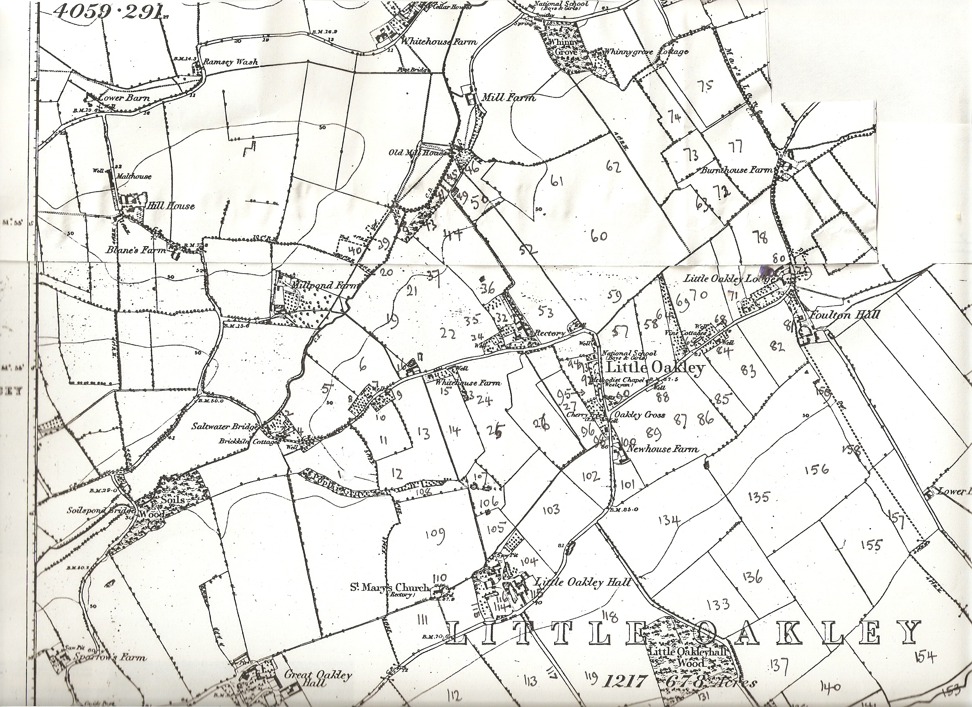
Map 1.
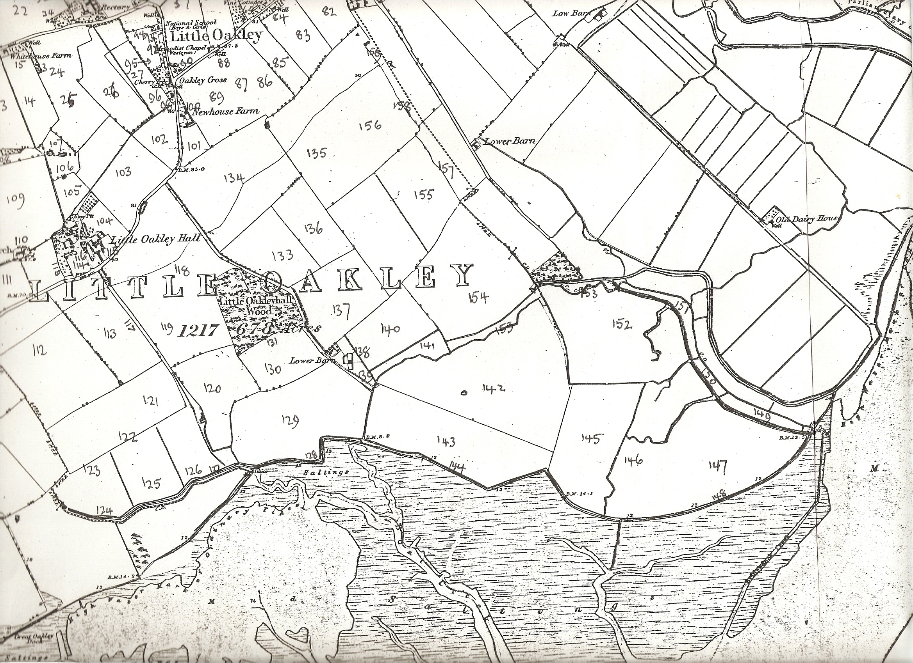
Map 2.

