THE PLACE-NAMES OF

MORETON

Recorder: James Kemble

Essex Place-names Project (Essex Society for Archaeology & History), 2014 (e-book).

www.essex.ac.uk/history/esah/essexplacenames

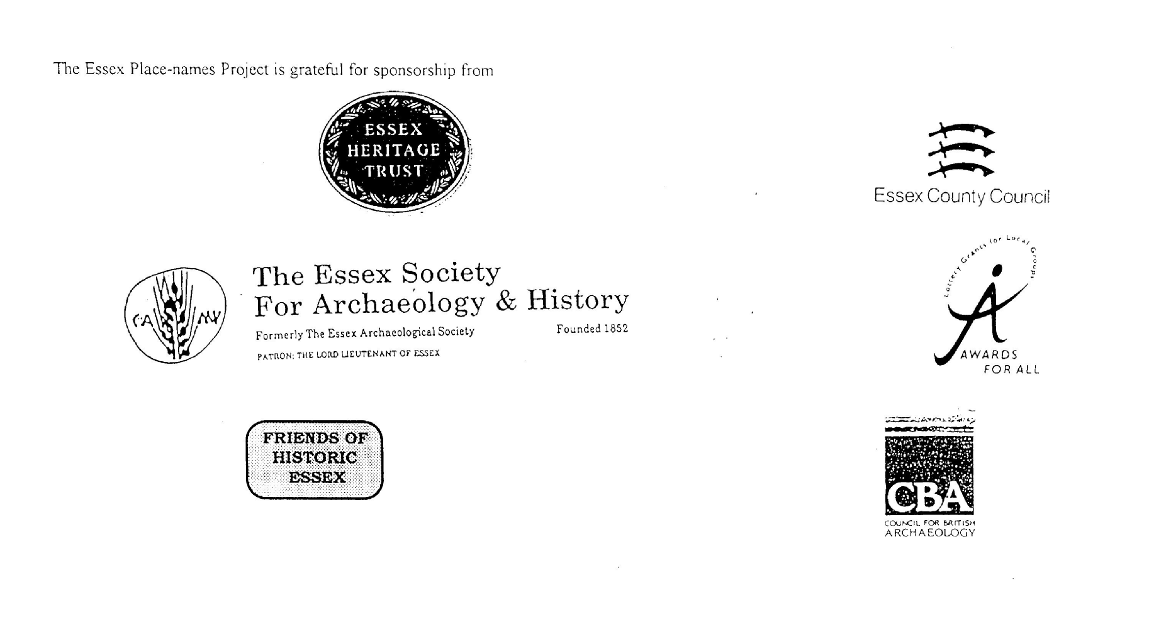

ESSEX PLACE-NAMES PROJECT.

The Essex Place-names Project is a County-wide survey to record place- and field-names from historical documents such as Tithe maps and apportionments, estate maps, sale
and auction catalogues, conveyances, terriers, deeds, rolls, inquisitions and surveys.

The second element of the Project is to investigate on-the-ground visible remains which correspond to the Place-names for actual or potential archaeological, agricultural and industrial
sites, and to record natural (topographical) and man-made features which may relate to the Place-name. This involves field-survey in rural and outside investigation in built-up areas.

It is anticipated that the Project will lead to identification of archaeological sites and lost historic buildings; it will enable analysis of indicators of early settlement, land holding, agricultural and industrial practices of the County. It will refine the more precise meaning of descriptive words and elements used by earlier settlers as they gave names appropriate to the topography of the landscape of their time.

For convenience the surveys are based on the parish, recognising that present civil parish boundaries are not necessarily identical to former ecclesiastical boundaries. Local Recorders
are supplied with templates of Record Forms to ensure consistency of recording across the County, and forward completed forms to a Central Coordinator for transfer to a county
computer database which is available to researchers on the internet at www.essex.ac.uk/history/esah/essexplacenames, and updated periodically.

This publication presents part of the information recorded from the Tithe or Estate Award and Map, and from other documents for this parish. The full record is contained on the master
database at Essex County Council (Historic Environment Section) and on the (above) website. Parish books are available to be downloaded from the website link ‘Books’ on the Home page. Please notify errors to the Project Coordinator at the Essex Record Office.

THE TITHE MAP AND APPORTIONMENT.

Since medieval times a tenth of the produce of land and stock had been paid by landholders to the church. At the Dissolution of the Monasteries, the property of many religious houses,
including the right to collect tithes, passed into lay hands. The Tithe Commutation Act which received Royal assent on 13th August 1836 abolished a rent payable in kind and
substituted rent-charges apportioned on each plot or parcel. The tithe-rent payable was assessed on the average value of wheat, barley and oats and was to fluctuate with price movements.

The commutation could be by voluntary agreement between the local owners and payers or, if agreement failed, could be compulsorily imposed by commissioners. A Valuer was to be
appointed to apportion the rent of each parcel of land and tenants could deduct that rent-charge from their rent paid to the landlord. The task fell to the Tithe Commissioners to produce a
map and an Apportionment (Award). A large-scale survey was produced for over 70% of England and Wales in the following 9 years, and about another 8% up to 1855. Most of the
parishes in Essex were surveyed. The map scales vary. The Award records ownership, tenancy and land-use, field by field and parcel by parcel (often quoting the field name) with the
ground area and rent-charge.

Land that was tithe-free tends to be less accurately mapped and contains few if any of the details recorded for those parcels subject to tithe. Rights of way and roads also tend to be
neglected. Boundaries of the tithe areas are shown as are some natural features such as streams, ponds, gardens, greens and commons. Buildings are often shown coloured red if dwellings
or grey if not. Because the Award may have been agreed only some time after the map was finished, discrepancies occur between the two. Enclosure Awards, when extant, usually date to the 18th and early 19th centuries. J.Kemble.
Reproduced by permission
of Essex County Council.

Reproduced by permission
of Essex County Council.
211

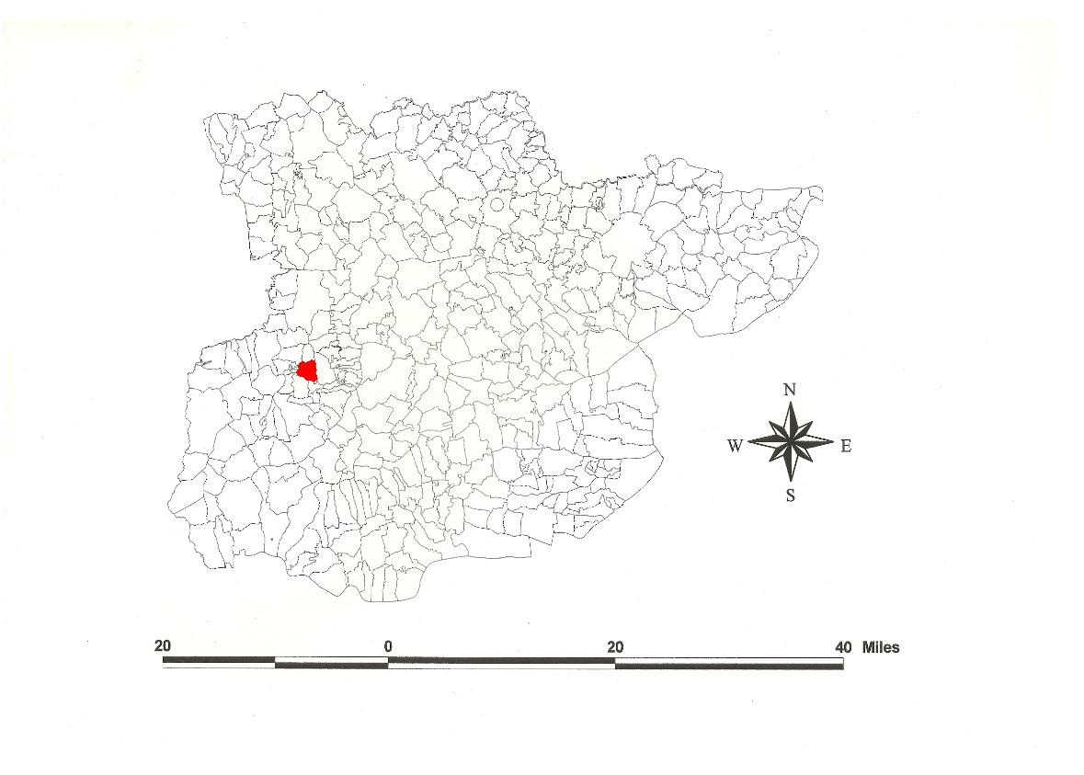
Moreton parish in the County of Essex
Reproduced by permission of
Essex County Council

The Parish of Moreton (in Ongar Hundred).

The Tithe Award of Moreton (Essex Record Office D/CT 244a), dated 1838, shows a rent-charge payable to the rector Henry Pepys of £375 plus £12-4-0 for rectorial glebe plus £3-1-0 for vicarial glebe (total £390-5-0). The whole parish measured 1435 acres 2 roods 15 perches, of which 1151a 2r 0p were arable, 273a 0r 17p meadow and pasture, 11 acres wood and 86a 0r 21p glebe. The Tithe Commissioners were Willam Blamire and JW Buller, the Valuer Robert Baker of Writtle.

The Tithe Map (ERO: D/CT 244b), dated 1839, was surveyed by Messrs Clayton of Ingatestone and copied by Robt Baker at a scale of 26.6” to a mile and measures 58”x65”. It was countersigned by Roger Kynaston, Assistant Tithe Commissioner.

In 1066x1077, William of Éscoeis granted to the abbey of St Stephen in Caen the church of Moreton with its lands and tithes (Hart, 1971). In Domesday Book, 1086, Mortuna was held by William of Écouis (from Eure, a tenant-in chief in three eastern counties, in Dorset and on the Welsh border) in lordship which Saxi had held as a manor for 1 hide and 20 acres (Morris, 1983; Kemble, 2007). Watts (2004) translates this from Old English mor tun, ‘moor settlement’ often implying a vill which was part of a larger territorial unit.

The church dedicated to St Mary has a C13 nave and chancel, and a brick tower rebuilt in 1787 (Andrews, 2003). Black Hall has exposed timbers and a gabled cross-wing, the hall subdivided in C16. The former Rectory south west of the church is mainly C17 with a Georgian front (Pevsner, 2007). Hancocks has a complete example of a mediaeval detached kitchen (Stenning, 1997).
.
The Hundred name in Domesday Book is 1086, Hangra, Angra. The wood at Aungre was bequeathed by Thurstan, son of Lustwine, in 1043x45 to his servants except the deer-enclosure and stud there, and to Thurgot the half hide which Ælfstan occupied (Whitelock, 1930). In 1068 Angra (Chipping Ongar) was confirmed to St Martin le Grand in London by William I (Hart, 1971). Reaney (1935) translates this from Old English anger, ‘grass land’. Christie (1926) sites the moot at Richard de Lucy’s castle at Chipping Ongar or at Toot Hill at Stanford Rivers where stands a ‘mill’ mound.

Place- and field-names from other documents are shown against the Tithe Award names. Place-names in Moreton from the Survey of Blake Hall (ERO: D/DCc E6), dated 1820, are contained in the Place-name e-book of Bobbingworth, Greensted etc at www.essex.ac.uk/history/esah/essexplacenames (Lamb, 2005).

References:
Andrews, D., 2003. Essex Archaeology & History, 34, 269.
Christie, M., 1926. Essex Hundred Moots. Trans Essex Archaeological Society, xviii (3), 192.
Hart, C., 1971. Early Charters of Essex. Leicester.
Kemble, J., 2007. Essex Place-names, Places, Streets & People. Historical Publications. p.74
Lamb, E., 2005. Survey of Blake Hall in Bobbingworth etc, 1820. www.essex.ac.uk/history/esah/essexplacenames. Then click on “Books”.
Morant, P., 1768. History & Antiquities of the County of Essex.
Pevsner, N., Bettley, J., 2007. Buildings of England - Essex. Yale.
Reaney, P., 1935. Place-names of Essex. Cambridge.
Stenning, D., 1997. Medieval Kitchens. Essex Archaeology & History, 28, 116.
Watts, V., 2004. Dictionary of English Place-names. Cambridge.
Whitelock, D., 1930. Anglo-Saxon Wills. Cambridge.

The Tithe Award Place-names of Moreton - by Parcel No.

Place-name | Alias | Fld No | Grd Ref | x | y | Acr | rd | pch | land use | Owner | Occupier | Other information
Barley Ley |  | 1 | TL | 524 | 065 | 0 | 1 | 33 | pasture | Elives, John Paine | Gingell, George | detached
Barley Ley |  | 2 | TL |  |  | 8 | 1 | 15 | arable | Elives, John Paine | Gingell, George
Great Mead |  | 3 | TL | 524 | 068 | 4 | 0 | 4 | pasture | Elives, John Paine | Gingell, George
High Laver Mead |  | 4 | TL |  |  | 4 | 0 | 20 | pasture | Elives, John Paine | Gingell, George
Gravel pits |  | 5 | TL | 525 | 066 | 9 | 1 | 10 | arable | Elives, John Paine | Gingell, George
Stack field |  | 6 | TL |  |  | 1 | 0 | 20 | pasture | Mathews, Charles | Smith, Thomas
Middle field |  | 7 | TL |  |  | 1 | 0 | 37 | pasture | Mathews, Charles | Smith, Thomas
Pagle field |  | 8 | TL | 527 | 066 | 1 | 0 | 16 | pasture | Mathews, Charles | Smith, Thomas
Pightle |  | 9 | TL |  |  | 2 | 0 | 22 | pasture | Knight, Charlotte | Knight, Charlotte
Brick mead |  | 10 | TL | 527 | 069 | 1 | 3 | 37 | pasture | Thistlewood, George | Thurgood, James
Humphreys field |  | 11 | TL |  |  | 5 | 3 | 23 | arable | Thistlewood, George | Thurgood, James
Slow field |  | 12 | TL |  |  | 0 | 3 | 20 | arable | Mathews, Charles | Smith, Thomas
Cart shed field |  | 13 | TL |  |  | 0 | 3 | 29 | pasture | Mathews, Charles | Smith, Thomas
Homestead |  | 14 | TL | 528 | 066 | 0 | 1 | 7 |  | Mathews, Charles | Smith, Thomas
Hoppit |  | 16 | TL |  |  | 0 | 3 | 21 | pasture | Mathews, Charles | Smith, Thomas
Cottage, gdn |  | 17 | TL |  |  | 0 | 1 | 5 |  | White, James Prentis | White, James
House, gdn. Padle(ye)s, 1576,MoretonPR | [at Padlers End, 1777,C; Pedlars End, 1962,OS] | 18 | TL | 528 | 066 | 0 | 1 | 20 |  | Hawks, Wm; Bird, Wm & Thos; Johnstone, Wm; Nash, Fredk John | Clark, Susannah | Christina Pedeleuere, 1327,SubRoll
Cottage, gdn |  | 19 | TL |  |  | 0 | 1 | 2 |  | Smith, James | Archer, John
Padlers end field |  | 20 | TL | 529 | 066 | 3 | 0 | 24 | arable | Hawks, Wm; Bird, Wm & Thos; Johnstone, Wm; Nash, Fredk John | Clark, Susannah
Padlers End field |  | 21 | TL |  |  | 4 | 1 | 5 | arable | Blackburn, William | Schooling, Henry
Padlers End mead |  | 22 | TL | 532 | 065 | 1 | 3 | 17 | pasture | Blackburn, William | Schooling, Henry
Humphreys field |  | 23 | TL |  |  | 1 | 1 | 24 | pasture | Thistlewood, George | Thurgood, James
First Padlers end field |  | 24 | TL |  |  | 1 | 3 | 35 | arable | Blackburn, William | Schooling, Henry
Two cottages, gdns |  | 25 | TL | 529 | 067 | 0 | 1 | 12 |  | Moreton Poor, trustees | Moreton Poor
House, gdn |  | 26 | TL | 529 | 067 | 0 | 0 | 28 |  | Camelin, Mark | White, Charles
Acre meadow |  | 27 | TL |  |  | 1 | 0 | 4 | pasture | Camelin, Mark | White, Charles
Padlers field |  | 28 | TL |  |  | 4 | 1 | 27 | arable | Thistlewood, George | Thurgood, James
Half acre meadow |  | 29 | TL |  |  | 0 | 3 | 25 | pasture | Camelin, Mark | White, Charles
Slipe |  | 30 | TL | 530 | 070 | 1 | 3 | 12 | pasture | Chaplin, Thomas | Chaplin, Thomas
Padlers End field |  | 31 | TL |  |  | 2 | 0 | 30 | arable | Algar, Wm Hill | Algar, Wm Hill
Scotch Croft |  | 32 | TL |  |  | 2 | 0 | 22 | arable | Thistlewood, George | Thurgood, James
Maltyens Hoppit |  | 33 | TL |  |  | 1 | 1 | 18 | pasture | Carter, John | Smith, Thomas
Cottage, gdn |  | 33a | TL |  |  | 0 | 0 | 32 |  | Maryon, William | Willey, Thomas
Bridge mead | [at Moreton Bridge, 1875,OS] | 34 | TL | 534 | 068 | 1 | 2 | 7 | pasture | Pepys, Rev Henry | Overall, Richard | glebe
The Meadow |  | 35 | TL | 534 | 070 | 1 | 2 | 15 | pasture | Poole, John | Abry, Claydon Robt
Skinners | Skinners, 1542,Waller | 36 | TL | 532 | 070 | 1 | 3 | 26 | pasture | Carter, Robert | White, James Arnold
Cottage, gdn |  | 37 | TL |  |  | 0 | 0 | 29 |  | Chaplin, Thomas | Chaplin, Thomas
Mill mead |  | 38 | TL | 531 | 072 | 5 | 1 | 14 | pasture | Chaplin, Thomas | Chaplin, Thomas
Long mead |  | 41 | TL | 531 | 073 | 2 | 0 | 0 | pasture | Carter, Robert | White, James Arnold
House, gdn |  | 43 | TL |  |  | 0 | 1 | 4 |  | Carter, Robert | White, James Arnold
Pond piece |  | 45 | TL | 533 | 072 | 0 | 2 | 0 | pasture | Carter, Robert | White, James Arnold
Road side hoppit |  | 46 | TL |  |  | 1 | 2 | 10 | pasture | Carter, Robert | White, James Arnold
Rainbow field |  | 47 | TL |  |  | 1 | 0 | 25 | arable | Blackburn, William | Schooling, Henry
Clay pit field |  | 48 | TL |  |  | 2 | 2 | 7 | arable | Algar, Wm Hill | Algar, Wm Hill
Shatten Leys |  | 49 | TL | 532 | 074 | 3 | 2 | 26 | pasture | Pepys, Rev Henry | Overall, Richard | glebe
Brick kiln hoppit |  | 50 | TL | 532 | 075 | 0 | 1 | 10 | pasture | Chaplin, Thomas | Chaplin, Thomas
Brick kiln hoppit |  | 51 | TL | 533 | 075 | 1 | 1 | 30 | pasture | Chaplin, Thomas | Chaplin, Thomas
London mead |  | 52 | TL |  |  | 2 | 0 | 0 | pasture | Algar, Wm Hill | Overall, Richard
London mead |  | 53 | TL | 532 | 076 | 2 | 0 | 17 | pasture | Algar, Wm Hill | Algar, Wm Hill
House, gdn | Castle House, 1875,OS; Crispins, 1962,OS | 54 | TL | 533 | 076 | 0 | 1 | 24 |  | Eve, Richard | Reddington, John
Moreton Mead |  | 55 | TL | 532 | 077 | 1 | 2 | 6 | pasture | Crooks, Jarah | Pavitt, William
Cottage, gdn |  | 56 | TL |  |  | 0 | 0 | 12 |  | Crooks, Sarah | Pavitt, William
Further field |  | 57 | TL |  |  | 2 | 0 | 7 | arable | Church Property, trustees | Morris, Joseph
Chase Lane |  | 58 | TL |  |  | 2 | 1 | 7 | pasture | Church Property, trustees | Morris, Joseph
House, gdn, orchard |  | 59 | TL | 531 | 078 | 0 | 2 | 29 |  | Eve, Richard | Eve, Richard
Reading |  | 61 | TL | 532 | 080 | 18 | 0 | 12 | arable | Quinton, Thomas | Barnard, William
Knaves Acre |  | 62 | TL |  |  | 1 | 1 | 30 | pasture | Eve, Richard | Reddington, John
Mill | Moreton Mill (Corn), 1875,OS | 63 | TL | 534 | 080 | 0 | 1 | 0 |  | Eve, Richard | Reddington, John
Hoppit |  | 64 | TL |  |  | 0 | 2 | 10 | pasture | Eve, Richard | Reddington, John
Cottage, gdn |  | 65 | TL | 534 | 080 | 0 | 0 | 35 |  | Eve, Richard | Reddington, John
Barren Lay |  | 66 | TL | 534 | 078 | 6 | 0 | 30 | arable | Algar, Wm Hill | Algar, Wm Hill
Morris's field |  | 67 | TL |  |  | 1 | 1 | 14 | arable | Carter, Robert | White, James Arnold
Cottage, gdn | Dealtrees, 1875,OS | 68 | TL | 534 | 077 | 0 | 0 | 28 |  | Houchin, John | Benton, George
Hither field |  | 70 | TL | 534 | 076 | 2 | 0 | 34 | arable | Church Property, trustees | Morris, Joseph
Mill field |  | 71 | TL | 535 | 077 | 17 | 3 | 20 | arable | Algar, Wm Hill | Algar, Wm Hill
Ten acre wood |  | 73 | TL |  |  | 11 | 1 | 0 | arable | Algar, Wm Hill | Algar, Wm Hill
Long mead |  | 74 | TL |  |  | 4 | 1 | 0 | pasture | Algar, Wm Hill | Algar, Wm Hill
Twelve acre wood |  | 75 | TL | 538 | 082 | 14 | 1 | 10 | arable | Algar, Wm Hill | Algar, Wm Hill
Dunge Lands |  | 76 | TL | 539 | 077 | 34 | 0 | 14 | arable | Algar, Wm Hill | Algar, Wm Hill | Roman rd runs thro’
Cottage, gdn | Church Farm, 1875,OS | 79 | TL | 534 | 076 | 0 | 1 | 27 |  | Church Property, trustees | Morris, Joseph
Gravel pit field |  | 80 | TL | 533 | 075 | 15 | 0 | 20 | arable | Algar, Wm Hill | Algar, Wm Hill
Church field |  | 81 | TL |  |  | 21 | 0 | 25 | arable | Algar, Wm Hill | Algar, Wm Hill
Lamb Coats |  | 82 | TL | 533 | 073 | 0 | 3 | 16 | arable | Carter, Robert | White, James Arnold
Lambs croft |  | 83 | TL |  |  | 2 | 2 | 25 | arable | Algar, Wm Hill | Algar, Wm Hill
Home field |  | 84 | TL | 534 | 072 | 4 | 2 | 39 | arable | Blackburn, William | Schooling, Henry
House, gdn |  | 91 | TL | 534 | 070 | 0 | 0 | 30 |  | Carter, Robert | White, James Arnold
White Hart Inn | Old White Hart P.H., 1875,OS | 92 | TL | 533 | 068 | 0 | 3 | 34 | inn | Hawks, Wm; Bird, Wm & Thos; Johnstone, Wm; Nash, Fredk John | Clark, Susannah | Roman road east
The Moors |  | 92a | TL |  |  | 1 | 2 | 10 | pasture | Algar, Wm Hill | Algar, Wm Hill
The Moors (pt) |  | 92b | TL |  |  | 1 | 0 | 0 | pasture | Stokes, Richard | Algar, Wm Hill
Garden |  | 101 | TL |  |  | 0 | 1 | 27 | pasture | White, James jnr | White, James jnr
Pen mead |  | 102 | TL | 545 | 069 | 8 | 0 | 30 | pasture | Algar, Wm Hill | Algar, Wm Hill
The Mead |  | 103 | TL |  |  | 1 | 2 | 17 | pasture | Hawks, Wm; Bird, Wm & Thos; Johnstone, Wm; Nash, Fredk John | Clark, Susannah
Little pen mead |  | 104 | TL |  |  | 0 | 3 | 14 | pasture | Algar, Wm Hill | Algar, Wm Hill
The Wood | Moreton Wood, 1875,OS | 105 | TL | 535 | 065 | 11 | 2 | 28 | wood | Freer, Robert Henry | Rogers, George
Wood mead |  | 106 | TL |  |  | 3 | 0 | 27 | pasture | Freer, Robert Henry | Rogers, George
Half acre mead |  | 107 | TL |  |  | 0 | 2 | 7 | pasture | Crue, William | Thurgood, James
Bonnets |  | 108 | TL | 538 | 065 | 6 | 0 | 32 | arable | Crue, William | Thurgood, James
Little piece |  | 109 | TL |  |  | 0 | 0 | 37 | pasture | Crue, William | Thurgood, James
Long mead |  | 110 | TL | 540 | 065 | 6 | 1 | 25 | pasture | White, Joseph | White, Joseph
The slip |  | 111 | TL |  |  | 0 | 1 | 14 | pasture | Crue, William | Thurgood, James
Great Evil |  | 114 | TL | 540 | 063 | 16 | 2 | 10 | pasture | White, Joseph | White, Joseph
Little Evil |  | 115 | TL |  |  | 4 | 2 | 30 | pasture | White, Joseph | White, Joseph
Home mead |  | 116 | TL |  |  | 8 | 3 | 26 | pasture | White, Joseph | White, Joseph
Homestead | Southend Newhouse, 1875,OS; Wood Farm, 1962,OS | 117 | TL | 543 | 059 | 2 | 0 | 4 |  | White, Joseph | White, Joseph
Hop garden |  | 118 | TL |  |  | 4 | 0 | 25 | pasture | Chaplin, John, late, trustees | Eve, William
Lower Stone Croft |  | 119 | TL |  |  | 10 | 0 | 32 | arable | White, Joseph | White, Joseph
Much mead |  | 120 | TL | 543 | 062 | 4 | 1 | 9 | pasture | White, Joseph | White, Joseph
The wood |  | 121 | TL |  |  | 5 | 2 | 20 | arable | White, Joseph | White, Joseph
White shots |  | 122 | TL |  |  | 10 | 2 | 34 | arable | White, Joseph | White, Joseph
Round mead |  | 123 | TL |  |  | 3 | 0 | 6 | pasture | White, Joseph | White, Joseph
Hop garden |  | 124 | TL |  |  | 3 | 0 | 37 | pasture | White, Joseph | White, Joseph
Hilly's Moors |  | 125 | TL | 541 | 065 | 8 | 0 | 12 | pasture | White, Joseph | White, Joseph
Lower Chaffords |  | 126 | TL |  |  | 2 | 2 | 27 | pasture | Freer, Robert Henry | Rogers, George
Upper Chaffords |  | 127 | TL | 540 | 067 | 6 | 2 | 18 | pasture | Freer, Robert Henry | Rogers, George
Over the River Mead |  | 128 | TL |  |  | 0 | 3 | 32 | pasture | Crue, William | Thurgood, James
Round mead |  | 129 | TL |  |  | 2 | 3 | 8 | pasture | Freer, Robert Henry | Rogers, George
Walnut tree piece |  | 130 | TL | 539 | 069 | 3 | 3 | 0 | pasture | Freer, Robert Henry | Rogers, George
Homestead | Ladyhalle, 1382,IpmR; Overhalle, 1538,FF; Upper Hall, 1538,LP | 131 | TL | 540 | 069 | 1 | 3 | 8 |  | Freer, Robert Henry | Rogers, George | Lady from Juliana, dau of John de Sandwich, Morant,i,145
Earls Mead |  | 132 | TL |  |  | 3 | 2 | 21 | pasture | Wrag, Lucy, execs | Algar, Wm Hill
Earls Mead |  | 133 | TL | 537 | 069 | 1 | 3 | 20 | pasture | Wrag, Lucy, execs | Algar, Wm Hill
House, gdn | Motton's Farm, 1875,OS | 134 | TL | 536 | 070 | 0 | 0 | 35 |  | Wrag, Lucy, execs | Algar, Wm Hill
Hoppet |  | 135 | TL |  |  | 2 | 1 | 35 | pasture | Algar, Wm Hill | Algar, Wm Hill
Rectory |  | 136 | TL | 536 | 071 | 1 | 0 | 28 |  | Pepys, Rev Henry | Overall, Richard | glebe
Church & Yard | [St Marys] | 137 | TL | 536 | 071 | 0 | 3 | 3 |  | .. | ..
Homestead | Netherhall al. Bourchers Hall, 1542,FF; Nether Hall, 1875,OS | 138 | TL | 539 | 070 | 0 | 2 | 6 |  | Algar, Wm Hill | Algar, Wm Hill | Robert Burghcher, c1349,Ipm
Stack yard |  | 139 | TL |  |  | 2 | 2 | 30 | pasture | Freer, Robert Henry | Rogers, George
Kitchen mead |  | 139a | TL |  |  | 0 | 1 | 10 | pasture | Freer, Robert Henry | Rogers, George
The Ley |  | 140 | TL | 540 | 071 | 9 | 1 | 17 | pasture | Algar, Wm Hill | Algar, Wm Hill
Lower Malting field |  | 142 | TL | 541 | 073 | 5 | 1 | 0 | arable | Pepys, Rev Henry | Overall, Richard | glebe
Malting field |  | 144 | TL | 541 | 074 | 1 | 3 | 5 | arable | Houchin, William | Schooling, Henry
Malting mead | [at North lane, 1875,OS] | 145 | TL | 540 | 074 | 0 | 3 | 27 | pasture | Houchin, William | Schooling, Henry
Malting mead |  | 146 | TL | 542 | 074 | 0 | 2 | 0 | pasture | Houchin, William | Schooling, Henry
Cottage, gdn | Malting, 1875,OS | 147 | TL | 543 | 074 | 0 | 1 | 6 |  | Houchin, John | Pearce, James
Wakerotes |  | 148 | TL |  |  | 2 | 3 | 10 | pasture | Smith, Elizabeth | Smith, Elizabeth
Homestead | Scotts Fm, 1962,OS | 149 | TL | 543 | 073 | 0 | 2 | 10 |  | Smith, Elizabeth | Smith, Elizabeth | William Scot, 1323,For
Little Hoppit |  | 150 | TL | 544 | 074 | 1 | 3 | 14 | pasture | Smith, Elizabeth | Smith, Elizabeth
Spring field |  | 151 | TL |  |  | 2 | 3 | 20 | arable | Smith, Elizabeth | Smith, Elizabeth
Chadwell |  | 152 | TL | 543 | 074 | 3 | 1 | 27 | arable | Algar, Wm Hill | Overall, Richard
Sheeps Tilts |  | 154 | TL |  |  | 2 | 3 | 28 | arable | Smith, Elizabeth | Smith, Elizabeth
Rainbow field |  | 155 | TL | 545 | 076 | 1 | 2 | 17 | arable | Church, John | Church, John
Hurleys |  | 158 | TL |  |  | 12 | 0 | 19 | arable | Algar, Wm Hill | Overall, Richard
Gate Croat |  | 159 | TL |  |  | 4 | 3 | 25 | arable | Maitland, Ebenezer Fuller | Clarence, Henry
Clark lands |  | 160 | TL | 545 | 077 | 10 | 2 | 10 | arable | Maitland, Ebenezer Fuller | Clarence, Henry
Fore mead |  | 161 | TL |  |  | 4 | 0 | 8 | pasture | Maitland, Ebenezer Fuller | Clarence, Henry
Spencers hoppit |  | 162 | TL |  |  | 1 | 0 | 10 | pasture | Maitland, Ebenezer Fuller | Clarence, Henry
Spencers hoppit |  | 163 | TL | 543 | 081 | 2 | 2 | 34 | pasture | Maitland, Ebenezer Fuller | Clarence, Henry
The little pasture |  | 165 | TL |  |  | 0 | 2 | 24 | pasture | Pegram, John | Pegram, John
House, gdn |  | 166 | TL | 544 | 079 | 0 | 1 | 6 |  | Pegram, John | Pegram, John
Great field |  | 167 | TL |  |  | 5 | 1 | 12 | arable | Pegram, John | Pegram, John
House, gdn |  | 168 | TL |  |  | 0 | 0 | 37 |  | Pegram, John | Pegram, John
Further Dunge Lands |  | 170 | TL | 541 | 080 | 16 | 0 | 4 | arable | Algar, Wm Hill | Algar, Wm Hill
Wood Croat |  | 171 | TL |  |  | 2 | 1 | 10 | arable | Maitland, Ebenezer Fuller | Clarence, Henry
Done pickle |  | 172 | TL | 540 | 083 | 5 | 2 | 24 | arable | Maitland, Ebenezer Fuller | Clarence, Henry
Rowen mead (pt) |  | 173 | TL |  |  | 0 | 0 | 35 | pasture | Maitland, Ebenezer Fuller | Clarence, Henry
Further Laver field |  | 176 | TL | 546 | 085 | 8 | 0 | 30 | arable | Maitland, Ebenezer Fuller | Clarence, Henry
Hither Laver field |  | 177 | TL |  |  | 7 | 3 | 35 | arable | Maitland, Ebenezer Fuller | Clarence, Henry
Moreton Seven acres | [at Black Lane, 1875,OS] | 179 | TL | 550 | 086 | 7 | 3 | 0 | arable | Brown, Charles | Tanner, John
Harwoods |  | 180 | TL | 552 | 085 | 3 | 1 | 25 | arable | Church, John | Church, John
Howwoods |  | 181 | TL |  |  | 9 | 2 | 20 | arable | Smith, Elizabeth | Smith, Elizabeth
Tarbart |  | 182 | TL | 552 | 084 | 8 | 1 | 17 | arable | Fyfield, Poor, trustees | Tarbard, James
Clarance |  | 183 | TL |  |  | 3 | 3 | 7 | arable | Maitland, Ebenezer Fuller | Clarence, Tabrum
Small gains |  | 184 | TL |  |  | 3 | 1 | 5 | arable | Felsted School, trustees | Taverner, Thomas
Pond piece |  | 186 | TL |  |  | 0 | 0 | 19 | arable | Brown, Charles | Tanner, John
Rockwells | Estones alias Rochells, al. Noks, 1542,Waller | 188 | TL | 548 | 083 | 8 | 1 | 15 | arable | Maitland, Ebenezer Fuller | Clarence, Henry
Neighbours field |  | 189 | TL |  |  | 7 | 0 | 30 | arable | Maitland, Ebenezer Fuller | Clarence, Henry
Kitchen field |  | 190 | TL | 545 | 082 | 5 | 3 | 0 | arable | Maitland, Ebenezer Fuller | Clarence, Henry
Homestead | newhouse, 1585,  Moreton PR | 191 | TL | 545 | 081 | 1 | 1 | 20 |  | Maitland, Ebenezer Fuller | Clarence, Henry | moated
Orchard |  | 192 | TL |  |  | 3 | 3 | 20 | pasture | Maitland, Ebenezer Fuller | Clarence, Henry
Green Coat |  | 193 | TL |  |  | 2 | 2 | 8 | arable | Maitland, Ebenezer Fuller | Clarence, Henry
Cottage, gdn |  | 194 | TL |  |  | 0 | 1 | 0 |  | Maitland, Ebenezer Fuller | Clarence, Henry
Clarks |  | 195 | TL | 550 | 081 | 7 | 1 | 7 | arable | Church, John | Church, John
Clarance |  | 196 | TL |  |  | 3 | 3 | 37 | arable | Maitland, Ebenezer Fuller | Clarence, Tabrum
Clarance |  | 197 | TL | 552 | 082 | 1 | 2 | 34 | pasture | Maitland, Ebenezer Fuller | Clarence, Tabrum
Clarance |  | 198 | TL |  |  | 1 | 2 | 23 | pasture | Maitland, Ebenezer Fuller | Clarence, Tabrum
Clarance |  | 199 | TL |  |  | 0 | 3 | 14 | pasture | Maitland, Ebenezer Fuller | Clarence, Tabrum
Homestead | Emperors, 1875,OS | 200 | TL | 555 | 083 | 0 | 2 | 16 |  | Maitland, Ebenezer Fuller | Clarence, Tabrum
Acre mead |  | 203 | TL |  |  | 0 | 3 | 33 | pasture | Church, John | Church, John
Cottage, gdn |  | 204 | TL |  |  | 0 | 1 | 7 |  | Church, John | Church, John
Noaks Orchard |  | 205 | TL | 550 | 078 | 1 | 0 | 20 | pasture | Church, John | Church, John | John atte Noke, 1381,SubRoll
Church mead |  | 207 | TL |  |  | 3 | 0 | 19 | pasture | Church, John | Church, John
Robbins field |  | 208 | TL | 549 | 080 | 6 | 2 | 25 | arable | Maitland, Ebenezer Fuller | Clarence, Henry
The Ley |  | 209 | TL |  |  | 2 | 3 | 4 | pasture | Church, John | Church, John
Home mead |  | 210 | TL |  |  | 2 | 1 | 9 | pasture | Church, John | Church, John
Homestead | Netherhall al. Grenys, 1542,Waller; Greens, 1875,OS | 211 | TL | 548 | 079 | 0 | 2 | 0 |  | Church, John | Church, John | Thomas atte Greene, 1327,SubRoll
One acre mead |  | 212 | TL |  |  | 1 | 0 | 30 | pasture | Stock, Richard | Stock, Richard
House, gdn |  | 213 | TL |  |  | 0 | 3 | 12 |  | Stock, Richrad | Stock, Richrad
Hamsicles |  | 215 | TL | 546 | 076 | 3 | 0 | 31 | arable | Maitland, Ebenezer Fuller | Clarence, Henry
Cottage, gdn | Tanner's Cottages, 1875,OS | 216 | TL | 548 | 076 | 0 | 3 | 30 |  | Tanner, John | Speed, James
Great Bulmans |  | 217 | TL |  |  | 5 | 3 | 27 | arable | Smith, Elizabeth | Smith, Elizabeth
Newmans |  | 218 | TL |  |  | 4 | 0 | 18 | arable | Smith, Elizabeth | Smith, Elizabeth
Little Bulmans |  | 219 | TL |  |  | 4 | 0 | 15 | arable | Smith, Elizabeth | Smith, Elizabeth
Hill field |  | 220 | TL | 548 | 073 | 11 | 3 | 14 | arable | Algar, Wm Hill | Overall, Richard
Little Hill field |  | 221 | TL |  |  | 4 | 2 | 32 | arable | Algar, Wm Hill | Overall, Richard
Kitchen field |  | 222 | TL |  |  | 7 | 1 | 13 | arable | Algar, Wm Hill | Overall, Richard
Further Hoppet |  | 223 | TL |  |  | 1 | 0 | 0 | pasture | Algar, Wm Hill | Overall, Richard
Homestead | Hill Farm, 1875,OS | 224 | TL | 545 | 074 | 1 | 0 | 25 |  | Algar, Wm Hill | Overall, Richard
Middle Hoppet |  | 225 | TL |  |  | 2 | 1 | 0 | pasture | Algar, Wm Hill | Overall, Richard
New piece |  | 226 | TL |  |  | 1 | 0 | 20 | pasture | Algar, Wm Hill | Overall, Richard
Sterrys |  | 227 | TL | 546 | 073 | 2 | 1 | 21 | arable | Algar, Wm Hill | Overall, Richard
Hop Garden |  | 228 | TL |  |  | 9 | 1 | 35 | pasture | Freer, Robert Henry | Rogers, George
Great Hall field |  | 229 | TL | 543 | 073 | 27 | 3 | 5 | arable | Freer, Robert Henry | Rogers, George
Ley |  | 230 | TL | 542 | 068 | 10 | 3 | 5 | pasture | Freer, Robert Henry | Rogers, George
Little Hall field |  | 231 | TL |  |  | 5 | 1 | 33 | arable | Freer, Robert Henry | Rogers, George
Little Oval |  | 232 | TL |  |  | 14 | 0 | 0 | arable | Freer, Robert Henry | Rogers, George
Great Oval |  | 233 | TL |  |  | 21 | 2 | 30 | arable | Freer, Robert Henry | Rogers, George
Oval field |  | 234 | TL | 546 | 064 | 24 | 1 | 20 | arable | White, Joseph | White, Joseph
Upper Stone Rock |  | 236 | TL |  |  | 8 | 1 | 35 | arable | White, Joseph | White, Joseph
Five acre mead |  | 237 | TL |  |  | 5 | 1 | 24 | arable | Cure, Capel | Willy, John
Warmsley (pt) |  | 238 | TL |  |  | 12 | 1 | 30 | pasture | Chaplin, John, late, trustees | Eve, William
Spring field | Spring field, 1820, D/DCc E6 | 239 | TL | 550 | 062 | 10 | 2 | 5 | arable | Cure, Capel | Willy, John
Wall field |  | 240 | TL | 552 | 060 | 18 | 2 | 35 | arable | Chaplin, John, late, trustees | Eve, William
Homestead | Brandish, Burndhatch al. Burndish, 1542,Waller; Burndish Hall, 1875,OS | 241 | TL | 553 | 058 | 2 | 1 | 15 |  | Chaplin, John, late, trustees | Eve, William | moated. John de Burndish (Sflk), 1304,Orig
Shelley Hall (pt) |  | 242 | TL |  |  | 3 | 0 | 33 | arable | Tomlinson, James | Tomlinson, James
Cart house field |  | 243 | TL |  |  | 23 | 2 | 0 | arable | Chaplin, John, late, trustees | Eve, William
The Ley |  | 244 | TL |  |  | 4 | 3 | 30 | pasture | Chaplin, John, late, trustees | Eve, William
Horse pasture |  | 246 | TL | 556 | 059 | 3 | 0 | 8 | arable | Chaplin, John, late, trustees | Eve, William
Reading |  | 247 | TL |  |  | 15 | 3 | 0 | arable | Chaplin, John, late, trustees | Eve, William
Fold |  | 248 | TL |  |  | 8 | 2 | 12 | arable | Chaplin, John, late, trustees | Eve, William
Cottage, gdn |  | 249 | TL | 555 | 063 | 0 | 1 | 9 |  | Felsted School, trustees | Taverner, Thomas
Hammer field |  | 253 | TL | 555 | 064 | 3 | 1 | 14 | arable | Algar, Wm Hill | Smith, Thomas
Eliza's |  | 254 | TL |  |  | 3 | 3 | 17 | arable | Felsted School, trustees | Taverner, Thomas
Brook Croat |  | 255 | TL | 555 | 066 | 2 | 3 | 15 | arable | Chaplin, John, late, trustees | Eve, William
Cottage, gdn |  | 255a | TL |  |  | 0 | 0 | 32 |  | Chaplin, John, late, trustees | Eve, William
Colt Croft |  | 256 | TL |  |  | 1 | 3 | 30 | arable | Felsted School, trustees | Taverner, Thomas
Homestead | Crosslees, 1650, MoretonPR; Cross Lees, 1875,OS | 257 | TL | 555 | 065 | 2 | 2 | 14 |  | Cure, Capel | Willy, John | moated
Cross path field |  | 258 | TL |  |  | 10 | 3 | 25 | arable | Cure, Capel | Willy, John
Gibbs's | Gyppes, tElizI, ChancP | 260 | TL | 552 | 066 | 21 | 2 | 20 | arable | White, Joseph | White, Joseph
Long mead |  | 261 | TL | 549 | 066 | 2 | 1 | 8 | arable | Cure, Capel | Willy, John
Hop Garden Mead |  | 262 | TL |  |  | 1 | 1 | 27 | pasture | Algar, Wm Hill | Overall, Richard
Mill field hoppit |  | 263 | TL | 558 | 067 | 1 | 1 | 20 | pasture | Freer, Robert Henry | Rogers, George
Mill field |  | 264 | TL | 557 | 070 | 34 | 1 | 30 | arable | Freer, Robert Henry | Rogers, George
Barn croft |  | 267 | TL |  |  | 1 | 2 | 20 | pasture | Felsted School, trustees | Taverner, Thomas
Homestead | Harriets, 1875,OS | 268 | TL | 554 | 067 | 0 | 2 | 10 |  | Felsted School, trustees | Taverner, Thomas
Colt Croft |  | 269 | TL |  |  | 1 | 1 | 7 | pasture | Felsted School, trustees | Taverner, Thomas
Barn field | Barn field, 1820,  D/DCc E6 | 270 | TL | 553 | 066 | 11 | 2 | 27 | arable | Cure, Capel | Willy, John
Giles's |  | 271 | TL | 554 | 070 | 5 | 1 | 34 | pasture | Felsted School, trustees | Taverner, Thomas
Cottage, gdn | Lofty Hall, 1875,OS | 271a | TL | 554 | 072 | 0 | 2 | 27 |  | Lewis, Jonathan | Smith, Thomas
Brambles |  | 273 | TL |  |  | 5 | 1 | 35 | arable | Felsted School, trustees | Taverner, Thomas
Further field |  | 274 | TL |  |  | 4 | 2 | 20 | arable | Algar, Wm Hill | Overall, Richard
Great Reas |  | 274a | TL | 552 | 072 | 7 | 2 | 32 | arable | Freer, Robert Henry | Rogers, George
Parsonage field |  | 275 | TL | 552 | 070 | 11 | 0 | 35 | arable | Cure, Capel | Willy, John
Gate Croft |  | 276 | TL |  |  | 3 | 2 | 0 | arable | Algar, Wm Hill | Overall, Richard
Ash field |  | 277 | TL |  |  | 23 | 1 | 25 | arable | Freer, Robert Henry | Rogers, George
Little Reas |  | 278 | TL |  |  | 4 | 3 | 32 | arable | Freer, Robert Henry | Rogers, George
Brook Croft | Brook Croft, 1820, D/DCc E6 | 279 | TL |  |  | 2 | 3 | 20 | arable | Cure, Capel | Willy, John
Rowleys |  | 280 | TL | 554 | 074 | 6 | 2 | 0 | arable | Freer, Robert Henry | Rogers, George
House, gdn |  | 281a | TL |  |  | 0 | 0 | 22 |  | Rayner, Edward | Tabert, James
Constables land |  | 282 | TL |  |  | 5 | 1 | 30 | arable | Freer, Robert Henry | Rogers, George
Six acres |  | 283 | TL |  |  | 6 | 2 | 0 | arable | Rayner, Edward | Tabert, James
White shots | Embley's Farm, 1875,OS | 284 | TL | 554 | 075 | 12 | 3 | 9 | arable | Freer, Robert Henry | Rogers, George
Barn yard | Old Barns, 1875,OS | 285 | TL | 555 | 076 | 0 | 1 | 29 | arable | Freer, Robert Henry | Rogers, George
Long Dukes |  | 286 | TL |  |  | 4 | 3 | 32 | arable | Freer, Robert Henry | Rogers, George
Cobbs |  | 287 | TL | 553 | 077 | 14 | 0 | 0 | arable | Felsted School, trustees | Taverner, Thomas
Laver Cobbs (pt) |  | 288 | TL |  |  | 2 | 2 | 30 | arable | Felsted School, trustees | Taverner, Thomas

For abbreviations, see Reaney, P., 1935, Place-names of Essex. Cambridge; and Kemble, J., 2007, Essex Place-names, Places, Streets & People. Historical Publications, p151.

The Tithe Award Place-names of Moreton - by Owner.

Place-name | Alias | Fld No | Grd Ref | x | y | Acr | rd | pch | land use | Owner | Occupier | Other information
Pen mead |  | 102 | TL | 545 | 069 | 8 | 0 | 30 | pasture | Algar, Wm Hill | Algar, Wm Hill
Little pen mead |  | 104 | TL |  |  | 0 | 3 | 14 | pasture | Algar, Wm Hill | Algar, Wm Hill
Hoppet |  | 135 | TL |  |  | 2 | 1 | 35 | pasture | Algar, Wm Hill | Algar, Wm Hill
Homestead | Netherhall al. Bourchers Hall, 1542,FF; Nether Hall, 1875,OS | 138 | TL | 539 | 070 | 0 | 2 | 6 |  | Algar, Wm Hill | Algar, Wm Hill | Robert Burghcher, c1349,Ipm
The Ley |  | 140 | TL | 540 | 071 | 9 | 1 | 17 | pasture | Algar, Wm Hill | Algar, Wm Hill
Further Dunge Lands |  | 170 | TL | 541 | 080 | 16 | 0 | 4 | arable | Algar, Wm Hill | Algar, Wm Hill
Padlers End field |  | 31 | TL |  |  | 2 | 0 | 30 | arable | Algar, Wm Hill | Algar, Wm Hill
Clay pit field |  | 48 | TL |  |  | 2 | 2 | 7 | arable | Algar, Wm Hill | Algar, Wm Hill
London mead |  | 53 | TL | 532 | 076 | 2 | 0 | 17 | pasture | Algar, Wm Hill | Algar, Wm Hill
Barren Lay |  | 66 | TL | 534 | 078 | 6 | 0 | 30 | arable | Algar, Wm Hill | Algar, Wm Hill
Mill field |  | 71 | TL | 535 | 077 | 17 | 3 | 20 | arable | Algar, Wm Hill | Algar, Wm Hill
Ten acre wood |  | 73 | TL |  |  | 11 | 1 | 0 | arable | Algar, Wm Hill | Algar, Wm Hill
Long mead |  | 74 | TL |  |  | 4 | 1 | 0 | pasture | Algar, Wm Hill | Algar, Wm Hill
Twelve acre wood |  | 75 | TL | 538 | 082 | 14 | 1 | 10 | arable | Algar, Wm Hill | Algar, Wm Hill
Dunge Lands |  | 76 | TL | 539 | 077 | 34 | 0 | 14 | arable | Algar, Wm Hill | Algar, Wm Hill | Roman rd runs thro’
Gravel pit field |  | 80 | TL | 533 | 075 | 15 | 0 | 20 | arable | Algar, Wm Hill | Algar, Wm Hill
Church field |  | 81 | TL |  |  | 21 | 0 | 25 | arable | Algar, Wm Hill | Algar, Wm Hill
Lambs croft |  | 83 | TL |  |  | 2 | 2 | 25 | arable | Algar, Wm Hill | Algar, Wm Hill
The Moors |  | 92a | TL |  |  | 1 | 2 | 10 | pasture | Algar, Wm Hill | Algar, Wm Hill
Chadwell |  | 152 | TL | 543 | 074 | 3 | 1 | 27 | arable | Algar, Wm Hill | Overall, Richard
Hurleys |  | 158 | TL |  |  | 12 | 0 | 19 | arable | Algar, Wm Hill | Overall, Richard
Hill field |  | 220 | TL | 548 | 073 | 11 | 3 | 14 | arable | Algar, Wm Hill | Overall, Richard
Little Hill field |  | 221 | TL |  |  | 4 | 2 | 32 | arable | Algar, Wm Hill | Overall, Richard
Kitchen field |  | 222 | TL |  |  | 7 | 1 | 13 | arable | Algar, Wm Hill | Overall, Richard
Further Hoppet |  | 223 | TL |  |  | 1 | 0 | 0 | pasture | Algar, Wm Hill | Overall, Richard
Homestead | Hill Farm, 1875,OS | 224 | TL | 545 | 074 | 1 | 0 | 25 |  | Algar, Wm Hill | Overall, Richard
Middle Hoppet |  | 225 | TL |  |  | 2 | 1 | 0 | pasture | Algar, Wm Hill | Overall, Richard
New piece |  | 226 | TL |  |  | 1 | 0 | 20 | pasture | Algar, Wm Hill | Overall, Richard
Sterrys |  | 227 | TL | 546 | 073 | 2 | 1 | 21 | arable | Algar, Wm Hill | Overall, Richard
Hop Garden Mead |  | 262 | TL |  |  | 1 | 1 | 27 | pasture | Algar, Wm Hill | Overall, Richard
Further field |  | 274 | TL |  |  | 4 | 2 | 20 | arable | Algar, Wm Hill | Overall, Richard
Gate Croft |  | 276 | TL |  |  | 3 | 2 | 0 | arable | Algar, Wm Hill | Overall, Richard
London mead |  | 52 | TL |  |  | 2 | 0 | 0 | pasture | Algar, Wm Hill | Overall, Richard
Hammer field |  | 253 | TL | 555 | 064 | 3 | 1 | 14 | arable | Algar, Wm Hill | Smith, Thomas
Padlers End field |  | 21 | TL |  |  | 4 | 1 | 5 | arable | Blackburn, William | Schooling, Henry
Padlers End mead |  | 22 | TL | 532 | 065 | 1 | 3 | 17 | pasture | Blackburn, William | Schooling, Henry
First Padlers end field |  | 24 | TL |  |  | 1 | 3 | 35 | arable | Blackburn, William | Schooling, Henry
Rainbow field |  | 47 | TL |  |  | 1 | 0 | 25 | arable | Blackburn, William | Schooling, Henry
Home field |  | 84 | TL | 534 | 072 | 4 | 2 | 39 | arable | Blackburn, William | Schooling, Henry
Moreton Seven acres | [at Black Lane, 1875,OS] | 179 | TL | 550 | 086 | 7 | 3 | 0 | arable | Brown, Charles | Tanner, John
Pond piece |  | 186 | TL |  |  | 0 | 0 | 19 | arable | Brown, Charles | Tanner, John
House, gdn |  | 26 | TL | 529 | 067 | 0 | 0 | 28 |  | Camelin, Mark | White, Charles
Acre meadow |  | 27 | TL |  |  | 1 | 0 | 4 | pasture | Camelin, Mark | White, Charles
Half acre meadow |  | 29 | TL |  |  | 0 | 3 | 25 | pasture | Camelin, Mark | White, Charles
Maltyens Hoppit |  | 33 | TL |  |  | 1 | 1 | 18 | pasture | Carter, John | Smith, Thomas
Skinners | Skinners, 1542,Waller | 36 | TL | 532 | 070 | 1 | 3 | 26 | pasture | Carter, Robert | White, James Arnold
Long mead |  | 41 | TL | 531 | 073 | 2 | 0 | 0 | pasture | Carter, Robert | White, James Arnold
House, gdn |  | 43 | TL |  |  | 0 | 1 | 4 |  | Carter, Robert | White, James Arnold
Pond piece |  | 45 | TL | 533 | 072 | 0 | 2 | 0 | pasture | Carter, Robert | White, James Arnold
Road side hoppit |  | 46 | TL |  |  | 1 | 2 | 10 | pasture | Carter, Robert | White, James Arnold
Morris's field |  | 67 | TL |  |  | 1 | 1 | 14 | arable | Carter, Robert | White, James Arnold
Lamb Coats |  | 82 | TL | 533 | 073 | 0 | 3 | 16 | arable | Carter, Robert | White, James Arnold
House, gdn |  | 91 | TL | 534 | 070 | 0 | 0 | 30 |  | Carter, Robert | White, James Arnold
Hop garden |  | 118 | TL |  |  | 4 | 0 | 25 | pasture | Chaplin, John, late, trustees | Eve, William
Warmsley (pt) |  | 238 | TL |  |  | 12 | 1 | 30 | pasture | Chaplin, John, late, trustees | Eve, William
Wall field |  | 240 | TL | 552 | 060 | 18 | 2 | 35 | arable | Chaplin, John, late, trustees | Eve, William
Homestead | Brandish, Burndhatch al. Burndish, 1542,Waller; Burndish Hall, 1875,OS | 241 | TL | 553 | 058 | 2 | 1 | 15 |  | Chaplin, John, late, trustees | Eve, William | moated. John de Burndish (Sflk), 1304,Orig
Cart house field |  | 243 | TL |  |  | 23 | 2 | 0 | arable | Chaplin, John, late, trustees | Eve, William
The Ley |  | 244 | TL |  |  | 4 | 3 | 30 | pasture | Chaplin, John, late, trustees | Eve, William
Horse pasture |  | 246 | TL | 556 | 059 | 3 | 0 | 8 | arable | Chaplin, John, late, trustees | Eve, William
Reading |  | 247 | TL |  |  | 15 | 3 | 0 | arable | Chaplin, John, late, trustees | Eve, William
Fold |  | 248 | TL |  |  | 8 | 2 | 12 | arable | Chaplin, John, late, trustees | Eve, William
Brook Croat |  | 255 | TL | 555 | 066 | 2 | 3 | 15 | arable | Chaplin, John, late, trustees | Eve, William
Cottage, gdn |  | 255a | TL |  |  | 0 | 0 | 32 |  | Chaplin, John, late, trustees | Eve, William
Slipe |  | 30 | TL | 530 | 070 | 1 | 3 | 12 | pasture | Chaplin, Thomas | Chaplin, Thomas
Cottage, gdn |  | 37 | TL |  |  | 0 | 0 | 29 |  | Chaplin, Thomas | Chaplin, Thomas
Mill mead |  | 38 | TL | 531 | 072 | 5 | 1 | 14 | pasture | Chaplin, Thomas | Chaplin, Thomas
Brick kiln hoppit |  | 50 | TL | 532 | 075 | 0 | 1 | 10 | pasture | Chaplin, Thomas | Chaplin, Thomas
Brick kiln hoppit |  | 51 | TL | 533 | 075 | 1 | 1 | 30 | pasture | Chaplin, Thomas | Chaplin, Thomas
Further field |  | 57 | TL |  |  | 2 | 0 | 7 | arable | Church Property, trustees | Morris, Joseph
Chase Lane |  | 58 | TL |  |  | 2 | 1 | 7 | pasture | Church Property, trustees | Morris, Joseph
Hither field |  | 70 | TL | 534 | 076 | 2 | 0 | 34 | arable | Church Property, trustees | Morris, Joseph
Cottage, gdn | Church Farm, 1875,OS | 79 | TL | 534 | 076 | 0 | 1 | 27 |  | Church Property, trustees | Morris, Joseph
Rainbow field |  | 155 | TL | 545 | 076 | 1 | 2 | 17 | arable | Church, John | Church, John
Harwoods |  | 180 | TL | 552 | 085 | 3 | 1 | 25 | arable | Church, John | Church, John
Clarks |  | 195 | TL | 550 | 081 | 7 | 1 | 7 | arable | Church, John | Church, John
Acre mead |  | 203 | TL |  |  | 0 | 3 | 33 | pasture | Church, John | Church, John
Cottage, gdn |  | 204 | TL |  |  | 0 | 1 | 7 |  | Church, John | Church, John
Noaks Orchard |  | 205 | TL | 550 | 078 | 1 | 0 | 20 | pasture | Church, John | Church, John | John atte Noke, 1381,SubRoll
Church mead |  | 207 | TL |  |  | 3 | 0 | 19 | pasture | Church, John | Church, John
The Ley |  | 209 | TL |  |  | 2 | 3 | 4 | pasture | Church, John | Church, John
Home mead |  | 210 | TL |  |  | 2 | 1 | 9 | pasture | Church, John | Church, John
Homestead | Netherhall al. Grenys, 1542,Waller; Greens, 1875,OS | 211 | TL | 548 | 079 | 0 | 2 | 0 |  | Church, John | Church, John | Thomas atte Greene, 1327,SubRoll
Moreton Mead |  | 55 | TL | 532 | 077 | 1 | 2 | 6 | pasture | Crooks, Jarah | Pavitt, William
Cottage, gdn |  | 56 | TL |  |  | 0 | 0 | 12 |  | Crooks, Sarah | Pavitt, William
Half acre mead |  | 107 | TL |  |  | 0 | 2 | 7 | pasture | Crue, William | Thurgood, James
Bonnets |  | 108 | TL | 538 | 065 | 6 | 0 | 32 | arable | Crue, William | Thurgood, James
Little piece |  | 109 | TL |  |  | 0 | 0 | 37 | pasture | Crue, William | Thurgood, James
The slip |  | 111 | TL |  |  | 0 | 1 | 14 | pasture | Crue, William | Thurgood, James
Over the River Mead |  | 128 | TL |  |  | 0 | 3 | 32 | pasture | Crue, William | Thurgood, James
Five acre mead |  | 237 | TL |  |  | 5 | 1 | 24 | arable | Cure, Capel | Willy, John
Spring field | Spring field, 1820, D/DCc E6 | 239 | TL | 550 | 062 | 10 | 2 | 5 | arable | Cure, Capel | Willy, John
Homestead | Crosslees, 1650, Moreton PR; Cross Lees, 1875,OS | 257 | TL | 555 | 065 | 2 | 2 | 14 |  | Cure, Capel | Willy, John | moated
Cross path field |  | 258 | TL |  |  | 10 | 3 | 25 | arable | Cure, Capel | Willy, John
Long mead |  | 261 | TL | 549 | 066 | 2 | 1 | 8 | arable | Cure, Capel | Willy, John
Barn field | Barn field, 1820,  D/DCc E6 | 270 | TL | 553 | 066 | 11 | 2 | 27 | arable | Cure, Capel | Willy, John
Parsonage field |  | 275 | TL | 552 | 070 | 11 | 0 | 35 | arable | Cure, Capel | Willy, John
Brook Croft | Brook Croft, 1820, D/DCc E6 | 279 | TL |  |  | 2 | 3 | 20 | arable | Cure, Capel | Willy, John
Barley Ley |  | 1 | TL | 524 | 065 | 0 | 1 | 33 | pasture | Elives, John Paine | Gingell, George | detached
Barley Ley |  | 2 | TL |  |  | 8 | 1 | 15 | arable | Elives, John Paine | Gingell, George
Great Mead |  | 3 | TL | 524 | 068 | 4 | 0 | 4 | pasture | Elives, John Paine | Gingell, George
High Laver Mead |  | 4 | TL |  |  | 4 | 0 | 20 | pasture | Elives, John Paine | Gingell, George
Gravel pits |  | 5 | TL | 525 | 066 | 9 | 1 | 10 | arable | Elives, John Paine | Gingell, George
House, gdn, orchard |  | 59 | TL | 531 | 078 | 0 | 2 | 29 |  | Eve, Richard | Eve, Richard
House, gdn | Castle House, 1875,OS; Crispins, 1962,OS | 54 | TL | 533 | 076 | 0 | 1 | 24 |  | Eve, Richard | Reddington, John
Knaves Acre |  | 62 | TL |  |  | 1 | 1 | 30 | pasture | Eve, Richard | Reddington, John
Mill | Moreton Mill (Corn), 1875,OS | 63 | TL | 534 | 080 | 0 | 1 | 0 |  | Eve, Richard | Reddington, John
Hoppit |  | 64 | TL |  |  | 0 | 2 | 10 | pasture | Eve, Richard | Reddington, John
Cottage, gdn |  | 65 | TL | 534 | 080 | 0 | 0 | 35 |  | Eve, Richard | Reddington, John
Small gains |  | 184 | TL |  |  | 3 | 1 | 5 | arable | Felsted School, trustees | Taverner, Thomas
Cottage, gdn |  | 249 | TL | 555 | 063 | 0 | 1 | 9 |  | Felsted School, trustees | Taverner, Thomas
Eliza's |  | 254 | TL |  |  | 3 | 3 | 17 | arable | Felsted School, trustees | Taverner, Thomas
Colt Croft |  | 256 | TL |  |  | 1 | 3 | 30 | arable | Felsted School, trustees | Taverner, Thomas
Barn croft |  | 267 | TL |  |  | 1 | 2 | 20 | pasture | Felsted School, trustees | Taverner, Thomas
Homestead | Harriets, 1875,OS | 268 | TL | 554 | 067 | 0 | 2 | 10 |  | Felsted School, trustees | Taverner, Thomas
Colt Croft |  | 269 | TL |  |  | 1 | 1 | 7 | pasture | Felsted School, trustees | Taverner, Thomas
Giles's |  | 271 | TL | 554 | 070 | 5 | 1 | 34 | pasture | Felsted School, trustees | Taverner, Thomas
Brambles |  | 273 | TL |  |  | 5 | 1 | 35 | arable | Felsted School, trustees | Taverner, Thomas
Cobbs |  | 287 | TL | 553 | 077 | 14 | 0 | 0 | arable | Felsted School, trustees | Taverner, Thomas
Laver Cobbs (pt) |  | 288 | TL |  |  | 2 | 2 | 30 | arable | Felsted School, trustees | Taverner, Thomas
The Wood | Moreton Wood, 1875,OS | 105 | TL | 535 | 065 | 11 | 2 | 28 | wood | Freer, Robert Henry | Rogers, George
Wood mead |  | 106 | TL |  |  | 3 | 0 | 27 | pasture | Freer, Robert Henry | Rogers, George
Lower Chaffords |  | 126 | TL |  |  | 2 | 2 | 27 | pasture | Freer, Robert Henry | Rogers, George
Upper Chaffords |  | 127 | TL | 540 | 067 | 6 | 2 | 18 | pasture | Freer, Robert Henry | Rogers, George
Round mead |  | 129 | TL |  |  | 2 | 3 | 8 | pasture | Freer, Robert Henry | Rogers, George
Walnut tree piece |  | 130 | TL | 539 | 069 | 3 | 3 | 0 | pasture | Freer, Robert Henry | Rogers, George
Homestead | Ladyhalle, 1382,IpmR; Overhalle, 1538,FF; Upper Hall, 1538,LP | 131 | TL | 540 | 069 | 1 | 3 | 8 |  | Freer, Robert Henry | Rogers, George | Lady from Juliana, dau of John de Sandwich, Morant,i,145
Stack yard |  | 139 | TL |  |  | 2 | 2 | 30 | pasture | Freer, Robert Henry | Rogers, George
Kitchen mead |  | 139a | TL |  |  | 0 | 1 | 10 | pasture | Freer, Robert Henry | Rogers, George
Hop Garden |  | 228 | TL |  |  | 9 | 1 | 35 | pasture | Freer, Robert Henry | Rogers, George
Great Hall field |  | 229 | TL | 543 | 073 | 27 | 3 | 5 | arable | Freer, Robert Henry | Rogers, George
Ley |  | 230 | TL | 542 | 068 | 10 | 3 | 5 | pasture | Freer, Robert Henry | Rogers, George
Little Hall field |  | 231 | TL |  |  | 5 | 1 | 33 | arable | Freer, Robert Henry | Rogers, George
Little Oval |  | 232 | TL |  |  | 14 | 0 | 0 | arable | Freer, Robert Henry | Rogers, George
Great Oval |  | 233 | TL |  |  | 21 | 2 | 30 | arable | Freer, Robert Henry | Rogers, George
Mill field hoppit |  | 263 | TL | 558 | 067 | 1 | 1 | 20 | pasture | Freer, Robert Henry | Rogers, George
Mill field |  | 264 | TL | 557 | 070 | 34 | 1 | 30 | arable | Freer, Robert Henry | Rogers, George
Great Reas |  | 274a | TL | 552 | 072 | 7 | 2 | 32 | arable | Freer, Robert Henry | Rogers, George
Ash field |  | 277 | TL |  |  | 23 | 1 | 25 | arable | Freer, Robert Henry | Rogers, George
Little Reas |  | 278 | TL |  |  | 4 | 3 | 32 | arable | Freer, Robert Henry | Rogers, George
Rowleys |  | 280 | TL | 554 | 074 | 6 | 2 | 0 | arable | Freer, Robert Henry | Rogers, George
Constables land |  | 282 | TL |  |  | 5 | 1 | 30 | arable | Freer, Robert Henry | Rogers, George
White shots | Embley's Farm, 1875,OS | 284 | TL | 554 | 075 | 12 | 3 | 9 | arable | Freer, Robert Henry | Rogers, George
Barn yard | Old Barns, 1875,OS | 285 | TL | 555 | 076 | 0 | 1 | 29 | arable | Freer, Robert Henry | Rogers, George
Long Dukes |  | 286 | TL |  |  | 4 | 3 | 32 | arable | Freer, Robert Henry | Rogers, George
Tarbart |  | 182 | TL | 552 | 084 | 8 | 1 | 17 | arable | Fyfield, Poor, trustees | Tarbard, James
The Mead |  | 103 | TL |  |  | 1 | 2 | 17 | pasture | Hawks, Wm; Bird, Wm & Thos; Johnstone, Wm; Nash, Fredk John | Clark, Susannah
House, gdn. Padle(ye)s, 1576,MoretonPR | [at Padlers End, 1777,C; Pedlars End, 1962,OS] | 18 | TL | 528 | 066 | 0 | 1 | 20 |  | Hawks, Wm; Bird, Wm & Thos; Johnstone, Wm; Nash, Fredk John | Clark, Susannah | Christina Pedeleuere, 1327,SubRoll
Padlers end field |  | 20 | TL | 529 | 066 | 3 | 0 | 24 | arable | Hawks, Wm; Bird, Wm & Thos; Johnstone, Wm; Nash, Fredk John | Clark, Susannah
White Hart Inn | Old White Hart P.H., 1875,OS | 92 | TL | 533 | 068 | 0 | 3 | 34 | inn | Hawks, Wm; Bird, Wm & Thos; Johnstone, Wm; Nash, Fredk John | Clark, Susannah | Roman road east
Cottage, gdn | Dealtrees, 1875,OS | 68 | TL | 534 | 077 | 0 | 0 | 28 |  | Houchin, John | Benton, George
Cottage, gdn | Malting, 1875,OS | 147 | TL | 543 | 074 | 0 | 1 | 6 |  | Houchin, John | Pearce, James
Malting field |  | 144 | TL | 541 | 074 | 1 | 3 | 5 | arable | Houchin, William | Schooling, Henry
Malting mead | [at NorthLane, 1875,OS] | 145 | TL | 540 | 074 | 0 | 3 | 27 | pasture | Houchin, William | Schooling, Henry
Malting mead |  | 146 | TL | 542 | 074 | 0 | 2 | 0 | pasture | Houchin, William | Schooling, Henry
Pightle |  | 9 | TL |  |  | 2 | 0 | 22 | pasture | Knight, Charlotte | Knight, Charlotte
Cottage, gdn | Lofty Hall, 1875,OS | 271a | TL | 554 | 072 | 0 | 2 | 27 |  | Lewis, Jonathan | Smith, Thomas
Gate Croat |  | 159 | TL |  |  | 4 | 3 | 25 | arable | Maitland, Ebenezer Fuller | Clarence, Henry
Clark lands |  | 160 | TL | 545 | 077 | 10 | 2 | 10 | arable | Maitland, Ebenezer Fuller | Clarence, Henry
Fore mead |  | 161 | TL |  |  | 4 | 0 | 8 | pasture | Maitland, Ebenezer Fuller | Clarence, Henry
Spencers hoppit |  | 162 | TL |  |  | 1 | 0 | 10 | pasture | Maitland, Ebenezer Fuller | Clarence, Henry
Spencers hoppit |  | 163 | TL | 543 | 081 | 2 | 2 | 34 | pasture | Maitland, Ebenezer Fuller | Clarence, Henry
Wood Croat |  | 171 | TL |  |  | 2 | 1 | 10 | arable | Maitland, Ebenezer Fuller | Clarence, Henry
Done pickle |  | 172 | TL | 540 | 083 | 5 | 2 | 24 | arable | Maitland, Ebenezer Fuller | Clarence, Henry
Rowen mead (pt) |  | 173 | TL |  |  | 0 | 0 | 35 | pasture | Maitland, Ebenezer Fuller | Clarence, Henry
Further Laver field |  | 176 | TL | 546 | 085 | 8 | 0 | 30 | arable | Maitland, Ebenezer Fuller | Clarence, Henry
Hither Laver field |  | 177 | TL |  |  | 7 | 3 | 35 | arable | Maitland, Ebenezer Fuller | Clarence, Henry
Rockwells | Estones alias Rochells, al. Noks, 1542,Waller | 188 | TL | 548 | 083 | 8 | 1 | 15 | arable | Maitland, Ebenezer Fuller | Clarence, Henry
Neighbours field |  | 189 | TL |  |  | 7 | 0 | 30 | arable | Maitland, Ebenezer Fuller | Clarence, Henry
Kitchen field |  | 190 | TL | 545 | 082 | 5 | 3 | 0 | arable | Maitland, Ebenezer Fuller | Clarence, Henry
Homestead | newhouse, 1585,  Moreton PR | 191 | TL | 545 | 081 | 1 | 1 | 20 |  | Maitland, Ebenezer Fuller | Clarence, Henry | moated
Orchard |  | 192 | TL |  |  | 3 | 3 | 20 | pasture | Maitland, Ebenezer Fuller | Clarence, Henry
Green Coat |  | 193 | TL |  |  | 2 | 2 | 8 | arable | Maitland, Ebenezer Fuller | Clarence, Henry
Cottage, gdn |  | 194 | TL |  |  | 0 | 1 | 0 |  | Maitland, Ebenezer Fuller | Clarence, Henry
Robbins field |  | 208 | TL | 549 | 080 | 6 | 2 | 25 | arable | Maitland, Ebenezer Fuller | Clarence, Henry
Hamsicles |  | 215 | TL | 546 | 076 | 3 | 0 | 31 | arable | Maitland, Ebenezer Fuller | Clarence, Henry
Clarance |  | 183 | TL |  |  | 3 | 3 | 7 | arable | Maitland, Ebenezer Fuller | Clarence, Tabrum
Clarance |  | 196 | TL |  |  | 3 | 3 | 37 | arable | Maitland, Ebenezer Fuller | Clarence, Tabrum
Clarance |  | 197 | TL | 552 | 082 | 1 | 2 | 34 | pasture | Maitland, Ebenezer Fuller | Clarence, Tabrum
Clarance |  | 198 | TL |  |  | 1 | 2 | 23 | pasture | Maitland, Ebenezer Fuller | Clarence, Tabrum
Clarance |  | 199 | TL |  |  | 0 | 3 | 14 | pasture | Maitland, Ebenezer Fuller | Clarence, Tabrum
Homestead | Emperors, 1875,OS | 200 | TL | 555 | 083 | 0 | 2 | 16 |  | Maitland, Ebenezer Fuller | Clarence, Tabrum
Cottage, gdn |  | 33a | TL |  |  | 0 | 0 | 32 |  | Maryon, William | Willey, Thomas
Slow field |  | 12 | TL |  |  | 0 | 3 | 20 | arable | Mathews, Charles | Smith, Thomas
Cart shed field |  | 13 | TL |  |  | 0 | 3 | 29 | pasture | Mathews, Charles | Smith, Thomas
Homestead |  | 14 | TL | 528 | 066 | 0 | 1 | 7 |  | Mathews, Charles | Smith, Thomas
Hoppit |  | 16 | TL |  |  | 0 | 3 | 21 | pasture | Mathews, Charles | Smith, Thomas
Stack field |  | 6 | TL |  |  | 1 | 0 | 20 | pasture | Mathews, Charles | Smith, Thomas
Middle field |  | 7 | TL |  |  | 1 | 0 | 37 | pasture | Mathews, Charles | Smith, Thomas
Pagle field |  | 8 | TL | 527 | 066 | 1 | 0 | 16 | pasture | Mathews, Charles | Smith, Thomas
Two cottages, gdns |  | 25 | TL | 529 | 067 | 0 | 1 | 12 |  | Moreton Poor, trustees | Moreton Poor
The little pasture |  | 165 | TL |  |  | 0 | 2 | 24 | pasture | Pegram, John | Pegram, John
House, gdn |  | 166 | TL | 544 | 079 | 0 | 1 | 6 |  | Pegram, John | Pegram, John
Great field |  | 167 | TL |  |  | 5 | 1 | 12 | arable | Pegram, John | Pegram, John
House, gdn |  | 168 | TL |  |  | 0 | 0 | 37 |  | Pegram, John | Pegram, John
Rectory |  | 136 | TL | 536 | 071 | 1 | 0 | 28 |  | Pepys, Rev Henry | Overall, Richard | glebe
Lower Malting field |  | 142 | TL | 541 | 073 | 5 | 1 | 0 | arable | Pepys, Rev Henry | Overall, Richard | glebe
Bridge mead | [at Moreton Bridge, 1875,OS] | 34 | TL | 534 | 068 | 1 | 2 | 7 | pasture | Pepys, Rev Henry | Overall, Richard | glebe
Shatten Leys |  | 49 | TL | 532 | 074 | 3 | 2 | 26 | pasture | Pepys, Rev Henry | Overall, Richard | glebe
The Meadow |  | 35 | TL | 534 | 070 | 1 | 2 | 15 | pasture | Poole, John | Abry, Claydon Robt
Reading |  | 61 | TL | 532 | 080 | 18 | 0 | 12 | arable | Quinton, Thomas | Barnard, William
House, gdn |  | 281a | TL |  |  | 0 | 0 | 22 |  | Rayner, Edward | Tabert, James
Six acres |  | 283 | TL |  |  | 6 | 2 | 0 | arable | Rayner, Edward | Tabert, James
Wakerotes |  | 148 | TL |  |  | 2 | 3 | 10 | pasture | Smith, Elizabeth | Smith, Elizabeth
Homestead | Scotts Fm, 1962,OS | 149 | TL | 543 | 073 | 0 | 2 | 10 |  | Smith, Elizabeth | Smith, Elizabeth | William Scot, 1323,For
Little Hoppit |  | 150 | TL | 544 | 074 | 1 | 3 | 14 | pasture | Smith, Elizabeth | Smith, Elizabeth
Spring field |  | 151 | TL |  |  | 2 | 3 | 20 | arable | Smith, Elizabeth | Smith, Elizabeth
Sheeps Tilts |  | 154 | TL |  |  | 2 | 3 | 28 | arable | Smith, Elizabeth | Smith, Elizabeth
Howwoods |  | 181 | TL |  |  | 9 | 2 | 20 | arable | Smith, Elizabeth | Smith, Elizabeth
Great Bulmans |  | 217 | TL |  |  | 5 | 3 | 27 | arable | Smith, Elizabeth | Smith, Elizabeth
Newmans |  | 218 | TL |  |  | 4 | 0 | 18 | arable | Smith, Elizabeth | Smith, Elizabeth
Little Bulmans |  | 219 | TL |  |  | 4 | 0 | 15 | arable | Smith, Elizabeth | Smith, Elizabeth
Cottage, gdn |  | 19 | TL |  |  | 0 | 1 | 2 |  | Smith, James | Archer, John
One acre mead |  | 212 | TL |  |  | 1 | 0 | 30 | pasture | Stock, Richard | Stock, Richard
House, gdn |  | 213 | TL |  |  | 0 | 3 | 12 |  | Stock, Richrad | Stock, Richrad
The Moors (pt) |  | 92b | TL |  |  | 1 | 0 | 0 | pasture | Stokes, Richard | Algar, Wm Hill
Cottage, gdn | Tanner's Cottages, 1875,OS | 216 | TL | 548 | 076 | 0 | 3 | 30 |  | Tanner, John | Speed, James
Brick mead |  | 10 | TL | 527 | 069 | 1 | 3 | 37 | pasture | Thistlewood, George | Thurgood, James
Humphreys field |  | 11 | TL |  |  | 5 | 3 | 23 | arable | Thistlewood, George | Thurgood, James
Humphreys field |  | 23 | TL |  |  | 1 | 1 | 24 | pasture | Thistlewood, George | Thurgood, James
Padlers field |  | 28 | TL |  |  | 4 | 1 | 27 | arable | Thistlewood, George | Thurgood, James
Scotch Croft |  | 32 | TL |  |  | 2 | 0 | 22 | arable | Thistlewood, George | Thurgood, James
Shelley Hall (pt) |  | 242 | TL |  |  | 3 | 0 | 33 | arable | Tomlinson, James | Tomlinson, James
Garden |  | 101 | TL |  |  | 0 | 1 | 27 | pasture | White, James jnr | White, James jnr
Cottage, gdn |  | 17 | TL |  |  | 0 | 1 | 5 |  | White, James Prentis | White, James
Long mead |  | 110 | TL | 540 | 065 | 6 | 1 | 25 | pasture | White, Joseph | White, Joseph
Great Evil |  | 114 | TL | 540 | 063 | 16 | 2 | 10 | pasture | White, Joseph | White, Joseph
Little Evil |  | 115 | TL |  |  | 4 | 2 | 30 | pasture | White, Joseph | White, Joseph
Home mead |  | 116 | TL |  |  | 8 | 3 | 26 | pasture | White, Joseph | White, Joseph
Homestead | Southend Newhouse, 1875,OS; Wood Farm, 1962,OS | 117 | TL | 543 | 059 | 2 | 0 | 4 |  | White, Joseph | White, Joseph
Lower Stone Croft |  | 119 | TL |  |  | 10 | 0 | 32 | arable | White, Joseph | White, Joseph
Much mead |  | 120 | TL | 543 | 062 | 4 | 1 | 9 | pasture | White, Joseph | White, Joseph
The wood |  | 121 | TL |  |  | 5 | 2 | 20 | arable | White, Joseph | White, Joseph
White shots |  | 122 | TL |  |  | 10 | 2 | 34 | arable | White, Joseph | White, Joseph
Round mead |  | 123 | TL |  |  | 3 | 0 | 6 | pasture | White, Joseph | White, Joseph
Hop garden |  | 124 | TL |  |  | 3 | 0 | 37 | pasture | White, Joseph | White, Joseph
Hilly's Moors |  | 125 | TL | 541 | 065 | 8 | 0 | 12 | pasture | White, Joseph | White, Joseph
Oval field |  | 234 | TL | 546 | 064 | 24 | 1 | 20 | arable | White, Joseph | White, Joseph
Upper Stone Rock |  | 236 | TL |  |  | 8 | 1 | 35 | arable | White, Joseph | White, Joseph
Gibbs's | Gyppes, tElizI, ChancP | 260 | TL | 552 | 066 | 21 | 2 | 20 | arable | White, Joseph | White, Joseph
Earls Mead |  | 132 | TL |  |  | 3 | 2 | 21 | pasture | Wrag, Lucy, execs | Algar, Wm Hill
Earls Mead |  | 133 | TL | 537 | 069 | 1 | 3 | 20 | pasture | Wrag, Lucy, execs | Algar, Wm Hill
House, gdn | Motton's Farm, 1875,OS | 134 | TL | 536 | 070 | 0 | 0 | 35 |  | Wrag, Lucy, execs | Algar, Wm Hill
Church & Yard | [St Marys] | 137 | TL | 536 | 071 | 0 | 3 | 3 |  | .. | ..

For abbreviations, see Reaney, P., 1935, Place-names of Essex. Cambridge; and Kemble, J., 2007, Essex Place-names, Places, Streets & People. Historical Publications, p151.

Moreton

Map 1

Map 2
Map 3

6 inches = 1 mile

O.S. c.1875.

Sheets 42, 50, 51

Tithe parcel nos. superimposed.

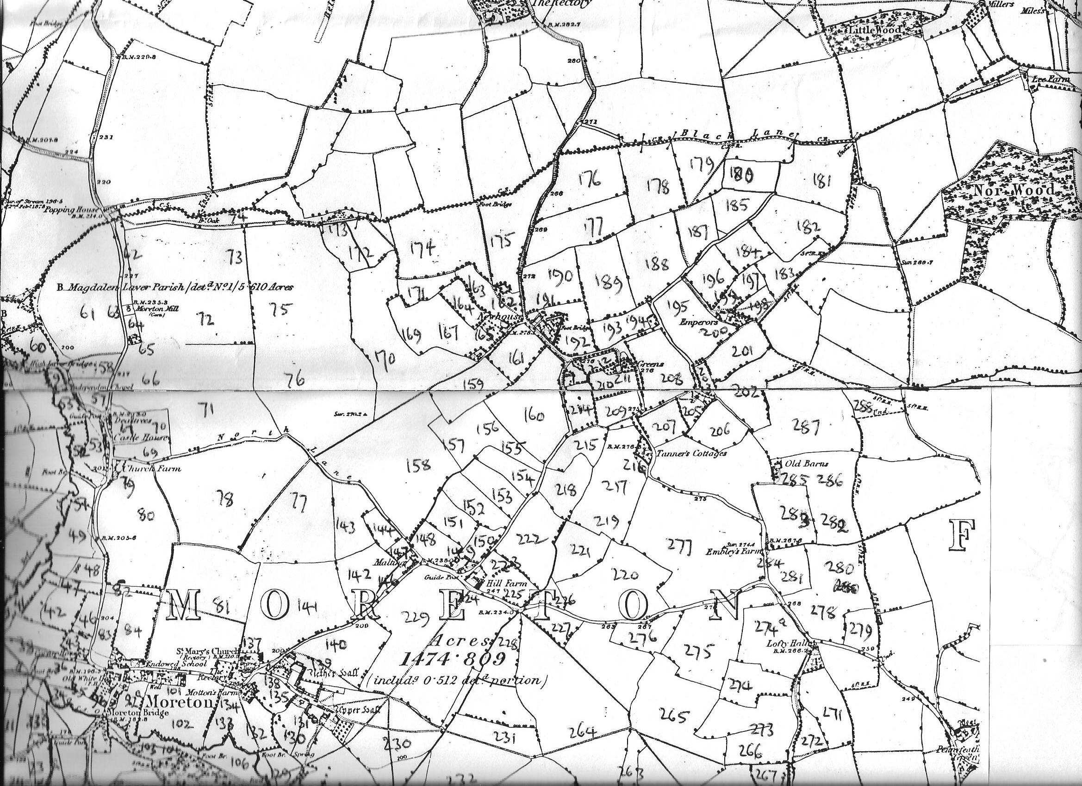
Map 1
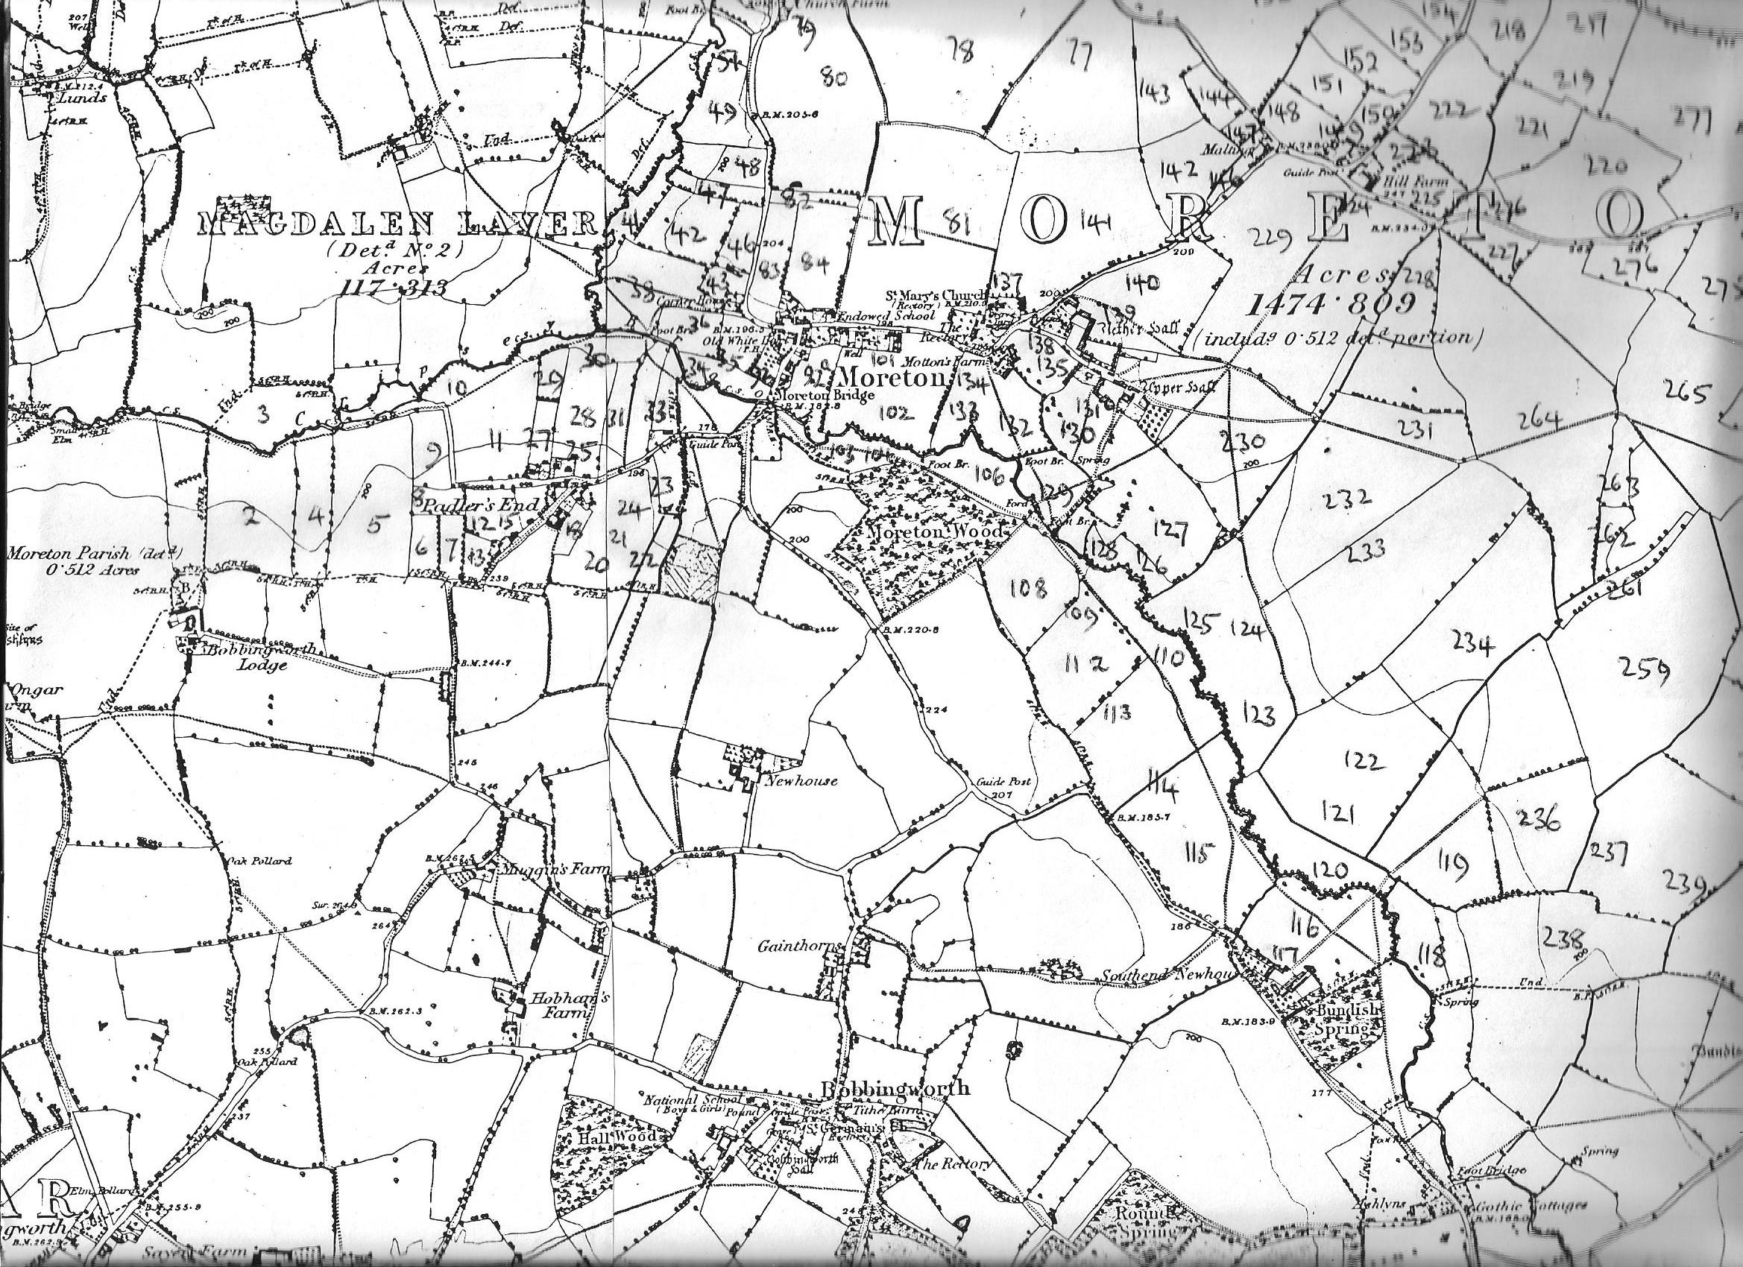
Map 2
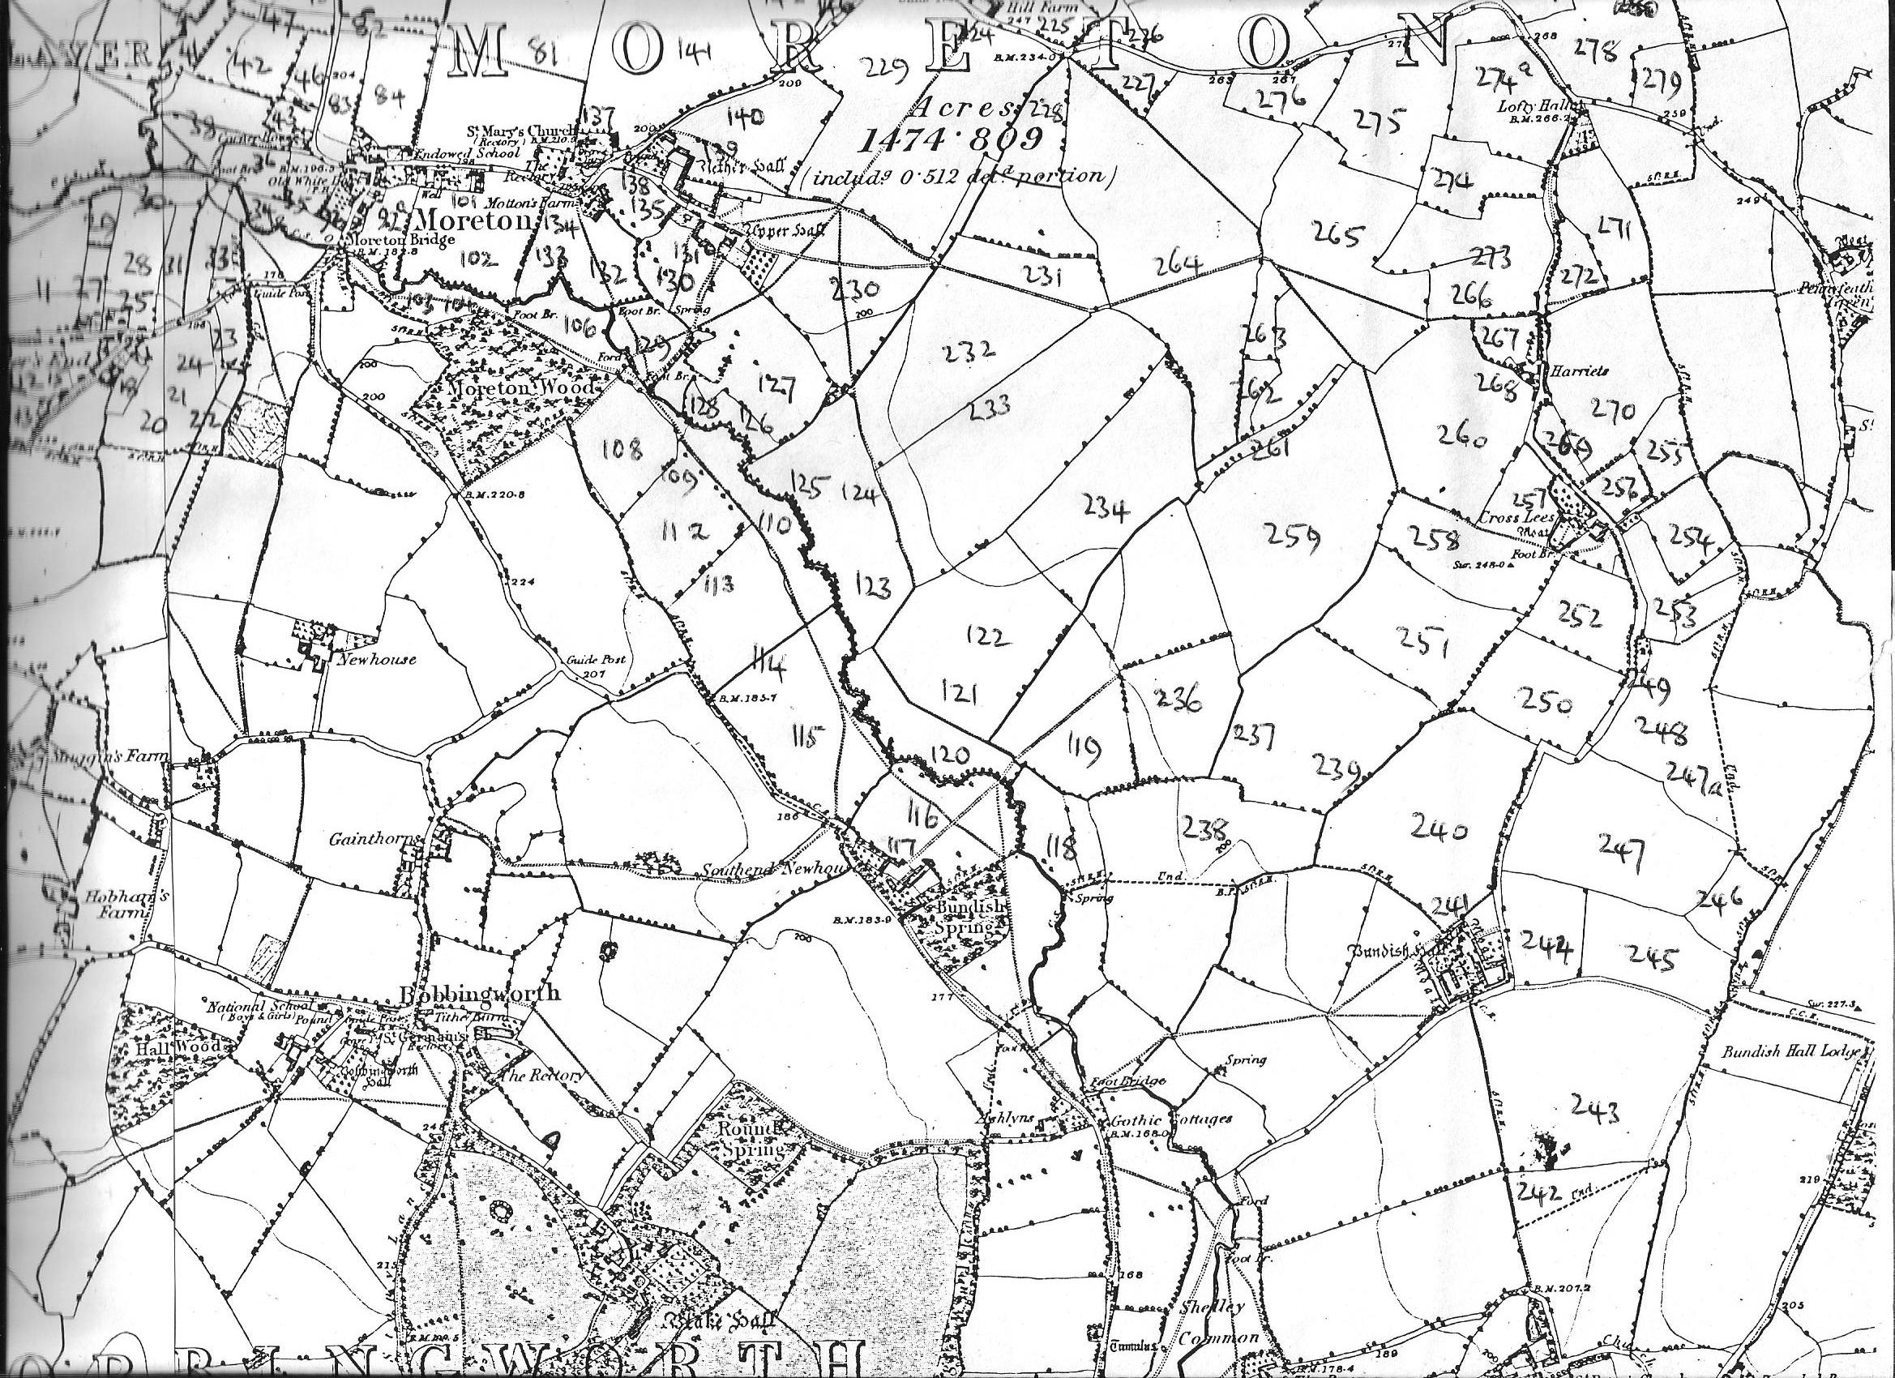
Map 3

