THE PLACE-NAMES

OF MUCKING

Recorder: James Kemble

Essex Place-names Project (Essex Society for Archaeology & History), 2013 (e-book).

www.essex.ac.uk/history/esah/essexplacenames

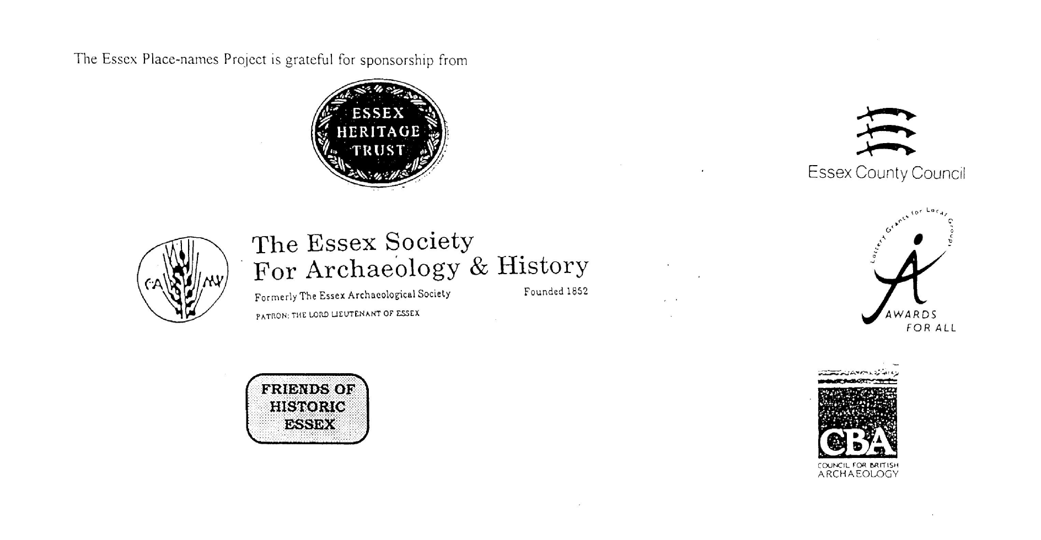

ESSEX PLACE-NAMES PROJECT.

The Essex Place-names Project is a County-wide survey to record place- and field-names from historical documents such as Tithe maps and apportionments, estate maps, sale
and auction catalogues, conveyances, terriers, deeds, rolls, inquisitions and surveys.

The second element of the Project is to investigate on-the-ground visible remains which correspond to the Place-names for actual or potential archaeological, agricultural and industrial
sites, and to record natural (topographical) and man-made features which may relate to the Place-name. This involves field-survey in rural and outside investigation in built-up areas.

It is anticipated that the Project will lead to identification of archaeological sites and lost historic buildings; it will enable analysis of indicators of early settlement, land holding, agricultural and industrial practices of the County. It will refine the more precise meaning of descriptive words and elements used by earlier settlers as they gave names appropriate to the topography of the landscape of their time.

For convenience the surveys are based on the parish, recognising that present civil parish boundaries are not necessarily identical to former ecclesiastical boundaries. Local Recorders
are supplied with templates of Record Forms to ensure consistency of recording across the County, and forward completed forms to a Central Coordinator for transfer to a county
computer database which is available to researchers on the internet at www.essex.ac.uk/history/esah/essexplacenames, and updated periodically.

This publication presents part of the information recorded from the Tithe or Estate Award and Map, and from other documents for this parish. The full record is contained on the master
database at Essex County Council (Historic Environment Section) and on the (above) website. Parish books are available to be downloaded from the website link ‘Books’ on the Home page. Please notify errors to the Project Coordinator at the Essex Record Office.

THE TITHE MAP AND APPORTIONMENT.

Since medieval times a tenth of the produce of land and stock had been paid by landholders to the church. At the Dissolution of the Monasteries, the property of many religious houses,
including the right to collect tithes, passed into lay hands. The Tithe Commutation Act which received Royal assent on 13th August 1836 abolished a rent payable in kind and
substituted rent-charges apportioned on each plot or parcel. The tithe-rent payable was assessed on the average value of wheat, barley and oats and was to fluctuate with price movements.

The commutation could be by voluntary agreement between the local owners and payers or, if agreement failed, could be compulsorily imposed by commissioners. A Valuer was to be
appointed to apportion the rent of each parcel of land and tenants could deduct that rent-charge from their rent paid to the landlord. The task fell to the Tithe Commissioners to produce a
map and an Apportionment (Award). A large-scale survey was produced for over 70% of England and Wales in the following 9 years, and about another 8% up to 1855. Most of the
parishes in Essex were surveyed. The map scales vary. The Award records ownership, tenancy and land-use, field by field and parcel by parcel (often quoting the field name) with the
ground area and rent-charge.

Land that was tithe-free tends to be less accurately mapped and contains few if any of the details recorded for those parcels subject to tithe. Rights of way and roads also tend to be
neglected. Boundaries of the tithe areas are shown as are some natural features such as streams, ponds, gardens, greens and commons. Buildings are often shown coloured red if dwellings
or grey if not. Because the Award may have been agreed only some time after the map was finished, discrepancies occur between the two. Enclosure Awards, when extant, usually date to the 18th and early 19th centuries. J.Kemble.
Reproduced by permission
of Essex County Council.

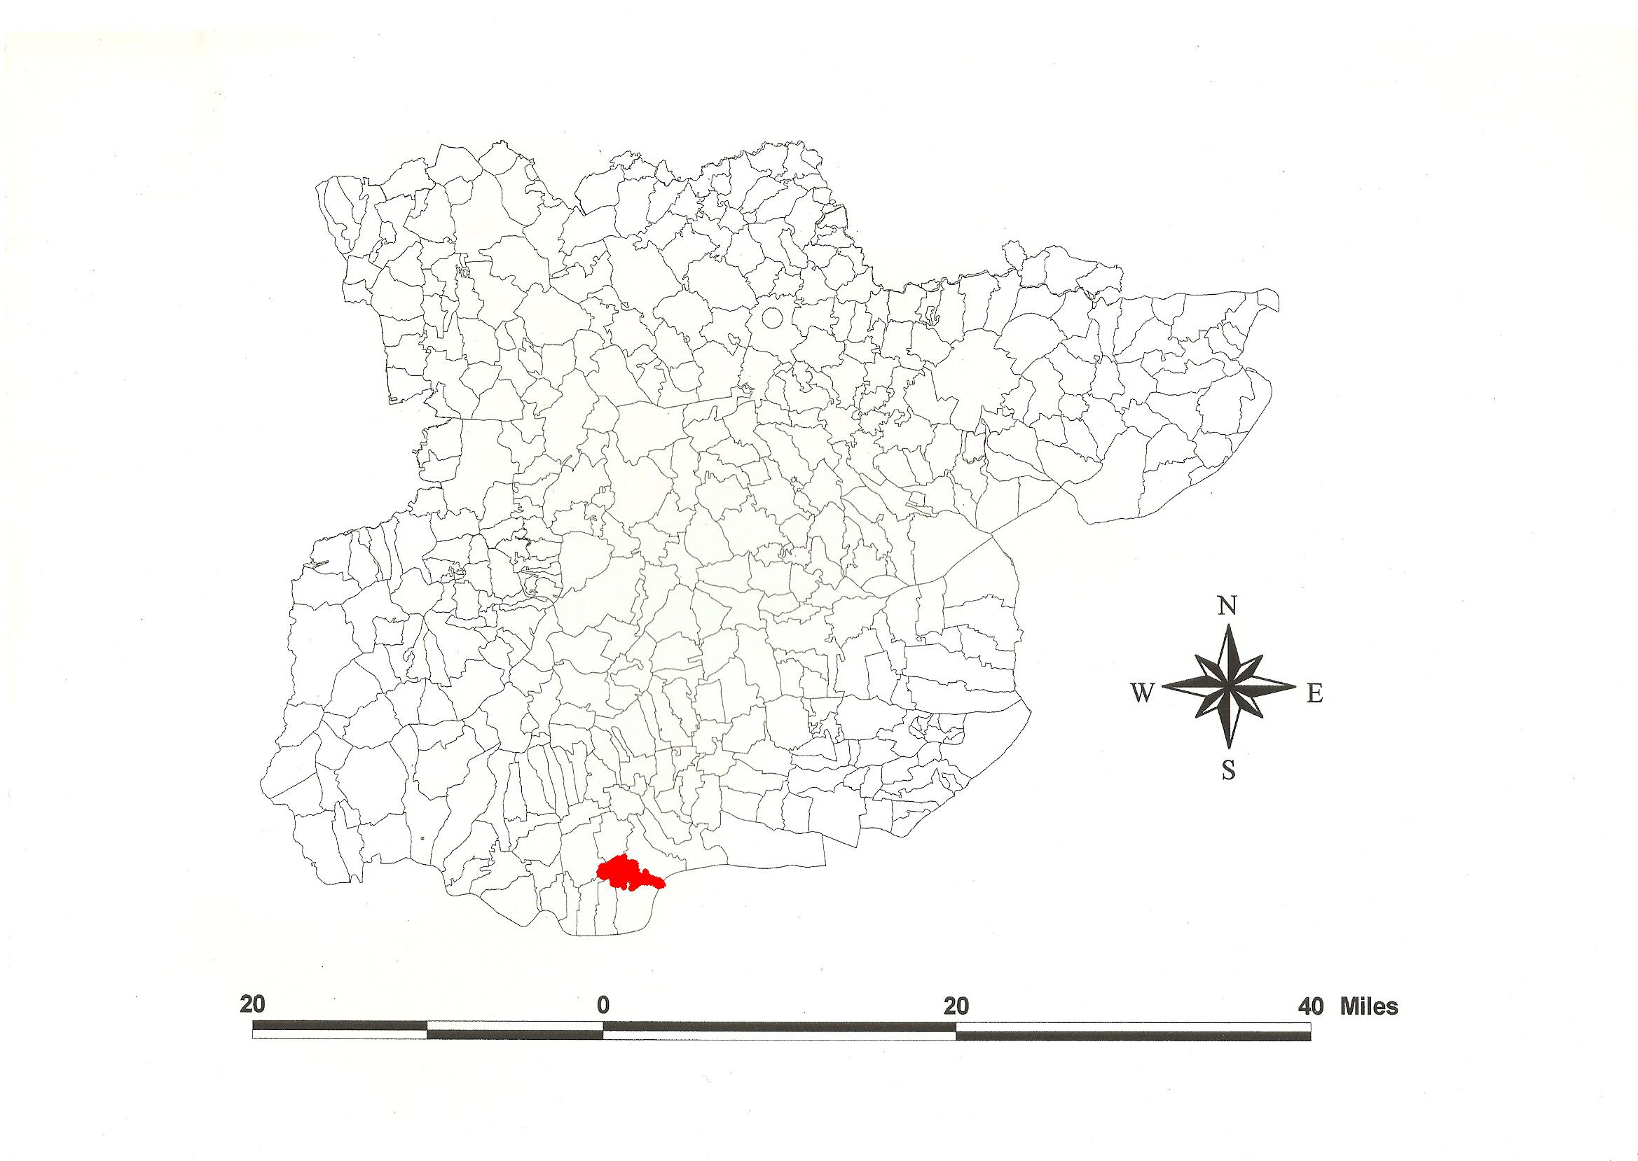
Mucking Parish in the County of Essex.
Reproduced by permission of
Essex County Council.

The Parish of Mucking (in Barstable Hundred).

The Tithe Award of Mucking (Essex Record Office D/CT 246a), dated 1846, shows a rent-charge for Great Tithes payable to the lessee of the Dean & Chapter of St Pauls Arthur Zachariah Button of Gloucester Place, Portman Square, London, of £400, and for Small Tithes to the vicar £200. The whole parish measured 2113 acres 1 rood 36 perches, of which 1355a 3r 23p were arable, 675a 0r 6p meadow and pasture, 54a 0r 33p wood, 28a 1r 14p buildings and gardens, 30a 0r 36p vicarial glebe. The Tithe Commissioners were William Blamire and R. Buller, the Assistant Thomas James Tatham of Bedford Place, London, and the Valuer Henry Crawter of 7 Southampton Buildings, Chancery Lane.

The Tithe map (ERO: D/CT 246b), dated 1846, was surveyed at a scale of 6 chains to an inch (13.3” to a mile) by Messrs Crawter of Cobham, Surrey, and Southampton Buildings, London. It was countersigned by G.K. Whalley, Assistant Tithe Commissioner. Detached parcels in Rugward Marshes south of Corringham parish are shown in an inset.

In Domesday Book, 1086, St Mary’s Abbey Barking held Mucinga for 7 hides. Thorold of Rochester took 30 acres and it was in the holding of Odo, Bishop of Bayeux (half brother of
William I); (that is, the 30 acres recorded under Chadwell, which a free man held before 1066). William held half a hide and 30 acres of Muchinga. This translates from a personal name Mucca + ingas, ‘ settlement of Mucca’s people’ or Old Scandinavian (Germanic) muk + ing, ‘muddy place’ (Morris, 1983; Gelling, 1976; Watts, 2004).

There were two manors: 1. At the Suppression of the Monasteries, Humfrey Tirrell held Mucking Hall with one mill. In 1547, Edward VI granted Mucking Hall to St Pauls. 2. Waltons. In 1341 a fine passed between John son of John Walton and Griffin de Sutton and others; afterwards Waltons was owned by John de Vere, 13th earl of Oxford, for one knight’s fee of the abbess of Barking (Morant, 1768).

A Neolithic camp has been identified north of Brook Farm. Further east, air photographs and subsequent excavations show an Iron Age hillfort, Roman pottery kilns and early Saxon occupation (Kemble, 2009).

The church dedicated to St John Baptist has a blocked 13th century arcade and a 15th century doorway to the tower. It was converted to residential use 2000-2005. St Clere’s Hall (the golf house) is 17th century, remodelled in 1735; the original house is represented by the timber-framed east wing. The hall has painted panels.

The meeting place of the Hundred, the moot, was at Barstable, the site marked by a stapol or pillar. Christy (1926) places it at Old Barstable Hall, formerly at the southwest extremity of Basildon parish on high ground. The first element may be a personal name, Bearda, or perhaps from O.E. beardede, hairy (Reaney, 1935).

References:
Christy, M, 1926. The Essex Hundred Moots. Trans Essex Archaeological Society, ns xviii (3), p194.
Gelling, M., 1976. Panorama, xix, 7-20. Place-names of the Mucking Area.
Kemble, J., 2007. Essex Place-names, Places, Streets & People. Historical Publications, London.
Kemble, J., 2009. Prehistoric & Roman Essex. History Press, Stroud.
Morant, P., 1768. History & Antiquities of the County of Essex., i, 236.
Morris, J., 1983. Domesday Book – Essex. Phillimore.
Pevsner, N., Bettley, J., 2007. Buildings of England – Essex. Yale.
Reaney, P., 1935. Place-names of Essex. Cambridge.
Watts, V., 2004. Dictionary of English Place-names. Cambridge.

The Tithe Award Place-names of Mucking – by Parcel No.

Place-name | Alias | Fld No | Grd Rf | x | y | Acr | rd | pch | land use | Owner | Occupier | Other information
Pasture |  | 1 | TQ | 654 | 804 | 0 | 1 | 1 | pasture | Radcliffe, Rev John | Joyner, Henry St John
Homestead. [Seaborough Hall, 1875,OS] | Seuebergh(e), 1293,FF, 1336,Ct; Seboroin Hall,1777,C | 2,3 | TQ | 654 | 804 | 0 | 3 | 34 |  | Radcliffe, Rev John | Joyner, Henry St John | O.E. beorg = [seven] hills/barrows
Arable | [at Old House Lane, 1875,OS] | 4 | TQ | 654 | 804 | 0 | 3 | 0 | arable | Radcliffe, Rev John | Joyner, Henry St John
Sowells field & Burnett |  | 5 | TQ | 656 | 804 | 41 | 3 | 36 | arable | St Pauls, Dean&Chapter | Button, Arthur Zachariah, lesseee; Cawston, Abraham | site of Neolithic camp, 1995,OS
Enclosure from waste |  | 5a | TQ | 655 | 805 | 1 | 1 | 0 | wood | Radcliffe, Rev John | Joyner, Henry St John
Pasture |  | 6 | TQ | 655 | 802 | 1 | 0 | 22 | pasture | Radcliffe, Rev John | Joyner, Henry St John
No name |  | 7 | TQ | 655 | 802 | 1 | 1 | 4 | arable | Gower, Samuel | Gower, Edward
Yard, bldgs | Brook Farm, 1875,OS | 8 | TQ | 655 | 800 | 0 | 2 | 15 |  | Gower, Samuel | Gower, Edward
The Chase Lane |  | 9 | TQ | 656 | 800 | 1 | 3 | 30 | pasture | Gower, Samuel | Gower, Edward
Shaw |  | 10 | TQ | 656 | 801 | 0 | 2 | 32 | wood | St Pauls, Dean&Chapter | Button, Arthur Zachariah, lesseee; Cawston, Abraham
Great Warren (pt) |  | 11 | TQ | 658 | 808 | 34 | 0 | 24 | arable | St Pauls, Dean&Chapter | Button, Arthur Zachariah, lesseee; Cawston, Abraham
Great Warren (pt) | [at Old House Lane, 1875,OS] | 11a | TQ | 656 | 808 | 20 | 3 | 10 | arable | St Pauls, Dean&Chapter | Button, Arthur Zachariah, lesseee; Cawston, Abraham
Cock Eighteen Acres |  | 12 | TQ | 656 | 812 | 19 | 3 | 33 | arable | St Pauls, Dean&Chapter | Button, Arthur Zachariah, lesseee; Cawston, Abraham
Little Warren field |  | 13 | TQ | 660 | 812 | 25 | 0 | 0 | arable | Button, Arthur Zachariah | Cawston, Abraham
Cottage, gdn, yd, bldgs | Mucking Heath Farm, 1875,OS | 13a | TQ | 661 | 810 | 0 | 1 | 17 |  | Button, Arthur Zachariah | Cawston, Abraham
Eight Acre Field | [at Witches Lane, 1875,OS] | 14 | TQ | 662 | 815 | 25 | 3 | 10 | arable | Button, Arthur Zachariah | Cawston, Abraham
Piece (taken out of field) | Smithy, 1875,OS | 15 | TQ | 662 | 817 | 0 | 2 | 8 | wood | Button, Arthur Zachariah | Cawston, Abraham
Mucking Heath | le Hethe, 1450,MnAt | 16 | TQ | 663 | 810 | 59 | 1 | 5 | wood | As Lords of the Manor | Button, Arthur Zachariah, lessee
Warren Hilly Field |  | 17 | TQ | 660 | 801 | 11 | 3 | 8 | arable | Gower, Samuel | Gower, Edward
Rough |  | 18 | TQ | 659 | 802 | 2 | 0 | 24 | wood | Gower, Samuel | Gower, Edward
Warren Hilly Field |  | 19 | TQ | 658 | 802 | 4 | 2 | 30 | arable | Gower, Samuel | Gower, Edward
Ten acre field |  | 20 | TQ | 658 | 801 | 9 | 3 | 20 | arable | Gower, Samuel | Gower, Edward
Twelve acre field |  | 21 | TQ | 660 | 800 | 12 | 3 | 14 | Arable | Gower, Samuel | Gower, Edward
Six acres |  | 22 | TQ | 662 | 801 | 5 | 2 | 20 | Arable | Gower, Samuel | Gower, Edward
Shaw |  | 23 | TQ | 662 | 801 | 1 | 3 | 26 | Wood | St Pauls, Dean&Chapter | Button, Arthur Zachariah, lesseee; Cawston, Abraham
Dean field |  | 24 | TQ | 663 | 802 | 11 | 1 | 8 | Arable | St Pauls, Dean&Chapter | Button, Arthur Zachariah, lesseee; Cawston, Abraham
Cherry Orchard Cottages (2), gdns |  | 25 | TQ | 662 | 804 | 0 | 2 | 5 |  | Button, Arthur Zachariah | Cawston, Abraham (lessee); Bearman, Geo; Sharpe, Harriett
Garden encroachment |  | 25a | TQ | 662 | 804 | 0 | 1 | 10 |  | Button, Arthur Zachariah | Cawston, Abraham, lessee; Sharpe, Harriett
Cherry Orchard | Cherry Garden, 1777,C | 26 | TQ | 663 | 804 | 4 | 0 | 20 | pasture | Button, Arthur Zachariah | Cawston, Abraham
Nine acres |  | 27 | TQ | 664 | 806 | 9 | 3 | 13 | Arable | Button, Arthur Zachariah | Cawston, Abraham
Small Gains Seven acres |  | 28 | TQ | 665 | 806 | 8 | 1 | 22 | Arable | Button, Arthur Zachariah | Cawston, Abraham
Small Dales |  | 29 | TQ | 665 | 805 | 6 | 0 | 16 | Arable | Button, Arthur Zachariah | Cawston, Abraham
Four acres |  | 30 | TQ | 664 | 805 | 4 | 0 | 28 | Arable | Button, Arthur Zachariah | Cawston, Abraham
Wood Eight acres |  | 31 | TQ | 664 | 801 | 8 | 0 | 0 | Arable | Button, Arthur Zachariah | Cawston, Abraham
The Oaks |  | 32 | TQ | 664 | 800 | 3 | 2 | 37 | Wood | Button, Arthur Zachariah | Button, Arthur Zachariah
Six acres |  | 33 | TQ | 665 | 801 | 4 | 3 | 15 | Arable | Button, Arthur Zachariah | Cawston, Abraham
Gravel Pit |  | 33a | TQ | 665 | 801 | 1 | 2 | 3 | Wood | Button, Arthur Zachariah | Cawston, Abraham
Musket Hill Shaw |  | 34 | TQ | 666 | 802 | 1 | 2 | 37 | Wood | Button, Arthur Zachariah | Cawston, Abraham
Musket Hill |  | 35 | TQ | 666 | 802 | 4 | 1 | 20 | Arable | Button, Arthur Zachariah | Cawston, Abraham
Shawcocks |  | 36 | TQ | 667 | 804 | 4 | 2 | 37 | Arable | St Pauls, Dean&Chapter | Button, Arthur Zachariah, lesseee; Cawston, Abraham
Ratcatchers field |  | 37 | TQ | 667 | 805 | 3 | 0 | 31 | Arable | St Pauls, Dean&Chapter | Button, Arthur Zachariah, lesseee; Cawston, Abraham
Shaw |  | 37a | TQ | 667 | 804 | 0 | 0 | 30 | Wood | St Pauls, Dean&Chapter | Button, Arthur Zachariah, lesseee; Cawston, Abraham
Two acres |  | 38 | TQ | 668 | 805 | 2 | 0 | 29 | Arable | Button, Arthur Zachariah | Cawston, Abraham
Eight Acre Field |  | 39 | TQ | 669 | 807 | 9 | 3 | 10 | Arable | Button, Arthur Zachariah | Cawston, Abraham
Seven acre field |  | 40 | TQ | 670 | 810 | 8 | 1 | 22 | arable | Button, Arthur Zachariah | Cawston, Abraham
Collingwood Barn, yd |  | 41 | TQ | 669 | 811 | 0 | 1 | 33 |  | Button, Arthur Zachariah | Cawston, Abraham
Twelve acre field |  | 42 | TQ | 668 | 810 | 13 | 3 | 25 | arable | Button, Arthur Zachariah | Cawston, Abraham
Seven acres |  | 43 | TQ | 668 | 808 | 6 | 2 | 20 | arable | Button, Arthur Zachariah | Cawston, Abraham
Five acres & Four acres |  | 44 | TQ | 665 | 809 | 9 | 0 | 34 | arable | Button, Arthur Zachariah | Cawston, Abraham
Ten acre field |  | 46 | TQ | 667 | 811 | 11 | 3 | 36 | arable | Button, Arthur Zachariah | Cawston, Abraham
Six acre field |  | 47 | TQ | 670 | 812 | 6 | 1 | 19 | arable | Button, Arthur Zachariah | Cawston, Abraham
Lower Whitedanes |  | 48 | TQ | 670 | 813 | 6 | 1 | 5 | arable | Button, Arthur Zachariah | Cawston, Abraham
Middle Whitedanes |  | 49 | TQ | 668 | 812 | 7 | 1 | 23 | arable | Button, Arthur Zachariah | Cawston, Abraham
Six acre field & Langtons field |  | 50 | TQ | 667 | 813 | 25 | 2 | 33 | arable | St Pauls, Dean&Chapter | Button, Arthur Zachariah, lessee; Sawell, John Hills
Langtons Barn, yd |  | 51 | TQ | 667 | 814 | 0 | 0 | 32 |  | St Pauls, Dean&Chapter | Button, Arthur Zachariah, lessee; Sawell, John Hills
Four acres |  | 52 | TQ | 667 | 814 | 4 | 2 | 4 | arable | St Pauls, Dean&Chapter | Button, Arthur Zachariah, lessee; Sawell, John Hills
Upper Whitedanes |  | 53 | TQ | 665 | 812 | 5 | 0 | 29 | arable | Button, Arthur Zachariah | Cawston, Abraham
Ten acre field |  | 54 | TQ | 665 | 814 | 12 | 1 | 16 | arable | St Pauls, Dean&Chapter | Button, Arthur Zachariah, lessee; Sawell, John Hills
Fifth Tillington |  | 55 | TQ | 665 | 815 | 10 | 3 | 5 | arable | Cooper, Rev Charles Beauchamp | Hanson, Anne
Fee Field |  | 56 | TQ | 664 | 815 | 7 | 0 | 18 | arable | Button, Arthur Zachariah | Cawston, Abraham
No name | [at Witches Lane, 1875,OS] | 57 | TQ | 663 | 816 | 5 | 0 | 10 | arable | Newcome, Samuel | Sumner, Thomas
Fourth Tillington |  | 58 | TQ | 663 | 817 | 8 | 1 | 1 | arable | Cooper, Rev Charles Beauchamp | Hanson, Anne
Cottage, gdn |  | 59 | TQ | 663 | 818 | 0 | 2 | 20 |  | Newcome, Samuel | Sumner, Thomas
Third Tillington, Red Lion piece, Second Tillington |  | 60-2 | TQ | 664 | 818 | 12 | 1 | 26 | arable | Cooper, Rev Charles Beauchamp | Hanson, Anne
First Tillington |  | 63 | TQ | 666 | 817 | 11 | 2 | 19 | arable | Cooper, Rev Charles Beauchamp | Hanson, Anne
Langtons field (pt) (late Coopers) |  | 64 | TQ | 668 | 815 | 2 | 0 | 39 | arable | Button, Arthur Zachariah | Sawell, John Hills
Bucklands |  | 65 | TQ | 669 | 818 | 9 | 1 | 19 | arable | Cooper, Rev Charles Beauchamp | Hanson, Anne
Bucklands |  | 66 | TQ | 670 | 819 | 18 | 3 | 4 | arable | Cooper, Rev Charles Beauchamp | Hanson, Anne
Strand Petts |  | 67 | TQ | 672 | 818 | 16 | 2 | 5 | arable | Cooper, Rev Charles Beauchamp | Hanson, Anne
New Trewes |  | 68 | TQ | 674 | 818 | 16 | 3 | 24 | arable | Cooper, Rev Charles Beauchamp | Hanson, Anne | O.E. treow = tree
Bridling Croft |  | 69 | TQ | 675 | 815 | 11 | 3 | 13 | arable | St Pauls, Dean&Chapter | Button, Arthur Zachariah, lessee; Sawell, John Hills
New Grounds |  | 70 | TQ | 673 | 815 | 17 | 1 | 30 | arable | St Pauls, Dean&Chapter | Button, Arthur Zachariah, lessee; Sawell, John Hills
Shaw |  | 70a | TQ | 674 | 816 | 0 | 2 | 11 | wood | St Pauls, Dean&Chapter | Button, Arthur Zachariah, lessee; Sawell, John Hills
Twelve acre field |  | 71 | TQ | 671 | 812 | 15 | 0 | 31 | arable | Button, Arthur Zachariah | Sawell, John Hills
New Grounds in one |  | 72-3 | TQ | 675 | 812 | 30 | 2 | 11 | arable | Button, Arthur Zachariah | Button, Arthur Zachariah, lessee; Sawell, John Hills
Anselms field |  | 74 | TQ | 678 | 813 | 29 | 1 | 7 | arable | Button, Arthur Zachariah | Button, Arthur Zachariah, lessee; Sawell, John Hills
No name |  | 75 | TQ | 677 | 815 | 2 | 1 | 32 | arable | Day, Rev Charles | Day, Rev Charles | glebe
Second Cayte perse |  | 76 | TQ | 679 | 816 | 16 | 2 | 29 | arable | Cooper, Rev Charles Beauchamp | Hanson, Anne
Third Cayte perse |  | 77 | TQ | 676 | 816 | 10 | 2 | 20 | arable | Cooper, Rev Charles Beauchamp | Hanson, Anne
Fern Down |  | 78 | TQ | 676 | 818 | 7 | 2 | 18 | arable | Cooper, Rev Charles Beauchamp | Hanson, Anne
First Cayte perse |  | 79 | TQ | 678 | 818 | 6 | 2 | 27 | arable | Cooper, Rev Charles Beauchamp | Hanson, Anne
Bywell Hook |  | 80 | TQ | 678 | 819 | 6 | 2 | 16 | arable | Cooper, Rev Charles Beauchamp | Hanson, Anne
Lane & Water |  | 81-2 | TQ | 677 | 820 | 0 | 2 | 32 |  | Cooper, Rev Charles Beauchamp | Hanson, Anne
New Trewes |  | 83 | TQ | 676 | 820 | 4 | 1 | 24 | mdw | Cooper, Rev Charles Beauchamp | Hanson, Anne
Jenkins House, offices, bldgs | Adamsley, 1777,C; New Jenkins, 1875,OS | 84 | TQ | 675 | 821 | 2 | 0 | 35 |  | Cooper, Rev Charles Beauchamp | Hanson, Anne | Adams acquired New Jenkins in 1730, Stifford
Bywell Mead & Duck Is. |  | 85 | TQ | 677 | 821 | 8 | 0 | 22 | mdw | Cooper, Rev Charles Beauchamp | Hanson, Anne
Orchard |  | 87 | TQ | 679 | 822 | 1 | 2 | 1 | . | Piggott, Zachariah | Piggott, Zachariah
House, gdn, cow yd, moat, chase | Jenkyn(e)s, 1594, Norden's map; Old Jenkins, 1875,OS | 88 | TQ | 679 | 822 | 2 | 1 | 34 |  | Piggott, Zachariah | Piggott, Zachariah | John Jenkins, 1563,Stifford
Barnfield |  | 89 | TQ | 681 | 822 | 8 | 0 | 14 | arable | Piggott, Zachariah | Piggott, Zachariah
Bridge Mead |  | 90 | TQ | 682 | 822 | 1 | 3 | 25 | pasture | Piggott, Zachariah | Piggott, Zachariah
Great Mead |  | 91 | TQ | 681 | 821 | 8 | 3 | 4 | pasture | Piggott, Zachariah | Piggott, Zachariah
Ten acres, Long 7 acres, Side Hill, Gt Hilly field, 6 acres, gravel pit |  | 92 | TQ | 681 | 817 | 65 | 1 | 4 | arable | Piggott, Zachariah | Piggott, Zachariah | cut by railway, 1875,OS
First Slipe |  | 95 | TQ | 683 | 820 | 3 | 1 | 7 | pasture | Piggott, Zachariah | Piggott, Zachariah
Second Slipe |  | 96 | TQ | 684 | 819 | 1 | 3 | 27 | pasture | Piggott, Zachariah | Piggott, Zachariah
Third Slipe |  | 97 | TQ | 685 | 817 | 1 | 0 | 10 | pasture | Piggott, Zachariah | Piggott, Zachariah
Mill Field (pt) |  | 100 | TQ | 680 | 815 | 0 | 1 | 12 | arable | Button, Arthur Zachariah | Sawell, John Hills
Mill Field (pt) | [at Butts Lane, 1875,OS] | 101 | TQ | 682 | 814 | 33 | 0 | 28 | arable | St Pauls, Dean&Chapter | Button, Arthur Zachariah, lessee; Sawell, John Hills | cut by railway, 1875,OS
South Mead |  | 103 | TQ | 687 | 815 | 8 | 0 | 30 | . | Piggott, Zachariah | Piggott, Zachariah
Gravel Pit field |  | 104 | TQ | 686 | 813 | 13 | 0 | 15 | . | St Pauls, Dean&Chapter | Button, Arthur Zachariah, lessee; Sawell, John Hills
Church Marsh |  | 104a | TQ | 687 | 814 | 2 | 3 | 35 | pasture | Button, Arthur Zachariah | Sawell, John Hills
Crown Publichouse, premises |  | 105 | TQ | 685 | 812 | 0 | 0 | 32 | inn | Button, Arthur Zachariah | Messrs Ind & Smith, lessees; Coe, Edward
Church yard | [St Johns] | 106 | TQ | 685 | 812 | 0 | 3 | 38 |  | Day, Rev Charles | Day, Rev Charles | glebe
House, gdn |  | 107 | TQ | 684 | 812 | 0 | 2 | 22 |  | Day, Rev Charles | Day, Rev Charles | glebe
Five acre field |  | 108 | TQ | 682 | 812 | 5 | 0 | 0 | arable | Button, Arthur Zachariah | Sawell, John Hills
Apple Orchrd field |  | 109 | TQ | 683 | 812 | 13 | 3 | 29 | arable | St Pauls, Dean&Chapter | Button, Arthur Zachariah, lessee; Sawell, John Hills
Cottage, gdn (Butts Lane) |  | 110 | TQ | 681 | 812 | 0 | 1 | 4 |  | Button, Arthur Zachariah | Sawell, John Hills, lessee; Letton, Thomas
Cottage, gdn |  | 111 | TQ | 681 | 812 | 0 | 1 | 4 |  | Button, Arthur Zachariah | Sawell, John Hills, lessee; Locke, Daniel
No name |  | 112 | TQ | 680 | 810 | 1 | 1 | 35 | pasture | Day, Rev Charles | Day, Rev Charles | glebe
No name |  | 114 | TQ | 679 | 810 | 4 | 0 | 7 | arable | Day, Rev Charles | Day, Rev Charles | glebe
New House field |  | 115 | TQ | 680 | 812 | 8 | 1 | 11 | arable | Button, Arthur Zachariah | Sawell, John Hills
No name |  | 116 | TQ | 688 | 812 | 3 | 1 | 34 | arable | Day, Rev Charles | Day, Rev Charles | glebe
At Saviours Hill (pt) | St Saviour's Hill, 1875,OS | 117 | TQ | 687 | 811 | 2 | 3 | 5 | arable | Button, Arthur Zachariah | Sawell, John Hills
At Saviours Hill (pt) |  | 117a | TQ | 687 | 812 | 1 | 3 | 8 | arable | Button, Arthur Zachariah | Sawell, John Hills
Plumtree field / Hanging Hills field |  | 118 | TQ | 688 | 809 | 17 | 2 | 24 | arable | Button, Arthur Zachariah | Sawell, John Hills
Ten acre field |  | 119 | TQ | 674 | 808 | 9 | 2 | 0 | arable | Button, Arthur Zachariah | Sawell, John Hills
No name |  | 120 | TQ | 674 | 810 | 9 | 3 | 4 | arable | Day, Rev Charles | Day, Rev Charles | glebe
Eight Acre Field |  | 121 | TQ | 671 | 809 | 9 | 3 | 0 | arable | Button, Arthur Zachariah | Sawell, John Hills
No name |  | 122 | TQ | 671 | 808 | 1 | 1 | 28 | arable | Day, Rev Charles | Day, Rev Charles | glebe
Piece of land held in common |  | 123 | TQ | 671 | 808 | 2 | 0 | 11 | arable | Button, Arthur Zachariah | Cawston, Abraham
Common PIece |  | 123a | TQ | 671 | 808 | 2 | 2 | 39 | arable | Button, Arthur Zachariah | Cawston, Abraham
No name |  | 124 | TQ | 671 | 807 | 2 | 1 | 32 | arable | Day, Rev Charles | Day, Rev Charles | glebe
Great & Little White Post field |  | 125 | TQ | 670 | 806 | 14 | 0 | 18 | arable | Button, Arthur Zachariah | Cawston, Abraham
White Post field |  | 127 | TQ | 670 | 805 | 2 | 0 | 0 | wood | St Pauls, Dean&Chapter | Button, Arthur Zachariah, lesseee; Cawston, Abraham
Five acres |  | 128 | TQ | 670 | 804 | 5 | 3 | 30 | Arable | Button, Arthur Zachariah | Cawston, Abraham
Wildings field |  | 129 | TQ | 670 | 803 | 3 | 2 | 16 | arable | St Pauls, Dean&Chapter | Button, Arthur Zachariah, lesseee; Cawston, Abraham
Stoney Piece |  | 130 | TQ | 671 | 804 | 2 | 1 | 16 | wood | Button, Arthur Zachariah | Cawston, Abraham
No name |  | 131 | TQ | 672 | 804 | 1 | 0 | 28 | . | Day, Rev Charles | Day, Rev Charles | glebe
No name |  | 131a | TQ | 672 | 805 | 0 | 0 | 32 | wood | Day, Rev Charles | Day, Rev Charles | glebe
Three acres |  | 132 | TQ | 672 | 806 | 3 | 2 | 10 | wood | Button, Arthur Zachariah | Cawston, Abraham
Wood |  | 132a |  | 672 | 806 | 0 | 0 | 32 | wood | Button, Arthur Zachariah | Cawston, Abraham
Common Hill |  | 133 | TQ | 672 | 806 | 2 | 3 | 1 | arable | St Pauls, Dean&Chapter | Button, Arthur Zachariah, lesseee; Cawston, Abraham
Wood (pt of common piece) |  | 133b | TQ | 672 | 806 | 0 | 0 | 38 | wood | Button, Arthur Zachariah | Cawston, Abraham
Newgate |  | 134 | TQ | 672 | 805 | 4 | 2 | 28 | arable | Button, Arthur Zachariah | Cawston, Abraham
Common Hill |  | 135 | TQ | 674 | 806 | 4 | 1 | 19 | arable | St Pauls, Dean&Chapter | Button, Arthur Zachariah, lesseee; Cawston, Abraham
Upper Whitings field |  | 136 | TQ | 675 | 806 | 18 | 2 | 5 | arable | Button, Arthur Zachariah | Cawston, Abraham
String field |  | 137 | TQ | 679 | 807 | 10 | 3 | 36 | arable | Button, Arthur Zachariah | Cawston, Abraham
Pudgroves & Little Pudgroves |  | 138 | TQ | 680 | 805 | 25 | 3 | 17 | arable | St Pauls, Dean&Chapter | Button, Arthur Zachariah, lessee; Sawell, John Hills
Lower Whitings field |  | 140 | TQ | 676 | 803 | 16 | 1 | 0 | arable | Button, Arthur Zachariah | Cawston, Abraham
Three acrs/Eight acres |  | 141 | TQ | 673 | 804 | 12 | 3 | 17 | arable | Button, Arthur Zachariah | Cawston, Abraham
Two acres |  | 142 | TQ | 672 | 803 | 2 | 1 | 30 | arable | Button, Arthur Zachariah | Cawston, Abraham
Barn field |  | 143 | TQ | 674 | 802 | 10 | 0 | 26 | arable | Button, Arthur Zachariah | Cawston, Abraham
Waltons Hall House, offices,yd, gdn | Waltons, 1580,Deed | 144 | TQ | 675 | 801 | 2 | 0 | 8 |  | Button, Arthur Zachariah | Cawston, Abraham | Simon de Waleton, 1199,Cur
Pasture (pt of Barn field) |  | 145 | TQ | 675 | 801 | 0 | 3 | 11 | pasture | Button, Arthur Zachariah | Cawston, Abraham
Slip & Upper Slip,/Barnfield |  | 146-7 | TQ | 672 | 802 | 12 | 3 | 8 | arable | Button, Arthur Zachariah | Cawston, Abraham
Suttons Farm House, offices, ochd |  | 148 | TQ | 672 | 800 | 1 | 0 | 39 |  | Button, Arthur Zachariah | Cawston, Abraham | Robert de Sudton', 1220,FeetFine
Five acres |  | 150 | TQ | 671 | 801 | 11 | 2 | 2 | arable | Button, Arthur Zachariah | Cawston, Abraham
No name |  | 152 | TQ | 671 | 799 | 3 | 0 | 36 | arable | Mansfard, Thomas | Mayhew, Mrs; Clark, Wm
No name |  | 153 | TQ | 669 | 800 | 56 | 2 | 30 | arable | Mansfard, Thomas | Mayhew, Mrs; Clark, Wm
Shaw |  | 154 | TQ | 668 | 799 | 0 | 2 | 8 | wood | Mansfard, Thomas | Mayhew, Mrs; Clark, Wm
White Post field |  | 156 | TQ | 668 | 802 | 10 | 0 | 14 | arable | St Pauls, Dean&Chapter | Button, Arthur Zachariah, lesseee; Cawston, Abraham
No name |  | 157 | TQ | 668 | 798 | 3 | 2 | 8 | arable | Mansfard, Thomas | Mayhew, Mrs; Clark, Wm
The Harp |  | 158 | TQ | 665 | 801 | 2 | 0 | 0 | wood | Button, Arthur Zachariah | Button, Arthur Zachariah
No name |  | 159 | TQ | 664 | 800 | 6 | 0 | 8 | arable | Aldgate School. Sir John Cass' Charity | Travis, Edward
Wood | Howford Wood, 1777,C; Hoford Wood, 1875,OS | 160 | TQ | 665 | 798 | 5 | 0 | 14 | wood | Mansfard, Thomas | Mayhew, Mrs; Clark, Wm
No name |  | 161 | TQ | 666 | 797 | 6 | 2 | 24 | arable | Mansfard, Thomas | Mayhew, Mrs; Clark, Wm
No name |  | 162 | TQ | 664 | 795 | 1 | 3 | 26 | pasture | Mansfard, Thomas | Mayhew, Mrs; Clark, Wm
No name |  | 163 | TQ | 665 | 795 | 1 | 2 | 13 | pasture | Mansfard, Thomas | Mayhew, Mrs; Clark, Wm
No name |  | 164 | TQ | 665 | 794 | 1 | 2 | 12 | pasture | Mansfard, Thomas | Mayhew, Mrs; Clark, Wm
No name |  | 165 | TQ | 666 | 793 | 3 | 2 | 21 | pasture | Mansfard, Thomas | Mayhew, Mrs; Clark, Wm
No name |  | 166 | TQ | 666 | 794 | 11 | 2 | 17 | arable | Mansfard, Thomas | Mayhew, Mrs; Clark, Wm
Wood |  | 167 | TQ | 667 | 795 | 3 | 2 | 8 | wood | Mansfard, Thomas | Mayhew, Mrs; Clark, Wm
No name |  | 168 | TQ | 668 | 795 | 3 | 1 | 30 | arable | Mansfard, Thomas | Mayhew, Mrs; Clark, Wm
No name |  | 169 | TQ | 669 | 794 | 7 | 0 | 24 | arable | Mansfard, Thomas | Mayhew, Mrs; Clark, Wm
No name |  | 170 | TQ | 670 | 795 | 13 | 0 | 5 | arable | Mansfard, Thomas | Mayhew, Mrs; Clark, Wm
No name |  | 171 | TQ | 671 | 794 | 6 | 1 | 33 | arable | Mansfard, Thomas | Mayhew, Mrs; Clark, Wm
Yards, bldgs |  | 172 | TQ | 672 | 794 | 0 | 2 | 6 |  | Mansfard, Thomas | Mayhew, Mrs; Clark, Wm
Pasture |  | 173 | TQ | 670 | 793 | 11 | 0 | 16 | pasture | Mansfard, Thomas | Mayhew, Mrs; Clark, Wm
Plantation |  | 173a | TQ | 672 | 793 | 0 | 1 | 32 | wood | Mansfard, Thomas | Mayhew, Mrs; Clark, Wm
Two cottages, gdns |  | 174 | TQ | 672 | 794 | 0 | 0 | 25 |  | Mansfard, Thomas | Townsend, Joseph etc
Farm house, yd, gdn, bldgs |  | 175 | TQ | 673 | 793 | 0 | 2 | 24 |  | Button, Arthur Zachariah | Smith, Charles
Garden |  | 176 | TQ | 673 | 793 | 0 | 1 | 16 |  | Button, Arthur Zachariah | Smith, Charles
Two cottages, gdns at Muckingford |  | 177 | TQ | 673 | 793 | 0 | 0 | 34 |  | Button, Arthur Zachariah | Martin, James; Rayner, George
George Inn, yds, gdns at Muckingford | George & Dragon PH, 1875,OS | 179 | TQ | 673 | 793 | 1 | 0 | 14 | inn | Button, Arthur Zachariah | Messrs Ind & Smith, lessees
Monks Farm, yd, bldgs | Monks Farm, 1875,OS | 180 | TQ | 673 | 793 | 1 | 0 | 10 |  | Button, Arthur Zachariah | Cawston, Abraham
Two cottages, gdns, adj Monks Farm yd |  | 180a | TQ | 673 | 792 | 0 | 0 | 34 |  | Button, Arthur Zachariah | Cawston, Abraham, lessee; Jarvis, Thomas; Peters, Peter
Cottage, gdn |  | 181 | TQ | 673 | 792 | 0 | 1 | 0 |  | Cotton, William | Richardson, George
Blacksmiths shop, gdn |  | 182 | TQ | 673 | 792 | 0 | 0 | 15 |  | Cotton, William | Peachey, William
Monks 9 acre field(pt) |  | 183 | TQ | 674 | 792 | 4 | 1 | 28 | arable | Button, Arthur Zachariah | Cawston, Abraham
Eight acres, 7 acres, 9 acres (pt) |  | 184 | TQ | 675 | 791 | 23 | 1 | 14 | pasture | Cotton, William | Sawell, John
Seven acre field (pt) |  | 186 | TQ | 674 | 793 | 4 | 1 | 14 | pasture | Button, Arthur Zachariah | Cawston, Abraham
Seven acre field (pt) |  | 186a | TQ | 673 | 793 | 3 | 0 | 0 | arable | Button, Arthur Zachariah | Messrs Ind & Smith; Rumball, Sarah
Seven acre field |  | 187 | TQ | 674 | 794 | 7 | 3 | 19 | arable | Button, Arthur Zachariah | Cawston, Abraham | cut by railway, 1875,OS
Third pasture on Long Piece |  | 188 | TQ | 675 | 796 | 1 | 2 | 30 | pasture | Button, Arthur Zachariah | Smith, Charles
Second pasture |  | 189 | TQ | 674 | 795 | 0 | 3 | 13 | pasture | Button, Arthur Zachariah | Smith, Charles
First pasture |  | 190 | TQ | 673 | 794 | 0 | 2 | 13 | . | Button, Arthur Zachariah | Smith, Charles
House, yd, gdn, bldgs | Merrylocks Farm, 1875,OS | 191 | TQ | 673 | 794 | 1 | 0 | 36 |  | Mansfard, Thomas | Mayhew, Mrs; Clark, Wm
Pasture |  | 192 | TQ | 673 | 794 | 2 | 0 | 9 | pasture | Mansfard, Thomas | Mayhew, Mrs; Clark, Wm
Pasture |  | 192a | TQ | 673 | 794 | 1 | 0 | 16 | pasture | Mansfard, Thomas | Mayhew, Mrs; Clark, Wm
Ozier Ground/ Rough pasture |  | 193 | TQ | 673 | 795 | 1 | 0 | 26 | oziers | Mansfard, Thomas | Mayhew, Mrs; Clark, Wm
Suttons Ozier Ground in one (pt) |  | 194 -a | TQ | 674 | 797 | 6 | 2 | 23 |  | Button, Arthur Zachariah | Cawston, Abraham
No name (with 168) |  | 195-6 | TQ | 673 | 796 | 18 | 2 | 12 |  | Mansfard, Thomas | Mayhew, Mrs; Clark, Wm
No name |  | 197 | TQ | 673 | 799 | 3 | 1 | 18 | pasture | Button, Arthur Zachariah | Cawston, Abraham
Barn field |  | 199 | TQ | 674 | 800 | 2 | 1 | 4 | mdw | Button, Arthur Zachariah | Cawston, Abraham
Turners Farm house, barn, offices, bldgs | Flamburgh Hall, 1875,OS | 200-a | TQ | 675 | 800 | 0 | 3 | 21 |  | Button, Arthur Zachariah | Cawston, Abraham
Cart House field formerly Cooper Brooks |  | 201 | TQ | 675 | 800 | 2 | 1 | 31 | pasture | Button, Arthur Zachariah | Cawston, Abraham
Garden |  | 202 | TQ | 675 | 800 | 0 | 0 | 24 |  | Button, Arthur Zachariah | Cawston, Abraham
Two acres |  | 203 | TQ | 675 | 800 | 2 | 3 | 16 | pasture | Button, Arthur Zachariah | Cawston, Abraham
Little Brook field |  | 204 | TQ | 676 | 799 | 0 | 3 | 30 | pasture | Button, Arthur Zachariah | Cawston, Abraham
Upper Brook field |  | 205 | TQ | 675 | 799 | 3 | 0 | 33 | pasture | Button, Arthur Zachariah | Cawston, Abraham
Lower Brook field |  | 206 | TQ | 676 | 798 | 4 | 1 | 26 | pasture | Button, Arthur Zachariah | Cawston, Abraham
Oak Tree Marsh |  | 207 | TQ | 677 | 798 | 3 | 3 | 6 | pasture | Button, Arthur Zachariah | Cawston, Abraham
Pegs Mead in one |  | 208, 210-1 | TQ | 677 | 798 | 3 | 0 | 18 | pasture | Button, Arthur Zachariah | Cawston, Abraham
Gravel Pit field 12 acres |  | 209 | TQ | 677 | 800 | 14 | 1 | 24 | arable | Button, Arthur Zachariah | Cawston, Abraham
Gravel Pit field Shaw |  | 209a | TQ | 677 | 799 | 0 | 1 | 20 | wood | Button, Arthur Zachariah | Cawston, Abraham
Waltons Hall Ozier Ground |  | 211a | TQ | 678 | 799 | 1 | 3 | 39 | reeds | Button, Arthur Zachariah | Button, Arthur Zachariah
No name |  | 212 | TQ | 680 | 800 | 1 | 3 | 37 | pasture | Day, Rev Charles | Day, Rev Charles | glebe
Heronry Marsh |  | 213 | TQ | 680 | 799 | 3 | 1 | 4 | . | Button, Arthur Zachariah | Cawston, Abraham
Mud Marsh |  | 214 | TQ | 679 | 799 | 2 | 2 | 0 | . | Button, Arthur Zachariah | Cawston, Abraham
Swan Ditch Marsh |  | 215 | TQ | 680 | 798 | 3 | 2 | 0 | pasture | Button, Arthur Zachariah | Cawston, Abraham
Rushey Marsh |  | 216 | TQ | 681 | 799 | 5 | 1 | 23 | pasture | Button, Arthur Zachariah | Cawston, Abraham
Eight Acre Marsh in one |  | 217-8 | TQ | 681 | 798 | 8 | 1 | 21 | pasture | St Pauls, Dean&Chapter | Button, Arthur Zachariah, lessee; Cawston, Abraham
Second Golden Marsh |  | 219 | TQ | 683 | 798 | 7 | 1 | 21 | pasture | St Pauls, Dean&Chapter | Button, Arthur Zachariah, lessee; Cawston, Abraham
First Golden Marsh |  | 220 | TQ | 692 | 799 | 8 | 3 | 19 | pasture | St Pauls, Dean&Chapter | Button, Arthur Zachariah, lessee; Cawston, Abraham
Golden Mead in one |  | 221, 223 | TQ | 681 | 801 | 9 | 0 | 29 | pasture | St Pauls, Dean&Chapter | Button, Arthur Zachariah, lessee; Cawston, Abraham
Ozier Ground late Cotton |  | 222 | TQ | 681 | 800 | 0 | 3 | 1 | reeds | Button, Arthur Zachariah | Button, Arthur Zachariah
Heronry | [at Golden Lane, 1875,OS] | 224 | TQ | 681 | 802 | 3 | 2 | 30 | reeds | Button, Arthur Zachariah | Button, Arthur Zachariah
Furzey Piece | Henry's Shaw, 1875,OS | 225 | TQ | 680 | 801 | 3 | 2 | 31 | wood | Button, Arthur Zachariah | Button, Arthur Zachariah
Arable |  | 226 | TQ | 679 | 801 | 3 | 1 | 7 | arable | Button, Arthur Zachariah | Cawston, Abraham
Gravel Pit field 4 acres |  | 227 | TQ | 678 | 801 | 6 | 2 | 16 | . | Button, Arthur Zachariah | Cawston, Abraham
Heronry fields 1-3-11 / East & West (late Cottons) 15-1-15 in one |  | 228-9 | TQ | 679 | 803 | 17 | 0 | 26 | arable | Button, Arthur Zachariah | Cawston, Abraham | cut by railway, 1875,OS
Two cottages, gdns nr Heronry | Golden Cottages, 1875,OS | 230 | TQ | 681 | 805 | 0 | 0 | 20 |  | Button, Arthur Zachariah | Sawell, John Hills, lessee; Cockman, Henry; McAndrew, John
Stone field/ 7 Acre field |  | 231 | TQ | 683 | 806 | 15 | 3 | 19 | arable | Button, Arthur Zachariah | Sawell, John Hills
Cherry Crote field |  | 232 | TQ | 682 | 808 | 8 | 3 | 4 | arable | Button, Arthur Zachariah | Sawell, John Hills | Essex dialect crote = croft
Blue House, bldgs, premises | Blue House, 1777,C | 233 | TQ | 682 | 810 | 1 | 0 | 26 |  | Button, Arthur Zachariah | Sawell, John Hills
Cherry Orchard field |  | 234 | TQ | 683 | 810 | 17 | 1 | 5 | arable | St Pauls, Dean&Chapter | Button, Arthur Zachariah, lessee; Sawell, John Hills
Mucking Hall, house, offices, gdn, lawn,bldgs | Mucinga, 1086,DB; Mokinga, 1182,P | 235 | TQ | 685 | 810 | 1 | 2 | 10 |  | St Pauls, Dean&Chapter | Button, Arthur Zachariah, lessee; Sawell, John Hills
Great & Lt Ware Croft |  | 236 | TQ | 686 | 810 | 7 | 0 | 15 | arable | St Pauls, Dean&Chapter | Button, Arthur Zachariah, lessee; Sawell, John Hills
Garden (pt) out of Field |  | 237 | TQ | 686 | 810 | 0 | 0 | 16 |  | Button, Arthur Zachariah | Button, Arthur Zachariah, lessee; Sawell, John Hills
Carvers pasture (pt) (late Cottons) 3-3-16/0-1-25 |  | 238-a | TQ | 686 | 808 | 4 | 1 | 1 | arable | Button, Arthur Zachariah | Button, Arthur Zachariah, lessee; Sawell, John Hills
Two cottages, gdns in Mucking Street |  | 239 | TQ | 686 | 809 | 0 | 0 | 38 |  | Button, Arthur Zachariah | Sawell, John Hills, lessee; Radley, Jno; Pusser, Jno
Yard, bldgs (late Cotton) |  | 240 | TQ | 686 | 810 | 1 | 1 | 24 |  | Button, Arthur Zachariah | Sawell, John Hills
Dwelling house, gdn (late Cotton) west side of Mucking Street |  | 241 | TQ | 686 | 810 | 0 | 0 | 29 |  | Button, Arthur Zachariah | Clarke, Samuel
The Crown Marsh |  | 243 | TQ | 687 | 810 | 6 | 2 | 34 | pasture | Button, Arthur Zachariah | Sawell, John Hills
The Crown Marsh (late Cottons) |  | 244 | TQ | 687 | 811 | 3 | 2 | 17 | pasture | Button, Arthur Zachariah | Sawell, John Hills
The Crown Salts |  | 245 | TQ | 688 | 809 | 1 | 2 | 16 | pasture | Button, Arthur Zachariah | Sawell, John Hills
Dwelling house, gdn (late Cotton) east side of Mucking Street |  | 247 | TQ | 687 | 808 | 0 | 1 | 3 |  | Button, Arthur Zachariah | Say, widow; Little, Wm; Wright, widow
Cottage, gdn |  | 248 | TQ | 687 | 807 | 0 | 1 | 0 |  | Button, Arthur Zachariah | Sawell, John Hills, lessee; Evans, John
Marsh or Half Acre |  | 250 | TQ | 687 | 807 | 0 | 2 | 7 | arable | Button, Arthur Zachariah | Sawell, John Hills
Dartford Marsh |  | 251 | TQ | 688 | 806 | 4 | 3 | 3 | pasture | St Pauls, Dean&Chapter | Button, Arthur Zachariah, lessee; Sawell, John Hills
Dartford Saltings | cf. Dortfordlese, 1450,MnAt | 252 | TQ | 690 | 805 | 13 | 1 | 7 | pasture | St Pauls, Dean&Chapter | Button, Arthur Zachariah, lessee; Sawell, John Hills
No name |  | 253 | TQ | 688 | 805 | 0 | 3 | 26 | . | Mansfard, Thomas | Mayhew, Mrs; Clark, Wm
Cottage, gdn |  | 254 | TQ | 688 | 805 | 0 | 1 | 11 |  | Mansfard, Thomas | Fuller, John
Four acres, scite of Sullings House etc |  | 255 | TQ | 687 | 805 | 6 | 2 | 21 | arable | Button, Arthur Zachariah | Sawell, John Hills
Palegates field |  | 257 | TQ | 684 | 805 | 19 | 2 | 29 | arable | Button, Arthur Zachariah | Sawell, John Hills
Horse Marsh | [at Golden Lane, 1875,OS] | 259 | TQ | 684 | 804 | 0 | 6 | 0 | . | Button, Arthur Zachariah | Sawell, John Hills
Ozier Ground in one |  | 260-2 | TQ | 684 | 802 | 16 | 1 | 1 | oziers | Button, Arthur Zachariah | Lindsell, Thomas
Third Sullings Marsh in one |  | 263-4 | TQ | 685 | 802 | 9 | 1 | 28 | pasture | Button, Arthur Zachariah | Button, Arthur Zachariah, lessee; Sawell, John Hills
First Sullings Marsh in one |  | 265-7 | TQ | 687 | 803 | 10 | 2 | 28 | pasture | Button, Arthur Zachariah | Sawell, John Hills
Common Fresh Marsh |  | 268 | TQ | 689 | 803 | 3 | 2 | 3 | pasture | As Lords of the Manor | Button, Arthur Zachariah, lessee
Second Sullings Marsh |  | 269 | TQ | 688 | 802 | 7 | 3 | 34 | pasture | Button, Arthur Zachariah | Sawell, John Hills
Cow Leys |  | 270 | TQ | 687 | 800 | 19 | 1 | 9 | pasture | St Pauls, Dean&Chapter | Button, Arthur Zachariah, lesseee; Cawston, Abraham
Ox Marsh in one |  | 271-2 | TQ | 684 | 799 | 16 | 0 | 3 | pasture | St Pauls, Dean&Chapter | Button, Arthur Zachariah, lesseee; Cawston, Abraham
No name |  | 273 | TQ | 687 | 798 | 7 | 1 | 16 | pasture | Cotton, William | Sawell, John
No name |  | 274 | TQ | 689 | 800 | 9 | 1 | 20 | pasture | Cotton, William | Sawell, John
Further Wharf Marsh (with 294) in one |  | 275 | TQ | 690 | 800 | 30 | 0 | 18 | pasture | St Pauls, Dean&Chapter | Button, Arthur Zachariah, lessee; Sawell, John Hills
Wharf Marsh |  | 276 | TQ | 690 | 801 | 1 | 3 | 11 | pasture | St Pauls, Dean&Chapter | Button, Arthur Zachariah, lessee; Sawell, John Hills
Salt water Marsh |  | 277 | TQ | 690 | 802 | 9 | 3 | 28 | pasture | Button, Arthur Zachariah | Sawell, John Hills
No name |  | 278 | TQ | 691 | 803 | 4 | 0 | 39 | pasture | As Lords of the Manor | Button, Arthur Zachariah, lessee
Little Wharf Marsh Salts |  | 279 | TQ | 691 | 802 | 1 | 2 | 33 | pasture | St Pauls, Dean&Chapter | Button, Arthur Zachariah, lessee; Sawell, John Hills
Mucking Wharf | Muckin Wharf, 1777,C | 280 | TQ | 694 | 804 | 1 | 1 | 13 | pasture | As Lords of the Manor | Button, Arthur Zachariah, lessee
Middle Wharf Marsh (with 290) in one |  | 281-2 | TQ | 693 | 800 | 33 | 1 | 3 | pasture | St Pauls, Dean&Chapter | Button, Arthur Zachariah, lessee; Sawell, John Hills
First Wharf Marsh in one |  | 283-8 | TQ | 696 | 802 | 32 | 0 | 1 |  | St Pauls, Dean&Chapter | Button, Arthur Zachariah, lessee; Sawell, John Hills
Little Wharf Marsh |  | 289 | TQ | 697 | 802 | 4 | 1 | 32 | pasture | St Pauls, Dean&Chapter | Button, Arthur Zachariah, lessee; Sawell, John Hills
The Sea Wall |  | 291 | TQ | 697 | 800 | 2 | 0 | 16 | pasture | St Pauls, Dean&Chapter | Button, Arthur Zachariah, lessee; Sawell, John Hills
Great Wharf Marsh Salts |  | 292-3 | TQ | 695 | 797 | 20 | 3 | 36 | pasture | St Pauls, Dean&Chapter | Button, Arthur Zachariah, lessee; Sawell, John Hills
The Chase & Thirty Acres |  | 295 | TQ | 687 | 796 | 30 | 3 | 28 | pasture | Cotton, William | Sawell, John
Horse Mead |  | 296 | TQ | 686 | 795 | 6 | 3 | 8 | pasture | Cotton, William | Sawell, John
Horse Mead |  | 296a | TQ | 685 | 796 | 7 | 1 | 4 | pasture | Cotton, William | Sawell, John
Ten acres |  | 297 | TQ | 685 | 795 | 11 | 3 | 16 | arable | Cotton, William | Sawell, John
Perry Mead |  | 298 | TQ | 682 | 796 | 9 | 0 | 0 | pasture | Cotton, William | Sawell, John
The Fifteen acres |  | 299 | TQ | 682 | 794 | 14 | 0 | 30 | arable | Cotton, William | Sawell, John
Fourteen acres (pt) |  | 300 | TQ | 681 | 794 | 2 | 0 | 0 | arable | Cotton, William | Sawell, John
Gobions Farm House, yds, gdn, bldgs | Gobyons, 1403,Ass; Gubbyns, 1548,FF | 301 | TQ | 681 | 793 | 2 | 1 | 38 |  | Cotton, William | Sawell, John | Thomas Gubyun, 1306, FeetFine
The Chase |  | 302 | TQ | 681 | 793 | 2 | 3 | 15 | pasture | Cotton, William | Sawell, John
Ten acres (pt) |  | 303 | TQ | 682 | 791 | 2 | 1 | 36 | pasture | Cotton, William | Sawell, John
Great Kitchen field(pt) |  | 304 | TQ | 680 | 791 | 9 | 3 | 6 | arable | Cotton, William | Sawell, John
Great Kitchen field(pt) |  | 305 | TQ | 680 | 790 | 7 | 0 | 20 | arable | Cotton, William | Sawell, John
Fleet Marsh | in Rugward Marshes, 1875,OS | 306 | TQ | 729 | 815 | 22 | 2 | 20 | pasture | St Pauls, Dean&Chapter | Button, Arthur Zachariah, lessee; Lawson, Holmes | detached. Since 1888 in Stanford le Hope par.
Great Marsh | in Rugward Marshes, 1875,OS | 307 | TQ | 725 | 816 | 26 | 2 | 30 | pasture | St Pauls, Dean&Chapter | Button, Arthur Zachariah, lessee; Lawson, Holmes | detached. Since 1888 in Stanford le Hope par.
Pound Marsh | in Rugward Marshes, 1875,OS | 308 | TQ | 723 | 819 | 26 | 2 | 30 | pasture | St Pauls, Dean&Chapter | Button, Arthur Zachariah, lessee; Lawson, Holmes | detached. ?OE ryge werth = rye marsh
First Marsh | in Rugward Marshes, 1875,OS | 309 | TQ | 722 | 814 | 14 | 2 | 3 | pasture | St Pauls, Dean&Chapter | Button, Arthur Zachariah, lessee; Lawson, Holmes | detached. Since 1888 in Stanford le Hope par.
Wall | in Rugward Marshes, 1875,OS | 310 | TQ | 729 | 816 | 3 | 2 | 3 |  | St Pauls, Dean&Chapter | Holmes, Lawson | detached. Since 1888 in Stanford le Hope par.
Saltings | in Rugward Marshes, 1875,OS | 311 | TQ | 725 | 815 | 0 | 3 | 11 |  | St Pauls, Dean&Chapter | Holmes, Lawson | detached. ?OE ryge werth = rye marsh
Saltings | in Rugward Marshes, 1875,OS | 312 | TQ | 727 | 815 | 0 | 1 | 0 |  | St Pauls, Dean&Chapter | Holmes, Lawson | detached. Since 1888 in Stanford le Hope par.
Saltings | Shelly Bay, in Rugward Marshes, 1875,OS | 313 | TQ | 731 | 815 | 2 | 2 | 36 |  | St Pauls, Dean&Chapter | Holmes, Lawson | detached. Since 1888 in Stanford le Hope par.

For abbreviations see Reaney, P., 1935, Place-names of Essex, Cambridge; and Kemble, J., 2007, Essex Place-names, Places, Streets & People, Historical Publications, p.153.

The Tithe Award Place-names of Mucking – by Owner.

Place-name | Alias | Fld No | Grd Rf | x | y | Acr | rd | pch | land use | Owner | Occupier | Other information
No name |  | 159 | TQ | 664 | 800 | 6 | 0 | 8 | arable | Aldgate School. Sir John Cass' Charity | Travis, Edward
Mucking Heath | le Hethe, 1450,MnAt | 16 | TQ | 663 | 810 | 59 | 1 | 5 | wood | As Lords of the Manor | Button, Arthur Zachariah, lessee
Common Fresh Marsh |  | 268 | TQ | 689 | 803 | 3 | 2 | 3 | pasture | As Lords of the Manor | Button, Arthur Zachariah, lessee
No name |  | 278 | TQ | 691 | 803 | 4 | 0 | 39 | pasture | As Lords of the Manor | Button, Arthur Zachariah, lessee
Mucking Wharf | Muckin Wharf, 1777,C | 280 | TQ | 694 | 804 | 1 | 1 | 13 | pasture | As Lords of the Manor | Button, Arthur Zachariah, lessee
The Harp |  | 158 | TQ | 665 | 801 | 2 | 0 | 0 | wood | Button, Arthur Zachariah | Button, Arthur Zachariah
Waltons Hall Ozier Ground |  | 211a | TQ | 678 | 799 | 1 | 3 | 39 | reeds | Button, Arthur Zachariah | Button, Arthur Zachariah
Ozier Ground late Cotton |  | 222 | TQ | 681 | 800 | 0 | 3 | 1 | reeds | Button, Arthur Zachariah | Button, Arthur Zachariah
Heronry | [at Golden Lane, 1875,OS] | 224 | TQ | 681 | 802 | 3 | 2 | 30 | reeds | Button, Arthur Zachariah | Button, Arthur Zachariah
Furzey Piece | Henry's Shaw, 1875,OS | 225 | TQ | 680 | 801 | 3 | 2 | 31 | wood | Button, Arthur Zachariah | Button, Arthur Zachariah
The Oaks |  | 32 | TQ | 664 | 800 | 3 | 2 | 37 | Wood | Button, Arthur Zachariah | Button, Arthur Zachariah
Garden (pt) out of Field |  | 237 | TQ | 686 | 810 | 0 | 0 | 16 |  | Button, Arthur Zachariah | Button, Arthur Zachariah, lessee; Sawell, John Hills
Carvers pasture (pt) (late Cottons) 3-3-16/0-1-25 |  | 238-a | TQ | 686 | 808 | 4 | 1 | 1 | arable | Button, Arthur Zachariah | Button, Arthur Zachariah, lessee; Sawell, John Hills
Third Sullings Marsh in one |  | 263-4 | TQ | 685 | 802 | 9 | 1 | 28 | pasture | Button, Arthur Zachariah | Button, Arthur Zachariah, lessee; Sawell, John Hills
New Grounds in one |  | 72-3 | TQ | 675 | 812 | 30 | 2 | 11 | arable | Button, Arthur Zachariah | Button, Arthur Zachariah, lessee; Sawell, John Hills
Anselms field |  | 74 | TQ | 678 | 813 | 29 | 1 | 7 | arable | Button, Arthur Zachariah | Button, Arthur Zachariah, lessee; Sawell, John Hills
Piece of land held in common |  | 123 | TQ | 671 | 808 | 2 | 0 | 11 | arable | Button, Arthur Zachariah | Cawston, Abraham
Common PIece |  | 123a | TQ | 671 | 808 | 2 | 2 | 39 | arable | Button, Arthur Zachariah | Cawston, Abraham
Great & Little White Post field |  | 125 | TQ | 670 | 806 | 14 | 0 | 18 | arable | Button, Arthur Zachariah | Cawston, Abraham
Five acres |  | 128 | TQ | 670 | 804 | 5 | 3 | 30 | Arable | Button, Arthur Zachariah | Cawston, Abraham
Little Warren field |  | 13 | TQ | 660 | 812 | 25 | 0 | 0 | arable | Button, Arthur Zachariah | Cawston, Abraham
Stoney Piece |  | 130 | TQ | 671 | 804 | 2 | 1 | 16 | wood | Button, Arthur Zachariah | Cawston, Abraham
Three acres |  | 132 | TQ | 672 | 806 | 3 | 2 | 10 | wood | Button, Arthur Zachariah | Cawston, Abraham
Wood |  | 132a |  | 672 | 806 | 0 | 0 | 32 | wood | Button, Arthur Zachariah | Cawston, Abraham
Wood (pt of common piece) |  | 133b | TQ | 672 | 806 | 0 | 0 | 38 | wood | Button, Arthur Zachariah | Cawston, Abraham
Newgate |  | 134 | TQ | 672 | 805 | 4 | 2 | 28 | arable | Button, Arthur Zachariah | Cawston, Abraham
Upper Whitings field |  | 136 | TQ | 675 | 806 | 18 | 2 | 5 | arable | Button, Arthur Zachariah | Cawston, Abraham
String field |  | 137 | TQ | 679 | 807 | 10 | 3 | 36 | arable | Button, Arthur Zachariah | Cawston, Abraham
Cottage, gdn, yd, bldgs | Mucking Heath Farm, 1875,OS | 13a | TQ | 661 | 810 | 0 | 1 | 17 |  | Button, Arthur Zachariah | Cawston, Abraham
Eight Acre Field | [at Witches Lane, 1875,OS] | 14 | TQ | 662 | 815 | 25 | 3 | 10 | arable | Button, Arthur Zachariah | Cawston, Abraham
Lower Whitings field |  | 140 | TQ | 676 | 803 | 16 | 1 | 0 | arable | Button, Arthur Zachariah | Cawston, Abraham
Three acrs/Eight acres |  | 141 | TQ | 673 | 804 | 12 | 3 | 17 | arable | Button, Arthur Zachariah | Cawston, Abraham
Two acres |  | 142 | TQ | 672 | 803 | 2 | 1 | 30 | arable | Button, Arthur Zachariah | Cawston, Abraham
Barn field |  | 143 | TQ | 674 | 802 | 10 | 0 | 26 | arable | Button, Arthur Zachariah | Cawston, Abraham
Waltons Hall House, offices,yd, gdn | Waltons, 1580,Deed | 144 | TQ | 675 | 801 | 2 | 0 | 8 |  | Button, Arthur Zachariah | Cawston, Abraham | Simon de Waleton, 1199,Cur
Pasture (pt of Barn field) |  | 145 | TQ | 675 | 801 | 0 | 3 | 11 | pasture | Button, Arthur Zachariah | Cawston, Abraham
Slip & Upper Slip,/Barnfield |  | 146-7 | TQ | 672 | 802 | 12 | 3 | 8 | arable | Button, Arthur Zachariah | Cawston, Abraham
Suttons Farm House, offices, ochd |  | 148 | TQ | 672 | 800 | 1 | 0 | 39 |  | Button, Arthur Zachariah | Cawston, Abraham | Robert de Sudton', 1220,FeetFine
Piece (taken out of field) | Smithy, 1875,OS | 15 | TQ | 662 | 817 | 0 | 2 | 8 | wood | Button, Arthur Zachariah | Cawston, Abraham
Five acres |  | 150 | TQ | 671 | 801 | 11 | 2 | 2 | arable | Button, Arthur Zachariah | Cawston, Abraham
Monks Farm, yd, bldgs | Monks Farm, 1875,OS | 180 | TQ | 673 | 793 | 1 | 0 | 10 |  | Button, Arthur Zachariah | Cawston, Abraham
Monks 9 acre field(pt) |  | 183 | TQ | 674 | 792 | 4 | 1 | 28 | arable | Button, Arthur Zachariah | Cawston, Abraham
Seven acre field (pt) |  | 186 | TQ | 674 | 793 | 4 | 1 | 14 | pasture | Button, Arthur Zachariah | Cawston, Abraham
Seven acre field |  | 187 | TQ | 674 | 794 | 7 | 3 | 19 | arable | Button, Arthur Zachariah | Cawston, Abraham | cut by railway, 1875,OS
Suttons Ozier Ground in one (pt) |  | 194 -a | TQ | 674 | 797 | 6 | 2 | 23 |  | Button, Arthur Zachariah | Cawston, Abraham
No name |  | 197 | TQ | 673 | 799 | 3 | 1 | 18 | pasture | Button, Arthur Zachariah | Cawston, Abraham
Barn field |  | 199 | TQ | 674 | 800 | 2 | 1 | 4 | mdw | Button, Arthur Zachariah | Cawston, Abraham
Turners Farm house, barn, offices, bldgs | Flamburgh Hall, 1875,OS | 200-a | TQ | 675 | 800 | 0 | 3 | 21 |  | Button, Arthur Zachariah | Cawston, Abraham
Cart House field formerly Cooper Brooks |  | 201 | TQ | 675 | 800 | 2 | 1 | 31 | pasture | Button, Arthur Zachariah | Cawston, Abraham
Garden |  | 202 | TQ | 675 | 800 | 0 | 0 | 24 |  | Button, Arthur Zachariah | Cawston, Abraham
Two acres |  | 203 | TQ | 675 | 800 | 2 | 3 | 16 | pasture | Button, Arthur Zachariah | Cawston, Abraham
Little Brook field |  | 204 | TQ | 676 | 799 | 0 | 3 | 30 | pasture | Button, Arthur Zachariah | Cawston, Abraham
Upper Brook field |  | 205 | TQ | 675 | 799 | 3 | 0 | 33 | pasture | Button, Arthur Zachariah | Cawston, Abraham
Lower Brook field |  | 206 | TQ | 676 | 798 | 4 | 1 | 26 | pasture | Button, Arthur Zachariah | Cawston, Abraham
Oak Tree Marsh |  | 207 | TQ | 677 | 798 | 3 | 3 | 6 | pasture | Button, Arthur Zachariah | Cawston, Abraham
Pegs Mead in one |  | 208, 210-1 | TQ | 677 | 798 | 3 | 0 | 18 | pasture | Button, Arthur Zachariah | Cawston, Abraham
Gravel Pit field 12 acres |  | 209 | TQ | 677 | 800 | 14 | 1 | 24 | arable | Button, Arthur Zachariah | Cawston, Abraham
Gravel Pit field Shaw |  | 209a | TQ | 677 | 799 | 0 | 1 | 20 | wood | Button, Arthur Zachariah | Cawston, Abraham
Heronry Marsh |  | 213 | TQ | 680 | 799 | 3 | 1 | 4 | . | Button, Arthur Zachariah | Cawston, Abraham
Mud Marsh |  | 214 | TQ | 679 | 799 | 2 | 2 | 0 | . | Button, Arthur Zachariah | Cawston, Abraham
Swan Ditch Marsh |  | 215 | TQ | 680 | 798 | 3 | 2 | 0 | pasture | Button, Arthur Zachariah | Cawston, Abraham
Rushey Marsh |  | 216 | TQ | 681 | 799 | 5 | 1 | 23 | pasture | Button, Arthur Zachariah | Cawston, Abraham
Arable |  | 226 | TQ | 679 | 801 | 3 | 1 | 7 | arable | Button, Arthur Zachariah | Cawston, Abraham
Gravel Pit field 4 acres |  | 227 | TQ | 678 | 801 | 6 | 2 | 16 | . | Button, Arthur Zachariah | Cawston, Abraham
Heronry fields 1-3-11 / East & West (late Cottons) 15-1-15 in one |  | 228-9 | TQ | 679 | 803 | 17 | 0 | 26 | arable | Button, Arthur Zachariah | Cawston, Abraham | cut by railway, 1875,OS
Cherry Orchard | Cherry Garden, 1777,C | 26 | TQ | 663 | 804 | 4 | 0 | 20 | pasture | Button, Arthur Zachariah | Cawston, Abraham
Nine acres |  | 27 | TQ | 664 | 806 | 9 | 3 | 13 | Arable | Button, Arthur Zachariah | Cawston, Abraham
Small Gains Seven acres |  | 28 | TQ | 665 | 806 | 8 | 1 | 22 | Arable | Button, Arthur Zachariah | Cawston, Abraham
Small Dales |  | 29 | TQ | 665 | 805 | 6 | 0 | 16 | Arable | Button, Arthur Zachariah | Cawston, Abraham
Four acres |  | 30 | TQ | 664 | 805 | 4 | 0 | 28 | Arable | Button, Arthur Zachariah | Cawston, Abraham
Wood Eight acres |  | 31 | TQ | 664 | 801 | 8 | 0 | 0 | Arable | Button, Arthur Zachariah | Cawston, Abraham
Six acres |  | 33 | TQ | 665 | 801 | 4 | 3 | 15 | Arable | Button, Arthur Zachariah | Cawston, Abraham
Gravel Pit |  | 33a | TQ | 665 | 801 | 1 | 2 | 3 | Wood | Button, Arthur Zachariah | Cawston, Abraham
Musket Hill Shaw |  | 34 | TQ | 666 | 802 | 1 | 2 | 37 | Wood | Button, Arthur Zachariah | Cawston, Abraham
Musket Hill |  | 35 | TQ | 666 | 802 | 4 | 1 | 20 | Arable | Button, Arthur Zachariah | Cawston, Abraham
Two acres |  | 38 | TQ | 668 | 805 | 2 | 0 | 29 | Arable | Button, Arthur Zachariah | Cawston, Abraham
Eight Acre Field |  | 39 | TQ | 669 | 807 | 9 | 3 | 10 | Arable | Button, Arthur Zachariah | Cawston, Abraham
Seven acre field |  | 40 | TQ | 670 | 810 | 8 | 1 | 22 | arable | Button, Arthur Zachariah | Cawston, Abraham
Collingwood Barn, yd |  | 41 | TQ | 669 | 811 | 0 | 1 | 33 |  | Button, Arthur Zachariah | Cawston, Abraham
Twelve acre field |  | 42 | TQ | 668 | 810 | 13 | 3 | 25 | arable | Button, Arthur Zachariah | Cawston, Abraham
Seven acres |  | 43 | TQ | 668 | 808 | 6 | 2 | 20 | arable | Button, Arthur Zachariah | Cawston, Abraham
Five acres & Four acres |  | 44 | TQ | 665 | 809 | 9 | 0 | 34 | arable | Button, Arthur Zachariah | Cawston, Abraham
Ten acre field |  | 46 | TQ | 667 | 811 | 11 | 3 | 36 | arable | Button, Arthur Zachariah | Cawston, Abraham
Six acre field |  | 47 | TQ | 670 | 812 | 6 | 1 | 19 | arable | Button, Arthur Zachariah | Cawston, Abraham
Lower Whitedanes |  | 48 | TQ | 670 | 813 | 6 | 1 | 5 | arable | Button, Arthur Zachariah | Cawston, Abraham
Middle Whitedanes |  | 49 | TQ | 668 | 812 | 7 | 1 | 23 | arable | Button, Arthur Zachariah | Cawston, Abraham
Upper Whitedanes |  | 53 | TQ | 665 | 812 | 5 | 0 | 29 | arable | Button, Arthur Zachariah | Cawston, Abraham
Fee Field |  | 56 | TQ | 664 | 815 | 7 | 0 | 18 | arable | Button, Arthur Zachariah | Cawston, Abraham
Cherry Orchard Cottages (2), gdns |  | 25 | TQ | 662 | 804 | 0 | 2 | 5 |  | Button, Arthur Zachariah | Cawston, Abraham (lessee); Bearman, Geo; Sharpe, Harriett
Two cottages, gdns, adj Monks Farm yd |  | 180a | TQ | 673 | 792 | 0 | 0 | 34 |  | Button, Arthur Zachariah | Cawston, Abraham, lessee; Jarvis, Thomas; Peters, Peter
Garden encroachment |  | 25a | TQ | 662 | 804 | 0 | 1 | 10 |  | Button, Arthur Zachariah | Cawston, Abraham, lessee; Sharpe, Harriett
Dwelling house, gdn (late Cotton) west side of Mucking Street |  | 241 | TQ | 686 | 810 | 0 | 0 | 29 |  | Button, Arthur Zachariah | Clarke, Samuel
Ozier Ground in one |  | 260-2 | TQ | 684 | 802 | 16 | 1 | 1 | oziers | Button, Arthur Zachariah | Lindsell, Thomas
Two cottages, gdns at Muckingford |  | 177 | TQ | 673 | 793 | 0 | 0 | 34 |  | Button, Arthur Zachariah | Martin, James; Rayner, George
George Inn, yds, gdns at Muckingford | George & Dragon PH, 1875,OS | 179 | TQ | 673 | 793 | 1 | 0 | 14 | inn | Button, Arthur Zachariah | Messrs Ind & Smith, lessees
Crown Publichouse, premises |  | 105 | TQ | 685 | 812 | 0 | 0 | 32 | inn | Button, Arthur Zachariah | Messrs Ind & Smith, lessees; Coe, Edward
Seven acre field (pt) |  | 186a | TQ | 673 | 793 | 3 | 0 | 0 | arable | Button, Arthur Zachariah | Messrs Ind & Smith; Rumball, Sarah
Mill Field (pt) |  | 100 | TQ | 680 | 815 | 0 | 1 | 12 | arable | Button, Arthur Zachariah | Sawell, John Hills
Church Marsh |  | 104a | TQ | 687 | 814 | 2 | 3 | 35 | pasture | Button, Arthur Zachariah | Sawell, John Hills
Five acre field |  | 108 | TQ | 682 | 812 | 5 | 0 | 0 | arable | Button, Arthur Zachariah | Sawell, John Hills
New House field |  | 115 | TQ | 680 | 812 | 8 | 1 | 11 | arable | Button, Arthur Zachariah | Sawell, John Hills
At Saviours Hill (pt) | St Saviour's Hill, 1875,OS | 117 | TQ | 687 | 811 | 2 | 3 | 5 | arable | Button, Arthur Zachariah | Sawell, John Hills
At Saviours Hill (pt) |  | 117a | TQ | 687 | 812 | 1 | 3 | 8 | arable | Button, Arthur Zachariah | Sawell, John Hills
Plumtree field / Hanging Hills field |  | 118 | TQ | 688 | 809 | 17 | 2 | 24 | arable | Button, Arthur Zachariah | Sawell, John Hills
Ten acre field |  | 119 | TQ | 674 | 808 | 9 | 2 | 0 | arable | Button, Arthur Zachariah | Sawell, John Hills
Eight Acre Field |  | 121 | TQ | 671 | 809 | 9 | 3 | 0 | arable | Button, Arthur Zachariah | Sawell, John Hills
Stone field/ 7 Acre field |  | 231 | TQ | 683 | 806 | 15 | 3 | 19 | arable | Button, Arthur Zachariah | Sawell, John Hills
Cherry Crote field |  | 232 | TQ | 682 | 808 | 8 | 3 | 4 | arable | Button, Arthur Zachariah | Sawell, John Hills | Essex dialect crote = croft
Blue House, bldgs, premises | Blue House, 1777,C | 233 | TQ | 682 | 810 | 1 | 0 | 26 |  | Button, Arthur Zachariah | Sawell, John Hills
Yard, bldgs (late Cotton) |  | 240 | TQ | 686 | 810 | 1 | 1 | 24 |  | Button, Arthur Zachariah | Sawell, John Hills
The Crown Marsh |  | 243 | TQ | 687 | 810 | 6 | 2 | 34 | pasture | Button, Arthur Zachariah | Sawell, John Hills
The Crown Marsh (late Cottons) |  | 244 | TQ | 687 | 811 | 3 | 2 | 17 | pasture | Button, Arthur Zachariah | Sawell, John Hills
The Crown Salts |  | 245 | TQ | 688 | 809 | 1 | 2 | 16 | pasture | Button, Arthur Zachariah | Sawell, John Hills
Marsh or Half Acre |  | 250 | TQ | 687 | 807 | 0 | 2 | 7 | arable | Button, Arthur Zachariah | Sawell, John Hills
Four acres, scite of Sullings House etc |  | 255 | TQ | 687 | 805 | 6 | 2 | 21 | arable | Button, Arthur Zachariah | Sawell, John Hills
Palegates field |  | 257 | TQ | 684 | 805 | 19 | 2 | 29 | arable | Button, Arthur Zachariah | Sawell, John Hills
Horse Marsh | [at Golden Lane, 1875,OS] | 259 | TQ | 684 | 804 | 0 | 6 | 0 | . | Button, Arthur Zachariah | Sawell, John Hills
First Sullings Marsh in one |  | 265-7 | TQ | 687 | 803 | 10 | 2 | 28 | pasture | Button, Arthur Zachariah | Sawell, John Hills
Second Sullings Marsh |  | 269 | TQ | 688 | 802 | 7 | 3 | 34 | pasture | Button, Arthur Zachariah | Sawell, John Hills
Salt water Marsh |  | 277 | TQ | 690 | 802 | 9 | 3 | 28 | pasture | Button, Arthur Zachariah | Sawell, John Hills
Langtons field (pt) (late Coopers) |  | 64 | TQ | 668 | 815 | 2 | 0 | 39 | arable | Button, Arthur Zachariah | Sawell, John Hills
Twelve acre field |  | 71 | TQ | 671 | 812 | 15 | 0 | 31 | arable | Button, Arthur Zachariah | Sawell, John Hills
Two cottages, gdns nr Heronry | Golden Cottages, 1875,OS | 230 | TQ | 681 | 805 | 0 | 0 | 20 |  | Button, Arthur Zachariah | Sawell, John Hills, lessee; Cockman, Henry; McAndrew, John
Cottage, gdn |  | 248 | TQ | 687 | 807 | 0 | 1 | 0 |  | Button, Arthur Zachariah | Sawell, John Hills, lessee; Evans, John
Cottage, gdn (Butts Lane) |  | 110 | TQ | 681 | 812 | 0 | 1 | 4 |  | Button, Arthur Zachariah | Sawell, John Hills, lessee; Letton, Thomas
Cottage, gdn |  | 111 | TQ | 681 | 812 | 0 | 1 | 4 |  | Button, Arthur Zachariah | Sawell, John Hills, lessee; Locke, Daniel
Two cottages, gdns in Mucking Street |  | 239 | TQ | 686 | 809 | 0 | 0 | 38 |  | Button, Arthur Zachariah | Sawell, John Hills, lessee; Radley, Jno; Pusser, Jno
Dwelling house, gdn (late Cotton) east side of Mucking Street |  | 247 | TQ | 687 | 808 | 0 | 1 | 3 |  | Button, Arthur Zachariah | Say, widow; Little, Wm; Wright, widow
Farm house, yd, gdn, bldgs |  | 175 | TQ | 673 | 793 | 0 | 2 | 24 |  | Button, Arthur Zachariah | Smith, Charles
Garden |  | 176 | TQ | 673 | 793 | 0 | 1 | 16 |  | Button, Arthur Zachariah | Smith, Charles
Third pasture on Long Piece |  | 188 | TQ | 675 | 796 | 1 | 2 | 30 | pasture | Button, Arthur Zachariah | Smith, Charles
Second pasture |  | 189 | TQ | 674 | 795 | 0 | 3 | 13 | pasture | Button, Arthur Zachariah | Smith, Charles
First pasture |  | 190 | TQ | 673 | 794 | 0 | 2 | 13 | . | Button, Arthur Zachariah | Smith, Charles
Fifth Tillington |  | 55 | TQ | 665 | 815 | 10 | 3 | 5 | arable | Cooper, Rev Charles Beauchamp | Hanson, Anne
Fourth Tillington |  | 58 | TQ | 663 | 817 | 8 | 1 | 1 | arable | Cooper, Rev Charles Beauchamp | Hanson, Anne
Third Tillington, Red Lion piece, Second Tillington |  | 60-2 | TQ | 664 | 818 | 12 | 1 | 26 | arable | Cooper, Rev Charles Beauchamp | Hanson, Anne
First Tillington |  | 63 | TQ | 666 | 817 | 11 | 2 | 19 | arable | Cooper, Rev Charles Beauchamp | Hanson, Anne
Bucklands |  | 65 | TQ | 669 | 818 | 9 | 1 | 19 | arable | Cooper, Rev Charles Beauchamp | Hanson, Anne
Bucklands |  | 66 | TQ | 670 | 819 | 18 | 3 | 4 | arable | Cooper, Rev Charles Beauchamp | Hanson, Anne
Strand Petts |  | 67 | TQ | 672 | 818 | 16 | 2 | 5 | arable | Cooper, Rev Charles Beauchamp | Hanson, Anne
New Trewes |  | 68 | TQ | 674 | 818 | 16 | 3 | 24 | arable | Cooper, Rev Charles Beauchamp | Hanson, Anne | O.E. treow = tree
Second Cayte perse |  | 76 | TQ | 679 | 816 | 16 | 2 | 29 | arable | Cooper, Rev Charles Beauchamp | Hanson, Anne
Third Cayte perse |  | 77 | TQ | 676 | 816 | 10 | 2 | 20 | arable | Cooper, Rev Charles Beauchamp | Hanson, Anne
Fern Down |  | 78 | TQ | 676 | 818 | 7 | 2 | 18 | arable | Cooper, Rev Charles Beauchamp | Hanson, Anne
First Cayte perse |  | 79 | TQ | 678 | 818 | 6 | 2 | 27 | arable | Cooper, Rev Charles Beauchamp | Hanson, Anne
Bywell Hook |  | 80 | TQ | 678 | 819 | 6 | 2 | 16 | arable | Cooper, Rev Charles Beauchamp | Hanson, Anne
Lane & Water |  | 81-2 | TQ | 677 | 820 | 0 | 2 | 32 |  | Cooper, Rev Charles Beauchamp | Hanson, Anne
New Trewes |  | 83 | TQ | 676 | 820 | 4 | 1 | 24 | mdw | Cooper, Rev Charles Beauchamp | Hanson, Anne
Jenkins House, offices, bldgs | Adamsley, 1777,C; New Jenkins, 1875,OS | 84 | TQ | 675 | 821 | 2 | 0 | 35 |  | Cooper, Rev Charles Beauchamp | Hanson, Anne | Adams acquired New Jenkins in 1730, Stifford
Bywell Mead & Duck Is. |  | 85 | TQ | 677 | 821 | 8 | 0 | 22 | mdw | Cooper, Rev Charles Beauchamp | Hanson, Anne
Blacksmiths shop, gdn |  | 182 | TQ | 673 | 792 | 0 | 0 | 15 |  | Cotton, William | Peachey, William
Cottage, gdn |  | 181 | TQ | 673 | 792 | 0 | 1 | 0 |  | Cotton, William | Richardson, George
Eight acres, 7 acres, 9 acres (pt) |  | 184 | TQ | 675 | 791 | 23 | 1 | 14 | pasture | Cotton, William | Sawell, John
No name |  | 273 | TQ | 687 | 798 | 7 | 1 | 16 | pasture | Cotton, William | Sawell, John
No name |  | 274 | TQ | 689 | 800 | 9 | 1 | 20 | pasture | Cotton, William | Sawell, John
The Chase & Thirty Acres |  | 295 | TQ | 687 | 796 | 30 | 3 | 28 | pasture | Cotton, William | Sawell, John
Horse Mead |  | 296 | TQ | 686 | 795 | 6 | 3 | 8 | pasture | Cotton, William | Sawell, John
Horse Mead |  | 296a | TQ | 685 | 796 | 7 | 1 | 4 | pasture | Cotton, William | Sawell, John
Ten acres |  | 297 | TQ | 685 | 795 | 11 | 3 | 16 | arable | Cotton, William | Sawell, John
Perry Mead |  | 298 | TQ | 682 | 796 | 9 | 0 | 0 | pasture | Cotton, William | Sawell, John
The Fifteen acres |  | 299 | TQ | 682 | 794 | 14 | 0 | 30 | arable | Cotton, William | Sawell, John
Fourteen acres (pt) |  | 300 | TQ | 681 | 794 | 2 | 0 | 0 | arable | Cotton, William | Sawell, John
Gobions Farm House, yds, gdn, bldgs | Gobyons, 1403,Ass; Gubbyns, 1548,FF | 301 | TQ | 681 | 793 | 2 | 1 | 38 |  | Cotton, William | Sawell, John | Thomas Gubyun, 1306, FeetFine
The Chase |  | 302 | TQ | 681 | 793 | 2 | 3 | 15 | pasture | Cotton, William | Sawell, John
Ten acres (pt) |  | 303 | TQ | 682 | 791 | 2 | 1 | 36 | pasture | Cotton, William | Sawell, John
Great Kitchen field(pt) |  | 304 | TQ | 680 | 791 | 9 | 3 | 6 | arable | Cotton, William | Sawell, John
Great Kitchen field(pt) |  | 305 | TQ | 680 | 790 | 7 | 0 | 20 | arable | Cotton, William | Sawell, John
Church yard | [St Johns] | 106 | TQ | 685 | 812 | 0 | 3 | 38 |  | Day, Rev Charles | Day, Rev Charles | glebe
House, gdn |  | 107 | TQ | 684 | 812 | 0 | 2 | 22 |  | Day, Rev Charles | Day, Rev Charles | glebe
No name |  | 112 | TQ | 680 | 810 | 1 | 1 | 35 | pasture | Day, Rev Charles | Day, Rev Charles | glebe
No name |  | 114 | TQ | 679 | 810 | 4 | 0 | 7 | arable | Day, Rev Charles | Day, Rev Charles | glebe
No name |  | 116 | TQ | 688 | 812 | 3 | 1 | 34 | arable | Day, Rev Charles | Day, Rev Charles | glebe
No name |  | 120 | TQ | 674 | 810 | 9 | 3 | 4 | arable | Day, Rev Charles | Day, Rev Charles | glebe
No name |  | 122 | TQ | 671 | 808 | 1 | 1 | 28 | arable | Day, Rev Charles | Day, Rev Charles | glebe
No name |  | 124 | TQ | 671 | 807 | 2 | 1 | 32 | arable | Day, Rev Charles | Day, Rev Charles | glebe
No name |  | 131 | TQ | 672 | 804 | 1 | 0 | 28 | . | Day, Rev Charles | Day, Rev Charles | glebe
No name |  | 131a | TQ | 672 | 805 | 0 | 0 | 32 | wood | Day, Rev Charles | Day, Rev Charles | glebe
No name |  | 212 | TQ | 680 | 800 | 1 | 3 | 37 | pasture | Day, Rev Charles | Day, Rev Charles | glebe
No name |  | 75 | TQ | 677 | 815 | 2 | 1 | 32 | arable | Day, Rev Charles | Day, Rev Charles | glebe
Warren Hilly Field |  | 17 | TQ | 660 | 801 | 11 | 3 | 8 | arable | Gower, Samuel | Gower, Edward
Rough |  | 18 | TQ | 659 | 802 | 2 | 0 | 24 | wood | Gower, Samuel | Gower, Edward
Warren Hilly Field |  | 19 | TQ | 658 | 802 | 4 | 2 | 30 | arable | Gower, Samuel | Gower, Edward
Ten acre field |  | 20 | TQ | 658 | 801 | 9 | 3 | 20 | arable | Gower, Samuel | Gower, Edward
Twelve acre field |  | 21 | TQ | 660 | 800 | 12 | 3 | 14 | Arable | Gower, Samuel | Gower, Edward
Six acres |  | 22 | TQ | 662 | 801 | 5 | 2 | 20 | Arable | Gower, Samuel | Gower, Edward
No name |  | 7 | TQ | 655 | 802 | 1 | 1 | 4 | arable | Gower, Samuel | Gower, Edward
Yard, bldgs | Brook Farm, 1875,OS | 8 | TQ | 655 | 800 | 0 | 2 | 15 |  | Gower, Samuel | Gower, Edward
The Chase Lane |  | 9 | TQ | 656 | 800 | 1 | 3 | 30 | pasture | Gower, Samuel | Gower, Edward
Cottage, gdn |  | 254 | TQ | 688 | 805 | 0 | 1 | 11 |  | Mansfard, Thomas | Fuller, John
No name |  | 152 | TQ | 671 | 799 | 3 | 0 | 36 | arable | Mansfard, Thomas | Mayhew, Mrs; Clark, Wm
No name |  | 153 | TQ | 669 | 800 | 56 | 2 | 30 | arable | Mansfard, Thomas | Mayhew, Mrs; Clark, Wm
Shaw |  | 154 | TQ | 668 | 799 | 0 | 2 | 8 | wood | Mansfard, Thomas | Mayhew, Mrs; Clark, Wm
No name |  | 157 | TQ | 668 | 798 | 3 | 2 | 8 | arable | Mansfard, Thomas | Mayhew, Mrs; Clark, Wm
Wood | Howford Wood, 1777,C; Hoford Wood, 1875,OS | 160 | TQ | 665 | 798 | 5 | 0 | 14 | wood | Mansfard, Thomas | Mayhew, Mrs; Clark, Wm
No name |  | 161 | TQ | 666 | 797 | 6 | 2 | 24 | arable | Mansfard, Thomas | Mayhew, Mrs; Clark, Wm
No name |  | 162 | TQ | 664 | 795 | 1 | 3 | 26 | pasture | Mansfard, Thomas | Mayhew, Mrs; Clark, Wm
No name |  | 163 | TQ | 665 | 795 | 1 | 2 | 13 | pasture | Mansfard, Thomas | Mayhew, Mrs; Clark, Wm
No name |  | 164 | TQ | 665 | 794 | 1 | 2 | 12 | pasture | Mansfard, Thomas | Mayhew, Mrs; Clark, Wm
No name |  | 165 | TQ | 666 | 793 | 3 | 2 | 21 | pasture | Mansfard, Thomas | Mayhew, Mrs; Clark, Wm
No name |  | 166 | TQ | 666 | 794 | 11 | 2 | 17 | arable | Mansfard, Thomas | Mayhew, Mrs; Clark, Wm
Wood |  | 167 | TQ | 667 | 795 | 3 | 2 | 8 | wood | Mansfard, Thomas | Mayhew, Mrs; Clark, Wm
No name |  | 168 | TQ | 668 | 795 | 3 | 1 | 30 | arable | Mansfard, Thomas | Mayhew, Mrs; Clark, Wm
No name |  | 169 | TQ | 669 | 794 | 7 | 0 | 24 | arable | Mansfard, Thomas | Mayhew, Mrs; Clark, Wm
No name |  | 170 | TQ | 670 | 795 | 13 | 0 | 5 | arable | Mansfard, Thomas | Mayhew, Mrs; Clark, Wm
No name |  | 171 | TQ | 671 | 794 | 6 | 1 | 33 | arable | Mansfard, Thomas | Mayhew, Mrs; Clark, Wm
Yards, bldgs |  | 172 | TQ | 672 | 794 | 0 | 2 | 6 |  | Mansfard, Thomas | Mayhew, Mrs; Clark, Wm
Pasture |  | 173 | TQ | 670 | 793 | 11 | 0 | 16 | pasture | Mansfard, Thomas | Mayhew, Mrs; Clark, Wm
Plantation |  | 173a | TQ | 672 | 793 | 0 | 1 | 32 | wood | Mansfard, Thomas | Mayhew, Mrs; Clark, Wm
House, yd, gdn, bldgs | Merrylocks Farm, 1875,OS | 191 | TQ | 673 | 794 | 1 | 0 | 36 |  | Mansfard, Thomas | Mayhew, Mrs; Clark, Wm
Pasture |  | 192 | TQ | 673 | 794 | 2 | 0 | 9 | pasture | Mansfard, Thomas | Mayhew, Mrs; Clark, Wm
Pasture |  | 192a | TQ | 673 | 794 | 1 | 0 | 16 | pasture | Mansfard, Thomas | Mayhew, Mrs; Clark, Wm
Ozier Ground/ Rough pasture |  | 193 | TQ | 673 | 795 | 1 | 0 | 26 | oziers | Mansfard, Thomas | Mayhew, Mrs; Clark, Wm
No name (with 168) |  | 195-6 | TQ | 673 | 796 | 18 | 2 | 12 |  | Mansfard, Thomas | Mayhew, Mrs; Clark, Wm
No name |  | 253 | TQ | 688 | 805 | 0 | 3 | 26 | . | Mansfard, Thomas | Mayhew, Mrs; Clark, Wm
Two cottages, gdns |  | 174 | TQ | 672 | 794 | 0 | 0 | 25 |  | Mansfard, Thomas | Townsend, Joseph etc
No name | [at Witches Lane, 1875,OS] | 57 | TQ | 663 | 816 | 5 | 0 | 10 | arable | Newcome, Samuel | Sumner, Thomas
Cottage, gdn |  | 59 | TQ | 663 | 818 | 0 | 2 | 20 |  | Newcome, Samuel | Sumner, Thomas
South Mead |  | 103 | TQ | 687 | 815 | 8 | 0 | 30 | . | Piggott, Zachariah | Piggott, Zachariah
Orchard |  | 87 | TQ | 679 | 822 | 1 | 2 | 1 | . | Piggott, Zachariah | Piggott, Zachariah
House, gdn, cow yd, moat, chase | Jenkyn(e)s, 1594, Norden's map; Old Jenkins, 1875,OS | 88 | TQ | 679 | 822 | 2 | 1 | 34 |  | Piggott, Zachariah | Piggott, Zachariah | John Jenkins, 1563,Stifford
Barnfield |  | 89 | TQ | 681 | 822 | 8 | 0 | 14 | arable | Piggott, Zachariah | Piggott, Zachariah
Bridge Mead |  | 90 | TQ | 682 | 822 | 1 | 3 | 25 | pasture | Piggott, Zachariah | Piggott, Zachariah
Great Mead |  | 91 | TQ | 681 | 821 | 8 | 3 | 4 | pasture | Piggott, Zachariah | Piggott, Zachariah
Ten acres, Long 7 acres, Side Hill, Gt Hilly field, 6 acres, gravel pit |  | 92 | TQ | 681 | 817 | 65 | 1 | 4 | arable | Piggott, Zachariah | Piggott, Zachariah | cut by railway, 1875,OS
First Slipe |  | 95 | TQ | 683 | 820 | 3 | 1 | 7 | pasture | Piggott, Zachariah | Piggott, Zachariah
Second Slipe |  | 96 | TQ | 684 | 819 | 1 | 3 | 27 | pasture | Piggott, Zachariah | Piggott, Zachariah
Third Slipe |  | 97 | TQ | 685 | 817 | 1 | 0 | 10 | pasture | Piggott, Zachariah | Piggott, Zachariah
Pasture |  | 1 | TQ | 654 | 804 | 0 | 1 | 1 | pasture | Radcliffe, Rev John | Joyner, Henry St John
Homestead. [Seaborough Hall, 1875,OS] | Seuebergh(e), 1293,FF, 1336,Ct; Seboroin Hall,1777,C | 2,3 | TQ | 654 | 804 | 0 | 3 | 34 |  | Radcliffe, Rev John | Joyner, Henry St John | O.E. beorg = [seven] hills/barrows
Arable | [at Old House Lane, 1875,OS] | 4 | TQ | 654 | 804 | 0 | 3 | 0 | arable | Radcliffe, Rev John | Joyner, Henry St John
Enclosure from waste |  | 5a | TQ | 655 | 805 | 1 | 1 | 0 | wood | Radcliffe, Rev John | Joyner, Henry St John
Pasture |  | 6 | TQ | 655 | 802 | 1 | 0 | 22 | pasture | Radcliffe, Rev John | Joyner, Henry St John
Eight Acre Marsh in one |  | 217-8 | TQ | 681 | 798 | 8 | 1 | 21 | pasture | St Pauls, Dean&Chapter | Button, Arthur Zachariah, lessee; Cawston, Abraham
Second Golden Marsh |  | 219 | TQ | 683 | 798 | 7 | 1 | 21 | pasture | St Pauls, Dean&Chapter | Button, Arthur Zachariah, lessee; Cawston, Abraham
First Golden Marsh |  | 220 | TQ | 692 | 799 | 8 | 3 | 19 | pasture | St Pauls, Dean&Chapter | Button, Arthur Zachariah, lessee; Cawston, Abraham
Golden Mead in one |  | 221, 223 | TQ | 681 | 801 | 9 | 0 | 29 | pasture | St Pauls, Dean&Chapter | Button, Arthur Zachariah, lessee; Cawston, Abraham
Fleet Marsh | in Rugward Marshes, 1875,OS | 306 | TQ | 729 | 815 | 22 | 2 | 20 | pasture | St Pauls, Dean&Chapter | Button, Arthur Zachariah, lessee; Lawson, Holmes | detached. Since 1888 in Stanford le Hope par.
Great Marsh | in Rugward Marshes, 1875,OS | 307 | TQ | 725 | 816 | 26 | 2 | 30 | pasture | St Pauls, Dean&Chapter | Button, Arthur Zachariah, lessee; Lawson, Holmes | detached. Since 1888 in Stanford le Hope par.
Pound Marsh | in Rugward Marshes, 1875,OS | 308 | TQ | 723 | 819 | 26 | 2 | 30 | pasture | St Pauls, Dean&Chapter | Button, Arthur Zachariah, lessee; Lawson, Holmes | detached. ?OE ryge werth = rye marsh
First Marsh | in Rugward Marshes, 1875,OS | 309 | TQ | 722 | 814 | 14 | 2 | 3 | pasture | St Pauls, Dean&Chapter | Button, Arthur Zachariah, lessee; Lawson, Holmes | detached. Since 1888 in Stanford le Hope par.
Mill Field (pt) | [at Butts Lane, 1875,OS] | 101 | TQ | 682 | 814 | 33 | 0 | 28 | arable | St Pauls, Dean&Chapter | Button, Arthur Zachariah, lessee; Sawell, John Hills | cut by railway, 1875,OS
Gravel Pit field |  | 104 | TQ | 686 | 813 | 13 | 0 | 15 | . | St Pauls, Dean&Chapter | Button, Arthur Zachariah, lessee; Sawell, John Hills
Apple Orchrd field |  | 109 | TQ | 683 | 812 | 13 | 3 | 29 | arable | St Pauls, Dean&Chapter | Button, Arthur Zachariah, lessee; Sawell, John Hills
Pudgroves & Little Pudgroves |  | 138 | TQ | 680 | 805 | 25 | 3 | 17 | arable | St Pauls, Dean&Chapter | Button, Arthur Zachariah, lessee; Sawell, John Hills
Cherry Orchard field |  | 234 | TQ | 683 | 810 | 17 | 1 | 5 | arable | St Pauls, Dean&Chapter | Button, Arthur Zachariah, lessee; Sawell, John Hills
Mucking Hall, house, offices, gdn, lawn,bldgs | Mucinga, 1086,DB; Mokinga, 1182,P | 235 | TQ | 685 | 810 | 1 | 2 | 10 |  | St Pauls, Dean&Chapter | Button, Arthur Zachariah, lessee; Sawell, John Hills
Great & Lt Ware Croft |  | 236 | TQ | 686 | 810 | 7 | 0 | 15 | arable | St Pauls, Dean&Chapter | Button, Arthur Zachariah, lessee; Sawell, John Hills
Dartford Marsh |  | 251 | TQ | 688 | 806 | 4 | 3 | 3 | pasture | St Pauls, Dean&Chapter | Button, Arthur Zachariah, lessee; Sawell, John Hills
Dartford Saltings | cf. Dortfordlese, 1450,MnAt | 252 | TQ | 690 | 805 | 13 | 1 | 7 | pasture | St Pauls, Dean&Chapter | Button, Arthur Zachariah, lessee; Sawell, John Hills
Further Wharf Marsh (with 294) in one |  | 275 | TQ | 690 | 800 | 30 | 0 | 18 | pasture | St Pauls, Dean&Chapter | Button, Arthur Zachariah, lessee; Sawell, John Hills
Wharf Marsh |  | 276 | TQ | 690 | 801 | 1 | 3 | 11 | pasture | St Pauls, Dean&Chapter | Button, Arthur Zachariah, lessee; Sawell, John Hills
Little Wharf Marsh Salts |  | 279 | TQ | 691 | 802 | 1 | 2 | 33 | pasture | St Pauls, Dean&Chapter | Button, Arthur Zachariah, lessee; Sawell, John Hills
Middle Wharf Marsh (with 290) in one |  | 281-2 | TQ | 693 | 800 | 33 | 1 | 3 | pasture | St Pauls, Dean&Chapter | Button, Arthur Zachariah, lessee; Sawell, John Hills
First Wharf Marsh in one |  | 283-8 | TQ | 696 | 802 | 32 | 0 | 1 |  | St Pauls, Dean&Chapter | Button, Arthur Zachariah, lessee; Sawell, John Hills
Little Wharf Marsh |  | 289 | TQ | 697 | 802 | 4 | 1 | 32 | pasture | St Pauls, Dean&Chapter | Button, Arthur Zachariah, lessee; Sawell, John Hills
The Sea Wall |  | 291 | TQ | 697 | 800 | 2 | 0 | 16 | pasture | St Pauls, Dean&Chapter | Button, Arthur Zachariah, lessee; Sawell, John Hills
Great Wharf Marsh Salts |  | 292-3 | TQ | 695 | 797 | 20 | 3 | 36 | pasture | St Pauls, Dean&Chapter | Button, Arthur Zachariah, lessee; Sawell, John Hills
Six acre field & Langtons field |  | 50 | TQ | 667 | 813 | 25 | 2 | 33 | arable | St Pauls, Dean&Chapter | Button, Arthur Zachariah, lessee; Sawell, John Hills
Langtons Barn, yd |  | 51 | TQ | 667 | 814 | 0 | 0 | 32 |  | St Pauls, Dean&Chapter | Button, Arthur Zachariah, lessee; Sawell, John Hills
Four acres |  | 52 | TQ | 667 | 814 | 4 | 2 | 4 | arable | St Pauls, Dean&Chapter | Button, Arthur Zachariah, lessee; Sawell, John Hills
Ten acre field |  | 54 | TQ | 665 | 814 | 12 | 1 | 16 | arable | St Pauls, Dean&Chapter | Button, Arthur Zachariah, lessee; Sawell, John Hills
Bridling Croft |  | 69 | TQ | 675 | 815 | 11 | 3 | 13 | arable | St Pauls, Dean&Chapter | Button, Arthur Zachariah, lessee; Sawell, John Hills
New Grounds |  | 70 | TQ | 673 | 815 | 17 | 1 | 30 | arable | St Pauls, Dean&Chapter | Button, Arthur Zachariah, lessee; Sawell, John Hills
Shaw |  | 70a | TQ | 674 | 816 | 0 | 2 | 11 | wood | St Pauls, Dean&Chapter | Button, Arthur Zachariah, lessee; Sawell, John Hills
Shaw |  | 10 | TQ | 656 | 801 | 0 | 2 | 32 | wood | St Pauls, Dean&Chapter | Button, Arthur Zachariah, lesseee; Cawston, Abraham
Great Warren (pt) |  | 11 | TQ | 658 | 808 | 34 | 0 | 24 | arable | St Pauls, Dean&Chapter | Button, Arthur Zachariah, lesseee; Cawston, Abraham
Great Warren (pt) | [at Old House Lane, 1875,OS] | 11a | TQ | 656 | 808 | 20 | 3 | 10 | arable | St Pauls, Dean&Chapter | Button, Arthur Zachariah, lesseee; Cawston, Abraham
Cock Eighteen Acres |  | 12 | TQ | 656 | 812 | 19 | 3 | 33 | arable | St Pauls, Dean&Chapter | Button, Arthur Zachariah, lesseee; Cawston, Abraham
White Post field |  | 127 | TQ | 670 | 805 | 2 | 0 | 0 | wood | St Pauls, Dean&Chapter | Button, Arthur Zachariah, lesseee; Cawston, Abraham
Wildings field |  | 129 | TQ | 670 | 803 | 3 | 2 | 16 | arable | St Pauls, Dean&Chapter | Button, Arthur Zachariah, lesseee; Cawston, Abraham
Common Hill |  | 133 | TQ | 672 | 806 | 2 | 3 | 1 | arable | St Pauls, Dean&Chapter | Button, Arthur Zachariah, lesseee; Cawston, Abraham
Common Hill |  | 135 | TQ | 674 | 806 | 4 | 1 | 19 | arable | St Pauls, Dean&Chapter | Button, Arthur Zachariah, lesseee; Cawston, Abraham
White Post field |  | 156 | TQ | 668 | 802 | 10 | 0 | 14 | arable | St Pauls, Dean&Chapter | Button, Arthur Zachariah, lesseee; Cawston, Abraham
Shaw |  | 23 | TQ | 662 | 801 | 1 | 3 | 26 | Wood | St Pauls, Dean&Chapter | Button, Arthur Zachariah, lesseee; Cawston, Abraham
Dean field |  | 24 | TQ | 663 | 802 | 11 | 1 | 8 | Arable | St Pauls, Dean&Chapter | Button, Arthur Zachariah, lesseee; Cawston, Abraham
Cow Leys |  | 270 | TQ | 687 | 800 | 19 | 1 | 9 | pasture | St Pauls, Dean&Chapter | Button, Arthur Zachariah, lesseee; Cawston, Abraham
Ox Marsh in one |  | 271-2 | TQ | 684 | 799 | 16 | 0 | 3 | pasture | St Pauls, Dean&Chapter | Button, Arthur Zachariah, lesseee; Cawston, Abraham
Shawcocks |  | 36 | TQ | 667 | 804 | 4 | 2 | 37 | Arable | St Pauls, Dean&Chapter | Button, Arthur Zachariah, lesseee; Cawston, Abraham
Ratcatchers field |  | 37 | TQ | 667 | 805 | 3 | 0 | 31 | Arable | St Pauls, Dean&Chapter | Button, Arthur Zachariah, lesseee; Cawston, Abraham
Shaw |  | 37a | TQ | 667 | 804 | 0 | 0 | 30 | Wood | St Pauls, Dean&Chapter | Button, Arthur Zachariah, lesseee; Cawston, Abraham
Sowells field & Burnett |  | 5 | TQ | 656 | 804 | 41 | 3 | 36 | arable | St Pauls, Dean&Chapter | Button, Arthur Zachariah, lesseee; Cawston, Abraham | site of Neolithic camp, 1995,OS
Wall | in Rugward Marshes, 1875,OS | 310 | TQ | 729 | 816 | 3 | 2 | 3 |  | St Pauls, Dean&Chapter | Holmes, Lawson | detached. Since 1888 in Stanford le Hope par.
Saltings | in Rugward Marshes, 1875,OS | 311 | TQ | 725 | 815 | 0 | 3 | 11 |  | St Pauls, Dean&Chapter | Holmes, Lawson | detached. ?OE ryge werth = rye marsh
Saltings | in Rugward Marshes, 1875,OS | 312 | TQ | 727 | 815 | 0 | 1 | 0 |  | St Pauls, Dean&Chapter | Holmes, Lawson | detached. Since 1888 in Stanford le Hope par.
Saltings | Shelly Bay, in Rugward Marshes, 1875,OS | 313 | TQ | 731 | 815 | 2 | 2 | 36 |  | St Pauls, Dean&Chapter | Holmes, Lawson | detached. Since 1888 in Stanford le Hope par.

For abbreviations see Reaney, P., 1935, Place-names of Essex, Cambridge; and Kemble, J., 2007, Essex Place-names, Places, Streets & People, Historical Publications, p.153.

Mucking.

Rugward Marshes
Map 1 Map 4

Map 2

Map 3

6 inches = 1 mile

O.S. c.1875.

Sheet 84

Tithe Award Parcel Nos. superimposed.

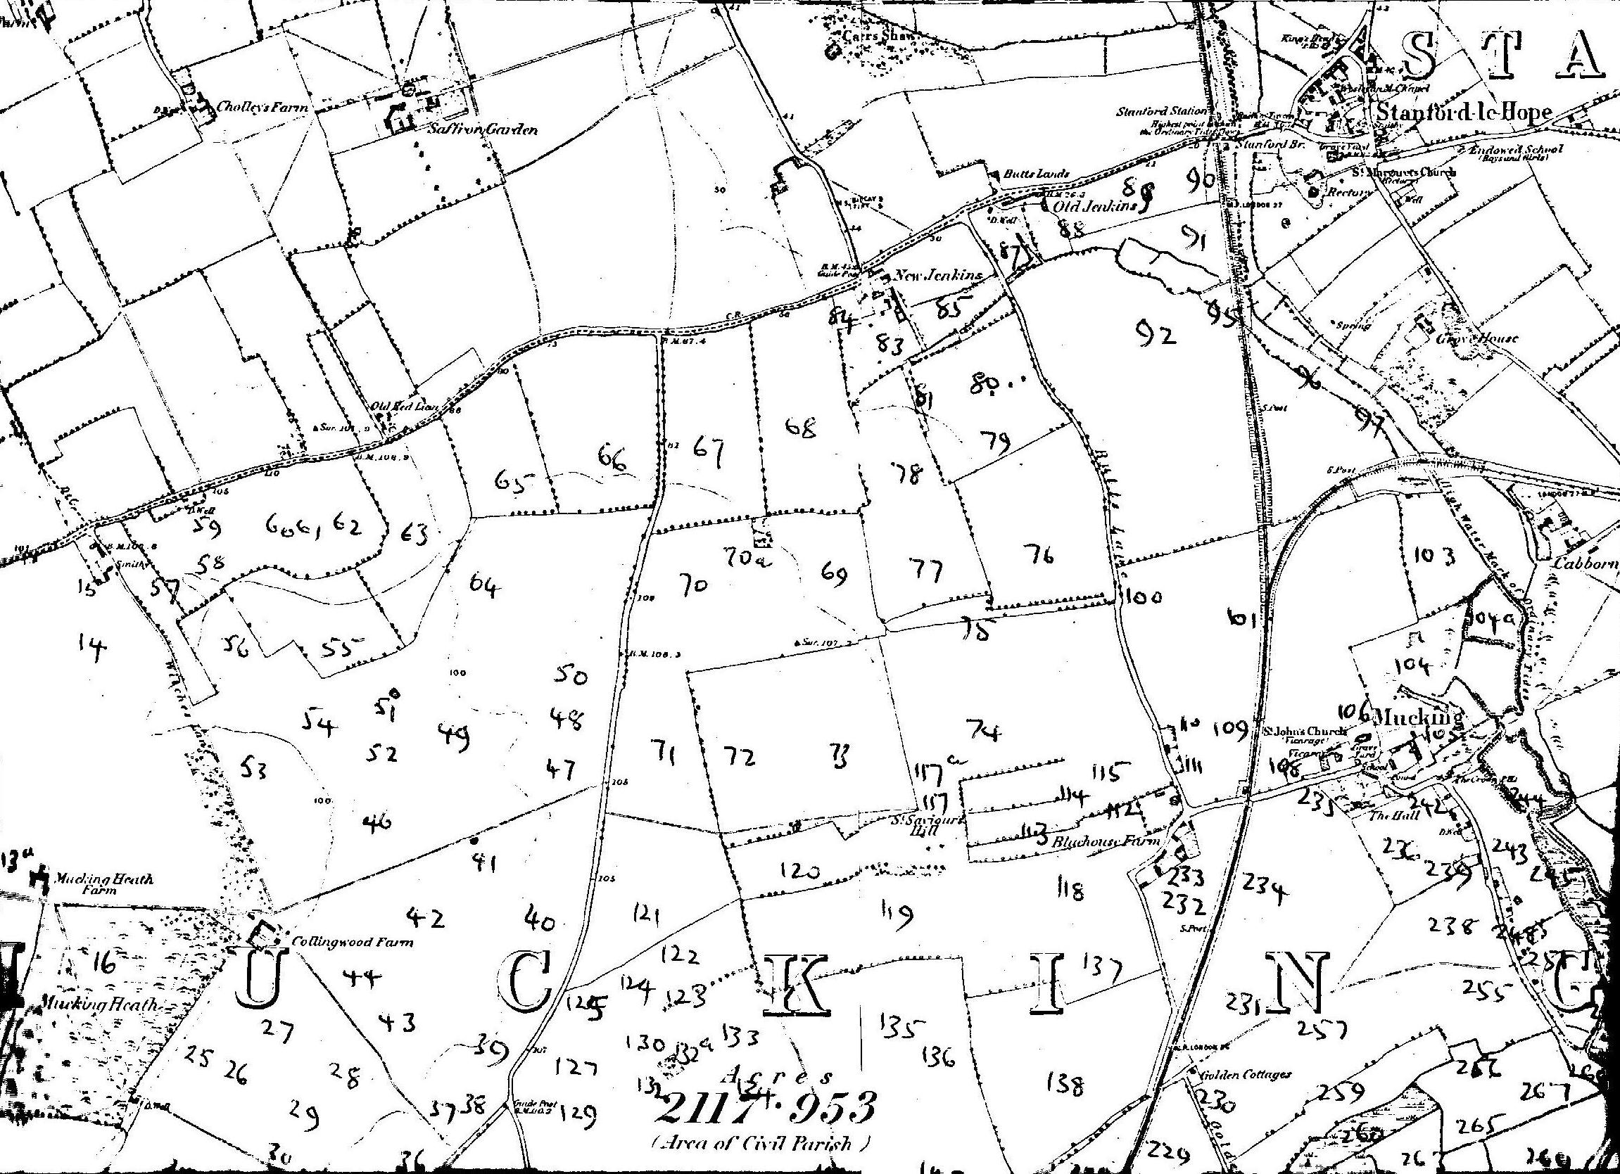
Map 1.
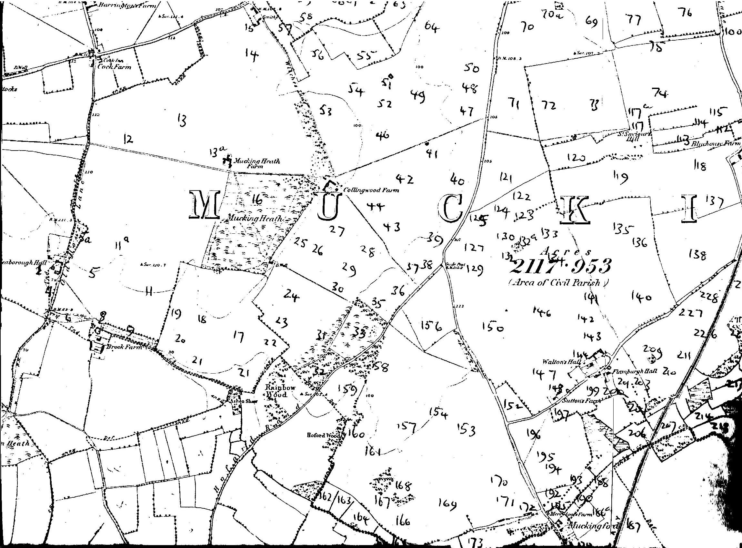
Map 2.
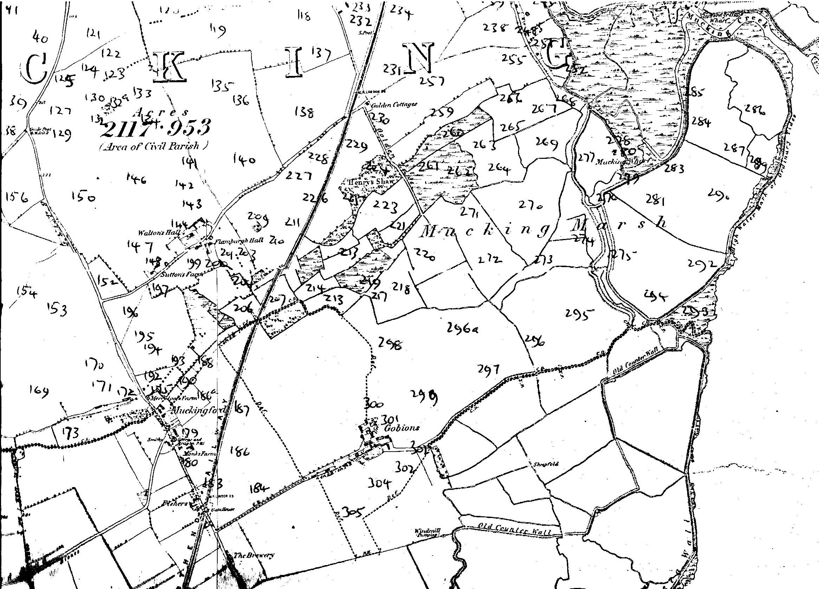
Map 3
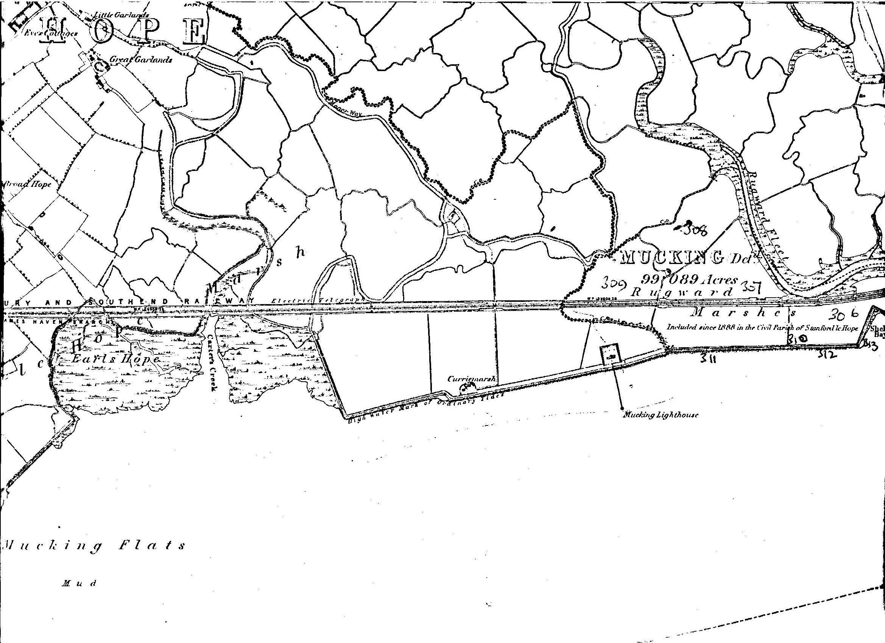
River Thames
Map 4.

