**THE PLACE-NAMES**

**OF MUNDON**

**Recorder: James Kemble**

**Essex Place-names Project (Essex Society for Archaeology & History) e-book, 2015**

[**www.essex.ac.uk/history/esah/essexplacenames**](http://www.essex.ac.uk/history/esah/essexplacenames)

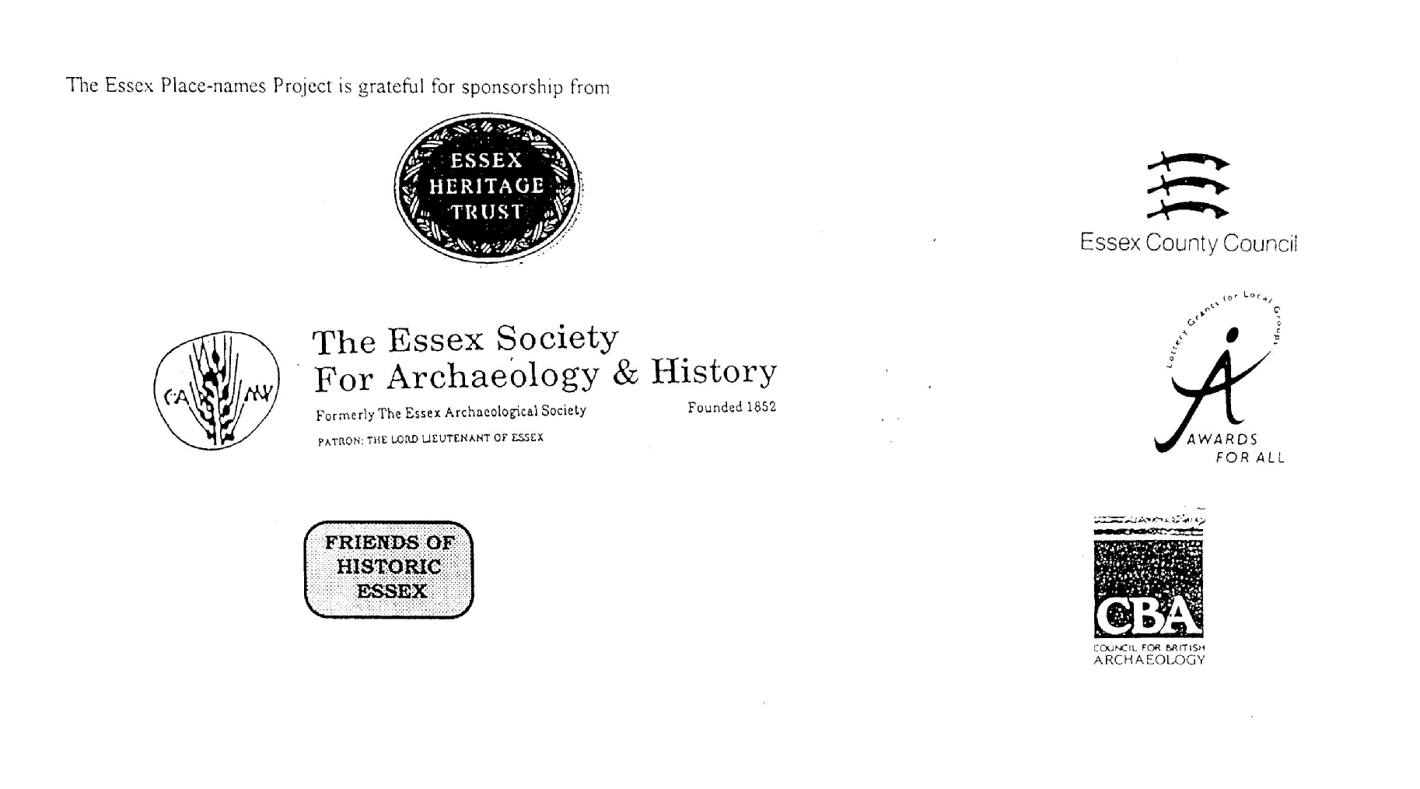

**ESSEX PLACE-NAMES PROJECT.**

The Essex Place-names Project is a County-wide survey to record place- and field-names from historical documents such as Tithe maps and apportionments, estate maps, sale and auction catalogues, conveyances, terriers, deeds, rolls, inquisitions and surveys.

The second element of the Project is to investigate on-the-ground visible remains which correspond to the Place-names for actual or potential archaeological, agricultural and industrial

sites, and to record natural (topographical) and man-made features which may relate to the Place-name. This involves field-survey in rural and outside investigation in built-up areas.

It is anticipated that the Project will lead to identification of archaeological sites and lost historic buildings; it will enable analysis of indicators of early settlement, land holding, agricultural and industrial practices of the County. It will refine the more precise meaning of descriptive words and elements used by earlier settlers as they gave names appropriate to the topography of the landscape of their time.

For convenience the surveys are based on the parish, recognising that present civil parish boundaries are not necessarily identical to former ecclesiastical boundaries. Local Recorders

are supplied with templates of Record Forms to ensure consistency of recording across the County, and forward completed forms to a Central Coordinator for transfer to a county

computer database which is available at the Essex Record Office to researchers.

This publication presents part of the information recorded from the Tithe or Estate Award and Map, (and from other documents for this parish.) The full record is contained on the master database in the Essex Record Office, Wharf Road, Chelmsford CM2 6YT and the website www.essex.ac.uk/history/esah/essexplacenames. Parish books are available from the ERO on disc or in hard copy or may be downloaded from the website. Please notify errors to the Project Coordinator at the Essex Record Office.

**THE TITHE MAP AND APPORTIONMENT.**

Since medieval times a tenth of the produce of land and stock had been paid by landholders to the church. At the Dissolution of the Monasteries, the property of many religious houses,

including the right to collect tithes, passed into lay hands. The Tithe Commutation Act which received Royal assent on 13th August 1836 abolished a rent payable in kind and

substituted rent-charges apportioned on each plot or parcel. The tithe-rent payable was assessed on the average value of wheat, barley and oats and was to fluctuate with price movements.

The commutation could be by voluntary agreement between the local owners and payers or, if agreement failed, could be compulsorily imposed by commissioners. A Valuer was to be

appointed to apportion the rent of each parcel of land and tenants could deduct that rent-charge from their rent paid to the landlord. The task fell to the Tithe Commissioners to produce a map and an Apportionment (Award). A large-scale survey was produced for over 70% of England and Wales in the following 9 years, and about another 8% up to 1855. Most of the

parishes in Essex were surveyed. The map scales vary. The Award records ownership, tenancy and land-use, field by field and parcel by parcel (often quoting the field name) with the

ground area and rent-charge.

Land that was tithe-free tends to be less accurately mapped and contains few if any of the details recorded for those parcels subject to tithe. Rights of way and roads also tend to be

neglected. Boundaries of the tithe areas are shown as are some natural features such as streams, ponds, gardens, greens and commons. Buildings are often shown coloured red if dwellings or grey if not. Because the Award may have been agreed only some time after the map was finished, discrepancies occur between the two. Enclosure Awards, when extant, usually date to the 18th and early 19th centuries. J.Kemble.

Reproduced by permission

of Essex County Council.

Reproduced by permission of

Essex County Council

**Mundon parish in the County of Essex.**

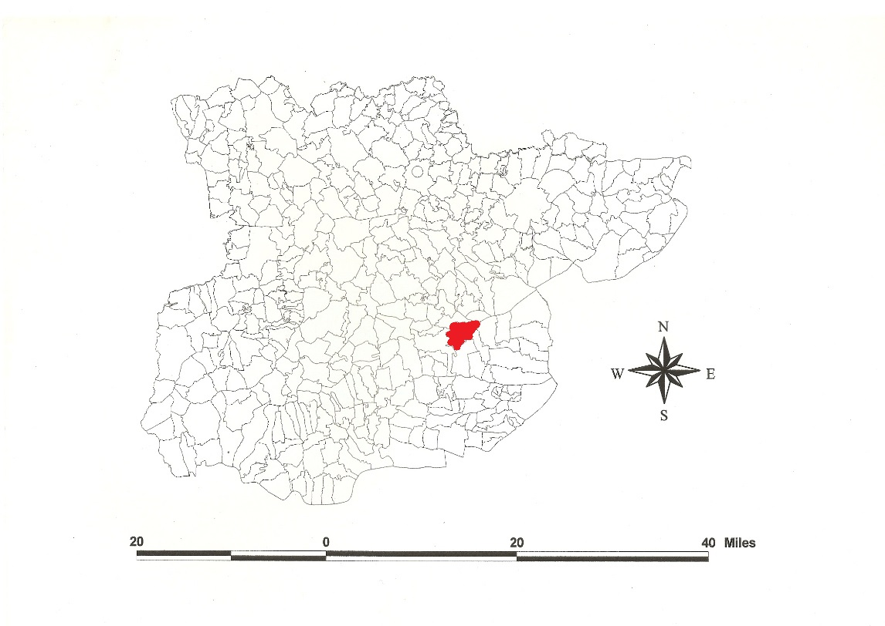

**Mundon Parish (in Dengie Hundred).**

The Tithe Award of Mundon (Essex Record Office (D/CT 247a), dated 1841, shows a rent-charge of £204-15-4 to William Hart, £323 to Rt Hon Charles Callis, £4-5-6 to John Hewson, £45 to Abraham Johnson, £13-7-0 to John Culls, £26 to Jeremiah Holloway, and £179-5-5 to the vicar, total £795-13-3. The whole parish measured 3104 acres 2 roods 6 perches of which 1909a 3r 21p were arable, 671a 1r 38p meadow and pasture, 56a 25p wood, 467a 2p waste. Parsonage Farm, 83a 3r 23p, of Chares Parker of Springfield was tithe exempt. The Tithe Commissioners were William Blamire and Rchd Jones, the Assistant Thomas J. Tatham and the Valuer Robert Baker of Writtle.

The Tithe map (ERO: D/CT 321b) was surveyed at a scale of 20” to a mile and measures 78”x57”. It was countersigned by Roger Kynaston, Assistant Tithe Commissioner.

In Domesday Book, 1086, Eudo dapifer held *Munduna* which Godwin, a king’s thane, had held as a manor for 10 hides with 2 arpents of vines. Attached was *Wringehala* 20 acres held by a freeman (unidentified) (Morris, 1973; Powell, 1964/5). Watts (2004) translates this from Old English *mund* + *dun*, ‘hill offering protection’ [from floods], though Reaney (1935) prefers a personal name ‘Munda’s hill’. *Eltenai* in Domesday Book [Iltney Farm] was held by Count Eustace in 1086 which Engelric had held before 1066 as a manor for 2 hides; *Altenai* was held by Ralph from Earl Swein which Leofstan had held freely as a manor for 1½ hides 40 acres. *Elteneie* was confirmed to Westminster Abbey in 1087 (Hart, 1971; Kemble, 2008). This is from OE *eg*, ‘Elta’s low-lying land’ (Reaney, 1935; Kemble, 2007).

Mundon Hall was granted to St Johns Abbey Colchester by Eudo, the steward. In 1539 after the Dissolution it came to Thomas Cromwell. In 1558 the Hall was annexed to the Duchy of Lancaster. Elteney: in 1556 William Harrys esq held a messuage and land. In 1426 Robert Teye held one messuage and 80 acres of arable etc (Morant, 1768).

The church of St Mary has a C16 west tower and a north porch *c.*1600. White House is mid-17th century. A canal and sea-lock built in 1832 connect to the Blackwater estuary (Pevsner, 2007).

In Domesday Book, the Hundred name is *Witbrictesherna*, *Wibrictesherna*, ‘Wihtbeorht’s corner’ which included the bishop of London’s estates of Tillingham and Southminster In 1189-1199 *Denegeia* is documented, related to *dæninga hris*, ‘brushwood of the Dænningas tribe’ (Reaney, 1935). Christy (1926) places the moot at Lawling. A field in Dengie parish near the church was called Barrowhill in 1714, not yet been investigated.

Place- and field-names from the Walker map of Mundon Hall and Wick (ERO: D/DFg P2), dated 1612, and from other documents are shown against the Tithe names.

**References:**

Christy, M., 1926. Essex Archaeology & History, xviii(3), 182. Essex Hundred Moots.

Hart, C.,1971, Early Charters of Essex. Leicester.

Kemble, J., 2007. Essex Place-names, Places, Streets & People, Historical Publications, pp 12, 74, 122.

Kemble, J., 2008. The Saxon Estates of Westminster Abbey. *Essex Archaeology & History*, 39, 156.

Morant, P., 1768. History & Antiquities of the County of Essex. i 357.

Morris, J., 1983. Domesday Book – Essex, Phillimore

Pevsner, N., Bettley, J., 2007. Buildings of England – Essex. Yale

Powell, W.R., 1964-5. Essex Domesday Topography. *Essex Archaeology & History*, 16, 46.

Reaney, P., 1935. Place-names of Essex, Cambridge

**The Tithe Award Place-names of Mundon – by Parcel No.**

**www.essex.ac.uk/history/esah/essexplacenames**

|  |  |  |  |  |  |  |  |  |  |  |  |  |
| --- | --- | --- | --- | --- | --- | --- | --- | --- | --- | --- | --- | --- |
| **Place name** | **alias** | **Fld No** | **Grd** | **x** | **y** | **Acr** | **Rd** | **Pch** | **Land use** | **Owner** | **Occupier** | **Text** |
|  |  |  |  |  |  |  |  |  |  |  |  |  |
| Oxly Marsh |  | 1 | TL | 870 | 047 | 7 | 0 | 25 | pasture | Hooper, Mary Ann | Fairhead, Mary |  |
| The Six acres |  | 2 | TL |  |  | 5 | 3 | 38 | arable | Hooper, Mary Ann | Fairhead, Mary |  |
| Eight Acres |  | 3 | TL | 872 | 047 | 7 | 3 | 37 | arable | Hooper, Mary Ann | Fairhead, Mary |  |
| First Marsh |  | 4 | TL |  |  | 21 | 0 | 35 | pasture | Hooper, Mary Ann | Fairhead, Mary |  |
| Saltings |  | 5 | TL | 874 | 051 | 35 | 2 | 27 | pasture | Hooper, Mary Ann | Fairhead, Mary |  |
| Saltings |  | 6 | TL |  |  | 16 | 1 | 0 | sltg | Marriage, James | Marriage, James |  |
| Little pasture |  | 7 | TL |  |  | 2 | 0 | 7 | pasture | Hooper, Mary Ann | Fairhead, Mary |  |
| Hilly Marsh |  | 8 | TL | 874 | 048 | 25 | 3 | 28 | pasture | Hooper, Mary Ann | Fairhead, Mary |  |
| Middle Marsh |  | 9 | TL |  |  | 15 | 3 | 28 | pasture | Hooper, Mary Ann | Fairhead, Mary |  |
| Barn field |  | 10 | TL | 874 | 045 | 13 | 0 | 18 | arable | Hooper, Mary Ann | Fairhead, Mary |  |
| Homestead. Bramble Hall | Brambell Hawe, Brombell, tHyVIII, Dugd | 11 | TL | 873 | 044 | 0 | 2 | 6 |  | Hooper, Mary Ann | Fairhead, Mary |  |
| The pasture |  | 12 | TL |  |  | 2 | 2 | 26 | pasture | Hooper, Mary Ann | Fairhead, Mary |  |
| Sixteen acres |  | 13 | TL |  |  | 16 | 2 | 24 | arable | Hooper, Mary Ann | Fairhead, Mary |  |
| Thirteen acres |  | 15 | TL | 871 | 044 | 14 | 3 | 9 | arable | Hooper, Mary Ann | Fairhead, Mary |  |
| No name |  | 16 | TL |  |  | 5 | 3 | 4 |  | Crombie, Dr., trustees | Grainger, William, execs |  |
| No name |  | 17 | TL | 870 | 042 | 8 | 0 | 39 | arable | Crombie, Dr., trustees | Grainger, William, execs |  |
| Nine acres |  | 18 | TL |  |  | 8 | 0 | 19 | arable | Johnson, Abraham | Marthams, John |  |
| The pasture |  | 19 | TL |  |  | 6 | 2 | 29 | pasture | Johnson, Abraham | Marthams, John |  |
| Stable field |  | 20 | TL | 874 | 043 | 5 | 3 | 25 | arable | Johnson, Abraham | Marthams, John |  |
| Sea field |  | 20a | TL | 875 | 045 | 15 | 2 | 38 | arable | Johnson, Abraham | Marthams, John |  |
| Homestead. Garlands | Garlonns, 1526,Rntl; Garlandes, 1586,Ct; North House,1777,C | 21 | TL | 873 | 042 | 1 | 2 | 26 |  | Johnson, Abraham | Marthams, John | Richard Gerlaund, 1327,SubRoll |
| Long Marsh |  | 22 | TL |  |  | 12 | 0 | 16 | arable | Hooper, Mary Ann | Fairhead, Mary |  |
| The Island | [at Mundon Wash, 1936,OS] | 22a | TL | 875 | 043 | 5 | 1 | 20 | arable | Hooper, Mary Ann | Fairhead, Mary |  |
| Saw pit field |  | 23 | TL | 874 | 040 | 12 | 1 | 18 | arable | Johnson, Abraham | Marthams, John |  |
| The Marsh |  | 23a | TL | 874 | 038 | 8 | 2 | 9 | pasture | Johnson, Abraham | Marthams, John |  |
| Cart Lodge pasture |  | 24 | TL | 873 | 040 | 6 | 1 | 26 | pasture | Johnson, Abraham | Marthams, John |  |
| The Fourteen Acres |  | 25 | TL |  |  | 15 | 3 | 17 | arable | Johnson, Abraham | Marthams, John |  |
| The Sixteen acres |  | 27 | TL |  |  | 19 | 0 | 14 | arable | Johnson, Abraham | Marthams, John |  |
| Great Brook Field |  | 28 | TL | 868 | 035 | 14 | 1 | 39 | arable | Johnson, Abraham | Marthams, John |  |
| Great Brook Field (pt) |  | 29 | TL |  |  | 10 | 0 | 0 | arble, pstre | Johnson, Abraham | Marthams, John |  |
| The Grove |  | 30 | TL | 871 | 035 | 1 | 3 | 33 | wood | Johnson, Abraham | Marthams, John |  |
| Little Brook field |  | 31 | TL |  |  | 6 | 0 | 13 | arable | Johnson, Abraham | Marthams, John |  |
| The Bottoms (pt) |  | 32 | TL | 866 | 033 | 4 | 1 | 1 | arble, pstre | Holloway, Jeremiah Barker | Holloway, Jeremiah Barker |  |
| The Bottoms (pt) |  | 33 | TL | 866 | 033 | 2 | 1 | 12 | pasture | Holloway, Jeremiah Barker | Holloway, Jeremiah Barker |  |
| Road Ten acres |  | 35 | TL | 866 | 035 | 10 | 2 | 17 | arable | Holloway, Jeremiah Barker | Holloway, Jeremiah Barker |  |
| Kitchen field |  | 38 | TL |  |  | 9 | 1 | 18 | arable | Holloway, Jeremiah Barker | Holloway, Jeremiah Barker |  |
| Homestead. Copkitchens | Copedkechene, 1426,IpmR; Coxes Kitchen, 1836,OS | 41 | TL | 864 | 035 | 2 | 2 | 1 |  | Holloway, Jeremiah Barker | Holloway, Jeremiah Barker |  |
| Long Ten acres |  | 43 | TL |  |  | 10 | 3 | 14 | arable | Holloway, Jeremiah Barker | Holloway, Jeremiah Barker |  |
| The Ten acres |  | 44 | TL |  |  | 9 | 2 | 6 | arable | Holloway, Jeremiah Barker | Holloway, Jeremiah Barker |  |
| Bottoms (pt) |  | 45 | TL |  |  | 1 | 3 | 32 | pasture | Holloway, Jeremiah Barker | Holloway, Jeremiah Barker |  |
| Bottoms (pt) |  | 46 | TL | 864 | 032 | 3 | 0 | 29 | arble, pstre | Holloway, Jeremiah Barker | Holloway, Jeremiah Barker |  |
| Creek Croft |  | 47 | TL | 866 | 032 | 4 | 2 | 19 | arable | Parker, Charles George | Deeks, John |  |
| Little Borehams |  | 48 | TL | 867 | 033 | 2 | 2 | 15 | arable | Marriage, James | Perry, John |  |
| Two cottages, gdns |  | 49 | TL | 867 | 033 | 0 | 1 | 5 |  | Marriage, James | Brown, David; Bradshaw, Wm |  |
| Great Borehams | [at Mundon Hill, 1875,OS] | 50 | TL | 869 | 030 | 11 | 2 | 38 | arable | Marriage, James | Marriage, James |  |
| The Grove |  | 51 | TL | 870 | 030 | 0 | 2 | 6 | wood | Marriage, James | Marriage, James |  |
| Eighteen Acres |  | 52 | TL |  |  | 20 | 0 | 24 | arable | Felton, James | Dawson, William |  |
| No name |  | 53 | TL |  |  | 6 | 0 | 39 | pasture | Felton, James | Dawson, William |  |
| The Five acres |  | 54 | TL | 872 | 035 | 5 | 2 | 19 | arable | Felton, James | Dawson, William |  |
| No name |  | 55 | TL |  |  | 9 | 1 | 23 | arable | Felton, James | Dawson, William |  |
| Two cottages, gdns |  | 56 | TL | 875 | 035 | 0 | 0 | 31 |  | Felton, James | Peake, Wm; Browne, Abraham |  |
| The Meadow |  | 57 | TL |  |  | 3 | 1 | 7 | arable | Felton, James | Dawson, William |  |
| No name |  | 58 | TL |  |  | 11 | 1 | 15 | arable | Felton, James | Dawson, William |  |
| Three cottages, gdns | Ivyinpan Hall, 1839, Tithe map | 59 | TL | 873 | 034 | 3 | 3 | 16 |  | Wordsworth, Rev | Peake, Francis snr & jnr; Williams, Joseph |  |
| Three acres |  | 60 | TL |  |  | 3 | 3 | 16 | arable | Wordsworth, Rev | Payne, Edward |  |
| Two acres |  | 62 | TL |  |  | 2 | 1 | 1 | arable | Wordsworth, Rev | Payne, Edward |  |
| Pightle |  | 63 | TL | 873 | 033 | 1 | 3 | 33 | pasture | Wordsworth, Rev | Payne, Edward |  |
| No name |  | 64 | TL |  |  | 2 | 2 | 28 | pasture | Felton, James | Bridge, James |  |
| Cottages, gdns |  | 65 | TL | 870 | 033 | 0 | 1 | 28 |  | Felton, James | Keys, John; Prior,Thomas; Williams,Wm;Dawson,Wm |  |
| No name |  | 66 | TL |  |  | 7 | 3 | 18 | a | Felton, James | Dawson, William |  |
| No name |  | 67 | TL | 871 | 032 | 12 | 2 | 38 | arable | Felton, James | Dawson, William |  |
| No name |  | 68 | TL | 871 | 030 | 3 | 3 | 31 | arable | Payne, Rev Coventry | Payne, Edward | glebe |
| No name | [at Vicarage Lane, 1875,OS] | 69 | TL | 872 | 031 | 5 | 2 | 15 | arable | Payne, Rev Coventry | Payne, Edward | glebe |
| Two cottages | Parsonage, 1777,C; Vicarage, 1839,Tithe map | 70 | TL | 872 | 030 | 0 | 0 | 24 |  | Payne, Rev Coventry | Payne, Edward | glebe |
| Barn yard |  | 71 | TL |  |  | 0 | 2 | 0 |  | Payne, Rev Coventry | Payne, Edward | glebe |
| Homestead. Rogers | Roger's Farm, 1875,OS | 73 | TL | 874 | 030 | 1 | 1 | 36 |  | Felton, James | Dawson, William |  |
| No name |  | 75 | TL |  |  | 5 | 2 | 11 | arable | Felton, James | Dawson, William |  |
| No name |  | 77 | TL |  |  | 5 | 0 | 4 | arable | Felton, James | Dawson, William |  |
| Cottages, gdns | [in Mundon Village, Tithe map] | 78 | TL | 869 | 028 | 0 | 0 | 27 |  | Felton, James | Carter, Joseph; Brown, Edward |  |
| Bake house |  | 79 | TL | 869 | 028 | 0 | 0 | 6 |  | Solly, Richard | Bridge, James |  |
| Cottages, gdns |  | 80 | TL |  |  | 0 | 0 | 20 |  | Solly, Richard | Bridge, James; Eve, Charles; Cooper, Henry |  |
| The White Horse Inn | White Horse PH, 1875,OS | 81 | TL | 869 | 027 | 0 | 0 | 29 | inn | Crabb, Richard Hatley | Deeks, John |  |
| Three gardens |  | 82 | TL | 869 | 027 | 0 | 0 | 26 |  | Solly, Richard | .. |  |
| Two cottages, gdns |  | 83 | TL | 869 | 027 | 0 | 0 | 15 |  | Wallace, Joseph | Camp, Samuel; Deeks, John jnr |  |
| Two cottages |  | 84 | TL | 869 | 027 | 0 | 0 | 5 |  | Wallace, Joseph | Mallow, Elizabeth; Cardy, Joseph |  |
| Two cottages, shop |  | 85 | TL | 869 | 027 | 0 | 0 | 23 |  | Burchell, Sarah | Burchell, Samuel & Daniel |  |
| Three cottages |  | 86 | TL | 869 | 027 | 0 | 0 | 32 |  | Waring, Sarah | Bridge, James; Dedman, Thomas |  |
| The Six acres |  | 87 | TL | 876 | 034 | 6 | 0 | 15 |  | Marriage, James | Marriage, James |  |
| The Eighteen acres |  | 88 | TL | 877 | 034 | 7 | 3 | 15 | arable | Marriage, James | Marriage, James |  |
| Spring field | cp. Westfelde Springe corner, 1585,Ct | 89 | TL | 878 | 036 | 17 | 2 | 4 | arable | Marriage, James | Marriage, James |  |
| Long Ten acres | [at New Hall Lane, 1875,OS] | 90 | TL | 880 | 037 | 10 | 1 | 2 | arable | Chase, Louisa | Snow, John |  |
| Rough Waste |  | 90a | TL |  |  | 0 | 0 | 23 | pasture | Chase, Louisa | Snow, John |  |
| Hunger Downs |  | 91 | TL | 881 | 037 | 13 | 0 | 16 | arable | Marriage, James | Marriage, James |  |
| Homestead. White Horse | White House Farm, 1875,OS | 93 | TL | 876 | 036 | 2 | 0 | 16 |  | Marriage, James | Marriage, James |  |
| Nine acres |  | 94 | TL |  |  | 11 | 2 | 33 | arable | Marriage, James | Marriage, James |  |
| Long meadow |  | 95 | TL |  |  | 15 | 0 | 27 | pasture | Marriage, James | Marriage, James |  |
| Ten acres |  | 96 | TL |  |  | 11 | 1 | 35 | arable | Marriage, James | Marriage, James |  |
| Thirteen acres |  | 97 | TL | 880 | 040 | 13 | 3 | 24 | arable | Plume, Dr., trustees | Burchell, John |  |
| Haydons | Haysdones Mershe, 1585,Ct | 98 | TL | 878 | 043 | 21 | 1 | 2 | arable | Marriage, James | Marriage, James |  |
| Second Marsh |  | 99 | TL |  |  | 10 | 0 | 34 | pasture | Marriage, James | Marriage, James |  |
| Fourth Marsh |  | 100 | TL | 878 | 046 | 13 | 1 | 13 | pasture | Marriage, James | Marriage, James |  |
| Canal | White House Farm Canal (disused), 1875,OS | 100a | TL | 879 | 045 | 2 | 3 | 18 |  | Marriage, James | Marriage, James |  |
| Fifth Marsh |  | 101 | TL |  |  | 3 | 3 | 6 | pasture | Marriage, James | Marriage, James |  |
| Sixth Marsh |  | 101a | TL |  |  | 6 | 3 | 36 | pasture | Marriage, James | Marriage, James |  |
| Six acres |  | 102 | TL | 881 | 047 | 5 | 3 | 17 | . | Marriage, James | Marriage, James |  |
| Ninth Marsh |  | 103 | TL |  |  | 5 | 0 | 22 | . | Marriage, James | Marriage, James |  |
| Saltings |  | 105 | TL | 881 | 052 | 28 | 1 | 10 | sltg | Plume, Dr., trustees | Burchell, John |  |
| Eight acres (2nd pt) |  | 106 | TL |  |  | 10 | 1 | 23 | pasture | Plume, Dr., trustees | Burchell, John |  |
| Eight acres (1st pt) |  | 107 | TL |  |  | 9 | 2 | 19 | pasture | Plume, Dr., trustees | Burchell, John |  |
| Horse Marsh |  | 108 | TL | 884 | 049 | 16 | 3 | 10 | pasture | Plume, Dr., trustees | Burchell, John |  |
| Spring field |  | 109 | TL |  |  | 1 | 0 | 5 | wood | Plume, Dr., trustees | Burchell, John |  |
| Barn field |  | 110 | TL | 885 | 046 | 23 | 2 | 11 | arable | Plume, Dr., trustees | Burchell, John |  |
| Twenty five acres |  | 111 | TL |  |  | 24 | 3 | 15 | arable | Plume, Dr., trustees | Burchell, John |  |
| The Hilly Field |  | 112 | TL | 882 | 044 | 29 | 0 | 13 | arable | Plume, Dr., trustees | Burchell, John |  |
| The Eighteen acres |  | 113 | TL |  |  | 18 | 2 | 20 | arable | Plume, Dr., trustees | Burchell, John |  |
| The Eleven acres |  | 114 | TL |  |  | 12 | 1 | 33 | arable | Plume, Dr., trustees | Burchell, John |  |
| Homestead. Ilney | Elteneie,1087,WDB; Altenai,Eltenai, 1086,DB; Iltney Fm, 1875,OS | 115 | TL | 885 | 045 | 2 | 1 | 35 |  | Plume, Dr., trustees | Burchell, John |  |
| Hoppit |  | 116 | TL |  |  | 1 | 0 | 6 | pasture | Plume, Dr., trustees | Burchell, John |  |
| The Garden Field |  | 117 | TL |  |  | 14 | 1 | 25 | arable | Plume, Dr., trustees | Burchell, John |  |
| Three cottages, gdns | [at New Hall Lane, 1875,OS] | 118 | TL | 887 | 042 | 0 | 1 | 23 |  | Callis, RtHon Charles, Lord Western | French,Edward; Peck,John; Moss,Thomas |  |
| Pond field |  | 119 | TL |  |  | 19 | 0 | 22 | arable | Callis, RtHon Charles, Lord Western | Blakeley, Francis |  |
| Little Flat Marsh |  | 120 | TL | 889 | 040 | 12 | 1 | 8 | arable | Callis, RtHon Charles, Lord Western | Blakeley, Francis |  |
| Great Flat Marsh (pt) |  | 121 | TL |  |  | 10 | 3 | 9 | arable | Callis, RtHon Charles, Lord Western | Blakeley, Francis |  |
| Grove field |  | 122 | TL | 888 | 044 | 18 | 3 | 10 | arable | Callis, RtHon Charles, Lord Western | Blakeley, Francis |  |
| Great Barn field |  | 123 | TL | 888 | 046 | 21 | 1 | 32 | arable | Callis, RtHon Charles, Lord Western | Blakeley, Francis |  |
| Saltings |  | 124 | TL |  |  | 24 | 0 | 25 | sltg | Callis, RtHon Charles, Lord Western | Blakeley, Francis |  |
| Little Barn field |  | 125 | TL |  |  | 17 | 1 | 7 | arable | Callis, RtHon Charles, Lord Western | Blakeley, Francis |  |
| Sea field |  | 126 | TL | 894 | 046 | 27 | 2 | 8 | arable | Callis, RtHon Charles, Lord Western | Blakeley, Francis |  |
| Saltings |  | 127 | TL |  |  | 76 | 2 | 11 | sltg | Callis, RtHon Charles, Lord Western | Blakeley, Francis |  |
| South Hill |  | 128 | TL | 891 | 044 | 38 | 2 | 17 | arable | Callis, RtHon Charles, Lord Western | Blakeley, Francis |  |
| Mole Hill Marsh |  | 129 | TL |  |  | 8 | 0 | 36 | pasture | Callis, RtHon Charles, Lord Western | Blakeley, Francis |  |
| Great Flat Marsh (pt) |  | 130 | TL | 891 | 040 | 10 | 3 | 18 | arable | Callis, RtHon Charles, Lord Western | Blakeley, Francis |  |
| Hogs Cote Marsh |  | 131 | TL | 892 | 038 | 23 | 0 | 0 | pasture | Callis, RtHon Charles, Lord Western | Blakeley, Francis |  |
| Home Marsh |  | 132 | TL |  |  | 9 | 1 | 32 | pasture | Callis, RtHon Charles, Lord Western | Blakeley, Francis |  |
| Homestead. New Hall | New Hall, 1777,C | 133 | TL | 894 | 041 | 1 | 1 | 10 |  | Callis, RtHon Charles, Lord Western | Blakeley, Francis |  |
| Mowing marsh |  | 134 | TL | 895 | 040 | 17 | 1 | 34 | pasture | Callis, RtHon Charles, Lord Western | Blakeley, Francis |  |
| Little Piece |  | 135 | TL |  |  | 1 | 3 | 10 | pasture | Callis, RtHon Charles, Lord Western | Blakeley, Francis |  |
| Saltings |  | 136 | TL |  |  | 29 | 1 | 22 | sltg | Callis, RtHon Charles, Lord Western | Sewell, Sarah |  |
| Sea field | [at Mundon Stone Point, 1936,OS] | 137 | TL | 906 | 044 | 25 | 1 | 28 | arable | Callis, RtHon Charles, Lord Western | Sewell, Sarah |  |
| Seventeen acres |  | 138 | TL |  |  | 18 | 2 | 24 | arable | Callis, RtHon Charles, Lord Western | Sewell, Sarah |  |
| The Intales |  | 139 | TL | 905 | 041 | 3 | 2 | 34 | pasture | Callis, RtHon Charles, Lord Western | Sewell, Sarah |  |
| Further Nine acres |  | 140 | TL |  |  | 21 | 2 | 30 | arable | Callis, RtHon Charles, Lord Western | Sewell, Sarah |  |
| Barn piece |  | 141 | TL | 901 | 040 | 5 | 0 | 17 | pasture | Callis, RtHon Charles, Lord Western | Sewell, Sarah |  |
| Barn yard |  | 142 | TL | 901 | 040 | 0 | 0 | 35 |  | Callis, RtHon Charles, Lord Western | Sewell, Sarah |  |
| Nineteen acres |  | 143 | TL |  |  | 21 | 1 | 17 | arable | Callis, RtHon Charles, Lord Western | Sewell, Sarah |  |
| Saltings |  | 144 | TL | 900 | 035 | 141 | 3 | 9 | sltg | Callis, RtHon Charles, Lord Western | Sewell, Sarah |  |
| The Twenty acres |  | 145 | TL |  |  | 22 | 2 | 16 | arable | Callis, RtHon Charles, Lord Western | Sewell, Sarah |  |
| The Eighteen acres |  | 147 | TL |  |  | 20 | 0 | 21 | arable | Callis, RtHon Charles, Lord Western | Sewell, Sarah |  |
| The Home Ten acres |  | 148 | TL | 898 | 034 | 12 | 2 | 2 | arable | Callis, RtHon Charles, Lord Western | Sewell, Sarah |  |
| The Two acre Piece |  | 149 | TL |  |  | 1 | 2 | 36 | pasture | Callis, RtHon Charles, Lord Western | Sewell, Sarah |  |
| The Large Marsh |  | 150 | TL | 898 | 033 | 11 | 1 | 24 | pasture | Callis, RtHon Charles, Lord Western | Sewell, Sarah |  |
| The Hoppit |  | 151 | TL |  |  | 1 | 0 | 9 | pasture | Callis, RtHon Charles, Lord Western | Sewell, Sarah |  |
| Garden, Drying Ground |  | 152 | TL | 897 | 033 | 0 | 3 | 37 | arable | Callis, RtHon Charles, Lord Western | Sewell, Sarah |  |
| Homestead. Brick House | Brick House, 1777,C | 154 | TL | 897 | 033 | 1 | 1 | 6 |  | Callis, RtHon Charles, Lord Western | Sewell, Sarah |  |
| Hoppit |  | 155 | TL |  |  | 2 | 2 | 9 | arable | Callis, RtHon Charles, Lord Western | Sewell, Sarah |  |
| The Four acres |  | 156 | TL |  |  | 4 | 2 | 36 | arable | Callis, RtHon Charles, Lord Western | Sewell, Sarah |  |
| Five acres |  | 158 | TL | 894 | 034 | 5 | 0 | 23 | arable | Dalton, Charles | Sewell, Sarah |  |
| Homestead. Pickworths |  | 159 | TL | 894 | 035 | 1 | 1 | 16 |  | Dalton, Charles | Sewell, Sarah |  |
| Five acres |  | 161 | TL |  |  | 5 | 2 | 30 | arable | Dalton, Charles | Sewell, Sarah |  |
| Five acres |  | 162 | TL |  |  | 5 | 1 | 4 | arable | Dalton, Charles | Sewell, Sarah |  |
| Kitchen field |  | 164 | TL | 894 | 037 | 11 | 1 | 30 | arable | Callis, RtHon Charles, Lord Western | Sewell, Sarah |  |
| No name |  | 165 | TL |  |  | 10 | 3 | 18 | pasture | Dalton, Charles | Sewell, Sarah |  |
| No name |  | 167 | TL | 891 | 033 | 7 | 1 | 32 | pasture | Dalton, Charles | Sewell, Sarah |  |
| Nine acres |  | 168 | TL |  |  | 9 | 2 | 5 | pasture | Pattisson, Joseph | Pattisson, Joseph |  |
| Cottages, gdns | Sparrow Hall, Tithe map | 168a | TL | 894 | 032 | 0 | 1 | 12 |  | Pattisson, Joseph | Cotty, Joseph; Packmore, John | Anthony Sparrowe, 1562,Extent |
| Seven acres |  | 170 | TL |  |  | 7 | 3 | 36 | pasture | Pattisson, Joseph | Pattisson, Joseph |  |
| Twenty acres |  | 170a | TL | 893 | 031 | 22 | 0 | 1 | pasture | Pattisson, Joseph | Pattisson, Joseph |  |
| Pightle |  | 171 | TL |  |  | 0 | 2 | 27 | pasture | Pattisson, Joseph | Pattisson, Joseph |  |
| Saltings | [at Mundon Creek, 1875,OS] | 173 | TL | 895 | 026 | 3 | 2 | 8 | sltg | Pattisson, Joseph | Pattisson, Joseph |  |
| Saltings |  | 174 | TL | 893 | 027 | 6 | 0 | 24 | sltg | Pattisson, Joseph | Pattisson, Joseph |  |
| Upper Nine acres |  | 175 | TL | 883 | 039 | 9 | 1 | 29 | arable | Chase, Louisa | Snow, John |  |
| Lower Nine acres |  | 176 | TL |  |  | 9 | 2 | 23 | arable | Chase, Louisa | Snow, John |  |
| Little Five acres |  | 178 | TL | 883 | 036 | 6 | 2 | 18 | arable | Chase, Louisa | Snow, John |  |
| Cartlodge field |  | 180 | TL | 884 | 036 | 7 | 0 | 15 | arable | Chase, Louisa | Snow, John |  |
| Homestall, Small pasture | Mullettes, 1526,Rntl; Mollets,1839,Tithe map | 181 | TL | 885 | 037 | 1 | 1 | 9 |  | Chase, Louisa | Snow, John | John Mulet, 1341,NI |
| Lower Chase field |  | 182 | TL |  |  | 8 | 1 | 37 | arable | Chase, Louisa | Snow, John |  |
| Upper Chase field |  | 183 | TL | 885 | 039 | 11 | 1 | 11 | arable | Chase, Louisa | Snow, John |  |
| Duck House field |  | 184 | TL | 886 | 036 | 4 | 3 | 12 | arable | Chase, Louisa | Snow, John |  |
| Middle marsh |  | 185 | TL |  |  | 9 | 1 | 3 | pasture | Chase, Louisa | Snow, John |  |
| Further marsh |  | 186 | TL | 890 | 036 | 8 | 0 | 17 | pasture | Chase, Louisa | Snow, John |  |
| Ten acre marsh |  | 187 | TL |  |  | 6 | 3 | 13 | arable | Chase, Louisa | Snow, John |  |
| Black Pit Marsh |  | 189 | TL | 888 | 034 | 28 | 0 | 34 | arable | Callis, RtHon Charles, Lord Western | Solly, Richard |  |
| Black Pit field |  | 190 | TL | 885 | 034 | 22 | 0 | 26 | arable | Callis, RtHon Charles, Lord Western | Solly, Richard |  |
| Great Eighteen acres |  | 192 | TL |  |  | 33 | 2 | 17 | arable | Callis, RtHon Charles, Lord Western | Solly, Richard |  |
| Great Downs | Downes, 1612, D/DFg P2 | 193 | TL | 878 | 030 | 30 | 2 | 16 | arable | Callis, RtHon Charles, Lord Western | Solly, Richard |  |
| Little Downs |  | 194 | TL |  |  | 6 | 2 | 15 | arable | Callis, RtHon Charles, Lord Western | Solly, Richard |  |
| Lambs croft | Lambe crofte, 1612,D/DFg P2 | 195 | TL | 875 | 031 | 30 | 0 | 11 | arable | Callis, RtHon Charles, Lord Western | Solly, Richard |  |
| Wood |  | 197 | TL | 875 | 028 | 1 | 1 | 17 | wood | Callis, RtHon Charles, Lord Western | Solly, Richard |  |
| Cottage, gdn |  | 198 | TL | 875 | 027 | 0 | 1 | 37 |  | Callis, RtHon Charles, Lord Western | Brown, William |  |
| Little West |  | 199 | TL |  |  | 23 | 3 | 17 | arable | Callis, RtHon Charles, Lord Western | Solly, Richard |  |
| Great West | Weste Fielde, 1612,D/DFg P2 | 200 | TL | 874 | 025 | 54 | 3 | 12 | arable | Callis, RtHon Charles, Lord Western | Solly, Richard |  |
| The Mundon Furze |  | 201 | TL | 870 | 024 | 33 | 3 | 27 | wood | Callis, RtHon Charles, Lord Western | Callis, RtHon Charles, Lord Western |  |
| Wood field |  | 202 | TL | 868 | 021 | 6 | 1 | 6 | arable | Callis, RtHon Charles, Lord Western | Solly, Richard |  |
| Three cottages, gdns |  | 203 | TL |  |  | 0 | 1 | 10 |  | Callis, RtHon Charles, Lord Western | Basket, Wm; Challis,Joseph; one empty |  |
| Eight acres | Newe meade, 1612, D/DFg P2 | 204 | TL | 876 | 028 | 9 | 2 | 4 | arable | Callis, RtHon Charles, Lord Western | Solly, Richard |  |
| The Little Meadow | Gostages, 1612,D/DFg P2 | 205 | TL | 876 | 026 | 11 | 3 | 0 | pasture | Callis, RtHon Charles, Lord Western | Solly, Richard |  |
| The Great Mead | Olde Meade, 1612,D/DFg P2 | 206 | TL | 877 | 025 | 16 | 2 | 26 | pasture | Callis, RtHon Charles, Lord Western | Solly, Richard |  |
| Rolls |  | 207 | TL | 877 | 023 | 15 | 0 | 13 | arable | Callis, RtHon Charles, Lord Western | Solly, Richard |  |
| Vensons |  | 208 | TL | 878 | 020 | 24 | 3 | 35 | arable | Callis, RtHon Charles, Lord Western | Solly, Richard |  |
| Upper Molehill Marsh |  | 209 | TL | 880 | 018 | 12 | 2 | 10 | pasture | Callis, RtHon Charles, Lord Western | Solly, Richard |  |
| Newlands | Oate each by Rowles, 1612,D/DFg P2 | 210 | TL | 881 | 020 | 20 | 0 | 25 | arable | Callis, RtHon Charles, Lord Western | Solly, Richard |  |
| Rolles | Rowles, 1612, D/DFg P2 | 211 | TL | 880 | 024 | 13 | 0 | 38 | arable | Callis, RtHon Charles, Lord Western | Solly, Richard |  |
| The Wood | The Plantation, 1875,OS | 212 | TL | 879 | 025 | 2 | 3 | 26 | wood | Callis, RtHon Charles, Lord Western | Solly, Richard |  |
| The Chase Pightle |  | 213 | TL | 879 | 026 | 3 | 3 | 39 | pasture | Callis, RtHon Charles, Lord Western | Solly, Richard |  |
| Homestead. Mundon Hall | Munduna, 1086,DB; Monden, 1238,SR | 214 | TL | 878 | 027 | 3 | 2 | 34 |  | Callis, RtHon Charles, Lord Western | Solly, Richard |  |
| Moat Piece |  | 215 | TL | 879 | 027 | 1 | 3 | 33 | pasture | Callis, RtHon Charles, Lord Western | Solly, Richard |  |
| Upper Pightle |  | 216 | TL |  |  | 3 | 2 | 26 | pasture | Callis, RtHon Charles, Lord Western | Solly, Richard |  |
| Saw Pit Piece |  | 217 | TL | 877 | 027 | 3 | 1 | 19 | pasture | Callis, RtHon Charles, Lord Western | Solly, Richard |  |
| Lower Pightle |  | 218 | TL |  |  | 3 | 0 | 8 | pasture | Callis, RtHon Charles, Lord Western | Solly, Richard |  |
| The Old Grove |  | 219 | TL | 880 | 027 | 11 | 3 | 15 | pasture | Callis, RtHon Charles, Lord Western | Solly, Richard |  |
| Upper Fourteen Acres | Horsecroft,1586,Ct; Horse crofte,1612, D/DFg P2 | 220 | TL |  |  | 15 | 2 | 20 | arable | Callis, RtHon Charles, Lord Western | Solly, Richard |  |
| Horse Croft | Horsecroft,1586,Ct; Horse crofte,1612, D/DFg P2 | 221 | TL | 881 | 030 | 14 | 3 | 28 | arable | Callis, RtHon Charles, Lord Western | Solly, Richard |  |
| The Meadow |  | 222 | TL |  |  | 39 | 0 | 10 | pasture | Callis, RtHon Charles, Lord Western | Solly, Richard |  |
| Thirty acres | Flatt marshe, 1612, D/DFg P2 | 223 | TL | 884 | 030 | 29 | 3 | 37 | pasture | Callis, RtHon Charles, Lord Western | Solly, Richard |  |
| Forty five acres | Greate field by the wicke, 1612,  D/DFg P2 | 225 | TL | 884 | 024 | 51 | 2 | 24 | arable | Callis, RtHon Charles, Lord Western | Solly, Richard |  |
| Chase |  | 226 | TL |  |  | 0 | 3 | 0 |  | Callis, RtHon Charles, Lord Western | Solly, Richard |  |
| Twelve acres |  | 227 | TL | 886 | 025 | 14 | 1 | 1 | pasture | Callis, RtHon Charles, Lord Western | Solly, Richard |  |
| Shepherds Cottage | Mundon Wicke, 1612, D/DFg P2; Shepherds, 1839,Tithe map | 228 | TL | 886 | 025 | 0 | 3 | 22 |  | Callis, RtHon Charles, Lord Western | Solly, Richard |  |
| Pightle |  | 229 | TL |  |  | 1 | 1 | 6 | pasture | Callis, RtHon Charles, Lord Western | Solly, Richard |  |
| Twenty four acres | Two pitt fielde, 1612, D/DFg P2 | 230 | TL | 889 | 026 | 26 | 1 | 10 | arable | Callis, RtHon Charles, Lord Western | Solly, Richard |  |
| Thirty three acres | South als sluice marshe, 1612,D/DFg P2 | 231 | TL | 887 | 022 | 37 | 2 | 2 | pasture | Callis, RtHon Charles, Lord Western | Solly, Richard |  |
| Small Pightle |  | 232 | TL | 892 | 028 | 0 | 2 | 0 | pasture | Callis, RtHon Charles, Lord Western | Solly, Richard |  |
| Saltings |  | 233 | TL |  |  | 8 | 1 | 21 | sltg | Callis, RtHon Charles, Lord Western | Solly, Richard |  |
| Twenty three acres |  | 234 | TL | 890 | 020 | 26 | 0 | 24 | pasture | Callis, RtHon Charles, Lord Western | Solly, Richard |  |
| Fourteen acres |  | 235 | TL |  |  | 15 | 3 | 18 | pasture | Callis, RtHon Charles, Lord Western | Solly, Richard |  |
| Two acres |  | 236 | TL | 883 | 020 | 2 | 0 | 19 | pasture | Callis, RtHon Charles, Lord Western | Solly, Richard |  |
| Fourteen acres |  | 237 | TL |  |  | 15 | 2 | 16 | pasture | Callis, RtHon Charles, Lord Western | Solly, Richard |  |
| Twenty four acres |  | 238 | TL | 886 | 021 | 26 | 1 | 23 | pasture | Callis, RtHon Charles, Lord Western | Solly, Richard |  |
| Nine acres |  | 239 | TL |  |  | 10 | 0 | 8 | pasture | Callis, RtHon Charles, Lord Western | Solly, Richard |  |
| Thirteen acres |  | 240 | TL | 886 | 019 | 14 | 3 | 12 | pasture | Callis, RtHon Charles, Lord Western | Solly, Richard |  |
| Great Pasture | Greate Justice, 1612, D/DFg P2 | 241 | TL | 872 | 021 | 12 | 2 | 11 | arable | Hewson, John | Hart, William |  |
| Eight acres |  | 242 | TL |  |  | 8 | 2 | 2 | arable | Hewson, John | Hart, William |  |
| Great Vincents |  | 243 | TL | 876 | 020 | 15 | 3 | 7 | arable | Hewson, John | Hart, William |  |
| Little Six acres |  | 244 | TL |  |  | 6 | 2 | 5 | arable | Hewson, John | Hart, William |  |
| Little Justice |  | 245 | TL | 871 | 020 | 5 | 2 | 15 | arable | Hewson, John | Hart, William |  |
| Blackmonds |  | 246 | TL | 871 | 017 | 12 | 3 | 36 | arable | Hewson, John | Hart, William |  |
| The Park (pt) |  | 247 | TL | 873 | 019 | 7 | 2 | 26 | pasture | Hewson, John | Hart, William |  |
| Pasture |  | 248 | TL |  |  | 1 | 0 | 11 | pasture | Hewson, John | Hart, William |  |
| Homestead | Lymbourne, 1526,Rntl; Limdon, 1777,C; Limbourne Park Fm, 1875,OS | 249 | TL | 874 | 019 | 1 | 1 | 35 |  | Hewson, John | Hart, William | John de Lymborne, 1327,SubRoll |
| Hoppit |  | 251 | TL |  |  | 1 | 1 | 24 | pasture | Hewson, John | Hart, William |  |
| Sawpit field |  | 252 | TL | 875 | 019 | 9 | 2 | 24 | arable | Hewson, John | Hart, William |  |
| Little Vincents |  | 254 | TL | 876 | 018 | 11 | 2 | 1 | arable | Hewson, John | Hart, William |  |
| Cottages |  | 255 | TL |  |  | 0 | 0 | 11 |  | Hewson, John | Clark, John; Wiggins, Joseph |  |
| Cottages, gdns |  | 256 | TL | 871 | 016 | 0 | 1 | 5 |  | Hewson, John | Sams, John; Dowsett, Richard |  |
| The Grove | The Shrubbery, 1875,OS | 257 | TL | 871 | 016 | 1 | 0 | 34 | wood | Hewson, John | Hart, William |  |
| Upper Deadaway |  | 258 | TL | 872 | 015 | 9 | 1 | 30 | arable | Hewson, John | Hart, William |  |
| Home field |  | 259 | TL |  |  | 10 | 0 | 10 | arable | Hewson, John | Hart, William |  |
| Park (pt) |  | 260 | TL | 873 | 016 | 10 | 1 | 17 | pasture | Hewson, John | Hart, William |  |
| Long Ten acres |  | 261 | TL |  |  | 10 | 0 | 11 | arable | Hewson, John | Hart, William |  |
| Round Pond field |  | 263 | TL | 878 | 015 | 15 | 1 | 19 | arable | Hewson, John | Hart, William |  |
| Ozier piece |  | 263a | TL | 879 | 015 | 0 | 0 | 25 | oziers | Hewson, John | Hart, William |  |
| Middle Deadaway |  | 264 | TL | 873 | 013 | 12 | 1 | 23 | arable | Hewson, John | Hart, William |  |
| Thirteen acres |  | 266 | TL |  |  | 14 | 0 | 5 | arable | Hewson, John | Hart, William |  |
| The Marsh |  | 267 | TL | 877 | 014 | 9 | 3 | 13 | arable | Hewson, John | Hart, William |  |
| Lower Deadaway | [at Deadaway Bridge, 1875,OS] | 268 | TL | 874 | 011 | 15 | 2 | 11 | arable | Hewson, John | Hart, William |  |
| Furze field |  | 269 | TL | 868 | 026 | 13 | 1 | 1 | arable | Parker, Charles George | Jarvis, Joseph; Baldwin, Thomas |  |
| The Twelve acres |  | 270 | TL | 867 | 020 | 14 | 3 | 38 | arable | Parker, Charles George | Jarvis, Joseph; Baldwin, Thomas |  |
| Mundon field |  | 271 | TL | 865 | 020 | 11 | 0 | 1 | arable | Charter House, gvnrs of | Clark, James |  |
| The Fourteen Acres |  | 272 | TL |  |  | 15 | 3 | 9 | arable | Parker, Charles George | Jarvis, Joseph; Baldwin, Thomas |  |
| The Homestead | Parsonage Farm, 1875,OS | 274 | TL | 868 | 018 | 1 | 1 | 8 |  | Parker, Charles George | Jarvis, Joseph; Baldwin, Thomas |  |
| Home meadow |  | 275 | TL |  |  | 5 | 2 | 34 | pasture | Parker, Charles George | Jarvis, Joseph; Baldwin, Thomas |  |
| The Corner field |  | 276 | TL | 865 | 016 | 15 | 3 | 17 | arable | Parker, Charles George | Jarvis, Joseph; Baldwin, Thomas |  |
| Peacocks |  | 277 | TL | 872 | 016 | 10 | 0 | 2 | arable | Parker, Charles George | Jarvis, Joseph; Baldwin, Thomas |  |
| Twelve acres (pt) |  | 278 | TL | 866 | 022 | 0 | 0 | 18 | arable | Parker, Charles George | Jarvis, Joseph; Baldwin, Thomas |  |

For abbreviations see **Reaney, P., Place-names of Essex, Cambridge 1935; and Kemble, J., Essex Place-names, Places, Streets & People, Historical Publications, London 2007, p153.**

**The Tithe Award Place-names of Mundon – by Owner**

**www.essex.ac.uk/history/esah/essexplacenames**

|  |  |  |  |  |  |  |  |  |  |  |  |  |
| --- | --- | --- | --- | --- | --- | --- | --- | --- | --- | --- | --- | --- |
| **Place name** | **alias** | **Fld No** | **Grd** | **x** | **y** | **Acr** | **Rd** | **Pch** | **Land use** | **Owner** | **Occupier** | **Text** |
|  |  |  |  |  |  |  |  |  |  |  |  |  |
| Two cottages, shop |  | 85 | TL | 869 | 027 | 0 | 0 | 23 |  | Burchell, Sarah | Burchell, Samuel & Daniel |  |
| Three cottages, gdns |  | 203 | TL |  |  | 0 | 1 | 10 |  | Callis, RtHon Charles, Lord Western | Basket, Wm; Challis,Joseph; one empty |  |
| Pond field |  | 119 | TL |  |  | 19 | 0 | 22 | arable | Callis, RtHon Charles, Lord Western | Blakeley, Francis |  |
| Little Flat Marsh |  | 120 | TL | 889 | 040 | 12 | 1 | 8 | arable | Callis, RtHon Charles, Lord Western | Blakeley, Francis |  |
| Great Flat Marsh (pt) |  | 121 | TL |  |  | 10 | 3 | 9 | arable | Callis, RtHon Charles, Lord Western | Blakeley, Francis |  |
| Grove field |  | 122 | TL | 888 | 044 | 18 | 3 | 10 | arable | Callis, RtHon Charles, Lord Western | Blakeley, Francis |  |
| Great Barn field |  | 123 | TL | 888 | 046 | 21 | 1 | 32 | arable | Callis, RtHon Charles, Lord Western | Blakeley, Francis |  |
| Saltings |  | 124 | TL |  |  | 24 | 0 | 25 | sltg | Callis, RtHon Charles, Lord Western | Blakeley, Francis |  |
| Little Barn field |  | 125 | TL |  |  | 17 | 1 | 7 | arable | Callis, RtHon Charles, Lord Western | Blakeley, Francis |  |
| Sea field |  | 126 | TL | 894 | 046 | 27 | 2 | 8 | arable | Callis, RtHon Charles, Lord Western | Blakeley, Francis |  |
| Saltings |  | 127 | TL |  |  | 76 | 2 | 11 | sltg | Callis, RtHon Charles, Lord Western | Blakeley, Francis |  |
| South Hill |  | 128 | TL | 891 | 044 | 38 | 2 | 17 | arable | Callis, RtHon Charles, Lord Western | Blakeley, Francis |  |
| Mole Hill Marsh |  | 129 | TL |  |  | 8 | 0 | 36 | pasture | Callis, RtHon Charles, Lord Western | Blakeley, Francis |  |
| Great Flat Marsh (pt) |  | 130 | TL | 891 | 040 | 10 | 3 | 18 | arable | Callis, RtHon Charles, Lord Western | Blakeley, Francis |  |
| Hogs Cote Marsh |  | 131 | TL | 892 | 038 | 23 | 0 | 0 | pasture | Callis, RtHon Charles, Lord Western | Blakeley, Francis |  |
| Home Marsh |  | 132 | TL |  |  | 9 | 1 | 32 | pasture | Callis, RtHon Charles, Lord Western | Blakeley, Francis |  |
| Homestead. New Hall | New Hall, 1777,C | 133 | TL | 894 | 041 | 1 | 1 | 10 |  | Callis, RtHon Charles, Lord Western | Blakeley, Francis |  |
| Mowing marsh |  | 134 | TL | 895 | 040 | 17 | 1 | 34 | pasture | Callis, RtHon Charles, Lord Western | Blakeley, Francis |  |
| Little Piece |  | 135 | TL |  |  | 1 | 3 | 10 | pasture | Callis, RtHon Charles, Lord Western | Blakeley, Francis |  |
| Cottage, gdn |  | 198 | TL | 875 | 027 | 0 | 1 | 37 |  | Callis, RtHon Charles, Lord Western | Brown, William |  |
| The Mundon Furze |  | 201 | TL | 870 | 024 | 33 | 3 | 27 | wood | Callis, RtHon Charles, Lord Western | Callis, RtHon Charles, Lord Western |  |
| Three cottages, gdns | [at New Hall Lane, 1875,OS] | 118 | TL | 887 | 042 | 0 | 1 | 23 |  | Callis, RtHon Charles, Lord Western | French,Edward; Peck,John; Moss,Thomas |  |
| Saltings |  | 136 | TL |  |  | 29 | 1 | 22 | sltg | Callis, RtHon Charles, Lord Western | Sewell, Sarah |  |
| Sea field | [at Mundon Stone Point, 1936,OS] | 137 | TL | 906 | 044 | 25 | 1 | 28 | arable | Callis, RtHon Charles, Lord Western | Sewell, Sarah |  |
| Seventeen acres |  | 138 | TL |  |  | 18 | 2 | 24 | arable | Callis, RtHon Charles, Lord Western | Sewell, Sarah |  |
| The Intales |  | 139 | TL | 905 | 041 | 3 | 2 | 34 | pasture | Callis, RtHon Charles, Lord Western | Sewell, Sarah |  |
| Further Nine acres |  | 140 | TL |  |  | 21 | 2 | 30 | arable | Callis, RtHon Charles, Lord Western | Sewell, Sarah |  |
| Barn piece |  | 141 | TL | 901 | 040 | 5 | 0 | 17 | pasture | Callis, RtHon Charles, Lord Western | Sewell, Sarah |  |
| Barn yard |  | 142 | TL | 901 | 040 | 0 | 0 | 35 |  | Callis, RtHon Charles, Lord Western | Sewell, Sarah |  |
| Nineteen acres |  | 143 | TL |  |  | 21 | 1 | 17 | arable | Callis, RtHon Charles, Lord Western | Sewell, Sarah |  |
| Saltings |  | 144 | TL | 900 | 035 | 141 | 3 | 9 | sltg | Callis, RtHon Charles, Lord Western | Sewell, Sarah |  |
| The Twenty acres |  | 145 | TL |  |  | 22 | 2 | 16 | arable | Callis, RtHon Charles, Lord Western | Sewell, Sarah |  |
| The Eighteen acres |  | 147 | TL |  |  | 20 | 0 | 21 | arable | Callis, RtHon Charles, Lord Western | Sewell, Sarah |  |
| The Home Ten acres |  | 148 | TL | 898 | 034 | 12 | 2 | 2 | arable | Callis, RtHon Charles, Lord Western | Sewell, Sarah |  |
| The Two acre Piece |  | 149 | TL |  |  | 1 | 2 | 36 | pasture | Callis, RtHon Charles, Lord Western | Sewell, Sarah |  |
| The Large Marsh |  | 150 | TL | 898 | 033 | 11 | 1 | 24 | pasture | Callis, RtHon Charles, Lord Western | Sewell, Sarah |  |
| The Hoppit |  | 151 | TL |  |  | 1 | 0 | 9 | pasture | Callis, RtHon Charles, Lord Western | Sewell, Sarah |  |
| Garden, Drying Ground |  | 152 | TL | 897 | 033 | 0 | 3 | 37 | arable | Callis, RtHon Charles, Lord Western | Sewell, Sarah |  |
| Homestead. Brick House | Brick House, 1777,C | 154 | TL | 897 | 033 | 1 | 1 | 6 |  | Callis, RtHon Charles, Lord Western | Sewell, Sarah |  |
| Hoppit |  | 155 | TL |  |  | 2 | 2 | 9 | arable | Callis, RtHon Charles, Lord Western | Sewell, Sarah |  |
| The Four acres |  | 156 | TL |  |  | 4 | 2 | 36 | arable | Callis, RtHon Charles, Lord Western | Sewell, Sarah |  |
| Kitchen field |  | 164 | TL | 894 | 037 | 11 | 1 | 30 | arable | Callis, RtHon Charles, Lord Western | Sewell, Sarah |  |
| Black Pit Marsh |  | 189 | TL | 888 | 034 | 28 | 0 | 34 | arable | Callis, RtHon Charles, Lord Western | Solly, Richard |  |
| Black Pit field |  | 190 | TL | 885 | 034 | 22 | 0 | 26 | arable | Callis, RtHon Charles, Lord Western | Solly, Richard |  |
| Great Eighteen acres |  | 192 | TL |  |  | 33 | 2 | 17 | arable | Callis, RtHon Charles, Lord Western | Solly, Richard |  |
| Great Downs | Downes, 1612, D/DFg P2 | 193 | TL | 878 | 030 | 30 | 2 | 16 | arable | Callis, RtHon Charles, Lord Western | Solly, Richard |  |
| Little Downs |  | 194 | TL |  |  | 6 | 2 | 15 | arable | Callis, RtHon Charles, Lord Western | Solly, Richard |  |
| Lambs croft | Lambe crofte, 1612,D/DFg P2 | 195 | TL | 875 | 031 | 30 | 0 | 11 | arable | Callis, RtHon Charles, Lord Western | Solly, Richard |  |
| Wood |  | 197 | TL | 875 | 028 | 1 | 1 | 17 | wood | Callis, RtHon Charles, Lord Western | Solly, Richard |  |
| Little West |  | 199 | TL |  |  | 23 | 3 | 17 | arable | Callis, RtHon Charles, Lord Western | Solly, Richard |  |
| Great West | Weste Fielde, 1612,D/DFg P2 | 200 | TL | 874 | 025 | 54 | 3 | 12 | arable | Callis, RtHon Charles, Lord Western | Solly, Richard |  |
| Wood field |  | 202 | TL | 868 | 021 | 6 | 1 | 6 | arable | Callis, RtHon Charles, Lord Western | Solly, Richard |  |
| Eight acres | Newe meade, 1612, D/DFg P2 | 204 | TL | 876 | 028 | 9 | 2 | 4 | arable | Callis, RtHon Charles, Lord Western | Solly, Richard |  |
| The Little Meadow | Gostages, 1612,D/DFg P2 | 205 | TL | 876 | 026 | 11 | 3 | 0 | pasture | Callis, RtHon Charles, Lord Western | Solly, Richard |  |
| The Great Mead | Olde Meade, 1612,D/DFg P2 | 206 | TL | 877 | 025 | 16 | 2 | 26 | pasture | Callis, RtHon Charles, Lord Western | Solly, Richard |  |
| Rolls |  | 207 | TL | 877 | 023 | 15 | 0 | 13 | arable | Callis, RtHon Charles, Lord Western | Solly, Richard |  |
| Vensons |  | 208 | TL | 878 | 020 | 24 | 3 | 35 | arable | Callis, RtHon Charles, Lord Western | Solly, Richard |  |
| Upper Molehill Marsh |  | 209 | TL | 880 | 018 | 12 | 2 | 10 | pasture | Callis, RtHon Charles, Lord Western | Solly, Richard |  |
| Newlands | Oate each by Rowles, 1612,D/DFg P2 | 210 | TL | 881 | 020 | 20 | 0 | 25 | arable | Callis, RtHon Charles, Lord Western | Solly, Richard |  |
| Rolles | Rowles, 1612, D/DFg P2 | 211 | TL | 880 | 024 | 13 | 0 | 38 | arable | Callis, RtHon Charles, Lord Western | Solly, Richard |  |
| The Wood | The Plantation, 1875,OS | 212 | TL | 879 | 025 | 2 | 3 | 26 | wood | Callis, RtHon Charles, Lord Western | Solly, Richard |  |
| The Chase Pightle |  | 213 | TL | 879 | 026 | 3 | 3 | 39 | pasture | Callis, RtHon Charles, Lord Western | Solly, Richard |  |
| Homestead. Mundon Hall | Munduna, 1086,DB; Monden, 1238,SR | 214 | TL | 878 | 027 | 3 | 2 | 34 |  | Callis, RtHon Charles, Lord Western | Solly, Richard |  |
| Moat Piece |  | 215 | TL | 879 | 027 | 1 | 3 | 33 | pasture | Callis, RtHon Charles, Lord Western | Solly, Richard |  |
| Upper Pightle |  | 216 | TL |  |  | 3 | 2 | 26 | pasture | Callis, RtHon Charles, Lord Western | Solly, Richard |  |
| Saw Pit Piece |  | 217 | TL | 877 | 027 | 3 | 1 | 19 | pasture | Callis, RtHon Charles, Lord Western | Solly, Richard |  |
| Lower Pightle |  | 218 | TL |  |  | 3 | 0 | 8 | pasture | Callis, RtHon Charles, Lord Western | Solly, Richard |  |
| The Old Grove |  | 219 | TL | 880 | 027 | 11 | 3 | 15 | pasture | Callis, RtHon Charles, Lord Western | Solly, Richard |  |
| Upper Fourteen Acres | Horsecroft,1586,Ct; Horse crofte,1612, D/DFg P2 | 220 | TL |  |  | 15 | 2 | 20 | arable | Callis, RtHon Charles, Lord Western | Solly, Richard |  |
| Horse Croft | Horsecroft,1586,Ct; Horse crofte,1612, D/DFg P2 | 221 | TL | 881 | 030 | 14 | 3 | 28 | arable | Callis, RtHon Charles, Lord Western | Solly, Richard |  |
| The Meadow |  | 222 | TL |  |  | 39 | 0 | 10 | pasture | Callis, RtHon Charles, Lord Western | Solly, Richard |  |
| Thirty acres | Flatt marshe, 1612, D/DFg P2 | 223 | TL | 884 | 030 | 29 | 3 | 37 | pasture | Callis, RtHon Charles, Lord Western | Solly, Richard |  |
| Forty five acres | Greate field by the wicke, 1612,  D/DFg P2 | 225 | TL | 884 | 024 | 51 | 2 | 24 | arable | Callis, RtHon Charles, Lord Western | Solly, Richard |  |
| Chase |  | 226 | TL |  |  | 0 | 3 | 0 |  | Callis, RtHon Charles, Lord Western | Solly, Richard |  |
| Twelve acres |  | 227 | TL | 886 | 025 | 14 | 1 | 1 | pasture | Callis, RtHon Charles, Lord Western | Solly, Richard |  |
| Shepherds Cottage | Mundon Wicke, 1612, D/DFg P2; Shepherds, 1839,Tithe map | 228 | TL | 886 | 025 | 0 | 3 | 22 |  | Callis, RtHon Charles, Lord Western | Solly, Richard |  |
| Pightle |  | 229 | TL |  |  | 1 | 1 | 6 | pasture | Callis, RtHon Charles, Lord Western | Solly, Richard |  |
| Twenty four acres | Two pitt fielde, 1612, D/DFg P2 | 230 | TL | 889 | 026 | 26 | 1 | 10 | arable | Callis, RtHon Charles, Lord Western | Solly, Richard |  |
| Thirty three acres | South als sluice marshe, 1612,D/DFg P2 | 231 | TL | 887 | 022 | 37 | 2 | 2 | pasture | Callis, RtHon Charles, Lord Western | Solly, Richard |  |
| Small Pightle |  | 232 | TL | 892 | 028 | 0 | 2 | 0 | pasture | Callis, RtHon Charles, Lord Western | Solly, Richard |  |
| Saltings |  | 233 | TL |  |  | 8 | 1 | 21 | sltg | Callis, RtHon Charles, Lord Western | Solly, Richard |  |
| Twenty three acres |  | 234 | TL | 890 | 020 | 26 | 0 | 24 | pasture | Callis, RtHon Charles, Lord Western | Solly, Richard |  |
| Fourteen acres |  | 235 | TL |  |  | 15 | 3 | 18 | pasture | Callis, RtHon Charles, Lord Western | Solly, Richard |  |
| Two acres |  | 236 | TL | 883 | 020 | 2 | 0 | 19 | pasture | Callis, RtHon Charles, Lord Western | Solly, Richard |  |
| Fourteen acres |  | 237 | TL |  |  | 15 | 2 | 16 | pasture | Callis, RtHon Charles, Lord Western | Solly, Richard |  |
| Twenty four acres |  | 238 | TL | 886 | 021 | 26 | 1 | 23 | pasture | Callis, RtHon Charles, Lord Western | Solly, Richard |  |
| Nine acres |  | 239 | TL |  |  | 10 | 0 | 8 | pasture | Callis, RtHon Charles, Lord Western | Solly, Richard |  |
| Thirteen acres |  | 240 | TL | 886 | 019 | 14 | 3 | 12 | pasture | Callis, RtHon Charles, Lord Western | Solly, Richard |  |
| Mundon field |  | 271 | TL | 865 | 020 | 11 | 0 | 1 | arable | Charter House, gvnrs of | Clark, James |  |
| Upper Nine acres |  | 175 | TL | 883 | 039 | 9 | 1 | 29 | arable | Chase, Louisa | Snow, John |  |
| Lower Nine acres |  | 176 | TL |  |  | 9 | 2 | 23 | arable | Chase, Louisa | Snow, John |  |
| Little Five acres |  | 178 | TL | 883 | 036 | 6 | 2 | 18 | arable | Chase, Louisa | Snow, John |  |
| Cartlodge field |  | 180 | TL | 884 | 036 | 7 | 0 | 15 | arable | Chase, Louisa | Snow, John |  |
| Homestall, Small pasture | Mullettes, 1526,Rntl; Mollets,1839,Tithe map | 181 | TL | 885 | 037 | 1 | 1 | 9 |  | Chase, Louisa | Snow, John | John Mulet, 1341,NI |
| Lower Chase field |  | 182 | TL |  |  | 8 | 1 | 37 | arable | Chase, Louisa | Snow, John |  |
| Upper Chase field |  | 183 | TL | 885 | 039 | 11 | 1 | 11 | arable | Chase, Louisa | Snow, John |  |
| Duck House field |  | 184 | TL | 886 | 036 | 4 | 3 | 12 | arable | Chase, Louisa | Snow, John |  |
| Middle marsh |  | 185 | TL |  |  | 9 | 1 | 3 | pasture | Chase, Louisa | Snow, John |  |
| Further marsh |  | 186 | TL | 890 | 036 | 8 | 0 | 17 | pasture | Chase, Louisa | Snow, John |  |
| Ten acre marsh |  | 187 | TL |  |  | 6 | 3 | 13 | arable | Chase, Louisa | Snow, John |  |
| Long Ten acres | [at New Hall Lane, 1875,OS] | 90 | TL | 880 | 037 | 10 | 1 | 2 | arable | Chase, Louisa | Snow, John |  |
| Rough Waste |  | 90a | TL |  |  | 0 | 0 | 23 | pasture | Chase, Louisa | Snow, John |  |
| The White Horse Inn | White Horse PH, 1875,OS | 81 | TL | 869 | 027 | 0 | 0 | 29 | inn | Crabb, Richard Hatley | Deeks, John |  |
| No name |  | 16 | TL |  |  | 5 | 3 | 4 |  | Crombie, Dr., trustees | Grainger, William, execs |  |
| No name |  | 17 | TL | 870 | 042 | 8 | 0 | 39 | arable | Crombie, Dr., trustees | Grainger, William, execs |  |
| Five acres |  | 158 | TL | 894 | 034 | 5 | 0 | 23 | arable | Dalton, Charles | Sewell, Sarah |  |
| Homestead. Pickworths |  | 159 | TL | 894 | 035 | 1 | 1 | 16 |  | Dalton, Charles | Sewell, Sarah |  |
| Five acres |  | 161 | TL |  |  | 5 | 2 | 30 | arable | Dalton, Charles | Sewell, Sarah |  |
| Five acres |  | 162 | TL |  |  | 5 | 1 | 4 | arable | Dalton, Charles | Sewell, Sarah |  |
| No name |  | 165 | TL |  |  | 10 | 3 | 18 | pasture | Dalton, Charles | Sewell, Sarah |  |
| No name |  | 167 | TL | 891 | 033 | 7 | 1 | 32 | pasture | Dalton, Charles | Sewell, Sarah |  |
| No name |  | 64 | TL |  |  | 2 | 2 | 28 | pasture | Felton, James | Bridge, James |  |
| Cottages, gdns | [in Mundon Village, Tithe map] | 78 | TL | 869 | 028 | 0 | 0 | 27 |  | Felton, James | Carter, Joseph; Brown, Edward |  |
| Eighteen Acres |  | 52 | TL |  |  | 20 | 0 | 24 | arable | Felton, James | Dawson, William |  |
| No name |  | 53 | TL |  |  | 6 | 0 | 39 | pasture | Felton, James | Dawson, William |  |
| The Five acres |  | 54 | TL | 872 | 035 | 5 | 2 | 19 | arable | Felton, James | Dawson, William |  |
| No name |  | 55 | TL |  |  | 9 | 1 | 23 | arable | Felton, James | Dawson, William |  |
| The Meadow |  | 57 | TL |  |  | 3 | 1 | 7 | arable | Felton, James | Dawson, William |  |
| No name |  | 58 | TL |  |  | 11 | 1 | 15 | arable | Felton, James | Dawson, William |  |
| No name |  | 66 | TL |  |  | 7 | 3 | 18 | a | Felton, James | Dawson, William |  |
| No name |  | 67 | TL | 871 | 032 | 12 | 2 | 38 | arable | Felton, James | Dawson, William |  |
| Homestead. Rogers | Roger's Farm, 1875,OS | 73 | TL | 874 | 030 | 1 | 1 | 36 |  | Felton, James | Dawson, William |  |
| No name |  | 75 | TL |  |  | 5 | 2 | 11 | arable | Felton, James | Dawson, William |  |
| No name |  | 77 | TL |  |  | 5 | 0 | 4 | arable | Felton, James | Dawson, William |  |
| Cottages, gdns |  | 65 | TL | 870 | 033 | 0 | 1 | 28 |  | Felton, James | Keys, John; Prior,Thomas; Williams,Wm;Dawson,Wm |  |
| Two cottages, gdns |  | 56 | TL | 875 | 035 | 0 | 0 | 31 |  | Felton, James | Peake, Wm; Browne, Abraham |  |
| Cottages |  | 255 | TL |  |  | 0 | 0 | 11 |  | Hewson, John | Clark, John; Wiggins, Joseph |  |
| Great Pasture | Greate Justice, 1612, D/DFg P2 | 241 | TL | 872 | 021 | 12 | 2 | 11 | arable | Hewson, John | Hart, William |  |
| Eight acres |  | 242 | TL |  |  | 8 | 2 | 2 | arable | Hewson, John | Hart, William |  |
| Great Vincents |  | 243 | TL | 876 | 020 | 15 | 3 | 7 | arable | Hewson, John | Hart, William |  |
| Little Six acres |  | 244 | TL |  |  | 6 | 2 | 5 | arable | Hewson, John | Hart, William |  |
| Little Justice |  | 245 | TL | 871 | 020 | 5 | 2 | 15 | arable | Hewson, John | Hart, William |  |
| Blackmonds |  | 246 | TL | 871 | 017 | 12 | 3 | 36 | arable | Hewson, John | Hart, William |  |
| The Park (pt) |  | 247 | TL | 873 | 019 | 7 | 2 | 26 | pasture | Hewson, John | Hart, William |  |
| Pasture |  | 248 | TL |  |  | 1 | 0 | 11 | pasture | Hewson, John | Hart, William |  |
| Homestead | Lymbourne, 1526,Rntl; Limdon, 1777,C; Limbourne Park Fm, 1875,OS | 249 | TL | 874 | 019 | 1 | 1 | 35 |  | Hewson, John | Hart, William | John de Lymborne, 1327,SubRoll |
| Hoppit |  | 251 | TL |  |  | 1 | 1 | 24 | pasture | Hewson, John | Hart, William |  |
| Sawpit field |  | 252 | TL | 875 | 019 | 9 | 2 | 24 | arable | Hewson, John | Hart, William |  |
| Little Vincents |  | 254 | TL | 876 | 018 | 11 | 2 | 1 | arable | Hewson, John | Hart, William |  |
| The Grove | The Shrubbery, 1875,OS | 257 | TL | 871 | 016 | 1 | 0 | 34 | wood | Hewson, John | Hart, William |  |
| Upper Deadaway |  | 258 | TL | 872 | 015 | 9 | 1 | 30 | arable | Hewson, John | Hart, William |  |
| Home field |  | 259 | TL |  |  | 10 | 0 | 10 | arable | Hewson, John | Hart, William |  |
| Park (pt) |  | 260 | TL | 873 | 016 | 10 | 1 | 17 | pasture | Hewson, John | Hart, William |  |
| Long Ten acres |  | 261 | TL |  |  | 10 | 0 | 11 | arable | Hewson, John | Hart, William |  |
| Round Pond field |  | 263 | TL | 878 | 015 | 15 | 1 | 19 | arable | Hewson, John | Hart, William |  |
| Ozier piece |  | 263a | TL | 879 | 015 | 0 | 0 | 25 | oziers | Hewson, John | Hart, William |  |
| Middle Deadaway |  | 264 | TL | 873 | 013 | 12 | 1 | 23 | arable | Hewson, John | Hart, William |  |
| Thirteen acres |  | 266 | TL |  |  | 14 | 0 | 5 | arable | Hewson, John | Hart, William |  |
| The Marsh |  | 267 | TL | 877 | 014 | 9 | 3 | 13 | arable | Hewson, John | Hart, William |  |
| Lower Deadaway | [at Deadaway Bridge, 1875,OS] | 268 | TL | 874 | 011 | 15 | 2 | 11 | arable | Hewson, John | Hart, William |  |
| Cottages, gdns |  | 256 | TL | 871 | 016 | 0 | 1 | 5 |  | Hewson, John | Sams, John; Dowsett, Richard |  |
| The Bottoms (pt) |  | 32 | TL | 866 | 033 | 4 | 1 | 1 | arble, pstre | Holloway, Jeremiah Barker | Holloway, Jeremiah Barker |  |
| The Bottoms (pt) |  | 33 | TL | 866 | 033 | 2 | 1 | 12 | pasture | Holloway, Jeremiah Barker | Holloway, Jeremiah Barker |  |
| Road Ten acres |  | 35 | TL | 866 | 035 | 10 | 2 | 17 | arable | Holloway, Jeremiah Barker | Holloway, Jeremiah Barker |  |
| Kitchen field |  | 38 | TL |  |  | 9 | 1 | 18 | arable | Holloway, Jeremiah Barker | Holloway, Jeremiah Barker |  |
| Homestead. Copkitchens | Copedkechene, 1426,IpmR; Coxes Kitchen, 1836,OS | 41 | TL | 864 | 035 | 2 | 2 | 1 |  | Holloway, Jeremiah Barker | Holloway, Jeremiah Barker |  |
| Long Ten acres |  | 43 | TL |  |  | 10 | 3 | 14 | arable | Holloway, Jeremiah Barker | Holloway, Jeremiah Barker |  |
| The Ten acres |  | 44 | TL |  |  | 9 | 2 | 6 | arable | Holloway, Jeremiah Barker | Holloway, Jeremiah Barker |  |
| Bottoms (pt) |  | 45 | TL |  |  | 1 | 3 | 32 | pasture | Holloway, Jeremiah Barker | Holloway, Jeremiah Barker |  |
| Bottoms (pt) |  | 46 | TL | 864 | 032 | 3 | 0 | 29 | arble, pstre | Holloway, Jeremiah Barker | Holloway, Jeremiah Barker |  |
| Oxly Marsh |  | 1 | TL | 870 | 047 | 7 | 0 | 25 | pasture | Hooper, Mary Ann | Fairhead, Mary |  |
| Barn field |  | 10 | TL | 874 | 045 | 13 | 0 | 18 | arable | Hooper, Mary Ann | Fairhead, Mary |  |
| Homestead. Bramble Hall | Brambell Hawe, Brombell, tHyVIII, Dugd | 11 | TL | 873 | 044 | 0 | 2 | 6 |  | Hooper, Mary Ann | Fairhead, Mary |  |
| The pasture |  | 12 | TL |  |  | 2 | 2 | 26 | pasture | Hooper, Mary Ann | Fairhead, Mary |  |
| Sixteen acres |  | 13 | TL |  |  | 16 | 2 | 24 | arable | Hooper, Mary Ann | Fairhead, Mary |  |
| Thirteen acres |  | 15 | TL | 871 | 044 | 14 | 3 | 9 | arable | Hooper, Mary Ann | Fairhead, Mary |  |
| The Six acres |  | 2 | TL |  |  | 5 | 3 | 38 | arable | Hooper, Mary Ann | Fairhead, Mary |  |
| Long Marsh |  | 22 | TL |  |  | 12 | 0 | 16 | arable | Hooper, Mary Ann | Fairhead, Mary |  |
| The Island | [at Mundon Wash, 1936,OS] | 22a | TL | 875 | 043 | 5 | 1 | 20 | arable | Hooper, Mary Ann | Fairhead, Mary |  |
| Eight Acres |  | 3 | TL | 872 | 047 | 7 | 3 | 37 | arable | Hooper, Mary Ann | Fairhead, Mary |  |
| First Marsh |  | 4 | TL |  |  | 21 | 0 | 35 | pasture | Hooper, Mary Ann | Fairhead, Mary |  |
| Saltings |  | 5 | TL | 874 | 051 | 35 | 2 | 27 | pasture | Hooper, Mary Ann | Fairhead, Mary |  |
| Little pasture |  | 7 | TL |  |  | 2 | 0 | 7 | pasture | Hooper, Mary Ann | Fairhead, Mary |  |
| Hilly Marsh |  | 8 | TL | 874 | 048 | 25 | 3 | 28 | pasture | Hooper, Mary Ann | Fairhead, Mary |  |
| Middle Marsh |  | 9 | TL |  |  | 15 | 3 | 28 | pasture | Hooper, Mary Ann | Fairhead, Mary |  |
| Nine acres |  | 18 | TL |  |  | 8 | 0 | 19 | arable | Johnson, Abraham | Marthams, John |  |
| The pasture |  | 19 | TL |  |  | 6 | 2 | 29 | pasture | Johnson, Abraham | Marthams, John |  |
| Stable field |  | 20 | TL | 874 | 043 | 5 | 3 | 25 | arable | Johnson, Abraham | Marthams, John |  |
| Sea field |  | 20a | TL | 875 | 045 | 15 | 2 | 38 | arable | Johnson, Abraham | Marthams, John |  |
| Homestead. Garlands | Garlonns, 1526,Rntl; Garlandes, 1586,Ct; North House,1777,C | 21 | TL | 873 | 042 | 1 | 2 | 26 |  | Johnson, Abraham | Marthams, John | Richard Gerlaund, 1327,SubRoll |
| Saw pit field |  | 23 | TL | 874 | 040 | 12 | 1 | 18 | arable | Johnson, Abraham | Marthams, John |  |
| The Marsh |  | 23a | TL | 874 | 038 | 8 | 2 | 9 | pasture | Johnson, Abraham | Marthams, John |  |
| Cart Lodge pasture |  | 24 | TL | 873 | 040 | 6 | 1 | 26 | pasture | Johnson, Abraham | Marthams, John |  |
| The Fourteen Acres |  | 25 | TL |  |  | 15 | 3 | 17 | arable | Johnson, Abraham | Marthams, John |  |
| The Sixteen acres |  | 27 | TL |  |  | 19 | 0 | 14 | arable | Johnson, Abraham | Marthams, John |  |
| Great Brook Field |  | 28 | TL | 868 | 035 | 14 | 1 | 39 | arable | Johnson, Abraham | Marthams, John |  |
| Great Brook Field (pt) |  | 29 | TL |  |  | 10 | 0 | 0 | arble, pstre | Johnson, Abraham | Marthams, John |  |
| The Grove |  | 30 | TL | 871 | 035 | 1 | 3 | 33 | wood | Johnson, Abraham | Marthams, John |  |
| Little Brook field |  | 31 | TL |  |  | 6 | 0 | 13 | arable | Johnson, Abraham | Marthams, John |  |
| Two cottages, gdns |  | 49 | TL | 867 | 033 | 0 | 1 | 5 |  | Marriage, James | Brown, David; Bradshaw, Wm |  |
| Fourth Marsh |  | 100 | TL | 878 | 046 | 13 | 1 | 13 | pasture | Marriage, James | Marriage, James |  |
| Canal | White House Farm Canal (disused), 1875,OS | 100a | TL | 879 | 045 | 2 | 3 | 18 |  | Marriage, James | Marriage, James |  |
| Fifth Marsh |  | 101 | TL |  |  | 3 | 3 | 6 | pasture | Marriage, James | Marriage, James |  |
| Sixth Marsh |  | 101a | TL |  |  | 6 | 3 | 36 | pasture | Marriage, James | Marriage, James |  |
| Six acres |  | 102 | TL | 881 | 047 | 5 | 3 | 17 | . | Marriage, James | Marriage, James |  |
| Ninth Marsh |  | 103 | TL |  |  | 5 | 0 | 22 | . | Marriage, James | Marriage, James |  |
| Great Borehams | [at Mundon Hill, 1875,OS] | 50 | TL | 869 | 030 | 11 | 2 | 38 | arable | Marriage, James | Marriage, James |  |
| The Grove |  | 51 | TL | 870 | 030 | 0 | 2 | 6 | wood | Marriage, James | Marriage, James |  |
| Saltings |  | 6 | TL |  |  | 16 | 1 | 0 | sltg | Marriage, James | Marriage, James |  |
| The Six acres |  | 87 | TL | 876 | 034 | 6 | 0 | 15 |  | Marriage, James | Marriage, James |  |
| The Eighteen acres |  | 88 | TL | 877 | 034 | 7 | 3 | 15 | arable | Marriage, James | Marriage, James |  |
| Spring field | cp. Westfelde Springe corner, 1585,Ct | 89 | TL | 878 | 036 | 17 | 2 | 4 | arable | Marriage, James | Marriage, James |  |
| Hunger Downs |  | 91 | TL | 881 | 037 | 13 | 0 | 16 | arable | Marriage, James | Marriage, James |  |
| Homestead. White Horse | White House Farm, 1875,OS | 93 | TL | 876 | 036 | 2 | 0 | 16 |  | Marriage, James | Marriage, James |  |
| Nine acres |  | 94 | TL |  |  | 11 | 2 | 33 | arable | Marriage, James | Marriage, James |  |
| Long meadow |  | 95 | TL |  |  | 15 | 0 | 27 | pasture | Marriage, James | Marriage, James |  |
| Ten acres |  | 96 | TL |  |  | 11 | 1 | 35 | arable | Marriage, James | Marriage, James |  |
| Haydons | Haysdones Mershe, 1585,Ct | 98 | TL | 878 | 043 | 21 | 1 | 2 | arable | Marriage, James | Marriage, James |  |
| Second Marsh |  | 99 | TL |  |  | 10 | 0 | 34 | pasture | Marriage, James | Marriage, James |  |
| Little Borehams |  | 48 | TL | 867 | 033 | 2 | 2 | 15 | arable | Marriage, James | Perry, John |  |
| Creek Croft |  | 47 | TL | 866 | 032 | 4 | 2 | 19 | arable | Parker, Charles George | Deeks, John |  |
| Furze field |  | 269 | TL | 868 | 026 | 13 | 1 | 1 | arable | Parker, Charles George | Jarvis, Joseph; Baldwin, Thomas |  |
| The Twelve acres |  | 270 | TL | 867 | 020 | 14 | 3 | 38 | arable | Parker, Charles George | Jarvis, Joseph; Baldwin, Thomas |  |
| The Fourteen Acres |  | 272 | TL |  |  | 15 | 3 | 9 | arable | Parker, Charles George | Jarvis, Joseph; Baldwin, Thomas |  |
| The Homestead | Parsonage Farm, 1875,OS | 274 | TL | 868 | 018 | 1 | 1 | 8 |  | Parker, Charles George | Jarvis, Joseph; Baldwin, Thomas |  |
| Home meadow |  | 275 | TL |  |  | 5 | 2 | 34 | pasture | Parker, Charles George | Jarvis, Joseph; Baldwin, Thomas |  |
| The Corner field |  | 276 | TL | 865 | 016 | 15 | 3 | 17 | arable | Parker, Charles George | Jarvis, Joseph; Baldwin, Thomas |  |
| Peacocks |  | 277 | TL | 872 | 016 | 10 | 0 | 2 | arable | Parker, Charles George | Jarvis, Joseph; Baldwin, Thomas |  |
| Twelve acres (pt) |  | 278 | TL | 866 | 022 | 0 | 0 | 18 | arable | Parker, Charles George | Jarvis, Joseph; Baldwin, Thomas |  |
| Cottages, gdns | Sparrow Hall, Tithe map | 168a | TL | 894 | 032 | 0 | 1 | 12 |  | Pattisson, Joseph | Cotty, Joseph; Packmore, John | Anthony Sparrowe, 1562,Extent |
| Nine acres |  | 168 | TL |  |  | 9 | 2 | 5 | pasture | Pattisson, Joseph | Pattisson, Joseph |  |
| Seven acres |  | 170 | TL |  |  | 7 | 3 | 36 | pasture | Pattisson, Joseph | Pattisson, Joseph |  |
| Twenty acres |  | 170a | TL | 893 | 031 | 22 | 0 | 1 | pasture | Pattisson, Joseph | Pattisson, Joseph |  |
| Pightle |  | 171 | TL |  |  | 0 | 2 | 27 | pasture | Pattisson, Joseph | Pattisson, Joseph |  |
| Saltings | [at Mundon Creek, 1875,OS] | 173 | TL | 895 | 026 | 3 | 2 | 8 | sltg | Pattisson, Joseph | Pattisson, Joseph |  |
| Saltings |  | 174 | TL | 893 | 027 | 6 | 0 | 24 | sltg | Pattisson, Joseph | Pattisson, Joseph |  |
| No name |  | 68 | TL | 871 | 030 | 3 | 3 | 31 | arable | Payne, Rev Coventry | Payne, Edward | glebe |
| No name | [at Vicarage Lane, 1875,OS] | 69 | TL | 872 | 031 | 5 | 2 | 15 | arable | Payne, Rev Coventry | Payne, Edward | glebe |
| Two cottages | Parsonage, 1777,C; Vicarage, 1839,Tithe map | 70 | TL | 872 | 030 | 0 | 0 | 24 |  | Payne, Rev Coventry | Payne, Edward | glebe |
| Barn yard |  | 71 | TL |  |  | 0 | 2 | 0 |  | Payne, Rev Coventry | Payne, Edward | glebe |
| Saltings |  | 105 | TL | 881 | 052 | 28 | 1 | 10 | sltg | Plume, Dr., trustees | Burchell, John |  |
| Eight acres (2nd pt) |  | 106 | TL |  |  | 10 | 1 | 23 | pasture | Plume, Dr., trustees | Burchell, John |  |
| Eight acres (1st pt) |  | 107 | TL |  |  | 9 | 2 | 19 | pasture | Plume, Dr., trustees | Burchell, John |  |
| Horse Marsh |  | 108 | TL | 884 | 049 | 16 | 3 | 10 | pasture | Plume, Dr., trustees | Burchell, John |  |
| Spring field |  | 109 | TL |  |  | 1 | 0 | 5 | wood | Plume, Dr., trustees | Burchell, John |  |
| Barn field |  | 110 | TL | 885 | 046 | 23 | 2 | 11 | arable | Plume, Dr., trustees | Burchell, John |  |
| Twenty five acres |  | 111 | TL |  |  | 24 | 3 | 15 | arable | Plume, Dr., trustees | Burchell, John |  |
| The Hilly Field |  | 112 | TL | 882 | 044 | 29 | 0 | 13 | arable | Plume, Dr., trustees | Burchell, John |  |
| The Eighteen acres |  | 113 | TL |  |  | 18 | 2 | 20 | arable | Plume, Dr., trustees | Burchell, John |  |
| The Eleven acres |  | 114 | TL |  |  | 12 | 1 | 33 | arable | Plume, Dr., trustees | Burchell, John |  |
| Homestead. Ilney | Elteneie,1087,WDB; Altenai,Eltenai, 1086,DB; Iltney Fm, 1875,OS | 115 | TL | 885 | 045 | 2 | 1 | 35 |  | Plume, Dr., trustees | Burchell, John |  |
| Hoppit |  | 116 | TL |  |  | 1 | 0 | 6 | pasture | Plume, Dr., trustees | Burchell, John |  |
| The Garden Field |  | 117 | TL |  |  | 14 | 1 | 25 | arable | Plume, Dr., trustees | Burchell, John |  |
| Thirteen acres |  | 97 | TL | 880 | 040 | 13 | 3 | 24 | arable | Plume, Dr., trustees | Burchell, John |  |
| Three gardens |  | 82 | TL | 869 | 027 | 0 | 0 | 26 |  | Solly, Richard | .. |  |
| Bake house |  | 79 | TL | 869 | 028 | 0 | 0 | 6 |  | Solly, Richard | Bridge, James |  |
| Cottages, gdns |  | 80 | TL |  |  | 0 | 0 | 20 |  | Solly, Richard | Bridge, James; Eve, Charles; Cooper, Henry |  |
| Two cottages, gdns |  | 83 | TL | 869 | 027 | 0 | 0 | 15 |  | Wallace, Joseph | Camp, Samuel; Deeks, John jnr |  |
| Two cottages |  | 84 | TL | 869 | 027 | 0 | 0 | 5 |  | Wallace, Joseph | Mallow, Elizabeth; Cardy, Joseph |  |
| Three cottages |  | 86 | TL | 869 | 027 | 0 | 0 | 32 |  | Waring, Sarah | Bridge, James; Dedman, Thomas |  |
| Three acres |  | 60 | TL |  |  | 3 | 3 | 16 | arable | Wordsworth, Rev | Payne, Edward |  |
| Two acres |  | 62 | TL |  |  | 2 | 1 | 1 | arable | Wordsworth, Rev | Payne, Edward |  |
| Pightle |  | 63 | TL | 873 | 033 | 1 | 3 | 33 | pasture | Wordsworth, Rev | Payne, Edward |  |
| Three cottages, gdns | Ivyinpan Hall, 1839, Tithe map | 59 | TL | 873 | 034 | 3 | 3 | 16 |  | Wordsworth, Rev | Peake, Francis snr & jnr; Williams, Joseph |  |

For abbreviations see **Reaney, P., Place-names of Essex, Cambridge 1935; and Kemble, J., Essex Place-names, Places, Streets & People, Historical Publications, London 2007, p153.**

**Mundon**

**Map 1**

**Map 2**

**Map 3**

**Map 4**

40%

**6 inches = 1 mile**

**O.S. *c.*1875**

**Sheets 54, 62**

**Tithe Parcel Nos. superimposed.**

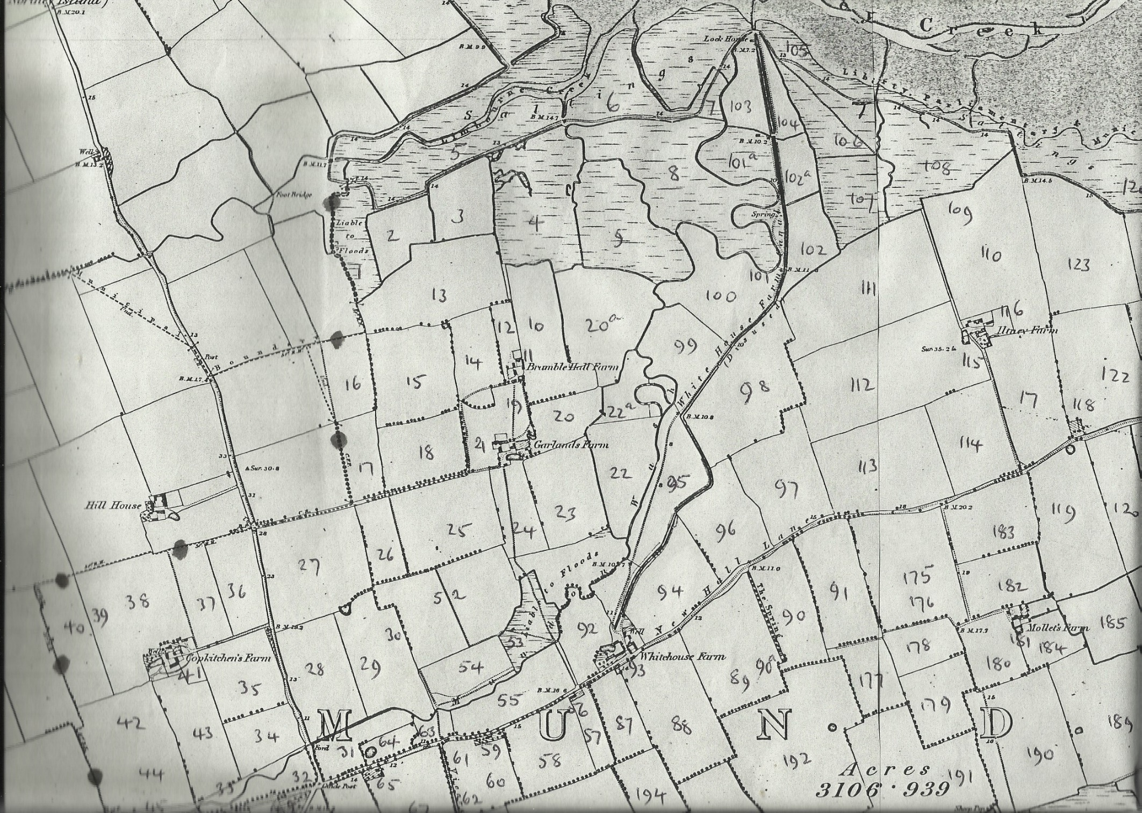

**Map 1**

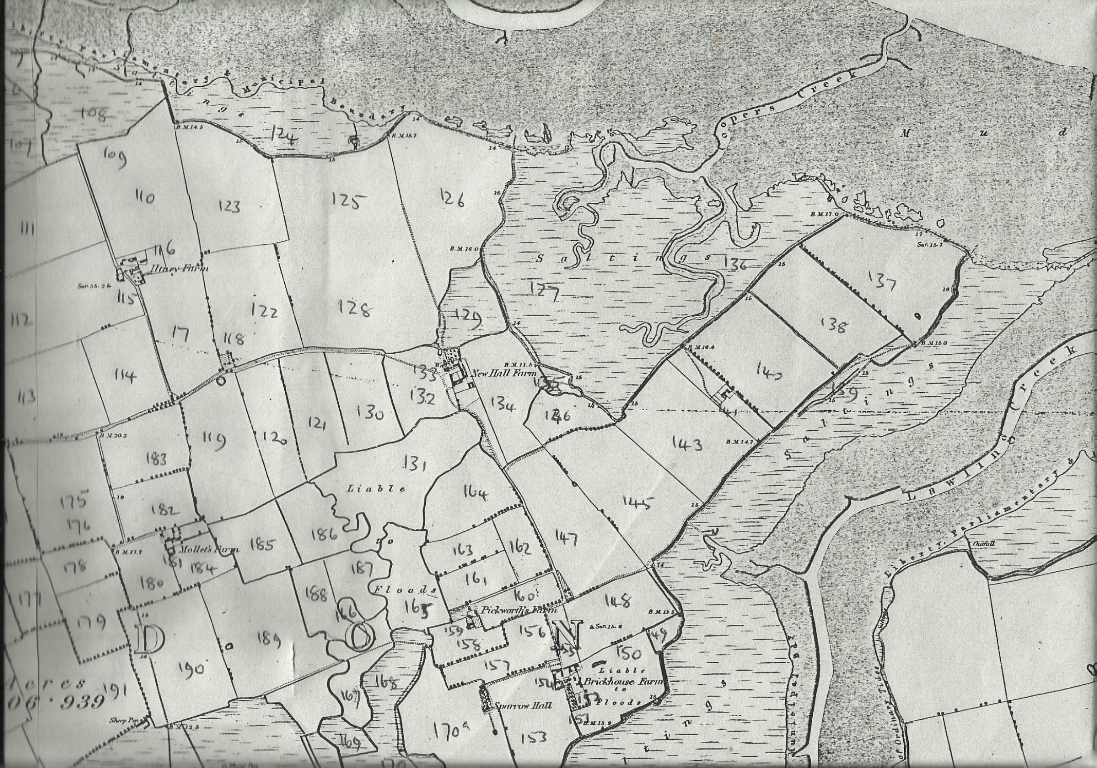

**Map 2**

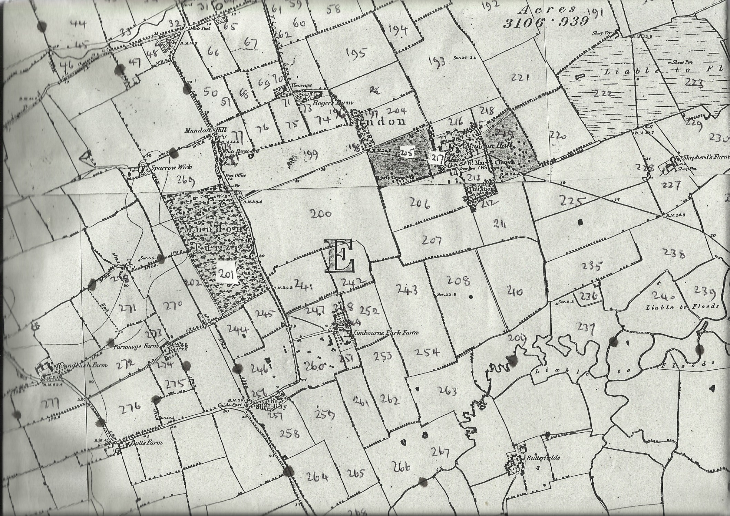

**Map 3**

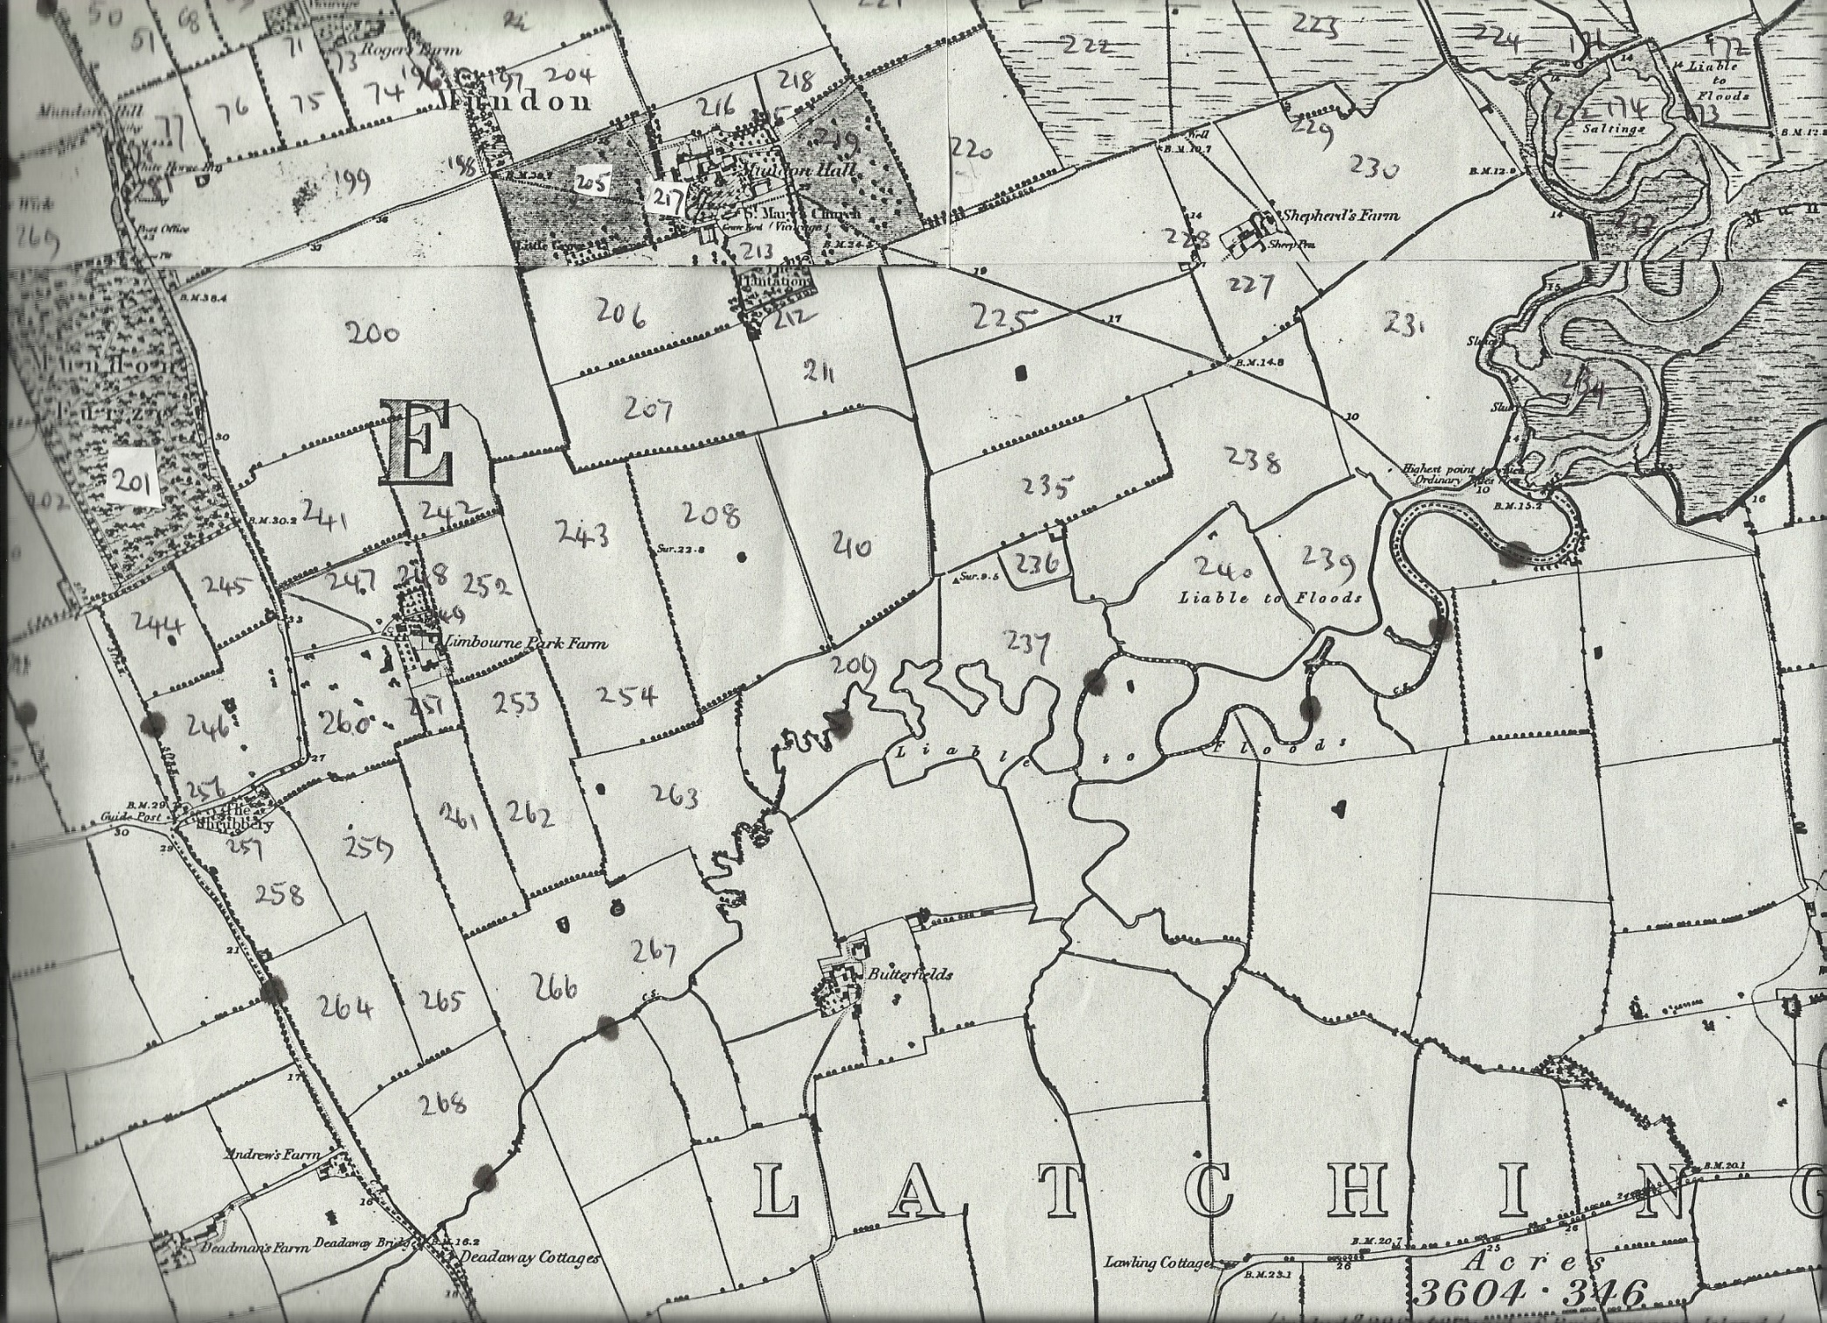

**Map 4**