THE PLACE-NAMES

OF OVINGTON

Recorder: Eileen Owen

Essex Place-names Project (Essex Society for Archaeology & History)

Essex Record Office e-book, 2011. (1st edition hard copy 2003).

www.essex.ac.uk/history/esah/essexplacenames

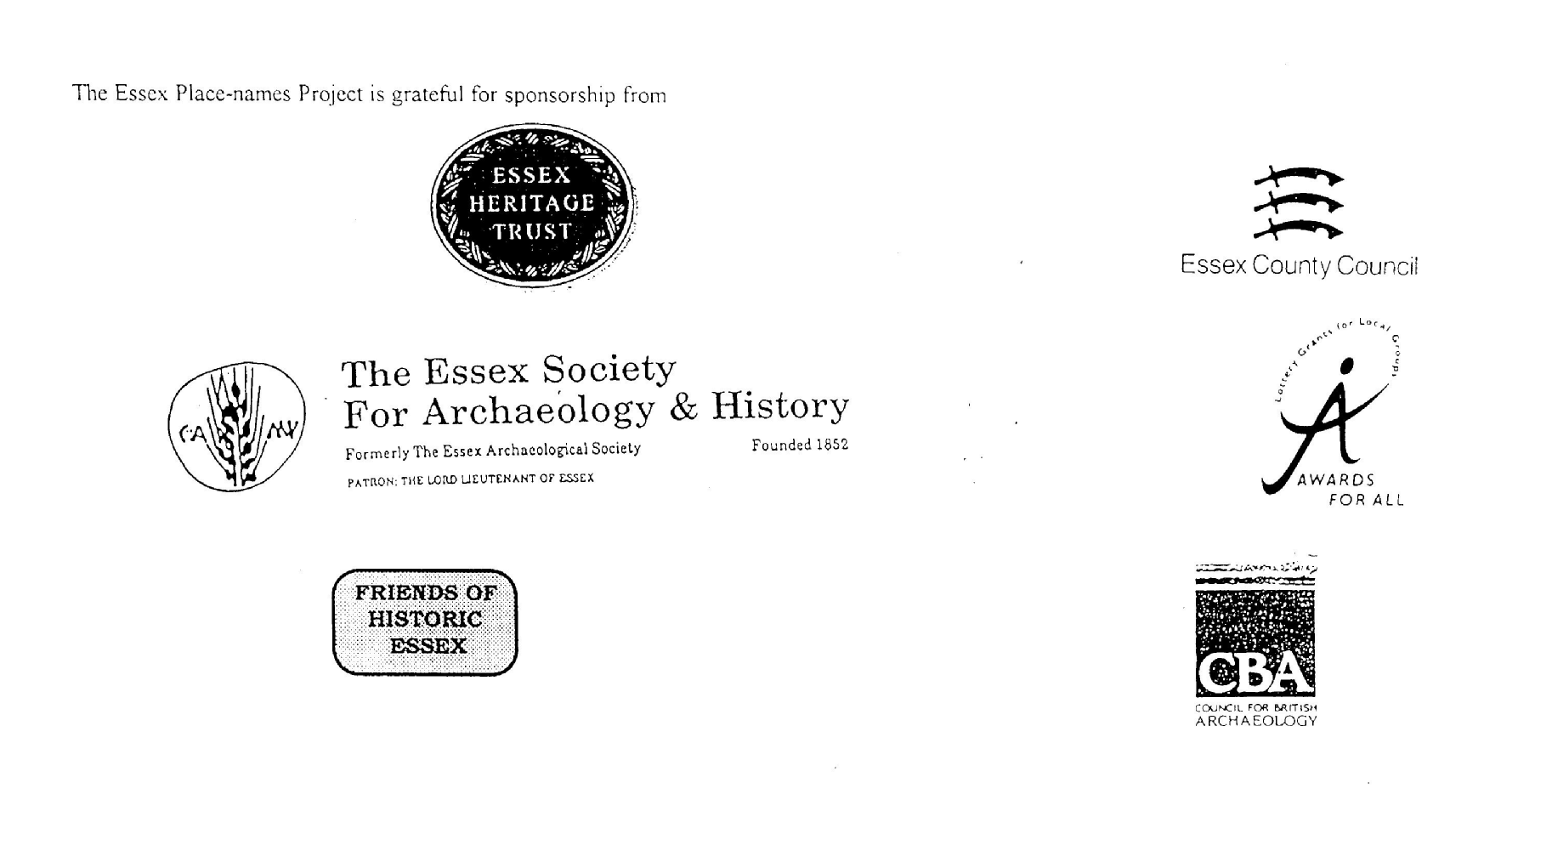

ESSEX PLACE-NAMES PROJECT.

The Essex Place-names Project is a County-wide survey to record place- and field-names from historical documents such as Tithe maps and apportionments, estate maps, sale and auction catalogues, conveyances, terriers, deeds, rolls, inquisitions and surveys.

The second element of the Project is to investigate on-the-ground visible remains which correspond to the Place-names for actual or potential archaeological, agricultural and industrial
sites, and to record natural (topographical) and man-made features which may relate to the Place-name. This involves field-survey in rural and outside investigation in built-up areas.

It is anticipated that the Project will lead to identification of archaeological sites and lost historic buildings; it will enable analysis of indicators of early settlement, land holding, agricultural and industrial practices of the County. It will refine the more precise meaning of descriptive words and elements used by earlier settlers as they gave names appropriate to the topography of the landscape of their time.

For convenience the surveys are based on the parish, recognising that present civil parish boundaries are not necessarily identical to former ecclesiastical boundaries. Local Recorders
are supplied with templates of Record Forms to ensure consistency of recording across the County, and forward completed forms to a Central Coordinator for transfer to a county
computer database which is available at the Essex Record Office to researchers.

This publication presents part of the information recorded from the Tithe or Estate Award and Map, (and from other documents for this parish.) The full record is contained on the master database in the Essex Record Office, Wharf Road, Chelmsford CM2 6YT and the website www.essex.ac.uk/history/esah/essexplacenames. Parish books are available from the ERO on disc or in hard copy or may be downloaded from the website. Please notify errors to the Project Coordinator at the Essex Record Office.

THE TITHE MAP AND APPORTIONMENT.

Since medieval times a tenth of the produce of land and stock had been paid by landholders to the church. At the Dissolution of the Monasteries, the property of many religious houses,
including the right to collect tithes, passed into lay hands. The Tithe Commutation Act which received Royal assent on 13th August 1836 abolished a rent payable in kind and
substituted rent-charges apportioned on each plot or parcel. The tithe-rent payable was assessed on the average value of wheat, barley and oats and was to fluctuate with price movements.

The commutation could be by voluntary agreement between the local owners and payers or, if agreement failed, could be compulsorily imposed by commissioners. A Valuer was to be
appointed to apportion the rent of each parcel of land and tenants could deduct that rent-charge from their rent paid to the landlord. The task fell to the Tithe Commissioners to produce a map and an Apportionment (Award). A large-scale survey was produced for over 70% of England and Wales in the following 9 years, and about another 8% up to 1855. Most of the
parishes in Essex were surveyed. The map scales vary. The Award records ownership, tenancy and land-use, field by field and parcel by parcel (often quoting the field name) with the
ground area and rent-charge.

Land that was tithe-free tends to be less accurately mapped and contains few if any of the details recorded for those parcels subject to tithe. Rights of way and roads also tend to be
neglected. Boundaries of the tithe areas are shown as are some natural features such as streams, ponds, gardens, greens and commons. Buildings are often shown coloured red if dwellings or grey if not. Because the Award may have been agreed only some time after the map was finished, discrepancies occur between the two. Enclosure Awards, when extant, usually date to the 18th and early 19th centuries. J.Kemble.
Reproduced by permission
of Essex County Council.

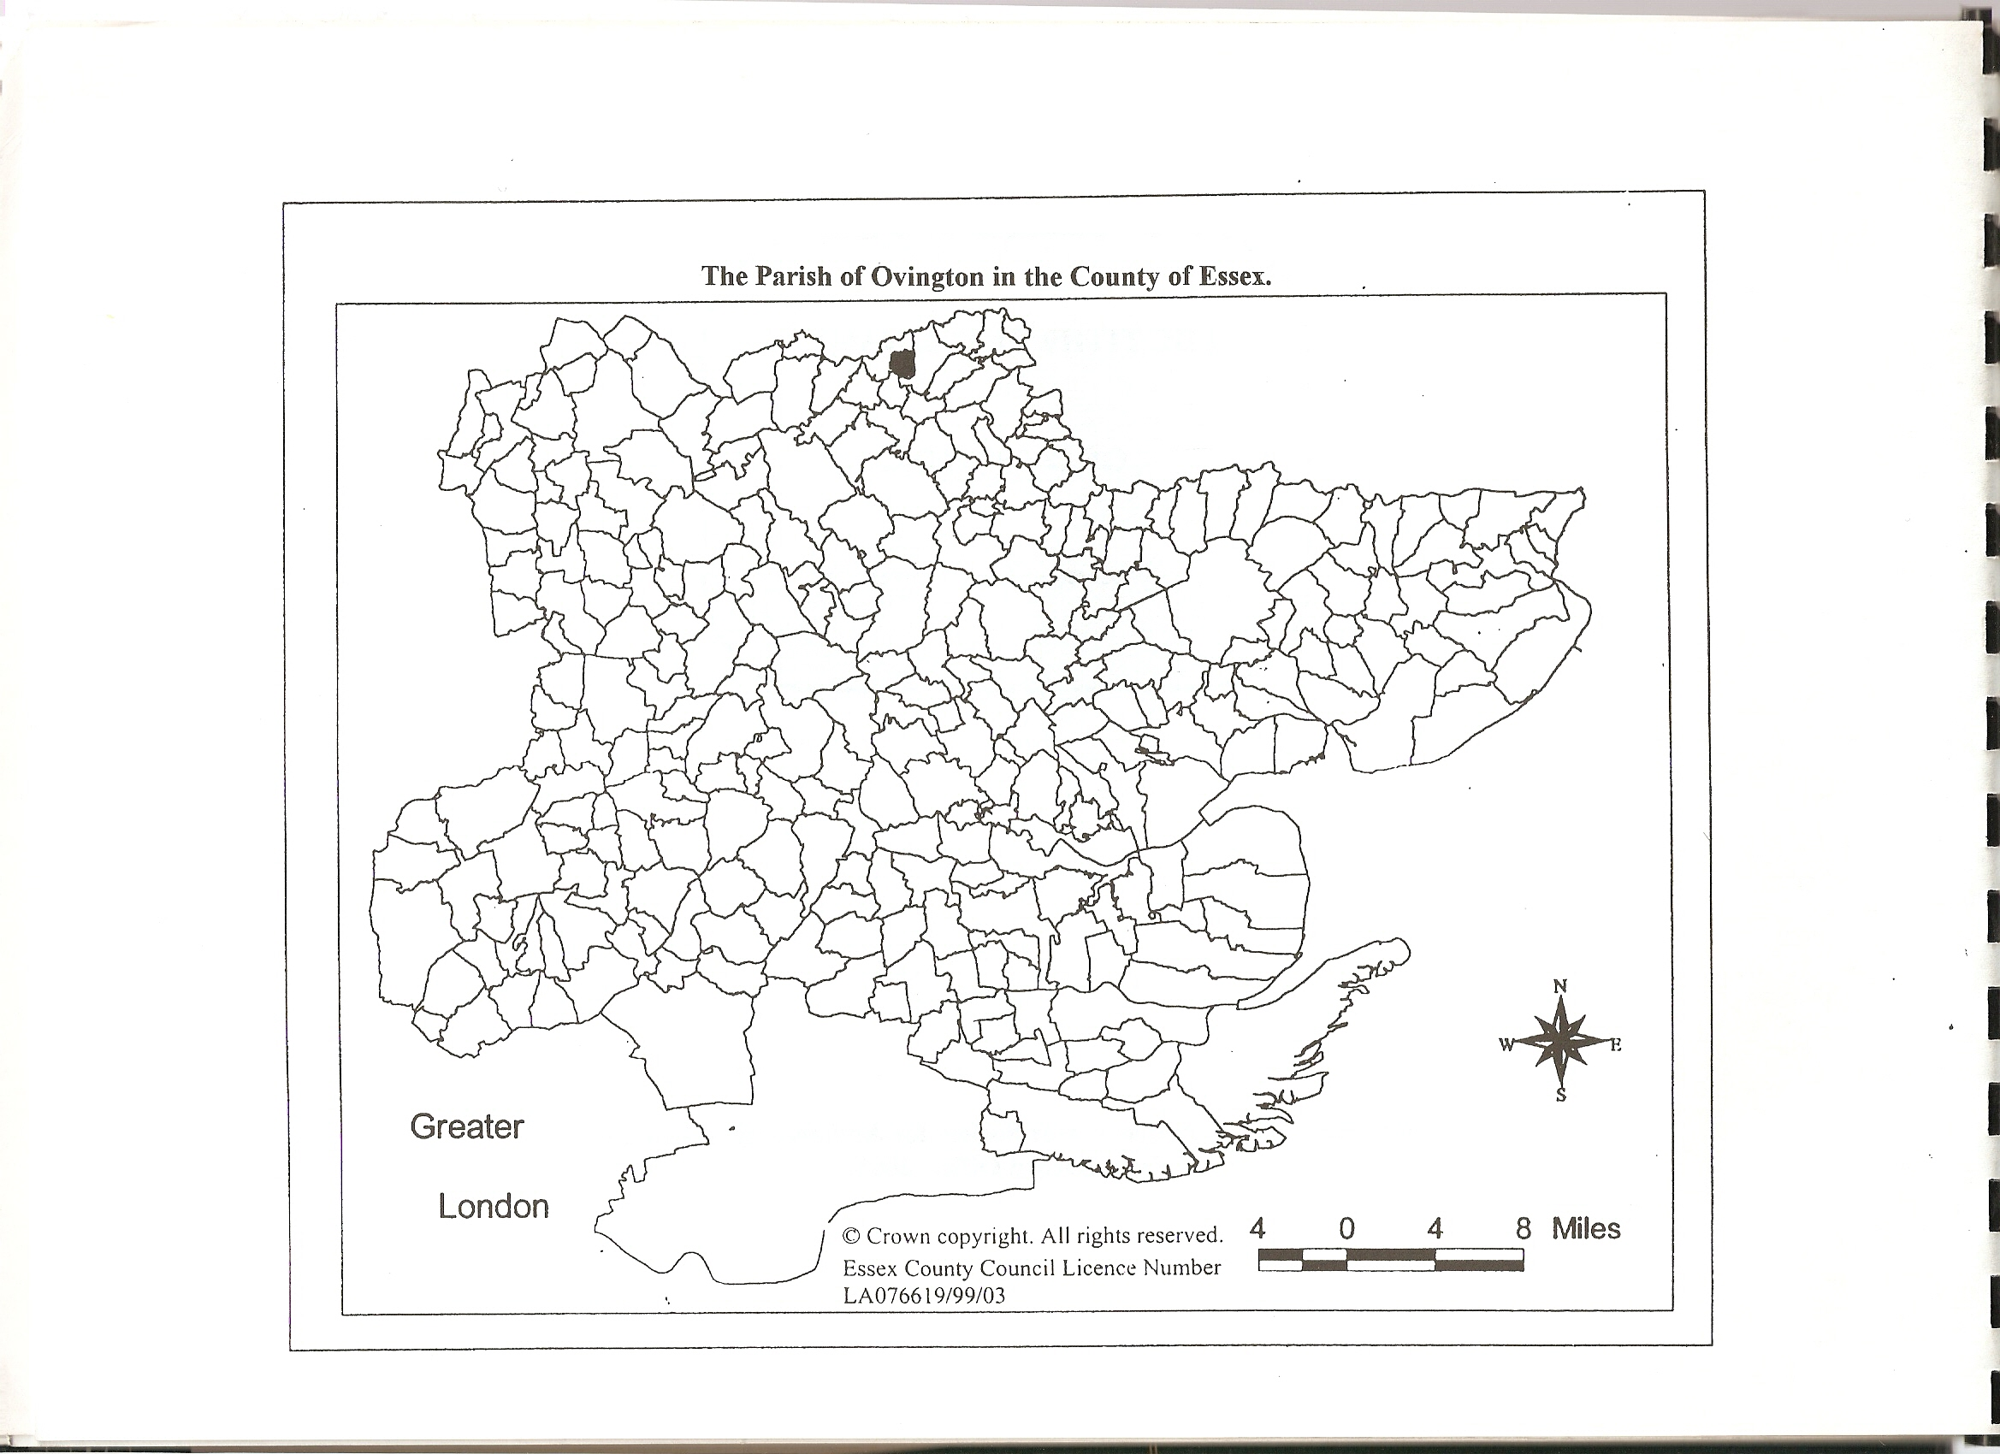

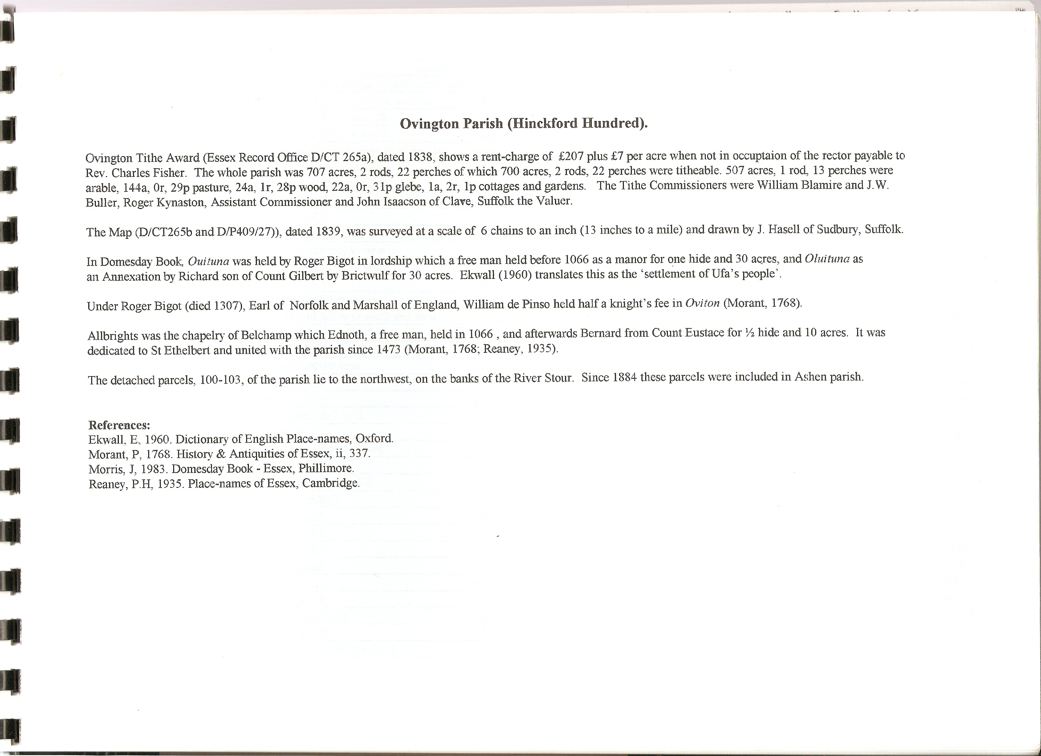

The Tithe Award Place-names of Ovington – by Parcel No.

Place-name | Alias | Fld No | Gd Ref | x | y | Place Type | Acr | rd | pch | Land use | Owner | Occupier | Name of farm | Other information
Upper Ley (part) |  | 1 | TL | 768 | 435 | Field | 10 | 0 | 0 | Arable | English, John | Chickall, Thomas | Ovington Hall
Further Bedwell |  | 2 | TL | 767 | 434 | Field | 10 | 3 | 14 | Arable | English, John | Chickall, Thomas | Ovington Hall
Middle Bedwell |  | 3 | TL | 764 | 434 | Field | 18 | 3 | 0 | Arable | English, John | Chickall, Thomas | Ovington Hall
Ovington |  | 4 | TL | 763 | 434 | Field | 5 | 3 | 8 | Arable | English, John | Chickall, Thomas | Ovington Hall
Hop Meadow |  | 5 | TL | 767 | 433 | Field | 9 | 1 | 32 | Pasture | English, John | Chickall, Thomas | Ovington Hall
Long Meadow |  | 6 | TL | 762 | 432 | Field | 11 | 2 | 10 | Pasture | English, John | Chickall, Thomas | Ovington Hall
Home Foxhill |  | 7 | TL | 762 | 429 | Field | 24 | 3 | 10 | Arable | English, John | Chickall, Thomas | Ovington Hall
Gravel Pit Field |  | 8 | TL | 758 | 432 | Field | 17 | 2 | 37 | Arable | English, John | Chickall, Thomas | Ovington Hall
Lower Kings (part) |  | 9 | TL | 757 | 433 | Field | 3 | 1 | 45 | Arable | English, John | Chickall, Thomas | Ovington Hall
Upper Kings (part) |  | 10 | TL | 757 | 433 | Field | 1 | 0 | 24 | Arable | English, John | Chickall, Thomas | Ovington Hall
Barn Field (part) |  | 11 | TL | 757 | 427 | Field | 1 | 0 | 16 | Arable | English, John | Chickall, Thomas | Ovington Hall
Upper Fox Hill |  | 12 | TL | 758 | 428 | Field | 14 | 1 | 15 | Arable | English, John | Chickall, Thomas | Ovington Hall
Wood Field (part) |  | 13 | TL | 756 | 425 | Field | 11 | 3 | 31 | Arable | English, John | Chickall, Thomas | Ovington Hall
Hall Wood (part) |  | 14 | TL | 757 | 424 | Wd | 8 | 1 | 11 | Wood | English, John | Chickall, Thomas | Ovington Hall
Fifteen Acres |  | 15 | TL | 760 | 424 | Field | 17 | 3 | 28 | Arable | English, John | Chickall, Thomas | Ovington Hall
Park Field |  | 16 | TL | 761 | 422 | Field | 21 | 0 | 6 | Arable | English, John | Chickall, Thomas | Ovington Hall
Great Church Field |  | 17 | TL | 764 | 424 | Field | 18 | 2 | 2 | Arable | English, John | Chickall, Thomas | Ovington Hall
Little Church Field |  | 18 | TL | 765 | 425 | Field | 12 | 3 | 20 | Arable | English, John | Chickall, Thomas | Ovington Hall
Drift to Hall |  | 19 | TL | 765 | 426 | field | 1 | 0 | 26 | Pasture | English, John | Chickall, Thomas | Ovington Hall
Seven Acres |  | 20 | TL | 762 | 425 | field | 5 | 2 | 2 | Pasture | English, John | Chickall, Thomas | Ovington Hall
The Hall, Yards | Ouituna, 1086,DB | 21 | TL | 763 | 426 | Hmstd | 4 | 2 | 12 | Hmestd | English, John | Chickall, Thomas | Ovington Hall
Church Pightle |  | 22 | TL | 763 | 427 | Field | 1 | 1 | 30 | Pasture | English, John | Chickall, Thomas | Ovington Hall
Bushy Pasture |  | 23 | TL | 765 | 426 | field | 13 | 2 | 12 | Pasture | English, John | Chickall, Thomas | Ovington Hall
Laundow |  | 24 | TL | 764 | 428 | Field | 9 | 1 | 33 | Pasture | English, John | Chickall, Thomas | Ovington Hall
Hall Field |  | 25 | TL | 759 | 426 | Field | 18 | 9 | 20 | Arable | English, John | Chickall, Thomas | Ovington Hall
Much Croft |  | 26 | TL | 772 | 432 | Field | 10 | 1 | 20 | Arable | English, John | King, John | Upper Farm
Clooks |  | 27 | TL | 769 | 429 | Field | 17 | 2 | 26 | Arable | English, John | King, John | Upper Farm
Great Mill Field |  | 28 | TL | 768 | 432 | Field | 19 | 2 | 37 | Arable | English, John | King, John | Upper Farm
Hop Meadow |  | 29 | TL | 766 | 432 | Field | 2 | 0 | 32 | Pasture | English, John | King, John | Upper Farm
Six Acres |  | 30 | TL | 765 | 430 | Field | 7 | 1 | 20 | Arable | English, John | King, John | Upper Farm
The Chase Pasture |  | 31 | TL | 765 | 428 | Field | 7 | 1 | 20 | Arable | English, John | King, John | Upper Farm
Twelve Acres |  | 32 | TL | 767 | 429 | Field | 14 | 3 | 35 | Arable | English, John | King, John | Upper Farm
Home Field |  | 33 | TL | 767 | 427 | Field | 17 | 2 | 16 | Arable | English, John | King, John | Upper Farm
New Field or Worlds |  | 34 | TL | 771 | 427 | Field | 8 | 3 | 29 | Pasture | English, John | King, John | Upper Farm
Worlds with Hop Ground |  | 34 | TL | 768 | 425 | Field | 7 | 1 | 21 | Pasture | English, John | King, John | Upper Farm
Calves Pightle |  | 36 | TL | 768 | 429 | Field | 1 | 1 | 34 | Pasture | English, John | King, John | Upper Farm
Farm, Yards |  | 37 | TL | 767 | 424 | Farm yd | 1 | 1 | 6 | Farm | English, John | King, John | Upper Farm
Upper Farm House, Gdn, etc | Upper Farm, 1875,OS | 38 | TL | 767 | 424 | Hmstd | 1 | 1 | 12 | Farmhse | English, John | King, John | Upper Farm
Home Pasture |  | 39 | TL | 767 | 423 | field | 5 | 1 | 6 | Pasture | English, John | King, John | Upper Farm
Cox's Field |  | 40 | TL | 768 | 424 | Field | 9 | 2 | 30 | Arable | English, John | King, John | Upper Farm
Street Field |  | 41 | TL | 760 | 424 | Field | 12 | 21 | 30 | Arable | English, John | King, John | Upper Farm
Thistley Wigley |  | 42 | TL | 772 | 425 | Field | 9 | 2 | 34 | Arable | English, John | King, John | Upper Farm
Caysens Llay |  | 43 | TL | 773 | 425 | Field | 8 | 3 | 38 | Arable | English, John | King, John | Upper Farm
Long Pasture |  | 44 | TL | 773 | 423 | Field | 8 | 1 | 14 | Pasture | English, John | King, John | Upper Farm
New Lands |  | 45 | TL | 774 | 422 | Field | 10 | 0 | 0 | Arable | English, John | King, John | Upper Farm
Old Lands or Ley |  | 46 | TL | 773 | 422 | Field | 11 | 0 | 15 | Arable | English, John | King, John | Upper Farm
Gravel Pit Field |  | 47 | TL | 770 | 422 | Field | 13 | 0 | 33 | Arable | English, John | King, John | Upper Farm
Gravel Pit Meadow |  | 48 | TL | 769 | 424 | Field | 5 | 9 | 18 | Pasture | English, John | King, John | Upper Farm
Ash Plantation |  | 49 | TL | 768 | 421 | Wd | 0 | 0 | 24 | Wood | English, John | King, John | Upper Farm
Wigleys Meadow |  | 50 | TL | 767 | 421 | Field | 1 | 1 | 31 | Pasture | English, John | King, John | Upper Farm
Cottages |  | 51 | TL | 768 | 421 | Tnmnt | 0 | 0 | 22 | House | English, John | Everett, William; Twitchet, Daniel | Upper Farm
Wigleys Field |  | 52 | TL | 767 | 419 | Field | 4 | 1 | 30 | Arable | English, John | King, John | Upper Farm
Cottages |  | 53 | TL | 768 | 418 | Tnmnt | 0 | 1 | 8 | House | English, John | Agar, William; Bartrem, Reubon | Upper Farm
Guilets Field |  | 54 | TL | 764 | 422 | Field | 3 | 0 | 1 | Arable | English, John | King, John | Upper Farm
Cottages |  | 55 | TL | 764 | 422 | Tnmnt | 0 | 0 | 20 | House | English, John | Byford, George, junr; Parker, Wm; Wilkin, Mary; Overeth, Mary | Upper Farm
Cottages |  | 56 | TL | 763 | 421 | Tnmnt | 0 | 2 | 20 | House | English, John | Byford, William; Bartrem, Joseph | Upper Farm
Cottage |  | 56a | TL | 763 | 421 | Tnmnt | 0 | 1 | 15 | House | English, John | Plum, John; Plum, Stephen | Upper Farm
Meat Pasture |  | 57 | TL | 764 | 420 | Field | 1 | 3 | 20 | Pasture | English, John | King, John | Upper Farm
Cartlodge Pasture |  | 58 | TL | 763 | 421 | Field | 1 | 2 | 31 | Pasture | English, John | King, John | Upper Farm
Meat Meadow |  | 59 | TL | 765 | 420 | Field | 3 | 0 | 30 | Pasture | English, John | King, John | Upper Farm
Turners Piece |  | 60 | TL | 767 | 423 | Field | 1 | 3 | 0 | Pasture | English, John | King, John | Upper Farm
Cottage |  | 61 | TL | 767 | 423 | Tnmnt | 0 | 1 | 9 | House | English, John | Bartram, Joseph; Say, John; Hull, Thomas
Eight Acre Ley (pt) |  | 62 | TL | 774 | 434 | Field | 3 | 2 | 3 | Arable | Wellesley, Hon. William Pole Long Tylney | Fox, William | Lower Farm
Seven Acre Ley |  | 63 | TL | 774 | 433 | Field | 7 | 2 | 36 | Arable | Wellesley, Hon. William Pole Long Tylney | Fox, William | Lower Farm
Five Acre Ley |  | 64 | TL | 772 | 433 | Field | 3 | 1 | 28 | Arable | Wellesley, Hon. William Pole Long Tylney | Fox, William | Lower Farm
Further Park |  | 65 | TL | 768 | 417 | Field | 9 | 1 | 10 | Arable | Wellesley, Hon. William Pole Long Tylney | Fox, William | Lower Farm
Middle Park |  | 66 | TL | 765 | 418 | Field | 9 | 5 | 29 | Arable | Wellesley, Hon. William Pole Long Tylney | Fox, William | Lower Farm
Great Park (part of) |  | 67 | TL | 764 | 413 | Field | 13 | 1 | 36 | Arable | Wellesley, Hon. William Pole Long Tylney | Fox, William | Lower Farm
Middle Piece |  | 68 | TL | 765 | 419 | Field | 1 | 3 | 3 | Pasture | Wellesley, Hon. William Pole Long Tylney | Fox, William | Lower Farm
Home Pasture |  | 69 | TL | 764 | 418 | Field | 5 | 8 | 17 | Pasture | Wellesley, Hon. William Pole Long Tylney | Fox, William | Lower Farm
Lower Farm, farm yards | Hole Farm, 1875,OS | 70 | TL | 763 | 419 | Hmstd | 0 | 2 | 24 | Hse,yard | Wellesley, Hon. William Pole Long Tylney | Fox, William | Lower Farm
Wood Field part |  | 71 | TL | 759 | 420 | Field | 1 | 3 | 9 | Arable | Wellesley, Hon. William Pole Long Tylney | Fox, William | Lower Farm
Ovington Field |  | 72 | TL | 765 | 422 | Field | 3 | 0 | 16 | Arable | Sperling, John, esquire | Fisher, Rev Charles
Cottage and Garden |  | 73 | TL | 764 | 423 | Cttage | 0 | 1 | 14 | House | Sperling, John, esquire | Parker, Jesse
Tenement, Appurtenances |  | 74 | TL | 765 | 423 | Tnmnt | 0 | 0 | 39 | House | Smith, John | Byford, Penelope; Bertram, John
Blacksmiths Piece |  | 75 | TL | 769 | 418 | Field | 3 | 2 | 5 | Arable | Carter, William | Carter, William | Wakes Hall
Cow Pasture |  | 76 | TL | 771 | 417 | Field | 3 | 1 | 15 | Pasture | Carter, William | Carter, William | Wakes Hall
Round Pasture |  | 77 | TL | 769 | 415 | Field | 1 | 2 | 23 | Pasture | Carter, William | Carter, William | Wakes Hall
Six Acres (part) |  | 78 | TL | 772 | 417 | Field | 3 | 3 | 38 | Arable | Carter, William | Carter, William | Wakes Hall
Nine Acres (part) |  | 79 | TL | 774 | 417 | Field | 4 | 3 | 24 | Arable | Carter, William | Carter, William | Wakes Hall
Gravel Pit Wood Field (pt) |  | 80 | TL | 774 | 418 | Field | 6 | 2 | 8 | Arable | Carter, William | Carter, William | Wakes Hall
Farm Cottage |  | 81 | TL | 767 | 423 | Hmstd | 0 | 2 | 30 | House | Fisher, Rev Charles | Fisher, Rev Charles |  | Glebe
Green Slip |  | 82 | TL | 767 | 424 | Field | 1 | 0 | 14 | Pasture | Fisher, Rev Charles | Fisher, Rev Charles
Rectory Lawn, Pleasure Ground |  | 83 | TL | 766 | 424 | Rctory | 1 | 2 | 32 | Hse,lawn | Fisher, Rev Charles | Fisher, Rev Charles |  | Glebe
Orchard |  | 84 | TL | 766 | 423 | Ochd | 1 | 0 | 25 | Orchard | Fisher, Rev Charles | Fisher, Rev Charles
Glebe Four Acres |  | 85 | TL | 766 | 423 | Field | 3 | 1 | 3 | Arable | Fisher, Rev Charles | Fisher, Rev Charles
Glebe Five Acrea |  | 86 | TL | 767 | 423 | Field | 2 | 3 | 34 | Pasture | Fisher, Rev Charles | Fisher, Rev Charles |  | Glebe
Glebe Meadow |  | 87 | TL | 767 | 421 | Field | 2 | 0 | 20 | Pasture | Fisher, Rev Charles | Fisher, Rev Charles |  | Glebe
Eight Acres |  | 88 | TL | 766 | 419 | Field | 5 | 3 | 33 | Arable | Fisher, Rev Charles | Fisher, Rev Charles |  | Glebe
Two Acres |  | 89 | TL | 768 | 418 | Field | 1 | 3 | 21 | Arable | Fisher, Rev Charles | Fisher, Rev Charles |  | Glebe
Church Yard | [St Mary’s] | 90 | TL | 764 | 426 | Field | 0 | 3 | 3 | Pasture | Fisher, Rev Charles | Fisher, Rev Charles
Parsonage Green |  | 91 | TL | 766 | 425 | Green | 0 | 2 | 4 | Pasture | Fisher, Rev Charles | Fisher, Rev Charles
Cottage |  | 92 | TL | 774 | 433 | Cttage | 0 | 0 | 20 | Cottage | English, John | Byford George, snr
Upper Roses (part) |  | 93 | TL | 774 | 432 | Field | 5 | 3 | 36 | Arable | English, John | Baker, Samuel
Middle Roses (part) |  | 94 | TL | 774 | 429 | Field | 1 | 3 | 36 | Arable | English, John | Baker, Samuel
Barn field |  | 95 | TL | 773 | 428 | Field | 5 | 3 | 1 | Arable | English, John | Baker, Samuel
Home Pasture |  | 96 | TL | 773 | 428 | Field | 3 | 3 | 22 | Pasture | English, John | Baker, Samuel
Homestead | Little Farm, 1875,OS | 97 | TL | 773 | 428 | Farm | 0 | 0 | 27 | House | English, John | Baker, Samuel
House and garden |  | 98 | TL | 772 | 428 | Hse | 0 | 0 | 30 | House | English, John | Baker, Samuel
Blacksmith's Field |  | 99 | TL | 773 | 427 | Field | 7 | 2 | 24 |  | English, John | Baker, Samuel
Further Meadow (part) |  | 100 | TL | 751 | 442 | Field | 8 | 3 | 0 | Pasture | Clives, John Payne | Chickall, Thomas | Claret Hall | Detached. Second Schedule for Tithes issued 25th September 1936
Little Meadow (part) |  | 101 | TL | 754 | 443 | Field | 3 | 0 | 27 | Pasture | Clives, John Payne | Chickall, Thomas | Claret Hall | Detached
Little Meadow (part) |  | 101a | TL | 755 | 444 | Field | 0 | 2 | 30 | Pasture | Clives, John Payne | Chickall, Thomas | Claret Hall | Detached
Hilley Ley |  | 102 | TL | 755 | 443 | Field | 12 | 1 | 14 | Arable | Clives, John Payne | Chickall, Thomas | Claret Hall | Detached
Down Hilly (part) |  | 103 | TL | 754 | 442 | Field | 1 | 0 | 0 | Arable | Clives, John Payne | Clark, Elizabeth | Stour Farm | Detached
Eight Acres (part) |  | 104 | TL | 772 | 434 | Field | 0 | 2 | 28 |  | Jowell, Martha | Chickall, Arthur
Gravel Pit Wood Field |  | 105 | TL | 772 | 418 | Field | 9 | 2 | 3 | Arable |  | Chapman, James |  | Note in margin of Tithe Award: cultivated as Wood in 7 yrs ending Christmas 1835
The Grove Field |  | 106 | TL | 769 | 416 | Field | 3 | 2 | 2 | Arable |  | Chapman, James |  | Note in margin of Tithe Award: cultivated as Wood in 7 yrs ending Christmas 1835
Blands Wood field (pt) |  | 107 | TL | 771 | 415 | Field | 1 | 0 | 3 | Arable |  | Chapman, James |  | Note in margin of Tithe Award: cultivated as Wood in 7 yrs ending Christmas 1835
Meadow |  | 108 |  |  |  | Field | 1 | 1 | 33 | Pasture | Fisher, Captain William | Fisher, Rev Charles |  | Not found on Map
Cottage,gdn, Blacksmith shop |  | 109 | TL | 772 | 427 | Cttg | 0 | 0 | 23 | House | Smith, James | Smith, James
House, gdn., Beershop, tenement |  | 110 | TL | 772 | 426 | Hse | 0 | 0 | 26 | Hse,shop | Smith, John | Smith, John
Cottage and Garden |  | 111 |  |  |  | Cttg | 0 | 0 | 18 | House | Smith, James | Golding, Daniel |  | Not found on Map
Garden (piece of) |  | 112 |  |  |  | Gdn | 0 | 0 | 9 | Garden | English, John | Smith, James |  | Not found on Map
Tenement,appurtenances |  | 113 |  |  |  | Tnmnt | 0 | 0 | 2 | Tnement | Smith, James | Golding, Daniel |  | Not found on Map
Garden (piece of) |  | 114 |  |  |  | Gdn | 0 | 0 | 6 | Garden | English, John | Smith, James |  | Not found on Map

For abbreviations see Reaney, P., Place-names of Essex, Cambridge 1935; and Kemble, J., Essex Place-names, Places, Streets & People, Historical Publications, London 2007.

The Tithe Award Place-names of Ovington – by Place-name.

Place-name | Alias | Fld No | Gd Ref | x | y | Place Type | Acr | rd | pch | Land use | Owner | Occupier | Name of farm | Other information
Ash Plantation |  | 49 | TL | 768 | 421 | Wd | 0 | 0 | 24 | Wood | English, John | King, John | Upper Farm
Barn field |  | 95 | TL | 773 | 428 | Field | 5 | 3 | 1 | Arable | English, John | Baker, Samuel
Barn Field (part) |  | 11 | TL | 757 | 427 | Field | 1 | 0 | 16 | Arable | English, John | Chickall, Thomas | Ovington Hall
Blacksmith's Field |  | 99 | TL | 773 | 427 | Field | 7 | 2 | 24 |  | English, John | Baker, Samuel
Blacksmiths Piece |  | 75 | TL | 769 | 418 | Field | 3 | 2 | 5 | Arable | Carter, William | Carter, William | Wakes Hall
Blands Wood field (pt) |  | 107 | TL | 771 | 415 | Field | 1 | 0 | 3 | Arable |  | Chapman, James |  | Note in margin of Tithe Award: cultivated as Wood in 7 yrs ending Christmas 1835
Bushy Pasture |  | 23 | TL | 765 | 426 | field | 13 | 2 | 12 | Pasture | English, John | Chickall, Thomas | Ovington Hall
Calves Pightle |  | 36 | TL | 768 | 429 | Field | 1 | 1 | 34 | Pasture | English, John | King, John | Upper Farm
Cartlodge Pasture |  | 58 | TL | 763 | 421 | Field | 1 | 2 | 31 | Pasture | English, John | King, John | Upper Farm
Caysens Llay |  | 43 | TL | 773 | 425 | Field | 8 | 3 | 38 | Arable | English, John | King, John | Upper Farm
Church Pightle |  | 22 | TL | 763 | 427 | Field | 1 | 1 | 30 | Pasture | English, John | Chickall, Thomas | Ovington Hall
Church Yard | [St Mary’s] | 90 | TL | 764 | 426 | Field | 0 | 3 | 3 | Pasture | Fisher, Rev Charles | Fisher, Rev Charles
Clooks |  | 27 | TL | 769 | 429 | Field | 17 | 2 | 26 | Arable | English, John | King, John | Upper Farm
Cottage |  | 61 | TL | 767 | 423 | Tnmnt | 0 | 1 | 9 | House | English, John | Bartram, Joseph; Say, John; Hull, Thomas
Cottage |  | 92 | TL | 774 | 433 | Cttage | 0 | 0 | 20 | Cottage | English, John | Byford George, snr
Cottage |  | 56a | TL | 763 | 421 | Tnmnt | 0 | 1 | 15 | House | English, John | Plum, John; Plum, Stephen | Upper Farm
Cottage and Garden |  | 111 |  |  |  | Cttg | 0 | 0 | 18 | House | Smith, James | Golding, Daniel |  | Not found on Map
Cottage and Garden |  | 73 | TL | 764 | 423 | Cttage | 0 | 1 | 14 | House | Sperling, John, esquire | Parker, Jesse
Cottage,gdn, Blacksmith shop |  | 109 | TL | 772 | 427 | Cttg | 0 | 0 | 23 | House | Smith, James | Smith, James
Cottages |  | 53 | TL | 768 | 418 | Tnmnt | 0 | 1 | 8 | House | English, John | Agar, William; Bartrem, Reubon | Upper Farm
Cottages |  | 55 | TL | 764 | 422 | Tnmnt | 0 | 0 | 20 | House | English, John | Byford, George, junr; Parker, Wm; Wilkin, Mary; Overeth, Mary | Upper Farm
Cottages |  | 56 | TL | 763 | 421 | Tnmnt | 0 | 2 | 20 | House | English, John | Byford, William; Bartrem, Joseph | Upper Farm
Cottages |  | 51 | TL | 768 | 421 | Tnmnt | 0 | 0 | 22 | House | English, John | Everett, William; Twitchet, Daniel | Upper Farm
Cow Pasture |  | 76 | TL | 771 | 417 | Field | 3 | 1 | 15 | Pasture | Carter, William | Carter, William | Wakes Hall
Cox's Field |  | 40 | TL | 768 | 424 | Field | 9 | 2 | 30 | Arable | English, John | King, John | Upper Farm
Down Hilly (part) |  | 103 | TL | 754 | 442 | Field | 1 | 0 | 0 | Arable | Clives, John Payne | Clark, Elizabeth | Stour Farm | Detached
Drift to Hall |  | 19 | TL | 765 | 426 | field | 1 | 0 | 26 | Pasture | English, John | Chickall, Thomas | Ovington Hall
Eight Acre Ley (pt) |  | 62 | TL | 774 | 434 | Field | 3 | 2 | 3 | Arable | Wellesley, Hon. William Pole Long Tylney | Fox, William | Lower Farm
Eight Acres |  | 88 | TL | 766 | 419 | Field | 5 | 3 | 33 | Arable | Fisher, Rev Charles | Fisher, Rev Charles |  | Glebe
Eight Acres (part) |  | 104 | TL | 772 | 434 | Field | 0 | 2 | 28 |  | Jowell, Martha | Chickall, Arthur
Farm Cottage |  | 81 | TL | 767 | 423 | Hmstd | 0 | 2 | 30 | House | Fisher, Rev Charles | Fisher, Rev Charles |  | Glebe
Farm, Yards |  | 37 | TL | 767 | 424 | Farm yd | 1 | 1 | 6 | Farm | English, John | King, John | Upper Farm
Fifteen Acres |  | 15 | TL | 760 | 424 | Field | 17 | 3 | 28 | Arable | English, John | Chickall, Thomas | Ovington Hall
Five Acre Ley |  | 64 | TL | 772 | 433 | Field | 3 | 1 | 28 | Arable | Wellesley, Hon. William Pole Long Tylney | Fox, William | Lower Farm
Further Bedwell |  | 2 | TL | 767 | 434 | Field | 10 | 3 | 14 | Arable | English, John | Chickall, Thomas | Ovington Hall
Further Meadow (part) |  | 100 | TL | 751 | 442 | Field | 8 | 3 | 0 | Pasture | Clives, John Payne | Chickall, Thomas | Claret Hall | Detached. Second Schedule for Tithes issued 25th September 1936
Further Park |  | 65 | TL | 768 | 417 | Field | 9 | 1 | 10 | Arable | Wellesley, Hon. William Pole Long Tylney | Fox, William | Lower Farm
Garden (piece of) |  | 112 |  |  |  | Gdn | 0 | 0 | 9 | Garden | English, John | Smith, James |  | Not found on Map
Garden (piece of) |  | 114 |  |  |  | Gdn | 0 | 0 | 6 | Garden | English, John | Smith, James |  | Not found on Map
Glebe Five Acrea |  | 86 | TL | 767 | 423 | Field | 2 | 3 | 34 | Pasture | Fisher, Rev Charles | Fisher, Rev Charles |  | Glebe
Glebe Four Acres |  | 85 | TL | 766 | 423 | Field | 3 | 1 | 3 | Arable | Fisher, Rev Charles | Fisher, Rev Charles
Glebe Meadow |  | 87 | TL | 767 | 421 | Field | 2 | 0 | 20 | Pasture | Fisher, Rev Charles | Fisher, Rev Charles |  | Glebe
Gravel Pit Field |  | 8 | TL | 758 | 432 | Field | 17 | 2 | 37 | Arable | English, John | Chickall, Thomas | Ovington Hall
Gravel Pit Field |  | 47 | TL | 770 | 422 | Field | 13 | 0 | 33 | Arable | English, John | King, John | Upper Farm
Gravel Pit Meadow |  | 48 | TL | 769 | 424 | Field | 5 | 9 | 18 | Pasture | English, John | King, John | Upper Farm
Gravel Pit Wood Field |  | 105 | TL | 772 | 418 | Field | 9 | 2 | 3 | Arable |  | Chapman, James |  | Note in margin of Tithe Award: cultivated as Wood in 7 yrs ending Christmas 1835
Gravel Pit Wood Field (pt) |  | 80 | TL | 774 | 418 | Field | 6 | 2 | 8 | Arable | Carter, William | Carter, William | Wakes Hall
Great Church Field |  | 17 | TL | 764 | 424 | Field | 18 | 2 | 2 | Arable | English, John | Chickall, Thomas | Ovington Hall
Great Mill Field |  | 28 | TL | 768 | 432 | Field | 19 | 2 | 37 | Arable | English, John | King, John | Upper Farm
Great Park (part of) |  | 67 | TL | 764 | 413 | Field | 13 | 1 | 36 | Arable | Wellesley, Hon. William Pole Long Tylney | Fox, William | Lower Farm
Green Slip |  | 82 | TL | 767 | 424 | Field | 1 | 0 | 14 | Pasture | Fisher, Rev Charles | Fisher, Rev Charles
Guilets Field |  | 54 | TL | 764 | 422 | Field | 3 | 0 | 1 | Arable | English, John | King, John | Upper Farm
Hall Field |  | 25 | TL | 759 | 426 | Field | 18 | 9 | 20 | Arable | English, John | Chickall, Thomas | Ovington Hall
Hall Wood (part) |  | 14 | TL | 757 | 424 | Wd | 8 | 1 | 11 | Wood | English, John | Chickall, Thomas | Ovington Hall
Hilley Ley |  | 102 | TL | 755 | 443 | Field | 12 | 1 | 14 | Arable | Clives, John Payne | Chickall, Thomas | Claret Hall | Detached
Home Field |  | 33 | TL | 767 | 427 | Field | 17 | 2 | 16 | Arable | English, John | King, John | Upper Farm
Home Foxhill |  | 7 | TL | 762 | 429 | Field | 24 | 3 | 10 | Arable | English, John | Chickall, Thomas | Ovington Hall
Home Pasture |  | 96 | TL | 773 | 428 | Field | 3 | 3 | 22 | Pasture | English, John | Baker, Samuel
Home Pasture |  | 39 | TL | 767 | 423 | field | 5 | 1 | 6 | Pasture | English, John | King, John | Upper Farm
Home Pasture |  | 69 | TL | 764 | 418 | Field | 5 | 8 | 17 | Pasture | Wellesley, Hon. William Pole Long Tylney | Fox, William | Lower Farm
Homestead | Little Farm, 1875,OS | 97 | TL | 773 | 428 | Farm | 0 | 0 | 27 | House | English, John | Baker, Samuel
Hop Meadow |  | 5 | TL | 767 | 433 | Field | 9 | 1 | 32 | Pasture | English, John | Chickall, Thomas | Ovington Hall
Hop Meadow |  | 29 | TL | 766 | 432 | Field | 2 | 0 | 32 | Pasture | English, John | King, John | Upper Farm
House and garden |  | 98 | TL | 772 | 428 | Hse | 0 | 0 | 30 | House | English, John | Baker, Samuel
House, gdn., Beershop, tenement |  | 110 | TL | 772 | 426 | Hse | 0 | 0 | 26 | Hse,shop | Smith, John | Smith, John
Laundow |  | 24 | TL | 764 | 428 | Field | 9 | 1 | 33 | Pasture | English, John | Chickall, Thomas | Ovington Hall
Little Church Field |  | 18 | TL | 765 | 425 | Field | 12 | 3 | 20 | Arable | English, John | Chickall, Thomas | Ovington Hall
Little Meadow (part) |  | 101 | TL | 754 | 443 | Field | 3 | 0 | 27 | Pasture | Clives, John Payne | Chickall, Thomas | Claret Hall | Detached
Little Meadow (part) |  | 101a | TL | 755 | 444 | Field | 0 | 2 | 30 | Pasture | Clives, John Payne | Chickall, Thomas | Claret Hall | Detached
Long Meadow |  | 6 | TL | 762 | 432 | Field | 11 | 2 | 10 | Pasture | English, John | Chickall, Thomas | Ovington Hall
Long Pasture |  | 44 | TL | 773 | 423 | Field | 8 | 1 | 14 | Pasture | English, John | King, John | Upper Farm
Lower Farm, farm yards | Hole Farm, 1875,OS | 70 | TL | 763 | 419 | Hmstd | 0 | 2 | 24 | Hse,yard | Wellesley, Hon. William Pole Long Tylney | Fox, William | Lower Farm
Lower Kings (part) |  | 9 | TL | 757 | 433 | Field | 3 | 1 | 45 | Arable | English, John | Chickall, Thomas | Ovington Hall
Meadow |  | 108 |  |  |  | Field | 1 | 1 | 33 | Pasture | Fisher, Captain William | Fisher, Rev Charles |  | Not found on Map
Meat Meadow |  | 59 | TL | 765 | 420 | Field | 3 | 0 | 30 | Pasture | English, John | King, John | Upper Farm
Meat Pasture |  | 57 | TL | 764 | 420 | Field | 1 | 3 | 20 | Pasture | English, John | King, John | Upper Farm
Middle Bedwell |  | 3 | TL | 764 | 434 | Field | 18 | 3 | 0 | Arable | English, John | Chickall, Thomas | Ovington Hall
Middle Park |  | 66 | TL | 765 | 418 | Field | 9 | 5 | 29 | Arable | Wellesley, Hon. William Pole Long Tylney | Fox, William | Lower Farm
Middle Piece |  | 68 | TL | 765 | 419 | Field | 1 | 3 | 3 | Pasture | Wellesley, Hon. William Pole Long Tylney | Fox, William | Lower Farm
Middle Roses (part) |  | 94 | TL | 774 | 429 | Field | 1 | 3 | 36 | Arable | English, John | Baker, Samuel
Much Croft |  | 26 | TL | 772 | 432 | Field | 10 | 1 | 20 | Arable | English, John | King, John | Upper Farm
New Field or Worlds |  | 34 | TL | 771 | 427 | Field | 8 | 3 | 29 | Pasture | English, John | King, John | Upper Farm
New Lands |  | 45 | TL | 774 | 422 | Field | 10 | 0 | 0 | Arable | English, John | King, John | Upper Farm
Nine Acres (part) |  | 79 | TL | 774 | 417 | Field | 4 | 3 | 24 | Arable | Carter, William | Carter, William | Wakes Hall
Old Lands or Ley |  | 46 | TL | 773 | 422 | Field | 11 | 0 | 15 | Arable | English, John | King, John | Upper Farm
Orchard |  | 84 | TL | 766 | 423 | Ochd | 1 | 0 | 25 | Orchard | Fisher, Rev Charles | Fisher, Rev Charles
Ovington |  | 4 | TL | 763 | 434 | Field | 5 | 3 | 8 | Arable | English, John | Chickall, Thomas | Ovington Hall
Ovington Field |  | 72 | TL | 765 | 422 | Field | 3 | 0 | 16 | Arable | Sperling, John, esquire | Fisher, Rev Charles
Park Field |  | 16 | TL | 761 | 422 | Field | 21 | 0 | 6 | Arable | English, John | Chickall, Thomas | Ovington Hall
Parsonage Green |  | 91 | TL | 766 | 425 | Green | 0 | 2 | 4 | Pasture | Fisher, Rev Charles | Fisher, Rev Charles
Rectory Lawn, Pleasure Ground |  | 83 | TL | 766 | 424 | Rctory | 1 | 2 | 32 | Hse,lawn | Fisher, Rev Charles | Fisher, Rev Charles |  | Glebe
Round Pasture |  | 77 | TL | 769 | 415 | Field | 1 | 2 | 23 | Pasture | Carter, William | Carter, William | Wakes Hall
Seven Acre Ley |  | 63 | TL | 774 | 433 | Field | 7 | 2 | 36 | Arable | Wellesley, Hon. William Pole Long Tylney | Fox, William | Lower Farm
Seven Acres |  | 20 | TL | 762 | 425 | field | 5 | 2 | 2 | Pasture | English, John | Chickall, Thomas | Ovington Hall
Six Acres |  | 30 | TL | 765 | 430 | Field | 7 | 1 | 20 | Arable | English, John | King, John | Upper Farm
Six Acres (part) |  | 78 | TL | 772 | 417 | Field | 3 | 3 | 38 | Arable | Carter, William | Carter, William | Wakes Hall
Street Field |  | 41 | TL | 760 | 424 | Field | 12 | 21 | 30 | Arable | English, John | King, John | Upper Farm
Tenement,  Appurtenances |  | 74 | TL | 765 | 423 | Tnmnt | 0 | 0 | 39 | House | Smith, John | Byford, Penelope; Bertram, John
Tenement,appurtenances |  | 113 |  |  |  | Tnmnt | 0 | 0 | 2 | Tnement | Smith, James | Golding, Daniel |  | Not found on Map
The Chase Pasture |  | 31 | TL | 765 | 428 | Field | 7 | 1 | 20 | Arable | English, John | King, John | Upper Farm
The Grove Field |  | 106 | TL | 769 | 416 | Field | 3 | 2 | 2 | Arable |  | Chapman, James |  | Note in margin of Tithe Award: cultivated as Wood in 7 yrs ending Christmas 1835
The Hall, Yards | Ouituna, 1086,DB | 21 | TL | 763 | 426 | Hmstd | 4 | 2 | 12 | Hmestd | English, John | Chickall, Thomas | Ovington Hall
Thistley Wigley |  | 42 | TL | 772 | 425 | Field | 9 | 2 | 34 | Arable | English, John | King, John | Upper Farm
Turners Piece |  | 60 | TL | 767 | 423 | Field | 1 | 3 | 0 | Pasture | English, John | King, John | Upper Farm
Twelve Acres |  | 32 | TL | 767 | 429 | Field | 14 | 3 | 35 | Arable | English, John | King, John | Upper Farm
Two Acres |  | 89 | TL | 768 | 418 | Field | 1 | 3 | 21 | Arable | Fisher, Rev Charles | Fisher, Rev Charles |  | Glebe
Upper Farm House, Gdn, etc | Upper Farm, 1875,OS | 38 | TL | 767 | 424 | Hmstd | 1 | 1 | 12 | Farmhse | English, John | King, John | Upper Farm
Upper Fox Hill |  | 12 | TL | 758 | 428 | Field | 14 | 1 | 15 | Arable | English, John | Chickall, Thomas | Ovington Hall
Upper Kings (part) |  | 10 | TL | 757 | 433 | Field | 1 | 0 | 24 | Arable | English, John | Chickall, Thomas | Ovington Hall
Upper Ley (part) |  | 1 | TL | 768 | 435 | Field | 10 | 0 | 0 | Arable | English, John | Chickall, Thomas | Ovington Hall
Upper Roses (part) |  | 93 | TL | 774 | 432 | Field | 5 | 3 | 36 | Arable | English, John | Baker, Samuel
Wigleys Field |  | 52 | TL | 767 | 419 | Field | 4 | 1 | 30 | Arable | English, John | King, John | Upper Farm
Wigleys Meadow |  | 50 | TL | 767 | 421 | Field | 1 | 1 | 31 | Pasture | English, John | King, John | Upper Farm
Wood Field (part) |  | 13 | TL | 756 | 425 | Field | 11 | 3 | 31 | Arable | English, John | Chickall, Thomas | Ovington Hall
Wood Field part |  | 71 | TL | 759 | 420 | Field | 1 | 3 | 9 | Arable | Wellesley, Hon. William Pole Long Tylney | Fox, William | Lower Farm
Worlds with Hop Ground |  | 34 | TL | 768 | 425 | Field | 7 | 1 | 21 | Pasture | English, John | King, John | Upper Farm

For abbreviations see Reaney, P., Place-names of Essex, Cambridge 1935; and Kemble, J., Essex Place-names, Places, Streets & People, Historical Publications, London 2007.

