THE PLACE-NAMES

OF PITSEA

Recorder: James Kemble

Essex Place-names Project (Essex Society for Archaeology & History), 2013 (e-book).

www.essex.ac.uk/history/esah/essexplacenames

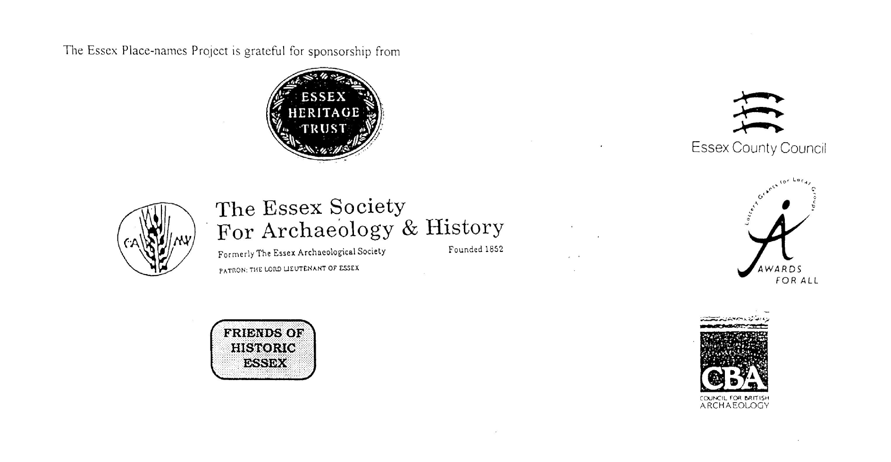

ESSEX PLACE-NAMES PROJECT.

The Essex Place-names Project is a County-wide survey to record place- and field-names from historical documents such as Tithe maps and apportionments, estate maps, sale
and auction catalogues, conveyances, terriers, deeds, rolls, inquisitions and surveys.

The second element of the Project is to investigate on-the-ground visible remains which correspond to the Place-names for actual or potential archaeological, agricultural and industrial
sites, and to record natural (topographical) and man-made features which may relate to the Place-name. This involves field-survey in rural and outside investigation in built-up areas.

It is anticipated that the Project will lead to identification of archaeological sites and lost historic buildings; it will enable analysis of indicators of early settlement, land holding, agricultural and industrial practices of the County. It will refine the more precise meaning of descriptive words and elements used by earlier settlers as they gave names appropriate to the topography of the landscape of their time.

For convenience the surveys are based on the parish, recognising that present civil parish boundaries are not necessarily identical to former ecclesiastical boundaries. Local Recorders
are supplied with templates of Record Forms to ensure consistency of recording across the County, and forward completed forms to a Central Coordinator for transfer to a county
computer database which is available to researchers on the internet at www.essex.ac.uk/history/esah/essexplacenames, and updated periodically.

This publication presents part of the information recorded from the Tithe or Estate Award and Map, and from other documents for this parish. The full record is contained on the master
database at Essex County Council (Historic Environment Section) and on the (above) website. Parish books are available to be downloaded from the website link ‘Books’ on the Home page. Please notify errors to the Project Coordinator at the Essex Record Office.

THE TITHE MAP AND APPORTIONMENT.

Since medieval times a tenth of the produce of land and stock had been paid by landholders to the church. At the Dissolution of the Monasteries, the property of many religious houses,
including the right to collect tithes, passed into lay hands. The Tithe Commutation Act which received Royal assent on 13th August 1836 abolished a rent payable in kind and
substituted rent-charges apportioned on each plot or parcel. The tithe-rent payable was assessed on the average value of wheat, barley and oats and was to fluctuate with price movements.

The commutation could be by voluntary agreement between the local owners and payers or, if agreement failed, could be compulsorily imposed by commissioners. A Valuer was to be
appointed to apportion the rent of each parcel of land and tenants could deduct that rent-charge from their rent paid to the landlord. The task fell to the Tithe Commissioners to produce a
map and an Apportionment (Award). A large-scale survey was produced for over 70% of England and Wales in the following 9 years, and about another 8% up to 1855. Most of the
parishes in Essex were surveyed. The map scales vary. The Award records ownership, tenancy and land-use, field by field and parcel by parcel (often quoting the field name) with the
ground area and rent-charge.

Land that was tithe-free tends to be less accurately mapped and contains few if any of the details recorded for those parcels subject to tithe. Rights of way and roads also tend to be
neglected. Boundaries of the tithe areas are shown as are some natural features such as streams, ponds, gardens, greens and commons. Buildings are often shown coloured red if dwellings
or grey if not. Because the Award may have been agreed only some time after the map was finished, discrepancies occur between the two. Enclosure Awards, when extant, usually date to the 18th and early 19th centuries. J.Kemble.
Reproduced by permission
of Essex County Council.

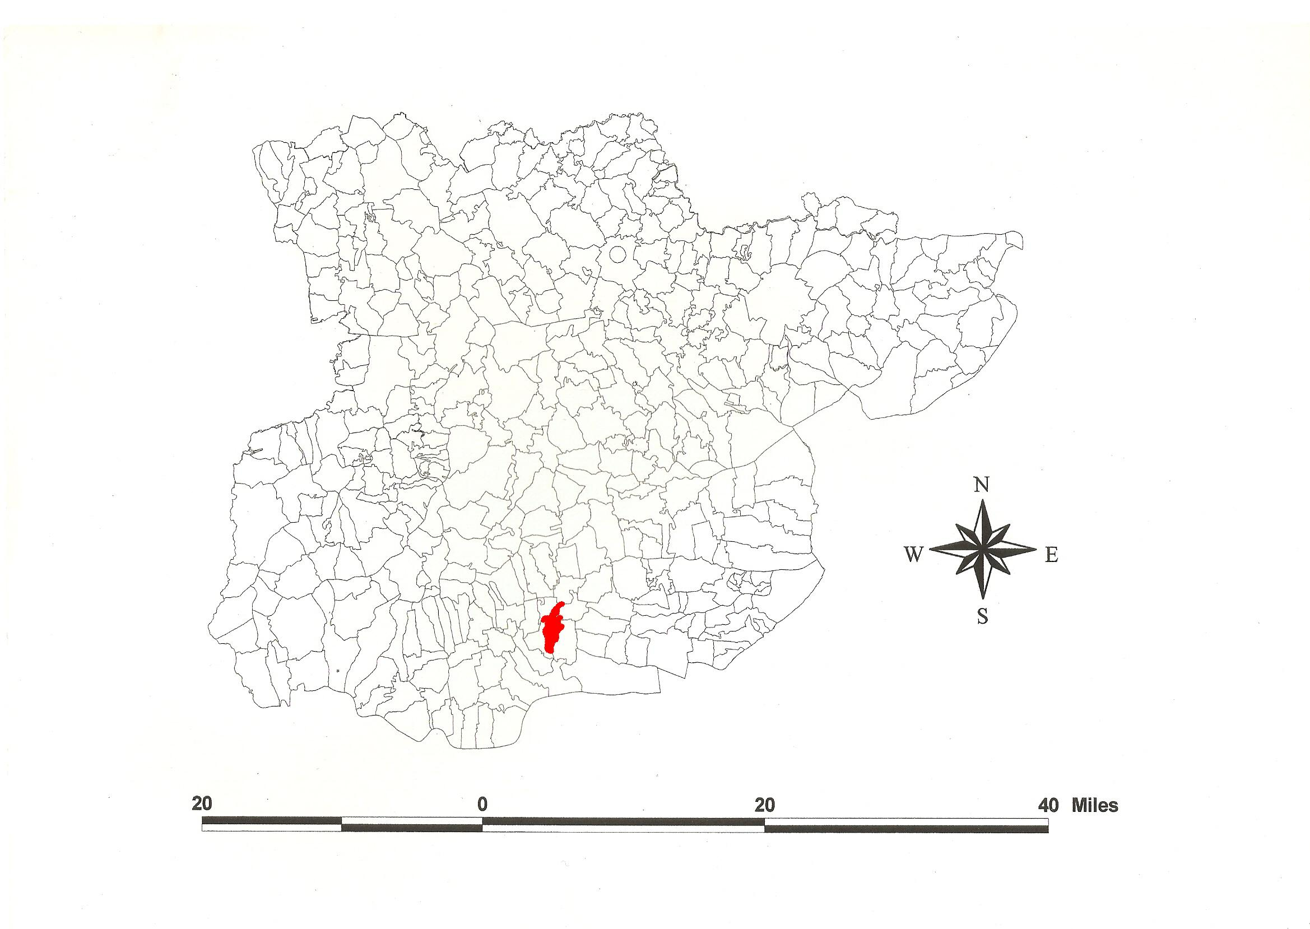
Pitsea Parish in the County of Essex.
Reproduced by permission
of Essex County Council.

The Parish of Pitsea (in Barstable Hundred).

The Tithe Award of Pitsea (Essex Record Office D/CT 274a), dated 1847, shows a rent-charge payable to the impropriator Henry Prescott Blencow esq of Bath of £170-10-0 and to the vicar £424-17-0. The whole parish measured 2048 acres 2 roods 1 perch of which 1402a 3r 2p was arable, 395a 2r 0p meadow and pasture, 14a 1r 0p wood, 123a 2r 9p saltings and 12a 2r 16p reeds. The Tithe Commissioners were J.W. Buller and R. Jones, Assistant Thomas Tatham, the Valuer Abraham Offin of Hutton.

The Tithe map (ERO: D/CT 274b) was surveyed at a scale of 26.6” to a mile and measures 105”x68”. Detached portions of the parish were in Bowers Marsh and Canvey Island.

In Domesday Book, 1086, in Piceseia, there were 3 hides with a mill before 1066 which Wulfeva, wife of Finn [the Dane] held. 3 other hides and 30 acres of woodland were added where 8 freemen dwelt. These 3 hides still belonged to the King. Wulfeva’s lands were granted to Eudo the Steward by William II in 1099 or 1100. Finn who had held Langham and Barrow Hall in Little Wakering, died after 1066 (Morris, 1983; Kemble, 2007). Watts (2004) translates this from an Old English personal name + ea, ‘ Pic’s island (or marshland)’ (Reaney, 1935).

There were two manors: 1. Pitsea Hall was that which Eudo the Steward granted to the foundation of St John’s Abbey. At the Dissolution it came to Thomas Cromwell and thereafter to Thomas Howard, Duke of Norfolk. 2. Chalvedon Hall was that part not granted to St John’s. It was held by the Prior of St Mary’s-without-Bishopsgate, London, under Robert Fitzwalter (died 1328). Henry VIII granted it to Thomas Cromwell (Morant, 1768).

The restored west tower, c.1500, of St. Michael’s church stands above Pitsea Creek and the Thames marshes northeast of the former Pitsea Hall. The Hall (Cromwell Manor) is timber-framed c. 1600. In Wat Tyler Country Park are two houses rescued when Stansted Airport threatened to engulf them: Little Cooper’s Cottage is a 3-bay hall house, 15th century. Blunts Cottage is 16th century. St Gabriel’s church was built in 1963-4. Pitsea had a railway station in 1855; Railway Hotel dates from 1927. The village was subsumed into the plans for Basildon New Town started in 1956 (Pevsner, 2007).

The meeting place of the Hundred, the moot, was at Barstable, the site marked by a stapol or pillar. Christy (1926) places it at Old Barstable Hall, formerly at the southwest extremity of Basildon parish on high ground. The first element may be a personal name, Bearda, or perhaps from O.E. beardede, hairy (Reaney, 1935).

References:
Christy, M, 1926. The Essex Hundred Moots. Trans Essex Archaeological Society, ns xviii (3), p194.
Kemble, J., 2007. Essex Place-names, Places, Streets & People. Historical Publications, London.
Morant, P., 1768. History & Antiquites of the County of Essex, i, 255.
Morris, J., 1983. Domesday Book – Essex, Kent. Phillimore.
Pevsner, N., Bettley, J., 2007. Buildings of England – Essex. Yale.
Reaney, P., 1935. Place-names of Essex. Cambridge.
Watts, V., 2004. Dictionary of English Place-names. Cambridge.

The Tithe Award Place-names of Pitsea – by Parcel No.

Place-name | Alias | Fld No | Gd Ref | x | y | Acr | rd | pch | land use | Owner | Occupier | Name of Farm | Other information
Hovefields Farm (pt) |  | 1 | TQ |  |  | 23 | 0 | 24 | arable | Ashburton, Rt Hon Lord | Talbot, Robert Riggs | Hovefields (pt)
Hovefields Farm (pt) |  | 2 | TQ |  |  | 11 | 1 | 7 | arable | Ashburton, Rt Hon Lord | Talbot, Robert Riggs | Hovefields (pt)
Hovefields Farm (pt) |  | 3 | TQ |  |  | 10 | 1 | 9 | arable | Ashburton, Rt Hon Lord | Talbot, Robert Riggs | Hovefields (pt)
Hovefields Farm (pt) |  | 4 | TQ | 746 | 908 | 4 | 1 | 37 | arable | Ashburton, Rt Hon Lord | Talbot, Robert Riggs | Hovefields (pt)
Hovefields Farm (pt) |  | 5 | TQ | 745 | 908 | 4 | 2 | 20 | pasture | Ashburton, Rt Hon Lord | Talbot, Robert Riggs | Hovefields (pt)
Hovefields Farm (pt) |  | 6 | TQ | 743 | 906 | 11 | 2 | 20 | arable | Ashburton, Rt Hon Lord | Talbot, Robert Riggs | Hovefields (pt)
Cowhouse field (pt) |  | 7 | TQ | 742 | 906 | 2 | 2 | 7 | arable | Walmersley, Richard esq | Harrison, Henry
Long Mead (pt) |  | 8 | TQ |  |  | 1 | 1 | 24 | pasture | Walmersley, Richard esq | Harrison, Henry
Hovefields Farm (pt) |  | 9 | TQ |  |  | 12 | 0 | 12 | arable | Ashburton, Rt Hon Lord | Talbot, Robert Riggs | Hovefields (pt)
Homestead (pt). Hovefields | Hobbles, 1777,C | 10 | TQ | 744 | 906 | 1 | 1 | 20 |  | Ashburton, Rt Hon Lord | Talbot, Robert Riggs | Hovefields (pt)
Hoppit (pt) |  | 11 | TQ |  |  | 0 | 3 | 30 | pasture | Ashburton, Rt Hon Lord | Talbot, Robert Riggs | Hovefields (pt)
Lane |  | 12 | TQ |  |  | 2 | 0 | 14 |  | Ashburton, Rt Hon Lord | Talbot, Robert Riggs | Hovefields (pt)
Hovefields Farm (pt) |  | 13 | TQ |  |  | 6 | 3 | 16 | arable | Ashburton, Rt Hon Lord | Talbot, Robert Riggs | Hovefields (pt)
Hovefields Farm (pt) |  | 13a | TQ |  |  | 0 | 0 | 10 | arable | Ashburton, Rt Hon Lord | Talbot, Robert Riggs | Hovefields (pt)
Hovefields Farm (pt) |  | 14 | TQ | 742 | 903 | 21 | 1 | 2 | arable | Ashburton, Rt Hon Lord | Talbot, Robert Riggs | Hovefields (pt)
Hovefields Farm (pt) |  | 15 | TQ | 740 | 904 | 9 | 0 | 18 | arable | Ashburton, Rt Hon Lord | Talbot, Robert Riggs | Hovefields (pt)
Hovefields Farm (pt) |  | 16 | TQ | 738 | 943 | 10 | 3 | 37 | pasture | Ashburton, Rt Hon Lord | Talbot, Robert Riggs | Hovefields (pt)
Pitsea Bush |  | 17 | TQ |  |  | 11 | 0 | 6 | wood | Blencowe, Prescott esq | Abrey, Charles | Grtcharlton Hall
Grove mead |  | 18 | TQ |  |  | 11 | 0 | 0 | pasture | Blencowe, Prescott esq | Abrey, Charles | Grtcharlton Hall
Burnt Millfield |  | 19 | TQ | 741 | 900 | 44 | 1 | 25 | arable | Blencowe, Prescott esq | Abrey, Charles | Grtcharlton Hall
Burnt Mills Homestead (pt) | Burnt Mill Farm, 1777,C | 20 | TQ | 741 | 900 | 0 | 1 | 2 |  | Downe, Lord Viscount | Sparks, John | Burnt House
Hoppit |  | 21 | TQ |  |  | 3 | 3 | 2 | pasture | Downe, Lord Viscount | Sparks, John | Burnt House
Garden |  | 22 | TQ |  |  | 0 | 0 | 30 |  | Downe, Lord Viscount | Sparks, John | Burnt House
Garden |  | 23 | TQ |  |  | 0 | 0 | 9 |  | Downe, Lord Viscount | Sparks, John | Burnt House
Cottage, garden |  | 24 | TQ | 743 | 901 | 0 | 0 | 26 |  | Stock, Jas, execs of | Ellis, Joseph
Great Mead (pt) |  | 25 | TQ |  |  | 5 | 0 | 24 | pasture | Downe, Lord Viscount | Sparks, John | Burnt House
Eight acres (pt) |  | 26 | TQ | 742 | 896 | 6 | 2 | 6 | arable | Downe, Lord Viscount | Sparks, John | Burnt House
Eighteen acres |  | 27 | TQ | 743 | 895 | 19 | 0 | 35 | arable | Blencowe, Prescott esq | Laycell, George | Little Charlton Hall
Lower Black Down |  | 28 | TQ | 744 | 894 | 20 | 2 | 6 | arable | Blencowe, Prescott esq | Abrey, Charles | Grtcharlton Hall
Home mead |  | 29 | TQ |  |  | 11 | 1 | 12 | pasture | Blencowe, Prescott esq | Abrey, Charles | Grtcharlton Hall
Cottage, garden |  | 30 | TQ |  |  | 0 | 0 | 12 |  | Abrey, Charles | Pomfret, Samuel
Seven acres |  | 31 | TQ |  |  | 8 | 2 | 12 | arable | Blencowe, Prescott esq | Abrey, Charles | Grtcharlton Hall
West field |  | 32 | TQ | 737 | 894 | 21 | 1 | 5 | arable | Blencowe, Prescott esq | Abrey, Charles | Grtcharlton Hall
Wood field |  | 33 | TQ | 794 | 895 | 10 | 1 | 4 | arable | Smith, Sir C.J., execs of | Wright,Abraham & William | Filmonds
Four acres |  | 34 | TQ |  |  | 4 | 2 | 12 | arable | Smith, Sir C.J., execs of | Wright, Abraham & William | Filmonds
Seven acres |  | 35 | TQ |  |  | 7 | 3 | 2 | arable | Smith, Sir C.J., execs of | Wright, Abraham & William | Filmonds
Three acres |  | 36 | TQ |  |  | 2 | 1 | 29 | arable | Smith, Sir C.J., execs of | Wright, Abraham & William | Filmonds
Lane |  | 36a | TQ |  |  | 0 | 0 | 20 |  | Smith, Sir C.J., execs of | Wright, Abraham & William | Filmonds
Two acres |  | 37 | TQ |  |  | 3 | 0 | 14 | pasture | Smith, Sir C.J., execs of | Wright, Abraham & William | Filmonds
Four acres |  | 38 | TQ |  |  | 4 | 1 | 26 | arable | Knox, Vicesimus | Darby, John
Six acre field |  | 39 | TQ |  |  | 7 | 0 | 14 | arable | Offin, Abraham | Offin, Abraham
Ten acre field |  | 40 | TQ | 726 | 891 | 11 | 3 | 33 | arable | Offin, Abraham | Offin, Abraham
Seven acres |  | 41 | TQ |  |  | 8 | 0 | 10 | arable | Knox, Vicesimus | Darby, John
Little field |  | 42 | TQ |  |  | 1 | 2 | 3 | pasture | Smith, Sir C.J., execs of | Wright, Abraham & William | Filmonds
Five acres |  | 43 | TQ |  |  | 2 | 2 | 2 | arable | Smith, Sir C.J., execs of | Wright, Abraham & William | Filmonds
Five acres |  | 43a | TQ |  |  | 3 | 1 | 0 | arable | Smith, Sir C.J., execs of | Wright, Abraham & William | Filmonds
Lane |  | 47a | TQ |  |  | 0 | 1 | 13 |  | Smith, Sir C.J., execs of | Wright, Abraham & William | Filmonds
Barn field |  | 44 | TQ | 732 | 893 | 8 | 2 | 29 | arable | Smith, Sir C.J., execs of | Wright, Abraham & William | Filmonds
Lane |  | 45 | TQ |  |  | 0 | 2 | 28 | pasture | Smith, Sir C.J., execs of | Wright, Abraham & William | Filmonds
Homestead | Felmores, 1875,OS | 46 | TQ | 733 | 893 | 1 | 0 | 11 |  | Smith, Sir C.J., execs of | Wright, Abraham & William | Filmonds
Cow house |  | 47 | TQ | 734 | 893 | 9 | 3 | 25 | arable | Smith, Sir C.J., execs of | Wright, Abraham & William | Filmonds
West field |  | 48 | TQ | 737 | 893 | 17 | 0 | 7 | arable | Blencowe, Prescott esq | Abrey, Charles | Grtcharlton Hall
Cowhouse field |  | 49 | TQ |  |  | 32 | 0 | 31 | arable | Blencowe, Prescott esq | Abrey, Charles | Grtcharlton Hall
Ten acres |  | 50 | TQ |  |  | 10 | 2 | 26 | arable | Blencowe, Prescott esq | Laycell, George | Little Charlton Hall
Chapel field |  | 51 | TQ | 746 | 889 | 27 | 2 | 38 | arable | Blencowe, Prescott esq | Laycell, George | Little Charlton Hall
Chapel field |  | 52 | TQ | 743 | 889 | 26 | 1 | 12 | arable | Blencowe, Prescott esq | Abrey, Charles | Grtcharlton Hall
Homestead. Charlton Hall | Chauendona, 1119, Colch; Great Chalvedon Hall, 1875,OS | 53 | TQ | 842 | 891 | 2 | 3 | 5 |  | Blencowe, Prescott esq | Abrey, Charles | Grtcharlton Hall
Hoppit |  | 54 | TQ |  |  | 2 | 1 | 18 | pasture | Blencowe, Prescott esq | Abrey, Charles | Grtcharlton Hall
Pound field |  | 55 | TQ | 741 | 887 | 19 | 0 | 35 | arable | Blencowe, Prescott esq | Abrey, Charles | Grtcharlton Hall
Cottage, garden |  | 56 | TQ | 740 | 888 | 0 | 0 | 14 |  | Freeman, Stephen | Lobley, William
Dockey field |  | 57 | TQ | 739 | 890 | 18 | 0 | 15 | arable | Blencowe, Prescott esq | Abrey, Charles | Grtcharlton Hall
Little Rowleys |  | 58 | TQ | 737 | 888 | 16 | 3 | 23 | arable | Blencowe, Prescott esq | Abrey, Charles | Grtcharlton Hall
Barnfield |  | 59 | TQ | 735 | 891 | 2 | 3 | 25 | arable | Knox, Vicesimus | Darby, John
Hoppit |  | 60 | TQ |  |  | 0 | 3 | 28 | pasture | Knox, Vicesimus | Darby, John
Homestead | Filmans, 1875,OS | 61 | TQ | 733 | 891 | 0 | 3 | 26 |  | Knox, Vicesimus | Darby, John
Pond field |  | 63 | TQ |  |  | 7 | 2 | 16 | arable | Knox, Vicesimus | Darby, John
Four acres |  | 64 | TQ |  |  | 5 | 0 | 9 | arable | Smith, Sir C.J., execs of | Wright, Abraham & William | Filmonds
Five acres |  | 65 | TQ | 732 | 890 | 5 | 1 | 10 | arable | Knox, Vicesimus | Darby, John
Six acres |  | 66 | TQ |  |  | 6 | 1 | 6 | arable | Knox, Vicesimus | Darby, John
Eight & half acres |  | 67 | TQ | 732 | 888 | 8 | 0 | 25 | arable | Downe, Lord Viscount; Heathcote, Rev George | Bayley, Charles | Pitsea Hall
Shaw |  | 67a | TQ | 733 | 889 | 1 | 1 | 0 | wood | Downe, Lord Viscount; Heathcote, Rev George | Bayley, Charles
Six & half acres |  | 68 | TQ | 730 | 888 | 6 | 2 | 14 | arable | Downe, Lord Viscount; Heathcote, Rev George | Bayley, Charles | Pitsea Hall
Shaw |  | 68a | TQ |  |  | 0 | 0 | 21 | wood | Downe, Lord Viscount; Heathcote, Rev George | Bayley, Charles
Six acres |  | 69 | TQ |  |  | 7 | 0 | 38 | arable | Knox, Vicesimus | Darby, John
Further Nine acres (pt) |  | 70 | TQ |  |  | 9 | 1 | 2 | arable | Freeman, John Button esq | Moss, Benjamin
Nine acres (pt) |  | 71 | TQ |  |  | 3 | 0 | 30 | arable | Freeman, John Button esq | Moss, Benjamin
Vange Hook |  | 72 | TQ |  |  | 4 | 1 | 32 | arable | Knox, Vicesimus | Darby, John
Seventeen acres |  | 74 | TQ | 730 | 886 | 17 | 0 | 7 | arable | Downe, Lord Viscount; Heathcote, Rev George | Bayley, Charles | Pitsea Hall
Shaw |  | 74a | TQ |  |  | 0 | 2 | 38 | wood | Downe, Lord Viscount; Heathcote, Rev George | Bayley, Charles
Fourteen acres |  | 75 | TQ |  |  | 15 | 1 | 28 | arable | Downe, Lord Viscount; Heathcote, Rev George | Bayley, Charles | Pitsea Hall
Cromptsfield |  | 76 | TQ |  |  | 19 | 3 | 3 | arable | Downe, Lord Viscount; Heathcote, Rev George | Bayley, Charles | Pitsea Hall
Shaw |  | 77 | TQ |  |  | 0 | 2 | 12 | wood | Downe, Lord Viscount; Heathcote, Rev George | Bayley, Charles | Pitsea Hall
Shaw |  | 78 | TQ |  |  | 0 | 2 | 3 | wood | Downe, Lord Viscount; Heathcote, Rev George | Bayley, Charles | Pitsea Hall
Nineteen acres |  | 79 | TQ | 731 | 884 | 19 | 2 | 29 | arable | Downe, Lord Viscount; Heathcote, Rev George | Bayley, Charles | Pitsea Hall
Further field |  | 80 | TQ |  |  | 5 | 0 | 24 | arable | Hewitt, Charles | Edwards, Rev L.T. |  | glebe
Eighteen acres |  | 81 | TQ | 735 | 884 | 19 | 3 | 11 | arable | Downe, Lord Viscount; Heathcote, Rev George | Bayley, Charles | Pitsea Hall
Further Rowleys |  | 82 | TQ |  |  | 17 | 2 | 30 | arable | Blencowe, Prescott esq | Abrey, Charles | Grtcharlton Hall
Rowleys |  | 83 | TQ | 739 | 885 | 21 | 2 | 11 | arable | Blencowe, Prescott esq | Abrey, Charles | Grtcharlton Hall
Gapes Downs |  | 84 | TQ | 742 | 885 | 18 | 2 | 11 | arable | Blencowe, Prescott esq | Laycell, George | Little Charlton Hall
Middle Millfield |  | 85 | TQ | 744 | 885 | 17 | 0 | 31 | arable | Blencowe, Prescott esq | Laycell, George | Little Charlton Hall
Mill field |  | 86 | TQ | 746 | 885 | 17 | 0 | 28 | arable | Blencowe, Prescott esq | Laycell, George | Little Charlton Hall
Lower Six acres |  | 87 | TQ |  |  | 6 | 3 | 32 | arable | Downe, Lord Viscount | Bayley, Charles | Bull
Lower cross path field |  | 88 | TQ | 749 | 886 | 6 | 1 | 14 | arable | Downe, Lord Viscount | Bayley, Charles | Bull
Long Salmons (pt) |  | 89 | TQ | 750 | 886 | 3 | 0 | 5 | arable | Spitty, Thomas esq | Shuttleworth, Charles
Three acres |  | 90 | TQ | 751 | 886 | 2 | 3 | 28 | arable | Spitty, Thomas esq | Shuttleworth, Charles
Five acres |  | 91 | TQ |  |  | 6 | 3 | 32 | arable | Downe, Lord Viscount | Bayley, Charles | Bull
Upper cross pathfield |  | 92 | TQ | 748 | 885 | 6 | 1 | 14 | arable | Downe, Lord Viscount | Large, Samuel
Cottage field, cottage, garden |  | 93 | TQ |  |  | 2 | 0 | 21 | arable | Bluck, Rev | Large, Samuel
Poorhouse field |  | 94 | TQ | 749 | 883 | 3 | 3 | 37 | arable | Downe, Lord Viscount | Bayley, Charles | Bull
Pond mead |  | 95 | TQ | 748 | 883 | 2 | 3 | 18 | pasture | Downe, Lord Viscount | Bayley, Charles | Bull
Little mead |  | 96 | TQ |  |  | 1 | 0 | 0 | pasture | Stock, James, execs | Green, William
Great mead |  | 97 | TQ | 747 | 883 | 2 | 2 | 3 | pasture | Stock, James, execs | Green, William
Mill field |  | 98 | TQ | 746 | 882 | 5 | 2 | 17 | arable | Downe, Lord Viscount | Bayley, Charles | Bull
Mill house, premises |  | 99 | TQ | 745 | 883 | 0 | 1 | 0 | mill | Blencowe, Prescott esq | Grout, Robert
Meadow | Pitsea Windmill (Corn), 1875,OS | 100 | TQ | 744 | 883 | 4 | 0 | 34 | pasture | Blencowe, Prescott esq | Grout, Robert
Middle mill field |  | 101 | TQ | 744 | 882 | 3 | 0 | 20 | arable | Downe, Lord Viscount | Bayley, Charles | Bull
Three & half acre |  | 102 | TQ |  |  | 4 | 0 | 19 | arable | Downe, Lord Viscount | Bayley, Charles | Bull
Beckneys mead |  | 103 | TQ | 743 | 881 | 8 | 1 | 5 | pasture | Spitty, Thomas esq | Blakeley, Sarah Ann | Blue House (pt)
Mill lane |  | 104 | TQ | 743 | 883 | 1 | 0 | 0 | pasture | Blencowe, Prescott esq | Grout, Robert
Gapes Downs |  | 105 | TQ | 743 | 883 | 12 | 1 | 38 | arable | Blencowe, Prescott esq | Laycell, George | Little Charlton Hall
Cottage, garden |  | 106 | TQ |  |  | 0 | 0 | 24 |  | Downe, Lord Viscount | Bayley, Charles | Bull
Cottage, garden |  | 107 | TQ |  |  | 0 | 0 | 32 |  | Stock, James, execs | Smith, James
Bull Public House |  | 108 | TQ | 747 | 882 | 0 | 1 | 6 | inn | Stock, James, execs | Green, William
Homestead | Bull Farm, 1875,OS | 109 | TQ | 747 | 882 | 0 | 2 | 29 |  | Downe, Lord Viscount | Bayley, Charles | Bull
Cottage, garden |  | 111 | TQ |  |  | 0 | 1 | 9 |  | Bayley, Charles | Spooner, James; Mead, James
Cottages, gardens |  | 112 | TQ |  |  | 0 | 0 | 24 |  | Spitty, Thomas esq | Bettis, Christopher; Dock, Samuel
Cottage, garden |  | 113 | TQ |  |  | 0 | 0 | 6 |  | Buck, Rev | Theobald, Wm; Saveall, James; Cracknell, Mira
Shop House garden |  | 114 | TQ | 749 | 882 | 0 | 0 | 33 |  | Freeman, Stephen | Crooks, Abraham
House shop gdn |  | 115 | TQ | 749 | 882 | 0 | 1 | 19 |  | Stock, James, execs | Freeman, Stephen
Two acre mead |  | 116 | TQ |  |  | 2 | 0 | 2 | pasture | Edwards, Rev L.T. | Edwards, Rev L.T. | Shop House
Hoppit |  | 117 | TQ |  |  | 0 | 3 | 17 | pasture | Edwards, Rev L.T. | Edwards, Rev L.T. | Shop House
Homestead | Shop House, 1777,C | 118 | TQ | 740 | 882 | 0 | 1 | 10 |  | Edwards, Rev L.T. | Edwards, Rev L.T. | Shop House
Cottage, garden |  | 119 | TQ | 740 | 882 | 0 | 0 | 16 |  | Edwards, Rev L.T. | Empty
Three acres |  | 120 | TQ | 740 | 882 | 3 | 0 | 24 | pasture | Edwards, Rev L.T. | Edwards, Rev L.T. | Shop House
Eight acres |  | 121 | TQ |  |  | 7 | 1 | 11 | arable | Edwards, Rev L.T. | Edwards, Rev L.T. | Shop House
Six & half acres |  | 122 | TQ | 738 | 883 | 7 | 1 | 18 | arable | Edwards, Rev L.T. | Edwards, Rev L.T. | Shop House
Sixteen acres |  | 123 | TQ | 735 | 882 | 17 | 2 | 34 | arable | Downe, Lord Viscount; Heathcote, Rev George | Bayley, Charles | Pitsea Hall
Three acres |  | 124 | TQ |  |  | 3 | 0 | 25 | arable | Edwards, Rev L.T. | Edwards, Rev L.T. | Shop House
Five acres |  | 125 | TQ |  |  | 5 | 0 | 7 | arable | Edwards, Rev L.T. | Edwards, Rev L.T. | Shop House
Seven acres |  | 126 | TQ |  |  | 8 | 0 | 12 | arable | Edwards, Rev L.T. | Edwards, Rev L.T. | Shop House
Cottage, garden |  | 127 | TQ |  |  | 0 | 0 | 32 |  | Bulver, Joslin | Hickford, John; Hunwicks, Wm
Barn yard & gdn |  | 128 | TQ |  |  | 0 | 0 | 37 |  | Spitty, Thomas esq | Blakeley, Sarah Ann | Blue House (pt)
Barn field |  | 129 | TQ |  |  | 5 | 0 | 21 | arable | Spitty, Thomas esq | Blakeley, Sarah Ann | Blue House (pt)
Six acres |  | 130 | TQ |  |  | 6 | 2 | 7 | arable | Spitty, Thomas esq | Blakeley, Sarah Ann | Blue House (pt)
First field |  | 131 | TQ |  |  | 6 | 0 | 25 |  | Hewitt, Rev Charles | Edwards, Rev L.T. |  | glebe
Five acres |  | 132 | TQ |  |  | 5 | 2 | 2 | arable | Downe, Lord Viscount; Heathcote, Rev George | Bayley, Charles | Pitsea Hall
Upper Nine acres |  | 133 | TQ | 732 | 881 | 9 | 3 | 2 | arable | Bulver, Joslin | Sparks, John | Brick House
Upper eight acres |  | 134 | TQ | 729 | 880 | 9 | 3 | 35 | arable | Bulver, Joslin | Sparks, John | Brick House
Further eight acres |  | 135 | TQ | 728 | 877 | 8 | 2 | 29 | arable | Bulver, Joslin | Sparks, John | Brick House
Eight acres |  | 136 | TQ | 730 | 877 | 8 | 3 | 25 | arable | Bulver, Joslin | Sparks, John | Brick House
Eleven acres |  | 137 | TQ |  |  | 12 | 2 | 18 | arable | Bulver, Joslin | Sparks, John | Brick House
Barnfield |  | 138 | TQ |  |  | 9 | 0 | 22 | arable | Bulver, Joslin | Sparks, John | Brick House
Hoppit |  | 139 | TQ | 733 | 876 | 0 | 2 | 38 | pasture | Bulver, Joslin | Sparks, John | Brick House
Homestead | Brickhouse, 1875,OS | 140 | TQ | 733 | 876 | 1 | 1 | 13 |  | Bulver, Joslin | Sparks, John | Brick House
Orchard mead |  | 141 | TQ |  |  | 1 | 1 | 36 | pasture | Bulver, Joslin | Sparks, John | Brick House
Galley field |  | 142 | TQ | 730 | 874 | 12 | 1 | 28 | arable | Bulver, Joslin | Sparks, John | Brick House
Post field |  | 143 | TQ | 733 | 873 | 7 | 0 | 13 | arable | Spitty, Thomas esq | Benton, James E. | Kiln
Maprills |  | 144 | TQ |  |  | 6 | 2 | 5 | arable | Spitty, Thomas esq | Benton, James E. | Kiln
Lemon mead |  | 145 | TQ |  |  | 7 | 1 | 11 | pasture | Bulver, Joslin | Sparks, John | Brick House
Great mead |  | 146 | TQ |  |  | 4 | 2 | 27 | pasture | Bulver, Joslin | Sparks, John | Brick House
Rectory House | Rectory, 1875,OS | 147 | TQ | 734 | 875 | 0 | 2 | 1 |  | Edwards, Rev L.T. | Edwards, Rev L.T. |  | glebe
Rectory Mead |  | 148 | TQ | 734 | 875 | 4 | 1 | 19 | pasture | Edwards, Rev L.T. | Edwards, Rev L.T. |  | glebe
Parsonage field |  | 149 | TQ | 735 | 876 | 5 | 1 | 3 | arable | Spitty, Thomas esq | Blakeley, Sarah Ann | Blue House (pt)
Cottage, garden |  | 150 | TQ | 736 | 876 | 0 | 0 | 14 |  | Downe, Lord Viscount; Heathcote, Rev George | Smith, Samuel
Further Churchfield |  | 151 | TQ | 737 | 876 | 5 | 2 | 3 | arable | Spitty, Thomas esq | Blakeley, Sarah Ann | Blue House (pt)
Hither Churchfield |  | 152 | TQ | 739 | 876 | 4 | 3 | 22 | arable | Spitty, Thomas esq | Blakeley, Sarah Ann | Blue House (pt)
Cottage, garden |  | 153 | TQ |  |  | 0 | 2 | 22 |  | Bayley, Charles | Burnells, Abraham; others
House, garden |  | 154 | TQ |  |  | 0 | 2 | 24 |  | Stock, James, execs | Bowtell, Wm; Hide, Robert
House, garden |  | 156 | TQ |  |  | 0 | 1 | 22 |  | Harrod, James | Harrod, James
Meadow |  | 157 | TQ | 740 | 876 | 1 | 1 | 1 | pasture | Stock, James, execs | Bowtell, Wm; Hide, Robert
Meadow |  | 158 | TQ |  |  | 1 | 1 | 0 | pasture | Stock, James, execs | Bowtell, Wm; Hide, Robert
Meadow |  | 159 | TQ |  |  | 1 | 2 | 10 | pasture | Harrod, James | Harrod, James
Barn mead |  | 160 | TQ | 743 | 877 | 7 | 3 | 32 | pasture | Spitty, Thomas esq | Blakeley, Sarah Ann | Blue House (pt)
Homestead (pt) | Great Garrets or Blue House, 1875,OS | 161 | TQ | 744 | 877 | 1 | 3 | 9 |  | Spitty, Thomas esq | Blakeley, Sarah Ann | Blue House (pt)
Bowers Mead (pt) |  | 162 | TQ | 744 | 875 | 1 | 2 | 25 | pasture | Spitty, Thomas esq | Blakeley, Sarah Ann | Blue House (pt)
Cowhouse field |  | 163 | TQ | 743 | 876 | 12 | 0 | 28 | arable | Spitty, Thomas esq | Blakeley, Sarah Ann | Blue House (pt)
Church field |  | 164 | TQ | 741 | 876 | 11 | 0 | 29 | arable | Downe, Lord Viscount; Heathcote, Rev George | Bayley, Charles | Pitsea Hall
Church, churchyard | [St Michael] | 165 | TQ | 739 | 875 | 0 | 1 | 22 |  | Hewitt, Rev Charles | Edwards, Rev L.T. |  | glebe
Church Hill |  | 166 | TQ | 739 | 876 | 19 | 1 | 38 | pasture | Downe, Lord Viscount; Heathcote, Rev George | Bayley, Charles | Pitsea Hall
Road |  | 168 | TQ |  |  | 0 | 0 | 35 |  | Downe, Lord Viscount; Heathcote, Rev George | Bayley, Charles | Pitsea Hall
Upper meadow |  | 169 | TQ | 735 | 875 | 23 | 3 | 18 | pasture | Downe, Lord Viscount; Heathcote, Rev George | Bayley, Charles | Pitsea Hall
Reeds pond |  | 170 | TQ |  |  | 0 | 1 | 10 | reeds | Downe, Lord Viscount; Heathcote, Rev George | Bayley, Charles | Pitsea Hall
Lower meadow |  | 171 | TQ |  |  | 21 | 2 | 16 | pasture | Downe, Lord Viscount; Heathcote, Rev George | Bayley, Charles | Pitsea Hall
Shed field |  | 172 | TQ |  |  | 8 | 2 | 0 | arable | Spitty, Thomas esq | Benton, James E. | Kiln
Home mead |  | 173 | TQ |  |  | 3 | 1 | 32 | pasture | Spitty, Thomas esq | Benton, James E. | Kiln
Homestead | Kiln Farm, 1875,OS | 174 | TQ | 733 | 872 | 0 | 2 | 10 |  | Spitty, Thomas esq | Benton, James E. | Kiln
Horne marsh |  | 175 | TQ |  |  | 2 | 3 | 37 | pasture | Spitty, Thomas esq | Benton, James E. | Kiln
Marsh field |  | 176 | TQ | 734 | 871 | 4 | 2 | 26 | arable | Spitty, Thomas esq | Benton, James E. | Kiln
Nine acre marsh |  | 177 | TQ | 733 | 868 | 11 | 1 | 9 | pasture | Spitty, Thomas esq | Benton, James E. | Kiln
Coal house marsh |  | 178 | TQ | 734 | 869 | 6 | 0 | 35 | pasture | Spitty, Thomas esq | Benton, James E. | Kiln
Reeds |  | 179 | TQ | 735 | 870 | 0 | 3 | 1 |  | Spitty, Thomas esq | Benton, James E. | Kiln
Little marsh |  | 180 | TQ |  |  | 2 | 0 | 28 | pasture | Spitty, Thomas esq | Benton, James E. | Kiln
Wall etc |  | 181 | TQ | 733 | 867 | 0 | 1 | 38 | pasture | Spitty, Thomas esq | Benton, James E. | Kiln
Saltings |  | 182 | TQ |  |  | 5 | 1 | 17 |  | Spitty, Thomas esq | Benton, James E. | Kiln
Pitsea Creek |  | 183 | TQ | 730 | 866 | 18 | 2 | 24 |  | . | .
Timber Creek |  | 183a | TQ | 733 | 865 | 11 | 1 | 19 |  | Downe, Lord Viscount; Heathcote, Rev George | Bayley, Charles
Saltings |  | 184 | TQ | 736 | 871 | 8 | 1 | 23 |  | Downe, Lord Viscount; Heathcote, Rev George | Bayley, Charles | Pitsea Hall
Saltings |  | 185 | TQ | 738 | 873 | 2 | 3 | 6 |  | Downe, Lord Viscount; Heathcote, Rev George | Bayley, Charles | Pitsea Hall | Pitsea Station, 1875,OS
Homestead & Wharf | Piceseia, 1086,DB; Pitsea Hall,1875,OS; Cromwell Manor, 2007 | 186 | TQ | 738 | 873 | 6 | 0 | 18 |  | Downe, Lord Viscount; Heathcote, Rev George | Bayley, Charles | Pitsea Hall
Hoppit |  | 187 | TQ | 740 | 874 | 1 | 1 | 22 | pasture | Downe, Lord Viscount; Heathcote, Rev George | Bayley, Charles | Pitsea Hall
First Wharf field |  | 187a | TQ |  |  | 15 | 1 | 19 | arable | Downe, Lord Viscount; Heathcote, Rev George | Bayley, Charles
Second Wharf field |  | 188 | TQ | 741 | 874 | 6 | 0 | 18 | arable | Downe, Lord Viscount; Heathcote, Rev George | Bayley, Charles | Pitsea Hall
Fourteen acres |  | 189 | TQ |  |  | 14 | 3 | 11 | arable | Spitty, Thomas esq | Blakeley, Sarah Ann | Blue House (pt) | cut by railway, 1875,OS
Ten acres (pt) |  | 190 | TQ | 746 | 874 | 9 | 2 | 2 | arable | Spitty, Thomas esq | Blakeley, Sarah Ann | Blue House (pt) | cut by railway, 1875,OS
Rushy marsh |  | 191 | TQ |  |  | 20 | 2 | 31 | pasture | Spitty, Thomas esq | Blakeley, Sarah Ann | Blue House (pt)
Fleet |  | 191a | TQ |  |  | 1 | 0 | 1 | reeds | Spitty, Thomas esq | Blakeley, Sarah Ann
Willow marsh |  | 192 | TQ | 744 | 870 | 8 | 1 | 21 | pasture | Downe, Lord Viscount; Heathcote, Rev George | Bayley, Charles | Pitsea Hall
Great Rushy mead |  | 193 | TQ | 743 | 870 | 11 | 0 | 37 | pasture | Downe, Lord Viscount; Heathcote, Rev George | Bayley, Charles | Pitsea Hall
Little Rushy mead |  | 194 | TQ | 744 | 868 | 5 | 1 | 30 | pasture | Downe, Lord Viscount; Heathcote, Rev George | Bayley, Charles | Pitsea Hall
Further Willow Marsh |  | 195 | TQ | 742 | 866 | 14 | 2 | 13 | pasture | Downe, Lord Viscount; Heathcote, Rev George | Bayley, Charles | Pitsea Hall
First Middle marsh |  | 196 | TQ | 740 | 870 | 10 | 2 | 33 | pasture | Downe, Lord Viscount; Heathcote, Rev George | Bayley, Charles | Pitsea Hall
Skirts marsh |  | 197 | TQ | 740 | 866 | 14 | 2 | 25 | pasture | Downe, Lord Viscount; Heathcote, Rev George | Bayley, Charles
Wick field |  | 198 | TQ | 738 | 866 | 25 | 1 | 31 | arable | Downe, Lord Viscount; Heathcote, Rev George | Bayley, Charles
Road & Wall |  | 199 | TQ | 739 | 872 | 2 | 1 | 36 | pasture | Downe, Lord Viscount; Heathcote, Rev George | Bayley, Charles
Saltings |  | 200 | TQ |  |  | 88 | 0 | 7 |  | Downe, Lord Viscount; Heathcote, Rev George | Bayley, Charles
Saltings |  | 201 | TQ |  |  | 4 | 2 | 14 |  | Downe, Lord Viscount; Heathcote, Rev George | Bayley, Charles
Three acre marsh |  | 203 | TQ |  |  | 3 | 2 | 26 | pasture | Downe, Lord Viscount; Heathcote, Rev George | Bayley, Charles
Seventeen Acre Island |  | 204 | TQ | 740 | 863 | 16 | 2 | 30 | arable | Downe, Lord Viscount; Heathcote, Rev George | Bayley, Charles
Twenty Acre Island | Wat Tyler Country Park, 1986,OS | 205 | TQ | 737 | 863 | 20 | 1 | 14 | arable | Downe, Lord Viscount; Heathcote, Rev George | Bayley, Charles
Creek pasture | Wat Tyler Country Park, 1986,OS | 206 | TQ | 735 | 861 | 3 | 3 | 30 | pasture | Downe, Lord Viscount; Heathcote, Rev George | Bayley, Charles
Reed pond |  | 207 | TQ | 734 | 860 | 0 | 0 | 30 | reeds | Downe, Lord Viscount; Heathcote, Rev George | Bayley, Charles
Saltings |  | 208 | TQ | 734 | 859 | 10 | 3 | 17 |  | Downe, Lord Viscount; Heathcote, Rev George | Bayley, Charles
Twelve Acre Island |  | 209 | TQ | 736 | 860 | 12 | 0 | 14 | arable | Downe, Lord Viscount; Heathcote, Rev George | Bayley, Charles
Eighteen Acre Island |  | 210 | TQ | 736 | 858 | 17 | 2 | 0 | arable | Downe, Lord Viscount; Heathcote, Rev George | Bayley, Charles
Sixteen Acre Island |  | 211 | TQ | 740 | 859 | 16 | 0 | 0 | arable | Downe, Lord Viscount; Heathcote, Rev George | Bayley, Charles
Saltings |  | 212 | TQ |  |  | 3 | 2 | 5 |  | Downe, Lord Viscount; Heathcote, Rev George | Bayley, Charles
Ditch to Creek (Half of) |  | 212a | TQ |  |  | 0 | 1 | 10 |  | Downe, Lord Viscount; Heathcote, Rev George | Bayley, Charles
Old Creek |  | 213 | TQ |  |  | 6 | 3 | 10 | reeds | Downe, Lord Viscount; Heathcote, Rev George | Bayley, Charles
Old Creek |  | 214 | TQ | 744 | 866 | 9 | 3 | 7 | . | Downe, Lord Viscount; Heathcote, Rev George | Bayley, Charles
No name |  | 215 | TQ | 780 | 833 | 4 | 3 | 34 | arable | Wood, Henry | Wellard, James |  | on Canvey Island
No name |  | 216 | TQ |  |  | 5 | 3 | 8 | arable | Wood, Henry | Wellard, James |  | on Canvey Island
No name |  | 217 | TQ |  |  | 3 | 2 | 12 | arable | Wood, Henry | Wellard, James |  | on Canvey Island
Homestead | Hillhouse, 1875,OS | 218 | TQ | 780 | 832 | 0 | 0 | 24 |  | Wood, Henry | Wellard, James |  | on Canvey Island
House, garden |  | 219 | TQ | 780 | 832 | 0 | 2 | 4 |  | Hilton, William | Smith, Samuel |  | on Canvey Island
Cottage, garden |  | 220 | TQ |  |  | 0 | 1 | 3 |  | Cross, William | Palmer, James |  | on Canvey Island
Brick House Farm in Island |  | 221 | TQ | 785 | 829 | 17 | 2 | 19 | pasture | Wood, Jonathan | Wood, Jonathan |  | on Canvey Island
Brick House Farm in Island |  | 222 | TQ |  |  | 13 | 2 | 6 |  | Wood, Jonathan | Wood, Jonathan |  | on Canvey Island
Brick House Farm in Island |  | 223 | TQ |  |  | 1 | 3 | 25 | reeds | Wood, Jonathan | Wood, Jonathan |  | on Canvey Island
Brick House Farm in Island |  | 224 | TQ |  |  | 9 | 2 | 27 | arable | Wood, Jonathan | Wood, Jonathan |  | on Canvey Island
Brick House Farm in Island |  | 225 | TQ | 785 | 826 | 9 | 3 | 2 | arable | Wood, Jonathan | Wood, Jonathan |  | on Canvey Island
Brick House Farm in Island |  | 226 | TQ |  |  | 13 | 1 | 1 | arable | Wood, Jonathan | Wood, Jonathan |  | on Canvey Island
Brick House Farm in Island |  | 227 | TQ |  |  | 9 | 1 | 34 | pasture | Wood, Jonathan | Wood, Jonathan |  | on Canvey Island
Brick House Farm in Island |  | 228 | TQ |  |  | 1 | 2 | 30 | pasture | Wood, Jonathan | Wood, Jonathan |  | on Canvey Island
Brick House Farm in Island |  | 229 | TQ |  |  | 6 | 1 | 4 | pasture | Wood, Jonathan | Wood, Jonathan |  | on Canvey Island
Homestead. Antlers Farm | Brickhouse, 1875,OS | 230 | TQ | 780 | 829 | 1 | 0 | 14 |  | Wood, Jonathan | Wood, Jonathan |  | on Canvey Island
Stack yard |  | 231 | TQ |  |  | 0 | 0 | 38 |  | Wood, Jonathan | Wood, Jonathan |  | on Canvey Island
Brick House Farm in Island |  | 232 | TQ |  |  | 8 | 3 | 15 | arable | Wood, Jonathan | Wood, Jonathan |  | on Canvey Island
Brick House Farm in Island |  | 233 | TQ |  |  | 12 | 0 | 20 | arable | Wood, Jonathan | Wood, Jonathan |  | on Canvey Island
Brick House Farm in Island |  | 234 | TQ |  |  | 5 | 3 | 26 | arable | Wood, Jonathan | Wood, Jonathan |  | on Canvey Island
Brick House Farm in Island |  | 235 | TQ | 778 | 828 | 15 | 1 | 11 | arable | Wood, Jonathan | Wood, Jonathan |  | on Canvey Island
The Fleet (Half of) |  | 236 | TQ |  |  | 1 | 1 | 16 | reeds | Wood, Jonathan | Wood, Jonathan |  | on Canvey Island
Brick House Farm in Island |  | 237 | TQ |  |  | 15 | 1 | 19 | pasture | Wood, Jonathan | Wood, Jonathan |  | on Canvey Island
Brick House Farm in Island |  | 238 | TQ |  |  | 13 | 2 | 7 | arable | Wood, Jonathan | Wood, Jonathan |  | on Canvey Island
Brick House Farm in Island |  | 239 | TQ |  |  | 6 | 1 | 15 | arable | Wood, Jonathan | Wood, Jonathan |  | on Canvey Island
Brick House Farm in Island |  | 240 | TQ | 781 | 823 | 16 | 0 | 15 | arable | Wood, Jonathan | Wood, Jonathan |  | on Canvey Island
Brick House Farm in Island |  | 241 | TQ |  |  | 11 | 1 | 23 | arable | Wood, Jonathan | Wood, Jonathan |  | on Canvey Island
The Fleet (Half of) |  | 242 | TQ |  |  | 2 | 0 | 28 |  | Wood, Jonathan | Wood, Jonathan |  | on Canvey Island
Brick House Farm in Island |  | 243 | TQ |  |  | 10 | 1 | 22 | arable | Wood, Jonathan | Wood, Jonathan |  | on Canvey Island
Brick House Farm in Island |  | 244 | TQ |  |  | 14 | 0 | 10 | pasture | Wood, Jonathan | Wood, Jonathan |  | on Canvey Island
Brick House Farm in Island |  | 245 | TQ |  |  | 1 | 0 | 6 | arable | Wood, Jonathan | Wood, Jonathan |  | on Canvey Island
Brick House Farm in Island |  | 246 | TQ | 778 | 821 | 7 | 1 | 0 | arable | Wood, Jonathan | Wood, Jonathan |  | on Canvey Island
Wall |  | 247 |  |  |  | 1 | 1 | 8 |  | Canvey Island, Commissioners of |  |  | on Canvey Island
To Old Wall |  | 248 |  |  |  | 11 | 2 | 9 |  | Canvey Island, Commissioners of |  |  | on Canvey Island
Reeds |  | 250 | TQ | 747 | 850 | 1 | 2 | 4 | . | Wood, Ambrose esq | Dean, Robert | Bradford Marshes | on Bowers Marshes
Fleet (pt) |  | 251 | TQ | 747 | 850 | 10 | 2 | 18 | arable | Wood, Ambrose esq | Dean, Robert |  | on Bowers Marshes
Bradford Marshes (pt) | Bradewerde Mariscus de North, Sud, tEdwI, 1360,BL; Palmersmershe, 1539,MnAt | 252 | TQ | 747 | 850 | 0 | 2 | 16 | arable | Wood, Ambrose esq | Dean, Robert |  | on Bowers Marshes
Fleet 20 acres |  | 253 | TQ | 747 | 850 | 20 | 1 | 36 | arable | Wood, Ambrose esq | Dean, Robert |  | on Bowers Marshes
Ten acres |  | 254 | TQ | 747 | 850 | 20 | 1 | 36 | arable | Wood, Ambrose esq | Dean, Robert |  | on Bowers Marshes
Manor Way Marsh (pt) |  | 255 | TQ | 747 | 850 | 4 | 1 | 21 | pasture | Wood, Ambrose esq | Dean, Robert |  | on Bowers Marshes
Home marsh |  | 256 | TQ | 747 | 850 | 10 | 1 | 28 | pasture | Wood, Ambrose esq | Dean, Robert |  | on Bowers Marshes
Homestead | Old Barn, 1875,OS | 257 | TQ | 747 | 850 | 0 | 2 | 16 |  | Wood, Ambrose esq | Dean, Robert | Bradford Marshes | on Bowers Marshes
Large marsh |  | 258 | TQ | 747 | 850 | 19 | 3 | 2 | pasture | Wood, Ambrose esq | Dean, Robert | Bradford Marshes | on Bowers Marshes
Four acres |  | 259 | TQ | 747 | 850 | 4 | 2 | 7 | arable | Wood, Ambrose esq | Dean, Robert | Bradford Marshes | on Bowers Marshes
Roads |  | . | TQ |  |  | 14 | 3 | 5 |  | . | .
Roads in Canvey Island |  | . | TQ |  |  | 4 | 0 | 4 |  | . | .

For abbreviations see Reaney, P., 1935, Place-names of Essex, Cambridge; and Kemble, J., 2007, Essex Place-names, Places, Streets & People, Historical Publications, p.153.

The Tithe Award Place-names of Pitsea – by Owner.

Place-name | Alias | Fld No | Gd Ref | x | y | Acr | rd | pch | land use | Owner | Occupier | Name of Farm | Other information
Cottage, garden |  | 30 | TQ |  |  | 0 | 0 | 12 |  | Abrey, Charles | Pomfret, Samuel
Hovefields Farm (pt) |  | 1 | TQ |  |  | 23 | 0 | 24 | arable | Ashburton, Rt Hon Lord | Talbot, Robert Riggs | Hovefields (pt)
Homestead (pt). Hovefields | Hobbles, 1777,C | 10 | TQ | 744 | 906 | 1 | 1 | 20 |  | Ashburton, Rt Hon Lord | Talbot, Robert Riggs | Hovefields (pt)
Hoppit (pt) |  | 11 | TQ |  |  | 0 | 3 | 30 | pasture | Ashburton, Rt Hon Lord | Talbot, Robert Riggs | Hovefields (pt)
Lane |  | 12 | TQ |  |  | 2 | 0 | 14 |  | Ashburton, Rt Hon Lord | Talbot, Robert Riggs | Hovefields (pt)
Hovefields Farm (pt) |  | 13 | TQ |  |  | 6 | 3 | 16 | arable | Ashburton, Rt Hon Lord | Talbot, Robert Riggs | Hovefields (pt)
Hovefields Farm (pt) |  | 13a | TQ |  |  | 0 | 0 | 10 | arable | Ashburton, Rt Hon Lord | Talbot, Robert Riggs | Hovefields (pt)
Hovefields Farm (pt) |  | 14 | TQ | 742 | 903 | 21 | 1 | 2 | arable | Ashburton, Rt Hon Lord | Talbot, Robert Riggs | Hovefields (pt)
Hovefields Farm (pt) |  | 15 | TQ | 740 | 904 | 9 | 0 | 18 | arable | Ashburton, Rt Hon Lord | Talbot, Robert Riggs | Hovefields (pt)
Hovefields Farm (pt) |  | 16 | TQ | 738 | 943 | 10 | 3 | 37 | pasture | Ashburton, Rt Hon Lord | Talbot, Robert Riggs | Hovefields (pt)
Hovefields Farm (pt) |  | 2 | TQ |  |  | 11 | 1 | 7 | arable | Ashburton, Rt Hon Lord | Talbot, Robert Riggs | Hovefields (pt)
Hovefields Farm (pt) |  | 3 | TQ |  |  | 10 | 1 | 9 | arable | Ashburton, Rt Hon Lord | Talbot, Robert Riggs | Hovefields (pt)
Hovefields Farm (pt) |  | 4 | TQ | 746 | 908 | 4 | 1 | 37 | arable | Ashburton, Rt Hon Lord | Talbot, Robert Riggs | Hovefields (pt)
Hovefields Farm (pt) |  | 5 | TQ | 745 | 908 | 4 | 2 | 20 | pasture | Ashburton, Rt Hon Lord | Talbot, Robert Riggs | Hovefields (pt)
Hovefields Farm (pt) |  | 6 | TQ | 743 | 906 | 11 | 2 | 20 | arable | Ashburton, Rt Hon Lord | Talbot, Robert Riggs | Hovefields (pt)
Hovefields Farm (pt) |  | 9 | TQ |  |  | 12 | 0 | 12 | arable | Ashburton, Rt Hon Lord | Talbot, Robert Riggs | Hovefields (pt)
Cottage, garden |  | 153 | TQ |  |  | 0 | 2 | 22 |  | Bayley, Charles | Burnells, Abraham; others
Cottage, garden |  | 111 | TQ |  |  | 0 | 1 | 9 |  | Bayley, Charles | Spooner, James; Mead, James
Pitsea Bush |  | 17 | TQ |  |  | 11 | 0 | 6 | wood | Blencowe, Prescott esq | Abrey, Charles | Grtcharlton Hall
Grove mead |  | 18 | TQ |  |  | 11 | 0 | 0 | pasture | Blencowe, Prescott esq | Abrey, Charles | Grtcharlton Hall
Burnt Millfield |  | 19 | TQ | 741 | 900 | 44 | 1 | 25 | arable | Blencowe, Prescott esq | Abrey, Charles | Grtcharlton Hall
Lower Black Down |  | 28 | TQ | 744 | 894 | 20 | 2 | 6 | arable | Blencowe, Prescott esq | Abrey, Charles | Grtcharlton Hall
Home mead |  | 29 | TQ |  |  | 11 | 1 | 12 | pasture | Blencowe, Prescott esq | Abrey, Charles | Grtcharlton Hall
Seven acres |  | 31 | TQ |  |  | 8 | 2 | 12 | arable | Blencowe, Prescott esq | Abrey, Charles | Grtcharlton Hall
West field |  | 32 | TQ | 737 | 894 | 21 | 1 | 5 | arable | Blencowe, Prescott esq | Abrey, Charles | Grtcharlton Hall
West field |  | 48 | TQ | 737 | 893 | 17 | 0 | 7 | arable | Blencowe, Prescott esq | Abrey, Charles | Grtcharlton Hall
Cowhouse field |  | 49 | TQ |  |  | 32 | 0 | 31 | arable | Blencowe, Prescott esq | Abrey, Charles | Grtcharlton Hall
Chapel field |  | 52 | TQ | 743 | 889 | 26 | 1 | 12 | arable | Blencowe, Prescott esq | Abrey, Charles | Grtcharlton Hall
Homestead. Charlton Hall | Chauendona, 1119, Colch; Great Chalvedon Hall, 1875,OS | 53 | TQ | 842 | 891 | 2 | 3 | 5 |  | Blencowe, Prescott esq | Abrey, Charles | Grtcharlton Hall
Hoppit |  | 54 | TQ |  |  | 2 | 1 | 18 | pasture | Blencowe, Prescott esq | Abrey, Charles | Grtcharlton Hall
Pound field |  | 55 | TQ | 741 | 887 | 19 | 0 | 35 | arable | Blencowe, Prescott esq | Abrey, Charles | Grtcharlton Hall
Dockey field |  | 57 | TQ | 739 | 890 | 18 | 0 | 15 | arable | Blencowe, Prescott esq | Abrey, Charles | Grtcharlton Hall
Little Rowleys |  | 58 | TQ | 737 | 888 | 16 | 3 | 23 | arable | Blencowe, Prescott esq | Abrey, Charles | Grtcharlton Hall
Further Rowleys |  | 82 | TQ |  |  | 17 | 2 | 30 | arable | Blencowe, Prescott esq | Abrey, Charles | Grtcharlton Hall
Rowleys |  | 83 | TQ | 739 | 885 | 21 | 2 | 11 | arable | Blencowe, Prescott esq | Abrey, Charles | Grtcharlton Hall
Meadow | Pitsea Windmill (Corn), 1875,OS | 100 | TQ | 744 | 883 | 4 | 0 | 34 | pasture | Blencowe, Prescott esq | Grout, Robert
Mill lane |  | 104 | TQ | 743 | 883 | 1 | 0 | 0 | pasture | Blencowe, Prescott esq | Grout, Robert
Mill house, premises |  | 99 | TQ | 745 | 883 | 0 | 1 | 0 | mill | Blencowe, Prescott esq | Grout, Robert
Gapes Downs |  | 105 | TQ | 743 | 883 | 12 | 1 | 38 | arable | Blencowe, Prescott esq | Laycell, George | Little Charlton Hall
Eighteen acres |  | 27 | TQ | 743 | 895 | 19 | 0 | 35 | arable | Blencowe, Prescott esq | Laycell, George | Little Charlton Hall
Ten acres |  | 50 | TQ |  |  | 10 | 2 | 26 | arable | Blencowe, Prescott esq | Laycell, George | Little Charlton Hall
Chapel field |  | 51 | TQ | 746 | 889 | 27 | 2 | 38 | arable | Blencowe, Prescott esq | Laycell, George | Little Charlton Hall
Gapes Downs |  | 84 | TQ | 742 | 885 | 18 | 2 | 11 | arable | Blencowe, Prescott esq | Laycell, George | Little Charlton Hall
Middle Millfield |  | 85 | TQ | 744 | 885 | 17 | 0 | 31 | arable | Blencowe, Prescott esq | Laycell, George | Little Charlton Hall
Mill field |  | 86 | TQ | 746 | 885 | 17 | 0 | 28 | arable | Blencowe, Prescott esq | Laycell, George | Little Charlton Hall
Cottage field, cottage, garden |  | 93 | TQ |  |  | 2 | 0 | 21 | arable | Bluck, Rev | Large, Samuel
Cottage, garden |  | 113 | TQ |  |  | 0 | 0 | 6 |  | Buck, Rev | Theobald, Wm; Saveall, James; Cracknell, Mira
Cottage, garden |  | 127 | TQ |  |  | 0 | 0 | 32 |  | Bulver, Joslin | Hickford, John; Hunwicks, Wm
Upper Nine acres |  | 133 | TQ | 732 | 881 | 9 | 3 | 2 | arable | Bulver, Joslin | Sparks, John | Brick House
Upper eight acres |  | 134 | TQ | 729 | 880 | 9 | 3 | 35 | arable | Bulver, Joslin | Sparks, John | Brick House
Further eight acres |  | 135 | TQ | 728 | 877 | 8 | 2 | 29 | arable | Bulver, Joslin | Sparks, John | Brick House
Eight acres |  | 136 | TQ | 730 | 877 | 8 | 3 | 25 | arable | Bulver, Joslin | Sparks, John | Brick House
Eleven acres |  | 137 | TQ |  |  | 12 | 2 | 18 | arable | Bulver, Joslin | Sparks, John | Brick House
Barnfield |  | 138 | TQ |  |  | 9 | 0 | 22 | arable | Bulver, Joslin | Sparks, John | Brick House
Hoppit |  | 139 | TQ | 733 | 876 | 0 | 2 | 38 | pasture | Bulver, Joslin | Sparks, John | Brick House
Homestead | Brickhouse, 1875,OS | 140 | TQ | 733 | 876 | 1 | 1 | 13 |  | Bulver, Joslin | Sparks, John | Brick House
Orchard mead |  | 141 | TQ |  |  | 1 | 1 | 36 | pasture | Bulver, Joslin | Sparks, John | Brick House
Galley field |  | 142 | TQ | 730 | 874 | 12 | 1 | 28 | arable | Bulver, Joslin | Sparks, John | Brick House
Lemon mead |  | 145 | TQ |  |  | 7 | 1 | 11 | pasture | Bulver, Joslin | Sparks, John | Brick House
Great mead |  | 146 | TQ |  |  | 4 | 2 | 27 | pasture | Bulver, Joslin | Sparks, John | Brick House
Wall |  | 247 |  |  |  | 1 | 1 | 8 |  | Canvey Island, Commissioners of |  |  | on Canvey Island
To Old Wall |  | 248 |  |  |  | 11 | 2 | 9 |  | Canvey Island, Commissioners of |  |  | on Canvey Island
Cottage, garden |  | 220 | TQ |  |  | 0 | 1 | 3 |  | Cross, William | Palmer, James |  | on Canvey Island
Middle mill field |  | 101 | TQ | 744 | 882 | 3 | 0 | 20 | arable | Downe, Lord Viscount | Bayley, Charles | Bull
Three & half acre |  | 102 | TQ |  |  | 4 | 0 | 19 | arable | Downe, Lord Viscount | Bayley, Charles | Bull
Cottage, garden |  | 106 | TQ |  |  | 0 | 0 | 24 |  | Downe, Lord Viscount | Bayley, Charles | Bull
Homestead | Bull Farm, 1875,OS | 109 | TQ | 747 | 882 | 0 | 2 | 29 |  | Downe, Lord Viscount | Bayley, Charles | Bull
Lower Six acres |  | 87 | TQ |  |  | 6 | 3 | 32 | arable | Downe, Lord Viscount | Bayley, Charles | Bull
Lower cross path field |  | 88 | TQ | 749 | 886 | 6 | 1 | 14 | arable | Downe, Lord Viscount | Bayley, Charles | Bull
Five acres |  | 91 | TQ |  |  | 6 | 3 | 32 | arable | Downe, Lord Viscount | Bayley, Charles | Bull
Poorhouse field |  | 94 | TQ | 749 | 883 | 3 | 3 | 37 | arable | Downe, Lord Viscount | Bayley, Charles | Bull
Pond mead |  | 95 | TQ | 748 | 883 | 2 | 3 | 18 | pasture | Downe, Lord Viscount | Bayley, Charles | Bull
Upper cross pathfield |  | 92 | TQ | 748 | 885 | 6 | 1 | 14 | arable | Downe, Lord Viscount | Large, Samuel
Burnt Mills Homestead (pt) | Burnt Mill Farm, 1777,C | 20 | TQ | 741 | 900 | 0 | 1 | 2 |  | Downe, Lord Viscount | Sparks, John | Burnt House
Hoppit |  | 21 | TQ |  |  | 3 | 3 | 2 | pasture | Downe, Lord Viscount | Sparks, John | Burnt House
Garden |  | 22 | TQ |  |  | 0 | 0 | 30 |  | Downe, Lord Viscount | Sparks, John | Burnt House
Garden |  | 23 | TQ |  |  | 0 | 0 | 9 |  | Downe, Lord Viscount | Sparks, John | Burnt House
Great Mead (pt) |  | 25 | TQ |  |  | 5 | 0 | 24 | pasture | Downe, Lord Viscount | Sparks, John | Burnt House
Eight acres (pt) |  | 26 | TQ | 742 | 896 | 6 | 2 | 6 | arable | Downe, Lord Viscount | Sparks, John | Burnt House
Mill field |  | 98 | TQ | 746 | 882 | 5 | 2 | 17 | arable | Downe, Lord Viscount | Bayley, Charles | Bull
Sixteen acres |  | 123 | TQ | 735 | 882 | 17 | 2 | 34 | arable | Downe, Lord Viscount; Heathcote, Rev George | Bayley, Charles | Pitsea Hall
Five acres |  | 132 | TQ |  |  | 5 | 2 | 2 | arable | Downe, Lord Viscount; Heathcote, Rev George | Bayley, Charles | Pitsea Hall
Church field |  | 164 | TQ | 741 | 876 | 11 | 0 | 29 | arable | Downe, Lord Viscount; Heathcote, Rev George | Bayley, Charles | Pitsea Hall
Church Hill |  | 166 | TQ | 739 | 876 | 19 | 1 | 38 | pasture | Downe, Lord Viscount; Heathcote, Rev George | Bayley, Charles | Pitsea Hall
Road |  | 168 | TQ |  |  | 0 | 0 | 35 |  | Downe, Lord Viscount; Heathcote, Rev George | Bayley, Charles | Pitsea Hall
Upper meadow |  | 169 | TQ | 735 | 875 | 23 | 3 | 18 | pasture | Downe, Lord Viscount; Heathcote, Rev George | Bayley, Charles | Pitsea Hall
Reeds pond |  | 170 | TQ |  |  | 0 | 1 | 10 | reeds | Downe, Lord Viscount; Heathcote, Rev George | Bayley, Charles | Pitsea Hall
Lower meadow |  | 171 | TQ |  |  | 21 | 2 | 16 | pasture | Downe, Lord Viscount; Heathcote, Rev George | Bayley, Charles | Pitsea Hall
Timber Creek |  | 183a | TQ | 733 | 865 | 11 | 1 | 19 |  | Downe, Lord Viscount; Heathcote, Rev George | Bayley, Charles
Saltings |  | 184 | TQ | 736 | 871 | 8 | 1 | 23 |  | Downe, Lord Viscount; Heathcote, Rev George | Bayley, Charles | Pitsea Hall
Saltings |  | 185 | TQ | 738 | 873 | 2 | 3 | 6 |  | Downe, Lord Viscount; Heathcote, Rev George | Bayley, Charles | Pitsea Hall | Pitsea Station, 1875,OS
Homestead & Wharf | Piceseia, 1086,DB; Pitsea Hall,1875,OS; Cromwell Manor, 2007 | 186 | TQ | 738 | 873 | 6 | 0 | 18 |  | Downe, Lord Viscount; Heathcote, Rev George | Bayley, Charles | Pitsea Hall
Hoppit |  | 187 | TQ | 740 | 874 | 1 | 1 | 22 | pasture | Downe, Lord Viscount; Heathcote, Rev George | Bayley, Charles | Pitsea Hall
First Wharf field |  | 187a | TQ |  |  | 15 | 1 | 19 | arable | Downe, Lord Viscount; Heathcote, Rev George | Bayley, Charles
Second Wharf field |  | 188 | TQ | 741 | 874 | 6 | 0 | 18 | arable | Downe, Lord Viscount; Heathcote, Rev George | Bayley, Charles | Pitsea Hall
Willow marsh |  | 192 | TQ | 744 | 870 | 8 | 1 | 21 | pasture | Downe, Lord Viscount; Heathcote, Rev George | Bayley, Charles | Pitsea Hall
Great Rushy mead |  | 193 | TQ | 743 | 870 | 11 | 0 | 37 | pasture | Downe, Lord Viscount; Heathcote, Rev George | Bayley, Charles | Pitsea Hall
Little Rushy mead |  | 194 | TQ | 744 | 868 | 5 | 1 | 30 | pasture | Downe, Lord Viscount; Heathcote, Rev George | Bayley, Charles | Pitsea Hall
Further Willow Marsh |  | 195 | TQ | 742 | 866 | 14 | 2 | 13 | pasture | Downe, Lord Viscount; Heathcote, Rev George | Bayley, Charles | Pitsea Hall
First Middle marsh |  | 196 | TQ | 740 | 870 | 10 | 2 | 33 | pasture | Downe, Lord Viscount; Heathcote, Rev George | Bayley, Charles | Pitsea Hall
Skirts marsh |  | 197 | TQ | 740 | 866 | 14 | 2 | 25 | pasture | Downe, Lord Viscount; Heathcote, Rev George | Bayley, Charles
Wick field |  | 198 | TQ | 738 | 866 | 25 | 1 | 31 | arable | Downe, Lord Viscount; Heathcote, Rev George | Bayley, Charles
Road & Wall |  | 199 | TQ | 739 | 872 | 2 | 1 | 36 | pasture | Downe, Lord Viscount; Heathcote, Rev George | Bayley, Charles
Saltings |  | 200 | TQ |  |  | 88 | 0 | 7 |  | Downe, Lord Viscount; Heathcote, Rev George | Bayley, Charles
Saltings |  | 201 | TQ |  |  | 4 | 2 | 14 |  | Downe, Lord Viscount; Heathcote, Rev George | Bayley, Charles
Three acre marsh |  | 203 | TQ |  |  | 3 | 2 | 26 | pasture | Downe, Lord Viscount; Heathcote, Rev George | Bayley, Charles
Seventeen Acre Island |  | 204 | TQ | 740 | 863 | 16 | 2 | 30 | arable | Downe, Lord Viscount; Heathcote, Rev George | Bayley, Charles
Twenty Acre Island | Wat Tyler Country Park, 1986,OS | 205 | TQ | 737 | 863 | 20 | 1 | 14 | arable | Downe, Lord Viscount; Heathcote, Rev George | Bayley, Charles
Creek pasture | Wat Tyler Country Park, 1986,OS | 206 | TQ | 735 | 861 | 3 | 3 | 30 | pasture | Downe, Lord Viscount; Heathcote, Rev George | Bayley, Charles
Reed pond |  | 207 | TQ | 734 | 860 | 0 | 0 | 30 | reeds | Downe, Lord Viscount; Heathcote, Rev George | Bayley, Charles
Saltings |  | 208 | TQ | 734 | 859 | 10 | 3 | 17 |  | Downe, Lord Viscount; Heathcote, Rev George | Bayley, Charles
Twelve Acre Island |  | 209 | TQ | 736 | 860 | 12 | 0 | 14 | arable | Downe, Lord Viscount; Heathcote, Rev George | Bayley, Charles
Eighteen Acre Island |  | 210 | TQ | 736 | 858 | 17 | 2 | 0 | arable | Downe, Lord Viscount; Heathcote, Rev George | Bayley, Charles
Sixteen Acre Island |  | 211 | TQ | 740 | 859 | 16 | 0 | 0 | arable | Downe, Lord Viscount; Heathcote, Rev George | Bayley, Charles
Saltings |  | 212 | TQ |  |  | 3 | 2 | 5 |  | Downe, Lord Viscount; Heathcote, Rev George | Bayley, Charles
Ditch to Creek (Half of) |  | 212a | TQ |  |  | 0 | 1 | 10 |  | Downe, Lord Viscount; Heathcote, Rev George | Bayley, Charles
Old Creek |  | 213 | TQ |  |  | 6 | 3 | 10 | reeds | Downe, Lord Viscount; Heathcote, Rev George | Bayley, Charles
Old Creek |  | 214 | TQ | 744 | 866 | 9 | 3 | 7 | . | Downe, Lord Viscount; Heathcote, Rev George | Bayley, Charles
Eight & half acres |  | 67 | TQ | 732 | 888 | 8 | 0 | 25 | arable | Downe, Lord Viscount; Heathcote, Rev George | Bayley, Charles | Pitsea Hall
Shaw |  | 67a | TQ | 733 | 889 | 1 | 1 | 0 | wood | Downe, Lord Viscount; Heathcote, Rev George | Bayley, Charles
Six & half acres |  | 68 | TQ | 730 | 888 | 6 | 2 | 14 | arable | Downe, Lord Viscount; Heathcote, Rev George | Bayley, Charles | Pitsea Hall
Shaw |  | 68a | TQ |  |  | 0 | 0 | 21 | wood | Downe, Lord Viscount; Heathcote, Rev George | Bayley, Charles
Seventeen acres |  | 74 | TQ | 730 | 886 | 17 | 0 | 7 | arable | Downe, Lord Viscount; Heathcote, Rev George | Bayley, Charles | Pitsea Hall
Shaw |  | 74a | TQ |  |  | 0 | 2 | 38 | wood | Downe, Lord Viscount; Heathcote, Rev George | Bayley, Charles
Fourteen acres |  | 75 | TQ |  |  | 15 | 1 | 28 | arable | Downe, Lord Viscount; Heathcote, Rev George | Bayley, Charles | Pitsea Hall
Cromptsfield |  | 76 | TQ |  |  | 19 | 3 | 3 | arable | Downe, Lord Viscount; Heathcote, Rev George | Bayley, Charles | Pitsea Hall
Shaw |  | 77 | TQ |  |  | 0 | 2 | 12 | wood | Downe, Lord Viscount; Heathcote, Rev George | Bayley, Charles | Pitsea Hall
Shaw |  | 78 | TQ |  |  | 0 | 2 | 3 | wood | Downe, Lord Viscount; Heathcote, Rev George | Bayley, Charles | Pitsea Hall
Nineteen acres |  | 79 | TQ | 731 | 884 | 19 | 2 | 29 | arable | Downe, Lord Viscount; Heathcote, Rev George | Bayley, Charles | Pitsea Hall
Eighteen acres |  | 81 | TQ | 735 | 884 | 19 | 3 | 11 | arable | Downe, Lord Viscount; Heathcote, Rev George | Bayley, Charles | Pitsea Hall
Cottage, garden |  | 150 | TQ | 736 | 876 | 0 | 0 | 14 |  | Downe, Lord Viscount; Heathcote, Rev George | Smith, Samuel
Two acre mead |  | 116 | TQ |  |  | 2 | 0 | 2 | pasture | Edwards, Rev L.T. | Edwards, Rev L.T. | Shop House
Hoppit |  | 117 | TQ |  |  | 0 | 3 | 17 | pasture | Edwards, Rev L.T. | Edwards, Rev L.T. | Shop House
Homestead | Shop House, 1777,C | 118 | TQ | 740 | 882 | 0 | 1 | 10 |  | Edwards, Rev L.T. | Edwards, Rev L.T. | Shop House
Three acres |  | 120 | TQ | 740 | 882 | 3 | 0 | 24 | pasture | Edwards, Rev L.T. | Edwards, Rev L.T. | Shop House
Eight acres |  | 121 | TQ |  |  | 7 | 1 | 11 | arable | Edwards, Rev L.T. | Edwards, Rev L.T. | Shop House
Six & half acres |  | 122 | TQ | 738 | 883 | 7 | 1 | 18 | arable | Edwards, Rev L.T. | Edwards, Rev L.T. | Shop House
Three acres |  | 124 | TQ |  |  | 3 | 0 | 25 | arable | Edwards, Rev L.T. | Edwards, Rev L.T. | Shop House
Five acres |  | 125 | TQ |  |  | 5 | 0 | 7 | arable | Edwards, Rev L.T. | Edwards, Rev L.T. | Shop House
Seven acres |  | 126 | TQ |  |  | 8 | 0 | 12 | arable | Edwards, Rev L.T. | Edwards, Rev L.T. | Shop House
Rectory House | Rectory, 1875,OS | 147 | TQ | 734 | 875 | 0 | 2 | 1 |  | Edwards, Rev L.T. | Edwards, Rev L.T. |  | glebe
Rectory Mead |  | 148 | TQ | 734 | 875 | 4 | 1 | 19 | pasture | Edwards, Rev L.T. | Edwards, Rev L.T. |  | glebe
Cottage, garden |  | 119 | TQ | 740 | 882 | 0 | 0 | 16 |  | Edwards, Rev L.T. | Empty
Further Nine acres (pt) |  | 70 | TQ |  |  | 9 | 1 | 2 | arable | Freeman, John Button esq | Moss, Benjamin
Nine acres (pt) |  | 71 | TQ |  |  | 3 | 0 | 30 | arable | Freeman, John Button esq | Moss, Benjamin
Shop House garden |  | 114 | TQ | 749 | 882 | 0 | 0 | 33 |  | Freeman, Stephen | Crooks, Abraham
Cottage, garden |  | 56 | TQ | 740 | 888 | 0 | 0 | 14 |  | Freeman, Stephen | Lobley, William
House, garden |  | 156 | TQ |  |  | 0 | 1 | 22 |  | Harrod, James | Harrod, James
Meadow |  | 159 | TQ |  |  | 1 | 2 | 10 | pasture | Harrod, James | Harrod, James
Further field |  | 80 | TQ |  |  | 5 | 0 | 24 | arable | Hewitt, Charles | Edwards, Rev L.T. |  | glebe
First field |  | 131 | TQ |  |  | 6 | 0 | 25 |  | Hewitt, Rev Charles | Edwards, Rev L.T. |  | glebe
Church, churchyard | [St Michael] | 165 | TQ | 739 | 875 | 0 | 1 | 22 |  | Hewitt, Rev Charles | Edwards, Rev L.T. |  | glebe
House, garden |  | 219 | TQ | 780 | 832 | 0 | 2 | 4 |  | Hilton, William | Smith, Samuel |  | on Canvey Island
Four acres |  | 38 | TQ |  |  | 4 | 1 | 26 | arable | Knox, Vicesimus | Darby, John
Seven acres |  | 41 | TQ |  |  | 8 | 0 | 10 | arable | Knox, Vicesimus | Darby, John
Barnfield |  | 59 | TQ | 735 | 891 | 2 | 3 | 25 | arable | Knox, Vicesimus | Darby, John
Hoppit |  | 60 | TQ |  |  | 0 | 3 | 28 | pasture | Knox, Vicesimus | Darby, John
Homestead | Filmans, 1875,OS | 61 | TQ | 733 | 891 | 0 | 3 | 26 |  | Knox, Vicesimus | Darby, John
Pond field |  | 63 | TQ |  |  | 7 | 2 | 16 | arable | Knox, Vicesimus | Darby, John
Five acres |  | 65 | TQ | 732 | 890 | 5 | 1 | 10 | arable | Knox, Vicesimus | Darby, John
Six acres |  | 66 | TQ |  |  | 6 | 1 | 6 | arable | Knox, Vicesimus | Darby, John
Six acres |  | 69 | TQ |  |  | 7 | 0 | 38 | arable | Knox, Vicesimus | Darby, John
Vange Hook |  | 72 | TQ |  |  | 4 | 1 | 32 | arable | Knox, Vicesimus | Darby, John
Six acre field |  | 39 | TQ |  |  | 7 | 0 | 14 | arable | Offin, Abraham | Offin, Abraham
Ten acre field |  | 40 | TQ | 726 | 891 | 11 | 3 | 33 | arable | Offin, Abraham | Offin, Abraham
Four acres |  | 34 | TQ |  |  | 4 | 2 | 12 | arable | Smith, Sir C.J., execs of | Wright, Abraham & William | Filmonds
Seven acres |  | 35 | TQ |  |  | 7 | 3 | 2 | arable | Smith, Sir C.J., execs of | Wright, Abraham & William | Filmonds
Three acres |  | 36 | TQ |  |  | 2 | 1 | 29 | arable | Smith, Sir C.J., execs of | Wright, Abraham & William | Filmonds
Lane |  | 36a | TQ |  |  | 0 | 0 | 20 |  | Smith, Sir C.J., execs of | Wright, Abraham & William | Filmonds
Two acres |  | 37 | TQ |  |  | 3 | 0 | 14 | pasture | Smith, Sir C.J., execs of | Wright, Abraham & William | Filmonds
Little field |  | 42 | TQ |  |  | 1 | 2 | 3 | pasture | Smith, Sir C.J., execs of | Wright, Abraham & William | Filmonds
Five acres |  | 43 | TQ |  |  | 2 | 2 | 2 | arable | Smith, Sir C.J., execs of | Wright, Abraham & William | Filmonds
Five acres |  | 43a | TQ |  |  | 3 | 1 | 0 | arable | Smith, Sir C.J., execs of | Wright, Abraham & William | Filmonds
Barn field |  | 44 | TQ | 732 | 893 | 8 | 2 | 29 | arable | Smith, Sir C.J., execs of | Wright, Abraham & William | Filmonds
Lane |  | 45 | TQ |  |  | 0 | 2 | 28 | pasture | Smith, Sir C.J., execs of | Wright, Abraham & William | Filmonds
Homestead | Felmores, 1875,OS | 46 | TQ | 733 | 893 | 1 | 0 | 11 |  | Smith, Sir C.J., execs of | Wright, Abraham & William | Filmonds
Cow house |  | 47 | TQ | 734 | 893 | 9 | 3 | 25 | arable | Smith, Sir C.J., execs of | Wright, Abraham & William | Filmonds
Lane |  | 47a | TQ |  |  | 0 | 1 | 13 |  | Smith, Sir C.J., execs of | Wright, Abraham & William | Filmonds
Four acres |  | 64 | TQ |  |  | 5 | 0 | 9 | arable | Smith, Sir C.J., execs of | Wright, Abraham & William | Filmonds
Wood field |  | 33 | TQ | 794 | 895 | 10 | 1 | 4 | arable | Smith, Sir C.J., execs of | Wright,Abraham & William | Filmonds
Post field |  | 143 | TQ | 733 | 873 | 7 | 0 | 13 | arable | Spitty, Thomas esq | Benton, James E. | Kiln
Maprills |  | 144 | TQ |  |  | 6 | 2 | 5 | arable | Spitty, Thomas esq | Benton, James E. | Kiln
Shed field |  | 172 | TQ |  |  | 8 | 2 | 0 | arable | Spitty, Thomas esq | Benton, James E. | Kiln
Home mead |  | 173 | TQ |  |  | 3 | 1 | 32 | pasture | Spitty, Thomas esq | Benton, James E. | Kiln
Homestead | Kiln Farm, 1875,OS | 174 | TQ | 733 | 872 | 0 | 2 | 10 |  | Spitty, Thomas esq | Benton, James E. | Kiln
Horne marsh |  | 175 | TQ |  |  | 2 | 3 | 37 | pasture | Spitty, Thomas esq | Benton, James E. | Kiln
Marsh field |  | 176 | TQ | 734 | 871 | 4 | 2 | 26 | arable | Spitty, Thomas esq | Benton, James E. | Kiln
Nine acre marsh |  | 177 | TQ | 733 | 868 | 11 | 1 | 9 | pasture | Spitty, Thomas esq | Benton, James E. | Kiln
Coal house marsh |  | 178 | TQ | 734 | 869 | 6 | 0 | 35 | pasture | Spitty, Thomas esq | Benton, James E. | Kiln
Reeds |  | 179 | TQ | 735 | 870 | 0 | 3 | 1 |  | Spitty, Thomas esq | Benton, James E. | Kiln
Little marsh |  | 180 | TQ |  |  | 2 | 0 | 28 | pasture | Spitty, Thomas esq | Benton, James E. | Kiln
Wall etc |  | 181 | TQ | 733 | 867 | 0 | 1 | 38 | pasture | Spitty, Thomas esq | Benton, James E. | Kiln
Saltings |  | 182 | TQ |  |  | 5 | 1 | 17 |  | Spitty, Thomas esq | Benton, James E. | Kiln
Cottages, gardens |  | 112 | TQ |  |  | 0 | 0 | 24 |  | Spitty, Thomas esq | Bettis, Christopher; Dock, Samuel
Beckneys mead |  | 103 | TQ | 743 | 881 | 8 | 1 | 5 | pasture | Spitty, Thomas esq | Blakeley, Sarah Ann | Blue House (pt)
Barn yard & gdn |  | 128 | TQ |  |  | 0 | 0 | 37 |  | Spitty, Thomas esq | Blakeley, Sarah Ann | Blue House (pt)
Barn field |  | 129 | TQ |  |  | 5 | 0 | 21 | arable | Spitty, Thomas esq | Blakeley, Sarah Ann | Blue House (pt)
Six acres |  | 130 | TQ |  |  | 6 | 2 | 7 | arable | Spitty, Thomas esq | Blakeley, Sarah Ann | Blue House (pt)
Parsonage field |  | 149 | TQ | 735 | 876 | 5 | 1 | 3 | arable | Spitty, Thomas esq | Blakeley, Sarah Ann | Blue House (pt)
Further Churchfield |  | 151 | TQ | 737 | 876 | 5 | 2 | 3 | arable | Spitty, Thomas esq | Blakeley, Sarah Ann | Blue House (pt)
Hither Churchfield |  | 152 | TQ | 739 | 876 | 4 | 3 | 22 | arable | Spitty, Thomas esq | Blakeley, Sarah Ann | Blue House (pt)
Barn mead |  | 160 | TQ | 743 | 877 | 7 | 3 | 32 | pasture | Spitty, Thomas esq | Blakeley, Sarah Ann | Blue House (pt)
Homestead (pt) | Great Garrets or Blue House, 1875,OS | 161 | TQ | 744 | 877 | 1 | 3 | 9 |  | Spitty, Thomas esq | Blakeley, Sarah Ann | Blue House (pt)
Bowers Mead (pt) |  | 162 | TQ | 744 | 875 | 1 | 2 | 25 | pasture | Spitty, Thomas esq | Blakeley, Sarah Ann | Blue House (pt)
Cowhouse field |  | 163 | TQ | 743 | 876 | 12 | 0 | 28 | arable | Spitty, Thomas esq | Blakeley, Sarah Ann | Blue House (pt)
Fourteen acres |  | 189 | TQ |  |  | 14 | 3 | 11 | arable | Spitty, Thomas esq | Blakeley, Sarah Ann | Blue House (pt) | cut by railway, 1875,OS
Ten acres (pt) |  | 190 | TQ | 746 | 874 | 9 | 2 | 2 | arable | Spitty, Thomas esq | Blakeley, Sarah Ann | Blue House (pt) | cut by railway, 1875,OS
Rushy marsh |  | 191 | TQ |  |  | 20 | 2 | 31 | pasture | Spitty, Thomas esq | Blakeley, Sarah Ann | Blue House (pt)
Fleet |  | 191a | TQ |  |  | 1 | 0 | 1 | reeds | Spitty, Thomas esq | Blakeley, Sarah Ann
Long Salmons (pt) |  | 89 | TQ | 750 | 886 | 3 | 0 | 5 | arable | Spitty, Thomas esq | Shuttleworth, Charles
Three acres |  | 90 | TQ | 751 | 886 | 2 | 3 | 28 | arable | Spitty, Thomas esq | Shuttleworth, Charles
House, garden |  | 154 | TQ |  |  | 0 | 2 | 24 |  | Stock, James, execs | Bowtell, Wm; Hide, Robert
Meadow |  | 157 | TQ | 740 | 876 | 1 | 1 | 1 | pasture | Stock, James, execs | Bowtell, Wm; Hide, Robert
Meadow |  | 158 | TQ |  |  | 1 | 1 | 0 | pasture | Stock, James, execs | Bowtell, Wm; Hide, Robert
House shop gdn |  | 115 | TQ | 749 | 882 | 0 | 1 | 19 |  | Stock, James, execs | Freeman, Stephen
Bull Public House |  | 108 | TQ | 747 | 882 | 0 | 1 | 6 | inn | Stock, James, execs | Green, William
Little mead |  | 96 | TQ |  |  | 1 | 0 | 0 | pasture | Stock, James, execs | Green, William
Great mead |  | 97 | TQ | 747 | 883 | 2 | 2 | 3 | pasture | Stock, James, execs | Green, William
Cottage, garden |  | 107 | TQ |  |  | 0 | 0 | 32 |  | Stock, James, execs | Smith, James
Cottage, garden |  | 24 | TQ | 743 | 901 | 0 | 0 | 26 |  | Stock, Jas, execs of | Ellis, Joseph
Cowhouse field (pt) |  | 7 | TQ | 742 | 906 | 2 | 2 | 7 | arable | Walmersley, Richard esq | Harrison, Henry
Long Mead (pt) |  | 8 | TQ |  |  | 1 | 1 | 24 | pasture | Walmersley, Richard esq | Harrison, Henry
Reeds |  | 250 | TQ | 747 | 850 | 1 | 2 | 4 | . | Wood, Ambrose esq | Dean, Robert | Bradford Marshes | on Bowers Marshes
Fleet (pt) |  | 251 | TQ | 747 | 850 | 10 | 2 | 18 | arable | Wood, Ambrose esq | Dean, Robert |  | on Bowers Marshes
Bradford Marshes (pt) | Bradewerde Mariscus de North, Sud, tEdwI, 1360,BL; Palmersmershe, 1539,MnAt | 252 | TQ | 747 | 850 | 0 | 2 | 16 | arable | Wood, Ambrose esq | Dean, Robert |  | on Bowers Marshes
Fleet 20 acres |  | 253 | TQ | 747 | 850 | 20 | 1 | 36 | arable | Wood, Ambrose esq | Dean, Robert |  | on Bowers Marshes
Ten acres |  | 254 | TQ | 747 | 850 | 20 | 1 | 36 | arable | Wood, Ambrose esq | Dean, Robert |  | on Bowers Marshes
Manor Way Marsh (pt) |  | 255 | TQ | 747 | 850 | 4 | 1 | 21 | pasture | Wood, Ambrose esq | Dean, Robert |  | on Bowers Marshes
Home marsh |  | 256 | TQ | 747 | 850 | 10 | 1 | 28 | pasture | Wood, Ambrose esq | Dean, Robert |  | on Bowers Marshes
Homestead | Old Barn, 1875,OS | 257 | TQ | 747 | 850 | 0 | 2 | 16 |  | Wood, Ambrose esq | Dean, Robert | Bradford Marshes | on Bowers Marshes
Large marsh |  | 258 | TQ | 747 | 850 | 19 | 3 | 2 | pasture | Wood, Ambrose esq | Dean, Robert | Bradford Marshes | on Bowers Marshes
Four acres |  | 259 | TQ | 747 | 850 | 4 | 2 | 7 | arable | Wood, Ambrose esq | Dean, Robert | Bradford Marshes | on Bowers Marshes
No name |  | 215 | TQ | 780 | 833 | 4 | 3 | 34 | arable | Wood, Henry | Wellard, James |  | on Canvey Island
No name |  | 216 | TQ |  |  | 5 | 3 | 8 | arable | Wood, Henry | Wellard, James |  | on Canvey Island
No name |  | 217 | TQ |  |  | 3 | 2 | 12 | arable | Wood, Henry | Wellard, James |  | on Canvey Island
Homestead | Hillhouse, 1875,OS | 218 | TQ | 780 | 832 | 0 | 0 | 24 |  | Wood, Henry | Wellard, James |  | on Canvey Island
Brick House Farm in Island |  | 221 | TQ | 785 | 829 | 17 | 2 | 19 | pasture | Wood, Jonathan | Wood, Jonathan |  | on Canvey Island
Brick House Farm in Island |  | 222 | TQ |  |  | 13 | 2 | 6 |  | Wood, Jonathan | Wood, Jonathan |  | on Canvey Island
Brick House Farm in Island |  | 223 | TQ |  |  | 1 | 3 | 25 | reeds | Wood, Jonathan | Wood, Jonathan |  | on Canvey Island
Brick House Farm in Island |  | 224 | TQ |  |  | 9 | 2 | 27 | arable | Wood, Jonathan | Wood, Jonathan |  | on Canvey Island
Brick House Farm in Island |  | 225 | TQ | 785 | 826 | 9 | 3 | 2 | arable | Wood, Jonathan | Wood, Jonathan |  | on Canvey Island
Brick House Farm in Island |  | 226 | TQ |  |  | 13 | 1 | 1 | arable | Wood, Jonathan | Wood, Jonathan |  | on Canvey Island
Brick House Farm in Island |  | 227 | TQ |  |  | 9 | 1 | 34 | pasture | Wood, Jonathan | Wood, Jonathan |  | on Canvey Island
Brick House Farm in Island |  | 228 | TQ |  |  | 1 | 2 | 30 | pasture | Wood, Jonathan | Wood, Jonathan |  | on Canvey Island
Brick House Farm in Island |  | 229 | TQ |  |  | 6 | 1 | 4 | pasture | Wood, Jonathan | Wood, Jonathan |  | on Canvey Island
Homestead. Antlers Farm | Brickhouse, 1875,OS | 230 | TQ | 780 | 829 | 1 | 0 | 14 |  | Wood, Jonathan | Wood, Jonathan |  | on Canvey Island
Stack yard |  | 231 | TQ |  |  | 0 | 0 | 38 |  | Wood, Jonathan | Wood, Jonathan |  | on Canvey Island
Brick House Farm in Island |  | 232 | TQ |  |  | 8 | 3 | 15 | arable | Wood, Jonathan | Wood, Jonathan |  | on Canvey Island
Brick House Farm in Island |  | 233 | TQ |  |  | 12 | 0 | 20 | arable | Wood, Jonathan | Wood, Jonathan |  | on Canvey Island
Brick House Farm in Island |  | 234 | TQ |  |  | 5 | 3 | 26 | arable | Wood, Jonathan | Wood, Jonathan |  | on Canvey Island
Brick House Farm in Island |  | 235 | TQ | 778 | 828 | 15 | 1 | 11 | arable | Wood, Jonathan | Wood, Jonathan |  | on Canvey Island
The Fleet (Half of) |  | 236 | TQ |  |  | 1 | 1 | 16 | reeds | Wood, Jonathan | Wood, Jonathan |  | on Canvey Island
Brick House Farm in Island |  | 237 | TQ |  |  | 15 | 1 | 19 | pasture | Wood, Jonathan | Wood, Jonathan |  | on Canvey Island
Brick House Farm in Island |  | 238 | TQ |  |  | 13 | 2 | 7 | arable | Wood, Jonathan | Wood, Jonathan |  | on Canvey Island
Brick House Farm in Island |  | 239 | TQ |  |  | 6 | 1 | 15 | arable | Wood, Jonathan | Wood, Jonathan |  | on Canvey Island
Brick House Farm in Island |  | 240 | TQ | 781 | 823 | 16 | 0 | 15 | arable | Wood, Jonathan | Wood, Jonathan |  | on Canvey Island
Brick House Farm in Island |  | 241 | TQ |  |  | 11 | 1 | 23 | arable | Wood, Jonathan | Wood, Jonathan |  | on Canvey Island
The Fleet (Half of) |  | 242 | TQ |  |  | 2 | 0 | 28 |  | Wood, Jonathan | Wood, Jonathan |  | on Canvey Island
Brick House Farm in Island |  | 243 | TQ |  |  | 10 | 1 | 22 | arable | Wood, Jonathan | Wood, Jonathan |  | on Canvey Island
Brick House Farm in Island |  | 244 | TQ |  |  | 14 | 0 | 10 | pasture | Wood, Jonathan | Wood, Jonathan |  | on Canvey Island
Brick House Farm in Island |  | 245 | TQ |  |  | 1 | 0 | 6 | arable | Wood, Jonathan | Wood, Jonathan |  | on Canvey Island
Brick House Farm in Island |  | 246 | TQ | 778 | 821 | 7 | 1 | 0 | arable | Wood, Jonathan | Wood, Jonathan |  | on Canvey Island
Pitsea Creek |  | 183 | TQ | 730 | 866 | 18 | 2 | 24 |  | . | .
Roads |  | . | TQ |  |  | 14 | 3 | 5 |  | . | .
Roads in Canvey Island |  | . | TQ |  |  | 4 | 0 | 4 |  | . | .

For abbreviations see Reaney, P., 1935, Place-names of Essex, Cambridge; and Kemble, J., 2007, Essex Place-names, Places, Streets & People, Historical Publications, p.153.

Pitsea.

Map 1

Map 2

Map 3

Map 4

6 inches = 1 mile

O.S. c.1875.

Sheets 68, 69, 76, 77, 85
Map 5
Canvey Island
Tithe Parcel Nos. superimposed.

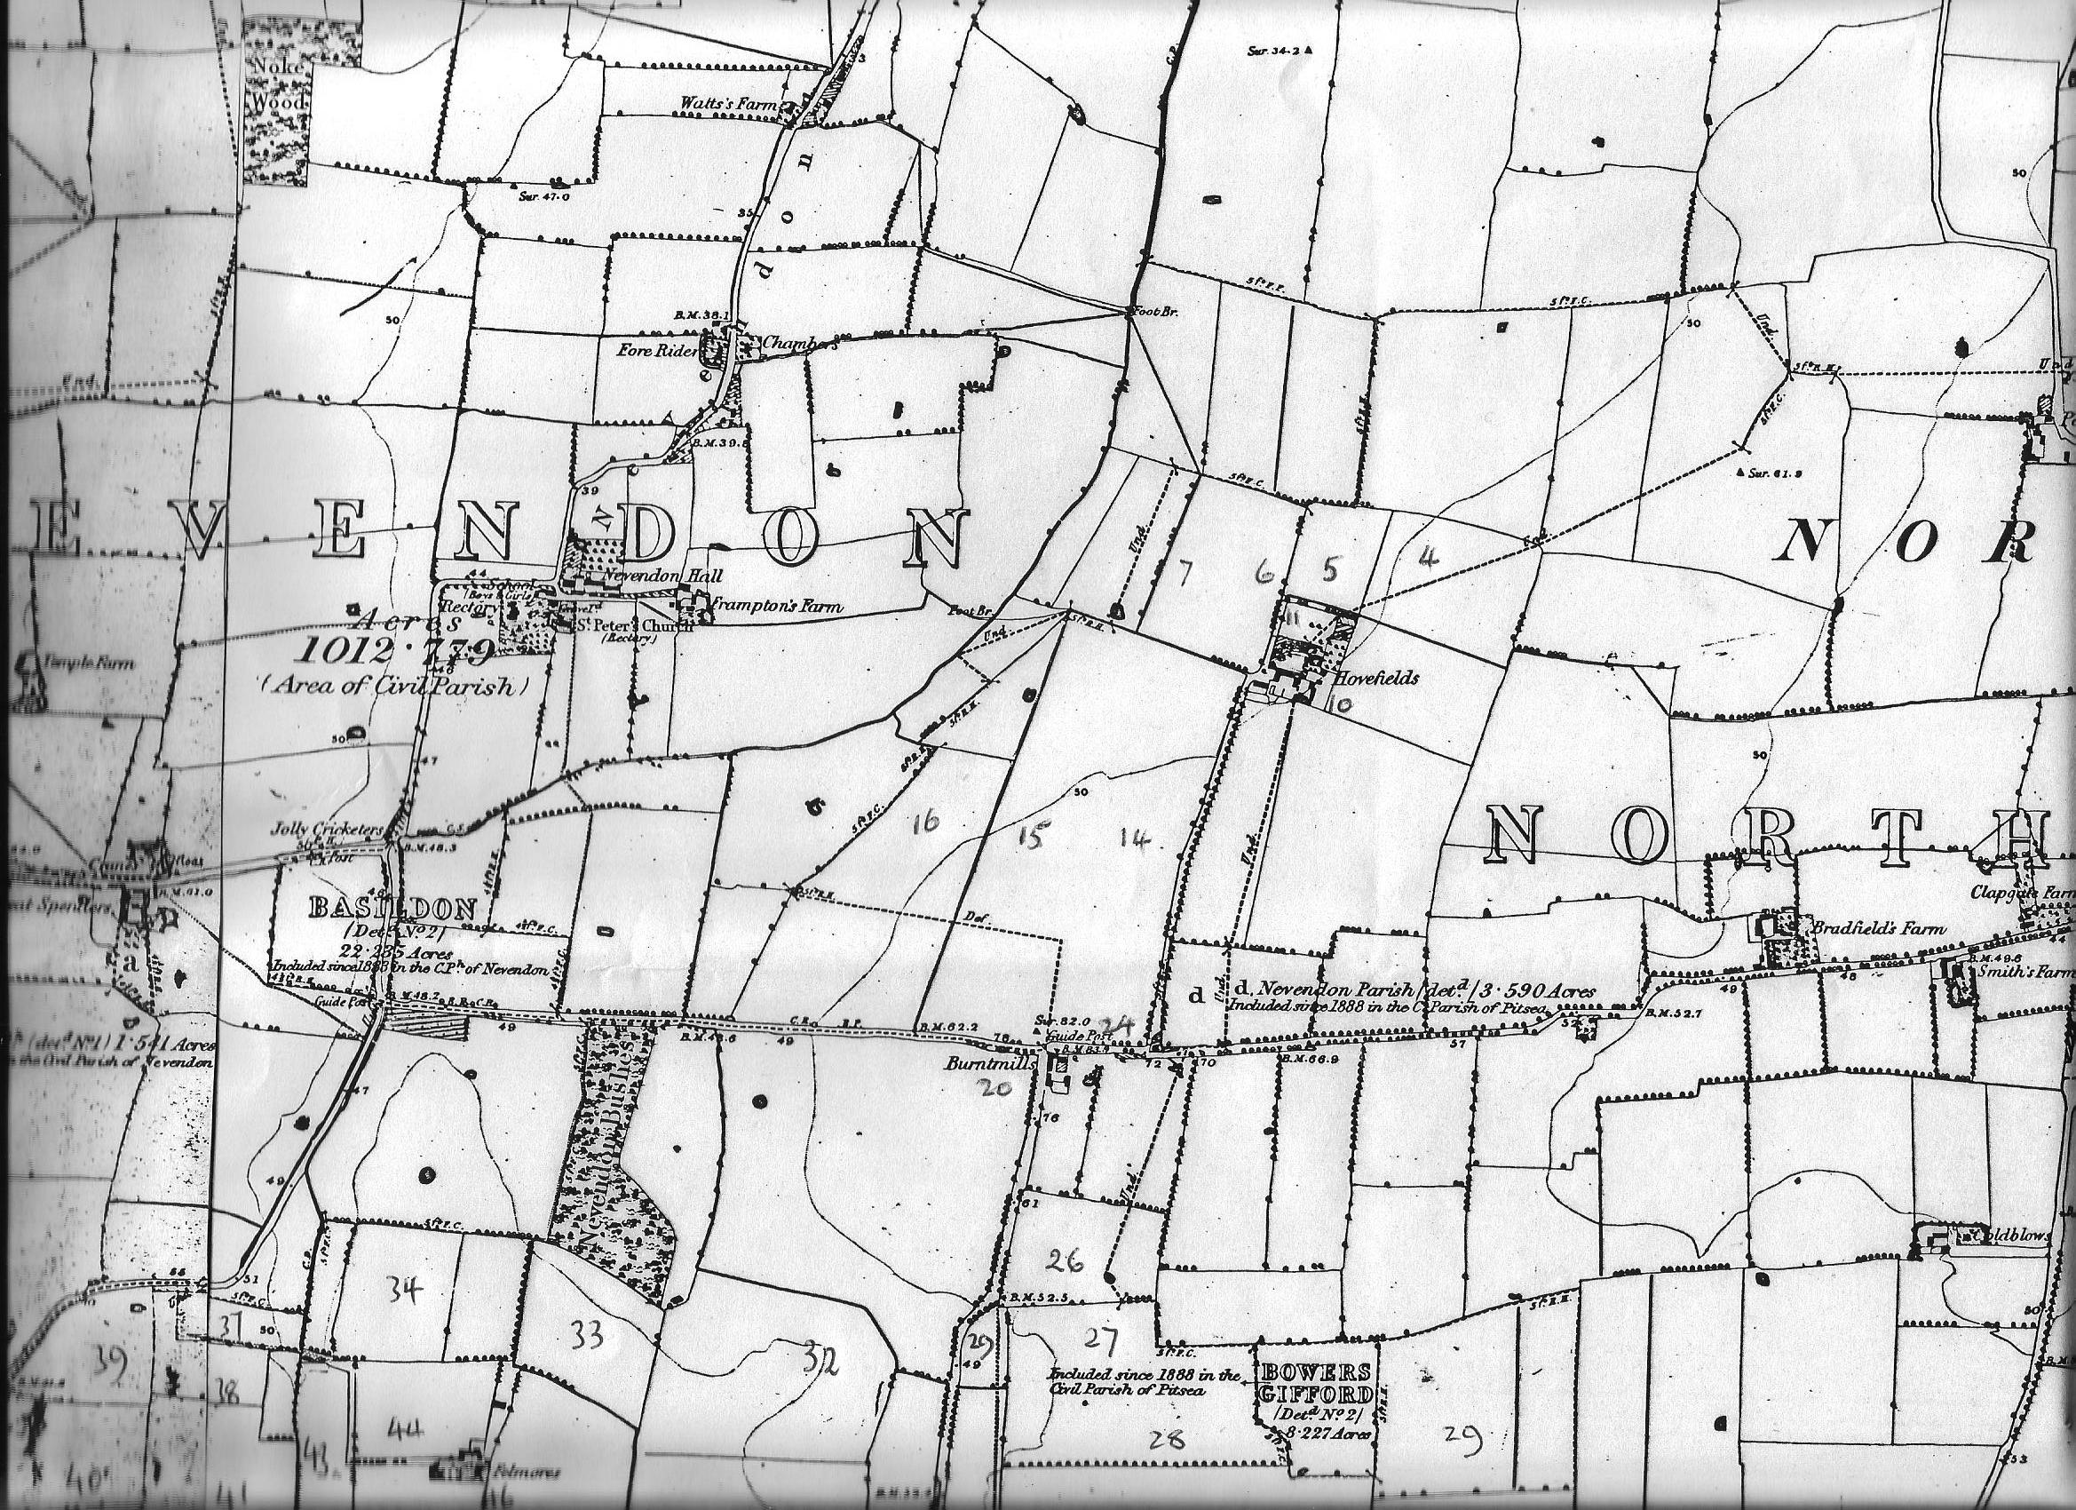
Map 1.
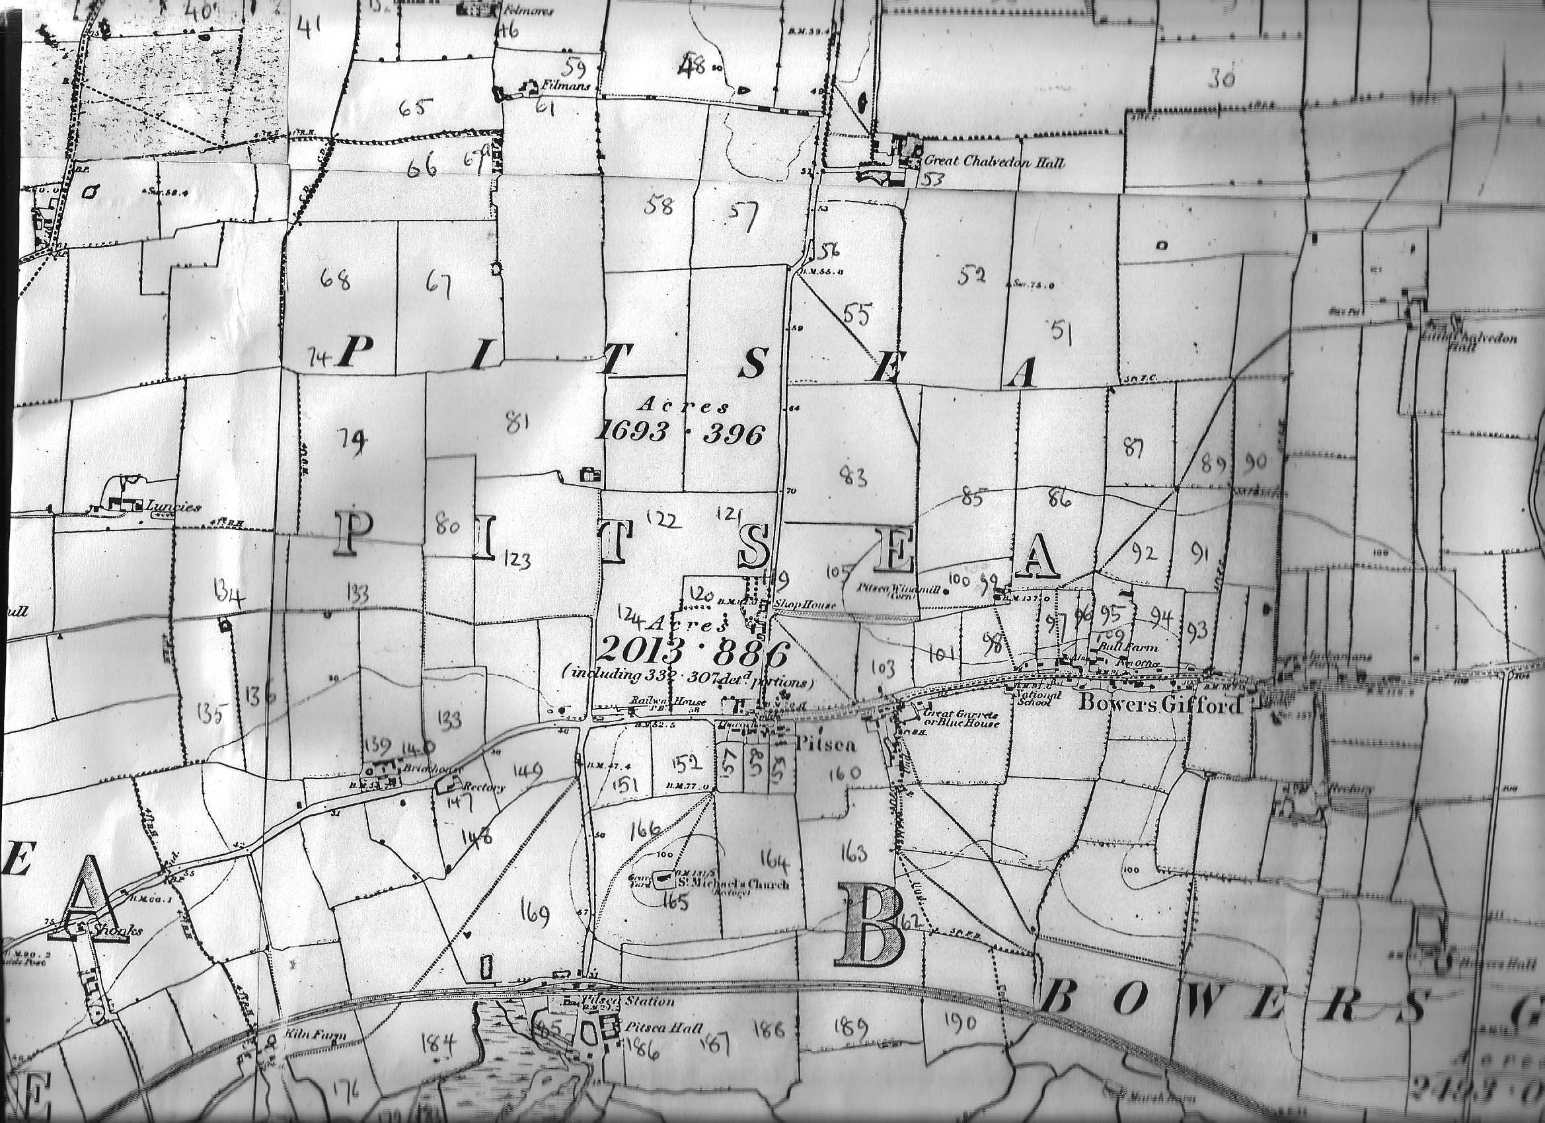
Map 2.
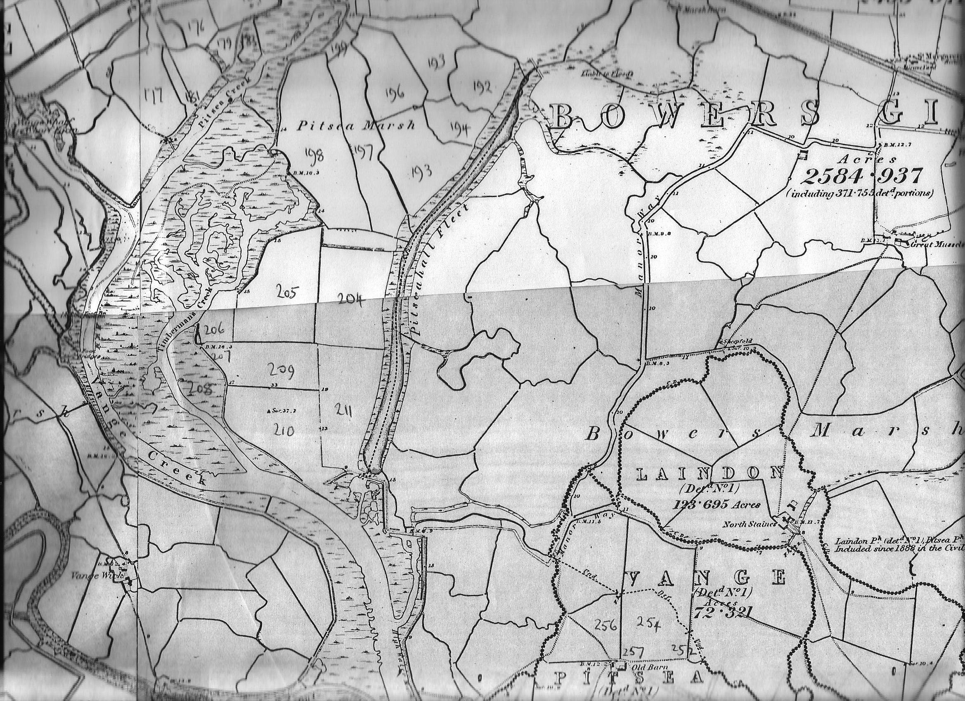
Map 3.
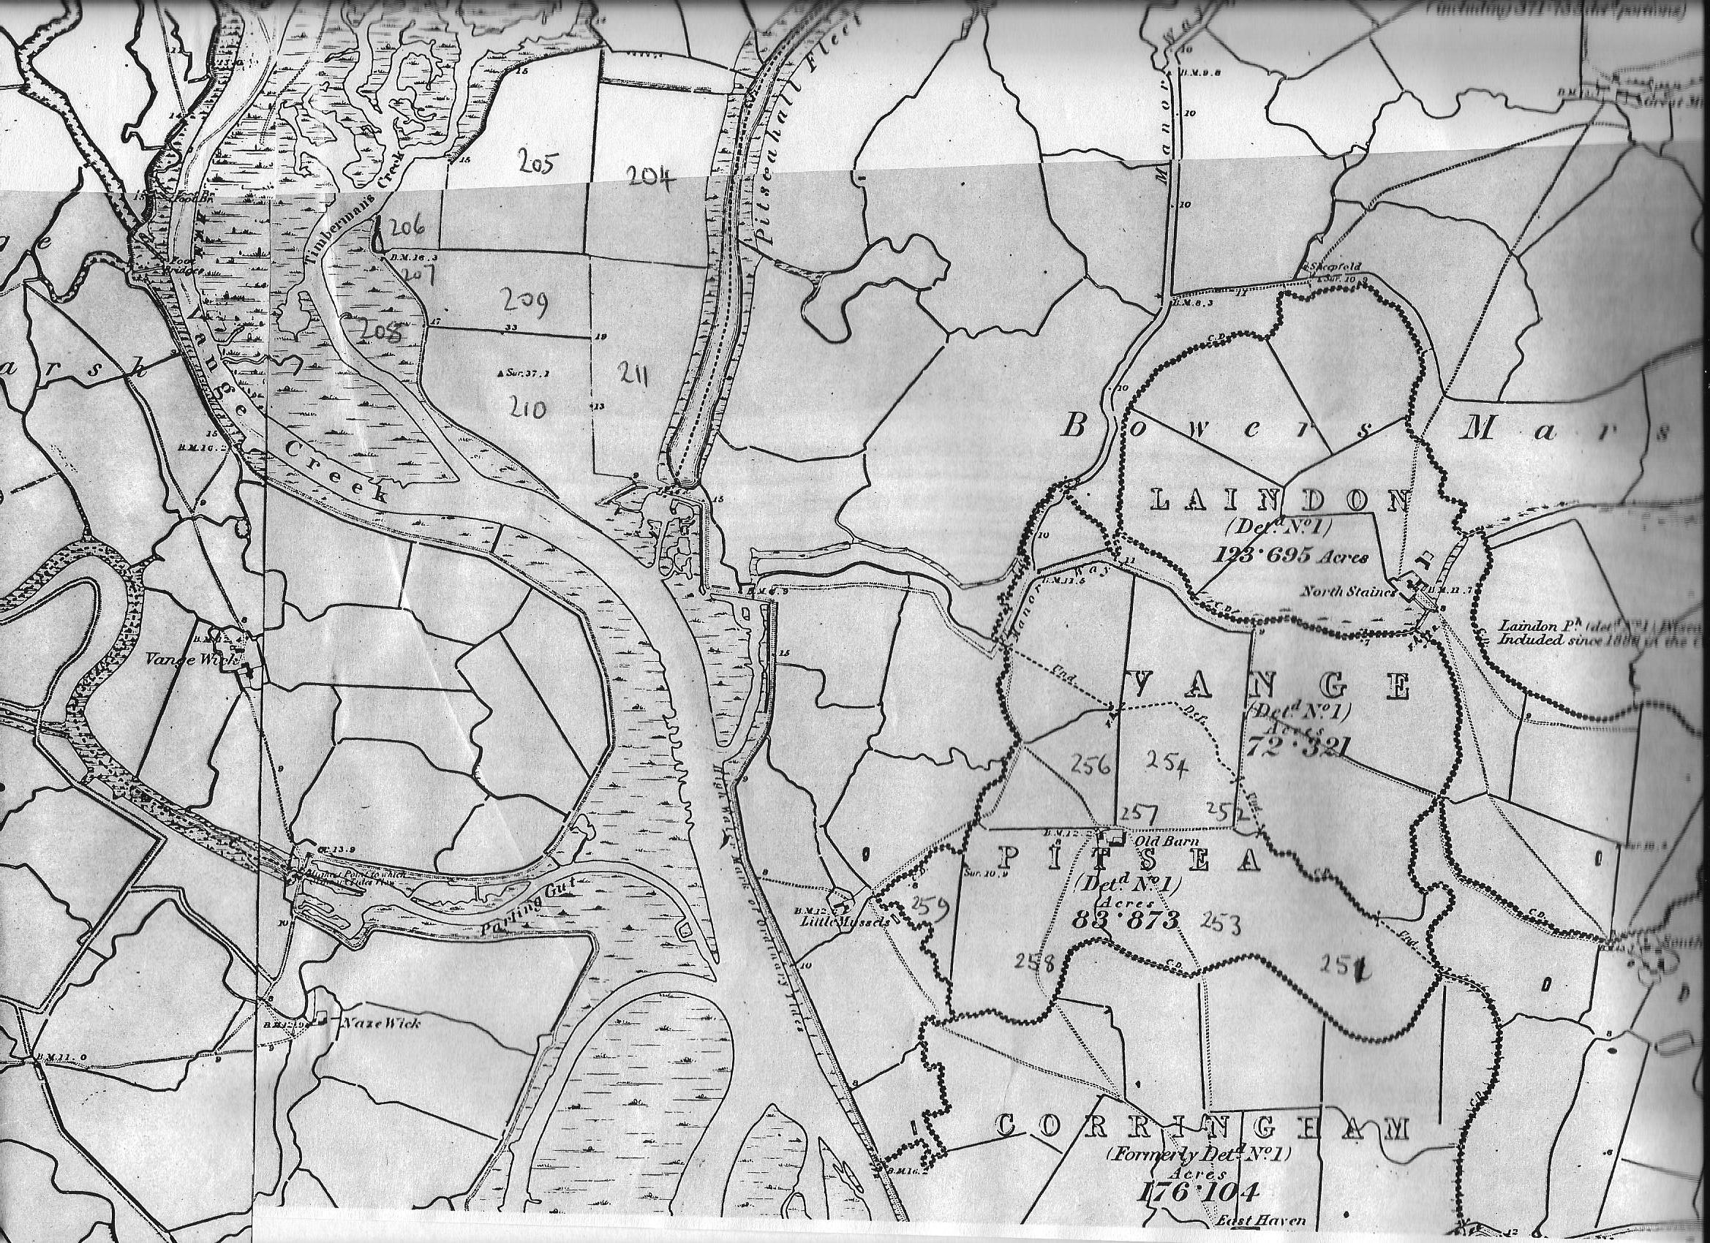
Map 4.
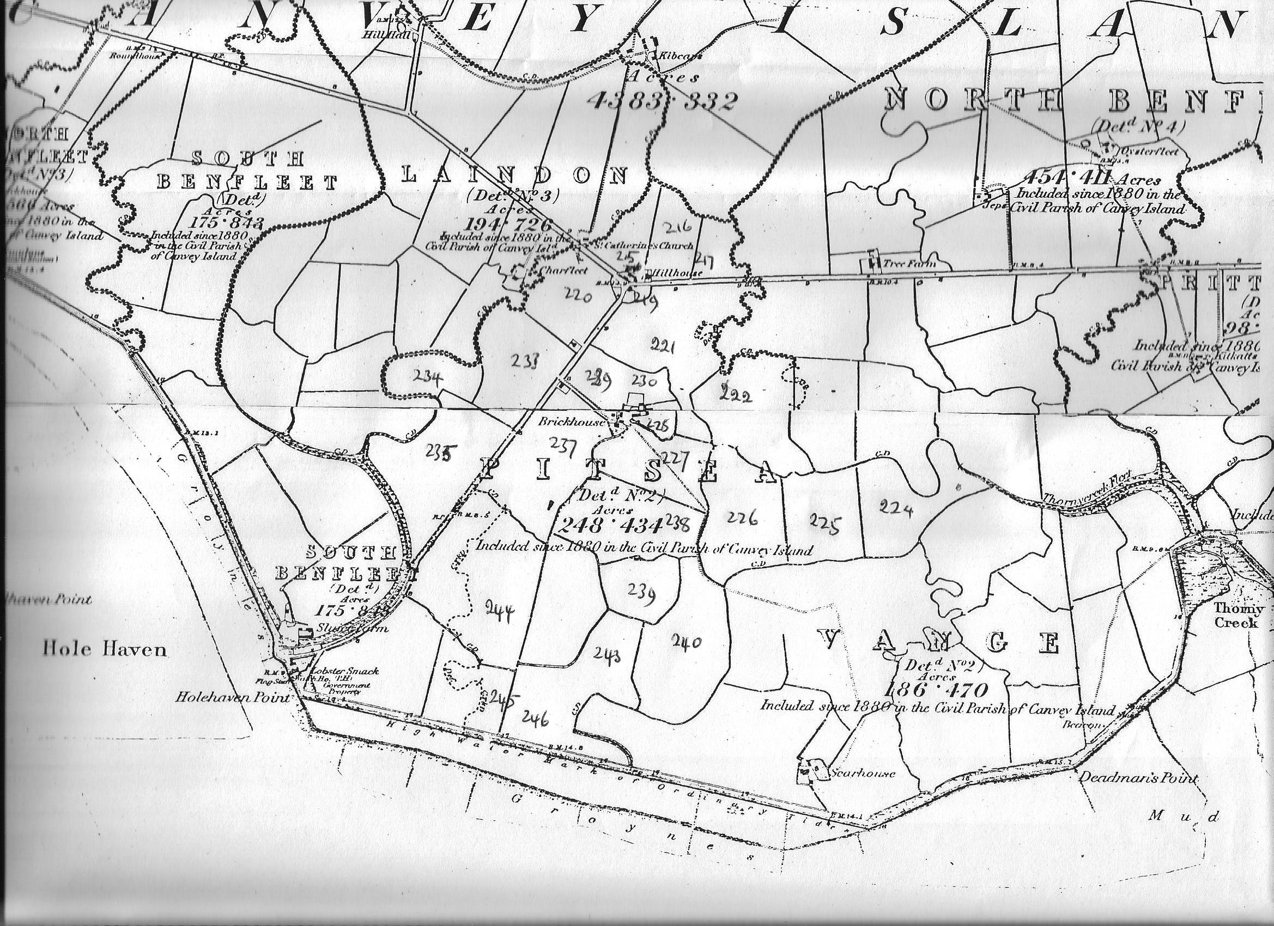
R. Thames
Map 5.

