THE PLACE-NAMES

OF PLESHEY

Recorder: James Kemble

Essex Place-names Project (Essex Society for Archaeology & History)

Essex Record Office e-book, 2010, (1st edition hard copy 2005).

www.essex.ac.uk/history/esah/essexplacenames

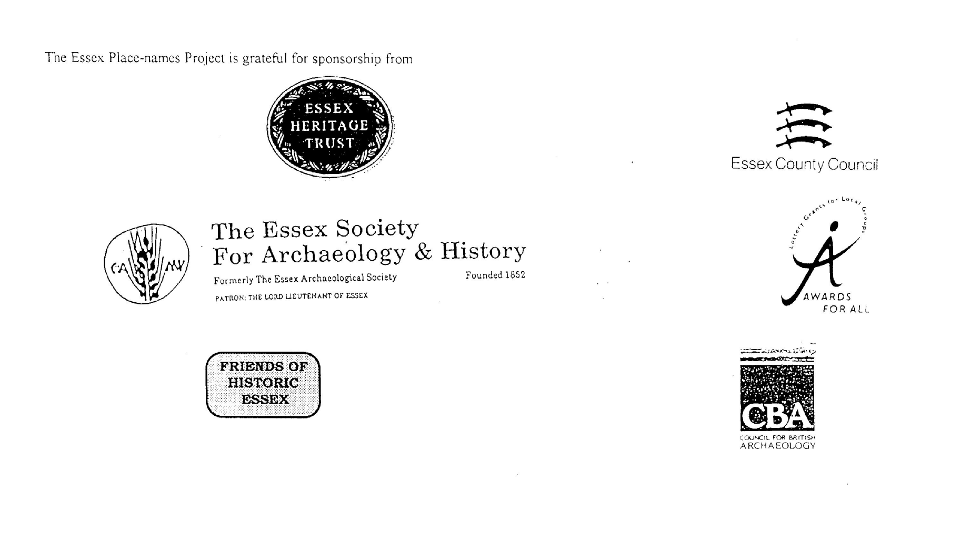

ESSEX PLACE-NAMES PROJECT.

The Essex Place-names Project is a County-wide survey to record place- and field-names from historical documents such as Tithe maps and apportionments, estate maps, sale and auction catalogues, conveyances, terriers, deeds, rolls, inquisitions and surveys.

The second element of the Project is to investigate on-the-ground visible remains which correspond to the Place-names for actual or potential archaeological, agricultural and industrial
sites, and to record natural (topographical) and man-made features which may relate to the Place-name. This involves field-survey in rural and outside investigation in built-up areas.

It is anticipated that the Project will lead to identification of archaeological sites and lost historic buildings; it will enable analysis of indicators of early settlement, land holding, agricultural and industrial practices of the County. It will refine the more precise meaning of descriptive words and elements used by earlier settlers as they gave names appropriate to the topography of the landscape of their time.

For convenience the surveys are based on the parish, recognising that present civil parish boundaries are not necessarily identical to former ecclesiastical boundaries. Local Recorders
are supplied with templates of Record Forms to ensure consistency of recording across the County, and forward completed forms to a Central Coordinator for transfer to a county
computer database which is available at the Essex Record Office to researchers.

This publication presents part of the information recorded from the Tithe or Estate Award and Map, (and from other documents for this parish.) The full record is contained on the master database in the Essex Record Office, Wharf Road, Chelmsford CM2 6YT and the website www.essex.ac.uk/history/esah/essexplacenames. Parish books are available from the ERO on disc or in hard copy or may be downloaded from the website. Please notify errors to the Project Coordinator at the Essex Record Office.

THE TITHE MAP AND APPORTIONMENT.

Since medieval times a tenth of the produce of land and stock had been paid by landholders to the church. At the Dissolution of the Monasteries, the property of many religious houses,
including the right to collect tithes, passed into lay hands. The Tithe Commutation Act which received Royal assent on 13th August 1836 abolished a rent payable in kind and
substituted rent-charges apportioned on each plot or parcel. The tithe-rent payable was assessed on the average value of wheat, barley and oats and was to fluctuate with price movements.

The commutation could be by voluntary agreement between the local owners and payers or, if agreement failed, could be compulsorily imposed by commissioners. A Valuer was to be
appointed to apportion the rent of each parcel of land and tenants could deduct that rent-charge from their rent paid to the landlord. The task fell to the Tithe Commissioners to produce a map and an Apportionment (Award). A large-scale survey was produced for over 70% of England and Wales in the following 9 years, and about another 8% up to 1855. Most of the
parishes in Essex were surveyed. The map scales vary. The Award records ownership, tenancy and land-use, field by field and parcel by parcel (often quoting the field name) with the
ground area and rent-charge.

Land that was tithe-free tends to be less accurately mapped and contains few if any of the details recorded for those parcels subject to tithe. Rights of way and roads also tend to be
neglected. Boundaries of the tithe areas are shown as are some natural features such as streams, ponds, gardens, greens and commons. Buildings are often shown coloured red if dwellings or grey if not. Because the Award may have been agreed only some time after the map was finished, discrepancies occur between the two. Enclosure Awards, when extant, usually date to the 18th and early 19th centuries. J.Kemble.
Reproduced by permission
of Essex County Council.

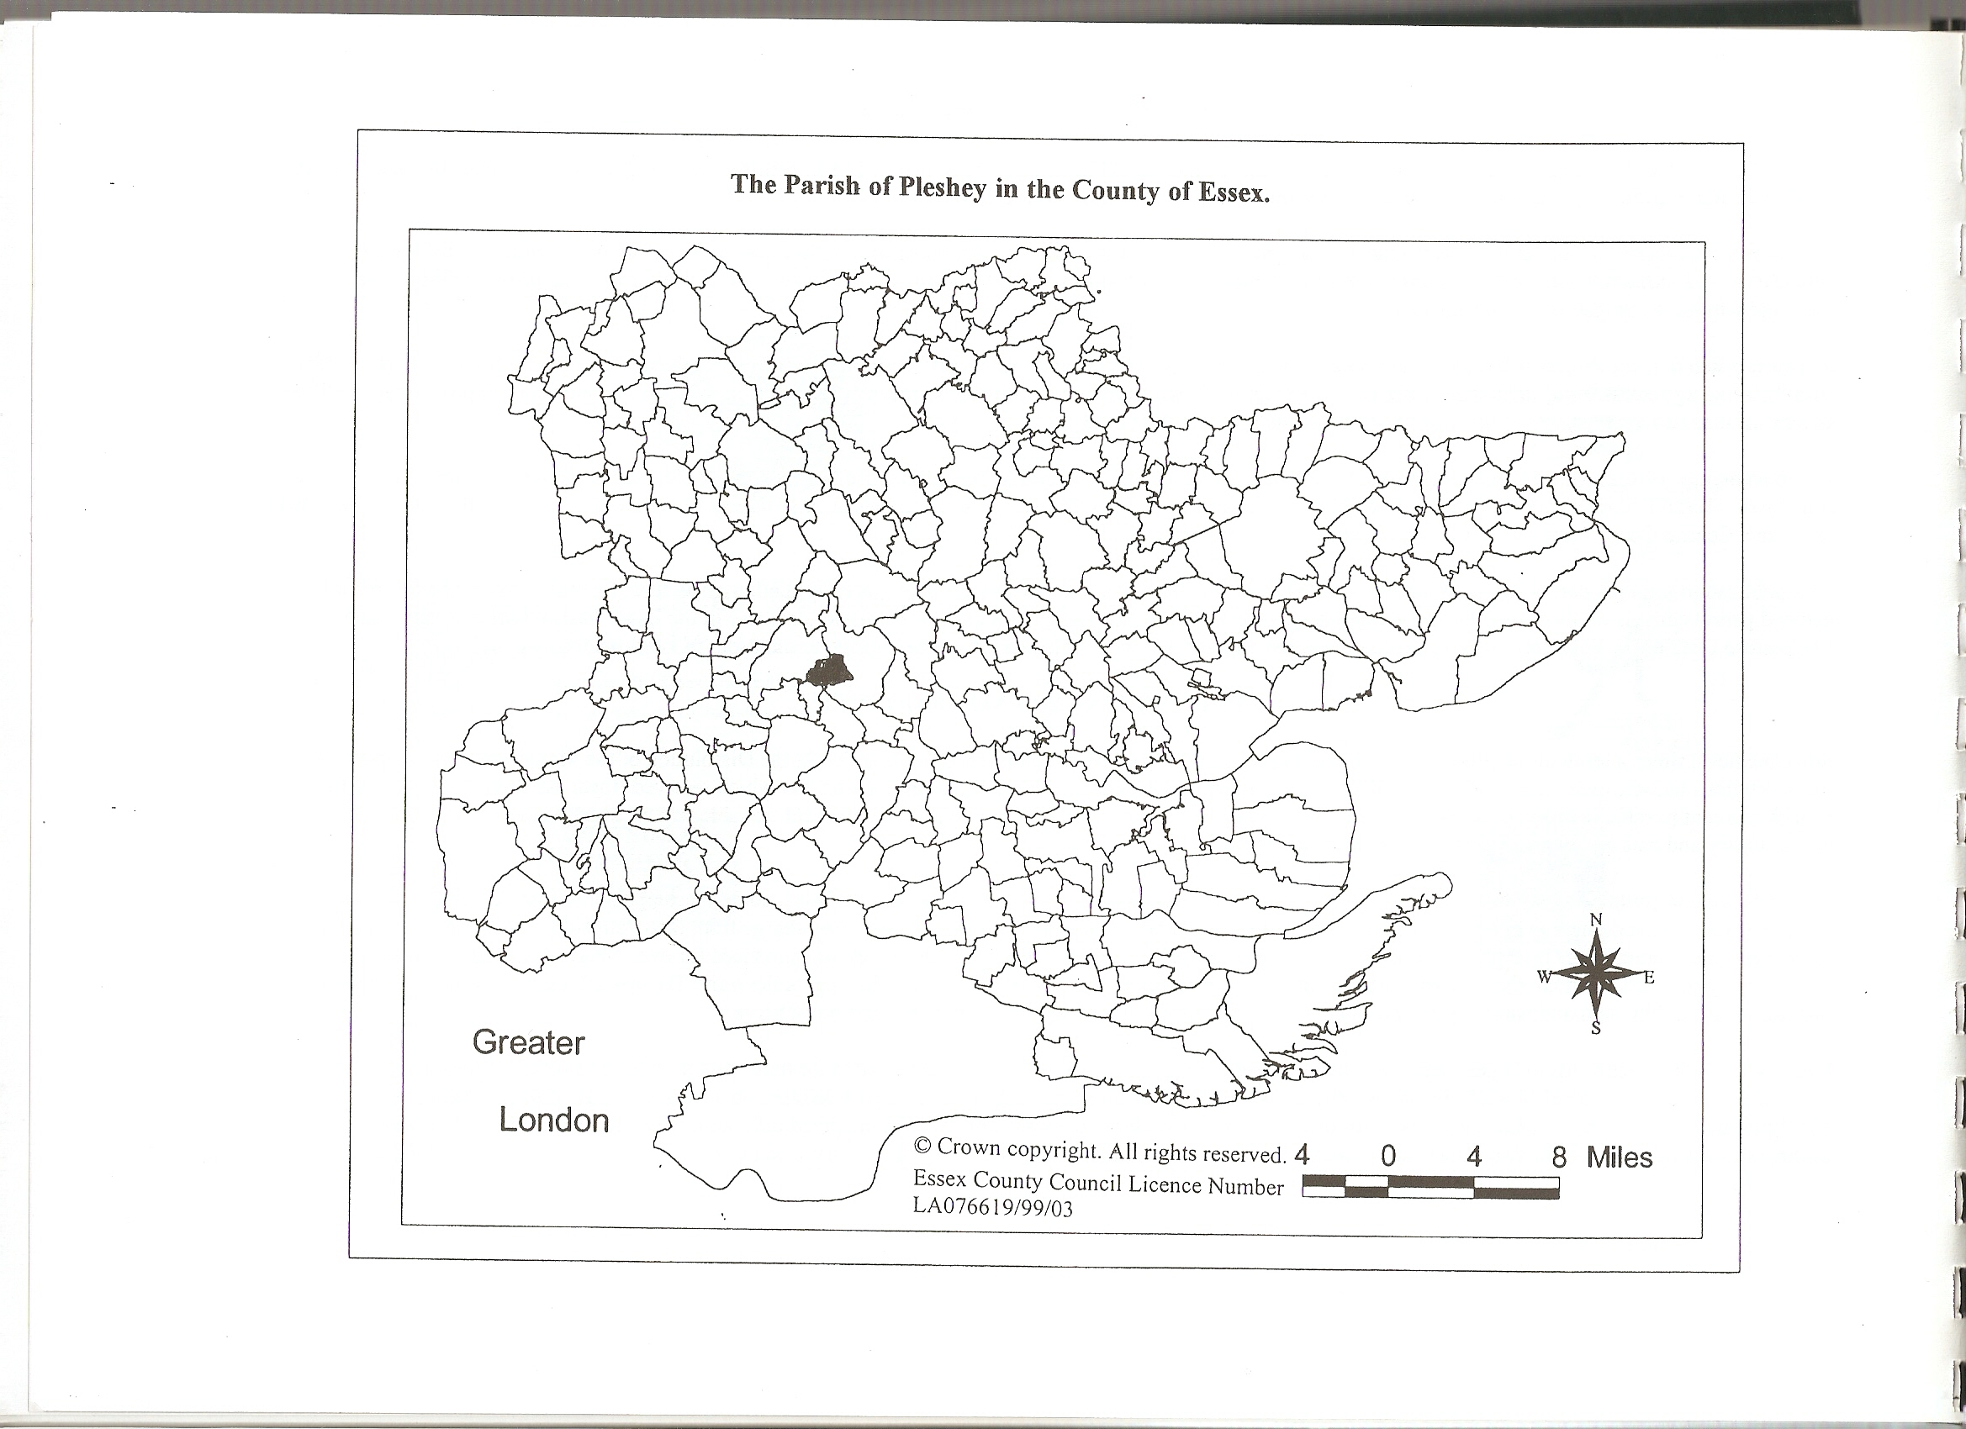

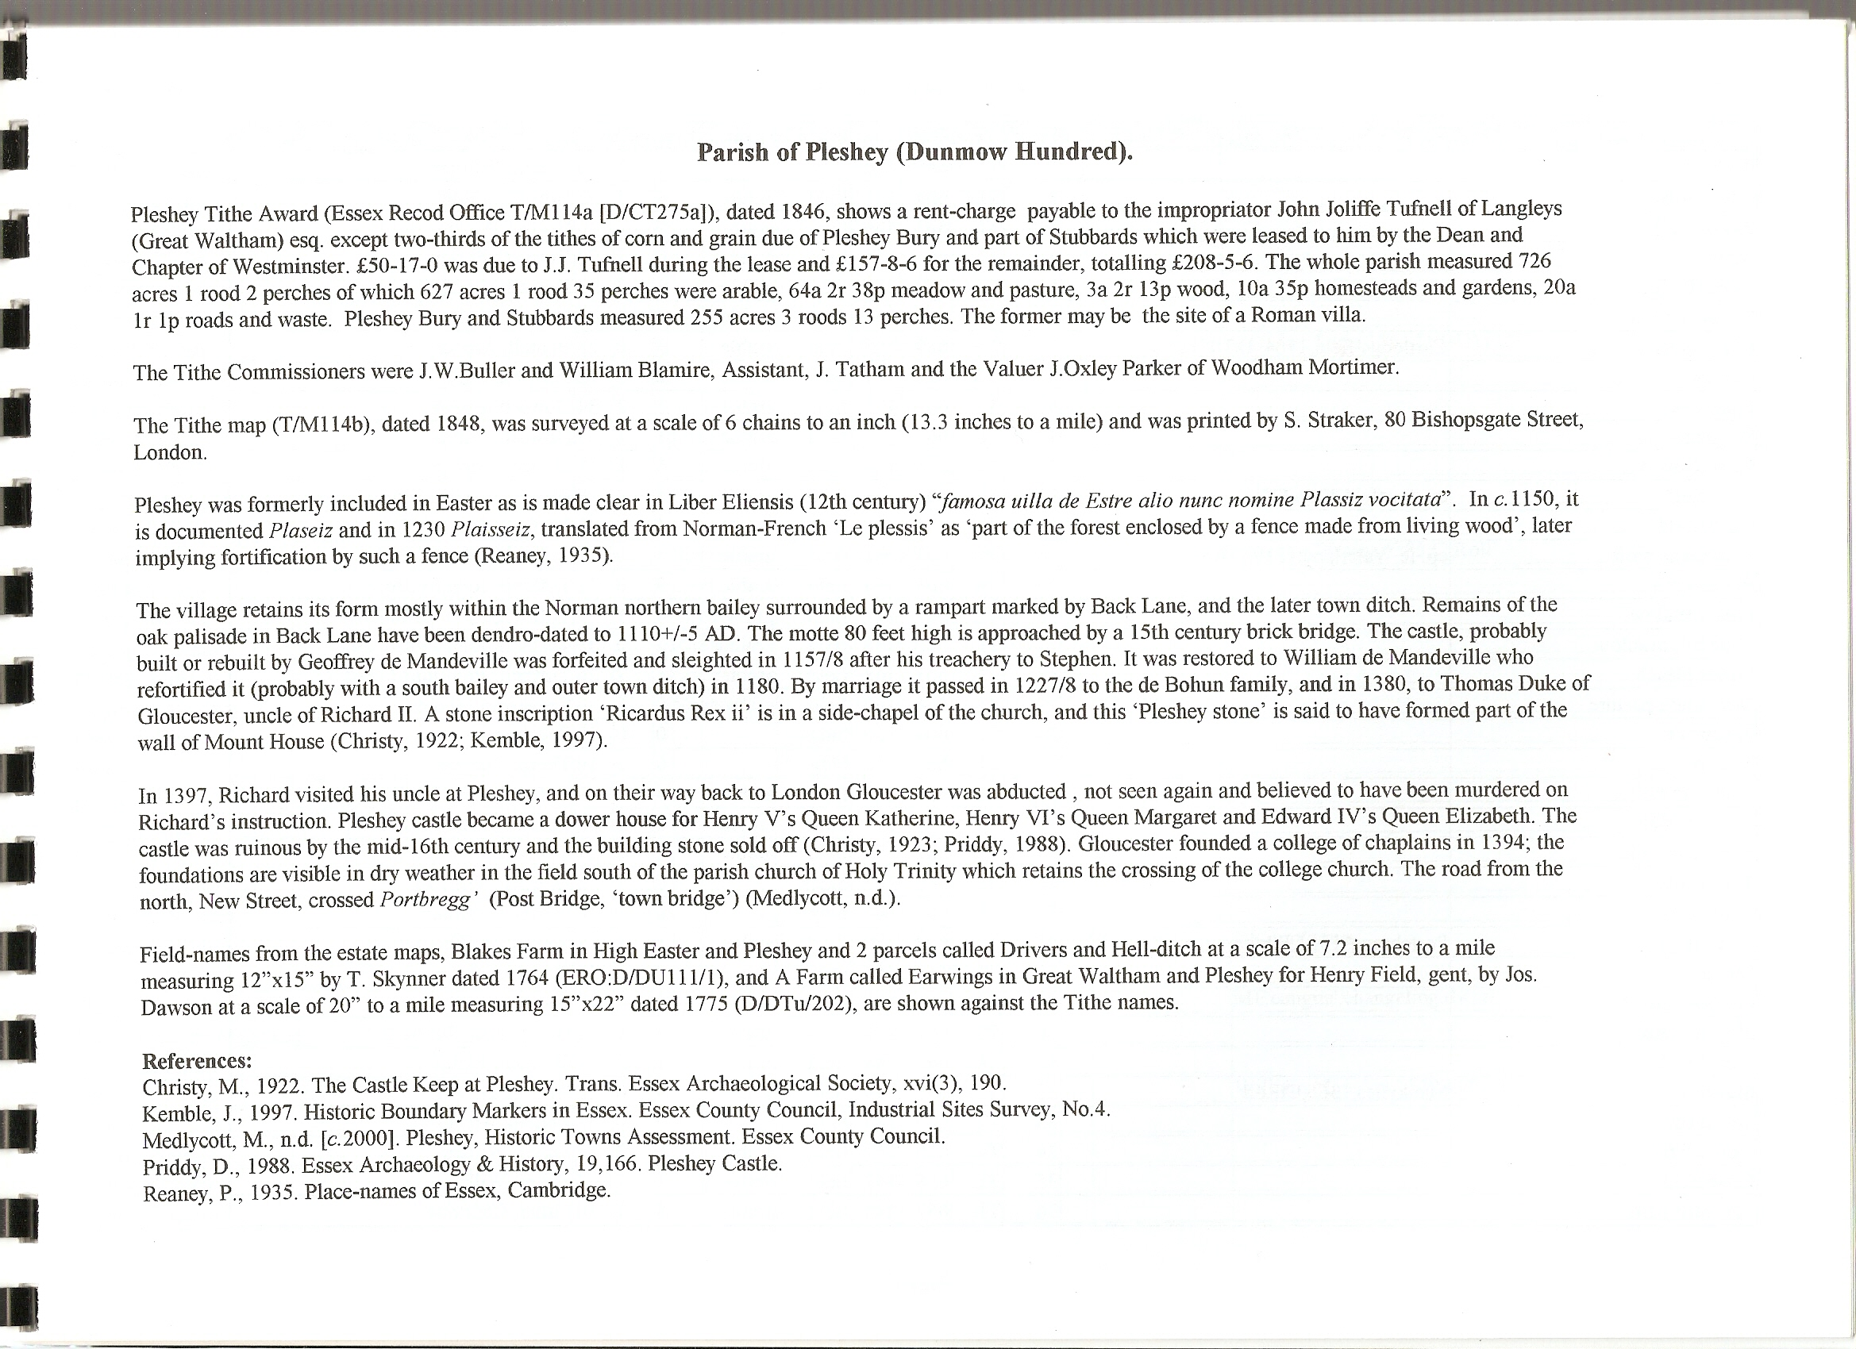

The Tithe Award Place-names of Pleshey – by Parcel No.

Place-name | Alias | Fld No | Gd Ref | x | y | Acr | rd | pch | Land use | Owner | Occupier | Other information
Orchard (pt) |  | 1 | TL | 665 | 156 | 0 | 1 | 36 |  | Everitt, William | Everitt, William
Little Downs |  | 2 | TL | 664 | 155 | 4 | 2 | 37 | arble | Dowsett, Philip | Dowsett, Philip
Pasture (pt) |  | 3 | TL | 663 | 155 | 0 | 2 | 0 | grass | Bentall, Archer | Bentall, Archer
No name |  | 4 | TL | 663 | 155 | 0 | 2 | 32 | grass | Dowsett, Philip | Dowsett, Philip
Upper Padgeons |  | 5 | TL | 662 | 155 | 5 | 0 | 4 | arble | Dowsett, Philip | Dowsett, Philip
Upper Groves |  | 6 | TL | 660 | 155 | 4 | 2 | 35 | arble | Dowsett, Philip | Dowsett, Philip
Charters field | Cartlodge field,1764, D/DU 111/1 | 7 | TL | 659 | 155 | 3 | 0 | 25 | arble | Bentall, Archer | Bentall, Archer | of Blakes Farm,1764,  D/DU 111/1
Groves |  | 8 | TL | 661 | 154 | 2 | 1 | 12 | arble | Dowsett, Philip | Dowsett, Philip
Padgeons |  | 9 | TL | 662 | 153 | 8 | 2 | 34 | arble | Dowsett, Philip | Dowsett, Philip
Padgeons |  | 10 | TL | 663 | 151 | 1 | 1 | 27 | arble | Dowsett, Philip | Dowsett, Philip
Great Downs |  | 11 | TL | 663 | 154 | 6 | 1 | 39 | arble | Dowsett, Philip | Dowsett, Philip
Townfield | cp. Portfeld,1394,CtRoll | 12 | TL | 664 | 154 | 4 | 3 | 8 | arble | Pleshey, parishoners of | Rayment, John Leigh | OE'port',town
Chalk field |  | 13 | TL | 664 | 151 | 4 | 2 | 30 | arble | Tuffnell, John Joliffe, esq | Young, William
Water lane croft | cp. le Waterlane, 1519,CtRoll | 14 | TL | 663 | 151 | 3 | 0 | 12 | arble | Tuffnell, John Joliffe, esq | Young, William | John atte Watere,1385,CtRoll
Rooters hill |  | 15 | TL | 668 | 148 | 9 | 0 | 11 | arble | Tuffnell, John Joliffe, esq | Young, William
Long meadow |  | 16 | TL | 667 | 147 | 4 | 1 | 0 | grass | Tuffnell, John Joliffe, esq | Young, William
Mole hill meadow |  | 17 | TL | 666 | 149 | 2 | 0 | 33 | grass | Tuffnell, John Joliffe, esq | Young, William
Lower pleach |  | 18 | TL | 665 | 148 | 11 | 2 | 26 | arble | Tuffnell, John Joliffe, esq | Young, William
New house pasture |  | 19 | TL | 664 | 150 | 0 | 2 | 0 | grass | Speakman, Thomas | Rayment, William
Tenements |  | 20 | TL | 664 | 150 | 0 | 0 | 18 |  | Speakman | Smith & Everitt
Tenement |  | 21 | TL | 663 | 150 | 0 | 1 | 16 |  | Thorp, Thomas | Hornsby, James
Four acre field |  | 22 | TL | 664 | 149 | 4 | 0 | 18 | arble | Tuffnell, John Joliffe, esq | Young, William
Rainbow field |  | 23 | TL | 663 | 157 | 8 | 2 | 38 | arble | Tuffnell, John Joliffe, esq | Young, William
Eight acre field |  | 24 | TL | 662 | 158 | 7 | 3 | 27 | arble | Tuffnell, John Joliffe, esq | Young, William
Tenements |  | 25 | TL | 660 | 147 | 0 | 1 | 8 |  | Dowsett, William | Dowsett, William
Tenements |  | 26 | TL | 659 | 146 | 0 | 0 | 10 |  | Dowsett, William | Dowsett, William
Post bridge | Portebregg',1351; Purtebregge,1404,CtRl | 27 | TL | 662 | 150 | 1 | 3 | 8 | arble | Speakman, Thomas | Rayment, William | OE'port',town
Chase |  | 28 | TL | 662 | 150 | 0 | 0 | 13 |  | Dowsett, Philip | Dowsett, Philip
Congous grove |  | 29 | TL | 661 | 150 | 2 | 0 | 15 | arble | Speakman, Thomas | Rayment, William | ME 'cangun', changeling,dwarf
Millers Bleach |  | 30 | TL | 661 | 149 | 4 | 1 | 2 | arble | Hutchinson, Rev James | Rayment, John Leigh esq
Bays Croft |  | 31 | TL | 660 | 148 | 2 | 2 | 16 | arble | Dowsett, Philip | Dowsett, Philip
Mankins | Mankynes,1366,CtRoll | 32 | TL | 659 | 145 | 6 | 0 | 27 | arble | Bentall, Archer | Bentall, Archer | William Manekin,1249,CtRoll
Tenements |  | 33 | TL | 660 | 146 | 0 | 0 | 31 |  | Bentall, Archer | Sewell, Thomas
Ladies field |  | 34 | TL | 655 | 147 | 5 | 2 | 32 | arble | Fuller, William | Fuller, William
Little field |  | 35 | TL | 658 | 147 | 1 | 1 | 4 | arble | Fuller, William | Fuller, William
Tile barn field |  | 36 | TL | 657 | 148 | 8 | 1 | 30 | arble | Fuller, Charlotte | Fuller, William
Little Hook field |  | 37 | TL | 656 | 149 | 3 | 2 | 5 | arble | Fuller, Charlotte | Fuller, William | OE 'hoc', spur,promontory
Six acre field (pt) |  | 38 | TL | 657 | 150 | 4 | 3 | 6 | arble | Fuller, Charlotte | Fuller, William
Burnt house field (pt) | Old House,1777,C&A | 39 | TL | 657 | 151 | 0 | 3 | 24 | arble | Rayment, John Leigh | Rayment, John Leigh
Middle Burnt House field |  | 40 | TL | 657 | 152 | 2 | 2 | 2 | arble | Rayment, John Leigh | Rayment, John Leigh
Upper Burnt house field |  | 41 | TL | 658 | 153 | 3 | 0 | 27 | arble | Rayment, John Leigh | Rayment, John Leigh
Cowlins |  | 42 | TL | 657 | 153 | 3 | 1 | 34 | arble | Fuller, Charlotte | Fuller, William
Blacklands |  | 43 | TL | 656 | 153 | 6 | 0 | 20 | arble | Fuller, Charlotte | Fuller, William
Woods pasture |  | 44 | TL | 656 | 152 | 1 | 3 | 6 | past | Fuller, Charlotte | Fuller, William
Homestall, Woods | Old Aldens,1777,C&A | 45 | TL | 656 | 151 | 1 | 0 | 10 |  | Fuller, Charlotte | Fuller, William
Kitchen field |  | 46 | TL | 656 | 150 | 2 | 0 | 3 | arble | Fuller, Charlotte | Fuller, William
Black land (pt) |  | 47 | TL | 655 | 150 | 4 | 3 | 16 | arble | Tuffnell, John Joliffe, esq | Joslin, Joseph
Tile barn field |  | 48 | TL | 653 | 147 | 9 | 2 | 26 | arble | Fuller, Charlotte | Fuller, William
Penny Common |  | 49 | TL | 649 | 145 | 4 | 3 | 6 | arble | Tuffnell, John Joliffe, esq | Fuller, William
Perry Common |  | 50 | TL | 650 | 145 | 1 | 0 | 20 | arble | Tuffnell, John Joliffe, esq | Fuller, William
Pleshey field (pt) |  | 51 | TL | 650 | 145 | 3 | 1 | 17 | arble | Walmsley, Richard esq | Rayment, John Leigh
Fourteen acre field |  | 52 | TL | 652 | 145 | 17 | 3 | 4 | arble | Tuffnell, John Joliffe, esq | Fuller, William
Six acre field |  | 53 | TL | 655 | 146 | 6 | 3 | 24 | arble | Tuffnell, John Joliffe, esq | Fuller, William
Tile barn wood |  | 54 | TL | 656 | 147 | 1 | 0 | 18 | wood | Fuller, Charlotte | Fuller, William
Lower Tile barn field |  | 55 | TL | 657 | 147 | 1 | 1 | 12 | arble | Fuller, Charlotte | Fuller, William
Slate field |  | 56 | TL | 655 | 145 | 23 | 1 | 29 | gr/ar | Tuffnell, John Joliffe, esq | Fuller, William
Ladies Tile | ladystyll,-style,1517,CtRoll | 57 | TL | 659 | 146 | 5 | 0 | 2 | arble | Tuffnell, John Joliffe, esq | Young, William
Pound field |  | 58 | TL | 658 | 145 | 9 | 3 | 33 | arble | Tuffnell, John Joliffe, esq | Fuller, William
Pound field |  | 59 | TL | 660 | 145 | 10 | 0 | 6 | arble | Tuffnell, John Joliffe, esq | Young, William
Pleach field |  | 60 | TL | 662 | 145 | 18 | 1 | 26 | arble | Tuffnell, John Joliffe, esq | Young, William
White Horse Inn |  | 61 | TL | 664 | 144 | 0 | 1 | 4 |  | Whatney, Thomas esq | Everitt, William
Tenements |  | 62 | TL | 664 | 144 | 0 | 0 | 27 |  | Dowsett, Philip | Swallow
Tenements |  | 63 | TL | 664 | 144 | 0 | 1 | 2 |  | Purfett, william | Brewster & Brewster
Tenements |  | 64 | TL | 664 | 144 | 0 | 0 | 23 |  | Young, William | Crabb & Pitts
Church lands |  | 65 | TL | 664 | 145 | 1 | 1 | 34 | arble | Hutchinson, Rev James | Rayment, John Leigh esq
Barn & yard |  | 66 | TL | 664 | 145 | 0 | 0 | 30 |  | Hutchinson, Rev James | Rayment, John Leigh esq
Old Church yard |  | 67 | TL | 665 | 145 | 2 | 0 | 10 | grass | Tuffnell, John Joliffe, esq | Young, William
Homestall yards, garden |  | 68 | TL | 665 | 145 | 1 | 3 | 22 |  | Tuffnell, John Joliffe, esq | Young, William
Tenement |  | 69 | TL | 665 | 145 | 0 | 0 | 26 |  | Fuller, John | Cannon, Bligh
Tenement |  | 70 | TL | 665 | 145 | 0 | 0 | 19 |  | Fuller, John | Fuller, John
Garden |  | 71 | TL | 665 | 145 | 0 | 0 | 30 |  | Tufnell, J.Joliffe esq | Ketley, Thomas
Tenements |  | 72 | TL | 665 | 145 | 0 | 0 | 34 |  | Everitt, George | Everitt, George
Garden |  | 73 | TL | 665 | 145 | 0 | 0 | 22 |  | Tufnell, J.Joliffe esq | Cannon, Bligh
Tenement |  | 74 | TL | 665 | 145 | 0 | 1 | 20 |  | Young, William | Cannon, Daniel
Tenement |  | 75 | TL | 665 | 145 | 0 | 0 | 31 |  | .. | ..
Tenement |  | 76 | TL | 665 | 146 | 0 | 0 | 13 |  | Rayment, John Leigh | Everitt, Thomas
Orchard |  | 77 | TL | 665 | 146 | 0 | 1 | 8 |  | Everitt, William | Everitt, William
Tenement |  | 78 | TL | 665 | 146 | 0 | 0 | 15 |  | Dowsett, James | Hasler, widow
Orchard |  | 79 | TL | 665 | 146 | 0 | 3 | 17 |  | Speakman, Thomas | Rayment, William
Pippin hall |  | 80 | TL | 664 | 146 | 1 | 1 | 3 | arble | Speakman, Thomas | Rayment, William
Orchard |  | 81 | TL | 665 | 146 | 0 | 1 | 22 |  | Speakman, Thomas | Rayment, William
Tenements |  | 82 | TL | 665 | 146 | 0 | 0 | 35 |  | Speakman, Thomas | Cannon & Feast
House etc |  | 83 | TL | 665 | 146 | 0 | 1 | 25 |  | Tufnell, J.Joliffe esq | Hutchinson, Rev James
Rumballs garden | Rumboldes,1395,CtRoll | 84 | TL | 666 | 146 | 1 | 2 | 21 | arble | Tuffnell, John Joliffe, esq | Young, William
Woolmans |  | 85 | TL | 666 | 146 | 4 | 0 | 13 | arble | Rayment, William | Rayment, William
Old Orchard |  | 86 | TL | 667 | 145 | 1 | 0 | 24 | grass | Tuffnell, John Joliffe, esq | Young, William
Garden |  | 87 | TL | 667 | 145 | 0 | 0 | 8 |  | Cannon, Daniel | Cannon, daniel
Tenements |  | 88 | TL | 667 | 145 | 0 | 0 | 21 |  | Kemp, Samuel | Portway, abraham
Garden |  | 89 | TL | 667 | 145 | 0 | 1 | 4 |  | Everett, George | Everett, George
Tenements |  | 90 | TL | 667 | 145 | 0 | 0 | 20 |  | Owers, John | Owers, John
Tenement |  | 91 | TL | 667 | 145 | 0 | 0 | 10 |  | Hasler, John | Fuller, Martha
Homestall |  | 92 | TL | 667 | 145 | 0 | 1 | 36 |  | Rayment, William | Rayment, William
Garden |  | 93 | TL | 667 | 145 | 0 | 0 | 20 |  | Parishoners | Rayment, William
Tenements |  | 94 | TL | 667 | 145 | 0 | 1 | 27 |  | Clapham, Dixon | Stock & Bush
Tenement |  | 95 | TL | 667 | 145 | 0 | 0 | 10 |  | Fuller, William | Clark, James
Pleshey pasture |  | 96 | TL | 667 | 145 | 1 | 2 | 0 | grass | Fuller, William | Fuller, William
Homestall, yards,gardens |  | 97 | TL | 667 | 145 | 0 | 3 | 17 |  | Rayment, John Leigh | Rayment, John Leigh
Pasture |  | 98 | TL | 667 | 145 | 0 | 3 | 16 | grass | Rayment, John Leigh | Rayment, John Leigh
Pasture |  | 99 | TL | 667 | 145 | 4 | 0 | 24 | grass | Tuffnell, John Joliffe, esq | Young, William
Tenement |  | 100 | TL | 666 | 145 | 0 | 0 | 8 |  | Rayment, John Leigh | Pitts, widow
Tenements |  | 101 | TL | 666 | 145 | 0 | 1 | 9 |  | Young, William | Reeve & Cannon
Tenements |  | 102 | TL | 666 | 145 | 0 | 0 | 10 |  | Dowsett, James | Reeve & Lenham
Tenement |  | 103 | TL | 666 | 145 | 0 | 0 | 17 |  | Hasler, William | Sewell
Tenement |  | 104 | TL | 666 | 145 | 0 | 0 | 24 |  | Hasler | Clark & Ketley
Tenement |  | 105 | TL | 666 | 145 | 0 | 0 | 13 |  | Tufnell, J.Joliffe esq | Cannon, George
Orchard, garden |  | 106 | TL | 666 | 145 | 0 | 1 | 16 |  | Tufnell, J.Joliffe esq | Everitt, Mrs
Tenement |  | 107 | TL | 666 | 145 | 0 | 0 | 10 |  | Rayment, John Leigh | Ketley & Reve
Tenement |  | 108 | TL | 666 | 145 | 0 | 0 | 17 |  | Fuller, John | Walden, widow
Tenement |  | 109 | TL | 666 | 145 | 0 | 0 | 25 |  | Rayment, Miss | Rayment, Miss
Tenement |  | 110 | TL | 666 | 145 | 0 | 1 | 11 |  | Knight, William | Knight
Tenement |  | 111 | TL | 664 | 144 | 0 | 1 | 22 |  | Tufnell, J.J, lessee | Dean & Chapter of Westminster
Gardens |  | 112 | TL | 664 | 144 | 0 | 3 | 8 |  | Everitt, William | Everitt, William
Tenements |  | 113 | TL | 664 | 144 | 0 | 0 | 25 |  | Young, William | Cannon & Husler
Church yard |  | 114 | TL | 664 | 144 | 0 | 3 | 26 |  | Tufnell, J.Joliffe esq | Hutchinson, Rev James
Church pasture |  | 115 | TL | 664 | 144 | 0 | 3 | 38 | grass | Hutchinson, Rev James | Rayment, John Leigh esq
Queens Orchard |  | 116 | TL | 665 | 144 | 3 | 3 | 27 | grass | Tuffnell, John Joliffe, esq | Young, William
Pleshey mount & moat |  | 117 | TL | 665 | 145 | 7 | 1 | 23 | grass | Tuffnell, John Joliffe, esq | Young, William
Homestall, orchard,  gdn, Lodge Farm | Pleshey Lodge,1777,C&A | 118 | TL | 666 | 144 | 2 | 1 | 0 |  | Tuffnell, John Joliffe, esq | Young, William
Barn pasture |  | 119 | TL | 667 | 144 | 9 | 2 | 0 | grass | Tuffnell, John Joliffe, esq | Young, William
Old croft |  | 120 | TL | 668 | 142 | 9 | 1 | 10 | arble | Tuffnell, John Joliffe, esq | Young, William
New Orchard |  | 121 | TL | 667 | 142 | 5 | 1 | 14 | arble | Tuffnell, John Joliffe, esq | Young, William
Cooks field (pt) |  | 122 | TL | 668 | 140 | 14 | 0 | 24 | arble | Tuffnell, John Joliffe, esq | Young, William
Far ponds |  | 123 | TL | 666 | 138 | 6 | 2 | 14 | arble | Tuffnell, John Joliffe, esq | Young, William
Brick clamps moore |  | 124 | TL | 666 | 140 | 13 | 2 | 23 | arble | Tuffnell, John Joliffe, esq | Young, William
Smiths pasture |  | 125 | TL | 664 | 140 | 2 | 3 | 33 | grass | Tuffnell, John Joliffe, esq | Young, William
Church field |  | 126 | TL | 664 | 141 | 10 | 1 | 3 | arble | Tuffnell, John Joliffe, esq | Young, William
College field |  | 127 | TL | 663 | 142 | 4 | 1 | 19 | arble | Hutchinson, Rev James | Rayment, John Leigh esq
Allotment stone croft |  | 128 | TL | 661 | 141 | 4 | 2 | 32 | arble | Tuffnell, John Joliffe, esq | Young, William
Berwick Common (pt) |  | 129 | TL | 661 | 141 | 0 | 2 | 33 | arble | Tuffnell, John Joliffe, esq | Young, William
Common field |  | 130 | TL | 661 | 141 | 2 | 1 | 31 | arble | Everitt, William | Everitt, William
Berwick Common (pt) |  | 131 | TL | 661 | 140 | 1 | 0 | 3 | arble | Tuffnell, John Joliffe, esq | Young, William
Berwick Common |  | 132 | TL | 661 | 140 | 2 | 2 | 2 | arble | Hutchinson, Rev James | Rayment, John Leigh esq
Berwick Common (pt) |  | 133 | TL | 661 | 139 | 2 | 3 | 0 | arble | Tuffnell, John Joliffe, esq | Young, William
Berwick Common (pt) |  | 134 | TL | 661 | 139 | 1 | 0 | 26 | .. | Whatney, Thomas esq | Everitt, William
Berwick Common (pt) |  | 135 | TL | 663 | 138 | 1 | 2 | 9 | .. | Whatney, Thomas esq | Everitt, William
Berwick Common (pt) |  | 136 | TL | 663 | 138 | 1 | 3 | 6 | arble | Tuffnell, John Joliffe, esq | Young, William
Great Let field | letefold(hach),1329,Rntl,  c1400,CtRoll | 137 | TL | 664 | 138 | 12 | 1 | 9 | arble | Tuffnell, John Joliffe, esq | Young, William | ?OE 'leaht',channel(hatch)
Pleshey field |  | 138 | TL | 666 | 137 | 4 | 0 | 21 | arble | Tuffnell, John Joliffe, esq | Young, William
Tenements |  | 139 | TL | 665 | 137 | 0 | 0 | 20 |  | Clapham, Dixon Henry | Hornsby, Edward
Stulps |  | 140 | TL | 665 | 136 | 1 | 0 | 24 | arble | Clapham, Dixon Henry | Hawkins, James | ME'stulpe',stake,post
Parsons land (pt) |  | 141 | TL | 664 | 135 | 11 | 1 | 1 | arble | Tuffnell, John Joliffe, esq | Young, William
Little Let field | letefold(hach),1329,Rntl,  c1400,CtRoll | 142 | TL | 664 | 137 | 4 | 2 | 17 | arble | Tuffnell, John Joliffe, esq | Young, William | ?OE 'leaht',channel(hatch)
Chase |  | 143 | TL | 663 | 137 | 0 | 2 | 14 |  | Tuffnell, John Joliffe, esq | Young, William
Hawbush |  | 144 | TL | 661 | 138 | 7 | 1 | 13 | arble | Tuffnell, John Joliffe, esq | Fuller, William
Five acre field |  | 146 | TL | 661 | 135 | 4 | 2 | 36 | arble | Tuffnell, John Joliffe, esq | Fuller, William
Seven acre field |  | 147 | TL | 660 | 136 | 9 | 2 | 8 | arble | Tuffnell, John Joliffe, esq | Fuller, William
Three acre field |  | 148 | TL | 660 | 137 | 3 | 0 | 25 | arble | Tuffnell, John Joliffe, esq | Fuller, William
High field |  | 149 | TL | 658 | 137 | 26 | 3 | 12 | arble | Tuffnell, John Joliffe, esq | Fuller, William
Hawbush mead |  | 150 | TL | 660 | 137 | 2 | 0 | 8 | grass | Tuffnell, John Joliffe, esq | Fuller, William
Middle pasture |  | 151 | TL | 659 | 138 | 1 | 2 | 14 | grass | Tuffnell, John Joliffe, esq | Fuller, William
Home pasture |  | 152 | TL | 658 | 139 | 3 | 2 | 20 | grass | Tuffnell, John Joliffe, esq | Fuller, William
Home field |  | 153 | TL | 659 | 140 | 26 | 3 | 18 | arble | Tuffnell, John Joliffe, esq | Fuller, William
Homestall,gdn,Pleshy Bury |  | 154 | TL | 658 | 143 | 3 | 0 | 18 |  | Tuffnell, John Joliffe, esq | Fuller, William
Chase |  | 155 | TL | 658 | 142 | 0 | 1 | 36 |  | Tuffnell, John Joliffe, esq | Fuller, William
Carters field |  | 156 | TL | 655 | 142 | 27 | 1 | 36 | arble | Tuffnell, John Joliffe, esq | Fuller, William
Oxney mead | cp.Oxenhethe,1510,CtRoll | 157 | TL | 656 | 140 | 3 | 3 | 5 | grass | Tuffnell, John Joliffe, esq | Fuller, William
Oxney field | cp.Oxenhethe,1510,CtRoll | 158 | TL | 654 | 140 | 2 | 1 | 14 | arble | Tuffnell, John Joliffe, esq | Fuller, William
Oxney spring | cp.Oxenhethe,1510,CtRoll | 159 | TL | 654 | 140 | 1 | 3 | 6 | wood | Tuffnell, John Joliffe, esq | Fuller, William
Eighteen acre field |  | 160 | TL | 655 | 139 | 21 | 2 | 8 | arble | Tuffnell, John Joliffe, esq | Fuller, William
Spring | Highfield Spring,OS,c1875 | 161 | TL | 657 | 138 | 0 | 1 | 15 | wood | Tuffnell, John Joliffe, esq | Fuller, William
Spring |  | 162 | TL | 657 | 138 | 0 | 1 | 14 |  | Walmsley, Richard esq | Mead, Edward
Howes field |  | 163 | TL | 654 | 136 | 20 | 2 | 12 | arble | Walmsley, Richard esq | Mead, Edward
Grass croft |  | 164 | TL | 652 | 128 | 9 | 2 | 35 | arble | Tuffnell, John Joliffe, esq | Fuller, William
No name |  | 165 | TL | 650 | 137 | 3 | 2 | 35 | arble | Dowsett, Philip | Hitchen, George
Six acre field |  | 166 | TL | 651 | 139 | 6 | 1 | 36 | arble | Dowsett, Philip | Hitchen, George
Stetch lands | Stechland,1641,ERxx | 167 | TL | 651 | 142 | 13 | 0 | 26 | arble | Tuffnell, John Joliffe, esq | Fuller, William | OE 'stycc',ploughing land
Willow Croft | Welowcroft,1497,CtRoll | 168 | TL | 650 | 142 | 7 | 1 | 25 | arble | Dowsett, Philip | Hitchen, George
Kitchen field |  | 169 | TL | 650 | 139 | 2 | 3 | 30 | arble | Dowsett, Philip | Hitchen, George
Garden pasture |  | 170 | TL | 649 | 139 | 1 | 0 | 25 | past | Dowsett, Philip | Hitchen, George
Homestall,gdn,Linstead | Linsted,1777,C&A | 171 | TL | 648 | 139 | 1 | 0 | 0 |  | Dowsett, Philip | Hitchen, George | OE 'lin', lime-tree
Chase |  | 172 | TL | 648 | 139 | 0 | 0 | 10 |  | Dowsett, Philip | Hitchen, George
Home field |  | 173 | TL | 648 | 139 | 2 | 3 | 5 | arble | Dowsett, Philip | Hitchen, George
No name |  | 174 | TL | 648 | 141 | 2 | 3 | 6 | arble | Buckle, George | Buckle, George
Tenements |  | 175 | TL | 648 | 142 | 0 | 0 | 34 |  | Sylvester, Henry | Smith &
Homestall | Hell-ditch,  1774,D/DTu 202 | 176 | TL | 648 | 142 | 0 | 1 | 16 |  | Buckle, George | Buckle, George | of Henry Field, gent, 1774,D/DTu 202
No name |  | 177 | TL | 648 | 142 | 1 | 2 | 35 | arble | Buckle, George | Buckle, George
No name |  | 178 | TL | 648 | 141 | 3 | 3 | 7 | arble | Buckle, George | Buckle, George
No name |  | 179 | TL | 648 | 140 | 3 | 3 | 30 | arble | Buckle, George | Buckle, George
Tenements | Drivers,1774,D/DTu 202 | 180 | TL | 648 | 140 | 0 | 1 | 0 |  | Buckle, George | Barnard & Dowsett | of Henry Field, gent, 1774,D/DTu 202
No name |  | 181 | TL | 648 | 140 | 3 | 1 | 32 | arble | Buckle, George | Buckle, George

For abbreviations see Reaney, P., Place-names of Essex, Cambridge 1935; and Kemble, J., Essex Place-names, Places, Streets & People, Historical Publications, London 2007.

The Tithe Award Place-names of Pleshey – by Place-name.

Place-name | Alias | Fld No | Gd Ref | x | y | Acr | rd | pch | Land use | Owner | Occupier | Other information
Allotment stone croft |  | 128 | TL | 661 | 141 | 4 | 2 | 32 | arble | Tuffnell, John Joliffe, esq | Young, William
Barn & yard |  | 66 | TL | 664 | 145 | 0 | 0 | 30 |  | Hutchinson, Rev James | Rayment, John Leigh esq
Barn pasture |  | 119 | TL | 667 | 144 | 9 | 2 | 0 | grass | Tuffnell, John Joliffe, esq | Young, William
Bays Croft |  | 31 | TL | 660 | 148 | 2 | 2 | 16 | arble | Dowsett, Philip | Dowsett, Philip
Berwick Common |  | 132 | TL | 661 | 140 | 2 | 2 | 2 | arble | Hutchinson, Rev James | Rayment, John Leigh esq
Berwick Common (pt) |  | 129 | TL | 661 | 141 | 0 | 2 | 33 | arble | Tuffnell, John Joliffe, esq | Young, William
Berwick Common (pt) |  | 131 | TL | 661 | 140 | 1 | 0 | 3 | arble | Tuffnell, John Joliffe, esq | Young, William
Berwick Common (pt) |  | 133 | TL | 661 | 139 | 2 | 3 | 0 | arble | Tuffnell, John Joliffe, esq | Young, William
Berwick Common (pt) |  | 136 | TL | 663 | 138 | 1 | 3 | 6 | arble | Tuffnell, John Joliffe, esq | Young, William
Berwick Common (pt) |  | 134 | TL | 661 | 139 | 1 | 0 | 26 | .. | Whatney, Thomas esq | Everitt, William
Berwick Common (pt) |  | 135 | TL | 663 | 138 | 1 | 2 | 9 | .. | Whatney, Thomas esq | Everitt, William
Black land (pt) |  | 47 | TL | 655 | 150 | 4 | 3 | 16 | arble | Tuffnell, John Joliffe, esq | Joslin, Joseph
Blacklands |  | 43 | TL | 656 | 153 | 6 | 0 | 20 | arble | Fuller, Charlotte | Fuller, William
Brick clamps moore |  | 124 | TL | 666 | 140 | 13 | 2 | 23 | arble | Tuffnell, John Joliffe, esq | Young, William
Burnt house field (pt) | Old House,1777,C&A | 39 | TL | 657 | 151 | 0 | 3 | 24 | arble | Rayment, John Leigh | Rayment, John Leigh
Carters field |  | 156 | TL | 655 | 142 | 27 | 1 | 36 | arble | Tuffnell, John Joliffe, esq | Fuller, William
Chalk field |  | 13 | TL | 664 | 151 | 4 | 2 | 30 | arble | Tuffnell, John Joliffe, esq | Young, William
Charters field | Cartlodge field,1764, D/DU 111/1 | 7 | TL | 659 | 155 | 3 | 0 | 25 | arble | Bentall, Archer | Bentall, Archer | of Blakes Farm,1764,  D/DU 111/1
Chase |  | 28 | TL | 662 | 150 | 0 | 0 | 13 |  | Dowsett, Philip | Dowsett, Philip
Chase |  | 172 | TL | 648 | 139 | 0 | 0 | 10 |  | Dowsett, Philip | Hitchen, George
Chase |  | 155 | TL | 658 | 142 | 0 | 1 | 36 |  | Tuffnell, John Joliffe, esq | Fuller, William
Chase |  | 143 | TL | 663 | 137 | 0 | 2 | 14 |  | Tuffnell, John Joliffe, esq | Young, William
Church field |  | 126 | TL | 664 | 141 | 10 | 1 | 3 | arble | Tuffnell, John Joliffe, esq | Young, William
Church lands |  | 65 | TL | 664 | 145 | 1 | 1 | 34 | arble | Hutchinson, Rev James | Rayment, John Leigh esq
Church pasture |  | 115 | TL | 664 | 144 | 0 | 3 | 38 | grass | Hutchinson, Rev James | Rayment, John Leigh esq
Church yard | [Holy Trinity] | 114 | TL | 664 | 144 | 0 | 3 | 26 |  | Tufnell, J.Joliffe esq | Hutchinson, Rev James
College field |  | 127 | TL | 663 | 142 | 4 | 1 | 19 | arble | Hutchinson, Rev James | Rayment, John Leigh esq
Common field |  | 130 | TL | 661 | 141 | 2 | 1 | 31 | arble | Everitt, William | Everitt, William
Congous grove |  | 29 | TL | 661 | 150 | 2 | 0 | 15 | arble | Speakman, Thomas | Rayment, William | ME 'cangun', changeling,dwarf
Cooks field (pt) |  | 122 | TL | 668 | 140 | 14 | 0 | 24 | arble | Tuffnell, John Joliffe, esq | Young, William
Cowlins |  | 42 | TL | 657 | 153 | 3 | 1 | 34 | arble | Fuller, Charlotte | Fuller, William
Eight acre field |  | 24 | TL | 662 | 158 | 7 | 3 | 27 | arble | Tuffnell, John Joliffe, esq | Young, William
Eighteen acre field |  | 160 | TL | 655 | 139 | 21 | 2 | 8 | arble | Tuffnell, John Joliffe, esq | Fuller, William
Far ponds |  | 123 | TL | 666 | 138 | 6 | 2 | 14 | arble | Tuffnell, John Joliffe, esq | Young, William
Five acre field |  | 146 | TL | 661 | 135 | 4 | 2 | 36 | arble | Tuffnell, John Joliffe, esq | Fuller, William
Four acre field |  | 22 | TL | 664 | 149 | 4 | 0 | 18 | arble | Tuffnell, John Joliffe, esq | Young, William
Fourteen acre field |  | 52 | TL | 652 | 145 | 17 | 3 | 4 | arble | Tuffnell, John Joliffe, esq | Fuller, William
Garden |  | 87 | TL | 667 | 145 | 0 | 0 | 8 |  | Cannon, Daniel | Cannon, daniel
Garden |  | 89 | TL | 667 | 145 | 0 | 1 | 4 |  | Everett, George | Everett, George
Garden |  | 93 | TL | 667 | 145 | 0 | 0 | 20 |  | Parishoners | Rayment, William
Garden |  | 73 | TL | 665 | 145 | 0 | 0 | 22 |  | Tufnell, J.Joliffe esq | Cannon, Bligh
Garden |  | 71 | TL | 665 | 145 | 0 | 0 | 30 |  | Tufnell, J.Joliffe esq | Ketley, Thomas
Garden pasture |  | 170 | TL | 649 | 139 | 1 | 0 | 25 | past | Dowsett, Philip | Hitchen, George
Gardens |  | 112 | TL | 664 | 144 | 0 | 3 | 8 |  | Everitt, William | Everitt, William
Grass croft |  | 164 | TL | 652 | 128 | 9 | 2 | 35 | arble | Tuffnell, John Joliffe, esq | Fuller, William
Great Downs |  | 11 | TL | 663 | 154 | 6 | 1 | 39 | arble | Dowsett, Philip | Dowsett, Philip
Great Let field | letefold(hach), 1329,Rntl,  c1400,CtRoll | 137 | TL | 664 | 138 | 12 | 1 | 9 | arble | Tuffnell, John Joliffe, esq | Young, William | ?OE 'leaht',channel(hatch)
Groves |  | 8 | TL | 661 | 154 | 2 | 1 | 12 | arble | Dowsett, Philip | Dowsett, Philip
Hawbush |  | 144 | TL | 661 | 138 | 7 | 1 | 13 | arble | Tuffnell, John Joliffe, esq | Fuller, William
Hawbush mead |  | 150 | TL | 660 | 137 | 2 | 0 | 8 | grass | Tuffnell, John Joliffe, esq | Fuller, William
High field |  | 149 | TL | 658 | 137 | 26 | 3 | 12 | arble | Tuffnell, John Joliffe, esq | Fuller, William
Home field |  | 173 | TL | 648 | 139 | 2 | 3 | 5 | arble | Dowsett, Philip | Hitchen, George
Home field |  | 153 | TL | 659 | 140 | 26 | 3 | 18 | arble | Tuffnell, John Joliffe, esq | Fuller, William
Home pasture |  | 152 | TL | 658 | 139 | 3 | 2 | 20 | grass | Tuffnell, John Joliffe, esq | Fuller, William
Homestall | Hell-ditch,  1774,D/DTu 202 | 176 | TL | 648 | 142 | 0 | 1 | 16 |  | Buckle, George | Buckle, George | of Henry Field, gent, 1774,D/DTu 202
Homestall |  | 92 | TL | 667 | 145 | 0 | 1 | 36 |  | Rayment, William | Rayment, William
Homestall, yards, garden |  | 68 | TL | 665 | 145 | 1 | 3 | 22 |  | Tuffnell, John Joliffe, esq | Young, William
Homestall, orchard,  gdn, Lodge Farm | Pleshey Lodge,1777,C&A | 118 | TL | 666 | 144 | 2 | 1 | 0 |  | Tuffnell, John Joliffe, esq | Young, William
Homestall, Woods | Old Aldens,1777,C&A | 45 | TL | 656 | 151 | 1 | 0 | 10 |  | Fuller, Charlotte | Fuller, William
Homestall, yards,gardens |  | 97 | TL | 667 | 145 | 0 | 3 | 17 |  | Rayment, John Leigh | Rayment, John Leigh
Homestall,gdn,Linstead | Linsted,1777,C&A | 171 | TL | 648 | 139 | 1 | 0 | 0 |  | Dowsett, Philip | Hitchen, George | OE 'lin', lime-tree
Homestall, gdn, Pleshy Bury |  | 154 | TL | 658 | 143 | 3 | 0 | 18 |  | Tuffnell, John Joliffe, esq | Fuller, William
House etc |  | 83 | TL | 665 | 146 | 0 | 1 | 25 |  | Tufnell, J.Joliffe esq | Hutchinson, Rev James
Howes field |  | 163 | TL | 654 | 136 | 20 | 2 | 12 | arble | Walmsley, Richard esq | Mead, Edward
Kitchen field |  | 169 | TL | 650 | 139 | 2 | 3 | 30 | arble | Dowsett, Philip | Hitchen, George
Kitchen field |  | 46 | TL | 656 | 150 | 2 | 0 | 3 | arble | Fuller, Charlotte | Fuller, William
Ladies field |  | 34 | TL | 655 | 147 | 5 | 2 | 32 | arble | Fuller, William | Fuller, William
Ladies Tile | ladystyll,-style,1517,CtRoll | 57 | TL | 659 | 146 | 5 | 0 | 2 | arble | Tuffnell, John Joliffe, esq | Young, William
Little Downs |  | 2 | TL | 664 | 155 | 4 | 2 | 37 | arble | Dowsett, Philip | Dowsett, Philip
Little field |  | 35 | TL | 658 | 147 | 1 | 1 | 4 | arble | Fuller, William | Fuller, William
Little Hook field |  | 37 | TL | 656 | 149 | 3 | 2 | 5 | arble | Fuller, Charlotte | Fuller, William | OE 'hoc', spur,promontory
Little Let field | letefold(hach),1329,Rntl,  c1400,CtRoll | 142 | TL | 664 | 137 | 4 | 2 | 17 | arble | Tuffnell, John Joliffe, esq | Young, William | ?OE 'leaht',channel(hatch)
Long meadow |  | 16 | TL | 667 | 147 | 4 | 1 | 0 | grass | Tuffnell, John Joliffe, esq | Young, William
Lower pleach |  | 18 | TL | 665 | 148 | 11 | 2 | 26 | arble | Tuffnell, John Joliffe, esq | Young, William
Lower Tile barn field |  | 55 | TL | 657 | 147 | 1 | 1 | 12 | arble | Fuller, Charlotte | Fuller, William
Mankins | Mankynes,1366,CtRoll | 32 | TL | 659 | 145 | 6 | 0 | 27 | arble | Bentall, Archer | Bentall, Archer | William Manekin,1249,CtRoll
Middle Burnt House field |  | 40 | TL | 657 | 152 | 2 | 2 | 2 | arble | Rayment, John Leigh | Rayment, John Leigh
Middle pasture |  | 151 | TL | 659 | 138 | 1 | 2 | 14 | grass | Tuffnell, John Joliffe, esq | Fuller, William
Millers Bleach |  | 30 | TL | 661 | 149 | 4 | 1 | 2 | arble | Hutchinson, Rev James | Rayment, John Leigh esq
Mole hill meadow |  | 17 | TL | 666 | 149 | 2 | 0 | 33 | grass | Tuffnell, John Joliffe, esq | Young, William
New house pasture |  | 19 | TL | 664 | 150 | 0 | 2 | 0 | grass | Speakman, Thomas | Rayment, William
New Orchard |  | 121 | TL | 667 | 142 | 5 | 1 | 14 | arble | Tuffnell, John Joliffe, esq | Young, William
No name |  | 174 | TL | 648 | 141 | 2 | 3 | 6 | arble | Buckle, George | Buckle, George
No name |  | 177 | TL | 648 | 142 | 1 | 2 | 35 | arble | Buckle, George | Buckle, George
No name |  | 178 | TL | 648 | 141 | 3 | 3 | 7 | arble | Buckle, George | Buckle, George
No name |  | 179 | TL | 648 | 140 | 3 | 3 | 30 | arble | Buckle, George | Buckle, George
No name |  | 181 | TL | 648 | 140 | 3 | 1 | 32 | arble | Buckle, George | Buckle, George
No name |  | 4 | TL | 663 | 155 | 0 | 2 | 32 | grass | Dowsett, Philip | Dowsett, Philip
No name |  | 165 | TL | 650 | 137 | 3 | 2 | 35 | arble | Dowsett, Philip | Hitchen, George
Old Church yard |  | 67 | TL | 665 | 145 | 2 | 0 | 10 | grass | Tuffnell, John Joliffe, esq | Young, William
Old croft |  | 120 | TL | 668 | 142 | 9 | 1 | 10 | arble | Tuffnell, John Joliffe, esq | Young, William
Old Orchard |  | 86 | TL | 667 | 145 | 1 | 0 | 24 | grass | Tuffnell, John Joliffe, esq | Young, William
Orchard |  | 77 | TL | 665 | 146 | 0 | 1 | 8 |  | Everitt, William | Everitt, William
Orchard |  | 79 | TL | 665 | 146 | 0 | 3 | 17 |  | Speakman, Thomas | Rayment, William
Orchard |  | 81 | TL | 665 | 146 | 0 | 1 | 22 |  | Speakman, Thomas | Rayment, William
Orchard (pt) |  | 1 | TL | 665 | 156 | 0 | 1 | 36 |  | Everitt, William | Everitt, William
Orchard, garden |  | 106 | TL | 666 | 145 | 0 | 1 | 16 |  | Tufnell, J.Joliffe esq | Everitt, Mrs
Oxney field | cp.Oxenhethe,1510,CtRoll | 158 | TL | 654 | 140 | 2 | 1 | 14 | arble | Tuffnell, John Joliffe, esq | Fuller, William
Oxney mead | cp.Oxenhethe,1510,CtRoll | 157 | TL | 656 | 140 | 3 | 3 | 5 | grass | Tuffnell, John Joliffe, esq | Fuller, William
Oxney spring | cp.Oxenhethe,1510,CtRoll | 159 | TL | 654 | 140 | 1 | 3 | 6 | wood | Tuffnell, John Joliffe, esq | Fuller, William
Padgeons |  | 9 | TL | 662 | 153 | 8 | 2 | 34 | arble | Dowsett, Philip | Dowsett, Philip
Padgeons |  | 10 | TL | 663 | 151 | 1 | 1 | 27 | arble | Dowsett, Philip | Dowsett, Philip
Parsons land (pt) |  | 141 | TL | 664 | 135 | 11 | 1 | 1 | arble | Tuffnell, John Joliffe, esq | Young, William
Pasture |  | 98 | TL | 667 | 145 | 0 | 3 | 16 | grass | Rayment, John Leigh | Rayment, John Leigh
Pasture |  | 99 | TL | 667 | 145 | 4 | 0 | 24 | grass | Tuffnell, John Joliffe, esq | Young, William
Pasture (pt) |  | 3 | TL | 663 | 155 | 0 | 2 | 0 | grass | Bentall, Archer | Bentall, Archer
Penny Common |  | 49 | TL | 649 | 145 | 4 | 3 | 6 | arble | Tuffnell, John Joliffe, esq | Fuller, William
Perry Common |  | 50 | TL | 650 | 145 | 1 | 0 | 20 | arble | Tuffnell, John Joliffe, esq | Fuller, William
Pippin hall |  | 80 | TL | 664 | 146 | 1 | 1 | 3 | arble | Speakman, Thomas | Rayment, William
Pleach field |  | 60 | TL | 662 | 145 | 18 | 1 | 26 | arble | Tuffnell, John Joliffe, esq | Young, William
Pleshey field |  | 138 | TL | 666 | 137 | 4 | 0 | 21 | arble | Tuffnell, John Joliffe, esq | Young, William
Pleshey field (pt) |  | 51 | TL | 650 | 145 | 3 | 1 | 17 | arble | Walmsley, Richard esq | Rayment, John Leigh
Pleshey mount & moat |  | 117 | TL | 665 | 145 | 7 | 1 | 23 | grass | Tuffnell, John Joliffe, esq | Young, William
Pleshey pasture |  | 96 | TL | 667 | 145 | 1 | 2 | 0 | grass | Fuller, William | Fuller, William
Post bridge | Portebregg',1351; Purtebregge,1404,CtRl | 27 | TL | 662 | 150 | 1 | 3 | 8 | arble | Speakman, Thomas | Rayment, William | OE'port',town
Pound field |  | 58 | TL | 658 | 145 | 9 | 3 | 33 | arble | Tuffnell, John Joliffe, esq | Fuller, William
Pound field |  | 59 | TL | 660 | 145 | 10 | 0 | 6 | arble | Tuffnell, John Joliffe, esq | Young, William
Queens Orchard |  | 116 | TL | 665 | 144 | 3 | 3 | 27 | grass | Tuffnell, John Joliffe, esq | Young, William
Rainbow field |  | 23 | TL | 663 | 157 | 8 | 2 | 38 | arble | Tuffnell, John Joliffe, esq | Young, William
Rooters hill |  | 15 | TL | 668 | 148 | 9 | 0 | 11 | arble | Tuffnell, John Joliffe, esq | Young, William
Rumballs garden | Rumboldes,1395,CtRoll | 84 | TL | 666 | 146 | 1 | 2 | 21 | arble | Tuffnell, John Joliffe, esq | Young, William
Seven acre field |  | 147 | TL | 660 | 136 | 9 | 2 | 8 | arble | Tuffnell, John Joliffe, esq | Fuller, William
Six acre field |  | 166 | TL | 651 | 139 | 6 | 1 | 36 | arble | Dowsett, Philip | Hitchen, George
Six acre field |  | 53 | TL | 655 | 146 | 6 | 3 | 24 | arble | Tuffnell, John Joliffe, esq | Fuller, William
Six acre field (pt) |  | 38 | TL | 657 | 150 | 4 | 3 | 6 | arble | Fuller, Charlotte | Fuller, William
Slate field |  | 56 | TL | 655 | 145 | 23 | 1 | 29 | gr/ar | Tuffnell, John Joliffe, esq | Fuller, William
Smiths pasture |  | 125 | TL | 664 | 140 | 2 | 3 | 33 | grass | Tuffnell, John Joliffe, esq | Young, William
Spring | Highfield Spring,OS,c1875 | 161 | TL | 657 | 138 | 0 | 1 | 15 | wood | Tuffnell, John Joliffe, esq | Fuller, William
Spring |  | 162 | TL | 657 | 138 | 0 | 1 | 14 |  | Walmsley, Richard esq | Mead, Edward
Stetch lands | Stechland,1641,ERxx | 167 | TL | 651 | 142 | 13 | 0 | 26 | arble | Tuffnell, John Joliffe, esq | Fuller, William | OE 'stycc',ploughing land
Stulps |  | 140 | TL | 665 | 136 | 1 | 0 | 24 | arble | Clapham, Dixon Henry | Hawkins, James | ME'stulpe',stake,post
Tenement |  | 75 | TL | 665 | 145 | 0 | 0 | 31 |  | .. | ..
Tenement |  | 78 | TL | 665 | 146 | 0 | 0 | 15 |  | Dowsett, James | Hasler, widow
Tenement |  | 69 | TL | 665 | 145 | 0 | 0 | 26 |  | Fuller, John | Cannon, Bligh
Tenement |  | 70 | TL | 665 | 145 | 0 | 0 | 19 |  | Fuller, John | Fuller, John
Tenement |  | 108 | TL | 666 | 145 | 0 | 0 | 17 |  | Fuller, John | Walden, widow
Tenement |  | 95 | TL | 667 | 145 | 0 | 0 | 10 |  | Fuller, William | Clark, James
Tenement |  | 104 | TL | 666 | 145 | 0 | 0 | 24 |  | Hasler | Clark & Ketley
Tenement |  | 91 | TL | 667 | 145 | 0 | 0 | 10 |  | Hasler, John | Fuller, Martha
Tenement |  | 103 | TL | 666 | 145 | 0 | 0 | 17 |  | Hasler, William | Sewell
Tenement |  | 110 | TL | 666 | 145 | 0 | 1 | 11 |  | Knight, William | Knight
Tenement |  | 76 | TL | 665 | 146 | 0 | 0 | 13 |  | Rayment, John Leigh | Everitt, Thomas
Tenement |  | 107 | TL | 666 | 145 | 0 | 0 | 10 |  | Rayment, John Leigh | Ketley & Reve
Tenement |  | 100 | TL | 666 | 145 | 0 | 0 | 8 |  | Rayment, John Leigh | Pitts, widow
Tenement |  | 109 | TL | 666 | 145 | 0 | 0 | 25 |  | Rayment, Miss | Rayment, Miss
Tenement |  | 21 | TL | 663 | 150 | 0 | 1 | 16 |  | Thorp, Thomas | Hornsby, James
Tenement |  | 111 | TL | 664 | 144 | 0 | 1 | 22 |  | Tufnell, J.J, lessee | Dean & Chapter of Westminster
Tenement |  | 105 | TL | 666 | 145 | 0 | 0 | 13 |  | Tufnell, J.Joliffe esq | Cannon, George
Tenement |  | 74 | TL | 665 | 145 | 0 | 1 | 20 |  | Young, William | Cannon, Daniel
Tenements |  | 33 | TL | 660 | 146 | 0 | 0 | 31 |  | Bentall, Archer | Sewell, Thomas
Tenements | Drivers,1774,D/DTu 202 | 180 | TL | 648 | 140 | 0 | 1 | 0 |  | Buckle, George | Barnard & Dowsett | of Henry Field, gent, 1774,D/DTu 202
Tenements |  | 94 | TL | 667 | 145 | 0 | 1 | 27 |  | Clapham, Dixon | Stock & Bush
Tenements |  | 139 | TL | 665 | 137 | 0 | 0 | 20 |  | Clapham, Dixon Henry | Hornsby, Edward
Tenements |  | 102 | TL | 666 | 145 | 0 | 0 | 10 |  | Dowsett, James | Reeve & Lenham
Tenements |  | 62 | TL | 664 | 144 | 0 | 0 | 27 |  | Dowsett, Philip | Swallow
Tenements |  | 25 | TL | 660 | 147 | 0 | 1 | 8 |  | Dowsett, William | Dowsett, William
Tenements |  | 26 | TL | 659 | 146 | 0 | 0 | 10 |  | Dowsett, William | Dowsett, William
Tenements |  | 72 | TL | 665 | 145 | 0 | 0 | 34 |  | Everitt, George | Everitt, George
Tenements |  | 88 | TL | 667 | 145 | 0 | 0 | 21 |  | Kemp, Samuel | Portway, abraham
Tenements |  | 90 | TL | 667 | 145 | 0 | 0 | 20 |  | Owers, John | Owers, John
Tenements |  | 63 | TL | 664 | 144 | 0 | 1 | 2 |  | Purfett, william | Brewster & Brewster
Tenements |  | 20 | TL | 664 | 150 | 0 | 0 | 18 |  | Speakman | Smith & Everitt
Tenements |  | 82 | TL | 665 | 146 | 0 | 0 | 35 |  | Speakman, Thomas | Cannon & Feast
Tenements |  | 175 | TL | 648 | 142 | 0 | 0 | 34 |  | Sylvester, Henry | Smith &
Tenements |  | 113 | TL | 664 | 144 | 0 | 0 | 25 |  | Young, William | Cannon & Husler
Tenements |  | 64 | TL | 664 | 144 | 0 | 0 | 23 |  | Young, William | Crabb & Pitts
Tenements |  | 101 | TL | 666 | 145 | 0 | 1 | 9 |  | Young, William | Reeve & Cannon
Three acre field |  | 148 | TL | 660 | 137 | 3 | 0 | 25 | arble | Tuffnell, John Joliffe, esq | Fuller, William
Tile barn field |  | 36 | TL | 657 | 148 | 8 | 1 | 30 | arble | Fuller, Charlotte | Fuller, William
Tile barn field |  | 48 | TL | 653 | 147 | 9 | 2 | 26 | arble | Fuller, Charlotte | Fuller, William
Tile barn wood |  | 54 | TL | 656 | 147 | 1 | 0 | 18 | wood | Fuller, Charlotte | Fuller, William
Townfield | cp. Portfeld,1394,CtRoll | 12 | TL | 664 | 154 | 4 | 3 | 8 | arble | Pleshey, parishoners of | Rayment, John Leigh | OE 'port', town
Upper Burnt house field |  | 41 | TL | 658 | 153 | 3 | 0 | 27 | arble | Rayment, John Leigh | Rayment, John Leigh
Upper Groves |  | 6 | TL | 660 | 155 | 4 | 2 | 35 | arble | Dowsett, Philip | Dowsett, Philip
Upper Padgeons |  | 5 | TL | 662 | 155 | 5 | 0 | 4 | arble | Dowsett, Philip | Dowsett, Philip
Water lane croft | cp. le Waterlane, 1519,CtRoll | 14 | TL | 663 | 151 | 3 | 0 | 12 | arble | Tuffnell, John Joliffe, esq | Young, William | John atte Watere,1385,CtRoll
White Horse Inn |  | 61 | TL | 664 | 144 | 0 | 1 | 4 |  | Whatney, Thomas esq | Everitt, William
Willow Croft | Welowcroft,1497,CtRoll | 168 | TL | 650 | 142 | 7 | 1 | 25 | arble | Dowsett, Philip | Hitchen, George
Woods pasture |  | 44 | TL | 656 | 152 | 1 | 3 | 6 | past | Fuller, Charlotte | Fuller, William
Woolmans |  | 85 | TL | 666 | 146 | 4 | 0 | 13 | arble | Rayment, William | Rayment, William

For abbreviations see Reaney, P., Place-names of Essex, Cambridge 1935; and Kemble, J., Essex Place-names, Places, Streets & People, Historical Publications, London 2007.

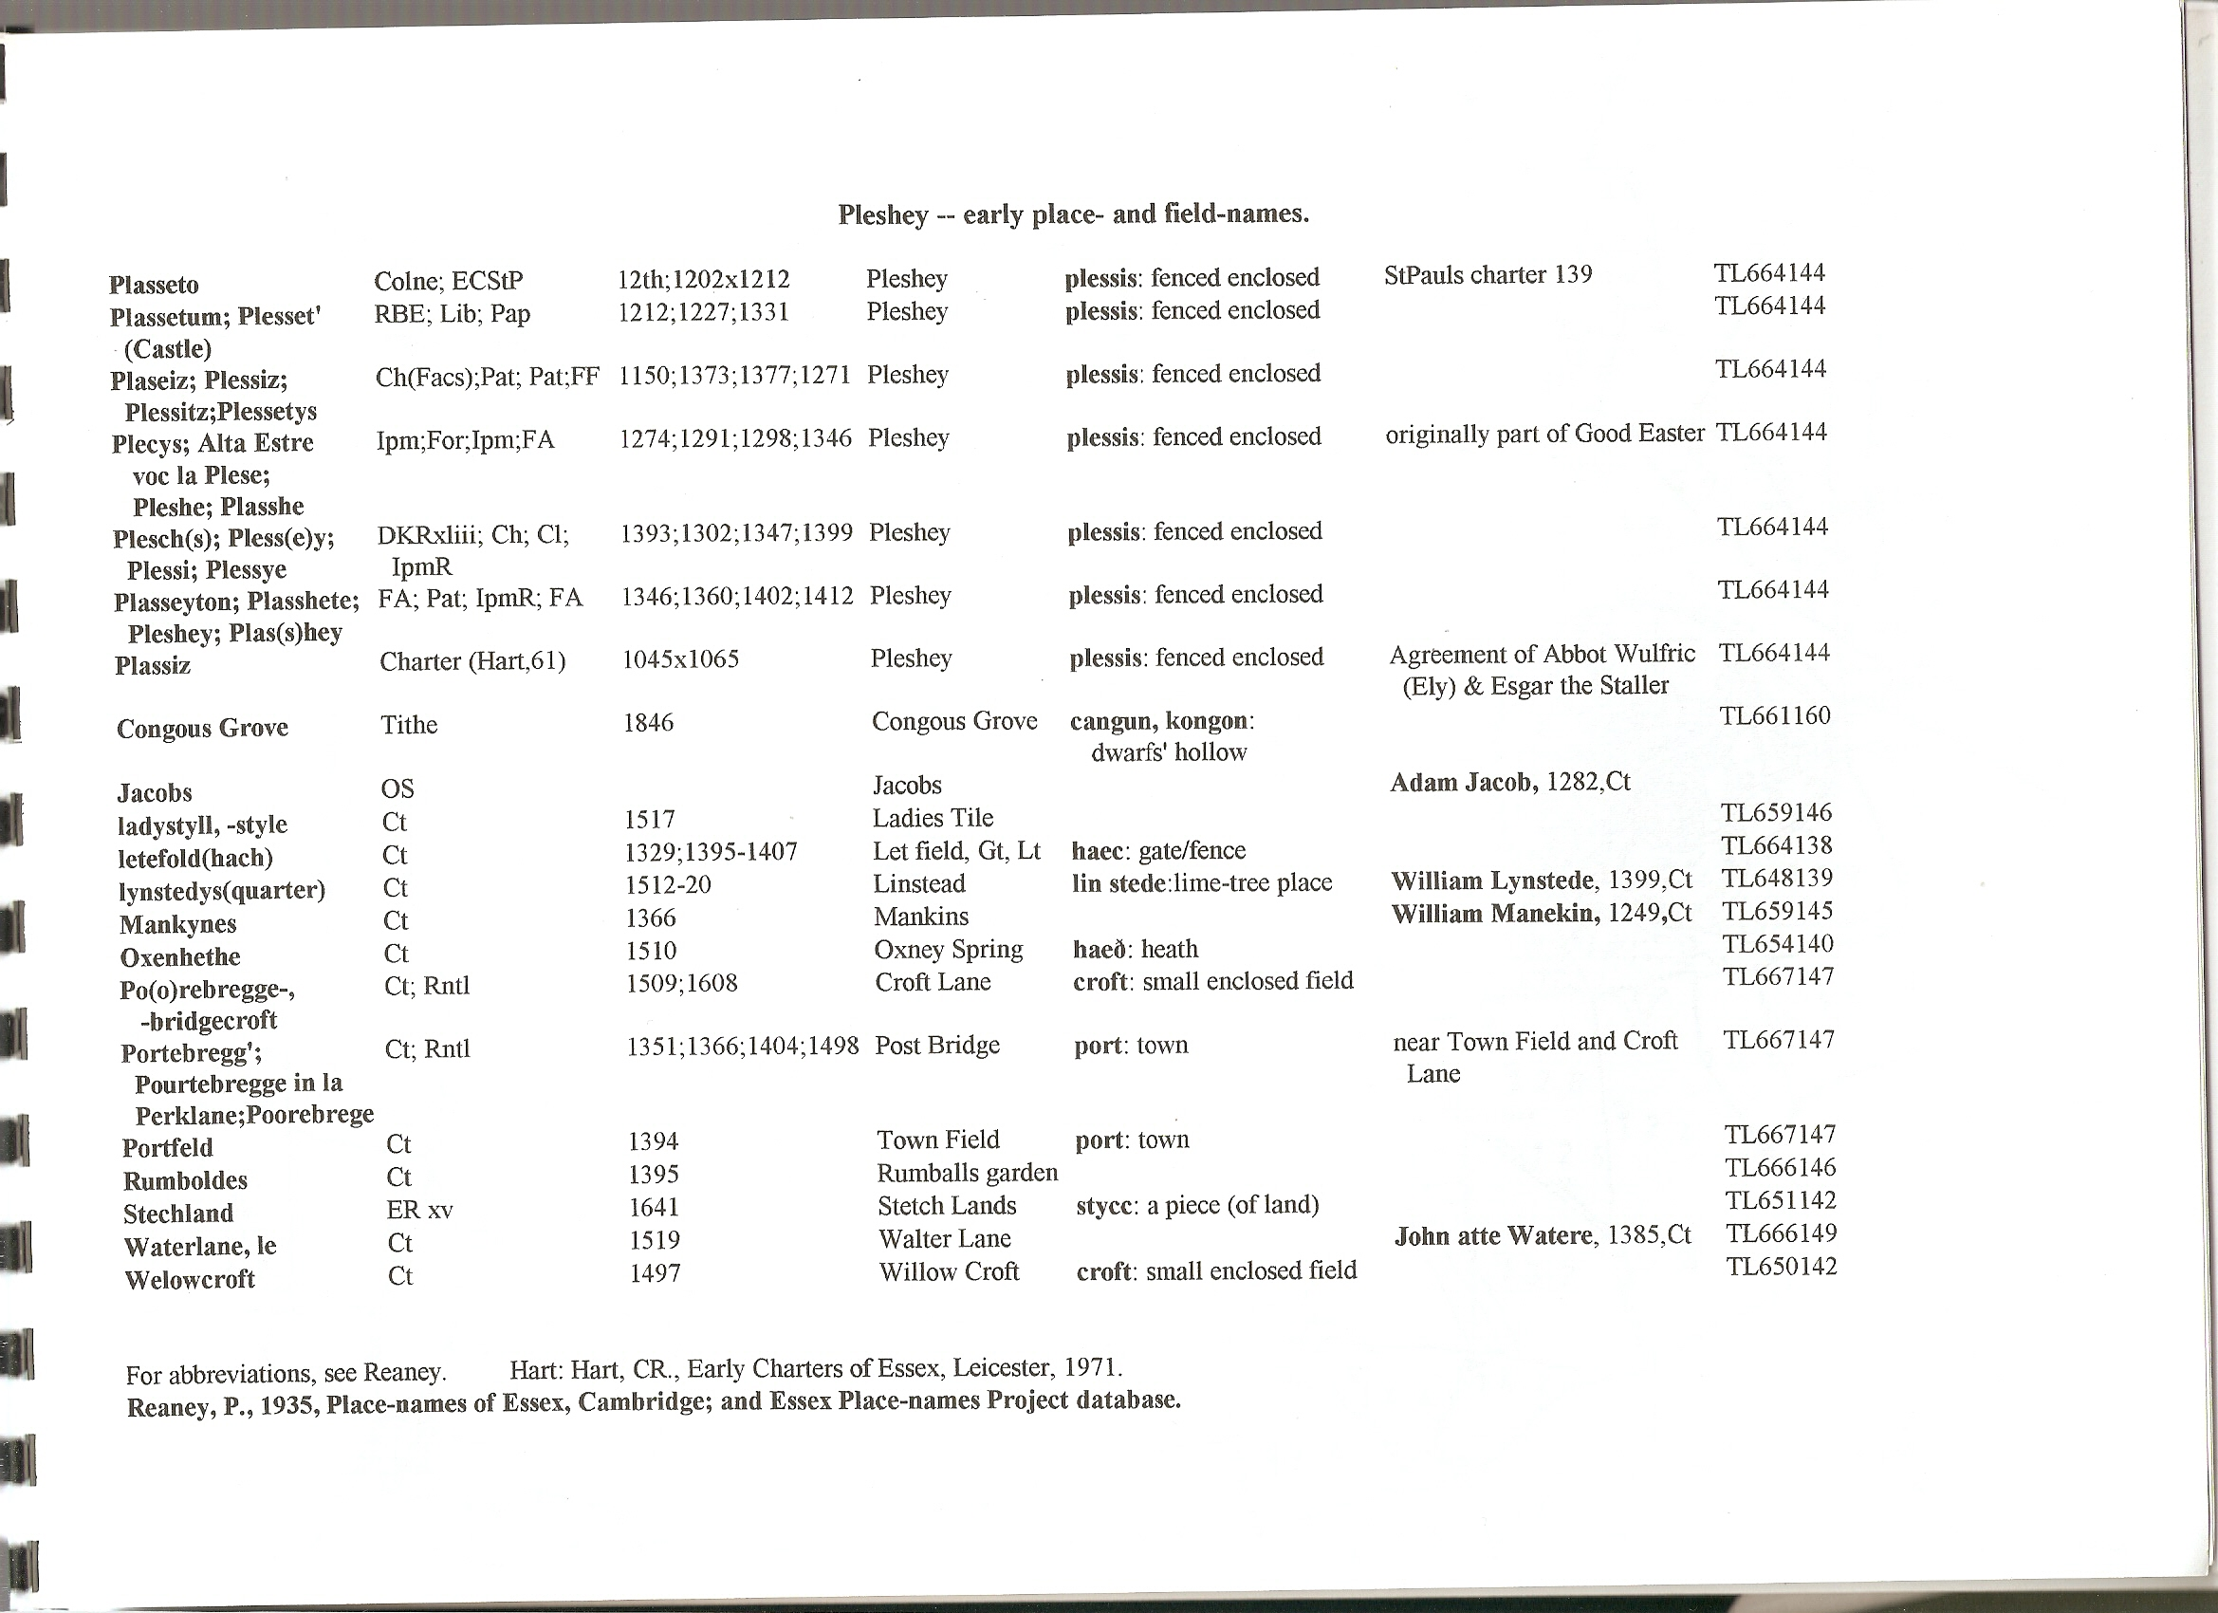

Ordnance Survey, c.1875, 6” = 1 mile (sheets 33, 43), Tithe parcel nos. superimposed : --
