THE PLACE-NAMES

OF QUENDON

Recorder: James Kemble

Essex Place-names Project (Essex Society for Archaeology & History)

Essex Record Office e-book 2010 (1st edition hard copy 2004).

www.essex.ac.uk/history/esah/essexplacenames

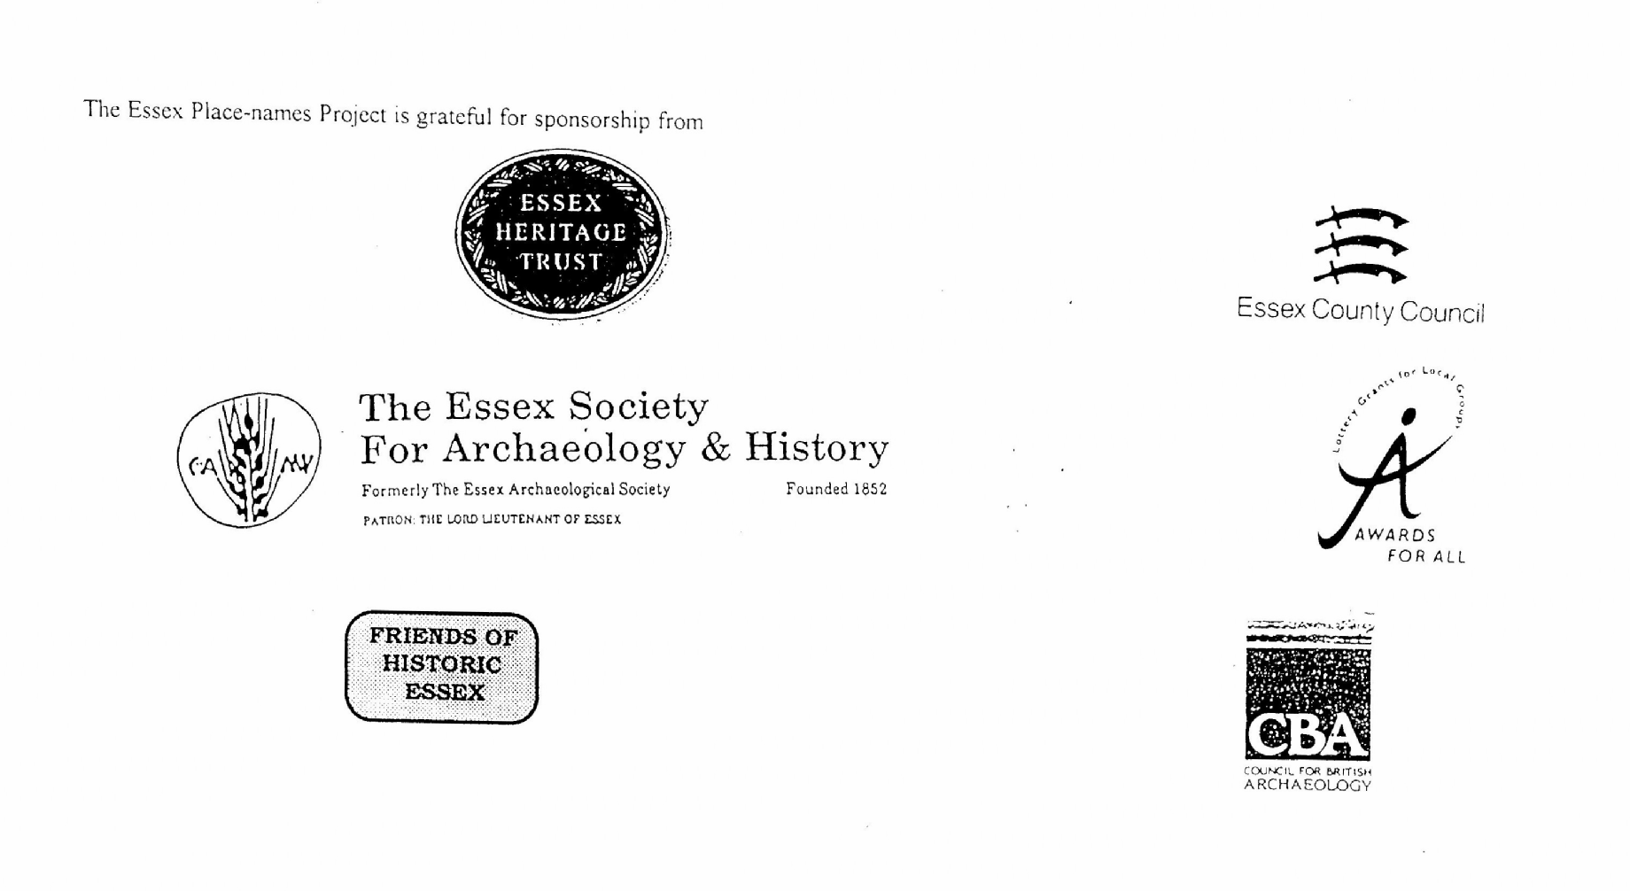

ESSEX PLACE-NAMES PROJECT.

The Essex Place-names Project is a County-wide survey to record place- and field-names from historical documents such as Tithe maps and apportionments, estate maps, sale and
auction catalogues, conveyances, terriers, deeds, rolls, inquisitions and surveys.

The second element of the Project is to investigate on-the-ground visible remains which correspond to the Place-names for actual or potential archaeological, agricultural and industrial
sites, and to record natural (topographical) and man-made features which may relate to the Place-name. This involves field-survey in rural and outside investigation in built-up areas.

It is anticipated that the Project will lead to identification of archaeological sites and lost historic buildings; it will enable analysis of indicators of early settlement, land holding, agricultural and industrial practices of the County. It will refine the more precise meaning of descriptive words and elements used by earlier settlers as they gave names appropriate to the topography of the landscape of their time.

For convenience the surveys are based on the parish, recognising that present civil parish boundaries are not necessarily identical to former ecclesiastical boundaries. Local Recorders
are supplied with templates of Record Forms to ensure consistency of recording across the County, and forward completed forms to a Central Coordinator for transfer to a county
computer database which is available at the Essex Record Office to researchers.

This publication presents part of the information recorded from the Tithe or Estate Award and Map, (and from other documents for this parish.) The full record is contained on the master database in the Essex Record Office, Wharf Road, Chelmsford CM2 6YT and the website www.essex.ac.uk/history/esah/essexplacenames. Parish books are available from the ERO on disc or in hard copy or may be downloaded from the website. Please notify errors to the Project Coordinator at the Essex Record Office.

THE TITHE MAP AND APPORTIONMENT.

Since medieval times a tenth of the produce of land and stock had been paid by landholders to the church. At the Dissolution of the Monasteries, the property of many religious houses,
including the right to collect tithes, passed into lay hands. The Tithe Commutation Act which received Royal assent on 13th August 1836 abolished a rent payable in kind and
substituted rent-charges apportioned on each plot or parcel. The tithe-rent payable was assessed on the average value of wheat, barley and oats and was to fluctuate with price movements.

The commutation could be by voluntary agreement between the local owners and payers or, if agreement failed, could be compulsorily imposed by commissioners. A Valuer was to be
appointed to apportion the rent of each parcel of land and tenants could deduct that rent-charge from their rent paid to the landlord. The task fell to the Tithe Commissioners to produce a map and an Apportionment (Award). A large-scale survey was produced for over 70% of England and Wales in the following 9 years, and about another 8% up to 1855. Most of the
parishes in Essex were surveyed. The map scales vary. The Award records ownership, tenancy and land-use, field by field and parcel by parcel (often quoting the field name) with the
ground area and rent-charge.

Land that was tithe-free tends to be less accurately mapped and contains few if any of the details recorded for those parcels subject to tithe. Rights of way and roads also tend to be
neglected. Boundaries of the tithe areas are shown as are some natural features such as streams, ponds, gardens, greens and commons. Buildings are often shown coloured red if dwellings or grey if not. Because the Award may have been agreed only some time after the map was finished, discrepancies occur between the two. Enclosure Awards, when extant, usually date to the 18th and early 19th centuries. J.Kemble.
Reproduced by permission
of Essex County Council.

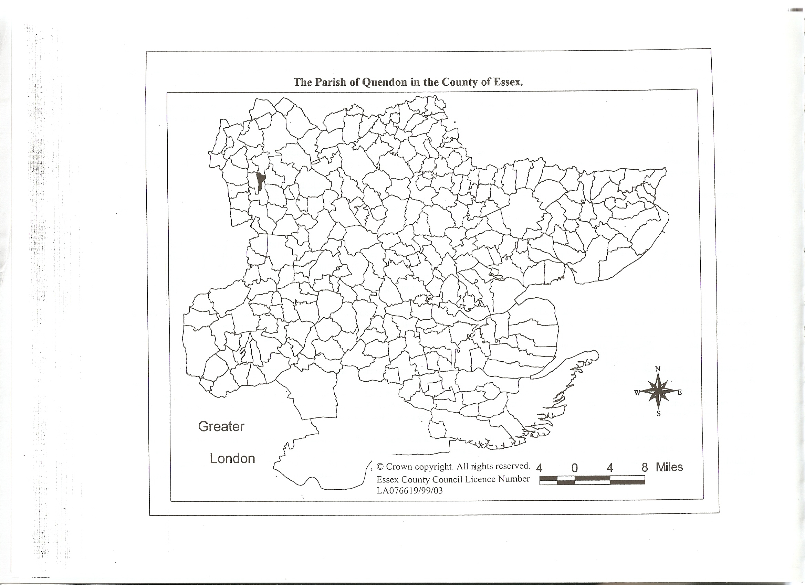
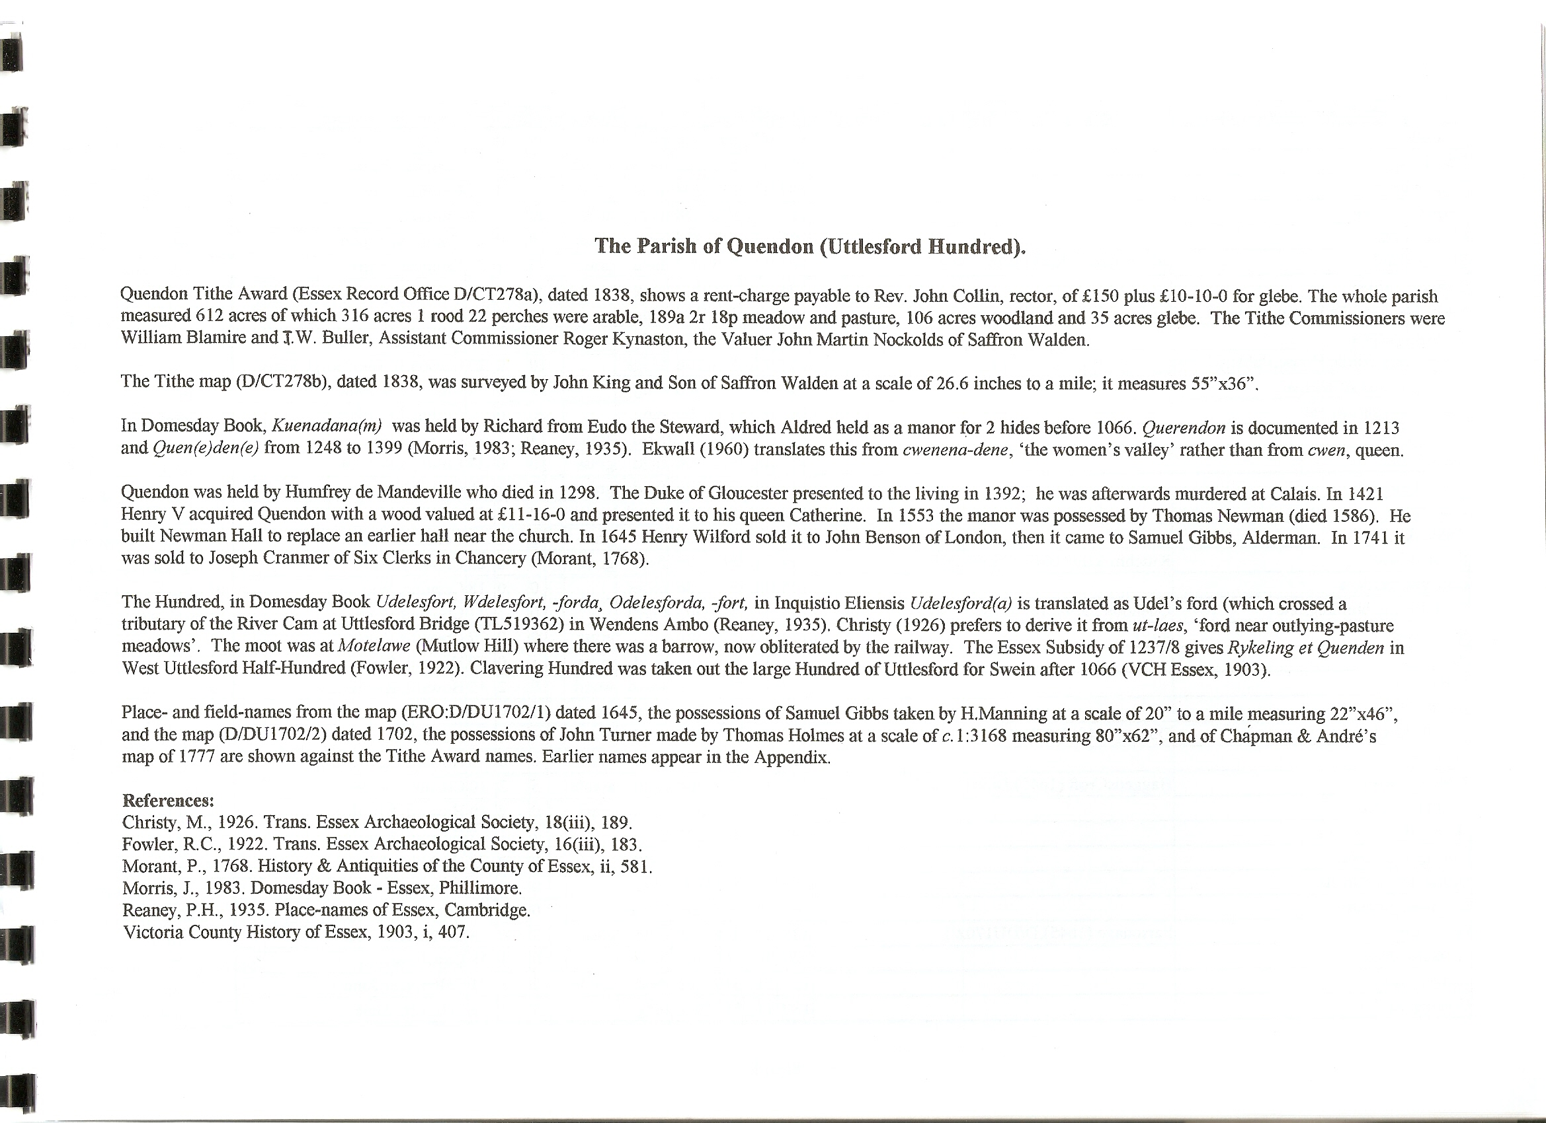

The Tithe Award Place-names of Quendon – by Parcel No.

Place-name | Alias | Fld No | Gd Ref | x | y | Place Type | Acr | rd | pch | Land use | Owner | Occupier | Other information
Fulwells |  | 1 | TL | 508 | 324 | field | 9 | 0 | 8 | arable | Cranmer, Anne | Cranmer, Anne
Slugs Corner |  | 2 | TL | 509 | 324 | field | 1 | 1 | 23 | arable | Collin, Rev John | Cranmer, Ann
Slugs Corner |  | 3 | TL | 509 | 324 | field | 10 | 3 | 27 | arable | Cranmer, Anne | Cranmer, Anne
Slugs Spring wood |  | 4 | TL | 510 | 324 | wood | 0 | 1 | 35 | wood | Cranmer, Anne | Cranmer, Anne
Nine Acres |  | 5 | TL | 512 | 324 | field | 8 | 2 | 12 | arable | Cranmer, Anne | Cranmer, Anne
Slugs Grove | Bushes Lays (1645),D/DU 1702/1 | 6 | TL | 511 | 324 | wood | 2 | 2 | 16 | wood | Cranmer, Anne | Cranmer, Anne | Bushy Lays, OS,1875
The Spring | Spring Close, c1875,OS | 7 | TL | 513 | 324 | wood | 5 | 1 | 3 | wood | Cranmer, Anne | Cranmer, Anne
Avenue Spring |  | 8 | TL | 514 | 324 | wood | 1 | 1 | 11 | wood | Cranmer, Anne | Cranmer, Anne
Spring Close |  | 9 | TL | 513 | 323 | field | 1 | 3 | 37 | arable | Cranmer, Anne | Cranmer, Anne
The Spring |  | 10 | TL | 513 | 323 | wood | 2 | 2 | 9 | wood | Cranmer, Anne | Cranmer, Anne
Lemon Dale |  | 11 | TL | 512 | 322 | field | 14 | 3 | 28 | arable | Cranmer, Anne | Cranmer, Anne
Lemon Dale |  | 12 | TL | 511 | 322 | field | 1 | 0 | 4 | arable | Collin, Rev John | Cranmer, Ann
Lemon Dale |  | 13 | TL | 510 | 322 | field | 0 | 1 | 21 | arable | Collin, Rev John | Cranmer, Ann
Lemon Dale |  | 14 | TL | 508 | 322 | field | 0 | 2 | 31 | arable | Collin, Rev John | Cranmer, Ann
Mobbs Garden |  | 15 | TL | 509 | 319 | field | 2 | 2 | 4 | grass | Collin, Rev John | Cranmer, Ann
Mobbs Garden |  | 16 | TL | 510 | 318 | field | 0 | 3 | 29 | grass | Collin, Rev John | Cranmer, Ann
Mobbs Garden |  | 17 | TL | 510 | 319 | field | 8 | 2 | 27 | grass | Cranmer, Anne | Cranmer, Anne
Gallows Croft |  | 18 | TL | 511 | 320 | field | 2 | 0 | 1 | grass | Collin, Rev John | Cranmer, Ann
Gallows Croft |  | 19 | TL | 512 | 320 | field | 5 | 1 | 35 | grass | Cranmer, Anne | Cranmer, Anne
Gallows Croft |  | 20 | TL | 512 | 320 | field | 1 | 0 | 37 | grass | Collin, Rev John | Cranmer, Ann
Spring |  | 21 | TL | 513 | 321 | wood | 0 | 1 | 11 | wood | Cranmer, Anne | Cranmer, Anne
Roadway |  | 22 | TL | 513 | 322 | road | 0 | 3 | 34 |  | Cranmer, Anne | Cranmer, Anne
Haystack Seven Acres |  | 23 | TL | 513 | 322 | field | 7 | 1 | 16 | grass | Cranmer, Anne | Cranmer, Anne
The Avenue |  | 24 | TL | 514 | 323 | field | 5 | 2 | 9 | grass | Cranmer, Anne | Cranmer, Anne
North Croft | BowlingGreen(1645),D/DU 1702/1 | 25 | TL | 514 | 324 | field | 3 | 0 | 12 | grass | Cranmer, Anne | Cranmer, Anne
North Croft Spring |  | 26 | TL | 515 | 324 | wood | 2 | 1 | 36 | wood | Cranmer, Anne | Cranmer, Anne
Orchard 7 Acres |  | 27 | TL | 514 | 322 | field | 7 | 3 | 4 | grass | Cranmer, Anne | Cranmer, Anne
Eight Acres | Mary Ann Plantation,c1875,OS | 28 | TL | 517 | 323 | field | 8 | 3 | 24 | grass | Cranmer, Anne | Cranmer, Anne
Long Croft Spring | Longcroft Spring,c1875,OS | 29 | TL | 519 | 322 | wood | 1 | 1 | 29 | wood | Cranmer, Anne | Cranmer, Anne
Little Pigs Parlour |  | 30 | TL | 524 | 323 | field | 2 | 0 | 25 | arable | Cranmer, Anne | Edridge, Thomas
12 Acre Mead field |  | 31 | TL | 522 | 323 | field | 8 | 0 | 6 | arable | Cranmer, Anne | Edridge, Thomas
12 Acre Mead field |  | 32 | TL | 522 | 322 | field | 3 | 1 | 36 | arable | Collin, Rev John | Edridge, Thomas
Long Croft | LongCroft/TavernersCroft (1645) D/DU 1702/1 | 33 | TL | 520 | 320 | field | 26 | 0 | 22 | arable | Cranmer, Anne | Edridge, Thomas
High Field Ley |  | 34 | TL | 517 | 320 | field | 14 | 3 | 32 | arable | Cranmer, Anne | Cranmer, Anne
Plantation |  | 35 | TL | 516 | 320 | wood | 1 | 1 | 19 | wood | Cranmer, Anne | Cranmer, Anne
Orchard |  | 36 | TL | 515 | 320 | field | 2 | 0 | 3 | grass | Cranmer, Anne | Cranmer, Anne
Mansion House, Offices, Pleasu Ground, Gdns | Quendon Hall, 1777,C&A | 37 | TL | 515 | 319 | bldgs | 5 | 2 | 20 |  | Cranmer, Anne | Cranmer, Anne | Newmanhall (Norden, 1594). Morant,ii,581
10 Acre Mead field |  | 38 | TL | 513 | 320 | field | 0 | 1 | 36 | arable | Collin, Rev John | Edridge, Thomas
Farm, buildings, yards, stables |  | 38 | TL | 513 | 320 | bldgs | 4 | 0 | 7 |  | Cranmer, Anne | Cranmer, Anne
Bailiffs Cottage |  | 39 | TL | 513 | 318 | bldg | 0 | 0 | 33 |  | Cranmer, Anne | Cranmer, Anne
Paddock |  | 40 | TL | 513 | 318 | field | 2 | 1 | 39 | grass | Cranmer, Anne | Cranmer, Anne
Lower Common |  | 41 | TL | 512 | 327 | field | 11 | 2 | 26 | arable | Cranmer, Anne | Cranmer, Anne
Upper Common |  | 42 | TL | 510 | 317 | field | 0 | 2 | 2 | arable | Collin, Rev John | Cranmer, Ann
Upper Common |  | 43 | TL | 510 | 317 | field | 11 | 1 | 32 | arable | Cranmer, Anne | Cranmer, Anne
Upper Common |  | 44 | TL | 510 | 315 | field | 0 | 2 | 28 | arable | Collin, Rev John | Cranmer, Ann
Lower Common |  | 45 | TL | 512 | 315 | field | 0 | 3 | 37 | arable | Collin, Rev John | Cranmer, Ann
Lower Common |  | 46 | TL | 512 | 315 | field | 0 | 3 | 28 | arable | Collin, Rev John | Cranmer, Ann
Ten Acres |  | 48 | TL | 511 | 314 | field | 7 | 0 | 8 | arable | Cranmer, Anne | Cranmer, Anne
Ten Acres |  | 49 | TL | 511 | 314 | field | 1 | 2 | 38 | arable | Collin, Rev John | Cranmer, Ann
Broomey field |  | 50 | TL | 513 | 314 | field | 6 | 0 | 31 | arable | Collin, Rev John | Collin, Rev John
Roadway |  | 51 | TL | 513 | 324 | road | 0 | 1 | 11 |  | Cranmer, Anne | Cranmer, Anne
The Park |  | 52 | TL | 514 | 315 | field | 8 | 1 | 4 | grass | Cranmer, Anne | Cranmer, Anne | Tumulus marked (OS,1975)
The Deer Park | PondStangate/SibcoppsLaye (1645), D/DU 1702/1 | 53 | TL | 516 | 327 | field | 44 | 0 | 32 | grass | Cranmer, Anne | Cranmer, Anne | Man Hall Park (1702),D/DU 1702/2
Stangates | Upper Stangate(1645),D/DU 1702/1 | 54 | TL | 519 | 327 | field | 15 | 3 | 9 | arable | Cranmer, Anne | Cranmer, Anne
Stangates | Stangate Hole(1645),D/DU 1702/1 | 55 | TL | 521 | 318 | field | 14 | 1 | 27 | arable | Cranmer, Anne | Edridge, Thomas
The Pit |  | 56 | TL | 521 | 318 | field | 0 | 2 | 27 | arable | Cranmer, Anne | Edridge, Thomas
Turnpike house, garden, watercourse |  | 57 | TL | 522 | 317 | bldg | 0 | 1 | 0 |  | Turnpike Trustees | Turnpike Trustees | Parcels 57 and 81 are together
18 Acre Mead field |  | 59 | TL | 523 | 319 | field | 14 | 1 | 33 | arable | Cranmer, Anne | Edridge, Thomas
10 Acre Mead field |  | 60 | TL | 523 | 318 | field | 2 | 0 | 15 | arable | Collin, Rev John | Edridge, Thomas
10 Acre Mead field |  | 61 | TL | 523 | 317 | field | 0 | 3 | 24 | arable | Collin, Rev John | Edridge, Thomas
Long Mead |  | 62 | TL | 514 | 320 | field | 6 | 3 | 12 | grass | Cranmer, Anne | Edridge, Thomas
Hay Mead |  | 63 | TL | 524 | 318 | field | 2 | 2 | 31 | grass | Cranmer, Anne | Edridge, Thomas
Oxleys | Oxleys Mead(1645),D/DU 1702/1 | 64 | TL | 523 | 326 | field | 5 | 0 | 0 | grass | Cranmer, Anne | Edridge, Thomas
Little Mead field |  | 65 | TL | 523 | 327 | field | 6 | 1 | 6 | arable | Cranmer, Anne | Edridge, Thomas
Wash Mead | Paynsden Mead (1645),  D/DU 1702/1 | 66 | TL | 520 | 315 | field | 8 | 0 | 32 | grass | Cranmer, Anne | Edridge, Thomas
Plantation |  | 67 | TL | 518 | 314 | wood | 0 | 2 | 33 | wood | Cranmer, Anne | Cranmer, Anne
Broom Hills | Bromhills (1645),D/DU 1702/1 | 68 | TL | 518 | 315 | field | 5 | 0 | 31 | arable | Cranmer, Anne | Cranmer, Anne
Pound wood | Sibcopps Wood (1645),  D/DU 1702/1 | 69 | TL | 515 | 314 | wood | 4 | 2 | 20 | wood | Cranmer, Anne | Cranmer, Anne
Plantation |  | 70 | TL | 514 | 314 | wood | 0 | 0 | 14 | wood | Cranmer, Anne | Cranmer, Anne
Cottages, gardens |  | 71 | TL | 514 | 314 | bldgs | 0 | 1 | 27 |  | Cranmer, Anne | Davis,John;Tillett,James
Three Acres |  | 72 | TL | 513 | 313 | field | 2 | 2 | 22 | arable | Cranmer, Anne | Collin, Rev John
Barn Hills |  | 73 | TL | 511 | 312 | field | 0 | 3 | 0 | arable | Collin, Rev John | Collin, Rev John
Barn Hills |  | 74 | TL | 511 | 313 | field | 1 | 0 | 17 | arable | Collin, Rev John | Collin, Rev John
Barn Hills |  | 75 | TL | 512 | 312 | field | 10 | 1 | 20 | arable | Cranmer, Anne | Collin, Rev John
Three Acres |  | 76 | TL | 513 | 313 | field | 3 | 1 | 38 | arable | Cranmer, Anne | Cranmer, Anne
Old Lay |  | 77 | TL | 515 | 313 | field | 9 | 0 | 16 | arable | Cranmer, Anne | Cranmer, Anne
Roadway |  | 78 | TL | 516 | 313 | road | 0 | 3 | 30 |  | Cranmer, Anne | Cranmer, Anne
Bowers Croft |  | 79 | TL | 517 | 313 | field | 3 | 0 | 34 | arable | Cranmer, Anne | Cranmer, Anne
Plantation |  | 80 | TL | 517 | 313 | wood | 0 | 2 | 37 | wood | Cranmer, Anne | Cranmer, Anne
Turnpike house, garden, watercourse |  | 81 | TL | 522 | 317 | bldg | 0 | 1 | 0 |  | Turnpike Trustees | Turnpike Trustees | Parcels 57 and 81 are together
Pansdale Wood | Payden Wood(1645),D/DU 1702/1 | 82 | TL | 521 | 313 | wood | 11 | 2 | 20 | wood | Cranmer, Anne | Cranmer, Anne
Little Mill field | Nether Mill feilde (1645),  D/DU 1702/1 | 83 | TL | 518 | 313 | field | 22 | 0 | 9 | arable | Cranmer, Anne | Edridge, Thomas
House, windmill, barn, stable etc |  | 84 | TL | 518 | 312 | bldgs | 0 | 3 | 18 |  | Cranmer, Anne | Osborne, James | Corn windmill (OS, c1875) Parcels 84 and 97 are together
Great Mill field | Mill feilde (1645),D/DU 1702/1 | 85 | TL | 518 | 310 | field | 26 | 0 | 30 | arable | Cranmer, Anne | Edridge, Thomas
Church Green Close |  | 86 | TL | 516 | 309 | field | 2 | 1 | 14 | grass | Cranmer, Anne | Collin, Rev John
Blacksmiths Shop (pt) |  | 87 | TL | 515 | 309 | bldg | 0 | 0 | 1 |  | Chipperfield, Mary | Chipperfield, Mary
Cottages, gardens |  | 88 | TL | 515 | 309 | bldgs | 0 | 0 | 37 |  | Parish, John | Negus, George; Osborne, William | Pcls 88, 92 together
Cottage, garden |  | 89 | TL | 515 | 309 | bldg | 0 | 0 | 9 |  | Parish, William | Ives, William | Pcls 89, 91 together
Cottages, gardens |  | 90 | TL | 515 | 309 | bldgs | 0 | 0 | 9 |  | Johnson, Benjamin | Johnson, Benjamin; Newland, Benjamin
Cottage, garden |  | 91 | TL | 515 | 309 | bldg | 0 | 0 | 9 |  | Parish, William | Ives, William | Pcls 89, 91together
Cottages, gardens |  | 92 | TL | 515 | 309 | bldgs | 0 | 0 | 37 |  | Parish, John | Negus, George; Osborne, Wm | Pcls 88, 92 together
Cottages, gardens |  | 93 | TL | 515 | 309 | bldgs | 0 | 0 | 7 |  | Jellis, Elizabeth | Davis,Thomas;Skipper,William
Cottages, gardens |  | 94 | TL | 515 | 309 | bldgs | 0 | 0 | 6 |  | Osborne, William | Warman, James; Knightley, John
House,carpenters shop,gdn |  | 95 | TL | 515 | 318 | bldgs | 0 | 1 | 7 |  | Cranmer, Anne | Burgoyne, Robert
Cottage, garden |  | 96 | TL | 515 | 308 | bldg | 0 | 0 | 7 |  | Reynolds, Mary | Reynolds, Mary
House,windmill,barn,stable etc |  | 97 | TL | 518 | 312 | bldgs | 0 | 3 | 18 |  | Cranmer, Anne | Osborne, James | Corn windmill (OS, c1875) Parcels 84 and 97 are together
Cottages, gardens |  | 98 | TL | 515 | 308 | bldgs | 0 | 0 | 39 |  | Wilkinson, Joseph | Wilkinson, Joseph; unoccupied
Church Yard | St Simon & St Judes (OS,c1875) | 99 | TL | 515 | 307 | field | 0 | 2 | 20 |  |  | ..
Church Green |  | 100 | TL | 517 | 308 | field | 1 | 3 | 11 | grass | Cranmer, Anne | Edridge, Thomas
Dovehouse field |  | 101 | TL | 518 | 308 | field | 20 | 3 | 6 | arable | Cranmer, Anne | Edridge, Thomas
Church Path |  | 102 | TL | 515 | 306 | path | 0 | 0 | 27 | grass | Collin, Rev John | Collin, Rev John
Millers Croft | Herd's Croft (1645),D/DU 1702/1 | 103 | TL | 515 | 307 | field | 2 | 1 | 37 | grass | Cranmer, Anne | Collin, Rev John
Cottage, garden |  | 104 | TL | 515 | 306 | bldg | 0 | 0 | 3 |  | Tyler, John | Frost, Charles
Kings Head Public House, stable, yard |  | 105 | TL | 515 | 306 | bldgs | 0 | 0 | 27 |  | Gibson,Wyatt George,Francis | Patmore, Mary | Parcels 105 and 107 are together
Cottage, garden |  | 106 | TL | 515 | 306 | bldg | 0 | 0 | 6 |  | Woodcock, John | Smith, Job
Kings Head Public House, stable, yard |  | 107 | TL | 515 | 306 | bldgs | 0 | 0 | 27 |  | Gibson,Wyatt George,Francis | Patmore, Mary | Parcels 105 and 107 are together
Rectory House,offices,yd |  | 108 | TL | 515 | 306 | bldg | 1 | 3 | 1 |  | Collin, Rev John | Collin, Rev John
Stable,yard,garden etc |  | 109 | TL | 515 | 306 | bldg | 0 | 0 | 34 |  | Collin, Rev John | Collin, Rev John
Stack Yard |  | 110 | TL | 515 | 306 | field | 0 | 0 | 37 | grass | Collin, Rev John | Collin, Rev John
Home Paddock |  | 111 | TL | 515 | 306 | field | 1 | 1 | 10 | grass | Collin, Rev John | Collin, Rev John
Plantation |  | 112 | TL | 516 | 306 | wood | 0 | 0 | 10 | wood | Collin, Rev John | Collin, Rev John
Paddock |  | 113 | TL | 516 | 306 | field | 0 | 1 | 9 | grass | Collin, Rev John | Collin, Rev John
Kitchen field | Kittchin feild (1645),D/DU 1702/1 | 114 | TL | 517 | 305 | field | 0 | 2 | 29 | grass | Cranmer, Anne | Edridge, Thomas
Cottages, gardens |  | 115 | TL | 515 | 306 | bldgs | 0 | 0 | 18 |  | Canning, William | Read,Mary;Banks,William
Farm House, buildings etc | Quendon Farm,c1875,OS | 116 | TL | 515 | 305 | bldgs | 0 | 3 | 21 |  | Cranmer, Anne | Edridge, Thomas
Stack Yard |  | 117 | TL | 515 | 305 | yd | 0 | 0 | 27 | grass | Cranmer, Anne | Edridge, Thomas
Paddock |  | 118 | TL | 515 | 305 | field | 1 | 0 | 39 | grass | Howard, Rev Henry | Howard, Rev Henry
Plantation |  | 119 | TL | 516 | 305 | wood | 0 | 2 | 19 | wood | Howard, Rev Henry | Howard, Rev Henry
East Paddock | Doole (1645),D/DU 1702/1 | 120 | TL | 517 | 305 | field | 1 | 1 | 14 | grass | Howard, Rev Henry | Howard, Rev Henry
Foot Path |  | 121 | TL | 517 | 305 | path | 0 | 0 | 6 | grass | Howard, Rev Henry | Howard, Rev Henry
Little Common | HaggettsCroft (1645),D/DU 1702/1 | 122 | TL | 517 | 304 | field | 5 | 3 | 10 | arable | Cranmer, Anne | Edridge, Thomas
South Paddock |  | 123 | TL | 516 | 305 | field | 0 | 2 | 19 | grass | Howard, Rev Henry | Howard, Rev Henry
House,offices,yd,gdn |  | 124 | TL | 515 | 304 | bldg | 1 | 1 | 3 |  | Howard, Rev Henry | Howard, Rev Henry
Cottages, gardens |  | 125 | TL | 515 | 304 | bldgs | 0 | 0 | 29 |  | Nockolds, Martin | Canning, Williamm; Knightley, Alice; Linsdell, James; Rickard, John
House, shop, gdn etc |  | 126 | TL | 515 | 304 | bldg | 0 | 0 | 15 |  | Womwell, John | Womwell, John
Cottages, gardens |  | 127 | TL | 515 | 302 | bldgs | 0 | 0 | 36 |  | Horsley, Rebecca | Ridgewell, Samuel; Horsley, Rebecca
Green Croft | Parsonage (1645),D/DU 1702/1 | 128 | TL | 516 | 304 | field | 3 | 0 | 8 | grass | Collin, Rev John | Collin, Rev John
Cottages, gardens |  | 129 | TL | 515 | 303 | bldgs | 0 | 1 | 38 |  | Day, James | Day, George; Bray, Joseph; Johnson, Jonathan
Cottage, garden |  | 130 | TL | 515 | 302 | bldg | 0 | 1 | 3 |  | Cranmer, Anne | Player, William
Green Close | RaynardsCroft(1645),D/DU 1702/1 | 131 | TL | 515 | 300 | field | 5 | 3 | 8 | grass | Cranmer, Anne | Edridge, Thomas
Quendon Wood |  | 132 | TL | 518 | 300 | wood | 82 | 3 | 31 | wood | Cranmer, Anne | Cranmer, Anne
Outward | Outwoods,(1645),D/DU 1702/1 | 133 | TL | 516 | 297 | field | 16 | 0 | 30 | arable | Cranmer, Anne | Edridge, Thomas
Cottages, gardens |  | 134 | TL | 515 | 297 | bldgs | 0 | 1 | 25 |  | Cranmer, Anne | Symonds,Joseph;Read,William
House, yard,garden |  | 135 | TL | 515 | 297 | bldg | 0 | 1 | 2 |  | Porter, Thomas | Porter, Thomas

For abbreviations see Reaney, P., Place-names of Essex, Cambridge 1935; and Kemble, J., Essex Place-names, Places, Streets & People, Historical Publications, London 2007.

The Tithe Award Place-names of Quendon – by Place-name.

Place-name | Alias | Fld No | Gd Ref | x | y | Place Type | Acr | rd | pch | Land use | Owner | Occupier | Other information
10 Acre Mead field |  | 38 | TL | 513 | 320 | field | 0 | 1 | 36 | arable | Collin, Rev John | Edridge, Thomas
10 Acre Mead field |  | 60 | TL | 523 | 318 | field | 2 | 0 | 15 | arable | Collin, Rev John | Edridge, Thomas
10 Acre Mead field |  | 61 | TL | 523 | 317 | field | 0 | 3 | 24 | arable | Collin, Rev John | Edridge, Thomas
12 Acre Mead field |  | 32 | TL | 522 | 322 | field | 3 | 1 | 36 | arable | Collin, Rev John | Edridge, Thomas
12 Acre Mead field |  | 31 | TL | 522 | 323 | field | 8 | 0 | 6 | arable | Cranmer, Anne | Edridge, Thomas
18 Acre Mead field |  | 59 | TL | 523 | 319 | field | 14 | 1 | 33 | arable | Cranmer, Anne | Edridge, Thomas
Avenue Spring |  | 8 | TL | 514 | 324 | wood | 1 | 1 | 11 | wood | Cranmer, Anne | Cranmer, Anne
Bailiffs Cottage |  | 39 | TL | 513 | 318 | bldg | 0 | 0 | 33 |  | Cranmer, Anne | Cranmer, Anne
Barn Hills |  | 73 | TL | 511 | 312 | field | 0 | 3 | 0 | arable | Collin, Rev John | Collin, Rev John
Barn Hills |  | 74 | TL | 511 | 313 | field | 1 | 0 | 17 | arable | Collin, Rev John | Collin, Rev John
Barn Hills |  | 75 | TL | 512 | 312 | field | 10 | 1 | 20 | arable | Cranmer, Anne | Collin, Rev John
Blacksmiths Shop (pt) |  | 87 | TL | 515 | 309 | bldg | 0 | 0 | 1 |  | Chipperfield, Mary | Chipperfield, Mary
Bowers Croft |  | 79 | TL | 517 | 313 | field | 3 | 0 | 34 | arable | Cranmer, Anne | Cranmer, Anne
Broom Hills | Bromhills (1645),D/DU 1702/1 | 68 | TL | 518 | 315 | field | 5 | 0 | 31 | arable | Cranmer, Anne | Cranmer, Anne
Broomey field |  | 50 | TL | 513 | 314 | field | 6 | 0 | 31 | arable | Collin, Rev John | Collin, Rev John
Church Green |  | 100 | TL | 517 | 308 | field | 1 | 3 | 11 | grass | Cranmer, Anne | Edridge, Thomas
Church Green Close |  | 86 | TL | 516 | 309 | field | 2 | 1 | 14 | grass | Cranmer, Anne | Collin, Rev John
Church Path |  | 102 | TL | 515 | 306 | path | 0 | 0 | 27 | grass | Collin, Rev John | Collin, Rev John
Church Yard | St Simon & St Judes (OS,c1875) | 99 | TL | 515 | 307 | field | 0 | 2 | 20 |  |  | ..
Cottage, garden |  | 130 | TL | 515 | 302 | bldg | 0 | 1 | 3 |  | Cranmer, Anne | Player, William
Cottage, garden |  | 89 | TL | 515 | 309 | bldg | 0 | 0 | 9 |  | Parish, William | Ives, William | Pcls 89, 91 together
Cottage, garden |  | 91 | TL | 515 | 309 | bldg | 0 | 0 | 9 |  | Parish, William | Ives, William | Pcls 89, 91together
Cottage, garden |  | 96 | TL | 515 | 308 | bldg | 0 | 0 | 7 |  | Reynolds, Mary | Reynolds, Mary
Cottage, garden |  | 104 | TL | 515 | 306 | bldg | 0 | 0 | 3 |  | Tyler, John | Frost, Charles
Cottage, garden |  | 106 | TL | 515 | 306 | bldg | 0 | 0 | 6 |  | Woodcock, John | Smith, Job
Cottages, gardens |  | 115 | TL | 515 | 306 | bldgs | 0 | 0 | 18 |  | Canning, William | Read,Mary;Banks,William
Cottages, gardens |  | 71 | TL | 514 | 314 | bldgs | 0 | 1 | 27 |  | Cranmer, Anne | Davis,John;Tillett,James
Cottages, gardens |  | 134 | TL | 515 | 297 | bldgs | 0 | 1 | 25 |  | Cranmer, Anne | Symonds,Joseph;Read,William
Cottages, gardens |  | 129 | TL | 515 | 303 | bldgs | 0 | 1 | 38 |  | Day, James | Day, George; Bray, Joseph; Johnson, Jonathan
Cottages, gardens |  | 127 | TL | 515 | 302 | bldgs | 0 | 0 | 36 |  | Horsley, Rebecca | Ridgewell, Samuel; Horsley, Rebecca
Cottages, gardens |  | 93 | TL | 515 | 309 | bldgs | 0 | 0 | 7 |  | Jellis, Elizabeth | Davis,Thomas;Skipper,William
Cottages, gardens |  | 90 | TL | 515 | 309 | bldgs | 0 | 0 | 9 |  | Johnson, Benjamin | Johnson, Benjamin; Newland, Benjamin
Cottages, gardens |  | 125 | TL | 515 | 304 | bldgs | 0 | 0 | 29 |  | Nockolds, Martin | Canning, Williamm; Knightley, Alice; Linsdell, James; Rickard, John
Cottages, gardens |  | 94 | TL | 515 | 309 | bldgs | 0 | 0 | 6 |  | Osborne, William | Warman, James; Knightley, John
Cottages, gardens |  | 88 | TL | 515 | 309 | bldgs | 0 | 0 | 37 |  | Parish, John | Negus, George; Osborne, William | Pcls 88, 92 together
Cottages, gardens |  | 92 | TL | 515 | 309 | bldgs | 0 | 0 | 37 |  | Parish, John | Negus, George; Osborne, Wm | Pcls 88, 92 together
Cottages, gardens |  | 98 | TL | 515 | 308 | bldgs | 0 | 0 | 39 |  | Wilkinson, Joseph | Wilkinson, Joseph; unoccupied
Dovehouse field |  | 101 | TL | 518 | 308 | field | 20 | 3 | 6 | arable | Cranmer, Anne | Edridge, Thomas
East Paddock | Doole (1645),D/DU 1702/1 | 120 | TL | 517 | 305 | field | 1 | 1 | 14 | grass | Howard, Rev Henry | Howard, Rev Henry
Eight Acres | Mary Ann Plantation,c1875,OS | 28 | TL | 517 | 323 | field | 8 | 3 | 24 | grass | Cranmer, Anne | Cranmer, Anne
Farm House, buildings etc | Quendon Farm,c1875,OS | 116 | TL | 515 | 305 | bldgs | 0 | 3 | 21 |  | Cranmer, Anne | Edridge, Thomas
Farm, buildings, yards, stables |  | 38 | TL | 513 | 320 | bldgs | 4 | 0 | 7 |  | Cranmer, Anne | Cranmer, Anne
Foot Path |  | 121 | TL | 517 | 305 | path | 0 | 0 | 6 | grass | Howard, Rev Henry | Howard, Rev Henry
Fulwells |  | 1 | TL | 508 | 324 | field | 9 | 0 | 8 | arable | Cranmer, Anne | Cranmer, Anne
Gallows Croft |  | 18 | TL | 511 | 320 | field | 2 | 0 | 1 | grass | Collin, Rev John | Cranmer, Ann
Gallows Croft |  | 20 | TL | 512 | 320 | field | 1 | 0 | 37 | grass | Collin, Rev John | Cranmer, Ann
Gallows Croft |  | 19 | TL | 512 | 320 | field | 5 | 1 | 35 | grass | Cranmer, Anne | Cranmer, Anne
Great Mill field | Mill feilde (1645),D/DU 1702/1 | 85 | TL | 518 | 310 | field | 26 | 0 | 30 | arable | Cranmer, Anne | Edridge, Thomas
Green Close | RaynardsCroft(1645),D/DU 1702/1 | 131 | TL | 515 | 300 | field | 5 | 3 | 8 | grass | Cranmer, Anne | Edridge, Thomas
Green Croft | Parsonage (1645),D/DU 1702/1 | 128 | TL | 516 | 304 | field | 3 | 0 | 8 | grass | Collin, Rev John | Collin, Rev John
Hay Mead |  | 63 | TL | 524 | 318 | field | 2 | 2 | 31 | grass | Cranmer, Anne | Edridge, Thomas
Haystack Seven Acres |  | 23 | TL | 513 | 322 | field | 7 | 1 | 16 | grass | Cranmer, Anne | Cranmer, Anne
High Field Ley |  | 34 | TL | 517 | 320 | field | 14 | 3 | 32 | arable | Cranmer, Anne | Cranmer, Anne
Home Paddock |  | 111 | TL | 515 | 306 | field | 1 | 1 | 10 | grass | Collin, Rev John | Collin, Rev John
House, shop, gdn etc |  | 126 | TL | 515 | 304 | bldg | 0 | 0 | 15 |  | Womwell, John | Womwell, John
House, windmill, barn, stable etc |  | 84 | TL | 518 | 312 | bldgs | 0 | 3 | 18 |  | Cranmer, Anne | Osborne, James | Corn windmill (OS, c1875) Parcels 84 and 97 are together
House, yard,garden |  | 135 | TL | 515 | 297 | bldg | 0 | 1 | 2 |  | Porter, Thomas | Porter, Thomas
House,carpenters shop,gdn |  | 95 | TL | 515 | 318 | bldgs | 0 | 1 | 7 |  | Cranmer, Anne | Burgoyne, Robert
House,offices,yd,gdn |  | 124 | TL | 515 | 304 | bldg | 1 | 1 | 3 |  | Howard, Rev Henry | Howard, Rev Henry
House,windmill,barn,stable etc |  | 97 | TL | 518 | 312 | bldgs | 0 | 3 | 18 |  | Cranmer, Anne | Osborne, James | Corn windmill (OS, c1875) Parcels 84 and 97 are together
Kings Head Public House, stable, yard |  | 105 | TL | 515 | 306 | bldgs | 0 | 0 | 27 |  | Gibson,Wyatt George,Francis | Patmore, Mary | Parcels 105 and 107 are together
Kings Head Public House, stable, yard |  | 107 | TL | 515 | 306 | bldgs | 0 | 0 | 27 |  | Gibson,Wyatt George,Francis | Patmore, Mary | Parcels 105 and 107 are together
Kitchen field | Kittchin feild (1645),D/DU 1702/1 | 114 | TL | 517 | 305 | field | 0 | 2 | 29 | grass | Cranmer, Anne | Edridge, Thomas
Lemon Dale |  | 12 | TL | 511 | 322 | field | 1 | 0 | 4 | arable | Collin, Rev John | Cranmer, Ann
Lemon Dale |  | 13 | TL | 510 | 322 | field | 0 | 1 | 21 | arable | Collin, Rev John | Cranmer, Ann
Lemon Dale |  | 14 | TL | 508 | 322 | field | 0 | 2 | 31 | arable | Collin, Rev John | Cranmer, Ann
Lemon Dale |  | 11 | TL | 512 | 322 | field | 14 | 3 | 28 | arable | Cranmer, Anne | Cranmer, Anne
Little Common | HaggettsCroft (1645),D/DU 1702/1 | 122 | TL | 517 | 304 | field | 5 | 3 | 10 | arable | Cranmer, Anne | Edridge, Thomas
Little Mead field |  | 65 | TL | 523 | 327 | field | 6 | 1 | 6 | arable | Cranmer, Anne | Edridge, Thomas
Little Mill field | Nether Mill feilde (1645),  D/DU 1702/1 | 83 | TL | 518 | 313 | field | 22 | 0 | 9 | arable | Cranmer, Anne | Edridge, Thomas
Little Pigs Parlour |  | 30 | TL | 524 | 323 | field | 2 | 0 | 25 | arable | Cranmer, Anne | Edridge, Thomas
Long Croft | LongCroft/TavernersCroft (1645) D/DU 1702/1 | 33 | TL | 520 | 320 | field | 26 | 0 | 22 | arable | Cranmer, Anne | Edridge, Thomas
Long Croft Spring | Longcroft Spring,c1875,OS | 29 | TL | 519 | 322 | wood | 1 | 1 | 29 | wood | Cranmer, Anne | Cranmer, Anne
Long Mead |  | 62 | TL | 514 | 320 | field | 6 | 3 | 12 | grass | Cranmer, Anne | Edridge, Thomas
Lower Common |  | 45 | TL | 512 | 315 | field | 0 | 3 | 37 | arable | Collin, Rev John | Cranmer, Ann
Lower Common |  | 46 | TL | 512 | 315 | field | 0 | 3 | 28 | arable | Collin, Rev John | Cranmer, Ann
Lower Common |  | 41 | TL | 512 | 327 | field | 11 | 2 | 26 | arable | Cranmer, Anne | Cranmer, Anne
Mansion House, Offices, Pleasu Ground, Gdns | Quendon Hall, 1777,C&A | 37 | TL | 515 | 319 | bldgs | 5 | 2 | 20 |  | Cranmer, Anne | Cranmer, Anne | Newmanhall (Norden, 1594). Morant,ii,581
Millers Croft | Herd's Croft (1645),D/DU 1702/1 | 103 | TL | 515 | 307 | field | 2 | 1 | 37 | grass | Cranmer, Anne | Collin, Rev John
Mobbs Garden |  | 15 | TL | 509 | 319 | field | 2 | 2 | 4 | grass | Collin, Rev John | Cranmer, Ann
Mobbs Garden |  | 16 | TL | 510 | 318 | field | 0 | 3 | 29 | grass | Collin, Rev John | Cranmer, Ann
Mobbs Garden |  | 17 | TL | 510 | 319 | field | 8 | 2 | 27 | grass | Cranmer, Anne | Cranmer, Anne
Nine Acres |  | 5 | TL | 512 | 324 | field | 8 | 2 | 12 | arable | Cranmer, Anne | Cranmer, Anne
North Croft | BowlingGreen(1645),D/DU 1702/1 | 25 | TL | 514 | 324 | field | 3 | 0 | 12 | grass | Cranmer, Anne | Cranmer, Anne
North Croft Spring |  | 26 | TL | 515 | 324 | wood | 2 | 1 | 36 | wood | Cranmer, Anne | Cranmer, Anne
Old Lay |  | 77 | TL | 515 | 313 | field | 9 | 0 | 16 | arable | Cranmer, Anne | Cranmer, Anne
Orchard |  | 36 | TL | 515 | 320 | field | 2 | 0 | 3 | grass | Cranmer, Anne | Cranmer, Anne
Orchard 7 Acres |  | 27 | TL | 514 | 322 | field | 7 | 3 | 4 | grass | Cranmer, Anne | Cranmer, Anne
Outward | Outwoods,(1645),D/DU 1702/1 | 133 | TL | 516 | 297 | field | 16 | 0 | 30 | arable | Cranmer, Anne | Edridge, Thomas
Oxleys | Oxleys Mead(1645),D/DU 1702/1 | 64 | TL | 523 | 326 | field | 5 | 0 | 0 | grass | Cranmer, Anne | Edridge, Thomas
Paddock |  | 113 | TL | 516 | 306 | field | 0 | 1 | 9 | grass | Collin, Rev John | Collin, Rev John
Paddock |  | 40 | TL | 513 | 318 | field | 2 | 1 | 39 | grass | Cranmer, Anne | Cranmer, Anne
Paddock |  | 118 | TL | 515 | 305 | field | 1 | 0 | 39 | grass | Howard, Rev Henry | Howard, Rev Henry
Pansdale Wood | Payden Wood(1645),D/DU 1702/1 | 82 | TL | 521 | 313 | wood | 11 | 2 | 20 | wood | Cranmer, Anne | Cranmer, Anne
Plantation |  | 112 | TL | 516 | 306 | wood | 0 | 0 | 10 | wood | Collin, Rev John | Collin, Rev John
Plantation |  | 35 | TL | 516 | 320 | wood | 1 | 1 | 19 | wood | Cranmer, Anne | Cranmer, Anne
Plantation |  | 67 | TL | 518 | 314 | wood | 0 | 2 | 33 | wood | Cranmer, Anne | Cranmer, Anne
Plantation |  | 70 | TL | 514 | 314 | wood | 0 | 0 | 14 | wood | Cranmer, Anne | Cranmer, Anne
Plantation |  | 80 | TL | 517 | 313 | wood | 0 | 2 | 37 | wood | Cranmer, Anne | Cranmer, Anne
Plantation |  | 119 | TL | 516 | 305 | wood | 0 | 2 | 19 | wood | Howard, Rev Henry | Howard, Rev Henry
Pound wood | Sibcopps Wood (1645),  D/DU 1702/1 | 69 | TL | 515 | 314 | wood | 4 | 2 | 20 | wood | Cranmer, Anne | Cranmer, Anne
Quendon Wood |  | 132 | TL | 518 | 300 | wood | 82 | 3 | 31 | wood | Cranmer, Anne | Cranmer, Anne
Rectory House,offices,yd |  | 108 | TL | 515 | 306 | bldg | 1 | 3 | 1 |  | Collin, Rev John | Collin, Rev John
Roadway |  | 22 | TL | 513 | 322 | road | 0 | 3 | 34 |  | Cranmer, Anne | Cranmer, Anne
Roadway |  | 51 | TL | 513 | 324 | road | 0 | 1 | 11 |  | Cranmer, Anne | Cranmer, Anne
Roadway |  | 78 | TL | 516 | 313 | road | 0 | 3 | 30 |  | Cranmer, Anne | Cranmer, Anne
Slugs Corner |  | 2 | TL | 509 | 324 | field | 1 | 1 | 23 | arable | Collin, Rev John | Cranmer, Ann
Slugs Corner |  | 3 | TL | 509 | 324 | field | 10 | 3 | 27 | arable | Cranmer, Anne | Cranmer, Anne
Slugs Grove | Bushes Lays (1645),D/DU 1702/1 | 6 | TL | 511 | 324 | wood | 2 | 2 | 16 | wood | Cranmer, Anne | Cranmer, Anne | Bushy Lays, OS,1875
Slugs Spring wood |  | 4 | TL | 510 | 324 | wood | 0 | 1 | 35 | wood | Cranmer, Anne | Cranmer, Anne
South Paddock |  | 123 | TL | 516 | 305 | field | 0 | 2 | 19 | grass | Howard, Rev Henry | Howard, Rev Henry
Spring |  | 21 | TL | 513 | 321 | wood | 0 | 1 | 11 | wood | Cranmer, Anne | Cranmer, Anne
Spring Close |  | 9 | TL | 513 | 323 | field | 1 | 3 | 37 | arable | Cranmer, Anne | Cranmer, Anne
Stable,yard,garden etc |  | 109 | TL | 515 | 306 | bldg | 0 | 0 | 34 |  | Collin, Rev John | Collin, Rev John
Stack Yard |  | 110 | TL | 515 | 306 | field | 0 | 0 | 37 | grass | Collin, Rev John | Collin, Rev John
Stack Yard |  | 117 | TL | 515 | 305 | yd | 0 | 0 | 27 | grass | Cranmer, Anne | Edridge, Thomas
Stangates | Upper Stangate(1645),D/DU 1702/1 | 54 | TL | 519 | 327 | field | 15 | 3 | 9 | arable | Cranmer, Anne | Cranmer, Anne
Stangates | Stangate Hole(1645),D/DU 1702/1 | 55 | TL | 521 | 318 | field | 14 | 1 | 27 | arable | Cranmer, Anne | Edridge, Thomas
Ten Acres |  | 49 | TL | 511 | 314 | field | 1 | 2 | 38 | arable | Collin, Rev John | Cranmer, Ann
Ten Acres |  | 48 | TL | 511 | 314 | field | 7 | 0 | 8 | arable | Cranmer, Anne | Cranmer, Anne
The Avenue |  | 24 | TL | 514 | 323 | field | 5 | 2 | 9 | grass | Cranmer, Anne | Cranmer, Anne
The Deer Park | PondStangate/SibcoppsLaye (1645), D/DU 1702/1 | 53 | TL | 516 | 327 | field | 44 | 0 | 32 | grass | Cranmer, Anne | Cranmer, Anne | Man Hall Park (1702),D/DU 1702/2
The Park |  | 52 | TL | 514 | 315 | field | 8 | 1 | 4 | grass | Cranmer, Anne | Cranmer, Anne | Tumulus marked (OS,1975)
The Pit |  | 56 | TL | 521 | 318 | field | 0 | 2 | 27 | arable | Cranmer, Anne | Edridge, Thomas
The Spring | Spring Close, c1875,OS | 7 | TL | 513 | 324 | wood | 5 | 1 | 3 | wood | Cranmer, Anne | Cranmer, Anne
The Spring |  | 10 | TL | 513 | 323 | wood | 2 | 2 | 9 | wood | Cranmer, Anne | Cranmer, Anne
Three Acres |  | 72 | TL | 513 | 313 | field | 2 | 2 | 22 | arable | Cranmer, Anne | Collin, Rev John
Three Acres |  | 76 | TL | 513 | 313 | field | 3 | 1 | 38 | arable | Cranmer, Anne | Cranmer, Anne
Turnpike house, garden, watercourse |  | 57 | TL | 522 | 317 | bldg | 0 | 1 | 0 |  | Turnpike Trustees | Turnpike Trustees | Parcels 57 and 81 are together
Turnpike house, garden, watercourse |  | 81 | TL | 522 | 317 | bldg | 0 | 1 | 0 |  | Turnpike Trustees | Turnpike Trustees | Parcels 57 and 81 are together
Upper Common |  | 42 | TL | 510 | 317 | field | 0 | 2 | 2 | arable | Collin, Rev John | Cranmer, Ann
Upper Common |  | 44 | TL | 510 | 315 | field | 0 | 2 | 28 | arable | Collin, Rev John | Cranmer, Ann
Upper Common |  | 43 | TL | 510 | 317 | field | 11 | 1 | 32 | arable | Cranmer, Anne | Cranmer, Anne
Wash Mead | Paynsden Mead (1645),  D/DU 1702/1 | 66 | TL | 520 | 315 | field | 8 | 0 | 32 | grass | Cranmer, Anne | Edridge, Thomas

For abbreviations see Reaney, P., Place-names of Essex, Cambridge 1935; and Kemble, J., Essex Place-names, Places, Streets & People, Historical Publications, London 2007.

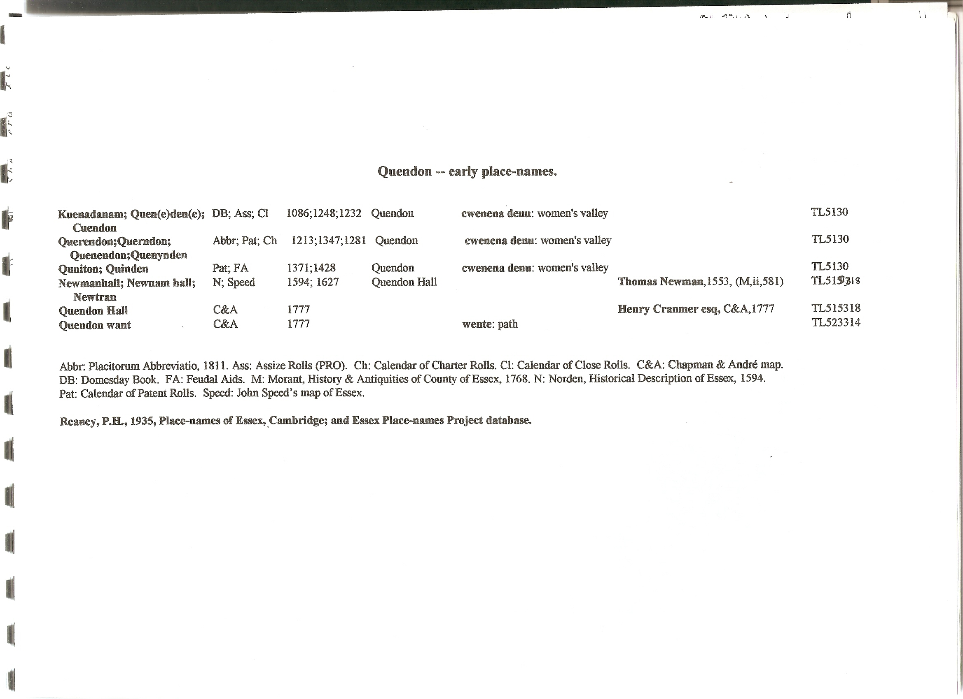

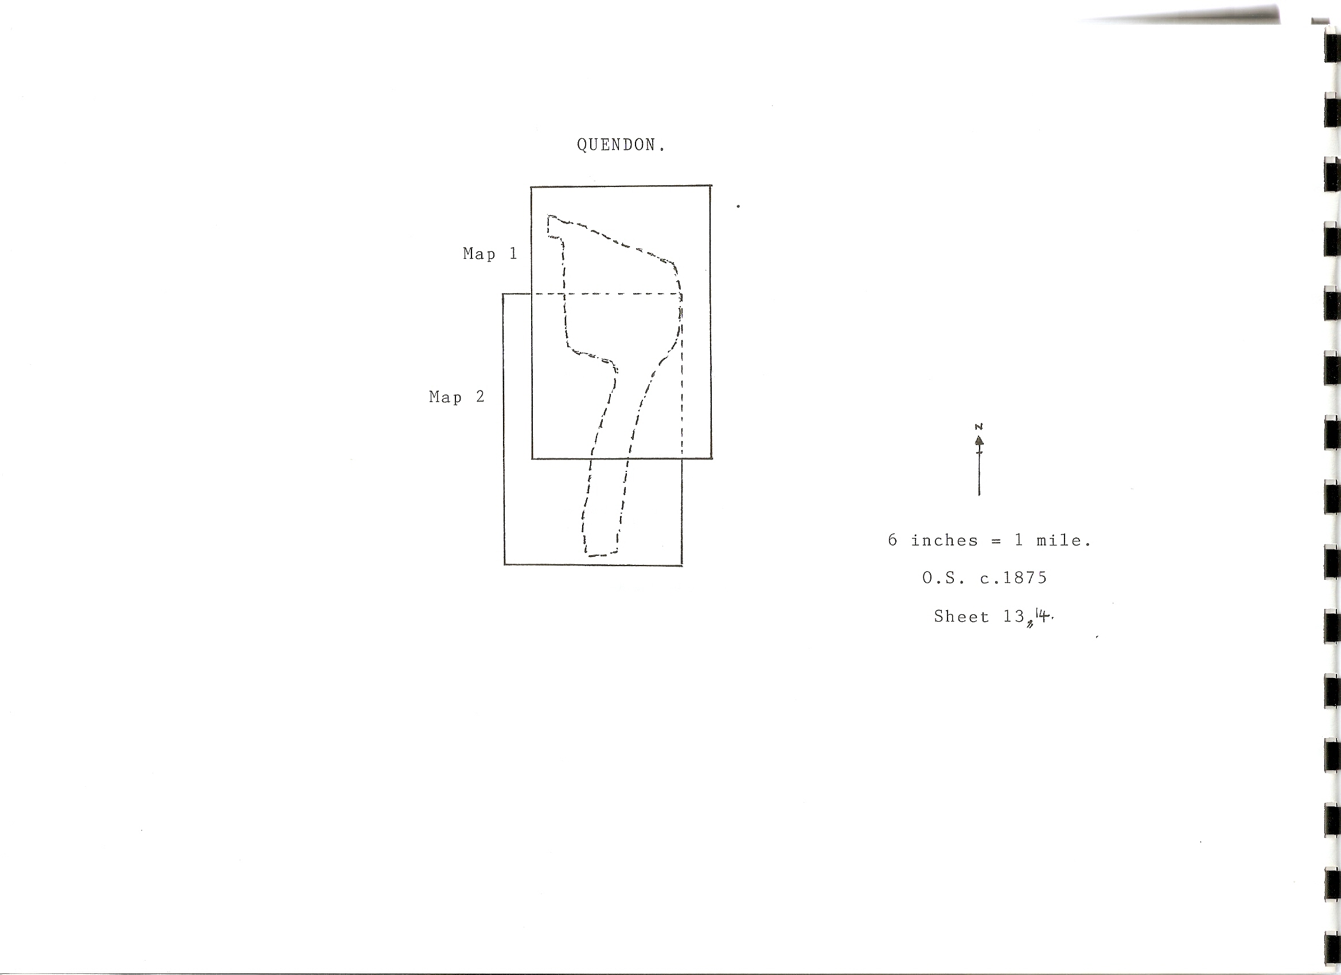
Tithe parcel nos. superimposed

