THE PLACE-NAMES

OF RAINHAM

Recorder: James Kemble

Essex Place-names Project (Essex Society for Archaeology & History), 2016 (e-book).

www.essex.ac.uk/histor-y/esah/essexplacenames

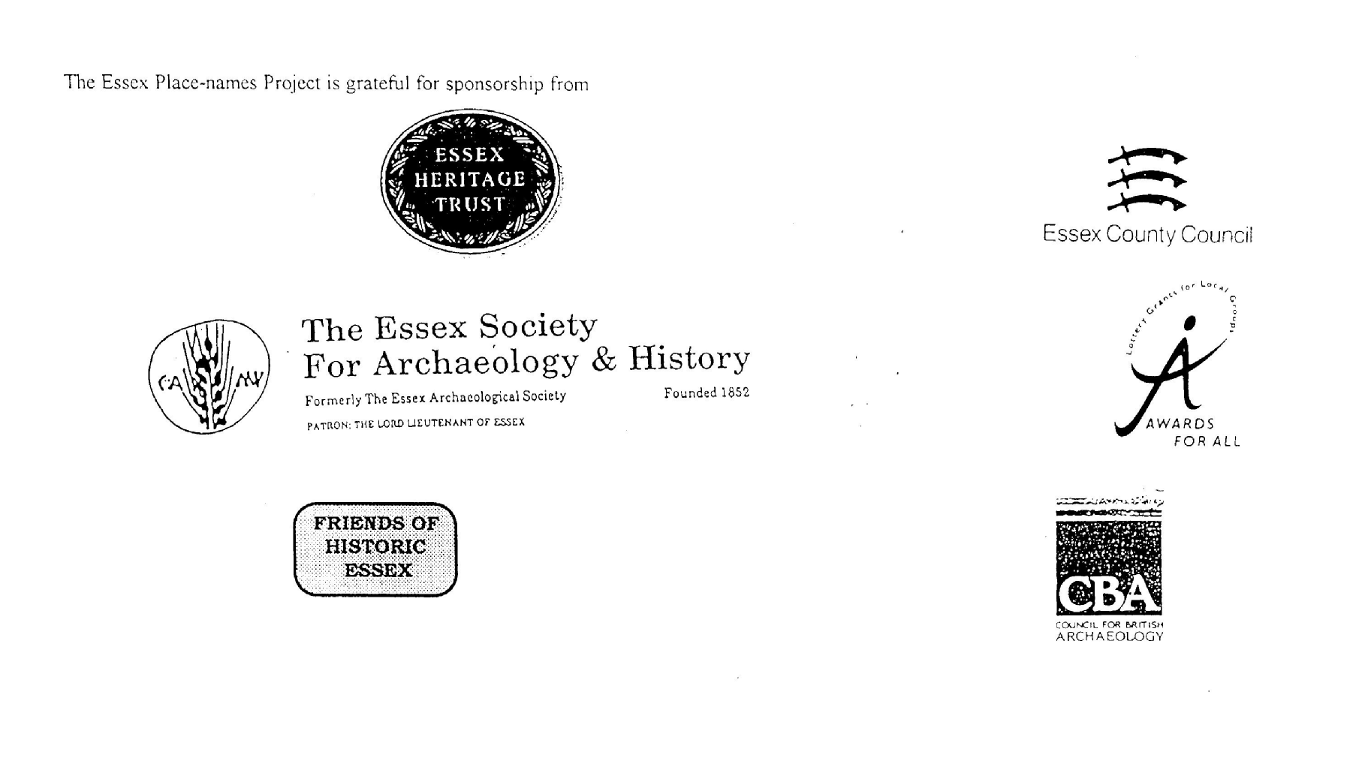

ESSEX PLACE-NAMES PROJECT.

The Essex Place-names Project is a County-wide survey to record place- and field-names from historical documents such as Tithe maps and apportionments, estate maps, sale
and auction catalogues, conveyances, terriers, deeds, rolls, inquisitions and surveys.

The second element of the Project is to investigate on-the-ground visible remains which correspond to the Place-names for actual or potential archaeological, agricultural and industrial sites, and to record natural (topographical) and man-made features which may relate to the Place-name. This involves field-survey in rural and outside investigation in built-up areas.

It is anticipated that the Project will lead to identification of archaeological sites and lost historic buildings; it will enable analysis of indicators of early settlement, land holding, agricultural and industrial practices of the County. It will refine the more precise meaning of descriptive words and elements used by earlier settlers as they gave names appropriate to the topography of the landscape of their time.

For convenience the surveys are based on the parish, recognising that present civil parish boundaries are not necessarily identical to former ecclesiastical boundaries. Local Recorders are supplied with templates of Record Forms to ensure consistency of recording across the County, and forward completed forms to a Central Coordinator for transfer to a county computer database which is available to researchers on the internet at www.essex.ac.uk/history/esah/essexplacenames, and updated periodically.

This publication presents part of the information recorded from the Tithe or Estate Award and Map, and from other documents for this parish. The full record is contained on the master database at Essex County Council (Historic Environment Section) and on the (above) website. Parish books are available to be downloaded from the website link ‘Books’ on the Home page. Please notify errors to the Project Coordinator at the Essex Record Office.

THE TITHE MAP AND APPORTIONMENT.

Since medieval times a tenth of the produce of land and stock had been paid by landholders to the church. At the Dissolution of the Monasteries, the property of many religious houses,
including the right to collect tithes, passed into lay hands. The Tithe Commutation Act which received Royal assent on 13th August 1836 abolished a rent payable in kind and
substituted rent-charges apportioned on each plot or parcel. The tithe-rent payable was assessed on the average value of wheat, barley and oats and was to fluctuate with price movements.

The commutation could be by voluntary agreement between the local owners and payers or, if agreement failed, could be compulsorily imposed by commissioners. A Valuer was to be appointed to apportion the rent of each parcel of land and tenants could deduct that rent-charge from their rent paid to the landlord. The task fell to the Tithe Commissioners to produce a map and an Apportionment (Award). A large-scale survey was produced for over 70% of England and Wales in the following 9 years, and about another 8% up to 1855. Most of the parishes in Essex were surveyed. The map scales vary. The Award records ownership, tenancy and land-use, field by field and parcel by parcel (often quoting the field name) with the ground area and rent-charge.

Land that was tithe-free tends to be less accurately mapped and contains few if any of the details recorded for those parcels subject to tithe. Rights of way and roads also tend to be neglected. Boundaries of the tithe areas are shown as are some natural features such as streams, ponds, gardens, greens and commons. Buildings are often shown coloured red if dwellingsor grey if not. Because the Award may have been agreed only some time after the map was finished, discrepancies occur between the two. Enclosure Awards, when extant, usually date to the 18th and early 19th centuries. J..Kemble.

Reproduced by permission
of Essex County Council.

Rainham Parish formerly in the County of Essex
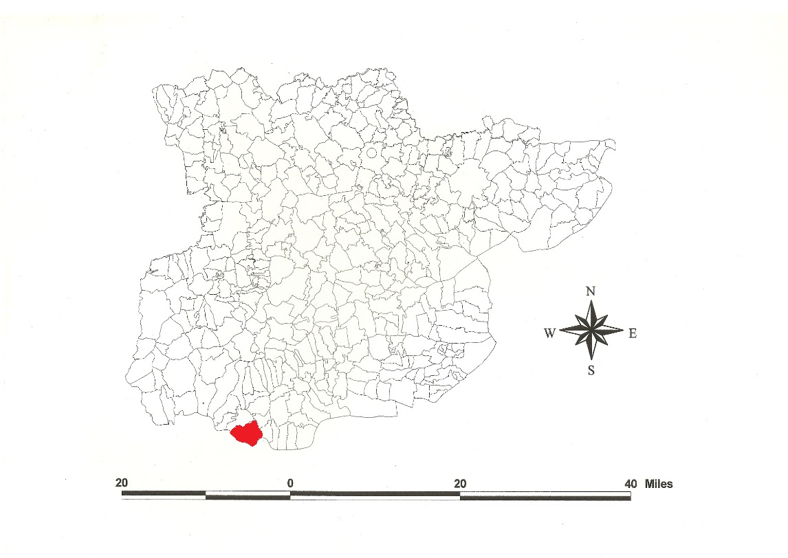
Reproduced by permission of
Essex County Council.

The Parish of Rainham (in Chafford Hundred).

The Tithe Award of Rainham (Essex Record Office D/CT 280a), dated 1838, shows a rent-charge of £260 including 15/0d for glebe payable to John Crosse Godsalve Crosse esq, impropriator of Great Tithes, and £430-10-0 including 15/0d for glebe to Rev John Thomas Godsalve Crosse, vicar, for Small Tithes. The whole parish measured 3140 acres 2 roods of which 1729 acres were subject to tithes. 897 acres 2 roods were arable, 798 acres were meadow and pasture, 21a 1r wood, 12a 1r homesteads and gardens. There was a modus of 20/0d for Moor Hall, 15/0d for Messuage Farm and Berwick Ponds Farm, 353a 1r, 15/0d for Berwick House Farm, 311a 2r, 10/0d for Rainham Lodge, 179a 2r. 166 acres 1 rood were tithe free. The Tithe Commissioners were William Blamire and R. Jones, the Valuers Samuel Weston and John Eaton Joyner of Laindon Hills and West Thurrock. The Tithe Map (ERO: D/CT 280b) dated 1839 was surveyed at a scale of 26.6” to one mile and measures 93”x61”. It was countersigned by Josh Townsend, Assistant Tithe Commissioner.

In Domesday Book, 1086, Hugh held Reneham from the Bishop of Bayeux which Alfsi had held as a manor for 4 hides before 1066; this was South Hall. Robert held Renaham from Robert Gernon which Alfward had held as a manor for 3½ hides; this was Berwick. Walter of Douai held Reineham in lordship which Leofstan the reeve had held before 1066 as a manor for 8 hides; this was Rainham Hall. Hagebern held Raineham which a priest had held for half a hide; this was Launders (Morris, 1983; Powell, 1984/5). Watts (2004) derives this from a personal name + Old English ham, ‘Regna’s homestead’, but allows comparison with the Kent Rainham, ‘homestead of the Roegingas, prevailing people’ (Kemble, 2007).

There were these manors: 1. South Hall; in 1254 Henry de Crammavill held 20 l. of land by service of the wardship of Dover Castle. 2. Berwic, 2 miles north of the church. Gilbert de Montfichet gave it to the Knights Templar, confirmed t. John. 3. Gerpins, named from the family Jarpenville, one mile NE of the church. Laurence de Jarpeville (died 1297) held of the Prior of St John of Jerusalem for 1/20th of a knight’s fee 60 acres of arable, 5 acres of meadow and 5 acres of pasture. 4. A caracute in Launders was acquired by marriage by Richard de Landa in 1205 and held by John Leventhorp in 1440. 5. Rainham Hall was granted by Gilbert de Vere to the Knights Hospitaller and one virgate (Elmhouse) to St Bartholomews Hospital c.1190 (Kemble, 2015). Dovers manor in Hornchurch extended by one-third in to Rainham. Moor Hall (Le More) in the SE of the parish was held by the Knights Hospitaller in 1314 (Morant, 1768: VCH, 1978).

East of Dovers Corner, excavations revealed a Bronze Age cremation cemetery, and, nearby, an Iron Age triple-ditched enclosure (Kemble, 2009). At Berwick Ponds Farm is evidence of a Saxon farmstead (Firth, 2003). Saxon drinking horns are in the British Museum. The Norman church dedicated to SS Helen and Giles was built c.1170 by Richard de Lucy, justicar, who married a daughter of Henry II. Rainham Hall, three stories, built c.1729 by John Harle, merchant and owner of Rainham wharf, has Corinthian columns. The Vicarage in the Broadway was built c.1710. Albyns is timber-framed C16/17, refronted in C18. Redbury House associated with the wharf is c.1800. The new Roman Catholic church of Our Lady of the Salette has superb aumbries (Weinreb, 1983; Pevsner, 2005).

The Hundred name Ceford, Cæfforde is documented in 1066-86 in Westminster Domesday. Ceffeorda, Ceffeworda, Ceffeurda appear in Domesday Book, 1086. Reaney (1935) derives this from OE cealfa weorth, ‘calves’ enclosure’. Christy (1926) suggests that the moot was on Chafford Heath in Upminster parish north of Heath Farm TQ567834 between Stubbers and Belhus.

Place- and field names from other documents are shown against the Tithe Award names.

References:

Christie, M., 1926. Essex Hundred Moots. Trans Essex Archaeological Soc., n.s., xviii
(3), 182.
Firth, H., 2003. Essex Archaeology & History, 34, 244. Rainham Berwick Ponds.
Kemble, J., 2007. Essex Place-names, Places, Streets & People. Historical Publications,
London, pp. 77, 131.
Kemble, J., 2009. Prehistoric & Roman Essex. History Press. pp 53, 151.
Kemble, J., 2015. Medieval Estates of St Bartholomews Hospital. Essex Journal, 50, 5.
Morant, P., 1763. History & Antiquities of the County of Essex, i, 87.
Morris, J., 1983. Domesday Book – Essex. Phillimore.
Pevsner, N., Cherry, B., Obrien, C., 2005. Buildings of England – London East. Yale.
Powell.W.R., 1984-5. Essex Domesday Topography. Essex Archaeology &
History, 16, 40.
Reaney, P., 1935. Place-names of Essex. Cambridge.
Victoria County History of Essex, 1978, vii, 126.
Watts, V., 2004. Dictionary of English Place-names. Cambridge.
Weinreb, B., Hibbert, C., 1983. London Encyclopaedia. London.

The Tithe Award Place-names of Rainham - by parcel no.

Place -name | alias | Fld No | Grd | X | y | Acr | Rd | Pch | Land use | Owner | Occupier | Farm | Other information
Wall Marsh |  | 1 | TQ | 515 | 810 | 12 | 2 | 18 | arable | Crosse, John Crosse Godsalve esq | Blewitt, Mr Wm
Reed Shore | Wadeflet, 1206,Cur; Raynam flete, 1547, Pat; Rainham Creek, 1839,Tithe map | 2 | TQ | 514 | 810 | 1 | 0 | 4 |  | Crosse, John Crosse Godsalve esq | Blewitt, Mr Wm
Bennetts Salts |  | 3 | TQ |  |  | 5 | 1 | 22 | sltg | Freeman, John, esq | Freeman, John, esq
Bennetts Marsh |  | 4 | TQ | 517 | 813 | 30 | 3 | 33 | pasture | Freeman, John, esq | Freeman, John, esq
Corner piece |  | 5 | TQ |  |  | 2 | 2 | 20 | pasture | Freeman, John, esq | Freeman, John, esq
Little Town Marsh |  | 6 | TQ | 519 | 815 | 14 | 3 | 15 | pasture | Surridge, North, esq | Surridge, North, esq
Great Salt Marsh |  | 7 | TQ |  |  | 4 | 3 | 16 | pasture | Surridge, North, esq | Surridge, North, esq
Great Town Marsh |  | 8 | TQ | 521 | 816 | 23 | 2 | 17 | pasture | Surridge, North, esq | Eve, Mr Charles
The Garden |  | 9 | TQ |  |  | 0 | 1 | 10 | gdn | Smith, Mr William | Ennever, Mr John
Hilly Marsh |  | 10 | TQ | 523 | 817 | 10 | 3 | 14 | pasture | Smith, Mr William | Ennever, Mr John
Little Brights |  | 11 | TQ | 526 | 816 | 11 | 3 | 36 | arable | Crosse, John Crosse Godsalve esq | Blewitt, Mr Wm | New Hall (pt) | cut by railway, 1875,OS
Eighteen acres |  | 12 | TQ |  |  | 15 | 3 | 4 | pasture | Surridge, Mr John | Surridge, Mr North
Lady mead | Rifle Ranges, 1932,OS | 13 | TQ | 523 | 814 | 21 | 2 | 24 | pasture | Surridge, North, esq | Surridge, North, esq
Thirty acres |  | 14 | TQ |  |  | 34 | 1 | 13 | pasture | Surridge, Mr John | Surridge, Mr North
Bandy Hook |  | 15 | TQ | 524 | 811 | 24 | 0 | 29 | pasture | Smith, Mr William | Ennever, Mr John
Five acres |  | 16 | TQ |  |  | 5 | 2 | 8 | pasture | Surridge, Robert,esq | Surridge, Robert, esq
Eleven acres |  | 17 | TQ |  |  | 11 | 2 | 2 | arable | Benton, Mr Samuel | Benton, Mr Samuel
Thirteen acres |  | 18 | TQ |  |  | 13 | 0 | 17 | pasture | Crosse, John Crosse Godsalve esq | Blewitt, Mr Wm
Five acres |  | 19 | TQ | 520 | 808 | 5 | 0 | 18 | pasture | Dare, Robt Westley Hall, esq | Marden, Mr Wiliam, jnr
The Long Marsh | le mersshe, 1487, MnAt; Rainham Marsh, 1875,OS | 20 | TQ | 522 | 807 | 12 | 3 | 18 | pasture | Dare, Robt Westley Hall, esq | Marden, Mr Wiliam, jnr
Eight acres |  | 21 | TQ |  |  | 8 | 0 | 28 | pasture | Dare, Robt Westley Hall, esq | Marden, Mr Wiliam, jnr
Seven acres |  | 22 | TQ |  |  | 7 | 1 | 14 | pasture | Dare, Robt Westley Hall, esq | Marden, Mr Wiliam, jnr
Sheep House Marsh |  | 23 | TQ | 522 | 804 | 24 | 1 | 17 | pasture | Dare, Robt Westley Hall, esq | Freeman, Mr Robert
Ten acres |  | 24 | TQ | 520 | 806 | 10 | 3 | 14 | pasture | Dare, Robt Westley Hall, esq | Benton, Mr Samuel
Great Carters marsh |  | 25 | TQ | 518 | 808 | 11 | 1 | 38 | pasture | Banks, Thomas, esq | Benton, Mr Samuel
Brick house marsh | [at Manor Way, 1875,OS] | 26 | TQ | 517 | 810 | 4 | 1 | 2 | arable | Dare, Robt Westley Hall, esq | Benton, Mr William
Little Carters marsh |  | 27 | TQ | 516 | 809 | 6 | 3 | 0 | pasture | Banks, Thomas, esq | Benton, Mr Samuel
Ferry Lane marsh |  | 28 | TQ | 515 | 808 | 5 | 3 | 34 | pasture | Pead, Benjamin, esq | Joslin, Mr Henry
Wall marsh |  | 29 | TQ |  |  | 5 | 3 | 36 | pasture | Pead, Benjamin, esq | Joslin, Mr Henry
Wall, Reed Shore |  | 30 | TQ | 514 | 808 | 1 | 1 | 11 | pasture | Pead, Benjamin, esq | Joslin, Mr Henry
Wall, Reed Shore |  | 31 | TQ |  |  | 1 | 2 | 22 | . | Dare, Robt Westley Hall, esq | Lee, Mr Joseph
Lane piece |  | 32 | TQ |  |  | 1 | 0 | 22 | pasture | Dare, Robt Westley Hall, esq | Lee, Mr Joseph
Ferry Lane marsh |  | 33 | TQ | 516 | 806 | 5 | 0 | 31 | pasture | Dare, Robt Westley Hall, esq | Benton, Mr Samuel
Ferry Marsh |  | 34 | TQ | 517 | 805 | 16 | 0 | 29 | pasture | Dare, Robt Westley Hall, esq | Benton, Mr Samuel
Three Crowns P.H. |  | 35 | TQ | 516 | 804 | 0 | 2 | 20 | gdn | Lee, Joseph, esq | Collins, Mr Thomas
Wall, Reed Shore |  | 36 | TQ |  |  | 0 | 2 | 1 |  | Lee, Joseph, esq | Collins, Mr Thomas
The Saltings |  | 37 | TQ |  |  | 0 | 3 | 6 | sltg | Lee, Joseph, esq | Collins, Mr Thomas
The Close |  | 38 | TQ |  |  | 3 | 0 | 27 | pasture | Lee, Joseph, esq | Collins, Mr Thomas
Well Marsh |  | 39 | TQ | 519 | 804 | 17 | 0 | 3 | pasture | Dare, Robt Westley Hall, esq | Benton, Mr Samuel
The Ferry marsh |  | 40 | TQ | 519 | 800 | 17 | 1 | 23 | pasture | Surridge, North, esq | Surridge, North, esq
Little Salt marsh |  | 41 | TQ |  |  | 1 | 1 | 39 | pasture | Surridge, North, esq | Surridge, North, esq
Pent Stock Marsh |  | 42 | TQ | 524 | 806 | 21 | 0 | 17 | pasture | Dare, Robt Westley Hall, esq | Freeman, Mr Robert
Saltings | adj. Tamesim, 54BC, Caesar; ripa Tamensis, c730,Bede; River Thames, 1932,OS | 43 | TQ | 520 | 798 | 4 | 2 | 11 | pasture | Dare, Robt Westley Hall, esq | Freeman, Mr Robert
Wall, Saltings |  | 44 | TQ |  |  | 5 | 1 | 5 | pasture | Dare, Robt Westley Hall, esq | Heathcote, Mr Thomas
Sluice piece |  | 45 | TQ |  |  | 1 | 0 | 12 | pasture | Dare, Robt Westley Hall, esq | Heathcote, Mr Thomas
House, yd | Little Coldharbour, 1875,OS | 46 | TQ | 521 | 795 | 1 | 0 | 25 |  | Dare, Robt Westley Hall, esq | Heathcote, Mr Thomas |  | OE here-beorg = shelter/lodging, later derogatory. See Coates, R., 1984, Nomina, 8, p73
Pent Stock piece |  | 47 | TQ |  |  | 3 | 2 | 12 | pasture | Dare, Robt Westley Hall, esq | Heathcote, Mr Thomas
Middle marsh |  | 48 | TQ |  |  | 6 | 0 | 17 | pasture | Dare, Robt Westley Hall, esq | Heathcote, Mr Thomas
Wall marsh |  | 49 | TQ | 522 | 792 | 14 | 1 | 18 | pasture | Dare, Robt Westley Hall, esq | Heathcote, Mr Thomas
Crooket five acres |  | 52 | TQ | 523 | 798 | 5 | 0 | 24 | pasture | Dare, Robt Westley Hall, esq | Heathcote, Mr Thomas
Twenty eight acres |  | 53 | TQ |  |  | 28 | 2 | 1 | pasture | Dare, Robt Westley Hall, esq | Heathcote, Mr Thomas
Waters marsh (pt) |  | 55 | TQ |  |  | 5 | 3 | 24 | pasture | Dare, Robt Westley Hall, esq | Benton, Mr Samuel
Nether Bitterns |  | 56 | TQ | 530 | 798 | 5 | 2 | 34 | pasture | Crosse, John Crosse Godsalve esq | Polley, Mr James
Eighteen acres |  | 59 | TQ |  |  | 15 | 2 | 38 | pasture | Dare, Robt Westley Hall, esq | Heathcote, Mr Thomas
Sheep House Marsh |  | 60 | TQ | 524 | 802 | 24 | 0 | 11 | pasture | Dare, Robt Westley Hall, esq | Benton, Mr Samuel
Top piece |  | 62 | TQ |  |  | 3 | 1 | 19 | pasture | Dare, Robt Westley Hall, esq | Heathcote, Mr Thomas
Eight Acre March |  | 63 | TQ | 526 | 807 | 8 | 3 | 25 | pasture | Crosse, John Crosse Godsalve esq | Surridge, Mr North
Dikes slipe |  | 64 | TQ | 528 | 807 | 8 | 0 | 24 | pasture | Crosse, John Crosse Godsalve esq | Surridge, Mr North
Wennington Marsh |  | 65 | TQ | 531 | 800 | 12 | 0 | 31 | pasture | Martin, Miss Esther Emeline; Surridge, Mr John | Surridge, Mr North
Elm Marsh | cp. Elmhouse, 1295, Elmehuses, c1300, StBart Cartulary [1245 & 1246] | 66 | TQ | 530 | 806 | 16 | 1 | 24 | pasture | Crosse, John Crosse Godsalve esq | Blewitt, Mr Wm | New Hall (pt) | Grant by John son of Henry Sott to GeoffreyCranbroke, with arable, pasture & meadow, 1295, St Bart Cartulary
Twenty acres |  | 67 | TQ |  |  | 23 | 3 | 4 | pasture | Crosse, John Crosse Godsalve esq | Blewitt, Mr Wm | New Hall (pt)
Middle Bitterns |  | 68 | TQ |  |  | 14 | 1 | 20 | pasture | Crosse, John Crosse Godsalve esq | Polley, Mr James
Long Bitterns | water called the Byttorne, 1545,LP | 69 | TQ | 532 | 805 | 31 | 0 | 3 | pasture | Crosse, John Crosse Godsalve esq | Polley, Mr James
Half the Rant |  | 70 | TQ | 531 | 860 | 1 | 0 | 38 | pasture | Crosse, John Crosse Godsalve esq | Blewitt, Mr Wm | New Hall (pt)
Half the Rant |  | 70a | TQ | 531 | 860 | 1 | 0 | 38 | arable | Crosse, John Crosse Godsalve esq | Polley, Mr James
First Elm Marsh |  | 71 | TQ |  |  | 17 | 1 | 6 | pasture | Crosse, John Crosse Godsalve esq | Blewitt, Mr Wm | New Hall (pt) | [see Kerling, N., 1973, Cartulary of St Bartholomews Hospital; and Kemble, J., 2015, Essex Jrnl 50(i), p5
Ten acre Marsh |  | 72 | TQ |  |  | 10 | 3 | 26 | pasture | Crosse, John Crosse Godsalve esq | Surridge, Mr North
Pound Marsh |  | 73 | TQ | 526 | 809 | 16 | 0 | 0 | pasture | Crosse, John Crosse Godsalve esq | Surridge, Mr North
Bakers Marsh |  | 74 | TQ |  |  | 15 | 3 | 14 | pasture | Crosse, John Crosse Godsalve esq | Surridge, Mr North |  | cut by railway, 1875,OS
Great Bakers Marsh |  | 75 | TQ | 530 | 810 | 18 | 0 | 14 | pasture | Crosse, John Crosse Godsalve esq | Surridge, Mr North
Little Marsh |  | 76 | TQ |  |  | 14 | 3 | 23 | pasture | Crosse, John Crosse Godsalve esq | Blewitt, Mr Wm | New Hall (pt)
Little Square Piece |  | 77 | TQ | 529 | 816 | 0 | 2 | 8 | pasture | Dare, Robt Westley Hall, esq | Freeman, Mr Robert
Oziers |  | 78 | TQ |  |  | 0 | 3 | 13 | oziers | Dare, Robt Westley Hall, esq | Freeman, Mr Robert
Square piece |  | 79 | TQ |  |  | 0 | 1 | 9 | arable | Dare, Robt Westley Hall, esq | Freeman, Mr Robert
Wat Ground | cf. Jakwatteslandys, 1487,MnAt | 80 | TQ | 530 | 815 | 27 | 2 | 13 | pasture | Dare, Robt Westley Hall, esq | Freeman, Mr Robert
Front Pasture |  | 81 | TQ |  |  | 22 | 0 | 7 | pasture | Dare, Robt Westley Hall, esq | Freeman, Mr Robert
Home mead |  | 82 | TQ |  |  | 7 | 2 | 39 | pasture | Dare, Robt Westley Hall, esq | Freeman, Mr Robert
South Hall | Reneham, 1086,DB; South(h)all[e], 1338,Cl, 1498,Pat | 83 | TQ | 534 | 814 | 2 | 3 | 8 |  | Dare, Robt Westley Hall, esq | Freeman, Mr Robert
Horse pasture |  | 84 | TQ |  |  | 3 | 1 | 16 | pasture | Dare, Robt Westley Hall, esq | Freeman, Mr Robert
Barn field |  | 85 | TQ |  |  | 9 | 1 | 38 | arable | Dare, Robt Westley Hall, esq | Freeman, Mr Robert
Mill Hill Field | [at Lambs Lane, 1875,OS] | 86 | TQ | 534 | 818 | 24 | 3 | 38 | arable | Dare, Robt Westley Hall, esq | Freeman, Mr Robert
Twenty acres |  | 87 | TQ |  |  | 23 | 1 | 36 | arable | Dare, Robt Westley Hall, esq | Freeman, Mr Robert
Drift pasture |  | 89 | TQ |  |  | 21 | 0 | 25 | pasture | Dare, Robt Westley Hall, esq | Freeman, Mr Robert
Long mead |  | 90 | TQ | 540 | 816 | 13 | 2 | 18 | pasture | Dare, Robt Westley Hall, esq | Freeman, Mr Robert
Great field |  | 92 | TQ |  |  | 25 | 1 | 2 | arable | Dare, Robt Westley Hall, esq | Benton, Mr William
Eighteen acres |  | 94 | TQ |  |  | 18 | 0 | 32 | arable | Dare, Robt Westley Hall, esq | Benton, Mr Samuel
The Wood & cottage | Spring Cottages, 1875,OS | 95 | TQ | 543 | 824 | 5 | 1 | 13 | wood | Dare, Robt Westley Hall, esq | Dare, Robt Westley Hall, esq
Great field |  | 96 | TQ | 542 | 826 | 31 | 2 | 26 | arable | Dare, Robt Westley Hall, esq | Benton, Mr Samuel
Lane field | [at Launders Lane, 1875,OS] | 97 | TQ | 545 | 825 | 17 | 0 | 24 | arable | Dare, Robt Westley Hall, esq | Benton, Mr Samuel
Aylets field |  | 98 | TQ | 545 | 828 | 15 | 2 | 14 | arable | Dare, Robt Westley Hall, esq | Benton, Mr Samuel
Great field |  | 99 | TQ | 544 | 830 | 38 | 3 | 4 | arable | Crosse, John Crosse Godsalve esq | Blewitt, Mr Wm
Great field |  | 100 | TQ | 540 | 839 | 34 | 0 | 0 | arable | Crosse, John Crosse Godsalve esq | Surridge, Mr North | Barwick House (pt)
Thirty acres |  | 101 | TQ |  |  | 30 | 1 | 17 | arable | Crosse, John Crosse Godsalve esq | Blewitt, Mr Wm
Barn field |  | 102 | TQ |  |  | 14 | 3 | 23 | arable | Crosse, John Crosse Godsalve esq | Blewitt, Mr Wm | New Hall (pt)
Acre piece |  | 104 | TQ |  |  | 1 | 0 | 22 | arable | Dare, Robt Westley Hall, esq | Freeman, Mr Robert
Lane Two acres | [at Lambs Lane, 1875,OS] | 105 | TQ | 536 | 824 | 2 | 0 | 33 | arable | Gale, Mr John | Blewitt, Mr William
The Three acres |  | 107 | TQ |  |  | 2 | 3 | 37 | arable | Gale, Mr John | Blewitt, Mr William
Cartlodge field |  | 108 | TQ | 533 | 822 | 22 | 3 | 5 | pasture | Crosse, John Crosse Godsalve esq | Blewitt, Mr Wm | New Hall (pt)
Cottages | Wants Cottages, 1875,OS | 111 | TQ | 531 | 817 | 0 | 2 | 9 | gdn | Freeman, Mr Robert | Lee, Thomas; others
Giles field |  | 112 | TQ |  |  | 19 | 0 | 19 | arable | Crosse, John Crosse Godsalve esq | Blewitt, Mr Wm | New Hall (pt)
Brights Farm |  | 113 | TQ | 531 | 823 | 3 | 0 | 30 |  | Crosse, John Crosse Godsalve esq | Blewitt, Mr Wm | New Hall (pt)
Home slip |  | 114 | TQ |  |  | 4 | 0 | 34 | pasture | Crosse, John Crosse Godsalve esq | Blewitt, Mr Wm | New Hall (pt)
Road field |  | 115 | TQ |  |  | 6 | 2 | 16 | arable | Crosse, John Crosse Godsalve esq | Blewitt, Mr Wm | New Hall (pt)
Town field |  | 116 | TQ | 527 | 820 | 21 | 2 | 18 | arable | Crosse, John Crosse Godsalve esq | Blewitt, Mr Wm | New Hall (pt)
Great Brights |  | 117 | TQ | 528 | 817 | 23 | 1 | 23 | arable | Crosse, John Crosse Godsalve esq | Blewitt, Mr Wm | New Hall (pt)
Captains field |  | 118 | TQ | 525 | 819 | 8 | 2 | 24 | pasture | Chambers, Miss Susanna Dearsley | Daldy, Mrs Catherine
Houses |  | 119 | TQ |  |  | 0 | 0 | 34 | gdn | French, Joseph, esq | Turrell, Mr David; others
Cottages |  | 120 | TQ | 525 | 820 | 0 | 0 | 16 | gdn | Miles, Wm, esq | Wintern, Benjamin; others
Cottage |  | 121 | TQ | 525 | 820 | 0 | 0 | 11 | gdn | Gale, Mrs Sarah | Britt, Benjamin
Cottages |  | 122 | TQ |  |  | 0 | 0 | 21 | gdn | Beal, Mr Francis | Everitt, John; others
Cottages |  | 123 | TQ | 524 | 819 | 0 | 0 | 18 | gdn | Surridge, North, esq | Phillips, Thomas; another
Cottage |  | 124 | TQ | 524 | 819 | 0 | 0 | 14 | gdn | Daldy, Mrs Caroline | Edward, John ; others
Cottage |  | 125 | TQ | 523 | 819 | 0 | 0 | 35 | gdn | Smith, Mr Stephen | Smith, Mr Stephen
Church yard | [SS Giles & Helens] | 126 | TQ | 522 | 819 | 0 | 2 | 32 |  | Crosse, Rev John | Crosse, Rev John |  | vicarial glebe
Mansion, gdns | Reineham, 1086,DB; Rainham Hall, 1777,C | 127 | TQ | 523 | 818 | 2 | 1 | 20 |  | Chambers, Miss Susanna Dearsley | Daldy, Mrs Catherine
Piece near the Village |  | 128 | TQ |  |  | 0 | 3 | 34 | pasture | Crosse, John Crosse Godsalve esq | Crosse, John Crosse Godsalve esq
Chapel, cottages |  | 129 | TQ |  |  | 0 | 0 | 27 | gdn | Stafford, Mr James | Bassett, Wm; others
Phoenix Inn |  | 130 | TQ | 522 | 819 | 0 | 1 | 30 | gdn | Ind, Edward, esq | Horvell, Mr Thomas
Hoppit |  | 131 | TQ |  |  | 0 | 2 | 16 | pasture | Surridge, North, esq | Mayhew, Mr Samuel
Butchers shop, yd |  | 132 | TQ |  |  | 0 | 1 | 8 | gdn | Surridge, North, esq | Mayhew, Mr Samuel
Cottage |  | 133 | TQ |  |  | 0 | 1 | 2 | gdn | Stafford, Mr James | Stafford, Mr George
Cottage |  | 134 | TQ |  |  | 0 | 0 | 5 | gdn | Wallis, Mr Wm | Rainham parish
Cottage |  | 135 | TQ | 521 | 819 | 0 | 0 | 4 | . | Lee, Joseph, esq | Innever, James
Cottage |  | 136 | TQ | 521 | 819 | 0 | 0 | 6 | . | Benton, Mr Samuel | Hall, Joseph
Vicarage |  | 137 | TQ | 522 | 819 | 0 | 1 | 17 | gdn | Crosse, Rev John | Crosse, Rev John |  | vicarial glebe
House |  | 138 | TQ |  |  | 0 | 1 | 32 | gdn | Surridge, North, esq | Eve, Mr Charles
Hoppit |  | 139 | TQ |  |  | 0 | 2 | 30 | pasture | Surridge, North, esq | Eve, Mr Charles
Angel Public House |  | 140 | TQ | 521 | 819 | 0 | 0 | 19 | . | Harvey, Mr Stephen | Beal, Mr George
Malting wharf, premises |  | 141 | TQ | 521 | 819 | 1 | 2 | 2 | . | Chambers, Miss Susanna Dearsley | Daldy, Mrs Catherine
Lousy mead | adj. ingceburne, 1062, KCD; River Ingerburn, 1777,C; Ingrebourne River, 1932,OS | 142 | TQ | 522 | 821 | 1 | 3 | 9 | pasture | Chambers, Miss Susanna Dearsley | Daldy, Mrs Catherine
Bridge meadow | [at Red Bridge, 1875,OS] | 143 | TQ | 523 | 822 | 5 | 2 | 23 | pasture | Beal, Mr Francis | Beal, Mr George
Bell Public House |  | 144 | TQ | 522 | 820 | 0 | 1 | 4 | gdn | St Giles London, parish of | Ennever, Mr John
Cottage |  | 145 | TQ |  |  | 0 | 0 | 18 | gdn | Gentry, Mr Mark | Ennever, Mr Robert
Houses |  | 146 | TQ |  |  | 0 | 1 | 5 | gdn | French, Joseph, esq | Gentry, Mr Mark; others
Blacksmiths shop, cottages |  | 147 | TQ | 522 | 820 | 0 | 0 | 22 | gdn | Barrett, Mr Edward | Payne, Mr Henry; others
Cottages |  | 148 | TQ |  |  | 0 | 1 | 17 | gdn | Beal, Mr Francis | Hill, Mr John; others
Town field |  | 150 | TQ | 524 | 821 | 7 | 3 | 27 | pasture | Beal, Mr Francis | Beal, Mr George
Coney mead |  | 151 | TQ |  |  | 2 | 3 | 24 | pasture | Beal, Mr Francis | Beal, Mr George
Cottages |  | 152 | TQ |  |  | 0 | 0 | 23 | gdn | Smith, Mr Stephen | Gregory, Thomas
Wheelwrights shop, house |  | 153 | TQ | 525 | 821 | 0 | 0 | 26 |  | Surridge, North, esq | Vandeyward, Mr Wm
House |  | 154 | TQ |  |  | 0 | 0 | 25 | gdn | Marden, William, esq | Cooper, Mr Richard; others
Old School House |  | 155 | TQ | 525 | 821 | 0 | 0 | 22 | gdn | Rainham parish | Blewitt, Mr Wm
Land |  | 156 | TQ |  |  | 2 | 0 | 17 | pasture | French, Joseph, esq | Gentry, Mr Mark
Second Coney mead |  | 157 | TQ | 524 | 822 | 3 | 2 | 18 | pasture | Beal, Mr Francis | Beal, Mr George
4th Mead (pt) |  | 158 | TQ |  |  | 1 | 3 | 29 | pasture | Beal, Mr Francis | Beal, Mr George
4th Mead (pt) |  | 159 | TQ |  |  | 1 | 0 | 36 | pasture | Beal, Mr Francis | Beal, Mr George
Barn field |  | 160 | TQ |  |  | 3 | 0 | 11 | arable | French, Joseph, esq | Benton, Mr William
Burnt Barn yd & lane | Phoenix Building, 1875,OS | 161 | TQ | 528 | 823 | 0 | 1 | 6 |  | French, Joseph, esq | Benton, Mr William
First meadow |  | 163 | TQ |  |  | 2 | 2 | 26 | pasture | French, Joseph, esq | Benton, Mr William
Second meadow |  | 164 | TQ | 526 | 825 | 1 | 2 | 22 | pasture | French, Joseph, esq | Benton, Mr William
First meadow |  | 165 | TQ |  |  | 2 | 2 | 26 | pasture | Dare, Robt Westley Hall, esq | Benton, Mr William
Second meadow |  | 166 | TQ |  |  | 2 | 0 | 9 | pasture | Dare, Robt Westley Hall, esq | Benton, Mr William
Cottage |  | 169 | TQ |  |  | 0 | 1 | 1 |  | Dare, Robt Westley Hall, esq | Johnson, Thomas
Cottage |  | 170 | TQ | 528 | 823 | 0 | 0 | 10 | gdn | Vincent, John | Vincent, John
Cottage |  | 171 | TQ | 528 | 823 | 0 | 0 | 15 | gdn | Graham, Mrs Mary | Arter, Richard; others
Cottage |  | 172 | TQ | 528 | 823 | 0 | 0 | 34 | arable | French, Joseph, esq | Benton, Mr William
Brick House |  | 173 | TQ | 530 | 824 | 0 | 3 | 25 |  | Dare, Robt Westley Hall, esq | Benton, Mr William
Home field |  | 174 | TQ |  |  | 3 | 1 | 21 | pasture | Dare, Robt Westley Hall, esq | Benton, Mr William
Eight acres |  | 176 | TQ |  |  | 7 | 2 | 2 | arable | Dare, Robt Westley Hall, esq | Benton, Mr William
Third meadow |  | 177 | TQ |  |  | 2 | 0 | 8 | pasture | Dare, Robt Westley Hall, esq | Benton, Mr William
First Lower marsh |  | 180 | TQ | 530 | 829 | 2 | 2 | 20 | pasture | Crosse, John Crosse Godsalve esq | Blewitt, Mr Wm
Second Lower marsh |  | 181 | TQ |  |  | 3 | 0 | 24 | pasture | Crosse, John Crosse Godsalve esq | Blewitt, Mr Wm
Third Lower marsh |  | 182 | TQ |  |  | 8 | 2 | 16 | pasture | Crosse, John Crosse Godsalve esq | Blewitt, Mr Wm
Jorden mead |  | 183 | TQ | 533 | 832 | 7 | 1 | 17 | pasture | Crosse, John Crosse Godsalve esq | Blewitt, Mr Wm
Oziers |  | 184 | TQ |  |  | 0 | 2 | 4 | oziers | Crosse, John Crosse Godsalve esq | Blewitt, Mr Wm
Sandpit field |  | 185 | TQ | 533 | 830 | 11 | 2 | 36 | arable | Crosse, John Crosse Godsalve esq | Blewitt, Mr Wm
Parsonage farm | Rainham Parsonage, 1777,C | 186 | TQ | 531 | 828 | 6 | 1 | 20 |  | Crosse, John Crosse Godsalve esq | Blewitt, Mr Wm
Barn field |  | 187 | TQ |  |  | 4 | 3 | 16 | pasture | Crosse, John Crosse Godsalve esq | Blewitt, Mr Wm
Four acres |  | 189 | TQ |  |  | 4 | 1 | 24 | pasture | Crosse, Rev John | Blewitt, Mr William
Fourteen acres |  | 190 | TQ |  |  | 13 | 1 | 0 | arable | Crosse, John Crosse Godsalve esq | Blewitt, Mr Wm
Cartlodge field |  | 191 | TQ | 534 | 827 | 8 | 3 | 22 | arable | Crosse, John Crosse Godsalve esq | Blewitt, Mr Wm
Ten acres |  | 192 | TQ |  |  | 10 | 0 | 31 | arable | Crosse, John Crosse Godsalve esq | Blewitt, Mr Wm
Further field |  | 193 | TQ |  |  | 14 | 1 | 20 | arable | Crosse, John Crosse Godsalve esq | Blewitt, Mr Wm
Thistly field |  | 194 | TQ |  |  | 3 | 0 | 0 | pasture | Crosse, John Crosse Godsalve esq | Blewitt, Mr Wm
Meadow |  | 196 | TQ |  |  | 16 | 3 | 37 | pasture | Crosse, John Crosse Godsalve esq | Blewitt, Mr Wm
Oziers, Cottage, Wood | Abbey House, Abbey Wood, 1875,OS | 197 | TQ | 536 | 836 | 7 | 0 | 31 | oziers, wd | Crosse, John Crosse Godsalve esq | Crosse, John Crosse Godsalve esq | Barwick House (pt)
Broom field |  | 198 | TQ |  |  | 6 | 1 | 0 | pasture | Crosse, John Crosse Godsalve esq | Surridge, Mr North | Barwick House (pt)
Eighteen acres |  | 199 | TQ |  |  | 18 | 0 | 6 | arable | Crosse, John Crosse Godsalve esq | Surridge, Mr North | Barwick House (pt)
Twenty acres |  | 200 | TQ |  |  | 20 | 3 | 4 | arable | Crosse, John Crosse Godsalve esq | Surridge, Mr North | Barwick House (pt)
Stub field |  | 201 | TQ | 542 | 833 | 8 | 3 | 10 | arable | Crosse, John Crosse Godsalve esq | Surridge, Mr North | Barwick House (pt)
The Ponds | Berwick Pond, 1875,OS | 202 | TQ | 540 | 835 | 19 | 0 | 6 |  | Crosse, John Crosse Godsalve esq | Crosse, John Crosse Godsalve esq | Barwick House (pt)
Pond Three Acres |  | 203 | TQ |  |  | 3 | 0 | 28 | arable | Crosse, John Crosse Godsalve esq | Crosse, John Crosse Godsalve esq | Barwick House (pt)
Dove house field |  | 204 | TQ | 545 | 834 | 8 | 0 | 27 | pasture | Crosse, John Crosse Godsalve esq | Crosse, John Crosse Godsalve esq | Barwick House (pt)
Pond two acres |  | 205 | TQ | 546 | 835 | 2 | 3 | 24 | arable | Crosse, John Crosse Godsalve esq | Crosse, John Crosse Godsalve esq | Barwick House (pt)
Home mead |  | 206 | TQ |  |  | 3 | 0 | 17 | pasture | Crosse, John Crosse Godsalve esq | Crosse, John Crosse Godsalve esq | Barwick House (pt)
Wood |  | 207 | TQ | 547 | 835 | 1 | 1 | 23 | wood | Crosse, John Crosse Godsalve esq | Crosse, John Crosse Godsalve esq | Barwick House (pt)
Horse pasture |  | 208 | TQ |  |  | 4 | 3 | 21 | pasture | Crosse, John Crosse Godsalve esq | Crosse, John Crosse Godsalve esq | Barwick House (pt)
Little mead |  | 209 | TQ |  |  | 1 | 3 | 7 | pasture | Crosse, John Crosse Godsalve esq | Crosse, John Crosse Godsalve esq | Barwick House (pt)
Eighteen acres |  | 210 | TQ |  |  | 18 | 2 | 13 | arable | Crosse, John Crosse Godsalve esq | Crosse, John Crosse Godsalve esq | Barwick House (pt)
Corner field |  | 211 | TQ | 548 | 832 | 13 | 2 | 7 | arable | Crosse, John Crosse Godsalve esq | Crosse, John Crosse Godsalve esq | Barwick House (pt)
Barwick House | Renaham, 1086,DB; Berwy[c]k, 1361,Hstngs, 1412,FA; Berwick, 1777,C | 212 | TQ | 545 | 834 | 3 | 0 | 34 |  | Crosse, John Crosse Godsalve esq | Crosse, John Crosse Godsalve esq | Barwick House (pt)
Chestnut field |  | 213 | TQ |  |  | 4 | 3 | 34 | arable | Lennard, Thomas Barrett, esq | Blewitt, Mr William
Pond field |  | 214 | TQ |  |  | 6 | 0 | 34 | arable | Lennard, Thomas Barrett, esq | Blewitt, Mr William
The Orchard |  | 215 | TQ |  |  | 0 | 2 | 9 | arable | Lennard, Thomas Barrett, esq | Blewitt, Mr William
Ayletts | Aylwards, 1568.M; Elliotts, 1777,C | 216 | TQ | 548 | 828 | 3 | 0 | 8 |  | Lennard, Thomas Barrett, esq | Blewitt, Mr William |  | John Ayleward, 1339,FeetFine
Barn field |  | 217 | TQ |  |  | 9 | 1 | 2 | arable | Lennard, Thomas Barrett, esq | Blewitt, Mr William
Stable field |  | 218 | TQ |  |  | 8 | 3 | 23 | pasture | Lennard, Thomas Barrett, esq | Blewitt, Mr William
Orchard field |  | 219 | TQ |  |  | 10 | 1 | 4 | arable | Lennard, Thomas Barrett, esq | Blewitt, Mr William
Landers Hill |  | 220 | TQ | 548 | 825 | 7 | 3 | 23 | arable | Lennard, Thomas Barrett, esq | Blewitt, Mr William
Spring field |  | 221 | TQ |  |  | 13 | 1 | 33 | arable | Lennard, Thomas Barrett, esq | Blewitt, Mr William
The Ten acres |  | 222 | TQ |  |  | 11 | 1 | 31 | arable | Lennard, Thomas Barrett, esq | Blewitt, Mr William
Launders Hill |  | 223 | TQ | 549 | 822 | 24 | 2 | 19 | arable | Crosse, John Crosse Godsalve esq | Polley, Mr James
Little Arnolds | [at Launders Lane, 1875,OS] | 224 | TQ | 544 | 822 | 21 | 1 | 32 | arable | Crosse, John Crosse Godsalve esq | Polley, Mr James
Great Arnolds | Arnolds gate, 1572,Sessions | 225 | TQ | 542 | 818 | 27 | 2 | 20 | arable | Crosse, John Crosse Godsalve esq | Polley, Mr James
Burgamy Shots |  | 226 | TQ | 546 | 819 | 21 | 3 | 37 | arable | Crosse, John Crosse Godsalve esq | Polley, Mr James
Lane & yard | Raineham, 1086,DB; les Laundres, 1365,Ct; Lawnders, 1559,Deed; Launders Barn, 1875,OS | 227 | TQ | 548 | 820 | 6 | 0 | 30 |  | Crosse, John Crosse Godsalve esq | Polley, Mr James |  | John Launder, 1503,Ipm
White field |  | 228 | TQ |  |  | 21 | 2 | 36 | arable | Crosse, John Crosse Godsalve esq | Polley, Mr James
Bushy Lays |  | 229 | TQ |  |  | 21 | 1 | 33 | arable | Crosse, John Crosse Godsalve esq | Polley, Mr James
Thistly Lays |  | 230 | TQ | 555 | 819 | 16 | 0 | 38 | arable | Crosse, John Crosse Godsalve esq | Polley, Mr James
Little mead |  | 231 | TQ |  |  | 2 | 1 | 1 | arable | Crosse, John Crosse Godsalve esq | Polley, Mr James
Sluice Pit Mead |  | 232 | TQ | 556 | 816 | 5 | 0 | 36 | pasture | Crosse, John Crosse Godsalve esq | Polley, Mr James
Nightless |  | 233 | TQ |  |  | 22 | 1 | 27 | pasture | Crosse, John Crosse Godsalve esq | Polley, Mr James
Boundary field (pt) |  | 235 | TQ |  |  | 10 | 1 | 9 | arable | Crosse, John Crosse Godsalve esq | Polley, Mr James
Moor Hall | Mor[e]land, 1200,Cur, -hall, 1333,StJhn; Moor Hall, 1777,C | 236 | TQ | 556 | 815 | 6 | 0 | 4 |  | Crosse, John Crosse Godsalve esq | Polley, Mr James
Orchard |  | 237 | TQ |  |  | 0 | 3 | 38 |  | Crosse, John Crosse Godsalve esq | Polley, Mr James
Orchard Mead |  | 238 | TQ |  |  | 10 | 3 | 28 | pasture | Crosse, John Crosse Godsalve esq | Polley, Mr James
Upper Clays |  | 239 | TQ | 556 | 821 | 16 | 2 | 10 | arable | Crosse, John Crosse Godsalve esq | Polley, Mr James
Round Wood |  | 241 | TQ |  |  | 11 | 3 | 14 | arable | Crosse, John Crosse Godsalve esq | Polley, Mr James
Deadmans Pits |  | 242 | TQ | 552 | 822 | 23 | 1 | 36 | arable | Crosse, John Crosse Godsalve esq | Polley, Mr James
Lower Clays |  | 243 | TQ |  |  | 20 | 3 | 35 | arable | Crosse, John Crosse Godsalve esq | Polley, Mr James
Great Filpots |  | 244 | TQ | 556 | 826 | 16 | 2 | 10 | arable | Crosse, John Crosse Godsalve esq | Polley, Mr James
Rushy field |  | 249 | TQ |  |  | 9 | 3 | 13 | pasture | Lennard, Thomas Barrett, esq | Blewitt, Mr William
Twelve acres |  | 251 | TQ |  |  | 14 | 1 | 25 | arable | Lennard, Thomas Barrett, esq | Blewitt, Mr William
Burnt Corner |  | 252 | TQ | 550 | 832 | 10 | 0 | 30 | arable | Marden, William, esq | Marden, Mr William, jnr
Great Clays field |  | 253 | TQ |  |  | 24 | 2 | 32 | arable | Lennard, Thomas Barrett, esq | Mitchell, Mr John
Seven acres |  | 255 | TQ |  |  | 7 | 2 | 7 | arable | Lennard, Thomas Barrett, esq | Blewitt, Mr William
Little Clays field |  | 256 | TQ | 556 | 833 | 18 | 2 | 20 | arable | Lennard, Thomas Barrett, esq | Mitchell, Mr John
Newmans Piece |  | 257 | TQ |  |  | 3 | 1 | 30 | wood | Lennard, Thomas Barrett, esq | Lennard, Thomas Barrett, esq
Aylets Wood |  | 258 | TQ | 559 | 833 | 9 | 1 | 17 | wood | Lennard, Thomas Barrett, esq | Lennard, Thomas Barrett, esq
High field |  | 259 | TQ |  |  | 17 | 2 | 8 | arable | Lennard, Thomas Barrett, esq | Mitchell, Mr John
Ayleswood field |  | 260 | TQ | 558 | 836 | 18 | 1 | 36 | arable | Lennard, Thomas Barrett, esq | Mitchell, Mr John
Damyns Wood |  | 261 | TQ | 561 | 836 | 1 | 3 | 36 | wood | Lennard, Thomas Barrett, esq | Lennard, Thomas Barrett, esq
Great Moors |  | 262 | TQ |  |  | 10 | 0 | 12 | pasture | Lennard, Thomas Barrett, esq | Mitchell, Mr John
Road pasture |  | 263 | TQ | 561 | 838 | 9 | 0 | 5 | pasture | Lennard, Thomas Barrett, esq | Mitchell, Mr John
Little Moors |  | 264 | TQ |  |  | 3 | 1 | 9 | pasture | Lennard, Thomas Barrett, esq | Mitchell, Mr John
Sawpit mead |  | 265 | TQ | 557 | 837 | 8 | 0 | 0 | pasture | Lennard, Thomas Barrett, esq | Mitchell, Mr John
Upper Cross field |  | 266 | TQ |  |  | 6 | 1 | 16 | pasture | Lennard, Thomas Barrett, esq | Mitchell, Mr John
Lower Cross field |  | 267 | TQ | 555 | 835 | 8 | 1 | 3 | arable | Lennard, Thomas Barrett, esq | Mitchell, Mr John
Clays mead |  | 268 | TQ |  |  | 9 | 0 | 0 | arable | Lennard, Thomas Barrett, esq | Mitchell, Mr John
Holy Bread |  | 269 | TQ | 554 | 838 | 25 | 2 | 33 | arable | Lennard, Thomas Barrett, esq | Mitchell, Mr John
Garden mead |  | 270 | TQ |  |  | 12 | 1 | 17 | pasture | Lennard, Thomas Barrett, esq | Mitchell, Mr John
Orchard mead |  | 271 | TQ |  |  | 4 | 2 | 32 | pasture | Lennard, Thomas Barrett, esq | Mitchell, Mr John
Damyns Hall | Damyans, 1545,LP; Damemans, 1777,C; Damins, 1805,OS | 272 | TQ | 556 | 840 | 1 | 2 | 34 |  | Lennard, Thomas Barrett, esq | Mitchell, Mr John |  | William Damyon, 1480,AddCh
Hoppet & close |  | 273 | TQ |  |  | 2 | 1 | 30 | pasture | Lennard, Thomas Barrett, esq | Mitchell, Mr John
Barn field |  | 274 | TQ |  |  | 9 | 1 | 32 | arable | Lennard, Thomas Barrett, esq | Mitchell, Mr John
Highway field |  | 275 | TQ | 559 | 840 | 11 | 3 | 6 | arable | Lennard, Thomas Barrett, esq | Mitchell, Mr John
Wheel Hall field |  | 276 | TQ | 558 | 842 | 10 | 1 | 14 | arable | Marden, William,esq | Marden, Mr Wm, jnr
Blue House hoppet |  | 277 | TQ |  |  | 1 | 2 | 10 | pasture | Marden, William,esq | Marden, Mr Wm, jnr
Blue House cottage |  | 278 | TQ | 557 | 845 | 1 | 0 | 28 | gdn | Marden, William,esq | Marden, Mr Wm, jnr
Chapmans field |  | 279 | TQ | 557 | 846 | 4 | 3 | 8 | arable | Marden, William,esq | Marden, Mr Wm, jnr
Twenty acres |  | 281 | TQ |  |  | 20 | 2 | 3 | arable | Marden, William,esq | Marden, Mr Wm, jnr
Home field |  | 282 | TQ |  |  | 6 | 1 | 23 | arable | Marden, William,esq | Marden, Mr Wm, jnr
Front field |  | 283 | TQ | 552 | 837 | 17 | 1 | 30 | arable | Marden, William,esq | Marden, Mr Wm, jnr
Front Field Pasture |  | 285 | TQ |  |  | 3 | 2 | 23 | pasture | Marden, William,esq | Marden, Mr Wm, jnr
Lane mead |  | 286 | TQ |  |  | 1 | 1 | 12 | pasture | Marden, William,esq | Marden, Mr Wm, jnr
Turnip piece |  | 287 | TQ |  |  | 1 | 2 | 11 | arable | Marden, William,esq | Marden, Mr Wm, jnr
Gerpins | Gerpilesplaces; 1401,Cl; Gerbevyl; 1472,Pat; Jerpines als Garleviles, 1631,M | 288 | TQ | 552 | 840 | 2 | 0 | 5 |  | Marden, William,esq | Marden, Mr Wm, jnr |  | John & Laurence (de) Jarpe(n)ville, 1258,Misc; William Jerpeville, 1327,SR
Barn mead |  | 289 | TQ |  |  | 16 | 3 | 39 | pasture | Marden, William,esq | Marden, Mr Wm, jnr
Rushy Moor |  | 290 | TQ |  |  | 4 | 2 | 27 | pasture | Marden, William,esq | Marden, Mr Wm, jnr
Rainham field |  | 291 | TQ | 554 | 846 | 15 | 0 | 10 | arable | Marden, William,esq | Marden, Mr Wm, jnr
Pond field |  | 292 | TQ | 556 | 846 | 9 | 2 | 19 | arable | Marden, William,esq | Marden, Mr Wm, jnr
Smoke Hall Cottage | Smoke Holes, 1875,OS | 293 | TQ | 556 | 847 | 0 | 2 | 33 | gdn | Marden, William,esq | Marden, Mr Wm, jnr
Barn field |  | 294 | TQ |  |  | 9 | 1 | 1 | arable | Marden, William,esq | Marden, Mr Wm, jnr
Smoke Hall Bottom |  | 295 | TQ | 553 | 846 | 3 | 0 | 0 | pasture | Marden, William,esq | Marden, Mr Wm, jnr
Broad shots |  | 296 | TQ |  |  | 19 | 1 | 27 | arable | Marden, William,esq | Marden, Mr Wm, jnr
Dog Kennel Field |  | 297 | TQ | 550 | 849 | 20 | 3 | 28 | arable | Marden, William,esq | Marden, Mr Wm, jnr
Sandy field |  | 298 | TQ |  |  | 11 | 0 | 1 | arable | Marden, William,esq | Marden, Mr Wm, jnr
Ten acres |  | 299 | TQ |  |  | 10 | 2 | 0 | arable | Crosse, John Crosse Godsalve esq | Surridge, Mr North
Chapel lands |  | 300 | TQ | 550 | 842 | 22 | 1 | 32 | pasture | Crosse, John Crosse Godsalve esq | Surridge, Mr North
Cooks piece |  | 301 | TQ | 550 | 840 | 9 | 3 | 31 | arable | Crosse, John Crosse Godsalve esq | Surridge, Mr North
Readings |  | 302 | TQ | 549 | 838 | 15 | 0 | 13 | arable | Crosse, John Crosse Godsalve esq | Surridge, Mr North
Road mead |  | 303 | TQ | 548 | 836 | 190 | 1 | 24 | pasture | Crosse, John Crosse Godsalve esq | Surridge, Mr North | Barwick House (pt)
Rush mead |  | 304 | TQ |  |  | 12 | 1 | 0 | pasture | Crosse, John Crosse Godsalve esq | Surridge, Mr North
Gravel pit field |  | 305 | TQ | 545 | 839 | 19 | 3 | 24 | arable | Crosse, John Crosse Godsalve esq | Surridge, Mr North
Rush field |  | 306 | TQ | 545 | 836 | 5 | 3 | 14 | arable | Crosse, John Crosse Godsalve esq | Surridge, Mr North
Pond mead |  | 307 | TQ | 545 | 836 | 6 | 1 | 24 | pasture | Crosse, John Crosse Godsalve esq | Surridge, Mr North | Barwick House (pt)
Barn field |  | 308 | TQ |  |  | 3 | 3 | 36 | pasture | Crosse, John Crosse Godsalve esq | Surridge, Mr North
Barwick Ponds | Berwick Pondes Farm, 1875,OS | 309 | TQ | 544 | 836 | 3 | 2 | 27 |  | Crosse, John Crosse Godsalve esq | Surridge, Mr North
Hoppet |  | 310 | TQ |  |  | 7 | 2 | 4 | pasture | Crosse, John Crosse Godsalve esq | Surridge, Mr North
Stony Ox |  | 311 | TQ | 540 | 836 | 17 | 0 | 37 | pasture | Crosse, John Crosse Godsalve esq | Surridge, Mr North
Home field |  | 312 | TQ |  |  | 13 | 3 | 38 | arable | Crosse, John Crosse Godsalve esq | Surridge, Mr North
Cottage Field, cottage |  | 313 | TQ | 542 | 839 | 16 | 2 | 12 | arable | Crosse, John Crosse Godsalve esq | Surridge, Mr North
Ox field |  | 314 | TQ | 540 | 839 | 16 | 1 | 21 | arable | Crosse, John Crosse Godsalve esq | Surridge, Mr North
Meadow |  | 315 | TQ |  |  | 12 | 3 | 6 | pasture | Crosse, John Crosse Godsalve esq | Surridge, Mr North
Broom field |  | 316 | TQ | 540 | 842 | 22 | 1 | 7 | arable | Crosse, John Crosse Godsalve esq | Surridge, Mr North
Nineteen acres |  | 317 | TQ |  |  | 18 | 2 | 11 | arable | Crosse, John Crosse Godsalve esq | Surridge, Mr North
Thirteen acres |  | 319 | TQ |  |  | 13 | 0 | 24 | arable | Crosse, John Crosse Godsalve esq | Surridge, Mr North
Lodge field |  | 321 | TQ | 545 | 844 | 10 | 3 | 8 | arable | Crosse, John Crosse Godsalve esq | Surridge, Mr North
Brick Lands |  | 322 | TQ | 547 | 847 | 16 | 3 | 36 | pasture | Pell, Paul Mildmay, esq | Mitchell, Mr Samuel
Little meadow |  | 323 | TQ |  |  | 1 | 2 | 8 | pasture | Pell, Paul Mildmay, esq | Mitchell, Mr Samuel
Park corner |  | 324 | TQ |  |  | 14 | 1 | 31 | arable | Pell, Paul Mildmay, esq | Mitchell, Mr Samuel
Cottages | [at Hacton, 1875,OS] | 325 | TQ | 547 | 851 | 0 | 1 | 20 |  | Pell, Paul Mildmay, esq | Mitchell, Mr Samuel
Barn field |  | 326 | TQ |  |  | 12 | 2 | 19 | arable | Pell, Paul Mildmay, esq | Mitchell, Mr Samuel
Rainham Lodge |  | 327 | TQ | 546 | 846 | 2 | 3 | 26 |  | Pell, Paul Mildmay, esq | Mitchell, Mr Samuel |  | Owner Henry Heaton esq, 1777,C
Paradise field |  | 328 | TQ | 545 | 845 | 15 | 1 | 34 | arable | Pell, Paul Mildmay, esq | Mitchell, Mr Samuel
Twelve acres |  | 329 | TQ |  |  | 12 | 0 | 20 | arable | Pell, Paul Mildmay, esq | Mitchell, Mr Samuel
Lower meadow |  | 331 | TQ |  |  | 8 | 0 | 1 | pasture | Pell, Paul Mildmay, esq | Mitchell, Mr Samuel
Gravel pit field |  | 332 | TQ | 540 | 846 | 12 | 3 | 38 | arable | Pell, Paul Mildmay, esq | Mitchell, Mr Samuel
Hither Ten acres |  | 333 | TQ |  |  | 11 | 1 | 114 | arable | Pell, Paul Mildmay, esq | Mitchell, Mr Samuel
Chase Lane piece |  | 334 | TQ |  |  | 2 | 2 | 14 | pasture | Pell, Paul Mildmay, esq | Mitchell, Mr Samuel
Stack field |  | 335 | TQ | 543 | 850 | 13 | 3 | 22 | arable | Pell, Paul Mildmay, esq | Mitchell, Mr Samuel
Nine acres |  | 337 | TQ |  |  | 10 | 0 | 20 | arable | Pell, Paul Mildmay, esq | Mitchell, Mr Samuel
Wood field |  | 338 | TQ |  |  | 11 | 1 | 27 | arable | Pell, Paul Mildmay, esq | Mitchell, Mr Samuel
Ozier piece |  | 339 | TQ | 542 | 850 | 2 | 3 | 38 | oziers | Pell, Paul Mildmay, esq | Mitchell, Mr Samuel
Upper meadow |  | 340 | TQ |  |  | 7 | 3 | 10 | pasture | Pell, Paul Mildmay, esq | Mitchell, Mr Samuel
Four acres (pt) |  | 341 | TQ | 540 | 851 | 0 | 1 | 5 | pasture | New College Oxford | Clarke, Mr Charles

For abbreviations see Reaney, P., The Place-names of Essex, Cambridge, 1935; and Kemble, J., Essex Place-names, Places, Streets & People. Historical Press, 2007, p, 153.

The Tithe Award Place-names of Rainham- by Owner

Place -name | alias | Fld No | Grd | X | y | Acr | Rd | Pch | Land use | Owner | Occupier | Farm | Other information
Great Carters marsh |  | 25 | TQ | 518 | 808 | 11 | 1 | 38 | pasture | Banks, Thomas, esq | Benton, Mr Samuel
Little Carters marsh |  | 27 | TQ | 516 | 809 | 6 | 3 | 0 | pasture | Banks, Thomas, esq | Benton, Mr Samuel
Blacksmiths shop, cottages |  | 147 | TQ | 522 | 820 | 0 | 0 | 22 | gdn | Barrett, Mr Edward | Payne, Mr Henry; others
Bridge meadow | [at Red Bridge, 1875,OS] | 143 | TQ | 523 | 822 | 5 | 2 | 23 | pasture | Beal, Mr Francis | Beal, Mr George
Town field |  | 150 | TQ | 524 | 821 | 7 | 3 | 27 | pasture | Beal, Mr Francis | Beal, Mr George
Coney mead |  | 151 | TQ |  |  | 2 | 3 | 24 | pasture | Beal, Mr Francis | Beal, Mr George
Second Coney mead |  | 157 | TQ | 524 | 822 | 3 | 2 | 18 | pasture | Beal, Mr Francis | Beal, Mr George
4th Mead (pt) |  | 158 | TQ |  |  | 1 | 3 | 29 | pasture | Beal, Mr Francis | Beal, Mr George
4th Mead (pt) |  | 159 | TQ |  |  | 1 | 0 | 36 | pasture | Beal, Mr Francis | Beal, Mr George
Cottages |  | 122 | TQ |  |  | 0 | 0 | 21 | gdn | Beal, Mr Francis | Everitt, John; others
Cottages |  | 148 | TQ |  |  | 0 | 1 | 17 | gdn | Beal, Mr Francis | Hill, Mr John; others
Eleven acres |  | 17 | TQ |  |  | 11 | 2 | 2 | arable | Benton, Mr Samuel | Benton, Mr Samuel
Cottage |  | 136 | TQ | 521 | 819 | 0 | 0 | 6 | . | Benton, Mr Samuel | Hall, Joseph
Captains field |  | 118 | TQ | 525 | 819 | 8 | 2 | 24 | pasture | Chambers, Miss Susanna Dearsley | Daldy, Mrs Catherine
Mansion, gdns | Reineham, 1086,DB; Rainham Hall, 1777,C | 127 | TQ | 523 | 818 | 2 | 1 | 20 |  | Chambers, Miss Susanna Dearsley | Daldy, Mrs Catherine
Malting wharf, premises |  | 141 | TQ | 521 | 819 | 1 | 2 | 2 | . | Chambers, Miss Susanna Dearsley | Daldy, Mrs Catherine
Lousy mead | adj. ingceburne, 1062, KCD; River Ingerburn, 1777,C; Ingrebourne River, 1932,OS | 142 | TQ | 522 | 821 | 1 | 3 | 9 | pasture | Chambers, Miss Susanna Dearsley | Daldy, Mrs Catherine
Wall Marsh |  | 1 | TQ | 515 | 810 | 12 | 2 | 18 | arable | Crosse, John Crosse Godsalve esq | Blewitt, Mr Wm
Thirty acres |  | 101 | TQ |  |  | 30 | 1 | 17 | arable | Crosse, John Crosse Godsalve esq | Blewitt, Mr Wm
Barn field |  | 102 | TQ |  |  | 14 | 3 | 23 | arable | Crosse, John Crosse Godsalve esq | Blewitt, Mr Wm | New Hall (pt)
Cartlodge field |  | 108 | TQ | 533 | 822 | 22 | 3 | 5 | pasture | Crosse, John Crosse Godsalve esq | Blewitt, Mr Wm | New Hall (pt)
Little Brights |  | 11 | TQ | 526 | 816 | 11 | 3 | 36 | arable | Crosse, John Crosse Godsalve esq | Blewitt, Mr Wm | New Hall (pt) | cut by railway, 1875,OS
Giles field |  | 112 | TQ |  |  | 19 | 0 | 19 | arable | Crosse, John Crosse Godsalve esq | Blewitt, Mr Wm | New Hall (pt)
Brights Farm |  | 113 | TQ | 531 | 823 | 3 | 0 | 30 |  | Crosse, John Crosse Godsalve esq | Blewitt, Mr Wm | New Hall (pt)
Home slip |  | 114 | TQ |  |  | 4 | 0 | 34 | pasture | Crosse, John Crosse Godsalve esq | Blewitt, Mr Wm | New Hall (pt)
Road field |  | 115 | TQ |  |  | 6 | 2 | 16 | arable | Crosse, John Crosse Godsalve esq | Blewitt, Mr Wm | New Hall (pt)
Town field |  | 116 | TQ | 527 | 820 | 21 | 2 | 18 | arable | Crosse, John Crosse Godsalve esq | Blewitt, Mr Wm | New Hall (pt)
Great Brights |  | 117 | TQ | 528 | 817 | 23 | 1 | 23 | arable | Crosse, John Crosse Godsalve esq | Blewitt, Mr Wm | New Hall (pt)
Thirteen acres |  | 18 | TQ |  |  | 13 | 0 | 17 | pasture | Crosse, John Crosse Godsalve esq | Blewitt, Mr Wm
First Lower marsh |  | 180 | TQ | 530 | 829 | 2 | 2 | 20 | pasture | Crosse, John Crosse Godsalve esq | Blewitt, Mr Wm
Second Lower marsh |  | 181 | TQ |  |  | 3 | 0 | 24 | pasture | Crosse, John Crosse Godsalve esq | Blewitt, Mr Wm
Third Lower marsh |  | 182 | TQ |  |  | 8 | 2 | 16 | pasture | Crosse, John Crosse Godsalve esq | Blewitt, Mr Wm
Jorden mead |  | 183 | TQ | 533 | 832 | 7 | 1 | 17 | pasture | Crosse, John Crosse Godsalve esq | Blewitt, Mr Wm
Oziers |  | 184 | TQ |  |  | 0 | 2 | 4 | oziers | Crosse, John Crosse Godsalve esq | Blewitt, Mr Wm
Sandpit field |  | 185 | TQ | 533 | 830 | 11 | 2 | 36 | arable | Crosse, John Crosse Godsalve esq | Blewitt, Mr Wm
Parsonage farm | Rainham Parsonage, 1777,C | 186 | TQ | 531 | 828 | 6 | 1 | 20 |  | Crosse, John Crosse Godsalve esq | Blewitt, Mr Wm
Barn field |  | 187 | TQ |  |  | 4 | 3 | 16 | pasture | Crosse, John Crosse Godsalve esq | Blewitt, Mr Wm
Fourteen acres |  | 190 | TQ |  |  | 13 | 1 | 0 | arable | Crosse, John Crosse Godsalve esq | Blewitt, Mr Wm
Cartlodge field |  | 191 | TQ | 534 | 827 | 8 | 3 | 22 | arable | Crosse, John Crosse Godsalve esq | Blewitt, Mr Wm
Ten acres |  | 192 | TQ |  |  | 10 | 0 | 31 | arable | Crosse, John Crosse Godsalve esq | Blewitt, Mr Wm
Further field |  | 193 | TQ |  |  | 14 | 1 | 20 | arable | Crosse, John Crosse Godsalve esq | Blewitt, Mr Wm
Thistly field |  | 194 | TQ |  |  | 3 | 0 | 0 | pasture | Crosse, John Crosse Godsalve esq | Blewitt, Mr Wm
Meadow |  | 196 | TQ |  |  | 16 | 3 | 37 | pasture | Crosse, John Crosse Godsalve esq | Blewitt, Mr Wm
Reed Shore | Wadeflet, 1206,Cur; Raynam flete, 1547, Pat; Rainham Creek, 1839,Tithe map | 2 | TQ | 514 | 810 | 1 | 0 | 4 |  | Crosse, John Crosse Godsalve esq | Blewitt, Mr Wm
Elm Marsh | cp. Elmhouse, 1295, Elmehuses, c1300, StBart Cartulary [1245 & 1246] | 66 | TQ | 530 | 806 | 16 | 1 | 24 | pasture | Crosse, John Crosse Godsalve esq | Blewitt, Mr Wm | New Hall (pt) | Grant by John son of Henry Sott to GeoffreyCranbroke, with arable, pasture & meadow, 1295, St Bart Cartulary
Twenty acres |  | 67 | TQ |  |  | 23 | 3 | 4 | pasture | Crosse, John Crosse Godsalve esq | Blewitt, Mr Wm | New Hall (pt)
Half the Rant |  | 70 | TQ | 531 | 860 | 1 | 0 | 38 | pasture | Crosse, John Crosse Godsalve esq | Blewitt, Mr Wm | New Hall (pt)
First Elm Marsh |  | 71 | TQ |  |  | 17 | 1 | 6 | pasture | Crosse, John Crosse Godsalve esq | Blewitt, Mr Wm | New Hall (pt) | [see Kerling, N., 1973, Cartulary of St Bartholomews Hospital; and Kemble, J., 2015, Essex Jrnl 50(i), p5
Little Marsh |  | 76 | TQ |  |  | 14 | 3 | 23 | pasture | Crosse, John Crosse Godsalve esq | Blewitt, Mr Wm | New Hall (pt)
Great field |  | 99 | TQ | 544 | 830 | 38 | 3 | 4 | arable | Crosse, John Crosse Godsalve esq | Blewitt, Mr Wm
Piece near the Village |  | 128 | TQ |  |  | 0 | 3 | 34 | pasture | Crosse, John Crosse Godsalve esq | Crosse, John Crosse Godsalve esq
Oziers, Cottage, Wood | Abbey House, Abbey Wood, 1875,OS | 197 | TQ | 536 | 836 | 7 | 0 | 31 | oziers, wd | Crosse, John Crosse Godsalve esq | Crosse, John Crosse Godsalve esq | Barwick House (pt)
The Ponds | Berwick Pond, 1875,OS | 202 | TQ | 540 | 835 | 19 | 0 | 6 |  | Crosse, John Crosse Godsalve esq | Crosse, John Crosse Godsalve esq | Barwick House (pt)
Pond Three Acres |  | 203 | TQ |  |  | 3 | 0 | 28 | arable | Crosse, John Crosse Godsalve esq | Crosse, John Crosse Godsalve esq | Barwick House (pt)
Dove house field |  | 204 | TQ | 545 | 834 | 8 | 0 | 27 | pasture | Crosse, John Crosse Godsalve esq | Crosse, John Crosse Godsalve esq | Barwick House (pt)
Pond two acres |  | 205 | TQ | 546 | 835 | 2 | 3 | 24 | arable | Crosse, John Crosse Godsalve esq | Crosse, John Crosse Godsalve esq | Barwick House (pt)
Home mead |  | 206 | TQ |  |  | 3 | 0 | 17 | pasture | Crosse, John Crosse Godsalve esq | Crosse, John Crosse Godsalve esq | Barwick House (pt)
Wood |  | 207 | TQ | 547 | 835 | 1 | 1 | 23 | wood | Crosse, John Crosse Godsalve esq | Crosse, John Crosse Godsalve esq | Barwick House (pt)
Horse pasture |  | 208 | TQ |  |  | 4 | 3 | 21 | pasture | Crosse, John Crosse Godsalve esq | Crosse, John Crosse Godsalve esq | Barwick House (pt)
Little mead |  | 209 | TQ |  |  | 1 | 3 | 7 | pasture | Crosse, John Crosse Godsalve esq | Crosse, John Crosse Godsalve esq | Barwick House (pt)
Eighteen acres |  | 210 | TQ |  |  | 18 | 2 | 13 | arable | Crosse, John Crosse Godsalve esq | Crosse, John Crosse Godsalve esq | Barwick House (pt)
Corner field |  | 211 | TQ | 548 | 832 | 13 | 2 | 7 | arable | Crosse, John Crosse Godsalve esq | Crosse, John Crosse Godsalve esq | Barwick House (pt)
Barwick House | Renaham, 1086,DB; Berwy[c]k, 1361,Hstngs, 1412,FA; Berwick, 1777,C | 212 | TQ | 545 | 834 | 3 | 0 | 34 |  | Crosse, John Crosse Godsalve esq | Crosse, John Crosse Godsalve esq | Barwick House (pt)
Launders Hill |  | 223 | TQ | 549 | 822 | 24 | 2 | 19 | arable | Crosse, John Crosse Godsalve esq | Polley, Mr James
Little Arnolds | [at Launders Lane, 1875,OS] | 224 | TQ | 544 | 822 | 21 | 1 | 32 | arable | Crosse, John Crosse Godsalve esq | Polley, Mr James
Great Arnolds | Arnolds gate, 1572,Sessions | 225 | TQ | 542 | 818 | 27 | 2 | 20 | arable | Crosse, John Crosse Godsalve esq | Polley, Mr James
Burgamy Shots |  | 226 | TQ | 546 | 819 | 21 | 3 | 37 | arable | Crosse, John Crosse Godsalve esq | Polley, Mr James
Lane & yard | Raineham, 1086,DB; les Laundres, 1365,Ct; Lawnders, 1559,Deed; Launders Barn, 1875,OS | 227 | TQ | 548 | 820 | 6 | 0 | 30 |  | Crosse, John Crosse Godsalve esq | Polley, Mr James |  | John Launder, 1503,Ipm
White field |  | 228 | TQ |  |  | 21 | 2 | 36 | arable | Crosse, John Crosse Godsalve esq | Polley, Mr James
Bushy Lays |  | 229 | TQ |  |  | 21 | 1 | 33 | arable | Crosse, John Crosse Godsalve esq | Polley, Mr James
Thistly Lays |  | 230 | TQ | 555 | 819 | 16 | 0 | 38 | arable | Crosse, John Crosse Godsalve esq | Polley, Mr James
Little mead |  | 231 | TQ |  |  | 2 | 1 | 1 | arable | Crosse, John Crosse Godsalve esq | Polley, Mr James
Sluice Pit Mead |  | 232 | TQ | 556 | 816 | 5 | 0 | 36 | pasture | Crosse, John Crosse Godsalve esq | Polley, Mr James
Nightless |  | 233 | TQ |  |  | 22 | 1 | 27 | pasture | Crosse, John Crosse Godsalve esq | Polley, Mr James
Boundary field (pt) |  | 235 | TQ |  |  | 10 | 1 | 9 | arable | Crosse, John Crosse Godsalve esq | Polley, Mr James
Moor Hall | Mor[e]land, 1200,Cur, -hall, 1333,StJhn; Moor Hall, 1777,C | 236 | TQ | 556 | 815 | 6 | 0 | 4 |  | Crosse, John Crosse Godsalve esq | Polley, Mr James
Orchard |  | 237 | TQ |  |  | 0 | 3 | 38 |  | Crosse, John Crosse Godsalve esq | Polley, Mr James
Orchard Mead |  | 238 | TQ |  |  | 10 | 3 | 28 | pasture | Crosse, John Crosse Godsalve esq | Polley, Mr James
Upper Clays |  | 239 | TQ | 556 | 821 | 16 | 2 | 10 | arable | Crosse, John Crosse Godsalve esq | Polley, Mr James
Round Wood |  | 241 | TQ |  |  | 11 | 3 | 14 | arable | Crosse, John Crosse Godsalve esq | Polley, Mr James
Deadmans Pits |  | 242 | TQ | 552 | 822 | 23 | 1 | 36 | arable | Crosse, John Crosse Godsalve esq | Polley, Mr James
Lower Clays |  | 243 | TQ |  |  | 20 | 3 | 35 | arable | Crosse, John Crosse Godsalve esq | Polley, Mr James
Great Filpots |  | 244 | TQ | 556 | 826 | 16 | 2 | 10 | arable | Crosse, John Crosse Godsalve esq | Polley, Mr James
Nether Bitterns |  | 56 | TQ | 530 | 798 | 5 | 2 | 34 | pasture | Crosse, John Crosse Godsalve esq | Polley, Mr James
Middle Bitterns |  | 68 | TQ |  |  | 14 | 1 | 20 | pasture | Crosse, John Crosse Godsalve esq | Polley, Mr James
Long Bitterns | water called the Byttorne, 1545,LP | 69 | TQ | 532 | 805 | 31 | 0 | 3 | pasture | Crosse, John Crosse Godsalve esq | Polley, Mr James
Half the Rant |  | 70a | TQ | 531 | 860 | 1 | 0 | 38 | arable | Crosse, John Crosse Godsalve esq | Polley, Mr James
Great field |  | 100 | TQ | 540 | 839 | 34 | 0 | 0 | arable | Crosse, John Crosse Godsalve esq | Surridge, Mr North | Barwick House (pt)
Broom field |  | 198 | TQ |  |  | 6 | 1 | 0 | pasture | Crosse, John Crosse Godsalve esq | Surridge, Mr North | Barwick House (pt)
Eighteen acres |  | 199 | TQ |  |  | 18 | 0 | 6 | arable | Crosse, John Crosse Godsalve esq | Surridge, Mr North | Barwick House (pt)
Twenty acres |  | 200 | TQ |  |  | 20 | 3 | 4 | arable | Crosse, John Crosse Godsalve esq | Surridge, Mr North | Barwick House (pt)
Stub field |  | 201 | TQ | 542 | 833 | 8 | 3 | 10 | arable | Crosse, John Crosse Godsalve esq | Surridge, Mr North | Barwick House (pt)
Ten acres |  | 299 | TQ |  |  | 10 | 2 | 0 | arable | Crosse, John Crosse Godsalve esq | Surridge, Mr North
Chapel lands |  | 300 | TQ | 550 | 842 | 22 | 1 | 32 | pasture | Crosse, John Crosse Godsalve esq | Surridge, Mr North
Cooks piece |  | 301 | TQ | 550 | 840 | 9 | 3 | 31 | arable | Crosse, John Crosse Godsalve esq | Surridge, Mr North
Readings |  | 302 | TQ | 549 | 838 | 15 | 0 | 13 | arable | Crosse, John Crosse Godsalve esq | Surridge, Mr North
Road mead |  | 303 | TQ | 548 | 836 | 190 | 1 | 24 | pasture | Crosse, John Crosse Godsalve esq | Surridge, Mr North | Barwick House (pt)
Rush mead |  | 304 | TQ |  |  | 12 | 1 | 0 | pasture | Crosse, John Crosse Godsalve esq | Surridge, Mr North
Gravel pit field |  | 305 | TQ | 545 | 839 | 19 | 3 | 24 | arable | Crosse, John Crosse Godsalve esq | Surridge, Mr North
Rush field |  | 306 | TQ | 545 | 836 | 5 | 3 | 14 | arable | Crosse, John Crosse Godsalve esq | Surridge, Mr North
Pond mead |  | 307 | TQ | 545 | 836 | 6 | 1 | 24 | pasture | Crosse, John Crosse Godsalve esq | Surridge, Mr North | Barwick House (pt)
Barn field |  | 308 | TQ |  |  | 3 | 3 | 36 | pasture | Crosse, John Crosse Godsalve esq | Surridge, Mr North
Barwick Ponds | Berwick Pondes Farm, 1875,OS | 309 | TQ | 544 | 836 | 3 | 2 | 27 |  | Crosse, John Crosse Godsalve esq | Surridge, Mr North
Hoppet |  | 310 | TQ |  |  | 7 | 2 | 4 | pasture | Crosse, John Crosse Godsalve esq | Surridge, Mr North
Stony Ox |  | 311 | TQ | 540 | 836 | 17 | 0 | 37 | pasture | Crosse, John Crosse Godsalve esq | Surridge, Mr North
Home field |  | 312 | TQ |  |  | 13 | 3 | 38 | arable | Crosse, John Crosse Godsalve esq | Surridge, Mr North
Cottage Field, cottage |  | 313 | TQ | 542 | 839 | 16 | 2 | 12 | arable | Crosse, John Crosse Godsalve esq | Surridge, Mr North
Ox field |  | 314 | TQ | 540 | 839 | 16 | 1 | 21 | arable | Crosse, John Crosse Godsalve esq | Surridge, Mr North
Meadow |  | 315 | TQ |  |  | 12 | 3 | 6 | pasture | Crosse, John Crosse Godsalve esq | Surridge, Mr North
Broom field |  | 316 | TQ | 540 | 842 | 22 | 1 | 7 | arable | Crosse, John Crosse Godsalve esq | Surridge, Mr North
Nineteen acres |  | 317 | TQ |  |  | 18 | 2 | 11 | arable | Crosse, John Crosse Godsalve esq | Surridge, Mr North
Thirteen acres |  | 319 | TQ |  |  | 13 | 0 | 24 | arable | Crosse, John Crosse Godsalve esq | Surridge, Mr North
Lodge field |  | 321 | TQ | 545 | 844 | 10 | 3 | 8 | arable | Crosse, John Crosse Godsalve esq | Surridge, Mr North
Eight Acre March |  | 63 | TQ | 526 | 807 | 8 | 3 | 25 | pasture | Crosse, John Crosse Godsalve esq | Surridge, Mr North
Dikes slipe |  | 64 | TQ | 528 | 807 | 8 | 0 | 24 | pasture | Crosse, John Crosse Godsalve esq | Surridge, Mr North
Ten acre Marsh |  | 72 | TQ |  |  | 10 | 3 | 26 | pasture | Crosse, John Crosse Godsalve esq | Surridge, Mr North
Pound Marsh |  | 73 | TQ | 526 | 809 | 16 | 0 | 0 | pasture | Crosse, John Crosse Godsalve esq | Surridge, Mr North
Bakers Marsh |  | 74 | TQ |  |  | 15 | 3 | 14 | pasture | Crosse, John Crosse Godsalve esq | Surridge, Mr North |  | cut by railway, 1875,OS
Great Bakers Marsh |  | 75 | TQ | 530 | 810 | 18 | 0 | 14 | pasture | Crosse, John Crosse Godsalve esq | Surridge, Mr North
Four acres |  | 189 | TQ |  |  | 4 | 1 | 24 | pasture | Crosse, Rev John | Blewitt, Mr William
Church yard | [SS Giles & Helens] | 126 | TQ | 522 | 819 | 0 | 2 | 32 |  | Crosse, Rev John | Crosse, Rev John |  | vicarial glebe
Vicarage |  | 137 | TQ | 522 | 819 | 0 | 1 | 17 | gdn | Crosse, Rev John | Crosse, Rev John |  | vicarial glebe
Cottage |  | 124 | TQ | 524 | 819 | 0 | 0 | 14 | gdn | Daldy, Mrs Caroline | Edward, John ; others
Ten acres |  | 24 | TQ | 520 | 806 | 10 | 3 | 14 | pasture | Dare, Robt Westley Hall, esq | Benton, Mr Samuel
Ferry Lane marsh |  | 33 | TQ | 516 | 806 | 5 | 0 | 31 | pasture | Dare, Robt Westley Hall, esq | Benton, Mr Samuel
Ferry Marsh |  | 34 | TQ | 517 | 805 | 16 | 0 | 29 | pasture | Dare, Robt Westley Hall, esq | Benton, Mr Samuel
Well Marsh |  | 39 | TQ | 519 | 804 | 17 | 0 | 3 | pasture | Dare, Robt Westley Hall, esq | Benton, Mr Samuel
Waters marsh (pt) |  | 55 | TQ |  |  | 5 | 3 | 24 | pasture | Dare, Robt Westley Hall, esq | Benton, Mr Samuel
Sheep House Marsh |  | 60 | TQ | 524 | 802 | 24 | 0 | 11 | pasture | Dare, Robt Westley Hall, esq | Benton, Mr Samuel
Eighteen acres |  | 94 | TQ |  |  | 18 | 0 | 32 | arable | Dare, Robt Westley Hall, esq | Benton, Mr Samuel
Great field |  | 96 | TQ | 542 | 826 | 31 | 2 | 26 | arable | Dare, Robt Westley Hall, esq | Benton, Mr Samuel
Lane field | [at Launders Lane, 1875,OS] | 97 | TQ | 545 | 825 | 17 | 0 | 24 | arable | Dare, Robt Westley Hall, esq | Benton, Mr Samuel
Aylets field |  | 98 | TQ | 545 | 828 | 15 | 2 | 14 | arable | Dare, Robt Westley Hall, esq | Benton, Mr Samuel
First meadow |  | 165 | TQ |  |  | 2 | 2 | 26 | pasture | Dare, Robt Westley Hall, esq | Benton, Mr William
Second meadow |  | 166 | TQ |  |  | 2 | 0 | 9 | pasture | Dare, Robt Westley Hall, esq | Benton, Mr William
Brick House |  | 173 | TQ | 530 | 824 | 0 | 3 | 25 |  | Dare, Robt Westley Hall, esq | Benton, Mr William
Home field |  | 174 | TQ |  |  | 3 | 1 | 21 | pasture | Dare, Robt Westley Hall, esq | Benton, Mr William
Eight acres |  | 176 | TQ |  |  | 7 | 2 | 2 | arable | Dare, Robt Westley Hall, esq | Benton, Mr William
Third meadow |  | 177 | TQ |  |  | 2 | 0 | 8 | pasture | Dare, Robt Westley Hall, esq | Benton, Mr William
Brick house marsh | [at Manor Way, 1875,OS] | 26 | TQ | 517 | 810 | 4 | 1 | 2 | arable | Dare, Robt Westley Hall, esq | Benton, Mr William
Great field |  | 92 | TQ |  |  | 25 | 1 | 2 | arable | Dare, Robt Westley Hall, esq | Benton, Mr William
The Wood & cottage | Spring Cottages, 1875,OS | 95 | TQ | 543 | 824 | 5 | 1 | 13 | wood | Dare, Robt Westley Hall, esq | Dare, Robt Westley Hall, esq
Acre piece |  | 104 | TQ |  |  | 1 | 0 | 22 | arable | Dare, Robt Westley Hall, esq | Freeman, Mr Robert
Sheep House Marsh |  | 23 | TQ | 522 | 804 | 24 | 1 | 17 | pasture | Dare, Robt Westley Hall, esq | Freeman, Mr Robert
Pent Stock Marsh |  | 42 | TQ | 524 | 806 | 21 | 0 | 17 | pasture | Dare, Robt Westley Hall, esq | Freeman, Mr Robert
Saltings | adj. Tamesim, 54BC, Caesar; ripa Tamensis, c730,Bede; River Thames, 1932,OS | 43 | TQ | 520 | 798 | 4 | 2 | 11 | pasture | Dare, Robt Westley Hall, esq | Freeman, Mr Robert
Little Square Piece |  | 77 | TQ | 529 | 816 | 0 | 2 | 8 | pasture | Dare, Robt Westley Hall, esq | Freeman, Mr Robert
Oziers |  | 78 | TQ |  |  | 0 | 3 | 13 | oziers | Dare, Robt Westley Hall, esq | Freeman, Mr Robert
Square piece |  | 79 | TQ |  |  | 0 | 1 | 9 | arable | Dare, Robt Westley Hall, esq | Freeman, Mr Robert
Wat Ground | cf. Jakwatteslandys, 1487,MnAt | 80 | TQ | 530 | 815 | 27 | 2 | 13 | pasture | Dare, Robt Westley Hall, esq | Freeman, Mr Robert
Front Pasture |  | 81 | TQ |  |  | 22 | 0 | 7 | pasture | Dare, Robt Westley Hall, esq | Freeman, Mr Robert
Home mead |  | 82 | TQ |  |  | 7 | 2 | 39 | pasture | Dare, Robt Westley Hall, esq | Freeman, Mr Robert
South Hall | Reneham, 1086,DB; South(h)all[e], 1338,Cl, 1498,Pat | 83 | TQ | 534 | 814 | 2 | 3 | 8 |  | Dare, Robt Westley Hall, esq | Freeman, Mr Robert
Horse pasture |  | 84 | TQ |  |  | 3 | 1 | 16 | pasture | Dare, Robt Westley Hall, esq | Freeman, Mr Robert
Barn field |  | 85 | TQ |  |  | 9 | 1 | 38 | arable | Dare, Robt Westley Hall, esq | Freeman, Mr Robert
Mill Hill Field | [at Lambs Lane, 1875,OS] | 86 | TQ | 534 | 818 | 24 | 3 | 38 | arable | Dare, Robt Westley Hall, esq | Freeman, Mr Robert
Twenty acres |  | 87 | TQ |  |  | 23 | 1 | 36 | arable | Dare, Robt Westley Hall, esq | Freeman, Mr Robert
Drift pasture |  | 89 | TQ |  |  | 21 | 0 | 25 | pasture | Dare, Robt Westley Hall, esq | Freeman, Mr Robert
Long mead |  | 90 | TQ | 540 | 816 | 13 | 2 | 18 | pasture | Dare, Robt Westley Hall, esq | Freeman, Mr Robert
Wall, Saltings |  | 44 | TQ |  |  | 5 | 1 | 5 | pasture | Dare, Robt Westley Hall, esq | Heathcote, Mr Thomas
Sluice piece |  | 45 | TQ |  |  | 1 | 0 | 12 | pasture | Dare, Robt Westley Hall, esq | Heathcote, Mr Thomas
House, yd | Little Coldharbour, 1875,OS | 46 | TQ | 521 | 795 | 1 | 0 | 25 |  | Dare, Robt Westley Hall, esq | Heathcote, Mr Thomas |  | OE here-beorg = shelter/lodging, later derogatory. See Coates, R., 1984, Nomina, 8, p73
Pent Stock piece |  | 47 | TQ |  |  | 3 | 2 | 12 | pasture | Dare, Robt Westley Hall, esq | Heathcote, Mr Thomas
Middle marsh |  | 48 | TQ |  |  | 6 | 0 | 17 | pasture | Dare, Robt Westley Hall, esq | Heathcote, Mr Thomas
Wall marsh |  | 49 | TQ | 522 | 792 | 14 | 1 | 18 | pasture | Dare, Robt Westley Hall, esq | Heathcote, Mr Thomas
Crooket five acres |  | 52 | TQ | 523 | 798 | 5 | 0 | 24 | pasture | Dare, Robt Westley Hall, esq | Heathcote, Mr Thomas
Twenty eight acres |  | 53 | TQ |  |  | 28 | 2 | 1 | pasture | Dare, Robt Westley Hall, esq | Heathcote, Mr Thomas
Eighteen acres |  | 59 | TQ |  |  | 15 | 2 | 38 | pasture | Dare, Robt Westley Hall, esq | Heathcote, Mr Thomas
Top piece |  | 62 | TQ |  |  | 3 | 1 | 19 | pasture | Dare, Robt Westley Hall, esq | Heathcote, Mr Thomas
Cottage |  | 169 | TQ |  |  | 0 | 1 | 1 |  | Dare, Robt Westley Hall, esq | Johnson, Thomas
Wall, Reed Shore |  | 31 | TQ |  |  | 1 | 2 | 22 | . | Dare, Robt Westley Hall, esq | Lee, Mr Joseph
Lane piece |  | 32 | TQ |  |  | 1 | 0 | 22 | pasture | Dare, Robt Westley Hall, esq | Lee, Mr Joseph
Five acres |  | 19 | TQ | 520 | 808 | 5 | 0 | 18 | pasture | Dare, Robt Westley Hall, esq | Marden, Mr Wiliam, jnr
The Long Marsh | le mersshe, 1487, MnAt; Rainham Marsh, 1875,OS | 20 | TQ | 522 | 807 | 12 | 3 | 18 | pasture | Dare, Robt Westley Hall, esq | Marden, Mr Wiliam, jnr
Eight acres |  | 21 | TQ |  |  | 8 | 0 | 28 | pasture | Dare, Robt Westley Hall, esq | Marden, Mr Wiliam, jnr
Seven acres |  | 22 | TQ |  |  | 7 | 1 | 14 | pasture | Dare, Robt Westley Hall, esq | Marden, Mr Wiliam, jnr
Bennetts Salts |  | 3 | TQ |  |  | 5 | 1 | 22 | sltg | Freeman, John, esq | Freeman, John, esq
Bennetts Marsh |  | 4 | TQ | 517 | 813 | 30 | 3 | 33 | pasture | Freeman, John, esq | Freeman, John, esq
Corner piece |  | 5 | TQ |  |  | 2 | 2 | 20 | pasture | Freeman, John, esq | Freeman, John, esq
Cottages | Wants Cottages, 1875,OS | 111 | TQ | 531 | 817 | 0 | 2 | 9 | gdn | Freeman, Mr Robert | Lee, Thomas; others
Barn field |  | 160 | TQ |  |  | 3 | 0 | 11 | arable | French, Joseph, esq | Benton, Mr William
Burnt Barn yd & lane | Phoenix Building, 1875,OS | 161 | TQ | 528 | 823 | 0 | 1 | 6 |  | French, Joseph, esq | Benton, Mr William
First meadow |  | 163 | TQ |  |  | 2 | 2 | 26 | pasture | French, Joseph, esq | Benton, Mr William
Second meadow |  | 164 | TQ | 526 | 825 | 1 | 2 | 22 | pasture | French, Joseph, esq | Benton, Mr William
Cottage |  | 172 | TQ | 528 | 823 | 0 | 0 | 34 | arable | French, Joseph, esq | Benton, Mr William
Land |  | 156 | TQ |  |  | 2 | 0 | 17 | pasture | French, Joseph, esq | Gentry, Mr Mark
Houses |  | 146 | TQ |  |  | 0 | 1 | 5 | gdn | French, Joseph, esq | Gentry, Mr Mark; others
Houses |  | 119 | TQ |  |  | 0 | 0 | 34 | gdn | French, Joseph, esq | Turrell, Mr David; others
Lane Two acres | [at Lambs Lane, 1875,OS] | 105 | TQ | 536 | 824 | 2 | 0 | 33 | arable | Gale, Mr John | Blewitt, Mr William
The Three acres |  | 107 | TQ |  |  | 2 | 3 | 37 | arable | Gale, Mr John | Blewitt, Mr William
Cottage |  | 121 | TQ | 525 | 820 | 0 | 0 | 11 | gdn | Gale, Mrs Sarah | Britt, Benjamin
Cottage |  | 145 | TQ |  |  | 0 | 0 | 18 | gdn | Gentry, Mr Mark | Ennever, Mr Robert
Cottage |  | 171 | TQ | 528 | 823 | 0 | 0 | 15 | gdn | Graham, Mrs Mary | Arter, Richard; others
Angel Public House |  | 140 | TQ | 521 | 819 | 0 | 0 | 19 | . | Harvey, Mr Stephen | Beal, Mr George
Phoenix Inn |  | 130 | TQ | 522 | 819 | 0 | 1 | 30 | gdn | Ind, Edward, esq | Horvell, Mr Thomas
Three Crowns P.H. |  | 35 | TQ | 516 | 804 | 0 | 2 | 20 | gdn | Lee, Joseph, esq | Collins, Mr Thomas
Wall, Reed Shore |  | 36 | TQ |  |  | 0 | 2 | 1 |  | Lee, Joseph, esq | Collins, Mr Thomas
The Saltings |  | 37 | TQ |  |  | 0 | 3 | 6 | sltg | Lee, Joseph, esq | Collins, Mr Thomas
The Close |  | 38 | TQ |  |  | 3 | 0 | 27 | pasture | Lee, Joseph, esq | Collins, Mr Thomas
Cottage |  | 135 | TQ | 521 | 819 | 0 | 0 | 4 | . | Lee, Joseph, esq | Innever, James
Chestnut field |  | 213 | TQ |  |  | 4 | 3 | 34 | arable | Lennard, Thomas Barrett, esq | Blewitt, Mr William
Pond field |  | 214 | TQ |  |  | 6 | 0 | 34 | arable | Lennard, Thomas Barrett, esq | Blewitt, Mr William
The Orchard |  | 215 | TQ |  |  | 0 | 2 | 9 | arable | Lennard, Thomas Barrett, esq | Blewitt, Mr William
Ayletts | Aylwards, 1568.M; Elliotts, 1777,C | 216 | TQ | 548 | 828 | 3 | 0 | 8 |  | Lennard, Thomas Barrett, esq | Blewitt, Mr William |  | John Ayleward, 1339,FeetFine
Barn field |  | 217 | TQ |  |  | 9 | 1 | 2 | arable | Lennard, Thomas Barrett, esq | Blewitt, Mr William
Stable field |  | 218 | TQ |  |  | 8 | 3 | 23 | pasture | Lennard, Thomas Barrett, esq | Blewitt, Mr William
Orchard field |  | 219 | TQ |  |  | 10 | 1 | 4 | arable | Lennard, Thomas Barrett, esq | Blewitt, Mr William
Landers Hill |  | 220 | TQ | 548 | 825 | 7 | 3 | 23 | arable | Lennard, Thomas Barrett, esq | Blewitt, Mr William
Spring field |  | 221 | TQ |  |  | 13 | 1 | 33 | arable | Lennard, Thomas Barrett, esq | Blewitt, Mr William
The Ten acres |  | 222 | TQ |  |  | 11 | 1 | 31 | arable | Lennard, Thomas Barrett, esq | Blewitt, Mr William
Rushy field |  | 249 | TQ |  |  | 9 | 3 | 13 | pasture | Lennard, Thomas Barrett, esq | Blewitt, Mr William
Twelve acres |  | 251 | TQ |  |  | 14 | 1 | 25 | arable | Lennard, Thomas Barrett, esq | Blewitt, Mr William
Seven acres |  | 255 | TQ |  |  | 7 | 2 | 7 | arable | Lennard, Thomas Barrett, esq | Blewitt, Mr William
Newmans Piece |  | 257 | TQ |  |  | 3 | 1 | 30 | wood | Lennard, Thomas Barrett, esq | Lennard, Thomas Barrett, esq
Aylets Wood |  | 258 | TQ | 559 | 833 | 9 | 1 | 17 | wood | Lennard, Thomas Barrett, esq | Lennard, Thomas Barrett, esq
Damyns Wood |  | 261 | TQ | 561 | 836 | 1 | 3 | 36 | wood | Lennard, Thomas Barrett, esq | Lennard, Thomas Barrett, esq
Great Clays field |  | 253 | TQ |  |  | 24 | 2 | 32 | arable | Lennard, Thomas Barrett, esq | Mitchell, Mr John
Little Clays field |  | 256 | TQ | 556 | 833 | 18 | 2 | 20 | arable | Lennard, Thomas Barrett, esq | Mitchell, Mr John
High field |  | 259 | TQ |  |  | 17 | 2 | 8 | arable | Lennard, Thomas Barrett, esq | Mitchell, Mr John
Ayleswood field |  | 260 | TQ | 558 | 836 | 18 | 1 | 36 | arable | Lennard, Thomas Barrett, esq | Mitchell, Mr John
Great Moors |  | 262 | TQ |  |  | 10 | 0 | 12 | pasture | Lennard, Thomas Barrett, esq | Mitchell, Mr John
Road pasture |  | 263 | TQ | 561 | 838 | 9 | 0 | 5 | pasture | Lennard, Thomas Barrett, esq | Mitchell, Mr John
Little Moors |  | 264 | TQ |  |  | 3 | 1 | 9 | pasture | Lennard, Thomas Barrett, esq | Mitchell, Mr John
Sawpit mead |  | 265 | TQ | 557 | 837 | 8 | 0 | 0 | pasture | Lennard, Thomas Barrett, esq | Mitchell, Mr John
Upper Cross field |  | 266 | TQ |  |  | 6 | 1 | 16 | pasture | Lennard, Thomas Barrett, esq | Mitchell, Mr John
Lower Cross field |  | 267 | TQ | 555 | 835 | 8 | 1 | 3 | arable | Lennard, Thomas Barrett, esq | Mitchell, Mr John
Clays mead |  | 268 | TQ |  |  | 9 | 0 | 0 | arable | Lennard, Thomas Barrett, esq | Mitchell, Mr John
Holy Bread |  | 269 | TQ | 554 | 838 | 25 | 2 | 33 | arable | Lennard, Thomas Barrett, esq | Mitchell, Mr John
Garden mead |  | 270 | TQ |  |  | 12 | 1 | 17 | pasture | Lennard, Thomas Barrett, esq | Mitchell, Mr John
Orchard mead |  | 271 | TQ |  |  | 4 | 2 | 32 | pasture | Lennard, Thomas Barrett, esq | Mitchell, Mr John
Damyns Hall | Damyans, 1545,LP; Damemans, 1777,C; Damins, 1805,OS | 272 | TQ | 556 | 840 | 1 | 2 | 34 |  | Lennard, Thomas Barrett, esq | Mitchell, Mr John |  | William Damyon, 1480,AddCh
Hoppet & close |  | 273 | TQ |  |  | 2 | 1 | 30 | pasture | Lennard, Thomas Barrett, esq | Mitchell, Mr John
Barn field |  | 274 | TQ |  |  | 9 | 1 | 32 | arable | Lennard, Thomas Barrett, esq | Mitchell, Mr John
Highway field |  | 275 | TQ | 559 | 840 | 11 | 3 | 6 | arable | Lennard, Thomas Barrett, esq | Mitchell, Mr John
House |  | 154 | TQ |  |  | 0 | 0 | 25 | gdn | Marden, William,esq | Cooper, Mr Richard; others
Burnt Corner |  | 252 | TQ | 550 | 832 | 10 | 0 | 30 | arable | Marden, William,esq | Marden, Mr Wm, jnr
Wheel Hall field |  | 276 | TQ | 558 | 842 | 10 | 1 | 14 | arable | Marden, William,esq | Marden, Mr Wm, jnr
Blue House hoppet |  | 277 | TQ |  |  | 1 | 2 | 10 | pasture | Marden, William,esq | Marden, Mr Wm, jnr
Blue House cottage |  | 278 | TQ | 557 | 845 | 1 | 0 | 28 | gdn | Marden, William,esq | Marden, Mr Wm, jnr
Chapmans field |  | 279 | TQ | 557 | 846 | 4 | 3 | 8 | arable | Marden, William,esq | Marden, Mr Wm, jnr
Twenty acres |  | 281 | TQ |  |  | 20 | 2 | 3 | arable | Marden, William,esq | Marden, Mr Wm, jnr
Home field |  | 282 | TQ |  |  | 6 | 1 | 23 | arable | Marden, William,esq | Marden, Mr Wm, jnr
Front field |  | 283 | TQ | 552 | 837 | 17 | 1 | 30 | arable | Marden, William,esq | Marden, Mr Wm, jnr
Front Field Pasture |  | 285 | TQ |  |  | 3 | 2 | 23 | pasture | Marden, William,esq | Marden, Mr Wm, jnr
Lane mead |  | 286 | TQ |  |  | 1 | 1 | 12 | pasture | Marden, William,esq | Marden, Mr Wm, jnr
Turnip piece |  | 287 | TQ |  |  | 1 | 2 | 11 | arable | Marden, William,esq | Marden, Mr Wm, jnr
Gerpins | Gerpilesplaces; 1401,Cl; Gerbevyl; 1472,Pat; Jerpines als Garleviles, 1631,M | 288 | TQ | 552 | 840 | 2 | 0 | 5 |  | Marden, William,esq | Marden, Mr Wm, jnr |  | John & Laurence (de) Jarpe(n)ville, 1258,Misc; William Jerpeville, 1327,SR
Barn mead |  | 289 | TQ |  |  | 16 | 3 | 39 | pasture | Marden, William,esq | Marden, Mr Wm, jnr
Rushy Moor |  | 290 | TQ |  |  | 4 | 2 | 27 | pasture | Marden, William,esq | Marden, Mr Wm, jnr
Rainham field |  | 291 | TQ | 554 | 846 | 15 | 0 | 10 | arable | Marden, William,esq | Marden, Mr Wm, jnr
Pond field |  | 292 | TQ | 556 | 846 | 9 | 2 | 19 | arable | Marden, William,esq | Marden, Mr Wm, jnr
Smoke Hall Cottage | Smoke Holes, 1875,OS | 293 | TQ | 556 | 847 | 0 | 2 | 33 | gdn | Marden, William,esq | Marden, Mr Wm, jnr
Barn field |  | 294 | TQ |  |  | 9 | 1 | 1 | arable | Marden, William,esq | Marden, Mr Wm, jnr
Smoke Hall Bottom |  | 295 | TQ | 553 | 846 | 3 | 0 | 0 | pasture | Marden, William,esq | Marden, Mr Wm, jnr
Broad shots |  | 296 | TQ |  |  | 19 | 1 | 27 | arable | Marden, William,esq | Marden, Mr Wm, jnr
Dog Kennel Field |  | 297 | TQ | 550 | 849 | 20 | 3 | 28 | arable | Marden, William,esq | Marden, Mr Wm, jnr
Sandy field |  | 298 | TQ |  |  | 11 | 0 | 1 | arable | Marden, William,esq | Marden, Mr Wm, jnr
Cottages |  | 120 | TQ | 525 | 820 | 0 | 0 | 16 | gdn | Miles, Wm, esq | Wintern, Benjamin; others
Four acres (pt) |  | 341 | TQ | 540 | 851 | 0 | 1 | 5 | pasture | New College Oxford | Clarke, Mr Charles
Ferry Lane marsh |  | 28 | TQ | 515 | 808 | 5 | 3 | 34 | pasture | Pead, Benjamin, esq | Joslin, Mr Henry
Wall marsh |  | 29 | TQ |  |  | 5 | 3 | 36 | pasture | Pead, Benjamin, esq | Joslin, Mr Henry
Wall, Reed Shore |  | 30 | TQ | 514 | 808 | 1 | 1 | 11 | pasture | Pead, Benjamin, esq | Joslin, Mr Henry
Brick Lands |  | 322 | TQ | 547 | 847 | 16 | 3 | 36 | pasture | Pell, Paul Mildmay, esq | Mitchell, Mr Samuel
Little meadow |  | 323 | TQ |  |  | 1 | 2 | 8 | pasture | Pell, Paul Mildmay, esq | Mitchell, Mr Samuel
Park corner |  | 324 | TQ |  |  | 14 | 1 | 31 | arable | Pell, Paul Mildmay, esq | Mitchell, Mr Samuel
Cottages | [at Hacton, 1875,OS] | 325 | TQ | 547 | 851 | 0 | 1 | 20 |  | Pell, Paul Mildmay, esq | Mitchell, Mr Samuel
Barn field |  | 326 | TQ |  |  | 12 | 2 | 19 | arable | Pell, Paul Mildmay, esq | Mitchell, Mr Samuel
Rainham Lodge |  | 327 | TQ | 546 | 846 | 2 | 3 | 26 |  | Pell, Paul Mildmay, esq | Mitchell, Mr Samuel |  | Owner Henry Heaton esq, 1777,C
Paradise field |  | 328 | TQ | 545 | 845 | 15 | 1 | 34 | arable | Pell, Paul Mildmay, esq | Mitchell, Mr Samuel
Twelve acres |  | 329 | TQ |  |  | 12 | 0 | 20 | arable | Pell, Paul Mildmay, esq | Mitchell, Mr Samuel
Lower meadow |  | 331 | TQ |  |  | 8 | 0 | 1 | pasture | Pell, Paul Mildmay, esq | Mitchell, Mr Samuel
Gravel pit field |  | 332 | TQ | 540 | 846 | 12 | 3 | 38 | arable | Pell, Paul Mildmay, esq | Mitchell, Mr Samuel
Hither Ten acres |  | 333 | TQ |  |  | 11 | 1 | 114 | arable | Pell, Paul Mildmay, esq | Mitchell, Mr Samuel
Chase Lane piece |  | 334 | TQ |  |  | 2 | 2 | 14 | pasture | Pell, Paul Mildmay, esq | Mitchell, Mr Samuel
Stack field |  | 335 | TQ | 543 | 850 | 13 | 3 | 22 | arable | Pell, Paul Mildmay, esq | Mitchell, Mr Samuel
Nine acres |  | 337 | TQ |  |  | 10 | 0 | 20 | arable | Pell, Paul Mildmay, esq | Mitchell, Mr Samuel
Wood field |  | 338 | TQ |  |  | 11 | 1 | 27 | arable | Pell, Paul Mildmay, esq | Mitchell, Mr Samuel
Ozier piece |  | 339 | TQ | 542 | 850 | 2 | 3 | 38 | oziers | Pell, Paul Mildmay, esq | Mitchell, Mr Samuel
Upper meadow |  | 340 | TQ |  |  | 7 | 3 | 10 | pasture | Pell, Paul Mildmay, esq | Mitchell, Mr Samuel
Old School House |  | 155 | TQ | 525 | 821 | 0 | 0 | 22 | gdn | Rainham parish | Blewitt, Mr Wm
Cottages |  | 152 | TQ |  |  | 0 | 0 | 23 | gdn | Smith, Mr Stephen | Gregory, Thomas
Cottage |  | 125 | TQ | 523 | 819 | 0 | 0 | 35 | gdn | Smith, Mr Stephen | Smith, Mr Stephen
Hilly Marsh |  | 10 | TQ | 523 | 817 | 10 | 3 | 14 | pasture | Smith, Mr William | Ennever, Mr John
Bandy Hook |  | 15 | TQ | 524 | 811 | 24 | 0 | 29 | pasture | Smith, Mr William | Ennever, Mr John
The Garden |  | 9 | TQ |  |  | 0 | 1 | 10 | gdn | Smith, Mr William | Ennever, Mr John
Bell Public House |  | 144 | TQ | 522 | 820 | 0 | 1 | 4 | gdn | St Giles London, parish of | Ennever, Mr John
Chapel, cottages |  | 129 | TQ |  |  | 0 | 0 | 27 | gdn | Stafford, Mr James | Bassett, Wm; others
Cottage |  | 133 | TQ |  |  | 0 | 1 | 2 | gdn | Stafford, Mr James | Stafford, Mr George
Eighteen acres |  | 12 | TQ |  |  | 15 | 3 | 4 | pasture | Surridge, Mr John | Surridge, Mr North
Thirty acres |  | 14 | TQ |  |  | 34 | 1 | 13 | pasture | Surridge, Mr John | Surridge, Mr North
Wennington Marsh |  | 65 | TQ | 531 | 800 | 12 | 0 | 31 | pasture | Martin, Miss Esther Emeline; Surridge, Mr John | Surridge, Mr North
House |  | 138 | TQ |  |  | 0 | 1 | 32 | gdn | Surridge, North, esq | Eve, Mr Charles
Hoppit |  | 139 | TQ |  |  | 0 | 2 | 30 | pasture | Surridge, North, esq | Eve, Mr Charles
Great Town Marsh |  | 8 | TQ | 521 | 816 | 23 | 2 | 17 | pasture | Surridge, North, esq | Eve, Mr Charles
Hoppit |  | 131 | TQ |  |  | 0 | 2 | 16 | pasture | Surridge, North, esq | Mayhew, Mr Samuel
Butchers shop, yd |  | 132 | TQ |  |  | 0 | 1 | 8 | gdn | Surridge, North, esq | Mayhew, Mr Samuel
Cottages |  | 123 | TQ | 524 | 819 | 0 | 0 | 18 | gdn | Surridge, North, esq | Phillips, Thomas; another
Lady mead | Rifle Ranges, 1932,OS | 13 | TQ | 523 | 814 | 21 | 2 | 24 | pasture | Surridge, North, esq | Surridge, North, esq
The Ferry marsh |  | 40 | TQ | 519 | 800 | 17 | 1 | 23 | pasture | Surridge, North, esq | Surridge, North, esq
Little Salt marsh |  | 41 | TQ |  |  | 1 | 1 | 39 | pasture | Surridge, North, esq | Surridge, North, esq
Little Town Marsh |  | 6 | TQ | 519 | 815 | 14 | 3 | 15 | pasture | Surridge, North, esq | Surridge, North, esq
Great Salt Marsh |  | 7 | TQ |  |  | 4 | 3 | 16 | pasture | Surridge, North, esq | Surridge, North, esq
Wheelwrights shop, house |  | 153 | TQ | 525 | 821 | 0 | 0 | 26 |  | Surridge, North, esq | Vandeyward, Mr Wm
Five acres |  | 16 | TQ |  |  | 5 | 2 | 8 | pasture | Surridge, Robert,esq | Surridge, Robert, esq
Cottage |  | 170 | TQ | 528 | 823 | 0 | 0 | 10 | gdn | Vincent, John | Vincent, John
Cottage |  | 134 | TQ |  |  | 0 | 0 | 5 | gdn | Wallis, Mr Wm | Rainham parish

For abbreviations see Reaney, P., The Place-names of Essex, Cambridge, 1935; and Kemble, J., Essex Place-names, Places, Streets & People. Historical Press, 2007, p, 153.

Rainham Parish.

Map 1

Map 2

Map 3

Map 4



6 inches = 1 mile

O.S. c.1875.

Sheets 75, 82, 83

Tithe Parcel Nos. superimposed.
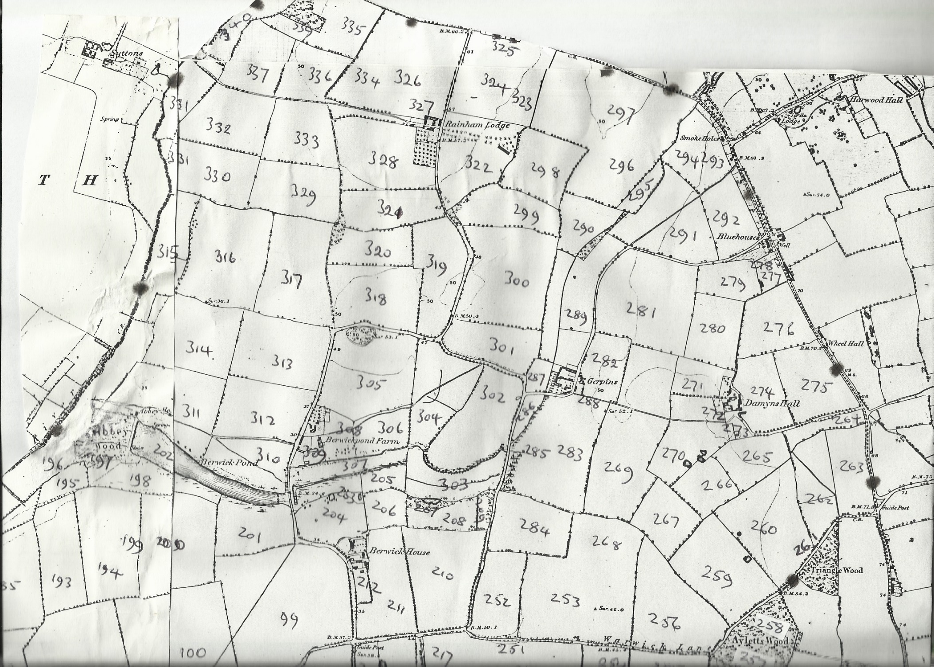
Map 1
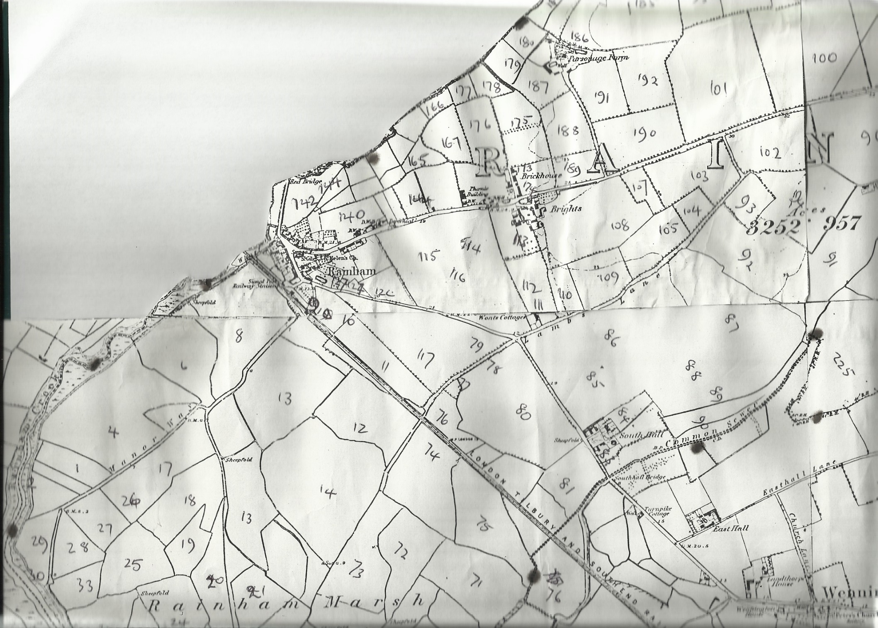

Map 2
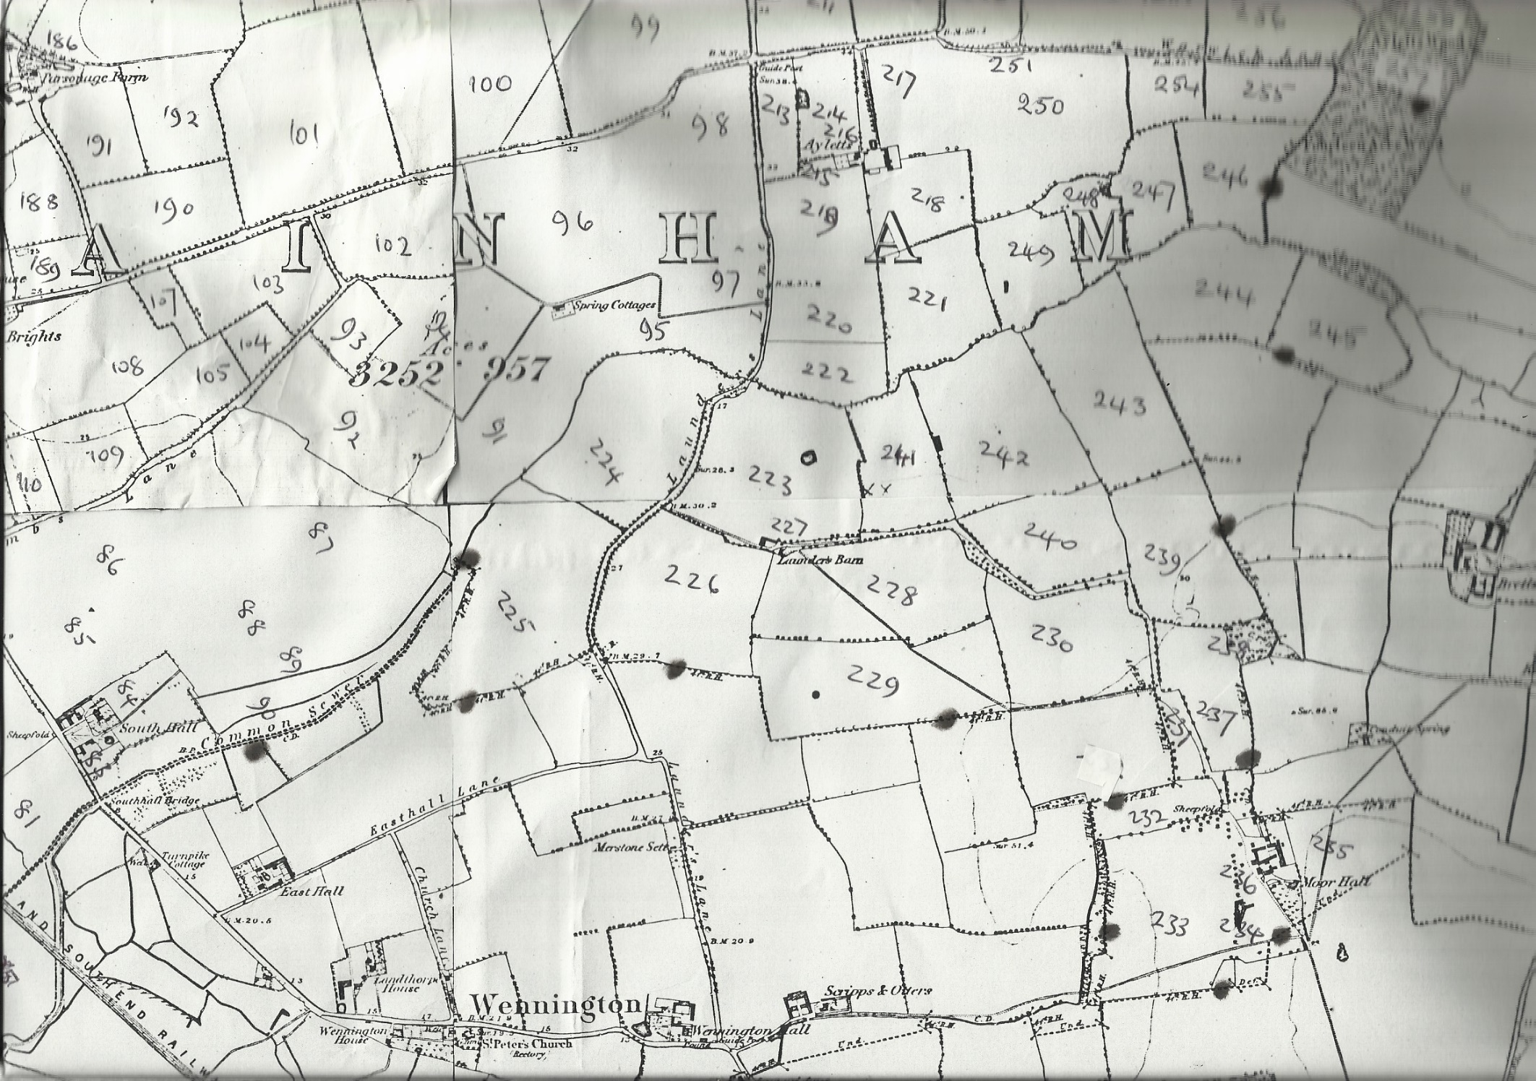
Map 3
Map 2
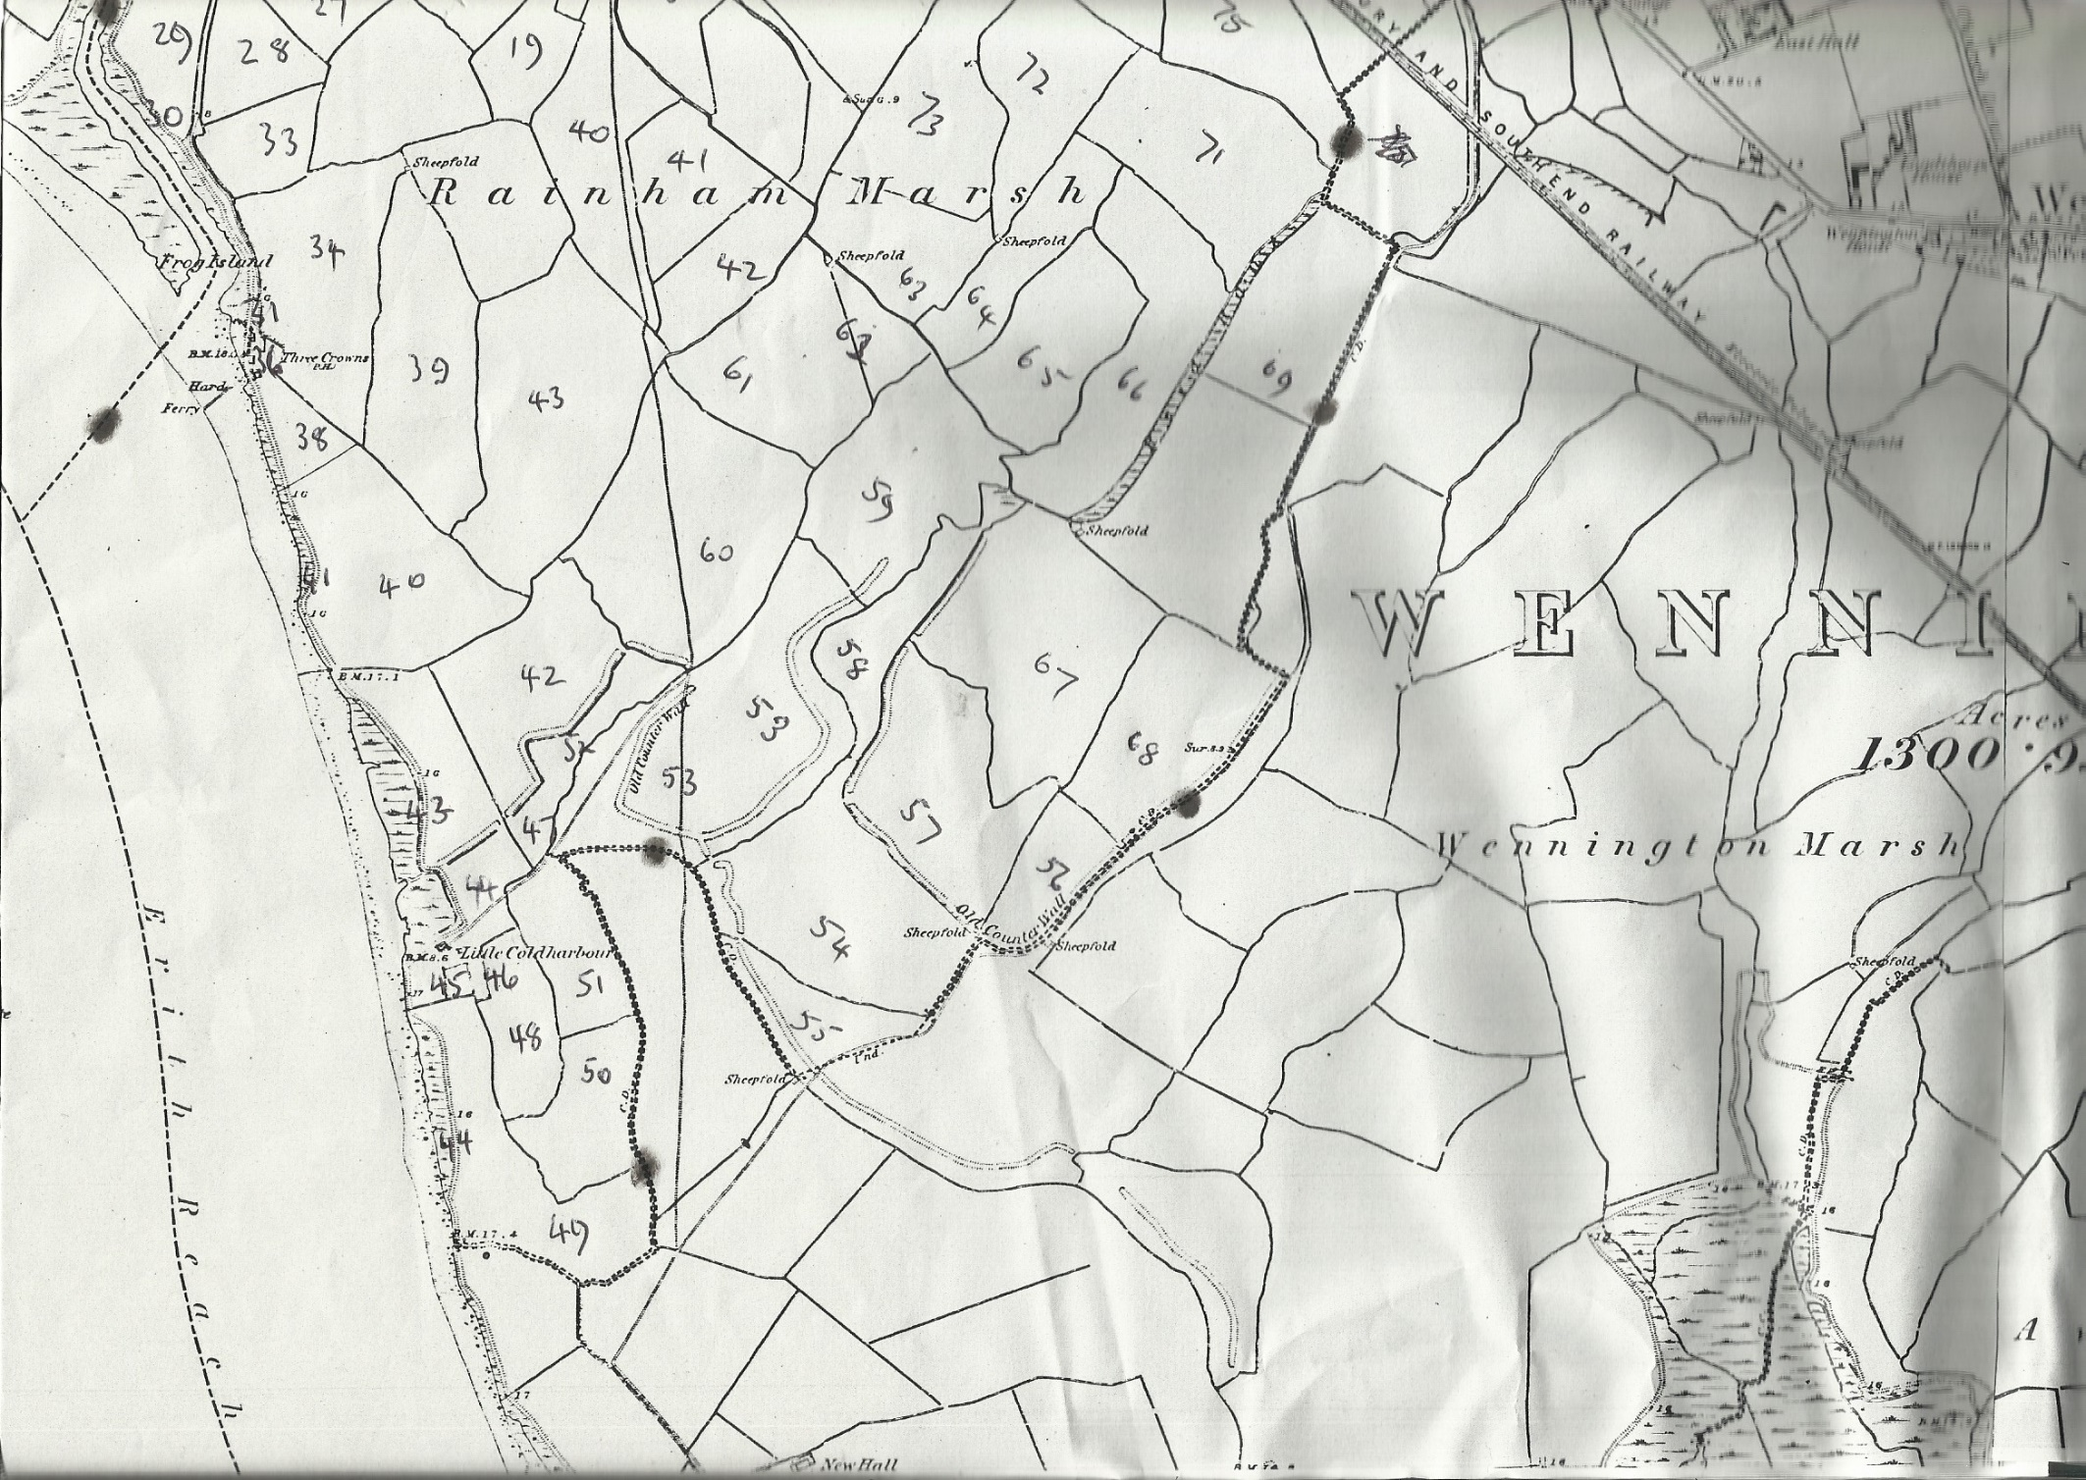
Map 4

