THE PLACE-NAMES

OF SALCOTT

Recorder: James Kemble

Essex Place-names Project (Essex Society for Archaeology & History)

Essex Record Office e-book, 2010. (1st edition hard copy, 2003)

www.essex.ac.uk/history/esah/essexplacenames

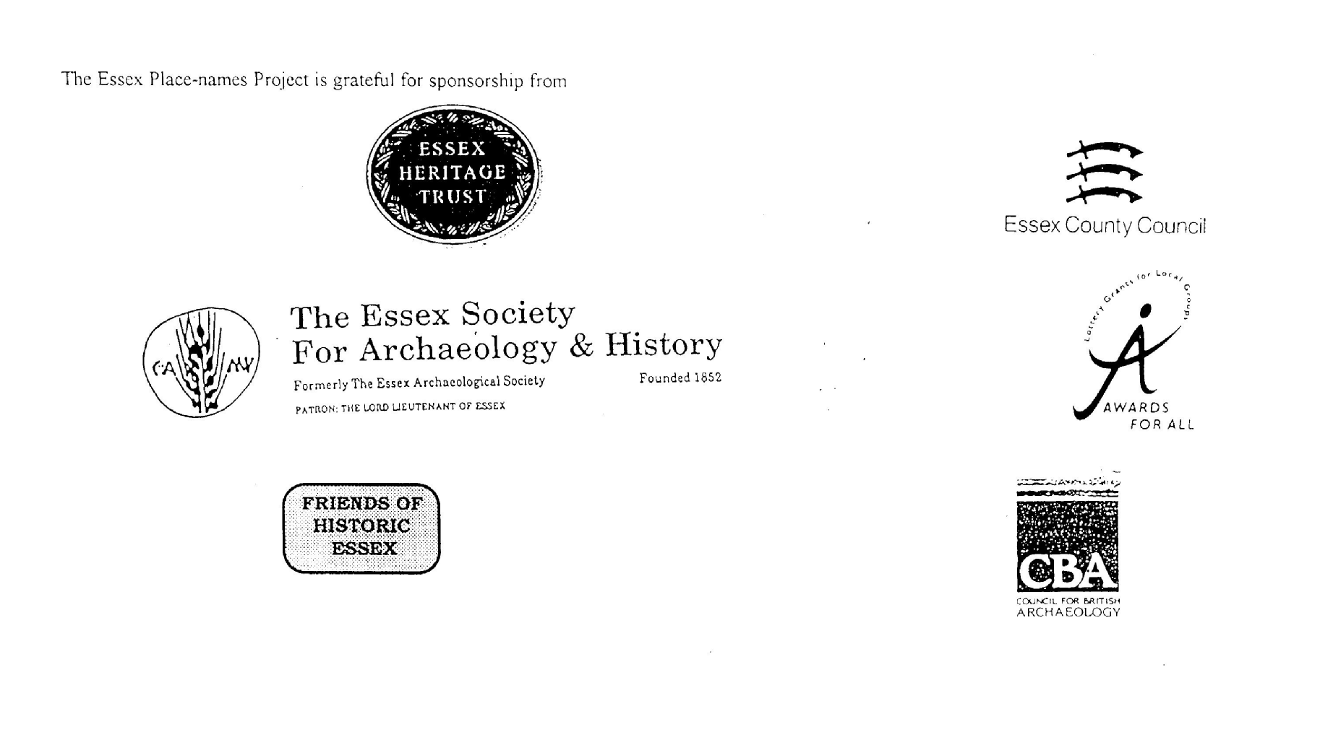

ESSEX PLACE-NAMES PROJECT.

The Essex Place-names Project is a County-wide survey to record place- and field-names from historical documents such as Tithe maps and apportionments, estate maps, sale and auction catalogues, conveyances, terriers, deeds, rolls, inquisitions and surveys.

The second element of the Project is to investigate on-the-ground visible remains which correspond to the Place-names for actual or potential archaeological, agricultural and industrial
sites, and to record natural (topographical) and man-made features which may relate to the Place-name. This involves field-survey in rural and outside investigation in built-up areas.

It is anticipated that the Project will lead to identification of archaeological sites and lost historic buildings; it will enable analysis of indicators of early settlement, land holding, agricultural and industrial practices of the County. It will refine the more precise meaning of descriptive words and elements used by earlier settlers as they gave names appropriate to the topography of the landscape of their time.

For convenience the surveys are based on the parish, recognising that present civil parish boundaries are not necessarily identical to former ecclesiastical boundaries. Local Recorders
are supplied with templates of Record Forms to ensure consistency of recording across the County, and forward completed forms to a Central Coordinator for transfer to a county
computer database which is available at the Essex Record Office to researchers.

This publication presents part of the information recorded from the Tithe or Estate Award and Map, (and from other documents for this parish.) The full record is contained on the master database in the Essex Record Office, Wharf Road, Chelmsford CM2 6YT and the website www.essex.ac.uk/history/esah/essexplacenames. Parish books are available from the ERO on disc or in hard copy or may be downloaded from the website. Please notify errors to the Project Coordinator at the Essex Record Office.

THE TITHE MAP AND APPORTIONMENT.

Since medieval times a tenth of the produce of land and stock had been paid by landholders to the church. At the Dissolution of the Monasteries, the property of many religious houses,
including the right to collect tithes, passed into lay hands. The Tithe Commutation Act which received Royal assent on 13th August 1836 abolished a rent payable in kind and
substituted rent-charges apportioned on each plot or parcel. The tithe-rent payable was assessed on the average value of wheat, barley and oats and was to fluctuate with price movements.

The commutation could be by voluntary agreement between the local owners and payers or, if agreement failed, could be compulsorily imposed by commissioners. A Valuer was to be
appointed to apportion the rent of each parcel of land and tenants could deduct that rent-charge from their rent paid to the landlord. The task fell to the Tithe Commissioners to produce a map and an Apportionment (Award). A large-scale survey was produced for over 70% of England and Wales in the following 9 years, and about another 8% up to 1855. Most of the
parishes in Essex were surveyed. The map scales vary. The Award records ownership, tenancy and land-use, field by field and parcel by parcel (often quoting the field name) with the
ground area and rent-charge.

Land that was tithe-free tends to be less accurately mapped and contains few if any of the details recorded for those parcels subject to tithe. Rights of way and roads also tend to be
neglected. Boundaries of the tithe areas are shown as are some natural features such as streams, ponds, gardens, greens and commons. Buildings are often shown coloured red if dwellings or grey if not. Because the Award may have been agreed only some time after the map was finished, discrepancies occur between the two. Enclosure Awards, when extant, usually date to the 18th and early 19th centuries. J.Kemble.
Reproduced by permission
of Essex County Council.

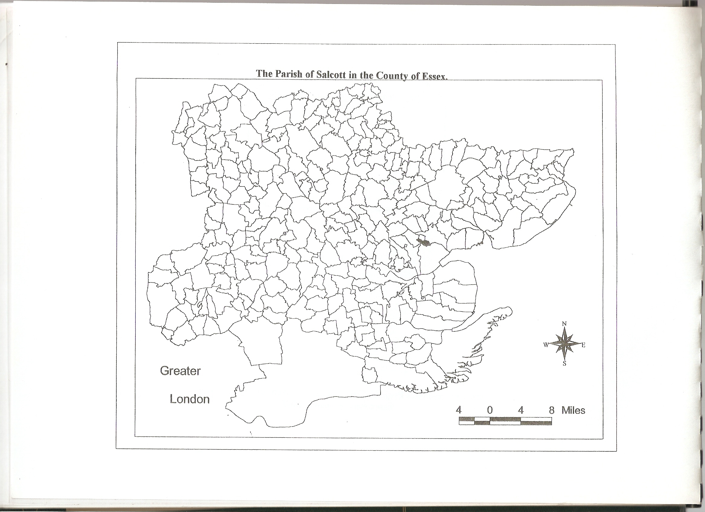

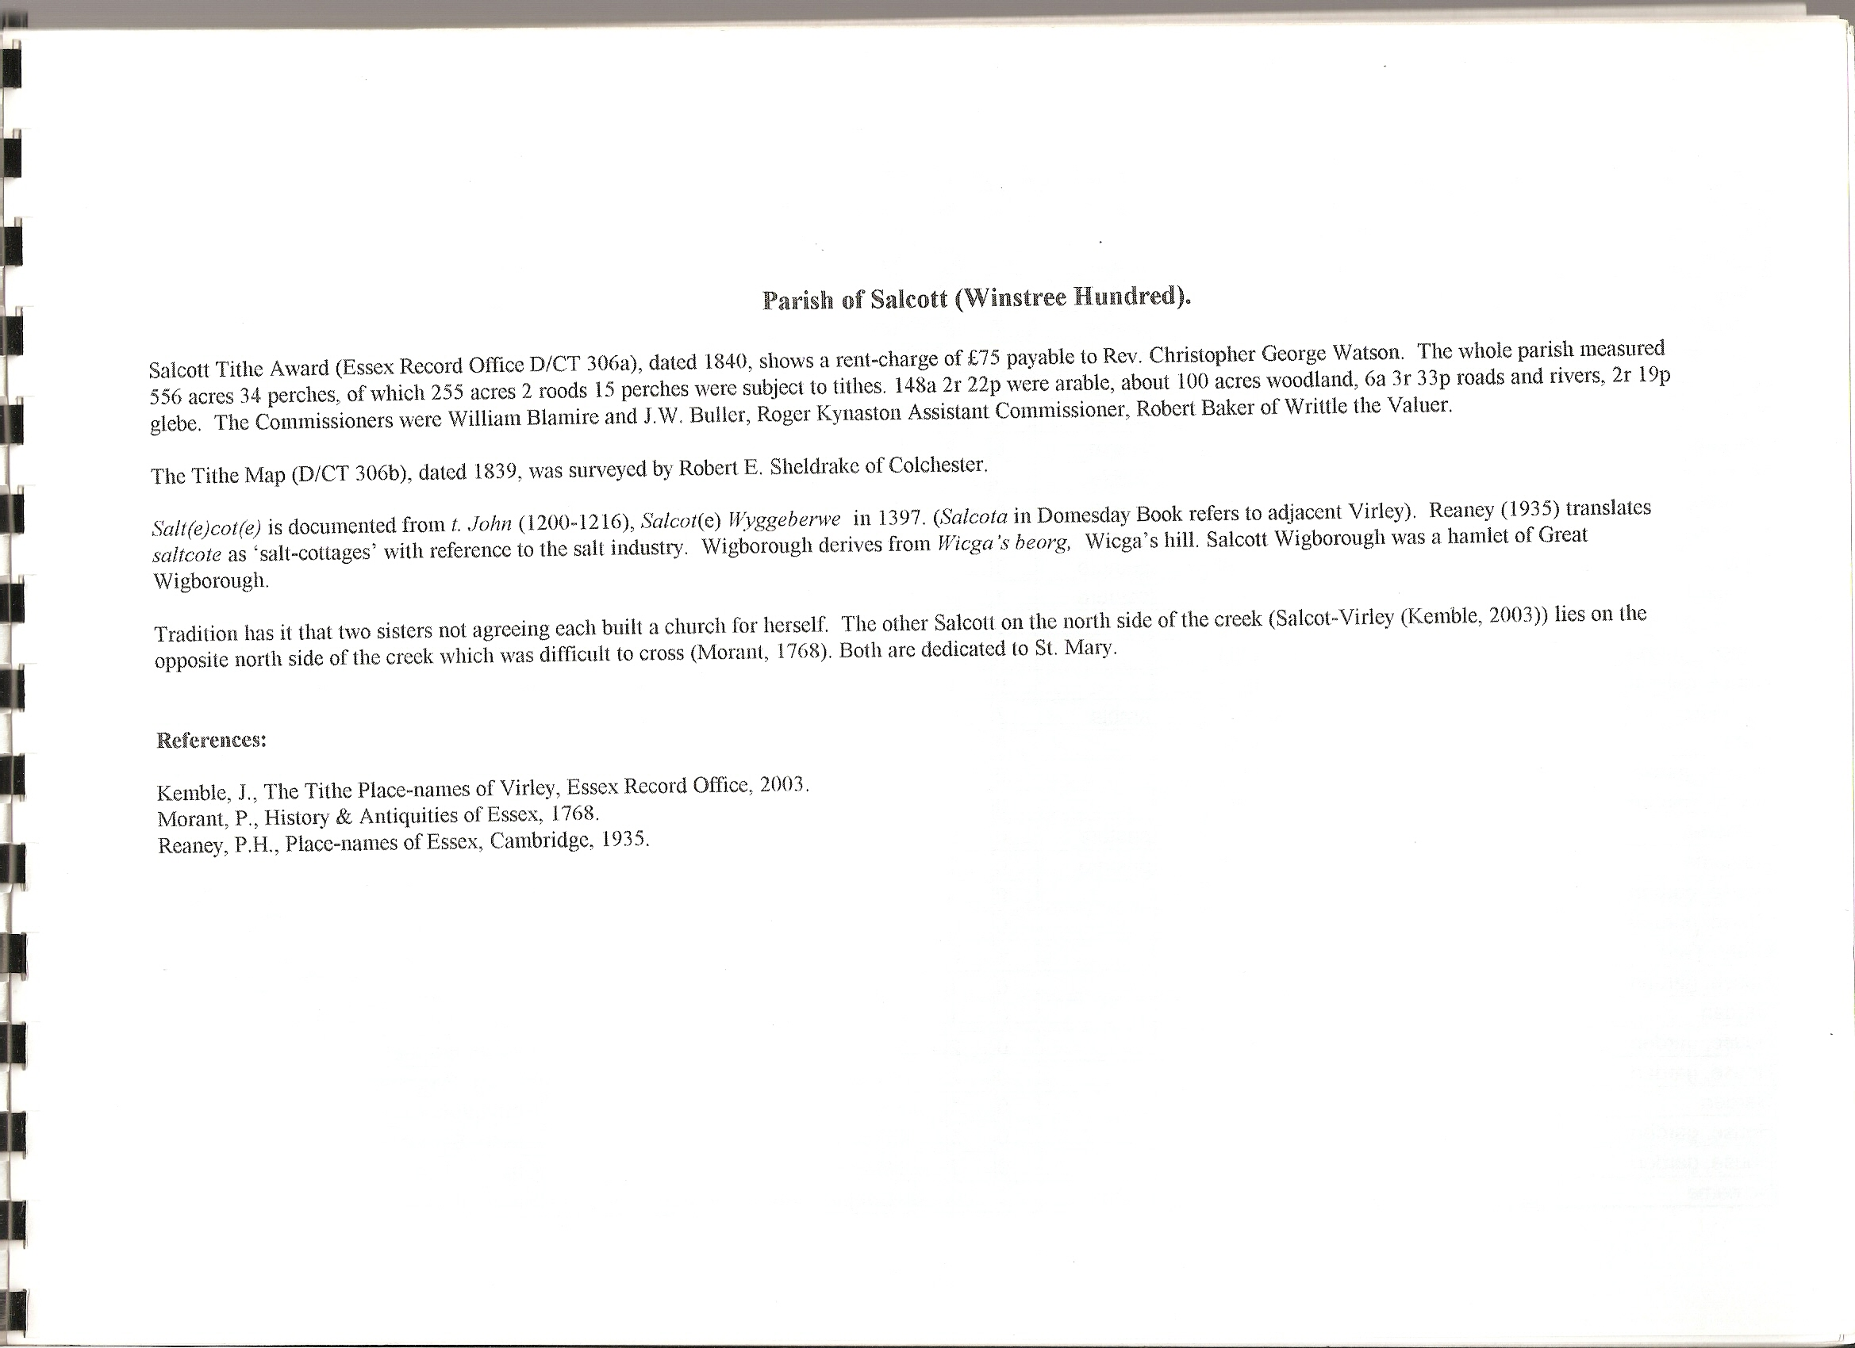

The Tithe Award Place-names of Salcott – by Parcel No.

Place-name | Alias | Fld No | Gd Ref | x | y | Place Type | Acr | rd | pch | Land use | Owner | Occupier | Name of farm | Other information
Barn field |  | 1 | TL | 937 | 138 | field | 10 | 3 | 35 | arable | Poor of Maldon | Heard, Gideon
Barn, yard | Boyes, 1548,Pat | 2 | TL | 937 | 138 | bldg | 0 | 2 | 20 |  | Poor of Maldon | Heard, Gideon | Boyes Barn, 1875,OS
Pond field |  | 3 | TL | 938 | 138 | field | 12 | 0 | 4 | arable | Poor of Maldon | Heard, Gideon
Trites |  | 4 | TL | 940 | 138 | field | 9 | 0 | 0 | arable | Abdy,John;Rutherford,Hatch | Weeks, John
Foreleet |  | 5 | TL | 942 | 138 | field | 7 | 3 | 3 | arable | Cooper, Thomas, execs | Heard, William
Alderbury |  | 6 | TL | 943 | 139 | field | 3 | 1 | 12 | arable | Seabrook, Thos | Seabrook, Thos
No name |  | 6a | TL | 943 | 138 | field | 1 | 3 | 18 | arable | Turnage, Thomas | Turnage, Thomas
Six acres |  | 7 | TL | 944 | 138 | field | 6 | 1 | 4 | arable | Cooper, Thomas, execs | Heard, William
Bell field |  | 8 | TL | 945 | 136 | field | 6 | 2 | 35 | arable | Richardson, Hannah | Turnage, Thos
No name |  | 9 | TL | 946 | 136 | field | 4 | 3 | 9 | arable | Cooper, Thomas, execs | Heard, William
No name |  | 10 | TL | 947 | 136 | field | 6 | 1 | 2 | arable | Cooper, Thomas, execs | Heard, William
No name |  | 11 | TL | 948 | 136 | field | 8 | 1 | 31 | arable | Cooper, Thomas, execs | Heard, William
Pightle |  | 12 | TL | 948 | 137 | field | 1 | 2 | 38 | pasture | Cooper, Thomas, execs | Heard, William
No name |  | 14 | TL | 948 | 137 | field | 1 | 0 | 12 | pasture | Abdy,John;Rutherford,Hatch | Harrington, Isaac
House, garden |  | 15 | TL | 949 | 137 | bldg | 0 | 1 | 20 |  | Blyth, Samuel | Cullam, Samuel, snr
House, garden |  | 16 | TL | 949 | 137 | bldg | 0 | 0 | 38 |  | Turnage, Samuel | Turnage, Samuel
House, garden |  | 17 | TL | 949 | 137 | bldg | 0 | 1 | 18 |  | Cooper, Thomas, execs | Heard, William
No name |  | 18 | TL | 950 | 136 | field | 7 | 0 | 26 | arable | Cooper, Thomas, execs | Heard, William
Lane |  | 18a | TL | 951 | 136 | lane | 0 | 1 | 3 |  | Cooper, Thomas, execs | Heard, William
House, garden |  | 19 | TL | 950 | 137 | bldg | 0 | 1 | 24 |  | Woodyard, Frederick | Ball, James; others
House, garden |  | 20 | TL | 951 | 137 | bldg | 0 | 1 | 0 |  | Harrington, Isaac | Harrington, Isaac
No name |  | 21 | TL | 951 | 137 | field | 0 | 0 | 31 | pasture | Wash, John | Smith, John
No name |  | 22 | TL | 951 | 138 | field | 0 | 0 | 3 | pasture | Wash, John | Smith, John
House, garden |  | 23 | TL | 951 | 137 | bldg | 0 | 0 | 23 |  | Beard, George | Chaplin, John
House, garden |  | 24 | TL | 952 | 137 | bldg | 0 | 0 | 28 |  | Osborne, John | Palmer, Henry
Green Yard |  | 25 | TL | 953 | 137 |  | 1 | 0 | 31 |  | Unwin, Jordan | Unwin, Jordan
House, garden |  | 26 | TL | 953 | 136 | bldg | 0 | 1 | 6 |  | Smith, John | Smith, John
Garden |  | 27 | TL | 953 | 136 | gdn | 0 | 1 | 4 |  | Unwin, Jorden | Clark, John
House, garden |  | 28 | TL | 953 | 136 | bldg | 0 | 2 | 35 |  | Chaplin, John | Wellan, Samuel
House, garden |  | 29 | TL | 952 | 136 | bldg | 0 | 2 | 0 |  | Chaplin, John | Harvey, Benjamin
Garden |  | 30 | TL | 952 | 136 | gdn | 0 | 1 | 19 |  | Harrington, Isaac | Harrington, Isaac
House, garden |  | 31 | TL | 951 | 136 | bldg | 0 | 1 | 4 |  | Woodyard, Frederick | Cullam,Samuel jnr;  2 others
House, garden |  | 32 | TL | 951 | 136 | bldg | 0 | 1 | 28 |  | Marriage, Joseph | Clarke, William
No name |  | 33 | TL | 951 | 135 | field | 3 | 0 | 36 | arable | Cooper, Thomas, execs | Heard, William
Six acres (pt) |  | 34 | TL | 953 | 134 | field | 2 | 0 | 0 | arable | Unwin, Jordan | Unwin, Jordan
Two acres |  | 35 | TL | 952 | 135 | field | 2 | 0 | 24 | arable | Unwin, Jordan | Unwin, Jordan
House, garden |  | 36 | TL | 952 | 136 | bldg | 0 | 0 | 35 |  | Woodyard, Frederick | Osborne, Stephen; another | Green Farm, c1875,OS
No name |  | 37 | TL | 952 | 136 |  | 0 | 0 | 26 |  | Harrington, Isaac | Harrington, Isaac
No name |  | 38 | TL | 952 | 136 |  | 0 | 0 | 37 |  | Harrington, Isaac | Harrington, Isaac
Path field |  | 39 | TL | 953 | 135 | field | 3 | 1 | 20 | arable | Cooper, Thomas, execs | Heard, William
Great Storms (pt) |  | 40 | TL | 954 | 134 | field | 5 | 0 | 22 | arable | Unwin, Jordan | Unwin, Jordan
Stack Yard field |  | 41 | TL | 954 | 135 | field | 2 | 2 | 20 | arable | Unwin, Jordan | Unwin, Jordan
Old Orchard |  | 42 | TL | 954 | 136 | field | 1 | 0 | 6 | arable | Unwin, Jordan | Unwin, Jordan
House, garden |  | 43 | TL | 953 | 137 | bldg | 0 | 0 | 18 |  | Belcher, Thomas | Allison, James
House, garden |  | 44 | TL | 953 | 137 | bldg | 0 | 0 | 15 |  | Powell, William | Vince, Thomas
House, garden |  | 45 | TL | 953 | 137 | bldg | 0 | 0 | 24 |  | Frostdike, William | Young, Charles
House, garden |  | 46 | TL | 953 | 137 | bldg | 0 | 1 | 23 |  | Beard, George | Harvey, William
No name |  | 47 | TL | 953 | 138 | field | 2 | 0 | 17 | pasture | Beard, George | Smith, John
Garden |  | 48 | TL | 954 | 137 |  | 0 | 0 | 36 |  | Smith, John | Smith, John
Barn, yard |  | 49 | TL | 954 | 136 | bldg | 0 | 2 | 31 |  | Unwin, Jordan | Unwin, Jordan
Home field |  | 50 | TL | 955 | 135 | field | 8 | 1 | 2 | arable | Unwin, Jordan | Unwin, Jordan
House, garden |  | 126 | TL | 955 | 136 | bldg | 0 | 2 | 22 |  | Unwin, Jordan | Bowley, William;another
Little Storms (pt) |  | 51 | TL | 955 | 134 | field | 4 | 3 | 18 | arable | Unwin, Jordan | Unwin, Jordan
Greenfield (pt) |  | 52 | TL | 956 | 134 | field | 5 | 3 | 17 | arable | Unwin, Jordan | Unwin, Jordan
No name |  | 53 | TL | 956 | 135 | field | 2 | 0 | 30 | arable | Beard, George | Chaplin, John
Church Land |  | 54 | TL | 956 | 135 | field | 2 | 0 | 38 | arable | Salcott Parish Trustees | Unwin, Jordan
No name |  | 55 | TL | 955 | 137 | field | 2 | 1 | 8 | arable | Beard, George | Chaplin, John
No name |  | 56 | TL | 955 | 136 | field | 1 | 1 | 23 | arable | Beard, George | Chaplin, John
Church, yard | [St Marys] | 57 | TL | 955 | 135 |  | 0 | 2 | 19
No name |  | 58 | TL | 956 | 138 | field | 1 | 2 | 25 | pasture | Beard, George | Chaplin, John
No name |  | 59 | TL | 956 | 139 | field | 2 | 3 | 16 | pasture | Beard, George | Chaplin, John
Ten acres |  | 60 | TL | 968 | 138 | field | 12 | 1 | 8 | arable | Unwin, Jordan | Unwin, Jordan
Seven Acres |  | 61 | TL | 961 | 139 | field | 9 | 1 | 10 | arable | Unwin, Jordan | Unwin, Jordan
One Acre |  | 62 | TL | 960 | 138 | field | 2 | 0 | 7 | arable | Unwin, Jordan | Unwin, Jordan
Four Acres |  | 63 | TL | 959 | 138 | field | 4 | 2 | 20 | arable | Unwin, Jordan | Unwin, Jordan
Fourteen Acres - marsh |  | 64 | TL | 958 | 136 | field | 14 | 2 | 23 | pasture | Chine, Margaret | Dickson, Robert
Forty Acres - marsh |  | 66 | TL | 963 | 133 | field | 44 | 2 | 33 | pasture | Chine, Margaret | Dickson, Robert
Eastlands |  | 65 | TL | 958 | 134 | field | 9 | 3 | 38 | arable | Unwin, Jordan | Unwin, Jordan

For abbreviations see Reaney, P., Place-names of Essex, Cambridge 1935; and Kemble, J., Essex Place-names, Places, Streets & People, Historical Publications, London 2007.

The Tithe Award Place-names of Salcott – by Place-name.

Place-name | Alias | Fld No | Gd Ref | x | y | Place Type | Acr | rd | pch | Land use | Owner | Occupier | Name of farm | Other information
Alderbury |  | 6 | TL | 943 | 139 | field | 3 | 1 | 12 | arable | Seabrook, Thos | Seabrook, Thos
Barn field |  | 1 | TL | 937 | 138 | field | 10 | 3 | 35 | arable | Poor of Maldon | Heard, Gideon
Barn, yard | Boyes, 1548,Pat | 2 | TL | 937 | 138 | bldg | 0 | 2 | 20 |  | Poor of Maldon | Heard, Gideon | Boyes Barn, 1875,OS
Barn, yard |  | 49 | TL | 954 | 136 | bldg | 0 | 2 | 31 |  | Unwin, Jordan | Unwin, Jordan
Bell field |  | 8 | TL | 945 | 136 | field | 6 | 2 | 35 | arable | Richardson, Hannah | Turnage, Thos
Church Land |  | 54 | TL | 956 | 135 | field | 2 | 0 | 38 | arable | Salcott Parish Trustees | Unwin, Jordan
Church, yard | [St Marys] | 57 | TL | 955 | 135 |  | 0 | 2 | 19
Eastlands |  | 65 | TL | 958 | 134 | field | 9 | 3 | 38 | arable | Unwin, Jordan | Unwin, Jordan
Foreleet |  | 5 | TL | 942 | 138 | field | 7 | 3 | 3 | arable | Cooper, Thomas, execs | Heard, William
Forty Acres - marsh |  | 66 | TL | 963 | 133 | field | 44 | 2 | 33 | pasture | Chine, Margaret | Dickson, Robert
Four Acres |  | 63 | TL | 959 | 138 | field | 4 | 2 | 20 | arable | Unwin, Jordan | Unwin, Jordan
Fourteen Acres - marsh |  | 64 | TL | 958 | 136 | field | 14 | 2 | 23 | pasture | Chine, Margaret | Dickson, Robert
Garden |  | 30 | TL | 952 | 136 | gdn | 0 | 1 | 19 |  | Harrington, Isaac | Harrington, Isaac
Garden |  | 48 | TL | 954 | 137 |  | 0 | 0 | 36 |  | Smith, John | Smith, John
Garden |  | 27 | TL | 953 | 136 | gdn | 0 | 1 | 4 |  | Unwin, Jorden | Clark, John
Great Storms (pt) |  | 40 | TL | 954 | 134 | field | 5 | 0 | 22 | arable | Unwin, Jordan | Unwin, Jordan
Green Yard |  | 25 | TL | 953 | 137 |  | 1 | 0 | 31 |  | Unwin, Jordan | Unwin, Jordan
Greenfield (pt) |  | 52 | TL | 956 | 134 | field | 5 | 3 | 17 | arable | Unwin, Jordan | Unwin, Jordan
Home field |  | 50 | TL | 955 | 135 | field | 8 | 1 | 2 | arable | Unwin, Jordan | Unwin, Jordan
House, garden |  | 23 | TL | 951 | 137 | bldg | 0 | 0 | 23 |  | Beard, George | Chaplin, John
House, garden |  | 46 | TL | 953 | 137 | bldg | 0 | 1 | 23 |  | Beard, George | Harvey, William
House, garden |  | 43 | TL | 953 | 137 | bldg | 0 | 0 | 18 |  | Belcher, Thomas | Allison, James
House, garden |  | 15 | TL | 949 | 137 | bldg | 0 | 1 | 20 |  | Blyth, Samuel | Cullam, Samuel, snr
House, garden |  | 29 | TL | 952 | 136 | bldg | 0 | 2 | 0 |  | Chaplin, John | Harvey, Benjamin
House, garden |  | 28 | TL | 953 | 136 | bldg | 0 | 2 | 35 |  | Chaplin, John | Wellan, Samuel
House, garden |  | 17 | TL | 949 | 137 | bldg | 0 | 1 | 18 |  | Cooper, Thomas, execs | Heard, William
House, garden |  | 45 | TL | 953 | 137 | bldg | 0 | 0 | 24 |  | Frostdike, William | Young, Charles
House, garden |  | 20 | TL | 951 | 137 | bldg | 0 | 1 | 0 |  | Harrington, Isaac | Harrington, Isaac
House, garden |  | 32 | TL | 951 | 136 | bldg | 0 | 1 | 28 |  | Marriage, Joseph | Clarke, William
House, garden |  | 24 | TL | 952 | 137 | bldg | 0 | 0 | 28 |  | Osborne, John | Palmer, Henry
House, garden |  | 44 | TL | 953 | 137 | bldg | 0 | 0 | 15 |  | Powell, William | Vince, Thomas
House, garden |  | 26 | TL | 953 | 136 | bldg | 0 | 1 | 6 |  | Smith, John | Smith, John
House, garden |  | 16 | TL | 949 | 137 | bldg | 0 | 0 | 38 |  | Turnage, Samuel | Turnage, Samuel
House, garden |  | 126 | TL | 955 | 136 | bldg | 0 | 2 | 22 |  | Unwin, Jordan | Bowley, William;another
House, garden |  | 19 | TL | 950 | 137 | bldg | 0 | 1 | 24 |  | Woodyard, Frederick | Ball, James; others
House, garden |  | 31 | TL | 951 | 136 | bldg | 0 | 1 | 4 |  | Woodyard, Frederick | Cullam,Samuel jnr;  2 others
House, garden |  | 36 | TL | 952 | 136 | bldg | 0 | 0 | 35 |  | Woodyard, Frederick | Osborne, Stephen; another | Green Farm, c1875,OS
Lane |  | 18a | TL | 951 | 136 | lane | 0 | 1 | 3 |  | Cooper, Thomas, execs | Heard, William
Little Storms (pt) |  | 51 | TL | 955 | 134 | field | 4 | 3 | 18 | arable | Unwin, Jordan | Unwin, Jordan
No name |  | 14 | TL | 948 | 137 | field | 1 | 0 | 12 | pasture | Abdy,John;Rutherford,Hatch | Harrington, Isaac
No name |  | 53 | TL | 956 | 135 | field | 2 | 0 | 30 | arable | Beard, George | Chaplin, John
No name |  | 55 | TL | 955 | 137 | field | 2 | 1 | 8 | arable | Beard, George | Chaplin, John
No name |  | 56 | TL | 955 | 136 | field | 1 | 1 | 23 | arable | Beard, George | Chaplin, John
No name |  | 58 | TL | 956 | 138 | field | 1 | 2 | 25 | pasture | Beard, George | Chaplin, John
No name |  | 59 | TL | 956 | 139 | field | 2 | 3 | 16 | pasture | Beard, George | Chaplin, John
No name |  | 47 | TL | 953 | 138 | field | 2 | 0 | 17 | pasture | Beard, George | Smith, John
No name |  | 9 | TL | 946 | 136 | field | 4 | 3 | 9 | arable | Cooper, Thomas, execs | Heard, William
No name |  | 10 | TL | 947 | 136 | field | 6 | 1 | 2 | arable | Cooper, Thomas, execs | Heard, William
No name |  | 11 | TL | 948 | 136 | field | 8 | 1 | 31 | arable | Cooper, Thomas, execs | Heard, William
No name |  | 18 | TL | 950 | 136 | field | 7 | 0 | 26 | arable | Cooper, Thomas, execs | Heard, William
No name |  | 33 | TL | 951 | 135 | field | 3 | 0 | 36 | arable | Cooper, Thomas, execs | Heard, William
No name |  | 37 | TL | 952 | 136 |  | 0 | 0 | 26 |  | Harrington, Isaac | Harrington, Isaac
No name |  | 38 | TL | 952 | 136 |  | 0 | 0 | 37 |  | Harrington, Isaac | Harrington, Isaac
No name |  | 6a | TL | 943 | 138 | field | 1 | 3 | 18 | arable | Turnage, Thomas | Turnage, Thomas
No name |  | 21 | TL | 951 | 137 | field | 0 | 0 | 31 | pasture | Wash, John | Smith, John
No name |  | 22 | TL | 951 | 138 | field | 0 | 0 | 3 | pasture | Wash, John | Smith, John
Old Orchard |  | 42 | TL | 954 | 136 | field | 1 | 0 | 6 | arable | Unwin, Jordan | Unwin, Jordan
One Acre |  | 62 | TL | 960 | 138 | field | 2 | 0 | 7 | arable | Unwin, Jordan | Unwin, Jordan
Path field |  | 39 | TL | 953 | 135 | field | 3 | 1 | 20 | arable | Cooper, Thomas, execs | Heard, William
Pightle |  | 12 | TL | 948 | 137 | field | 1 | 2 | 38 | pasture | Cooper, Thomas, execs | Heard, William
Pond field |  | 3 | TL | 938 | 138 | field | 12 | 0 | 4 | arable | Poor of Maldon | Heard, Gideon
Seven Acres |  | 61 | TL | 961 | 139 | field | 9 | 1 | 10 | arable | Unwin, Jordan | Unwin, Jordan
Six acres |  | 7 | TL | 944 | 138 | field | 6 | 1 | 4 | arable | Cooper, Thomas, execs | Heard, William
Six acres (pt) |  | 34 | TL | 953 | 134 | field | 2 | 0 | 0 | arable | Unwin, Jordan | Unwin, Jordan
Stack Yard field |  | 41 | TL | 954 | 135 | field | 2 | 2 | 20 | arable | Unwin, Jordan | Unwin, Jordan
Ten acres |  | 60 | TL | 968 | 138 | field | 12 | 1 | 8 | arable | Unwin, Jordan | Unwin, Jordan
Trites |  | 4 | TL | 940 | 138 | field | 9 | 0 | 0 | arable | Abdy,John;Rutherford,Hatch | Weeks, John
Two acres |  | 35 | TL | 952 | 135 | field | 2 | 0 | 24 | arable | Unwin, Jordan | Unwin, Jordan

For abbreviations see Reaney, P., Place-names of Essex, Cambridge 1935; and Kemble, J., Essex Place-names, Places, Streets & People, Historical Publications, London 2007.

