THE PLACE-NAMES

OF SNOREHAM

Recorder: James Kemble

Essex Place-names Project (Essex Society for Archaeology & History)

Essex Record Office e-book, 2nd edition, 2010. (1st edition in hard copy 2004).

www.essex.ac.uk/history/esah/essexplacenames

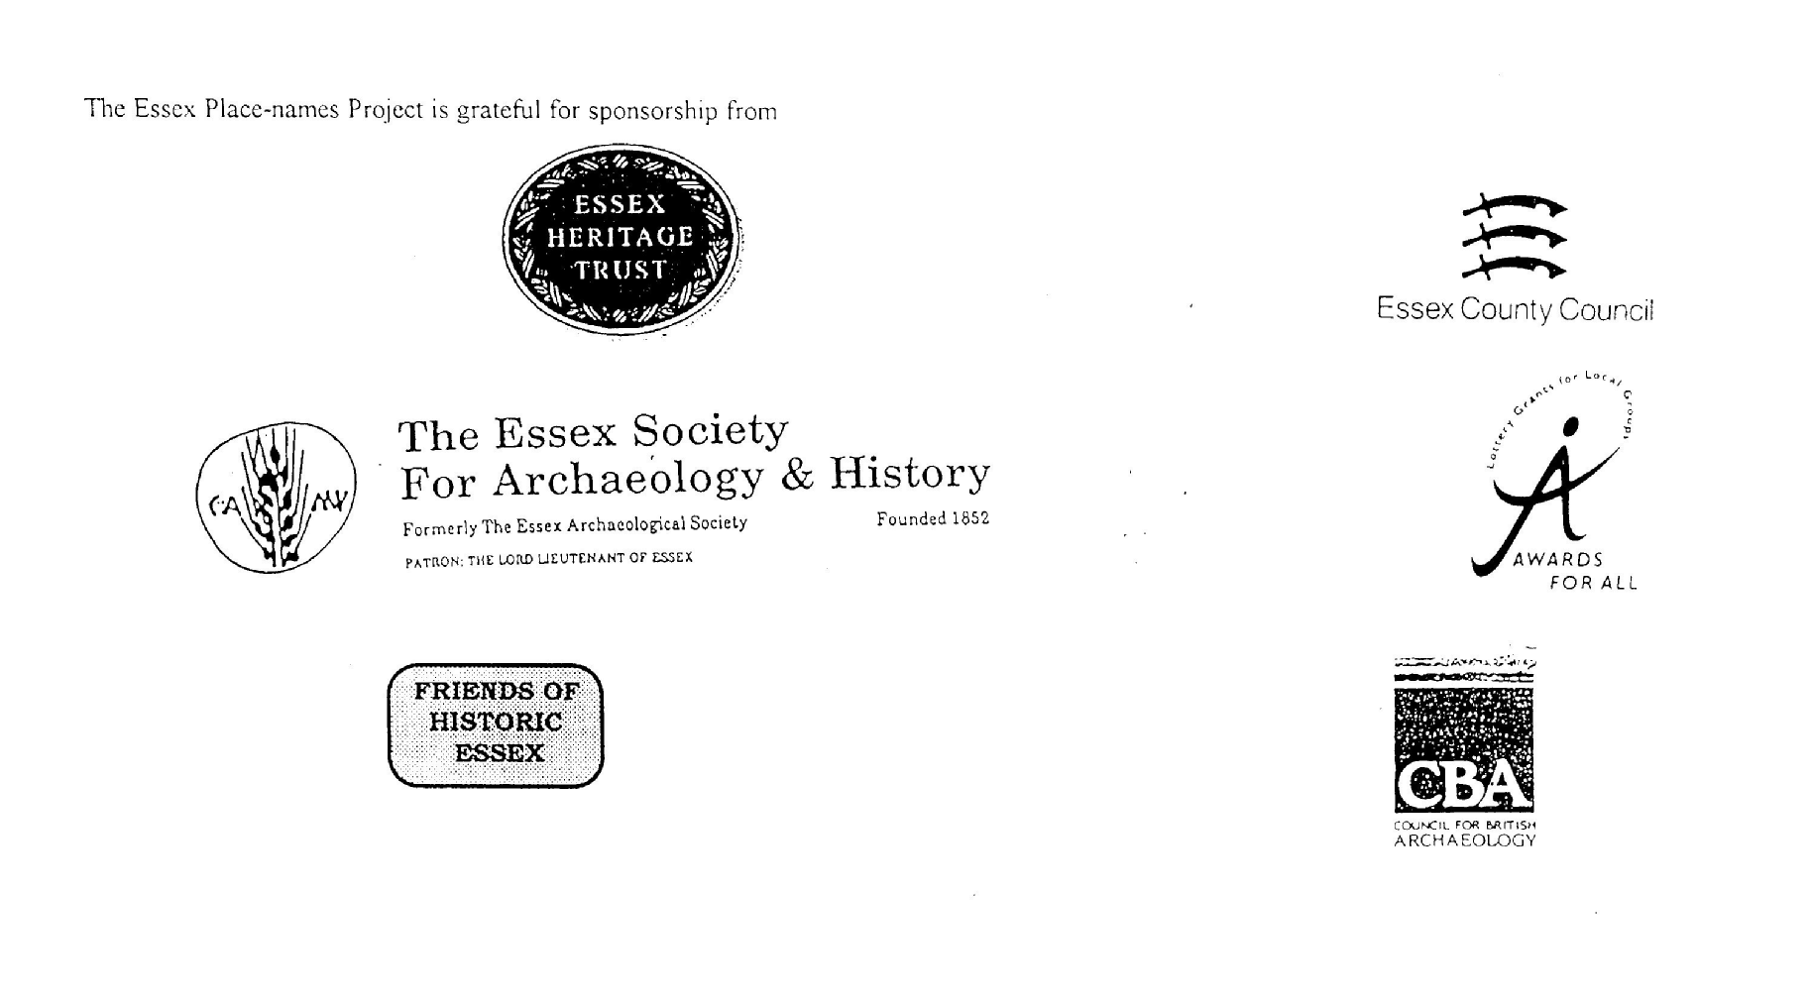

ESSEX PLACE-NAMES PROJECT.

The Essex Place-names Project is a County-wide survey to record place- and field-names from historical documents such as Tithe maps and apportionments, estate maps, sale and
auction catalogues, conveyances, terriers, deeds, rolls, inquisitions and surveys.

The second element of the Project is to investigate on-the-ground visible remains which correspond to the Place-names for actual or potential archaeological, agricultural and industrial
sites, and to record natural (topographical) and man-made features which may relate to the Place-name. This involves field-survey in rural and outside investigation in built-up areas.

It is anticipated that the Project will lead to identification of archaeological sites and lost historic buildings; it will enable analysis of indicators of early settlement, land holding, agricultural and industrial practices of the County. It will refine the more precise meaning of descriptive words and elements used by earlier settlers as they gave names appropriate to the topography of the landscape of their time.

For convenience the surveys are based on the parish, recognizing that present civil parish boundaries are not necessarily identical to former ecclesiastical boundaries. Local Recorders
are supplied with templates of Record Forms to ensure consistency of recording across the County, and forward completed forms to a Central Coordinator for transfer to a county
computer database which is available at the Essex Record Office to researchers.

This publication presents part of the information recorded from the Tithe or Estate Award and Map, (and from other documents for this parish.) The full record is contained on the master database in the Essex Record Office, Wharf Road, Chelmsford CM2 6YT and the website www.essex.ac.uk/history/esah/essexplacenames. Parish books are available from the ERO on disc or in hard copy or may be downloaded from the website. Please notify errors to the Project Coordinator at the Essex Record Office.

THE TITHE MAP AND APPORTIONMENT.

Since medieval times a tenth of the produce of land and stock had been paid by landholders to the church. At the Dissolution of the Monasteries, the property of many religious houses,
including the right to collect tithes, passed into lay hands. The Tithe Commutation Act which received Royal assent on 13th August 1836 abolished a rent payable in kind and
substituted rent-charges apportioned on each plot or parcel. The tithe-rent payable was assessed on the average value of wheat, barley and oats and was to fluctuate with price movements.

The commutation could be by voluntary agreement between the local owners and payers or, if agreement failed, could be compulsorily imposed by commissioners. A Valuer was to be
appointed to apportion the rent of each parcel of land and tenants could deduct that rent-charge from their rent paid to the landlord. The task fell to the Tithe Commissioners to produce a map and an Apportionment (Award). A large-scale survey was produced for over 70% of England and Wales in the following 9 years, and about another 8% up to 1855. Most of the
parishes in Essex were surveyed. The map scales vary. The Award records ownership, tenancy and land-use, field by field and parcel by parcel (often quoting the field name) with the
ground area and rent-charge.

Land that was tithe-free tends to be less accurately mapped and contains few if any of the details recorded for those parcels subject to tithe. Rights of way and roads also tend to be
neglected. Boundaries of the tithe areas are shown as are some natural features such as streams, ponds, gardens, greens and commons. Buildings are often shown coloured red if dwellings or grey if not. Because the Award may have been agreed only some time after the map was finished, discrepancies occur between the two. Enclosure Awards, when extant, usually date to the 18th and early 19th centuries. J.Kemble.
Reproduced by permission
of Essex County Council.

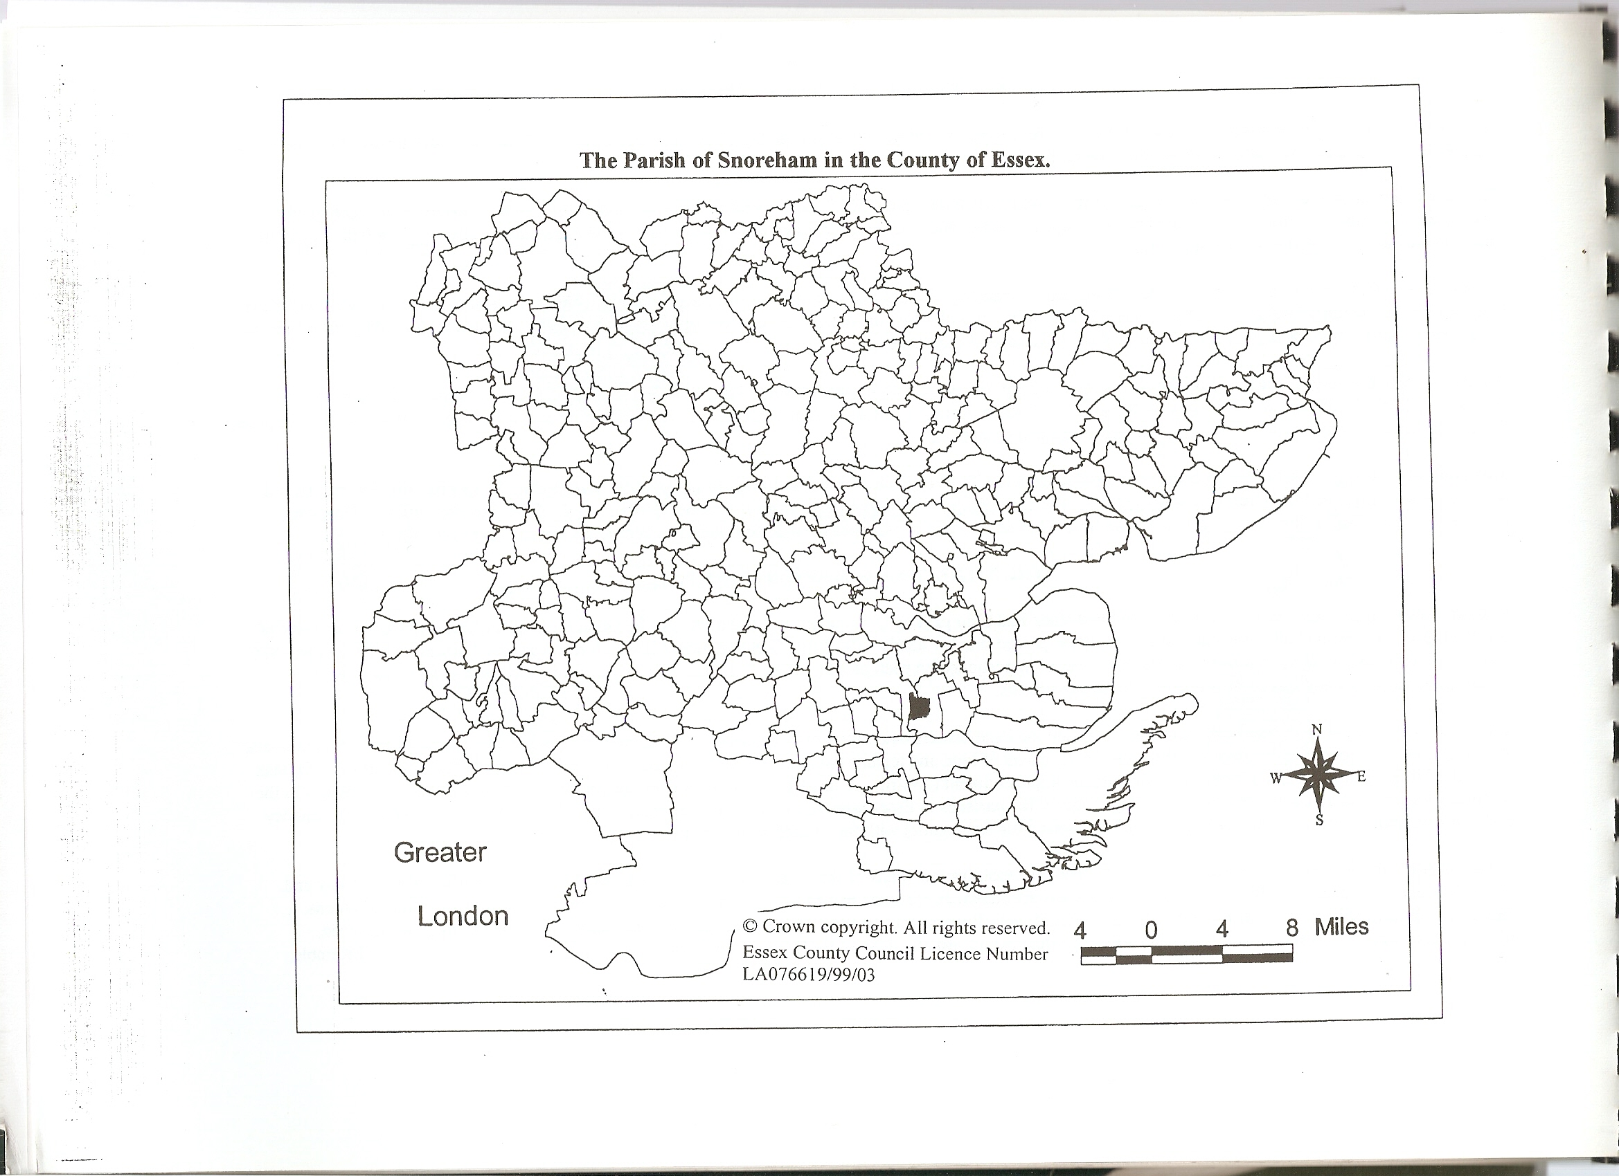

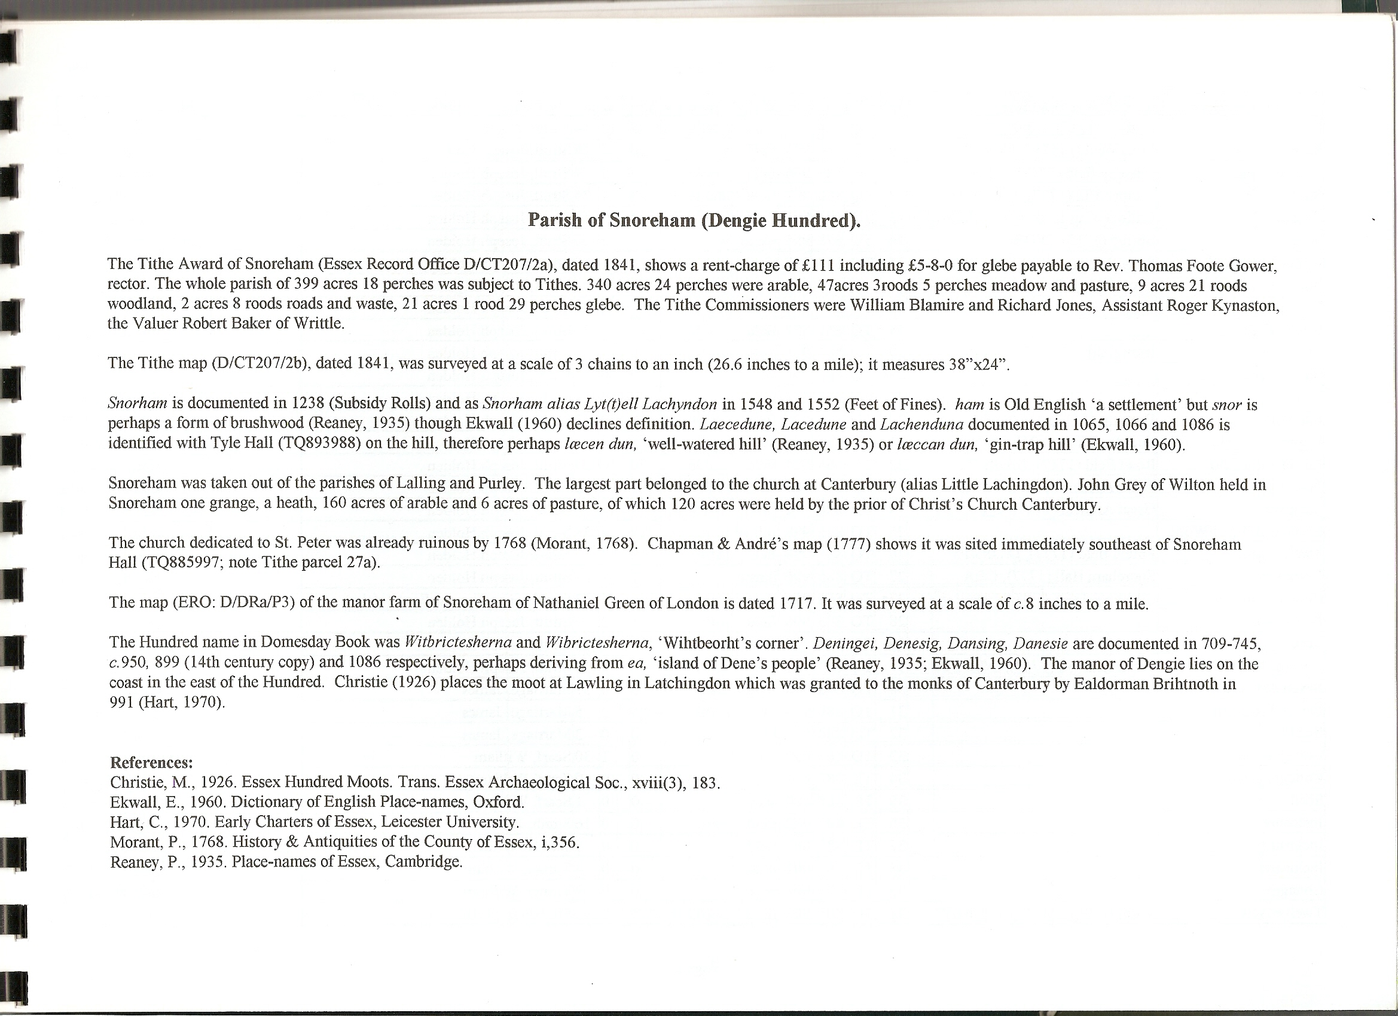
For Latchingdon, see “The Place-names of Latchingdon”, Essex Record Office e-book, 2010.

The Tithe Award Place-names of Snoreham – by Parcel No.

Place-name | Alias | Fld No | Gd Ref | x | y | Place Type | Acr | rd | pch | Land use | Owner | Occupier | Other information
Five acres | Rodyes (1717), D/DRa P3 | 1 | TQ | 884 | 987 | field | 5 | 3 | 14 | arable | Hayes, Andrew | Wiffin, William
Lane |  | 2 | TQ | 886 | 987 | lane | 0 | 0 | 13 |  | Strutt, Joseph Holden | Carter, Charles
Sixteen Acres | South Hill (pt) (1717), D/DRa P3 | 3 | TQ | 883 | 988 | field | 15 | 3 | 30 | arable | Strutt, Joseph Holden | Carter, Charles
Twelve Acres | South Hill (pt) (1717), D/DRa P3 | 3a | TQ | 885 | 988 | field | 12 | 2 | 15 | arable | Strutt, Joseph Holden | Carter, Charles
Fifteen Acres | North Hill (pt) (1717), D/DRa P3 | 4 | TQ | 883 | 991 | field | 16 | 0 | 32 | arable | Strutt, Joseph Holden | Carter, Charles
Seven acres | North Hill (pt) (1717), D/DRa P3 | 5 | TQ | 885 | 991 | field | 9 | 0 | 2 | arable | Strutt, Joseph Holden | Carter, Charles
Six acres | Great Mead (pt) (1717), D/DRa P3 | 6 | TQ | 887 | 992 | field | 8 | 3 | 2 | arable | Gower, Rev Thomas Foote(glebe) | Carter, Charles
Nine acres | Vicarage (1717), D/DRa P3 | 7 | TQ | 888 | 993 | field | 10 | 2 | 11 | pstre | Gower, Rev Thomas Foote(glebe) | Carter, Charles
Dyers | Dyers field (1717), D/DRa P3 | 8 | TQ | 888 | 995 | field | 25 | 3 | 22 | arable | Strutt, Joseph Holden | Carter, Charles
Dovehouse Mead | Great Mead (pt) (1717),D/DRa P3 | 9 | TQ | 886 | 995 | field | 11 | 0 | 5 | arable | Strutt, Joseph Holden | Carter, Charles
Seventeen acres | Long field (1717), D/DRa P3 | 10 | TQ | 884 | 994 | field | 20 | 1 | 15 | arable | Strutt, Joseph Holden | Carter, Charles
Thistley field | Thistley field (1717), D/DRa P3 | 11 | TQ | 883 | 996 | field | 25 | 3 | 7 | arable | Strutt, Joseph Holden | Carter, Charles
Rayleigh field | Further Hill (1717), D/DRa P3 | 12 | TQ | 880 | 992 | field | 19 | 1 | 25 | arable | Strutt, Joseph Holden | Carter, Charles
Four acres | Little Spring field (1717), D/DRa P3 | 13 | TQ | 877 | 997 | field | 4 | 1 | 12 | arable | Strutt, Joseph Holden | Carter, Charles
Wood | Spring (1717), D/DRa P3 | 14 | TQ | 878 | 995 | wood | 6 | 2 | 20 | wd | Strutt, Joseph Holden | Strutt, Joseph Holden
Upper Long field | Song Spring field (1717), D/DRa P3 | 15 | TQ | 879 | 997 | field | 11 | 1 | 12 | arable | Strutt, Joseph Holden | Carter, Charles
Six acres | Great Spring field (1717), D/DRa P3 | 16 | TQ | 877 | 997 | field | 6 | 3 | 36 | arable | Strutt, Joseph Holden | Carter, Charles
Lower Long field |  | 17 | TQ | 879 | 997 | field | 10 | 2 | 28 | arable | Strutt, Joseph Holden | Carter, Charles
Round field |  | 18 | TQ | 881 | 997 | field | 16 | 3 | 30 | arable | Strutt, Joseph Holden | Carter, Charles
Five acres | Barn field (1717), D/DRa P3 | 19 | TQ | 881 | 998 | field | 6 | 1 | 31 | arable | Strutt, Joseph Holden | Carter, Charles
Sheep Yard |  | 19a | TQ | 882 | 998 | yd | 0 | 0 | 7 |  | Strutt, Joseph Holden | Carter, Charles
Flat field | Bottoms (1717), D/DRa P3 | 20 | TL | 880 | 000 | field | 17 | 0 | 12 | arable | Strutt, Joseph Holden | Carter, Charles
Upper Lion field | Foot Path field (1717), D/DRa P3 | 21 | TL | 884 | 002 | field | 25 | 3 | 34 | arable | Strutt, Joseph Holden | Carter, Charles
Lower Lion field | Road field (1717), D/DRa P3 | 22 | TL | 884 | 004 | field | 20 | 0 | 28 | arable | Strutt, Joseph Holden | Carter, Charles
Four acres | Great Archers (1717), D/DRa P3 | 23 | TL | 886 | 004 | field | 5 | 1 | 12 | arable | Strutt, Joseph Holden | Carter, Charles
not given | Great Archers (1717), D/DRa P3 | 24 | TL | 886 | 002 | field |  |  |  |  | Strutt, Joseph Holden | Carter, Charles
Seventeen Acres/Wood |  | 25 | TQ | 886 | 998 | fld/wd | 19 | 4 | 38 | pstre/wd | Strutt, Joseph Holden | Carter, Charles
Twelve acres | Pound field (1717), D/DRa P3 | 26 | TQ | 884 | 998 | field | 12 | 2 | 11 | pstre | Strutt, Joseph Holden | Carter, Charles
Church yard piece |  | 27a | TQ | 885 | 996 | field | 1 | 2 | 33 | pstre | Gower, Rev Thomas Foote(glebe) | Carter, Charles | St. Peter's was ruinous by 1768
Homestead | Snoreham Hall (1777), C&A | 27 | TQ | 885 | 996 | hmstd | 1 | 1 | 29 |  | Strutt, Joseph Holden | Carter, Charles
New Piece |  | 28 | TQ | 885 | 996 | field | 1 | 2 | 0 | pstre | Strutt, Joseph Holden | Carter, Charles
Lane |  | 29 | TQ | 888 | 996 | lane | 0 | 2 | 22 |  | Strutt, Joseph Holden | Carter, Charles
Seven Acres (pt) |  | 30 | TQ | 888 | 998 | field | 5 | 0 | 37 | arable | Marriage, James | Gentry, Robert
Seven Acres (pt) |  | 31 | TQ | 888 | 999 | field | 3 | 3 | 5 | arable | Marriage, James | Gentry, Robert
Stable |  | 32 | TQ | 888 | 999 | bldg | 0 | 0 | 3 |  | Marriage, James | Gentry, Robert
Cottages, gdns |  | 33 | TQ | 887 | 999 | cttgs | 0 | 1 | 30 |  | Scarf, William | Freeman,Abraham;Carter,Isaac
Cottage, garden |  | 34 | TL | 887 | 000 | cttg | 0 | 0 | 9 |  | Scarf, William | Scarf, William
Shed |  | 35 | TL | 887 | 000 | shed | 0 | 0 | 1 |  | Scarf, William | Scarf, William
Inclosure |  | 36 | TL | 887 | 002 | field | 0 | 0 | 16 | pstre | Smith, James | Ellis, George
Inclosure |  | 37 | TL | 887 | 002 | field | 0 | 0 | 5 |  | Turner, William | Challis, Samuel
Inclosure |  | 38 | TL | 887 | 002 | field | 0 | 0 | 4 |  | Turner, William | Webb, William
Cottages |  | 39 | TL | 887 | 003 | cttgs | 0 | 0 | 9 |  | Turner, William | Webb, William
Cottage, garden |  | 40 | TL | 887 | 003 | cttg | 0 | 0 | 9 |  | Turner, William | Collier,Martha;Ridgewell,John
Cottage, garden |  | 41 | TL | 887 | 004 | cttg | 0 | 0 | 21 |  | Aldridge, Edward | Freeman, Thomas;Nash, Sarah
Cottage, garden |  | 42 | TL | 887 | 004 | cttg | 0 | 0 | 23 |  | Aldridge, Edward | Wallis, Joseph; Steele, James
Cottage, garden |  | 43 | TL | 887 | 005 | cttg | 0 | 0 | 27 |  | Glasscock, John | Hitch, Thomas
House, shop |  | 44 | TL | 887 | 005 | bldg | 0 | 1 | 13 |  | Glasscock, John | Upson, James
Slipe |  | 45 | TL | 886 | 005 | field | 0 | 0 | 24 | pstre | Glasscock, John | Upson, James
Cottage, garden |  | 46 | TL | 884 | 005 | cttg | 0 | 0 | 11 |  | Quihampton, Henry | Martin, William
Cottages, gardens |  | 47 | TL | 884 | 005 | cttgs | 0 | 0 | 11 |  | Turner, Mary | Crush, Ann; Docura, John; Hart, Wm; Fairbank, James; Bunn, Sarah
Cottage, garden |  | 48 | TL | 884 | 005 | cttg | 0 | 0 | 8 |  | Rush, George | Reynolds, Matthias
Lion Inn |  | 49 | TL | 882 | 004 | inn | 0 | 1 | 26 |  | Lambirth, Henry (late),execs | Taylor, Elizabeth
Cottage, garden |  | 50 | TL | 882 | 004 | cttg | 0 | 1 | 20 |  | Trussell, Mary | (empty)
Two cottages, gardens |  | 51 | TL | 881 | 004 | cttgs | 0 | 0 | 26 |  | Reed, Mary | Reed, Mary;Harris,Thomas
Slipe |  | 52 | TL | 880 | 004 | field | 0 | 3 | 33 | pstre | Parker, Charles George | Carter,Thomas;Curtis,George
Homestead |  | 53 | TL | 879 | 003 | bldg | 0 | 3 | 28 |  | Parker, Charles George | Carter,Thomas;Curtis,George
Pightle | Crooks (1717), D/DRa P3 | 54 | TL | 879 | 003 | field | 1 | 1 | 13 | pstre | Parker, Charles George | Carter,Thomas;Curtis,George
Pasture field | Crooks (1717), D/DRa P3 | 55 | TL | 880 | 002 | field | 5 | 2 | 26 | arable | Parker, Charles George | Carter,Thomas;Curtis,George
Garden field | Crooks (1717), D/DRa P3 | 56 | TL | 880 | 003 | field | 5 | 1 | 20 | arable | Parker, Charles George | Carter,Thomas;Curtis,George
Lion field | Crooks (1717), D/DRa P3 | 57 | TL | 881 | 003 | field | 5 | 3 | 32 | arable | Parker, Charles George | Carter,Thomas;Curtis,George

For abbreviations see Reaney, P., Place-names of Essex, Cambridge 1935; and Kemble, J., Essex Place-names, Places, Streets & People, Historical Publications, Lonbdon 2007.

The Tithe Award Place-names of Snoreham – by Place-name.

Place-name | Alias | Fld No | Gd Ref | x | y | Place Type | Acr | rd | pch | Land use | Owner | Occupier | Other information
Church yard piece |  | 27a | TQ | 885 | 996 | field | 1 | 2 | 33 | pstre | Gower, Rev Thomas Foote(glebe) | Carter, Charles | St. Peter's was ruinous by 1768
Cottage, garden |  | 41 | TL | 887 | 004 | cttg | 0 | 0 | 21 |  | Aldridge, Edward | Freeman, Thomas;Nash, Sarah
Cottage, garden |  | 42 | TL | 887 | 004 | cttg | 0 | 0 | 23 |  | Aldridge, Edward | Wallis, Joseph; Steele, James
Cottage, garden |  | 43 | TL | 887 | 005 | cttg | 0 | 0 | 27 |  | Glasscock, John | Hitch, Thomas
Cottage, garden |  | 46 | TL | 884 | 005 | cttg | 0 | 0 | 11 |  | Quihampton, Henry | Martin, William
Cottage, garden |  | 48 | TL | 884 | 005 | cttg | 0 | 0 | 8 |  | Rush, George | Reynolds, Matthias
Cottage, garden |  | 34 | TL | 887 | 000 | cttg | 0 | 0 | 9 |  | Scarf, William | Scarf, William
Cottage, garden |  | 50 | TL | 882 | 004 | cttg | 0 | 1 | 20 |  | Trussell, Mary | (empty)
Cottage, garden |  | 40 | TL | 887 | 003 | cttg | 0 | 0 | 9 |  | Turner, William | Collier,Martha;Ridgewell,John
Cottages |  | 39 | TL | 887 | 003 | cttgs | 0 | 0 | 9 |  | Turner, William | Webb, William
Cottages, gardens |  | 47 | TL | 884 | 005 | cttgs | 0 | 0 | 11 |  | Turner, Mary | Crush, Ann; Docura, John; Hart, Wm; Fairbank, James; Bunn, Sarah
Cottages, gdns |  | 33 | TQ | 887 | 999 | cttgs | 0 | 1 | 30 |  | Scarf, William | Freeman,Abraham;Carter,Isaac
Dovehouse Mead | Great Mead (pt) (1717),D/DRa P3 | 9 | TQ | 886 | 995 | field | 11 | 0 | 5 | arable | Strutt, Joseph Holden | Carter, Charles
Dyers | Dyers field (1717), D/DRa P3 | 8 | TQ | 888 | 995 | field | 25 | 3 | 22 | arable | Strutt, Joseph Holden | Carter, Charles
Fifteen Acres | North Hill (pt) (1717), D/DRa P3 | 4 | TQ | 883 | 991 | field | 16 | 0 | 32 | arable | Strutt, Joseph Holden | Carter, Charles
Five acres | Rodyes (1717), D/DRa P3 | 1 | TQ | 884 | 987 | field | 5 | 3 | 14 | arable | Hayes, Andrew | Wiffin, William
Five acres | Barn field (1717), D/DRa P3 | 19 | TQ | 881 | 998 | field | 6 | 1 | 31 | arable | Strutt, Joseph Holden | Carter, Charles
Flat field | Bottoms (1717), D/DRa P3 | 20 | TL | 880 | 000 | field | 17 | 0 | 12 | arable | Strutt, Joseph Holden | Carter, Charles
Four acres | Little Spring field (1717), D/DRa P3 | 13 | TQ | 877 | 997 | field | 4 | 1 | 12 | arable | Strutt, Joseph Holden | Carter, Charles
Four acres | Great Archers (1717), D/DRa P3 | 23 | TL | 886 | 004 | field | 5 | 1 | 12 | arable | Strutt, Joseph Holden | Carter, Charles
Garden field | Crooks (1717), D/DRa P3 | 56 | TL | 880 | 003 | field | 5 | 1 | 20 | arable | Parker, Charles George | Carter,Thomas;Curtis,George
Homestead |  | 53 | TL | 879 | 003 | bldg | 0 | 3 | 28 |  | Parker, Charles George | Carter,Thomas;Curtis,George
Homestead | Snoreham Hall (1777), C&A | 27 | TQ | 885 | 996 | hmstd | 1 | 1 | 29 |  | Strutt, Joseph Holden | Carter, Charles
House, shop |  | 44 | TL | 887 | 005 | bldg | 0 | 1 | 13 |  | Glasscock, John | Upson, James
Inclosure |  | 36 | TL | 887 | 002 | field | 0 | 0 | 16 | pstre | Smith, James | Ellis, George
Inclosure |  | 37 | TL | 887 | 002 | field | 0 | 0 | 5 |  | Turner, William | Challis, Samuel
Inclosure |  | 38 | TL | 887 | 002 | field | 0 | 0 | 4 |  | Turner, William | Webb, William
Lane |  | 2 | TQ | 886 | 987 | lane | 0 | 0 | 13 |  | Strutt, Joseph Holden | Carter, Charles
Lane |  | 29 | TQ | 888 | 996 | lane | 0 | 2 | 22 |  | Strutt, Joseph Holden | Carter, Charles
Lion field | Crooks (1717), D/DRa P3 | 57 | TL | 881 | 003 | field | 5 | 3 | 32 | arable | Parker, Charles George | Carter,Thomas;Curtis,George
Lion Inn |  | 49 | TL | 882 | 004 | inn | 0 | 1 | 26 |  | Lambirth, Henry (late),execs | Taylor, Elizabeth
Lower Lion field | Road field (1717), D/DRa P3 | 22 | TL | 884 | 004 | field | 20 | 0 | 28 | arable | Strutt, Joseph Holden | Carter, Charles
Lower Long field |  | 17 | TQ | 879 | 997 | field | 10 | 2 | 28 | arable | Strutt, Joseph Holden | Carter, Charles
New Piece |  | 28 | TQ | 885 | 996 | field | 1 | 2 | 0 | pstre | Strutt, Joseph Holden | Carter, Charles
Nine acres | Vicarage (1717), D/DRa P3 | 7 | TQ | 888 | 993 | field | 10 | 2 | 11 | pstre | Gower, Rev Thomas Foote(glebe) | Carter, Charles
not given | Great Archers (1717), D/DRa P3 | 24 | TL | 886 | 002 | field |  |  |  |  | Strutt, Joseph Holden | Carter, Charles
Pasture field | Crooks (1717), D/DRa P3 | 55 | TL | 880 | 002 | field | 5 | 2 | 26 | arable | Parker, Charles George | Carter,Thomas;Curtis,George
Pightle | Crooks (1717), D/DRa P3 | 54 | TL | 879 | 003 | field | 1 | 1 | 13 | pstre | Parker, Charles George | Carter,Thomas;Curtis,George
Rayleigh field | Further Hill (1717), D/DRa P3 | 12 | TQ | 880 | 992 | field | 19 | 1 | 25 | arable | Strutt, Joseph Holden | Carter, Charles
Round field |  | 18 | TQ | 881 | 997 | field | 16 | 3 | 30 | arable | Strutt, Joseph Holden | Carter, Charles
Seven acres | North Hill (pt) (1717), D/DRa P3 | 5 | TQ | 885 | 991 | field | 9 | 0 | 2 | arable | Strutt, Joseph Holden | Carter, Charles
Seven Acres (pt) |  | 30 | TQ | 888 | 998 | field | 5 | 0 | 37 | arable | Marriage, James | Gentry, Robert
Seven Acres (pt) |  | 31 | TQ | 888 | 999 | field | 3 | 3 | 5 | arable | Marriage, James | Gentry, Robert
Seventeen acres | Long field (1717), D/DRa P3 | 10 | TQ | 884 | 994 | field | 20 | 1 | 15 | arable | Strutt, Joseph Holden | Carter, Charles
Seventeen Acres/Wood |  | 25 | TQ | 886 | 998 | fld/wd | 19 | 4 | 38 | pstre/wd | Strutt, Joseph Holden | Carter, Charles
Shed |  | 35 | TL | 887 | 000 | shed | 0 | 0 | 1 |  | Scarf, William | Scarf, William
Sheep Yard |  | 19a | TQ | 882 | 998 | yd | 0 | 0 | 7 |  | Strutt, Joseph Holden | Carter, Charles
Six acres | Great Mead (pt) (1717), D/DRa P3 | 6 | TQ | 887 | 992 | field | 8 | 3 | 2 | arable | Gower, Rev Thomas Foote(glebe) | Carter, Charles
Six acres | Great Spring field (1717), D/DRa P3 | 16 | TQ | 877 | 997 | field | 6 | 3 | 36 | arable | Strutt, Joseph Holden | Carter, Charles
Sixteen Acres | South Hill (pt) (1717), D/DRa P3 | 3 | TQ | 883 | 988 | field | 15 | 3 | 30 | arable | Strutt, Joseph Holden | Carter, Charles
Slipe |  | 45 | TL | 886 | 005 | field | 0 | 0 | 24 | pstre | Glasscock, John | Upson, James
Slipe |  | 52 | TL | 880 | 004 | field | 0 | 3 | 33 | pstre | Parker, Charles George | Carter,Thomas;Curtis,George
Stable |  | 32 | TQ | 888 | 999 | bldg | 0 | 0 | 3 |  | Marriage, James | Gentry, Robert
Thistley field | Thistley field (1717), D/DRa P3 | 11 | TQ | 883 | 996 | field | 25 | 3 | 7 | arable | Strutt, Joseph Holden | Carter, Charles
Twelve Acres | South Hill (pt) (1717), D/DRa P3 | 3a | TQ | 885 | 988 | field | 12 | 2 | 15 | arable | Strutt, Joseph Holden | Carter, Charles
Twelve acres | Pound field (1717), D/DRa P3 | 26 | TQ | 884 | 998 | field | 12 | 2 | 11 | pstre | Strutt, Joseph Holden | Carter, Charles
Two cottages, gardens |  | 51 | TL | 881 | 004 | cttgs | 0 | 0 | 26 |  | Reed, Mary | Reed, Mary;Harris,Thomas
Upper Lion field | Foot Path field (1717), D/DRa P3 | 21 | TL | 884 | 002 | field | 25 | 3 | 34 | arable | Strutt, Joseph Holden | Carter, Charles
Upper Long field | Song Spring field (1717), D/DRa P3 | 15 | TQ | 879 | 997 | field | 11 | 1 | 12 | arable | Strutt, Joseph Holden | Carter, Charles
Wood | Spring (1717), D/DRa P3 | 14 | TQ | 878 | 995 | wood | 6 | 2 | 20 | wd | Strutt, Joseph Holden | Strutt, Joseph Holden

For abbreviations see Reaney, P., Place-names of Essex, Cambridge 1935; and Kemble, J., Essex Place-names, Places, Streets & People, Historical Publications, Lonbdon 2007.

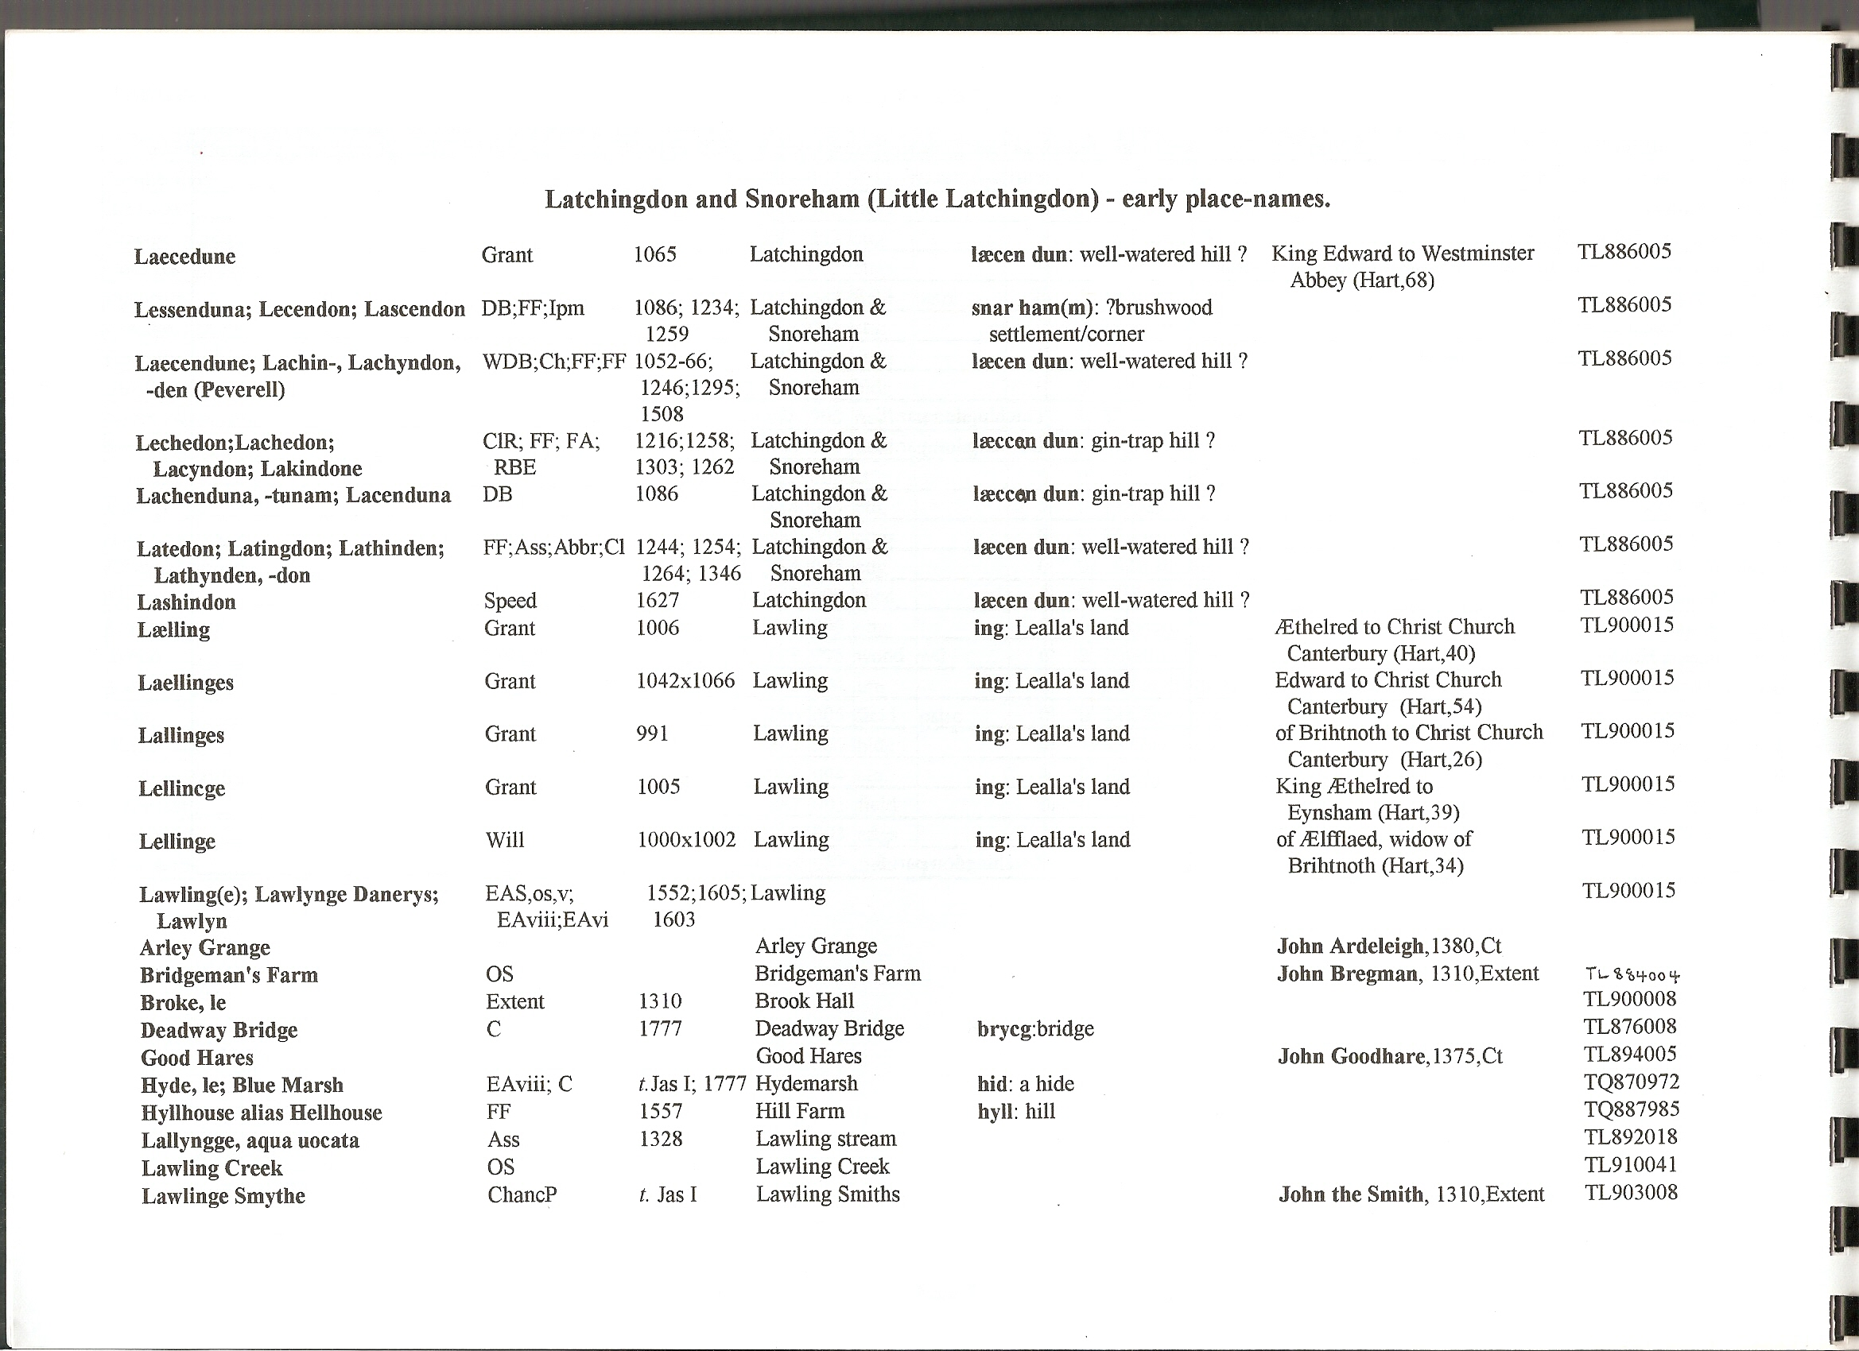

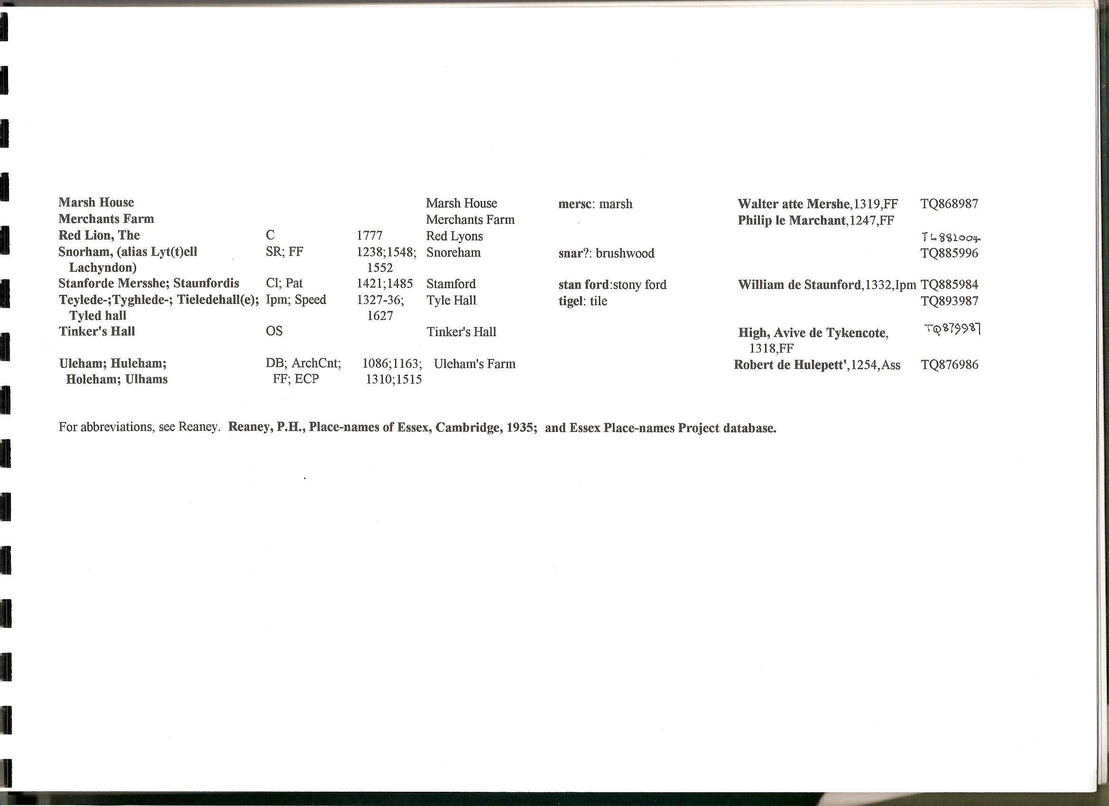

Ordnance Survey c.1875, 6 = 1 mile, Tithe parcel nos. superimposed :--
