**THE PLACE-NAMES OF**

**STANFORD LE HOPE**

**Recorder: James Kemble**

**Essex Place-names Project (Essex Society for Archaeology & History), 2015 (e-book).**

[**www.essex.ac.uk/history/esah/essexplacenames**](http://www.essex.ac.uk/history/esah/essexplacenames)

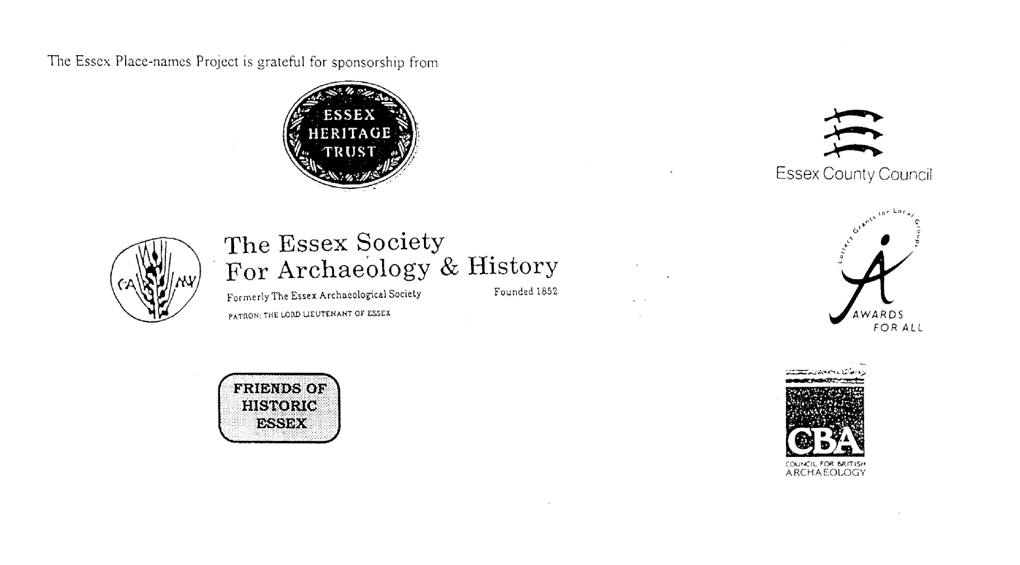

**ESSEX PLACE-NAMES PROJECT.**

The Essex Place-names Project is a County-wide survey to record place- and field-names from historical documents such as Tithe maps and apportionments, estate maps, sale

and auction catalogues, conveyances, terriers, deeds, rolls, inquisitions and surveys.

The second element of the Project is to investigate on-the-ground visible remains which correspond to the Place-names for actual or potential archaeological, agricultural and industrial sites, and to record natural (topographical) and man-made features which may relate to the Place-name. This involves field-survey in rural and outside investigation in built-up areas.

It is anticipated that the Project will lead to identification of archaeological sites and lost historic buildings; it will enable analysis of indicators of early settlement, land holding, agricultural and industrial practices of the County. It will refine the more precise meaning of descriptive words and elements used by earlier settlers as they gave names appropriate to the topography of the landscape of their time.

For convenience the surveys are based on the parish, recognising that present civil parish boundaries are not necessarily identical to former ecclesiastical boundaries. Local Recorders are supplied with templates of Record Forms to ensure consistency of recording across the County, and forward completed forms to a Central Coordinator for transfer to a county computer database which is available to researchers on the internet at [www.essex.ac.uk/history/esah/essexplacenames](http://www.essex.ac.uk/history/esah/essexplacenames), and updated periodically.

This publication presents part of the information recorded from the Tithe or Estate Award and Map, and from other documents for this parish. The full record is contained on the master database at Essex County Council (Historic Environment Section) and on the (above) website. Parish books are available to be downloaded from the website link ‘Books’ on the Home page. Please notify errors to the Project Coordinator at the Essex Record Office.

**THE TITHE MAP AND APPORTIONMENT.**

Since medieval times a tenth of the produce of land and stock had been paid by landholders to the church. At the Dissolution of the Monasteries, the property of many religious houses,

including the right to collect tithes, passed into lay hands. The Tithe Commutation Act which received Royal assent on 13th August 1836 abolished a rent payable in kind and

substituted rent-charges apportioned on each plot or parcel. The tithe-rent payable was assessed on the average value of wheat, barley and oats and was to fluctuate with price movements.

The commutation could be by voluntary agreement between the local owners and payers or, if agreement failed, could be compulsorily imposed by commissioners. A Valuer was to be appointed to apportion the rent of each parcel of land and tenants could deduct that rent-charge from their rent paid to the landlord. The task fell to the Tithe Commissioners to produce a map and an Apportionment (Award). A large-scale survey was produced for over 70% of England and Wales in the following 9 years, and about another 8% up to 1855. Most of the parishes in Essex were surveyed. The map scales vary. The Award records ownership, tenancy and land-use, field by field and parcel by parcel (often quoting the field name) with the ground area and rent-charge.

Land that was tithe-free tends to be less accurately mapped and contains few if any of the details recorded for those parcels subject to tithe. Rights of way and roads also tend to be neglected. Boundaries of the tithe areas are shown as are some natural features such as streams, ponds, gardens, greens and commons. Buildings are often shown coloured red if dwellingsor grey if not. Because the Award may have been agreed only some time after the map was finished, discrepancies occur between the two. Enclosure Awards, when extant, usually date to the 18th and early 19th centuries. J..Kemble.

Reproduced by permission

of Essex County Council.

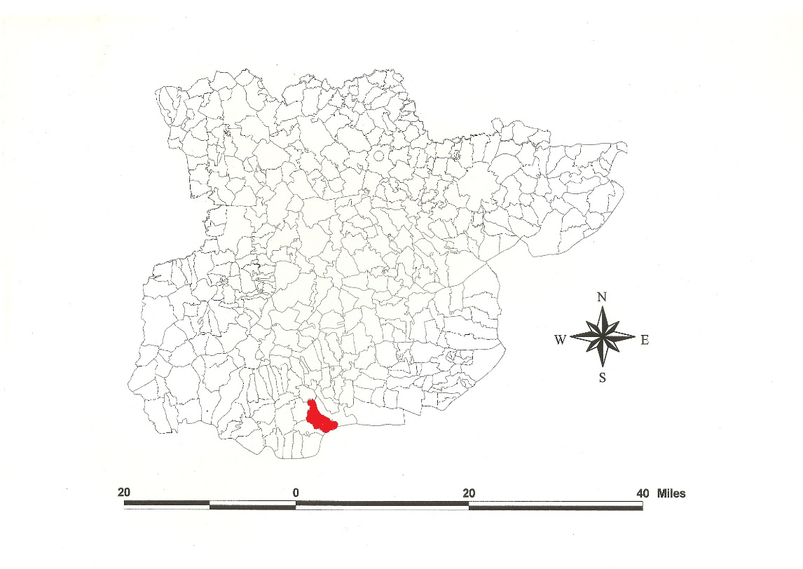

Reproduced by permission of

Essex County Council.

**Stanford le Hope Parish in the County of Essex**

**The Parish of Stanford le Hope (in Barstaple Hundred).**

The Tithe Award of Stanford le Hope (Essex Record Office D/CT 326a), dated 1839, shows a rent-charge of £851-17-7 payable to rector, £56-3-0 to Thomas Mashiter, £21-13-4 to Richard Holdich, £4-6-8 to Mary Bridge, total £933-17-7. The whole parish measured 2418 acres 2 roods 13 perches of which 1488a 2r 28p were arable, 746a 1r 30p meadow and pasture, 24a 22p wood, 159a 1r 4p saltings and commons, 26a 1r 1p glebe. Thomas Mashiter of Hornchurch had the right of 138a 36p, Richard Harding of Great Baddow 5/6 of the remainder, and Mary Bridge 1/6. The Tithe Commissioners were William Blamire and JW Buller, the Assistant Thomas J. Tatham, the Valuer Thomas Bygrave of Clements Inn.

The Tithe map (ERO: D/CT 326b), dated 1839, was surveyed at a scale of 20” to a mile and measures 72x56”. It was countersigned by Roger Kynaston, Assistant Tithe Commissioner.

In Domesday Book, 1086, Thorold’s son held *Hasinghebroc* (Hassenbrook Hall] from the Odo, Bishop of Bayeux, which 16 free men had held before 1066 for 12 hides 13½ acres. This passed with Vange Hall as part of the Honour of Swanscombe (Powell, 1990). Thorold held *Hasingebroc* from Earl Swein which Leofstan had held for one hide 30 acres (Hart, 1971; Morris, 1983). This is ‘the brook of Hassa’s people’. In 1361 Robert Borenare of Bradewell quitclaimed to John Cogger of *Stanford in the Hope* one messuage and land for 100 marks (Kemble, 2007). This is ‘the stone ford by the reach at the winding river’, perhaps referring to the bend of the Thames at this point or a stream flowing into Mucking Creek (Reaney, 1935).

There were these manors: **1.** Hassenbroke Hall, after Turold, was held in 1255 by William de Montchesney. In 1488 William Wettenhale alienated it with Vange to James Crowner and others. **2.** Calbourne: in 1342 John de Newenton held a messuage, 100 acres of arable etc of Hugh Fitzsimon. **3.** Abbots (of Aluric and Ulwin, then Sasselin) was given by William de Septem Molis to Waltham Abbey, no date. After the Suppression the estate was farmed by Robert Pake. In 1543 Henry VIII gave the parish to Walter Farr alias Gillingham (Morant, 1768). Morris (1983) identifies this last as in Ramsden Bellhouse, not Stanford.

The church dedicated to St Margaret of Antioch has a C12 west wall and part of the south wall of the nave. At Garlands Farm has been excavated evidence of a medieval farm, quern stones and cereal (Peachey, 2005). Hassenbrook Hall is timber-framed with brick gables, C17 (Pevsner, 2007).

The Hundred name in Domesday Book is *Berdestapla* which Reaney (1935) translates from Old English *stapol*, post or pillar + *beardede*, ‘hairy’.Christie (1926) places the moot at or near Barstable Hall (TQ 703885) in Basildon parish.

Place- and field-names from other documents are shown against the Tithe Award names.

**References:**

Christie, M., 1926. Essex Hundred Moots. *Trans Essex Archaeological Soc., n.s.*, xviii (3), 182.

Hart, C., 1971. Early Charters of Essex, Leicester.

Kemble, J., 2007. Essex Place-names, Places, Streets & People. Historical Publications, London, pp 33, 82.

Morant, P., 1763. History & Antiquities of the County of Essex, i, 237.

Morris, J., 1983. Domesday Book – Essex. Phillimore.

Peachey, M., 2005. Garlands Farm. *Essex Archaeology & History,* 36, 131.

Pevsner, N., Bettley, J., 2007. Buildings of England – Essex. Yale.

Powell, WR., 1990. Domesday Book. *Essex Archaeology & History,* 21, 50.

Reaney, P., 1935. Place-names of Essex. Cambridge.

**The Tithe Award Place-names of Stanford le Hope - by parcel no.**

|  |  |  |  |  |  |  |  |  |  |  |  |  |  |
| --- | --- | --- | --- | --- | --- | --- | --- | --- | --- | --- | --- | --- | --- |
| **Place name** | **alias** | **Fld No** | **Grd** | **x** | **y** | **Acr** | **Rd** | **Pch** | **Land use** | **Owner** | **Occupier** | **Farm** | **Other information** |
|  |  |  |  |  |  |  |  |  |  |  |  |  |  |
| Great Shutten Wood | Great Sutton Wood, 1875,OS | 1 | TQ | 685 | 857 | 8 | 3 | 2 | wood | Soames, Henry | Massey, John | Northlands (pt) |  |
| Great Hill | Old Hill, 1875,OS | 2 | TQ | 683 | 857 | 29 | 3 | 0 | grass | Soames, Henry | Massey, John | Northlands (pt) |  |
| Shutten House field | Shodneyhill, 1554, Shednehill, Shodnehill, 1575,Ct | 3 | TQ | 682 | 854 | 18 | 0 | 35 | grass | Soames, Henry | Massey, John | Northlands (pt) |  |
| Tinkers field |  | 4 | TQ | 685 | 855 | 9 | 0 | 7 | grass | Soames, Henry | Massey, John | Northlands (pt) |  |
| Nineteen acres |  | 5 | TQ |  |  | 17 | 3 | 30 | arable | Soames, Henry | Massey, John | Northlands (pt) |  |
| Eight acres |  | 6 | TQ |  |  | 13 | 0 | 20 | arable | Soames, Henry | Massey, John | Northlands (pt) |  |
| Horndon mead |  | 7 | TQ | 682 | 852 | 8 | 3 | 29 | arable | Soames, Henry | Massey, John | Northlands (pt) |  |
| Cottage, Slip |  | 8 | TQ | 684 | 850 | 0 | 1 | 36 |  | Soames, Henry | Massey, John | Northlands (pt) |  |
| Horndon field |  | 9 | TQ | 685 | 850 | 10 | 2 | 37 | arable | Soames, Henry | Massey, John | Northlands (pt) |  |
| Four acres |  | 10 | TQ |  |  | 5 | 1 | 11 | arable | Soames, Henry | Massey, John | Northlands (pt) |  |
| Nine acres |  | 11 | TQ |  |  | 10 | 3 | 15 | arable | Soames, Henry | Massey, John | Northlands (pt) |  |
| Wood field |  | 12 | TQ | 687 | 855 | 23 | 3 | 25 | arable | Soames, Henry | Massey, John | Northlands (pt) |  |
| Long Mead (pt) |  | 13 | TQ |  |  | 3 | 0 | 33 | grass | Soames, Henry | Massey, John | Northlands (pt) |  |
| Little mead (pt) |  | 14 | TQ |  |  | 0 | 2 | 6 | grass | Soames, Henry | Massey, John | Northlands (pt) |  |
| Crock field |  | 16 | TQ | 690 | 851 | 26 | 1 | 20 | arable | Soames, Henry | Massey, John | Northlands (pt) |  |
| Three acres |  | 17 | TQ |  |  | 4 | 0 | 19 | arable | Soames, Henry | Massey, John | Northlands (pt) |  |
| New field coppice |  | 18 | TQ | 694 | 848 | 1 | 2 | 32 | wood | Moore, John | Wilson, William | Moore Place |  |
| New field |  | 19 | TQ |  |  | 10 | 2 | 21 | arable | Moore, John | Wilson, William | Moore Place |  |
| Long field |  | 20 | TQ | 694 | 846 | 5 | 2 | 30 | grass | Moore, John | Wilson, William | Moore Place |  |
| Nine acres |  | 21 | TQ |  |  | 10 | 3 | 5 | arable | Moore, John | Wilson, William | Moore Place | cut by railway, 1875,OS |
| Further Causeway field |  | 22 | TQ |  |  | 7 | 3 | 16 | arable | Moore, John | Wilson, William | Moore Place |  |
| Causeway field |  | 23 | TQ | 695 | 843 | 9 | 2 | 26 | arable | Moore, John | Wilson, William | Moore Place |  |
| Hilly field |  | 24 | TQ | 693 | 843 | 12 | 2 | 32 | arable | Moore, John | Wilson, William | Moore Place |  |
| Horse Nails |  | 25 | TQ | 690 | 846 | 22 | 0 | 36 | arable | Moore, John | Wilson, William | Moore Place |  |
| Crockfield Wood |  | 26 | TQ | 690 | 849 | 3 | 1 | 2 | wood | Moore, John | Wilson, William | Moore Place |  |
| Upper field |  | 27 | TQ |  |  | 7 | 3 | 26 | arable | Moore, John | Wilson, William | Moore Place |  |
| Pond field |  | 28 | TQ | 685 | 848 | 9 | 3 | 17 | arable | Moore, John | Wilson, William | Moore Place |  |
| The Copse |  | 29 | TQ | 686 | 844 | 3 | 3 | 30 | wood | Moore, John | Wilson, William | Moore Place |  |
| Fourteen acres |  | 30 | TQ |  |  | 17 | 1 | 38 | arable | Moore, John | Wilson, William | Moore Place |  |
| Twelve acres |  | 31 | TQ |  |  | 12 | 1 | 30 | arable | Moore, John | Wilson, William | Moore Place |  |
| Little mead |  | 34 | TQ | 692 | 843 | 3 | 1 | 11 | grass | Moore, John | Wilson, William | Moore Place |  |
| Homestead | Brick Barns, 1875,OS | 35 | TQ | 692 | 843 | 1 | 1 | 34 |  | Moore, John | Wilson, William | Moore Place |  |
| Long Hubbards |  | 36 | TQ | 690 | 843 | 16 | 0 | 13 | arable | Moore, John | Wilson, William | Moore Place | cut by railway, 1875,OS |
| Horndon field |  | 37 | TQ | 684 | 844 | 16 | 0 | 26 | arable | Moore, John | Wilson, William | Moore Place |  |
| Cradle field |  | 38 | TQ | 686 | 843 | 10 | 1 | 24 | arable | Moore, John | Wilson, William | Moore Place |  |
| Penny field |  | 40 | TQ | 689 | 840 | 9 | 0 | 16 | arable | Moore, John | Wilson, William | Moore Place | cut by railway, 1875,OS |
| The Broad mead |  | 41 | TQ | 688 | 837 | 14 | 1 | 0 | arable | Moore, John | Wilson, William | Moore Place |  |
| Long field |  | 42 | TQ |  |  | 16 | 2 | 1 | arable | Moore, John | Wilson, William | Moore Place |  |
| Wood |  | 43 | TQ | 685 | 841 | 2 | 1 | 36 | wood | Moore, John | Wilson, William | Moore Place |  |
| Pond Ten acres |  | 44 | TQ | 684 | 841 | 12 | 2 | 18 | arable | Moore, John | Wilson, William | Moore Place |  |
| Fourteen acres |  | 46 | TQ |  |  | 17 | 2 | 30 | arable | Moore, John | Wilson, William | Moore Place |  |
| Kitchen field |  | 47 | TQ | 686 | 836 | 16 | 0 | 5 | arable | Moore, John | Wilson, William | Moore Place |  |
| Home Field, Bldgs | Traps, 1777,C; Littletraps, 1875,OS | 48 | TQ | 688 | 835 | 15 | 3 | 31 | grass | Moore, John | Wilson, William | Moore Place |  |
| Back pasture |  | 50 | TQ |  |  | 3 | 1 | 8 | grass | Scratton, John | Scratton, John | Hassenbrook Hall |  |
| Tory field |  | 51 | TQ | 683 | 833 | 12 | 3 | 24 | arable | Scratton, John | Scratton, John | Hassenbrook Hall |  |
| Coney Burrows |  | 52 | TQ | 682 | 835 | 24 | 1 | 27 | arable | Scratton, John | Scratton, John |  |  |
| Broom & Plumtree field |  | 53 | TQ | 681 | 837 | 11 | 2 | 10 | arable | Moore, John | Wilson, William |  |  |
| Acre Mead |  | 54 | TQ |  |  | 1 | 2 | 22 | grass | Moore, John | Wilson, William |  |  |
| Brook field |  | 55 | TQ | 680 | 832 | 7 | 1 | 19 | arable | Scratton, John | Scratton, John |  |  |
| Old Barn field |  | 57 | TQ | 680 | 829 | 13 | 2 | 11 | arable | Scratton, John | Scratton, John |  |  |
| Black Fallow |  | 58 | TQ | 680 | 828 | 4 | 0 | 35 | grass | Scratton, John | Scratton, John |  |  |
| Great Mead |  | 59 | TQ | 682 | 827 | 11 | 2 | 8 | grass | Scratton, John | Scratton, John |  | cut by railway, 1875,OS |
| Little Mead & Wood |  | 60 | TQ | 683 | 828 | 3 | 2 | 26 | grs, wd | Scratton, John | Scratton, John |  |  |
| Great Meadow | [at pons de Stanford, 1285,Ass; Stanford Br., 1875,OS] | 61 | TQ | 682 | 824 | 3 | 1 | 10 | grass | Armstrong, Rev William | Armstrong, Rev William |  | glebe |
| Kings Head P.H., premises |  | 62 | TQ | 683 | 824 | 0 | 1 | 20 |  | Nelson, Ann | Morley, William |  |  |
| Watch House Piece | [at Stanford Green] | 63 | TQ | 683 | 824 | 1 | 3 | 24 | grass | Nelson, Ann | Morley, William |  |  |
| Barn Close |  | 64 | TQ | 682 | 824 | 3 | 0 | 12 | grass | Nelson, Ann | Morley, William |  |  |
| Pound field |  | 65 | TQ | 683 | 825 | 7 | 1 | 33 | arable | Nelson, Ann | Morley, William |  |  |
| Long Mead |  | 66 | TQ |  |  | 3 | 2 | 26 | grass | Nelson, Ann | Morley, William |  |  |
| Leg of Mutton field |  | 67 | TQ | 684 | 826 | 2 | 0 | 33 | arable | Nelson, Ann | Morley, William |  |  |
| The Brotches |  | 68 | TQ | 684 | 828 | 10 | 2 | 29 | grass | Scratton, John | Scratton, John |  |  |
| Homestead | Hasing(h)ebroc, 1086, DB; Harsynbroke, 1436, Cl; Hazenbrook Hall, Tithe map; Hassenbrook Hall, 1875,OS | 69 | TQ | 685 | 831 | 4 | 3 | 10 |  | Scratton, John | Scratton, John |  |  |
| Home field |  | 70 | TQ |  |  | 12 | 0 | 21 | grass | Scratton, John | Scratton, John |  |  |
| Orchard field |  | 71 | TQ | 687 | 833 | 17 | 3 | 20 | arable | Moore, John | Wilson, William | Moore Place |  |
| Moore Place Homestead |  | 72 | TQ | 688 | 835 | 2 | 3 | 36 |  | Moore, John | Wilson, William | Moore Place | John Moore, 1523,SubRoll |
| Barn field |  | 73 | TQ | 690 | 834 | 9 | 1 | 39 | grass | Moore, John | Wilson, William | Moore Place |  |
| Hither Eight Acres |  | 74 | TQ |  |  | 9 | 1 | 21 | arable | Moore, John | Wilson, William | Moore Place |  |
| Further Eight Acres |  | 75 | TQ | 691 | 836 | 9 | 3 | 34 | arable | Moore, John | Wilson, William | Moore Place |  |
| Causeway field |  | 76 | TQ | 693 | 838 | 8 | 1 | 33 | arable | Moore, John | Wilson, William | Moore Place |  |
| Fourteen acres |  | 79 | TQ |  |  | 15 | 0 | 19 | arable | Moore, John | Wilson, William | Moore Place |  |
| Long Downs (pt) |  | 80 | TQ | 696 | 838 | 3 | 0 | 35 | arable | Pryor, Elizabeth | Hallam, John | Pease & Grubbs |  |
| Causeway field |  | 81 | TQ | 695 | 837 | 14 | 0 | 33 | arable | Pryor, Elizabeth | Hallam, John | Pease & Grubbs |  |
| Hilly field |  | 82 | TQ | 696 | 835 | 15 | 2 | 6 | arable | Pryor, Elizabeth | Hallam, John | Pease & Grubbs |  |
| Upper Eleven acres |  | 83 | TQ |  |  | 12 | 0 | 32 | arable | Pryor, Elizabeth | Hallam, John | Pease & Grubbs |  |
| Upper Eight acres |  | 84 | TQ |  |  | 9 | 1 | 8 | arable | Pryor, Elizabeth | Hallam, John | Pease & Grubbs |  |
| Fourteen acres |  | 87 | TQ |  |  | 13 | 3 | 30 | arable | Pryor, Elizabeth | Hallam, John | Pease & Grubbs |  |
| Weazles (pt) |  | 88 | TQ | 701 | 832 | 1 | 3 | 15 | arable | Pryor, Elizabeth | Hallam, John | Pease & Grubbs |  |
| Long Six acres |  | 89 | TQ |  |  | 9 | 0 | 14 | arable | Pryor, Elizabeth | Hallam, John | Pease & Grubbs |  |
| Rainbow |  | 90 | TQ | 697 | 827 | 2 | 3 | 10 | arable | Pryor, Elizabeth | Hallam, John | Pease & Grubbs |  |
| Chapel field |  | 91 | TQ | 697 | 828 | 12 | 2 | 1 | arable | Mashiter, Thomas | Offwood, Stephen Henry |  |  |
| Four Acres |  | 92 | TQ |  |  | 4 | 2 | 15 | arable | Baker, Jane | Hallam, John |  |  |
| Homestead | Abbottes Hall, 1548,Pat; Abbots Hall, Tithe map | 93 | TQ | 694 | 828 | 4 | 0 | 8 |  | Turner, Richard | Wilson, William | Abbots Hall | of abbot of Waltham |
| Home field |  | 94 | TQ |  |  | 3 | 2 | 3 | arable | Turner, Richard | Wilson, William | Abbots Hall |  |
| Chapel field |  | 95 | TQ | 696 | 830 | 21 | 0 | 11 | arable | Turner, Richard | Wilson, William | Abbots Hall |  |
| Hall Mead |  | 97 | TQ |  |  | 8 | 1 | 16 | grass | Turner, Richard | Wilson, William | Abbots Hall |  |
| Large Hill |  | 98 | TQ | 694 | 834 | 29 | 2 | 4 | arable | Turner, Richard | Wilson, William | Abbots Hall |  |
| Hilly Mead |  | 99 | TQ | 692 | 832 | 9 | 2 | 27 | grass | Turner, Richard | Wilson, William | Abbots Hall |  |
| Cottage, gdn, plant |  | 99a | TQ | 693 | 833 | 0 | 2 | 22 |  | Turner, Richard | Wilson, William | Abbots Hall |  |
| Wills Hill |  | 100 | TQ | 690 | 830 | 11 | 3 | 5 | arable | Turner, Richard | Wilson, William | Abbots Hall |  |
| Cottage, bldgs, Slip |  | 100a | TQ | 691 | 831 | 1 | 2 | 5 |  | Turner, Richard | Wilson, William | Abbots Hall |  |
| Wills Hill |  | 101 | TQ | 688 | 830 | 7 | 1 | 24 | arable | Scratton, John | Scratton, John |  |  |
| Church Field |  | 102 | TQ | 691 | 827 | 22 | 3 | 3 | arable | Turner, Richard | Wilson, William | Abbots Hall |  |
| Falstones |  | 103 | TQ | 693 | 825 | 11 | 0 | 24 | arable | Scratton, John | Scratton, John |  |  |
| Acre Piece |  | 104 | TQ | 691 | 824 | 1 | 0 | 6 | arable | Eastwood, Joseph & Wm | Eastwood, Joseph & Wm |  |  |
| Lower Twelve acres |  | 105 | TQ |  |  | 13 | 0 | 8 | arable | Scratton, John | Scratton, John |  |  |
| Coblers field |  | 106 | TQ | 688 | 824 | 11 | 2 | 25 | arable | Scratton, John | Scratton, John |  |  |
| Fox Burrows |  | 107 | TQ | 688 | 826 | 17 | 0 | 37 | arable | Scratton, John | Scratton, John |  |  |
| Ten acres |  | 108 | TQ |  |  | 13 | 3 | 2 | arable | Scratton, John | Scratton, John |  |  |
| Maiden field |  | 109 | TQ | 685 | 825 | 15 | 2 | 2 | arable | Scratton, John | Scratton, John |  |  |
| Public House, premises |  | 111 | TQ | 684 | 824 | 0 | 3 | 6 |  | Ind & Smith | Beckwith, David |  |  |
| Two acres |  | 112 | TQ | 685 | 824 | 2 | 3 | 33 | arable | Ind & Smith | Beckwith, David |  |  |
| Three acres |  | 113 | TQ | 685 | 824 | 3 | 0 | 32 | arable | Wilson, William | Ratford, Thomas |  |  |
| House, Grounds |  | 114 | TQ | 684 | 824 | 0 | 3 | 4 |  | Wilson, William | Ratford, Thomas |  |  |
| Buildings, yard |  | 116 | TQ | 683 | 823 | 0 | 0 | 24 |  | Armstrong, Rev William | Armstrong, Rev William |  | glebe |
| Rectory House, Grounds |  | 117 | TQ | 683 | 823 | 3 | 3 | 27 |  | Armstrong, Rev William | Armstrong, Rev William |  | glebe |
| Barn field |  | 118 | TQ | 683 | 821 | 6 | 2 | 21 | arable | Armstrong, Rev William | Armstrong, Rev William |  | glebe |
| Long Meadow |  | 119 | TQ | 682 | 820 | 1 | 0 | 30 | grass | Armstrong, Rev William | Armstrong, Rev William |  | glebe |
| Little meadow |  | 120 | TQ | 682 | 819 | 0 | 3 | 17 | grass | Turner, Richard | Fordham, M ichael |  |  |
| The Green Field |  | 121 | TQ | 683 | 820 | 5 | 2 | 6 | arable | Turner, Richard | Fordham, M ichael |  |  |
| Five acres |  | 122 | TQ |  |  | 5 | 2 | 15 | arable | Cooper, Charles | Hanson, Elizabeth |  |  |
| Mead |  | 123 | TQ |  |  | 1 | 3 | 32 | grass | Cooper, Charles | Hanson, Elizabeth |  |  |
| Bottom Piece |  | 124 | TQ | 684 | 818 | 0 | 2 | 38 | wood | Nelson, Ann | Morley, William |  |  |
| Halls Field |  | 125 | TQ | 684 | 819 | 3 | 1 | 27 | arable | Nelson, Ann | Morley, William |  |  |
| The Harp |  | 126 | TQ | 685 | 822 | 1 | 2 | 38 | arable | Armstrong, Rev William | Armstrong, Rev William |  | glebe |
| House, gdn, Acre Piece (pt) |  | 127 | TQ | 685 | 821 | 1 | 3 | 12 |  | Turner, Richard | Fordham, M ichael |  |  |
| Six acres |  | 128 | TQ |  |  | 6 | 1 | 4 | arable | Eastwood, Joseph & Wm | Eastwood, Joseph & Wm |  |  |
| Nine acres |  | 129 | TQ |  |  | 9 | 0 | 21 | arable | Armstrong, Rev William | Armstrong, Rev William |  | glebe |
| Jolly Harts |  | 130 | TQ | 688 | 819 | 7 | 0 | 15 | arable | Mayes, John | Mayes, John | Cabbons |  |
| Church Field |  | 131 | TQ | 690 | 820 | 22 | 1 | 35 | arable | French, Joseph | Reeve, James | Ivy Walls |  |
| Five acres |  | 133 | TQ |  |  | 4 | 3 | 39 | arable | French, Joseph | Reeve, James | Ivy Walls |  |
| Broom field |  | 134 | TQ | 692 | 823 | 9 | 1 | 2 | arable | French, Joseph | Reeve, James | Ivy Walls |  |
| House field |  | 135 | TQ | 694 | 823 | 14 | 1 | 6 | arable | French, Joseph | Reeve, James | Ivy Walls |  |
| Corner field |  | 136 | TQ | 695 | 824 | 1 | 1 | 26 | arable | Baker, Jane | Hallam, John |  |  |
| Princes Corner field |  | 137 | TQ | 696 | 825 | 2 | 11 | 6 | arable | Baker, Jane | Hallam, John |  |  |
| Princes Large Corner field |  | 138 | TQ | 697 | 825 | 13 | 0 | 2 | arable | Pryor, Elizabeth | Hallam, John |  |  |
| Three acres |  | 139 | TQ |  |  | 2 | 2 | 15 | arable | Mashiter, Thomas | Offwood, Stephen Henry | Sprats or Broad Hope |  |
| Grubbs Eight acres |  | 140 | TQ | 699 | 827 | 8 | 1 | 30 | arable | Pryor, Elizabeth | Hallam, John | Pease & Grubbs |  |
| Four acres |  | 142 | TQ |  |  | 4 | 3 | 28 | arable | Pryor, Elizabeth | Hallam, John | Pease & Grubbs |  |
| Stone field |  | 144 | TQ | 703 | 828 | 7 | 1 | 2 | arable | Pryor, Elizabeth | Hallam, John | Pease & Grubbs |  |
| Pease Homestead |  | 145 | TQ | 702 | 826 | 1 | 3 | 18 |  | Pryor, Elizabeth | Hallam, John | Pease & Grubbs |  |
| Homestead | Pitseys, 1875,OS | 145a | TQ | 703 | 826 | 0 | 1 | 20 |  | Hawkins Hospital, Chatham | Spitty, George |  |  |
| Kitchen mead |  | 146 | TQ | 702 | 827 | 5 | 0 | 14 | grass | Pryor, Elizabeth | Hallam, John | Pease & Grubbs |  |
| Grubbs Homestead |  | 147 | TQ | 701 | 825 | 1 | 0 | 29 |  | Pryor, Elizabeth | Hallam, John | Pease & Grubbs |  |
| Grubbs mead |  | 148 | TQ | 700 | 826 | 6 | 2 | 30 | grass | Pryor, Elizabeth | Hallam, John | Pease & Grubbs |  |
| Grubbs Eleven acres |  | 149 | TQ |  |  | 12 | 0 | 34 | arable | Pryor, Elizabeth | Hallam, John | Pease & Grubbs |  |
| Grubbs Billett field |  | 150 | TQ | 698 | 823 | 9 | 1 | 10 | arable | Pryor, Elizabeth | Hallam, John | Pease & Grubbs |  |
| Homestead | Juy[e]wall, 1594,N; Ivywall Farm , 1875,OS | 151 | TQ | 694 | 822 | 1 | 1 | 4 |  | French, Joseph | Reeve, James | Ivy Walls |  |
| Orchard |  | 152 | TQ |  |  | 1 | 0 | 7 | grass | French, Joseph | Reeve, James | Ivy Walls |  |
| Hoppett |  | 153 | TQ |  |  | 1 | 3 | 38 | grass | French, Joseph | Reeve, James | Ivy Walls |  |
| Footpath field |  | 154 | TQ | 696 | 822 | 11 | 1 | 8 | arable | French, Joseph | Reeve, James | Ivy Walls |  |
| Little Billett |  | 155 | TQ | 697 | 822 | 1 | 3 | 14 | arable | French, Joseph | Reeve, James | Ivy Walls |  |
| Great Billett Field |  | 156 | TQ | 696 | 820 | 7 | 0 | 26 | arable | French, Joseph | Reeve, James | Ivy Walls |  |
| Thistley field |  | 157 | TQ | 698 | 820 | 12 | 0 | 2 | arable | French, Joseph | Reeve, James | Ivy Walls |  |
| Mill Field | Mellefeld, 1414,Ct | 158 | TQ | 700 | 817 | 17 | 1 | 0 | arable | French, Joseph | Reeve, James | Ivy Walls |  |
| Little Thistley |  | 159 | TQ | 698 | 817 | 6 | 1 | 22 | arable | French, Joseph | Reeve, James | Ivy Walls |  |
| Kitchen field |  | 160 | TQ | 695 | 819 | 11 | 3 | 13 | arable | French, Joseph | Reeve, James | Ivy Walls |  |
| Barn field |  | 161 | TQ | 693 | 820 | 19 | 2 | 36 | arable | French, Joseph | Reeve, James | Ivy Walls |  |
| Acre Piece |  | 162 | TQ | 689 | 818 | 1 | 1 | 10 | arable | Dentry, William | Dentry, William |  |  |
| Homestead, Grass paddock (pt) | Cabournes, 1470, ECP; Cawbornes, 1555,Ct; Cauvers or Caubers, 1713,Deed; Cabborns, Tithe map | 163 | TQ | 686 | 817 | 6 | 3 | 0 |  | Mayes, John | Mayes, John |  | Grove House, 1875,OS |
| Kitts Hill Coppice |  | 164 | TQ | 685 | 817 | 2 | 0 | 12 | wood | Mayes, John | Mayes, John | Cabbons |  |
| Kitts Hill Mead |  | 165 | TQ | 685 | 816 | 1 | 2 | 37 | grass | Mayes, John | Mayes, John | Cabbons |  |
| The Wet Mead |  | 166 | TQ | 687 | 815 | 6 | 0 | 28 | grass | Mayes, John | Mayes, John | Cabbons |  |
| Homestead | Cabborns, 1875,OS | 167 | TQ | 688 | 815 | 3 | 1 | 10 |  | Mayes, John | Mayes, John | Cabbons | John Caborne, 1429,FeetFine |
| Cow House field |  | 168 | TQ | 688 | 816 | 14 | 2 | 29 | arable | Mayes, John | Mayes, John | Cabbons |  |
| Cabbons field |  | 169 | TQ | 690 | 818 | 7 | 3 | 10 | arable | Mayes, John | Mayes, John | Cabbons |  |
| Daniels Field |  | 171 | TQ | 690 | 817 | 5 | 0 | 2 | arable | Mayes, John | Mayes, John | Cabbons |  |
| Sixteen acres |  | 172 | TQ |  |  | 16 | 1 | 0 | arable | Mayes, John | Mayes, John | Cabbons |  |
| Pond Field |  | 173 | TQ | 694 | 817 | 9 | 0 | 14 | arable | Mayes, John | Mayes, John | Cabbons |  |
| Broom field |  | 175 | TQ | 696 | 814 | 9 | 2 | 0 | arable | Mayes, John | Mayes, John | Cabbons | cut by railway, 1875,OS |
| Barn field |  | 176 | TQ | 698 | 815 | 13 | 2 | 23 | arable | Mayes, John | Mayes, John | Cabbons |  |
| Five acres by Marshes |  | 177 | TQ |  |  | 5 | 0 | 32 | arable | Mayes, John | Mayes, John | Cabbons |  |
| Nine acres by Marshes |  | 178 | TQ | 698 | 813 | 11 | 0 | 10 | arable | Mayes, John | Mayes, John | Cabbons |  |
| Ten acres |  | 180 | TQ |  |  | 9 | 2 | 22 | arable | Mayes, John | Mayes, John | Cabbons |  |
| Buildings, yard |  | 181 | TQ | 694 | 811 | 0 | 1 | 5 | arable | Mayes, John | Mayes, John | Cabbons |  |
| Long Seven acres |  | 182 | TQ |  |  | 8 | 0 | 23 | arable | Mayes, John | Mayes, John | Cabbons |  |
| Thirteen acres |  | 183 | TQ |  |  | 13 | 1 | 24 | arable | Mayes, John | Mayes, John | Cabbons | cut by railway, 1875,OS |
| Mucking Home field |  | 184 | TQ | 690 | 813 | 18 | 0 | 23 | grass | Mayes, John | Mayes, John | Cabbons |  |
| The Skirts |  | 185 | TQ | 688 | 811 | 3 | 1 | 20 | grass | Mayes, John | Mayes, John | Cabbons |  |
| Acre Piece |  | 186 | TQ | 692 | 813 | 1 | 2 | 22 | arable | Stanford le Hope Parish | Mayes, John |  |  |
| The Warren |  | 187 | TQ | 691 | 811 | 15 | 1 | 0 | arable | Mayes, John | Mayes, John | Cabbons |  |
| The Further Warren |  | 188 | TQ | 692 | 810 | 9 | 3 | 0 | arable | Mayes, John | Mayes, John | Cabbons |  |
| Rushey Marsh |  | 189 | TQ | 692 | 808 | 12 | 1 | 30 | grass | Mayes, John | Mayes, John | Cabbons |  |
| Saltings, Wall |  | 189a | TQ | 693 | 805 | 32 | 2 | 32 |  | Mayes, John | Mayes, John | Cabbons |  |
| Wharf Marsh | The Vigilant (Coastguard Station), 1875,OS | 191 | TQ | 695 | 808 | 5 | 2 | 34 | grass | Mayes, John | Mayes, John | Cabbons |  |
| Hawkes Marsh |  | 192 | TQ | 695 | 810 | 12 | 0 | 3 | grass | Mayes, John | Mayes, John | Cabbons |  |
| Mole Hill Marsh |  | 193 | TQ | 697 | 811 | 11 | 2 | 12 | grass | Mayes, John | Mayes, John | Cabbons |  |
| Wet Marsh |  | 194 | TQ | 700 | 812 | 5 | 1 | 3 | grass | Mayes, John | Mayes, John | Cabbons |  |
| Little Barn Marsh |  | 195 | TQ | 701 | 812 | 4 | 3 | 37 | grass | Mayes, John | Mayes, John | Cabbons |  |
| East pt of 20 acre marsh |  | 196 | TQ | 700 | 810 | 9 | 0 | 16 | grass | Mayes, John | Mayes, John | Cabbons |  |
| West pt of 20 acre marsh | Wharf, 1875,OS | 197 | TQ | 697 | 808 | 10 | 0 | 3 | grass | Mayes, John | Mayes, John | Cabbons |  |
| Four Acre Marsh |  | 198 | TQ |  |  | 7 | 0 | 19 | grass | Mayes, John | Mayes, John | Cabbons |  |
| Ten acre marsh |  | 199 | TQ |  |  | 11 | 3 | 6 | grass | Mayes, John | Mayes, John | Cabbons |  |
| Five acre marsh |  | 200 | TQ | 702 | 810 | 7 | 0 | 19 | grass | Mayes, John | Mayes, John | Cabbons |  |
| Seven acres |  | 201 | TQ |  |  | 8 | 1 | 10 | grass | Mashiter, Thomas | Offwood, Stephen Henry | Sprats or Broad Hope |  |
| Little Marsh |  | 202 | TQ | 704 | 811 | 0 | 3 | 35 | grass | Mayes, John | Mayes, John | Cabbons |  |
| Saltings, Wall | Earls Hope, 1875,OS | 203 | TQ | 705 | 810 | 45 | 1 | 9 |  | Mayes, John | Mayes, John | Cabbons |  |
| Ten acres |  | 205 | TQ |  |  | 10 | 1 | 24 | arable | Mashiter, Thomas | Offwood, Stephen Henry | Sprats or Broad Hope |  |
| Small four acres |  | 206 | TQ | 701 | 815 | 4 | 0 | 14 | arable | Mashiter, Thomas | Offwood, Stephen Henry | Sprats or Broad Hope |  |
| Large four acres |  | 207 | TQ | 702 | 816 | 4 | 2 | 14 | arable | Mashiter, Thomas | Offwood, Stephen Henry | Sprats or Broad Hope |  |
| Chase |  | 208 | TQ |  |  | 2 | 1 | 3 | grass | Mashiter, Thomas | Offwood, Stephen Henry | Sprats or Broad Hope |  |
| Barn field |  | 210 | TQ | 703 | 817 | 5 | 2 | 5 | arable | Mashiter, Thomas | Offwood, Stephen Henry | Sprats or Broad Hope |  |
| Sixteen acres |  | 211 | TQ |  |  | 17 | 0 | 24 | arable | Mashiter, Thomas | Eastwood, Joseph & Wm | Great Garlands |  |
| Four acres |  | 212 | TQ |  |  | 3 | 3 | 25 | arable | Mashiter, Thomas | Eastwood, Joseph & Wm | Great Garlands |  |
| Garden field |  | 214 | TQ | 702 | 818 | 5 | 0 | 13 | arable | Mashiter, Thomas | Offwood, Stephen Henry | Sprats or Broad Hope |  |
| Homestead | Brodhoppe, 1414,Ct; Spratts or Broad Hope, 1871,Stifford | 215 | TQ | 701 | 819 | 1 | 0 | 31 |  | Mashiter, Thomas | Offwood, Stephen Henry | Sprats or Broad Hope |  |
| Offwood's Hoppett |  | 216 | TQ | 700 | 819 | 1 | 0 | 19 | grass | Mashiter, Thomas | Offwood, Stephen Henry | Sprats or Broad Hope |  |
| Seven acres |  | 217 | TQ |  |  | 7 | 0 | 2 | grass | Mashiter, Thomas | Offwood, Stephen Henry | Sprats or Broad Hope |  |
| Cottages, gdns |  | 218 | TQ | 699 | 821 | 0 | 2 | 11 |  | Mashiter, Thomas | Offwood, Stephen Henry | Sprats or Broad Hope |  |
| Cottages, gdns | Crooked Billet, 1875,OS | 220 | TQ | 698 | 822 | 0 | 1 | 27 |  | Mashiter, Thomas | Offwood, Stephen Henry | Sprats or Broad Hope |  |
| Billett Field |  | 221 | TQ | 699 | 822 | 3 | 3 | 20 | arable | Mashiter, Thomas | Offwood, Stephen Henry | Sprats or Broad Hope |  |
| Long Hawkins |  | 222 | TQ | 701 | 824 | 6 | 1 | 24 | arable | Pryor, Elizabeth | Hallam, John | Pease & Grubbs |  |
| Five acres |  | 223 | TQ |  |  | 5 | 1 | 8 | arable | Mashiter, Thomas | Eastwood, Joseph & Wm | Great Garlands |  |
| Garden field |  | 225 | TQ | 703 | 824 | 5 | 1 | 32 | arable | Mashiter, Thomas | Eastwood, Joseph & Wm | Great Garlands |  |
| Little Hawkins |  | 226 | TQ | 702 | 825 | 3 | 2 | 27 | arable | Pryor, Elizabeth | Hallam, John | Pease & Grubbs |  |
| Home field |  | 227 | TQ | 704 | 825 | 3 | 3 | 7 | arable | Mashiter, Thomas | Eastwood, Joseph & Wm |  |  |
| Six acres |  | 228 | TQ | 704 | 827 | 6 | 2 | 28 | arable | Hawkins Hospital, Chatham | Spitty, George |  |  |
| Ten acres |  | 229 | TQ | 705 | 826 | 10 | 0 | 39 | arable | Hawkins Hospital, Chatham | Spitty, George |  |  |
| Home mead |  | 230 | TQ |  |  | 2 | 2 | 28 | grass | Mashiter, Thomas | Eastwood, Joseph & Wm | Great Garlands |  |
| Homestead | Great Garlands, Tithe map | 231 | TQ | 704 | 824 | 2 | 0 | 7 |  | Mashiter, Thomas | Eastwood, Joseph & Wm | Great Garlands |  |
| Barn field |  | 232 | TQ | 704 | 823 | 4 | 2 | 7 | arable | Mashiter, Thomas | Eastwood, Joseph & Wm | Great Garlands |  |
| Saw pit field |  | 233 | TQ | 705 | 822 | 5 | 3 | 16 | arable | Mashiter, Thomas | Eastwood, Joseph & Wm | Great Garlands |  |
| Barn Marsh |  | 234 | TQ | 706 | 822 | 2 | 3 | 35 | grass | Mashiter, Thomas | Eastwood, Joseph & Wm | Great Garlands |  |
| Cow House field |  | 235 | TQ | 705 | 823 | 3 | 2 | 22 | arable | Mashiter, Thomas | Eastwood, Joseph & Wm | Great Garlands |  |
| Barn, yd, Chase | Little Garlands, 1875,OS | 237 | TQ | 704 | 826 | 1 | 1 | 29 |  | Hawkins Hospital, Chatham | Spitty, George |  |  |
| Ten acres |  | 238 | TQ |  |  | 10 | 2 | 4 | arable | Hawkins Hospital, Chatham | Spitty, George |  |  |
| Bobs Marsh |  | 239 | TQ | 709 | 826 | 3 | 3 | 17 | grass | Hawkins Hospital, Chatham | Spitty, George |  |  |
| Skirts |  | 240 | TQ | 709 | 825 | 5 | 1 | 11 | grass | Mashiter, Thomas | Eastwood, Joseph & Wm | Great Garlands |  |
| Seven acres |  | 241 | TQ | 712 | 824 | 10 | 0 | 15 | grass | Hawkins Hospital, Chatham | Spitty, George |  |  |
| Marsh below Eight acres |  | 243 | TQ | 708 | 824 | 7 | 0 | 1 | grass | Mashiter, Thomas | Eastwood, Joseph & Wm | Great Garlands |  |
| The Skirts |  | 244 | TQ | 707 | 820 | 6 | 1 | 6 | grass | Mashiter, Thomas | Eastwood, Joseph & Wm | Great Garlands |  |
| Eastwoods Skirts |  | 245 | TQ | 707 | 818 | 7 | 2 | 4 | grass | Mashiter, Thomas | Eastwood, Joseph & Wm | Great Garlands |  |
| Marsh below Six acres |  | 246 | TQ | 706 | 818 | 11 | 3 | 21 | grass | Mashiter, Thomas | Eastwood, Joseph & Wm | Great Garlands |  |
| Six acres |  | 248 | TQ |  |  | 5 | 3 | 13 | grass | Mashiter, Thomas | Offwood, Stephen Henry | Sprats or Broad Hope |  |
| Eight acres |  | 249 | TQ |  |  | 8 | 0 | 13 | grass | Mashiter, Thomas | Offwood, Stephen Henry | Sprats or Broad Hope |  |
| Four acres |  | 251 | TQ | 707 | 814 | 3 | 2 | 11 | grass | Mashiter, Thomas | Offwood, Stephen Henry | Sprats or Broad Hope | cut by railway, 1875,OS |
| Three acres |  | 253 | TQ |  |  | 2 | 3 | 3 | grass | Mashiter, Thomas | Offwood, Stephen Henry | Sprats or Broad Hope |  |
| Saltings, Wall |  | 254-5 | TQ | 707 | 813 | 20 | 0 | 34 | grass | Mashiter, Thomas | Offwood, Stephen Henry | Sprats or Broad Hope |  |
| Eleven acres |  | 256 | TQ |  |  | 13 | 1 | 17 | grass | Mashiter, Thomas | Eastwood, Joseph & Wm | Great Garlands |  |
| Six acres |  | 258 | TQ |  |  | 7 | 1 | 28 | grass | Hawkins Hospital, Chatham | Spitty, George |  |  |
| Large Marsh |  | 259 | TQ | 715 | 820 | 22 | 2 | 21 | grass | Hawkins Hospital, Chatham | Spitty, George |  |  |
| Lower Marsh |  | 260 | TQ | 716 | 817 | 21 | 3 | 16 | grass | Hawkins Hospital, Chatham | Spitty, George |  |  |
| Lower Marsh |  | 261 | TQ |  |  | 8 | 0 | 27 | grass | Hawkins Hospital, Chatham | Spitty, George |  |  |
| Lower Marsh |  | 262 | TQ | 712 | 815 | 13 | 3 | 29 | grass | Hawkins Hospital, Chatham | Spitty, George |  |  |
| Skirts |  | 263 | TQ | 717 | 815 | 9 | 0 | 24 | grass | Hawkins Hospital, Chatham | Spitty, George |  |  |
| Skirts |  | 264 | TQ |  |  | 2 | 0 | 27 | grass | Hawkins Hospital, Chatham | Spitty, George |  |  |
| Sea Wall |  | 265 | TQ | 712 | 814 | 1 | 0 | 6 | grass | Hawkins Hospital, Chatham | Spitty, George |  |  |
| Saltings |  | 266 | TQ |  |  | 4 | 2 | 19 | grass | Hawkins Hospital, Chatham | Spitty, George |  |  |
| Currey Marsh |  | 267 | TQ | 715 | 813 | 32 | 0 | 37 | grass | Spitty, George | Spitty, George | Currey | cut by railway, 1875,OS |
| Currey Marsh | Curriemarsh, 1875,OS | 268 | TQ | 717 | 813 | 28 | 2 | 27 | grass | Spitty, George | Spitty, George | Currey | cut by railway, 1875,OS |
| Shed, yard |  | 269 | TQ | 718 | 816 | 0 | 0 | 20 |  | Spitty, George | Spitty, George | Currey |  |
| Cottage, gdn |  | 270 | TQ | 718 | 818 | 0 | 0 | 20 |  | Wingfield, William | Spitty, George |  |  |
| Driftway |  | 271 | TQ | 715 | 823 | 4 | 0 | 5 | grass | Hawkins Hospital, Chatham | Spitty, George |  |  |
| Skirts |  | 272 | TQ | 715 | 824 | 6 | 2 | 39 | grass | Wingfield, William | Spitty, George |  |  |
| Little Marsh |  | 273 | TQ | 720 | 821 | 2 | 0 | 8 | grass | Wingfield, William | Spitty, George |  |  |
| Fourteen acre marsh |  | 274 | TQ |  |  | 14 | 3 | 19 | grass | Wingfield, William | Spitty, George |  |  |
| Twelve acre marsh |  | 275 | TQ | 721 | 820 | 12 | 2 | 29 | grass | Wingfield, William | Spitty, George |  |  |
| Twelve acre marsh |  | 276 | TQ |  |  | 12 | 2 | 27 | grass | Wingfield, William | Spitty, George |  |  |
| The Skirts |  | 277 | TQ | 720 | 817 | 6 | 3 | 25 | grass | Wingfield, William | Spitty, George |  |  |
| Currey Marsh |  | 278 | TQ | 721 | 815 | 32 | 0 | 0 | grass | Spitty, George | Spitty, George | Currey | cut by railway, 1875,OS |
| Currey Marsh | Mucking lighthouse, 1875,OS | 279 | TQ | 724 | 814 | 8 | 1 | 32 | grass | Spitty, George | Spitty, George | Currey |  |
| Sea Wall |  | 280 | TQ | 720 | 813 | 2 | 3 | 20 | grass | Spitty, George | Spitty, George | Currey |  |
| Saltings |  | 281 | TQ | 711 | 813 | 27 | 1 | 27 | grass | Spitty, George | Spitty, George | Currey |  |

**For abbreviations see Reaney, P., The Place-names of Essex, Cambridge, 1935; and Kemble, J., Essex Place-names, Places, Streets & People. Historical Press, p, 153.**

**The Tithe Award Place-names of Stanford le Hope - by Owner.**

|  |  |  |  |  |  |  |  |  |  |  |  |  |  |
| --- | --- | --- | --- | --- | --- | --- | --- | --- | --- | --- | --- | --- | --- |
| **Place name** | **alias** | **Fld No** | **Grd** | **x** | **y** | **Acr** | **Rd** | **Pch** | **Land use** | **Owner** | **Occupier** | **Farm** | **Other information** |
|  |  |  |  |  |  |  |  |  |  |  |  |  |  |
| Buildings, yard |  | 116 | TQ | 683 | 823 | 0 | 0 | 24 |  | Armstrong, Rev William | Armstrong, Rev William |  | glebe |
| Rectory House, Grounds |  | 117 | TQ | 683 | 823 | 3 | 3 | 27 |  | Armstrong, Rev William | Armstrong, Rev William |  | glebe |
| Barn field |  | 118 | TQ | 683 | 821 | 6 | 2 | 21 | arable | Armstrong, Rev William | Armstrong, Rev William |  | glebe |
| Long Meadow |  | 119 | TQ | 682 | 820 | 1 | 0 | 30 | grass | Armstrong, Rev William | Armstrong, Rev William |  | glebe |
| The Harp |  | 126 | TQ | 685 | 822 | 1 | 2 | 38 | arable | Armstrong, Rev William | Armstrong, Rev William |  | glebe |
| Nine acres |  | 129 | TQ |  |  | 9 | 0 | 21 | arable | Armstrong, Rev William | Armstrong, Rev William |  | glebe |
| Great Meadow | [at pons de Stanford, 1285,Ass; Stanford Br., 1875,OS] | 61 | TQ | 682 | 824 | 3 | 1 | 10 | grass | Armstrong, Rev William | Armstrong, Rev William |  | glebe |
| Corner field |  | 136 | TQ | 695 | 824 | 1 | 1 | 26 | arable | Baker, Jane | Hallam, John |  |  |
| Princes Corner field |  | 137 | TQ | 696 | 825 | 2 | 11 | 6 | arable | Baker, Jane | Hallam, John |  |  |
| Four Acres |  | 92 | TQ |  |  | 4 | 2 | 15 | arable | Baker, Jane | Hallam, John |  |  |
| Five acres |  | 122 | TQ |  |  | 5 | 2 | 15 | arable | Cooper, Charles | Hanson, Elizabeth |  |  |
| Mead |  | 123 | TQ |  |  | 1 | 3 | 32 | grass | Cooper, Charles | Hanson, Elizabeth |  |  |
| Acre Piece |  | 162 | TQ | 689 | 818 | 1 | 1 | 10 | arable | Dentry, William | Dentry, William |  |  |
| Acre Piece |  | 104 | TQ | 691 | 824 | 1 | 0 | 6 | arable | Eastwood, Joseph & Wm | Eastwood, Joseph & Wm |  |  |
| Six acres |  | 128 | TQ |  |  | 6 | 1 | 4 | arable | Eastwood, Joseph & Wm | Eastwood, Joseph & Wm |  |  |
| Church Field |  | 131 | TQ | 690 | 820 | 22 | 1 | 35 | arable | French, Joseph | Reeve, James | Ivy Walls |  |
| Five acres |  | 133 | TQ |  |  | 4 | 3 | 39 | arable | French, Joseph | Reeve, James | Ivy Walls |  |
| Broom field |  | 134 | TQ | 692 | 823 | 9 | 1 | 2 | arable | French, Joseph | Reeve, James | Ivy Walls |  |
| House field |  | 135 | TQ | 694 | 823 | 14 | 1 | 6 | arable | French, Joseph | Reeve, James | Ivy Walls |  |
| Homestead | Juy[e]wall, 1594,N; Ivywall Farm , 1875,OS | 151 | TQ | 694 | 822 | 1 | 1 | 4 |  | French, Joseph | Reeve, James | Ivy Walls |  |
| Orchard |  | 152 | TQ |  |  | 1 | 0 | 7 | grass | French, Joseph | Reeve, James | Ivy Walls |  |
| Hoppett |  | 153 | TQ |  |  | 1 | 3 | 38 | grass | French, Joseph | Reeve, James | Ivy Walls |  |
| Footpath field |  | 154 | TQ | 696 | 822 | 11 | 1 | 8 | arable | French, Joseph | Reeve, James | Ivy Walls |  |
| Little Billett |  | 155 | TQ | 697 | 822 | 1 | 3 | 14 | arable | French, Joseph | Reeve, James | Ivy Walls |  |
| Great Billett Field |  | 156 | TQ | 696 | 820 | 7 | 0 | 26 | arable | French, Joseph | Reeve, James | Ivy Walls |  |
| Thistley field |  | 157 | TQ | 698 | 820 | 12 | 0 | 2 | arable | French, Joseph | Reeve, James | Ivy Walls |  |
| Mill Field | Mellefeld, 1414,Ct | 158 | TQ | 700 | 817 | 17 | 1 | 0 | arable | French, Joseph | Reeve, James | Ivy Walls |  |
| Little Thistley |  | 159 | TQ | 698 | 817 | 6 | 1 | 22 | arable | French, Joseph | Reeve, James | Ivy Walls |  |
| Kitchen field |  | 160 | TQ | 695 | 819 | 11 | 3 | 13 | arable | French, Joseph | Reeve, James | Ivy Walls |  |
| Barn field |  | 161 | TQ | 693 | 820 | 19 | 2 | 36 | arable | French, Joseph | Reeve, James | Ivy Walls |  |
| Homestead | Pitseys, 1875,OS | 145a | TQ | 703 | 826 | 0 | 1 | 20 |  | Hawkins Hospital, Chatham | Spitty, George |  |  |
| Six acres |  | 228 | TQ | 704 | 827 | 6 | 2 | 28 | arable | Hawkins Hospital, Chatham | Spitty, George |  |  |
| Ten acres |  | 229 | TQ | 705 | 826 | 10 | 0 | 39 | arable | Hawkins Hospital, Chatham | Spitty, George |  |  |
| Barn, yd, Chase | Little Garlands, 1875,OS | 237 | TQ | 704 | 826 | 1 | 1 | 29 |  | Hawkins Hospital, Chatham | Spitty, George |  |  |
| Ten acres |  | 238 | TQ |  |  | 10 | 2 | 4 | arable | Hawkins Hospital, Chatham | Spitty, George |  |  |
| Bobs Marsh |  | 239 | TQ | 709 | 826 | 3 | 3 | 17 | grass | Hawkins Hospital, Chatham | Spitty, George |  |  |
| Seven acres |  | 241 | TQ | 712 | 824 | 10 | 0 | 15 | grass | Hawkins Hospital, Chatham | Spitty, George |  |  |
| Six acres |  | 258 | TQ |  |  | 7 | 1 | 28 | grass | Hawkins Hospital, Chatham | Spitty, George |  |  |
| Large Marsh |  | 259 | TQ | 715 | 820 | 22 | 2 | 21 | grass | Hawkins Hospital, Chatham | Spitty, George |  |  |
| Lower Marsh |  | 260 | TQ | 716 | 817 | 21 | 3 | 16 | grass | Hawkins Hospital, Chatham | Spitty, George |  |  |
| Lower Marsh |  | 261 | TQ |  |  | 8 | 0 | 27 | grass | Hawkins Hospital, Chatham | Spitty, George |  |  |
| Lower Marsh |  | 262 | TQ | 712 | 815 | 13 | 3 | 29 | grass | Hawkins Hospital, Chatham | Spitty, George |  |  |
| Skirts |  | 263 | TQ | 717 | 815 | 9 | 0 | 24 | grass | Hawkins Hospital, Chatham | Spitty, George |  |  |
| Skirts |  | 264 | TQ |  |  | 2 | 0 | 27 | grass | Hawkins Hospital, Chatham | Spitty, George |  |  |
| Sea Wall |  | 265 | TQ | 712 | 814 | 1 | 0 | 6 | grass | Hawkins Hospital, Chatham | Spitty, George |  |  |
| Saltings |  | 266 | TQ |  |  | 4 | 2 | 19 | grass | Hawkins Hospital, Chatham | Spitty, George |  |  |
| Driftway |  | 271 | TQ | 715 | 823 | 4 | 0 | 5 | grass | Hawkins Hospital, Chatham | Spitty, George |  |  |
| Public House, premises |  | 111 | TQ | 684 | 824 | 0 | 3 | 6 |  | Ind & Smith | Beckwith, David |  |  |
| Two acres |  | 112 | TQ | 685 | 824 | 2 | 3 | 33 | arable | Ind & Smith | Beckwith, David |  |  |
| Sixteen acres |  | 211 | TQ |  |  | 17 | 0 | 24 | arable | Mashiter, Thomas | Eastwood, Joseph & Wm | Great Garlands |  |
| Four acres |  | 212 | TQ |  |  | 3 | 3 | 25 | arable | Mashiter, Thomas | Eastwood, Joseph & Wm | Great Garlands |  |
| Five acres |  | 223 | TQ |  |  | 5 | 1 | 8 | arable | Mashiter, Thomas | Eastwood, Joseph & Wm | Great Garlands |  |
| Garden field |  | 225 | TQ | 703 | 824 | 5 | 1 | 32 | arable | Mashiter, Thomas | Eastwood, Joseph & Wm | Great Garlands |  |
| Home field |  | 227 | TQ | 704 | 825 | 3 | 3 | 7 | arable | Mashiter, Thomas | Eastwood, Joseph & Wm |  |  |
| Home mead |  | 230 | TQ |  |  | 2 | 2 | 28 | grass | Mashiter, Thomas | Eastwood, Joseph & Wm | Great Garlands |  |
| Homestead | Great Garlands, Tithe map | 231 | TQ | 704 | 824 | 2 | 0 | 7 |  | Mashiter, Thomas | Eastwood, Joseph & Wm | Great Garlands |  |
| Barn field |  | 232 | TQ | 704 | 823 | 4 | 2 | 7 | arable | Mashiter, Thomas | Eastwood, Joseph & Wm | Great Garlands |  |
| Saw pit field |  | 233 | TQ | 705 | 822 | 5 | 3 | 16 | arable | Mashiter, Thomas | Eastwood, Joseph & Wm | Great Garlands |  |
| Barn Marsh |  | 234 | TQ | 706 | 822 | 2 | 3 | 35 | grass | Mashiter, Thomas | Eastwood, Joseph & Wm | Great Garlands |  |
| Cow House field |  | 235 | TQ | 705 | 823 | 3 | 2 | 22 | arable | Mashiter, Thomas | Eastwood, Joseph & Wm | Great Garlands |  |
| Skirts |  | 240 | TQ | 709 | 825 | 5 | 1 | 11 | grass | Mashiter, Thomas | Eastwood, Joseph & Wm | Great Garlands |  |
| Marsh below Eight acres |  | 243 | TQ | 708 | 824 | 7 | 0 | 1 | grass | Mashiter, Thomas | Eastwood, Joseph & Wm | Great Garlands |  |
| The Skirts |  | 244 | TQ | 707 | 820 | 6 | 1 | 6 | grass | Mashiter, Thomas | Eastwood, Joseph & Wm | Great Garlands |  |
| Eastwoods Skirts |  | 245 | TQ | 707 | 818 | 7 | 2 | 4 | grass | Mashiter, Thomas | Eastwood, Joseph & Wm | Great Garlands |  |
| Marsh below Six acres |  | 246 | TQ | 706 | 818 | 11 | 3 | 21 | grass | Mashiter, Thomas | Eastwood, Joseph & Wm | Great Garlands |  |
| Eleven acres |  | 256 | TQ |  |  | 13 | 1 | 17 | grass | Mashiter, Thomas | Eastwood, Joseph & Wm | Great Garlands |  |
| Three acres |  | 139 | TQ |  |  | 2 | 2 | 15 | arable | Mashiter, Thomas | Offwood, Stephen Henry | Sprats or Broad Hope |  |
| Seven acres |  | 201 | TQ |  |  | 8 | 1 | 10 | grass | Mashiter, Thomas | Offwood, Stephen Henry | Sprats or Broad Hope |  |
| Ten acres |  | 205 | TQ |  |  | 10 | 1 | 24 | arable | Mashiter, Thomas | Offwood, Stephen Henry | Sprats or Broad Hope |  |
| Small four acres |  | 206 | TQ | 701 | 815 | 4 | 0 | 14 | arable | Mashiter, Thomas | Offwood, Stephen Henry | Sprats or Broad Hope |  |
| Large four acres |  | 207 | TQ | 702 | 816 | 4 | 2 | 14 | arable | Mashiter, Thomas | Offwood, Stephen Henry | Sprats or Broad Hope |  |
| Chase |  | 208 | TQ |  |  | 2 | 1 | 3 | grass | Mashiter, Thomas | Offwood, Stephen Henry | Sprats or Broad Hope |  |
| Barn field |  | 210 | TQ | 703 | 817 | 5 | 2 | 5 | arable | Mashiter, Thomas | Offwood, Stephen Henry | Sprats or Broad Hope |  |
| Garden field |  | 214 | TQ | 702 | 818 | 5 | 0 | 13 | arable | Mashiter, Thomas | Offwood, Stephen Henry | Sprats or Broad Hope |  |
| Homestead | Brodhoppe, 1414,Ct; Spratts or Broad Hope, 1871,Stifford | 215 | TQ | 701 | 819 | 1 | 0 | 31 |  | Mashiter, Thomas | Offwood, Stephen Henry | Sprats or Broad Hope |  |
| Offwood's Hoppett |  | 216 | TQ | 700 | 819 | 1 | 0 | 19 | grass | Mashiter, Thomas | Offwood, Stephen Henry | Sprats or Broad Hope |  |
| Seven acres |  | 217 | TQ |  |  | 7 | 0 | 2 | grass | Mashiter, Thomas | Offwood, Stephen Henry | Sprats or Broad Hope |  |
| Cottages, gdns |  | 218 | TQ | 699 | 821 | 0 | 2 | 11 |  | Mashiter, Thomas | Offwood, Stephen Henry | Sprats or Broad Hope |  |
| Cottages, gdns | Crooked Billet, 1875,OS | 220 | TQ | 698 | 822 | 0 | 1 | 27 |  | Mashiter, Thomas | Offwood, Stephen Henry | Sprats or Broad Hope |  |
| Billett Field |  | 221 | TQ | 699 | 822 | 3 | 3 | 20 | arable | Mashiter, Thomas | Offwood, Stephen Henry | Sprats or Broad Hope |  |
| Six acres |  | 248 | TQ |  |  | 5 | 3 | 13 | grass | Mashiter, Thomas | Offwood, Stephen Henry | Sprats or Broad Hope |  |
| Eight acres |  | 249 | TQ |  |  | 8 | 0 | 13 | grass | Mashiter, Thomas | Offwood, Stephen Henry | Sprats or Broad Hope |  |
| Four acres |  | 251 | TQ | 707 | 814 | 3 | 2 | 11 | grass | Mashiter, Thomas | Offwood, Stephen Henry | Sprats or Broad Hope | cut by railway, 1875,OS |
| Three acres |  | 253 | TQ |  |  | 2 | 3 | 3 | grass | Mashiter, Thomas | Offwood, Stephen Henry | Sprats or Broad Hope |  |
| Saltings, Wall |  | 254-5 | TQ | 707 | 813 | 20 | 0 | 34 | grass | Mashiter, Thomas | Offwood, Stephen Henry | Sprats or Broad Hope |  |
| Chapel field |  | 91 | TQ | 697 | 828 | 12 | 2 | 1 | arable | Mashiter, Thomas | Offwood, Stephen Henry |  |  |
| Jolly Harts |  | 130 | TQ | 688 | 819 | 7 | 0 | 15 | arable | Mayes, John | Mayes, John | Cabbons |  |
| Homestead, Grass paddock (pt) | Cabournes, 1470, ECP; Cawbornes, 1555,Ct; Cauvers or Caubers, 1713,Deed; Cabborns, Tithe map | 163 | TQ | 686 | 817 | 6 | 3 | 0 |  | Mayes, John | Mayes, John |  | Grove House, 1875,OS |
| Kitts Hill Coppice |  | 164 | TQ | 685 | 817 | 2 | 0 | 12 | wood | Mayes, John | Mayes, John | Cabbons |  |
| Kitts Hill Mead |  | 165 | TQ | 685 | 816 | 1 | 2 | 37 | grass | Mayes, John | Mayes, John | Cabbons |  |
| The Wet Mead |  | 166 | TQ | 687 | 815 | 6 | 0 | 28 | grass | Mayes, John | Mayes, John | Cabbons |  |
| Homestead | Cabborns, 1875,OS | 167 | TQ | 688 | 815 | 3 | 1 | 10 |  | Mayes, John | Mayes, John | Cabbons | John Caborne, 1429,FeetFine |
| Cow House field |  | 168 | TQ | 688 | 816 | 14 | 2 | 29 | arable | Mayes, John | Mayes, John | Cabbons |  |
| Cabbons field |  | 169 | TQ | 690 | 818 | 7 | 3 | 10 | arable | Mayes, John | Mayes, John | Cabbons |  |
| Daniels Field |  | 171 | TQ | 690 | 817 | 5 | 0 | 2 | arable | Mayes, John | Mayes, John | Cabbons |  |
| Sixteen acres |  | 172 | TQ |  |  | 16 | 1 | 0 | arable | Mayes, John | Mayes, John | Cabbons |  |
| Pond Field |  | 173 | TQ | 694 | 817 | 9 | 0 | 14 | arable | Mayes, John | Mayes, John | Cabbons |  |
| Broom field |  | 175 | TQ | 696 | 814 | 9 | 2 | 0 | arable | Mayes, John | Mayes, John | Cabbons | cut by railway, 1875,OS |
| Barn field |  | 176 | TQ | 698 | 815 | 13 | 2 | 23 | arable | Mayes, John | Mayes, John | Cabbons |  |
| Five acres by Marshes |  | 177 | TQ |  |  | 5 | 0 | 32 | arable | Mayes, John | Mayes, John | Cabbons |  |
| Nine acres by Marshes |  | 178 | TQ | 698 | 813 | 11 | 0 | 10 | arable | Mayes, John | Mayes, John | Cabbons |  |
| Ten acres |  | 180 | TQ |  |  | 9 | 2 | 22 | arable | Mayes, John | Mayes, John | Cabbons |  |
| Buildings, yard |  | 181 | TQ | 694 | 811 | 0 | 1 | 5 | arable | Mayes, John | Mayes, John | Cabbons |  |
| Long Seven acres |  | 182 | TQ |  |  | 8 | 0 | 23 | arable | Mayes, John | Mayes, John | Cabbons |  |
| Thirteen acres |  | 183 | TQ |  |  | 13 | 1 | 24 | arable | Mayes, John | Mayes, John | Cabbons | cut by railway, 1875,OS |
| Mucking Home field |  | 184 | TQ | 690 | 813 | 18 | 0 | 23 | grass | Mayes, John | Mayes, John | Cabbons |  |
| The Skirts |  | 185 | TQ | 688 | 811 | 3 | 1 | 20 | grass | Mayes, John | Mayes, John | Cabbons |  |
| The Warren |  | 187 | TQ | 691 | 811 | 15 | 1 | 0 | arable | Mayes, John | Mayes, John | Cabbons |  |
| The Further Warren |  | 188 | TQ | 692 | 810 | 9 | 3 | 0 | arable | Mayes, John | Mayes, John | Cabbons |  |
| Rushey Marsh |  | 189 | TQ | 692 | 808 | 12 | 1 | 30 | grass | Mayes, John | Mayes, John | Cabbons |  |
| Saltings, Wall |  | 189a | TQ | 693 | 805 | 32 | 2 | 32 |  | Mayes, John | Mayes, John | Cabbons |  |
| Wharf Marsh | The Vigilant (Coastguard Station), 1875,OS | 191 | TQ | 695 | 808 | 5 | 2 | 34 | grass | Mayes, John | Mayes, John | Cabbons |  |
| Hawkes Marsh |  | 192 | TQ | 695 | 810 | 12 | 0 | 3 | grass | Mayes, John | Mayes, John | Cabbons |  |
| Mole Hill Marsh |  | 193 | TQ | 697 | 811 | 11 | 2 | 12 | grass | Mayes, John | Mayes, John | Cabbons |  |
| Wet Marsh |  | 194 | TQ | 700 | 812 | 5 | 1 | 3 | grass | Mayes, John | Mayes, John | Cabbons |  |
| Little Barn Marsh |  | 195 | TQ | 701 | 812 | 4 | 3 | 37 | grass | Mayes, John | Mayes, John | Cabbons |  |
| East pt of 20 acre marsh |  | 196 | TQ | 700 | 810 | 9 | 0 | 16 | grass | Mayes, John | Mayes, John | Cabbons |  |
| West pt of 20 acre marsh | Wharf, 1875,OS | 197 | TQ | 697 | 808 | 10 | 0 | 3 | grass | Mayes, John | Mayes, John | Cabbons |  |
| Four Acre Marsh |  | 198 | TQ |  |  | 7 | 0 | 19 | grass | Mayes, John | Mayes, John | Cabbons |  |
| Ten acre marsh |  | 199 | TQ |  |  | 11 | 3 | 6 | grass | Mayes, John | Mayes, John | Cabbons |  |
| Five acre marsh |  | 200 | TQ | 702 | 810 | 7 | 0 | 19 | grass | Mayes, John | Mayes, John | Cabbons |  |
| Little Marsh |  | 202 | TQ | 704 | 811 | 0 | 3 | 35 | grass | Mayes, John | Mayes, John | Cabbons |  |
| Saltings, Wall | Earls Hope, 1875,OS | 203 | TQ | 705 | 810 | 45 | 1 | 9 |  | Mayes, John | Mayes, John | Cabbons |  |
| New field coppice |  | 18 | TQ | 694 | 848 | 1 | 2 | 32 | wood | Moore, John | Wilson, William | Moore Place |  |
| New field |  | 19 | TQ |  |  | 10 | 2 | 21 | arable | Moore, John | Wilson, William | Moore Place |  |
| Long field |  | 20 | TQ | 694 | 846 | 5 | 2 | 30 | grass | Moore, John | Wilson, William | Moore Place |  |
| Nine acres |  | 21 | TQ |  |  | 10 | 3 | 5 | arable | Moore, John | Wilson, William | Moore Place | cut by railway, 1875,OS |
| Further Causeway field |  | 22 | TQ |  |  | 7 | 3 | 16 | arable | Moore, John | Wilson, William | Moore Place |  |
| Causeway field |  | 23 | TQ | 695 | 843 | 9 | 2 | 26 | arable | Moore, John | Wilson, William | Moore Place |  |
| Hilly field |  | 24 | TQ | 693 | 843 | 12 | 2 | 32 | arable | Moore, John | Wilson, William | Moore Place |  |
| Horse Nails |  | 25 | TQ | 690 | 846 | 22 | 0 | 36 | arable | Moore, John | Wilson, William | Moore Place |  |
| Crockfield Wood |  | 26 | TQ | 690 | 849 | 3 | 1 | 2 | wood | Moore, John | Wilson, William | Moore Place |  |
| Upper field |  | 27 | TQ |  |  | 7 | 3 | 26 | arable | Moore, John | Wilson, William | Moore Place |  |
| Pond field |  | 28 | TQ | 685 | 848 | 9 | 3 | 17 | arable | Moore, John | Wilson, William | Moore Place |  |
| The Copse |  | 29 | TQ | 686 | 844 | 3 | 3 | 30 | wood | Moore, John | Wilson, William | Moore Place |  |
| Fourteen acres |  | 30 | TQ |  |  | 17 | 1 | 38 | arable | Moore, John | Wilson, William | Moore Place |  |
| Twelve acres |  | 31 | TQ |  |  | 12 | 1 | 30 | arable | Moore, John | Wilson, William | Moore Place |  |
| Little mead |  | 34 | TQ | 692 | 843 | 3 | 1 | 11 | grass | Moore, John | Wilson, William | Moore Place |  |
| Homestead | Brick Barns, 1875,OS | 35 | TQ | 692 | 843 | 1 | 1 | 34 |  | Moore, John | Wilson, William | Moore Place |  |
| Long Hubbards |  | 36 | TQ | 690 | 843 | 16 | 0 | 13 | arable | Moore, John | Wilson, William | Moore Place | cut by railway, 1875,OS |
| Horndon field |  | 37 | TQ | 684 | 844 | 16 | 0 | 26 | arable | Moore, John | Wilson, William | Moore Place |  |
| Cradle field |  | 38 | TQ | 686 | 843 | 10 | 1 | 24 | arable | Moore, John | Wilson, William | Moore Place |  |
| Penny field |  | 40 | TQ | 689 | 840 | 9 | 0 | 16 | arable | Moore, John | Wilson, William | Moore Place | cut by railway, 1875,OS |
| The Broad mead |  | 41 | TQ | 688 | 837 | 14 | 1 | 0 | arable | Moore, John | Wilson, William | Moore Place |  |
| Long field |  | 42 | TQ |  |  | 16 | 2 | 1 | arable | Moore, John | Wilson, William | Moore Place |  |
| Wood |  | 43 | TQ | 685 | 841 | 2 | 1 | 36 | wood | Moore, John | Wilson, William | Moore Place |  |
| Pond Ten acres |  | 44 | TQ | 684 | 841 | 12 | 2 | 18 | arable | Moore, John | Wilson, William | Moore Place |  |
| Fourteen acres |  | 46 | TQ |  |  | 17 | 2 | 30 | arable | Moore, John | Wilson, William | Moore Place |  |
| Kitchen field |  | 47 | TQ | 686 | 836 | 16 | 0 | 5 | arable | Moore, John | Wilson, William | Moore Place |  |
| Home Field, Bldgs | Traps, 1777,C; Littletraps, 1875,OS | 48 | TQ | 688 | 835 | 15 | 3 | 31 | grass | Moore, John | Wilson, William | Moore Place |  |
| Broom & Plumtree field |  | 53 | TQ | 681 | 837 | 11 | 2 | 10 | arable | Moore, John | Wilson, William |  |  |
| Acre Mead |  | 54 | TQ |  |  | 1 | 2 | 22 | grass | Moore, John | Wilson, William |  |  |
| Orchard field |  | 71 | TQ | 687 | 833 | 17 | 3 | 20 | arable | Moore, John | Wilson, William | Moore Place |  |
| Moore Place Homestead |  | 72 | TQ | 688 | 835 | 2 | 3 | 36 |  | Moore, John | Wilson, William | Moore Place | John Moore, 1523,SubRoll |
| Barn field |  | 73 | TQ | 690 | 834 | 9 | 1 | 39 | grass | Moore, John | Wilson, William | Moore Place |  |
| Hither Eight Acres |  | 74 | TQ |  |  | 9 | 1 | 21 | arable | Moore, John | Wilson, William | Moore Place |  |
| Further Eight Acres |  | 75 | TQ | 691 | 836 | 9 | 3 | 34 | arable | Moore, John | Wilson, William | Moore Place |  |
| Causeway field |  | 76 | TQ | 693 | 838 | 8 | 1 | 33 | arable | Moore, John | Wilson, William | Moore Place |  |
| Fourteen acres |  | 79 | TQ |  |  | 15 | 0 | 19 | arable | Moore, John | Wilson, William | Moore Place |  |
| Bottom Piece |  | 124 | TQ | 684 | 818 | 0 | 2 | 38 | wood | Nelson, Ann | Morley, William |  |  |
| Halls Field |  | 125 | TQ | 684 | 819 | 3 | 1 | 27 | arable | Nelson, Ann | Morley, William |  |  |
| Kings Head P.H., premises |  | 62 | TQ | 683 | 824 | 0 | 1 | 20 |  | Nelson, Ann | Morley, William |  |  |
| Watch House Piece | [at Stanford Green] | 63 | TQ | 683 | 824 | 1 | 3 | 24 | grass | Nelson, Ann | Morley, William |  |  |
| Barn Close |  | 64 | TQ | 682 | 824 | 3 | 0 | 12 | grass | Nelson, Ann | Morley, William |  |  |
| Pound field |  | 65 | TQ | 683 | 825 | 7 | 1 | 33 | arable | Nelson, Ann | Morley, William |  |  |
| Long Mead |  | 66 | TQ |  |  | 3 | 2 | 26 | grass | Nelson, Ann | Morley, William |  |  |
| Leg of Mutton field |  | 67 | TQ | 684 | 826 | 2 | 0 | 33 | arable | Nelson, Ann | Morley, William |  |  |
| Princes Large Corner field |  | 138 | TQ | 697 | 825 | 13 | 0 | 2 | arable | Pryor, Elizabeth | Hallam, John |  |  |
| Grubbs Eight acres |  | 140 | TQ | 699 | 827 | 8 | 1 | 30 | arable | Pryor, Elizabeth | Hallam, John | Pease & Grubbs |  |
| Four acres |  | 142 | TQ |  |  | 4 | 3 | 28 | arable | Pryor, Elizabeth | Hallam, John | Pease & Grubbs |  |
| Stone field |  | 144 | TQ | 703 | 828 | 7 | 1 | 2 | arable | Pryor, Elizabeth | Hallam, John | Pease & Grubbs |  |
| Pease Homestead |  | 145 | TQ | 702 | 826 | 1 | 3 | 18 |  | Pryor, Elizabeth | Hallam, John | Pease & Grubbs |  |
| Kitchen mead |  | 146 | TQ | 702 | 827 | 5 | 0 | 14 | grass | Pryor, Elizabeth | Hallam, John | Pease & Grubbs |  |
| Grubbs Homestead |  | 147 | TQ | 701 | 825 | 1 | 0 | 29 |  | Pryor, Elizabeth | Hallam, John | Pease & Grubbs |  |
| Grubbs mead |  | 148 | TQ | 700 | 826 | 6 | 2 | 30 | grass | Pryor, Elizabeth | Hallam, John | Pease & Grubbs |  |
| Grubbs Eleven acres |  | 149 | TQ |  |  | 12 | 0 | 34 | arable | Pryor, Elizabeth | Hallam, John | Pease & Grubbs |  |
| Grubbs Billett field |  | 150 | TQ | 698 | 823 | 9 | 1 | 10 | arable | Pryor, Elizabeth | Hallam, John | Pease & Grubbs |  |
| Long Hawkins |  | 222 | TQ | 701 | 824 | 6 | 1 | 24 | arable | Pryor, Elizabeth | Hallam, John | Pease & Grubbs |  |
| Little Hawkins |  | 226 | TQ | 702 | 825 | 3 | 2 | 27 | arable | Pryor, Elizabeth | Hallam, John | Pease & Grubbs |  |
| Long Downs (pt) |  | 80 | TQ | 696 | 838 | 3 | 0 | 35 | arable | Pryor, Elizabeth | Hallam, John | Pease & Grubbs |  |
| Causeway field |  | 81 | TQ | 695 | 837 | 14 | 0 | 33 | arable | Pryor, Elizabeth | Hallam, John | Pease & Grubbs |  |
| Hilly field |  | 82 | TQ | 696 | 835 | 15 | 2 | 6 | arable | Pryor, Elizabeth | Hallam, John | Pease & Grubbs |  |
| Upper Eleven acres |  | 83 | TQ |  |  | 12 | 0 | 32 | arable | Pryor, Elizabeth | Hallam, John | Pease & Grubbs |  |
| Upper Eight acres |  | 84 | TQ |  |  | 9 | 1 | 8 | arable | Pryor, Elizabeth | Hallam, John | Pease & Grubbs |  |
| Fourteen acres |  | 87 | TQ |  |  | 13 | 3 | 30 | arable | Pryor, Elizabeth | Hallam, John | Pease & Grubbs |  |
| Weazles (pt) |  | 88 | TQ | 701 | 832 | 1 | 3 | 15 | arable | Pryor, Elizabeth | Hallam, John | Pease & Grubbs |  |
| Long Six acres |  | 89 | TQ |  |  | 9 | 0 | 14 | arable | Pryor, Elizabeth | Hallam, John | Pease & Grubbs |  |
| Rainbow |  | 90 | TQ | 697 | 827 | 2 | 3 | 10 | arable | Pryor, Elizabeth | Hallam, John | Pease & Grubbs |  |
| Wills Hill |  | 101 | TQ | 688 | 830 | 7 | 1 | 24 | arable | Scratton, John | Scratton, John |  |  |
| Falstones |  | 103 | TQ | 693 | 825 | 11 | 0 | 24 | arable | Scratton, John | Scratton, John |  |  |
| Lower Twelve acres |  | 105 | TQ |  |  | 13 | 0 | 8 | arable | Scratton, John | Scratton, John |  |  |
| Coblers field |  | 106 | TQ | 688 | 824 | 11 | 2 | 25 | arable | Scratton, John | Scratton, John |  |  |
| Fox Burrows |  | 107 | TQ | 688 | 826 | 17 | 0 | 37 | arable | Scratton, John | Scratton, John |  |  |
| Ten acres |  | 108 | TQ |  |  | 13 | 3 | 2 | arable | Scratton, John | Scratton, John |  |  |
| Maiden field |  | 109 | TQ | 685 | 825 | 15 | 2 | 2 | arable | Scratton, John | Scratton, John |  |  |
| Back pasture |  | 50 | TQ |  |  | 3 | 1 | 8 | grass | Scratton, John | Scratton, John | Hassenbrook Hall |  |
| Tory field |  | 51 | TQ | 683 | 833 | 12 | 3 | 24 | arable | Scratton, John | Scratton, John | Hassenbrook Hall |  |
| Coney Burrows |  | 52 | TQ | 682 | 835 | 24 | 1 | 27 | arable | Scratton, John | Scratton, John |  |  |
| Brook field |  | 55 | TQ | 680 | 832 | 7 | 1 | 19 | arable | Scratton, John | Scratton, John |  |  |
| Old Barn field |  | 57 | TQ | 680 | 829 | 13 | 2 | 11 | arable | Scratton, John | Scratton, John |  |  |
| Black Fallow |  | 58 | TQ | 680 | 828 | 4 | 0 | 35 | grass | Scratton, John | Scratton, John |  |  |
| Great Mead |  | 59 | TQ | 682 | 827 | 11 | 2 | 8 | grass | Scratton, John | Scratton, John |  | cut by railway, 1875,OS |
| Little Mead & Wood |  | 60 | TQ | 683 | 828 | 3 | 2 | 26 | grs, wd | Scratton, John | Scratton, John |  |  |
| The Brotches |  | 68 | TQ | 684 | 828 | 10 | 2 | 29 | grass | Scratton, John | Scratton, John |  |  |
| Homestead | Hasing(h)ebroc, 1086, DB; Harsynbroke, 1436, Cl; Hazenbrook Hall, Tithe map; Hassenbrook Hall, 1875,OS | 69 | TQ | 685 | 831 | 4 | 3 | 10 |  | Scratton, John | Scratton, John |  |  |
| Home field |  | 70 | TQ |  |  | 12 | 0 | 21 | grass | Scratton, John | Scratton, John |  |  |
| Great Shutten Wood | Great Sutton Wood, 1875,OS | 1 | TQ | 685 | 857 | 8 | 3 | 2 | wood | Soames, Henry | Massey, John | Northlands (pt) |  |
| Four acres |  | 10 | TQ |  |  | 5 | 1 | 11 | arable | Soames, Henry | Massey, John | Northlands (pt) |  |
| Nine acres |  | 11 | TQ |  |  | 10 | 3 | 15 | arable | Soames, Henry | Massey, John | Northlands (pt) |  |
| Wood field |  | 12 | TQ | 687 | 855 | 23 | 3 | 25 | arable | Soames, Henry | Massey, John | Northlands (pt) |  |
| Long Mead (pt) |  | 13 | TQ |  |  | 3 | 0 | 33 | grass | Soames, Henry | Massey, John | Northlands (pt) |  |
| Little mead (pt) |  | 14 | TQ |  |  | 0 | 2 | 6 | grass | Soames, Henry | Massey, John | Northlands (pt) |  |
| Crock field |  | 16 | TQ | 690 | 851 | 26 | 1 | 20 | arable | Soames, Henry | Massey, John | Northlands (pt) |  |
| Three acres |  | 17 | TQ |  |  | 4 | 0 | 19 | arable | Soames, Henry | Massey, John | Northlands (pt) |  |
| Great Hill | Old Hill, 1875,OS | 2 | TQ | 683 | 857 | 29 | 3 | 0 | grass | Soames, Henry | Massey, John | Northlands (pt) |  |
| Shutten House field | Shodneyhill, 1554, Shednehill, Shodnehill, 1575,Ct | 3 | TQ | 682 | 854 | 18 | 0 | 35 | grass | Soames, Henry | Massey, John | Northlands (pt) |  |
| Tinkers field |  | 4 | TQ | 685 | 855 | 9 | 0 | 7 | grass | Soames, Henry | Massey, John | Northlands (pt) |  |
| Nineteen acres |  | 5 | TQ |  |  | 17 | 3 | 30 | arable | Soames, Henry | Massey, John | Northlands (pt) |  |
| Eight acres |  | 6 | TQ |  |  | 13 | 0 | 20 | arable | Soames, Henry | Massey, John | Northlands (pt) |  |
| Horndon mead |  | 7 | TQ | 682 | 852 | 8 | 3 | 29 | arable | Soames, Henry | Massey, John | Northlands (pt) |  |
| Cottage, Slip |  | 8 | TQ | 684 | 850 | 0 | 1 | 36 |  | Soames, Henry | Massey, John | Northlands (pt) |  |
| Horndon field |  | 9 | TQ | 685 | 850 | 10 | 2 | 37 | arable | Soames, Henry | Massey, John | Northlands (pt) |  |
| Currey Marsh |  | 267 | TQ | 715 | 813 | 32 | 0 | 37 | grass | Spitty, George | Spitty, George | Currey | cut by railway, 1875,OS |
| Currey Marsh | Curriemarsh, 1875,OS | 268 | TQ | 717 | 813 | 28 | 2 | 27 | grass | Spitty, George | Spitty, George | Currey | cut by railway, 1875,OS |
| Shed, yard |  | 269 | TQ | 718 | 816 | 0 | 0 | 20 |  | Spitty, George | Spitty, George | Currey |  |
| Currey Marsh |  | 278 | TQ | 721 | 815 | 32 | 0 | 0 | grass | Spitty, George | Spitty, George | Currey | cut by railway, 1875,OS |
| Currey Marsh | Mucking lighthouse, 1875,OS | 279 | TQ | 724 | 814 | 8 | 1 | 32 | grass | Spitty, George | Spitty, George | Currey |  |
| Sea Wall |  | 280 | TQ | 720 | 813 | 2 | 3 | 20 | grass | Spitty, George | Spitty, George | Currey |  |
| Saltings |  | 281 | TQ | 711 | 813 | 27 | 1 | 27 | grass | Spitty, George | Spitty, George | Currey |  |
| Acre Piece |  | 186 | TQ | 692 | 813 | 1 | 2 | 22 | arable | Stanford le Hope Parish | Mayes, John |  |  |
| Little meadow |  | 120 | TQ | 682 | 819 | 0 | 3 | 17 | grass | Turner, Richard | Fordham, M ichael |  |  |
| The Green Field |  | 121 | TQ | 683 | 820 | 5 | 2 | 6 | arable | Turner, Richard | Fordham, M ichael |  |  |
| House, gdn, Acre Piece (pt) |  | 127 | TQ | 685 | 821 | 1 | 3 | 12 |  | Turner, Richard | Fordham, M ichael |  |  |
| Wills Hill |  | 100 | TQ | 690 | 830 | 11 | 3 | 5 | arable | Turner, Richard | Wilson, William | Abbots Hall |  |
| Cottage, bldgs, Slip |  | 100a | TQ | 691 | 831 | 1 | 2 | 5 |  | Turner, Richard | Wilson, William | Abbots Hall |  |
| Church Field |  | 102 | TQ | 691 | 827 | 22 | 3 | 3 | arable | Turner, Richard | Wilson, William | Abbots Hall |  |
| Homestead | Abbottes Hall, 1548,Pat; Abbots Hall, Tithe map | 93 | TQ | 694 | 828 | 4 | 0 | 8 |  | Turner, Richard | Wilson, William | Abbots Hall | of abbot of Waltham |
| Home field |  | 94 | TQ |  |  | 3 | 2 | 3 | arable | Turner, Richard | Wilson, William | Abbots Hall |  |
| Chapel field |  | 95 | TQ | 696 | 830 | 21 | 0 | 11 | arable | Turner, Richard | Wilson, William | Abbots Hall |  |
| Hall Mead |  | 97 | TQ |  |  | 8 | 1 | 16 | grass | Turner, Richard | Wilson, William | Abbots Hall |  |
| Large Hill |  | 98 | TQ | 694 | 834 | 29 | 2 | 4 | arable | Turner, Richard | Wilson, William | Abbots Hall |  |
| Hilly Mead |  | 99 | TQ | 692 | 832 | 9 | 2 | 27 | grass | Turner, Richard | Wilson, William | Abbots Hall |  |
| Cottage, gdn, plant |  | 99a | TQ | 693 | 833 | 0 | 2 | 22 |  | Turner, Richard | Wilson, William | Abbots Hall |  |
| Three acres |  | 113 | TQ | 685 | 824 | 3 | 0 | 32 | arable | Wilson, William | Ratford, Thomas |  |  |
| House, Grounds |  | 114 | TQ | 684 | 824 | 0 | 3 | 4 |  | Wilson, William | Ratford, Thomas |  |  |
| Cottage, gdn |  | 270 | TQ | 718 | 818 | 0 | 0 | 20 |  | Wingfield, William | Spitty, George |  |  |
| Skirts |  | 272 | TQ | 715 | 824 | 6 | 2 | 39 | grass | Wingfield, William | Spitty, George |  |  |
| Little Marsh |  | 273 | TQ | 720 | 821 | 2 | 0 | 8 | grass | Wingfield, William | Spitty, George |  |  |
| Fourteen acre marsh |  | 274 | TQ |  |  | 14 | 3 | 19 | grass | Wingfield, William | Spitty, George |  |  |
| Twelve acre marsh |  | 275 | TQ | 721 | 820 | 12 | 2 | 29 | grass | Wingfield, William | Spitty, George |  |  |
| Twelve acre marsh |  | 276 | TQ |  |  | 12 | 2 | 27 | grass | Wingfield, William | Spitty, George |  |  |
| The Skirts |  | 277 | TQ | 720 | 817 | 6 | 3 | 25 | grass | Wingfield, William | Spitty, George |  |  |

**For abbreviations see Reaney, P., The Place-names of Essex, Cambridge, 1935; and Kemble, J., Essex Place-names, Places, Streets & People. Historical Press, p, 153.**

**Stanford le Hope**

**Map 1**

**Map 2**

**Map 3 Map 4**

40%

**6 inches = 1 mile**

**O.S. *c.*1875**

**Sheets 76, 84**

**Tithe Parcel Nos. superimposed.**

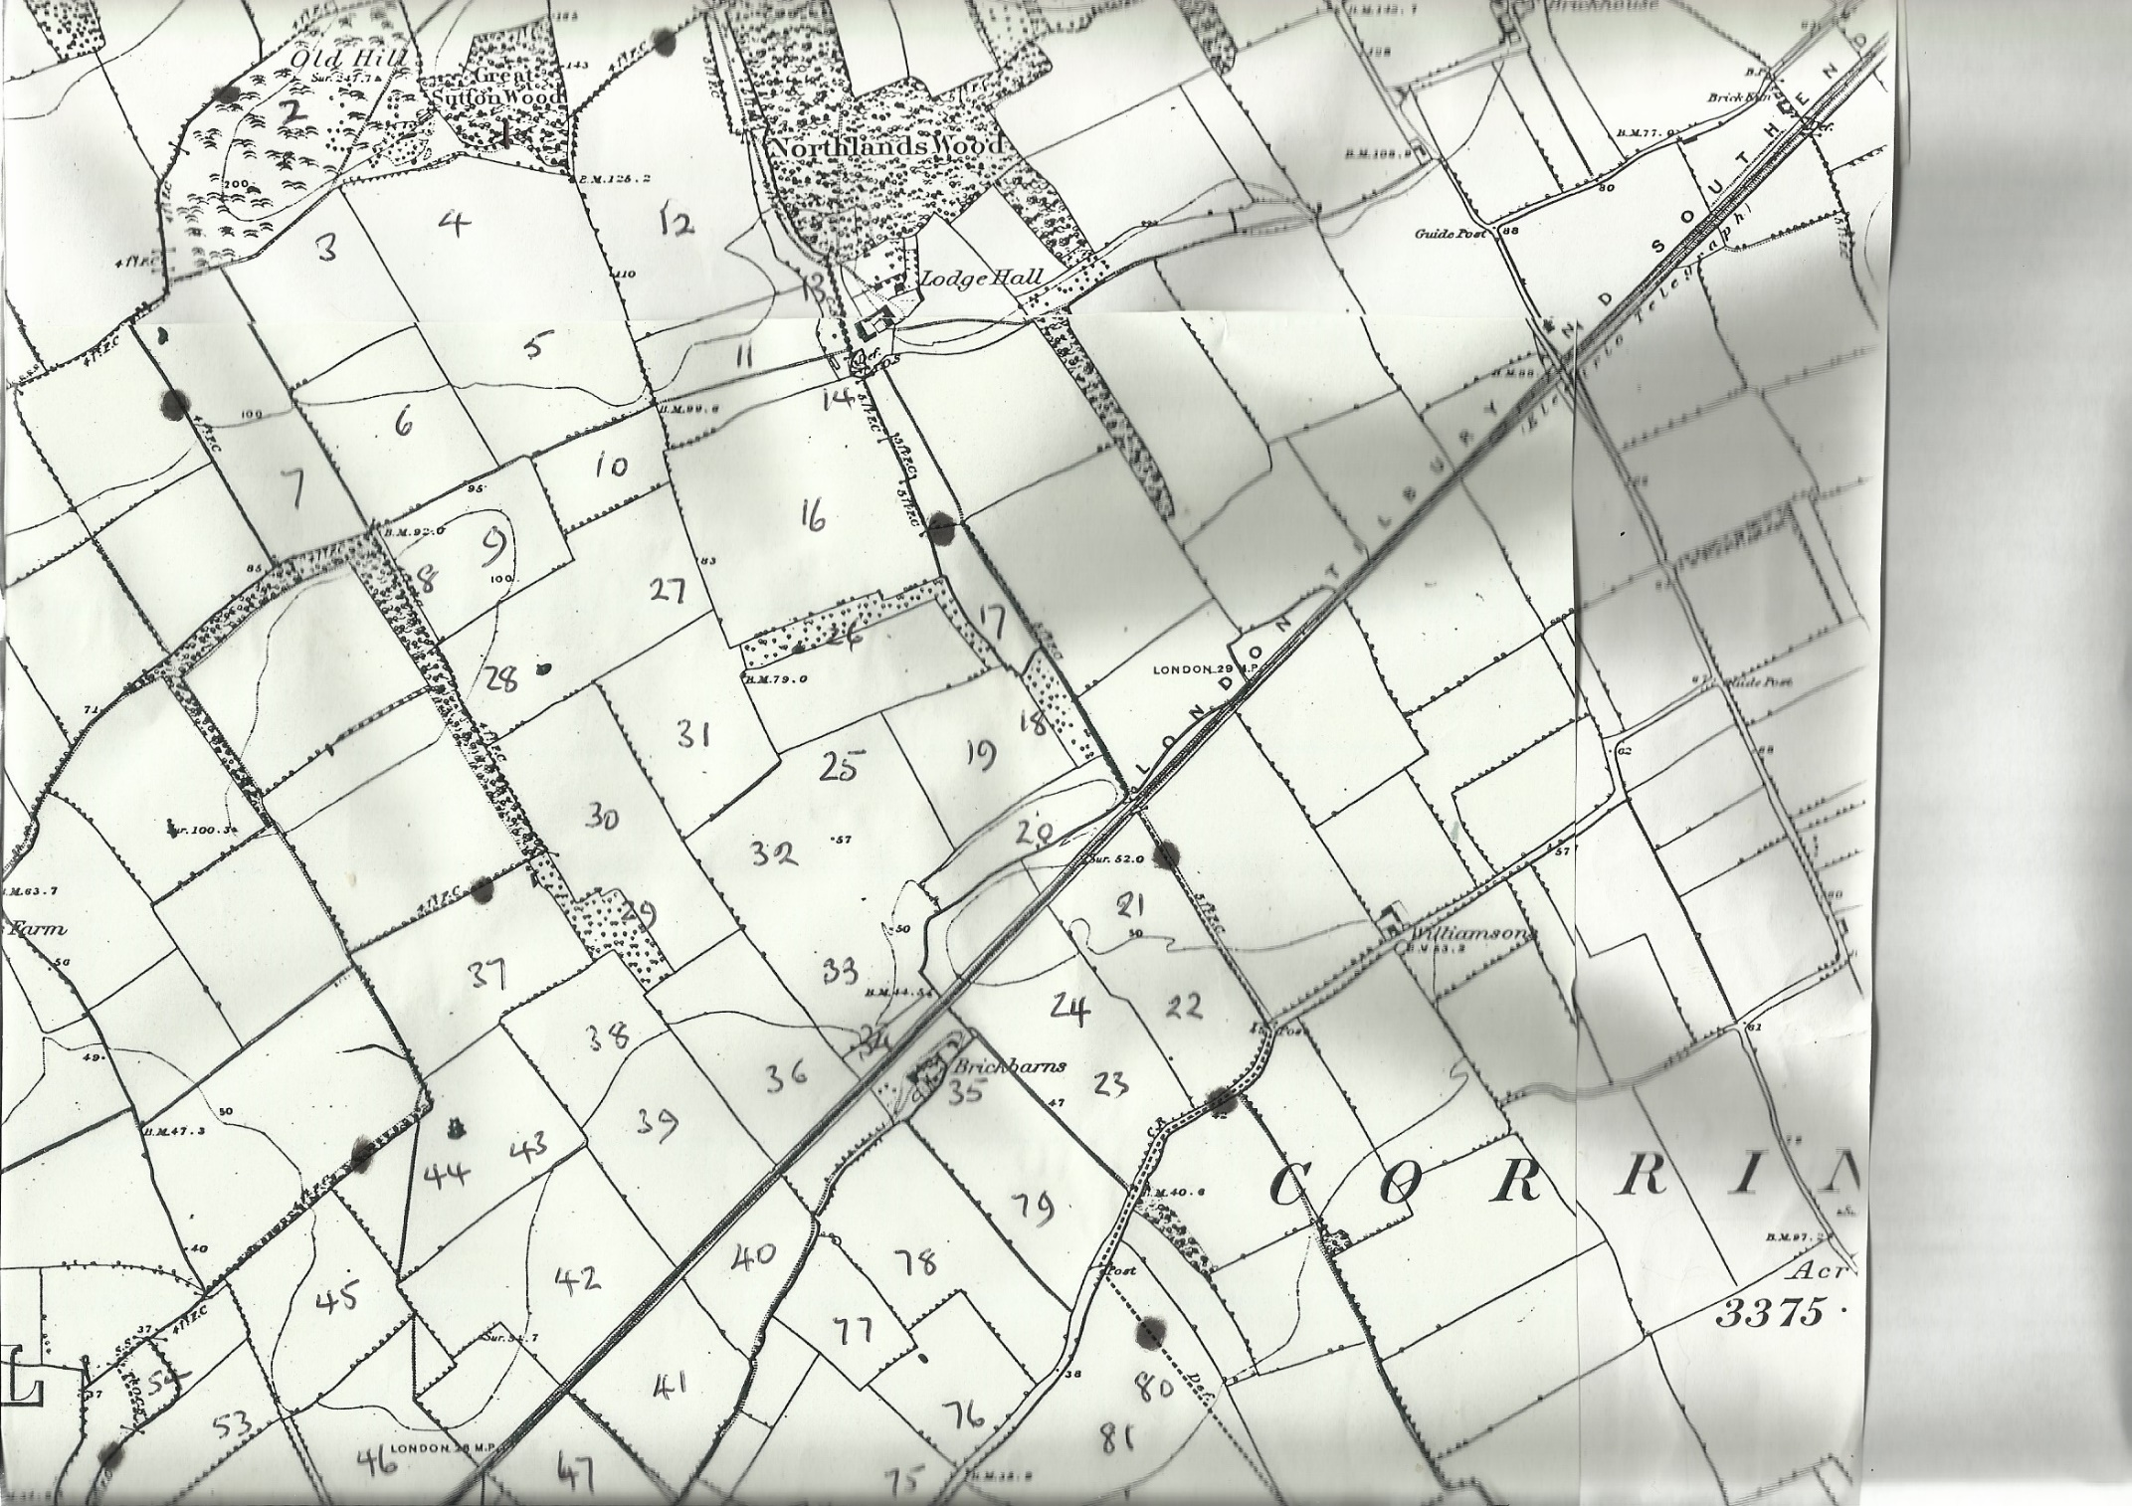

**Map 1**

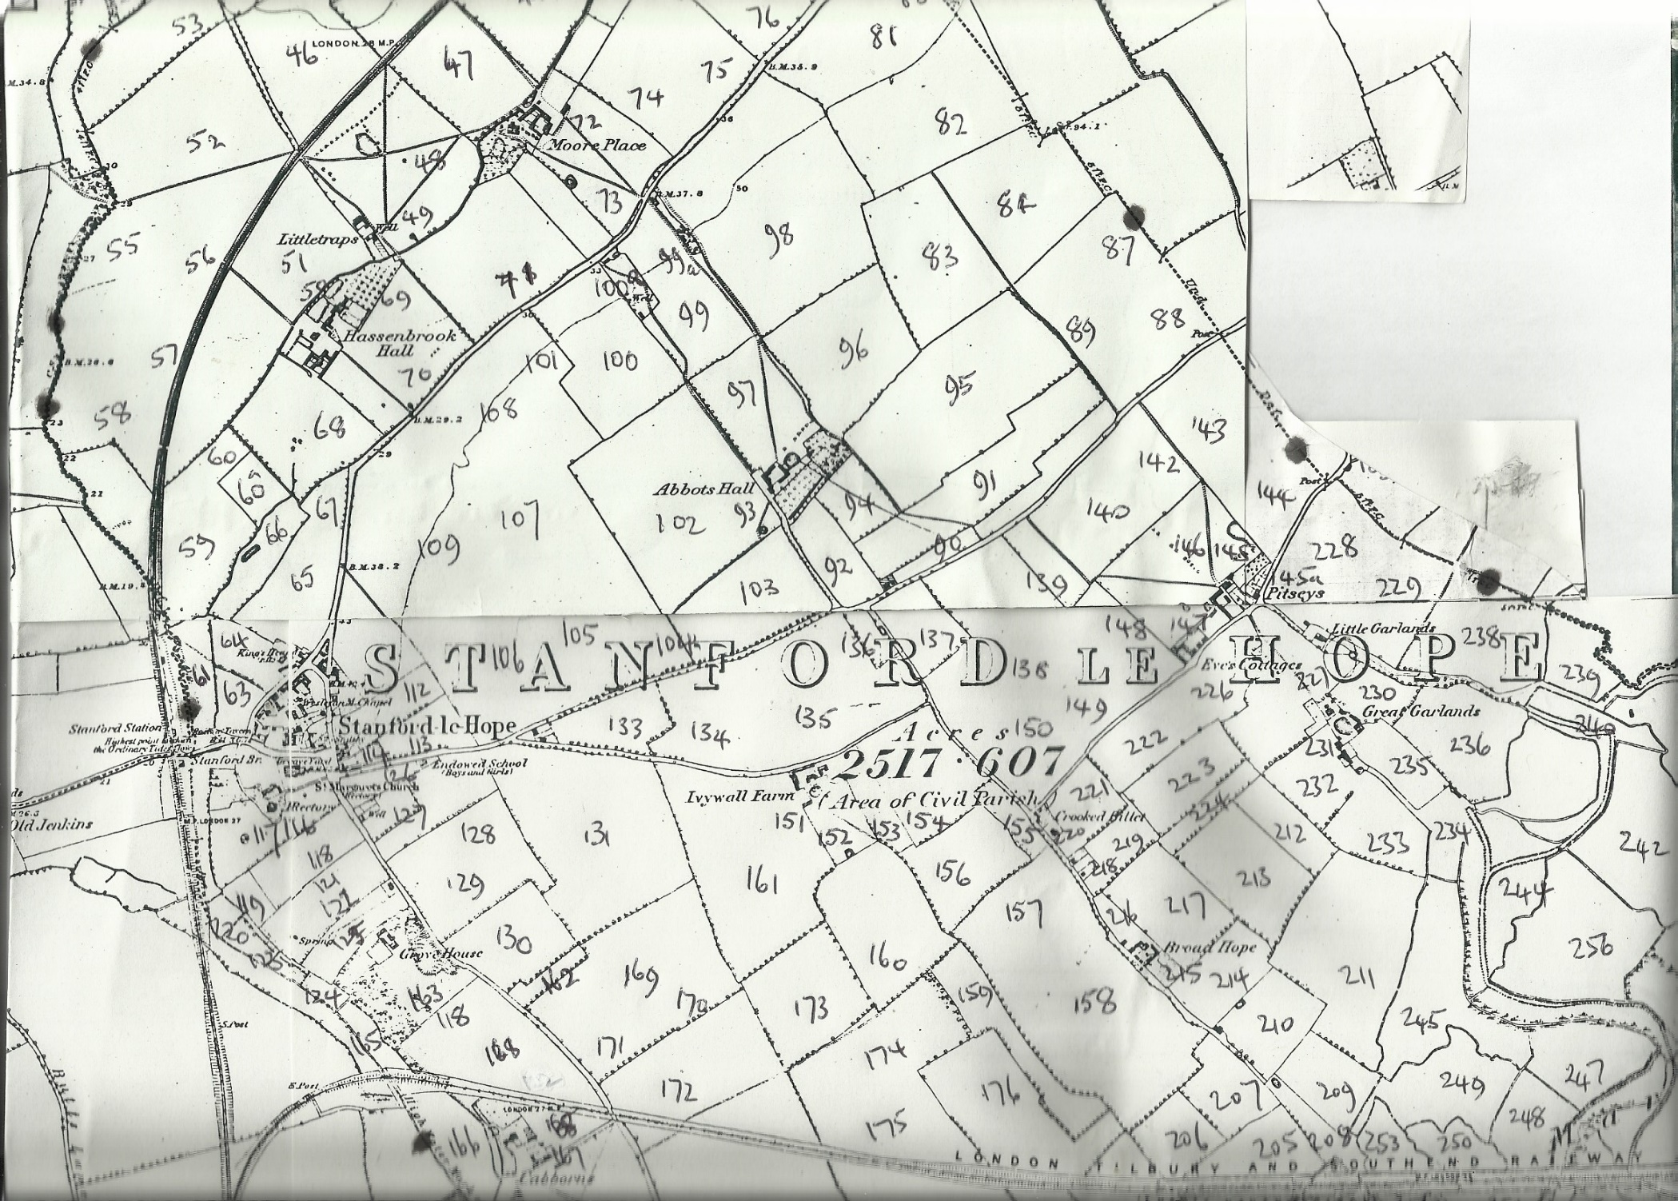

**Map 2**

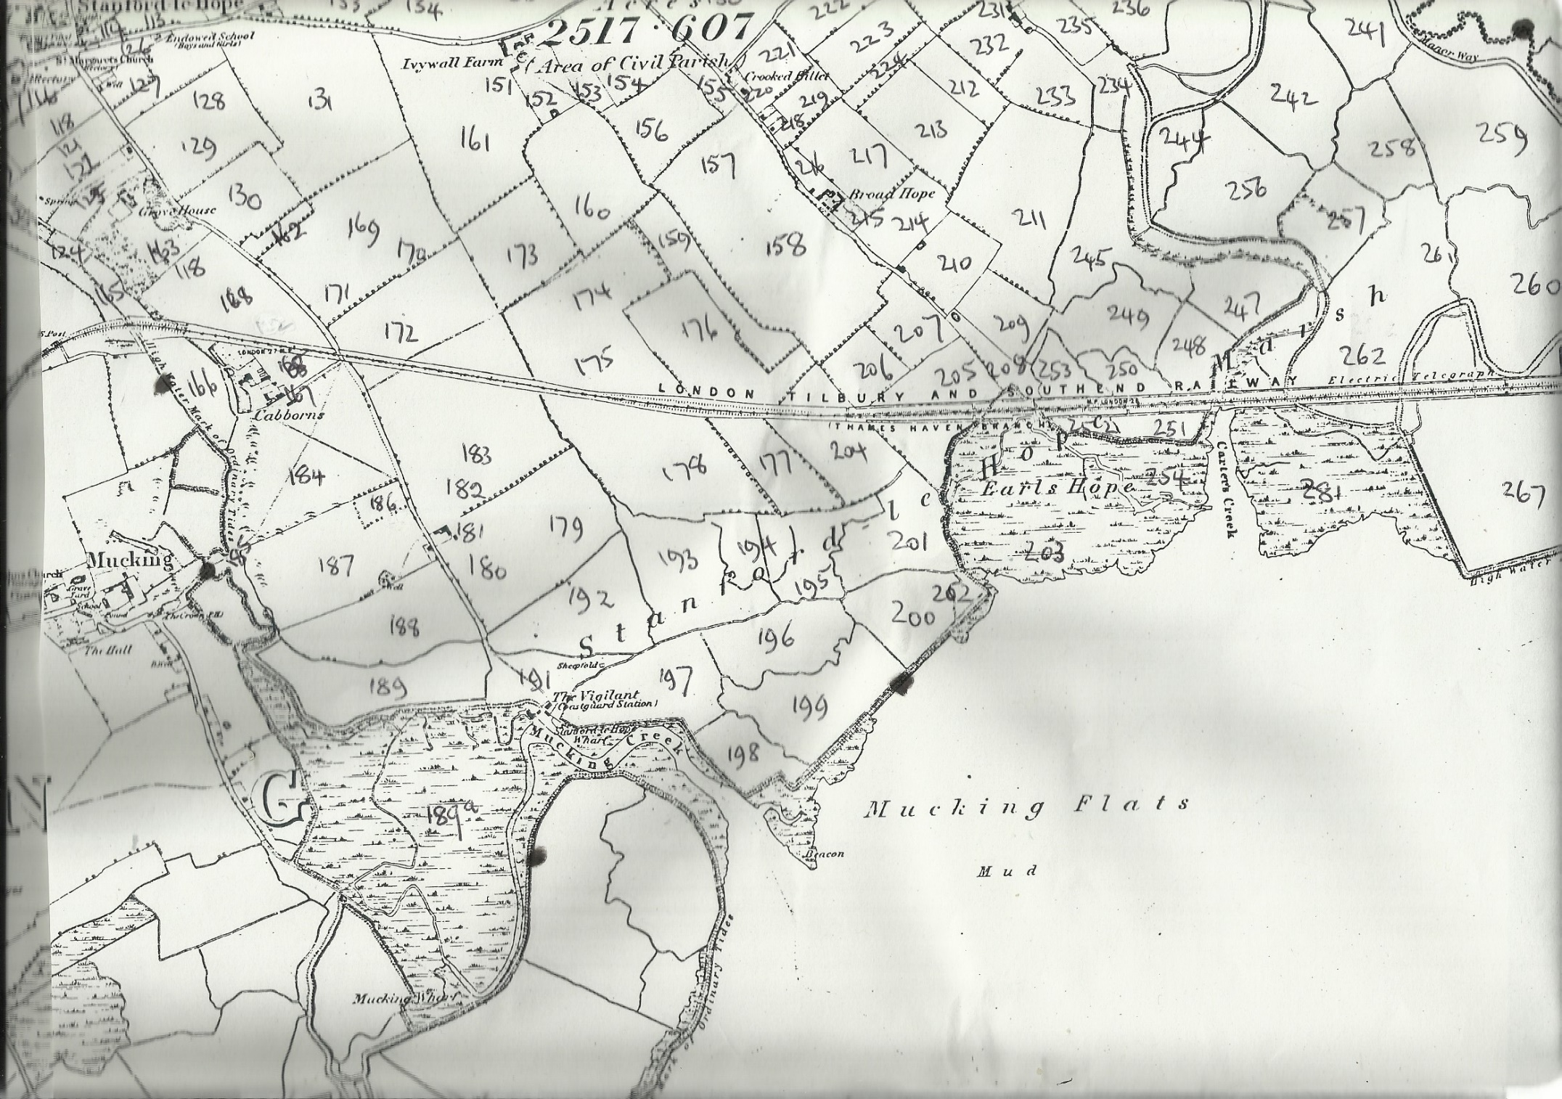

**Map 3**

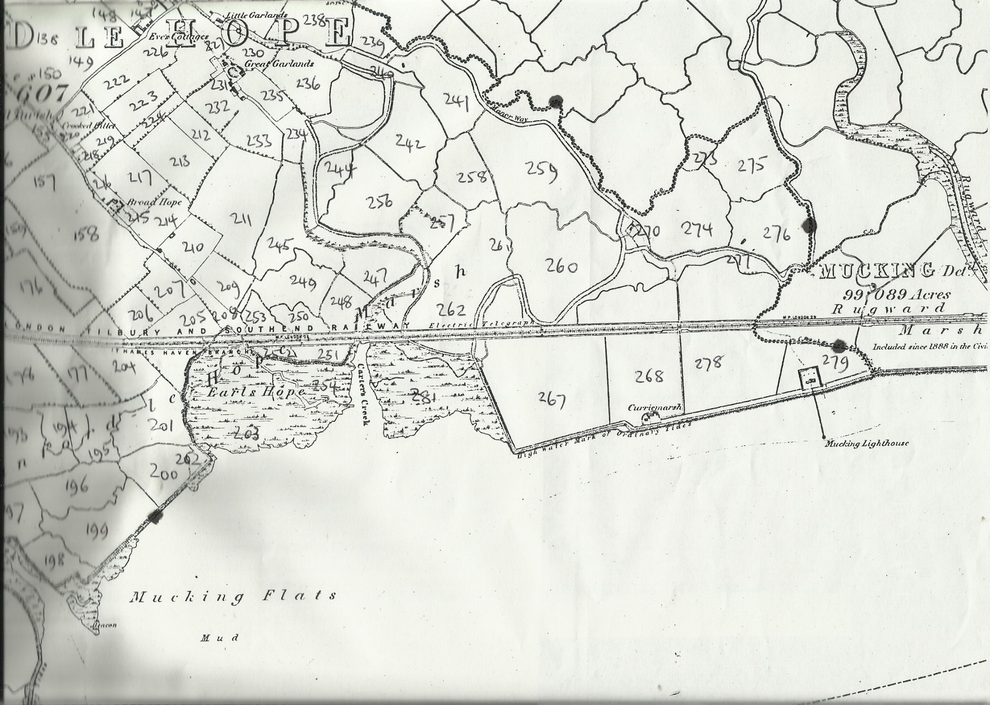

**Map 4**

*River Thames*