THE PLACE-NAMES

OF TILTY

Recorder: James Kemble

Essex Place-names Project (Essex Society for Archaeology & History), 2010 (e-book).

www.essex.ac.uk/history/esah/essexplacenames

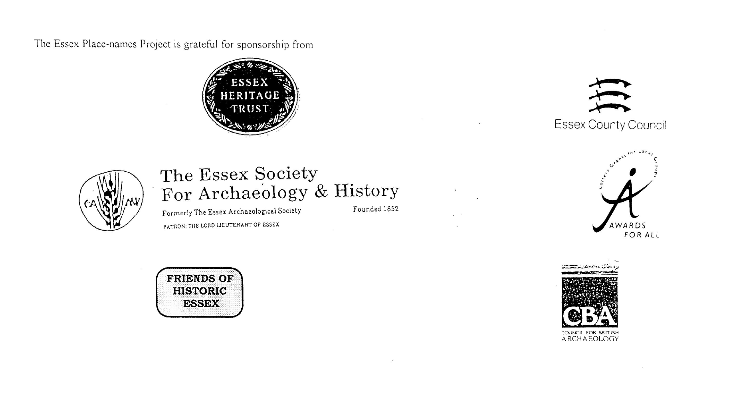

ESSEX PLACE-NAMES PROJECT.

The Essex Place-names Project is a County-wide survey to record place- and field-names from historical documents such as Tithe maps and apportionments, estate maps, sale
and auction catalogues, conveyances, terriers, deeds, rolls, inquisitions and surveys.

The second element of the Project is to investigate on-the-ground visible remains which correspond to the Place-names for actual or potential archaeological, agricultural and industrial
sites, and to record natural (topographical) and man-made features which may relate to the Place-name. This involves field-survey in rural and outside investigation in built-up areas.

It is anticipated that the Project will lead to identification of archaeological sites and lost historic buildings; it will enable analysis of indicators of early settlement, land holding, agricultural and industrial practices of the County. It will refine the more precise meaning of descriptive words and elements used by earlier settlers as they gave names appropriate to the topography of the landscape of their time.

For convenience the surveys are based on the parish, recognising that present civil parish boundaries are not necessarily identical to former ecclesiastical boundaries. Local Recorders
are supplied with templates of Record Forms to ensure consistency of recording across the County, and forward completed forms to a Central Coordinator for transfer to a county
computer database which is available at the Essex Record Office to researchers.

This publication presents part of the information recorded from the Tithe or Estate Award and Map, (and from other documents for this parish.) The full record is contained on the master
database in the Essex Record Office, Wharf Road, Chelmsford CM2 6YT and the website www.essex.ac.uk/history/esah/essexplacenames. Parish books are available from the Publications Manager, ERO, on disc or in hard copy or may be downloaded from the website. Please notify errors to the Project Coordinator at the Essex Record Office.

THE TITHE MAP AND APPORTIONMENT.

Since medieval times a tenth of the produce of land and stock had been paid by landholders to the church. At the Dissolution of the Monasteries, the property of many religious houses,
including the right to collect tithes, passed into lay hands. The Tithe Commutation Act which received Royal assent on 13th August 1836 abolished a rent payable in kind and
substituted rent-charges apportioned on each plot or parcel. The tithe-rent payable was assessed on the average value of wheat, barley and oats and was to fluctuate with price movements.

The commutation could be by voluntary agreement between the local owners and payers or, if agreement failed, could be compulsorily imposed by commissioners. A Valuer was to be
appointed to apportion the rent of each parcel of land and tenants could deduct that rent-charge from their rent paid to the landlord. The task fell to the Tithe Commissioners to produce a
map and an Apportionment (Award). A large-scale survey was produced for over 70% of England and Wales in the following 9 years, and about another 8% up to 1855. Most of the
parishes in Essex were surveyed. The map scales vary. The Award records ownership, tenancy and land-use, field by field and parcel by parcel (often quoting the field name) with the
ground area and rent-charge.

Land that was tithe-free tends to be less accurately mapped and contains few if any of the details recorded for those parcels subject to tithe. Rights of way and roads also tend to be
neglected. Boundaries of the tithe areas are shown as are some natural features such as streams, ponds, gardens, greens and commons. Buildings are often shown coloured red if dwellings
or grey if not. Because the Award may have been agreed only some time after the map was finished, discrepancies occur between the two. Enclosure Awards, when extant, usually date to the 18th and early 19th centuries. J.Kemble.

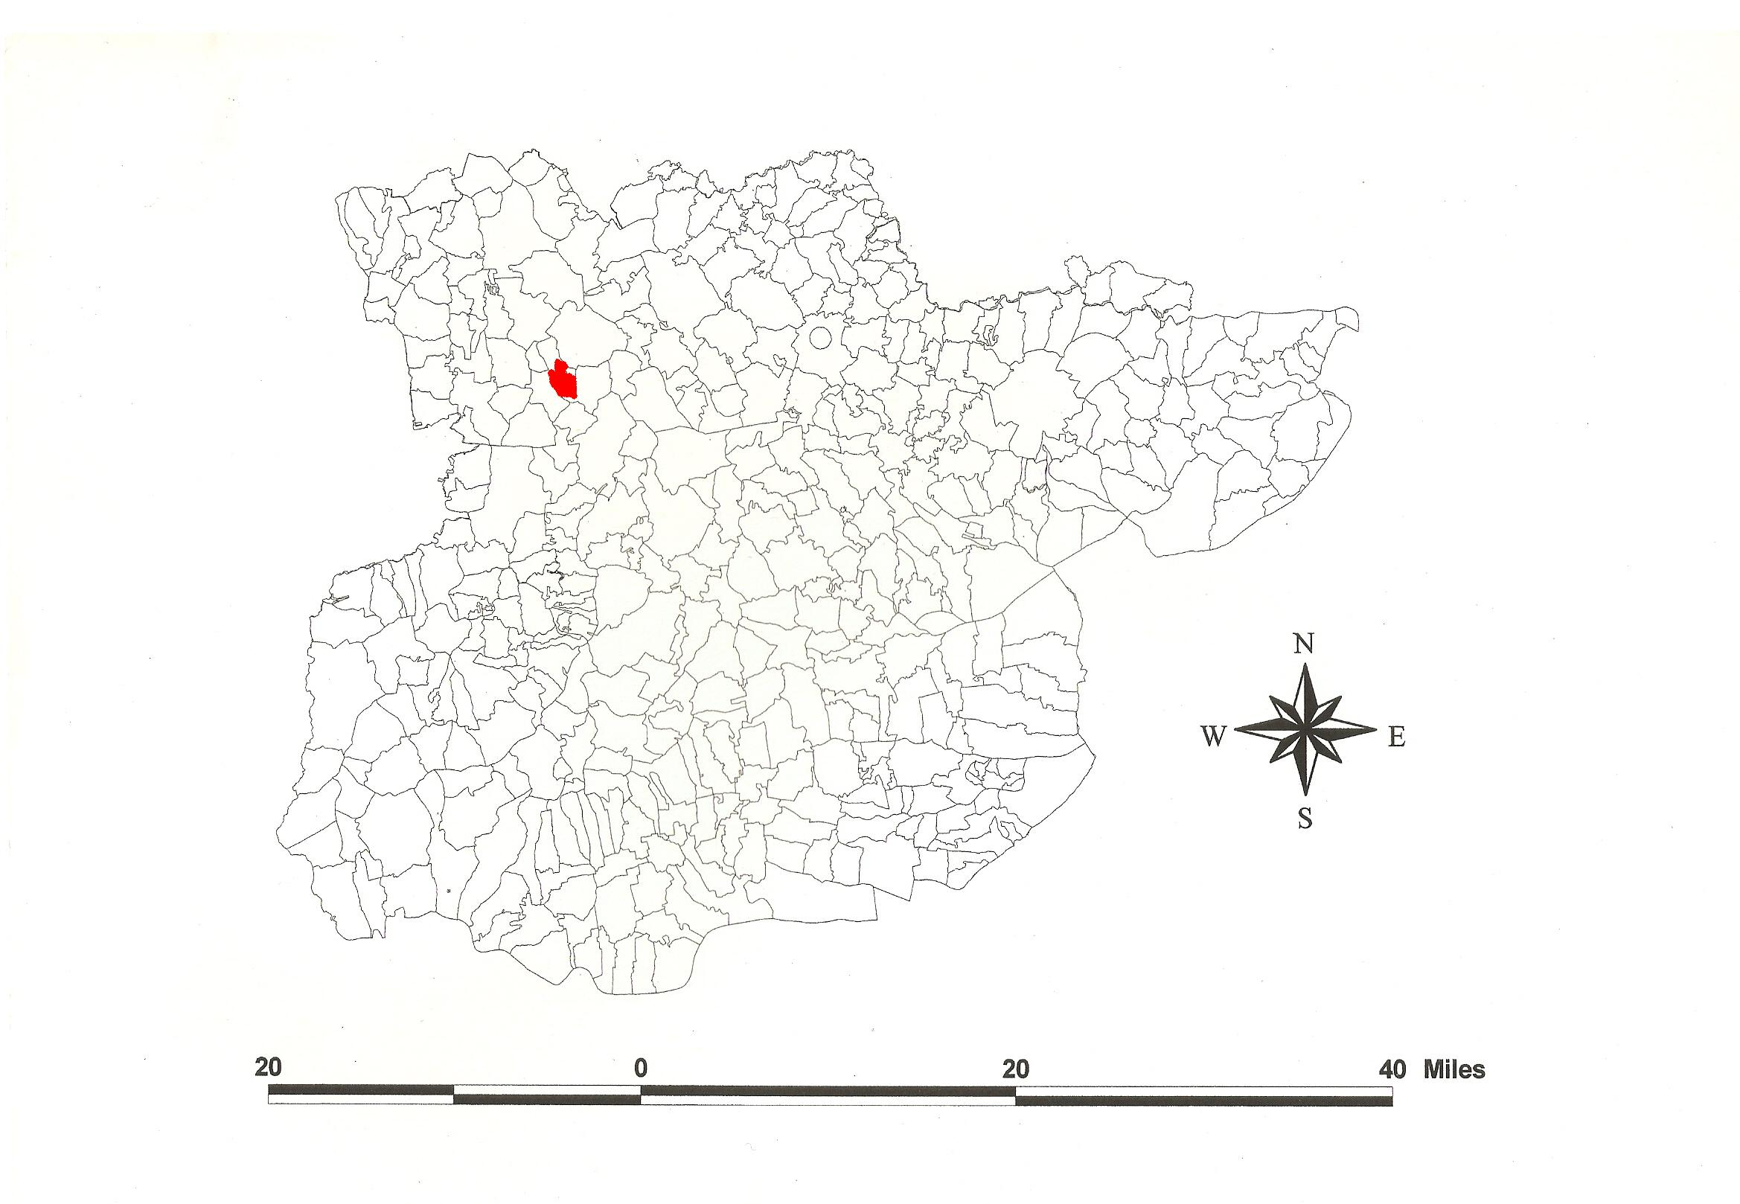
Reproduced by permission of Essex County Council.
The Parish of Tilty in the County of Essex.

Tilty Parish (in Dunmow Hundred).

Essex Record Office possesses no Tithe Award or Tithe Map of Tilty. Being formerly property of Tilty Abbey, the manor was demesne tithe-free land and therefore did not attract the attention of the Tithe Commissioners. It does however possess a map of the manors of Tilty, Broxted, Thaxted and Much Eiston [Great Easton] of Rt Hon Lord Henry Maynard
(D/DMg P1/1), dated 1730, upon which this record is based.

In Domesday Book, Tileteia(m) was held by Henry de Ferrers (from Ferrièrs-Saint-Hilaire, Eure) in lordship which Doding had held before 1066 as a manor for half a hide (Morris, 1983). Ekwall (1960) translates this from O.E. teag, ‘Tila’s enclosure’.

Of the Cistercian abbey founded c. 1153 by Maurice son of Geoffrey, the building in stone appears to date from c.1200. Abbots included Thomas Chishull (1370), John Leighs (1407) and John Browne (1520). In 1529, the guest house was leased to Thomas Grey, Marquis of Dorset, grandfather of Lady Jane Grey. At the Dissolution in 1535 there were seven monks. In 1542 the abbey’s possessions were granted to Sir Thomas Audley, with lands and tenements called Rycolts, Bingemores meadow in Tilty, Chawreth, Plesdon-green and Broxted for one-twentieth of a knight’s fee (Morant, 1768). In 1587, the abbey was acquired by Henry Maynard who c.1594 commissioned the Map by Ralph Agas of Stoke-by-Nayland. Ralph Agar’s map of Tilty (ERO: D/DMg P25), dated 1594, which also contains field-names is discussed in Essex Archaeology & History (2001) vol 32 pp189 and 198.

Part of the east wall of the abbey’s west cloister range survives (Andrews, 1992). The church, formerly chapel to the abbey, dedicated to St Mary is Early English with a 13th century nave. The chancel added c.1330 has a 5-light traceried east window. Tilty Grange is early 16th century with a gabled cross-wing; to its west is a 17th century barn , now residential. The brick mill is early 18th century (Steer, 1949; Pevsner, 2007).

The Hundred name in 1086 was variably Dom(m)auua and Dunham (Domesday Book and Inquisitio Eliensis), from O.E. dun and mawe, ‘hill meadow(s)’. Christy (1926) points out that three Roman roads meet in (Great) Dunmow in which parish the moot was probably situated. In 942x951 Theodred, bishop of London, willed his estate at Dunemowe to St Paul’s. In c.995x998 Dunmæwan with Tolleshunt was required by St Paul’s to provide one man for ship-duty against incursions (Hart, 1971; Kemble, 2007). Thurstan, husband of the great-granddaughter of earldorman Brihtnoth who died at the Battle of Maldon in 991, willed the estate at Dunmawe (Little Dunmow) to Merewine and his wife (Whitelock, 1930).

Bearing in mind the difficulty of transposing the Ordnance Survey grid onto the 18th map, the Grid References quoted in the following table are approximate.

References:
Andrews, D., Gilman, P., 1992. Tilty Abbey. Essex Archaeology & History, 23, 152.
Christy, M., 1926. The Essex Hundred Moots. Trans Essex Archaeological Society, ns xviii(3), 192.
Hall, J., Strachan, D., 2001. The Precinct of Tilty Abbey. Essex Archaeology & History, 32, 198.
Hart, C., 1981. Early Charters of Essex. Leicester.
Hunter, J., 2001. Desmesne Lands of Henry Maynard. Essex Archaeology & History, 32, 189.
Kemble, J., 2007. Essex Place-names, Places, Streets & People. Historical Publications, London.
Mornat, P., 1768. History & Antiquities of the County of Essex. ii, 435.
Morris, J., 1983. Domesday Book – Essex. Phillimore.
Pevsner, N., Bettley, J., 2007. Buildings of England – Essex. Yale.
Steer, F., 1949. A Short History of Tilty Abbey. Essex Review, 58, 169.
Whitelock, D., 1930. Anglo-Saxon Wills. Cambridge.

The Place-names of Tilty, Map of 1730, ERO: D/DMg P1/1 (from north to south).

Place-name | Alias | Gd Ref | x | y | Owner | Natural features next to field | Man-made features within field | Man-made features next to field
Abbots Close |  | TL | 586 | 284 | Maynard, RtHon Lord Henry |  |  | Broxted par. N
Further Harp field |  | TL | 586 | 282 | Maynard, RtHon Lord Henry
Middle Harp field |  | TL | 585 | 281 | Maynard, RtHon Lord Henry | Stream S
Great Perry field |  | TL | 589 | 282 | Maynard, RtHon Lord Henry
Further Perry field |  | TL | 589 | 580 | Maynard, RtHon Lord Henry
Noon Close |  | TL | 589 | 279 | Maynard, RtHon Lord Henry
Cross Crofte |  | TL | 594 | 277 | Maynard, RtHon Lord Henry |  |  | Broxted par. N
Mill field |  | TL | 600 | 278 | Maynard, RtHon Lord Henry |  |  | Broxted par. N
Steeple Mead |  | TL | 590 | 273 | Maynard, RtHon Lord Henry
The Moors |  | TL | 594 | 273 | Maynard, RtHon Lord Henry
Lower Lye Close |  | TL | 595 | 273 | Maynard, RtHon Lord Henry |  |  | Broxted par. N
Lye Closes |  | TL | 600 | 274 | Maynard, RtHon Lord Henry
Cherry Street |  | TL | 602 | 274 | Maynard, RtHon Lord Henry | R.Chelmer E
Floodgate Mead |  | TL | 594 | 272 | Maynard, RtHon Lord Henry | Stream S
Pool Hoppet |  | TL | 595 | 271 | Maynard, RtHon Lord Henry | Stream S
Upper Pond Mead |  | TL | 595 | 272 | Maynard, RtHon Lord Henry
Upper Esley field |  | TL | 599 | 273 | Maynard, RtHon Lord Henry
Lower Esley field |  | TL | 599 | 271 | Maynard, RtHon Lord Henry
Esley Wood | cp Eselworthbregge, 1445,Tilty | TL | 598 | 270 | Maynard, RtHon Lord Henry
New Orchard |  | TL | 601 | 268 | Maynard, RtHon Lord Henry
The Moors |  | TL | 601 | 267 | Maynard, RtHon Lord Henry
Lower Pond Mead |  | TL | 600 | 266 | Maynard, RtHon Lord Henry | Stream S
Tilekilln Close |  | TL | 585 | 274 | Maynard, RtHon Lord Henry | Stream N |  | Broxted par. W
Dairy Meadow |  | TL | 588 | 273 | Maynard, RtHon Lord Henry | Stream N
Colt harp Meadow |  | TL | 591 | 271 | Maynard, RtHon Lord Henry | Stream N
Conduit Closes |  | TL | 590 | 261 | Maynard, RtHon Lord Henry | Stream N
Long Down |  | TL | 591 | 270 | Maynard, RtHon Lord Henry | Stream N
Barn Close |  | TL | 593 | 266 | Maynard, RtHon Lord Henry
Home Wood |  | TL | 596 | 265 | Maynard, RtHon Lord Henry | Stream N
The Vineyard | [at Tilty Abbey] | TL | 601 | 266 | Maynard, RtHon Lord Henry | Stream N
Buckleshoe Close |  | TL | 588 | 268 | Maynard, RtHon Lord Henry
Windmill field |  | TL | 580 | 265 | Maynard, RtHon Lord Henry |  | Windmill | Broxted par. W
Causeway field |  | TL | 590 | 265 | Maynard, RtHon Lord Henry
The Green | [at Tilty Grange] | TL | 594 | 265 | Maynard, RtHon Lord Henry
Mill House | Tilty Mill (Corn), 1880,OS | TL | 597 | 267 | Maynard, RtHon Lord Henry
The Vineyard |  | TL | 601 | 265 | Maynard, RtHon Lord Henry
The Killn Croft |  | TL | 601 | 262 | Maynard, RtHon Lord Henry
Tanners Meadow |  | TL | 602 | 260 | Maynard, RtHon Lord Henry | R.Chelmer E
Oakeshot Close |  | TL | 587 | 261 | Maynard, RtHon Lord Henry |  |  | Broxted par. W
Brambleshot Close |  | TL | 590 | 262 | Maynard, RtHon Lord Henry
Browns shot |  | TL | 592 | 262 | Maynard, RtHon Lord Henry
Hogg shot field |  | TL | 595 | 263 | Maynard, RtHon Lord Henry
Great Barrow field |  | TL | 597 | 260 | Maynard, RtHon Lord Henry
Little Barrow field |  | TL | 601 | 260 | Maynard, RtHon Lord Henry
Mayesfield |  | TL | 589 | 259 | Maynard, RtHon Lord Henry |  |  | Broxted par. W
Pond field |  | TL | 591 | 260 | Maynard, RtHon Lord Henry
Pond Mays |  | TL | 592 | 260 | Maynard, RtHon Lord Henry
Middle Mays |  | TL | 594 | 261 | Maynard, RtHon Lord Henry
Hither Mays field |  | TL | 597 | 260 | Maynard, RtHon Lord Henry
Priors hill |  | TL | 601 | 260 | Maynard, RtHon Lord Henry
Mayes Wood | Maze Wood, 1880,OS | TL | 593 | 258 | Maynard, RtHon Lord Henry |  |  | Much Eiston manor S
Barn field |  | TL | 599 | 259 | Maynard, RtHon Lord Henry
Lower Hagden |  | TL | 599 | 257 | Maynard, RtHon Lord Henry
Upper Hagden |  | TL | 601 | 257 | Maynard, RtHon Lord Henry
Newlands Close |  | TL | 590 | 255 | Maynard, RtHon Lord Henry
The Moors |  | TL | 593 | 255 | Maynard, RtHon Lord Henry
Home Close |  | TL | 594 | 255 | Maynard, RtHon Lord Henry |  |  | Much Eiston manor S
High field |  | TL | 595 | 255 | Maynard, RtHon Lord Henry |  |  | Much Eiston manor S
Cock field |  | TL | 596 | 255 | Maynard, RtHon Lord Henry |  |  | Much Eiston manor S
Bridge field |  | TL | 600 | 255 | Maynard, RtHon Lord Henry |  |  | Much Eiston manor S

Other Place-names of Tilty

Ordnance Survey Map 6" | c1880 | Broadwater Ford | TL | 582 | 277
Ordnance Survey Map 6" | c1880 | Coldarbour Farm | TL | 587 | 273
Ordnance Survey Map 6" | c1880 | Delfits Lane | TL | 591 | 283
Ordnance Survey Map 6" | c1880 | Goodfellows [building] | TL | 600 | 260
Ordnance Survey Map 6" | c1880 | Lower Barn | TL | 594 | 274
Ordnance Survey Map 6" | c1880 | The Grange | TL | 595 | 265
Ordnance Survey Map 6" | c1880 | Tiltyhill Farm | TL | 598 | 276
Ordnance Survey Map 6" | 1988 | Malting Bridge | TL | 583 | 266

For abbreviations see Reaney, P., Place-names of Essex, Cambridge, 1935; and Kemble, J., Essex Place-names, Places, Streets and People, Historical Publications, 2007.

The Place-names of Tilty, Map of 1730, ERO: D/DMg P1/1 – by Place-name.

Place-name | Alias | Gd Ref | x | y | Owner | Natural features next to field | Man-made features within field | Man-made features next to field
Abbots Close |  | TL | 586 | 284 | Maynard, RtHon Lord Henry |  |  | Broxted par. N
Barn Close |  | TL | 593 | 266 | Maynard, RtHon Lord Henry
Barn field |  | TL | 599 | 259 | Maynard, RtHon Lord Henry
Brambleshot Close |  | TL | 590 | 262 | Maynard, RtHon Lord Henry
Bridge field |  | TL | 600 | 255 | Maynard, RtHon Lord Henry |  |  | Much Eiston manor S
Browns shot |  | TL | 592 | 262 | Maynard, RtHon Lord Henry
Buckleshoe Close |  | TL | 588 | 268 | Maynard, RtHon Lord Henry
Causeway field |  | TL | 590 | 265 | Maynard, RtHon Lord Henry
Cherry Street |  | TL | 602 | 274 | Maynard, RtHon Lord Henry | R.Chelmer E
Cock field |  | TL | 596 | 255 | Maynard, RtHon Lord Henry |  |  | Much Eiston manor S
Colt harp Meadow |  | TL | 591 | 271 | Maynard, RtHon Lord Henry | Stream N
Conduit Closes |  | TL | 590 | 261 | Maynard, RtHon Lord Henry | Stream N
Cross Crofte |  | TL | 594 | 277 | Maynard, RtHon Lord Henry |  |  | Broxted par. N
Dairy Meadow |  | TL | 588 | 273 | Maynard, RtHon Lord Henry | Stream N
Esley Wood | cp Eselworthbregge, 1445,Tilty | TL | 598 | 270 | Maynard, RtHon Lord Henry
Floodgate Mead |  | TL | 594 | 272 | Maynard, RtHon Lord Henry | Stream S
Further Harp field |  | TL | 586 | 282 | Maynard, RtHon Lord Henry
Further Perry field |  | TL | 589 | 580 | Maynard, RtHon Lord Henry
Great Barrow field |  | TL | 597 | 260 | Maynard, RtHon Lord Henry
Great Perry field |  | TL | 589 | 282 | Maynard, RtHon Lord Henry
High field |  | TL | 595 | 255 | Maynard, RtHon Lord Henry |  |  | Much Eiston manor S
Hither Mays field |  | TL | 597 | 260 | Maynard, RtHon Lord Henry
Hogg shot field |  | TL | 595 | 263 | Maynard, RtHon Lord Henry
Home Close |  | TL | 594 | 255 | Maynard, RtHon Lord Henry |  |  | Much Eiston manor S
Home Wood |  | TL | 596 | 265 | Maynard, RtHon Lord Henry | Stream N
Little Barrow field |  | TL | 601 | 260 | Maynard, RtHon Lord Henry
Long Down |  | TL | 591 | 270 | Maynard, RtHon Lord Henry | Stream N
Lower Esley field |  | TL | 599 | 271 | Maynard, RtHon Lord Henry
Lower Hagden |  | TL | 599 | 257 | Maynard, RtHon Lord Henry
Lower Lye Close |  | TL | 595 | 273 | Maynard, RtHon Lord Henry |  |  | Broxted par. N
Lower Pond Mead |  | TL | 600 | 266 | Maynard, RtHon Lord Henry | Stream S
Lye Closes |  | TL | 600 | 274 | Maynard, RtHon Lord Henry
Mayes Wood | Maze Wood, 1880,OS | TL | 593 | 258 | Maynard, RtHon Lord Henry |  |  | Much Eiston manor S
Mayesfield |  | TL | 589 | 259 | Maynard, RtHon Lord Henry |  |  | Broxted par. W
Middle Harp field |  | TL | 585 | 281 | Maynard, RtHon Lord Henry | Stream S
Middle Mays |  | TL | 594 | 261 | Maynard, RtHon Lord Henry
Mill field |  | TL | 600 | 278 | Maynard, RtHon Lord Henry |  |  | Broxted par. N
Mill House | Tilty Mill (Corn), 1880,OS | TL | 597 | 267 | Maynard, RtHon Lord Henry
New Orchard |  | TL | 601 | 268 | Maynard, RtHon Lord Henry
Newlands Close |  | TL | 590 | 255 | Maynard, RtHon Lord Henry
Noon Close |  | TL | 589 | 279 | Maynard, RtHon Lord Henry
Oakeshot Close |  | TL | 587 | 261 | Maynard, RtHon Lord Henry |  |  | Broxted par. W
Pond field |  | TL | 591 | 260 | Maynard, RtHon Lord Henry
Pond Mays |  | TL | 592 | 260 | Maynard, RtHon Lord Henry
Pool Hoppet |  | TL | 595 | 271 | Maynard, RtHon Lord Henry | Stream S
Priors hill |  | TL | 601 | 260 | Maynard, RtHon Lord Henry
Steeple Mead |  | TL | 590 | 273 | Maynard, RtHon Lord Henry
Tanners Meadow |  | TL | 602 | 260 | Maynard, RtHon Lord Henry | R.Chelmer E
The Green | [at Tilty Grange] | TL | 594 | 265 | Maynard, RtHon Lord Henry
The Killn Croft |  | TL | 601 | 262 | Maynard, RtHon Lord Henry
The Moors |  | TL | 594 | 273 | Maynard, RtHon Lord Henry
The Moors |  | TL | 601 | 267 | Maynard, RtHon Lord Henry
The Moors |  | TL | 593 | 255 | Maynard, RtHon Lord Henry
The Vineyard | [at Tilty Abbey] | TL | 601 | 266 | Maynard, RtHon Lord Henry | Stream N
The Vineyard |  | TL | 601 | 265 | Maynard, RtHon Lord Henry
Tilekilln Close |  | TL | 585 | 274 | Maynard, RtHon Lord Henry | Stream N |  | Broxted par. W
Upper Esley field |  | TL | 599 | 273 | Maynard, RtHon Lord Henry
Upper Hagden |  | TL | 601 | 257 | Maynard, RtHon Lord Henry
Upper Pond Mead |  | TL | 595 | 272 | Maynard, RtHon Lord Henry
Windmill field |  | TL | 580 | 265 | Maynard, RtHon Lord Henry |  | Windmill | Broxted par. W

For abbreviations see Reaney, P., Place-names of Essex, Cambridge, 1935; and Kemble, J., Essex Place-names, Places, Streets and People, Historical Publications, 2007.

Other Place-names of Tilty

Ordnance Survey Map 6" | c1880 | Broadwater Ford | TL | 582 | 277
Ordnance Survey Map 6" | c1880 | Coldarbour Farm | TL | 587 | 273
Ordnance Survey Map 6" | c1880 | Delfits Lane | TL | 591 | 283
Ordnance Survey Map 6" | c1880 | Goodfellows [building] | TL | 600 | 260
Ordnance Survey Map 6" | c1880 | Lower Barn | TL | 594 | 274
Ordnance Survey Map 6" | c1880 | The Grange | TL | 595 | 265
Ordnance Survey Map 6" | c1880 | Tiltyhill Farm | TL | 598 | 276
Ordnance Survey Map 6" | 1988 | Malting Bridge | TL | 583 | 266

Tilty.

Map
Map 1.

Map 2.

6 inches = 1 mile

O.S. map c.1880

Sheets 14, 23.

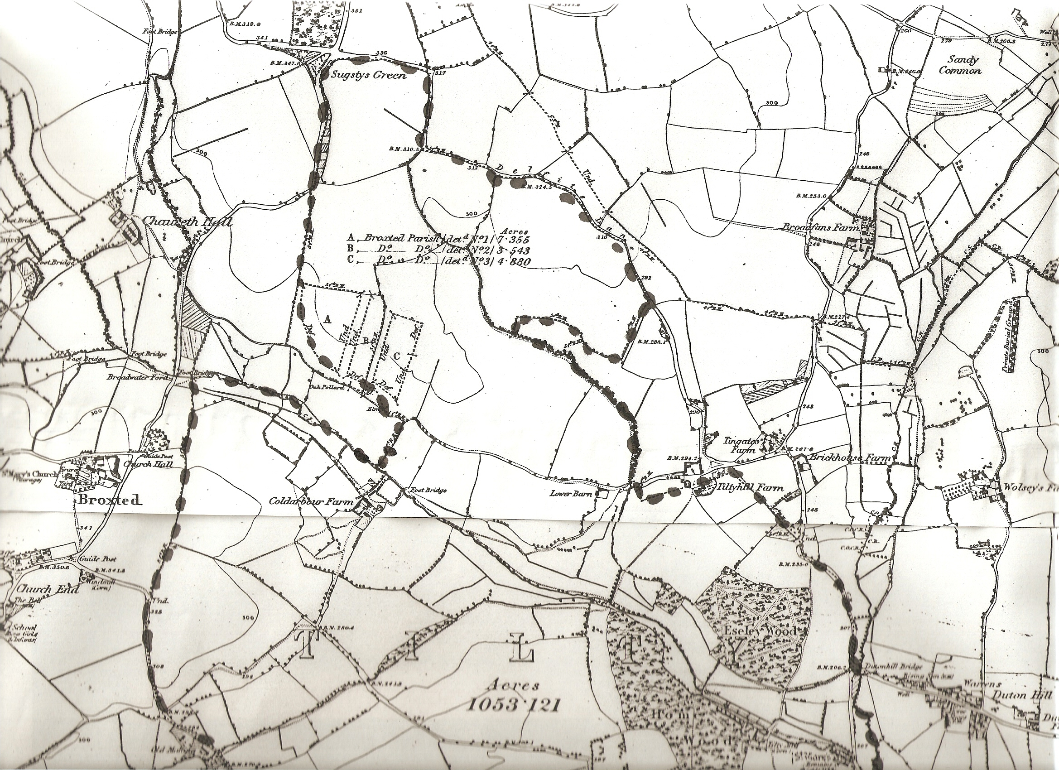
Map 1.
Tile killn Close & Lay, 1730 map
Abbots Croft, 1730 map
Steeple Mead, 1730 map
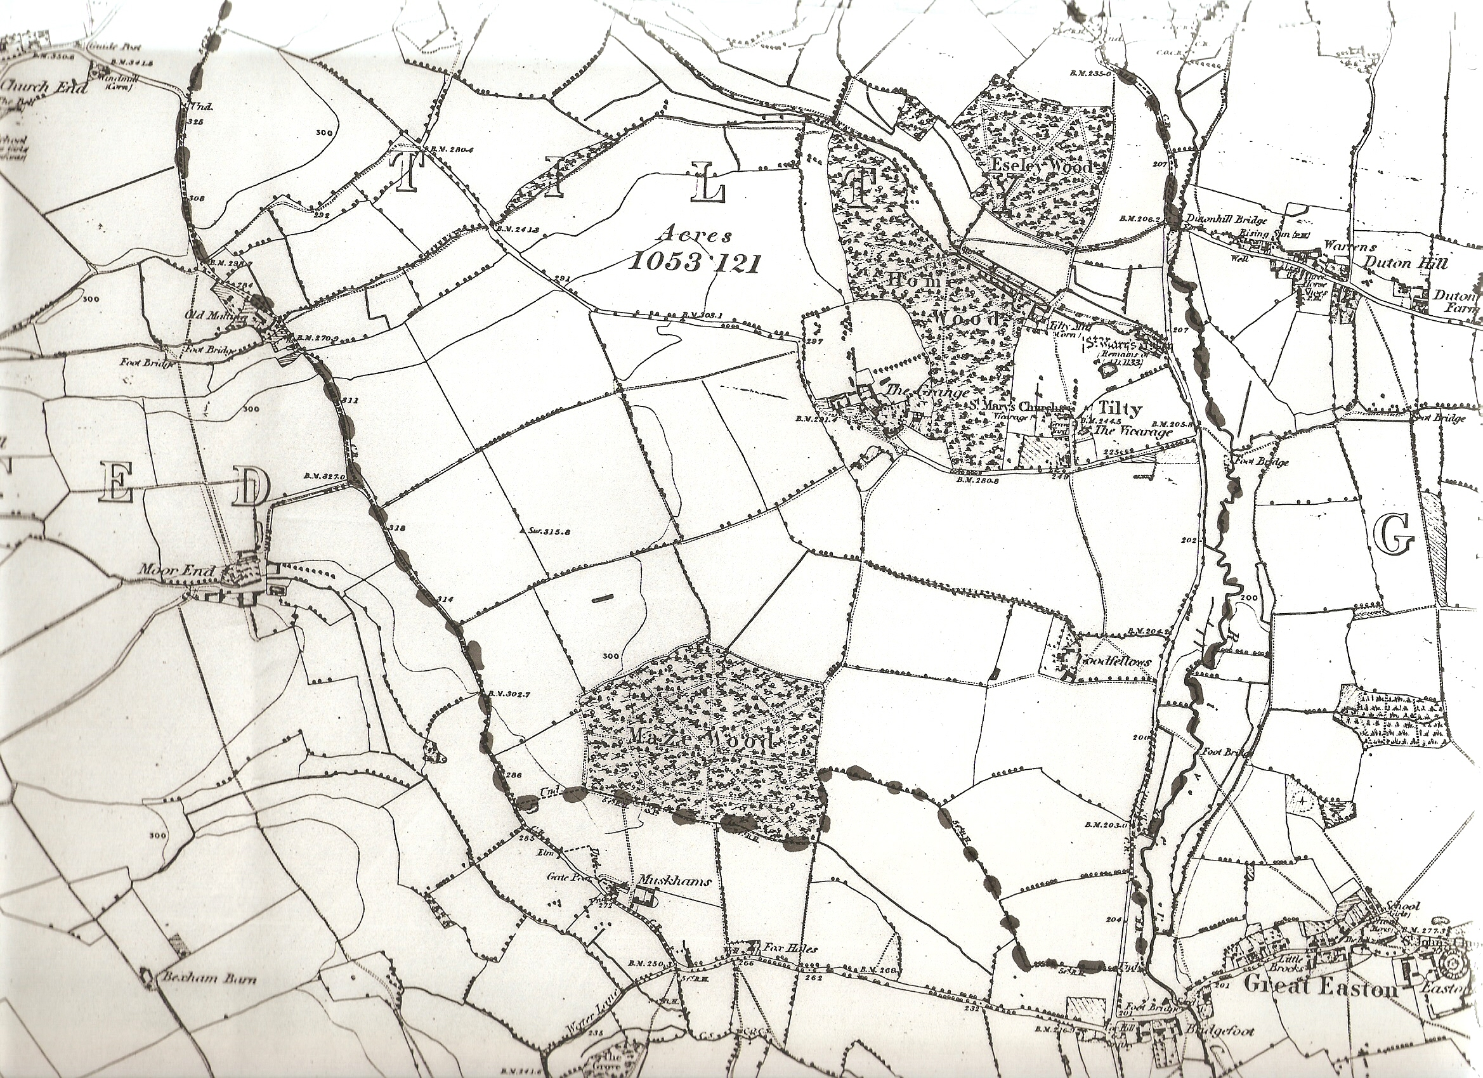
Map 2.
Gt & Lt Barrow fields,1730 map
Windmill field, 1730 map

