THE PLACE-NAMES

OF VANGE

Recorder: James Kemble

Essex Place-names Project (Essex Society for Archaeology & History), 2013 (e-book).

www.essex.ac.uk/history/esah/essexplacenames

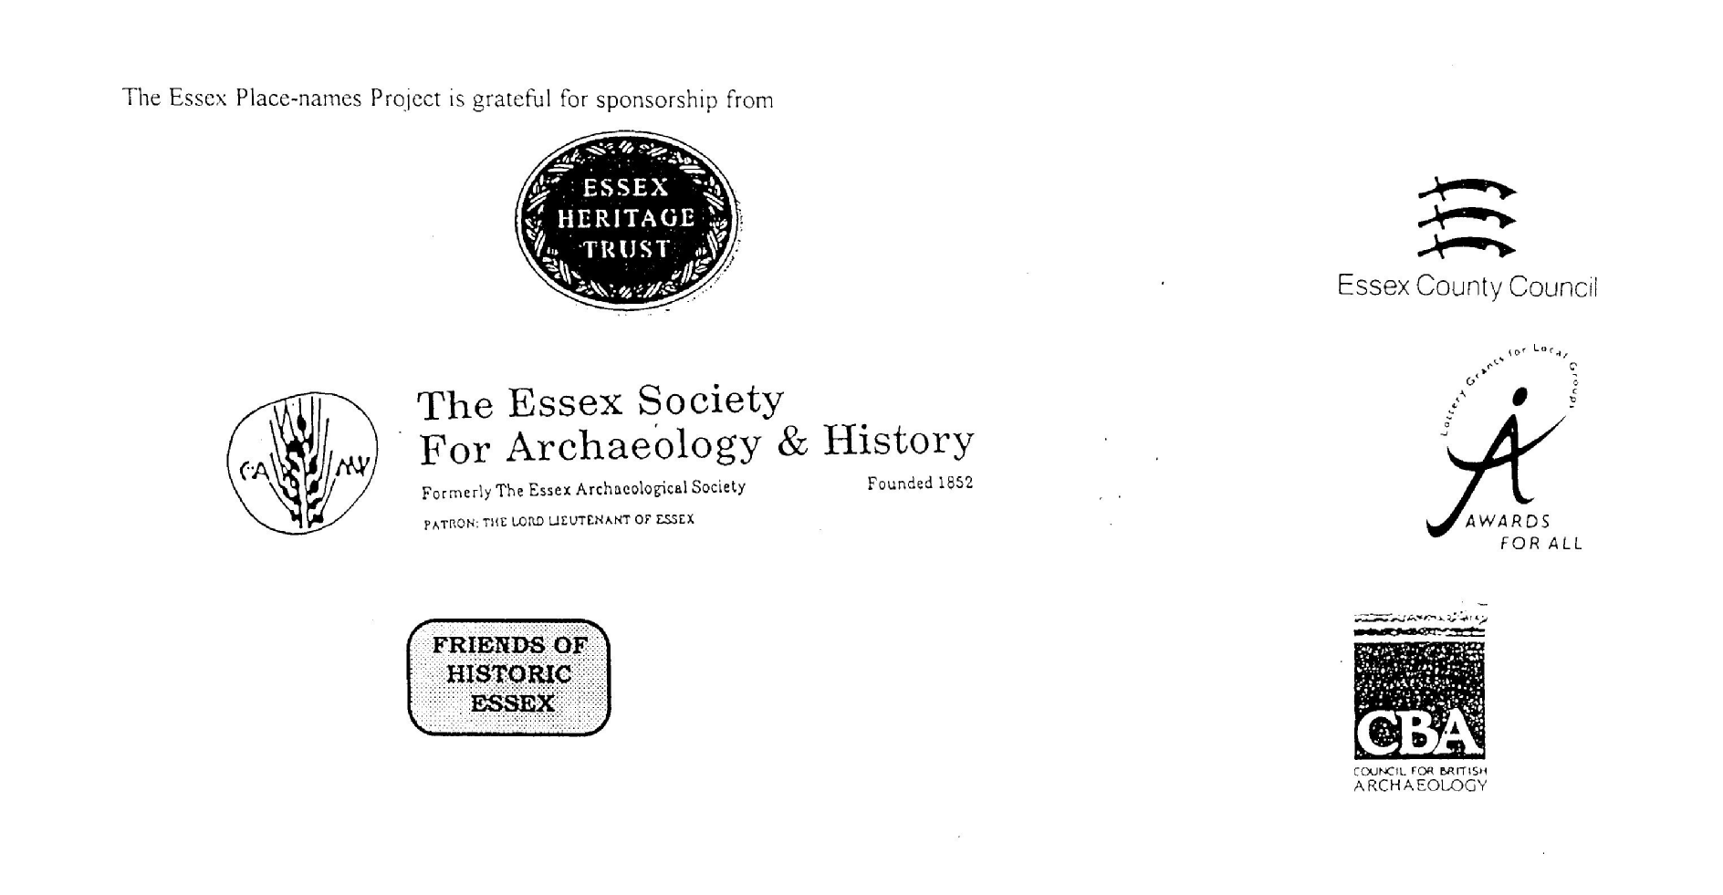

ESSEX PLACE-NAMES PROJECT.

The Essex Place-names Project is a County-wide survey to record place- and field-names from historical documents such as Tithe maps and apportionments, estate maps, sale
and auction catalogues, conveyances, terriers, deeds, rolls, inquisitions and surveys.

The second element of the Project is to investigate on-the-ground visible remains which correspond to the Place-names for actual or potential archaeological, agricultural and industrial
sites, and to record natural (topographical) and man-made features which may relate to the Place-name. This involves field-survey in rural and outside investigation in built-up areas.

It is anticipated that the Project will lead to identification of archaeological sites and lost historic buildings; it will enable analysis of indicators of early settlement, land holding, agricultural and industrial practices of the County. It will refine the more precise meaning of descriptive words and elements used by earlier settlers as they gave names appropriate to the topography of the landscape of their time.

For convenience the surveys are based on the parish, recognising that present civil parish boundaries are not necessarily identical to former ecclesiastical boundaries. Local Recorders
are supplied with templates of Record Forms to ensure consistency of recording across the County, and forward completed forms to a Central Coordinator for transfer to a county
computer database which is available to researchers on the internet at www.essex.ac.uk/history/esah/essexplacenames, and updated periodically.

This publication presents part of the information recorded from the Tithe or Estate Award and Map, and from other documents for this parish. The full record is contained on the master
database at Essex County Council (Historic Environment Section) and on the (above) website. Parish books are available to be downloaded from the website link ‘Books’ on the Home page. Please notify errors to the Project Coordinator at the Essex Record Office.

THE TITHE MAP AND APPORTIONMENT.

Since medieval times a tenth of the produce of land and stock had been paid by landholders to the church. At the Dissolution of the Monasteries, the property of many religious houses,
including the right to collect tithes, passed into lay hands. The Tithe Commutation Act which received Royal assent on 13th August 1836 abolished a rent payable in kind and
substituted rent-charges apportioned on each plot or parcel. The tithe-rent payable was assessed on the average value of wheat, barley and oats and was to fluctuate with price movements.

The commutation could be by voluntary agreement between the local owners and payers or, if agreement failed, could be compulsorily imposed by commissioners. A Valuer was to be
appointed to apportion the rent of each parcel of land and tenants could deduct that rent-charge from their rent paid to the landlord. The task fell to the Tithe Commissioners to produce a
map and an Apportionment (Award). A large-scale survey was produced for over 70% of England and Wales in the following 9 years, and about another 8% up to 1855. Most of the
parishes in Essex were surveyed. The map scales vary. The Award records ownership, tenancy and land-use, field by field and parcel by parcel (often quoting the field name) with the
ground area and rent-charge.

Land that was tithe-free tends to be less accurately mapped and contains few if any of the details recorded for those parcels subject to tithe. Rights of way and roads also tend to be
neglected. Boundaries of the tithe areas are shown as are some natural features such as streams, ponds, gardens, greens and commons. Buildings are often shown coloured red if dwellings
or grey if not. Because the Award may have been agreed only some time after the map was finished, discrepancies occur between the two. Enclosure Awards, when extant, usually date to the 18th and early 19th centuries. J.Kemble.
Reproduced by permission
of Essex County Council.

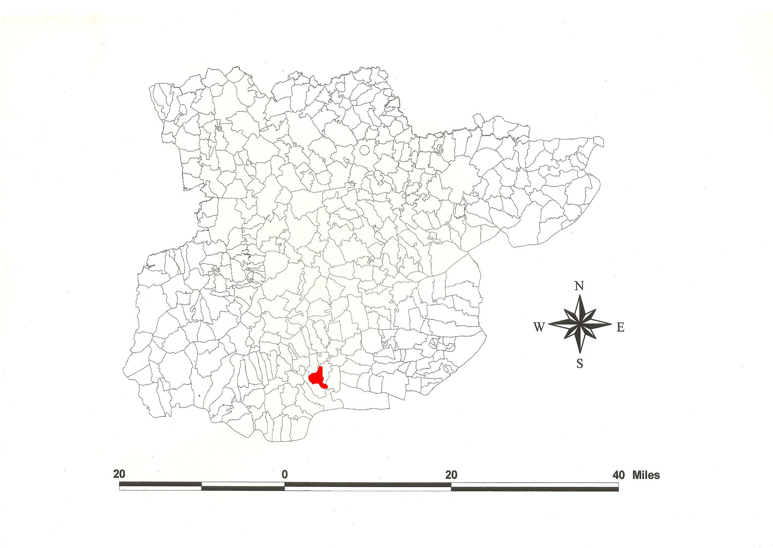
Vange Parish in the County of Essex.
Reproduced by permission
of Essex County Council.

Vange Parish (in Barstable Hundred).

The Tithe Award of Vange (Essex Record Office D/CT 374a), dated 1839, shows a rent-charge of payable to Rev. James Arrott Stewart of £325 including £15 for glebe. The whole parish measured 1451 acres 28 perches of which 895a 3r 32p were arable, 484a 1r 4p were meadow and pasture, 6a 3r 15p reeds and 3a 1r 22p homesteads. The Tithe Commissioners were William Blamire and J.W. Buller, the Valuer Robert Baker of Writtle.

The Tithe map (ERO: D/CT 374b) was surveyed by Robert Baker at a scale of 6 chains to an inch (13.3” to a mile) and measures 48”x41”. It was countersigned by Roger Kynaston, Assistant Tithe Commissioner. It shows as insets the detached parcels on Canvey Island and in Bowers Marsh.

In 963, Edgar, ruler of the whole of Britain, granted seven cassati (hides) at Fengge to the thegn Ingeram. Edgar’s grant of 963 gives the bounds of Vange which can still be traced from Vange Creek (Kemble, 2007). The same year Dunstan, archbishop of Canterbury, obtained Fenge from Ingelram, granting the same to Christ Church, Canterbury, now Canterbury cathedral (Hart, 1971). In Domesday Book, 1086, Thorold [of Rochester’s] son [Ralph] held Phenge from Odo, bishop of Bayeux, with a fishery and mill which two freemen had held for 5½ hides. Serlo held Phenge from Ranulf Peverel which a free man had held before 1066 as a manor for one hide. This manor perhaps became part of Fobbing (Morris, 1983; Powell, 1990). The name fenn ge, ‘fen district’, belongs to the early Saxon period (Gelling, 2000; Watts, 2004).

The one manor of Vange Hall went with Hassingbroke in nearby Stanford le Hope. From c.1280 to 1577 it was with the families of Montchesny, de Vere and de Valence, earl of Pembroke, who held, in 1323, one messuage, 70 acres etc. Thomas Wetenhale had licence to alienate to Thomas Newman of Quendon (died 1585) (Morant, 1768).

A hoard of bronze axes, spearheads and sword blades dating from c.900 BC have been found on the Swan Mead School site (Kemble, 2007). The church dedicated to All Saints has a Norman window in the nave and a Norman chancel arch. Vange, formerly a village above the marshes, was subsumed into the plans for Basildon New Town started in 1956 (Pevsner, 2007).

The meeting place of the Hundred, the moot, was at Barstable, the site marked by a stapol or pillar. Christy (1926) places it at Old Barstable Hall, formerly at the southwest extremity of Basildon parish on high ground. The first element may be a personal name, Bearda, or perhaps from O.E. beardede, hairy (Reaney, 1935).

References:
Christy, M, 1926. The Essex Hundred Moots. Trans Essex Archaeological Society, ns xviii (3), p194.
Gelling, M., Cole, A., 2000. The Landscape of Place-names. Tyas, Stamford. p.44.
Kemble, J., 2007. Essex Place-names, Places, Streets & People. Historical Publications, London. p. 38.
Kemble, J., 2009. Prehistoric & Roman Essex. History Press, Stroud. p. 159.
Morant, P., 1768. History & Antiquites of the County of Essex, i, 245.
Morris, J., 1983. Domesday Book – Essex, Kent. Phillimore.
Pevsner, N., Bettley, J., 2007. Buildings of England – Essex. Yale.
Powell, W.R., 1990. Essex Archaeology & History, 21, 50.
Reaney, P., 1935. Place-names of Essex. Cambridge.
Watts, V., 2004. Dictionary of English Place-names. Cambridge.

The Tithe Award Place-names of Vange – by Parcel No.

Place-name | Alias | Fld No | Grd Ref | x | y | Acr | rd | pch | land use | Owner | Occupier | Other information
Lower Undermines |  | 1 | TQ | 718 | 880 | 5 | 1 | 12 | arable | Morrin, Thomas | Clark, George
Barn field |  | 2 | TQ | 718 | 878 | 9 | 1 | 24 | pasture | Smith, Sir Charles Joshua, execs | Hockley, John
Five acres |  | 3 | TQ | 720 | 878 | 5 | 0 | 18 | arable | Smith, Sir Charles Joshua, execs | Hockley, John
Old Mead |  | 4 | TQ | 720 | 880 | 5 | 0 | 36 | pasture | Smith, Sir Charles Joshua, execs | Hockley, John
Long Nine acres |  | 5 | TQ | 721 | 880 | 9 | 1 | 17 | arable | Smith, Sir Charles Joshua, execs | Hockley, John
Further Timber Logs |  | 6 | TQ | 722 | 880 | 16 | 1 | 15 | arable | Smith, Sir Charles Joshua, execs | Hockley, John
Gate field | [at Basildon Bull, 1875,OS] | 7 | TQ | 725 | 882 | 15 | 3 | 37 | arable | Twoke, William | Abrey, Daniel
Basildon field (pt) | [at Timberlog Lane, 1875,OS] | 9a | TQ | 725 | 886 | 10 | 1 | 10 | arable | Twoke, William | Abrey, Daniel
Three acres |  | 10 | TQ | 728 | 888 | 3 | 1 | 14 | arable | Freeman, John | Hills, John
Six acres |  | 13 | TQ | 729 | 890 | 7 | 3 | 20 | arable | Freeman, John | Hills, John
Northlands |  | 14 | TQ | 731 | 890 | 5 | 1 | 26 | arable | Heathcote, James | Bailey, Charles
Chalk field |  | 16 | TQ | 730 | 887 | 12 | 2 | 26 | arable | Twoke, William | Abrey, Daniel
Pond Ten acres |  | 18 | TQ | 727 | 885 | 11 | 2 | 1 | arable | Twoke, William | Abrey, Daniel
Homestead | Lances, 1836,OS; Luncies, 1875,OS | 19 | TQ | 728 | 884 | 4 | 2 | 16 |  | Twoke, William | Abrey, Daniel
Spring field |  | 22 | TQ | 725 | 880 | 9 | 3 | 30 | arable | Twoke, William | Abrey, Daniel
Long field |  | 23 | TQ | 726 | 879 | 16 | 1 | 37 | arable | Twoke, William | Abrey, Daniel
Great Timber Logs |  | 24 | TQ | 723 | 877 | 11 | 3 | 6 | arable | Smith, Sir Charles Joshua, execs | Benton, James Emberson
Peacocks field |  | 26 | TQ | 720 | 877 | 7 | 2 | 22 | arable | Smith, Sir Charles Joshua, execs | Hockley, John
Round Hills |  | 27 | TQ | 720 | 876 | 6 | 2 | 34 | arable | Smith, Sir Charles Joshua, execs | Hockley, John
The Slades |  | 28 | TQ | 721 | 874 | 16 | 2 | 0 | arable | Smith, Sir Charles Joshua, execs | Hockley, John
Cottages, garden |  | 29 | TQ | 722 | 874 | 0 | 0 | 37 |  | Kemp, Robert | Gates, John; Rust, Anthony; Gribble, John
Cottage, garden |  | 30 | TQ | 722 | 874 | 0 | 0 | 23 |  | Freeman, Stephen | Herrington, Edward; Blewitt, Wm
Cottage, garden |  | 31 | TQ | 722 | 874 | 0 | 0 | 20 |  | Bright, John | Fretting, John
Cottage, garden |  | 32 | TQ | 724 | 875 | 0 | 0 | 32 |  | Buckingham, James | Reed, Robt; Fretting, John
Cottages, garden |  | 32a | TQ | 724 | 875 | 0 | 0 | 32 |  | Richardson, Thomas | Benton, Elizabeth; Speller, Edward
Wood field |  | 33 | TQ | 724 | 875 | 2 | 1 | 18 | pasture | Moss, Henry | Moss, Henry
Little Timber Logs |  | 34 | TQ | 724 | 876 | 7 | 0 | 8 | arable | Smith, Sir Charles Joshua, execs | Benton, James Emberson
Upper Biggotts |  | 35 | TQ | 726 | 877 | 14 | 2 | 33 | arable | Smith, Sir Charles Joshua, execs | Benton, James Emberson
Lower Biggotts |  | 36 | TQ | 728 | 877 | 8 | 2 | 10 | arable | Smith, Sir Charles Joshua, execs | Benton, James Emberson
Cottage, garden |  | 37 | TQ | 728 | 876 | 0 | 1 | 1 |  | King, George | King, George
Barge House, Drying Ground | Barge Inn, 1875,OS | 39 | TQ | 725 | 876 | 0 | 0 | 22 |  | Benton, William, execs | Adey, John
Stable, shed, gdn |  | 40 | TQ | 725 | 876 | 0 | 0 | 16 |  | Benton, William, execs | Adey, John
The Orchard |  | 41 | TQ | 725 | 876 | 0 | 0 | 25 | pasture | Benton, William, execs | Adey, John
Further Six acres |  | 43 | TQ | 722 | 873 | 6 | 3 | 21 | arable | Parker, Eliza Ann | Gibbs, Charles
Paintes Hills |  | 44 | TQ | 720 | 872 | 8 | 2 | 36 | arable | Parker, Eliza Ann | Gibbs, Charles
Cottages, garden |  | 45 | TQ | 721 | 871 | 0 | 1 | 0 |  | Stock, George, execs | Gilman, John; Rowland, Thomas; Wilson, James
Merrywigs field |  | 47 | TQ | 721 | 869 | 8 | 0 | 4 | arable | Smith, Sir Charles Joshua, execs | Benton, James Emberson
Eight acres |  | 48 | TQ | 722 | 870 | 8 | 3 | 4 | arable | Parker, Eliza Ann | Gibbs, Charles
Four Acres |  | 50 | TQ | 724 | 871 | 4 | 1 | 5 | arable | Parker, Eliza Ann | Gibbs, Charles | cut by railway, 1875,OS
Upper Wharf field |  | 52 | TQ | 725 | 873 | 6 | 3 | 7 | arable | Smith, Sir Charles Joshua, execs | Benton, James Emberson
Homestead | Shonks, 1875,OS | 54 | TQ | 728 | 875 | 2 | 0 | 12 |  | Moss, Henry | Moss, Henry | John Shonke, 1523,SubRoll
Six acres |  | 56 | TQ | 828 | 875 | 6 | 2 | 19 | arable | Moss, Henry | Moss, Henry
Five acre marsh |  | 57 | TQ | 730 | 872 | 6 | 2 | 5 | pasture | Moss, Henry | Moss, Henry
Chaseway |  | 59 | TQ | 729 | 873 | 0 | 2 | 39 |  | Moss, Henry | Moss, Henry
Nine acres |  | 60 | TQ | 728 | 872 | 8 | 2 | 29 | arable | Moss, Henry | Moss, Henry | cut by railway, 1875,OS
Lane eight acres |  | 61 | TQ | 727 | 872 | 7 | 3 | 9 | arable | Moss, Henry | Moss, Henry | cut by railway, 1875,OS
Wharf Lane |  | 62 | TQ | 726 | 872 | 1 | 2 | 0 |  | Smith, Sir Charles Joshua, execs | Benton, James Emberson
Lower Wharf field |  | 63 | TQ | 725 | 871 | 5 | 2 | 19 | arable | Smith, Sir Charles Joshua, execs | Benton, James Emberson
Homestead | Wharf Farm, 1875,OS | 64 | TQ | 726 | 870 | 3 | 1 | 4 |  | Smith, Sir Charles Joshua, execs | Benton, James Emberson
Homestead | Gouldings, 1875,OS | 65 | TQ | 725 | 769 | 1 | 1 | 6 |  | Parker, Eliza Ann | Gibbs, Charles
Skirts |  | 66 | TQ | 725 | 868 | 6 | 0 | 9 | arable | Parker, Eliza Ann | Gibbs, Charles
Five acre marsh |  | 67 | TQ | 723 | 867 | 6 | 1 | 23 | pasture | Parker, Eliza Ann | Gibbs, Charles
Merrywigs |  | 68 | TQ | 722 | 866 | 17 | 0 | 8 | pasture | Smith, Sir Charles Joshua, execs | Benton, James Emberson
Fleet |  | 71 | TQ | 727 | 867 | 5 | 1 | 28 |  | Parker, Eliza Ann | Gibbs, Charles
Upper & Lower Wharf |  | 72 | TQ | 727 | 870 | 3 | 2 | 24 |  | Smith, Sir Charles Joshua, execs | Benton, James Emberson
Cottages, garden |  | 72a | TQ | 727 | 870 | 0 | 1 | 4 |  | Smith, Sir Charles Joshua, execs | Benton, James Emberson
Three acre marsh |  | 73 | TQ | 729 | 870 | 6 | 1 | 26 | pasture | Moss, Henry | Moss, Henry
Ten acre marsh |  | 74 | TQ | 730 | 868 | 13 | 0 | 32 | pasture | Moss, Henry | Moss, Henry
Sea Wall, Saltings | [at Pitsea Creek, 1875,OS] | 75 | TQ | 732 | 867 | 3 | 2 | 25 | sltg | Moss, Henry | Moss, Henry
Salting |  | 76 | TQ | 730 | 866 | 5 | 0 | 13 | sltg | Smith, Sir Charles Joshua, execs | Benton, James Emberson
Wharf Marsh |  | 77 | TQ | 729 | 867 | 13 | 3 | 12 | pasture | Smith, Sir Charles Joshua, execs | Benton, James Emberson
Fleet (part) |  | 79 | TQ | 727 | 866 | 0 | 1 | 37 |  | Pocklington, Joseph | Pockington, Thomas
Fleet Marsh |  | 80 | TQ | 725 | 864 | 17 | 2 | 4 | pasture | Pocklington, Joseph | Pocklington, Thomas
Manor Way Marsh |  | 81 | TQ | 723 | 863 | 15 | 2 | 26 | pasture | Pocklington, Joseph | Pocklington, Thomas
Great Grass Marsh |  | 82 | TQ | 725 | 861 | 17 | 0 | 21 | pasture | Stewart, Rev James Arrott | Pocklington, John | glebe
Wall Marsh |  | 83 | TQ | 728 | 862 | 4 | 3 | 17 | pasture | Stewart, Rev James Arrott | Pocklington, Thomas | glebe
Black Ditch (pt) |  | 84 | TQ | 729 | 862 | 0 | 1 | 22 | fleet | Pocklington, Joseph | Pocklington, Thomas
Saltings |  | 85 | TQ | 729 | 862 | 0 | 3 | 2 | sltg | Pocklington, Joseph | Pocklington, Thomas
Saltings |  | 86 | TQ | 729 | 863 | 2 | 0 | 11 | sltg | Parker, Eliza Ann | Gibbs, Charles
Saltings |  | 87 | TQ | 731 | 858 | 10 | 0 | 12 | sltg | Norwich Hospital, gvnrs | Markwell, Joseph
Nine acres |  | 88 | TQ | 728 | 861 | 10 | 1 | 39 | sltg | Norwich Hospital, gvnrs | Markwell, Joseph
Fleet (part) |  | 89 | TQ | 728 | 862 | 0 | 1 | 22 |  | Norwich Hospital, gvnrs | Markwell, Joseph
Plough Marsh |  | 90 | TQ | 726 | 859 | 12 | 1 | 19 | arable | Stewart, Rev James Arrott | Pocklington, John | glebe
Little Grass Marsh |  | 90a | TQ | 725 | 860 | 3 | 0 | 38 | pasture | Stewart, Rev James Arrott | Pocklington, John | glebe
Fleet |  | 91 | TQ | 726 | 857 | 2 | 0 | 6 |  | Stewart, Rev James Arrott | Pocklington, John | glebe
Thirteen acres |  | 92 | TQ | 728 | 858 | 14 | 0 | 4 | pasture | Norwich Hospital, gvnrs | Markwell, Joseph
Fleet (part) |  | 95 | TQ | 728 | 855 | 4 | 3 | 17 |  | Norwich Hospital, gvnrs | Markwell, Joseph
Seven acres |  | 96 | TQ | 729 | 856 | 8 | 0 | 0 | arable | Norwich Hospital, gvnrs | Markwell, Joseph
Homestead | Whitehouse, 1836,OS; Vange Wick, 1875,OS | 98 | TQ | 730 | 866 | 1 | 3 | 22 |  | Norwich Hospital, gvnrs | Markwell, Joseph
Eleven acres |  | 100 | TQ | 733 | 856 | 11 | 3 | 3 | arable | Norwich Hospital, gvnrs | Markwell, Joseph
Potatoe Plack |  | 101 | TQ | 730 | 857 | 0 | 0 | 27 | arable | Norwich Hospital, gvnrs | Markwell, Joseph
Middle Saltings |  | 104 | TQ | 738 | 854 | 23 | 0 | 16 | sltg | Norwich Hospital, gvnrs | Markwell, Joseph
Eight acres |  | 105 | TQ | 737 | 856 | 8 | 1 | 17 | arable | Norwich Hospital, gvnrs | Markwell, Joseph
Fleet |  | 106 | TQ | 737 | 855 | 1 | 2 | 10 |  | Norwich Hospital, gvnrs | Markwell, Joseph | O.E. fleot = inlet
South Saltings |  | 108 | TQ | 736 | 854 | 3 | 3 | 6 | sltg | Norwich Hospital, gvnrs | Markwell, Joseph
Small Crooked Marsh |  | 110a | TQ | 736 | 855 | 0 | 2 | 9 | arable | Norwich Hospital, gvnrs | Markwell, Joseph
Partridge Bush |  | 112 | TQ | 717 | 877 | 16 | 0 | 22 | arable | Pocklington, Joseph | Pocklington, Thomas
Upper Undermines |  | 113 | TQ | 716 | 879 | 5 | 2 | 22 | arable | Morrin, Thomas | Clark, George
Furze field |  | 114 | TQ | 714 | 878 | 17 | 3 | 37 | arable | Pocklington, Joseph | Pocklington, Thomas
Corner Five acres |  | 115 | TQ | 711 | 878 | 5 | 0 | 20 | arable | Morrin, Thomas | Brett, Samuel
Long Meadow |  | 115a | TQ | 710 | 877 | 7 | 1 | 13 | pasture | Morrin, Thomas | Brett, Samuel
Clover Vange |  | 116 | TQ | 710 | 875 | 21 | 1 | 10 | arable | Morrin, Thomas | Brett, Samuel
Rushey Mead |  | 117 | TQ | 708 | 874 | 9 | 0 | 12 | pasture | Morrin, Thomas | Brett, Samuel
Second Meadow |  | 118 | TQ | 706 | 872 | 11 | 0 | 25 | pasture | Morrin, Thomas | Brett, Samuel
Home meadow |  | 119 | TQ | 706 | 872 | 8 | 0 | 34 | pasture | Morrin, Thomas | Brett, Samuel
Homestead | Little Vange Hall, 1875,OS | 120 | TQ | 706 | 872 | 0 | 3 | 36 |  | Morrin, Thomas | Brett, Samuel
Nine acres |  | 121 | TQ | 707 | 871 | 9 | 1 | 21 | arable | Morrin, Thomas | Brett, Samuel
High field |  | 122 | TQ | 709 | 872 | 9 | 1 | 0 | arable | Morrin, Thomas | Brett, Samuel
Upper Tompkins |  | 123 | TQ | 710 | 874 | 15 | 3 | 18 | arable | Pocklington, Joseph | Pocklington, Thomas
Round Hills |  | 124 | TQ | 712 | 875 | 10 | 0 | 9 | arable | Morrin, Thomas | Brett, Samuel
Cart House field |  | 125 | TQ | 714 | 876 | 12 | 0 | 38 | arable | Pocklington, Joseph | Pocklington, Thomas
Barn mead |  | 126 | TQ | 716 | 875 | 3 | 3 | 11 | pasture | Pocklington, Joseph | Pocklington, Thomas
Homestead | Vange Hall, 1875,OS | 127 | TQ | 715 | 875 | 1 | 2 | 13 |  | Pocklington, Joseph | Pocklington, Thomas
Hoppit |  | 127a | TQ | 715 | 875 | 1 | 1 | 6 | pasture | Pocklington, Joseph | Pocklington, Thomas
Hill field |  | 128 | TQ | 715 | 874 | 9 | 0 | 35 | pasture | Pocklington, Joseph | Pocklington, Thomas
First Sand Hill |  | 129 | TQ | 716 | 875 | 4 | 0 | 16 | pasture | Pocklington, Joseph | Pocklington, Thomas
Upper Sand Hills |  | 130 | TQ | 717 | 875 | 8 | 0 | 27 | arable | Smith, Sir Charles Joshua, execs | Hockley, John
Chaseway |  | 131 | TQ | 719 | 876 | 0 | 0 | 28 |  | Smith, Sir Charles Joshua, execs | Hockley, John
Homestead | le ffangehul, 1345,MnAt; Peacocks, 1836,OS; Hill Farm, 1875,OS | 132 | TQ | 719 | 876 | 1 | 2 | 24 |  | Smith, Sir Charles Joshua, execs | Hockley, John
Lower Sand Hills |  | 134 | TQ | 718 | 874 | 8 | 0 | 21 | arable | Smith, Sir Charles Joshua, execs | Hockley, John
Hanging Field |  | 135 | TQ | 718 | 873 | 4 | 3 | 8 | pasture | Smith, Sir Charles Joshua, execs | Hockley, John
Second Sand Hill |  | 136 | TQ | 717 | 874 | 7 | 2 | 12 | arable | Pocklington, Joseph | Pocklington, Thomas
Little Hanging Field |  | 137 | TQ | 717 | 873 | 3 | 0 | 18 | pasture | Smith, Sir Charles Joshua, execs | Hockley, John
Homestead |  | 139 | TQ | 718 | 872 | 0 | 1 | 24 |  | Drury, James | Brown, John
Six acres |  | 140 | TQ | 717 | 870 | 6 | 2 | 4 | arable | Drury, James | Brown, John
Cottage, garden |  | 141 | TQ | 717 | 870 | 0 | 0 | 18 |  | Drury, James | Brown, John
Sheepcotes |  | 143 | TQ | 715 | 871 | 16 | 1 | 30 | arable | Pocklington, Joseph | Pocklington, Thomas
Ten acres |  | 144 | TQ | 712 | 872 | 11 | 2 | 5 | arable | Stewart, Rev James Arrott | Pocklington, Thomas | glebe
Lower Tompkins |  | 145 | TQ | 710 | 870 | 14 | 2 | 18 | arable | Pocklington, Joseph | Pocklington, Thomas
Carraway field |  | 146 | TQ | 709 | 870 | 12 | 1 | 19 | arable | Morrin, Thomas | Brett, Samuel
Bell field |  | 147 | TQ | 709 | 867 | 11 | 1 | 3 | arable | Morrin, Thomas | Brett, Samuel
Little Bell field |  | 148 | TQ | 710 | 868 | 5 | 0 | 1 | arable | Lang, Henry | Clark, William
Six acres |  | 149 | TQ | 711 | 868 | 6 | 1 | 24 | arable | Stewart, Rev James Arrott | Pocklington, John | glebe
Eight acres |  | 152 | TQ | 713 | 870 | 8 | 3 | 38 | arable | Stewart, Rev James Arrott | Pocklington, John
Four acres |  | 153 | TQ | 713 | 868 | 4 | 0 | 11 | arable | Stewart, Rev James Arrott | Pocklington, John
House, gardens | Rectory, 1875,OS | 154 | TQ | 713 | 868 | 0 | 2 | 20 |  | Stewart, Rev James Arrott | Stewart, Rev James Arrott
Cottages, garden |  | 155 | TQ | 711 | 867 | 0 | 1 | 14 |  | Underwood, Mary | Underwood, Mary; Hardy, Cornelius
The Bells Inn | The 5 Bells, 1777,C | 156 | TQ | 710 | 866 | 0 | 2 | 15 | inn | Crabb, Richard Hatley | Brown, Henry
Corner Piece |  | 157 | TQ | 712 | 866 | 2 | 3 | 8 | arable | Smith, Sir Charles Joshua, execs | Benton, James Emberson
Barn , gdn & about |  | 159 | TQ | 713 | 867 | 1 | 0 | 2 |  | Stewart, Rev James Arrott | Pocklington, John | glebe
Church & yard | [All Saints] | 160 | TQ | 715 | 866 | 0 | 2 | 28 |  | Stewart, Rev James Arrott | Stewart, Rev James Arrott | glebe
Church field |  | 161 | TQ | 716 | 868 | 7 | 1 | 27 | arable | Smith, Sir Charles Joshua, execs | Benton, James Emberson
Small field |  | 162 | TQ | 715 | 869 | 1 | 0 | 6 | arable | Smith, Sir Charles Joshua, execs | Benton, James Emberson
Cottage, garden |  | 163 | TQ | 715 | 869 | 0 | 0 | 22 |  | Hudson, John | Hudson, John
Slip |  | 165 | TQ | 719 | 869 | 0 | 0 | 19 | pasture | Parker, Eliza Ann | Gibbs, Charles
Two acres |  | 167 | TQ | 720 | 868 | 2 | 0 | 22 | pasture | Hardy, Cornelius | Hudson, John
Three Corner Piece |  | 168 | TQ | 720 | 867 | 0 | 0 | 18 | arable | Parker, Eliza Ann | Gibbs, Charles
Barn Marsh |  | 170 | TQ | 719 | 867 | 13 | 1 | 15 | arable | Pocklington, Joseph | Pocklington, Thomas | cut by railway, 1875,OS
Driftway |  | 171 | TQ | 718 | 867 | 0 | 1 | 18 |  | Pocklington, Joseph | Pocklington, Thomas
Cherry Downs |  | 172 | TQ | 717 | 866 | 10 | 1 | 26 | arable | Pocklington, Joseph | Pocklington, Thomas | cut by railway, 1875,OS
Church Hill |  | 173 | TQ | 714 | 865 | 18 | 2 | 25 | arable | Pocklington, Joseph | Pocklington, Thomas | cut by railway, 1875,OS
Ten acres |  | 174 | TQ | 712 | 865 | 10 | 3 | 39 | arable | Pocklington, Joseph | Pocklington, Thomas | cut by railway, 1875,OS
Large Bells field |  | 175 | TQ | 711 | 864 | 13 | 0 | 38 | arable | Pocklington, Joseph | Pocklington, Thomas | cut by railway, 1875,OS
Little Crooked Brooks |  | 176 | TQ | 712 | 863 | 2 | 3 | 22 | arable | Spitty, George | Spitty, George
Ten acres |  | 177 | TQ | 713 | 861 | 11 | 3 | 14 | arble, waste | Lang, Henry | Clark, William
Great Crooked Brooks |  | 178 | TQ | 714 | 861 | 9 | 2 | 7 | arable | Spitty, George | Spitty, George
Paper Hills | Paperelles, 1536, Sessions; Paper Hill,1586,Harrison | 179 | TQ | 715 | 861 | 19 | 2 | 13 | arable | Pocklington, Joseph | Pocklington, Thomas
Three Corner Piece |  | 180 | TQ | 716 | 863 | 0 | 0 | 35 | arable | Pocklington, Joseph | Pocklington, Thomas
Pound Marsh |  | 181 | TQ | 717 | 864 | 12 | 3 | 19 | arable | Pocklington, Joseph | Pocklington, Thomas
Lower Barn & gdn | Marsh Farm, 1987,OS | 182 | TQ | 718 | 866 | 0 | 2 | 16 | . | Pocklington, Joseph | Pocklington, Thomas | Thomas ate Mersh, 1319,SubRoll
First Marsh |  | 183 | TQ | 719 | 865 | 16 | 1 | 39 | pasture | Pocklington, Joseph | Pocklington, Thomas
Thistley field |  | 184 | TQ | 722 | 865 | 10 | 0 | 19 | pasture | Pocklington, Joseph | Pocklington, Thomas
Pond Marsh |  | 185 | TQ | 720 | 863 | 15 | 1 | 36 | pasture | Pocklington, Joseph | Pocklington, Thomas
Fattening meadow |  | 186 | TQ | 719 | 861 | 22 | 1 | 0 | pasture | Pocklington, Joseph | Pocklington, Thomas
Marsh |  | 187 | TQ | 723 | 862 | 2 | 3 | 22 | pasture | Smith, Sir Charles Joshua, execs | Benton, James Emberson
Fleet 12 acres (pt) |  | 188 | TQ | 750 | 860 | 2 | 1 | 5 | arable | Welley, Ambrose | Dean, Robert | detached. In Bowers Marsh
Bradford Marsh (pt) | Bradewerde Mariscus de North, Sud, t.EdwI, 1360,BL; Palmersmershe, 1539, MnAt | 189 | TQ | 755 | 853 | 18 | 3 | 19 |  | Welley, Ambrose | Dean, Robert | detached. In Bowers Marsh
Twelve acres |  | 190 | TQ | 755 | 854 | 13 | 2 | 22 | arable | Welley, Ambrose | Dean, Robert | detached. In Bowers Marsh
Six acre marsh |  | 191 | TQ | 750 | 855 | 7 | 1 | 30 | pasture | Welley, Ambrose | Dean, Robert | detached. In Bowers Marsh
Path Way |  | 192 | TQ | 750 | 855 | 2 | 2 | 24 | pasture | Welley, Ambrose | Dean, Robert | detached. In Bowers Marsh
Manor Way Marsh (pt) |  | 194 | TQ | 750 | 855 | 11 | 2 | 16 | pasture | Welley, Ambrose | Dean, Robert | detached. In Bowers Marsh
Little Two acres |  | 195 | TQ | 747 | 856 | 2 | 3 | 34 | arable | Welley, Ambrose | Dean, Robert | detached. In Bowers Marsh
Pathway | Manor Way, 1875,OS | 196 | TQ | 746 | 856 | 0 | 2 | 24 |  | Welley, Ambrose | Dean, Robert | detached. In Bowers Marsh
First Near Marsh, Water |  | 197 | TQ | 783 | 820 | 10 | 1 | 16 | arable | Hilton, William | Hilton, William | detached. On Canvey Island
First Saltings & Wall |  | 199 | TQ | 784 | 820 | 13 | 2 | 31 | sltg | Hilton, William | Hilton, William | detached. On Canvey Island
Marsh before house; Waste |  | 200 | TQ | 786 | 821 | 10 | 1 | 31 | pasture | Hilton, William | Hilton, William | detached. On Canvey Island
Homestead | Scarhouse, 1875,OS | 201 | TQ | 785 | 821 | 0 | 3 | 27 |  | Hilton, William | Hilton, William | detached. On Canvey Island
Marsh before house |  | 202 | TQ | 785 | 821 | 12 | 1 | 0 | arable | Hilton, William | Hilton, William | detached. On Canvey Island
Six acres; Waste |  | 205 | TQ | 785 | 827 | 7 | 2 | 20 | arable | Hilton, William | Hilton, William | detached. On Canvey Island
Little Pasture Marsh |  | 207 | TQ | 788 | 826 | 2 | 1 | 31 | pasture | Hilton, William | Hilton, William | detached. On Canvey Island
Further Marsh; Waste |  | 208 | TQ | 790 | 826 | 14 | 3 | 2 | pasture | Spitty, George | Pocklington, Thomas | detached. On Canvey Island
Little Marsh |  | 209 | TQ | 792 | 825 | 4 | 2 | 4 | pasture | Spitty, George | Pocklington, Thomas | detached. On Canvey Island
Middle Marsh |  | 210 | TQ | 792 | 824 | 12 | 2 | 34 | pasture | Spitty, George | Pocklington, Thomas | detached. On Canvey Island
Big Marsh |  | 211 | TQ | 792 | 822 | 20 | 3 | 23 | pasture | Spitty, George | Pocklington, Thomas | detached. On Canvey Island
Sea Wall; Fleet | [at Deadman's Point, 1875,OS] | 213 | TQ | 792 | 821 | 3 | 1 | 19 | pasture | Spitty, George | Pocklington, Thomas | detached. On Canvey Island
First Further Marsh; Waste |  | 214 | TQ | 794 | 823 | 12 | 3 | 38 | pasture | Hilton, William | Hilton, William | detached. On Canvey Island
The Five acres |  | 215 | TQ | 794 | 826 | 6 | 0 | 19 | arable | Hilton, William | Hilton, William | detached. On Canvey Island
Twelve acres; Waste |  | 216 | TQ | 795 | 825 | 16 | 0 | 17 | pasture | Hilton, William | Hilton, William | detached. On Canvey Island
Further Saltings | [at Thorny Creek, 1875,OS] | 217 | TQ | 796 | 826 | 6 | 2 | 17 | sltg | Hilton, William | Hilton, William | detached. On Canvey Island
Creek by Fobbing (pt) |  | 218 | TQ | 736 | 852 | 4 | 0 | 11 |  | Welley, Ambrose | Dean, Robert
Creek by Pitsea (pt) |  | 219 | TQ | 731 | 867 | 24 | 2 | 34 |  | Welley, Ambrose | Dean, Robert
Roads |  | . | TQ |  |  | 10 | 3 | 21 | . | . | .

For abbreviations see Reaney, P., 1935, Place-names of Essex, Cambridge; and Kemble, J., 2007, Essex Place-names, Places, Streets & People, Historical Publications, p.153.

The Tithe Award Place-names of Vange – by Owner.

Place-name | Alias | Fld No | Grd Ref | x | y | Acr | rd | pch | land use | Owner | Occupier | Other information
Barge House, Drying Ground | Barge Inn, 1875,OS | 39 | TQ | 725 | 876 | 0 | 0 | 22 |  | Benton, William, execs | Adey, John
Stable, shed, gdn |  | 40 | TQ | 725 | 876 | 0 | 0 | 16 |  | Benton, William, execs | Adey, John
The Orchard |  | 41 | TQ | 725 | 876 | 0 | 0 | 25 | pasture | Benton, William, execs | Adey, John
Cottage, garden |  | 31 | TQ | 722 | 874 | 0 | 0 | 20 |  | Bright, John | Fretting, John
Cottage, garden |  | 32 | TQ | 724 | 875 | 0 | 0 | 32 |  | Buckingham, James | Reed, Robt; Fretting, John
The Bells Inn | The 5 Bells, 1777,C | 156 | TQ | 710 | 866 | 0 | 2 | 15 | inn | Crabb, Richard Hatley | Brown, Henry
Homestead |  | 139 | TQ | 718 | 872 | 0 | 1 | 24 |  | Drury, James | Brown, John
Six acres |  | 140 | TQ | 717 | 870 | 6 | 2 | 4 | arable | Drury, James | Brown, John
Cottage, garden |  | 141 | TQ | 717 | 870 | 0 | 0 | 18 |  | Drury, James | Brown, John
Three acres |  | 10 | TQ | 728 | 888 | 3 | 1 | 14 | arable | Freeman, John | Hills, John
Six acres |  | 13 | TQ | 729 | 890 | 7 | 3 | 20 | arable | Freeman, John | Hills, John
Cottage, garden |  | 30 | TQ | 722 | 874 | 0 | 0 | 23 |  | Freeman, Stephen | Herrington, Edward; Blewitt, Wm
Two acres |  | 167 | TQ | 720 | 868 | 2 | 0 | 22 | pasture | Hardy, Cornelius | Hudson, John
Northlands |  | 14 | TQ | 731 | 890 | 5 | 1 | 26 | arable | Heathcote, James | Bailey, Charles
First Near Marsh, Water |  | 197 | TQ | 783 | 820 | 10 | 1 | 16 | arable | Hilton, William | Hilton, William | detached. On Canvey Island
First Saltings & Wall |  | 199 | TQ | 784 | 820 | 13 | 2 | 31 | sltg | Hilton, William | Hilton, William | detached. On Canvey Island
Marsh before house; Waste |  | 200 | TQ | 786 | 821 | 10 | 1 | 31 | pasture | Hilton, William | Hilton, William | detached. On Canvey Island
Homestead | Scarhouse, 1875,OS | 201 | TQ | 785 | 821 | 0 | 3 | 27 |  | Hilton, William | Hilton, William | detached. On Canvey Island
Marsh before house |  | 202 | TQ | 785 | 821 | 12 | 1 | 0 | arable | Hilton, William | Hilton, William | detached. On Canvey Island
Six acres; Waste |  | 205 | TQ | 785 | 827 | 7 | 2 | 20 | arable | Hilton, William | Hilton, William | detached. On Canvey Island
Little Pasture Marsh |  | 207 | TQ | 788 | 826 | 2 | 1 | 31 | pasture | Hilton, William | Hilton, William | detached. On Canvey Island
First Further Marsh; Waste |  | 214 | TQ | 794 | 823 | 12 | 3 | 38 | pasture | Hilton, William | Hilton, William | detached. On Canvey Island
The Five acres |  | 215 | TQ | 794 | 826 | 6 | 0 | 19 | arable | Hilton, William | Hilton, William | detached. On Canvey Island
Twelve acres; Waste |  | 216 | TQ | 795 | 825 | 16 | 0 | 17 | pasture | Hilton, William | Hilton, William | detached. On Canvey Island
Further Saltings | [at Thorny Creek, 1875,OS] | 217 | TQ | 796 | 826 | 6 | 2 | 17 | sltg | Hilton, William | Hilton, William | detached. On Canvey Island
Cottage, garden |  | 163 | TQ | 715 | 869 | 0 | 0 | 22 |  | Hudson, John | Hudson, John
Cottages, garden |  | 29 | TQ | 722 | 874 | 0 | 0 | 37 |  | Kemp, Robert | Gates, John; Rust, Anthony; Gribble, John
Cottage, garden |  | 37 | TQ | 728 | 876 | 0 | 1 | 1 |  | King, George | King, George
Little Bell field |  | 148 | TQ | 710 | 868 | 5 | 0 | 1 | arable | Lang, Henry | Clark, William
Ten acres |  | 177 | TQ | 713 | 861 | 11 | 3 | 14 | arble, waste | Lang, Henry | Clark, William
Corner Five acres |  | 115 | TQ | 711 | 878 | 5 | 0 | 20 | arable | Morrin, Thomas | Brett, Samuel
Long Meadow |  | 115a | TQ | 710 | 877 | 7 | 1 | 13 | pasture | Morrin, Thomas | Brett, Samuel
Clover Vange |  | 116 | TQ | 710 | 875 | 21 | 1 | 10 | arable | Morrin, Thomas | Brett, Samuel
Rushey Mead |  | 117 | TQ | 708 | 874 | 9 | 0 | 12 | pasture | Morrin, Thomas | Brett, Samuel
Second Meadow |  | 118 | TQ | 706 | 872 | 11 | 0 | 25 | pasture | Morrin, Thomas | Brett, Samuel
Home meadow |  | 119 | TQ | 706 | 872 | 8 | 0 | 34 | pasture | Morrin, Thomas | Brett, Samuel
Homestead | Little Vange Hall, 1875,OS | 120 | TQ | 706 | 872 | 0 | 3 | 36 |  | Morrin, Thomas | Brett, Samuel
Nine acres |  | 121 | TQ | 707 | 871 | 9 | 1 | 21 | arable | Morrin, Thomas | Brett, Samuel
High field |  | 122 | TQ | 709 | 872 | 9 | 1 | 0 | arable | Morrin, Thomas | Brett, Samuel
Round Hills |  | 124 | TQ | 712 | 875 | 10 | 0 | 9 | arable | Morrin, Thomas | Brett, Samuel
Carraway field |  | 146 | TQ | 709 | 870 | 12 | 1 | 19 | arable | Morrin, Thomas | Brett, Samuel
Bell field |  | 147 | TQ | 709 | 867 | 11 | 1 | 3 | arable | Morrin, Thomas | Brett, Samuel
Lower Undermines |  | 1 | TQ | 718 | 880 | 5 | 1 | 12 | arable | Morrin, Thomas | Clark, George
Upper Undermines |  | 113 | TQ | 716 | 879 | 5 | 2 | 22 | arable | Morrin, Thomas | Clark, George
Wood field |  | 33 | TQ | 724 | 875 | 2 | 1 | 18 | pasture | Moss, Henry | Moss, Henry
Homestead | Shonks, 1875,OS | 54 | TQ | 728 | 875 | 2 | 0 | 12 |  | Moss, Henry | Moss, Henry | John Shonke, 1523,SubRoll
Six acres |  | 56 | TQ | 828 | 875 | 6 | 2 | 19 | arable | Moss, Henry | Moss, Henry
Five acre marsh |  | 57 | TQ | 730 | 872 | 6 | 2 | 5 | pasture | Moss, Henry | Moss, Henry
Chaseway |  | 59 | TQ | 729 | 873 | 0 | 2 | 39 |  | Moss, Henry | Moss, Henry
Nine acres |  | 60 | TQ | 728 | 872 | 8 | 2 | 29 | arable | Moss, Henry | Moss, Henry | cut by railway, 1875,OS
Lane eight acres |  | 61 | TQ | 727 | 872 | 7 | 3 | 9 | arable | Moss, Henry | Moss, Henry | cut by railway, 1875,OS
Three acre marsh |  | 73 | TQ | 729 | 870 | 6 | 1 | 26 | pasture | Moss, Henry | Moss, Henry
Ten acre marsh |  | 74 | TQ | 730 | 868 | 13 | 0 | 32 | pasture | Moss, Henry | Moss, Henry
Sea Wall, Saltings | [at Pitsea Creek, 1875,OS] | 75 | TQ | 732 | 867 | 3 | 2 | 25 | sltg | Moss, Henry | Moss, Henry
Eleven acres |  | 100 | TQ | 733 | 856 | 11 | 3 | 3 | arable | Norwich Hospital, gvnrs | Markwell, Joseph
Potatoe Plack |  | 101 | TQ | 730 | 857 | 0 | 0 | 27 | arable | Norwich Hospital, gvnrs | Markwell, Joseph
Middle Saltings |  | 104 | TQ | 738 | 854 | 23 | 0 | 16 | sltg | Norwich Hospital, gvnrs | Markwell, Joseph
Eight acres |  | 105 | TQ | 737 | 856 | 8 | 1 | 17 | arable | Norwich Hospital, gvnrs | Markwell, Joseph
Fleet |  | 106 | TQ | 737 | 855 | 1 | 2 | 10 |  | Norwich Hospital, gvnrs | Markwell, Joseph | O.E. fleot = inlet
South Saltings |  | 108 | TQ | 736 | 854 | 3 | 3 | 6 | sltg | Norwich Hospital, gvnrs | Markwell, Joseph
Small Crooked Marsh |  | 110a | TQ | 736 | 855 | 0 | 2 | 9 | arable | Norwich Hospital, gvnrs | Markwell, Joseph
Saltings |  | 87 | TQ | 731 | 858 | 10 | 0 | 12 | sltg | Norwich Hospital, gvnrs | Markwell, Joseph
Nine acres |  | 88 | TQ | 728 | 861 | 10 | 1 | 39 | sltg | Norwich Hospital, gvnrs | Markwell, Joseph
Fleet (part) |  | 89 | TQ | 728 | 862 | 0 | 1 | 22 |  | Norwich Hospital, gvnrs | Markwell, Joseph
Thirteen acres |  | 92 | TQ | 728 | 858 | 14 | 0 | 4 | pasture | Norwich Hospital, gvnrs | Markwell, Joseph
Fleet (part) |  | 95 | TQ | 728 | 855 | 4 | 3 | 17 |  | Norwich Hospital, gvnrs | Markwell, Joseph
Seven acres |  | 96 | TQ | 729 | 856 | 8 | 0 | 0 | arable | Norwich Hospital, gvnrs | Markwell, Joseph
Homestead | Whitehouse, 1836,OS; Vange Wick, 1875,OS | 98 | TQ | 730 | 866 | 1 | 3 | 22 |  | Norwich Hospital, gvnrs | Markwell, Joseph
Slip |  | 165 | TQ | 719 | 869 | 0 | 0 | 19 | pasture | Parker, Eliza Ann | Gibbs, Charles
Three Corner Piece |  | 168 | TQ | 720 | 867 | 0 | 0 | 18 | arable | Parker, Eliza Ann | Gibbs, Charles
Further Six acres |  | 43 | TQ | 722 | 873 | 6 | 3 | 21 | arable | Parker, Eliza Ann | Gibbs, Charles
Paintes Hills |  | 44 | TQ | 720 | 872 | 8 | 2 | 36 | arable | Parker, Eliza Ann | Gibbs, Charles
Eight acres |  | 48 | TQ | 722 | 870 | 8 | 3 | 4 | arable | Parker, Eliza Ann | Gibbs, Charles
Four Acres |  | 50 | TQ | 724 | 871 | 4 | 1 | 5 | arable | Parker, Eliza Ann | Gibbs, Charles | cut by railway, 1875,OS
Homestead | Gouldings, 1875,OS | 65 | TQ | 725 | 769 | 1 | 1 | 6 |  | Parker, Eliza Ann | Gibbs, Charles
Skirts |  | 66 | TQ | 725 | 868 | 6 | 0 | 9 | arable | Parker, Eliza Ann | Gibbs, Charles
Five acre marsh |  | 67 | TQ | 723 | 867 | 6 | 1 | 23 | pasture | Parker, Eliza Ann | Gibbs, Charles
Fleet |  | 71 | TQ | 727 | 867 | 5 | 1 | 28 |  | Parker, Eliza Ann | Gibbs, Charles
Saltings |  | 86 | TQ | 729 | 863 | 2 | 0 | 11 | sltg | Parker, Eliza Ann | Gibbs, Charles
Fleet (part) |  | 79 | TQ | 727 | 866 | 0 | 1 | 37 |  | Pocklington, Joseph | Pockington, Thomas
Partridge Bush |  | 112 | TQ | 717 | 877 | 16 | 0 | 22 | arable | Pocklington, Joseph | Pocklington, Thomas
Furze field |  | 114 | TQ | 714 | 878 | 17 | 3 | 37 | arable | Pocklington, Joseph | Pocklington, Thomas
Upper Tompkins |  | 123 | TQ | 710 | 874 | 15 | 3 | 18 | arable | Pocklington, Joseph | Pocklington, Thomas
Cart House field |  | 125 | TQ | 714 | 876 | 12 | 0 | 38 | arable | Pocklington, Joseph | Pocklington, Thomas
Barn mead |  | 126 | TQ | 716 | 875 | 3 | 3 | 11 | pasture | Pocklington, Joseph | Pocklington, Thomas
Homestead | Vange Hall, 1875,OS | 127 | TQ | 715 | 875 | 1 | 2 | 13 |  | Pocklington, Joseph | Pocklington, Thomas
Hoppit |  | 127a | TQ | 715 | 875 | 1 | 1 | 6 | pasture | Pocklington, Joseph | Pocklington, Thomas
Hill field |  | 128 | TQ | 715 | 874 | 9 | 0 | 35 | pasture | Pocklington, Joseph | Pocklington, Thomas
First Sand Hill |  | 129 | TQ | 716 | 875 | 4 | 0 | 16 | pasture | Pocklington, Joseph | Pocklington, Thomas
Second Sand Hill |  | 136 | TQ | 717 | 874 | 7 | 2 | 12 | arable | Pocklington, Joseph | Pocklington, Thomas
Sheepcotes |  | 143 | TQ | 715 | 871 | 16 | 1 | 30 | arable | Pocklington, Joseph | Pocklington, Thomas
Lower Tompkins |  | 145 | TQ | 710 | 870 | 14 | 2 | 18 | arable | Pocklington, Joseph | Pocklington, Thomas
Barn Marsh |  | 170 | TQ | 719 | 867 | 13 | 1 | 15 | arable | Pocklington, Joseph | Pocklington, Thomas | cut by railway, 1875,OS
Driftway |  | 171 | TQ | 718 | 867 | 0 | 1 | 18 |  | Pocklington, Joseph | Pocklington, Thomas
Cherry Downs |  | 172 | TQ | 717 | 866 | 10 | 1 | 26 | arable | Pocklington, Joseph | Pocklington, Thomas | cut by railway, 1875,OS
Church Hill |  | 173 | TQ | 714 | 865 | 18 | 2 | 25 | arable | Pocklington, Joseph | Pocklington, Thomas | cut by railway, 1875,OS
Ten acres |  | 174 | TQ | 712 | 865 | 10 | 3 | 39 | arable | Pocklington, Joseph | Pocklington, Thomas | cut by railway, 1875,OS
Large Bells field |  | 175 | TQ | 711 | 864 | 13 | 0 | 38 | arable | Pocklington, Joseph | Pocklington, Thomas | cut by railway, 1875,OS
Paper Hills | Paperelles, 1536,Sessions; Paper Hill,1586,Harrison | 179 | TQ | 715 | 861 | 19 | 2 | 13 | arable | Pocklington, Joseph | Pocklington, Thomas
Three Corner Piece |  | 180 | TQ | 716 | 863 | 0 | 0 | 35 | arable | Pocklington, Joseph | Pocklington, Thomas
Pound Marsh |  | 181 | TQ | 717 | 864 | 12 | 3 | 19 | arable | Pocklington, Joseph | Pocklington, Thomas
Lower Barn & gdn | Marsh Farm, 1987,OS | 182 | TQ | 718 | 866 | 0 | 2 | 16 | . | Pocklington, Joseph | Pocklington, Thomas | Thomas ate Mersh, 1319,SubRoll
First Marsh |  | 183 | TQ | 719 | 865 | 16 | 1 | 39 | pasture | Pocklington, Joseph | Pocklington, Thomas
Thistley field |  | 184 | TQ | 722 | 865 | 10 | 0 | 19 | pasture | Pocklington, Joseph | Pocklington, Thomas
Pond Marsh |  | 185 | TQ | 720 | 863 | 15 | 1 | 36 | pasture | Pocklington, Joseph | Pocklington, Thomas
Fattening meadow |  | 186 | TQ | 719 | 861 | 22 | 1 | 0 | pasture | Pocklington, Joseph | Pocklington, Thomas
Fleet Marsh |  | 80 | TQ | 725 | 864 | 17 | 2 | 4 | pasture | Pocklington, Joseph | Pocklington, Thomas
Manor Way Marsh |  | 81 | TQ | 723 | 863 | 15 | 2 | 26 | pasture | Pocklington, Joseph | Pocklington, Thomas
Black Ditch (pt) |  | 84 | TQ | 729 | 862 | 0 | 1 | 22 | fleet | Pocklington, Joseph | Pocklington, Thomas
Saltings |  | 85 | TQ | 729 | 862 | 0 | 3 | 2 | sltg | Pocklington, Joseph | Pocklington, Thomas
Cottages, garden |  | 32a | TQ | 724 | 875 | 0 | 0 | 32 |  | Richardson, Thomas | Benton, Elizabeth; Speller, Edward
Corner Piece |  | 157 | TQ | 712 | 866 | 2 | 3 | 8 | arable | Smith, Sir Charles Joshua, execs | Benton, James Emberson
Church field |  | 161 | TQ | 716 | 868 | 7 | 1 | 27 | arable | Smith, Sir Charles Joshua, execs | Benton, James Emberson
Small field |  | 162 | TQ | 715 | 869 | 1 | 0 | 6 | arable | Smith, Sir Charles Joshua, execs | Benton, James Emberson
Marsh |  | 187 | TQ | 723 | 862 | 2 | 3 | 22 | pasture | Smith, Sir Charles Joshua, execs | Benton, James Emberson
Great Timber Logs |  | 24 | TQ | 723 | 877 | 11 | 3 | 6 | arable | Smith, Sir Charles Joshua, execs | Benton, James Emberson
Little Timber Logs |  | 34 | TQ | 724 | 876 | 7 | 0 | 8 | arable | Smith, Sir Charles Joshua, execs | Benton, James Emberson
Upper Biggotts |  | 35 | TQ | 726 | 877 | 14 | 2 | 33 | arable | Smith, Sir Charles Joshua, execs | Benton, James Emberson
Lower Biggotts |  | 36 | TQ | 728 | 877 | 8 | 2 | 10 | arable | Smith, Sir Charles Joshua, execs | Benton, James Emberson
Merrywigs field |  | 47 | TQ | 721 | 869 | 8 | 0 | 4 | arable | Smith, Sir Charles Joshua, execs | Benton, James Emberson
Upper Wharf field |  | 52 | TQ | 725 | 873 | 6 | 3 | 7 | arable | Smith, Sir Charles Joshua, execs | Benton, James Emberson
Wharf Lane |  | 62 | TQ | 726 | 872 | 1 | 2 | 0 |  | Smith, Sir Charles Joshua, execs | Benton, James Emberson
Lower Wharf field |  | 63 | TQ | 725 | 871 | 5 | 2 | 19 | arable | Smith, Sir Charles Joshua, execs | Benton, James Emberson
Homestead | Wharf Farm, 1875,OS | 64 | TQ | 726 | 870 | 3 | 1 | 4 |  | Smith, Sir Charles Joshua, execs | Benton, James Emberson
Merrywigs |  | 68 | TQ | 722 | 866 | 17 | 0 | 8 | pasture | Smith, Sir Charles Joshua, execs | Benton, James Emberson
Upper & Lower Wharf |  | 72 | TQ | 727 | 870 | 3 | 2 | 24 |  | Smith, Sir Charles Joshua, execs | Benton, James Emberson
Cottages, garden |  | 72a | TQ | 727 | 870 | 0 | 1 | 4 |  | Smith, Sir Charles Joshua, execs | Benton, James Emberson
Salting |  | 76 | TQ | 730 | 866 | 5 | 0 | 13 | sltg | Smith, Sir Charles Joshua, execs | Benton, James Emberson
Wharf Marsh |  | 77 | TQ | 729 | 867 | 13 | 3 | 12 | pasture | Smith, Sir Charles Joshua, execs | Benton, James Emberson
Upper Sand Hills |  | 130 | TQ | 717 | 875 | 8 | 0 | 27 | arable | Smith, Sir Charles Joshua, execs | Hockley, John
Chaseway |  | 131 | TQ | 719 | 876 | 0 | 0 | 28 |  | Smith, Sir Charles Joshua, execs | Hockley, John
Homestead | le ffangehul, 1345,MnAt; Peacocks, 1836,OS; Hill Farm, 1875,OS | 132 | TQ | 719 | 876 | 1 | 2 | 24 |  | Smith, Sir Charles Joshua, execs | Hockley, John
Lower Sand Hills |  | 134 | TQ | 718 | 874 | 8 | 0 | 21 | arable | Smith, Sir Charles Joshua, execs | Hockley, John
Hanging Field |  | 135 | TQ | 718 | 873 | 4 | 3 | 8 | pasture | Smith, Sir Charles Joshua, execs | Hockley, John
Little Hanging Field |  | 137 | TQ | 717 | 873 | 3 | 0 | 18 | pasture | Smith, Sir Charles Joshua, execs | Hockley, John
Barn field |  | 2 | TQ | 718 | 878 | 9 | 1 | 24 | pasture | Smith, Sir Charles Joshua, execs | Hockley, John
Peacocks field |  | 26 | TQ | 720 | 877 | 7 | 2 | 22 | arable | Smith, Sir Charles Joshua, execs | Hockley, John
Round Hills |  | 27 | TQ | 720 | 876 | 6 | 2 | 34 | arable | Smith, Sir Charles Joshua, execs | Hockley, John
The Slades |  | 28 | TQ | 721 | 874 | 16 | 2 | 0 | arable | Smith, Sir Charles Joshua, execs | Hockley, John
Five acres |  | 3 | TQ | 720 | 878 | 5 | 0 | 18 | arable | Smith, Sir Charles Joshua, execs | Hockley, John
Old Mead |  | 4 | TQ | 720 | 880 | 5 | 0 | 36 | pasture | Smith, Sir Charles Joshua, execs | Hockley, John
Long Nine acres |  | 5 | TQ | 721 | 880 | 9 | 1 | 17 | arable | Smith, Sir Charles Joshua, execs | Hockley, John
Further Timber Logs |  | 6 | TQ | 722 | 880 | 16 | 1 | 15 | arable | Smith, Sir Charles Joshua, execs | Hockley, John
Further Marsh; Waste |  | 208 | TQ | 790 | 826 | 14 | 3 | 2 | pasture | Spitty, George | Pocklington, Thomas | detached. On Canvey Island
Little Marsh |  | 209 | TQ | 792 | 825 | 4 | 2 | 4 | pasture | Spitty, George | Pocklington, Thomas | detached. On Canvey Island
Middle Marsh |  | 210 | TQ | 792 | 824 | 12 | 2 | 34 | pasture | Spitty, George | Pocklington, Thomas | detached. On Canvey Island
Big Marsh |  | 211 | TQ | 792 | 822 | 20 | 3 | 23 | pasture | Spitty, George | Pocklington, Thomas | detached. On Canvey Island
Sea Wall; Fleet | [at Deadman's Point, 1875,OS] | 213 | TQ | 792 | 821 | 3 | 1 | 19 | pasture | Spitty, George | Pocklington, Thomas | detached. On Canvey Island
Little Crooked Brooks |  | 176 | TQ | 712 | 863 | 2 | 3 | 22 | arable | Spitty, George | Spitty, George
Great Crooked Brooks |  | 178 | TQ | 714 | 861 | 9 | 2 | 7 | arable | Spitty, George | Spitty, George
Six acres |  | 149 | TQ | 711 | 868 | 6 | 1 | 24 | arable | Stewart, Rev James Arrott | Pocklington, John | glebe
Eight acres |  | 152 | TQ | 713 | 870 | 8 | 3 | 38 | arable | Stewart, Rev James Arrott | Pocklington, John
Four acres |  | 153 | TQ | 713 | 868 | 4 | 0 | 11 | arable | Stewart, Rev James Arrott | Pocklington, John
Barn , gdn & about |  | 159 | TQ | 713 | 867 | 1 | 0 | 2 |  | Stewart, Rev James Arrott | Pocklington, John | glebe
Great Grass Marsh |  | 82 | TQ | 725 | 861 | 17 | 0 | 21 | pasture | Stewart, Rev James Arrott | Pocklington, John | glebe
Plough Marsh |  | 90 | TQ | 726 | 859 | 12 | 1 | 19 | arable | Stewart, Rev James Arrott | Pocklington, John | glebe
Little Grass Marsh |  | 90a | TQ | 725 | 860 | 3 | 0 | 38 | pasture | Stewart, Rev James Arrott | Pocklington, John | glebe
Fleet |  | 91 | TQ | 726 | 857 | 2 | 0 | 6 |  | Stewart, Rev James Arrott | Pocklington, John | glebe
Ten acres |  | 144 | TQ | 712 | 872 | 11 | 2 | 5 | arable | Stewart, Rev James Arrott | Pocklington, Thomas | glebe
Wall Marsh |  | 83 | TQ | 728 | 862 | 4 | 3 | 17 | pasture | Stewart, Rev James Arrott | Pocklington, Thomas | glebe
House, gardens | Rectory, 1875,OS | 154 | TQ | 713 | 868 | 0 | 2 | 20 |  | Stewart, Rev James Arrott | Stewart, Rev James Arrott
Church & yard | [All Saints] | 160 | TQ | 715 | 866 | 0 | 2 | 28 |  | Stewart, Rev James Arrott | Stewart, Rev James Arrott | glebe
Cottages, garden |  | 45 | TQ | 721 | 871 | 0 | 1 | 0 |  | Stock, George, execs | Gilman, John; Rowland, Thomas; Wilson, James
Chalk field |  | 16 | TQ | 730 | 887 | 12 | 2 | 26 | arable | Twoke, William | Abrey, Daniel
Pond Ten acres |  | 18 | TQ | 727 | 885 | 11 | 2 | 1 | arable | Twoke, William | Abrey, Daniel
Homestead | Lances, 1836,OS; Luncies, 1875,OS | 19 | TQ | 728 | 884 | 4 | 2 | 16 |  | Twoke, William | Abrey, Daniel
Spring field |  | 22 | TQ | 725 | 880 | 9 | 3 | 30 | arable | Twoke, William | Abrey, Daniel
Long field |  | 23 | TQ | 726 | 879 | 16 | 1 | 37 | arable | Twoke, William | Abrey, Daniel
Gate field | [at Basildon Bull, 1875,OS] | 7 | TQ | 725 | 882 | 15 | 3 | 37 | arable | Twoke, William | Abrey, Daniel
Basildon field (pt) | [at Timberlog Lane, 1875,OS] | 9a | TQ | 725 | 886 | 10 | 1 | 10 | arable | Twoke, William | Abrey, Daniel
Cottages, garden |  | 155 | TQ | 711 | 867 | 0 | 1 | 14 |  | Underwood, Mary | Underwood, Mary; Hardy, Cornelius
Fleet 12 acres (pt) |  | 188 | TQ | 750 | 860 | 2 | 1 | 5 | arable | Welley, Ambrose | Dean, Robert | detached. In Bowers Marsh
Bradford Marsh (pt) | Bradewerde Mariscus de North, Sud, t.EdwI, 1360,BL; Palmersmershe, 1539, MnAt | 189 | TQ | 755 | 853 | 18 | 3 | 19 |  | Welley, Ambrose | Dean, Robert | detached. In Bowers Marsh
Twelve acres |  | 190 | TQ | 755 | 854 | 13 | 2 | 22 | arable | Welley, Ambrose | Dean, Robert | detached. In Bowers Marsh
Six acre marsh |  | 191 | TQ | 750 | 855 | 7 | 1 | 30 | pasture | Welley, Ambrose | Dean, Robert | detached. In Bowers Marsh
Path Way |  | 192 | TQ | 750 | 855 | 2 | 2 | 24 | pasture | Welley, Ambrose | Dean, Robert | detached. In Bowers Marsh
Manor Way Marsh (pt) |  | 194 | TQ | 750 | 855 | 11 | 2 | 16 | pasture | Welley, Ambrose | Dean, Robert | detached. In Bowers Marsh
Little Two acres |  | 195 | TQ | 747 | 856 | 2 | 3 | 34 | arable | Welley, Ambrose | Dean, Robert | detached. In Bowers Marsh
Pathway | Manor Way, 1875,OS | 196 | TQ | 746 | 856 | 0 | 2 | 24 |  | Welley, Ambrose | Dean, Robert | detached. In Bowers Marsh
Creek by Fobbing (pt) |  | 218 | TQ | 736 | 852 | 4 | 0 | 11 |  | Welley, Ambrose | Dean, Robert
Creek by Pitsea (pt) |  | 219 | TQ | 731 | 867 | 24 | 2 | 34 |  | Welley, Ambrose | Dean, Robert
Roads |  | . | TQ |  |  | 10 | 3 | 21 | . | . | .

For abbreviations see Reaney, P., 1935, Place-names of Essex, Cambridge; and Kemble, J., 2007, Essex Place-names, Places, Streets & People, Historical Publications, p.153.

Vange.

Map 1

Map 2 Map 3

Map 4
Canvey Island

6 inches = 1 mile

O.S. c.1875.

Sheets 68, 69, 76, 77, 85

Tithe Parcel Nos. superimposed.

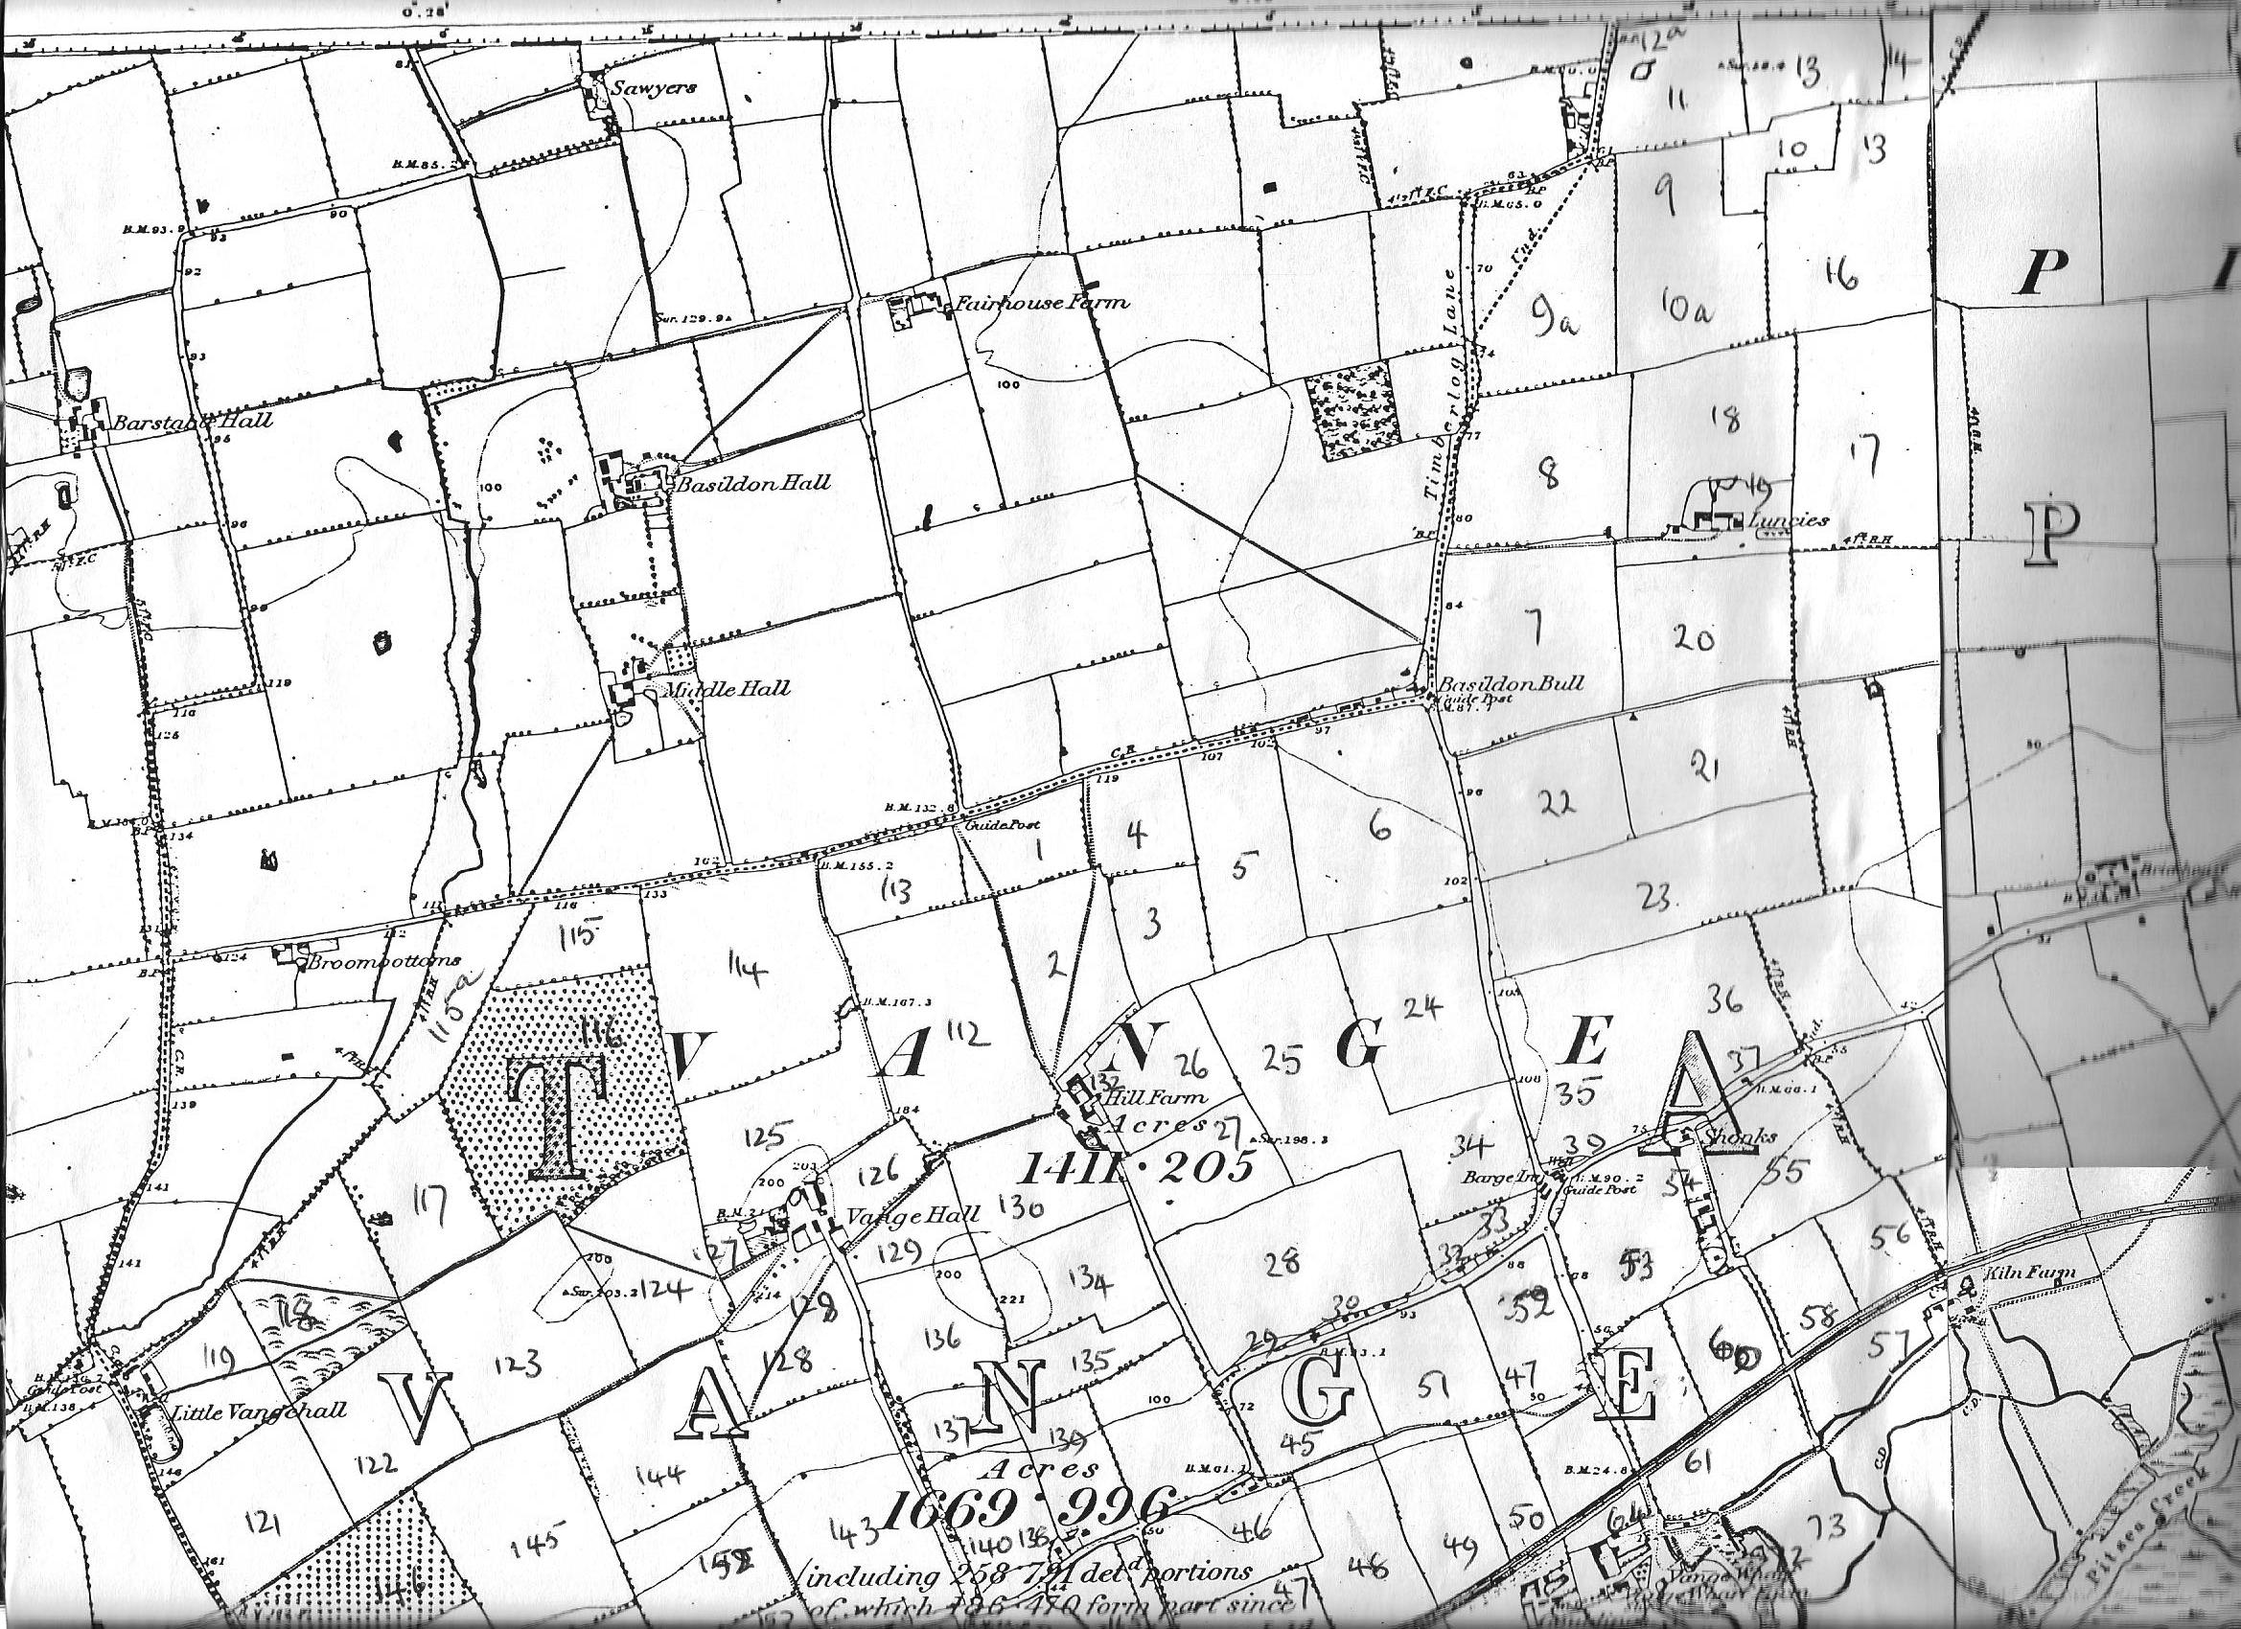
Map 1.
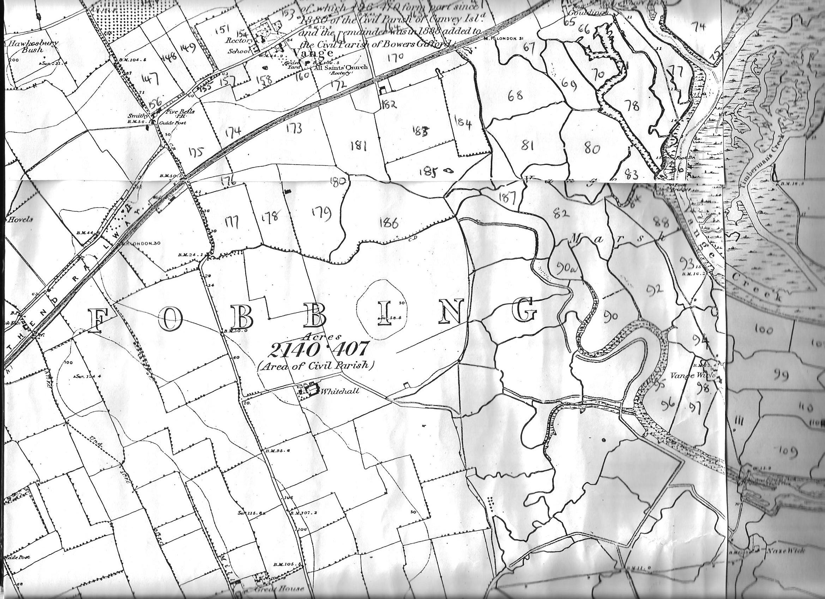
Map 2.
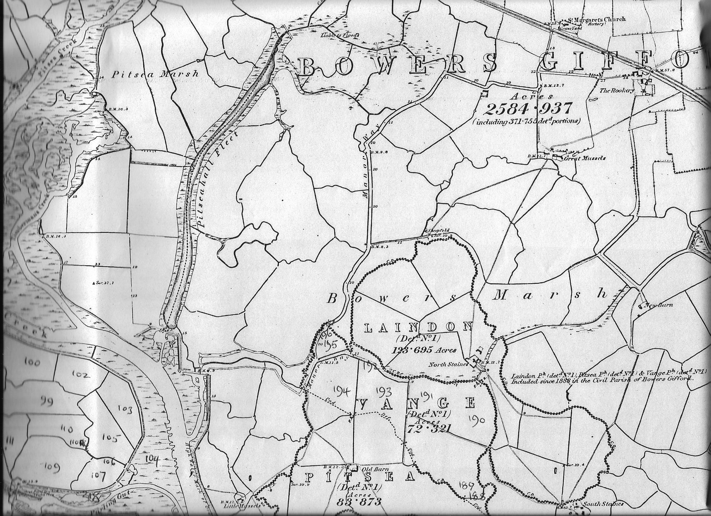
Map 3
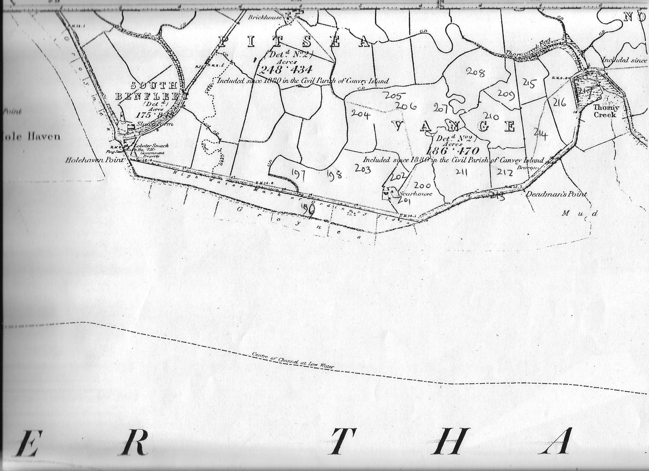
M E S
Map 4

