**THE PLACE-NAMES OF**

**WAKES COLNE**

**Recorder: James Kemble**

**Essex Place-names Project (Essex Society for Archaeology & History), 2014 (e-book).**

[**www.essex.ac.uk/history/esah/essexplacenames**](http://www.essex.ac.uk/history/esah/essexplacenames)

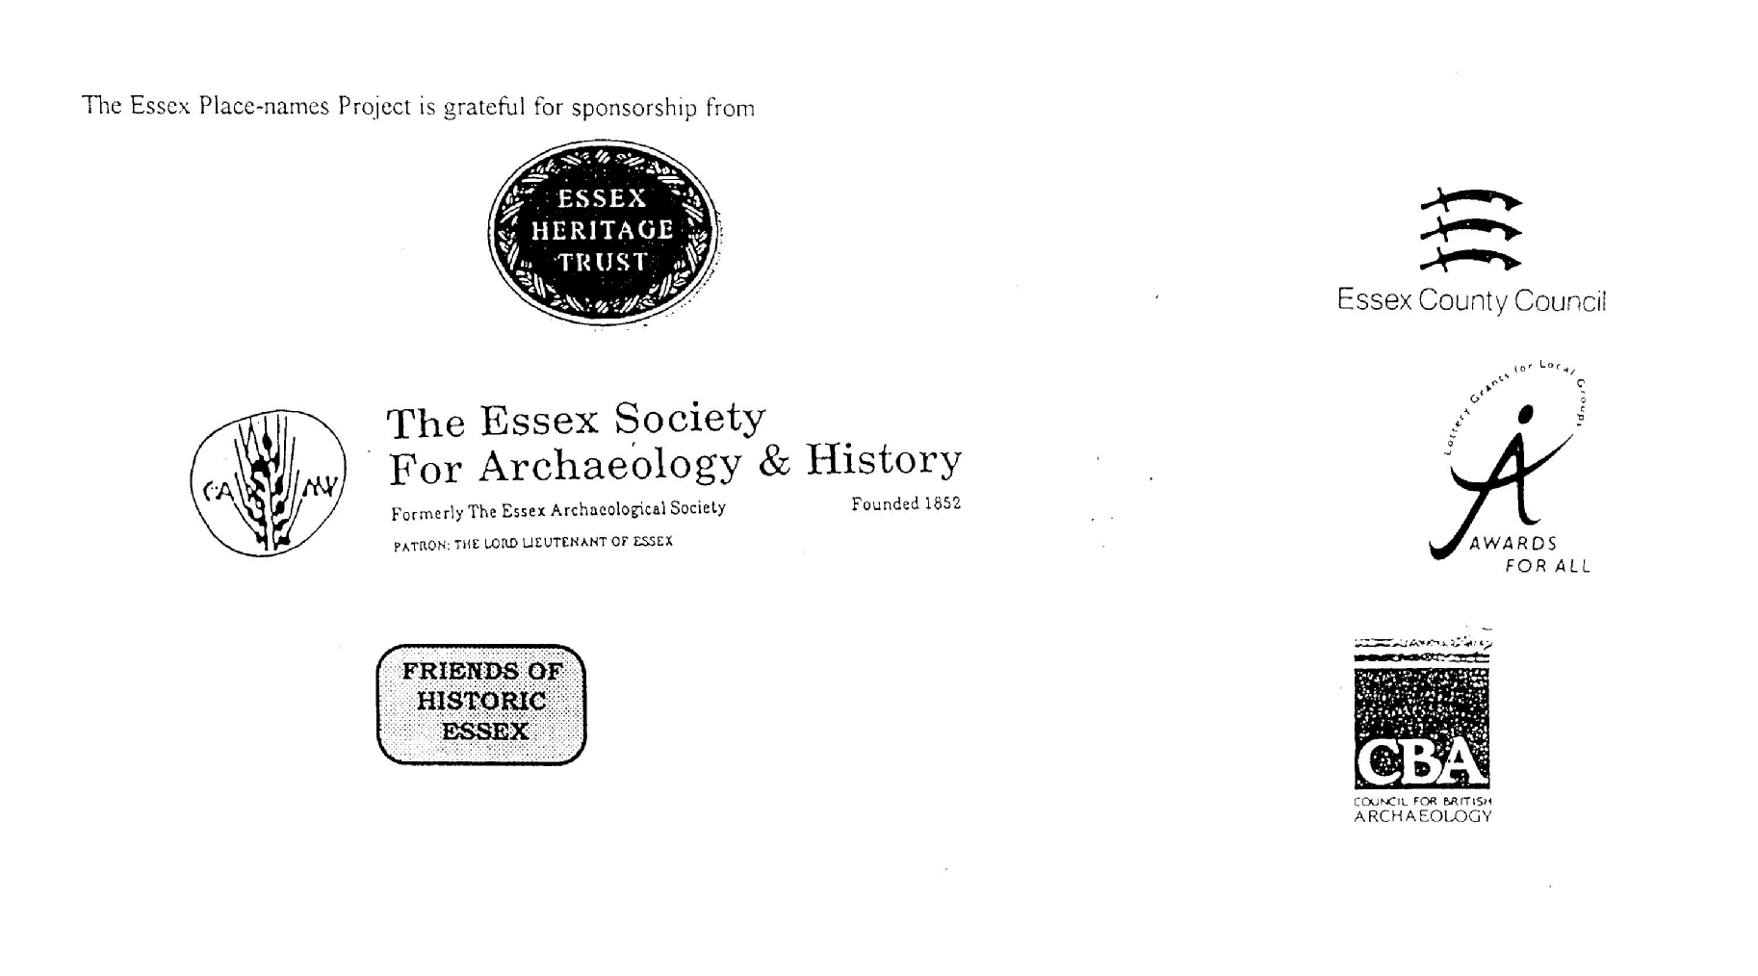

**ESSEX PLACE-NAMES PROJECT.**

The Essex Place-names Project is a County-wide survey to record place- and field-names from historical documents such as Tithe maps and apportionments, estate maps, sale

and auction catalogues, conveyances, terriers, deeds, rolls, inquisitions and surveys.

The second element of the Project is to investigate on-the-ground visible remains which correspond to the Place-names for actual or potential archaeological, agricultural and industrial

sites, and to record natural (topographical) and man-made features which may relate to the Place-name. This involves field-survey in rural and outside investigation in built-up areas.

It is anticipated that the Project will lead to identification of archaeological sites and lost historic buildings; it will enable analysis of indicators of early settlement, land holding, agricultural and industrial practices of the County. It will refine the more precise meaning of descriptive words and elements used by earlier settlers as they gave names appropriate to the topography of the landscape of their time.

For convenience the surveys are based on the parish, recognising that present civil parish boundaries are not necessarily identical to former ecclesiastical boundaries. Local Recorders

are supplied with templates of Record Forms to ensure consistency of recording across the County, and forward completed forms to a Central Coordinator for transfer to a county

computer database which is available to researchers on the internet at [www.essex.ac.uk/history/esah/essexplacenames](http://www.essex.ac.uk/history/esah/essexplacenames), and updated periodically.

This publication presents part of the information recorded from the Tithe or Estate Award and Map, and from other documents for this parish. The full record is contained on the master

database at Essex County Council (Historic Environment Section) and on the (above) website. Parish books are available to be downloaded from the website link ‘Books’ on the Home page. Please notify errors to the Project Coordinator at the Essex Record Office.

**THE TITHE MAP AND APPORTIONMENT.**

Since medieval times a tenth of the produce of land and stock had been paid by landholders to the church. At the Dissolution of the Monasteries, the property of many religious houses,

including the right to collect tithes, passed into lay hands. The Tithe Commutation Act which received Royal assent on 13th August 1836 abolished a rent payable in kind and

substituted rent-charges apportioned on each plot or parcel. The tithe-rent payable was assessed on the average value of wheat, barley and oats and was to fluctuate with price movements.

The commutation could be by voluntary agreement between the local owners and payers or, if agreement failed, could be compulsorily imposed by commissioners. A Valuer was to be

appointed to apportion the rent of each parcel of land and tenants could deduct that rent-charge from their rent paid to the landlord. The task fell to the Tithe Commissioners to produce a

map and an Apportionment (Award). A large-scale survey was produced for over 70% of England and Wales in the following 9 years, and about another 8% up to 1855. Most of the

parishes in Essex were surveyed. The map scales vary. The Award records ownership, tenancy and land-use, field by field and parcel by parcel (often quoting the field name) with the

ground area and rent-charge.

Land that was tithe-free tends to be less accurately mapped and contains few if any of the details recorded for those parcels subject to tithe. Rights of way and roads also tend to be

neglected. Boundaries of the tithe areas are shown as are some natural features such as streams, ponds, gardens, greens and commons. Buildings are often shown coloured red if dwellings

or grey if not. Because the Award may have been agreed only some time after the map was finished, discrepancies occur between the two. Enclosure Awards, when extant, usually date to the 18th and early 19th centuries. J.Kemble.

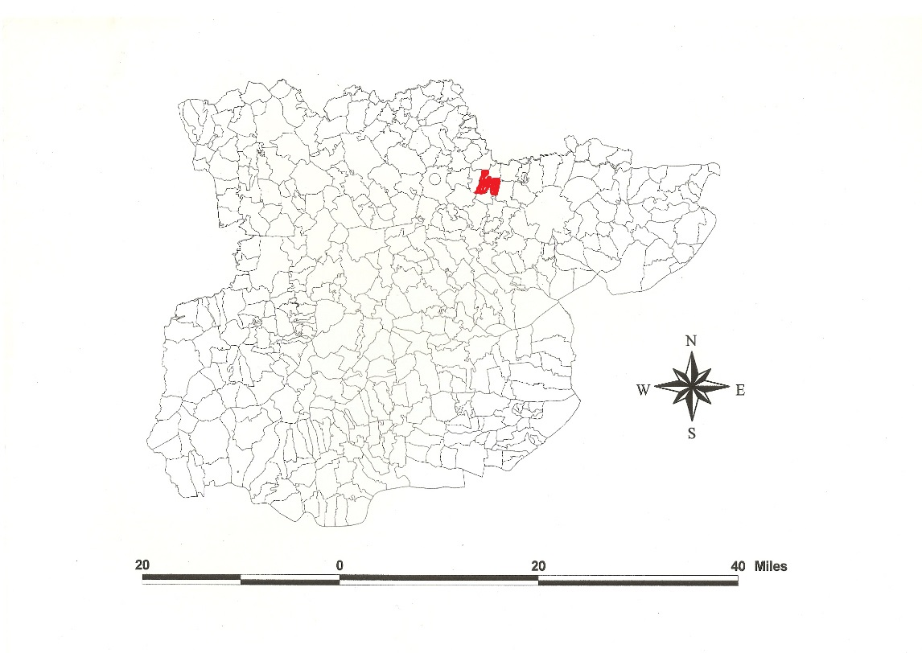

Reproduced by permission

of Essex County Council.

**Wakes Colne Parish in the County of Essex.**

**The Parish of Wakes Colne (in Lexden Hundred).**

The Tithe Award of Wakes Colne (Essex Record Office D/CT 103a), dated 1841, shows a rent-charge of £580 including £6 for glebe payable to Rev. Thomas Henderson. The whole parish measured 1908 acres 3 roods 9 perches, of which 1668a 14p were arable, 116a 3r 32p meadow and pasture, 52a wood and ozier ground, 53a 3r roads, 18a 2r 8p glebe. The Tithe Commissioners were William Blamire and R. Jones, The Valuer Edward Cook of Stratford St Mary.

The Tithe Map (ERO: D/CT 103b) was surveyed at a scale of 13.3” to a mile and measures 39”x33”. It was countersigned by Roger Kynaston, Assistant Tithe Commissioner.

In 946x951, Ælfgar, ealdorman of Essex, bequeathed *Colne* to his younger daughter, wife of ealdorman Brihtnoth who was killed at the Battle of Maldon in 991, and, after her death, to the religious community at Stoke [by Nayland] (Kemble, 2007). Following her father’s wishes Ælfflæd bequeathed *Colne* to Stoke in her Will, 1000x1002 (Whitelock, 1930). In Domesday Book, 1086, Robert Malet held *Colun* in lordship which Azorin had held as a manor with a mill for one hide and 30 acres. In 1227 Saher son of Richard Priest was granted 2½ acres in *Colum* *Malot*. Baldwin de Wake (died 1282) acquired the manor by marriage (Kemble, 2007). The Colnes take their name from the British name for the river Colne, meaning ‘water’. In *Crepinga* Alfward had held freely 60 acres and 4 acres and 4½ acres which Richard son of Count Gilbert held in 1086 (Morris, 1983). Reaney (1935) originates Crepping from a personal name + *ingas*, ‘settlement of the people of Cryppa’, associated with Old English *cryppan*, ‘to bend’.

There were two manors: 1. Wakes Hall was held by Walter Macerell *t.*Henry I, 1100-1135, and gave the tithes to Earls Colne Priory. 2. Crepping Hall, held by Alfward before 1066. Under Richard de Clare (died 47 Henry III, 1262/3) Hugh de Cressynge held two knights’ fees (Morant, 1768).

The church dedicated to St Mary has Norman windows in the north and south walls, the belfry C15. Crepping Hall has a C16 cross-wing, the hall once aisled, dendrodated 1301-37. Normandy Hall is an aisled hall-house, 1368. Old House Farm has C14 and C15 cross-wings. Wakes Colne Place is timber-framed, C17. Watch House dates from C16 with a cross-wing. Wakes Hall is a gault brick villa of 3 bays, c.1830. The water mill, now domestic, was built c.1840. Chappel & Wakes Colne Railway Station was opened in 1849, rebuilt in 1890-1 (Pevsner, 2007).

The Hundred name was *Lassendene, Laxendena, Lessendena* etc in Domesday Book. The Hundred Court was at Emperford alias Stanway Bridge (TL935241) by 1581, perhaps in the C14 in the northwest of the parish in land occupied by Mott (VCH, 1994). The Domesday Hundred of Colchester was probably taken out of the older Lexden Hundred (Round, 1903).

Place- and field-names from other documents are entered as ‘Alias’ against the Tithe names.

**References:**

Kemble, J., 2007. Essex Place-names, Places, Streets & People, Historical Publications. pp 88,143.

Morant, P., 1768. History & Antiquities of the County of Essex, ii, 221.

Morris, J., 1983. Domesday Book – Essex. Phillimore.

Pevsner, N., Bettley, J., 2007. The Buildings of England – Essex. Yale.

Reaney, P., 1935. The Place-names of Essex. Cambridge.

Round, H., 1903. Victoria Co. History. vol i, 406; 1907, ii, 353.

Victoria County History of Essex, 1994, vol ix, 391.

Whitelock, D., 1930. Anglo-Saxon Wills. Cambridge.

**The Tithe Award Place-names of Wakes Colne - by Parcel No.**

|  |  |  |  |  |  |  |  |  |  |  |  |  |
| --- | --- | --- | --- | --- | --- | --- | --- | --- | --- | --- | --- | --- |
| **Place name** | **alias** | **Fld No** | **Grd** | **x** | **y** | **Type** | **Acr** | **Rd** | **Pch** | **Owner** | **Occupier** | **Text** |
|  |  |  |  |  |  |  |  |  |  |  |  |  |
| Church Yard | [All Saints] | 1 | TL | 888 | 286 | bldg | 0 | 3 | 23 | Henderson, Rev Thomas | Simms, Rev George | glebe |
| Post Office, premises |  | 2 | TL | 888 | 286 | bldg | 0 | 1 | 11 | Josselyn, John | Brill, George |  |
| Cottage, gdn |  | 3 | TL |  |  | bldg | 0 | 0 | 35 | Josselyn, John | Patten; others |  |
| Cottage, gdn |  | 4 | TL |  |  | bldg | 0 | 0 | 5 | Poors Land, trustees | Bartholmew; others |  |
| Brook field |  | 5 | TL | 880 | 288 | field | 10 | 0 | 24 | Guyon, Mark | Guyon, Mark |  |
| Twelve acre Park | [at Joyburn Hill, 1875,OS] | 6 | TL |  |  | field | 14 | 1 | 16 | Skingley, Henry | Skingley, Henry |  |
| Park Meadow |  | 7 | TL |  |  | field | 2 | 3 | 33 | Skingley, Henry | Skingley, Henry |  |
| Hop Ground Meadow |  | 8 | TL |  |  | field | 3 | 3 | 19 | Skingley, Henry | Skingley, Henry |  |
| Lodge pasture | Old Wakes Hall, 1875,OS | 11 | TL | 884 | 288 | field | 0 | 1 | 15 | Skingley, Henry | Skingley, Henry | Baldwin de Wake, d 1282, Morant |
| Bridge meadow |  | 12 | TL |  |  | field | 2 | 1 | 14 | Skingley, Henry | Skingley, Henry |  |
| Long meadow |  | 13 | TL |  |  | field | 3 | 0 | 9 | Skingley, Henry | Skingley, Henry |  |
| Mill Bank |  | 14 | TL | 888 | 284 | field | 0 | 1 | 0 | Skingley, Henry | Skingley, Henry |  |
| Potash croft |  | 15 | TL |  |  | field | 2 | 1 | 17 | Skingley, Henry | Skingley, Henry |  |
| Five acre Park |  | 17 | TL |  |  | field | 5 | 1 | 34 | Skingley, Henry | Skingley, Henry |  |
| First Church field |  | 18 | TL |  |  | field | 11 | 1 | 27 | Skingley, Henry | Skingley, Henry |  |
| Mill field |  | 20 | TL | 890 | 285 | field | 4 | 0 | 27 | Skingley, Henry | Farrow, Christopher |  |
| Wakes Colne Place |  | 21 | TL | 891 | 285 |  | 0 | 1 | 20 | Brett, Mary | Brett, Mary |  |
| Pleasure Ground |  | 23 | TL |  |  |  | 1 | 2 | 13 | Brett, Mary | Brett, Mary |  |
| Orchard |  | 24 | TL |  |  | field | 0 | 3 | 7 | Brett, Mary | Brett, Mary |  |
| Wake Mill, premises | Wakesmyll, 1504,MnAt | 25 | TL | 890 | 284 | bldg | 0 | 2 | 33 | Skingley, Henry | Farrow, Christopher |  |
| Cross Path meadow |  | 29 | TL |  |  | field | 0 | 3 | 24 | Brett, Mary | Farrow, C. |  |
| Round meadow |  | 31 | TL |  |  | field | 1 | 0 | 11 | Brett, Mary | Brett, Mary |  |
| Long meadow | [at Chapel Bridge, 1875,OS] | 33 | TL | 894 | 284 | field | 0 | 1 | 15 | Brett, Mary | Brett, Mary |  |
| Bridge slip |  | 34 | TL |  |  | field | 1 | 2 | 22 | Hodgson, John | Worcester, William |  |
| Cottage, gdn | [at Chapel Corner, 1875,OS] | 35 | TL |  |  | bldg | 0 | 0 | 39 | Brett, Mary | Flower; others |  |
| Watch House, premises | Watch House, 1875,OS | 36 | TL | 894 | 285 | bldg | 0 | 1 | 27 | Brett, Mary | Brett, Mary |  |
| Barn field |  | 38 | TL |  |  | field | 1 | 2 | 19 | Brett, Mary | Brett, Mary |  |
| Kiln field |  | 39 | TL | 894 | 286 | field | 2 | 2 | 21 | Brett, Mary | Brett, Mary |  |
| Orchard field |  | 40 | TL |  |  | field | 3 | 3 | 1 | Brett, Mary | Brett, Mary |  |
| First Fen | cf. fenfeld, 1390,Rntl | 41 | TL |  |  | field | 1 | 1 | 16 | Brett, Mary | Brett, Mary |  |
| Further Fen |  | 42 | TL |  |  | field | 2 | 1 | 28 | Brett, Mary | Brett, Mary |  |
| Further Knights |  | 43 | TL | 892 | 286 | field | 9 | 0 | 13 | Skingley, Henry | Skingley, Henry |  |
| First Knights |  | 44 | TL |  |  | field | 9 | 2 | 18 | Skingley, Henry | Skingley, Henry |  |
| Long Bridge |  | 45 | TL | 890 | 287 | field | 7 | 0 | 3 | Skingley, Henry | Skingley, Henry |  |
| Cow Leaves |  | 46 | TL |  |  | field | 12 | 2 | 6 | Skingley, Henry | Skingley, Henry |  |
| Parsonage | Rectory, 1875,OS | 47 | TL | 886 | 286 | bldg | 1 | 3 | 16 | Henderson, Rev Thomas | Simms, Rev George | glebe |
| Little Perry field | Crow's Hall, 1875,OS | 48 | TL | 887 | 290 | field | 10 | 0 | 3 | Skingley, Henry | Skingley, Henry | John Crowe, 1341,FF |
| Clay Pit |  | 49 | TL |  |  | field | 0 | 1 | 18 | Skingley, Henry | Skingley, Henry |  |
| Right Replay |  | 50 | TL | 891 | 290 | field | 10 | 0 | 16 | Skingley, Henry | Skingley, Henry |  |
| Bended Ley |  | 51 | TL |  |  | field | 9 | 3 | 7 | Skingley, Henry | Skingley, Henry |  |
| Cookes Perry field |  | 52 | TL |  |  | field | 15 | 3 | 12 | Skingley, Henry | Skingley, Henry |  |
| Filly Gate field |  | 53 | TL |  |  | field | 7 | 1 | 24 | Brett, Rev John | Harvey, Thomas |  |
| Acorn Wood |  | 54 | TL |  |  | wood | 16 | 3 | 22 | Skingley, Henry | Skingley, Henry |  |
| Great Perry field | Peryfelde, 1504,MnAt | 55 | TL | 890 | 293 | field | 19 | 1 | 27 | Skingley, Henry | Skingley, Henry |  |
| Clay Pit |  | 56 | TL |  |  | field | 0 | 2 | 16 | Skingley, Henry | Skingley, Henry |  |
| Segars |  | 57 | TL | 895 | 294 | field | 13 | 0 | 34 | Brett, Rev John | Pettitt, Zachary |  |
| Cottage, gdn |  | 57a | TL |  |  | bldg | 0 | 1 | 1 | Brett, Rev John | Pettitt, Zachary |  |
| Little Segars |  | 58 | TL |  |  | field | 7 | 0 | 39 | Lay, Robert | Lay, Robert | cut by railway, 1875,OS |
| Great Segars |  | 59 | TL |  |  | field | 8 | 2 | 22 | Lay, Robert | Lay, Robert |  |
| Sear Croft |  | 60 | TL | 890 | 294 | field | 6 | 3 | 14 | Lay, Robert | Lay, Robert |  |
| Bone croft |  | 61 | TL |  |  | field | 2 | 3 | 2 | Lay, Robert | Lay, Robert |  |
| Farm Yard etc | Lane Farm, 1875,OS | 62 | TL | 890 | 296 | bldg | 0 | 2 | 7 | Lay, Robert | Lay, Robert |  |
| Orchard |  | 63 | TL |  |  | field | 0 | 1 | 17 | Lay, Robert | Lay, Robert |  |
| Nut Croft |  | 64 | TL |  |  | field | 5 | 0 | 18 | Lay, Robert | Lay, Robert |  |
| Broad field |  | 65 | TL |  |  | field | 5 | 2 | 4 | Lay, Robert | Lay, Robert |  |
| Rainbow |  | 67 | TL | 894 | 297 | field | 9 | 0 | 1 | Wilkins, James | Wilkins, James |  |
| Long Broad field |  | 68 | TL |  |  | field | 13 | 3 | 10 | Brett, Rev John | Pettitt, Zachary |  |
| Dooley field |  | 69 | TL | 894 | 300 | field | 9 | 0 | 18 | Brett, Rev John | Pettitt, Zachary |  |
| Round Orchard |  | 70 | TL |  |  | field | 0 | 0 | 27 | Brett, Rev John | Pettitt, Zachary |  |
| Leveretts field |  | 72 | TL |  |  | field | 5 | 1 | 16 | Potter, Ely | Potter, Ely | William Leverich, 1327,SubRoll |
| Cottage, gdn |  | 73 | TL |  |  | bldg | 0 | 0 | 11 | Ringer, Mrs Sarah | Ashley, John |  |
| Cottage, gdn |  | 74 | TL |  |  | bldg | 0 | 0 | 11 | Potter, Mary | Potter, Mary |  |
| House, Mill, Yards etc |  | 75 | TL | 891 | 300 | bldg | 0 | 1 | 19 | Childs, William | Lee, Charles |  |
| Mill field |  | 76 | TL |  |  | field | 3 | 0 | 19 | Wilkins, James | Wilkins, James |  |
| Home field |  | 78 | TL |  |  | field | 2 | 0 | 24 | Wilkins, James | Wilkins, James |  |
| House field |  | 79 | TL |  |  | field | 0 | 2 | 36 | Wilkins, James | Wilkins, James |  |
| House, gdn | Jordan's Farm, 1875,OS | 81 | TL | 894 | 301 | bldg | 0 | 1 | 28 | Payne, Elizabeth | Payne, Elizabeth | John Jurdon, 1341,FF |
| House, gdn |  | 82 | TL |  |  | bldg | 0 | 1 | 0 | Bugg, Mary | Bugg, Mary |  |
| Farther meadow |  | 84 | TL |  |  | field | 0 | 1 | 22 | Brett, Mary | Bugg, Mary |  |
| Bungay |  | 85 | TL | 895 | 295 | field | 2 | 1 | 32 | Brett, Mary | Brett, Mary |  |
| Lower Broad field |  | 86 | TL |  |  | field | 10 | 1 | 18 | Brett, Rev John | Harvey, Thomas |  |
| Upper Broad field |  | 87 | TL |  |  | field | 4 | 3 | 36 | Brett, Rev John | Harvey, Thomas | Railway station, 1875,OS |
| Glebe Land |  | 88 | TL |  |  | field | 6 | 3 | 31 | Henderson, Rev Thomas | Patten, Anthony | glebe |
| West field |  | 89 | TL |  |  | field | 4 | 0 | 36 | Brett, Rev John | Harvey, Thomas |  |
| Butchers field |  | 90 | TL | 900 | 290 | field | 3 | 0 | 33 | Brett, Rev John | Harvey, Thomas |  |
| Spring field |  | 91 | TL |  |  | field | 8 | 1 | 2 | Henderson, Rev Thomas | Patten, Anthony | glebe |
| Stable field |  | 92 | TL |  |  | field | 7 | 1 | 11 | Brett, Rev John | Harvey, Thomas |  |
| Homestead | Old House, 1777,C | 93 | TL | 896 | 291 | bldg | 2 | 3 | 7 | Brett, Rev John | Harvey, Thomas |  |
| Thorn field |  | 94 | TL |  |  | field | 7 | 0 | 4 | Brett, Rev John | Harvey, Thomas |  |
| Cobbs field |  | 95 | TL |  |  | field | 5 | 2 | 31 | Brett, Rev John | Pettitt, Zachary |  |
| Cobbs grove | cf. Cobbesleegh, 1399,MnAt | 96 | TL | 901 | 294 | wood | 1 | 0 | 8 | Brett, Rev John | Pettitt, Zachary |  |
| Thorn field |  | 97 | TL |  |  | field | 4 | 0 | 12 | Brett, Rev John | Pettitt, Zachary |  |
| Sibleys |  | 98 | TL |  |  | field | 11 | 2 | 36 | Brett, Rev John | Pettitt, Zachary |  |
| Brittians |  | 99 | TL | 900 | 296 | field | 16 | 3 | 31 | Brett, Rev John | Pettitt, Zachary |  |
| Ozier Ground |  | 100 | TL |  |  |  | 1 | 1 | 24 | Brett, Rev John | Pettitt, Zachary |  |
| Gate field |  | 101 | TL |  |  | field | 11 | 1 | 23 | Brett, Rev John | Pettitt, Zachary |  |
| Ozier Ground |  | 102 | TL |  |  |  | 0 | 1 | 10 | Brett, Rev John | Pettitt, Zachary |  |
| Garden field |  | 103 | TL |  |  | field | 13 | 1 | 34 | Brett, Rev John | Pettitt, Zachary |  |
| Fishers field |  | 104 | TL |  |  | field | 3 | 2 | 29 | Brett, Rev John | Pettitt, Zachary |  |
| Homestead | Fishers, 1777,C | 105 | TL | 897 | 300 | bldg | 1 | 2 | 39 | Brett, Rev John | Pettitt, Zachary | William le Fysscere, 1310,FF |
| Barn, yards etc | Boarded Barn, 1875,OS | 106 | TL | 903 | 294 | bldg | 0 | 0 | 33 | Fisher, William | Smith, John |  |
| Cottage, gdn |  | 107 | TL |  |  | bldg | 0 | 2 | 33 | Fisher, William | Brand, James |  |
| Boarded Barn field |  | 108 | TL |  |  | field | 11 | 0 | 6 | Fisher, William | Smith, James |  |
| Roundy Wood (pt) |  | 109 | TL |  |  | wood | 7 | 2 | 18 | Tuffnell, John Jolliffe | Hodgson, John |  |
| Roundy Wood (pt) |  | 110 | TL | 906 | 295 | wood | 0 | 1 | 36 | Tuffnell, John Jolliffe | Worcester, William |  |
| East Five acres |  | 112 | TL |  |  | field | 7 | 3 | 12 | Fisher, William | Smith, John |  |
| Castle Hill |  | 113 | TL | 905 | 290 | field | 11 | 0 | 2 | Hodgson, John | Worcester, William |  |
| Castle Bottom |  | 114 | TL |  |  | field | 2 | 2 | 28 | Hodgson, John | Worcester, William |  |
| Bottoms |  | 115 | TL |  |  | field | 1 | 1 | 3 | Hodgson, John | Worcester, William |  |
| Aldercar |  | 116 | TL | 905 | 289 | wood | 3 | 1 | 14 | Hodgson, John | Worcester, William |  |
| Foxhole Grove |  | 117 | TL |  |  | wood | 3 | 0 | 17 | Hodgson, John | Hodgson, John |  |
| Bottoms |  | 118 | TL |  |  | field | 3 | 2 | 6 | Hodgson, John | Worcester, William |  |
| Timberlands (pt) |  | 119 | TL |  |  | field | 8 | 0 | 2 | Hodgson, John | Worcester, William |  |
| Bottoms |  | 120 | TL | 904 | 285 | field | 2 | 0 | 37 | Hodgson, John | Worcester, William |  |
| Great Timberlands (pt) |  | 121 | TL |  |  | field | 7 | 3 | 26 | Hodgson, John | Worcester, William |  |
| Timber Bottoms |  | 122 | TL |  |  | field | 1 | 2 | 24 | Hodgson, John | Worcester, William |  |
| Downs |  | 123 | TL |  |  | field | 1 | 3 | 39 | Hodgson, John | Worcester, William |  |
| White Gate field |  | 126 | TL | 911 | 276 | field | 2 | 3 | 15 | Claryvince, Rev John | Harvey, James | detached |
| Hay field (pt) |  | 127 | TL |  |  | field | 3 | 2 | 30 | Claryvince, Rev John | Harvey, James |  |
| Upper Thusdams |  | 128 | TL |  |  | field | 6 | 2 | 1 | Claryvince, Rev John | Harvey, James |  |
| Lower Thusdams |  | 129 | TL | 914 | 273 | field | 3 | 3 | 27 | Claryvince, Rev John | Harvey, James |  |
| Brook meadow |  | 130 | TL |  |  | field | 5 | 3 | 7 | Claryvince, Rev John | Harvey, James |  |
| Rabbit Skins |  | 132 | TL |  |  | field | 2 | 2 | 9 | Dean, William | Worcester, William |  |
| Vallants (pt) |  | 135 | TL | 919 | 273 | field | 2 | 0 | 35 | Dean, William | Worcester, William |  |
| First Acre Piece |  | 136 | TL |  |  | field | 1 | 1 | 1 | Dean, William | Worcester, William |  |
| Cottage, gdn |  | 139 | TL |  |  | bldg | 0 | 0 | 29 | Hailstone, Rev John | Ladbrook, John |  |
| House, shop, gdn | Smithy, 1875,OS | 140 | TL | 913 | 275 | bldg | 0 | 2 | 11 | Hailstone, Rev John | Pool, Robert |  |
| How field | cf. le hoo crofte, tEliz I,Srvy | 141 | TL |  |  | field | 6 | 1 | 39 | Hailstone, Rev John | Patten, Anthony |  |
| Hall Tree field (pt) |  | 142 | TL |  |  | field | 0 | 1 | 3 | Hailstone, Rev John | Patten, Anthony |  |
| Bakers field (pt) |  | 144 | TL |  |  | field | 2 | 2 | 22 | Hailstone, Rev John | Patten, Anthony |  |
| Cottage, gdn | Blue Ho., 1875,OS | 145 | TL | 918 | 274 | bldg | 0 | 1 | 28 | Dean, William | Worcester, William |  |
| Swampy |  | 146 | TL |  |  | field | 6 | 2 | 18 | Dean, William | Worcester, William |  |
| Pound field |  | 147 | TL |  |  | field | 7 | 2 | 18 | Great Tey, feoffees of | Worcester, William |  |
| Cottage, gdn | Pound House, 1875,OS | 148 | TL | 918 | 279 | field | 0 | 1 | 7 | Great Tey, feoffees of | Worcester, William |  |
| The Rook Yards |  | 149 | TL |  |  | field | 11 | 1 | 27 | Hodgson, John | Worcester, William |  |
| The Downs |  | 150 | TL |  |  | field | 12 | 1 | 13 | Hodgson, John | Worcester, William |  |
| Homestall | Crepinga, 1086,DB; Crepping Hall, 1875,OS | 151 | TL | 917 | 282 | bldg | 3 | 2 | 23 | Hodgson, John | Worcester, William |  |
| Kitchen field |  | 152 | TL |  |  | field | 10 | 1 | 18 | Hodgson, John | Worcester, William |  |
| Clay Pits |  | 153 | TL |  |  | field | 8 | 0 | 20 | Hodgson, John | Worcester, William |  |
| Spring |  | 154 | TL |  |  |  | 0 | 3 | 5 | Hodgson, John | Worcester, William |  |
| Wheat Clay Pits |  | 155 | TL | 905 | 285 | field | 8 | 1 | 25 | Hodgson, John | Worcester, William |  |
| Roydon |  | 156 | TL |  |  | field | 17 | 0 | 16 | Hodgson, John | Worcester, William |  |
| Wheat Roydon |  | 157 | TL |  |  | field | 8 | 1 | 15 | Hodgson, John | Worcester, William |  |
| Great Field |  | 158 | TL |  |  | field | 13 | 0 | 14 | Hodgson, John | Worcester, William |  |
| The Grove |  | 159 | TL |  |  |  | 0 | 2 | 28 | Haynes, David | Leatherdale, Thomas |  |
| White field |  | 160 | TL | 920 | 285 | field | 6 | 2 | 33 | Haynes, David | Leatherdale, Thomas |  |
| Little field |  | 161 | TL |  |  | field | 8 | 3 | 1 | Hodgson, John | Worcester, William |  |
| Cottage, gdn |  | 164 | TL |  |  | bldg | 0 | 1 | 6 | Haynes, David | Leatherdale, Thomas |  |
| Horse pasture |  | 165 | TL |  |  | field | 10 | 2 | 27 | Hodgson, John | Worcester, William |  |
| *Deadmans Lay* |  | 166 | TL | 908 | 293 | field | 9 | 2 | 32 | Hawkins, William | Smith, John |  |
| Little Bug |  | 168 | TL |  |  | field | 2 | 3 | 0 | Hawkins, William | Smith, John |  |
| Freehold |  | 169 | TL |  |  | field | 4 | 0 | 36 | Hawkins, William | Smith, John |  |
| Farmyards etc | Oak Farm, 1875,OS | 170 | TL | 920 | 276 | bldg | 0 | 2 | 8 | Dean, William | Worcester, William |  |
| Little pasture |  | 171 | TL |  |  | field | 1 | 0 | 31 | Dean, William | Worcester, William |  |
| Long field (pt) |  | 172 | TL |  |  | field | 2 | 3 | 24 | Dean, William | Worcester, William |  |
| Oak field (pt) |  | 173 | TL |  |  | field | 5 | 1 | 3 | Dean, William | Worcester, William |  |
| Crosspath field |  | 174 | TL |  |  | field | 2 | 2 | 38 | Dean, William | Worcester, William |  |
| Pierse field |  | 176 | TL | 920 | 280 | field | 19 | 2 | 12 | Hodgson, John | Worcester, William |  |
| Bretts Grove |  | 178 | TL |  |  | wood | 1 | 2 | 12 | Hailstone, Rev John | Patten, Anthony |  |
| Grove field |  | 179 | TL |  |  | field | 4 | 1 | 28 | Hailstone, Rev John | Patten, Anthony |  |
| King field |  | 182 | TL |  |  | field | 7 | 2 | 38 | Hodgson, John | Worcester, William |  |
| House, yards | Bretts, 1777,C; Brettsgreen Farm, 1875,OS | 183 | TL | 922 | 285 | bldg | 1 | 0 | 3 | Haynes, David | Leatherdale, Thomas | William Bret, 1515,Srvy |
| Bretts pasture |  | 185 | TL |  |  | field | 5 | 3 | 37 | Haynes, David | Leatherdale, Thomas |  |
| Old Croals |  | 187 | TL | 922 | 293 | field | 3 | 0 | 26 | Hawkins, William | Smith, John |  |
| Long Mowns |  | 188 | TL |  |  | field | 2 | 0 | 14 | Hawkins, William | Smith, John |  |
| Cats Tail (pt) |  | 189 | TL |  |  | field | 1 | 0 | 23 | Hodgson, John | Worcester, William |  |
| Coal Hearth |  | 190 | TL | 924 | 291 | field | 13 | 2 | 4 | Hodgson, John | Worcester, William |  |
| Square Grove |  | 191 | TL |  |  |  | 6 | 1 | 23 | Hodgson, John | Worcester, William |  |
| Great Wood field (pt) |  | 192 | TL |  |  | field | 9 | 2 | 26 | Hodgson, John | Worcester, William |  |
| Blackmall (pt) |  | 193 | TL |  |  | field | 5 | 1 | 12 | Hodgson, John | Worcester, William |  |
| Cottage, gdn |  | 194 | TL |  |  | bldg | 0 | 2 | 26 | Brett, Rev John | Smith, John |  |
| Gig field |  | 195 | TL | 925 | 298 | field | 7 | 2 | 5 | Brett, Rev John | Smith, John |  |
| Moon field |  | 196 | TL |  |  | field | 2 | 1 | 0 | Brett, Rev John | Smith, John |  |
| Barn, yards etc |  | 197 | TL |  |  | bldg | 0 | 0 | 29 | Brett, Rev John | Smith, John |  |
| Great Blackmall (pt) |  | 198 | TL |  |  | field | 0 | 2 | 28 | Hodgson, John | Worcester, William |  |
| Turnip Coole |  | 199 | TL | 922 | 298 | field | 1 | 0 | 32 | Hawkins, William | Smith, John |  |
| Smiths Grove |  | 200 | TL |  |  |  | 1 | 2 | 39 | Hodgson, John | Hodgson, John |  |
| Farm yard, House etc | Goodwins, 1777,C | 203 | TL | 922 | 296 | bldg | 0 | 2 | 14 | Hawkins, William | Smith, John |  |
| Goodwins |  | 204 | TL |  |  | field | 4 | 1 | 35 | Hawkins, William | Smith, John |  |
| Stable field |  | 207 | TL |  |  | field | 14 | 0 | 13 | Hawkins, William | Smith, John |  |
| Little Wood field |  | 208 | TL | 922 | 301 | field | 6 | 3 | 14 | Walton, Rev Jonathan, DD | Josselyn, Hugh |  |
| Great Cadleys |  | 209 | TL |  |  | field | 18 | 2 | 34 | Hawkins, William | Smith, John |  |
| Second Pond Field |  | 210 | TL |  |  | field | 6 | 1 | 10 | Gree, Wm Egerton | Salmon, Philip |  |
| Top Pond field |  | 211 | TL |  |  | field | 5 | 0 | 39 | Gree, Wm Egerton | Salmon, Philip |  |
| Slough field |  | 212 | TL | 907 | 297 | field | 2 | 2 | 34 | Brett, Edward | Pettitt, Zachariah |  |
| First Pond field |  | 213 | TL |  |  | field | 3 | 0 | 0 | Gree, Wm Egerton | Salmon, Philip |  |
| Wood field |  | 214 | TL | 920 | 300 | field | 10 | 2 | 4 | Brett, Edward | Pettitt, Zachariah |  |
| Barn field |  | 215 | TL |  |  | field | 2 | 2 | 37 | Brett, Edward | Pettitt, Zachariah |  |
| Middle field |  | 216 | TL |  |  | field | 1 | 2 | 4 | Brett, Edward | Pettitt, Zachariah |  |
| Smiths Grove |  | 218 | TL |  |  | wood | 2 | 1 | 32 | Hawkins, William | Smith, John |  |
| Moat field |  | 219 | TL | 902 | 300 | field | 6 | 2 | 0 | Brett, Rev John | Pettitt, Zachary |  |
| Allcocks meadow |  | 220 | TL |  |  | field | 2 | 1 | 22 | Brett, Rev John | Pettitt, Zachary | cut by railway, 1875,OS |
| Barn field |  | 221 | TL |  |  | field | 10 | 3 | 14 | Brett, Rev John | Pettitt, Zachary |  |
| Cottage, gdn |  | 222 | TL |  |  | bldg | 0 | 0 | 35 | Brett, Rev John | Hum, George |  |
| Cottage pasture |  | 223 | TL |  |  | field | 1 | 0 | 12 | Brett, Rev John | Pettitt, Zachary |  |
| Stable field |  | 224 | TL |  |  | field | 2 | 1 | 8 | Patrick, John | Newman, John |  |
| House, yards | Jupeshill Farm, 1875,OS | 225 | TL | 898 | 302 | bldg | 0 | 3 | 13 | Patrick, John | Newman, John |  |
| Allcocks Green |  | 226 | TL |  |  | field | 2 | 2 | 9 | Manor, Lord of the | Common occupiers | John Alcock, 1563,SubRoll |
| Green field |  | 227 | TL |  |  | field | 5 | 3 | 19 | Patrick, John | Newman, John |  |
| Cobbs Lay |  | 228 | TL |  |  | field | 11 | 0 | 20 | Brett, Rev John | Pettitt, Zachary |  |
| Stone field | le Stonecroft, (Mikel) Stancrofte(feld), tEliz,Srvy | 229 | TL | 903 | 304 | field | 6 | 0 | 0 | Brett, Rev John | Pettitt, Zachary |  |
| New field |  | 231 | TL |  |  | field | 2 | 3 | 0 | Patrick, John | Newman, John |  |
| Long field |  | 233 | TL |  |  | field | 5 | 3 | 31 | Patrick, John | Newman, John |  |
| Wood field |  | 234 | TL |  |  | field | 3 | 2 | 38 | Patrick, John | Newman, John |  |
| Mothas Wood |  | 235 | TL |  |  | field | 6 | 1 | 35 | Patrick, John | Newman, John |  |
| Beck Homestead | Beak Farm, 1875,OS | 236 | TL | 903 | 309 | bldg | 0 | 1 | 20 | Walton, Rev Jonathan, DD | Harvey, Thomas jnr | John Beek, 1371,Fine |
| Fletchers Croft |  | 238 | TL |  |  | field | 3 | 2 | 27 | Walton, Rev Jonathan, DD | Harvey, Thomas jnr |  |
| Great Pightle |  | 241 | TL |  |  | field | 2 | 0 | 32 | Patrick, John | Newman, John |  |
| Winter's |  | 242 | TL | 896 | 302 | field | 6 | 3 | 20 | Brett, Rev John | Pettitt, Zachary |  |
| Cottage, gdn |  | 243 | TL |  |  | bldg | 0 | 0 | 28 | Brett, Rev John | Everitt, William |  |
| Cottage, gdn |  | 244 | TL |  |  | bldg | 0 | 2 | 37 | Brett, Rev John | Frost; others |  |
| Pond field |  | 245 | TL | 893 | 303 | field | 3 | 3 | 21 | Lawson, Robert | Harvey, Thomas |  |
| Cottage, gdn |  | 246 | TL |  |  | bldg | 0 | 1 | 13 | Lawson, Robert | Patten & French |  |
| Jacksons field | [at Wakes Colne Green, 1875,OS] | 247 | TL | 892 | 303 | field | 11 | 2 | 7 | Lawson, Robert | Harvey, Thomas |  |
| Cottage, gdn |  | 248 | TL |  |  | bldg | 0 | 0 | 24 | Sadd, Samuel | Patten & Pitchford |  |
| Cottage, gdn |  | 249 | TL |  |  | bldg | 0 | 0 | 27 | Patten, Mary | Patten, Mary; others |  |
| House, gdn | Slate Hall, 1875,OS | 250 | TL | 891 | 304 | bldg | 0 | 1 | 35 | Josselyn, John, execs | Lee, Charles |  |
| Barn field |  | 252 | TL |  |  | field | 3 | 3 | 17 | Josselyn, John, execs | Lee, Charles |  |
| Great Crooks field |  | 254 | TL |  |  | field | 9 | 1 | 35 | Lawson, Robert | Harvey, Thomas |  |
| Longlea |  | 255 | TL | 894 | 305 | field | 6 | 2 | 7 | Lawson, Robert | Harvey, Thomas |  |
| Winter's Upper field |  | 256 | TL |  |  | field | 6 | 3 | 17 | Brett, Rev John | Pettitt, Zachary |  |
| Mainhoods field |  | 257 | TL |  |  | field | 7 | 0 | 35 | Walton, Rev Jonathan, DD | Harvey, Thomas jnr |  |
| Little Downards |  | 258 | TL |  |  | field | 2 | 3 | 20 | Lawson, Robert | Harvey, Thomas |  |
| Great Nevills |  | 259 | TL | 896 | 306 | field | 4 | 2 | 5 | Davis, James | Bones, Thomas |  |
| Little Nevills |  | 260 | TL |  |  | field | 2 | 3 | 10 | Davis, James | Bones, Thomas |  |
| Little Bucks |  | 261 | TL |  |  | field | 3 | 0 | 29 | Wayland, Wm; Round, Edward | Wilkin, James |  |
| Stoneheads Barn |  | 262 | TL |  |  | field | 6 | 3 | 35 | Patrick, John | Newman, John | Richard Stonhard, 1341,FF |
| Wigley |  | 263 | TL | 898 | 305 | field | 6 | 2 | 6 | Wayland, Wm; Round, Edward | Wilkin, James | ?O.E. weoh =heathen temple |
| Dooley field |  | 264 | TL |  |  | field | 6 | 2 | 5 | Wayland, Wm; Round, Edward | Wilkin, James |  |
| Little Pightle |  | 265 | TL |  |  | field | 0 | 3 | 17 | Patrick, John | Newman, John |  |
| Dooley field |  | 266 | TL |  |  | field | 5 | 3 | 22 | Patrick, John | Newman, John |  |
| Wigley |  | 267 | TL | 894 | 307 | field | 7 | 1 | 8 | Brett, Rev John | Pettitt, Zachary | ?O.E. weoh =heathen temple |
| Birdsland |  | 268 | TL |  |  | field | 5 | 3 | 10 | Wayland, Wm; Round, Edward | Wilkin, James |  |
| Mutton field |  | 269 | TL | 899 | 306 | field | 6 | 2 | 6 | Patrick, John | Newman, John |  |
| Cottage, gdn |  | 270 | TL |  |  | bldg | 0 | 2 | 13 | Davis, James | Patten; others |  |
| House, gdn |  | 271 | TL |  |  | bldg | 0 | 3 | 12 | Wayland, Wm; Round, Edward | Wilkin, James |  |
| Cottage, gdn | Old Workhouse, 1875,OS | 272 | TL | 894 | 308 | bldg | 0 | 1 | 23 | Crabb, James | Bones; others |  |
| Croft |  | 273 | TL |  |  | field | 3 | 3 | 5 | Wayland, Wm; Round, Edward | Wilkin, James |  |
| Green field |  | 274 | TL |  |  | field | 5 | 2 | 22 | Lawson, Robert | Harvey, Thomas |  |
| Smythers |  | 275 | TL | 896 | 310 | field | 8 | 0 | 0 | Wayland, Wm; Round, Edward | Wilkin, James |  |
| Hobbys |  | 276 | TL |  |  | field | 6 | 2 | 8 | Poors Land, trustees | Harvey, Thomas |  |
| Goldfinches field | [at Inworth's Lane, 1875,OS] | 277 | TL | 898 | 310 | field | 6 | 2 | 5 | Blacklock, William | Farrow, William |  |
| Inworths field |  | 278 | TL |  |  | field | 8 | 2 | 21 | Garrod & Stuart | Newman, Thomas |  |
| Longrove |  | 279 | TL |  |  | field | 7 | 2 | 10 | Walton, Rev Jonathan, DD | Harvey, Thomas jnr |  |
| Potters field |  | 280 | TL | 902 | 310 | field | 3 | 3 | 17 | Garrod & Stuart | Newman, Thomas |  |
| Wood field |  | 281 | TL |  |  | field | 6 | 0 | 17 | Lawson, Robert | Harvey, Thomas |  |
| Cottage, gdn |  | 282 | TL |  |  | bldg | 0 | 0 | 16 | Garrod & Stuart | Newman, Thomas |  |
| Great Loveney Hall, premises | Louenayhalle, 1390,Rntl | 284 | TL | 897 | 314 | bldg | 1 | 2 | 19 | Lawson, Robert | Harvey, Thomas | John Loveney, 1460,Morant |
| Home Green |  | 285 | TL |  |  | field | 1 | 2 | 12 | Lawson, Robert | Harvey, Thomas |  |
| Mallards |  | 286 | TL | 896 | 313 | field | 7 | 3 | 8 | Lawson, Robert | Harvey, Thomas |  |
| Mallards Chase |  | 287 | TL |  |  |  | 0 | 2 | 22 | Lawson, Robert | Harvey, Thomas |  |
| Swampy field |  | 288 | TL |  |  | field | 8 | 1 | 16 | Lawson, Robert | Harvey, Thomas |  |
| Stable field |  | 289 | TL |  |  | field | 8 | 0 | 3 | Lawson, Robert | Harvey, Thomas |  |
| Hanging Chase |  | 290 | TL |  |  |  | 0 | 1 | 22 | Lawson, Robert | Harvey, Thomas |  |
| Home field |  | 291 | TL | 899 | 314 | field | 10 | 0 | 26 | Lawson, Robert | Harvey, Thomas |  |
| Hall field |  | 292 | TL |  |  | field | 7 | 3 | 12 | Lawson, Robert | Harvey, Thomas |  |
| Middle field |  | 293 | TL |  |  | field | 5 | 2 | 21 | Lawson, Robert | Harvey, Thomas |  |
| Hang On pasture |  | 294 | TL |  |  | field | 6 | 2 | 22 | Lawson, Robert | Harvey, Thomas |  |
| Linkglea |  | 295 | TL | 895 | 316 | field | 11 | 1 | 25 | Lawson, Robert | Harvey, Thomas |  |
| Wood |  | 296 | TL |  |  | wood | 0 | 0 | 32 | Lawson, Robert | Harvey, Thomas |  |
| Bricks field |  | 297 | TL | 894 | 316 | field | 8 | 0 | 7 | Walton, Rev Jonathan, DD | Harvey, Thomas jnr |  |
| Cottage, gdn | Bukkes, 1501, Will; Buck's Cottage, 1875,OS | 298 | TL | 894 | 315 | bldg | 0 | 0 | 33 | Walton, Rev Jonathan, DD | Harvey, Thomas jnr | Robert le Buk, 1327,SubRoll |
| Long Bucks |  | 299 | TL |  |  | field | 8 | 2 | 38 | Wayland, Wm; Round, Edward | Wilkin, James |  |
| Loveleys field |  | 300 | TL | 892 | 313 | field | 8 | 2 | 17 | Wayland, Wm; Round, Edward | Wilkin, James |  |
| Cottage, gdn |  | 301 | TL |  |  | bldg | 0 | 0 | 31 | Wayland, Wm; Round, Edward | Norfolk & Halls |  |
| Town field |  | 302 | TL |  |  | field | 6 | 1 | 26 | Lawson, Robert | Harvey, Thomas |  |
| Cottage, gdn |  | 303 | TL |  |  | bldg | 0 | 2 | 20 | Bull, George | Bull, George |  |
| Upper Peartree field |  | 304 | TL |  |  | field | 11 | 1 | 11 | Hanbury, Osgood | Francis, Samuel |  |
| Lower Peartree field |  | 305 | TL | 892 | 316 | field | 9 | 3 | 5 | Hanbury, Osgood | Francis, Samuel |  |
| Lusfield |  | 306 | TL |  |  | field | 6 | 1 | 22 | Hanbury, Osgood | Francis, Samuel |  |
| Long Bottom |  | 307 | TL |  |  | field | 0 | 2 | 10 | Hanbury, Osgood | Francis, Samuel |  |
| Further Bottom |  | 308 | TL |  |  | field | 1 | 3 | 3 | Hanbury, Osgood | Francis, Samuel |  |
| Furthest Bottom |  | 309 | TL |  |  | field | 2 | 3 | 16 | Hanbury, Osgood | Francis, Samuel |  |
| Folly |  | 310 | TL | 895 | 319 | field | 0 | 1 | 28 | Hanbury, Osgood | Francis, Samuel |  |
| Furthest field |  | 311 | TL |  |  | field | 2 | 0 | 33 | Lawson, Robert | Harvey, Thomas |  |
| Lower field |  | 312 | TL |  |  | field | 7 | 0 | 17 | Lawson, Robert | Harvey, Thomas |  |
| Brook pasture |  | 313 | TL |  |  | field | 3 | 0 | 25 | Lawson, Robert | Harvey, Thomas |  |
| First pasture |  | 314 | TL |  |  | field | 3 | 2 | 4 | Lawson, Robert | Harvey, Thomas |  |
| Old Bottoms |  | 315 | TL | 894 | 320 | field | 4 | 0 | 7 | Lawson, Robert | Harvey, Thomas |  |
| Spring Bottoms |  | 316 | TL |  |  | field | 1 | 1 | 30 | Lawson, Robert | Harvey, Thomas |  |
| Middle Bottoms |  | 317 | TL |  |  | field | 0 | 1 | 32 | Lawson, Robert | Harvey, Thomas |  |
| Upper Bottoms |  | 318 | TL |  |  | field | 0 | 2 | 12 | Lawson, Robert | Harvey, Thomas |  |
| Ash Ground |  | 319 | TL |  |  | field | 1 | 1 | 30 | Lawson, Robert | Harvey, Thomas |  |
| Alder Car Grove |  | 320 | TL | 893 | 321 | wood | 2 | 1 | 14 | Lawson, Robert | Harvey, Thomas |  |
| Sweeding | Swethynges, 1504, Swetelynges, 1509, MnAt | 321 | TL |  |  | field | 3 | 3 | 5 | Lawson, Robert | Harvey, Thomas |  |
| Kiln field |  | 322 | TL | 892 | 319 | field | 5 | 2 | 17 | Lawson, Robert | Harvey, Thomas |  |
| Stub Bottom |  | 323 | TL |  |  | field | 3 | 1 | 19 | Lawson, Robert | Harvey, Thomas |  |
| Cabbage field |  | 324 | TL |  |  | field | 0 | 2 | 8 | Lawson, Robert | Harvey, Thomas |  |
| Pea Hill |  | 325 | TL | 891 | 317 | field | 6 | 0 | 13 | Lawson, Robert | Harvey, Thomas |  |
| West Hill |  | 326 | TL |  |  | field | 5 | 3 | 7 | Lawson, Robert | Harvey, Thomas |  |
| Moat Hill |  | 327 | TL | 888 | 314 | field | 1 | 1 | 2 | Lawson, Robert | Harvey, Thomas |  |
| Little Loveney Hall, yds |  | 328 | TL | 889 | 314 | bldg | 1 | 0 | 34 | Lawson, Robert | Harvey, Thomas |  |
| Little field |  | 330 | TL |  |  | field | 1 | 3 | 10 | Lawson, Robert | Harvey, Thomas |  |
| Williams Croft |  | 332 | TL |  |  | field | 4 | 1 | 9 | Lawson, Robert | Harvey, Thomas |  |
| Wood |  | 333 | TL |  |  | wood | 0 | 3 | 24 | Henderson, Rev Thomas | Henderson, Rev Thomas | glebe |
| Conds field |  | 334 | TL | 890 | 311 | field | 6 | 0 | 17 | Wayland, Wm; Round, Edward | Wilkin, James |  |
| Cowards field |  | 335 | TL |  |  | field | 6 | 0 | 17 | Wayland, Wm; Round, Edward | Wilkin, James |  |
| Lower Ley |  | 336 | TL |  |  | field | 5 | 0 | 0 | Lay, Robert | Lay, Robert |  |
| Loveneys Pightle (pt) |  | 338 | TL |  |  | field | 3 | 2 | 1 | Lay, Robert | Lay, Robert |  |
| Townhouse field |  | 339 | TL | 893 | 888 | field | 6 | 3 | 22 | Lay, Robert | Lay, Robert |  |
| Loveney's Barn |  | 340 | TL | 893 | 306 | bldg | 0 | 1 | 19 | Lay, Robert | Lay, Robert |  |
| Acre Pightle |  | 341 | TL |  |  | field | 1 | 0 | 10 | Lay, Robert | Lay, Robert |  |
| Public House | Gardeners' Arms PH, 1875,OS | 342 | TL | 892 | 305 | bldg | 0 | 1 | 4 | Scott, John | Fairhead, Hezekiah |  |
| Moat field |  | 345 | TL | 890 | 306 | field | 4 | 3 | 16 | Lay, Robert | Lay, Robert |  |
| Barn field |  | 346 | TL |  |  | field | 3 | 2 | 29 | Lay, Robert | Lay, Robert |  |
| Cottage, gdn |  | 348 | TL |  |  | bldg | 0 | 0 | 13 | Sadd, Samuel | Smith, James |  |
| Cottage, gdn |  | 349 | TL |  |  | bldg | 0 | 1 | 29 | Sadd, Samuel | Sadd, Samuel |  |
| Little Bakers |  | 350 | TL | 890 | 305 | field | 2 | 2 | 25 | Blacklock, William | Sadd, Samuel |  |
| Middle field |  | 352 | TL |  |  | field | 3 | 3 | 2 | Scott, John | Fairhead, Hezekiah |  |
| Parkers Green |  | 353 | TL |  |  | field | 4 | 0 | 5 | Manor, Lord of the | Common occupiers |  |
| Parkers field |  | 354 | TL |  |  | field | 3 | 2 | 19 | Lawson, Robert | Harvey, Thomas |  |
| Pitt field |  | 356 | TL | 888 | 306 | field | 3 | 0 | 35 | Lawson, Robert | Harvey, Thomas |  |
| Private Road |  | 357 | TL |  |  |  | 0 | 0 | 31 | Lawson, Robert | Harvey, Thomas |  |
| North field |  | 358 | TL |  |  | field | 8 | 3 | 0 | Wayland, Wm; Round, Edward | Wilkin, James |  |
| Hanging field |  | 359 | TL |  |  | field | 3 | 2 | 14 | Lawson, Robert | Harvey, Thomas |  |
| Norfolk Piece |  | 360 | TL | 886 | 306 | field | 9 | 3 | 38 | Wayland, Wm; Round, Edward | Wilkin, James |  |
| Pond field |  | 361 | TL |  |  | field | 5 | 1 | 19 | Johnson, William | Johnson, William |  |
| Homestead | Normandyes, 1546,FF; Norman's Farm, 1875,OS | 363 | TL | 886 | 304 | bldg | 0 | 2 | 8 | Johnson, William | Johnson, William | Thomas Normandy, 1421,Ct |
| Scots field |  | 364 | TL |  |  | field | 3 | 0 | 23 | Lay, Robert | Lay, Robert |  |
| Pollys field |  | 365 | TL | 887 | 304 | field | 4 | 2 | 31 | Lay, Robert | Lay, Robert |  |
| Barn field |  | 366 | TL |  |  | field | 6 | 3 | 7 | Blacklock, William | Farrow, William |  |
| Swamp field |  | 367 | TL |  |  | field | 6 | 2 | 20 | Blacklock, William | Farrow, William |  |
| High field |  | 368 | TL |  |  | field | 5 | 3 | 39 | Lay, Robert | Lay, Robert |  |
| Second field |  | 369 | TL |  |  | field | 4 | 3 | 30 | Johnson, William | Johnson, William |  |
| Alder Car |  | 370 | TL | 884 | 303 | wood | 2 | 1 | 24 | Wayland, Wm; Round, Edward | Wilkin, James |  |
| Little field |  | 371 | TL |  |  | field | 2 | 0 | 6 | Johnson, William | Johnson, William |  |
| Great field |  | 372 | TL |  |  | field | 4 | 2 | 35 | Johnson, William | Johnson, William |  |
| Freehold Piece (pt) |  | 373 | TL |  |  | field | 0 | 0 | 28 | Johnson, William | Johnson, William |  |
| Slade |  | 374 | TL |  |  |  | 1 | 3 | 30 | Lay, Robert | Lay, Robert |  |
| Sandpit field |  | 375 | TL | 886 | 300 | field | 6 | 0 | 36 | Blacklock, William | Farrow, William |  |
| Two acres |  | 377 | TL |  |  | field | 2 | 3 | 9 | Blacklock, William | Farrow, William |  |
| House, yards | Sturgeon's Farm, 1875,OS | 378 | TL | 890 | 303 | bldg | 1 | 2 | 8 | Blacklock, William | Farrow, William | Richard Spurion, 1503,Deed |
| Cottage, gdn |  | 379 | TL |  |  | bldg | 0 | 0 | 31 | Brett, Rev John | Pitchford, William |  |
| Crab field |  | 380 | TL | 891 | 301 | field | 2 | 1 | 34 | Brett, Rev John | Brett, Rev John |  |
| Barn field |  | 381 | TL |  |  | field | 2 | 2 | 10 | Blacklock, William | Sadd, Samuel |  |
| Kings & Paynes field |  | 382 | TL |  |  | field | 5 | 3 | 24 | Lay, Robert | Lay, Robert |  |
| Cottage, gdn |  | 383 | TL |  |  | bldg | 0 | 0 | 27 | Lay, Robert | Pitchford, William |  |
| Cartlodge |  | 384 | TL |  |  | field | 3 | 1 | 30 | Lay, Robert | Lay, Robert |  |
| Chalk field |  | 385 | TL | 884 | 299 | field | 5 | 0 | 21 | Blacklock, William | Farrow, William |  |
| Folly |  | 386 | TL |  |  | field | 1 | 3 | 35 | Lay, Robert | Lay, Robert |  |
| Farthing Hill |  | 387 | TL |  |  | field | 12 | 0 | 28 | Lay, Robert | Lay, Robert |  |
| Chalk field |  | 388 | TL |  |  | field | 6 | 0 | 7 | Blacklock, William | Farrow, William |  |
| Middle Hill |  | 389 | TL |  |  | field | 6 | 2 | 13 | Lay, Robert | Lay, Robert |  |
| Long Hill |  | 390 | TL | 888 | 297 | field | 3 | 1 | 11 | Lay, Robert | Lay, Robert |  |
| House, gdn |  | 391 | TL |  |  | bldg | 0 | 3 | 6 | Lay, Robert | Lay, Robert |  |
| Green field |  | 392 | TL |  |  | field | 1 | 2 | 26 | Lay, Robert | Lay, Robert |  |
| Meadow Bottom |  | 394 | TL |  |  | field | 2 | 3 | 4 | Lay, Robert | Lay, Robert |  |
| Portway |  | 395 | TL | 885 | 295 | field | 23 | 3 | 5 | Skingley, Henry | Skingley, Henry |  |
| Cocks Croft |  | 396 | TL |  |  | field | 8 | 3 | 5 | Skingley, Henry | Skingley, Henry | cut by railway, 1875,OS |
| Hall field |  | 397 | TL |  |  | field | 8 | 0 | 26 | Skingley, Henry | Skingley, Henry |  |
| Parket field |  | 399 | TL |  |  | field | 13 | 2 | 14 | Skingley, Henry | Skingley, Henry |  |
| Plantation |  | 400 | TL |  |  | wood | 12 | 1 | 2 | Skingley, Henry | Skingley, Henry |  |
| Tyburn Hill |  | 401 | TL | 881 | 290 | field | 6 | 1 | 30 | Skingley, Henry | Skingley, Henry |  |
| Rushwoods Bottom |  | 402 | TL |  |  | field | 2 | 2 | 36 | Skingley, Henry | Skingley, Henry |  |
| Rushwoods |  | 403 | TL |  |  | field | 5 | 0 | 8 | Skingley, Henry | Skingley, Henry |  |
| Wakes Hall, premises | Colum Malot, 1227,FF; Culn Quincy, 1238,SR | 404 | TL | 884 | 288 | bldg | 4 | 0 | 12 | Skingley, Henry | Skingley, Henry | Saer de Qunicy, 1210, Morant |
| Bronk Field |  | 405 | TL |  |  | field | 12 | 1 | 36 | Skingley, Henry | Skingley, Henry |  |
| Alder Car |  | 406 | TL |  |  | wood | 1 | 1 | 8 | Skingley, Henry | Skingley, Henry |  |
| Prales |  | 407 | TL |  |  | field | 18 | 0 | 29 | Skingley, Henry | Skingley, Henry |  |
| Further Rushwoods |  | 408 | TL | 882 | 293 | field | 4 | 2 | 11 | Skingley, Henry | Skingley, Henry |  |
| Alder Car |  | 409 | TL |  |  | wood | 0 | 3 | 26 | Skingley, Henry | Skingley, Henry |  |
| Headland Meadow (pt) |  | 410 | TL | 880 | 286 | field | 1 | 2 | 1 | Brett, Rev John | Pettitt, Zachary |  |
| Headland Meadow (pt) |  | 411 | TL |  |  | field | 0 | 3 | 38 | Blacklock, William | Farrow, William |  |
| Freehold Piece (pt) |  | 413 | TL | 881 | 286 | field | 0 | 2 | 6 | Brett, Rev John | Johnson, William |  |
| Headland Meadow (pt) |  | 415 | TL | 881 | 286 | field | 0 | 2 | 22 | Lay, Robert | Lay, Robert |  |
| Headland Meadow (pt) |  | 417 | TL |  |  | field | 0 | 2 | 11 | Lawson, Robert | Harvey, Thomas |  |
| Wakes Green |  | 420 | TL | 893 | 302 | field | 7 | 2 | 32 | Manor, Lord of the | Common occupiers |  |

**For abbreviations see Reaney, P., Place-names of Essex, Cambridge 1935; and Kemble, J., Essex Place-names Places, Streets & People. Historical Publications, 2007, p153.**

**The Tithe Award Place-names of Wakes Colne - by Owner.**

|  |  |  |  |  |  |  |  |  |  |  |  |  |
| --- | --- | --- | --- | --- | --- | --- | --- | --- | --- | --- | --- | --- |
| **Place name** | **alias** | **Fld No** | **Grd** | **x** | **y** | **Type** | **Acr** | **Rd** | **Pch** | **Owner** | **Occupier** | **Text** |
|  |  |  |  |  |  |  |  |  |  |  |  |  |
| Goldfinches field | [at Inworth's Lane, 1875,OS] | 277 | TL | 898 | 310 | field | 6 | 2 | 5 | Blacklock, William | Farrow, William |  |
| Little Bakers |  | 350 | TL | 890 | 305 | field | 2 | 2 | 25 | Blacklock, William | Sadd, Samuel |  |
| Barn field |  | 366 | TL |  |  | field | 6 | 3 | 7 | Blacklock, William | Farrow, William |  |
| Swamp field |  | 367 | TL |  |  | field | 6 | 2 | 20 | Blacklock, William | Farrow, William |  |
| Sandpit field |  | 375 | TL | 886 | 300 | field | 6 | 0 | 36 | Blacklock, William | Farrow, William |  |
| Two acres |  | 377 | TL |  |  | field | 2 | 3 | 9 | Blacklock, William | Farrow, William |  |
| House, yards | Sturgeon's Farm, 1875,OS | 378 | TL | 890 | 303 | bldg | 1 | 2 | 8 | Blacklock, William | Farrow, William | Richard Spurion, 1503,Deed |
| Barn field |  | 381 | TL |  |  | field | 2 | 2 | 10 | Blacklock, William | Sadd, Samuel |  |
| Chalk field |  | 385 | TL | 884 | 299 | field | 5 | 0 | 21 | Blacklock, William | Farrow, William |  |
| Chalk field |  | 388 | TL |  |  | field | 6 | 0 | 7 | Blacklock, William | Farrow, William |  |
| Headland Meadow (pt) |  | 411 | TL |  |  | field | 0 | 3 | 38 | Blacklock, William | Farrow, William |  |
| Slough field |  | 212 | TL | 907 | 297 | field | 2 | 2 | 34 | Brett, Edward | Pettitt, Zachariah |  |
| Wood field |  | 214 | TL | 920 | 300 | field | 10 | 2 | 4 | Brett, Edward | Pettitt, Zachariah |  |
| Barn field |  | 215 | TL |  |  | field | 2 | 2 | 37 | Brett, Edward | Pettitt, Zachariah |  |
| Middle field |  | 216 | TL |  |  | field | 1 | 2 | 4 | Brett, Edward | Pettitt, Zachariah |  |
| Wakes Colne Place |  | 21 | TL | 891 | 285 |  | 0 | 1 | 20 | Brett, Mary | Brett, Mary |  |
| Pleasure Ground |  | 23 | TL |  |  |  | 1 | 2 | 13 | Brett, Mary | Brett, Mary |  |
| Orchard |  | 24 | TL |  |  | field | 0 | 3 | 7 | Brett, Mary | Brett, Mary |  |
| Cross Path meadow |  | 29 | TL |  |  | field | 0 | 3 | 24 | Brett, Mary | Farrow, C. |  |
| Round meadow |  | 31 | TL |  |  | field | 1 | 0 | 11 | Brett, Mary | Brett, Mary |  |
| Long meadow | [at Chapel Bridge, 1875,OS] | 33 | TL | 894 | 284 | field | 0 | 1 | 15 | Brett, Mary | Brett, Mary |  |
| Cottage, gdn | [at Chapel Corner, 1875,OS] | 35 | TL |  |  | bldg | 0 | 0 | 39 | Brett, Mary | Flower; others |  |
| Watch House, premises | Watch House, 1875,OS | 36 | TL | 894 | 285 | bldg | 0 | 1 | 27 | Brett, Mary | Brett, Mary |  |
| Barn field |  | 38 | TL |  |  | field | 1 | 2 | 19 | Brett, Mary | Brett, Mary |  |
| Kiln field |  | 39 | TL | 894 | 286 | field | 2 | 2 | 21 | Brett, Mary | Brett, Mary |  |
| Orchard field |  | 40 | TL |  |  | field | 3 | 3 | 1 | Brett, Mary | Brett, Mary |  |
| First Fen | cf. fenfeld, 1390,Rntl | 41 | TL |  |  | field | 1 | 1 | 16 | Brett, Mary | Brett, Mary |  |
| Further Fen |  | 42 | TL |  |  | field | 2 | 1 | 28 | Brett, Mary | Brett, Mary |  |
| Farther meadow |  | 84 | TL |  |  | field | 0 | 1 | 22 | Brett, Mary | Bugg, Mary |  |
| Bungay |  | 85 | TL | 895 | 295 | field | 2 | 1 | 32 | Brett, Mary | Brett, Mary |  |
| Ozier Ground |  | 100 | TL |  |  |  | 1 | 1 | 24 | Brett, Rev John | Pettitt, Zachary |  |
| Gate field |  | 101 | TL |  |  | field | 11 | 1 | 23 | Brett, Rev John | Pettitt, Zachary |  |
| Ozier Ground |  | 102 | TL |  |  |  | 0 | 1 | 10 | Brett, Rev John | Pettitt, Zachary |  |
| Garden field |  | 103 | TL |  |  | field | 13 | 1 | 34 | Brett, Rev John | Pettitt, Zachary |  |
| Fishers field |  | 104 | TL |  |  | field | 3 | 2 | 29 | Brett, Rev John | Pettitt, Zachary |  |
| Homestead | Fishers, 1777,C | 105 | TL | 897 | 300 | bldg | 1 | 2 | 39 | Brett, Rev John | Pettitt, Zachary | William le Fysscere, 1310,FF |
| Cottage, gdn |  | 194 | TL |  |  | bldg | 0 | 2 | 26 | Brett, Rev John | Smith, John |  |
| Gig field |  | 195 | TL | 925 | 298 | field | 7 | 2 | 5 | Brett, Rev John | Smith, John |  |
| Moon field |  | 196 | TL |  |  | field | 2 | 1 | 0 | Brett, Rev John | Smith, John |  |
| Barn, yards etc |  | 197 | TL |  |  | bldg | 0 | 0 | 29 | Brett, Rev John | Smith, John |  |
| Moat field |  | 219 | TL | 902 | 300 | field | 6 | 2 | 0 | Brett, Rev John | Pettitt, Zachary |  |
| Allcocks meadow |  | 220 | TL |  |  | field | 2 | 1 | 22 | Brett, Rev John | Pettitt, Zachary | cut by railway, 1875,OS |
| Barn field |  | 221 | TL |  |  | field | 10 | 3 | 14 | Brett, Rev John | Pettitt, Zachary |  |
| Cottage, gdn |  | 222 | TL |  |  | bldg | 0 | 0 | 35 | Brett, Rev John | Hum, George |  |
| Cottage pasture |  | 223 | TL |  |  | field | 1 | 0 | 12 | Brett, Rev John | Pettitt, Zachary |  |
| Cobbs Lay |  | 228 | TL |  |  | field | 11 | 0 | 20 | Brett, Rev John | Pettitt, Zachary |  |
| Stone field | le Stonecroft, (Mikel) Stancrofte(feld), tEliz,Srvy | 229 | TL | 903 | 304 | field | 6 | 0 | 0 | Brett, Rev John | Pettitt, Zachary |  |
| Winter's |  | 242 | TL | 896 | 302 | field | 6 | 3 | 20 | Brett, Rev John | Pettitt, Zachary |  |
| Cottage, gdn |  | 243 | TL |  |  | bldg | 0 | 0 | 28 | Brett, Rev John | Everitt, William |  |
| Cottage, gdn |  | 244 | TL |  |  | bldg | 0 | 2 | 37 | Brett, Rev John | Frost; others |  |
| Winter's Upper field |  | 256 | TL |  |  | field | 6 | 3 | 17 | Brett, Rev John | Pettitt, Zachary |  |
| Wigley |  | 267 | TL | 894 | 307 | field | 7 | 1 | 8 | Brett, Rev John | Pettitt, Zachary | ?O.E. weoh =heathen temple |
| Cottage, gdn |  | 379 | TL |  |  | bldg | 0 | 0 | 31 | Brett, Rev John | Pitchford, William |  |
| Crab field |  | 380 | TL | 891 | 301 | field | 2 | 1 | 34 | Brett, Rev John | Brett, Rev John |  |
| Headland Meadow (pt) |  | 410 | TL | 880 | 286 | field | 1 | 2 | 1 | Brett, Rev John | Pettitt, Zachary |  |
| Freehold Piece (pt) |  | 413 | TL | 881 | 286 | field | 0 | 2 | 6 | Brett, Rev John | Johnson, William |  |
| Filly Gate field |  | 53 | TL |  |  | field | 7 | 1 | 24 | Brett, Rev John | Harvey, Thomas |  |
| Segars |  | 57 | TL | 895 | 294 | field | 13 | 0 | 34 | Brett, Rev John | Pettitt, Zachary |  |
| Cottage, gdn |  | 57a | TL |  |  | bldg | 0 | 1 | 1 | Brett, Rev John | Pettitt, Zachary |  |
| Long Broad field |  | 68 | TL |  |  | field | 13 | 3 | 10 | Brett, Rev John | Pettitt, Zachary |  |
| Dooley field |  | 69 | TL | 894 | 300 | field | 9 | 0 | 18 | Brett, Rev John | Pettitt, Zachary |  |
| Round Orchard |  | 70 | TL |  |  | field | 0 | 0 | 27 | Brett, Rev John | Pettitt, Zachary |  |
| Lower Broad field |  | 86 | TL |  |  | field | 10 | 1 | 18 | Brett, Rev John | Harvey, Thomas |  |
| Upper Broad field |  | 87 | TL |  |  | field | 4 | 3 | 36 | Brett, Rev John | Harvey, Thomas | Railway station, 1875,OS |
| West field |  | 89 | TL |  |  | field | 4 | 0 | 36 | Brett, Rev John | Harvey, Thomas |  |
| Butchers field |  | 90 | TL | 900 | 290 | field | 3 | 0 | 33 | Brett, Rev John | Harvey, Thomas |  |
| Stable field |  | 92 | TL |  |  | field | 7 | 1 | 11 | Brett, Rev John | Harvey, Thomas |  |
| Homestead | Old House, 1777,C | 93 | TL | 896 | 291 | bldg | 2 | 3 | 7 | Brett, Rev John | Harvey, Thomas |  |
| Thorn field |  | 94 | TL |  |  | field | 7 | 0 | 4 | Brett, Rev John | Harvey, Thomas |  |
| Cobbs field |  | 95 | TL |  |  | field | 5 | 2 | 31 | Brett, Rev John | Pettitt, Zachary |  |
| Cobbs grove | cf. Cobbesleegh, 1399,MnAt | 96 | TL | 901 | 294 | wood | 1 | 0 | 8 | Brett, Rev John | Pettitt, Zachary |  |
| Thorn field |  | 97 | TL |  |  | field | 4 | 0 | 12 | Brett, Rev John | Pettitt, Zachary |  |
| Sibleys |  | 98 | TL |  |  | field | 11 | 2 | 36 | Brett, Rev John | Pettitt, Zachary |  |
| Brittians |  | 99 | TL | 900 | 296 | field | 16 | 3 | 31 | Brett, Rev John | Pettitt, Zachary |  |
| House, gdn |  | 82 | TL |  |  | bldg | 0 | 1 | 0 | Bugg, Mary | Bugg, Mary |  |
| Cottage, gdn |  | 303 | TL |  |  | bldg | 0 | 2 | 20 | Bull, George | Bull, George |  |
| House, Mill, Yards etc |  | 75 | TL | 891 | 300 | bldg | 0 | 1 | 19 | Childs, William | Lee, Charles |  |
| White Gate field |  | 126 | TL | 911 | 276 | field | 2 | 3 | 15 | Claryvince, Rev John | Harvey, James | detached |
| Hay field (pt) |  | 127 | TL |  |  | field | 3 | 2 | 30 | Claryvince, Rev John | Harvey, James |  |
| Upper Thusdams |  | 128 | TL |  |  | field | 6 | 2 | 1 | Claryvince, Rev John | Harvey, James |  |
| Lower Thusdams |  | 129 | TL | 914 | 273 | field | 3 | 3 | 27 | Claryvince, Rev John | Harvey, James |  |
| Brook meadow |  | 130 | TL |  |  | field | 5 | 3 | 7 | Claryvince, Rev John | Harvey, James |  |
| Cottage, gdn | Old Workhouse, 1875,OS | 272 | TL | 894 | 308 | bldg | 0 | 1 | 23 | Crabb, James | Bones; others |  |
| Great Nevills |  | 259 | TL | 896 | 306 | field | 4 | 2 | 5 | Davis, James | Bones, Thomas |  |
| Little Nevills |  | 260 | TL |  |  | field | 2 | 3 | 10 | Davis, James | Bones, Thomas |  |
| Cottage, gdn |  | 270 | TL |  |  | bldg | 0 | 2 | 13 | Davis, James | Patten; others |  |
| Rabbit Skins |  | 132 | TL |  |  | field | 2 | 2 | 9 | Dean, William | Worcester, William |  |
| Vallants (pt) |  | 135 | TL | 919 | 273 | field | 2 | 0 | 35 | Dean, William | Worcester, William |  |
| First Acre Piece |  | 136 | TL |  |  | field | 1 | 1 | 1 | Dean, William | Worcester, William |  |
| Cottage, gdn | Blue Ho., 1875,OS | 145 | TL | 918 | 274 | bldg | 0 | 1 | 28 | Dean, William | Worcester, William |  |
| Swampy |  | 146 | TL |  |  | field | 6 | 2 | 18 | Dean, William | Worcester, William |  |
| Farmyards etc | Oak Farm, 1875,OS | 170 | TL | 920 | 276 | bldg | 0 | 2 | 8 | Dean, William | Worcester, William |  |
| Little pasture |  | 171 | TL |  |  | field | 1 | 0 | 31 | Dean, William | Worcester, William |  |
| Long field (pt) |  | 172 | TL |  |  | field | 2 | 3 | 24 | Dean, William | Worcester, William |  |
| Oak field (pt) |  | 173 | TL |  |  | field | 5 | 1 | 3 | Dean, William | Worcester, William |  |
| Crosspath field |  | 174 | TL |  |  | field | 2 | 2 | 38 | Dean, William | Worcester, William |  |
| Barn, yards etc | Boarded Barn, 1875,OS | 106 | TL | 903 | 294 | bldg | 0 | 0 | 33 | Fisher, William | Smith, John |  |
| Cottage, gdn |  | 107 | TL |  |  | bldg | 0 | 2 | 33 | Fisher, William | Brand, James |  |
| Boarded Barn field |  | 108 | TL |  |  | field | 11 | 0 | 6 | Fisher, William | Smith, James |  |
| East Five acres |  | 112 | TL |  |  | field | 7 | 3 | 12 | Fisher, William | Smith, John |  |
| Inworths field |  | 278 | TL |  |  | field | 8 | 2 | 21 | Garrod & Stuart | Newman, Thomas |  |
| Potters field |  | 280 | TL | 902 | 310 | field | 3 | 3 | 17 | Garrod & Stuart | Newman, Thomas |  |
| Cottage, gdn |  | 282 | TL |  |  | bldg | 0 | 0 | 16 | Garrod & Stuart | Newman, Thomas |  |
| Pound field |  | 147 | TL |  |  | field | 7 | 2 | 18 | Great Tey, feoffees of | Worcester, William |  |
| Cottage, gdn | Pound House, 1875,OS | 148 | TL | 918 | 279 | field | 0 | 1 | 7 | Great Tey, feoffees of | Worcester, William |  |
| Second Pond Field |  | 210 | TL |  |  | field | 6 | 1 | 10 | Gree, Wm Egerton | Salmon, Philip |  |
| Top Pond field |  | 211 | TL |  |  | field | 5 | 0 | 39 | Gree, Wm Egerton | Salmon, Philip |  |
| First Pond field |  | 213 | TL |  |  | field | 3 | 0 | 0 | Gree, Wm Egerton | Salmon, Philip |  |
| Brook field |  | 5 | TL | 880 | 288 | field | 10 | 0 | 24 | Guyon, Mark | Guyon, Mark |  |
| Cottage, gdn |  | 139 | TL |  |  | bldg | 0 | 0 | 29 | Hailstone, Rev John | Ladbrook, John |  |
| House, shop, gdn | Smithy, 1875,OS | 140 | TL | 913 | 275 | bldg | 0 | 2 | 11 | Hailstone, Rev John | Pool, Robert |  |
| How field | cf. le hoo crofte, tEliz I,Srvy | 141 | TL |  |  | field | 6 | 1 | 39 | Hailstone, Rev John | Patten, Anthony |  |
| Hall Tree field (pt) |  | 142 | TL |  |  | field | 0 | 1 | 3 | Hailstone, Rev John | Patten, Anthony |  |
| Bakers field (pt) |  | 144 | TL |  |  | field | 2 | 2 | 22 | Hailstone, Rev John | Patten, Anthony |  |
| Bretts Grove |  | 178 | TL |  |  | wood | 1 | 2 | 12 | Hailstone, Rev John | Patten, Anthony |  |
| Grove field |  | 179 | TL |  |  | field | 4 | 1 | 28 | Hailstone, Rev John | Patten, Anthony |  |
| Upper Peartree field |  | 304 | TL |  |  | field | 11 | 1 | 11 | Hanbury, Osgood | Francis, Samuel |  |
| Lower Peartree field |  | 305 | TL | 892 | 316 | field | 9 | 3 | 5 | Hanbury, Osgood | Francis, Samuel |  |
| Lusfield |  | 306 | TL |  |  | field | 6 | 1 | 22 | Hanbury, Osgood | Francis, Samuel |  |
| Long Bottom |  | 307 | TL |  |  | field | 0 | 2 | 10 | Hanbury, Osgood | Francis, Samuel |  |
| Further Bottom |  | 308 | TL |  |  | field | 1 | 3 | 3 | Hanbury, Osgood | Francis, Samuel |  |
| Furthest Bottom |  | 309 | TL |  |  | field | 2 | 3 | 16 | Hanbury, Osgood | Francis, Samuel |  |
| Folly |  | 310 | TL | 895 | 319 | field | 0 | 1 | 28 | Hanbury, Osgood | Francis, Samuel |  |
| *Deadmans Lay* |  | 166 | TL | 908 | 293 | field | 9 | 2 | 32 | Hawkins, William | Smith, John |  |
| Little Bug |  | 168 | TL |  |  | field | 2 | 3 | 0 | Hawkins, William | Smith, John |  |
| Freehold |  | 169 | TL |  |  | field | 4 | 0 | 36 | Hawkins, William | Smith, John |  |
| Old Croals |  | 187 | TL | 922 | 293 | field | 3 | 0 | 26 | Hawkins, William | Smith, John |  |
| Long Mowns |  | 188 | TL |  |  | field | 2 | 0 | 14 | Hawkins, William | Smith, John |  |
| Turnip Coole |  | 199 | TL | 922 | 298 | field | 1 | 0 | 32 | Hawkins, William | Smith, John |  |
| Farm yard, House etc | Goodwins, 1777,C | 203 | TL | 922 | 296 | bldg | 0 | 2 | 14 | Hawkins, William | Smith, John |  |
| Goodwins |  | 204 | TL |  |  | field | 4 | 1 | 35 | Hawkins, William | Smith, John |  |
| Stable field |  | 207 | TL |  |  | field | 14 | 0 | 13 | Hawkins, William | Smith, John |  |
| Great Cadleys |  | 209 | TL |  |  | field | 18 | 2 | 34 | Hawkins, William | Smith, John |  |
| Smiths Grove |  | 218 | TL |  |  | wood | 2 | 1 | 32 | Hawkins, William | Smith, John |  |
| The Grove |  | 159 | TL |  |  |  | 0 | 2 | 28 | Haynes, David | Leatherdale, Thomas |  |
| White field |  | 160 | TL | 920 | 285 | field | 6 | 2 | 33 | Haynes, David | Leatherdale, Thomas |  |
| Cottage, gdn |  | 164 | TL |  |  | bldg | 0 | 1 | 6 | Haynes, David | Leatherdale, Thomas |  |
| House, yards | Bretts, 1777,C; Brettsgreen Farm, 1875,OS | 183 | TL | 922 | 285 | bldg | 1 | 0 | 3 | Haynes, David | Leatherdale, Thomas | William Bret, 1515,Srvy |
| Bretts pasture |  | 185 | TL |  |  | field | 5 | 3 | 37 | Haynes, David | Leatherdale, Thomas |  |
| Church Yard | [All Saints] | 1 | TL | 888 | 286 | bldg | 0 | 3 | 23 | Henderson, Rev Thomas | Simms, Rev George | glebe |
| Wood |  | 333 | TL |  |  | wood | 0 | 3 | 24 | Henderson, Rev Thomas | Henderson, Rev Thomas | glebe |
| Parsonage | Rectory, 1875,OS | 47 | TL | 886 | 286 | bldg | 1 | 3 | 16 | Henderson, Rev Thomas | Simms, Rev George | glebe |
| Glebe Land |  | 88 | TL |  |  | field | 6 | 3 | 31 | Henderson, Rev Thomas | Patten, Anthony | glebe |
| Spring field |  | 91 | TL |  |  | field | 8 | 1 | 2 | Henderson, Rev Thomas | Patten, Anthony | glebe |
| Castle Hill |  | 113 | TL | 905 | 290 | field | 11 | 0 | 2 | Hodgson, John | Worcester, William |  |
| Castle Bottom |  | 114 | TL |  |  | field | 2 | 2 | 28 | Hodgson, John | Worcester, William |  |
| Bottoms |  | 115 | TL |  |  | field | 1 | 1 | 3 | Hodgson, John | Worcester, William |  |
| Aldercar |  | 116 | TL | 905 | 289 | wood | 3 | 1 | 14 | Hodgson, John | Worcester, William |  |
| Foxhole Grove |  | 117 | TL |  |  | wood | 3 | 0 | 17 | Hodgson, John | Hodgson, John |  |
| Bottoms |  | 118 | TL |  |  | field | 3 | 2 | 6 | Hodgson, John | Worcester, William |  |
| Timberlands (pt) |  | 119 | TL |  |  | field | 8 | 0 | 2 | Hodgson, John | Worcester, William |  |
| Bottoms |  | 120 | TL | 904 | 285 | field | 2 | 0 | 37 | Hodgson, John | Worcester, William |  |
| Great Timberlands (pt) |  | 121 | TL |  |  | field | 7 | 3 | 26 | Hodgson, John | Worcester, William |  |
| Timber Bottoms |  | 122 | TL |  |  | field | 1 | 2 | 24 | Hodgson, John | Worcester, William |  |
| Downs |  | 123 | TL |  |  | field | 1 | 3 | 39 | Hodgson, John | Worcester, William |  |
| The Rook Yards |  | 149 | TL |  |  | field | 11 | 1 | 27 | Hodgson, John | Worcester, William |  |
| The Downs |  | 150 | TL |  |  | field | 12 | 1 | 13 | Hodgson, John | Worcester, William |  |
| Homestall | Crepinga, 1086,DB; Crepping Hall, 1875,OS | 151 | TL | 917 | 282 | bldg | 3 | 2 | 23 | Hodgson, John | Worcester, William |  |
| Kitchen field |  | 152 | TL |  |  | field | 10 | 1 | 18 | Hodgson, John | Worcester, William |  |
| Clay Pits |  | 153 | TL |  |  | field | 8 | 0 | 20 | Hodgson, John | Worcester, William |  |
| Spring |  | 154 | TL |  |  |  | 0 | 3 | 5 | Hodgson, John | Worcester, William |  |
| Wheat Clay Pits |  | 155 | TL | 905 | 285 | field | 8 | 1 | 25 | Hodgson, John | Worcester, William |  |
| Roydon |  | 156 | TL |  |  | field | 17 | 0 | 16 | Hodgson, John | Worcester, William |  |
| Wheat Roydon |  | 157 | TL |  |  | field | 8 | 1 | 15 | Hodgson, John | Worcester, William |  |
| Great Field |  | 158 | TL |  |  | field | 13 | 0 | 14 | Hodgson, John | Worcester, William |  |
| Little field |  | 161 | TL |  |  | field | 8 | 3 | 1 | Hodgson, John | Worcester, William |  |
| Horse pasture |  | 165 | TL |  |  | field | 10 | 2 | 27 | Hodgson, John | Worcester, William |  |
| Pierse field |  | 176 | TL | 920 | 280 | field | 19 | 2 | 12 | Hodgson, John | Worcester, William |  |
| King field |  | 182 | TL |  |  | field | 7 | 2 | 38 | Hodgson, John | Worcester, William |  |
| Cats Tail (pt) |  | 189 | TL |  |  | field | 1 | 0 | 23 | Hodgson, John | Worcester, William |  |
| Coal Hearth |  | 190 | TL | 924 | 291 | field | 13 | 2 | 4 | Hodgson, John | Worcester, William |  |
| Square Grove |  | 191 | TL |  |  |  | 6 | 1 | 23 | Hodgson, John | Worcester, William |  |
| Great Wood field (pt) |  | 192 | TL |  |  | field | 9 | 2 | 26 | Hodgson, John | Worcester, William |  |
| Blackmall (pt) |  | 193 | TL |  |  | field | 5 | 1 | 12 | Hodgson, John | Worcester, William |  |
| Great Blackmall (pt) |  | 198 | TL |  |  | field | 0 | 2 | 28 | Hodgson, John | Worcester, William |  |
| Smiths Grove |  | 200 | TL |  |  |  | 1 | 2 | 39 | Hodgson, John | Hodgson, John |  |
| Bridge slip |  | 34 | TL |  |  | field | 1 | 2 | 22 | Hodgson, John | Worcester, William |  |
| Pond field |  | 361 | TL |  |  | field | 5 | 1 | 19 | Johnson, William | Johnson, William |  |
| Homestead | Normandyes, 1546,FF; Norman's Farm, 1875,OS | 363 | TL | 886 | 304 | bldg | 0 | 2 | 8 | Johnson, William | Johnson, William | Thomas Normandy, 1421,Ct |
| Second field |  | 369 | TL |  |  | field | 4 | 3 | 30 | Johnson, William | Johnson, William |  |
| Little field |  | 371 | TL |  |  | field | 2 | 0 | 6 | Johnson, William | Johnson, William |  |
| Great field |  | 372 | TL |  |  | field | 4 | 2 | 35 | Johnson, William | Johnson, William |  |
| Freehold Piece (pt) |  | 373 | TL |  |  | field | 0 | 0 | 28 | Johnson, William | Johnson, William |  |
| Post Office, premises |  | 2 | TL | 888 | 286 | bldg | 0 | 1 | 11 | Josselyn, John | Brill, George |  |
| Cottage, gdn |  | 3 | TL |  |  | bldg | 0 | 0 | 35 | Josselyn, John | Patten; others |  |
| House, gdn | Slate Hall, 1875,OS | 250 | TL | 891 | 304 | bldg | 0 | 1 | 35 | Josselyn, John, execs | Lee, Charles |  |
| Barn field |  | 252 | TL |  |  | field | 3 | 3 | 17 | Josselyn, John, execs | Lee, Charles |  |
| Pond field |  | 245 | TL | 893 | 303 | field | 3 | 3 | 21 | Lawson, Robert | Harvey, Thomas |  |
| Cottage, gdn |  | 246 | TL |  |  | bldg | 0 | 1 | 13 | Lawson, Robert | Patten & French |  |
| Jacksons field | [at Wakes Colne Green, 1875,OS] | 247 | TL | 892 | 303 | field | 11 | 2 | 7 | Lawson, Robert | Harvey, Thomas |  |
| Great Crooks field |  | 254 | TL |  |  | field | 9 | 1 | 35 | Lawson, Robert | Harvey, Thomas |  |
| Longlea |  | 255 | TL | 894 | 305 | field | 6 | 2 | 7 | Lawson, Robert | Harvey, Thomas |  |
| Little Downards |  | 258 | TL |  |  | field | 2 | 3 | 20 | Lawson, Robert | Harvey, Thomas |  |
| Green field |  | 274 | TL |  |  | field | 5 | 2 | 22 | Lawson, Robert | Harvey, Thomas |  |
| Wood field |  | 281 | TL |  |  | field | 6 | 0 | 17 | Lawson, Robert | Harvey, Thomas |  |
| Great Loveney Hall, premises | Louenayhalle, 1390,Rntl | 284 | TL | 897 | 314 | bldg | 1 | 2 | 19 | Lawson, Robert | Harvey, Thomas | John Loveney, 1460,Morant |
| Home Green |  | 285 | TL |  |  | field | 1 | 2 | 12 | Lawson, Robert | Harvey, Thomas |  |
| Mallards |  | 286 | TL | 896 | 313 | field | 7 | 3 | 8 | Lawson, Robert | Harvey, Thomas |  |
| Mallards Chase |  | 287 | TL |  |  |  | 0 | 2 | 22 | Lawson, Robert | Harvey, Thomas |  |
| Swampy field |  | 288 | TL |  |  | field | 8 | 1 | 16 | Lawson, Robert | Harvey, Thomas |  |
| Stable field |  | 289 | TL |  |  | field | 8 | 0 | 3 | Lawson, Robert | Harvey, Thomas |  |
| Hanging Chase |  | 290 | TL |  |  |  | 0 | 1 | 22 | Lawson, Robert | Harvey, Thomas |  |
| Home field |  | 291 | TL | 899 | 314 | field | 10 | 0 | 26 | Lawson, Robert | Harvey, Thomas |  |
| Hall field |  | 292 | TL |  |  | field | 7 | 3 | 12 | Lawson, Robert | Harvey, Thomas |  |
| Middle field |  | 293 | TL |  |  | field | 5 | 2 | 21 | Lawson, Robert | Harvey, Thomas |  |
| Hang On pasture |  | 294 | TL |  |  | field | 6 | 2 | 22 | Lawson, Robert | Harvey, Thomas |  |
| Linkglea |  | 295 | TL | 895 | 316 | field | 11 | 1 | 25 | Lawson, Robert | Harvey, Thomas |  |
| Wood |  | 296 | TL |  |  | wood | 0 | 0 | 32 | Lawson, Robert | Harvey, Thomas |  |
| Town field |  | 302 | TL |  |  | field | 6 | 1 | 26 | Lawson, Robert | Harvey, Thomas |  |
| Furthest field |  | 311 | TL |  |  | field | 2 | 0 | 33 | Lawson, Robert | Harvey, Thomas |  |
| Lower field |  | 312 | TL |  |  | field | 7 | 0 | 17 | Lawson, Robert | Harvey, Thomas |  |
| Brook pasture |  | 313 | TL |  |  | field | 3 | 0 | 25 | Lawson, Robert | Harvey, Thomas |  |
| First pasture |  | 314 | TL |  |  | field | 3 | 2 | 4 | Lawson, Robert | Harvey, Thomas |  |
| Old Bottoms |  | 315 | TL | 894 | 320 | field | 4 | 0 | 7 | Lawson, Robert | Harvey, Thomas |  |
| Spring Bottoms |  | 316 | TL |  |  | field | 1 | 1 | 30 | Lawson, Robert | Harvey, Thomas |  |
| Middle Bottoms |  | 317 | TL |  |  | field | 0 | 1 | 32 | Lawson, Robert | Harvey, Thomas |  |
| Upper Bottoms |  | 318 | TL |  |  | field | 0 | 2 | 12 | Lawson, Robert | Harvey, Thomas |  |
| Ash Ground |  | 319 | TL |  |  | field | 1 | 1 | 30 | Lawson, Robert | Harvey, Thomas |  |
| Alder Car Grove |  | 320 | TL | 893 | 321 | wood | 2 | 1 | 14 | Lawson, Robert | Harvey, Thomas |  |
| Sweeding | Swethynges, 1504, Swetelynges, 1509, MnAt | 321 | TL |  |  | field | 3 | 3 | 5 | Lawson, Robert | Harvey, Thomas |  |
| Kiln field |  | 322 | TL | 892 | 319 | field | 5 | 2 | 17 | Lawson, Robert | Harvey, Thomas |  |
| Stub Bottom |  | 323 | TL |  |  | field | 3 | 1 | 19 | Lawson, Robert | Harvey, Thomas |  |
| Cabbage field |  | 324 | TL |  |  | field | 0 | 2 | 8 | Lawson, Robert | Harvey, Thomas |  |
| Pea Hill |  | 325 | TL | 891 | 317 | field | 6 | 0 | 13 | Lawson, Robert | Harvey, Thomas |  |
| West Hill |  | 326 | TL |  |  | field | 5 | 3 | 7 | Lawson, Robert | Harvey, Thomas |  |
| Moat Hill |  | 327 | TL | 888 | 314 | field | 1 | 1 | 2 | Lawson, Robert | Harvey, Thomas |  |
| Little Loveney Hall, yds |  | 328 | TL | 889 | 314 | bldg | 1 | 0 | 34 | Lawson, Robert | Harvey, Thomas |  |
| Little field |  | 330 | TL |  |  | field | 1 | 3 | 10 | Lawson, Robert | Harvey, Thomas |  |
| Williams Croft |  | 332 | TL |  |  | field | 4 | 1 | 9 | Lawson, Robert | Harvey, Thomas |  |
| Parkers field |  | 354 | TL |  |  | field | 3 | 2 | 19 | Lawson, Robert | Harvey, Thomas |  |
| Pitt field |  | 356 | TL | 888 | 306 | field | 3 | 0 | 35 | Lawson, Robert | Harvey, Thomas |  |
| Private Road |  | 357 | TL |  |  |  | 0 | 0 | 31 | Lawson, Robert | Harvey, Thomas |  |
| Hanging field |  | 359 | TL |  |  | field | 3 | 2 | 14 | Lawson, Robert | Harvey, Thomas |  |
| Headland Meadow (pt) |  | 417 | TL |  |  | field | 0 | 2 | 11 | Lawson, Robert | Harvey, Thomas |  |
| Lower Ley |  | 336 | TL |  |  | field | 5 | 0 | 0 | Lay, Robert | Lay, Robert |  |
| Loveneys Pightle (pt) |  | 338 | TL |  |  | field | 3 | 2 | 1 | Lay, Robert | Lay, Robert |  |
| Townhouse field |  | 339 | TL | 893 | 888 | field | 6 | 3 | 22 | Lay, Robert | Lay, Robert |  |
| Loveney's Barn |  | 340 | TL | 893 | 306 | bldg | 0 | 1 | 19 | Lay, Robert | Lay, Robert |  |
| Acre Pightle |  | 341 | TL |  |  | field | 1 | 0 | 10 | Lay, Robert | Lay, Robert |  |
| Moat field |  | 345 | TL | 890 | 306 | field | 4 | 3 | 16 | Lay, Robert | Lay, Robert |  |
| Barn field |  | 346 | TL |  |  | field | 3 | 2 | 29 | Lay, Robert | Lay, Robert |  |
| Scots field |  | 364 | TL |  |  | field | 3 | 0 | 23 | Lay, Robert | Lay, Robert |  |
| Pollys field |  | 365 | TL | 887 | 304 | field | 4 | 2 | 31 | Lay, Robert | Lay, Robert |  |
| High field |  | 368 | TL |  |  | field | 5 | 3 | 39 | Lay, Robert | Lay, Robert |  |
| Slade |  | 374 | TL |  |  |  | 1 | 3 | 30 | Lay, Robert | Lay, Robert |  |
| Kings & Paynes field |  | 382 | TL |  |  | field | 5 | 3 | 24 | Lay, Robert | Lay, Robert |  |
| Cottage, gdn |  | 383 | TL |  |  | bldg | 0 | 0 | 27 | Lay, Robert | Pitchford, William |  |
| Cartlodge |  | 384 | TL |  |  | field | 3 | 1 | 30 | Lay, Robert | Lay, Robert |  |
| Folly |  | 386 | TL |  |  | field | 1 | 3 | 35 | Lay, Robert | Lay, Robert |  |
| Farthing Hill |  | 387 | TL |  |  | field | 12 | 0 | 28 | Lay, Robert | Lay, Robert |  |
| Middle Hill |  | 389 | TL |  |  | field | 6 | 2 | 13 | Lay, Robert | Lay, Robert |  |
| Long Hill |  | 390 | TL | 888 | 297 | field | 3 | 1 | 11 | Lay, Robert | Lay, Robert |  |
| House, gdn |  | 391 | TL |  |  | bldg | 0 | 3 | 6 | Lay, Robert | Lay, Robert |  |
| Green field |  | 392 | TL |  |  | field | 1 | 2 | 26 | Lay, Robert | Lay, Robert |  |
| Meadow Bottom |  | 394 | TL |  |  | field | 2 | 3 | 4 | Lay, Robert | Lay, Robert |  |
| Headland Meadow (pt) |  | 415 | TL | 881 | 286 | field | 0 | 2 | 22 | Lay, Robert | Lay, Robert |  |
| Little Segars |  | 58 | TL |  |  | field | 7 | 0 | 39 | Lay, Robert | Lay, Robert | cut by railway, 1875,OS |
| Great Segars |  | 59 | TL |  |  | field | 8 | 2 | 22 | Lay, Robert | Lay, Robert |  |
| Sear Croft |  | 60 | TL | 890 | 294 | field | 6 | 3 | 14 | Lay, Robert | Lay, Robert |  |
| Bone croft |  | 61 | TL |  |  | field | 2 | 3 | 2 | Lay, Robert | Lay, Robert |  |
| Farm Yard etc | Lane Farm, 1875,OS | 62 | TL | 890 | 296 | bldg | 0 | 2 | 7 | Lay, Robert | Lay, Robert |  |
| Orchard |  | 63 | TL |  |  | field | 0 | 1 | 17 | Lay, Robert | Lay, Robert |  |
| Nut Croft |  | 64 | TL |  |  | field | 5 | 0 | 18 | Lay, Robert | Lay, Robert |  |
| Broad field |  | 65 | TL |  |  | field | 5 | 2 | 4 | Lay, Robert | Lay, Robert |  |
| Allcocks Green |  | 226 | TL |  |  | field | 2 | 2 | 9 | Manor, Lord of the | Common occupiers | John Alcock, 1563,SubRoll |
| Parkers Green |  | 353 | TL |  |  | field | 4 | 0 | 5 | Manor, Lord of the | Common occupiers |  |
| Wakes Green |  | 420 | TL | 893 | 302 | field | 7 | 2 | 32 | Manor, Lord of the | Common occupiers |  |
| Stable field |  | 224 | TL |  |  | field | 2 | 1 | 8 | Patrick, John | Newman, John |  |
| House, yards | Jupeshill Farm, 1875,OS | 225 | TL | 898 | 302 | bldg | 0 | 3 | 13 | Patrick, John | Newman, John |  |
| Green field |  | 227 | TL |  |  | field | 5 | 3 | 19 | Patrick, John | Newman, John |  |
| New field |  | 231 | TL |  |  | field | 2 | 3 | 0 | Patrick, John | Newman, John |  |
| Long field |  | 233 | TL |  |  | field | 5 | 3 | 31 | Patrick, John | Newman, John |  |
| Wood field |  | 234 | TL |  |  | field | 3 | 2 | 38 | Patrick, John | Newman, John |  |
| Mothas Wood |  | 235 | TL |  |  | field | 6 | 1 | 35 | Patrick, John | Newman, John |  |
| Great Pightle |  | 241 | TL |  |  | field | 2 | 0 | 32 | Patrick, John | Newman, John |  |
| Stoneheads Barn |  | 262 | TL |  |  | field | 6 | 3 | 35 | Patrick, John | Newman, John | Richard Stonhard, 1341,FF |
| Little Pightle |  | 265 | TL |  |  | field | 0 | 3 | 17 | Patrick, John | Newman, John |  |
| Dooley field |  | 266 | TL |  |  | field | 5 | 3 | 22 | Patrick, John | Newman, John |  |
| Mutton field |  | 269 | TL | 899 | 306 | field | 6 | 2 | 6 | Patrick, John | Newman, John |  |
| Cottage, gdn |  | 249 | TL |  |  | bldg | 0 | 0 | 27 | Patten, Mary | Patten, Mary; others |  |
| House, gdn | Jordan's Farm, 1875,OS | 81 | TL | 894 | 301 | bldg | 0 | 1 | 28 | Payne, Elizabeth | Payne, Elizabeth | John Jurdon, 1341,FF |
| Hobbys |  | 276 | TL |  |  | field | 6 | 2 | 8 | Poors Land, trustees | Harvey, Thomas |  |
| Cottage, gdn |  | 4 | TL |  |  | bldg | 0 | 0 | 5 | Poors Land, trustees | Bartholmew; others |  |
| Leveretts field |  | 72 | TL |  |  | field | 5 | 1 | 16 | Potter, Ely | Potter, Ely | William Leverich, 1327,SubRoll |
| Cottage, gdn |  | 74 | TL |  |  | bldg | 0 | 0 | 11 | Potter, Mary | Potter, Mary |  |
| Cottage, gdn |  | 73 | TL |  |  | bldg | 0 | 0 | 11 | Ringer, Mrs Sarah | Ashley, John |  |
| Cottage, gdn |  | 248 | TL |  |  | bldg | 0 | 0 | 24 | Sadd, Samuel | Patten & Pitchford |  |
| Cottage, gdn |  | 348 | TL |  |  | bldg | 0 | 0 | 13 | Sadd, Samuel | Smith, James |  |
| Cottage, gdn |  | 349 | TL |  |  | bldg | 0 | 1 | 29 | Sadd, Samuel | Sadd, Samuel |  |
| Public House | Gardeners' Arms PH, 1875,OS | 342 | TL | 892 | 305 | bldg | 0 | 1 | 4 | Scott, John | Fairhead, Hezekiah |  |
| Middle field |  | 352 | TL |  |  | field | 3 | 3 | 2 | Scott, John | Fairhead, Hezekiah |  |
| Lodge pasture | Old Wakes Hall, 1875,OS | 11 | TL | 884 | 288 | field | 0 | 1 | 15 | Skingley, Henry | Skingley, Henry | Baldwin de Wake, d 1282, Morant |
| Bridge meadow |  | 12 | TL |  |  | field | 2 | 1 | 14 | Skingley, Henry | Skingley, Henry |  |
| Long meadow |  | 13 | TL |  |  | field | 3 | 0 | 9 | Skingley, Henry | Skingley, Henry |  |
| Mill Bank |  | 14 | TL | 888 | 284 | field | 0 | 1 | 0 | Skingley, Henry | Skingley, Henry |  |
| Potash croft |  | 15 | TL |  |  | field | 2 | 1 | 17 | Skingley, Henry | Skingley, Henry |  |
| Five acre Park |  | 17 | TL |  |  | field | 5 | 1 | 34 | Skingley, Henry | Skingley, Henry |  |
| First Church field |  | 18 | TL |  |  | field | 11 | 1 | 27 | Skingley, Henry | Skingley, Henry |  |
| Mill field |  | 20 | TL | 890 | 285 | field | 4 | 0 | 27 | Skingley, Henry | Farrow, Christopher |  |
| Wake Mill, premises | Wakesmyll, 1504,MnAt | 25 | TL | 890 | 284 | bldg | 0 | 2 | 33 | Skingley, Henry | Farrow, Christopher |  |
| Portway |  | 395 | TL | 885 | 295 | field | 23 | 3 | 5 | Skingley, Henry | Skingley, Henry |  |
| Cocks Croft |  | 396 | TL |  |  | field | 8 | 3 | 5 | Skingley, Henry | Skingley, Henry | cut by railway, 1875,OS |
| Hall field |  | 397 | TL |  |  | field | 8 | 0 | 26 | Skingley, Henry | Skingley, Henry |  |
| Parket field |  | 399 | TL |  |  | field | 13 | 2 | 14 | Skingley, Henry | Skingley, Henry |  |
| Plantation |  | 400 | TL |  |  | wood | 12 | 1 | 2 | Skingley, Henry | Skingley, Henry |  |
| Tyburn Hill |  | 401 | TL | 881 | 290 | field | 6 | 1 | 30 | Skingley, Henry | Skingley, Henry |  |
| Rushwoods Bottom |  | 402 | TL |  |  | field | 2 | 2 | 36 | Skingley, Henry | Skingley, Henry |  |
| Rushwoods |  | 403 | TL |  |  | field | 5 | 0 | 8 | Skingley, Henry | Skingley, Henry |  |
| Wakes Hall, premises | Colum Malot, 1227,FF; Culn Quincy, 1238,SR | 404 | TL | 884 | 288 | bldg | 4 | 0 | 12 | Skingley, Henry | Skingley, Henry | Saer de Qunicy, 1210, Morant |
| Bronk Field |  | 405 | TL |  |  | field | 12 | 1 | 36 | Skingley, Henry | Skingley, Henry |  |
| Alder Car |  | 406 | TL |  |  | wood | 1 | 1 | 8 | Skingley, Henry | Skingley, Henry |  |
| Prales |  | 407 | TL |  |  | field | 18 | 0 | 29 | Skingley, Henry | Skingley, Henry |  |
| Further Rushwoods |  | 408 | TL | 882 | 293 | field | 4 | 2 | 11 | Skingley, Henry | Skingley, Henry |  |
| Alder Car |  | 409 | TL |  |  | wood | 0 | 3 | 26 | Skingley, Henry | Skingley, Henry |  |
| Further Knights |  | 43 | TL | 892 | 286 | field | 9 | 0 | 13 | Skingley, Henry | Skingley, Henry |  |
| First Knights |  | 44 | TL |  |  | field | 9 | 2 | 18 | Skingley, Henry | Skingley, Henry |  |
| Long Bridge |  | 45 | TL | 890 | 287 | field | 7 | 0 | 3 | Skingley, Henry | Skingley, Henry |  |
| Cow Leaves |  | 46 | TL |  |  | field | 12 | 2 | 6 | Skingley, Henry | Skingley, Henry |  |
| Little Perry field | Crow's Hall, 1875,OS | 48 | TL | 887 | 290 | field | 10 | 0 | 3 | Skingley, Henry | Skingley, Henry | John Crowe, 1341,FF |
| Clay Pit |  | 49 | TL |  |  | field | 0 | 1 | 18 | Skingley, Henry | Skingley, Henry |  |
| Right Replay |  | 50 | TL | 891 | 290 | field | 10 | 0 | 16 | Skingley, Henry | Skingley, Henry |  |
| Bended Ley |  | 51 | TL |  |  | field | 9 | 3 | 7 | Skingley, Henry | Skingley, Henry |  |
| Cookes Perry field |  | 52 | TL |  |  | field | 15 | 3 | 12 | Skingley, Henry | Skingley, Henry |  |
| Acorn Wood |  | 54 | TL |  |  | wood | 16 | 3 | 22 | Skingley, Henry | Skingley, Henry |  |
| Great Perry field | Peryfelde, 1504,MnAt | 55 | TL | 890 | 293 | field | 19 | 1 | 27 | Skingley, Henry | Skingley, Henry |  |
| Clay Pit |  | 56 | TL |  |  | field | 0 | 2 | 16 | Skingley, Henry | Skingley, Henry |  |
| Twelve acre Park | [at Joyburn Hill, 1875,OS] | 6 | TL |  |  | field | 14 | 1 | 16 | Skingley, Henry | Skingley, Henry |  |
| Park Meadow |  | 7 | TL |  |  | field | 2 | 3 | 33 | Skingley, Henry | Skingley, Henry |  |
| Hop Ground Meadow |  | 8 | TL |  |  | field | 3 | 3 | 19 | Skingley, Henry | Skingley, Henry |  |
| Roundy Wood (pt) |  | 109 | TL |  |  | wood | 7 | 2 | 18 | Tuffnell, John Jolliffe | Hodgson, John |  |
| Roundy Wood (pt) |  | 110 | TL | 906 | 295 | wood | 0 | 1 | 36 | Tuffnell, John Jolliffe | Worcester, William |  |
| Little Wood field |  | 208 | TL | 922 | 301 | field | 6 | 3 | 14 | Walton, Rev Jonathan, DD | Josselyn, Hugh |  |
| Beck Homestead | Beak Farm, 1875,OS | 236 | TL | 903 | 309 | bldg | 0 | 1 | 20 | Walton, Rev Jonathan, DD | Harvey, Thomas jnr | John Beek, 1371,Fine |
| Fletchers Croft |  | 238 | TL |  |  | field | 3 | 2 | 27 | Walton, Rev Jonathan, DD | Harvey, Thomas jnr |  |
| Mainhoods field |  | 257 | TL |  |  | field | 7 | 0 | 35 | Walton, Rev Jonathan, DD | Harvey, Thomas jnr |  |
| Longrove |  | 279 | TL |  |  | field | 7 | 2 | 10 | Walton, Rev Jonathan, DD | Harvey, Thomas jnr |  |
| Bricks field |  | 297 | TL | 894 | 316 | field | 8 | 0 | 7 | Walton, Rev Jonathan, DD | Harvey, Thomas jnr |  |
| Cottage, gdn | Bukkes, 1501, Will; Buck's Cottage, 1875,OS | 298 | TL | 894 | 315 | bldg | 0 | 0 | 33 | Walton, Rev Jonathan, DD | Harvey, Thomas jnr | Robert le Buk, 1327,SubRoll |
| Little Bucks |  | 261 | TL |  |  | field | 3 | 0 | 29 | Wayland, Wm; Round, Edward | Wilkin, James |  |
| Wigley |  | 263 | TL | 898 | 305 | field | 6 | 2 | 6 | Wayland, Wm; Round, Edward | Wilkin, James | ?O.E. weoh =heathen temple |
| Dooley field |  | 264 | TL |  |  | field | 6 | 2 | 5 | Wayland, Wm; Round, Edward | Wilkin, James |  |
| Birdsland |  | 268 | TL |  |  | field | 5 | 3 | 10 | Wayland, Wm; Round, Edward | Wilkin, James |  |
| House, gdn |  | 271 | TL |  |  | bldg | 0 | 3 | 12 | Wayland, Wm; Round, Edward | Wilkin, James |  |
| Croft |  | 273 | TL |  |  | field | 3 | 3 | 5 | Wayland, Wm; Round, Edward | Wilkin, James |  |
| Smythers |  | 275 | TL | 896 | 310 | field | 8 | 0 | 0 | Wayland, Wm; Round, Edward | Wilkin, James |  |
| Long Bucks |  | 299 | TL |  |  | field | 8 | 2 | 38 | Wayland, Wm; Round, Edward | Wilkin, James |  |
| Loveleys field |  | 300 | TL | 892 | 313 | field | 8 | 2 | 17 | Wayland, Wm; Round, Edward | Wilkin, James |  |
| Cottage, gdn |  | 301 | TL |  |  | bldg | 0 | 0 | 31 | Wayland, Wm; Round, Edward | Norfolk & Halls |  |
| Conds field |  | 334 | TL | 890 | 311 | field | 6 | 0 | 17 | Wayland, Wm; Round, Edward | Wilkin, James |  |
| Cowards field |  | 335 | TL |  |  | field | 6 | 0 | 17 | Wayland, Wm; Round, Edward | Wilkin, James |  |
| North field |  | 358 | TL |  |  | field | 8 | 3 | 0 | Wayland, Wm; Round, Edward | Wilkin, James |  |
| Norfolk Piece |  | 360 | TL | 886 | 306 | field | 9 | 3 | 38 | Wayland, Wm; Round, Edward | Wilkin, James |  |
| Alder Car |  | 370 | TL | 884 | 303 | wood | 2 | 1 | 24 | Wayland, Wm; Round, Edward | Wilkin, James |  |
| Rainbow |  | 67 | TL | 894 | 297 | field | 9 | 0 | 1 | Wilkins, James | Wilkins, James |  |
| Mill field |  | 76 | TL |  |  | field | 3 | 0 | 19 | Wilkins, James | Wilkins, James |  |
| Home field |  | 78 | TL |  |  | field | 2 | 0 | 24 | Wilkins, James | Wilkins, James |  |
| House field |  | 79 | TL |  |  | field | 0 | 2 | 36 | Wilkins, James | Wilkins, James |  |

**For abbreviations see Reaney, P., Place-names of Essex, Cambridge 1935; and Kemble, J., Essex Place-names Places, Streets & People. Historical Publications, 2007, p153.**

**Wakes Colne**

**Map 1**

**Map 2 Map 3**

**Map 4**

30%

**6 inches = 1 mile**

**O.S. *c.* 1875**

**Sheets 17,18,26,27**

**Tithe parcel nos. superimposed**

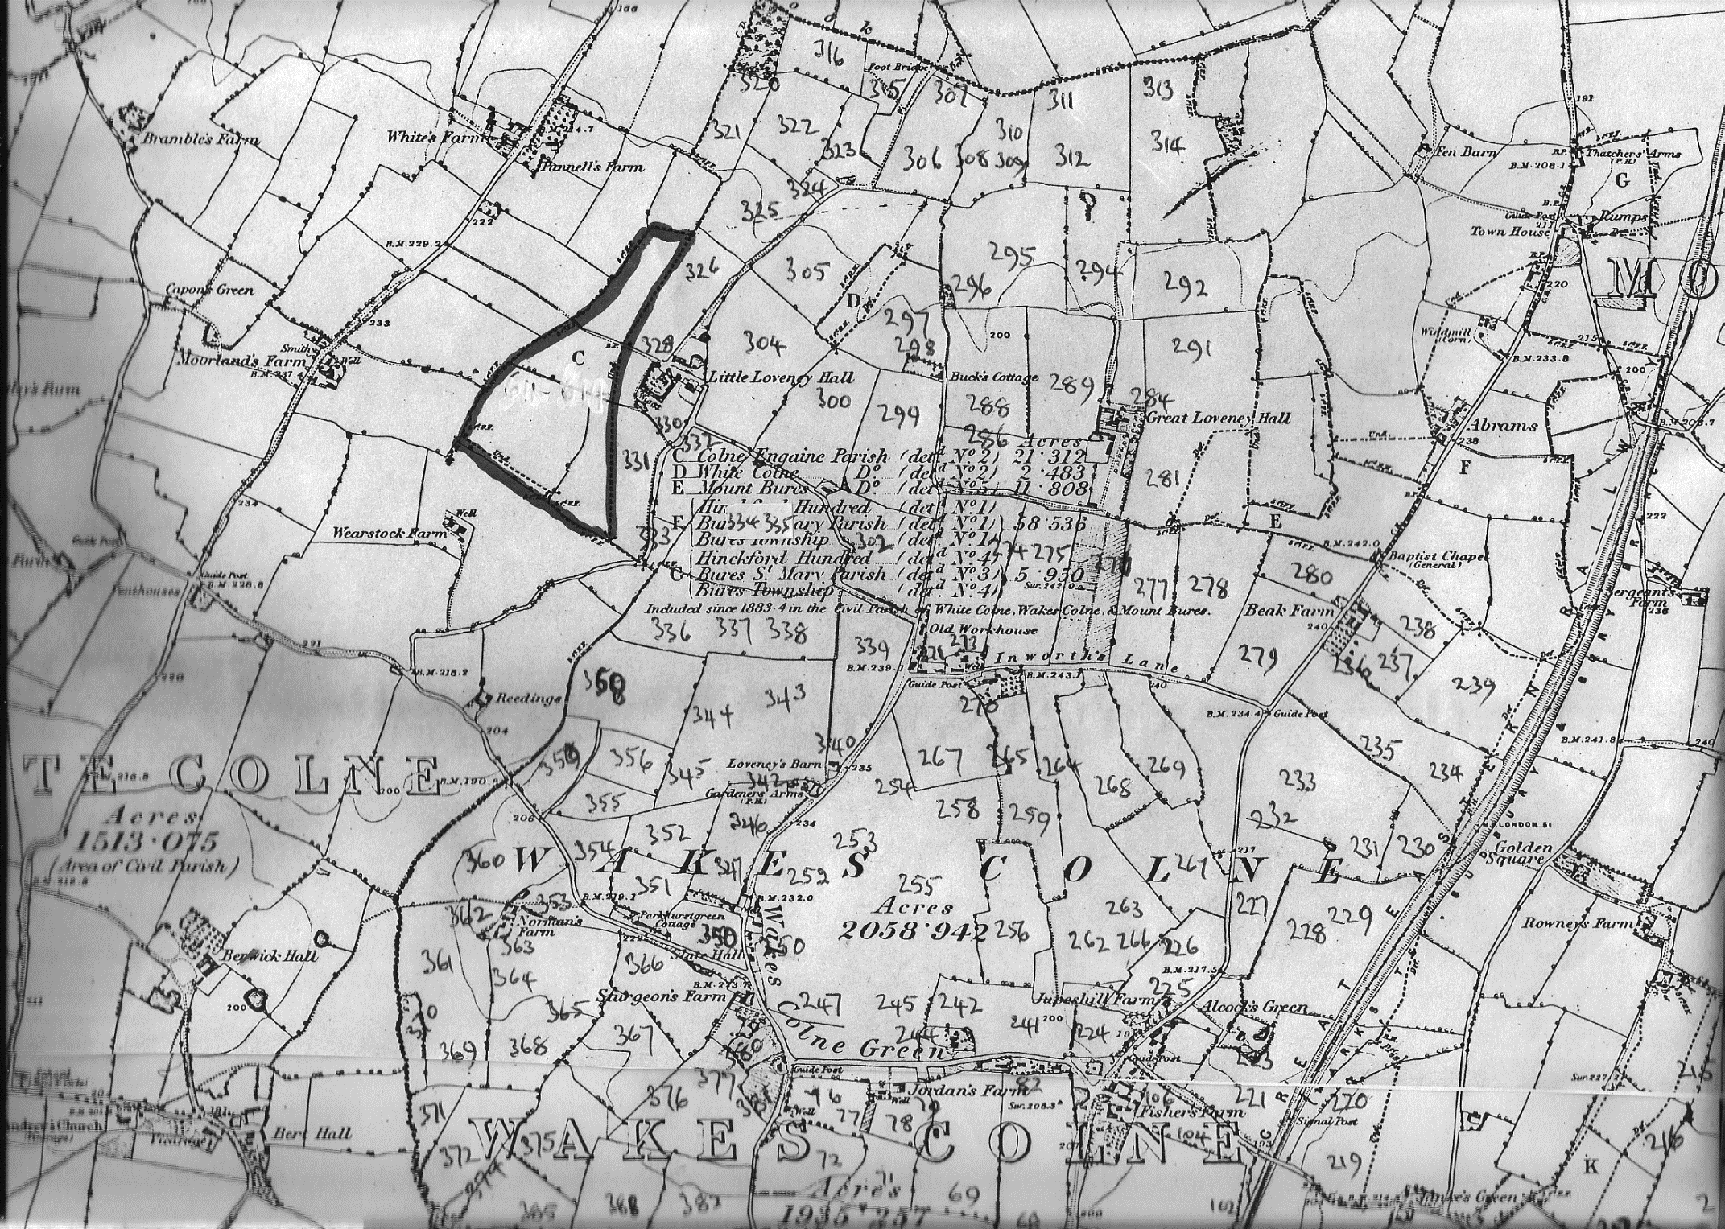

**Map 1**

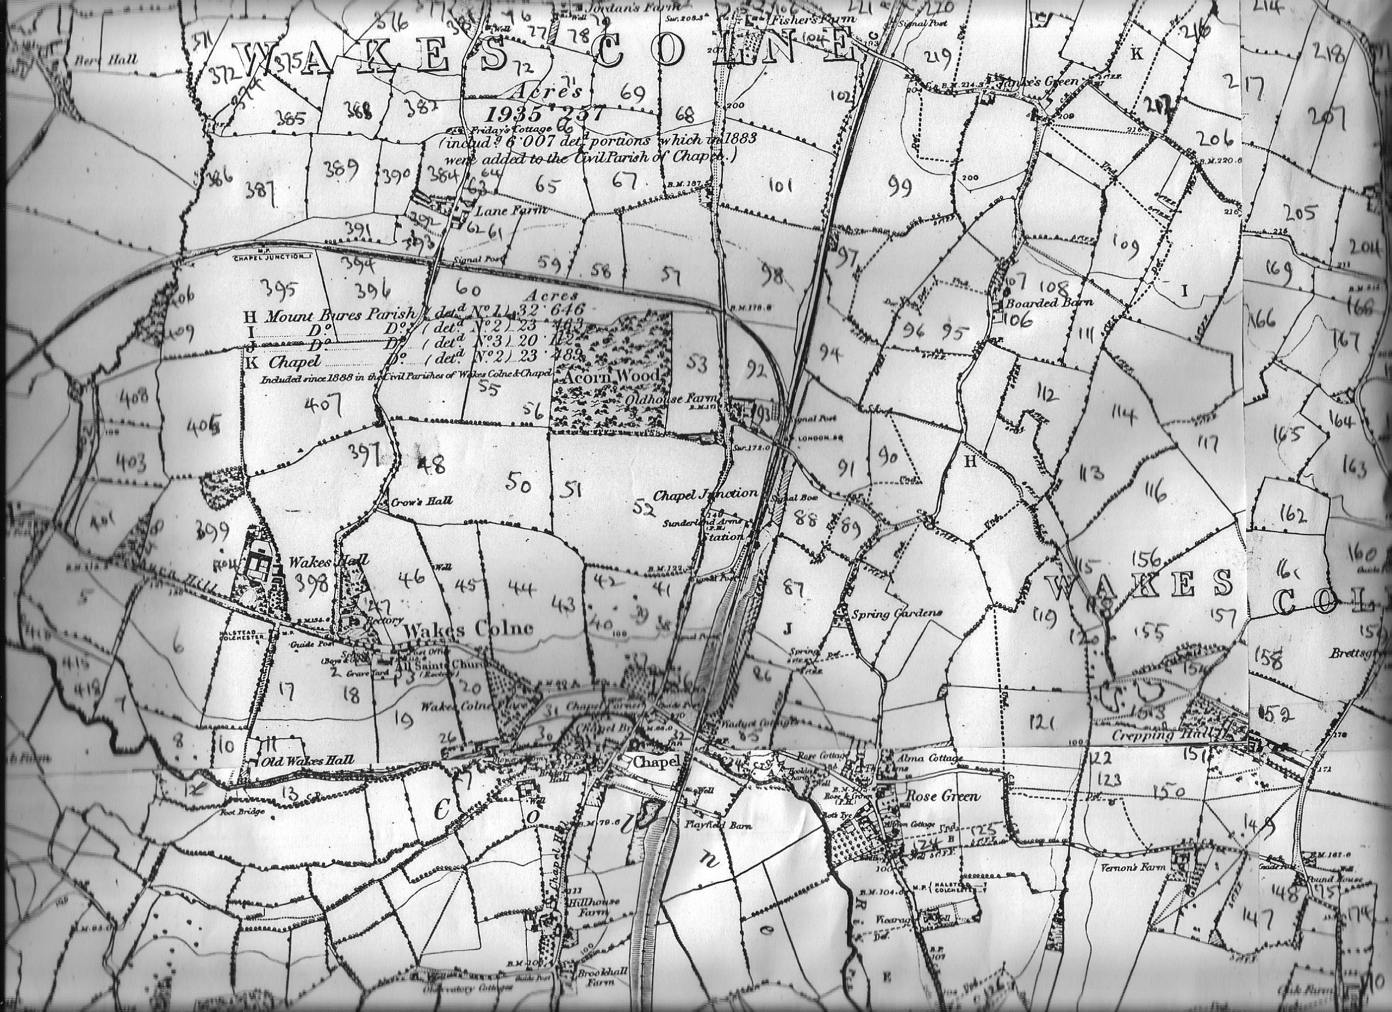

**Map 2**

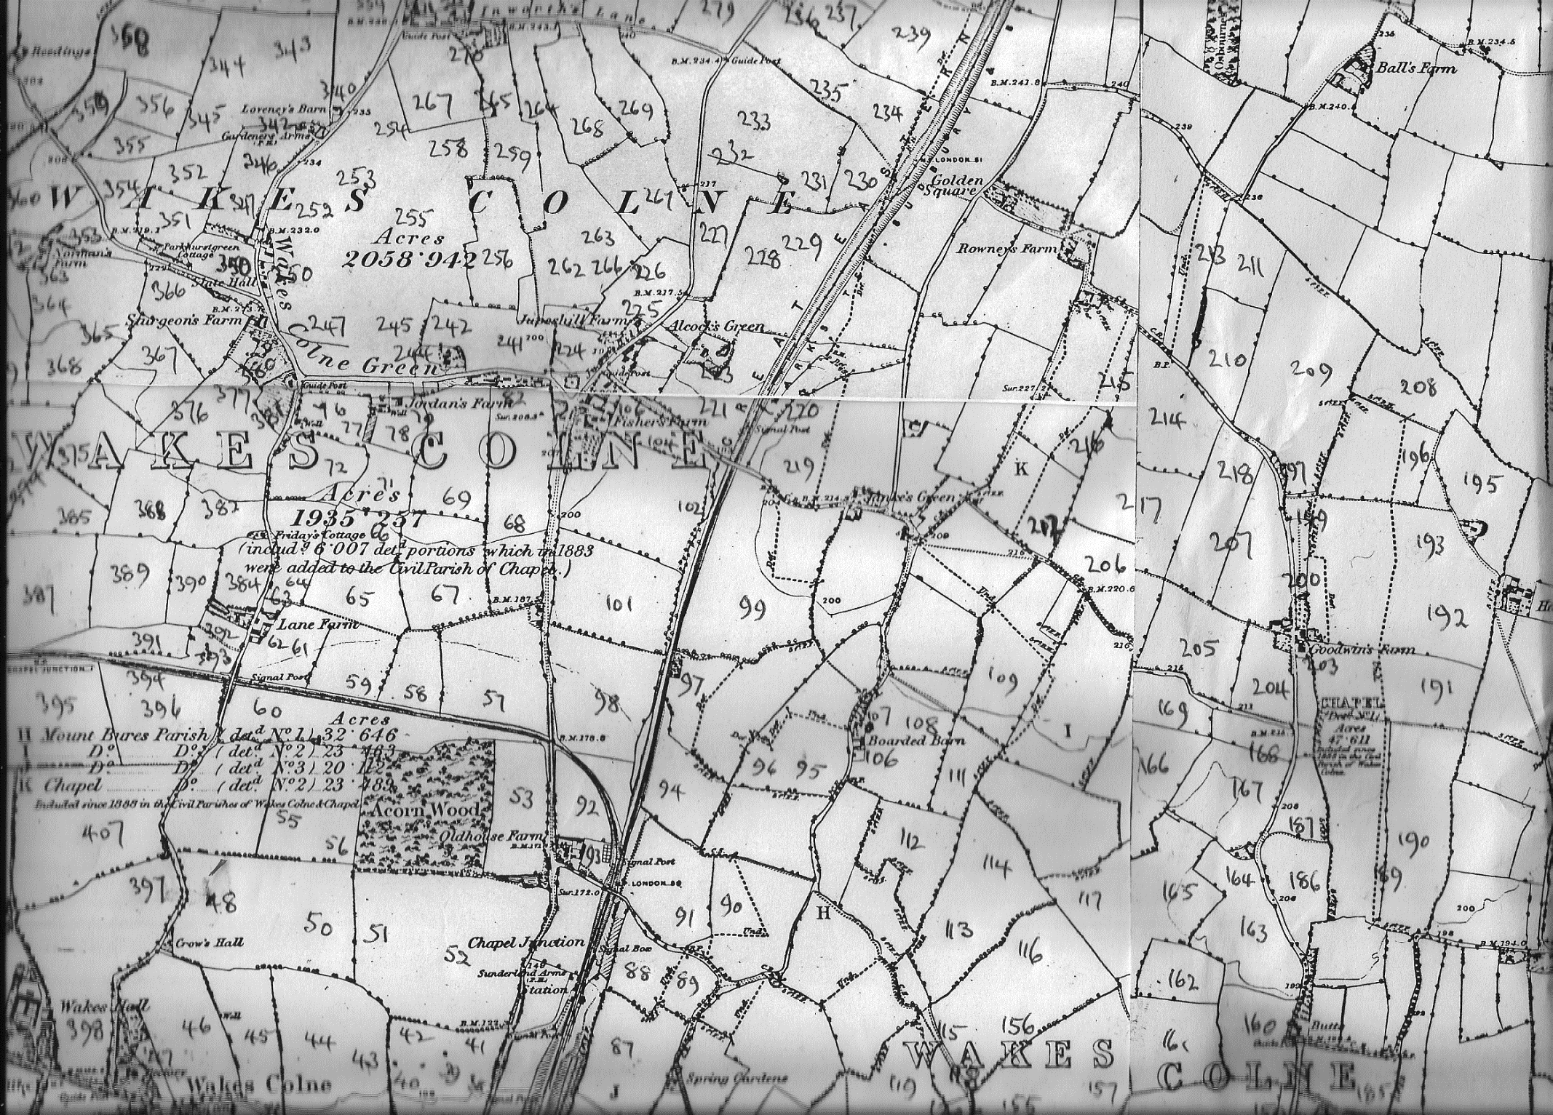

**Map 3**

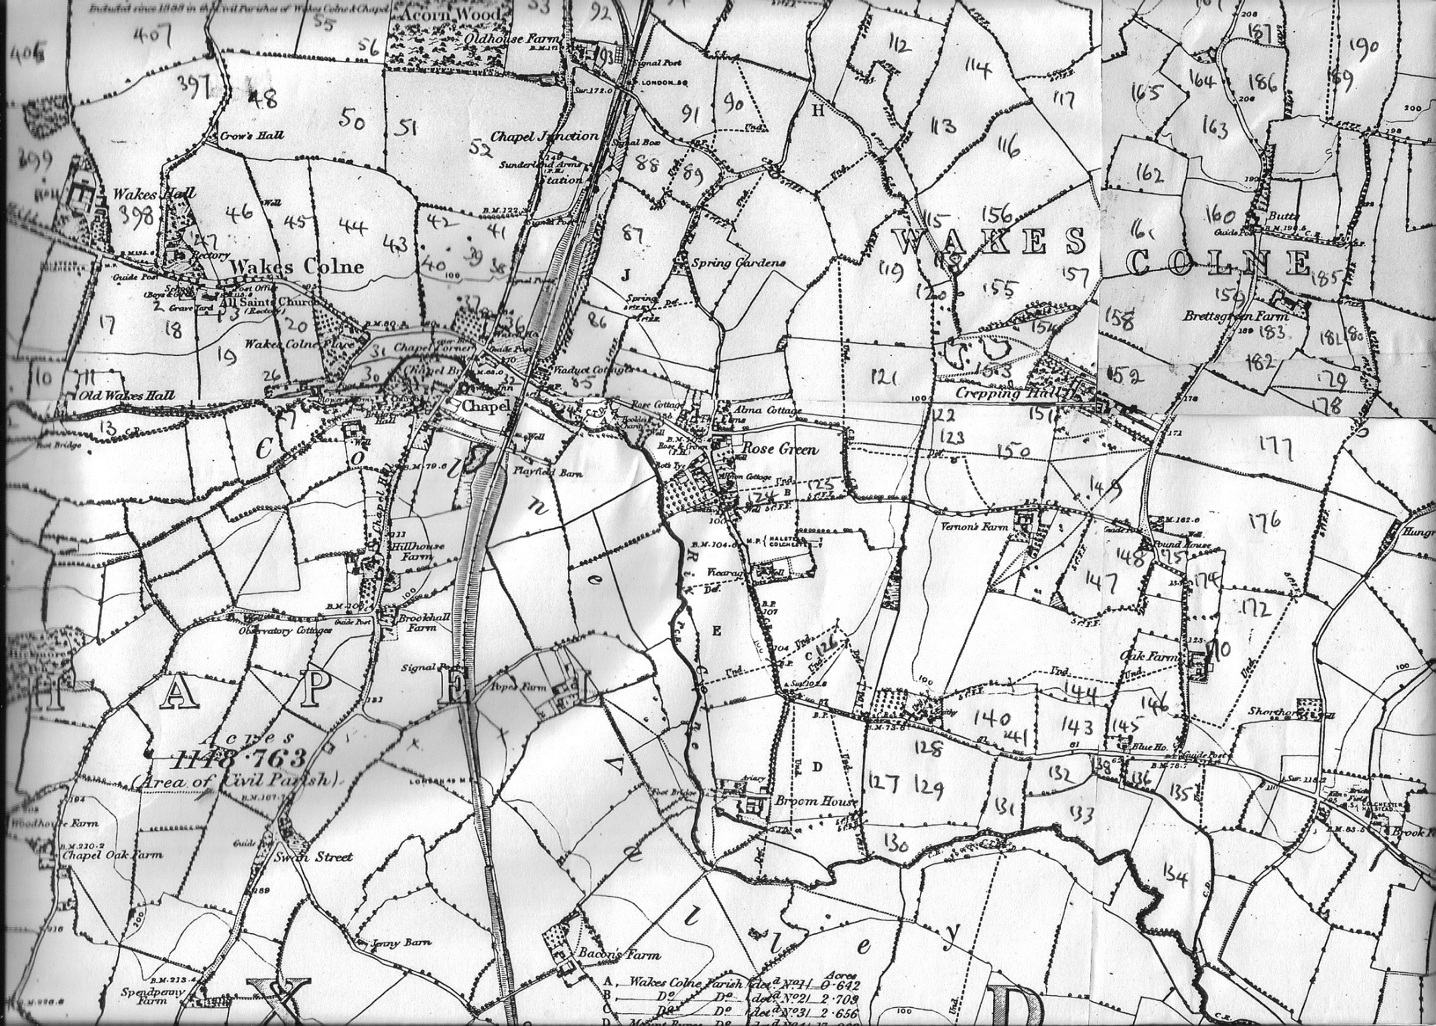

**ap 4**