THE TITHE AWARD PLACE-NAMES

OF WALTHAMSTOW

Recorder: James Kemble

Essex Place-names Project (Essex Society for Archaeology & History), 2016 (e-book).

www.essex.ac.uk/history/esah/essexplacenames

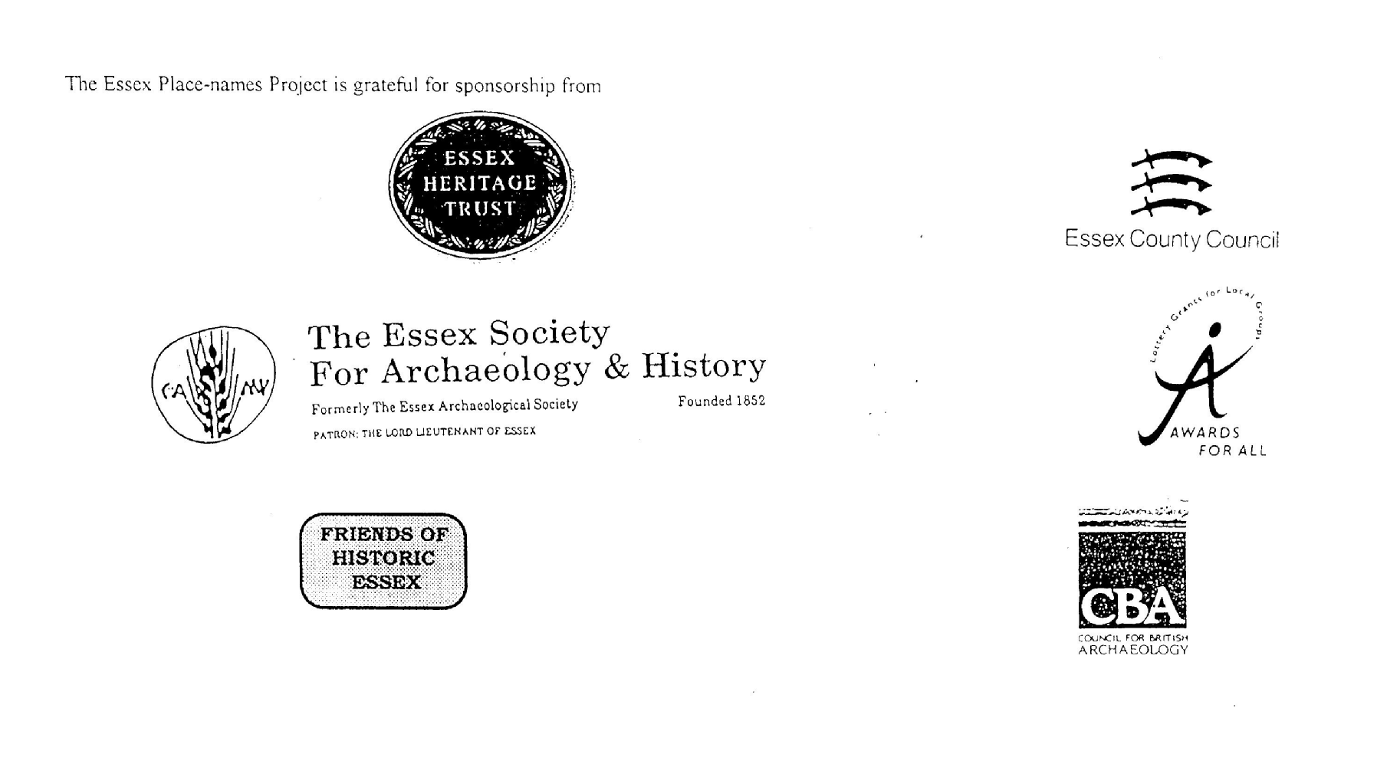

ESSEX PLACE-NAMES PROJECT.
The Essex Place-names Project is a County-wide survey to record place- and field-names from historical documents such as Tithe maps and apportionments, estate maps, sale and auction catalogues, conveyances, terriers, deeds, rolls, inquisitions and surveys. The second element of the Project is to investigate on-the-ground visible remains which correspond to the Place-names for actual or potential archaeological, agricultural and industrial sites, and to record natural (topographical) and man-made features which may relate to the Place-name. This involves field-survey in rural and outside investigation in built-up areas.
It is anticipated that the Project will lead to identification of archaeological sites and lost historic buildings; it will enable analysis of indicators of early settlement, land holding, agricultural and industrial practices of the County. It will refine the more precise meaning of descriptive words and elements used by earlier settlers as they gave names appropriate to the topography of the landscape of their time. For convenience the surveys are based on the parish, recognising that present civil parish boundaries are not necessarily identical to former ecclesiastical boundaries. Local Recorders are supplied with templates of Record Forms to ensure consistency of recording across the County, and forward completed forms to a Central Coordinator for transfer to a county computer database which is available at the Essex Record Office to researchers.
This publication presents part of the information recorded from the Tithe or Estate Award and Map, (and from other documents for this parish.) The full record is contained on the master database in the Essex Record Office, Wharf Road, Chelmsford CM2 6YT and the website www.essex.ac.uk/history/esah/essexplacenames. Parish books are available from the Publications Manger, ERO, on disc or in hard copy or may be downloaded from the website. Please notify errors to the Project Coordinator at the Essex Record Office.

THE TITHE MAP AND APPORTIONMENT.
Since medieval times a tenth of the produce of land and stock had been paid by landholders to the church. At the Dissolution of the Monasteries, the property of many religious houses, including the right to collect tithes, passed into lay hands. The Tithe Commutation Act which received Royal assent on 13th August 1836 abolished a rent payable in kind and substituted rent-charges apportioned on each plot or parcel. The tithe-rent payable was assessed on the average value of wheat, barley and oats and was to fluctuate with price movements.
The commutation could be by voluntary agreement between the local owners and payers or, if agreement failed, could be compulsorily imposed by commissioners. A Valuer was to be appointed to apportion the rent of each parcel of land and tenants could deduct that rent-charge from their rent paid to the landlord. The task fell to the Tithe Commissioners to produce a map and an Apportionment (Award). A large-scale survey was produced for over 70% of England and Wales in the following 9 years, and about another 8% up to 1855. Most of the parishes in Essex were surveyed. The map scales vary. The Award records ownership, tenancy and land-use, field by field and parcel by parcel (often quoting the field name) with the ground area and rent-charge. Land that was tithe-free tends to be less accurately mapped and contains few if any of the details recorded for those parcels subject to tithe. Rights of way and roads also tend to be neglected. Boundaries of the tithe areas are shown as are some natural features such as streams, ponds, gardens, greens and commons. Buildings are often shown coloured red if dwellings or grey if not. Because the Award may have been agreed only some time after the map was finished, discrepancies occur between the two. Enclosure Awards, when extant, usually date to the 18th and early 19th centuries.
J. Kemble.
Reproduced by permission
of Essex County Council.

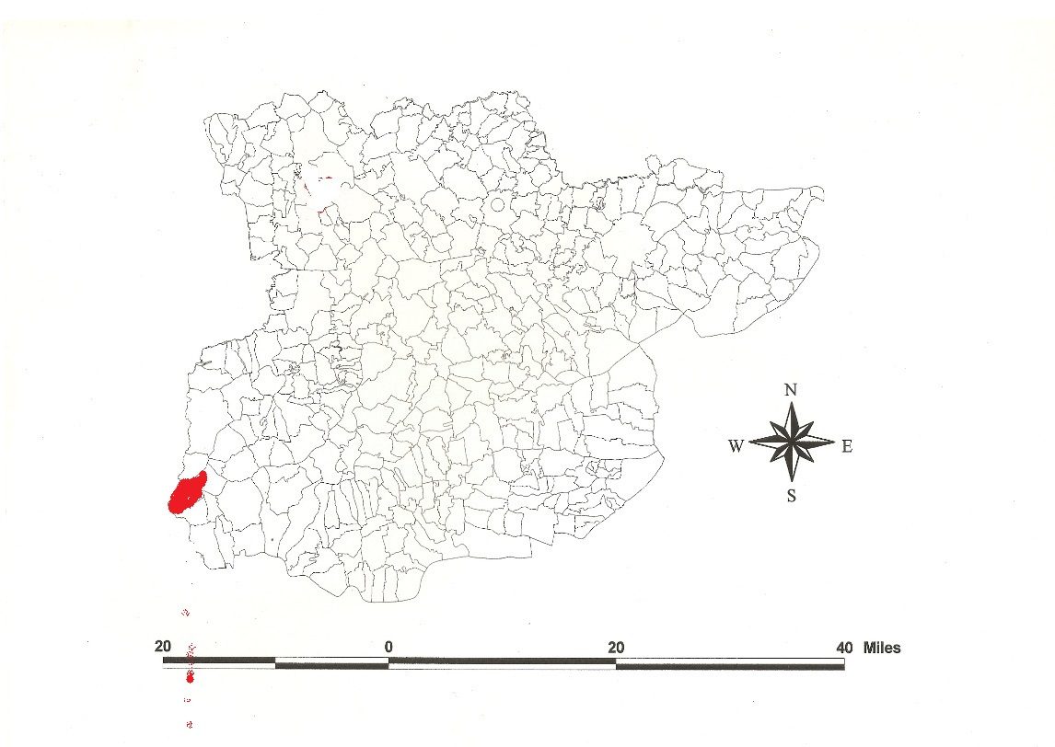
Reproduced by permission of
Essex County Council
Parish of Walthamstow formerly in the County of Essex.
Walthamstow Parish (in Becontree Hundred).
The Tithe Award of Walthamstow (Essex Record Office D/CT 382a), dated 1843, shows a rent-charge of £607 payable to the Vicar, and the following impropriators: Richard Orlebar £402, Robert Fitzwygram £13-15-10, Jeremiah Harman, £4-6-0, William Raikes & others as trustees of Charles Raikes £9-5-0, Henry Read Revill £4-8-6, Joseph Truven £13-10-0, Isabella Robinson & others as trustees of Charles Robinson £13, Samuel Fox £2-4-0, James Richardson £20, Samuel Gurney & others as trustees of Sarah Dillwyn £10-10-0, Thomas Aveside £4-18-0, Charles Cooke £4-2-4, Scott 12 shillings, Total £1153-6-8d. The whole titheable parish measured 4436 acres of which 915 acres were arable, 2628a meadow and pasture, 286a homesteads, 106a woods, 501a waste and forest. The following tithes were merged: Edward Forster snr owner, Edward Forster jnr, occupier 48acres 3 roods 36 perches, Wm and Frederick Raikes, John and Duncan Alves owners John Collins occupier 128a 1r 34p, Edward Copping owner Samuel Wheeler occupier 4a 1r 28p, Wm Masterman owner and occupier 19a 1r 26p, Jeffrey Fox owner and occupier 22a 29p, Charles Adams owner Hon Rev Baptist Noel occupier 19a 1r, Henry Caslon owner and occupier 9a 3r 22p, John Evans owner and occupier 5a 3r 14p, Eusabius Lloyd owner and occupier 55a 1r 22p, Wm Pulsford owner Miss Arandale occupier 18a 2r 30p, James Balantyne owner Octavius Wygram occupier 21a 22p, John Vale and others owners Wm Brown & others occupiers 225a 1r 7p, John Clinton owner and occupier 14a 2r 11p. The Tithe Commissioners were William Blamire and JW Buller, the Assistant John Maurice Herbert, the Valuer John Humphreys of 16 Old Broad Street, London. The Tithe Map (ERO: D/CT 382b), surveyed at a scale of 13.3 inches to a mile, measures 77”x34” was countersigned by John Maurice Herbert.
Wilcomestu was held by Earl Waltheof before 1066 as a manor for 10½ hides with a mill, and by his widow Countess Judith, niece of William I, in 1086. It is documented as Wilcomestue and Wilcomestuue in 1066-87 (Westminster Domesday Book, 14th century) and 1067 (Index to Charters & Rolls, BL) (Reaney, 1935; Morris, 1987). Ekwall (1960) translates this ‘Wilcume’s holy place’, Wilcume being an abbess or queen, but Reaney (1935) prefers ‘a place where strangers are welcome’. Round suggests that Walthamstow was a daughter-church of the abbey of Waltham (VCH). The manor of Hecha(m) (Higham Hill) was held before 1066 by Haldane, a free man, for 5 hides, and in 1086 by Peter de Valognes.
Waltheof joined an army of Danes against William I. He acquired Northumberland, Northampton and Huntingdon. He was beheaded at Winchester in 1076 for treason. His widow Judith married Ralph de Toni of Flamstead, Herts, standard bearer to William, to whom she brought the manor of Walthamstow Toni (High Hall). Thomas de Beauchamp, earl of Warwick (died 1369) came in to possession. Low Hall (taken out of Wilcumestou, alias Walthamstow Francis or Bedyk (Adam Bedyk, the king’s tailor, held it of William of Hadstock in 1285, and died in 1302. Simon Fraunceys, London merchant, died 1358), was granted by Elizabeth I to William Tipper and Robert Dawe(s), ‘concealers’. The house stood 1½ miles southwest of the church. The farm-house was destroyed by a flying-bomb in 1944 (Andrews, 2002). t. Henry VII the manor of Higham Hill was purchased by the Bensted family; John de Benstede, chancellor the Exchequer 1305-7, died 1323. The house stood about 1½ miles northwest of the church. It was rebuilt in 1768 for Antony Bacon, lord of the manor of Higham Benstead. The manor of Salisbury Hall (taken out of Hecham) is named from Margaret Plantagenet, countess of Salisbury, executed by Henry VIII. Sir Thomas Tirwhitt (died 1552) held it from the Countess. In 1590, Elizabeth I gave it to Robert Symons with Bradfield 4 acres, Little Goldsmith land 4 acres, Little Hors leaze 5 acres and Rowdens field 13 acres. The house, demolished in 1952, stood 1½ miles north of the church. The later manor of Mark lay astride the border of Walthamstow and Leyton (mearc = ‘boundary), now remembered in Markhouse Road (Morant, 1768).
There was a bridge over the River Lea at Higham Hill (TQ 360900) in 1594, and by 1687 a ferry called Boulton’s in the 18th century and Games’s in the late 19th. At Mill (Ferry) Lane were two bridges over the Rivers Fleet and Lea. In 1277 Ralph de Tony was required to make two bridges at Horseholme (holm = island) (TQ 355895) and Smethemers (‘smooth/flat marsh). The old bridge was demolished in 1915 when Ferry Lane bridge was built a little downstream (VCH 1973). At Copper Mill, coins were struck in the Napoloeonic Wars.
In 1869 during construction of the Maynard reservoir, an Iron Age crannog was excavated. In 1900 digging of the Lockwood reservoir revealed a Bronze Age flat-bottomed boat (now in British Museum), and a Saxon barge with a male skeleton. Ancient House is timber-framed with wings, dendro-dated 1564-92. The church dedicated to St Mary, rebuilt in 1535 but dating from 12th century, contains the vaults of the Conyers family (Mee, 1972; Andrews, 2002). In 1965 Walthamstow was included with Chingford and Leyton in Waltham Forest borough,
Early place-names of Walthamstow were documented by PH Reaney, 1930, for the Walthamstow Antiquarian Society, publication 24 (see www.essex.ac.uk/history/esah/essexplacenames).
References

Andrews, D., 2002. Essex Archaeology & History, 33, 191, 415, 452. Barns, S., 1923. Cal of Deeds of Walthamstow, Walthamstow Antiq Soc., 11 Ekwall, E., 1960. Dictionary of English Place-names, Oxford Hodder, London, p 410. Mee, A., 1972. The Kings England, London North of the Thames. Morant, P., 1768. History of the County of Essex, i, 131. Morris, J., 1983. Domesday Book, Essex. Phillimore. Reaney, P., 1935. Place-names of Essex. Cambridge. Round, H., Trans Essex Archaeological Society, vii, 330. Victoria County History of Essex, 1973, vi, 240.

Extract from Tithe Award Place-names of Walthamstow St Mary - by Owner
Place-name | alias | Field No | Grid | x | Y | Type | Acr | rd | pch | Owner | Occupier
House, yd, gdns |  | 666 | TQ |  |  | bldg | 0 | 2 | 18 | Benson, William | Benson, William
House, yd, gdn |  | 694 | TQ |  |  | bldg | 1 | 3 | 10 | Berthou, Amelia | Berthou, Miss
House, yd, gdn |  | 762 | TQ |  |  | bldg | 1 | 2 | 38 | Bill, Charles | Trueman, Charles
House, yd, gdn |  | 887 | TQ |  |  | bldg | 0 | 0 | 16 | Boltwood, Mary | Boltwood, Mary
House, homestead, gdn |  | 928 | TQ |  |  | bldg | 5 | 0 | 17 | Bosanquet, Samuel | Burrell, Charles
House, gdn, 3 cottages |  | 823 | TQ |  |  | bldg | 0 | 1 | 36 | Burchall, John Henry | Cooke, Mrs (late)
Homestead |  | 258 | TQ |  |  | bldg | 0 | 2 | 15 | Cazenove, John | Martin, James
Public House, yd, 4 cottages |  | 736 | TQ |  |  | bldg | 0 | 1 | 19 | Christie & Cathou, Messrs
House, shop |  | 725 | TQ |  |  | bldg | 0 | 0 | 6 | Clarke, Ebeneezer | Jeffrey
Stables, Farm, bldgs |  | 596 | TQ |  |  | bldg | 1 | 2 | 3 | Fitzwygram, Sir Robert | Fitzwygram, Sir Robert
Farm yd, bldgs. |  | 70 | TQ |  |  | bldg | 0 | 0 | 38 | Forster, Edward, snr | Forster, Edward, jnr
Copper Mills & 10 cottages | Cp. Coppermill Lane | 442 | TQ | 350 | 883 | bldg | 1 | 1 | 18 | Forster, William | Forster, William
Farm hs, yd |  | 493 | TQ |  |  | bldg | 3 | 0 | 0 | Fox, Samuel | Fox, Samuel
Farm yd, pleasure grounds |  | 850 | TQ |  |  | bldg | 4 | 0 | 15 | Freeman, Joseph | Trueman, Josh
House, yds, gdns |  | 668 | TQ |  |  | bldg | 3 | 2 | 32 | Gore, Robert | Gore, Robert
House, homestead, gdn |  | 85 | TQ |  |  | bldg | 0 | 1 | 33 | Harman, Jeremiah | Appleby, Christopher
House, bldgs, gdn |  | 135 | TQ |  |  | bldg | 0 | 1 | 2 | Harman, Jeremiah | Ashcroft, William
House, gdn, yd |  | 126 | TQ |  |  | bldg | 0 | 2 | 32 | Harman, Jeremiah | Harding, Frederick
House, gdn, homestead |  | 122 | TQ |  |  | bldg | 0 | 2 | 37 | Harman, Jeremiah | Harman, Jeremiah
Mansion, lodge, pleasure ground |  | 140 | TQ |  |  | bldg | 0 | 3 | 17 | Harman, Jeremiah | Harman, Jeremiah
House, stable gdn, ground |  | 307 | TQ |  |  | bldg | 2 | 2 | 28 | Haseldine, John | Niblock, Rev Dr
House, homestead, gdn |  | 282 | TQ |  |  | bldg | 1 | 0 | 3 | Hewes, Joseph, exec | Charlton, Adam
House, yd, gdn, orchard |  | 565 | TQ |  |  | bldg | 2 | 2 | 24 | Jacomb, Thomas | Pinching, Mr
House, yd, gdn, pleasure ground |  | 698 | TQ |  |  | bldg | 2 | 2 | 27 | Kendall, Peter | Branfill, Benjamin
House, homestead, gdn |  | 192 | TQ |  |  | bldg | 2 | 1 | 19 | King, John | Clarke, John
House, homestead, gdn, orchard |  | 244 | TQ |  |  | bldg | 2 | 3 | 0 | Lefeuvre, Charles Shaw | Wragg, Robert
House, homestead, gdn |  | 424 | TQ |  |  | bldg | 0 | 1 | 5 | Maynard, Lord | Prior, Matthew
2 houses, bldgs, gdns |  | 633 | TQ |  |  | bldg | 1 | 1 | 37 | Mills, John | Gollop, John
House, yd, gdn, pleasure ground |  | 687 | TQ |  |  | bldg | 2 | 1 | 25 | Mills, John | Masterman, Thomas
House, homestead |  | 446 | TQ |  |  | bldg | 0 | 2 | 32 | Richardson, James | Wragg, Robert
House, offices, gdn |  | 254 | TQ |  |  | bldg | 2 | 1 | 7 | Robinson, Wm Tooke, trustees
House, gdn, homestead |  | 17 | TQ |  |  | bldg | 0 | 2 | 2 | Rowe, William | Sinnas, James
6 Almshouses | [founded 1795] | 775 | TQ |  |  | bldg | 0 | 0 | 22 | Squires, trustees | Coode; others
Chapel, yard |  | 573 | TQ |  |  | bldg | 0 | 1 | 21 | Unitarian Chapel | Unitarian Chapel
House, stables, gdn, pleasure ground |  | 514 | TQ |  |  | bldg | 2 | 3 | 20 | Warner, Edward | Warner, Edward
Chapel of Ease |  | 226 | TQ |  |  | bldg | 0 | 2 | 10 | Wilson, Rev William, vicar | Nichols, Rev B
Chapel of Ease |  | 895 | TQ |  |  | bldg | 0 | 1 | 8 | Wilson, Rev William, vicar | Wilson, Rev William
Church, yard | [St Mary] | 776 | TQ | 381 | 894 | bldg | 0 | 2 | 24 | Wilson, Rev William, vicar | Wilson, Rev William
Infant School |  | 781 | TQ |  |  | bldg | 0 | 2 | 1 | Wilson, Rev William, vicar | Wilson, Rev William
Church Common | [Tithe map] | 799-815 | TQ | 380 | 892 |  |  |  |  | various | various
Higham Hill Common | Hecha(m), 1086,DB | 339-367 | TQ | 365 | 902 |  |  |  |  | various | various
Mark House Common | cp. Markhouse Road | 951-974 | TQ | 366 | 884 |  |  |  |  | various | various
Inner Marsh | [Walthamstow Marshes] | 904-1187 | TQ | 350 | 877 |  |  |  |  | various | various
Marsh Street | [High Street] |  | TQ | 368 | 890 | street |  |  |  | .. | ..
Wood Street | [Tithe map] |  | TQ | 383 | 896 | street |  |  |  | .. | ..
Clay Street | [Forest Road] |  | TQ | 366 | 897 | street |  |  |  | .. | ..
Chapel End | [Tithe map] |  | TQ | 375 | 906 |  |  |  |  | .. | ..
Hillier's Ferry [River Lea] | [Tithe map] |  | TQ | 352 | 893 |  |  |  |  | .. | ..

Other Names
Bridges at Horseholme (holm = island) (TQ 355895) and Smethemers (‘smooth/flat marsh), Ralph de Toni ordered to build, 1277 (VCH 1973) Stonyfielde and Nursefielde, PRO REQ2/300/1, 17th cent. Ashney fields, 1631, Sale by John Argall , Essex Archaeology & History, 33, 205 Markhouse Common, formerly Broom Field, 19^{th,} cent. Andrews, Essex Archaeology & History, 2002. Vol 33, 205 Salisbury Hall, 1875,OS (TQ 374912) [Demolished 1952] Low Hall Farm, 1875,OS (TQ 362880) High Hall, 1777, C&A (TQ 359897) Higham Hill, 1875,OS (TQ 359908) [Woodford County High School] Essex Hall, 1875,OS (TQ 356906) [Demolished 1933]
Bushe Marshe (of Low Hall), 16th cent. Owner Sir Ralph Sadler, ambassador, 1541 Hernes Marsh (of Low Hall), Owner Sir Ralph Sadler, 1541 Butchers Marshe (of Low Hall), Owner Sir Ralph Sadler, 1541. Essex Archeology & History, 2002, 33, 204

Walthamstow

Map 3

Map 2

Map 1


4.2 Inches = 1 mile
O.S. c.1875
Sheets 65, 73
