THE PLACE-NAMES OF

WICKFORD

Recorder: James Kemble

Essex Place-names Project (Essex Society for Archaeology & History), 2015 (e-book).

www.essex.ac.uk/history/esah/essexplacenames

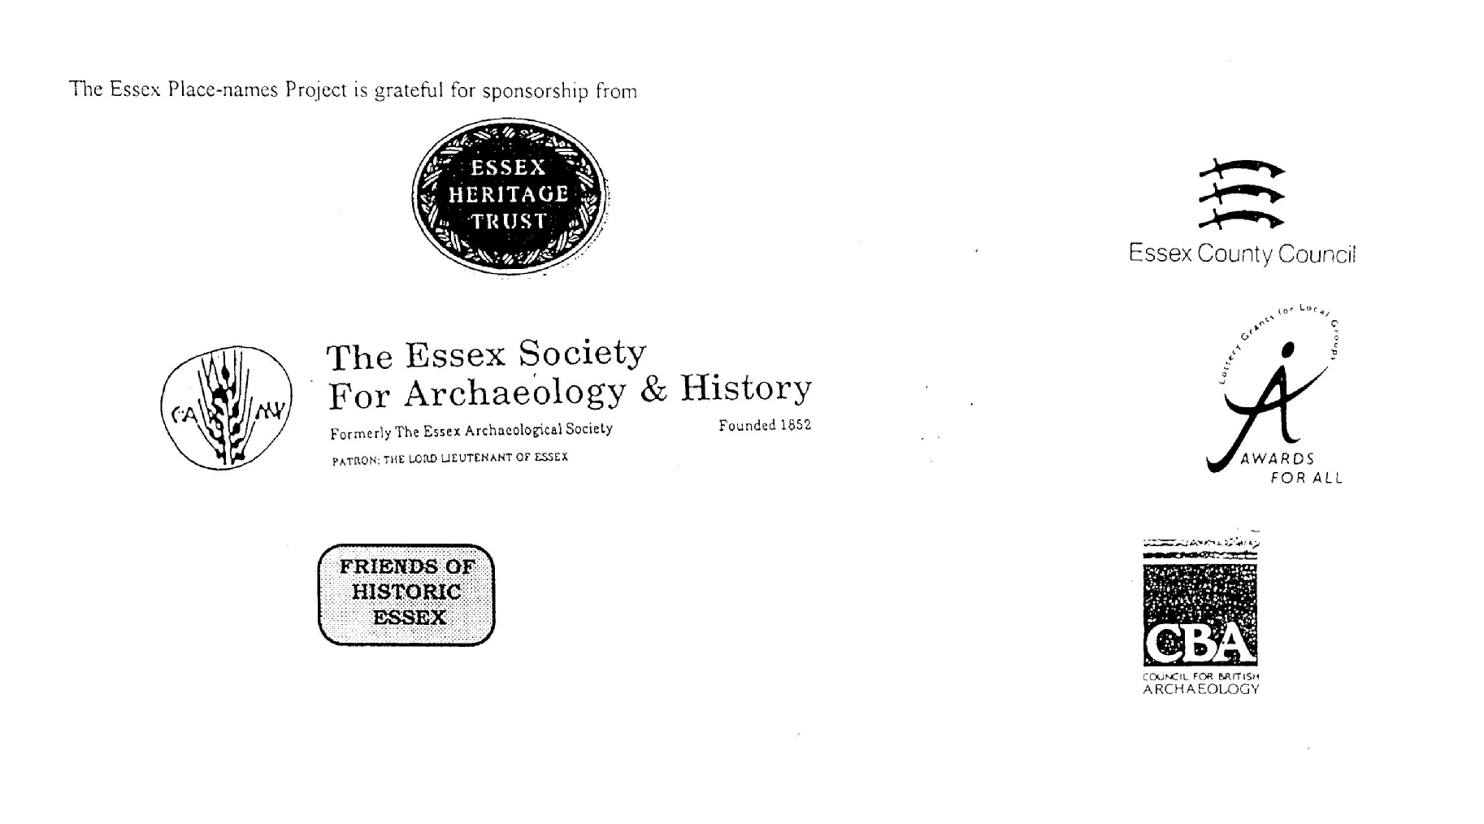

ESSEX PLACE-NAMES PROJECT.

The Essex Place-names Project is a County-wide survey to record place- and field-names from historical documents such as Tithe maps and apportionments, estate maps, sale
and auction catalogues, conveyances, terriers, deeds, rolls, inquisitions and surveys.

The second element of the Project is to investigate on-the-ground visible remains which correspond to the Place-names for actual or potential archaeological, agricultural and industrial sites, and to record natural (topographical) and man-made features which may relate to the Place-name. This involves field-survey in rural and outside investigation in built-up areas.

It is anticipated that the Project will lead to identification of archaeological sites and lost historic buildings; it will enable analysis of indicators of early settlement, land holding, agricultural and industrial practices of the County. It will refine the more precise meaning of descriptive words and elements used by earlier settlers as they gave names appropriate to the topography of the landscape of their time.

For convenience the surveys are based on the parish, recognising that present civil parish boundaries are not necessarily identical to former ecclesiastical boundaries. Local Recorders are supplied with templates of Record Forms to ensure consistency of recording across the County, and forward completed forms to a Central Coordinator for transfer to a county computer database which is available to researchers on the internet at www.essex.ac.uk/history/esah/essexplacenames, and updated periodically.

This publication presents part of the information recorded from the Tithe or Estate Award and Map, and from other documents for this parish. The full record is contained on the master database at Essex County Council (Historic Environment Section) and on the (above) website. Parish books are available to be downloaded from the website link ‘Books’ on the Home page. Please notify errors to the Project Coordinator at the Essex Record Office.

THE TITHE MAP AND APPORTIONMENT.

Since medieval times a tenth of the produce of land and stock had been paid by landholders to the church. At the Dissolution of the Monasteries, the property of many religious houses,
including the right to collect tithes, passed into lay hands. The Tithe Commutation Act which received Royal assent on 13th August 1836 abolished a rent payable in kind and
substituted rent-charges apportioned on each plot or parcel. The tithe-rent payable was assessed on the average value of wheat, barley and oats and was to fluctuate with price movements.

The commutation could be by voluntary agreement between the local owners and payers or, if agreement failed, could be compulsorily imposed by commissioners. A Valuer was to be appointed to apportion the rent of each parcel of land and tenants could deduct that rent-charge from their rent paid to the landlord. The task fell to the Tithe Commissioners to produce a map and an Apportionment (Award). A large-scale survey was produced for over 70% of England and Wales in the following 9 years, and about another 8% up to 1855. Most of the parishes in Essex were surveyed. The map scales vary. The Award records ownership, tenancy and land-use, field by field and parcel by parcel (often quoting the field name) with the ground area and rent-charge.

Land that was tithe-free tends to be less accurately mapped and contains few if any of the details recorded for those parcels subject to tithe. Rights of way and roads also tend to be neglected. Boundaries of the tithe areas are shown as are some natural features such as streams, ponds, gardens, greens and commons. Buildings are often shown coloured red if dwellingsor grey if not. Because the Award may have been agreed only some time after the map was finished, discrepancies occur between the two. Enclosure Awards, when extant, usually date to the 18th and early 19th centuries. J..Kemble.
Reproduced by permission
of Essex County Council.

Reproduced by permission of
Essex County Council.

Wickford Parish in the County of Essex

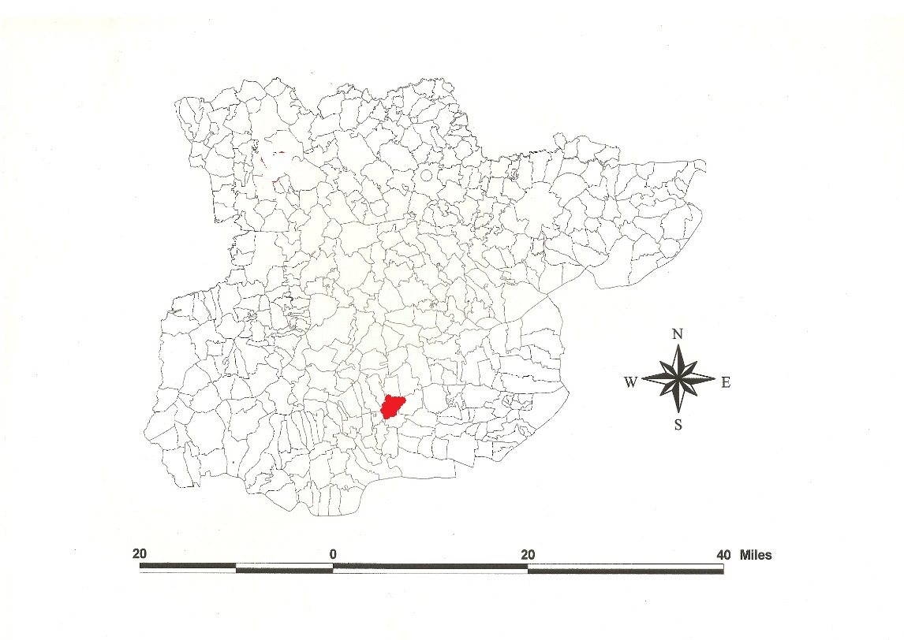

The Parish of Wickford (in Barstaple Hundred).

The Tithe Award of Wickford (Essex Record Office D/CT 395a), dated 1838, shows a rent-charge of £484 including £14 for glebe payable to Rev Richard Edward Rion Berens. The whole parish measured 1650 acres of which 1500a were arable, 146a meadow and pasture, 4 acres wood. The Tithe Commissioners were William Blamire and JW Buller, the Valuer Henry Clayton of Ingatestone. The Tithe map (ERO: D/CT 395b) was surveyed at a scale of 20” to a mile and measures 80”x55”. It was countersigned by Roger Kynaston, Assistant Tithe Commissioner.

In 962x991 Æthelflæd, daughter of ealdorman Ælfgar and second wife of King Edmund, willed 10 hides at Wicforda, to her kinsman Sibriht (S 1494; Hart, 1971). In Domesday Book, 1086, Pointel and Osbern held 2 hides in Wincfort and Wheatley from the bishop of Bayeux which 2 free men had held before 1066. Thorold’s son held from the bishop which 5 free men had held 2 hides and 48 acres in Wicfort. Teher held Wicfort from the bishop which Godric a free man had held before 1066 for one hide. Thorkell held Wicfort from Earl Swein which Leofstan had held as a manor for half a hide and 35 acres; Bricteva, a free woman, had held half a hide and 15 acres which Swein added to his above land and a further 54 acres. Swein held Wicfort in lordship which Godwin, a king’s thane, had held as a manor for 10 hides [formerly Æthelflæd’s]. William son of Odo held Wicfort from Swein which Dot had held as a manor for half a hide and 45 acres. Maynard held Wicfort from Swein which Godric had held for 30 acres. In Land of Modwin, Edwin Groat held Wicfort as a manor for half a hide. In Ilbod’s Land, 2 free men had held Wicfort before 1066 for 40 acres (Morris, 1983). Watts (2004) derives this from Old English ford, ‘ford by the farm or called Wick’. Gelling (1988) draws attention to an association with Latin vicus, a small self-governing unit in a Roman province. By late Anglo-Saxon times wic was used more specifically to denote a dairy-farm.

After 1086 there were these manors: 1. Wickford Hall was formerly Swein’s. After his grandson Henry de Essex was disinherited it was granted to Ulric, commander of the crossbow-men t.Richard I. Richard Orric (died 1247) held 320 acres and a mill etc. Stilemans was an estate half a mile north north of the church to the north of the river, the hall of which was taken down c. 1730. 2. A manor partly of Henry de Essex was granted t.Henry III in 1226 to Hubert de Burgh, earl of Kent (Morant, 1768). Adam de Burre granted 3 acres of land to St Bartholomews Hospital London c.1275. The hospital still held 3 acres in the 19th century (parcel no 172) (Kerling, 1970; Kemble, 2015).

At Shotgate Farm Neolithic and Bronze Age flint, pottery and post-hole structures have been excavated ((Dale, 2005). North of the Wickford-Rayleigh road was excavated a Romano-British villa-farm within a ditched enclosure approached by a metalled road from the east, the house tiled (one with an early Christian motif) and heated by flues (Kemble, 2009). The church dedicated to St Catherine was rebuilt c.1875, reusing a C15 window and the chancel roof c.1500 (Pevsner, 2007). Wickford Station, opened for freight from Shenfield in 1888 and in 1889 for passengers, was built next to the Castle Inn and the branch lines, with a connecting curve south of Belchamps opened later the same year (Kemble & Garwood, 2011).

The Hundred name in Domesday Book is Berdestapla which Reaney (1935) translates from Old English stapol, post or pillar + beardede, ‘hairy’. Christie (1926) places the moot at or near Barstable Hall (TQ 703885) in Basildon parish.

Place- and field names from the map of Great & Little Aimes and Kings Head (ERO: D/DFa P2), dated 1716, of Robert Western esq and from other documents are shown against the Tithe Award names.

References:

Christie, M., 1926. Essex Hundred Moots. Trans Essex Archaeological Soc., n.s., xviii
(3), 182.
Dale, R., Maynard, D., et al. Essex Archaeology & History, 36, 26.
Gelling, M., 1988. Signposts to the Past. Phillimore. pp 70, 247.
Kemble, J., 2007. Essex Place-names, Places, Streets & People. Historical Publications,
London, p 91.
Kemble, J., 2009.Prehistoric & Roman Essex, History Press. pp 99,101,103,107,161.
Kemble, J., Garwood, A., 2011. Railways of the Blackwater & Crouch Estuaries. Essex
County Council. 2 volumes.
Kemble, J., 2015. Medieval Estates of St Bartholomews Hospital. Essex Journal, 50(i),p5
Kerling, N., 1970. Cartulary of St Bartholomews Hospital, London.
Morant, P., 1763. History & Antiquities of the County of Essex, 1, 253.
Morris, J., 1983. Domesday Book – Essex. Phillimore.
Pevsner, N., Bettley, J., 2007. Buildings of England – Essex. Yale.
Reaney, P., 1935. Place-names of Essex. Cambridge.
Watts, V., 2004. Dictionary of English Place-names. Cambridge.
Whitelock, D., 1930. Anglo-Saxon Wills. Cambridge

The Tithe Award Place-names of Wickford - by parcel no.
www.essex.ac.uk/history/esah/essexplacenames
Place name | alias | Fld No | Grd | x | y | Acr | Rd | Pch | Land use | Owner | Occupier | Farm | Other information
Little Spinnage |  | 1 | TQ | 776 | 939 | 6 | 2 | 29 | arable | Fane, John esq | Archer, Daniel & David | Great Aimes
The Grove |  | 2 | TQ |  |  | 0 | 2 | 16 | wood | Fane, John esq | Archer, Daniel & David | Great Aimes
The Grove |  | 3 | TQ | 776 | 937 | 1 | 2 | 29 | wood | Fane, John esq | Archer, Daniel & David | Great Aimes
Little Spinnage |  | 4 | TQ |  |  | 6 | 3 | 17 | arable | Fane, John esq | Archer, Daniel & David | Great Aimes
Pond field |  | 5 | TQ | 775 | 935 | 0 | 2 | 14 | arable | Perry, Francis | Perry, Francis
Pond field |  | 6 | TQ |  |  | 13 | 0 | 4 | arable | Perry, Francis | Perry, Francis
Cottage, gdn |  | 7 | TQ | 773 | 934 | 0 | 0 | 37 |  | Perry, Francis | Perry, William
Common adj. Rawreth Shot | cp. Raureth Shert, 1517,FF; Rawrey Shot, 1640,Rochford | 7a | TQ | 773 | 934 | 11 | 2 | 3 | . | Perry, Francis | Perry, William
Little Aimes |  | 8 | TQ | 772 | 935 | 7 | 2 | 34 | arable | Fane, John esq | Archer, Daniel & David | Great Aimes
Nine acres | Chase Lane field, 1716,D/Dfa P2 | 9 | TQ |  |  | 9 | 3 | 5 | arable | Fane, John esq | Archer, Daniel & David | Great Aimes
Seven acres | Chase Lane field, 1716,D/Dfa P2 | 10 | TQ | 774 | 938 | 7 | 0 | 18 | arable | Fane, John esq | Archer, Daniel & David | Great Aimes
Six acres |  | 11 | TQ |  |  | 6 | 2 | 20 | arable | Fane, John esq | Archer, Daniel & David | Great Aimes
Cowhouse pasture |  | 12 | TQ |  |  | 19 | 0 | 6 | mdw | Fane, John esq | Archer, Daniel & David | Great Aimes
Great Aimes Homestead | G. Aimes, 1777,C; Shot Farm, 1875,OS | 13 | TQ | 771 | 934 | 3 | 1 | 17 |  | Fane, John esq | Archer, Daniel & David | Great Aimes
Kings Head mead |  | 14 | TQ |  |  | 9 | 1 | 11 | mdw | Fane, John esq | Archer, Daniel & David | Great Aimes
Cottage, gdn |  | 15 | TQ | 772 | 932 | 0 | 1 | 7 |  | Fane, John esq | Archer, Daniel & David | Great Aimes
Long mead |  | 16 | TQ |  |  | 7 | 1 | 9 | arable | Fane, John esq | Archer, Daniel & David | Great Aimes
Hither Road field |  | 17 | TQ | 768 | 932 | 15 | 1 | 10 | arable | Fane, John esq | Archer, Daniel & David | Great Aimes
Stable field |  | 18 | TQ |  |  | 15 | 2 | 23 | arable | Fane, John esq | Archer, Daniel & David | Great Aimes
Upper Eight Acres |  | 19 | TQ |  |  | 7 | 3 | 27 | arable | Fane, John esq | Archer, Daniel & David | Great Aimes
Lower Eight Acres |  | 20 | TQ | 768 | 938 | 9 | 3 | 23 | arable | Fane, John esq | Archer, Daniel & David | Great Aimes
Nine acres | Charin gate field, 1716,D/Dfa P2 | 21 | TQ |  |  | 11 | 0 | 39 | arable | Fane, John esq | Archer, Daniel & David | Great Aimes
Eleven acres |  | 23 | TQ |  |  | 10 | 2 | 27 | arable | Penny, Ann | Bell, Thomas | Gt Belchamps
Pond field |  | 24 | TQ | 764 | 939 | 11 | 2 | 7 | arable | Penny, Ann | Bell, Thomas | Gt Belchamps
Great Channels mead |  | 25 | TQ | 762 | 943 | 13 | 1 | 27 | arable | Penny, Ann | Bell, Thomas | Gt Belchamps
Little Channels mead |  | 26 | TQ |  |  | 3 | 2 | 22 | arable | Penny, Ann | Bell, Thomas | Gt Belchamps
Wood |  | 28 | TQ | 758 | 943 | 0 | 0 | 24 | wood | Fane, John esq | Archer, David | Wickford Hall
Appletree field |  | 29 | TQ |  |  | 14 | 0 | 24 | arable | Fane, John esq | Archer, David | Wickford Hall
Appletree mead |  | 30 | TQ | 757 | 943 | 0 | 2 | 24 | mdw | Fane, John esq | Archer, David | Wickford Hall
Middle field |  | 31 | TQ |  |  | 6 | 3 | 24 | mdw | Fane, John esq | Archer, David | Wickford Hall
Lower Seven acres |  | 32 | TQ |  |  | 7 | 3 | 14 | arable | Fane, John esq | Archer, David | Wickford Hall
Broken Backs |  | 33 | TQ | 758 | 940 | 10 | 2 | 35 | arable | Fane, John esq | Archer, David | Wickford Hall
Sixteen acres |  | 34 | TQ |  |  | 17 | 1 | 36 | arable | Penny, Ann | Bell, Thomas | Gt Belchamps
Eleven acres |  | 35 | TQ | 762 | 938 | 11 | 0 | 35 | arable | Penny, Ann | Bell, Thomas | Gt Belchamps
Five acres |  | 36 | TQ |  |  |  |  |  |  | Penny, Ann | Bell, Thomas | Gt Belchamps
Old mead |  | 37 | TQ | 764 | 935 | 16 | 3 | 2 | arable | Penny, Ann | Bell, Thomas | Gt Belchamps
Fifteen acres |  | 38 | TQ |  |  | 15 | 3 | 31 | arable | Fane, John esq | Archer, Daniel & David | Great Aimes
Great Roses |  | 39 | TQ | 765 | 934 | 16 | 1 | 34 | arable | Fane, John esq | Archer, Daniel & David | Great Aimes
Further Road field |  | 40 | TQ | 765 | 932 | 14 | 3 | 18 | arable | Fane, John esq | Archer, Daniel & David | Great Aimes
Cowhouse field |  | 41 | TQ |  |  | 16 | 2 | 31 | arable | Penny, Ann | Bell, Thomas | Gt Belchamps
Homestead. Great Belchamps | Bellchamp, 1777,C | 42 | TQ | 760 | 934 | 2 | 0 | 13 |  | Penny, Ann | Bell, Thomas | Gt Belchamps | John de Bello Campo, 1306, Cl;Beauchamp, 1327,SR
Hoppet |  | 43 | TQ |  |  | 1 | 0 | 37 | mdw | Penny, Ann | Bell, Thomas | Gt Belchamps
Nine acres |  | 44 | TQ |  |  | 9 | 3 | 1 | arable | Penny, Ann | Bell, Thomas | Gt Belchamps
Fourteen acres |  | 45 | TQ | 758 | 935 | 15 | 0 | 2 | . | Penny, Ann | Bell, Thomas | Gt Belchamps
Lower Church field |  | 46 | TQ | 757 | 936 | 10 | 0 | 38 | mdw | Fane, John esq | Archer, David | Wickford Hall
Upper Bit |  | 48 | TQ |  |  | 1 | 2 | 0 | mdw | Fane, John esq | Archer, David | Wickford Hall
Bridge mead |  | 50 | TQ | 754 | 942 | 7 | 0 | 37 | mdw | Fane, John esq | Archer, David | Wickford Hall
Spring field |  | 52 | TQ | 753 | 938 | 11 | 0 | 38 | arable | Fane, John esq | Archer, David | Wickford Hall
Homefield |  | 53 | TQ |  |  | 11 | 2 | 24 | mdw | Fane, John esq | Archer, David | Wickford Hall
Upper Church field |  | 54 | TQ | 756 | 935 | 11 | 0 | 6 | arable | Fane, John esq | Archer, David | Wickford Hall
Wickford Hall | Wicforda, 962x991, Will; Wicfort, 1086,DB | 55 | TQ | 755 | 935 | 1 | 2 | 23 |  | Fane, John esq | Archer, David | Wickford Hall
Hoppet |  | 56 | TQ |  |  | 1 | 1 | 39 | mdw | Fane, John esq | Archer, David | Wickford Hall
Wickford Church, yard | [St Catherines] | 57 | TQ | 755 | 935 | 0 | 2 | 35 | . | Fane, John esq | Archer, David |  | rebuilt 1875
Cartlodge field |  | 58 | TQ | 754 | 935 | 9 | 2 | 39 | arable | Fane, John esq | Archer, David | Wickford Hall
Fifteen acres |  | 59 | TQ |  |  | 16 | 1 | 18 | arable | Cockerton, William | Brunwin, Samuel | Stylemans
Bridge field |  | 60 | TQ | 749 | 936 | 8 | 3 | 35 | arable | Cockerton, William | Brunwin, Samuel | Stylemans
House, gdn |  | 61 | TQ | 748 | 937 | 0 | 2 | 28 |  | Bird, Benjamin | Adey, Aaron
Garden |  | 61a | TQ | 748 | 937 | 0 | 0 | 7 |  | Cockerton, William | Brunwin, Samuel
Cottage, yard |  | 62 | TQ | 748 | 937 | 0 | 0 | 18 |  | Cockerton, William | Agar, George
Oziers |  | 63 | TQ | 748 | 937 | 9 | 2 | 33 |  | Cockerton, William | Brunwin, Samuel | Stylemans
Garden |  | 64 | TQ | 748 | 937 | 0 | 3 | 34 |  | Crow, Ann | Wright, James; another
Hoppet |  | 65 | TQ |  |  | 0 | 1 | 27 | mdw | Crow, Ann | Wright, James; another
Meeting House, yd | Congregational Chapel, 1875,OS | 66 | TQ | 750 | 938 | 0 | 0 | 26 |  | Meeting House | Dissenters
Chapel mead |  | 67 | TQ | 751 | 938 | 3 | 3 | 14 | mdw | Cockerton, William | Brunwin, Samuel | Stylemans
Marsh mead |  | 68 | TQ |  |  | 7 | 2 | 18 | mdw | Carter, Thomas Stead | Cleeve, William | Lillies in the Valley
Cowhouse pasture |  | 69 | TQ | 753 | 943 | 1 | 1 | 30 | mdw | Carter, Thomas Stead | Cleeve, William | Lillies in the Valley
Barn mead |  | 70 | TQ | 752 | 943 | 1 | 0 | 33 | mdw | Carter, Thomas Stead | Cleeve, William | Lillies in the Valley
Crookes field |  | 71 | TQ |  |  | 1 | 2 | 8 | mdw | Carter, Thomas Stead | Cleeve, William | Lillies in the Valley
Orchard field |  | 73 | TQ | 750 | 941 | 17 | 0 | 15 | arable | Cockerton, William | Brunwin, Samuel | Stylemans
Cottage, gdn |  | 73a | TQ | 751 | 940 | 0 | 0 | 30 |  | Sneezum, William | Emson, James; another
Cottage, gdn |  | 74 | TQ | 749 | 939 | 0 | 1 | 16 |  | Whipps, Henry | Joyce, John; another
Home mead |  | 75 | TQ |  |  | 4 | 3 | 10 | mdw | Cockerton, William | Brunwin, Samuel | Stylemans
Runwell mead |  | 76 | TQ | 748 | 939 | 1 | 1 | 26 | mdw | Bird, Benjamin | Bartlett, Richard
Ploughed field |  | 78 | TQ | 746 | 940 | 1 | 0 | 26 | arable | Bird, Benjamin | Bartlett, Richard
Cottage, gdn |  | 78a | TQ | 746 | 940 | 0 | 0 | 12 |  | Larter, Simon | Marsh, William
The Mead |  | 79 | TQ |  |  | 2 | 0 | 5 | mdw | Bird, Benjamin | Bartlett, Richard
The Mead |  | 80 | TQ | 748 | 937 | 0 | 3 | 31 | mdw | Bird, Benjamin | Bartlett, Richard
Stylemans Homestead | Stylemans, 1566, Deed; Stilemans, 1875,OS | 81 | TQ | 748 | 937 | 0 | 3 | 0 |  | Cockerton, William | Brunwin, Samuel | Stylemans | William Styleman, 1398,AD
Cottage, gdn |  | 82 | TQ |  |  | 0 | 0 | 26 |  | Bird, Benjamin | Pease, Wm; another
Yard |  | 83 | TQ | 747 | 936 | 0 | 0 | 11 |  | Bird, Benjamin | Pease, Wm; another
Yard |  | 84 | TQ |  |  | 0 | 0 | 15 |  | Bird, Benjamin | Bartlett, Richard
Cottage, gdn |  | 85 | TQ | 747 | 936 | 0 | 0 | 25 |  | Bell, Thomas | Carter, Martha
House, wheelwrights shop |  | 86 | TQ | 747 | 936 | 0 | 0 | 17 |  | Bell, Thomas | Woollard, William
Cottage, gdn |  | 87 | TQ | 747 | 936 | 0 | 0 | 17 |  | Bell, Thomas | Rushbrook, Wm
Cottage, gdn |  | 88 | TQ | 747 | 936 | 0 | 0 | 37 |  | Bell, Thomas | Salmon, George
Three Acre Mead |  | 89 | TQ |  |  | 3 | 0 | 38 | mdw | Palmer | Larrett, James
Hoppet |  | 90 | TQ | 747 | 939 | 1 | 2 | 22 | arable | Palmer | Larrett, James
Little Stone Hills |  | 91 | TQ | 745 | 939 | 4 | 0 | 21 | arable | Palmer | Larrett, James
Castle field |  | 92 | TQ | 745 | 936 | 12 | 1 | 20 | arable | Cockerton, William | Brunwin, Samuel | Stylemans | Wickford station, 1889
Cottage, gdn |  | 93 | TQ |  |  | 0 | 0 | 14 |  | Smith, William | Frankling, Benjamin
Cottage, gdn |  | 94 | TQ |  |  | 0 | 0 | 17 |  | Crow, Ann | Crow, Ann
Hoppet |  | 95 | TQ | 746 | 936 | 0 | 2 | 7 | mdw | Wells & Perry | Jeffries, John | Wickford Castle
Castle Inn, yd | The Castle, 1875,OS | 96 | TQ | 746 | 936 | 0 | 2 | 9 | inn | Wells & Perry | Jeffries, John | Wickford Castle
Castle field |  | 97 | TQ | 746 | 935 | 7 | 0 | 27 | arable | Cockerton, William | Brewitt, John | Bridge House
House, gdn |  | 98 | TQ | 745 | 935 | 0 | 2 | 28 |  | Byas, James | Thackwayte Colchester
Cottage, gdn |  | 99 | TQ |  |  | 0 | 0 | 16 |  | Brewitt, John | North, John; another
House, Homestead |  | 100 | TQ | 745 | 935 | 0 | 1 | 26 |  | Larrett, James | Larrett, James
The Mead |  | 101 | TQ |  |  | 4 | 0 | 7 | mdw | Larrett, James | Larrett, James
One acre mead |  | 102 | TQ |  |  | 1 | 0 | 29 | mdw | Larrett, James | Larrett, James
Cottage, gdn |  | 103 | TQ | 747 | 936 | 0 | 0 | 38 |  | Tanner, Thomas | Lark, Francis; another
Cottages |  | 104 | TQ |  |  | 0 | 0 | 8 |  | Tanner, Howlett | Tanner, Howlett; another
White Horse field |  | 105 | TQ | 748 | 934 | 15 | 0 | 12 | . | Cockerton, William | Brunwin, Samuel | Stylemans | Cut by railway to Southend & Southminster, 1889
Barn field |  | 106 | TQ | 751 | 935 | 4 | 2 | 32 | arable | Bell, Thomas | Bell, Thomas | Beeches
Beeches Homestead | cp La Beche, 1345, Ipm; Beeches, 1875,OS | 107 | TQ | 752 | 935 | 0 | 2 | 24 |  | Bell, Thomas | Bell, Thomas | Beeches
First Four acres |  | 108 | TQ |  |  | 4 | 2 | 23 | mdw | Bell, Thomas | Bell, Thomas | Beeches
Second Four acres |  | 109 | TQ |  |  | 4 | 1 | 38 | arable | Bell, Thomas | Bell, Thomas | Beeches
Pond field |  | 110 | TQ | 751 | 934 | 4 | 1 | 14 | arable | Bell, Thomas | Bell, Thomas | Beeches
First Seven acres |  | 111 | TQ |  |  | 6 | 1 | 13 | arable | Bell, Thomas | Bell, Thomas | Beeches
Two acres |  | 112 | TQ |  |  | 2 | 1 | 17 | mdw | Larrett, James | Larrett, James
Second Seven acres |  | 113 | TQ | 748 | 932 | 6 | 3 | 18 | arable | Bell, Thomas | Bell, Thomas | Beeches
Hither Stoney field |  | 114 | TQ |  |  | 8 | 3 | 33 | arable | Fane, John esq | Archer, David
Further Stoney field |  | 115 | TQ | 752 | 932 | 6 | 0 | 30 | arable | Fane, John esq | Archer, David
Seven acres |  | 116 | TQ |  |  | 6 | 3 | 23 | arable | Berens, Rev Edward Rion | Wendon, Matthias |  | glebe
Barn field |  | 117 | TQ | 754 | 934 | 8 | 1 | 26 | arable | Berens, Rev Edward Rion | Wendon, Matthias |  | glebe
Little Ploughed field |  | 118 | TQ | 754 | 935 | 3 | 0 | 4 | arable | Berens, Rev Edward Rion | Wendon, Matthias |  | glebe
Mead | Rectory, 1875,OS | 119 | TQ | 754 | 934 | 0 | 2 | 19 | mdw | Berens, Rev Edward Rion | Wendon, Matthias |  | glebe
Mead |  | 120 | TQ | 754 | 934 | 0 | 1 | 9 | mdw | Berens, Rev Edward Rion | Wendon, Matthias |  | glebe
The Parsonage, Rectory House | Glebe Farm, 1875,OS | 121 | TQ | 754 | 934 | 0 | 3 | 9 |  | Berens, Rev Edward Rion | Wendon, Matthias |  | glebe. Moated
Little Mead |  | 122 | TQ |  |  | 0 | 1 | 24 | mdw | Berens, Rev Edward Rion | Wendon, Matthias |  | glebe
Moat field |  | 123 | TQ | 755 | 934 | 8 | 1 | 19 | arable | Berens, Rev Edward Rion | Wendon, Matthias |  | glebe
Six acres |  | 124 | TQ |  |  | 6 | 1 | 22 | arable | Berens, Rev Edward Rion | Wendon, Matthias |  | glebe
Barn field |  | 125 | TQ | 757 | 932 | 19 | 0 | 17 | arable | Penny, Ann | Bell, Thomas | Gt Belchamps | cut by railway to Southminster opened 1889
Long Field |  | 126 | TQ |  |  | 17 | 0 | 24 | arable | Penny, Ann | Bell, Thomas | Gt Belchamps | cut by railway to Southminster opened 1889
Little Long field |  | 127 | TQ | 764 | 932 | 7 | 1 | 21 | arable | Penny, Ann | Bell, Thomas | Gt Belchamps
Lower Wickford field |  | 128 | TQ | 764 | 930 | 31 | 2 | 1 | arable | Bishop of London | Brewitt, Thomas | Fanton Hall
Little Four acres |  | 129 | TQ |  |  | 4 | 1 | 22 | mdw | Brown, Daniel | Grout, William | Shot Gate
Great Four acres |  | 130 | TQ | 767 | 930 | 4 | 2 | 27 | arable | Brown, Daniel | Grout, William | Shot Gate
Five acres |  | 131 | TQ |  |  | 5 | 1 | 7 | arable | Brown, Daniel | Grout, William | Shot Gate
Long field |  | 132 | TQ |  |  | 7 | 2 | 25 | arable | Brown, Daniel | Grout, William | Shot Gate
Great Portland field |  | 133 | TQ | 767 | 924 | 2 | 2 | 22 | arable | Brown, Daniel | Grout, William | Shot Gate
Little Portland field |  | 134 | TQ |  |  | 2 | 0 | 34 | arable | Brown, Daniel | Grout, William | Shot Gate
Lower Wickford field |  | 136 | TQ | 764 | 925 | 30 | 3 | 25 | arable | Bishop of London | Brewitt, Thomas | Fanton Hall
The Mead (pt) |  | 137 | TQ |  |  | 0 | 0 | 20 | mdw | Bishop of London | Brewitt, Thomas | Fanton Hall
Yard | haia in Wykford voc Bernhalle, 1323,For; Wickford Barn, 1875,OS | 138 | TQ | 762 | 926 | 0 | 1 | 22 |  | Bishop of London | Brewitt, Thomas | Fanton Hall
Wickford field |  | 139 | TQ | 760 | 929 | 27 | 2 | 31 | arable | Bishop of London | Brewitt, Thomas | Fanton Hall | Cut by railway, 1889
Arable |  | 139a | TQ |  |  | 1 | 1 | 26 | arable | Bishop of London | Brewitt, Thomas | Fanton Hall
Twelve acres |  | 140 | TQ | 755 | 930 | 12 | 1 | 18 | arable | Berens, Rev Edward Rion | Wendon, Matthias |  | glebe
Further Kitchen field |  | 141 | TQ | 754 | 930 | 12 | 0 | 4 | arable | Fane, John esq | Bell, Thomas | The Wick
Hither Kitchen field |  | 142 | TQ |  |  | 12 | 0 | 14 | arable | Fane, John esq | Bell, Thomas | The Wick
The Wick Homestead | Wick Farm, 1875,OS | 143 | TQ | 753 | 926 | 0 | 3 | 35 |  | Fane, John esq | Bell, Thomas | The Wick
Homefield |  | 144 | TQ | 752 | 930 | 10 | 0 | 3 | arable | Fane, John esq | Bell, Thomas | The Wick
Homefield (pt) |  | 144a | TQ |  |  | 5 | 2 | 35 | mdw | Fane, John esq | Bell, Thomas
Hoppet |  | 145 | TQ | 752 | 926 | 3 | 0 | 27 | mdw | Fane, John esq | Bell, Thomas | The Wick
Mill field | Melnfeld, 1299,Ipm | 146 | TQ | 755 | 925 | 25 | 2 | 24 | arable | Bishop of London | Brewitt, Thomas | Fanton Hall
Thirty acres |  | 147 | TQ |  |  | 31 | 1 | 1 | arable | Fane, John esq | Bell, Thomas | The Wick
Arable |  | 147a | TQ | 760 | 921 | 5 | 2 | 35 | arable | Bishop of London | Brewitt, Thomas | Fanton Hall
Further Road field |  | 148 | TQ | 754 | 921 | 6 | 0 | 25 | arable | Dacre, Rev | Sparks, John | Sharwards or Quakers
Perry field |  | 149 | TQ | 754 | 923 | 13 | 3 | 4 | arable | Fane, John esq | Bell, Thomas | The Wick
Furze Field |  | 150 | TQ | 752 | 923 | 12 | 0 | 30 | arable | Fane, John esq | Bell, Thomas | The Wick
Barn field |  | 151 | TQ |  |  | 10 | 3 | 22 | arable | Fane, John esq | Bell, Thomas | The Wick
Sixteen acres |  | 153 | TQ | 750 | 925 | 18 | 1 | 11 | arable | Fane, John esq | Bell, Thomas | The Wick
Nine acres |  | 154 | TQ |  |  | 16 | 0 | 33 | arable | Fane, John esq | Bell, Thomas | The Wick
Eleven acres |  | 156 | TQ | 746 | 921 | 12 | 2 | 2 | arable | Penny, Ann | Bell, Thomas | Gt Belchamps
Long Mead |  | 158 | TQ |  |  | 8 | 1 | 24 | mdw | Fane, John esq | Bell, Thomas
Long field |  | 158a | TQ | 745 | 923 | 7 | 2 | 16 | arable | Penny, Ann | Bell, Thomas | Gt Belchamps
Four acres |  | 159 | TQ |  |  | 4 | 0 | 36 | mdw | Cockerton, William | Brewitt, John | Bridge House
Hither Brook field |  | 160 | TQ | 750 | 927 | 10 | 2 | 5 | arable | Fane, John esq | Bell, Thomas
Further Brook field |  | 161 | TQ |  |  | 12 | 0 | 17 | arable | Fane, John esq | Bell, Thomas |  | cut by railway to Southend, 1889
Eight acres |  | 162 | TQ | 748 | 929 | 10 | 0 | 23 | arable | Cockerton, William | Brewitt, John | Bridge House | cut by railway to Southend, 1889
Six acres |  | 163 | TQ |  |  | 6 | 0 | 4 | arable | Wood, John esq | Clarke, Sarah | Frying
Five acres |  | 164 | TQ | 746 | 932 | 6 | 0 | 29 | arable | Wood, John esq | Clarke, Sarah | Frying
Cottage, gdn |  | 165 | TQ | 745 | 933 | 0 | 0 | 19 |  | Tanner, Thomas | Tiney, Richard; another
Cottage, gdn |  | 166 | TQ | 745 | 933 | 0 | 0 | 8 |  | Cook, James | Eley, John; another
Cottage, gdn |  | 167 | TQ | 745 | 933 | 0 | 1 | 24 |  | Tanner, Thomas | Shepherd, Samuel; another
Cottage, gdns |  | 168 | TQ | 745 | 934 | 1 | 0 | 0 |  | Barrell, John | Kemp, Robert; another
Field |  | 169 | TQ | 745 | 934 | 2 | 0 | 29 | mdw | Brewitt, John | Brewitt, John
Hoppet, yard |  | 170 | TQ | 742 | 933 | 0 | 2 | 11 |  | Cockerton, William | Brewitt, John | Bridge House
Bridgehouse Homestead | Bridge House, 1875,OS | 171 | TQ | 742 | 933 | 1 | 0 | 24 |  | Cockerton, William | Brewitt, John | Bridge House
Road field |  | 172 | TQ | 741 | 933 | 3 | 0 | 23 | arable | Bartholomews Hospital | Clark, Sarah, widow | Old Barn | Detached. Grant by Adam de Burre to StBH, c1275, StBart Cartulary
Moat field |  | 173 | TQ | 740 | 933 | 6 | 0 | 29 | arable | Wood, John esq | Clarke, Sarah | Frying | detached
Home mead |  | 174 | TQ |  |  | 9 | 3 | 26 | mdw | Cockerton, William | Brewitt, John | Bridge House
Seven acres |  | 175 | TQ | 742 | 931 | 8 | 3 | 27 | arable | Cockerton, William | Brewitt, John | Bridge House
Eight acres |  | 176 | TQ |  |  | 4 | 2 | 26 | arable | Cockerton, William | Brewitt, John | Bridge House
Twelve acres |  | 177 | TQ | 741 | 928 | 13 | 3 | 25 | arable | Cockerton, William | Brewitt, John | Bridge House
Nine acres |  | 178 | TQ |  |  | 10 | 3 | 26 | arable | Cockerton, William | Brewitt, John | Bridge House
Seven acres |  | 179 | TQ | 745 | 931 | 7 | 1 | 0 | arable | Wood, John esq | Clarke, Sarah | Frying
Eight acres |  | 180 | TQ | 745 | 929 | 9 | 3 | 39 | arable | Cockerton, William | Brewitt, John | Bridge House
The Mead |  | 181 | TQ |  |  | 12 | 3 | 20 | arable | Cockerton, William | Brewitt, John | Bridge House
The Mead |  | 182 | TQ | 748 | 927 | 3 | 1 | 17 | mdw | Cockerton, William | Brewitt, John | Bridge House
Twelve acres |  | 183 | TQ |  |  | 12 | 0 | 22 | arable | Cockerton, William | Brewitt, John | Bridge House
The Wood |  | 184 | TQ | 747 | 924 | 1 | 1 | 29 | bushes | Francis, Philip esq | Bell, Abraham, execs | Broomfields
Wood field |  | 185 | TQ |  |  | 11 | 1 | 0 | pasture | Francis, Philip esq | Bell, Abraham, execs | Broomfields
Green Land |  | 186 | TQ | 743 | 921 | 9 | 2 | 31 | arable | Francis, Philip esq | Bell, Abraham, execs | Broomfields
Great Half Hedges |  | 187 | TQ |  |  | 14 | 0 | 11 | arable | Cockerton, William | Brewitt, John | Bridge House
Rush Bottoms |  | 188 | TQ | 744 | 925 | 13 | 3 | 2 | arable | Cockerton, William | Brewitt, John | Bridge House
Little Half Hedges |  | 189 | TQ |  |  | 4 | 3 | 23 | arable | Cockerton, William | Brewitt, John | Bridge House
Ten acres |  | 191 | TQ |  |  | 10 | 2 | 15 | arable | Eachus, George | Sparrow, William | Lt Broomfields
Twelve acres |  | 193 | TQ | 740 | 923 | 12 | 1 | 37 | arable | Eachus, George | Sparrow, William | Lt Broomfields
Road field |  | 194 | TQ | 739 | 920 | 5 | 3 | 23 | arable | Eachus, George | Sparrow, William | Lt Broomfields
Seven acres |  | 195 | TQ |  |  | 7 | 2 | 37 | arable | Eachus, George | Sparrow, William | Lt Broomfields
Rainbow |  | 196 | TQ | 742 | 920 | 5 | 3 | 7 | arable | Francis, Philip esq | Bell, Abraham, execs | Broomfields
Little mead |  | 197 | TQ |  |  | 3 | 1 | 27 | arable | Francis, Philip esq | Bell, Abraham, execs | Broomfields
Great Tye field |  | 198 | TQ | 744 | 919 | 8 | 2 | 33 | mdw | Francis, Philip esq | Bell, Abraham, execs | Broomfields
Little Tye field |  | 199 | TQ |  |  | 4 | 1 | 20 | mdw | Francis, Philip esq | Bell, Abraham, execs | Broomfields
Broomfields Homestead | Bromford, 1777,C; Great Broomfields, 1875,OS | 200 | TQ | 746 | 919 | 1 | 0 | 6 |  | Francis, Philip esq | Bell, Abraham, execs | Broomfields | Hubert de Bromfeld, 1285,Ass
Orchard |  | 201 | TQ |  |  | 0 | 2 | 1 | mdw | Francis, Philip esq | Bell, Abraham, execs | Broomfields
Kitchen field |  | 202 | TQ | 748 | 927 | 13 | 0 | 31 | arable | Francis, Philip esq | Bell, Abraham, execs | Broomfields
Fourteen acres |  | 203 | TQ |  |  | 15 | 0 | 30 | arable | Francis, Philip esq | Bell, Abraham, execs | Broomfields
Ten acres |  | 204 | TQ | 751 | 916 | 10 | 1 | 35 | arable | Dacre, Rev | Sparks, John | Sharwards or Quakers
Five acres |  | 205 | TQ |  |  | 5 | 2 | 1 | arable | Dacre, Rev | Sparks, John | Sharwards or Quakers
Five acre mead |  | 206 | TQ | 752 | 919 | 2 | 2 | 34 | arable | Dacre, Rev | Sparks, John | Sharwards or Quakers
Sharwards or Quakers Homestead | Quakers House, 1777,C; Cranfields, 1875,OS | 207 | TQ | 752 | 918 | 0 | 1 | 33 |  | Dacre, Rev | Sparks, John | Sharwards or Quakers
Hither Road field |  | 208 | TQ |  |  | 9 | 3 | 10 | arable | Dacre, Rev | Sparks, John | Sharwards or Quakers
First Six acres |  | 209 | TQ | 755 | 920 | 6 | 3 | 9 | arable | Barclay, Rev John Charles | Upson, John | Sappers
Second Six acres |  | 210 | TQ | 757 | 920 | 6 | 2 | 22 | mdw | Barclay, Rev John Charles | Upson, John | Sappers
Arable |  | 211 | TQ |  |  | 12 | 1 | 38 | . | Barclay, Rev John Charles | Upson, John | Sappers
Twelve acres |  | 212 | TQ |  |  | 14 | 1 | 25 | arable | Barclay, Rev John Charles | Upson, John | Sappers
Sappers Homestead | Sopperes wode, -lond,1311,AddCh; Soppers, 1777,C | 215 | TQ | 757 | 918 | 1 | 2 | 11 |  | Barclay, Rev John Charles | Upson, John | Sappers | John le Soppere, 1240,FeetFine
Road field |  | 217 | TQ | 753 | 916 | 2 | 2 | 30 | arable | Barclay, Rev John Charles | Upson, John | Sappers
Four acres |  | 219 | TQ |  |  | 4 | 0 | 29 | arable | Dacre, Rev | Sparks, John | Sharwards or Quakers
Wood field |  | 220 | TQ | 754 | 914 | 11 | 2 | 8 | arable | Offin, Abraham | Wilkinson, Thomas | Pantile House
Sawpit field |  | 221 | TQ | 756 | 914 | 6 | 1 | 15 | arable | Offin, Abraham | Wilkinson, Thomas | Pantile House
Two acres |  | 222 | TQ | 758 | 914 | 2 | 3 | 10 | arable | Barclay, Rev John Charles | Upson, John | Sappers
Long mead |  | 223 | TQ |  |  | 1 | 1 | 5 | mdw | Offin, Abraham | Wilkinson, Thomas | Pantile House
Ditch field |  | 224 | TQ | 757 | 913 | 9 | 3 | 9 | arable | Offin, Abraham | Wilkinson, Thomas | Pantile House
Ditch mead |  | 225 | TQ | 757 | 912 | 0 | 3 | 35 | mdw | Offin, Abraham | Wilkinson, Thomas | Pantile House
Cowhouse field |  | 226 | TQ | 754 | 913 | 6 | 2 | 31 | arable | Offin, Abraham | Wilkinson, Thomas | Pantile House
Grove field |  | 227 | TQ | 753 | 913 | 11 | 1 | 33 | arable | Offin, Abraham | Wilkinson, Thomas | Pantile House
Hopfield |  | 228 | TQ | 751 | 913 | 1 | 0 | 34 | arable | Ashburton, Lord | Talbort, Robert Riggs
Long field |  | 229 | TQ | 752 | 914 | 8 | 2 | 28 | arable | Offin, Abraham | Wilkinson, Thomas | Pantile House
Six acres |  | 230 | TQ | 751 | 914 | 6 | 0 | 8 | arable | Dacre, Rev | Sparks, John | Sharwards or Quakers
First Seven acres |  | 231 | TQ |  |  | 6 | 3 | 14 | arable | Francis, Philip esq | Bell, Abraham, execs | Broomfields
Second Seven acres |  | 232 | TQ | 749 | 914 | 7 | 2 | 0 | arable | Francis, Philip esq | Bell, Abraham, execs | Broomfields
Sixteen acres |  | 234 | TQ |  |  | 18 | 1 | 33 | arable | Francis, Philip esq | Bell, Abraham, execs | Broomfields
Fifteen acres |  | 235 | TQ | 743 | 916 | 15 | 2 | 11 | arable | Francis, Philip esq | Bell, Abraham, execs | Broomfields
Nine acres |  | 236 | TQ |  |  | 10 | 0 | 30 | arable | Francis, Philip esq | Bell, Abraham, execs | Broomfields
Arable |  | 260 | TQ | 743 | 948 | 11 | 3 | 38 | . | Berens, Rev Edward Rion | Archer, David | Barn Hall
Arable |  | 261 | TQ |  |  | 8 | 0 | 34 | . | Berens, Rev Edward Rion | Archer, David | Barn Hall
Arable |  | 262 | TQ | 744 | 945 | 4 | 0 | 19 | . | Berens, Rev Edward Rion | Archer, David | Barn Hall
Arable |  | 263 | TQ |  |  | 7 | 3 | 13 | . | Berens, Rev Edward Rion | Archer, David | Barn Hall
Spitlands |  | 264-5 | TQ | 744 | 944 | 8 | 2 | 34 | arable | Cockerton, William | Brunwin, Samuel | Stylemans
Cottage, gdn |  | 266 | TQ | 743 | 945 | 0 | 1 | 9 |  | Crow, Ann | Wright, James; another
Arable |  | 267 | TQ |  |  | 0 | 1 | 29 | . | Berens, Rev Edward Rion | Archer, David | Barn Hall
Arable |  | 268 | TQ | 746 | 948 | 0 | 3 | 32 | . | Berens, Rev Edward Rion | Archer, David | Barn Hall
Roads & waste |  | . | TQ |  |  | 35 | 1 | 21 |  | .. | ..

For abbreviations see Reaney, P., The Place-names of Essex, Cambridge, 1935; and Kemble, J., Essex Place-names, Places, Streets & People. Historical Press, p, 153.

The Tithe Award Place-names of Wickford - by Owner.
www.essex.ac.uk/history/esah/essexplacenames
Place name | alias | Fld No | Grd | x | y | Acr | Rd | Pch | Land use | Owner | Occupier | Farm | Other information
Hopfield |  | 228 | TQ | 751 | 913 | 1 | 0 | 34 | arable | Ashburton, Lord | Talbort, Robert Riggs
First Six acres |  | 209 | TQ | 755 | 920 | 6 | 3 | 9 | arable | Barclay, Rev John Charles | Upson, John | Sappers
Second Six acres |  | 210 | TQ | 757 | 920 | 6 | 2 | 22 | mdw | Barclay, Rev John Charles | Upson, John | Sappers
Arable |  | 211 | TQ |  |  | 12 | 1 | 38 | . | Barclay, Rev John Charles | Upson, John | Sappers
Twelve acres |  | 212 | TQ |  |  | 14 | 1 | 25 | arable | Barclay, Rev John Charles | Upson, John | Sappers
Sappers Homestead | Sopperes wode, -lond,1311,AddCh; Soppers, 1777,C | 215 | TQ | 757 | 918 | 1 | 2 | 11 |  | Barclay, Rev John Charles | Upson, John | Sappers | John le Soppere, 1240,FeetFine
Road field |  | 217 | TQ | 753 | 916 | 2 | 2 | 30 | arable | Barclay, Rev John Charles | Upson, John | Sappers
Two acres |  | 222 | TQ | 758 | 914 | 2 | 3 | 10 | arable | Barclay, Rev John Charles | Upson, John | Sappers
Cottage, gdns |  | 168 | TQ | 745 | 934 | 1 | 0 | 0 |  | Barrell, John | Kemp, Robert; another
Road field |  | 172 | TQ | 741 | 933 | 3 | 0 | 23 | arable | Bartholomews Hospital | Clark, Sarah, widow | Old Barn | Detached. Grant by Adam de Burre to StBH, c1275, StBart Cartulary
Barn field |  | 106 | TQ | 751 | 935 | 4 | 2 | 32 | arable | Bell, Thomas | Bell, Thomas | Beeches
Beeches Homestead | cp La Beche, 1345, Ipm; Beeches, 1875,OS | 107 | TQ | 752 | 935 | 0 | 2 | 24 |  | Bell, Thomas | Bell, Thomas | Beeches
First Four acres |  | 108 | TQ |  |  | 4 | 2 | 23 | mdw | Bell, Thomas | Bell, Thomas | Beeches
Second Four acres |  | 109 | TQ |  |  | 4 | 1 | 38 | arable | Bell, Thomas | Bell, Thomas | Beeches
Pond field |  | 110 | TQ | 751 | 934 | 4 | 1 | 14 | arable | Bell, Thomas | Bell, Thomas | Beeches
First Seven acres |  | 111 | TQ |  |  | 6 | 1 | 13 | arable | Bell, Thomas | Bell, Thomas | Beeches
Second Seven acres |  | 113 | TQ | 748 | 932 | 6 | 3 | 18 | arable | Bell, Thomas | Bell, Thomas | Beeches
Cottage, gdn |  | 85 | TQ | 747 | 936 | 0 | 0 | 25 |  | Bell, Thomas | Carter, Martha
Cottage, gdn |  | 87 | TQ | 747 | 936 | 0 | 0 | 17 |  | Bell, Thomas | Rushbrook, Wm
Cottage, gdn |  | 88 | TQ | 747 | 936 | 0 | 0 | 37 |  | Bell, Thomas | Salmon, George
House, wheelwrights shop |  | 86 | TQ | 747 | 936 | 0 | 0 | 17 |  | Bell, Thomas | Woollard, William
Arable |  | 260 | TQ | 743 | 948 | 11 | 3 | 38 | . | Berens, Rev Edward Rion | Archer, David | Barn Hall
Arable |  | 261 | TQ |  |  | 8 | 0 | 34 | . | Berens, Rev Edward Rion | Archer, David | Barn Hall
Arable |  | 262 | TQ | 744 | 945 | 4 | 0 | 19 | . | Berens, Rev Edward Rion | Archer, David | Barn Hall
Arable |  | 263 | TQ |  |  | 7 | 3 | 13 | . | Berens, Rev Edward Rion | Archer, David | Barn Hall
Arable |  | 267 | TQ |  |  | 0 | 1 | 29 | . | Berens, Rev Edward Rion | Archer, David | Barn Hall
Arable |  | 268 | TQ | 746 | 948 | 0 | 3 | 32 | . | Berens, Rev Edward Rion | Archer, David | Barn Hall
Seven acres |  | 116 | TQ |  |  | 6 | 3 | 23 | arable | Berens, Rev Edward Rion | Wendon, Matthias |  | glebe
Barn field |  | 117 | TQ | 754 | 934 | 8 | 1 | 26 | arable | Berens, Rev Edward Rion | Wendon, Matthias |  | glebe
Little Ploughed field |  | 118 | TQ | 754 | 935 | 3 | 0 | 4 | arable | Berens, Rev Edward Rion | Wendon, Matthias |  | glebe
Mead | Rectory, 1875,OS | 119 | TQ | 754 | 934 | 0 | 2 | 19 | mdw | Berens, Rev Edward Rion | Wendon, Matthias |  | glebe
Mead |  | 120 | TQ | 754 | 934 | 0 | 1 | 9 | mdw | Berens, Rev Edward Rion | Wendon, Matthias |  | glebe
The Parsonage, Rectory House | Glebe Farm, 1875,OS | 121 | TQ | 754 | 934 | 0 | 3 | 9 |  | Berens, Rev Edward Rion | Wendon, Matthias |  | glebe. Moated
Little Mead |  | 122 | TQ |  |  | 0 | 1 | 24 | mdw | Berens, Rev Edward Rion | Wendon, Matthias |  | glebe
Moat field |  | 123 | TQ | 755 | 934 | 8 | 1 | 19 | arable | Berens, Rev Edward Rion | Wendon, Matthias |  | glebe
Six acres |  | 124 | TQ |  |  | 6 | 1 | 22 | arable | Berens, Rev Edward Rion | Wendon, Matthias |  | glebe
Twelve acres |  | 140 | TQ | 755 | 930 | 12 | 1 | 18 | arable | Berens, Rev Edward Rion | Wendon, Matthias |  | glebe
House, gdn |  | 61 | TQ | 748 | 937 | 0 | 2 | 28 |  | Bird, Benjamin | Adey, Aaron
Runwell mead |  | 76 | TQ | 748 | 939 | 1 | 1 | 26 | mdw | Bird, Benjamin | Bartlett, Richard
Ploughed field |  | 78 | TQ | 746 | 940 | 1 | 0 | 26 | arable | Bird, Benjamin | Bartlett, Richard
The Mead |  | 79 | TQ |  |  | 2 | 0 | 5 | mdw | Bird, Benjamin | Bartlett, Richard
The Mead |  | 80 | TQ | 748 | 937 | 0 | 3 | 31 | mdw | Bird, Benjamin | Bartlett, Richard
Yard |  | 84 | TQ |  |  | 0 | 0 | 15 |  | Bird, Benjamin | Bartlett, Richard
Cottage, gdn |  | 82 | TQ |  |  | 0 | 0 | 26 |  | Bird, Benjamin | Pease, Wm; another
Yard |  | 83 | TQ | 747 | 936 | 0 | 0 | 11 |  | Bird, Benjamin | Pease, Wm; another
Lower Wickford field |  | 128 | TQ | 764 | 930 | 31 | 2 | 1 | arable | Bishop of London | Brewitt, Thomas | Fanton Hall
Lower Wickford field |  | 136 | TQ | 764 | 925 | 30 | 3 | 25 | arable | Bishop of London | Brewitt, Thomas | Fanton Hall
The Mead (pt) |  | 137 | TQ |  |  | 0 | 0 | 20 | mdw | Bishop of London | Brewitt, Thomas | Fanton Hall
Yard | haia in Wykford voc Bernhalle, 1323,For; Wickford Barn, 1875,OS | 138 | TQ | 762 | 926 | 0 | 1 | 22 |  | Bishop of London | Brewitt, Thomas | Fanton Hall
Wickford field |  | 139 | TQ | 760 | 929 | 27 | 2 | 31 | arable | Bishop of London | Brewitt, Thomas | Fanton Hall | Cut by railway, 1889
Arable |  | 139a | TQ |  |  | 1 | 1 | 26 | arable | Bishop of London | Brewitt, Thomas | Fanton Hall
Mill field | Melnfeld, 1299,Ipm | 146 | TQ | 755 | 925 | 25 | 2 | 24 | arable | Bishop of London | Brewitt, Thomas | Fanton Hall
Arable |  | 147a | TQ | 760 | 921 | 5 | 2 | 35 | arable | Bishop of London | Brewitt, Thomas | Fanton Hall
Field |  | 169 | TQ | 745 | 934 | 2 | 0 | 29 | mdw | Brewitt, John | Brewitt, John
Cottage, gdn |  | 99 | TQ |  |  | 0 | 0 | 16 |  | Brewitt, John | North, John; another
Little Four acres |  | 129 | TQ |  |  | 4 | 1 | 22 | mdw | Brown, Daniel | Grout, William | Shot Gate
Great Four acres |  | 130 | TQ | 767 | 930 | 4 | 2 | 27 | arable | Brown, Daniel | Grout, William | Shot Gate
Five acres |  | 131 | TQ |  |  | 5 | 1 | 7 | arable | Brown, Daniel | Grout, William | Shot Gate
Long field |  | 132 | TQ |  |  | 7 | 2 | 25 | arable | Brown, Daniel | Grout, William | Shot Gate
Great Portland field |  | 133 | TQ | 767 | 924 | 2 | 2 | 22 | arable | Brown, Daniel | Grout, William | Shot Gate
Little Portland field |  | 134 | TQ |  |  | 2 | 0 | 34 | arable | Brown, Daniel | Grout, William | Shot Gate
House, gdn |  | 98 | TQ | 745 | 935 | 0 | 2 | 28 |  | Byas, James | Thackwayte Colchester
Marsh mead |  | 68 | TQ |  |  | 7 | 2 | 18 | mdw | Carter, Thomas Stead | Cleeve, William | Lillies in the Valley
Cowhouse pasture |  | 69 | TQ | 753 | 943 | 1 | 1 | 30 | mdw | Carter, Thomas Stead | Cleeve, William | Lillies in the Valley
Barn mead |  | 70 | TQ | 752 | 943 | 1 | 0 | 33 | mdw | Carter, Thomas Stead | Cleeve, William | Lillies in the Valley
Crookes field |  | 71 | TQ |  |  | 1 | 2 | 8 | mdw | Carter, Thomas Stead | Cleeve, William | Lillies in the Valley
Cottage, yard |  | 62 | TQ | 748 | 937 | 0 | 0 | 18 |  | Cockerton, William | Agar, George
Four acres |  | 159 | TQ |  |  | 4 | 0 | 36 | mdw | Cockerton, William | Brewitt, John | Bridge House
Eight acres |  | 162 | TQ | 748 | 929 | 10 | 0 | 23 | arable | Cockerton, William | Brewitt, John | Bridge House | cut by railway to Southend, 1889
Hoppet, yard |  | 170 | TQ | 742 | 933 | 0 | 2 | 11 |  | Cockerton, William | Brewitt, John | Bridge House
Bridgehouse Homestead | Bridge House, 1875,OS | 171 | TQ | 742 | 933 | 1 | 0 | 24 |  | Cockerton, William | Brewitt, John | Bridge House
Home mead |  | 174 | TQ |  |  | 9 | 3 | 26 | mdw | Cockerton, William | Brewitt, John | Bridge House
Seven acres |  | 175 | TQ | 742 | 931 | 8 | 3 | 27 | arable | Cockerton, William | Brewitt, John | Bridge House
Eight acres |  | 176 | TQ |  |  | 4 | 2 | 26 | arable | Cockerton, William | Brewitt, John | Bridge House
Twelve acres |  | 177 | TQ | 741 | 928 | 13 | 3 | 25 | arable | Cockerton, William | Brewitt, John | Bridge House
Nine acres |  | 178 | TQ |  |  | 10 | 3 | 26 | arable | Cockerton, William | Brewitt, John | Bridge House
Eight acres |  | 180 | TQ | 745 | 929 | 9 | 3 | 39 | arable | Cockerton, William | Brewitt, John | Bridge House
The Mead |  | 181 | TQ |  |  | 12 | 3 | 20 | arable | Cockerton, William | Brewitt, John | Bridge House
The Mead |  | 182 | TQ | 748 | 927 | 3 | 1 | 17 | mdw | Cockerton, William | Brewitt, John | Bridge House
Twelve acres |  | 183 | TQ |  |  | 12 | 0 | 22 | arable | Cockerton, William | Brewitt, John | Bridge House
Great Half Hedges |  | 187 | TQ |  |  | 14 | 0 | 11 | arable | Cockerton, William | Brewitt, John | Bridge House
Rush Bottoms |  | 188 | TQ | 744 | 925 | 13 | 3 | 2 | arable | Cockerton, William | Brewitt, John | Bridge House
Little Half Hedges |  | 189 | TQ |  |  | 4 | 3 | 23 | arable | Cockerton, William | Brewitt, John | Bridge House
Castle field |  | 97 | TQ | 746 | 935 | 7 | 0 | 27 | arable | Cockerton, William | Brewitt, John | Bridge House
White Horse field |  | 105 | TQ | 748 | 934 | 15 | 0 | 12 | . | Cockerton, William | Brunwin, Samuel | Stylemans | Cut by railway to Southend & Southminster, 1889
Spitlands |  | 264-5 | TQ | 744 | 944 | 8 | 2 | 34 | arable | Cockerton, William | Brunwin, Samuel | Stylemans
Fifteen acres |  | 59 | TQ |  |  | 16 | 1 | 18 | arable | Cockerton, William | Brunwin, Samuel | Stylemans
Bridge field |  | 60 | TQ | 749 | 936 | 8 | 3 | 35 | arable | Cockerton, William | Brunwin, Samuel | Stylemans
Garden |  | 61a | TQ | 748 | 937 | 0 | 0 | 7 |  | Cockerton, William | Brunwin, Samuel
Oziers |  | 63 | TQ | 748 | 937 | 9 | 2 | 33 |  | Cockerton, William | Brunwin, Samuel | Stylemans
Chapel mead |  | 67 | TQ | 751 | 938 | 3 | 3 | 14 | mdw | Cockerton, William | Brunwin, Samuel | Stylemans
Orchard field |  | 73 | TQ | 750 | 941 | 17 | 0 | 15 | arable | Cockerton, William | Brunwin, Samuel | Stylemans
Home mead |  | 75 | TQ |  |  | 4 | 3 | 10 | mdw | Cockerton, William | Brunwin, Samuel | Stylemans
Stylemans Homestead | Stylemans, 1566, Deed; Stilemans, 1875,OS | 81 | TQ | 748 | 937 | 0 | 3 | 0 |  | Cockerton, William | Brunwin, Samuel | Stylemans | William Styleman, 1398,AD
Castle field |  | 92 | TQ | 745 | 936 | 12 | 1 | 20 | arable | Cockerton, William | Brunwin, Samuel | Stylemans | Wickford station, 1889
Cottage, gdn |  | 166 | TQ | 745 | 933 | 0 | 0 | 8 |  | Cook, James | Eley, John; another
Cottage, gdn |  | 94 | TQ |  |  | 0 | 0 | 17 |  | Crow, Ann | Crow, Ann
Cottage, gdn |  | 266 | TQ | 743 | 945 | 0 | 1 | 9 |  | Crow, Ann | Wright, James; another
Garden |  | 64 | TQ | 748 | 937 | 0 | 3 | 34 |  | Crow, Ann | Wright, James; another
Hoppet |  | 65 | TQ |  |  | 0 | 1 | 27 | mdw | Crow, Ann | Wright, James; another
Further Road field |  | 148 | TQ | 754 | 921 | 6 | 0 | 25 | arable | Dacre, Rev | Sparks, John | Sharwards or Quakers
Ten acres |  | 204 | TQ | 751 | 916 | 10 | 1 | 35 | arable | Dacre, Rev | Sparks, John | Sharwards or Quakers
Five acres |  | 205 | TQ |  |  | 5 | 2 | 1 | arable | Dacre, Rev | Sparks, John | Sharwards or Quakers
Five acre mead |  | 206 | TQ | 752 | 919 | 2 | 2 | 34 | arable | Dacre, Rev | Sparks, John | Sharwards or Quakers
Sharwards or Quakers Homestead | Quakers House, 1777,C; Cranfields, 1875,OS | 207 | TQ | 752 | 918 | 0 | 1 | 33 |  | Dacre, Rev | Sparks, John | Sharwards or Quakers
Hither Road field |  | 208 | TQ |  |  | 9 | 3 | 10 | arable | Dacre, Rev | Sparks, John | Sharwards or Quakers
Four acres |  | 219 | TQ |  |  | 4 | 0 | 29 | arable | Dacre, Rev | Sparks, John | Sharwards or Quakers
Six acres |  | 230 | TQ | 751 | 914 | 6 | 0 | 8 | arable | Dacre, Rev | Sparks, John | Sharwards or Quakers
Ten acres |  | 191 | TQ |  |  | 10 | 2 | 15 | arable | Eachus, George | Sparrow, William | Lt Broomfields
Twelve acres |  | 193 | TQ | 740 | 923 | 12 | 1 | 37 | arable | Eachus, George | Sparrow, William | Lt Broomfields
Road field |  | 194 | TQ | 739 | 920 | 5 | 3 | 23 | arable | Eachus, George | Sparrow, William | Lt Broomfields
Seven acres |  | 195 | TQ |  |  | 7 | 2 | 37 | arable | Eachus, George | Sparrow, William | Lt Broomfields
Little Spinnage |  | 1 | TQ | 776 | 939 | 6 | 2 | 29 | arable | Fane, John esq | Archer, Daniel & David | Great Aimes
Seven acres | Chase Lane field, 1716,D/Dfa P2 | 10 | TQ | 774 | 938 | 7 | 0 | 18 | arable | Fane, John esq | Archer, Daniel & David | Great Aimes
Six acres |  | 11 | TQ |  |  | 6 | 2 | 20 | arable | Fane, John esq | Archer, Daniel & David | Great Aimes
Cowhouse pasture |  | 12 | TQ |  |  | 19 | 0 | 6 | mdw | Fane, John esq | Archer, Daniel & David | Great Aimes
Great Aimes Homestead | G. Aimes, 1777,C; Shot Farm, 1875,OS | 13 | TQ | 771 | 934 | 3 | 1 | 17 |  | Fane, John esq | Archer, Daniel & David | Great Aimes
Kings Head mead |  | 14 | TQ |  |  | 9 | 1 | 11 | mdw | Fane, John esq | Archer, Daniel & David | Great Aimes
Cottage, gdn |  | 15 | TQ | 772 | 932 | 0 | 1 | 7 |  | Fane, John esq | Archer, Daniel & David | Great Aimes
Long mead |  | 16 | TQ |  |  | 7 | 1 | 9 | arable | Fane, John esq | Archer, Daniel & David | Great Aimes
Hither Road field |  | 17 | TQ | 768 | 932 | 15 | 1 | 10 | arable | Fane, John esq | Archer, Daniel & David | Great Aimes
Stable field |  | 18 | TQ |  |  | 15 | 2 | 23 | arable | Fane, John esq | Archer, Daniel & David | Great Aimes
Upper Eight Acres |  | 19 | TQ |  |  | 7 | 3 | 27 | arable | Fane, John esq | Archer, Daniel & David | Great Aimes
The Grove |  | 2 | TQ |  |  | 0 | 2 | 16 | wood | Fane, John esq | Archer, Daniel & David | Great Aimes
Lower Eight Acres |  | 20 | TQ | 768 | 938 | 9 | 3 | 23 | arable | Fane, John esq | Archer, Daniel & David | Great Aimes
Nine acres | Charin gate field, 1716,D/Dfa P2 | 21 | TQ |  |  | 11 | 0 | 39 | arable | Fane, John esq | Archer, Daniel & David | Great Aimes
The Grove |  | 3 | TQ | 776 | 937 | 1 | 2 | 29 | wood | Fane, John esq | Archer, Daniel & David | Great Aimes
Fifteen acres |  | 38 | TQ |  |  | 15 | 3 | 31 | arable | Fane, John esq | Archer, Daniel & David | Great Aimes
Great Roses |  | 39 | TQ | 765 | 934 | 16 | 1 | 34 | arable | Fane, John esq | Archer, Daniel & David | Great Aimes
Little Spinnage |  | 4 | TQ |  |  | 6 | 3 | 17 | arable | Fane, John esq | Archer, Daniel & David | Great Aimes
Further Road field |  | 40 | TQ | 765 | 932 | 14 | 3 | 18 | arable | Fane, John esq | Archer, Daniel & David | Great Aimes
Little Aimes |  | 8 | TQ | 772 | 935 | 7 | 2 | 34 | arable | Fane, John esq | Archer, Daniel & David | Great Aimes
Nine acres | Chase Lane field, 1716,D/Dfa P2 | 9 | TQ |  |  | 9 | 3 | 5 | arable | Fane, John esq | Archer, Daniel & David | Great Aimes
Hither Stoney field |  | 114 | TQ |  |  | 8 | 3 | 33 | arable | Fane, John esq | Archer, David
Further Stoney field |  | 115 | TQ | 752 | 932 | 6 | 0 | 30 | arable | Fane, John esq | Archer, David
Wood |  | 28 | TQ | 758 | 943 | 0 | 0 | 24 | wood | Fane, John esq | Archer, David | Wickford Hall
Appletree field |  | 29 | TQ |  |  | 14 | 0 | 24 | arable | Fane, John esq | Archer, David | Wickford Hall
Appletree mead |  | 30 | TQ | 757 | 943 | 0 | 2 | 24 | mdw | Fane, John esq | Archer, David | Wickford Hall
Middle field |  | 31 | TQ |  |  | 6 | 3 | 24 | mdw | Fane, John esq | Archer, David | Wickford Hall
Lower Seven acres |  | 32 | TQ |  |  | 7 | 3 | 14 | arable | Fane, John esq | Archer, David | Wickford Hall
Broken Backs |  | 33 | TQ | 758 | 940 | 10 | 2 | 35 | arable | Fane, John esq | Archer, David | Wickford Hall
Lower Church field |  | 46 | TQ | 757 | 936 | 10 | 0 | 38 | mdw | Fane, John esq | Archer, David | Wickford Hall
Upper Bit |  | 48 | TQ |  |  | 1 | 2 | 0 | mdw | Fane, John esq | Archer, David | Wickford Hall
Bridge mead |  | 50 | TQ | 754 | 942 | 7 | 0 | 37 | mdw | Fane, John esq | Archer, David | Wickford Hall
Spring field |  | 52 | TQ | 753 | 938 | 11 | 0 | 38 | arable | Fane, John esq | Archer, David | Wickford Hall
Homefield |  | 53 | TQ |  |  | 11 | 2 | 24 | mdw | Fane, John esq | Archer, David | Wickford Hall
Upper Church field |  | 54 | TQ | 756 | 935 | 11 | 0 | 6 | arable | Fane, John esq | Archer, David | Wickford Hall
Wickford Hall | Wicforda, 962x991, Will; Wicfort, 1086,DB | 55 | TQ | 755 | 935 | 1 | 2 | 23 |  | Fane, John esq | Archer, David | Wickford Hall
Hoppet |  | 56 | TQ |  |  | 1 | 1 | 39 | mdw | Fane, John esq | Archer, David | Wickford Hall
Wickford Church, yard | [St Catherines] | 57 | TQ | 755 | 935 | 0 | 2 | 35 | . | Fane, John esq | Archer, David |  | rebuilt 1875
Cartlodge field |  | 58 | TQ | 754 | 935 | 9 | 2 | 39 | arable | Fane, John esq | Archer, David | Wickford Hall
Further Kitchen field |  | 141 | TQ | 754 | 930 | 12 | 0 | 4 | arable | Fane, John esq | Bell, Thomas | The Wick
Hither Kitchen field |  | 142 | TQ |  |  | 12 | 0 | 14 | arable | Fane, John esq | Bell, Thomas | The Wick
The Wick Homestead | Wick Farm, 1875,OS | 143 | TQ | 753 | 926 | 0 | 3 | 35 |  | Fane, John esq | Bell, Thomas | The Wick
Homefield |  | 144 | TQ | 752 | 930 | 10 | 0 | 3 | arable | Fane, John esq | Bell, Thomas | The Wick
Homefield (pt) |  | 144a | TQ |  |  | 5 | 2 | 35 | mdw | Fane, John esq | Bell, Thomas
Hoppet |  | 145 | TQ | 752 | 926 | 3 | 0 | 27 | mdw | Fane, John esq | Bell, Thomas | The Wick
Thirty acres |  | 147 | TQ |  |  | 31 | 1 | 1 | arable | Fane, John esq | Bell, Thomas | The Wick
Perry field |  | 149 | TQ | 754 | 923 | 13 | 3 | 4 | arable | Fane, John esq | Bell, Thomas | The Wick
Furze Field |  | 150 | TQ | 752 | 923 | 12 | 0 | 30 | arable | Fane, John esq | Bell, Thomas | The Wick
Barn field |  | 151 | TQ |  |  | 10 | 3 | 22 | arable | Fane, John esq | Bell, Thomas | The Wick
Sixteen acres |  | 153 | TQ | 750 | 925 | 18 | 1 | 11 | arable | Fane, John esq | Bell, Thomas | The Wick
Nine acres |  | 154 | TQ |  |  | 16 | 0 | 33 | arable | Fane, John esq | Bell, Thomas | The Wick
Long Mead |  | 158 | TQ |  |  | 8 | 1 | 24 | mdw | Fane, John esq | Bell, Thomas
Hither Brook field |  | 160 | TQ | 750 | 927 | 10 | 2 | 5 | arable | Fane, John esq | Bell, Thomas
Further Brook field |  | 161 | TQ |  |  | 12 | 0 | 17 | arable | Fane, John esq | Bell, Thomas |  | cut by railway to Southend, 1889
The Wood |  | 184 | TQ | 747 | 924 | 1 | 1 | 29 | bushes | Francis, Philip esq | Bell, Abraham, execs | Broomfields
Wood field |  | 185 | TQ |  |  | 11 | 1 | 0 | pasture | Francis, Philip esq | Bell, Abraham, execs | Broomfields
Green Land |  | 186 | TQ | 743 | 921 | 9 | 2 | 31 | arable | Francis, Philip esq | Bell, Abraham, execs | Broomfields
Rainbow |  | 196 | TQ | 742 | 920 | 5 | 3 | 7 | arable | Francis, Philip esq | Bell, Abraham, execs | Broomfields
Little mead |  | 197 | TQ |  |  | 3 | 1 | 27 | arable | Francis, Philip esq | Bell, Abraham, execs | Broomfields
Great Tye field |  | 198 | TQ | 744 | 919 | 8 | 2 | 33 | mdw | Francis, Philip esq | Bell, Abraham, execs | Broomfields
Little Tye field |  | 199 | TQ |  |  | 4 | 1 | 20 | mdw | Francis, Philip esq | Bell, Abraham, execs | Broomfields
Broomfields Homestead | Bromford, 1777,C; Great Broomfields, 1875,OS | 200 | TQ | 746 | 919 | 1 | 0 | 6 |  | Francis, Philip esq | Bell, Abraham, execs | Broomfields | Hubert de Bromfeld, 1285,Ass
Orchard |  | 201 | TQ |  |  | 0 | 2 | 1 | mdw | Francis, Philip esq | Bell, Abraham, execs | Broomfields
Kitchen field |  | 202 | TQ | 748 | 927 | 13 | 0 | 31 | arable | Francis, Philip esq | Bell, Abraham, execs | Broomfields
Fourteen acres |  | 203 | TQ |  |  | 15 | 0 | 30 | arable | Francis, Philip esq | Bell, Abraham, execs | Broomfields
First Seven acres |  | 231 | TQ |  |  | 6 | 3 | 14 | arable | Francis, Philip esq | Bell, Abraham, execs | Broomfields
Second Seven acres |  | 232 | TQ | 749 | 914 | 7 | 2 | 0 | arable | Francis, Philip esq | Bell, Abraham, execs | Broomfields
Sixteen acres |  | 234 | TQ |  |  | 18 | 1 | 33 | arable | Francis, Philip esq | Bell, Abraham, execs | Broomfields
Fifteen acres |  | 235 | TQ | 743 | 916 | 15 | 2 | 11 | arable | Francis, Philip esq | Bell, Abraham, execs | Broomfields
Nine acres |  | 236 | TQ |  |  | 10 | 0 | 30 | arable | Francis, Philip esq | Bell, Abraham, execs | Broomfields
House, Homestead |  | 100 | TQ | 745 | 935 | 0 | 1 | 26 |  | Larrett, James | Larrett, James
The Mead |  | 101 | TQ |  |  | 4 | 0 | 7 | mdw | Larrett, James | Larrett, James
One acre mead |  | 102 | TQ |  |  | 1 | 0 | 29 | mdw | Larrett, James | Larrett, James
Two acres |  | 112 | TQ |  |  | 2 | 1 | 17 | mdw | Larrett, James | Larrett, James
Cottage, gdn |  | 78a | TQ | 746 | 940 | 0 | 0 | 12 |  | Larter, Simon | Marsh, William
Meeting House, yd | Congregational Chapel, 1875,OS | 66 | TQ | 750 | 938 | 0 | 0 | 26 |  | Meeting House | Dissenters
Wood field |  | 220 | TQ | 754 | 914 | 11 | 2 | 8 | arable | Offin, Abraham | Wilkinson, Thomas | Pantile House
Sawpit field |  | 221 | TQ | 756 | 914 | 6 | 1 | 15 | arable | Offin, Abraham | Wilkinson, Thomas | Pantile House
Long mead |  | 223 | TQ |  |  | 1 | 1 | 5 | mdw | Offin, Abraham | Wilkinson, Thomas | Pantile House
Ditch field |  | 224 | TQ | 757 | 913 | 9 | 3 | 9 | arable | Offin, Abraham | Wilkinson, Thomas | Pantile House
Ditch mead |  | 225 | TQ | 757 | 912 | 0 | 3 | 35 | mdw | Offin, Abraham | Wilkinson, Thomas | Pantile House
Cowhouse field |  | 226 | TQ | 754 | 913 | 6 | 2 | 31 | arable | Offin, Abraham | Wilkinson, Thomas | Pantile House
Grove field |  | 227 | TQ | 753 | 913 | 11 | 1 | 33 | arable | Offin, Abraham | Wilkinson, Thomas | Pantile House
Long field |  | 229 | TQ | 752 | 914 | 8 | 2 | 28 | arable | Offin, Abraham | Wilkinson, Thomas | Pantile House
Three Acre Mead |  | 89 | TQ |  |  | 3 | 0 | 38 | mdw | Palmer | Larrett, James
Hoppet |  | 90 | TQ | 747 | 939 | 1 | 2 | 22 | arable | Palmer | Larrett, James
Little Stone Hills |  | 91 | TQ | 745 | 939 | 4 | 0 | 21 | arable | Palmer | Larrett, James
Barn field |  | 125 | TQ | 757 | 932 | 19 | 0 | 17 | arable | Penny, Ann | Bell, Thomas | Gt Belchamps | cut by railway to Southminster opened 1889
Long Field |  | 126 | TQ |  |  | 17 | 0 | 24 | arable | Penny, Ann | Bell, Thomas | Gt Belchamps | cut by railway to Southminster opened 1889
Little Long field |  | 127 | TQ | 764 | 932 | 7 | 1 | 21 | arable | Penny, Ann | Bell, Thomas | Gt Belchamps
Eleven acres |  | 156 | TQ | 746 | 921 | 12 | 2 | 2 | arable | Penny, Ann | Bell, Thomas | Gt Belchamps
Long field |  | 158a | TQ | 745 | 923 | 7 | 2 | 16 | arable | Penny, Ann | Bell, Thomas | Gt Belchamps
Eleven acres |  | 23 | TQ |  |  | 10 | 2 | 27 | arable | Penny, Ann | Bell, Thomas | Gt Belchamps
Pond field |  | 24 | TQ | 764 | 939 | 11 | 2 | 7 | arable | Penny, Ann | Bell, Thomas | Gt Belchamps
Great Channels mead |  | 25 | TQ | 762 | 943 | 13 | 1 | 27 | arable | Penny, Ann | Bell, Thomas | Gt Belchamps
Little Channels mead |  | 26 | TQ |  |  | 3 | 2 | 22 | arable | Penny, Ann | Bell, Thomas | Gt Belchamps
Sixteen acres |  | 34 | TQ |  |  | 17 | 1 | 36 | arable | Penny, Ann | Bell, Thomas | Gt Belchamps
Eleven acres |  | 35 | TQ | 762 | 938 | 11 | 0 | 35 | arable | Penny, Ann | Bell, Thomas | Gt Belchamps
Five acres |  | 36 | TQ |  |  |  |  |  |  | Penny, Ann | Bell, Thomas | Gt Belchamps
Old mead |  | 37 | TQ | 764 | 935 | 16 | 3 | 2 | arable | Penny, Ann | Bell, Thomas | Gt Belchamps
Cowhouse field |  | 41 | TQ |  |  | 16 | 2 | 31 | arable | Penny, Ann | Bell, Thomas | Gt Belchamps
Homestead. Great Belchamps | Bellchamp, 1777,C | 42 | TQ | 760 | 934 | 2 | 0 | 13 |  | Penny, Ann | Bell, Thomas | Gt Belchamps | John de Bello Campo, 1306, Cl;Beauchamp, 1327,SR
Hoppet |  | 43 | TQ |  |  | 1 | 0 | 37 | mdw | Penny, Ann | Bell, Thomas | Gt Belchamps
Nine acres |  | 44 | TQ |  |  | 9 | 3 | 1 | arable | Penny, Ann | Bell, Thomas | Gt Belchamps
Fourteen acres |  | 45 | TQ | 758 | 935 | 15 | 0 | 2 | . | Penny, Ann | Bell, Thomas | Gt Belchamps
Pond field |  | 5 | TQ | 775 | 935 | 0 | 2 | 14 | arable | Perry, Francis | Perry, Francis
Pond field |  | 6 | TQ |  |  | 13 | 0 | 4 | arable | Perry, Francis | Perry, Francis
Cottage, gdn |  | 7 | TQ | 773 | 934 | 0 | 0 | 37 |  | Perry, Francis | Perry, William
Common adj. Rawreth Shot | cp. Raureth Shert, 1517,FF; Rawrey Shot, 1640,Rochford | 7a | TQ | 773 | 934 | 11 | 2 | 3 | . | Perry, Francis | Perry, William
Cottage, gdn |  | 93 | TQ |  |  | 0 | 0 | 14 |  | Smith, William | Frankling, Benjamin
Cottage, gdn |  | 73a | TQ | 751 | 940 | 0 | 0 | 30 |  | Sneezum, William | Emson, James; another
Cottages |  | 104 | TQ |  |  | 0 | 0 | 8 |  | Tanner, Howlett | Tanner, Howlett; another
Cottage, gdn |  | 103 | TQ | 747 | 936 | 0 | 0 | 38 |  | Tanner, Thomas | Lark, Francis; another
Cottage, gdn |  | 167 | TQ | 745 | 933 | 0 | 1 | 24 |  | Tanner, Thomas | Shepherd, Samuel; another
Cottage, gdn |  | 165 | TQ | 745 | 933 | 0 | 0 | 19 |  | Tanner, Thomas | Tiney, Richard; another
Hoppet |  | 95 | TQ | 746 | 936 | 0 | 2 | 7 | mdw | Wells & Perry | Jeffries, John | Wickford Castle
Castle Inn, yd | The Castle, 1875,OS | 96 | TQ | 746 | 936 | 0 | 2 | 9 | inn | Wells & Perry | Jeffries, John | Wickford Castle
Cottage, gdn |  | 74 | TQ | 749 | 939 | 0 | 1 | 16 |  | Whipps, Henry | Joyce, John; another
Six acres |  | 163 | TQ |  |  | 6 | 0 | 4 | arable | Wood, John esq | Clarke, Sarah | Frying
Five acres |  | 164 | TQ | 746 | 932 | 6 | 0 | 29 | arable | Wood, John esq | Clarke, Sarah | Frying
Moat field |  | 173 | TQ | 740 | 933 | 6 | 0 | 29 | arable | Wood, John esq | Clarke, Sarah | Frying | detached
Seven acres |  | 179 | TQ | 745 | 931 | 7 | 1 | 0 | arable | Wood, John esq | Clarke, Sarah | Frying
Roads & waste |  | . | TQ |  |  | 35 | 1 | 21 |  | .. | ..

For abbreviations see Reaney, P., The Place-names of Essex, Cambridge, 1935; and Kemble, J., Essex Place-names, Places, Streets & People. Historical Press, p, 153.

Wickford

Map 1
Map 2

Map 3

6 inches = 1 mile

O.S. c.1875

Sheet 69

Tithe Parcel Nos. superimposed.

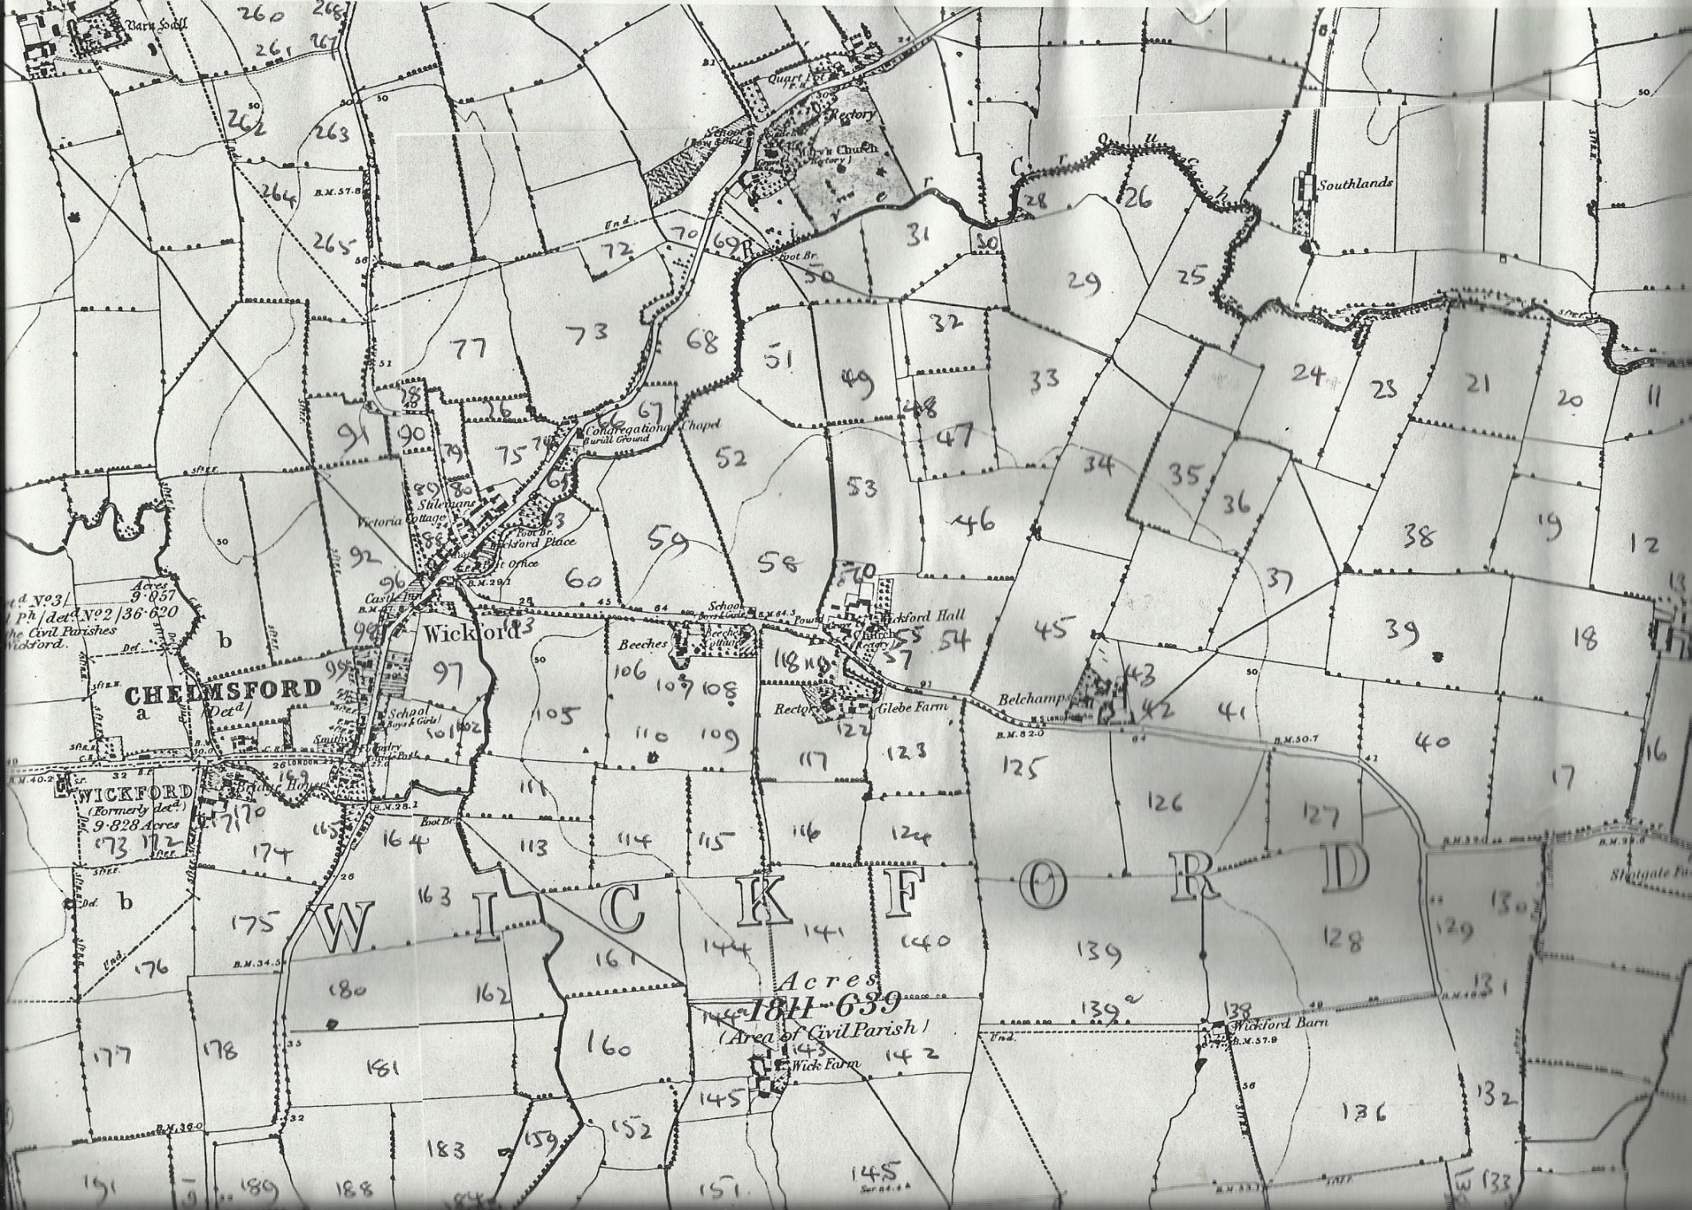
Map 1
Map 2
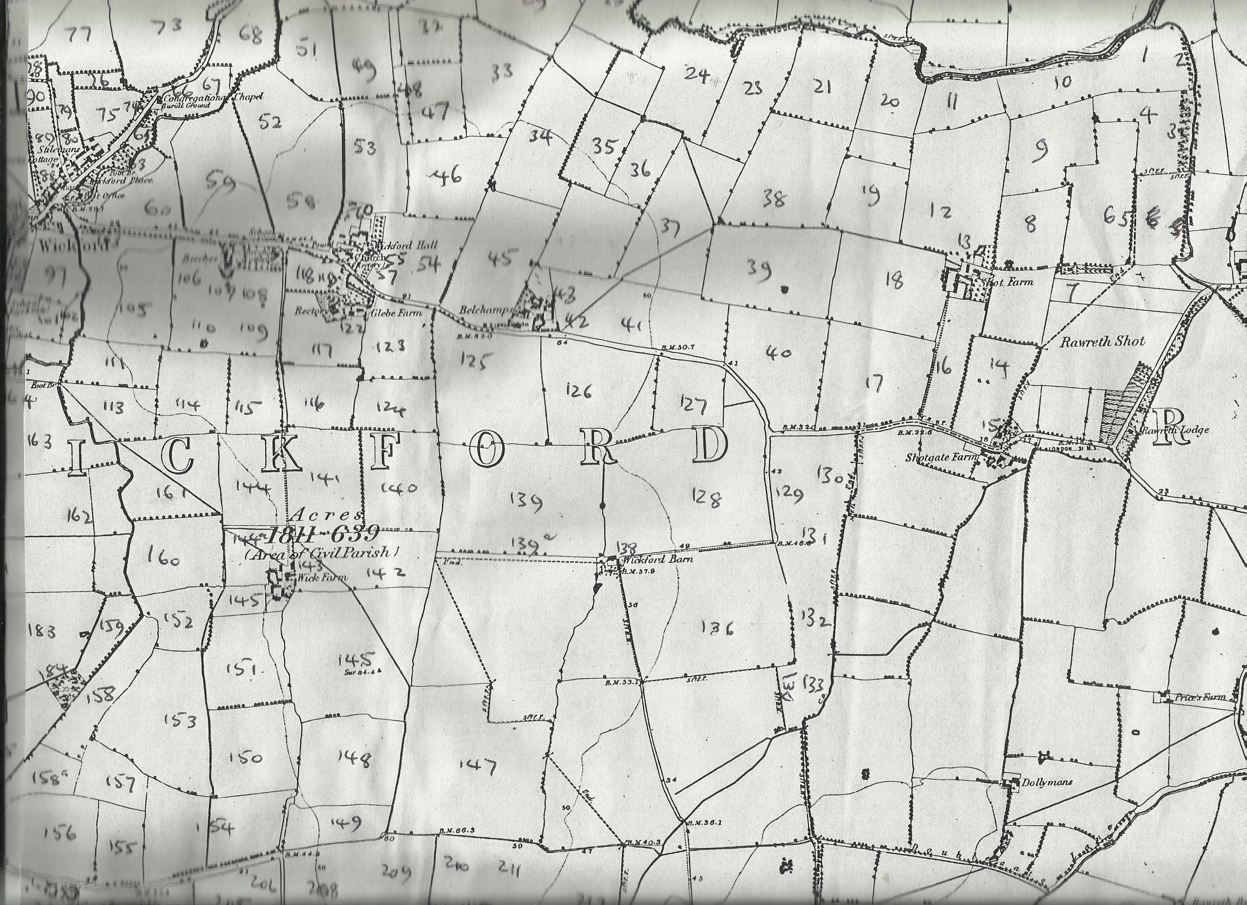
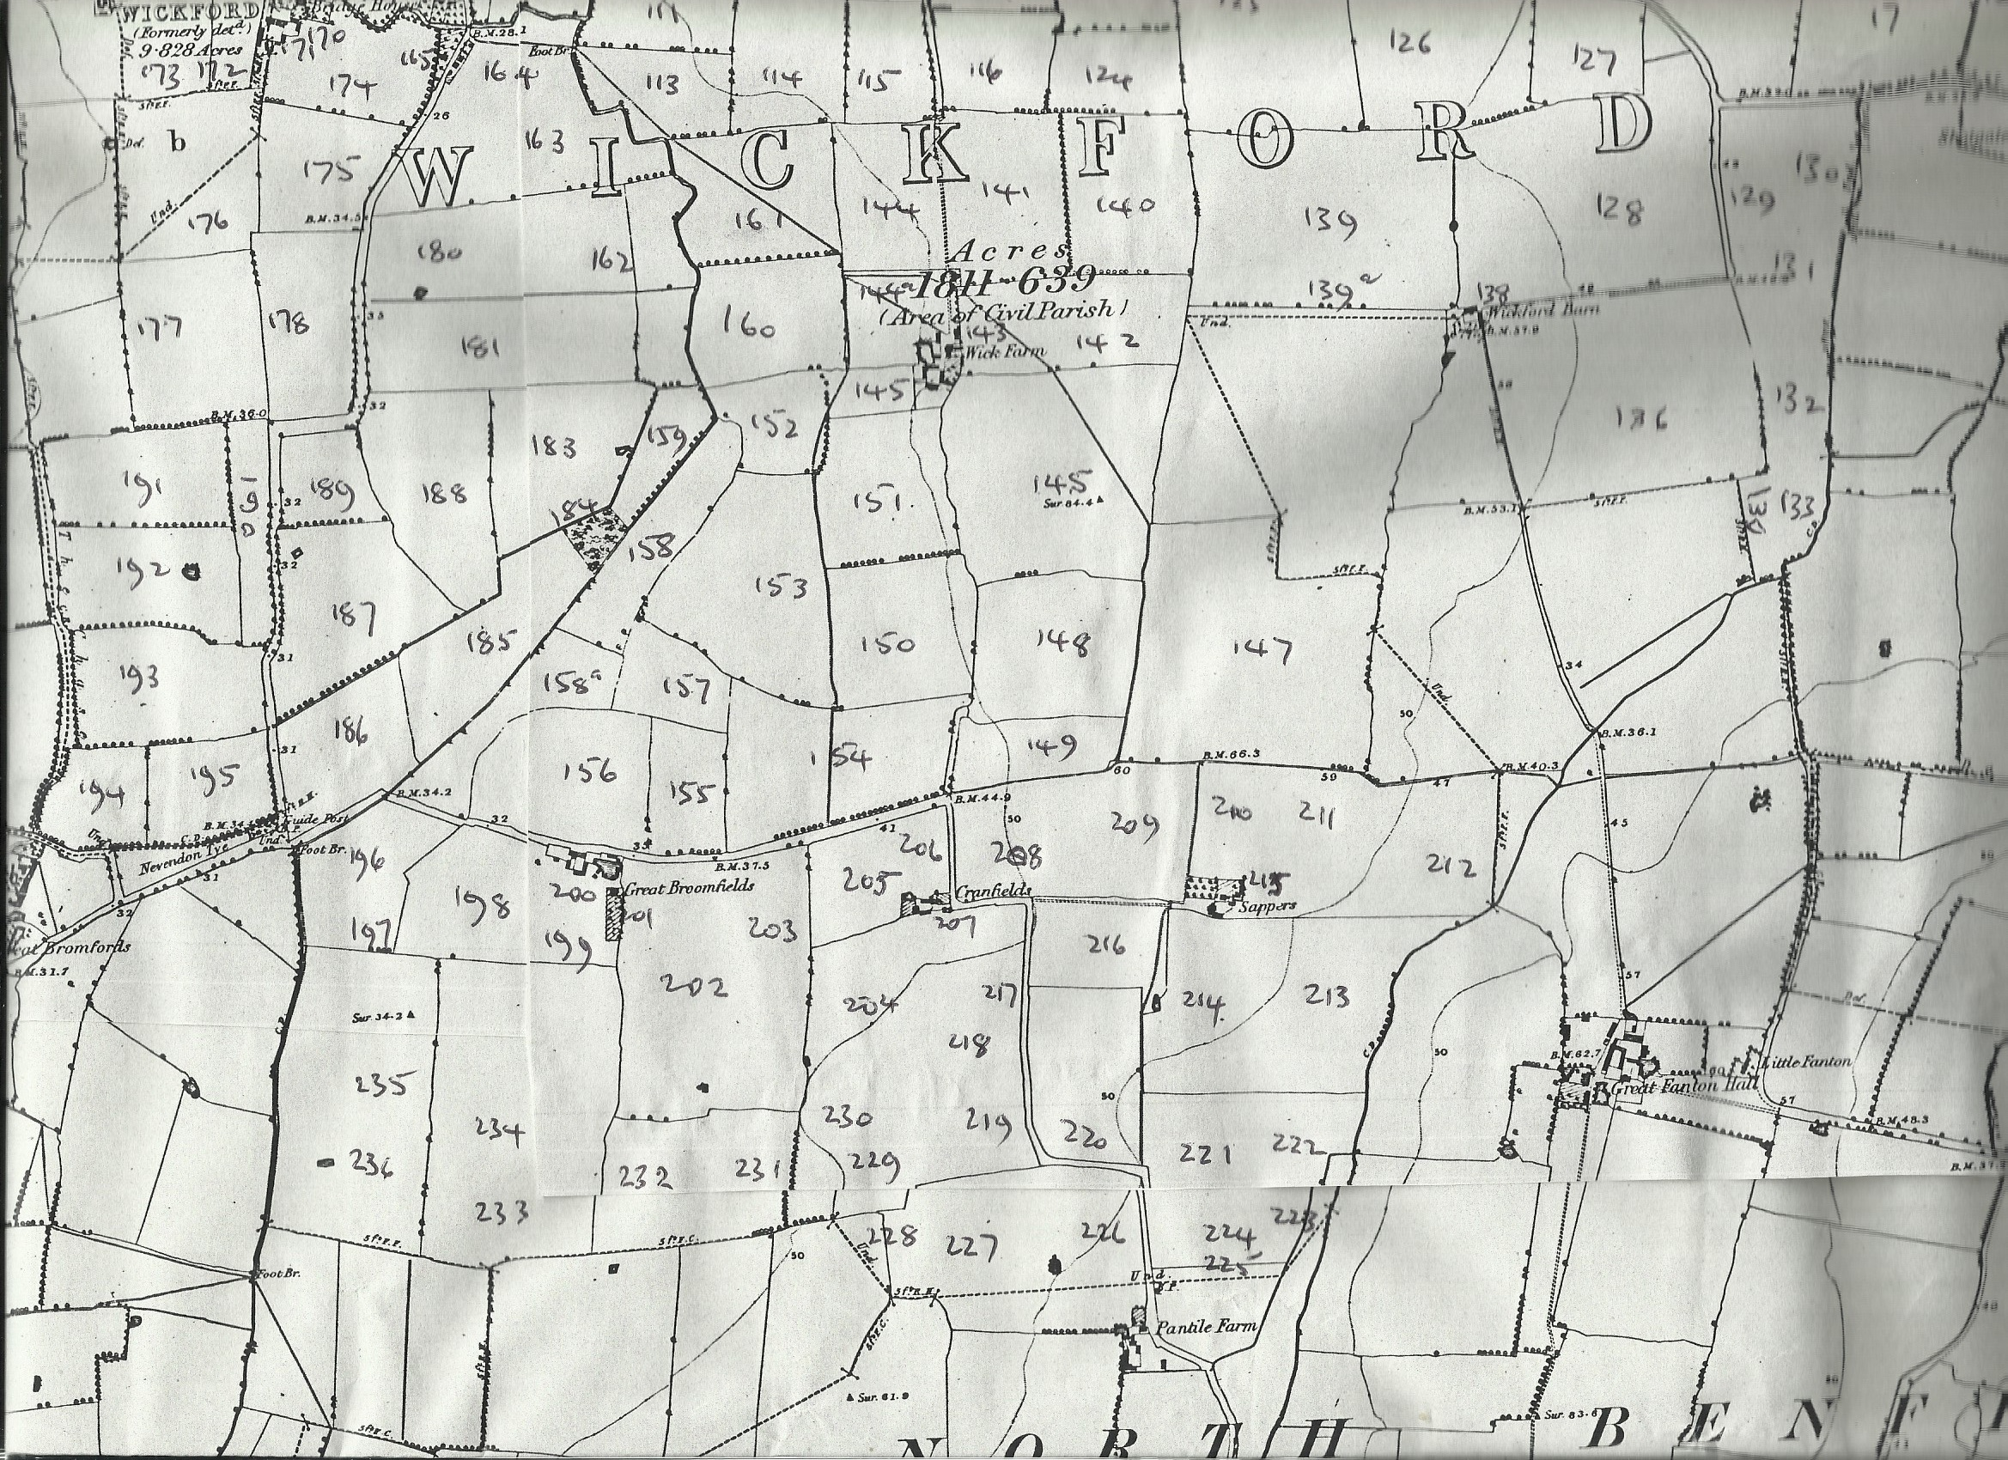
Map 3

