THE PLACE-NAMES OF

WICKHAM BONHUNT

Recorder: James Kemble

Essex Place-names Project (Essex Society for Archaeology & History)

Essex Record Office e-book, 2011. (1st edition hard copy 2004).

www.essex.ac.uk/history/esah/essexplacenames

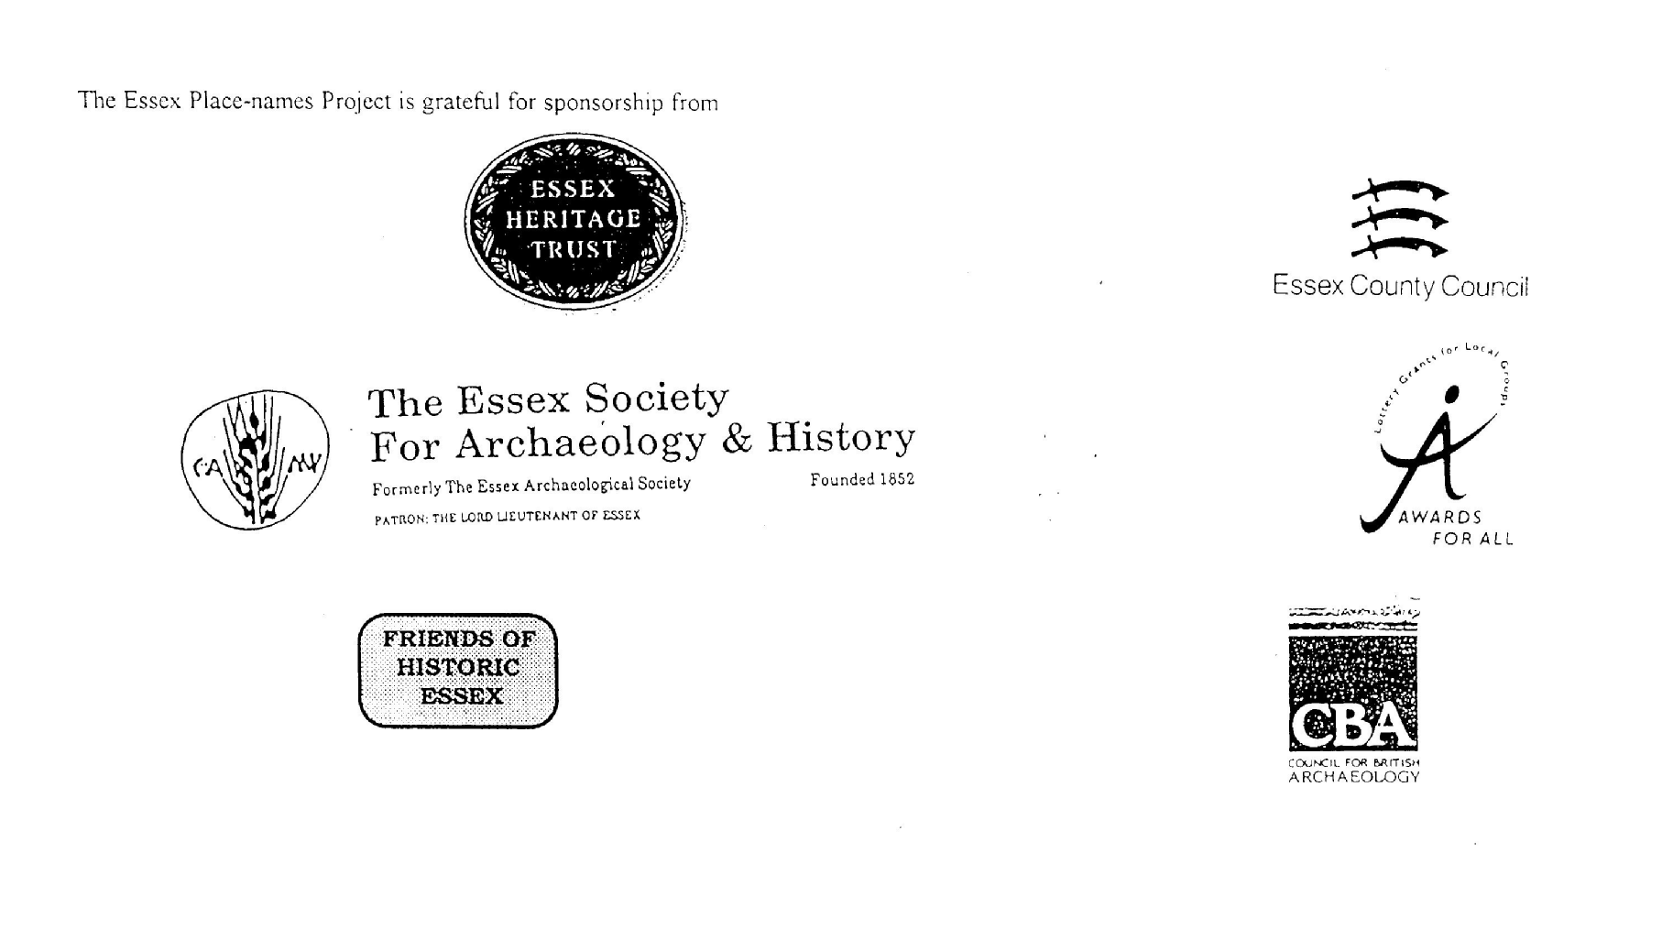

ESSEX PLACE-NAMES PROJECT.

The Essex Place-names Project is a County-wide survey to record place- and field-names from historical documents such as Tithe maps and apportionments, estate maps, sale and auction catalogues, conveyances, terriers, deeds, rolls, inquisitions and surveys.

The second element of the Project is to investigate on-the-ground visible remains which correspond to the Place-names for actual or potential archaeological, agricultural and industrial
sites, and to record natural (topographical) and man-made features which may relate to the Place-name. This involves field-survey in rural and outside investigation in built-up areas.

It is anticipated that the Project will lead to identification of archaeological sites and lost historic buildings; it will enable analysis of indicators of early settlement, land holding, agricultural and industrial practices of the County. It will refine the more precise meaning of descriptive words and elements used by earlier settlers as they gave names appropriate to the topography of the landscape of their time.

For convenience the surveys are based on the parish, recognising that present civil parish boundaries are not necessarily identical to former ecclesiastical boundaries. Local Recorders
are supplied with templates of Record Forms to ensure consistency of recording across the County, and forward completed forms to a Central Coordinator for transfer to a county
computer database which is available at the Essex Record Office to researchers.

This publication presents part of the information recorded from the Tithe or Estate Award and Map, (and from other documents for this parish.) The full record is contained on the master database in the Essex Record Office, Wharf Road, Chelmsford CM2 6YT and the website www.essex.ac.uk/history/esah/essexplacenames. Parish books are available from the ERO on disc or in hard copy or may be downloaded from the website. Please notify errors to the Project Coordinator at the Essex Record Office.

THE TITHE MAP AND APPORTIONMENT.

Since medieval times a tenth of the produce of land and stock had been paid by landholders to the church. At the Dissolution of the Monasteries, the property of many religious houses,
including the right to collect tithes, passed into lay hands. The Tithe Commutation Act which received Royal assent on 13th August 1836 abolished a rent payable in kind and
substituted rent-charges apportioned on each plot or parcel. The tithe-rent payable was assessed on the average value of wheat, barley and oats and was to fluctuate with price movements.

The commutation could be by voluntary agreement between the local owners and payers or, if agreement failed, could be compulsorily imposed by commissioners. A Valuer was to be
appointed to apportion the rent of each parcel of land and tenants could deduct that rent-charge from their rent paid to the landlord. The task fell to the Tithe Commissioners to produce a map and an Apportionment (Award). A large-scale survey was produced for over 70% of England and Wales in the following 9 years, and about another 8% up to 1855. Most of the
parishes in Essex were surveyed. The map scales vary. The Award records ownership, tenancy and land-use, field by field and parcel by parcel (often quoting the field name) with the
ground area and rent-charge.

Land that was tithe-free tends to be less accurately mapped and contains few if any of the details recorded for those parcels subject to tithe. Rights of way and roads also tend to be
neglected. Boundaries of the tithe areas are shown as are some natural features such as streams, ponds, gardens, greens and commons. Buildings are often shown coloured red if dwellings or grey if not. Because the Award may have been agreed only some time after the map was finished, discrepancies occur between the two. Enclosure Awards, when extant, usually date to the 18th and early 19th centuries. J.Kemble.
Reproduced by permission
of Essex County Council.

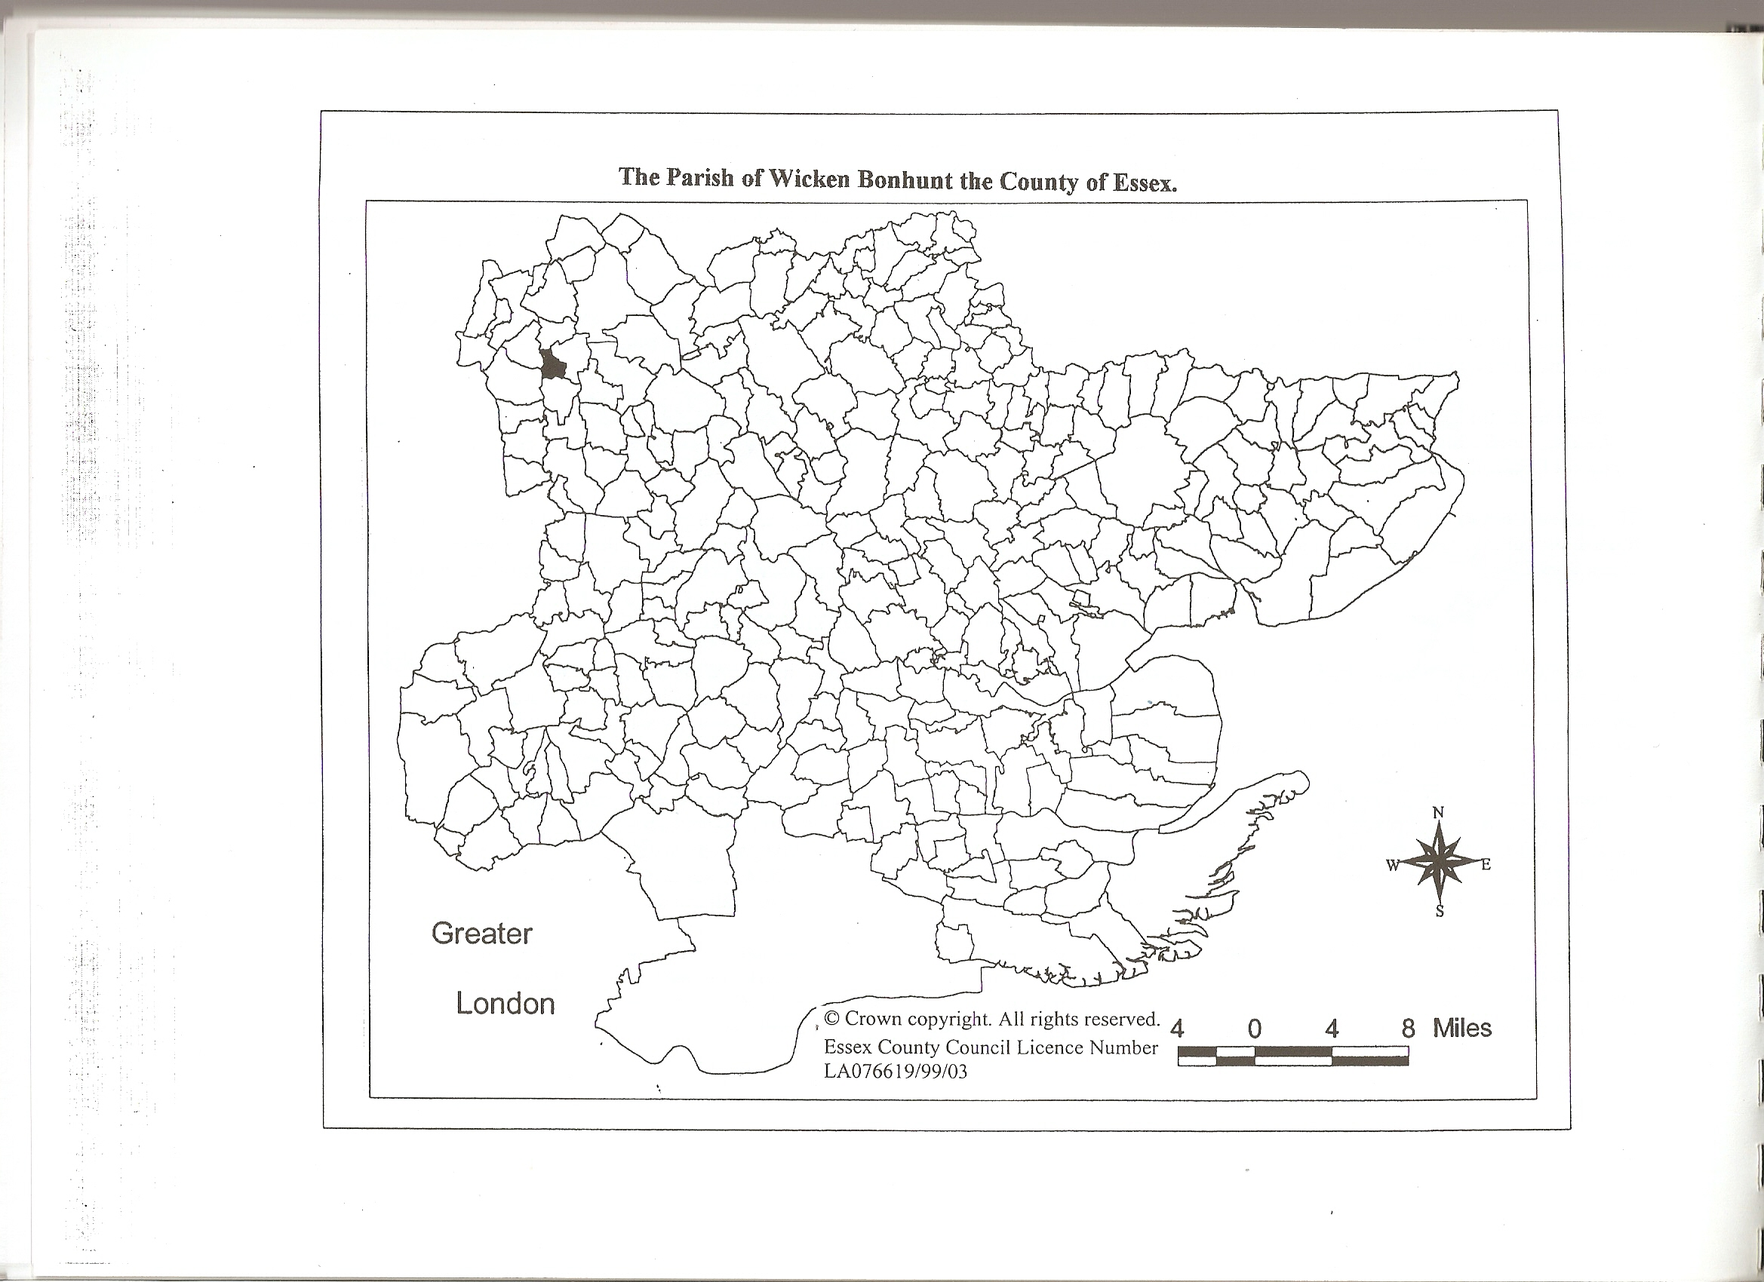

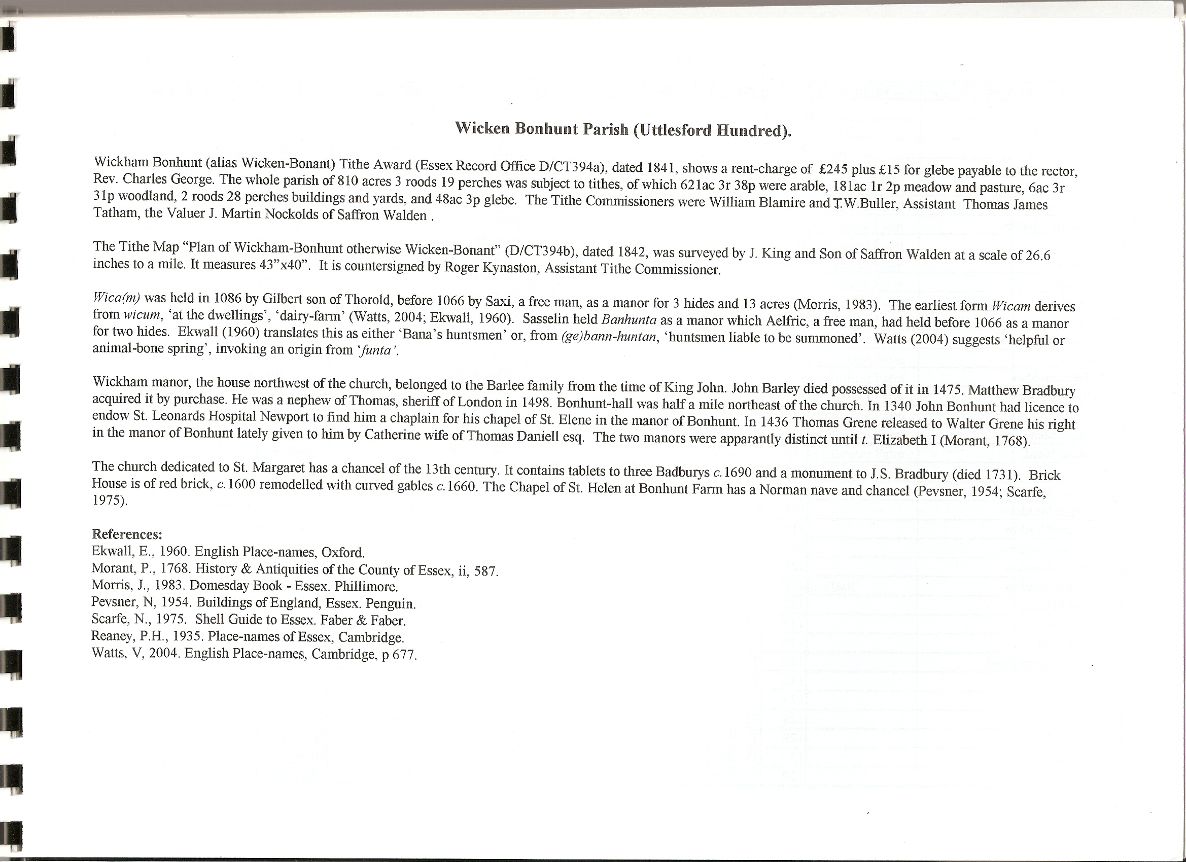

The Tithe Award Place-names of Wickham Bonhunt – by Parcel No.

Place-name | Alias | Fld No | Gd Ref | x | y | Acr | rd | pch | Land use | Owner | Occupier | Name of farm | Other information
Dodmoor Ley |  | 1 | TL | 495 | 347 | 25 | 1 | 10 | arable | Smith, William Charles | Gaifford, Anthony | Wicken Hall
Grove in Dodmoor Ley |  | 2 | TL | 496 | 347 | 0 | 1 | 22 | wood | Smith, William Charles | Gaifford, Anthony | Wicken Hall
Dodmoor |  | 3 | TL | 496 | 346 | 6 | 3 | 23 | arable | Martin, Joseph | Stock,Charles
In Dodmoor Common |  | 4 | TL | 498 | 346 | 1 | 3 | 15 | arable | Martin, Joseph | Stock,Charles
In Dodmoor Common |  | 5 | TL | 498 | 347 | 2 | 3 | 10 | arable | Smith, William Charles | Glasscock, Thomas
In Dodmoor Common |  | 6 | TL | 499 | 347 | 7 | 3 | 37 | arable | Smith, William Charles | Gaifford, Anthony | Wicken Hall
In Dodmoor Common |  | 7 | TL | 500 | 347 | 2 | 1 | 17 | arable | Smith, William Charles | Glasscock, Thomas
In Dodmoor Common |  | 8 | TL | 500 | 346 | 0 | 1 | 0 | arable | George, Rev Charles | Brooks, James |  | glebe
In Dodmoor Common |  | 9 | TL | 501 | 347 | 0 | 2 | 28 | arable | George, Rev Charles | Brooks, James |  | glebe
In Dodmoor Common |  | 10 | TL | 501 | 347 | 1 | 3 | 29 | arable | Smith, William Charles | Gaifford, Anthony | Wicken Hall
In Dodmoor Common |  | 11 | TL | 501 | 347 | 2 | 0 | 23 | arable | Smith, William Charles | Glasscock, Thomas
In Dodmoor Common |  | 12 | TL | 502 | 345 | 1 | 2 | 32 | arable | Martin, Joseph | Stock,Charles
In Dodmoor Common |  | 13 | TL | 502 | 347 | 1 | 0 | 23 | arable | Smith, William Charles | Glasscock, Thomas
In Dodmoor Common |  | 14 | TL | 502 | 345 | 4 | 0 | 7 | arable | Smith, William Charles | Glasscock, Thomas
In Dodmoor Common |  | 15 | TL | 501 | 346 | 3 | 0 | 31 | arable | Smith, William Charles | Gaifford, Anthony | Wicken Hall
In Dodmoor Common |  | 16 | TL | 500 | 346 | 1 | 3 | 15 | arable | Smith, William Charles | Gaifford, Anthony | Wicken Hall
In Dodmoor Common |  | 17 | TL | 499 | 346 | 1 | 2 | 15 | arable | Smith, William Charles | Glasscock, Thomas
In Dodmoor Common |  | 18 | TL | 498 | 344 | 1 | 0 | 12 | arable | Martin, Joseph | Stock,Charles
In Dodmoor Common |  | 19 | TL | 498 | 346 | 2 | 1 | 3 | arable | Smith, William Charles | Glasscock, Thomas
In Dodmoor Common |  | 20 | TL | 497 | 346 | 8 | 3 | 14 | arable | Smith, William Charles | Gaifford, Anthony | Wicken Hall
In Dodmoor Common |  | 21 | TL | 496 | 345 | 1 | 3 | 0 | arable | Smith, William Charles | Glasscock, Thomas
In Dodmoor Common |  | 22 | TL | 492 | 344 | 1 | 0 | 4 | arable | Martin, Joseph | Stock,Charles
In Dodmoor Common |  | 23 | TL | 496 | 345 | 0 | 3 | 33 | arable | Smith, William Charles | Glasscock, Thomas
In Dodmoor Common |  | 24 | TL | 496 | 345 | 3 | 2 | 5 | arable | Martin, Joseph | Stock,Charles
In Dodmoor Common |  | 25 | TL | 495 | 345 | 2 | 2 | 20 | arable | George, Rev Charles | Brooks, James |  | glebe
In Dodmoor Common |  | 26 | TL | 494 | 344 | 5 | 1 | 0 | arable | Smith, William Charles | Gaifford, Anthony | Wicken Hall
Grove |  | 27 | TL | 494 | 342 | 0 | 0 | 29 | wood | Smith, William Charles | Gaifford, Anthony | Wicken Hall
Grove |  | 28 | TL | 496 | 341 | 1 | 1 | 3 | wood | Smith, William Charles | Gaifford, Anthony | Wicken Hall
In Dodmoor Common |  | 29 | TL | 496 | 342 | 9 | 3 | 25 | arable | Smith, William Charles | Gaifford, Anthony | Wicken Hall
In Dodmoor Common |  | 30 | TL | 496 | 343 | 6 | 0 | 35 | arable | Smith, William Charles | Glasscock, Thomas
In Dodmoor Common |  | 31 | TL | 497 | 344 | 2 | 0 | 38 | arable | Martin, Joseph | Stock,Charles
In Dodmoor Common |  | 32 | TL | 497 | 344 | 2 | 0 | 17 | arable | Smith, William Charles | Gaifford, Anthony | Wicken Hall
In Dodmoor Common |  | 33 | TL | 497 | 344 | 0 | 3 | 30 | arable | Martin, Joseph | Stock,Charles
In Dodmoor Common |  | 34 | TL | 497 | 344 | 2 | 2 | 13 | arable | George, Rev Charles | Brooks, James |  | glebe
In Dodmoor Common |  | 35 | TL | 497 | 345 | 1 | 2 | 18 | arable | Smith, William Charles | Gaifford, Anthony | Wicken Hall
In Dodmoor Common |  | 36 | TL | 498 | 343 | 15 | 0 | 12 | arable | Smith, William Charles | Gaifford, Anthony | Wicken Hall
In Dodmoor Common |  | 37 | TL | 501 | 343 | 19 | 2 | 8 | arable | Smith, William Charles | Gaifford, Anthony | Wicken Hall
In Dodmoor Common |  | 38 | TL | 503 | 343 | 1 | 1 | 27 | arable | Smith, William Charles | Glasscock, Thomas
In Dodmoor Common |  | 39 | TL | 502 | 341 | 4 | 3 | 32 | arable | Smith, William Charles | Glasscock, Thomas
In East field |  | 40 | TL | 503 | 342 | 2 | 2 | 2 | arable | Smith, William Charles | Gaifford, Anthony | Wicken Hall
In East field |  | 41 | TL | 503 | 341 | 1 | 0 | 25 | arable | Smith, William Charles | Glasscock, Thomas
In East field |  | 42 | TL | 504 | 341 | 0 | 2 | 18 | arable | George, Rev Charles | Brooks, James |  | glebe
In East field |  | 43 | TL | 504 | 340 | 5 | 1 | 21 | arable | Smith, William Charles | Gaifford, Anthony | Wicken Hall
In East field |  | 44 | TL | 504 | 340 | 1 | 0 | 12 | arable | Martin, Joseph | Stock,Charles
In East field |  | 45 | TL | 505 | 340 | 1 | 1 | 20 | arable | Smith, William Charles | Glasscock, Thomas
In East field |  | 46 | TL | 505 | 340 | 0 | 2 | 33 | arable | George, Rev Charles | Brooks, James |  | glebe
In East field |  | 47 | TL | 505 | 340 | 3 | 0 | 12 | arable | Smith, William Charles | Glasscock, Thomas
In East field |  | 48 | TL | 506 | 340 | 0 | 3 | 14 | arable | George, Rev Charles | Brooks, James |  | glebe
In East field |  | 49 | TL | 506 | 340 | 1 | 3 | 13 | arable | Smith, William Charles | Glasscock, Thomas
In East field |  | 50 | TL | 506 | 339 | 1 | 1 | 18 | arable | Martin, Joseph | Stock,Charles
In East field |  | 51 | TL | 506 | 339 | 0 | 3 | 24 | arable | Smith, William Charles | Glasscock, Thomas
In East field |  | 52 | TL | 507 | 339 | 3 | 1 | 2 | arable | Smith, William Charles | Gaifford, Anthony | Wicken Hall
The Severals |  | 53 | TL | 510 | 337 | 26 | 1 | 4 | arable | Webb, Mary | Living, Joseph | Wicken Bonant
In East field |  | 54 | TL | 506 | 337 | 3 | 2 | 37 | arable | Smith, William Charles | Glasscock, Thomas
In East field |  | 55 | TL | 506 | 338 | 6 | 0 | 35 | arable | Smith, William Charles | Gaifford, Anthony | Wicken Hall
In East field |  | 56 | TL | 504 | 337 | 4 | 2 | 25 | arable | Smith, William Charles | Glasscock, Thomas
In East field |  | 57 | TL | 504 | 338 | 2 | 0 | 15 | arable | Martin, Joseph | Stock,Charles
In East field |  | 58 | TL | 503 | 338 | 5 | 2 | 12 | arable | George, Rev Charles | Brooks, James |  | glebe
The Severals |  | 59 | TL | 500 | 338 | 37 | 2 | 12 | arable | Smith, William Charles | Gaifford, Anthony | Wicken Hall
Roadway |  | 60 | TL | 498 | 338 | 0 | 3 | 30 |  | Smith, William Charles | Gaifford, Anthony | Wicken Hall
Wood field, Hog Yard Piece |  | 61 | TL | 497 | 338 | 34 | 2 | 28 | arable | Smith, William Charles | Gaifford, Anthony | Wicken Hall
Grove |  | 62 | TL | 495 | 339 | 0 | 3 | 10 | wood | Smith, William Charles | Gaifford, Anthony | Wicken Hall
Twelve Acre Wood |  | 63 | TL | 496 | 337 | 14 | 3 | 16 | arable | Martin, Joseph | Stock,Charles
Tarney Hooks (part) |  | 64 | TL | 495 | 333 | 4 | 2 | 18 | arable | Martin, Joseph | Stock,Charles
Tarney Hooks (part) |  | 64a | TL | 496 | 334 | 1 | 0 | 0 | arable | Martin, Joseph | Stock,Charles
Kings field |  | 65 | TL | 496 | 336 | 4 | 0 | 31 | arable | Martin, Joseph | Stock,Charles
Eight Acre Meadow |  | 66 | TL | 496 | 334 | 8 | 2 | 28 | grass | Martin, Joseph | Stock,Charles
Broom Hills |  | 67 | TL | 497 | 332 | 2 | 2 | 34 | grass | Martin, Joseph | Stock,Charles
Plantation |  | 68 | TL | 497 | 332 | 0 | 2 | 34 | wood | Martin, Joseph | Martin, Joseph
Coney yard |  | 69 | TL | 498 | 333 | 4 | 1 | 29 | grass | Smith, William Charles | Gaifford, Anthony | Wicken Hall
Wicken Hall Farm, homestead |  | 70 | TL | 498 | 334 | 1 | 2 | 27 |  | Smith, William Charles | Gaifford, Anthony | Wicken Hall
Church yard | [St Margarets] | 71 | TL | 499 | 334 | 0 | 1 | 9
Cottage, garden |  | 72 | TL | 499 | 334 | 0 | 0 | 31 |  | George, Rev Charles | Brooks, James |  | glebe
Barn yard etc |  | 73 | TL | 499 | 334 | 0 | 1 | 9 |  | George, Rev Charles | Brooks, James |  | glebe
Orchard |  | 74 | TL | 499 | 334 | 0 | 2 | 34 | grass | Smith, William Charles | Gaifford, Anthony | Wicken Hall
Hog yard |  | 75 | TL | 498 | 334 | 4 | 1 | 26 | grass | Smith, William Charles | Gaifford, Anthony | Wicken Hall
In Fletters Garden |  | 76 | TL | 500 | 336 | 3 | 3 | 27 | arable | George, Rev Charles | Osborne, James |  | glebe
In Fletters Garden |  | 77 | TL | 502 | 336 | 1 | 0 | 19 | arable | Smith, William Charles | Glasscock, Thomas
In Fletters Garden |  | 78 | TL | 500 | 336 | 0 | 3 | 21 | arable | Martin, Joseph | Stock,Charles
In Fletters Garden |  | 79 | TL | 503 | 335 | 11 | 0 | 22 | arable | Smith, William Charles | Glasscock, Thomas
Windmill, yard |  | 80 | TL | 502 | 335 | 0 | 1 | 37 |  | Smith, William Charles | Osborne, James
In Fletters Garden |  | 81 | TL | 500 | 335 | 1 | 2 | 1 | arable | George, Rev Charles | Osborne, James |  | glebe
In Fletters Garden |  | 82 | TL | 499 | 335 | 3 | 0 | 20 | arable | Smith, William Charles | Gaifford, Anthony | Wicken Hall
Paddock |  | 83 | TL | 500 | 334 | 2 | 2 | 30 | grass | George, Rev Charles | George, Rev Charles |  | glebe
Vicarage House, Pleasure Ground |  | 84 | TL | 500 | 334 | 1 | 0 | 39 |  | George, Rev Charles | George, Rev Charles |  | glebe
Garden |  | 85 | TL | 501 | 334 | 0 | 2 | 10 |  | George, Rev Charles | George, Rev Charles |  | glebe
Crab Tree Croft |  | 86 | TL | 502 | 334 | 1 | 1 | 15 | arable | Smith, William Charles | Glasscock, Thomas
Pasture |  | 87 | TL | 502 | 335 | 0 | 3 | 23 | grass | Smith, William Charles | Osborne, James
Reeds Close |  | 88 | TL | 502 | 335 | 3 | 2 | 17 | arable | Smith, William Charles | Glasscock, Thomas
House, garden |  | 89 | TL | 502 | 334 | 0 | 1 | 1 |  | Smith, William Charles | Osborne, James
Cottage, garden |  | 90 | TL | 502 | 335 | 0 | 0 | 15 |  | Smith, William Charles | Gaylor, James
Cottage, garden |  | 91 | TL | 503 | 335 | 0 | 1 | 2 |  | Smith, William Charles | Brooks,John;Gardiner,Joseph
Cottage, garden |  | 92 | TL | 502 | 334 | 0 | 0 | 17 |  | Clark, Joseph | Corby,Charles;Watson,James
Church Croft |  | 93 | TL | 503 | 335 | 1 | 0 | 38 | grass | Smith, William Charles | Glasscock, Thomas
Hop Ground |  | 94 | TL | 505 | 335 | 3 | 2 | 0 | grass | Smith, William Charles | Gaifford, Anthony | Wicken Hall
In Reynolds field |  | 95 | TL | 504 | 336 | 4 | 0 | 0 | arable | Smith, William Charles | Glasscock, Thomas
In Reynolds Field |  | 96 | TL | 505 | 336 | 4 | 0 | 37 | arable | George, Rev Charles | Brooks, James |  | glebe
In Reynolds field |  | 97 | TL | 505 | 336 | 3 | 1 | 24 | arable | Smith, William Charles | Glasscock, Thomas
Wren Park |  | 98 | TL | 507 | 336 | 3 | 1 | 32 | arable | Martin, Joseph | Stock,Charles
Lamb Pits |  | 99 | TL | 508 | 335 | 13 | 2 | 29 | arable | Webb, Mary | Living, Joseph | Wicken Bonant
Plantation |  | 100 | TL | 509 | 334 | 0 | 1 | 17 | wood | Smith, William Charles | Gaifford, Anthony | Wicken Hall
Acre Mead |  | 101 | TL | 510 | 334 | 0 | 3 | 38 | grass | Webb, Mary | Living, Joseph | Wicken Bonant
Chapel Close |  | 102 | TL | 510 | 335 | 7 | 1 | 18 | grass | Webb, Mary | Living, Joseph | Wicken Bonant
Wicken Bonant Farm homestead | Bonhunt, 1875,OS | 103 | TL | 512 | 335 | 1 | 0 | 14 |  | Webb, Mary | Living, Joseph | Wicken Bonant
House orchard garden |  | 104 | TL | 513 | 335 | 0 | 3 | 25 |  | Webb, Mary | Living, Joseph | Wicken Bonant
Rye field |  | 105 | TL | 513 | 336 | 3 | 2 | 20 | grass | Webb, Mary | Living, Joseph | Wicken Bonant
Bridge field |  | 106 | TL | 514 | 336 | 3 | 3 | 7 | arable | Webb, Mary | Living, Joseph | Wicken Bonant
Hop Ground |  | 107 | TL | 514 | 335 | 3 | 2 | 3 | grass | Webb, Mary | Living, Joseph | Wicken Bonant
Wood yard |  | 108 | TL | 512 | 335 | 0 | 3 | 25 | grass | Webb, Mary | Living, Joseph | Wicken Bonant
Roadway |  | 109 | TL | 512 | 334 | 0 | 0 | 22 |  | Webb, Mary | Living, Joseph | Wicken Bonant
The Borver |  | 110 | TL | 513 | 334 | 2 | 2 | 33 | grass | Webb, Mary | Living, Joseph | Wicken Bonant
Little Tobacco Shot |  | 111 | TL | 514 | 334 | 5 | 1 | 6 | grass | Webb, Mary | Living, Joseph | Wicken Bonant
Great Tobacco Shot |  | 112 | TL | 512 | 332 | 17 | 3 | 9 | grass | Webb, Mary | Living, Joseph | Wicken Bonant
Great Borver |  | 113 | TL | 511 | 333 | 3 | 1 | 29 | grass | Webb, Mary | Living, Joseph | Wicken Bonant
Seven Acre Mead |  | 114 | TL | 510 | 333 | 5 | 3 | 20 | grass | Webb, Mary | Living, Joseph | Wicken Bonant
Three Acre Mead |  | 115 | TL | 510 | 334 | 2 | 3 | 7 | grass | Webb, Mary | Living, Joseph | Wicken Bonant
Holmes |  | 116 | TL | 508 | 333 | 4 | 2 | 32 | grass | Smith, William Charles | Gaifford, Anthony | Wicken Hall
In Common Meadow |  | 117 | TL | 508 | 333 | 0 | 1 | 14 | grass | Smith, William Charles | Gaifford, Anthony | Wicken Hall
In Common Meadow |  | 118 | TL | 508 | 334 | 1 | 1 | 35 | grass | Smith, William Charles | Glasscock, Thomas
In Common Meadow |  | 119 | TL | 508 | 334 | 0 | 2 | 35 | grass | Martin, Joseph | Stock,Charles
In Common Meadow |  | 120 | TL | 507 | 334 | 1 | 2 | 17 | grass | Smith, William Charles | Glasscock, Thomas
In Common Meadow |  | 121 | TL | 506 | 334 | 7 | 3 | 3 | grass | Smith, William Charles | Gaifford, Anthony | Wicken Hall
Hill Field Bottom |  | 122 | TL | 504 | 334 | 3 | 0 | 35 | grass | Smith, William Charles | Glasscock, Thomas
Hill Field Top |  | 123 | TL | 504 | 334 | 6 | 2 | 31 | arable | Smith, William Charles | Glasscock, Thomas
Cart Shed field |  | 124 | TL | 503 | 334 | 1 | 3 | 7 | grass | Smith, William Charles | Glasscock, Thomas
Lower Farm Homestead |  | 125 | TL | 502 | 334 | 0 | 3 | 20 |  | Smith, William Charles | Glasscock, Thomas
Orchard |  | 126 | TL | 502 | 334 | 0 | 3 | 6 | grass | Smith, William Charles | Glasscock, Thomas
Pond field |  | 127 | TL | 504 | 333 | 1 | 3 | 29 | grass | Smith, William Charles | Glasscock, Thomas
Grove |  | 128 | TL | 503 | 333 | 0 | 0 | 31 | wood | Smith, William Charles | Glasscock, Thomas
Orchard field |  | 129 | TL | 503 | 333 | 2 | 1 | 35 | grass | Smith, William Charles | Glasscock, Thomas
Pightle |  | 130 | TL | 502 | 333 | 4 | 0 | 36 | arable | Smith, William Charles | Glasscock, Thomas
Pump Close |  | 131 | TL | 502 | 334 | 1 | 0 | 28 | grass | Smith, William Charles | Glasscock, Thomas
Cottage, garden |  | 132 | TL | 501 | 333 | 0 | 2 | 0 |  | Martin, Joseph | Holland,Jacob;Banks,William
Cottage garden & Close |  | 133 | TL | 501 | 333 | 1 | 0 | 1 | grass | Martin, Joseph | Corby, John
Four Acres (cottage allotments) |  | 134 | TL | 501 | 332 | 5 | 0 | 8 | arable | George, Rev Charles | George, Rev Charles |  | glebe
Grove |  | 135 | TL | 501 | 332 | 0 | 0 | 37 | wood | Smith, William Charles | Gaifford, Anthony | Wicken Hall
Pightle |  | 136 | TL | 500 | 333 | 0 | 3 | 31 | grass | George, Rev Charles | Brooks, James |  | glebe
National School |  | 137 | TL | 500 | 333 | 0 | 0 | 1
Three Horse Shoes Public House |  | 138 | TL | 499 | 333 | 0 | 0 | 32 |  | Martin, Joseph | Turner, James
Cottage, garden |  | 139 | TL | 499 | 333 | 0 | 0 | 14 |  | Martin, Joseph | Corby,George; Miller,John
Cottage, garden |  | 140 | TL | 498 | 332 | 0 | 0 | 28 |  | Clark, Joseph | Miller, Robert; Ward, James; Monk, William
Lower Horseleys |  | 141 | TL | 499 | 332 | 3 | 1 | 30 | grass | Smith, William Charles | Gaifford, Anthony | Wicken Hall
Horseleys |  | 142 | TL | 500 | 330 | 7 | 1 | 12 | arable | Smith, William Charles | Gaifford, Anthony | Wicken Hall
Grove |  | 143 | TL | 499 | 329 | 0 | 1 | 22 | wood | Smith, William Charles | Gaifford, Anthony | Wicken Hall
Plantation |  | 144 | TL | 498 | 330 | 0 | 0 | 9 | wood | Martin, Joseph | Martin, Joseph
Plantation |  | 145 | TL | 497 | 329 | 0 | 3 | 22 | wood | Martin, Joseph | Martin, Joseph
Dovehouse Close |  | 146 | TL | 497 | 331 | 1 | 3 | 21 | grass | Martin, Joseph | Martin, Joseph
Brick house, gdn, yard |  | 147 | TL | 497 | 332 | 1 | 2 | 35 |  | Martin, Joseph | Martin, Joseph
Plantation |  | 148a | TL | 497 | 332 | 0 | 0 | 12 | wood | Martin, Joseph | Martin, Joseph
Cottage, homestead | Brick House | 148 | TL | 497 | 332 | 0 | 1 | 22 |  | Martin, Joseph | Stock,Charles
Broom Hills (part) |  | 149 | TL | 496 | 332 | 1 | 0 | 16 | grass | Martin, Joseph | Stock,Charles
West Mead |  | 150 | TL | 495 | 332 | 9 | 3 | 22 | grass | Smith, William Charles | Gaifford, Anthony | Wicken Hall
Cottage, garden |  | 151 | TL | 494 | 331 | 0 | 0 | 25 |  | Smith, William Charles | Watson,William;Brooks,Joseph
Plantation |  | 152 | TL | 493 | 331 | 0 | 0 | 15 | wood | Wolfe, Richard Birch | Wolfe, Richard Birch
Cottage, garden |  | 153 | TL | 494 | 331 | 0 | 0 | 33 |  | Smith, William Charles | Turner,John;Clark,James
Cottage, garden |  | 154 | TL | 494 | 331 | 0 | 1 | 19 |  | Smith, William Charles | Read,Thomas;Bacon,William
Cottage, garden |  | 155 | TL | 495 | 331 | 0 | 1 | 1 |  | Smith, William Charles | Bush,Samuel;Gayler,William
Garden |  | 156 | TL | 496 | 331 | 0 | 0 | 24 |  | Martin, Joseph | Miller, John
Dovehouse Croft |  | 157 | TL | 496 | 331 | 0 | 2 | 25 | grass | Martin, Joseph | Stock,Charles
Dovehouse field |  | 158 | TL | 497 | 330 | 4 | 1 | 10 | grass | Martin, Joseph | Stock,Charles
Dovehouse field |  | 159 | TL | 496 | 330 | 4 | 1 | 2 | arable | Martin, Joseph | Stock,Charles
Little Bradley |  | 160 | TL | 496 | 330 | 6 | 0 | 38 | arable | Martin, Joseph | Stock,Charles
Sainfoin field |  | 161 | TL | 496 | 329 | 5 | 1 | 27 | arable | Martin, Joseph | Stock,Charles
New Croft |  | 162 | TL | 498 | 329 | 7 | 0 | 32 | arable | Martin, Joseph | Stock,Charles
Middle Horseleys |  | 163 | TL | 502 | 330 | 11 | 3 | 35 | arable | Smith, William Charles | Gaifford, Anthony | Wicken Hall
Grove |  | 164 | TL | 502 | 328 | 0 | 2 | 0 | wood | Smith, William Charles | Gaifford, Anthony | Wicken Hall
Ley Bridge |  | 165 | TL | 504 | 330 | 3 | 2 | 25 | arable | Smith, William Charles | Glasscock, Thomas
New Ground |  | 166 | TL | 504 | 332 | 8 | 2 | 13 | arable | Smith, William Charles | Glasscock, Thomas
Grove |  | 167 | TL | 505 | 332 | 0 | 2 | 5 | wood | Smith, William Charles | Glasscock, Thomas
Grove |  | 168 | TL | 505 | 331 | 0 | 3 | 19 | wood | Webb, Mary | Living, Joseph | Wicken Bonant
Mead field |  | 169 | TL | 507 | 331 | 37 | 1 | 15 | arable | Webb, Mary | Living, Joseph | Wicken Bonant
Mead field Pasture |  | 170 | TL | 509 | 332 | 3 | 0 | 37 | grass | Webb, Mary | Living, Joseph | Wicken Bonant
Grove |  | 171 | TL | 509 | 331 | 0 | 3 | 16 | wood | Webb, Mary | Living, Joseph | Wicken Bonant
Roadway |  | 172 | TL | 510 | 332 | 1 | 2 | 39 |  | Webb, Mary | Living, Joseph | Wicken Bonant
Grove |  | 173 | TL | 510 | 331 | 2 | 0 | 37 | wood | Webb, Mary | Living, Joseph | Wicken Bonant
In Fulwell Common |  | 174 | TL | 513 | 328 | 9 | 0 | 30 | arable | Smith, William Charles | Gayford, Dudley
Boaslers |  | 175 | TL | 513 | 328 | 2 | 0 | 8 | arable | Webb, Mary | Living, Joseph | Wicken Bonant
In Fulwell Common |  | 176 | TL | 512 | 326 | 4 | 0 | 13 | arable | Smith, William Charles | Gayford, Dudley
In Fulwell Common |  | 177 | TL | 510 | 325 | 23 | 1 | 2 | arable | Webb, Mary | Living, Joseph | Wicken Bonant
Long Milford |  | 178 | TL | 510 | 325 | 0 | 3 | 28 | arable | George, Rev Charles | Living, Joseph |  | glebe
London field |  | 179 | TL | 507 | 327 | 21 | 1 | 33 | arable | Webb, Mary | Living, Joseph | Wicken Bonant
London Ley |  | 180 | TL | 505 | 328 | 7 | 2 | 36 | arable | Webb, Mary | Living, Joseph | Wicken Bonant
Ley Bridges |  | 182 | TL | 505 | 330 | 2 | 3 | 10 | arable | George, Rev Charles | Brooks, James |  | glebe
Grove |  | 183 | TL | 505 | 329 | 0 | 2 | 10 | wood | Smith, William Charles | Gaifford, Anthony | Wicken Hall
Great Horseleys |  | 184 | TL | 503 | 328 | 30 | 0 | 32 | arable | Smith, William Charles | Gaifford, Anthony | Wicken Hall
Great Horseleys |  | 185 | TL | 504 | 326 | 13 | 1 | 22 | arable | Smith, William Charles | Gaifford, Anthony | Wicken Hall
In Cassey Common |  | 186 | TL | 503 | 325 | 2 | 3 | 15 | arable | George, Rev Charles | Brooks, James |  | glebe
In Cassey Common |  | 187 | TL | 501 | 325 | 4 | 0 | 1 | arable | Smith, William Charles | Glasscock, Thomas
In Cassey Common |  | 188 | TL | 500 | 325 | 1 | 1 | 37 | arable | Martin, Joseph | Stock, Charles
Grove |  | 189 | TL | 500 | 327 | 0 | 1 | 19 | wood | Smith, William Charles | Gaifford, Anthony | Wicken Hall
In Cassey Common |  | 190 | TL | 498 | 327 | 4 | 0 | 25 | arable | Smith, William Charles | Glasscock, Thomas
In Cassey Common |  | 191 | TL | 497 | 327 | 3 | 2 | 10 | arable | George, Rev Charles | Brooks, James |  | glebe
In Cassey Common |  | 192 | TL | 498 | 326 | 5 | 1 | 22 | arable | George, Rev Charles | Brooks, James |  | glebe
In Cassey Common |  | 193 | TL | 497 | 325 | 15 | 0 | 26 | arable | Smith, William Charles | Gaifford, Anthony | Wicken Hall
Grove |  | 194 | TL | 496 | 325 | 0 | 3 | 36 | wood | Smith, William Charles | Gaifford, Anthony | Wicken Hall
Great Bradleys |  | 195 | TL | 495 | 326 | 16 | 0 | 23 | arable | Smith, William Charles | Gaifford, Anthony | Wicken Hall

For abbreviations see Reaney, P., Place-names of Essex, Cambridge 1935; and Kemble, J., Essex Place-names, Places, Streets & People, Historical Publications, London 2007.

The Tithe Award Place-names of Wickham Bonhunt – by Place-name.

Place-name | Alias | Fld No | Gd Ref | x | y | Acr | rd | pch | Land use | Owner | Occupier | Name of farm | Other information
Acre Mead |  | 101 | TL | 510 | 334 | 0 | 3 | 38 | grass | Webb, Mary | Living, Joseph | Wicken Bonant
Barn yard etc |  | 73 | TL | 499 | 334 | 0 | 1 | 9 |  | George, Rev Charles | Brooks, James |  | glebe
Boaslers |  | 175 | TL | 513 | 328 | 2 | 0 | 8 | arable | Webb, Mary | Living, Joseph | Wicken Bonant
Brick house, gdn, yard |  | 147 | TL | 497 | 332 | 1 | 2 | 35 |  | Martin, Joseph | Martin, Joseph
Bridge field |  | 106 | TL | 514 | 336 | 3 | 3 | 7 | arable | Webb, Mary | Living, Joseph | Wicken Bonant
Broom Hills |  | 67 | TL | 497 | 332 | 2 | 2 | 34 | grass | Martin, Joseph | Stock,Charles
Broom Hills (part) |  | 149 | TL | 496 | 332 | 1 | 0 | 16 | grass | Martin, Joseph | Stock,Charles
Cart Shed field |  | 124 | TL | 503 | 334 | 1 | 3 | 7 | grass | Smith, William Charles | Glasscock, Thomas
Chapel Close |  | 102 | TL | 510 | 335 | 7 | 1 | 18 | grass | Webb, Mary | Living, Joseph | Wicken Bonant
Church Croft |  | 93 | TL | 503 | 335 | 1 | 0 | 38 | grass | Smith, William Charles | Glasscock, Thomas
Church yard | [St Margarets] | 71 | TL | 499 | 334 | 0 | 1 | 9
Coney yard |  | 69 | TL | 498 | 333 | 4 | 1 | 29 | grass | Smith, William Charles | Gaifford, Anthony | Wicken Hall
Cottage garden & Close |  | 133 | TL | 501 | 333 | 1 | 0 | 1 | grass | Martin, Joseph | Corby, John
Cottage, garden |  | 92 | TL | 502 | 334 | 0 | 0 | 17 |  | Clark, Joseph | Corby,Charles;Watson,James
Cottage, garden |  | 140 | TL | 498 | 332 | 0 | 0 | 28 |  | Clark, Joseph | Miller, Robert; Ward, James; Monk, William
Cottage, garden |  | 72 | TL | 499 | 334 | 0 | 0 | 31 |  | George, Rev Charles | Brooks, James |  | glebe
Cottage, garden |  | 139 | TL | 499 | 333 | 0 | 0 | 14 |  | Martin, Joseph | Corby,George; Miller,John
Cottage, garden |  | 132 | TL | 501 | 333 | 0 | 2 | 0 |  | Martin, Joseph | Holland,Jacob;Banks,William
Cottage, garden |  | 91 | TL | 503 | 335 | 0 | 1 | 2 |  | Smith, William Charles | Brooks,John;Gardiner,Joseph
Cottage, garden |  | 155 | TL | 495 | 331 | 0 | 1 | 1 |  | Smith, William Charles | Bush,Samuel;Gayler,William
Cottage, garden |  | 90 | TL | 502 | 335 | 0 | 0 | 15 |  | Smith, William Charles | Gaylor, James
Cottage, garden |  | 154 | TL | 494 | 331 | 0 | 1 | 19 |  | Smith, William Charles | Read,Thomas;Bacon,William
Cottage, garden |  | 153 | TL | 494 | 331 | 0 | 0 | 33 |  | Smith, William Charles | Turner,John;Clark,James
Cottage, garden |  | 151 | TL | 494 | 331 | 0 | 0 | 25 |  | Smith, William Charles | Watson,William;Brooks,Joseph
Cottage, homestead | Brick House | 148 | TL | 497 | 332 | 0 | 1 | 22 |  | Martin, Joseph | Stock,Charles
Crab Tree Croft |  | 86 | TL | 502 | 334 | 1 | 1 | 15 | arable | Smith, William Charles | Glasscock, Thomas
Dodmoor |  | 3 | TL | 496 | 346 | 6 | 3 | 23 | arable | Martin, Joseph | Stock,Charles
Dodmoor Ley |  | 1 | TL | 495 | 347 | 25 | 1 | 10 | arable | Smith, William Charles | Gaifford, Anthony | Wicken Hall
Dovehouse Close |  | 146 | TL | 497 | 331 | 1 | 3 | 21 | grass | Martin, Joseph | Martin, Joseph
Dovehouse Croft |  | 157 | TL | 496 | 331 | 0 | 2 | 25 | grass | Martin, Joseph | Stock,Charles
Dovehouse field |  | 158 | TL | 497 | 330 | 4 | 1 | 10 | grass | Martin, Joseph | Stock,Charles
Dovehouse field |  | 159 | TL | 496 | 330 | 4 | 1 | 2 | arable | Martin, Joseph | Stock,Charles
Eight Acre Meadow |  | 66 | TL | 496 | 334 | 8 | 2 | 28 | grass | Martin, Joseph | Stock,Charles
Four Acres (cottage allotments) |  | 134 | TL | 501 | 332 | 5 | 0 | 8 | arable | George, Rev Charles | George, Rev Charles |  | glebe
Garden |  | 85 | TL | 501 | 334 | 0 | 2 | 10 |  | George, Rev Charles | George, Rev Charles |  | glebe
Garden |  | 156 | TL | 496 | 331 | 0 | 0 | 24 |  | Martin, Joseph | Miller, John
Great Borver |  | 113 | TL | 511 | 333 | 3 | 1 | 29 | grass | Webb, Mary | Living, Joseph | Wicken Bonant
Great Bradleys |  | 195 | TL | 495 | 326 | 16 | 0 | 23 | arable | Smith, William Charles | Gaifford, Anthony | Wicken Hall
Great Horseleys |  | 184 | TL | 503 | 328 | 30 | 0 | 32 | arable | Smith, William Charles | Gaifford, Anthony | Wicken Hall
Great Horseleys |  | 185 | TL | 504 | 326 | 13 | 1 | 22 | arable | Smith, William Charles | Gaifford, Anthony | Wicken Hall
Great Tobacco Shot |  | 112 | TL | 512 | 332 | 17 | 3 | 9 | grass | Webb, Mary | Living, Joseph | Wicken Bonant
Grove |  | 27 | TL | 494 | 342 | 0 | 0 | 29 | wood | Smith, William Charles | Gaifford, Anthony | Wicken Hall
Grove |  | 28 | TL | 496 | 341 | 1 | 1 | 3 | wood | Smith, William Charles | Gaifford, Anthony | Wicken Hall
Grove |  | 62 | TL | 495 | 339 | 0 | 3 | 10 | wood | Smith, William Charles | Gaifford, Anthony | Wicken Hall
Grove |  | 135 | TL | 501 | 332 | 0 | 0 | 37 | wood | Smith, William Charles | Gaifford, Anthony | Wicken Hall
Grove |  | 143 | TL | 499 | 329 | 0 | 1 | 22 | wood | Smith, William Charles | Gaifford, Anthony | Wicken Hall
Grove |  | 164 | TL | 502 | 328 | 0 | 2 | 0 | wood | Smith, William Charles | Gaifford, Anthony | Wicken Hall
Grove |  | 183 | TL | 505 | 329 | 0 | 2 | 10 | wood | Smith, William Charles | Gaifford, Anthony | Wicken Hall
Grove |  | 189 | TL | 500 | 327 | 0 | 1 | 19 | wood | Smith, William Charles | Gaifford, Anthony | Wicken Hall
Grove |  | 194 | TL | 496 | 325 | 0 | 3 | 36 | wood | Smith, William Charles | Gaifford, Anthony | Wicken Hall
Grove |  | 128 | TL | 503 | 333 | 0 | 0 | 31 | wood | Smith, William Charles | Glasscock, Thomas
Grove |  | 167 | TL | 505 | 332 | 0 | 2 | 5 | wood | Smith, William Charles | Glasscock, Thomas
Grove |  | 168 | TL | 505 | 331 | 0 | 3 | 19 | wood | Webb, Mary | Living, Joseph | Wicken Bonant
Grove |  | 171 | TL | 509 | 331 | 0 | 3 | 16 | wood | Webb, Mary | Living, Joseph | Wicken Bonant
Grove |  | 173 | TL | 510 | 331 | 2 | 0 | 37 | wood | Webb, Mary | Living, Joseph | Wicken Bonant
Grove in Dodmoor Ley |  | 2 | TL | 496 | 347 | 0 | 1 | 22 | wood | Smith, William Charles | Gaifford, Anthony | Wicken Hall
Hill Field Bottom |  | 122 | TL | 504 | 334 | 3 | 0 | 35 | grass | Smith, William Charles | Glasscock, Thomas
Hill Field Top |  | 123 | TL | 504 | 334 | 6 | 2 | 31 | arable | Smith, William Charles | Glasscock, Thomas
Hog yard |  | 75 | TL | 498 | 334 | 4 | 1 | 26 | grass | Smith, William Charles | Gaifford, Anthony | Wicken Hall
Holmes |  | 116 | TL | 508 | 333 | 4 | 2 | 32 | grass | Smith, William Charles | Gaifford, Anthony | Wicken Hall
Hop Ground |  | 94 | TL | 505 | 335 | 3 | 2 | 0 | grass | Smith, William Charles | Gaifford, Anthony | Wicken Hall
Hop Ground |  | 107 | TL | 514 | 335 | 3 | 2 | 3 | grass | Webb, Mary | Living, Joseph | Wicken Bonant
Horseleys |  | 142 | TL | 500 | 330 | 7 | 1 | 12 | arable | Smith, William Charles | Gaifford, Anthony | Wicken Hall
House orchard garden |  | 104 | TL | 513 | 335 | 0 | 3 | 25 |  | Webb, Mary | Living, Joseph | Wicken Bonant
House, garden |  | 89 | TL | 502 | 334 | 0 | 1 | 1 |  | Smith, William Charles | Osborne, James
In Cassey Common |  | 186 | TL | 503 | 325 | 2 | 3 | 15 | arable | George, Rev Charles | Brooks, James |  | glebe
In Cassey Common |  | 191 | TL | 497 | 327 | 3 | 2 | 10 | arable | George, Rev Charles | Brooks, James |  | glebe
In Cassey Common |  | 192 | TL | 498 | 326 | 5 | 1 | 22 | arable | George, Rev Charles | Brooks, James |  | glebe
In Cassey Common |  | 188 | TL | 500 | 325 | 1 | 1 | 37 | arable | Martin, Joseph | Stock, Charles
In Cassey Common |  | 193 | TL | 497 | 325 | 15 | 0 | 26 | arable | Smith, William Charles | Gaifford, Anthony | Wicken Hall
In Cassey Common |  | 187 | TL | 501 | 325 | 4 | 0 | 1 | arable | Smith, William Charles | Glasscock, Thomas
In Cassey Common |  | 190 | TL | 498 | 327 | 4 | 0 | 25 | arable | Smith, William Charles | Glasscock, Thomas
In Common Meadow |  | 119 | TL | 508 | 334 | 0 | 2 | 35 | grass | Martin, Joseph | Stock,Charles
In Common Meadow |  | 117 | TL | 508 | 333 | 0 | 1 | 14 | grass | Smith, William Charles | Gaifford, Anthony | Wicken Hall
In Common Meadow |  | 121 | TL | 506 | 334 | 7 | 3 | 3 | grass | Smith, William Charles | Gaifford, Anthony | Wicken Hall
In Common Meadow |  | 118 | TL | 508 | 334 | 1 | 1 | 35 | grass | Smith, William Charles | Glasscock, Thomas
In Common Meadow |  | 120 | TL | 507 | 334 | 1 | 2 | 17 | grass | Smith, William Charles | Glasscock, Thomas
In Dodmoor Common |  | 8 | TL | 500 | 346 | 0 | 1 | 0 | arable | George, Rev Charles | Brooks, James |  | glebe
In Dodmoor Common |  | 9 | TL | 501 | 347 | 0 | 2 | 28 | arable | George, Rev Charles | Brooks, James |  | glebe
In Dodmoor Common |  | 25 | TL | 495 | 345 | 2 | 2 | 20 | arable | George, Rev Charles | Brooks, James |  | glebe
In Dodmoor Common |  | 34 | TL | 497 | 344 | 2 | 2 | 13 | arable | George, Rev Charles | Brooks, James |  | glebe
In Dodmoor Common |  | 4 | TL | 498 | 346 | 1 | 3 | 15 | arable | Martin, Joseph | Stock,Charles
In Dodmoor Common |  | 12 | TL | 502 | 345 | 1 | 2 | 32 | arable | Martin, Joseph | Stock,Charles
In Dodmoor Common |  | 18 | TL | 498 | 344 | 1 | 0 | 12 | arable | Martin, Joseph | Stock,Charles
In Dodmoor Common |  | 22 | TL | 492 | 344 | 1 | 0 | 4 | arable | Martin, Joseph | Stock,Charles
In Dodmoor Common |  | 24 | TL | 496 | 345 | 3 | 2 | 5 | arable | Martin, Joseph | Stock,Charles
In Dodmoor Common |  | 31 | TL | 497 | 344 | 2 | 0 | 38 | arable | Martin, Joseph | Stock,Charles
In Dodmoor Common |  | 33 | TL | 497 | 344 | 0 | 3 | 30 | arable | Martin, Joseph | Stock,Charles
In Dodmoor Common |  | 6 | TL | 499 | 347 | 7 | 3 | 37 | arable | Smith, William Charles | Gaifford, Anthony | Wicken Hall
In Dodmoor Common |  | 10 | TL | 501 | 347 | 1 | 3 | 29 | arable | Smith, William Charles | Gaifford, Anthony | Wicken Hall
In Dodmoor Common |  | 15 | TL | 501 | 346 | 3 | 0 | 31 | arable | Smith, William Charles | Gaifford, Anthony | Wicken Hall
In Dodmoor Common |  | 16 | TL | 500 | 346 | 1 | 3 | 15 | arable | Smith, William Charles | Gaifford, Anthony | Wicken Hall
In Dodmoor Common |  | 20 | TL | 497 | 346 | 8 | 3 | 14 | arable | Smith, William Charles | Gaifford, Anthony | Wicken Hall
In Dodmoor Common |  | 26 | TL | 494 | 344 | 5 | 1 | 0 | arable | Smith, William Charles | Gaifford, Anthony | Wicken Hall
In Dodmoor Common |  | 29 | TL | 496 | 342 | 9 | 3 | 25 | arable | Smith, William Charles | Gaifford, Anthony | Wicken Hall
In Dodmoor Common |  | 32 | TL | 497 | 344 | 2 | 0 | 17 | arable | Smith, William Charles | Gaifford, Anthony | Wicken Hall
In Dodmoor Common |  | 35 | TL | 497 | 345 | 1 | 2 | 18 | arable | Smith, William Charles | Gaifford, Anthony | Wicken Hall
In Dodmoor Common |  | 36 | TL | 498 | 343 | 15 | 0 | 12 | arable | Smith, William Charles | Gaifford, Anthony | Wicken Hall
In Dodmoor Common |  | 37 | TL | 501 | 343 | 19 | 2 | 8 | arable | Smith, William Charles | Gaifford, Anthony | Wicken Hall
In Dodmoor Common |  | 5 | TL | 498 | 347 | 2 | 3 | 10 | arable | Smith, William Charles | Glasscock, Thomas
In Dodmoor Common |  | 7 | TL | 500 | 347 | 2 | 1 | 17 | arable | Smith, William Charles | Glasscock, Thomas
In Dodmoor Common |  | 11 | TL | 501 | 347 | 2 | 0 | 23 | arable | Smith, William Charles | Glasscock, Thomas
In Dodmoor Common |  | 13 | TL | 502 | 347 | 1 | 0 | 23 | arable | Smith, William Charles | Glasscock, Thomas
In Dodmoor Common |  | 14 | TL | 502 | 345 | 4 | 0 | 7 | arable | Smith, William Charles | Glasscock, Thomas
In Dodmoor Common |  | 17 | TL | 499 | 346 | 1 | 2 | 15 | arable | Smith, William Charles | Glasscock, Thomas
In Dodmoor Common |  | 19 | TL | 498 | 346 | 2 | 1 | 3 | arable | Smith, William Charles | Glasscock, Thomas
In Dodmoor Common |  | 21 | TL | 496 | 345 | 1 | 3 | 0 | arable | Smith, William Charles | Glasscock, Thomas
In Dodmoor Common |  | 23 | TL | 496 | 345 | 0 | 3 | 33 | arable | Smith, William Charles | Glasscock, Thomas
In Dodmoor Common |  | 30 | TL | 496 | 343 | 6 | 0 | 35 | arable | Smith, William Charles | Glasscock, Thomas
In Dodmoor Common |  | 38 | TL | 503 | 343 | 1 | 1 | 27 | arable | Smith, William Charles | Glasscock, Thomas
In Dodmoor Common |  | 39 | TL | 502 | 341 | 4 | 3 | 32 | arable | Smith, William Charles | Glasscock, Thomas
In East field |  | 42 | TL | 504 | 341 | 0 | 2 | 18 | arable | George, Rev Charles | Brooks, James |  | glebe
In East field |  | 46 | TL | 505 | 340 | 0 | 2 | 33 | arable | George, Rev Charles | Brooks, James |  | glebe
In East field |  | 48 | TL | 506 | 340 | 0 | 3 | 14 | arable | George, Rev Charles | Brooks, James |  | glebe
In East field |  | 58 | TL | 503 | 338 | 5 | 2 | 12 | arable | George, Rev Charles | Brooks, James |  | glebe
In East field |  | 44 | TL | 504 | 340 | 1 | 0 | 12 | arable | Martin, Joseph | Stock,Charles
In East field |  | 50 | TL | 506 | 339 | 1 | 1 | 18 | arable | Martin, Joseph | Stock,Charles
In East field |  | 57 | TL | 504 | 338 | 2 | 0 | 15 | arable | Martin, Joseph | Stock,Charles
In East field |  | 40 | TL | 503 | 342 | 2 | 2 | 2 | arable | Smith, William Charles | Gaifford, Anthony | Wicken Hall
In East field |  | 43 | TL | 504 | 340 | 5 | 1 | 21 | arable | Smith, William Charles | Gaifford, Anthony | Wicken Hall
In East field |  | 52 | TL | 507 | 339 | 3 | 1 | 2 | arable | Smith, William Charles | Gaifford, Anthony | Wicken Hall
In East field |  | 55 | TL | 506 | 338 | 6 | 0 | 35 | arable | Smith, William Charles | Gaifford, Anthony | Wicken Hall
In East field |  | 41 | TL | 503 | 341 | 1 | 0 | 25 | arable | Smith, William Charles | Glasscock, Thomas
In East field |  | 45 | TL | 505 | 340 | 1 | 1 | 20 | arable | Smith, William Charles | Glasscock, Thomas
In East field |  | 47 | TL | 505 | 340 | 3 | 0 | 12 | arable | Smith, William Charles | Glasscock, Thomas
In East field |  | 49 | TL | 506 | 340 | 1 | 3 | 13 | arable | Smith, William Charles | Glasscock, Thomas
In East field |  | 51 | TL | 506 | 339 | 0 | 3 | 24 | arable | Smith, William Charles | Glasscock, Thomas
In East field |  | 54 | TL | 506 | 337 | 3 | 2 | 37 | arable | Smith, William Charles | Glasscock, Thomas
In East field |  | 56 | TL | 504 | 337 | 4 | 2 | 25 | arable | Smith, William Charles | Glasscock, Thomas
In Fletters Garden |  | 76 | TL | 500 | 336 | 3 | 3 | 27 | arable | George, Rev Charles | Osborne, James |  | glebe
In Fletters Garden |  | 81 | TL | 500 | 335 | 1 | 2 | 1 | arable | George, Rev Charles | Osborne, James |  | glebe
In Fletters Garden |  | 78 | TL | 500 | 336 | 0 | 3 | 21 | arable | Martin, Joseph | Stock,Charles
In Fletters Garden |  | 82 | TL | 499 | 335 | 3 | 0 | 20 | arable | Smith, William Charles | Gaifford, Anthony | Wicken Hall
In Fletters Garden |  | 77 | TL | 502 | 336 | 1 | 0 | 19 | arable | Smith, William Charles | Glasscock, Thomas
In Fletters Garden |  | 79 | TL | 503 | 335 | 11 | 0 | 22 | arable | Smith, William Charles | Glasscock, Thomas
In Fulwell Common |  | 174 | TL | 513 | 328 | 9 | 0 | 30 | arable | Smith, William Charles | Gayford, Dudley
In Fulwell Common |  | 176 | TL | 512 | 326 | 4 | 0 | 13 | arable | Smith, William Charles | Gayford, Dudley
In Fulwell Common |  | 177 | TL | 510 | 325 | 23 | 1 | 2 | arable | Webb, Mary | Living, Joseph | Wicken Bonant
In Reynolds Field |  | 96 | TL | 505 | 336 | 4 | 0 | 37 | arable | George, Rev Charles | Brooks, James |  | glebe
In Reynolds field |  | 95 | TL | 504 | 336 | 4 | 0 | 0 | arable | Smith, William Charles | Glasscock, Thomas
In Reynolds field |  | 97 | TL | 505 | 336 | 3 | 1 | 24 | arable | Smith, William Charles | Glasscock, Thomas
Kings field |  | 65 | TL | 496 | 336 | 4 | 0 | 31 | arable | Martin, Joseph | Stock,Charles
Lamb Pits |  | 99 | TL | 508 | 335 | 13 | 2 | 29 | arable | Webb, Mary | Living, Joseph | Wicken Bonant
Ley Bridge |  | 165 | TL | 504 | 330 | 3 | 2 | 25 | arable | Smith, William Charles | Glasscock, Thomas
Ley Bridges |  | 182 | TL | 505 | 330 | 2 | 3 | 10 | arable | George, Rev Charles | Brooks, James |  | glebe
Little Bradley |  | 160 | TL | 496 | 330 | 6 | 0 | 38 | arable | Martin, Joseph | Stock,Charles
Little Tobacco Shot |  | 111 | TL | 514 | 334 | 5 | 1 | 6 | grass | Webb, Mary | Living, Joseph | Wicken Bonant
London field |  | 179 | TL | 507 | 327 | 21 | 1 | 33 | arable | Webb, Mary | Living, Joseph | Wicken Bonant
London Ley |  | 180 | TL | 505 | 328 | 7 | 2 | 36 | arable | Webb, Mary | Living, Joseph | Wicken Bonant
Long Milford |  | 178 | TL | 510 | 325 | 0 | 3 | 28 | arable | George, Rev Charles | Living, Joseph |  | glebe
Lower Farm Homestead |  | 125 | TL | 502 | 334 | 0 | 3 | 20 |  | Smith, William Charles | Glasscock, Thomas
Lower Horseleys |  | 141 | TL | 499 | 332 | 3 | 1 | 30 | grass | Smith, William Charles | Gaifford, Anthony | Wicken Hall
Mead field |  | 169 | TL | 507 | 331 | 37 | 1 | 15 | arable | Webb, Mary | Living, Joseph | Wicken Bonant
Mead field Pasture |  | 170 | TL | 509 | 332 | 3 | 0 | 37 | grass | Webb, Mary | Living, Joseph | Wicken Bonant
Middle Horseleys |  | 163 | TL | 502 | 330 | 11 | 3 | 35 | arable | Smith, William Charles | Gaifford, Anthony | Wicken Hall
National School |  | 137 | TL | 500 | 333 | 0 | 0 | 1
New Croft |  | 162 | TL | 498 | 329 | 7 | 0 | 32 | arable | Martin, Joseph | Stock,Charles
New Ground |  | 166 | TL | 504 | 332 | 8 | 2 | 13 | arable | Smith, William Charles | Glasscock, Thomas
Orchard |  | 74 | TL | 499 | 334 | 0 | 2 | 34 | grass | Smith, William Charles | Gaifford, Anthony | Wicken Hall
Orchard |  | 126 | TL | 502 | 334 | 0 | 3 | 6 | grass | Smith, William Charles | Glasscock, Thomas
Orchard field |  | 129 | TL | 503 | 333 | 2 | 1 | 35 | grass | Smith, William Charles | Glasscock, Thomas
Paddock |  | 83 | TL | 500 | 334 | 2 | 2 | 30 | grass | George, Rev Charles | George, Rev Charles |  | glebe
Pasture |  | 87 | TL | 502 | 335 | 0 | 3 | 23 | grass | Smith, William Charles | Osborne, James
Pightle |  | 136 | TL | 500 | 333 | 0 | 3 | 31 | grass | George, Rev Charles | Brooks, James |  | glebe
Pightle |  | 130 | TL | 502 | 333 | 4 | 0 | 36 | arable | Smith, William Charles | Glasscock, Thomas
Plantation |  | 68 | TL | 497 | 332 | 0 | 2 | 34 | wood | Martin, Joseph | Martin, Joseph
Plantation |  | 144 | TL | 498 | 330 | 0 | 0 | 9 | wood | Martin, Joseph | Martin, Joseph
Plantation |  | 145 | TL | 497 | 329 | 0 | 3 | 22 | wood | Martin, Joseph | Martin, Joseph
Plantation |  | 148a | TL | 497 | 332 | 0 | 0 | 12 | wood | Martin, Joseph | Martin, Joseph
Plantation |  | 100 | TL | 509 | 334 | 0 | 1 | 17 | wood | Smith, William Charles | Gaifford, Anthony | Wicken Hall
Plantation |  | 152 | TL | 493 | 331 | 0 | 0 | 15 | wood | Wolfe, Richard Birch | Wolfe, Richard Birch
Pond field |  | 127 | TL | 504 | 333 | 1 | 3 | 29 | grass | Smith, William Charles | Glasscock, Thomas
Pump Close |  | 131 | TL | 502 | 334 | 1 | 0 | 28 | grass | Smith, William Charles | Glasscock, Thomas
Reeds Close |  | 88 | TL | 502 | 335 | 3 | 2 | 17 | arable | Smith, William Charles | Glasscock, Thomas
Roadway |  | 60 | TL | 498 | 338 | 0 | 3 | 30 |  | Smith, William Charles | Gaifford, Anthony | Wicken Hall
Roadway |  | 109 | TL | 512 | 334 | 0 | 0 | 22 |  | Webb, Mary | Living, Joseph | Wicken Bonant
Roadway |  | 172 | TL | 510 | 332 | 1 | 2 | 39 |  | Webb, Mary | Living, Joseph | Wicken Bonant
Rye field |  | 105 | TL | 513 | 336 | 3 | 2 | 20 | grass | Webb, Mary | Living, Joseph | Wicken Bonant
Sainfoin field |  | 161 | TL | 496 | 329 | 5 | 1 | 27 | arable | Martin, Joseph | Stock,Charles
Seven Acre Mead |  | 114 | TL | 510 | 333 | 5 | 3 | 20 | grass | Webb, Mary | Living, Joseph | Wicken Bonant
Tarney Hooks (part) |  | 64 | TL | 495 | 333 | 4 | 2 | 18 | arable | Martin, Joseph | Stock,Charles
Tarney Hooks (part) |  | 64a | TL | 496 | 334 | 1 | 0 | 0 | arable | Martin, Joseph | Stock,Charles
The Borver |  | 110 | TL | 513 | 334 | 2 | 2 | 33 | grass | Webb, Mary | Living, Joseph | Wicken Bonant
The Severals |  | 59 | TL | 500 | 338 | 37 | 2 | 12 | arable | Smith, William Charles | Gaifford, Anthony | Wicken Hall
The Severals |  | 53 | TL | 510 | 337 | 26 | 1 | 4 | arable | Webb, Mary | Living, Joseph | Wicken Bonant
Three Acre Mead |  | 115 | TL | 510 | 334 | 2 | 3 | 7 | grass | Webb, Mary | Living, Joseph | Wicken Bonant
Three Horse Shoes Public House |  | 138 | TL | 499 | 333 | 0 | 0 | 32 |  | Martin, Joseph | Turner, James
Twelve Acre Wood |  | 63 | TL | 496 | 337 | 14 | 3 | 16 | arable | Martin, Joseph | Stock,Charles
Vicarage House, Pleasure Ground |  | 84 | TL | 500 | 334 | 1 | 0 | 39 |  | George, Rev Charles | George, Rev Charles |  | glebe
West Mead |  | 150 | TL | 495 | 332 | 9 | 3 | 22 | grass | Smith, William Charles | Gaifford, Anthony | Wicken Hall
Wicken Bonant Farm homestead | Bonhunt, 1875,OS | 103 | TL | 512 | 335 | 1 | 0 | 14 |  | Webb, Mary | Living, Joseph | Wicken Bonant
Wicken Hall Farm, homestead |  | 70 | TL | 498 | 334 | 1 | 2 | 27 |  | Smith, William Charles | Gaifford, Anthony | Wicken Hall
Windmill, yard |  | 80 | TL | 502 | 335 | 0 | 1 | 37 |  | Smith, William Charles | Osborne, James
Wood field, Hog Yard Piece |  | 61 | TL | 497 | 338 | 34 | 2 | 28 | arable | Smith, William Charles | Gaifford, Anthony | Wicken Hall
Wood yard |  | 108 | TL | 512 | 335 | 0 | 3 | 25 | grass | Webb, Mary | Living, Joseph | Wicken Bonant
Wren Park |  | 98 | TL | 507 | 336 | 3 | 1 | 32 | arable | Martin, Joseph | Stock,Charles

For abbreviations see Reaney, P., Place-names of Essex, Cambridge 1935; and Kemble, J., Essex Place-names, Places, Streets & People, Historical Publications, London 2007.

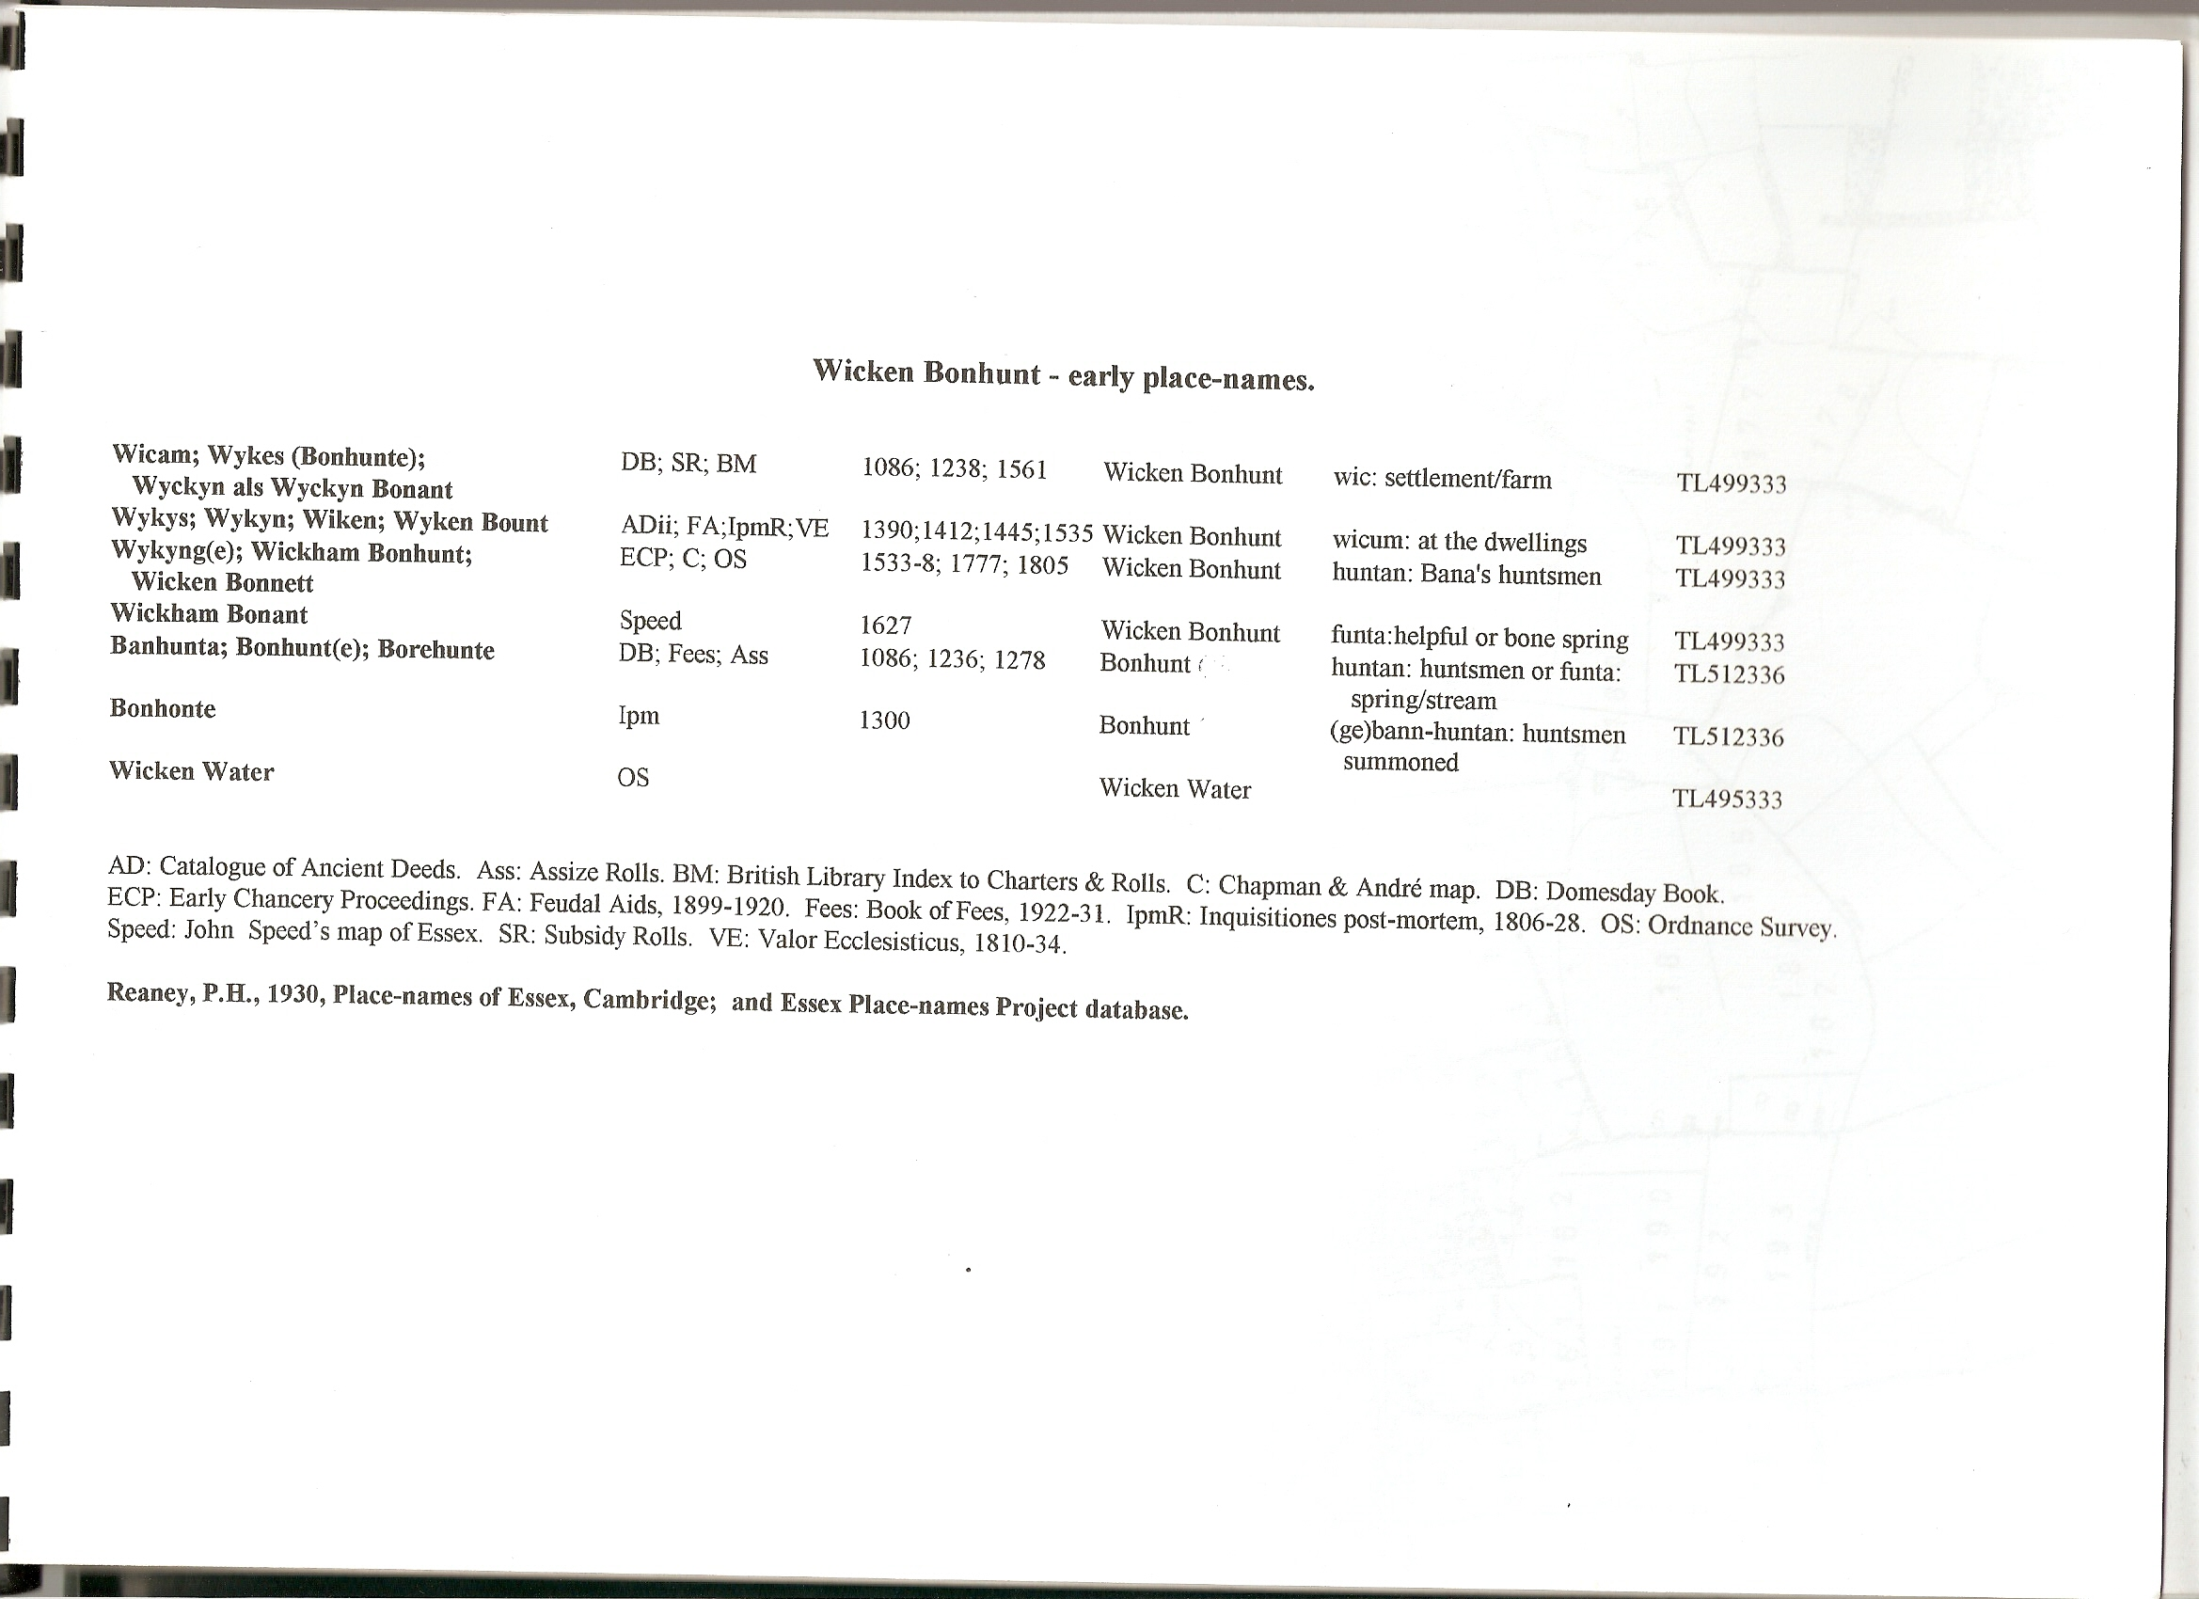

Tithe parcel numbers superimposed : --
