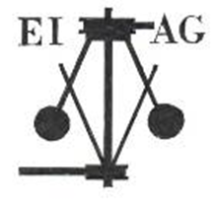
Essex Industrial Archaeology Group
EIAG Annual Meeting
Saturday 7th November 2026, 2:00pm
at the Essex Record Office
Wharf Rd, Chelmsford CM2 6YT
Our guest speaker this year is
Gary Armstrong
Trustee of the North Essex Heritage Trust
telling us about
Bringing Jumbo back to life: Restoration gets underway
