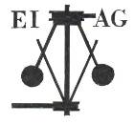
Essex Industrial Archaeology Group

NEWSLETTER

Number 10 May 2016

Welcome to this edition of the Essex Industrial Archaeology Group’s (EIAG) Newsletter. As well as the usual notices about up-coming visits, current exhibitions and other events, there are this season’s opening details for Alderford Mill and Waltham Abbey Royal Gunpowder Mills. Also we are able to include information on another lesser known Essex industrial businesses.

If you have any comments on the Newsletter generally or specific items in it, or wish to make a contribution to the next Newsletter, please contact us via our email address - essexiag@gmail.com.

ESAH/EIAG Industrial Visits 2016

The next visit of industrial interest is on Wednesday 3rd August at 10:00 to the Essex Fire Museum, Grays.
A guided tour of the museum will be followed by refreshments. The museum provides a fascinating look at the history of the Essex Fire Service through historic fire engines, firefighting equipment, uniforms and photographs. Those of you who attended the Industrial Heritage Fair last October will recall their very popular stand at the event.

This year’s EIAG Annual Meeting and Lecture will be on
Saturday 12th November at 12:30, the venue is Chelmsford Museum.

The lecture will be given by Roger Kennell on the Lost Port of Gunfleet at Holland Haven. Gunfleet was a medieval trading estuary and port which silted up in the 16th century. Refreshments included.

Bookings can be made with Dr Graham Gould on 0208 556 1423 or email DrGEGould@aol.com



The rest of this month sees the last opportunity to see this unique exhibition tracing the history of the Marconi companies in Essex and his contribution to the development of modern communication technologies. Not only is there material from Essex, but also special exhibition material provided by the Marconi Foundation is Italy.

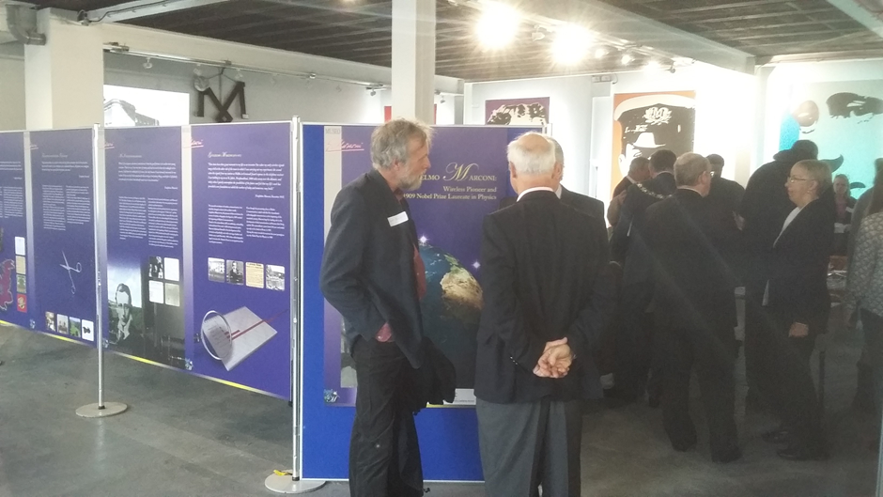

The official opening of the Marconi Exhibition, 18th March, showing some of the material provided by the Marconi Foundation in Italy

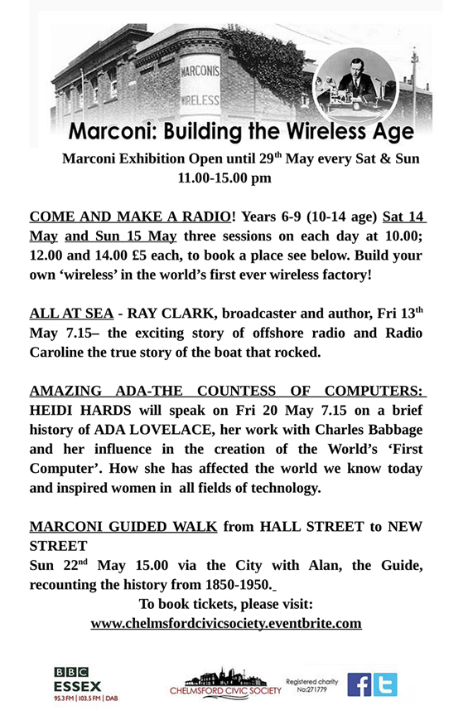

The Peculiar People

The Peculiar People is a temporary exhibition being held at the
Focal Point Gallery, The Forum, Elmer Square, Southend, SS1 1NB
from 19th April to 2nd July. Admission free.

This exhibition and events series examines and traces a history of radical, ideological and socio-political communal living experiments throughout 20th century Essex. Perhaps not immediately of interest to industrial historians (unless you see industrial archaeologists as ‘peculiar people’!!), but the exhibition does include material about Crittall’s Silver End village, Bata’s East Tilbury estate and the Salvation Army’s farm and industrial colony at Hadleigh.

For more information see the website: http://www.fpg.org.uk/exhibitions/current/63/

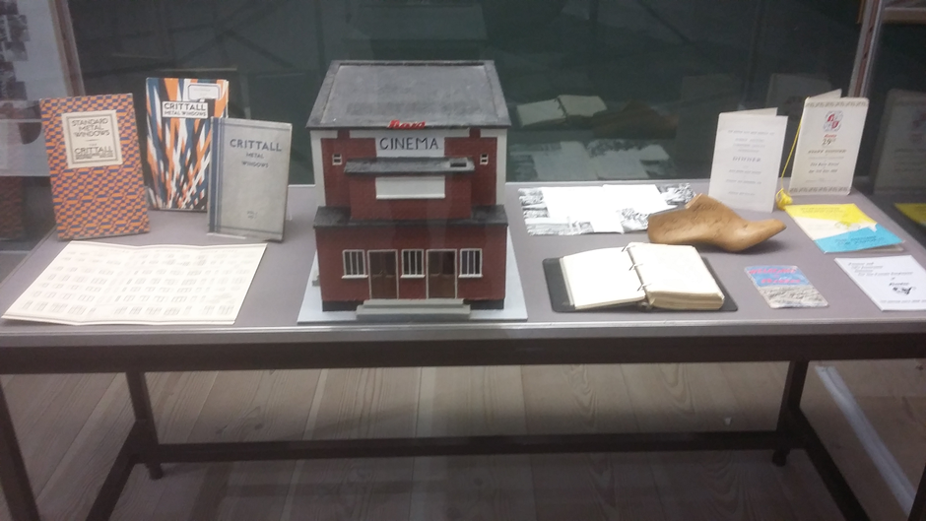

Above and below – parts of the Peculiar People exhibition relating to Silver End and East Tilbury

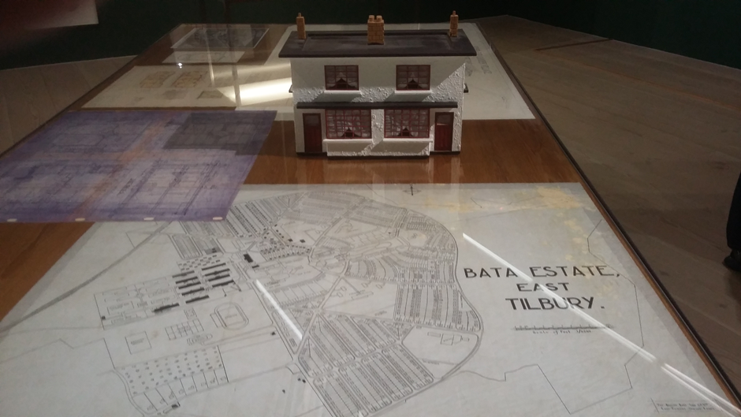

INDUSTRIAL AIR RAID SHELTERS

Many thanks to all those who have responded to the request for information about Industrial Air Raid Shelters. We are slowly gathering information. If you have not yet responded and know of any remaining or even remnants of Industrial Air Raid Shelters in your area then please contact me on the email address below. If you would like to get more involved, I now have a form to fill in to get the information for which I am looking. I look forward to plenty more responses. Thank you.
Jane Giffould, jgiffould@aol.com, if this bounces then try jgiffould@gmail.com

Alderford Mill, Sible Hedingham

OPENING TIMES FOR ALDERFORD MILL, ALDERFORD STREET, SIBLE HEDINGHAM CO9 3HX FOR 2016
The Friends of Alderford Mill (FOAM) has provided details of their 2016 programme of opening times, which are from 2pm to 5pm on the following dates:
Sunday, 10th April
Sunday 15th May
and thereafter every second Sunday in the month until the end of the season on 9th October, when a craft fair will be held.
Visitors will be able to explore the historic mill building from the top floor with the storage bins, to the stone floor and see the water wheel on the ground floor. Subject to there being sufficient water in the river, the water wheel will be in operation and on some opening days during the summer corn will be ground in the traditional way. FOAM invites you, your friends and relatives to visit and explore this magnificent water mill on the River Colne, which is an important part of our heritage. Admission to the mill is free but visitors may wish to make a donation towards its upkeep. There is free car parking nearby and refreshments will be available. For further details please see the website: www.alderfordmill.org

Waltham Abbey Royal Gunpowder Mills

SEASON TICKETS

Waltham Abbey Royal Gunpowder Mills are pleased to launch their Summer Season Ticket 2016 from the Bank Holiday event Victorian Days through to end of August. They have set a low price best-value ticket, enabling you to come back as often as you want - this includes Open Sundays from 30 April through to 28 August. 3 visits and you've more than recouped your investment!

Go to their website Events page to find out what's on when: https://www.royalgunpowdermills.com/
Find the Season Tickets online or buy at the gate.

European Route of Industrial Heritage (ERIH)

The next ERIH UK meeting will be held on Wednesday 8th June at Great Dunmow Maltings. The programme will start at 10.30am (with coffee available from 10.00am) and will end at 3.30pm. The day will include a tour of the site.

There is a very interesting programme planned for the day with the following speakers giving presentations:

1. Stephen Armson-Smith, Heritage Crime Prevention Advisor with Essex Police. Stephen will give a presentation about some of the crime risks faced by heritage sites and museums and will suggest ways of reducing those risks.

2. Michael Norton OBE, co-founded Buzzbnk in 2009. Buzzbnk’s website launched in January 2011 as the UK's 1st crowdfunding platform specifically for social enterprises and charities. Michael will give a presentation about crowdfunding and the potential it offers heritage sites and attractions as a way of raising funds for projects.

More information about the venue can be found on their website:
http://www.greatdunmowmaltings.co.uk/

East of England Regional Industrial Archaeology Conference

This year’s EERIAC event will be held on

Saturday 11th June 2016 at the Shuttleworth House and Collection,
Old Warden, Biggleswade, Bedfordshire, SG18 9EA

The day’s programme starts at 9:30 with talks and presentations during the morning and after lunch there will be tours of the collections. The formal programme ends at 3:35 and the cost is £18.50. For further details contact Robin Chandler at robin.chandler@outlook.com or on 07850 686820.

Lesser Known Essex Industries

In the last EIAG Newsletter we wrote about a couple of the lesser known Essex industries. In the Spring 2016 edition of the ESAH Newsletter, Peter Wynn contributed a fascinating article on the THE EDDINGTON ENGINEERING BUSINESS OF CHELMSFORD. Here is a short summary of that business, but do read the original article for the full story.

Alfred Eddington came to Chelmsford from Somerset, where he was born in 1833, to study agriculture. From 1855 Alfred was trading as an agricultural contractor based at Lion Terrace, Springfield and was advertising regularly in the Chelmsford Chronicle. His advertisements indicated he was using Fowler’s draining plough and Clayton & Shuttleworth steam thrashing machines. By 1856 Alfred was trading with his younger brother William as A & W Eddington. In 1857 it was reported that Wood and Son of Chelmsford were making windlasses for Eddingtons and in 1858 Everett and Taylor were making them. An advertisement of Eddingtons in 1859 stated that they had taken over the premises of the New Street Iron Brass Foundry from the latter firm and that this provided them with the opportunity to move beyond the repair of their own engines and machines. Although Alfred died in a rail accident in 1861 the business continued and by 1867 the firm had started to construct their own portable engines. By 1871 the firm was known as W & S Eddington, William’s brother Sylvanus, a mechanical engineer, having joined the family business. In 1882 the business of W & S Eddington & Co. was liquidated, but Sylvanus formed a partnership with a Mr. Steevenson at the New Street ironworks as well as a Queen Victoria Street office. This business ceased in 1894 on Sylvanus’s death.

