
Essex Industrial Archaeology Group

NEWSLETTER

Number 11 July 2016

Welcome to this European edition of the Essex Industrial Archaeology Group’s (EIAG) Newsletter. It remains to be seen what long term effect leaving the EU may have on the UK’s heritage, but one European organisation which has been operating in the UK, including here in the East of England, is the European Route of Industrial Heritage (ERIH) on which there are two articles below. Let us hope that progress can be made with revitalising ERIH in Essex before any changes happen. There is the usual round up of future events, reports of recent events, plus important news items on the future of the Colne Valley Railway and Waltham Abbey Royal Gunpowder Mills.

If you have any comments on the Newsletter generally or specific items in it, or wish to make a contribution to the next Newsletter, please contact us via our email address - essexiag@gmail.com.

ESAH/EIAG Industrial Events 2016

The next visit of industrial interest is on Wednesday 3rd August at 10:00 to the Essex Fire Museum, Grays.
A guided tour of the museum will be followed by refreshments. The museum provides a fascinating look at the history of the Essex Fire Service through historic fire engines, firefighting equipment, uniforms and photographs. Those of you who attended the Industrial Heritage Fair last October will recall their very popular stand at the event.

This year’s EIAG Annual Meeting and Lecture will be on
Saturday 12th November at 12:30, the venue is Chelmsford Museum.

The lecture will be given by Roger Kennell on the Lost Port of Gunfleet at Holland Haven. Gunfleet was a medieval trading estuary and port which silted up in the 16th century. Refreshments included.

Bookings can be made with Dr Graham Gould on 0208 556 1423 or email DrGEGould@aol.com
European Route of Industrial Heritage

The European Route of Industrial Heritage (ERIH) is the foremost tourism information network of industrial heritage in Europe. Currently it presents 1,315 sites in 45 European countries, which are grouped into Theme Routes and Regional Routes; full details can be found on the ERIH website. There are 13 Theme Routes, such as textiles, manufacturing, water, and housing & architecture, which are trans-national. Of the 19 Regional Routes, one of the UK routes is The Industrious East, which covers the East of England including 9 sites in Essex - http://www.erih.net/regional-routes/great-britain/the-industrious-east.html. ERIH is, therefore, an international organisation, but it has national co-ordinators who, amongst other tasks, organise events in their individual countries, the most recent UK meeting having been held in June at Great Dunmow Maltings (see report below).

Originally established in 2007, the Industrious East Route became an exemplar for Regional Routes as it developed an educational element with a travelling exhibition, which still exists but is in storage at present. Although this Route is still on the ERIH website, there is currently no active promotion taking place – in essence the Route is now dormant. A meeting between the EIAG Committee members and the ERIH national co-ordinator for the UK, Jonathan Lloyd, took place on 9th June to discuss how the Route could be re-invigorated, perhaps as a Route for Essex alone. (The South Wales Route was recently re-launched with a new leaflet, web presence and name – ‘The valleys that changed the world’.)

At the Industrial Heritage Fair organised by EIAG and held at Braintree District Museum in October 2015, those organisations which had stands at the Fair felt that the event was an excellent opportunity to network and expressed a desire to link together better in the future. One way of establishing links between the industrial sites, museums and groups in Essex would be to re-launch the Industrious East Route as an Essex only Route. There is the possibility of some pump-priming money from ERIH which is being explored; this money would be used to pay for someone to make a grant application to pay for new leaflets etc. The Industrial Heritage Fair 2017 which will be held on Saturday 7th October 2017 at Wat Tyler Country Park (formerly the site of Nobel’s explosives works) would be an excellent opportunity to re-launch the Route, but we need to gauge the interest amongst the industrial and transport groups and sites in the County before starting this initiative.

So … if your site/museum/group would be interested in being a part of a new Essex Route of Industrial Heritage, which would provide a marketing opportunity for you as well as a network for you to work together exchanging ideas, good practice etc., please let us know by (date) by emailing us at essexiag@gmail.com using ‘Essex Route IH’ as the subject.

European Route of Industrial Heritage (ERIH) UK Meeting at
Great Dunmow Maltings, 8th June 2016
Each year the UK chapter of the ERIH network organises a series of meetings in different parts of the country. They enable members and guests to find out about progress with the network and also to benefit from useful presentations by speakers who are experts in relevant topics. This, the most recent ERIH UK meeting, attracted twenty attendees from sites and organisations across England, Scotland and Ireland. The morning session included two excellent presentations, beginning with an ‘Introduction to Crowdfunding for Social Investment’ by Michael Norton, co-founder of Buzzbnk (www.buzzbnk.org). Michael presented interesting case studies to introduce the potential benefits of crowdfunding and also the pitfalls to be avoided.
The second presentation, ‘Crime Prevention, Protecting our heritage for this and future generations’ was by Stephen Armson-Smith, Crime Prevention Tactical Advisor & Heritage Crime Prevention Lead with Essex Police. Stephen explained the background to the relatively recent recognition of heritage crime as a category, and the threat it poses to the historic environment and heritage sites. He outlined the responses made by some police forces including Essex, who have appointed and trained officers take a lead in combating heritage crime. Stephen gave examples of heritage crime and listed the measures sites can adopt to deter and prevent criminals. He also explained what help is available from the police and heritage organisations. Both presentations are available on the ERIH website at http://www.erih.net/latest-news/detailsseite/article/erih-uk-chapter-meeting-in-essex/3.html.

The afternoon sessions included updates about the progress of ERIH internationally and in the UK, and also from regional routes and ERIH member sites. There was also information about forthcoming events, including the ERIH European Conference and AGM to be held at Porto from 26-29 October. This interesting and informative ERIH UK meeting concluded with an enjoyable guided tour of Great Dunmow Maltings. This was led by EIAG member Elphin Watkin who also gave a talk about the restoration of the building.

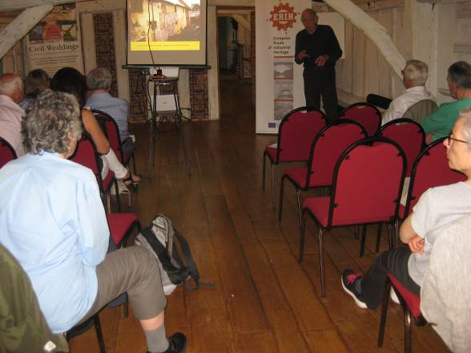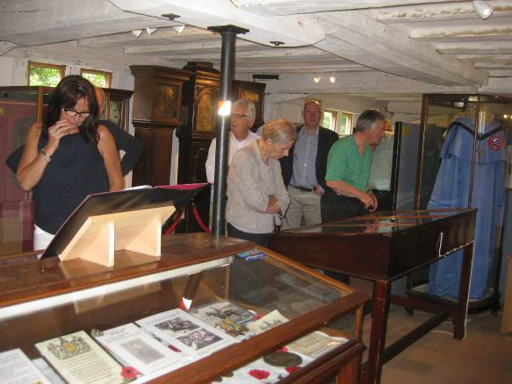

Attendees listen to a presentation by Elphin Attendees look around the Museum collection
Watkin about Great Dunmow Maltings in the ground floor of the Maltings
Photos by Dave Buckley

Marconi Exhibition – Hall Street Chelmsford

The Marconi Exhibition held by the Chelmsford Civic Society in collaboration with BBC Essex at the original Marconi wireless factory in Hall Street during March – May was a great success with excellent numbers visiting the exhibition and attending the lectures. They are now considering what to do next, including a possible Heritage Lottery Fund bid. Here are some photos of the exhibition taken by Dave Buckley:

General view of the exhibition in the original Hall Street wireless factory:

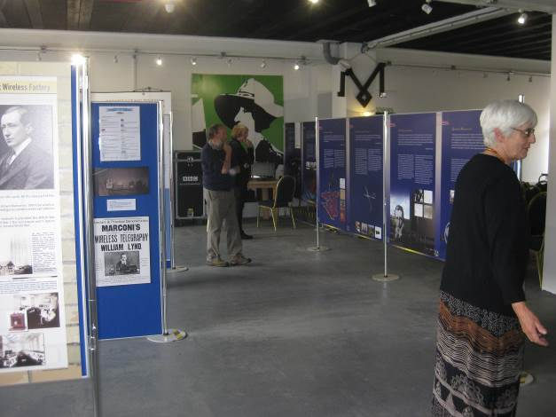

Reconstruction of Titanic radio room, and on the right with demonstrator:

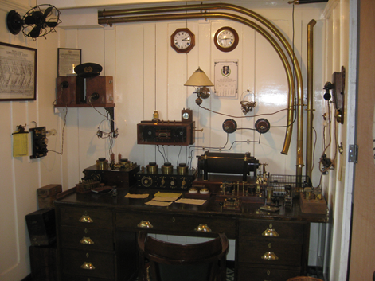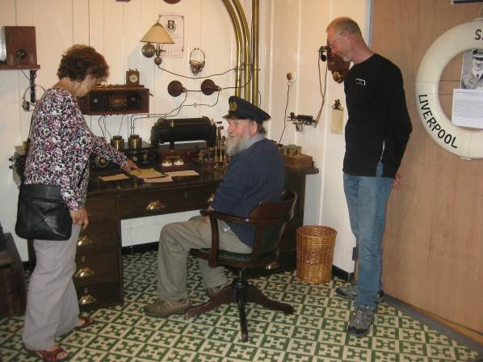

‘All Fired Up’ at Chelmsford Museum

Members of the EIAG may be interested to know about the 2016 temporary summer exhibition at Chelmsford Museums called “All Fired Up” which has been prepared by Mick Ford of the Essex Fire Museum, Grays. This celebrates the contribution that the Chelmsford and Essex Fire Brigades have made to the people of the county since the service was first established 150 years ago this summer. It was formally opened on Saturday 9th July by Linda Denston, Deputy Mayor of Chelmsford City, in the presence of Dave Bill, the Assistant Fire Officer for Essex, and many past and present serving fire officers. These included L E “Hockey” Hackett one of the first female officers in the NFS who was employed in fire communications in Essex during WWII.

The opening was marked with a gathering in Oaklands Park of fire engines old and modern including a ‘Godiva’ Fire Engine. These were first produced in the 1930s and were used in large numbers during WWII with some 4,000 in use in London alone since they were easy to take into restricted spaces and could be pulled behind taxis. Many were also to be found in use at industrial sites including the one on display, now owned by Alan Harris, which was bought in 1939 by Courtaulds in Halstead.

This is one of many links to industry to be found in the stories of fires, disasters and people told in the exhibition so it is well worth paying a visit. The exhibition continues until the 4th September and entry is free.

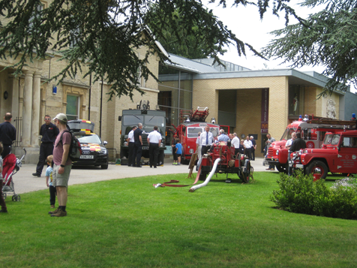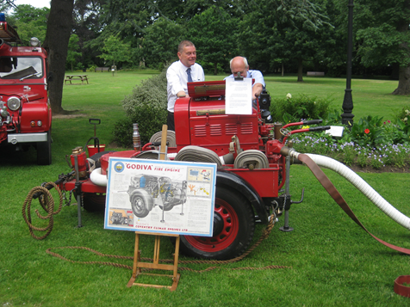

Left: A view of the fire engines on display for the opening event:
Right: Godiva Fire Engine, the owner Alan Harris on the left
Words and photos by Dave Buckley

Air Raid Shelters – Update

Thank you to those who have responded to my request for information about Industrial Air Raid Shelters in your vicinity. However either people are not aware of them or these buildings are fairly thin on/under the ground. I do have some places to follow up and have so far visited those in Halstead and Great Yeldham. The Halstead 21st Century Group committee members are wanting to help by visiting more and look forward to extending the list so far produced. The list for follow up includes Waltham Abbey, Waltham, Colchester, Southend, Ongar, Tillingham, Chelmsford, Ingatestone, and Tilbury. Current work includes working through Kelly’s Directory for 1937 to find what suitable industries would have existed at that time. Some have been found which might be relevant and will be followed up. And as an aside I have found my grandfather listed 4 times so far! Other research includes internet in such places as the National Archives and Hansard.

Do contact me if you can think of suitable places or would like to help with some of the research: jgiffould@aol.com

COLNE VALLEY RAILWAY PRESERVATION SOCIETY

It is nearly a year since the previous Colne Valley Railway report in EIAG newsletter No. 6 of August 2015. Since then progress has been made by the Society, which has recently been granted three planning permissions by Braintree District Council as follows:
- Extension to existing museum, including disabled access and W.Cs. – granted 27th April 2016
- Construction of a new steel framed building for use as a railway vehicle restoration centre – granted 21st June 2016
- Change of use of land for the provision of car, coach, motorcycle and cycle parking and creation of new entrance following the loss of existing entrance (in association with the existing Colne Valley Railway) and creation of new reception building – this application was recommended for refusal by planning officers, but was granted permission by members at a meeting on 21st June 2016.
With the benefit of these three permissions it is hoped that the Colne Valley Railway Preservation Society will be able to secure ownership of the majority of the site, particularly the track-bed, the land between the track-bed and Yeldham Road, buildings and rolling stock. This is subject to the railway being successful in the next stage of its Heritage Lottery Fund bid, which is now in progress. These three planning permissions were vital in enabling this process to continue for which EIAG has previously written a letter of support. It wishes the CVR every success and will include updates in future newsletters.

Waltham Abbey Royal Gunpowder Mills

Waltham Abbey Royal Gunpowder Mills (WARGM) is the site where, for over 300 years until 1991, gunpowder and other explosives were continuously produced, and where research and testing were undertaken. It is now a protected site, being in part a Scheduled Ancient Monument, having 22 Listed buildings and an SSSI, and is open to the public to enjoy and learn about. A very popular education programme is provided for local schools. However, for a number of years now the visitor attraction has been losing money, having to be subsidised from an endowment set aside when the Trust that manages the site was established. Discussions have, therefore, been taking place to find a way to make the site financially viable, and continue to preserve and conserve this internationally important industrial heritage asset. There is no doubt that the site is at risk and particularly a number of the important buildings, both those Listed and some unlisted.

A way forward was proposed which involved a commercial young people’s outdoor education provider taking over a number of historic buildings, part of the outdoor space and building new accommodation. This would provide WARGM with income which could be used to subsidise the visitor attraction, leaving the interest on the endowment to fund preservation and conservation work. A planning application was submitted along with an application for a grant from the Heritage Lottery Fund. The planning application was considered in early June but was refused on planning grounds, such as the demolition of unlisted buildings would detrimentally impact on the Conservation Area contrary to planning policies, and insufficient attention being given to the continuation and improvement of the visitor attraction, again contrary to local plan policy. This means that WARGM remains at risk, although discussions are underway as to the next steps to be taken to secure the future of this important site, its structures and public access.

