
Essex Industrial Archaeology Group

NEWSLETTER

Number 12 September 2016

Welcome to this edition of the Essex Industrial Archaeology Group’s (EIAG) Newsletter.

We hope you have all had a good summer, been able to visit some of Essex’s excellent industrial heritage, and are looking forward to future events. There are two major events to draw to your attention; our Annual Meeting in November and, looking further ahead, our second Industrial Heritage Fair in October 2017. There is a definite military theme to this edition and a question about the relevance of military history to industrial history, for members to respond with your comments, please.

If you have any comments on the Newsletter generally or specific items in it, or wish to make a contribution to the next Newsletter, please contact us via our email address - essexiag@gmail.com.

EIAG Annual Meeting and Lecture 2016

This year’s EIAG Annual Meeting and Lecture will be on
Saturday 12th November at 12:30, the venue is Chelmsford Museum.

The lecture will be given by Roger Kennell on the Lost Port of Gunfleet at Holland Haven. Gunfleet was a medieval trading estuary and port which silted up in the 16th century. Refreshments included.

Bookings can be made with Dr Graham Gould on 0208 556 1423 or email drgegould@aol.com

Free to members on production of programme card, non-members £2.00

As well as attending the meeting you will have an opportunity to look around Chelmsford Museum which has a number of displays relating to Chelmsford’s important industrial history, such as Marconi, Crompton, Hoffmann and Marriages which developed into key industrial pioneers.

Essex Industrial Heritage Fair 2017

Following the success of EIAG’s first Industrial Heritage Fair held in October 2015 at Braintree District Museum, planning is already underway for a similar, hopefully larger event in October 2017. The date and venue are booked, as follows:

Saturday 7th October 2017
Wat Tyler Country Park, Pitsea, SS16 4UH

We will again be inviting all the local industrial heritage groups, sites and museums to have displays at the Fair, putting on a series of short talks and giving an opportunity for the groups to network with each other. Also the site of the Country Park has a long and fascinating history, including industrial history, which can be explored using the Park’s Trails. The area was used for fishing and the cultivation of oysters as evidenced by the remains of oyster pits at Timberman's Creek on the edge of the Park as well as at many other sites across the marshes.

In the 19th century the British Explosives Syndicate established a factory manufact-uring nitro glycerine based explosives and some buildings and earthworks remain as evidence of this important industry. The site has been identified as an important factory site representing technological innovation. In 1920 the Nobel Explosives Company took over the site and whilst few of the original buildings remain, the protective blast barriers, in the form of large excavations or banks of earth, can still be found scattered throughout the Park.

During the Second World War the area of the Park was owned by the Ministry of Defence and buildings still survive now as evidence of a Naval Depot. More importantly the GHQ line, Britain's most important defensive line, began in the area of the Country Park before running up through Basildon to Chelmsford and beyond. Evidence of the line can still be seen in the Park in the form of four pill boxes and anti-tank ditches and blocks.

The venue is just off the A13 at Pitsea; Pitsea railway station is about a mile away and a number of bus routes stop at the railway station. There are full visitor facilities on the site including a café. For more information on the venue go to the Park’s website at: http://www.wattylercountrypark.org.uk/index.aspx?articleid=4958

So, put the date in your diaries now and we look forward to seeing you all at the Fair! Look out for details of the programme for the day as they develop which will be in future editions of this Newsletter and on other widely circulated publicity.

Following are two of the former explosives factory buildings which have been converted to new uses as part of the Country Park facilities:

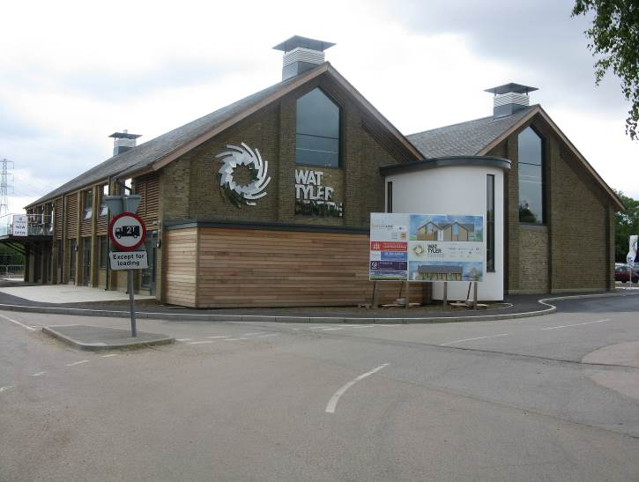

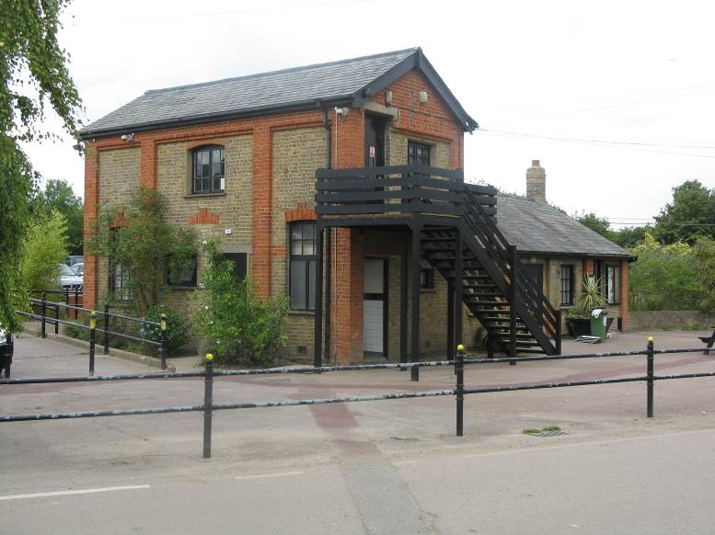

A question for members:

Is Military Heritage Industrial Heritage?
Mention was made above that Wat Tyler Country Park is the site of a former explosives factory and also of military defences. Across Essex we have a large number of former military establishments from WW1 and WW2, especially airfields with their multiplicity of buildings, as well as former civil defence sites. Discussion with non-EIAG friends has suggested that on size these are on a par with industry. However, we refer to ‘military services’, so are they part of the services of which we are consumers, whereas industry is the production of products? EIAG members’ views would be most welcome, so please email us at essexiag@gmail.com and we look forward to hearing your comments.

Another lesser known Essex industry

While walking one summer’s day last month in the Tillingham area I visited St Lawrence’s Church which was holding an exhibition regarding Zeppelin raids over Essex in WWI. Mention was also made in the displays of the manufacture of seaplanes at South Fambridge, of which I had not previously heard!

It is believed that South Fambridge was the first aerodrome to be established in the United Kingdom in late 1908 or early 1909. There were several designers of land based aeroplanes and sea-planes producing their early aircraft at hangars in South Fambridge and either taking off from the airfield or floating them out to carry out test runs and take-offs and landings in the very wide, straight and calm waters of the tidal River Crouch. The history of local boat building was an obvious asset to the construction of sea-planes. The aerodrome was already open and in service with a wide range of hangars and buildings when it was the subject of lengthy and detailed aviation magazine articles in 1909. In 1914 there was a brief period of aviation design and development activity at South Fambridge prior to WWI, when Messrs. Talbot and Quick developed and tested their unique seaplane called the Talbot Quick Waterplane, which unfortunately failed. A granite memorial stone was erected in South Fambridge in February 2009 to mark the 100th anniversary of the opening of Fambridge Airfield.

Tony Crosby

