
Essex Industrial Archaeology Group

NEWSLETTER

Number 13 November 2016

Welcome to this edition of the Essex Industrial Archaeology Group’s (EIAG) Newsletter.

As 2016 comes to a close we are reporting on a couple of the last events of 2016, a recent development proposal of concern, but principally looking forward to 2017, including the ESAH/ EIAG programme of visits, and especially the Industrial Heritage Fair in October. There are also a couple of ideas for Christmas gifts!

If you have any comments on the Newsletter generally or specific items in it, or wish to make a contribution to the next Newsletter, please contact us via our email address - essexiag@gmail.com.

Visit to Bata Heritage Centre

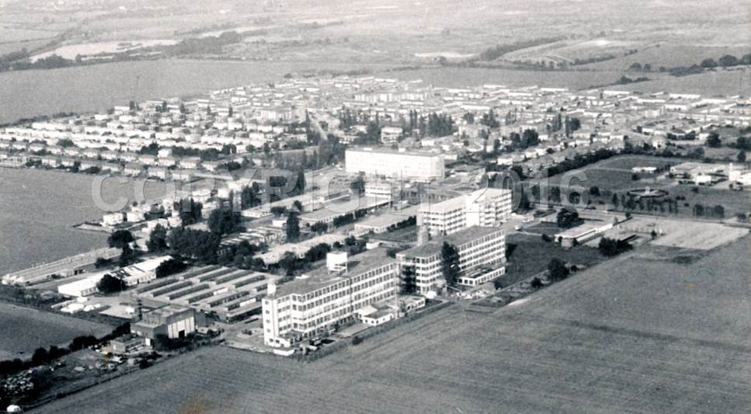
Back in 1932 Tomas Bata came over from Zlin, in what is now the Czech Republic, and set up a shoe making concern in East Tilbury. Being forward looking he was building a town round his factory so that there was everything the worker could need. Contented workers are productive. In 1939 WW2 started and the factory had many air raid shelters to protect the workers. There were different banks of them around the factory and as EIAG is doing a survey of industrial air raid shelters in Essex, a visit to Bata was on the books.
Bata factory with some air raid shelters, between factory buildings and fields

12 October 2016, Bata Heritage Centre, East Tilbury, offered an Open Day which included a tour round the Bata site and a talk in the afternoon along with a photographic display to enhance their display of a range of items. A fair number of people passed through including several classes from the local primary school. Some children were looking at ‘old’ newspapers dated 1971. They looked slightly bewildered when I said the papers were not that old, after all 1971 was the year I graduated. In the children’s eyes that made me something from ancient history!

The tour started with the former swimming pool which is now a car park, leading to the tennis courts which are being eyed up by a ‘developer’ for housing. The company housing style initially emulated that of Zlin with flat roofed houses painted white. A recent block of building, as land is re-developed, contained copies of the company houses along with standard British semis. We were told that the company copies sold off far more quickly. Initially there had been two hostels, one for males and one for females, along with a large hotel to provide accommodation. These are still standing. The first factory building, now grade 2 listed due to the type of welding done, was single storey so that they could get on with their first batch of shoes. This was then followed by standard Zlin style 5 storey buildings built with pillars a specific distance apart dictated by the size of the bricks in Zlin! We were informed that factories all round the world were built exactly the same with machinery placed in exactly the same positions. In this way if an engineer had to mend a machine he would know exactly where to find it in any factory in the world. Being a company town they had their own shop, cinema and petrol station. Initially this petrol station only had one pump and was for the company lorries. After WW2 when cars became more normal it had to expand. The main factory area has now been taken over with some of the buildings being used for national archives. We could only stand outside and peer in. We learnt that employees had to clock in at the gates. At a certain time the barrier would come down and any late comer had to go via the main door and give their reasons with the likelihood of docked pay. We saw their original computer building which is due for demolition. I was surprised that it was as late as 1972. It was in a separate building from the factory so that it would not worry the workers. We admired the statue of Tomas Bata and found out that although he was right in many aspects he lost his life by being wrong. On flying to a meeting he insisted the pilot took off despite the pilot warning of very bad weather ahead. The pilot was threatened with losing his job. He took off and lost both his job and his life. We walked back via the cinema, now a community hall, we examined the original parquet flooring of the hotel ballroom, now in a shop, and compared a range of housing where we learnt that it was the same as Bata company housing anywhere in the world.

The afternoon talk took us through the history of the Bata company starting with the initial Tomas Bata starting life in a cobbler’s family in Zlin. As he grew up he noted how shoes were very expensive because they were handmade and hence many people had no shoes. He decided that he would do something about this and researched into a more automated method of production. He was inspired by the Ford method with each worker having their own small job rather than each worker making a complete pair of shoes. From there he expanded round the world including Britain. After WW2 as the Western World became more expensive for labour so the company moved east and is now mainly where labour is cheaper.

And the air raid shelters? During WW2 there were many banks of air raid shelters around the factory, each shelter taking about 50 people. After WW2 the expansion of the site used the space from the air raid shelters. The last ones were bulldozed a few years ago and a google picture shows the area as a lorry park. https://www.google.co.uk/maps/place/East+Tilbury+Library/
Jane Giffould

EIAG Annual Meeting – November 2016

On 12th November we held our Annual Meeting which was very well attended by nearly 40 people. We started by reviewing 2016’s activities including the visits made to places of industrial interest, letters of support for project funding, representations made to local authorities, and the support given to Braintree & Bocking Civic Society, Braintree DC and Essex CC in developing a Local Heritage List for Braintree DC based upon the Courtauld buildings in the District. We then looked forward to 2017, the events already planned and other projects it is hoped we can develop during the year. Finally came the election of your Committee. Pam Corder-Birch has retired from the Committee and we thanked her for her very valuable contributions to the work of the Committee since its inception. A request for new Committee members drew interest from three people and we are pleased to welcome Peter Jones onto the Committee from January next.

The business was then followed by a fascinating talk by Roger Kennell on the Lost Port of Gunfleet at Holland Haven. This was based on the research undertaken by the Clacton Victoria County History Group and full details of the research can be found on the internet at: https://www.victoriacountyhistory.ac.uk/explore/items/gunfleet-estuary-and-holland-haven

Britvic Clock and Local Heritage lists.

Local Heritage Lists have been promoted as one way that surviving industrial heritage buildings and structures can be given a higher profile and hopefully protected for the future. However, how strongly local councils might defend a site on such lists is brought into question by Chelmsford City Council’s recent decision to allow demolition of the locally listed iconic Britvic Clock.
Chelmsford has an association with the soft drinks industry which goes back to the mid-19th century when a local chemist, Mr H. D. Rawlings began making Vitamin drinks and tonics from his shop in Tindal Street. The firm was later purchased by Ralph Chapman who used the name “The British Vitamin Products Company”, later to become Britvic. The present factory with its tall white clock tower was open in 1955 at Widford. It was in a prominent location close to the then main A12 road and the clock became symbolic of Chelmsford to everyone approaching the country town from London. It also became very successful, employing 600 people and producing 1.5 million cases of soft drinks annually. It remained so for many years, but changing circumstances saw the factory close in 2014 and this year proposals have been presented for the site to become a new retail park.
Initially there appeared to be an enlightened approach to the plans for redevelopment with clear recognition of the historical importance of the site by the City Council. The Council Leader Roy Whitehead started that “while we continue to grow and develop the City for the 21st century, we have to ensure that our residents have the opportunity to work here, so I am delighted that this sale will bring the site back into use as soon as possible and retain icons like the Britvic Clock Tower which remind us of our heritage”.
Sadly only a few months later an Environmental Impact Assessment produced for the developers included proposals for the existing clock tower to be demolished and for it to be replaced with a new clock tower close to the western boundary of the site. Included to support this proposal were:
” it is envisaged that the same or similar materials used in the existing tower will be used in the construction of its replacement, providing a local landmark”.
“It is not considered that the replacement of the tower will have a significant impact on heritage interests”
Rather than resisting the loss of the original clock tower Council Roy Whitehead now said that the makeup of the new development made it impossible for the current tower to remain where it is. Further, in a report on behalf of the Council`s Director of Sustainable Communities, David Green, the City Councils thinking about the value of the clock as a local heritage site is made clear when it is stated that “ the loss of this heritage asset would be no more than of local significance.”
Local conservation groups have made known their unhappiness about this decision but to no effect. It is clear from this case that while placing an industrial site on a local heritage list may help to identify its value this is only the first step, ensuring that it is actually protected and conserved requires much more. This decision is especially to be regretted at a time when there is growing appreciation of how much of the industrial heritage of Chelmsford has already been lost. Also that while the Council is trying to raise the profile of Chelmsford and give a distinctive identity to its new City status it fails to see the value of retaining such an iconic local feature as the Britvic Clock.

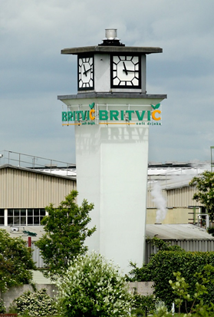

New Books – possible Christmas gifts!

‘Lost and Found: Journey to a Forgotten Railway’ by David Gridley, Slowcoach Publishing, £9.99 from May & Brett in Great Dunmow or www.swanbooks.co.uk.

This is a new book telling the story of the former Bishop’s Stortford, Dunmow and Braintree branch line, bringing the story right up to date to its present use as the Flitch Way.

Wind, Water and Steam: The Story of Hertfordshire’s Mills by Hugh Howes, Hertfordshire Publications, £14.99 - https://www.herts.ac.uk/uhpress/subject-areas/hertfordshire-publications

Although this book is about Hertfordshire it should be of interest to those of you who are mill enthusiasts, and as Essex shares a boundary with Hertfordshire, especially along the rivers Lea and Stort, it may have some relevance to Essex.

It is hoped to provide reviews of both of these books in this Newsletter early in 2017.

Programme of ESAH/EIAG visits 2017

The programme of visits in 2017 includes the following of industrial, maritime and transport interest. Full details will be provided on your Membership Programme card for 2017:

- An illustrated talk on the Cold War Vulcan Bomber – Chelmsford Museum - 22nd February, 6:00pm
- Tour of Coalhouse Fort – 18th May, 10:30am
- The ESAH AGM is being held at Silver End, the company village developed by Crittalls – 17th June, 2:00pm
- Thames Barge Cruise from Maldon – 12th July, 12 noon
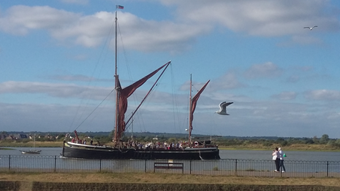
- Tour of Bulmer Brick Works – 23rd August, 10:30am
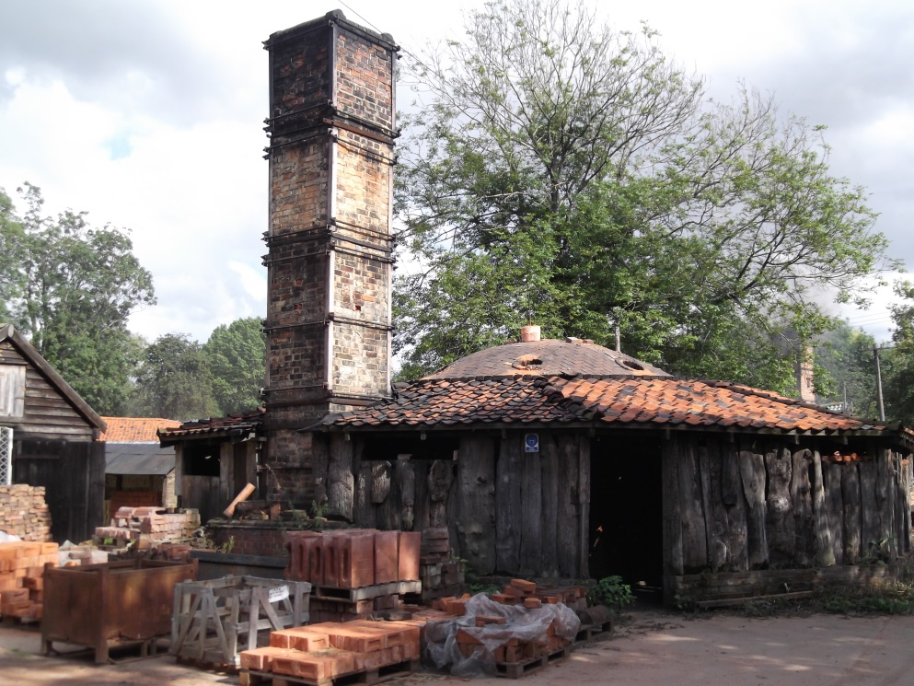
- Tour of Alderford Mill – 16th September, 10:30am
- EIAG Annual Meeting, plus lecture on Railways and Industry – Chelmsford Museum – 11th November, 2:00pm

Essex Industrial Heritage Fair 2017

Following the success of EIAG’s first Industrial Heritage Fair held in October 2015 at Braintree District Museum, planning is already underway for a similar, hopefully larger event in October 2017. The date and venue are booked, as follows:

Saturday 7th October 2017
Wat Tyler Country Park, Pitsea, SS16 4UH

We will again be inviting all the local industrial heritage groups, sites and museums to have displays at the Fair, putting on a series of short talks and activities, and giving an opportunity for the groups to network with each other. The site of the Country Park has a long and fascinating history, including industrial history, which can be explored using the Park’s Trails. The area was used for fishing and the cultivation of oysters as evidenced by the remains of oyster pits at Timberman's Creek on the edge of the Park as well as at many other sites across the marshes.

In the 19th century the British Explosives Syndicate established a factory manufact-uring nitro glycerine based explosives and in 1920 the Nobel Explosives Co. took over the site. Some of the original buildings and the protective blast barriers, in the form of large excavations or banks of earth, can still be found scattered throughout the Park.

During the Second World War the area of the Park was owned by the Ministry of Defence and buildings still survive now as evidence of a Naval Depot. More importantly the GHQ line, Britain's most important defensive line, began in the area of the Country Park before running up through Basildon to Chelmsford and beyond. Evidence of the line can still be seen in the Park in the form of four pill boxes and anti-tank ditches and blocks.

The venue is just off the A13 at Pitsea; Pitsea railway station is about a mile away and a number of bus routes stop at the railway station. There are full visitor facilities on the site including a café. For more information on the venue go to the Park’s website at: http://www.wattylercountrypark.org.uk/index.aspx?articleid=4958

So, put the date in your diaries now and we look forward to seeing you all at the Fair! Look out for details of the programme for the day as they develop which will be in future editions of this Newsletter and on other widely circulated publicity.

