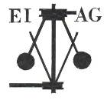
Essex Industrial Archaeology Group

NEWSLETTER

Number 14 January 2017

HAPPY NEW YEAR

Welcome to this first edition of the Essex Industrial Archaeology Group’s (EIAG) Newsletter for 2017.

2017 promises to be a busy, interesting and exciting year for EIAG with a number of visits of industrial interest throughout the year, the annual meeting in November, and also this year our Industrial Heritage Fair in October. Details of these events are set out below along with news and two feature articles, including one from our new Committee member, Peter Jones. We hope you enjoy reading this newsletter and taking part in this year’s events.

If you have any comments on the Newsletter generally or specific items in it, or wish to make a contribution to the next Newsletter, please contact us via our email address - essexiag@gmail.com.

Programme of ESAH/EIAG visits 2017

The programme of visits in 2017 includes the following of industrial, maritime and transport interest. Full details and booking instructions were circulated with the Winter 2016 ESAH Newsletter, so book your places soon to avoid disappointment:

An illustrated talk on the Cold War Vulcan Bomber – Chelmsford Museum - 22nd February, 6:00pm

Tour of Coalhouse Fort – 18th May, 10:30am

The ESAH AGM is being held at Silver End, the company village developed by Crittalls – 17th June, 2:00pm

Thames Barge Cruise from Maldon – 12th July, 12 noon

Tour of Bulmer Brick Works – 23rd August, 10:30am

Tour of Alderford Mill – 16th September, 10:30am

EIAG Annual Meeting, plus lecture on Railways and Industry – Chelmsford Museum – 11th November, 2:00pm

Essex Industrial Heritage Fair 2017

Following the success of EIAG’s first Industrial Heritage Fair held in October 2015 at Braintree District Museum, planning is already underway for a similar, hopefully larger event in October 2017. The date and venue are booked, as follows:

Saturday 7th October 2017
Wat Tyler Country Park, Pitsea, SS16 4UH

We will again be inviting all the local industrial heritage groups, sites and museums to have displays at the Fair, putting on a series of short talks and activities, and giving an opportunity for the groups to network with each other. The site of the Country Park has a long and fascinating history, including industrial history, which can be explored using the Park’s Trails. The area was used for fishing and the cultivation of oysters as evidenced by the remains of oyster pits at Timberman's Creek on the edge of the Park as well as at many other sites across the marshes.

In the 19th century the British Explosives Syndicate established a factory manufact-uring nitro glycerine based explosives and in 1920 the Nobel Explosives Co. took over the site. Some of the original buildings and the protective blast barriers, in the form of large excavations or banks of earth, can still be found scattered throughout the Park.

During the Second World War the area of the Park was owned by the Ministry of Defence and buildings still survive now as evidence of a Naval Depot. More importantly the GHQ line, Britain's most important defensive line, began in the area of the Country Park before running up through Basildon to Chelmsford and beyond. Evidence of the line can still be seen in the Park in the form of four pill boxes and anti-tank ditches and blocks.

The venue is just off the A13 at Pitsea; Pitsea railway station is about a mile away and a number of bus routes stop at the railway station. There are full visitor facilities on the site including a café. For more information on the venue go to the Park’s website at: http://www.wattylercountrypark.org.uk/index.aspx?articleid=4958

So, put the date in your diaries now and we look forward to seeing you all at the Fair! Look out for details of the programme for the day as they develop which will be in future editions of this Newsletter and on other widely circulated publicity.

Britvic Clock Tower
You will recall the article by Dave Buckley in the November 2017 edition of this newsletter regarding the Locally Listed Britvic Clock Tower. Your Chairman wrote to Chelmsford City Council`s Director of Sustainable Communities, David Green, on behalf of EIAG to add our voice to the protests at the proposed demolition of the Tower. The reply from one of the City Council’s Planning Officers said:
“Planning permission has been granted for the redevelopment of the Britvic site, including demolition of the Clock Tower and the construction of a replica on the Westway frontage, re-using the existing clock faces.
“The Clock Tower was extensively rebuilt when it was refurbished in c.2007 and its remaining significance was primarily as a landmark feature and for its association with the Britvic Company. The proposal to rebuild the Clock Tower in replica was considered to reinstate the landmark appearance and history of the site, but nonetheless to be harmful due to the loss of the remaining original fabric and relocation. This harm was considered to be justified by the public benefits delivered by the scheme as a whole, a test set out within the National Planning Policy Framework.”
And now the good news!

The Colne Valley Railway secures Heritage Lottery Fund investment

A press release issued early December 2016 announced that:

The Colne Valley Railway Preservation Society, a registered charity, has received a confirmed grant of £1,757,200 from the Heritage Lottery Fund (HLF) for its “All Aboard: Developing the Colne Valley Railway” project, it was announced today. The project aims to provide long term sustainability for the Colne Valley Railway (CVR) including the provision a new entrance and building which includes visitor facilities together with the development of two important centres on the CVR’s main site. These are the Cubitt Skills Centre, a workshop which will become a centre of excellence for the overhaul and restoration of historic railway carriages, and the Brewster Interpretation Centre, which will tell the story of the Railway and the local community through applying the latest developments in museum displays to both entertain and inform our visitors.

Through a collaboration programme working with the local community, the archive collections held by the Charity and others will be digitised and joined through a single web portal, allowing on-line public access to the collections for the first time. The Charity’s existing education programme will be enhanced and developed allowing a greater range of students to benefit.

The original Colne Valley (& Halstead) Railway was built by the local community itself after the area was ignored by the big Victorian railway companies and the preserved current day Colne Valley Railway celebrates that tradition. Since its inception in 1974, the current Colne Valley Railway has specialised in visits by schools (around 50 schools a year) and organisations caring with those with special needs, as well as welcoming local families and enthusiasts.

Paul Lemon, Chairman of the Colne Valley Railway Preservation Society said: “We are delighted that the Heritage Lottery Fund has given us their full support. This allows the Railway to secure its future and to develop the site with some first class facilities for the local community, our visitors and the railway preservation world alike. We would also like to thank Braintree District Council for their support with this project.”

Robyn Llewellyn, Head of HLF East of England, said: “Thanks to National Lottery players we’re delighted to support this project. Owning the land, trains and buildings will enable CVR to invest in a positive future for this heritage railway while new premises, digital access and training opportunities for apprentices will transform access to the railway’s many wonderful stories.”

Cllr Tom Cunningham, Cabinet Member for Economic Development at Braintree District Council, said: “We’re proud to have been able to support Colne Valley Railway Preservation Society via our Business Growth Loan Fund* which helped them secure a Heritage Lottery Fund grant of £1.75 million and will be directly invested in the North of the District. Colne Valley Railway is one of our major rural tourism and heritage destinations – a wonderful day out for families and school children and a great example of one of our local attractions.”

Joseph Cubitt (1811-1872) was the original engineer of the Colne Valley & Halstead Railway and designed the distinctive station buildings on the line, of which one has been relocated to Colne Valley Railway. He went on to design Blackfriars Railway Bridge in London. He was the son of Sir William Cubitt who is best known for the original Crystal Palace in Hyde Park, London.

James Brewster (1807-1890) was a farmer and landowner in Halstead, and was the driving force behind the setting up of the Colne Valley & Halstead Railway. He was the Railway’s first chairman from 1856 until 1879 and funded the railway’s locomotives when it could not afford to buy them itself.

More New Books – on which to spend those Christmas book tokens!

‘Branch lines to Maldon’ by Peter Paye, Lightmoor Press, £30.00 plus £6.50 p&p
For more details of this book, sample images and how to order, please see their website: http://lightmoor.co.uk/view_book.php?ref=L8160

‘The Philp Collection Special’, by John Garwood and Adam Brown, published by the East Anglian Traction Engine Society, 2016. 48 pages, paperback, including numerous photographs and information about the Philp family’s collection of Traction Engines and other agricultural machinery at Kirby Hall, Castle Hedingham, £3.50 – all enquiries to: East Anglian Traction Engine Society – www.eates.org

‘The Thames Iron Works 1837-1912: A Major Shipbuilder on the Thames’, by Daniel Harrison, published by Museum of London Archaeology, 2015, 114 pages, many illustrations, ISBN 978-1-907586-34-7, £10, A full review of this book will appear in the next volume of ESAH Transactions.

And finally one available to read free, but online only, is ‘The Trade Signs of Essex’, by Miller Christy. This is ‘a popular account of the origin and meanings of the Public House and other signs now or formerly found in the County of Essex’, 1887.
Log on to http://www.gutenberg.org/files/51885/51885-h/51885-h.htm to read it.

William Wire

In 1842 the Eastern Counties Railway line from London to Colchester was nearing completion. The approach to Colchester involved a mile long embankment from Marks Tey, a five arch viaduct and several fairly deep cuttings. All the earthworks were completed with pick and shovel and one man who was particularly interested in all this activity was William Wire, a Colchester clockmaker and noted amateur archaeologist. The company had granted Wire a pass giving him access to the works. The navvies had also been told to look out for anything interesting while digging and if they kept it for Mr Wire and there could be “drink in it for them”. Subsequently many interesting items found their way into Wire’s collection, which would ultimately form the basis of the Castle Museum collection.

William Wire was at Colchester station along with many others to witness the arrival of the first train. According to his diary:
27th February 1843
The town is in a state of excitement and bells are ringing in consequence of a report that the Railway Directors and Shareholders are coming by rail in four coaches drawn by an engine. Went to the station and after waiting for 2 hours finding they did not make their appearance, came home, after which it was reported that a bridge at Mountnessing was not considered safe to cross. Dare say there were 2000 people collected to witness their arrival, and much disappointment prevailed at their non appearance.

The train eventually arrived two days later! Although the line did not fully open to passengers until the 29th March.
There was one consequence of the railway opening that upset William Wire. At the top of Balkerne Hill next to the Mercury Theatre and in the shadow of the Jumbo the water tower stands a public house called ‘The Hole In The Wall’. In the 1840s it was known as the Kings Head and the landlord, possibly with an eye to new business that the railway might bring enlarged the premises. To allow more daylight into the bar and to give his customers a view of the new railway he knocked out a section of the Roman wall. William Wire was incensed and recorded in his diary:

9th May 1843
When I was walking up Balkerne Hill I saw that a portion on the north side of Balkerne Fort had been destroyed in order to build additional rooms to the Kings Head Inn to command a view of the railway.
What a pity that one of the best preserved remains of Roman times should be destroyed to administer to the sensual pleasures as it may be considered only as a decoy to induce persons to enter the house to drink.

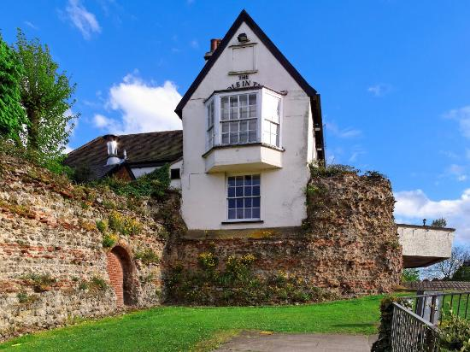
Although the pub had been known as the Kings Head since the Civil War after the desecration of the Roman wall it was always referred to by the locals as ‘The Hole in the Wall’ the name being officially adopted in 1961.

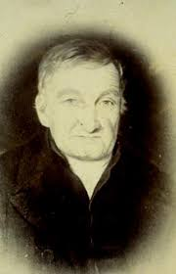
William Wire was a gifted archaeologist and left many detailed drawings and notebooks describing his techniques and activities. Because of his lack of classical education and his humble origins the archaeological hierarchy tended to dismiss Wire but he was ahead of his time. His meticulous attention to detail and working methods had become standard practice for archaeologists by the 1920s. William Wire was a fascinating character and did much to establish archaeology as a discipline, from which industrial archaeology would be ultimately derived. We are indebted to him for saving many priceless links to Colchester’s past.

Peter Jones

INDUSTRIAL HOUSING IN ESSEX

In 2006 Adrian Corder-Birch and I collaborated with the then Historic Environment Section of Essex CC on surveying the housing developed by various industrial companies for their workforce. These developments ranged from small isolated groups of houses for brick workers, engineering firms, and food & drink companies, through major developments by companies such as Courtaulds, Hunts in Earls Colne, and Bentalls in Heybridge, to the building of whole new communities by Crittalls and Bata. Although the resulting survey report was a weighty tome, inevitably since completion additional developments of workers’ housing have been re-discovered. This article describes two such instances where the houses survive after the industry has ceased.

MARCONI

The development of the New Street factory in Chelmsford as the world’s first purpose designed and built wireless factory by Marconi’s in 1912 is well known. Perhaps not so well known is that the company wanted this new manufacturing complex to be a self-contained village within the town. To the north of the factory site two new roads - Marconi Road and Bishop Road – of mostly terraced cottages were built for the factory workers. Unfortunately these two roads were all that were built of the proposed ‘village’ although the company did provide other social facilities for their workers elsewhere in Chelmsford. Although most of the site of the New Street works has been redeveloped for housing, the company cottages remain as a reminder of the scale and ambition of the Marconi group.

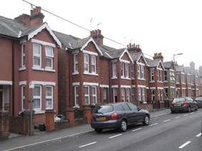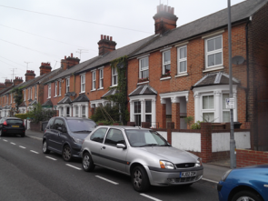

Marconi company housing in Bishop Road, Chelmsford adjacent to the New Street Works

The various Marconi group companies developed a large number of research, manufacturing and operational radio stations throughout Essex, only a few of which survive to this day. The Ongar Radio Station of 1922, one of the most advanced in the world at the time, has not survived. However, the nearby 12 staff houses still known as Marconi Bungalows on Epping Road in North Weald do survive, if greatly altered in some cases, as the only evidence of Marconi activity in the area.
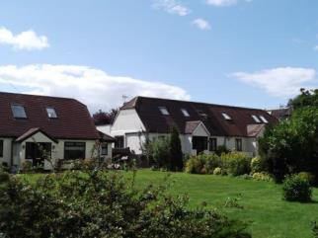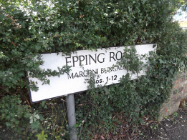

Marconi Bungalows, Epping Road, North Weald

ROCHFORD NURSERIES, STANSTED MOUNTFITCHET

In the late 1890s Edmund Rochford acquired an undeveloped piece of land to the southeast of Stansted Mountfitchet for his nursery business, growing grapes, tomatoes, cucumbers and chrysanthemums (in pots for cut flowers). All this produce was grown in large greenhouses which would eventually cover about 25 acres. This industrial scale agricultural undertaking included an onsite tramway for moving produce and fuel around the site, which also ran down to a siding adjacent to Stansted Mountfitchet Station. The coke and later coal was used to heat the boilers which provided heat to the greenhouses. The water for the heating boilers was extracted from the local brook and stored in tanks on top of the Foremen’s houses. The business closed in 1970 and the site has since been redeveloped as a large housing estate – Forest Hall Park.

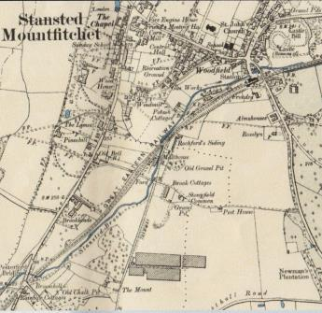
1896 - 1898 Map of Stansted Mountfitchet showing the developing Rochford Nursery site with glasshouses (centre bottom), tramway running north from the glasshouses passed a malthouse to Rochford’s Sidings (centre) just southwest of the GER Station.

The company developed housing and social facilities for the staff of the nurseries. These included around 60 houses in Stoney Common, a recreation room, allotments, shops, a swimming pool, mission room, and bowls club.

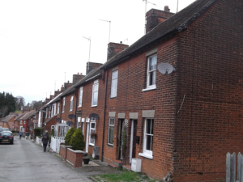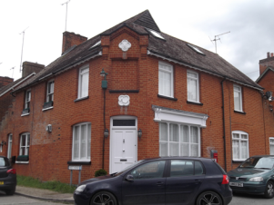

Workers’ cottages, Stoney Common Shop on the corner of Stoney Common and West Road

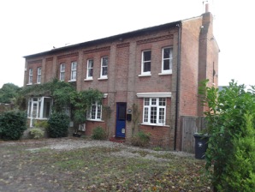

Surviving Foremen’s houses which originally had water tanks on the roof.

No. 1 ‘Meadowview’ and no. 2 ‘Woodview’.

Text and photos – Tony Crosby

