
Essex Industrial Archaeology Group

NEWSLETTER

Number 15 March 2017

Welcome to this latest edition of your Newsletter which this month includes news of the fire at the Bata Heritage Centre; details of the ESAH/EIAG visits this year, a special Marconi walk in Chelmsford, the Bata Open Day and EERIAC; a book review; and most importantly details of the Industrial Heritage Fair in October. Please do spread the word about the Fair to family, friends and colleagues, and especially encourage any industrial and transport groups to which you belong to support the Fair by having a stand at the Fair. Booking forms for a stand can be obtained by emailing us at the address below.

If you have any comments on the Newsletter generally or specific items in it, or wish to make a contribution to the next Newsletter, please contact us via our email address - essexiag@gmail.com.

Programme of ESAH/EIAG visits 2017

The programme of visits in 2017 includes the following of industrial, maritime and transport interest. Book your places soon to avoid disappointment:

Special Marconi Walk of Chelmsford – 20 April, 10.30. Cost £5. See detail p6

Tour of Coalhouse Fort – 18th May, 10:30am. Cost £6.00

EERIAC annual meeting – 03 June, 09.30 – 16.15, Braintree Museum. Cost £13, detail p5

The ESAH AGM is being held at Silver End, the company village developed by Crittalls – 17th June, 2:00pm.

Thames Barge Cruise from Maldon – 12th July, 12 noon. Cost £20.00, afternoon tea £11.50

Tour of Bulmer Brick Works – 23rd August, 10:30am. Cost £5.00

Tour of Alderford Mill – 16th September, 10:30am. Cost £5.00

Industrial Heritage Fair – 06 October, 10.00 – 16.00, (09.00 – 17.00 for stall holders)
Cost £15 for stall holders, free parking. Detail p2.

EIAG Annual Meeting, plus lecture on Railways and Industry – Chelmsford Museum – 11th November, 2:00pm. Free to members, £2.00 for non-members

To book contact the Excursions Secretary: (except for Marconi Walk, EERIAC, & IHF 2017)
Graham Gould, 16 Osbourne Road, Leyton, E10 5QW,
0208 556 1423 drgegould@aol.com
Essex Industrial Heritage Fair 2017

Following the success of EIAG’s first Industrial Heritage Fair held in October 2015 at Braintree District Museum, planning is already underway for a similar, hopefully larger event in October 2017. The date and venue are booked, as follows:

Saturday 7th October 2017
Wat Tyler Country Park, Pitsea, SS16 4UH

We will again be inviting all the local industrial heritage groups, sites and museums to have displays at the Fair, putting on a series of short talks and activities, and giving an opportunity for the groups to network with each other. The site of the Country Park has a long and fascinating history, including industrial history, which can be explored using the Park’s Trails. The area was used for fishing and the cultivation of oysters as evidenced by the remains of oyster pits at Timberman's Creek on the edge of the Park as well as at many other sites across the marshes.

In the 19th century the British Explosives Syndicate established a factory manufact-uring nitro glycerine based explosives and in 1920 the Nobel Explosives Co. took over the site. Some of the original buildings and the protective blast barriers, in the form of large excavations or banks of earth, can still be found scattered throughout the Park.

During the Second World War the area of the Park was owned by the Ministry of Defence and buildings still survive now as evidence of a Naval Depot. More importantly the GHQ line, Britain's most important defensive line, began in the area of the Country Park before running up through Basildon to Chelmsford and beyond. Evidence of the line can still be seen in the Park in the form of four pill boxes and anti-tank ditches and blocks.

The venue is just off the A13 at Pitsea; Pitsea railway station is about a mile away and a number of bus routes stop at the railway station. There are full visitor facilities on the site including a café. For more information on the venue go to the Park’s website at: https://www.wattylercountrypark.org.uk/our-story/

So, put the date in your diaries now and we look forward to seeing you all at the Fair! Look out for details of the programme for the day as they develop which will be in future editions of this Newsletter and on other widely circulated publicity. Also do encourage your local history group, society or museum to book a stand at the Fair. Booking forms can be obtained by emailing us at essexiag@gmail.com.

Courtaulds Godiva Trailer emerges
In 1939 Courtaulds at Halstead bought a fire pump trailer in case of fire, a sensible precaution with war coming. It was the same pump that all cities had. It was known as a Godiva Trailer pump, powered by a Coventry Climax engine. It was manned by Courtaulds staff and would be pulled by hand to where it was needed. It could either be connected to their own mains supply or draw water from a pond. Shortly after they bought it a new fire station was built nearby and it was never used.

The pump was put in a shed and forgotten about. In the 1970's the factory was closed and a local fireman (Rod Overall), who was interested in fire memorabilia, was sent to the factory to decommission it from a Fire Service point of view. He saw the pump and asked what was going to happen to it. He was told it was going for scrap. He bought it for the scrap value and fully restored it.

He took it to many shows until 2013 when he was unable to handle it, he was over 70. I knew Rod and said I would take it over. Below are two photos: one is a nozzle stamped with the company name, the other is with me attending an historic event.

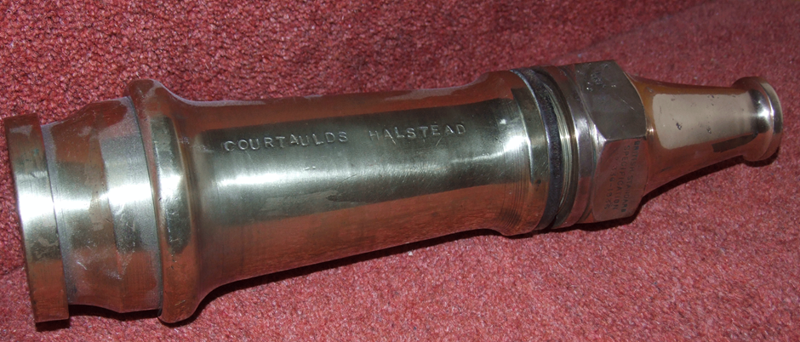

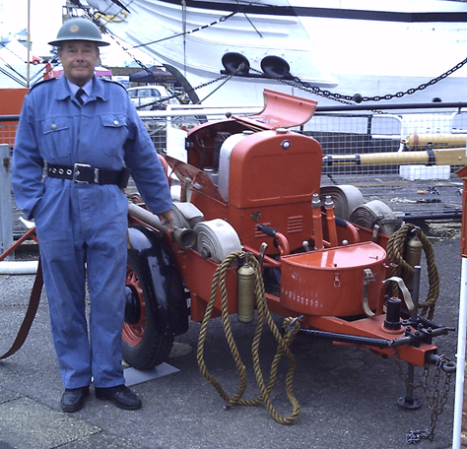 Alan Harris, Woodford U3A

Bata Heritage Centre News

Mike Tabard, Chairman of the Bata Heritage Centre wrote:
I am writing to update you on all our news. I am aware that some of you know about the arson attack on East Tilbury library but some of you do not. I am sorry not to have written before now but I had been waiting until I had some positive news to give you amongst what may be seen as “doom and gloom”. Around 4.30 am on Friday 6 January somebody reversed a vehicle into the doors of East Tilbury library (where we are based) and subsequently the vehicle caught fire. There was some structural damage to the building but considerable smoke damage to the interior including our collection. As a result of this the library is closed for the foreseeable future and we have no permanent base at the moment.

Whilst I am trying to ensure that it is “business as usual” this must be seen in perspective to what is currently happening. We have managed to retrieve around 90% of our collection from the smoke ridden library (some 5 weeks after the fire) and they are now safely stored locally. We have made a start on the restoration of some of our artefacts but it is a long, tortuous and soul destroying job. We are hoping that we can secure professional help via our insurance cover and discussions are currently at an advanced stage.

That all said we are extremely grateful for the support that we have received so far from many sources including Thurrock Council, I Big Storage (who own the former factory site), East Tilbury Scout Group, Thurrock History Group, Rosemary Bata, the local community and many others.

We do have one of our biannual Open Days on Wednesday 26 April. Because the library is currently closed we have had to change the venue and this time we will be using East Tilbury Scout Hall (Hammond Hall, Princess Margaret Road, East Tilbury, Essex, RM18 8SB) which is on the right, about 100 yards after the railway station crossing. There is a small car park through the entrance. We will be open from 10.00 am to 3.00 pm and I do hope that you will come along and show your support to us. We will also be planning walking tours during the day at £3 per person (bookable in advance please) and because we are a little further away from the centre of the estate we will start them at 12.00 noon. If necessary we will organise a couple of walks at this time.

On the positive side I recently attended the first of a series of project meetings with officers of Thurrock Council to discuss what needs to be done to replace the burnt out library building and how the Bata Heritage Centre will be part of this. This will not happen overnight but I am confident that, in time, whatever is built will give the local community and the Centre something to be proud of.

These are difficult times but we are doing everything that we can to rise from the ashes soonest. As ever I send best wishes to you all from all of us and my fellow volunteers and I do hope to see as many of you as possible on 26 April.

Your Chairman adds:

EIAG is very sorry to hear this sad news about one of the County’s key industrial heritage collections and has offered what support we can to the BHC. We are still hoping that they will be able to have a stand at the Industrial Heritage Fair in October and wish all the volunteers at BHC well with the difficult task they have ahead.

Book review:

Lost and Found: Journey to a Forgotten Railway by David Gridley

This book describes the author’s journey from London Liverpool Street Station to embark on an 18 mile, two day walk through Essex to explore the lost Bishop’s Stortford, Dunmow and Braintree branch railway line. It is not a detailed history of the line (that has already been written by Peter Paye), nor is it detailed step-by-step walk guide (it is after all a mostly straight forward route to follow, although the author does get lost on a couple of occasions where the line has been obliterated!). Rather it is a very accessible combination of the two which would appeal to those who enjoy a good walk in the countryside along a route with some fascinating history. The history of the line is summarised as the author progresses along the route and this local railway history is put in the context of the development of the UK’s railways in the mid-19th century as a whole, especially very useful for the reader who is not a railway historian. It describes a walk along the Flitch Way with details of the main surviving features and some of the people who worked and lived on the line, including the current Friends of the Flitch Way.

The book starts at Liverpool Street Station and with a description of the Great Eastern Hotel, the station and its modernisation, moving on to a summary history of the line, and then the walk begins. The author records interviews with Peter Paye and the lady who was the crossing keeper at Easton Lodge Halt and still lives in the crossing keeper’s cottage. After a description of the wildlife on the embankments and cuttings he arrives at Great Dunmow at the end of the first day and summarises the history of Dunmow, the malting industry, and the restored Great Dunmow Maltings. Again the history of the railway is placed in the context of wider UK history, especially its role in the two World Wars. Felsted station is described as he saw it, which was prior to its recent conversion to a private house, as is Bannister Green Halt since its restoration by the Friends group. At the restored Rayne station there is an interview with the grand-daughter of the former station master. The book closes with the closure of the line and the end of the walk in Braintree.

The 158 pages are illustrated with maps of the line, sketches of features along the route, and many archive and contemporary black and white photos. It is published by Slowcoach Publishing, 2016, and available from Swan Books in Upminster for £9.99 – www.swanbooks.co.uk or 01708 222930. ISBN no. 9780956412812.

David Gridley is also author of Walking the Lost Railways of Essex.

East of England Regional Industrial Archaeology Conference 2017

This year’s EERIAC event is on Saturday 3rd June at Braintree District Museum from 9:30 to 4:15. Included in the day’s programme are a talk by George Courtauld on the family business in Essex, a visit to the Warner Textile Archive, and a guided walk around Silver End, the Crittall company village. Full details and a booking form will accompany this newsletter or can be obtained by emailing us at essexiag@gmail.com



