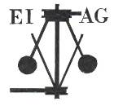
Essex Industrial Archaeology Group

NEWSLETTER

Number 17 July 2017

Welcome to this latest edition of your Newsletter which this month includes the ESAH/EIAG programme of visits for the rest of the summer; an invitation to a book-signing; an article on Martello Towers; brewery news; and most importantly details of the Industrial Heritage Fair in October. Please do spread the word about the Fair to family, friends and colleagues, and especially encourage any industrial and transport groups to which you belong to support the Fair by having a stand at the Fair. Booking forms for a stand can be obtained by emailing us at the address below.

If you have any comments on the Newsletter generally or specific items in it, or wish to make a contribution to the next Newsletter, please contact us via our email address - essexiag@gmail.com.

Programme of ESAH/EIAG visits 2017

The programme of visits in 2017 includes the following of industrial, maritime and transport interest. Book your places soon to avoid disappointment:

Tour of Bulmer Brick Works – 23rd August, 10:30am. Cost £5.00

Tour of Alderford Mill – 16th September, 10:30am. Cost £5.00

EIAG Annual Meeting, plus lecture on Railways and Industry – Chelmsford Museum – 11th November, 2:00pm. Free to members, £2.00 for non-members

To book contact the Excursions Secretary:
Graham Gould, 16 Osbourne Road, Leyton, E10 5QW,
0208 556 1423
drgegould@aol.com

Essex connections elsewhere

As you walk from High Street Kensington tube station in London, passed the former Derry & Toms building and then, immediately after the magnificent Barker’s building, on the right is a street named Kensington Court. The red brick building facing you as the road narrows announces itself with a stone plaque over the doorway ‘Electric Lighting Station’. This was constructed in the late 1890s as a generating station to provide electricity for the new housing development in the Court, designed by Colonel R E B Crompton. A blue plaque informs that Colonel Crompton lived and worked at the house to the rear of the generation station.
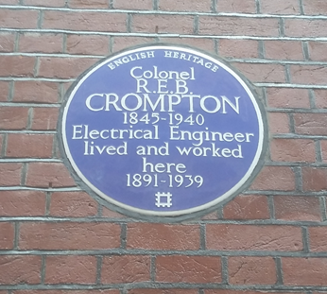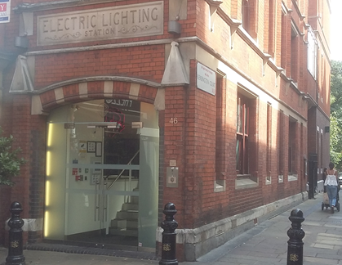

Essex Industrial Heritage Fair 2017

Saturday 7th October 2017
Wat Tyler Country Park, Pitsea, SS16 4UH

We have invited all the local industrial heritage groups, sites and museums to have displays at the Fair, and a good number have already signed up representing industries such as brickmaking, joinery works, maltings, mills, railways, explosives, shoe making and water supply. There will be five 30-minute talks on Bata shoes, Plotlands, EKCO radios and two on different Essex explosives factories. Other activities are still at the planning stage and will be announced soon. The miniature railway will be running (weather permitting!) along with the other attractions at the Country Park. The Fair will also give the opportunity for the groups to network with each other.

The site of the Country Park has a long and fascinating history, including industrial history, which can be explored using the Park’s Trails. The area was used for fishing and the cultivation of oysters as evidenced by the remains of oyster pits at Timberman's Creek on the edge of the Park as well as at many other sites across the marshes. In the 19th century the British Explosives Syndicate established a factory manufacturing nitro glycerine based explosives and in 1920 the Nobel Explosives Co. took over the site. Some of the original buildings and the protective blast barriers, in the form of large excavations or banks of earth, can still be found scattered throughout the Park.

During the Second World War the area of the Park was owned by the Ministry of Defence and buildings still survive now as evidence of a Naval Depot. More importantly the GHQ line, Britain's most important defensive line, began in the area of the Country Park before running up through Basildon to Chelmsford and beyond. Evidence of the line can still be seen in the Park in the form of four pill boxes and anti-tank ditches and blocks.

The venue is just off the A13 at Pitsea; Pitsea railway station is about a mile away and a number of bus routes stop at the railway station. There are full visitor facilities on the site including a café. For more information on the venue go to the Park’s website at: https://www.wattylercountrypark.org.uk/our-story/

So, put the date in your diaries now and we look forward to seeing you all at the Fair! Look out for more details of the programme for the day as they develop which will be in future editions of this Newsletter and on other widely circulated publicity. Also do encourage your local history group, society or museum to book a stand at the Fair. Booking forms can be obtained by emailing us at essexiag@gmail.com.
Book Signing

You are welcome to join Adrian Corder-Birch for a Book Signing
on Sunday, 3rd September 2017 between 1.30pm and 3.30pm
at the Reading Room, High Street, Great Yeldham CO9 4ER
when copies of his newly published book titled

‘WHITLOCK BROTHERS
A history of the family, farms, forage works, foundry and factory at Great Yeldham’

will be for sale at £14.95 each. Everyone is welcome to attend the Book Signing, when Mr. Nevil Whitlock will be in attendance and there will be a small exhibition relating to Whitlock’s history.

If you are unable to attend, but would like a copy of the book, please send your order to: Adrian Corder-Birch, Rustlings, Howe Drive, Halstead CO9 2QL – email: adrian@corder-birch.co.uk together with a remittance for £17.85 to include £2.90 postage and a copy will be posted to you on 4th September 2017. Cheques in English pounds sterling payable to ‘Adrian Corder-Birch’ please.
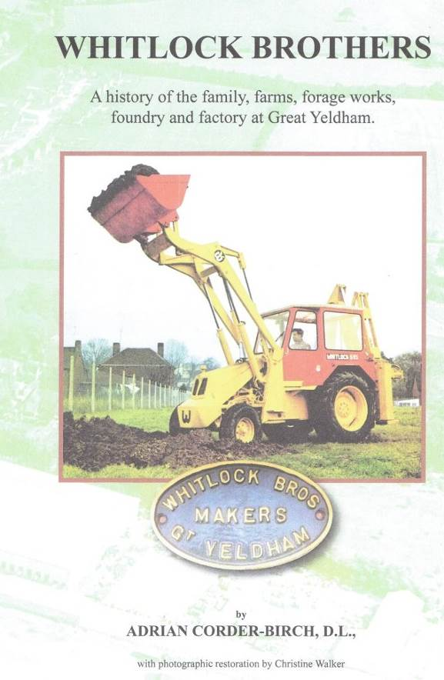
The book is a history of the Whitlock family, farms and industrial interests in Great Yeldham. They initially farmed on an extensive scale and later owned a brick-works, chaff works, and an agricultural engineering works. This was established in 1899 as Whitlock Brothers and gradually expanded to include a foundry and carpentry shops. All types of agricultural machinery, wagons, carts and trailers, together with a variety of wooden buildings were supplied.

In 1941 Whitlock Bros. Limited was incorporated and the company gradually diversified into earthmoving machinery. The Whitlock Dinkum Digger was the first ever tractor-mounted hydraulic excavator-loader in the World. This was followed by the first hydraulic dredger, known as the Whitlock Dinkum Dredger. In 1960 the first Dinkum Dumpers were built, followed in 1963 by Britain’s first Hydrostatic Dumpers. The name of ‘Whitlock’ was synonymous with earthmoving equipment and became well known around the World. The book includes the prominent positions which the Whitlock family and industries had in the history of Great Yeldham and details of all known employees.

The Martello Towers of Essex By Peter Jones

The Martello towers were coastal defences built during the Napoleonic wars to protect the south and east coast from invasion by the French. 73 Towers were built on the south coast between Seaford and Folkestone and 29 on the east coast between Brightlingsea and Aldeborough.

Eleven of the east coast towers were built in Essex and they provided a lot of work for Essex people. The towers looked like a large upturned flowerpot, 55 feet high and 35 ft diameter. They were built of brick, each tower consisting of over 700,000 bricks, enough to build 50 three-bedroom semi-detached houses.

Most of the bricks for the Essex towers were made in Grays, providing work for around 500 people, they were transported up the coast by barge to a landing place as near as possible to the site of the tower.
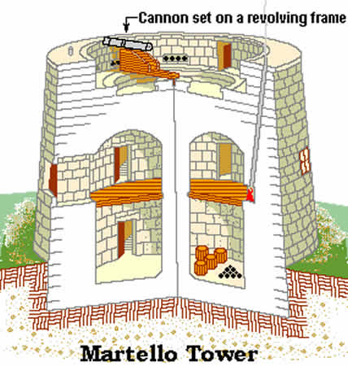
It is thought that most of the labour to build the towers was recruited locally under the supervision of the Royal Engineers. At first glance the towers appear to be quite a simple shape. However the walls have a 10º taper and the Essex towers are not circular but cam shaped, requiring highly skilled bricklaying. As can be seen from the drawing the walls are not of equal thickness. The thickest part of the wall, up to 3 metres, is on the seaward side.

The central column arches out to the outer walls giving the structure great strength. The mortar used to bind the bricks was developed at the Woolwich Arsenal. Known as ‘Hot Lime Mortar’ it consisted of ash, lime and tallow and it set like stone. The outer wall was given a stucco finish to make it smooth and unclimbable.

The inside of the tower consisted of three levels; the lowest level was a storeroom for food, fuel, gunpowder and ammunition. This could only be accessed from the floor above. Entry into the tower was also at this level, where there was the living accommodation for an officer and around 30 soldiers. Access to the gun platform was via two stairways built into the thickness of the walls. The towers were equipped with three smooth bore cannon. The main armament was a 24 pounder backed up with two smaller guns.

The towers were not permanently manned as they were considered to be unhealthy to live in. A barracks was built at Weeley in 1803 where the troops were stationed, it being within 2 hours march of all the towers.

The Essex towers were built between 1809 and 1812, ironically at a time when the French threat was diminishing. The year they were completed was the year of Napoleon’s disastrous retreat from Moscow when he lost over 400,000 men and three years later it was all over for him at the battle of Waterloo.

Although the south coast towers were numbered the east coast towers were identified by letters starting with A at Point Clear. Of the 11 towers built in Essex six still exist and two are open to the public.
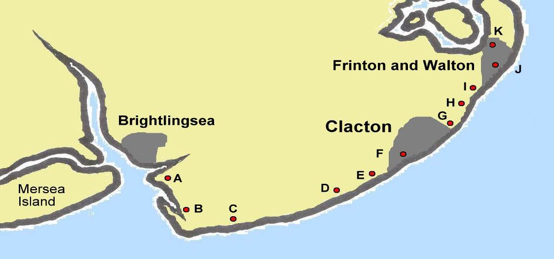

Tower A Point Clear is now home to the East Essex Aviation Museum. Although essentially an aircraft museum it does also have a lot of Army/Navy militaria.

Tower B St Oysth was demolished in 1967 to make way for housing, having been previously made into an observatory by a local business man, Frank Hyde, who was a keen amateur interested in radio astronomy and had collaborated with Sir Bernard Lovell at Jodrell Bank tracking the first Sputnik.

Tower C Jaywick was bought by Essex County Council for £1 in 2002, extensively renovated and is now a community and arts centre. You can even go up to the gun platform where they have full size replica cannon and gun carriage.

Tower D Clacton golf course, bricked up and in poor condition.

Tower E Formerly on the Butlins holiday camp site, in a similar condition to D

Tower F Near Clacton Pier, has had numerous previous uses, café, sea cadet base, children’s zoo etc. Recently put up for sale.

Towers G.H.I Located between Holland Haven and Frinton. Due to encroaching sea levels and a dispute between the War Office and landowners as to who should pay for sea defences the towers were sold in 1819 and demolished.

Tower J Located between Walton railway station and the pier. Due to unstable cliffs and coastal erosion the tower was sold in 1835 and demolished. The site was eventually levelled and can be seen today as the ‘The Round Garden’

Tower K Built to protect the backwaters of the Naze. Until recently it was in the middle of a huge caravan site, but this has now been sold for housing. The tower was offered for sale in 2015 for £200,000

Wherever Martello Towers survive they stand as a reminder to a completely different age of warfare and they remain part of our heritage, recalling a period in our history when Britain stood alone against the might of Napoleonic France.

For further information

Tower A http://www.aeroflight.co.uk/museums/main/east-essex-aviation-museum.htm
Tower C www.jaywickmartellotower.org

Brewery News

T. D. Ridley & Sons Brewery at Hartford End, Felsted was founded by Thomas Dixon Ridley in 1842 and remained in the family, although as a limited company from 1906, until it was bought by Greene King of Bury St Edmunds in 2005. Brewing then ceased and the last independent brewery in Essex was closed and the equipment stripped out, thus ending a family business that had operated continuously for over 160 years. At the time when Essex County Council undertook the survey of Essex Breweries (2002) the brewery was recommended for Grade II Listing, but this did not happen, leaving the brewery buildings at risk of development proposals.

The site is now being redeveloped for 26 units of housing including 8 units in the ‘Old Brewery’. The industrial architecture of the former Brewhouse has been retained, including the chimney, although apparently with much renewal of materials due the poor state of the originals. Ridleys also built two pairs of semi-detached workers’ cottages on site. These were recorded in the Essex County Council survey of Industrial Housing in Essex (2006) and were recommended for some protection. They have been retained in the new development as ‘The Brewer’s Cottages’, four semi-detached cottages but virtually doubled in size with major rear, two-storey extensions reflecting the original design.

View of redeveloped Brewhouse from developer’s brochure:

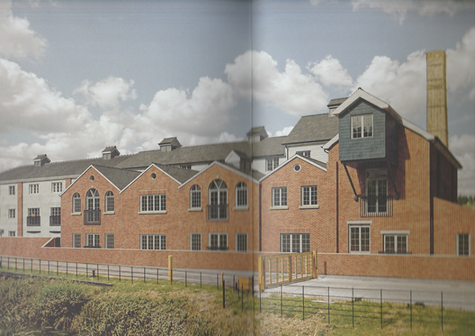

View of redeveloped Brewer’s Cottages from developer’s brochure:

