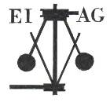
Essex Industrial Archaeology Group

NEWSLETTER

Number 18 September 2017

Welcome to this latest edition of your Newsletter which this month includes news of two mills, an article on the rail line to Ipswich, a new book announcement and, most importantly, details of the Industrial Heritage Fair in October. Please do spread the word about the Fair to family, friends and colleagues, and especially encourage any industrial and transport groups to which you belong to support the Fair by having a stand at the Fair. A few stands are still available and booking forms for a stand can be obtained by emailing us at the address below.

If you have any comments on the Newsletter generally or specific items in it, or wish to make a contribution to the next Newsletter, please contact us via our email address - essexiag@gmail.com.

Programme of ESAH/EIAG events 2017
The programme of events for 2017 concludes with:

Industrial Heritage Fair, Saturday 7th October 2017, 10:00 to 4:00 at Wat Tyler Country Park. Admission free. No booking required.

EIAG Annual Meeting, plus lecture on Railways and Industry – Chelmsford Museum – 11th November, 2:00pm. Free to members, £2.00 for non-members

To book for the Annual Meeting please contact the Excursions Secretary:
Graham Gould, 16 Osbourne Road, Leyton, E10 5QW, 0208 556 1423
drgegould@aol.com

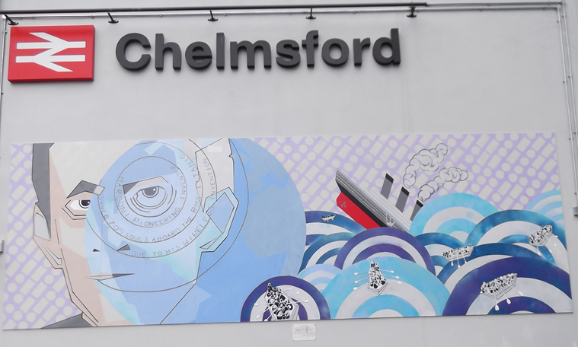
The Marconi Mural at Chelmsford Station unveiled 7th July
https://www.youtube.com/watch?v=wgEqXUfAp4k
Essex Industrial Heritage Fair 2017

Saturday 7th October 2017 10:00 – 4:00
The Green Centre, Wat Tyler Country Park, Pitsea,
SS16 4UH

Programme for the day

10:00 Fair opens to the public
11:00 Welcome by Tony Crosby, Chairman of Essex Industrial Archaeology Group followed by:

The Official opening of the Industrial Heritage Fair by Sir Bob Russell, former MP for Colchester, High Steward of Colchester and local historian.

A series of 30 minute talks will take place today in the Solar Room adjacent to the main display area in the Green Centre. These talks will start promptly at the times listed below and visitors are requested to make their way to the Solar Room for the start of the talk.

11:30 Sir John Tusa: Bata, shoe manufacturers at East Tilbury
12:05 Dawn Hoyle: Plotlands
12:40 John Williams: British Explosives Syndicate, Pitsea
1:15 Phil Smart: Waltham Abbey Royal Gunpowder Mills
1:50 Ken Crowe: EKCO Radios, Southend

Entrance to the Industrial Heritage Fair is free.
There is ample free car parking at the Centre
The Café in the Wat Tyler Centre will be open all day

Organisations at the Industrial Heritage Fair

Balkerne Tower Trust, Colchester
Bata Heritage Centre
Beeleigh Steam Mill
British Water Tower Appreciation Society
East Anglian Railway Museum
Epping Ongar Railway
Essex Industrial Archaeology Group
Essex Society for Archaeology and History
Friends of Upminster Windmill
Friends of Chelmsford Museum
Great Dunmow Maltings Preservation Trust
Greater London Industrial Archaeology Society
Halstead 21st Century Group
Industries of the Hedinghams and Yeldham (Brick making, joinery manufacturers and agricultural engineers)
Toll Roads and Toll Houses of East Anglia
Waltham Abbey Royal Gunpowder Mills

(Several of the above organisations will have publications for sale).

Basildon Heritage will have their permanent display available in the Green Centre, as will the Essex Field Club.

The Country Park is open to the public, with its Explosives Trail and WW2 Trail (leaflets available). The miniature railway will be running (weather permitting) for which there is a fare.

Announcing the publication of a new book on an Essex Industry

September 3rd saw the very successful launch of a new book by ESAH President and EIAG Vice-Chairman, Adrian Corder-Birch entitled:

WHITLOCK BROTHERS

A history of the family, farms, forage works, foundry and factory at Great Yeldham

The book is a history of the Whitlock family, farms and industrial interests in Great Yeldham. They initially farmed on an extensive scale and later owned a brick-works, a chaff works and an agricultural engineering works. This was established in 1899 as Whitlock Brothers and gradually expanded to include a foundry and carpentry shops. All types of agricultural machinery, wagons, carts and trailers, together with a variety of wooden buildings were supplied. In 1941 Whitlock Bros. Limited was incorporated and gradually diversified into earthmoving machinery. The Whitlock Dinkum Digger was the first ever tractor-mounted hydraulic excavator-loader. The name of ‘Whitlock’ was synonymous with earthmoving equipment and became well known around the World. The book includes the prominent positions which the Whitlock family and industries had in the history of Great Yeldham and details of employees. It comprises 192 pages and 200 illustrations.
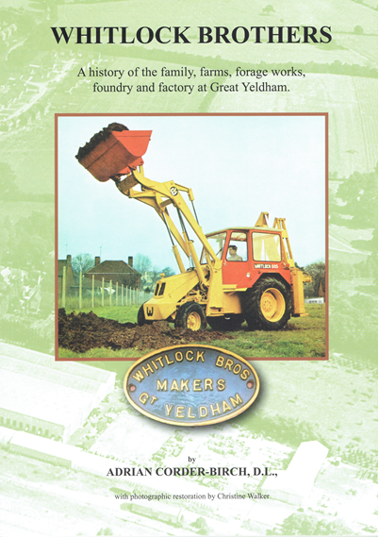
Price £14.95.

Books are available from the author: Adrian Corder-Birch, Rustlings, Howe Drive, Halstead CO9 2QL for £17.85 to include £2.90 postage.
Cheques payable to ‘Adrian Corder-Birch’ please. Email: adrian@corder-birch.co.uk

London to Ipswich, the railway that never was.

The first suggestion for a public railway to run through Essex linking London and Norwich came in December 1824. A London lawyer called John Wilkes Jnr promoted the line and in January 1825 a prospectus was issued for The Norfolk, Suffolk and Essex Rail Road Co. that planned to link London, Colchester, Ipswich, Norwich and Gt. Yarmouth with branches to Harwich, Bury St Edmunds and Kings Lynn. The capital required would be £1,000,000 for which subscriptions were invited in £100 shares.

Wilkes’ motives must be questioned, did he really want to build a railway or was it just a scam? This was an extremely ambitious project; no one had ever attempted anything on this scale before. Railways and steam locomotives were in their infancy, unreliable and inefficient. 126 miles from London to Great Yarmouth would have been a mammoth challenge.

The idea of a railway in the east was not met with much enthusiasm. The area was largely rural. All the major towns were connected by river/sea to each other and London. There was no industry to generate heavy mineral traffic and potential freight would likely be linked to agriculture that was seasonal and subject to slumps and the weather.

Despite the optimistic advertising, money was slow coming in but in spite of the poor uptake Wilkes proceeded to appoint “All the usual officers with liberal salaries” although there were insufficient funds even to allow work to start. On 1st November 1825 the company advertised that they intended to introduce a Bill to Parliament for a reduced scheme – “A Railway or Tram road” from Whitechapel to Ipswich. Wilkes employed a qualified civil engineer Henry Palmer to do the survey. His proposed route completed in October 1825, being very close to the line that the Eastern Counties Railway would ultimately take 18 years later.

Nothing more seemed to have happened until August 1826 when a special meeting of shareholders was called. It soon became apparent the company was bankrupt. Wilkes did not attend the meeting but according to accounts submitted by him, Palmer had been paid £1000 for his survey work. Palmer informed the meeting that he had in fact only received £750. After much heated discussion a committee was formed to investigate the company affairs.
It is not known if they ever reported back but the railway was never built. A lot of people lost money; Wilkes was revealed to be less than honest in his business activities and was branded as a swindler and charlatan. In June 1826 he was elected as MP for Sudbury.

He became known as “Bubble” Wilkes and was involved in numerous other dubious investments. The Directory of National Biography lists him as ‘Swindler’ and when he died in January 1846, The Suffolk Chronicle reported “This notorious individual paid the debt of nature; the only liability he ever settled…”

Had this railway been built it would have been one of the earliest railways in the country and at that time certainly the longest. It would be nearly a decade before a line of comparable length was built and 18 years before a railway line connected London and Colchester.

by Peter Jones

Beeleigh Steam Mill awarded an AIA Restoration Grant

We are very pleased to be able to report that the Beeleigh Mill Restoration Group (BMRG) has been awarded a Restoration Grant of £20,000 by the Association for Industrial Archaeology (AIA). Beeleigh Steam Mill on the River Chelmer near Maldon is listed at Grade II* and was originally a large water mill built in 1795, with barge docks off the navigation for loading and un-loading. In 1845 a Wentworth 12 hp beam engine was installed in the adjacent drying kiln building and in 1875 the water mill was destroyed by fire, the steam mill surviving.

The boiler for the steam mill is an ‘Elephant’ boiler made by John Hall & Sons of Dartford and is believed to be the only remaining example of this type left in situ in the country. The Wentworth engine is one of only three surviving beam engines made by this manufacturer. The hurst (the structure housing all the main driving mechanism of the mill and supporting the millstones) is of cast iron construction.

The restoration project is for the repair of the stone floor which suffered water damage, wet rot and woodworm, much of it as a result of a damaged roof, which has been repaired already. The AIA grant of £20,000 will kick-start this restoration project, while the rest of the money needed is raised.

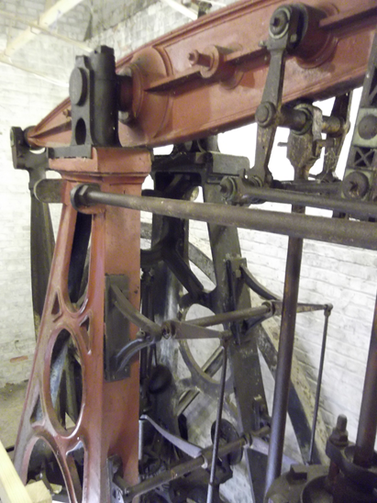
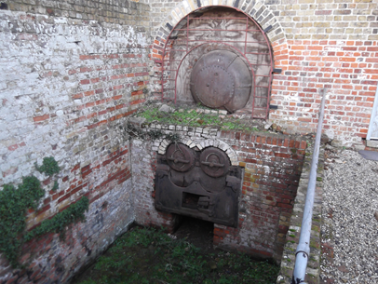

Above: Elephant Boiler

Right: Wentworth Beam Engine

Stansted Mountfitchet Windmill celebrates 230 years

Stansted Mountfitchet tower windmill was built by Joseph Linsell and his wife in 1787. Over the following century it was modified to incorporate technological advances in windmill design, principally the change from common canvas sails to patent shutter sails in 1857. Running the mill was financially perilous and after Linsell sold it in 1807 it was often run by tenant millers and was put up for auction three times. James Blyth, later to become the first Lord Blyth, bought the Mill in 1887. His son instituted initial preservation work on the Mill, an activity which has been continued to the present day. The Mill was “conveyed for the benefit of the inhabitants of Stansted” by the second Lord Blyth in 1935. The Mill was last worked, for crushing oats, in 1910.

The Mill was scheduled as an Ancient Monument in 1952 and is a Grade II* Listed Building. It is cared for by the volunteer group, Stansted Millers, and is open to the public on a number of weekend and Bank Holiday days between May and October – see the website for details: https://www.stanstedwindmill.co.uk/?page_id=34

