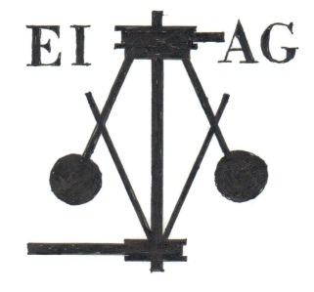
Essex Industrial Archaeology Group

NEWSLETTER

Number 2 December 2014

Welcome …

… to the second Newsletter for the Essex Industrial Archaeology Group (EIAG). This edition includes a report on the EIAG’s first annual meeting; dates for visits on industrial interest in 2015; details of a new publication charting the history of Chelmsford including the various industries which developed in the town; and reports from a number of sites including Upminster Windmill and Alderford Mill. If you have any comments on the Newsletter generally or the items in it, or wish to make a contribution to the next Newsletter, please contact Tony Crosby at tcrosby.iah@outlook.com.

Latest Visit

On Saturday 1st November 19 EIAG members gathered at St Mark’s College, Audley End, Saffron Walden for the EIAG’s first annual meeting and lecture. After some brief business which included the re-election of your Committee, we were treated to an excellent lecture by Professor Marilyn Palmer on Country House Technology with particular reference to Audley End House. She took us through the history of the House and how John Griffin Griffin ensured that the House was ahead of its time by installing domestic inventions and comforts. These included water pumped by a waterwheel installed in 1763 from the River Cam to tanks in the roof from where it was piped around the house; flushing toilets dating from 1775; oil lamps; and an ever expanding bell system for summoning servants.

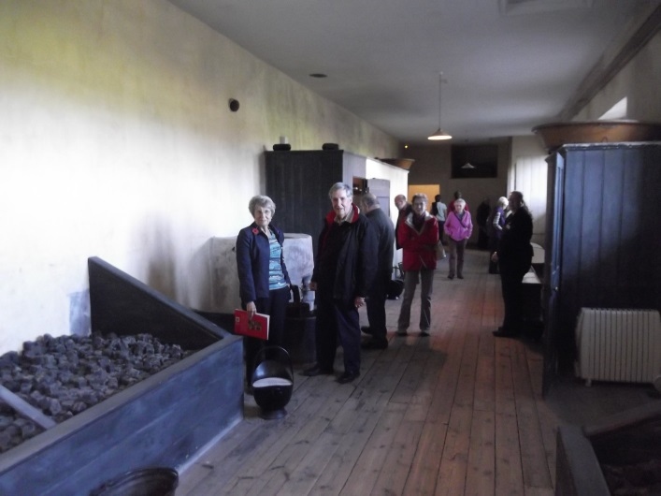
The most fascinating feature was the second floor coal gallery where coal was hauled up from outside by winch before being taken around the house to feed the many fires. Some of us were then guided by Marilyn around the house to look at the features she had described. More details on the technology at Audley End House can be found on the English Heritage website at:
https://www.english-heritage.org.uk/discover/explore/georgians/country-house-technology/

St Mark’s College itself has a long history, the site being associated with Walden Abbey, but some of the current buildings date from the 17th century. They do have open days when you can visit the college and in the summer cream teas are available. For more details see the website: www.stmarkscollege.co.uk

Events in 2015

The Essex Society for Archaeology & History in its programme of visits and talks for 2015 includes the following of industrial interest as suggested by members of the EIAG:

- Saturday 25th April – Beeleigh Mill, Langford, Maldon
- Saturday 4th July – Bata Reminiscence and Resource Centre, company village and factory site, East Tilbury
- Wednesday 16th September – Museum of Power, Langford, Maldon
- Saturday 14th November – EIAG Annual meeting and lecture by Keith Falconer, former Head of Industrial Archaeology at English Heritage and Chairman of the Association for Industrial Archaeology, Chelmsford Museum
- We are also hoping to hold an Industrial Heritage Fair on 10th October at Braintree District Museum, but this is provisional at present.

Fuller details of these events will be given in future EIAG Newsletters.

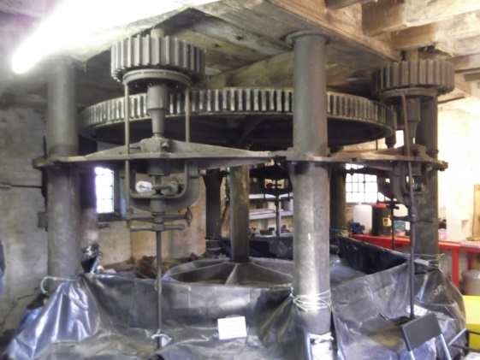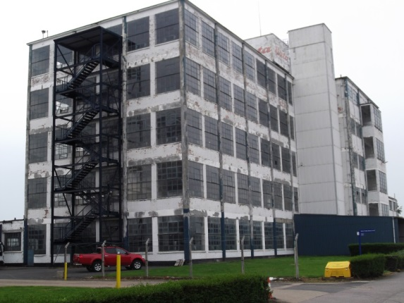

Beeleigh Mill, Maldon Bata Factory, East Tilbury

New Publication

The Latest Chelmsford Publication
The new book titled “From a Borough to a City: A History of Chelmsford 1888-2014” was launched at Chelmsford Museum on 19th November. The event was organised by the author, Stephen Norris, supported by the Friends of Chelmsford Museums. It took place in the presence of Lord Petre, President of the Friends, and the mayor of Chelmsford who received a copy of the book from the author.
This book is the outcome of nine years dedicated research into the ways in which Chelmsford has changed over the past 125 years. During this period the town evolved from a small county town dependent upon the local agricultural economy into a noted industrial centre, but more recently has become a rapidly expanding de-industrialised city. There are 28 chapters organised by topics which cover individual economic, social and political themes. Central to the story is the development of industry and technology as represented by a number of specific companies i.e. Christy (engineering), Crompton (electrical engineering), Marconi (telecommunications), and Hoffmann (precision bearing manufacture). Surprisingly publications about these companies have been relatively limited which makes the individual chapters devoted to each of particular importance to industrial heritage researchers. There is also a chapter about EEV, Britvic and other post-war industries. Throughout the book the influence of the big firms on all aspects of the lives of the town’s population is made clear, extending even to their participation in and enjoyment of sport and entertainment.
The book is not a light-weight read at 553 pages, excluding the index, and the author in his launch speech said that it was no cover to cover read. However, with so much new information about the industrial history of Chelmsford firms it will be an essential reference for researchers and also of general interest to anyone wanting to know more about their town. It is published by Authors Online Ltd., but can be obtained direct from Stephen Norris for £14 (fromaboroughtoacity@outlook.com).

Halstead Air Raid Shelters

In the last newsletter mention was made of the Courtauld built air raid shelters in Halstead. Attempts have been made to gain greater protection for these shelters, which are the subject of development proposals, so that they can be preserved for people to learn from and enjoy both now and in the future. One of the stumbling blocks to achieving this greater protection is that it is not known how many similar shelters survive in Essex, what condition they are in and how they compare to the Halstead examples, so the case can be made for their relative significance. So, if you know of other air raid shelters in Essex of similar design and construction, built by local industries for the protection of their workforce then please let us know by speaking to one of the Committee members or emailing Tony Crosby at tcrosby.iah@outlook.com.

Upminster Windmill Steam Mill and excavations

Upminster Windmill was built around 1802/03, and consisted of four sets of stones, two for corn, one for barley and one for beans. In 1811/12 a separate steam mill was constructed, which consisted of two sets of French stones. The steam mill was connected to the windmill by a 50 foot 2½ inch square drive shaft. Where this shaft terminated and shaft from the windmill met was a large wooden pulley which had at its centre a free wheel clutch with ratchet and pawl (a rarity and unique in windmill practice). This would allow one shaft to overrun the other; if when both wind and steam power were going ‘all out’, and the wind should drop, or the engine should labour; to prevent damage. Therefore Upminster Windmill had the capability of grinding with 4 or 6 or 2 sets of stones.

Steam plant consisted of Boulton & Watt bell crank engine, rated 6hp with a running speed of 40rpm and a 10ft diameter flywheel. The steam engine was modified to an under slung crankshaft. The boiler was a single fire tube brick set Cornish style boiler.

Archaeological excavations commenced in August to uncover the foundations of the steam plant. To date we have uncovered the brick set under flues on each side of the boiler, the engine mounting plinth and crankshaft pits, the flywheel pit, the grinding room gearing pit and three quarters of the coal place, this was where the coal was stored and the boiler was fed, as the end of the boiler protruded into the coal place.

So far the evidence uncovered by the archaeology has been instrumental in determining the measurements and location of the engine, boiler and gearing systems. With this information we are able to produce a working accurate computer generated model of the steam mill. It also appears that we have a fairly rare example of brick set under flues still intact and in situ. Work continues to expose the site in its entirety and subsequently open for display to the general public.
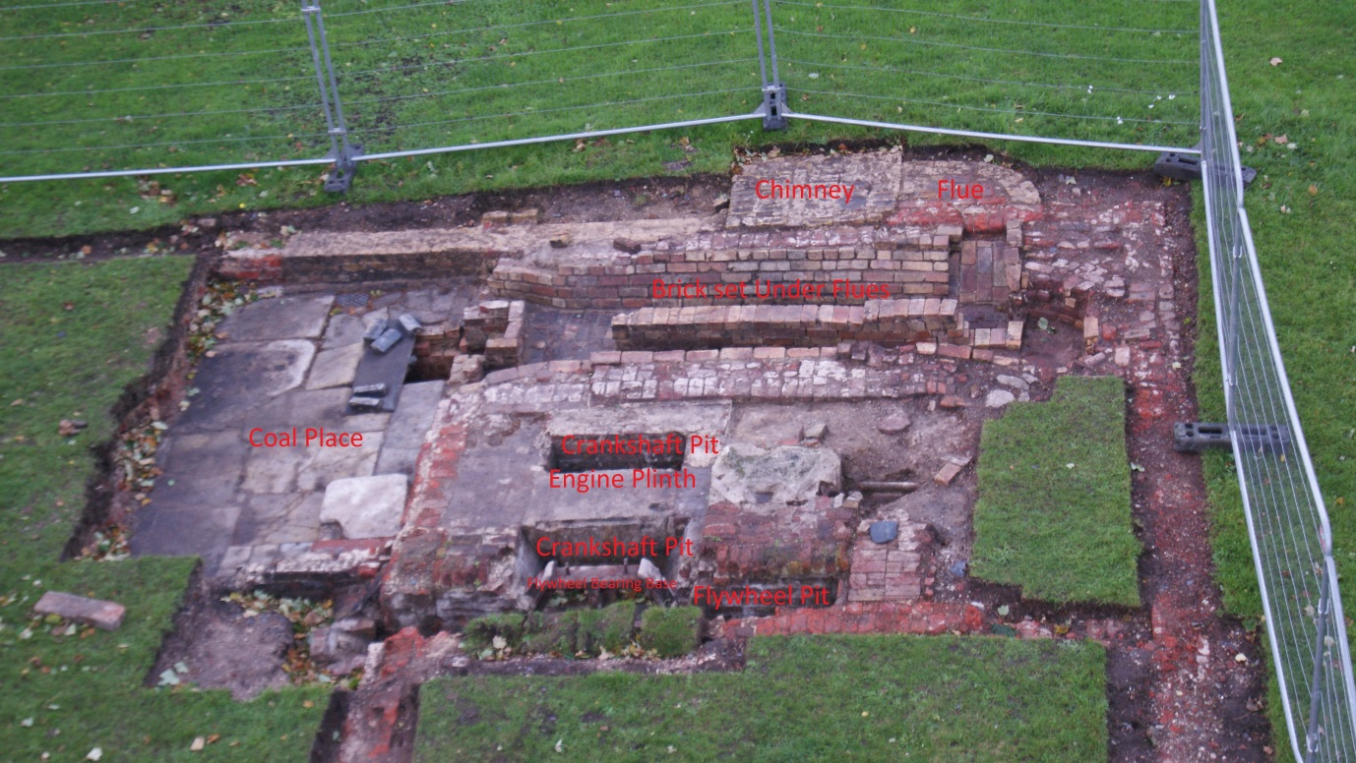

Archaeological excavations have uncovered the engine plinth, flues and coal place at Upminster windmill steam mill.

Alderford Mill

ALDERFORD MILL AND HEDINGHAM RIVERSIDE WALK, SIBLE HEDINGHAM

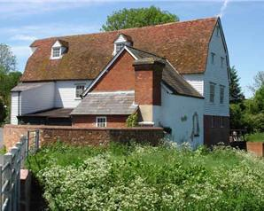
During the last few weeks the exterior of Alderford Mill at Sible Hedingham has been completely repainted and minor repairs carried out. This is a Grade II* Listed watermill owned by Essex County Council and cared for by it and the Friends of Alderford Mill (FOAM). The opportunity was taken to paint the mill while the road was closed to traffic, which enabled the extensive scaffolding to be erected and the work carried out safely. The road was closed for the rebuilding of a retaining wall between Alderford Brook and Alderford Street. This wall is immediately in front of Alderford Mill and has been replaced in keeping with the mill. Upon completion of the wall a bridge was placed across Alderford Brook to facilitate access to Hedingham Riverside Walk. On 13th November 2014 the bridge was opened by Cllr. David Finch, Leader of Essex County Council, in the presence of Councillors and members of FOAM. Adrian Corder-Birch, D.L., Vice Chairman of Essex Industrial Archaeology Group and Clerk of Sible Hedingham Parish Council was also in attendance. The Hedingham Riverside Walk, which starts at Alderford Mill, will eventually go through to Station Road. The first five acres has been acquired and a section of path has been completed. A further ten acres will be transferred during the next couple of years as development of the site of the former Ripper’s Joinery Works progresses. Ownership of the land, construction of the path and funding for the bridge has mainly been met from S106 agreements and with some funding from grants. The installation of the bridge now connects the Hedingham Riverside Walk with the village’s good network of footpaths one of which leads from Alderford Mill to Hulls Mill, now a house, which is on the border of Sible Hedingham with Great Maplestead. During recent years Alderford Mill has undergone renovation, including a new waterwheel and is once again able to grind corn after a lapse of many decades. The flour has been used to successfully make bread and cakes. The work on the mill has been undertaken by the Essex County Council millwright, with the support of FOAM. The mill will again be open to the public on the second Sunday afternoon of each month from April to September 2015 from 2pm to 5pm. A well-illustrated guide book of over 40 pages is available, which also details the extensive history of the mill. Further information is available from:
www.alderfordmill.org.uk
or
Brian Mills, Chairman of FOAM – 01787-460069 who will be pleased to receive enquiries for special visits or talks.

Balkerne Water Tower – ‘Jumbo’ - Colchester

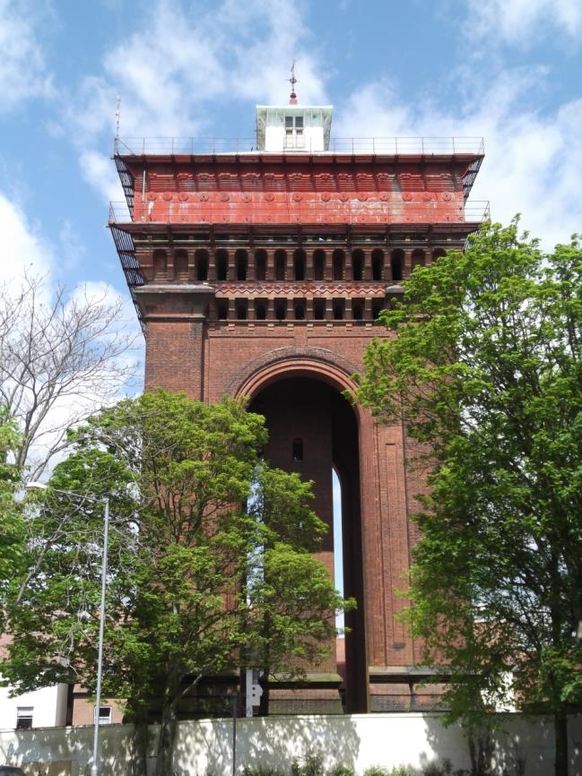
The Balkerne Tower Trust (BTT) are trying to persuade Colchester BC to take action over the appalling mess at the base of Jumbo (see http://www.savejumbo.org.uk/Plinth.html). They report that preparations to issue a section 215 Notice under the Town and Country Planning Act 1990 have been underway for at least two months. As revealed in the local paper recently the action is far more comprehensive than they had ever dared to hope – re-glazing and redecorating the cupola, painting the tank, replacing the vandalised original door with an accurate copy and 'other remedial works'. This will include removal of the rampant vegetation in the plinth and base area.

Brian Light, the Chairman of BTT is giving an illustrated talk on the history of Jumbo at the Colchester Recalled meeting at 7pm on January 15th 2015 at Colchester Institute (Room K357, third floor, music block).

http://www.savejumbo.org.uk/

Marriage’s Chelmer Mill

It was reported in the Essex Chronicle last month that Marriage’s, who have been making flour in Chelmsford since 1894 and have been at their current site for the last 116 years, are hoping to move further out of the city to a site near Boreham. If this move takes place it will mean that yet another of the City’s historic industrial buildings will become vacant and no doubt subject to redevelopment.
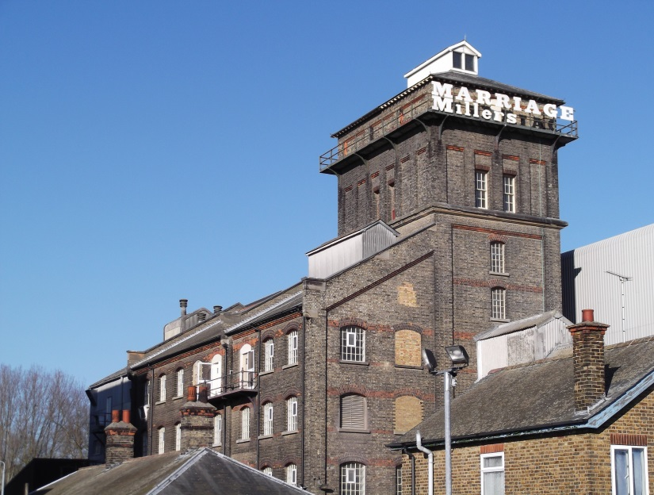
Chelmsford has already lost at least parts of, if not the whole of, many of its former historic industrial buildings, such as Hoffmann’s, Crompton’s Writtle Road site and Marconi’s New Street. The application to convert site the Marconi Hall Street site (as reported in the last newsletter) – the first wireless factory in the world – is being considered by the Council on 16th December 2014 and the recommendation is that the application be approved. The EIAG will monitor the future of the Marriage’s site should the company move out of the City and give whatever support it can for the preservation and appropriate re-use of the building.

EIAG at the European Route of Industrial Heritage (ERIH) Conference

Essex has had an association with ERIH for about 15 years through the County Council’s involvement in two European-funded projects, and EIAG is now a ‘friend of ERIH’. ERIH is a network that brings together hundreds of industrial sites to help each other, and to jointly promote them to visitors. The network is based on a successful route created in the Ruhr, Germany. Using this system, the most important sites, known as ‘anchor points’ act as magnets to draw people into the network and then encourage them to visit other sites on a variety of regional routes, one of which was established in the East of England, known as the ‘Industrious East’. The ERIH website (www.erih.net) also presents the diverse range of Europe’s industrial heritage through a number of theme routes, and biographies of key figures such as entrepreneurs and engineers.

EIRH is now an association registered in Germany and holds its annual conference in different countries. This year was the UK’s turn, at Cromford, Derbyshire (part of the Derwent Valley Mils World Heritage Site, and the location of Sir Richard Arkwright’s mill and the birth of the factory system). Paul Gilman and Dave Buckley have been long standing members and are honorary members, so they were well placed to represent EIAG at this important event, from 1-3 October.
Dave attended the pre conference tour which visited three anchor points on the new ‘Miners, Makers and Money regional route’, visiting Kelham Island Museum (Sheffield), Elsecar ironworking and coalmining village (home to the last Newcomen Beam Engine still in its original location) and the National Coal Mining Museum (Wakefield). At the conference proper, over 80 ERIH members and non-members gathered to discuss concepts and ideas about how local, regional, national and European networks are developed and maintained. In particular - "Founding-Managing-Funding-Marketing" were identified as the key challenges to face when a network is developed. It is especially difficult to secure the long-term viability and operation of such networks. Speakers from different countries including Holland, Germany, and Poland explained how they developed their network, and how they intend to maintain it or already are successfully maintaining it. The delegates discussed the different approaches and were especially interested in routes where crowd-funding and active participation of citizens, local initiatives and other stakeholders were applied. There were many lessons for EIAG, especially if we would like to revitalise part of the East of England route, for example by trying to create an Essex route.
The final day of the conference offered two local tours including one to the Derwent Valley mills World Heritage Site (which is 16 miles long), taking in visits to Crich, Tramway Museum, and the John Smedley and Masson Mills. The other tour went to Derby, including a visit to Rolls Royce. During the conference there was also an evening reception at the Derby Roundhouse, an excellent example of the successful conversion of an industrial heritage site. Formerly a turntable for the repair of steam locomotives, it is now part of Derby College and is used for diverse events including the national winter beer festival in February 2015.

For more information about the conference, including downloadable copies of the presentations, see: www.erih.net/latest-news/detailsseite/article/erih-conference-2014-new-ideas-for-networks/3.html.

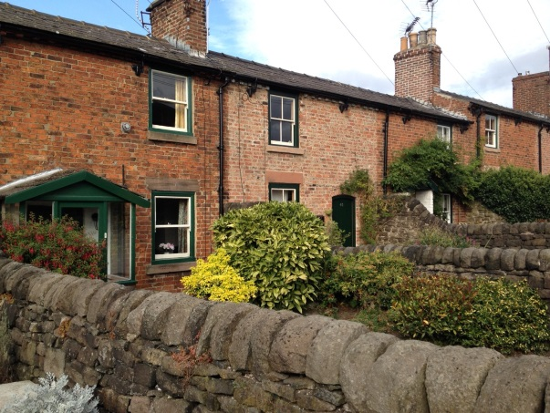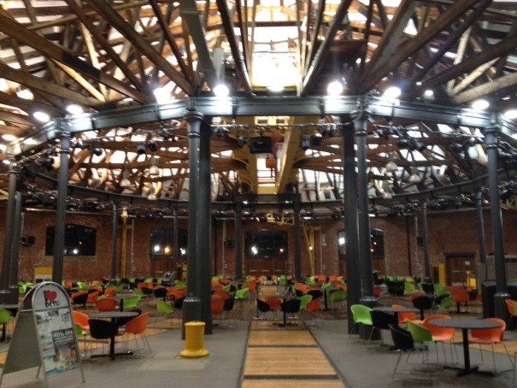

Industrial housing in Belper Derby roundhouse preserved and re-used

English Heritage Survey of Grade II Listed Buildings

English Heritage (EH) are about to embark on a national condition survey of Grade II Listed buildings and many industrial buildings that are listed are only at Grade II. EH are dependent upon local volunteers to undertake these surveys. More details can be found on their website at:
https://www.english-heritage.org.uk/caring/helphistoricbuildings/
There are a number of test projects being run and one of those will be in Essex involving two recording projects assessing the condition of Grade II buildings, one in Harlow District and one in Clavering Parish. Maria Medlycott at Essex CC is co-ordinating this work and if you are interested in being involved then do contact her at Maria.Medlycott@essex.gov.uk.

Essex Congress

Essex Archaeological and Historical Congress meetings and Symposia in 2015 include:

- Saturday 7th March, 10 a.m. to 4:30 p.m. - History Symposium at the United Reform Church, Chelmsford. The theme will be 'Transport'.
- Saturday 16th May, 10 am - 2015 Annual General Meeting at Great Dunmow Maltings, followed by tours of the Maltings and the town.
- Saturday 17th October, 10 a.m. - Archaeology Symposium in Harwich, with talks and a tour of the town.

Further details are available from the Assistant Secretary, Andrew Madeley
email: andrew.madeley@virgin.net tel: 020 8491 6514.

