
Essex Industrial Archaeology Group

NEWSLETTER

Number 20 January 2018

Welcome to this first edition of the Essex Industrial Archaeology Group’s (EIAG) Newsletter for 2018.

2018 seems to be starting very quietly, but promises to be another busy and interesting year for EIAG with, as usual, a number of visits of industrial interest throughout the year and the annual meeting in November. Details of these events are set out below, but please note a couple of corrections to the details you have already received in the Programme. Also there is some good news to report from a couple of sites in the County. We hope you enjoy reading this newsletter and taking part in this year’s events.

If you have any comments on the Newsletter generally or specific items in it, or wish to make a contribution to the next Newsletter, please contact us via our email address - essexiag@gmail.com.

Programme of ESAH/EIAG visits 2018

The programme of visits in 2018 includes the following of industrial, maritime and transport interest. Full details and booking instructions were circulated with the Winter 2017 ESAH Newsletter, so book your places soon to avoid disappointment:

Steam Tug ‘Brent’. A talk about the Steam Tug ‘Brent’ at Chelmsford Museum – Saturday 24th February, 2:00 pm - £2.00 for members, £3.00 for non-members

Morant Lecture. Millennium Tour of Clacton followed by a talk on Great Clacton by George Hardwick at Clacton Baptist Church – Saturday 10th March, 1:00 pm. ***Please note the start time which has changed from that advertised in the Programme*** £5.00 for members, £6.00 for non-members

Castle Point Transport Museum. Tour of Castle Point Transport Museum on Canvey Island based in the 1934 bus depot and housing over 30 commercial vehicles – Saturday 14th April, 10:30 am - £5.00

Pentlow Hall, Church and Watermill. Tour of a 15th and 16th century moated manor house with medieval watermill and a church – Saturday 18th August, 2:00 pm - £5.00

Historic Harwich and Redoubt Fort. Tour of the old town, followed by a tour of the redoubt in the afternoon – Saturday 22nd September, 10:30 am - £5.00 (Please note cost which was omitted from the Programme Descriptions sheet.) Please provide your own lunch.

EIAG Annual Meeting. AGM followed by a ‘study day’ looking at the railway, its impact on the industries of the Colne Valley, and a visit to the Colne Valley Railway. Saturday 10th November, 11;00 am – Free for members.

Britvic Clock Tower
The saga of the demolition of this iconic landmark industrial monument in Chelmsford seems now to have come to a conclusion. The original clock tower has now been demolished, although some of the features, including the clock and its mechanism, have been rescued for future display in Chelmsford Museum. A new clock tower has been erected at the entrance to the Clock Tower Retail Park – here are photos of the original and the new – and we leave you all to form your own opinions!!!
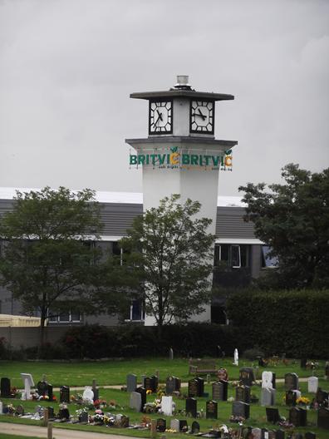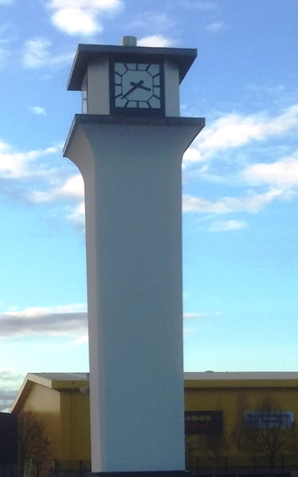

And now the good news!

Bata Heritage Centre

The BHC issued the following press release just before Christmas:

“The Heritage Lottery Fund (HLF) has delivered an early Christmas present for the residents of East Tilbury! Thanks to a £65,500 HLF grant, the priceless Bata artefacts which were damaged in a devastating fire [last] year will be restored during 2018. The 18-month ‘From the Flames’ project will also see a mobile exhibition developed to continue sharing East Tilbury’s Bata heritage with Thurrock’s community, while the library remains closed. There will be opportunities for local people to help by working with heritage professionals on the restoration and exhibition. This success was supported by a £5,000 Thurrock Voluntary Sector Development Fund grant, a £1,000 personal donation from the Bata family, and continued help from 1 Big Storage in East Tilbury who are housing the homeless Bata collection.

Commenting on the award, a delighted Mike Tarbard, Chairman of the Bata Heritage Centre said: ‘When the Heritage Centre went up in smoke, we thought that would be the end of our group. However, we have been overwhelmed and encouraged by the support we have received. Thanks to these supporters and the generous grant from the Heritage Lottery Fund, we can now take the first steps in bringing the Bata Heritage Centre back to life.’

Suzie Spence, Grants Officer at HLF said: ‘The industrial and social heritage of Bata in East Tilbury means so much to local people, including the school children who study this history as part of their curriculum. It is living history that communities still identify strongly with. As such, we are delighted to be able to support this project which will reconnect heritage, people and communities in East Tilbury once more whilst the library is rebuilt.”

Details of the next BHC Open Day are as follows:

With the kind permission of the owners of the former Bata factory site (1 Big Storage) BHC have agreed to host their next Open Day in this same venue and again on a Saturday – 28 April – from 10:00am to 2:00pm. Guided walks at £3 per person will be available and you are asked to pre-book a place on a tour by emailing brrcatbatamemories@hotmail.com
.

Balkerne Tower Trust – ‘Jumbo’

There seems to be good news at last coming out of Colchester with regard to the future ownership and use of the iconic landmark ‘Jumbo’ water tower. In early March 2017 a meeting took place between the owner’s agents, a representative of the Colchester and North East Essex Building Preservation Trust (CNEEBPT) and a new Conservation Officer at Colchester BC. Negotiations continued at intervals until early October 2017 when an agreement was reached on the future of Jumbo between the owner and the CNEEBPT. This agreement stipulates the start of a long term lease of Jumbo from the owner, but this is conditional upon the success of a major grant application to the Heritage Lottery Fund (HLF). The submission of stage one of this application is scheduled for March 2018. The projected scheme for Jumbo includes a restaurant at the base of Jumbo with a kitchen above, and a smaller restaurant on the floor under the tank. The tank itself will be used for events, and stairs and a lift will be provided. Major features of Jumbo such as the complete tank, the open arches between the legs and engineering artefacts such as pipes and valves will be preserved.
(Summarised from the BTT Annual Report 2017, courtesy Brian Light, Chairman BTT)

Association for Industrial Archaeology (AIA)

EIAG is an affiliated society of the national and, indeed, international organisation, the Association for Industrial Archaeology (AIA). Full details of the AIA can be found on their website at http://www.industrial-archaeology.org/. Your Chairman and Vice-Chairman are both individual members. As an affiliated society, EIAG receives copies of the AIA’s regular publications, a quarterly Newsletter (IA News) and a bi-annual Journal, Industrial Archaeology Review, each edition of which contains about five learned, peer reviewed articles on a variety of research projects from the UK and other parts of the world. These copies are deposited in the ESAH library. From now onwards any articles of local interest which appear in either IA News or IA Review will be highlighted in this Newsletter so that members can then access them in the ESAH library should they so wish.

EIAG Committee Members

As those of you who have attended the EIAG Annual Meetings in November each year will know, the Group is run by a Committee which currently consists of:

Chairman – Tony Crosby
Vice–Chairman – Adrian Corder-Birch
Secretary – Paul Gilman
Membership – Jane Giffould
Programme – Paul Sainsbury
Other members:
Dave Buckley
Elphin Watkin

When the Group was first established there were two other members who have had to step down over the last couple of years. So we are now seeking volunteers to join the Committee and help to run the Group, ensuring that it offers an interesting programme through the year, produces this Newsletter, and ensures the Group meets its remit as originally set out. The Committee meets four times a year in Chelmsford for about two hours. Liaison between meetings is mainly by email. If you are interested in joining the Committee please email us at the EIAG email address: essexiag@gmail.com. We look forward to hearing from you.

