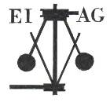
Essex Industrial Archaeology Group

NEWSLETTER

Number 23 July 2018

Welcome to this month’s edition of the EIAG Newsletter. As usual set out below are the ESAH/EIAG visits of industrial interest. There is a look forward to the Industrial Heritage Fair in 2019, the 2019 AGM, and events at the Bata Heritage Centre and Lea Valley. There is news of the gas holders in Chelmsford, along with a brief history of the site.

We hope you enjoy reading this edition. If you have any comments on the Newsletter generally or specific items in it, or wish to make a contribution to the next Newsletter, please contact us via our email address - essexiag@gmail.com.

Programme of ESAH/EIAG visits 2018

The programme of visits in 2018 includes the following of industrial, maritime and transport interest. Full details and booking instructions were circulated with the Winter 2017 ESAH Newsletter, so book your places soon to avoid disappointment:

Pentlow Hall, Church and Watermill. Tour of a 15th and 16th century moated manor house with medieval watermill and a church – Saturday 18th August, 2:00 pm - £5.00

Historic Harwich and Redoubt Fort. Tour of the old town, followed by a tour of the redoubt in the afternoon – Saturday 22nd September, 10:30 am - £5.00 (Please note cost which was omitted from the Programme Descriptions sheet.) Please provide your own lunch.

EIAG Annual Meeting. AGM followed by a ‘study day’ looking at the railway, its impact on the industries of the Colne Valley, and a visit to the Colne Valley Railway. Saturday 10th November, 11:00 am – Free for members.

To book contact the Excursions Secretary:
Graham Gould, 16 Osbourne Road, Leyton, E10 5QW,
0208 556 1423
drgegould@aol.com

Advance Notice – dates for your diaries

EIAG AGM NOVEMBER 2019

Our AGM next year will be held on Saturday 9th November 2019 at Chelmsford Museum. Our guest speaker will be Jim Lewis who will be sharing with us his extensive knowledge of the industries of the Lea Valley.
INDUSTRIAL HERITAGE FAIR 2019 (IHF 2019)

Following the successes of the Industrial Heritage Fairs of 2015 and 2017 we are responding to the requests of many people to hold another Industrial Heritage Fair in 2019. Feedback suggested a number of areas in Essex where it could be held of which Chelmsford seemed the best. Planning has now started:

Date: Saturday 5th October 2019
Venue: Sandford Mill Museum, Chelmsford is currently being investigated as the probable venue, having a particular accent on Essex industry.
Stand holders: Those with an industrial and transport history context. We know that there is a wealth of material over the county and we feel it important to share it. Stand holders in 2015 and 2017 said how much they appreciated talking with the other stands as well as with the general participants.
Lectures: 4 or 5 lectures on Industrial History topics relating to Essex.
Participants: Anyone with an interest in the Industrial History of Essex
Cost: This depends on the cost of the hall hire which naturally we wish to keep down.
Time Plan: January 2019 we will ask for expressions of interest.
March 2019 stand invitations will be sent out
May 2019 we will need to have bookings and payment completed.
October 2019 Industrial Heritage Fair 2019.

Note: IHF 2019 is not a top down event it is very much all of EIAG working together. Hence although run by the committee we very much welcome input from EIAG members. If you know of any organisation that might like to have a stand then do let us know and also let them know about IHF 2019 so that we can get together.

We are looking forward to IHF 2019 which can offer us so much information and pleasure in our Industrial Heritage.
Jane Giffould

News from the BATA HERITAGE CENTRE

Restoration Work
Although time consuming and tedious the restoration work on the artefacts damaged in the fire is going well with the company being used in East Tilbury, and Bata Heritage Centre are happy with the job being done. The members of staff have become closely involved with the Bata story – something they knew nothing about – and are really enjoying this work for the local community.

One piece of bad news is that this company had a burglary by opportunist thieves and, unfortunately, as far as they can see, a few of the Bata Heritage Centre items were stolen. They appear to be limited to the Fire Brigade helmets! There was an old leather helmet, a more modern yellow fibre glass one, and the antique brass French fire helmet with “Sapeurs Pompiers” engraved on it. This helmet had been presented by the Bata Fire Brigade, back in the 1950s, to Tony Marcanik, the then Commandant.
(However according to the website the helmets have been returned anonymously)

Open Day
The event held on 28 April was a success with a good attendance and also some new visitors, which was good. The next open day one will be on Saturday 13 October 2018, again from 10am to 2pm and in the ground floor of Building 13 (the former administration block – thanks again to 1 Big Storage for allowing us to use their premises). So PLEASE SAVE THE DATE. Website for details: https://www.bataheritagecentre.org.uk/

News from the LEA VALLEY HERITAGE ALLIANCE

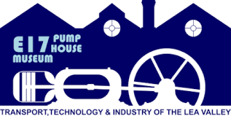
The Victoria Line 50th Anniversary Celebration
Saturday 1st and Sunday 2nd September 2018
The E17 Walthamstow Pumphouse
10 South Access Road Walthamstow E17 8AX
The Victoria Line opened on the 1st September 1968 from Walthamstow to Highbury and Islington without a celebration. The museum has two Victoria Line Underground cars in its collection of which part of one is the only original 1967 car that exists. The team at the museum has been busy restoring this car back to its original condition in time for this important celebration. The Victoria Line was the first fully automatic underground line in the world.

The event will also consist of a display about the line, models, and some vintage buses. The museums fire station, pumphouse, café and bookshop will all be open.

Come to the event and also learn about Waltham Forest being the home of British Transport and the museums future plans to be part of the Lea Valley Heritage Alliance’s exciting celebration of the Lea Valley

The event opens at 10.30 am on Saturday 1st September and is open until 4.00 pm. On Sunday 2nd September it is open from 11:00 am to 4:00 pm.

Association for Industrial Archaeology (AIA)

In the January 2018 edition of the EIAG Newsletter, details were given on the EIAG’s affiliation to the AIA, and particularly the fact that EIAG receive copies of the AIA publications, IA News and IA Review. The Summer 2018 edition (no. 185) of Industrial Archaeology News contained an article on the ‘Marine Engine House in Ferry Lane’, Walthamstow, part of the Lea Valley’s industrial heritage.

The May 2018 edition (Vol. 40, No. 1) of Industrial Archaeology Review contained an article ‘Portable Steam Engines and Traction Engines and Their Use in Rural Areas: The Case of Portugal’. Readers may well wonder at the connection between Portuguese rural agriculture and Essex industry! The authors of the article found that in the second half of the C19th the area of Leziria, Portugal, started to use portable steam and traction engines in agricultural production. Out of more than 100 original examples, all of them manufactured in England, only 17 survive in different states of preservation. Of these a number were made in Lincoln, four were made by Ransomes of Ipswich, and two by Davey, Paxman & Co. of Colchester. In fact ‘one of the best-preserved portable steam engines from Leziria is kept at the Benavente Museum … built by Davey Paxman & Co Ltd in Colchester…’

Copies of both AIA Publications will be accessible in the ESAH library.

CHELMSFORD GAS WORKS

In the last edition of the EIAG Newsletter, Dave Buckley reported on the purchase by the City Council of the former gas works site in Wharf Road, Chelmsford, and the likely demolition of the remaining two gas holders to make way for residential development. This, as Dave said, would result in the loss of yet another iconic industrial monument to Chelmsford’s industrial past and public works. This prompted Peter Wynn to write the following summary of an article he contributed to Essex Journal in 2009. He has also summarised his 2015 article on the ‘Church Family of Gas and Water Engineers’ which will be in a future edition of the EIAG Newsletter.

Summary of "A Century and a Half of Gas Manufacturing in Chelmsford"
Peter Wynn
Essex Journal Vol 44 No. 2 Autumn 2009 Pages 52 - 56

The Chelmsford Gas Light and Coke Company opened its works at the relatively early date of 1819. The works were initially situated on the north bank of the feeder channel to the Chelmer and Blackwater Navigation [where the Meadows multi storey car park now is]. There were initially 15 retorts and a condenser led to a lime tank for removal of impurities. The single gas holder had a capacity of 10000 cubic feet.

An additional site was purchased to the north east of Provident Row in 1856 and a tramway was constructed to link the 2 sites and in 1867 agreement was reached with the canal company to allow bridging of the feeder to connect to a newly acquired part of Floodgate Mead. A gasholder, condenser and purifier were constructed shortly after this acquisition.

In 1880 the company purchased the land occupied by Provident Row. However most subsequent development was on the Floodgate Mead side of the feeder where a further gasholder and retort house was constructed. 1912 saw the construction of a carburetted water gas plant to meet sudden increases in demand. In 1917 the older of the two remaining gasholders was completed, subsequent to the purchase of the undertaking by the local authority. In 1929 new purifiers for removal of hydrogen sulphide were installed. The retort house was extended in 1931 with new tar and ammonia wells the following year and a new boiler house shortly afterwards. The carburetted water gas plant was replaced in 1941, although it is now clear that a major reason for it construction was the production of hydrogen for barrage balloons.

The second of the two remaining gasholders was completed in 1947 but suffered settlement problems and required remedial piling work. The problems led to important research on plastic flow beneath foundations and on the ultimate bearing capacity of clay layers. After completion of this gasholder, Chelmsford was stated to have the second largest municipally owned gasworks in the southern half of England.

The works were transferred to the Eastern Gas Board on nationalisation in 1949 and a new retort house was completed by the board in 1953.

In 1968 the Eastern Gas Board completed, to the east of the coal gas plant, the construction of its largest plant for the manufacture of town gas from imported natural gas and the coal gas plant was decommissioned. The new plant had a relatively short life because it became more economic to use North Sea gas directly.

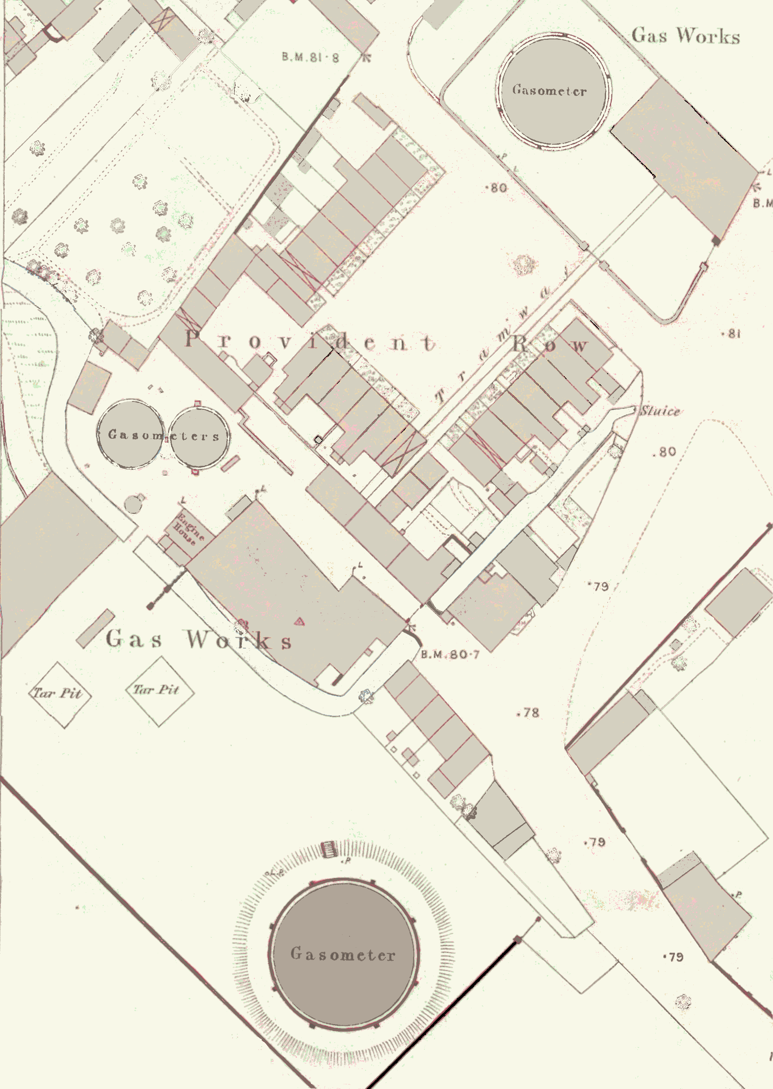
Acquired 1867
Original Site
First Gasholder
Acquired 1856
1870s OS Plan Showing early development
[not included in original article]

Good news of the Chelmsford Gas Works Site

Again, following on from Dave Buckley’s article and fear that Chelmsford would lose yet another iconic industrial monument, news has come that one of the gas holder frames is to be preserved as part of the development of the gas works site. This news comes following much wider concerns that the City would lose an iconic part of its industrial heritage. Part of the older of the two structures – known as gasholder 114 - is to be carefully dismantled and used in the eventual redevelopment of the site into new homes. The north east gasholder (114) was constructed in 1917 and the south west gasholder (115) dates from 1947. Gasholder 114 has a guide‐frame of 12 wrought iron lattice standards that support two tiers of horizontal members formed of lattice girders with diagonal bracing rods.
In a submission to Chelmsford City Council, Historic England said: “Historic England are concerned that the proposals for total demolition are premature, but should adequate justification be forthcoming for this approach Historic England would have no objections to the total demolition of the southwestern gasholder (115) or the associated structures.
“In relation to the northeastern gasholder (114), however, we consider its lattice frame provides a striking, positive contribution to the character and appearance of the conservation area which reflects its industrial heritage.
“We are therefore of the view that whilst we have no objections to the demolition of the gasholder itself, demolition of its frame would cause harm to the character and appearance of the conservation area.”
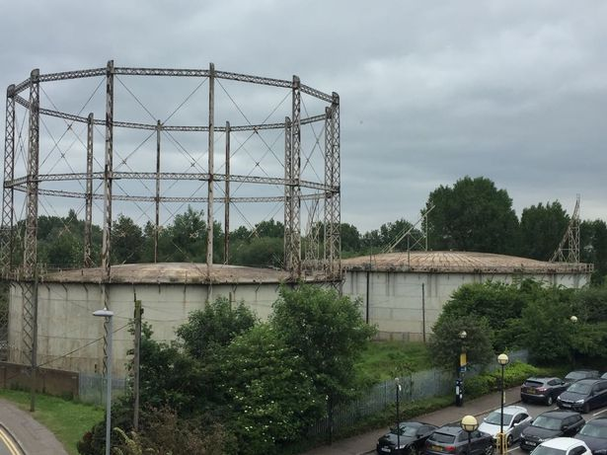

Waltham Abbey Royal Gunpowder Mills - Guided Walking Tours

The Royal Gunpowder Mills is a fascinating and important historic site, once a busy, thriving place of manufacture of explosives and propellants, with buildings uniquely constructed to cope with the event of an explosion, a network of waterways and canals (now mostly dry), and stories of innovation and working lives. A Guided Walking Tour allows people to get close up to the history in the company of knowledgeable guides. The tours take in 2 miles of this fascinating place over 2 hours. Tours cost £18 which includes refreshments – coffee, tea and cakes. Places are limited and therefore it is essential to pre-book, via the Invitation to View
website: https://www.invitationtoview.co.uk/properties/royal-gunpowder-mills/

Dates of the tours are as follows:
Sat 18 Aug | 1:00 pm
Sat 15 Sep | 1:00 pm
Sat 20 Oct | 1:00 pm
Sat 10 Nov | 12:00 pm

