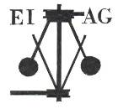
Essex Industrial Archaeology Group

NEWSLETTER

Number 24 September 2018

Welcome to this month’s edition of the EIAG Newsletter. As well as EIAG events, there is also a list of talks of industrial and transport interest being held by Local History Societies in Essex. There are articles on recent events, good news from the Bata Heritage Centre and of Pound End Mill, Braintree, and an article on the Church family of gas engineers.

We hope you enjoy reading this edition. If you have any comments on the Newsletter generally or specific items in it, or wish to make a contribution to the next Newsletter, please contact us via our email address - essexiag@gmail.com.

EIAG Annual Meeting.
Saturday 10th November, 11:00 am
Colne Valley Railway, Castle Hedingham
AGM followed by a ‘study day’ looking at the railway, its impact on the industries of the Colne Valley, and a visit to the Colne Valley Railway. Free for members.

To book contact the Excursions Secretary:
Graham Gould, 16 Osbourne Road, Leyton, E10 5QW,
0208 556 1423
drgegould@aol.com

Advance Notice – dates for your diaries

INDUSTRIAL HERITAGE FAIR 2019 (IHF 2019)

Following the successes of the Industrial Heritage Fairs of 2015 and 2017 we are responding to the requests of many people to hold another Industrial Heritage Fair in 2019. Feedback suggested a number of areas in Essex where it could be held of which Chelmsford seemed the best. Planning has now started:

Date: Saturday 5th October 2019
Venue: Sandford Mill Museum, Chelmsford is currently being investigated as the probable venue, having a particular accent on Essex industry.

EIAG Annual Meeting NOVEMBER 2019

Our AGM next year will be held on Saturday 9th November 2019 at Chelmsford Museum. Our guest speaker will be Jim Lewis who will be sharing with us his extensive knowledge of the industries of the Lea Valley.
Essex Local History Societies’ Meetings (September to December, 2018)

Below is a list of some of the talks of industrial and transport interest being held by various Local History Societies in Essex over the next few months:

Wednesday 26th September
Saffron Walden Historical Society. 7.45 p.m. Friends’ Meeting House, High Street, Saffron Walden.
Andrew Everett, An Early Railway Station Architect – the Life, Times and Works of Sancton Wood 1814-1886.

Tuesday, 2nd October
Jaywick Local History Society. 7 p.m. Golf Green Hall
Simon Gallup, Lavenham, Dedham and the cloth trade.

Wednesday, 3rd October.
South Woodham Ferrers Local History Society. 8 p.m. Champions Manor Hall, 94 Hullbridge Road, South Woodham Ferrers.
Charlotte Harding, Braintree silk-making and the families who worked at Warner Textiles.

Thursday, 18th October
Chingford Historical Society. 7.30 p.m. St Peter and St Paul Church, Chingford Green.
Neil Houghton, Gunpowder Paper and Leather: the Story of Chingford and Walthamstow Water Mills.

Friday, 16th November
Waltham Abbey Historical Society. 8 p.m. Baptist Church, Paradise Road, Waltham Abbey.
James Lewis, The Great Stink and a Little Bit more.

Please contact the relevant Society for further details, or just turn up on the night! (which we assume would be acceptable!)

HALL STREET MARCONI BOARD

As a member of both the EIAG and Friends of Chelmsford Museums committees on the 13th September I attended a ceremony for the unveiling of a small information board on the wall of the Woolpack public house in Mildmay Road, Chelmsford. This was an event organised by the Chelmsford Civic Society to coincide with Heritage Open Days in Chelmsford, 2018, and as a celebration of the City`s cultural heritage.

On the other side of the road from the Woolpack, on the corner of Mildmay Road and Hall Street, stands the iconic building where Marconi opened his first wireless factory. The board has text and pictures which outline the story of this site and explain its importance not only for industry in Chelmsford but also for the development of communication in the modern world.

The board was produced as a direct outcome of the research which the Civic Society carried out for the successful Marconi exhibition that they were able to hold inside the Hall Street building in 2016 prior to its conversion into apartments. It was funded by the money raised from that exhibition, talks, book sales and donations.

It was not possible to arrange for the information board to be placed on the wall of the Marconi building itself. However, it can now be read on the pub wall with the kind permission of brewers Greene King and the pub landlord, Will Turner. A short introduction was given about the reason for the board by Chris Neale from the Chelmsford Civic Society. It was then unveiled by Peter Turrell, President of the Marconi Veterans, who revealed afterwards that his own father worked at the original factory and that his face can be seen amongst the factory workers in a group picture used on the board.

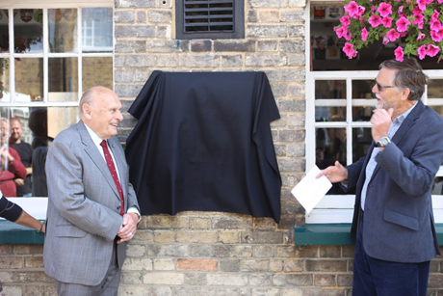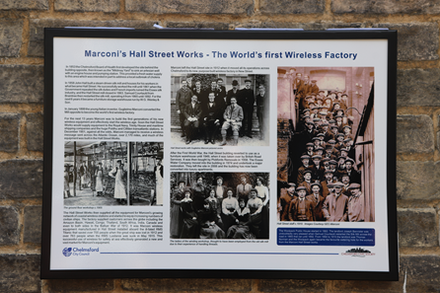

Text: Dave Buckley
Photos: Paul Mclean Photography

SANDFORD MILL OPENS ITS GATES

Sandford Mill is maintained and used as a store for its industrial collections by Chelmsford Museum Service but is only open to visitors for specially arranged events. Over the summer a number of these were held and details may be of interest to EIAG members.

For those who do not know the site it is set in tranquil countryside only a few miles from Chelmsford City centre. It was originally the site of a medieval mill driven by water from the River Chelmer. The Chelmer and Blackwater Navigation, constructed in 1797, passes close-by. In the 1920`s the site was converted into a waterworks and the original mill building demolished. Following closure of the works it began to be used by the museum.

This summer throughout the school holiday period the mill was open every Friday for specially organised `Summer of Science Discovery Days`. These provided an opportunity for children with their parents to experience `Mad Science` sessions, to seek out particular selected features and wildlife around the site and watch science of flight displays by birds of prey. The days proved extremely popular and introduced many family groups to the site for the first time.

This objective was also achieved on Sunday 9th September when the mill was one of the Chelmsford sites taking part in this year`s Heritage Open Days, being opened and run for the day on behalf of the museum by the Friends of Chelmsford Museum. It was possible to visit the site free of charge and simply look around or alternatively to take the opportunity to pre-book for one of the guided tours. During the day there were three tours of the former engine house by Tim Wander and three of the extensive nature area around the standing buildings. In the engine house the displays about Chelmsford industries provide information about the Christy, Marconi, Crompton, and Hoffmann factories. Former Marconi workers were available as volunteers on the day to demonstrate various items of repaired and working Marconi equipment. Friends of the Museum provided drinks and light refreshments in a former pump house building.

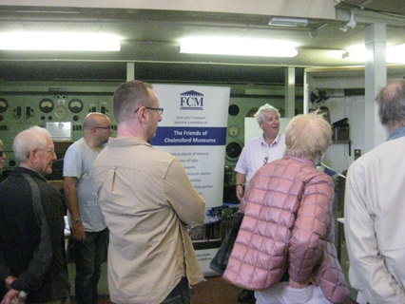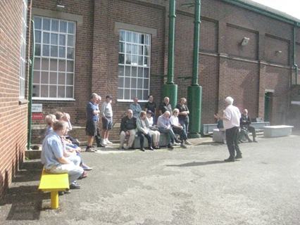
These events demonstrated the visitor potential of Sandford Mill and add weight to the EIAG committee`s consideration of the site for the holding of the next Industrial Heritage Fair there in 2019.

Text and photos: Dave Buckley

News from the BATA HERITAGE CENTRE

Our next Open Day will be on Saturday 13 October 2018 from 10am to 2pm.

With the kind permission of the owners of the site (1 Big Storage) it will, again, be in the former Bata Administration Block (Building 13) but this time it should be in the old staff department (through the revolving doors). For those of you driving please park in the Bata Memorial Park, across the road, and walk over to the site. If you need closer access because of a disability then please let me know and I will send you details separately.

Those of you who haven’t visited East Tilbury in a while will see major changes in this area. All the paths from Princess Margaret Road to the factory site have been re-laid with block paving and the gardens have been remodelled and replanted. Most of the old trees have been felled and new ones replace them. On the old car park/EDP area there are now properties being built.

As usual, we will organise guided walks at 11am, 12noon and 1pm and we suggest a £3 per person donation to BHC funds. We would appreciate you pre-booking a place by sending an email to Mike Ostler who is coordinating these for me (at feva-southessex@supanet.com). Please could you copy me in as well please (at brrcatbatamemories@hotmail.com).

Our collection is currently undergoing professional restoration locally in East Tilbury and we are delighted with the work that is being done for us. It is a very slow process and about 60% of the collection is as it was before the fire.

There is now more positive news about the library building. As you know since the fire in January 2017 I, and others from East Tilbury, have been working very closely with Thurrock Council on their project team. We are now at a stage where plans for a new building have been agreed by the project team and planning permission is due October 2018. Builders have been appointed and the funds to pay for it will come from the Council’s insurance on the building and their own funds. We are hoping that work will start in the next few weeks and that the new library will be open in the Spring of 2019. As I am sure you can imagine this is great news for us and the local community and I personally feel that we can now begin to see light at the other end of the tunnel. There will still be a lot of work to do moving our collection back in this building and setting it out either in display cabinets or storage but I am sure it will be worth it.

Mike Tarbard, Chairman BHC

News of POUND END MILL, Braintree

The name “Pound End” relates to the cattle market, as this was the area where bovine escapees from the market were kept once rounded up. The mill was the first Courtauld-owned premises, built in 1818 by Samuel Courtauld who paid £120 for the site. The power for the machinery was supplied by a horse-mill, but Courtauld’s were seeking a water-powered site and soon moved on in 1819. The Mill was empty and unused until 1822 when it was leased to Daniel Walters, another silk manufacturer who moved out of London. Walters was later taken over by Warners. After its use by silk manufacturers, it was used by the engineering firm, Bradbury’s. Eventually it was bought by Tesco’s for use as part of their supermarket site, but has been unused for many years, subject to vandalism and use by squatters. Planning permission was granted in August for conversion of the building into eight 2-bedroomed flats. Thus the future of this Grade II Listed building looks now to be secure.

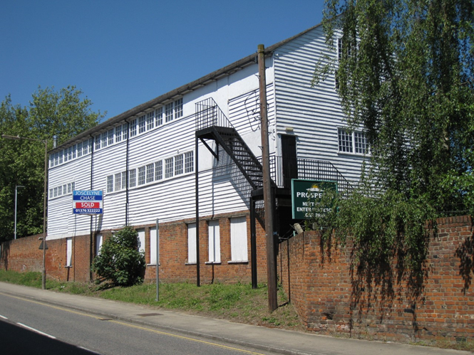

Text and photo: Tony Eve, Trustee of The Braintree Society

Walthamstow Wanderings

On Saturday 1st September I attended the Victoria Line 50th Anniversary Celebration event at the E17 Walthamstow Pumphouse Museum. As well as displaying their two Victoria Line underground cars, one of which is part of an original from 1967 under restoration, there was a display on the history of the Line, and access to all the other exhibits at the museum. Based in the Grade II Listed Low Hall sewerage pumping station of 1885, the museum has extensive displays about the pumphouse itself and the two surviving 1897 steam engines, as well as many of the industries of the Lea Valley and a large model railway based on Walthamstow. There is also a fire engine museum on the site. See their website for full details of opening times etc. - http://e17pumphouse.org.uk/

The next stop, a short car ride away, was the Walthamstow Wetlands, where the Walthamstow Reservoirs have been transformed into one of the largest urban wetland nature reserves in Europe. There are also two excellent examples of Victorian industrial architecture to be visited. The Wetlands Visitor Centre is in an 1894 steam engine house used to pump the water around the reservoirs. Further into the site is the Grade II Listed Copper Mill, which is on the site of a water mill recorded in Domesday, and has a long industrial history of producing gunpowder, paper, copper and well as corn milling, all powered by water in the Coppermill Stream. See their website for full details - https://walthamstowwetlands.com/

Both sites are well worth visiting and are close enough to each other to be seen in a day.

Text and photos: Tony Crosby

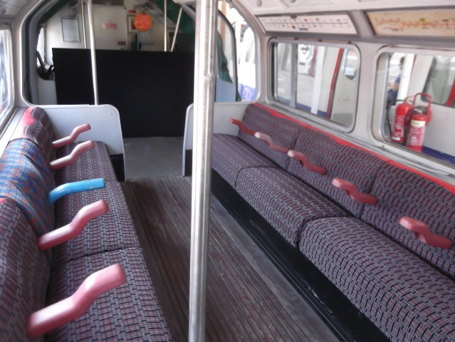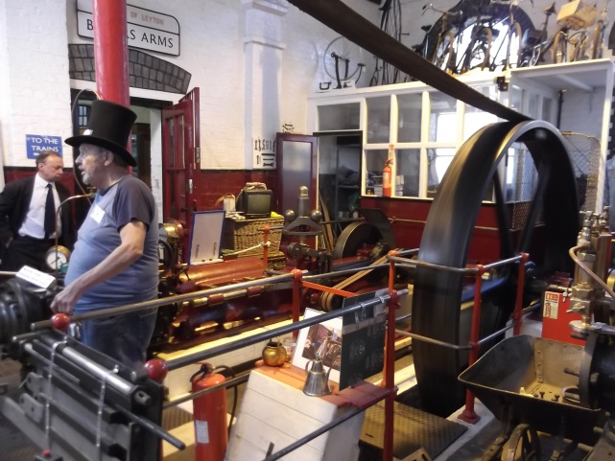

Original Victoria Line car undergoing Marshall horizontal steam engine of 1897
restoration at E17 Pumphouse Museum. being run in the 1885 pump house.

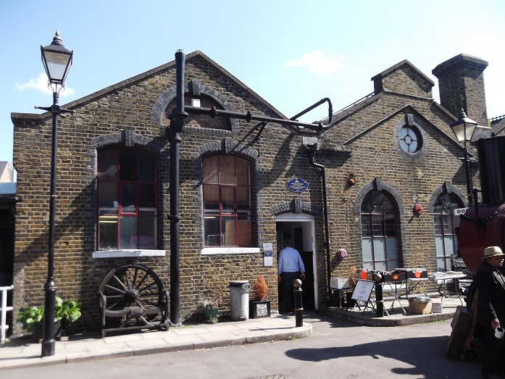

1885 Grade II Listed Low Hall Pumphouse.

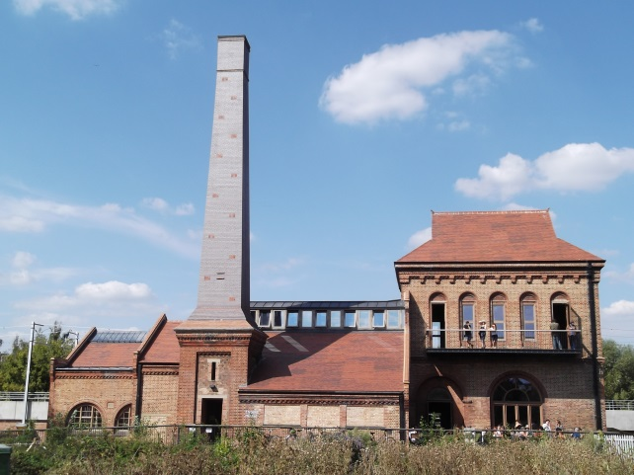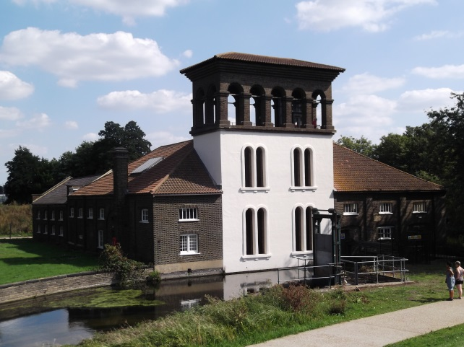

Walthamstow Wetlands visitor centre (left) in the 1894 Engine House, and the Grade II Listed Copper Mill building (right)

CHELMSFORD GAS WORKS

In the last edition of the EIAG Newsletter we published Peter Wynn’s summary of an article he contributed to Essex Journal in 2009. He has also summarised his 2015 article on the ‘Church Family of Gas and Water Engineers’ which is published below.

Summary of "The Church Family of Gas and Water Engineers"
Peter Wynn
Essex Journal Vol 50 No. 2 Autumn 2015 Pages 56 - 64

The Church family, originally from Rochester in Kent, were significant players in the provision of gas and water services, particularly in Essex. Of especial interest are the three generations of Jabez Church.

Jabez Church I
In the baptism record for his son in 1831, Jabez Church I was recorded as a Gas Factor at Springfield. In 1838 he went to Colchester as manager of the works there and subsequently became a joint lessee of the works with John Hudson Theobald, the Colchester Borough Treasurer. The enterprise was loss-making and after becoming bankrupt appears to have been employed as a gas engineer with the Phoenix Gas Company in Lambeth. He died at Brighton in 1865.

Jabez Church II
During the early 1840s he worked with his father at Colchester but in 1847 moved to the Chelmsford Gas Light and Coke Company where from 1854 he was styled as Clerk and Engineer to the company. He also took on consultancy work within Essex for gasworks in Romford, Harwich, Southend, Brightlingsea, Epping and Ilford. His work outside Essex included works at Market Deeping, Bury St Edmund's and Dublin. In 1872 he was appointed as President of both the Society of Engineers and the British Association of Gas Managers. By 1870 he had entered into partnership with his son, Jabez Church III and the firm of Jabez Church and Son extended their activities into water supply and treatment with work as far afield as Hull. A particular commission of interest was that of Epping where, because of the failure of the local board, Jabez Church II was personally given the full power of a sewerage authority by the government. Amongst his business interests were directorships of the Walton on the Naze Gas and Water Company and the Braintree and Bocking Gas Company.

Jabez Church III
He took over the business of Jabez Church and Son upon his father's death in 1875. Like his father he was elected as President of the Society of Engineers for a term of two years. Although continuing the association with gas and water undertakings in Essex and beyond, his association with the Chelmsford works does not seem to have been as strong as that of his father and grandfather: the plan for the 1885 Chelmsford Gas Order named Arthur Mead as its engineer. Mead was however a former pupil of Jabez Church II. Jabez Church II died in 1896.

A Chelmsford Anniversary, or more, ending in ‘8’
.
On September 7th 1888 Chelmsford was incorporated as a Borough with approval of grant of Charter on September 19th from Queen Victoria. In 1878 Colonel Crompton had started making electrical equipment at the works of THP Dennis & Company where Crompton was a partner. But in 1888 on November 1st Chelmsford elected its first Town Council with the first mayor elected on November 8^{th.} Between those dates on November 6th the front page of the Daily Telegraph announced the opening of the subscription list for £5 shares in Crompton & Company Ltd which until then had operated as RE Crompton & Company, as electric light engineers at Chelmsford and London. The article praised the work Crompton had done in introducing light to so many places. But this was the start of Arc Works, the World’s first purpose built electrical engineering factory, that originally filled a 3 acre site bounded by Moulsham, Anchor and Queen Street. By 1888 it employed 600 workers having grown from 350 in only four years. It was by 1892 that the works also housed a generating plant to provide electric lighting for the whole of Chelmsford. The Crompton works boomed and supplied equipment all over the world and eventually built the works in Writtle Road, Chelmsford. The whole, now Crompton Parkinson Ltd organisation was acquired by Hawker Siddley in 1967 with closure finally in 1968. It seems that years ending in an 8 have been notable for various reasons in Chelmsford. It is so sad that so much of industrial history was written in Chelmsford and that very little physical evidence survives today.

Elphin Watkin

A relevant national point to note: National Planning Policy Framework
The Government has published a revision of its National Planning Policy Framework, citing that the new NPPF will 'make it easier for councils to challenge poor quality and unattractive development, and give communities a greater voice about how developments should look and feel.' The new rule-book focuses on 'promoting high quality design of new homes and places, stronger protection for the environment, building the right number of homes in the right places and greater responsibility and accountability for housing delivery from councils and developers.'

The heritage sector responded to the NPPF consultation, and several points raised have been reflected in the final version. For instance, greater clarity is given to ensure that practices that protect heritage assets must be adhered to and are not simply recommended. Additionally, under section 16, paragraph 187 stipulates that local planning authorities maintain or have access to a historic environment record, a key factor in the safe-guarding of heritage. However, while some positive changes have been noted, there is a general overarching push for development in the new NPPF.

Given this, there has been a mixed response across our members. Matt Thomson, Head of Planning at the Campaign to Protect Rural England said, ‘it is a speculative developers’ charter and will lead to the death of the plan-led system’, while CIfA (Charted Institute for Archaeologists) states that ‘there should be no major impact on the way the historic environment is managed, or any lessening of the weight afford to heritage assets as a result of the revisions.’
The revised National Planning Policy Framework is available here.
The Government has also updated its Planning Practice Guidance, its Housing and Economic Development Needs Assessments Guidance, and its Viability Guidance, to bring these in line with the new Framework.

Jane Giffould

Association for Industrial Archaeology (AIA)

EIAG receives copies of the AIA publications, IA News and IA Review, copies of both of which are accessible in the ESAH library. The Autumn 2018 edition (no. 186) of Industrial Archaeology News contained an article on The Epping and Ongar Railway and one on the Chelmsford Gas Holders.

The Chelmsford Gasworks Redevelopment was also the subject of an article in the September issue, no.96, of Historic Gas Times.

