
Essex Industrial Archaeology Group

NEWSLETTER

Number 25 November 2018

Welcome to this edition of the Essex Industrial Archaeology Group’s (EIAG) Newsletter.

As 2018 comes to a close we are reporting on some of the last events of 2018, and looking forward to the ESAH/EIAG programme for 2019.

If you have any comments on the Newsletter generally or specific items in it, or wish to make a contribution to the next Newsletter, please contact us via our email address - essexiag@gmail.com.

EIAG Annual Meeting – November 2018

On 10th November we held our Annual Meeting at the Colne Valley Railway, which was attended by some 20 members. We started by reviewing 2018’s activities including: visits made to places of industrial interest; letters of support and representations made to local authorities; progress with a revision of the 1987 Chelmsford Industrial Trail; progress working with Braintree DC and Essex CC in developing a Local Heritage List (LHL) for Braintree DC based upon the Courtauld buildings in the District; and nominations made in respect of industrial buildings for the LHLs for Colchester and Uttlesford council areas.

We then looked forward to 2019, especially the Industrial Heritage Fair, the visits already planned, and other projects it is hoped we can develop during the year. Finally we held the election of your Committee. All Committee members had agreed to continue for 2019 and were approved by the meeting. We would warmly welcome new committee members, especially as 2019 will be a busy year as we plan for the Fair in October. As well as full members, we would welcome members who would be willing to be co-opted for next year only to help with the Fair, especially publicising the Fair by producing posters and leaflets, and contacting local newspapers etc. We will meet five times next year for a couple of hours in Chelmsford, other communication taking place in between meetings by email. Please do consider joining us on the committee so that we can continue to provide an interesting and varied programme of events and work to fulfil our aims to have an impact on Essex’s industrial heritage. Contact Tony on the email address above if you are interested.

The business was then followed by a number of short talks on the Colne Valley Railway and the industries along its route. Paul Lemon gave a short history of the development of the line; Adrian Corder-Birch spoke on the industries along the line which used the railway for bringing in raw materials and sending out finished products; and Nick Ellis described the history of the preservation of the line. After a ride along the full length of the line in a 1960s diesel multiple unit driven by Paul, Nick showed us around the new developments on the site.

Tony Crosby
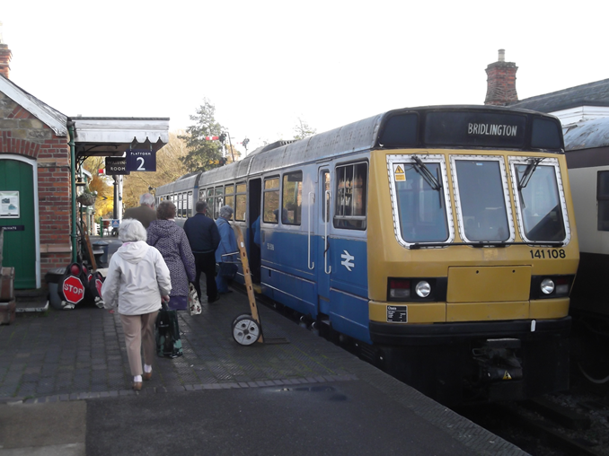

EIAG members boarding the train for a ride along the line as part of the Annual Meeting.

Uttlesford District Council, Local Heritage List

In 2017 Uttlesford District Council began the development of a Local Heritage List of structures and other assets which are considered to be locally significant to the character of the area. Heritage assets were identified as part of the conservation area appraisals, conservation management plans, and those nominated by the public up to November 2017. The public, as well as statutory consultees, were invited to provide feedback on the list, as part of a six week public consultation which ran from May to July 2018. Just over 400 assets were included on the draft list for consultation. Of the draft list, by far the vast majority are houses, chapels and village schools, public houses and shops, as would be expected considering the attractive rural village and market town architectural and aesthetic nature of an area such as Uttlesford. However, a number of assets on the list are farm buildings, directional signposts, telephone boxes, water pumps, war memorials and former industrial buildings. The latter include the railway stations at Newport, Stansted Mountfitchet and Thaxted; maltings at Newport and Stansted Mountfitchet; the railway viaduct at Newport; a sewerage pumping station, the station granary and workers’ housing in Stansted Mountfitchet. Tony Crosby on behalf of the Essex Industrial Archaeology Group nominated the industrial buildings in Stansted Mountfitchet and the surviving Thaxted Station buildings – the station building itself, the engine shed and water tower. The first issue of the Uttlesford LHL was approved by the council's Cabinet on 16th October 2018 and includes all the industrial and transport heritage assets mentioned above.

Full Uttlesford Local Heritage List can be found here.

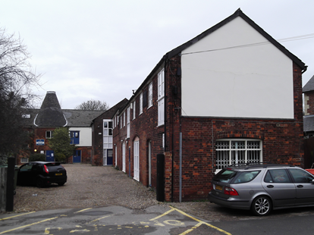
Station maltings, Newport

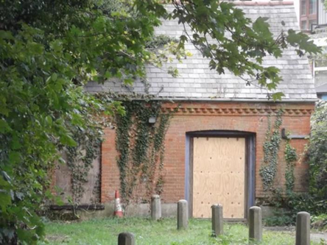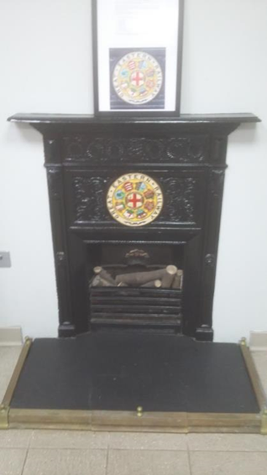

Sewerage pumping station, Water Lane, Cast iron fire place, Stansted
Stansted Mountfitchet Mountitchet station booking hall

Tony Crosby

Programme of ESAH/EIAG visits 2019

The programme of visits in 2019 includes the following of industrial, maritime and transport interest. Full details will be provided on your Membership Programme card for 2019 and in this Newsletter:

- Morant Lecture by John Miners on The Textiles in East Anglia – Halstead on 9th March.
- Visit to the East Anglian Railway Museum – Chappel & Wakes Colne on 24th April
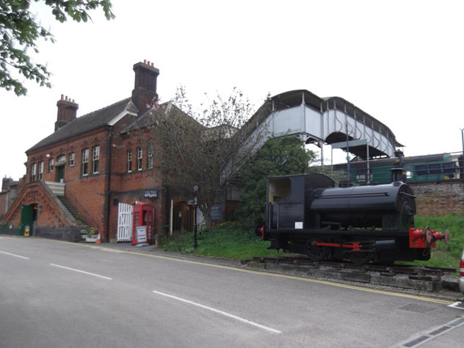
- Tour of W H Collier Brick and Tile Works – Marks Tey on 21st August
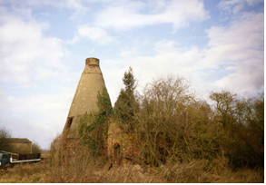

- Tour of Stow Maries airfield – Purleigh on 14th September
- Industrial Heritage Fair – Sandford Mill Museum on 5th October
- EIAG Annual Meeting and talk by Jim Lewis on the Industries of the Lea Valley – Chelmsford Museum on 9th November

REPLACEMENT WAR MEMORIAL UNVEILED FOR RIPPERS EMPLOYEES WHO LOST THEIR LIVES DURING THE FIRST WORLD WAR
This month, as we remember the centenary of the end of the First World War, it is appropriate to report upon the unveiling of a replacement war memorial to the eight employees of Rippers Joinery Manufacturers of Castle and Sible Hedingham who lost their lives.
The original memorial was unveiled on 10th September 1921 and was located on the outside wall of a workshop near the entrance to the joinery works. It was an oak memorial made at the works, featuring a carved cross with a wreath entwined and in the centre panel was engraved the names of the men surmounted by the works 'In Memoriam'. At the base was inscribed, 'Their name liveth for evermore 1914-1918'. The unveiling was carried out James
Redgewell, the oldest employee, in the presence of the employees and parents of the fallen. The eight employees were: Bertie Ambrose, Frank Drury, Rupert Hawkins, Edward Mead, Sidney Partridge, Hubert Ripper, Edward Thornton and Alfred Vale. They are also commemorated on the Castle and Sible Hedingham War Memorials.
This memorial survived until the mid-1970s when it mysteriously disappeared following the takeover of Rippers Limited by the Bowater Corporation. Sadly, no photographs of original war memorial have been found. A couple of years ago Adrian Corder-Birch gave a talk to the Hedingham Branch of the Royal British Legion, when he mentioned the loss of the original memorial, which inspired the replacement shown in the accompanying photograph. It will be interesting to know how many other war memorials exist in Essex to employees of our industries.

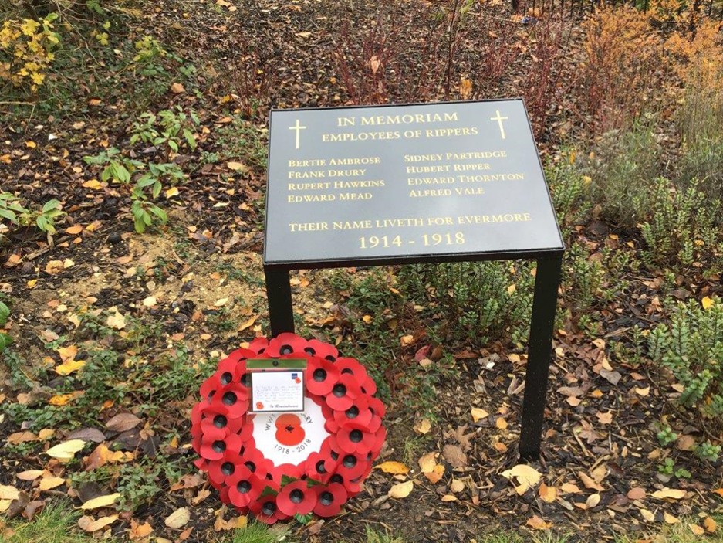
RESTORATION OF THE LONDON SCOTTISH WAR MEMORIAL BY RIPPERS LIMITED
During the Second World War the headquarters of the London Scottish Regiment at Horseferry Road, Westminster was badly damaged by bombing, including its First World War memorial, which was almost completely destroyed. Rippers restored the memorial using between 1300 and 1400 separate pieces of oak. The joiners completed the task so well that none of the restored parts were visible on the memorial. The joiners who carried out the repair work, were very proud to have played a small part in honouring the gallant men, who sadly lost their lives and whose names appeared on the memorial.
Pam and Adrian Corder-Birch.
Note: In 2014 Pam and Adrian Corder-Birch wrote and published a book titled, 'The Works A history of Rippers Joinery Manufacturers of Castle and Sible Hedingham. Only a few copies are left, which are available from the authors price £14.95plus £2.95 postage and packing. Email: adrian@corder-birch.co.uk

Halstead Heritage Park

Have you heard of Halstead Heritage Park? You may have done so without realising it.
Halstead Heritage Park is that piece of ‘waste’ land to the east of Halstead High Street that contains 16 industrial air raid shelters courtesy of Courtauld’s for their workers in WW2, along with a range of different habitats. ‘Developers’ consider it a perfect spot for building despite the spring line where alluvial gravel is covered by Thames clay. Note for some reason for the last 2000 years or more no one has built along that line! Halstead 21st Century Group have the ‘alternative vision’ of a Heritage and Environment Park.

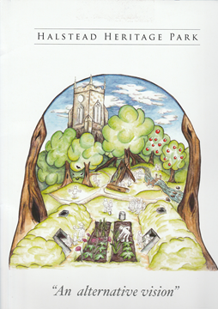
The group, with advice from North Essex Heritage, has now brought out a professional looking topic folder sponsored by Subterranea Britannica. This folder contains a detailed map of the area showing the different areas of the park and even providing space for lower-cost homes. Going with this map are 5 topic papers. Four of these are on the park zones and one on funding.

The suggested zones, which naturally overlap are: Heritage including the industrial air raid shelters which are possibly unique; Wildlife zone including a nature trail, orchard and Forest School area; Play haven in the Victorian garden area, a respite area, near the High Street for parents to relax with children; Housing offering a space for ‘affordable housing’ only.

A town meeting was held earlier in the year to launch the topic papers. Despite it being in the heat wave a number of people came and showed their interest.

The topic papers are available for public viewing. They can be seen in Halstead library and Halstead Museum. Copies have also been given to EIAG, ESAH and Halstead History Society as well as town and district councillors and of course our MP. To access them yourselves either visit the places in Halstead, look on the H21C website: www.halstead21stcentury.org.uk, or contact the group at: info@halstead21stcentury.org.uk.

Jane Giffould

Historic England Angel Awards

The Historic England Angel Awards celebrate the efforts of people taking action to champion their local heritage. The awards were founded by Andrew Lloyd Webber and are co-funded by the Andrew Lloyd Webber Foundation. There are 15 finalists in the Historic England Angel Awards 2018 and they include, from Essex, the Bulmer Brick and Tile Works, which is a finalist for the Best Craftsperson or Apprentice on a Heritage Rescue or Repair Project. All the shortlisted projects are in the running for the Historic England Followers’ Favourite award chosen solely by the public, so do vote for our local project at:

https://historicengland.org.uk/get-involved/angel-awards/

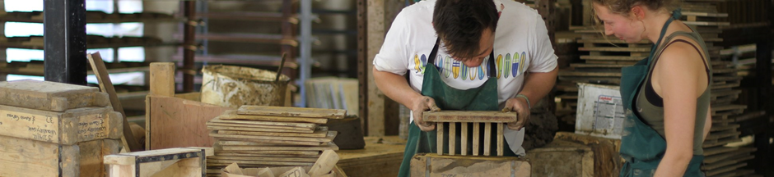

Merry Christmas and a Happy New Year to all our members.

