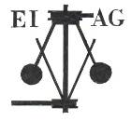
Essex Industrial Archaeology Group

NEWSLETTER

Number 27 March 2019

Welcome to this month’s edition of the EIAG Newsletter. As usual set out below are the ESAH/EIAG visits of industrial interest and we hope to see many of you at these events. There is also an up-date from the Bata Heritage Centre and notice of their next open day, plus more on the history of Boreham, news about Essex mills, the Heritage Lottery Fund and of a new publication from ESAH/EIAG.

We hope you enjoy reading this edition and if you have any comments on the Newsletter generally or specific items in it, or wish to make a contribution to the next Newsletter, please contact us via our email address - essexiag@gmail.com.

Programme of ESAH/EIAG visits 2019

The programme of visits in 2019 includes the following of industrial, maritime and transport interest:

East Anglian Railway Museum. Wednesday 24th April 2019, 10:30 am. A guided tour of the heritage centre and Victorian station buildings - £5.00

Colliers Brick and Tile Works. Wednesday 21st August 2019, 10:30 am. Church Lane, Marks Tey, CO6 1LN. Brick making by hand using traditional methods - £5.00

Stow Maries Airfield. Saturday 14th September 2019, 10:00 am. Hackmans Lane, Purleigh, CM3 6RN. Tour and history of the site. £12.00 including traditional cream tea.

Industrial Heritage Fair 2019. Saturday 5th October 2019, 10:00 am – 4:00 pm. Sandford Mill Museum, Chelmsford, CM2 6NY. Society and museum stalls and five short talks. Free admission. Light refreshments available all day. More details to follow in future newsletters.

EIAG Annual Meeting. Saturday 9th November 2019, 2:00 pm. Chelmsford Museum. AGM followed by a talk by Jim Lewis on the industries of the Lea Valley – Free for members, £2.00 for non-members.

For full details and to book places on these visits please contact the Hon. Secretary, Howard Brooks, via email, which is preferred, at Howard000brooks@gmail.com or by post to 13 Greenacres, Mile End, Colchester, CO4 5DX.

Bata Heritage Centre

Here is an update on the progress with the rebuilding/refurbishment of East Tilbury library, the base for the Bata Heritage Centre, from Mike Tarbard the Chairman:

The contract was awarded to H W Wilson from South Ockendon and they have been working on the project since before Christmas. There have been some problems along the line which include the exterior cladding and drainage issues in the car park. The work is anticipated to be completed in the Spring – but no specific date is understandably being given. I am in regular contact with and meet with Thurrock Council’s libraries staff over the build and the internal fittings and furniture have now been ordered. We are told that the company involved in the refit will be able to come in and do their part of the contract as soon as the building and related work is complete. It will then be about moving back in, which will take time. Our collection has largely been cleaned and restored by the professional firm that we engaged and we intend to catalogue the entire collection as part of the moving in process.

We are due an Open Day in the Spring but from the above you will understand, unfortunately, that we will not be in a position to host it in the new library area.

We have decided that the next Open Day will be held on Saturday 13 April in the ground floor area of the former Bata Building 13 (Administration Building) from 10am to 2pm.

There will be the usual photographs and artefacts on show as well as our volunteers being available to talk to you. Guided walks will be available at 11am, 12noon and 1pm and we are already getting requests for places. I would suggest that you contact me at brrcatbatamemories@hotmail.com with a reservation for a particular timed walk. We will ask the usual £3 per person payable on the day.

WEA Industrial Heritage Day

On the 26th of January seven members of the EIAG and about 60 others attended a one day course in the Keene Hall at Galleywood entitled ‘The Industrial Heritage of Essex’. The course lecturer was Steven Worsley, well known on the WEA circuit, having been involved with the organisation for around 30 years. He is, by profession, an architectural draftsman who has a special interest in transport related subjects. Although, as all historians know, it is quite difficult to keep to just one subject!

Steven’s lecture was very comprehensive and wide ranging. He began by setting the scene in the 17th century and describing the circumstances that led up to the industrial revolution. Transport obviously played an important part and although Essex has a long coastline and was well served with ports and rivers allowing extensive water transport, the roads were appalling. Potholes big enough to fall into, in winter a quagmire, in summer dry and dusty. With the coming of the turnpikes the situation did begin to improve, at least for the main roads. The Great Essex Road from London to Colchester and Harwich was one of the first to be “turnpiked” but the possibilities of better transport were always limited by what horses were capable of moving over the roads of the time.

We were told how industries worked in the 16th and 17th century. Most were very local affairs. One of the oldest industries in Essex was milling and as Steven explained it was typical of the way that industry operated those days. Mills were water powered and from the 12th century used wind as well. Both these power sources were on hand and did not require to be delivered. All the corn was grown locally and therefore did not need to be transported great distances and the flour baked into bread locally for local people.

The road improvements helped but it was the coming of the railways that really made the difference, reaching Harlow by August 1841 and Colchester by March 1843. Now commodities such as coal could be brought into the county relatively cheaply. This helped to spread steam power, much more reliable than wind or water, and subsequently enabled a workshop, for example, to be established anywhere coal could be delivered to. The railway was then able to convey the products to an ever increasing market. Gradually the local cottage industries like brick making, baking, brewing spinning and weaving became concentrated in factories that were able to implement more efficient manufacturing techniques. As a result more people moved from working on the land to the towns to work in the factories. The world was changing!

EIAG had a presence at the event in the form of a table manned by Membership Secretary, Jane Giffould. Although we did not get any new members on the day quite a few EIAG leaflets were taken as well as leaflets for the October Industrial Heritage Fair. Jane also sold a number of copies of chairman Tony Crosby’s book on Essex Industrial Archaeology.

After lunch Steven described some of the techniques of industrial archaeology and how it differed from the more traditional version. He then took us on a photographic tour of some of the sites and scenes of industry in Essex. From water and windmills, weaving and silk production, malting and brewing to the later industries like Crompton’s and Marconi’s who contributed so much to the development of electricity and radio and ultimately the world we know today.

It was an interesting day and really made the point that although many seem to disregard the contribution Essex made to the Industrial Revolution we have actually contributed quite a lot.

Peter Jones

Boreham Station

Following the piece about Boreham Airfield in the last issue of the newsletter this could be an opportune moment to mention Boreham railway station.

This was no ordinary station. In 1838 when the Eastern Counties Railway were building the line from London it involved crossing land owned by Sir John Tyssen Tyrell, Baronet and MP who resided at the nearby Boreham Hall. During the heady days of railway mania when the line was being planned it was envisaged that a 22% return on investments was likely. Consequently, to avoid holding up the work (and the profits) very generous payments and concessions were offered to influential landowners, Lord Petre, for example, getting £120,000 for a 5 mile strip of land. With regard to Sir John it seems no coincidence that at this point the line makes a deviation taking it 250 yards further away from Boreham Hall.

However Sir John’s most audacious demand was that the railway company provide him with his own private station at the nearest point to his house. He also insisted on the right to stop and board any train on which he wished to travel. By the time the line reached Boreham in 1843 the ECR was on the verge of bankruptcy and in no position to legally challenge the agreement made with Sir John. One concession they did manage to get was that the arrangement was not hereditary and would cease on his death.

So it was that Sir John got his station. As railway stations go it was a parsimonious affair, two 80ft wooden platforms and a hut for shelter. No detail remains of exactly how the trains were stopped. Even at 40 mph it could take a considerable distance, it would not be like hailing a cab. There is some evidence to suggest that a flag flown from a pole was used. The map shows a signal post on the site, could this have been a special signal for Sir John to use? Another possibility is that as the road from Boreham Hall continued over the railway line on a level crossing towards New Hall there may have been a crossing keeper who was in contact with adjacent signal boxes?

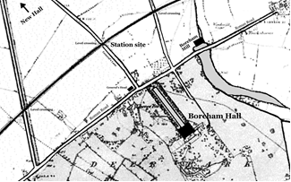
An enhanced map from the 1870s showing the position of the station.

It is not difficult to imagine what a thorn in the flesh of the railway operating department this arrangement must have been and even when the ECR merged into the Great Eastern Railway in 1862 the arrangement continued. Sir John enjoyed his special privilege until he died in September 1877 and two days after his funeral the station was demolished.

Peter Jones

ESSEX MILLS GROUP

During the last few weeks officers of the Essex Industrial Archaeology Group (EIAG) have been engaged in discussions with officers of the Essex Mills Group (EMG). The result is that EIAG has incorporated EMG, which has received the unanimous support of our parent body, The Essex Society for Archaeology and History (ESAH).

EMG was formed in 1985 to provide a focus for people with a common interest in wind and water mills. It arranged visits, collected historical and technical information and published regular newsletters. It participated in practical renovation and made representations to other authorities to preserve mills. It was very active until around 2013 when it sadly declined. This was not through lack of enthusiasm, but mainly as a result of the age of its members. As EMG has come to the end of its active life, in its present state, EIAG has agreed to incorporate it. Both groups have very similar aims and regard wind and water mills as an important feature of Essex Industrial history.

All members of EMG are being invited to become members of ESAH and thereby members of EIAG. The funds held by EMG will be ring fenced for the furtherance of mills in Essex. This will include funds for the Mills Archive in Reading and some much needed tools for an Essex millwright. At least one former officer of EMG will join the EIAG committee to provide some continuity and particularly advice upon Essex mills. In future the EIAG newsletter will contain regular features about Essex Mills.

Adrian Corder-Birch

MILLS OWNED BY ESSEX COUNTY COUNCIL

EIAG has recently sought clarification from Essex County Council regarding mills they currently own, which are as follows:
Alderford Water Mill, Sible Hedingham
Beeleigh Steam Mill
Finchingfield Post Mill
Mountnessing Post Mill
Stock Tower Mill
Thorrington Tide Mill
For further details of these mills please see: http://www.visitparks.co.uk/

ALDERFORD WATER MILL, SIBLE HEDINGHAM

Our regular readers will recall that Alderford Mill has occasionally featured in our newsletters. Although owned by Essex County Council it is cared for by a very active and hardworking friend’s organisation known as the Friends of Alderford Mill (FOAM). The latest project by FOAM is to replace the paddles on the waterwheel. The mill has a working water wheel, which is operated to mill grain during open days, but it cannot be used at present. The wooden parts of the water wheel have been affected by a fungal infection which has made the wood brittle, resulting in several of the paddle assemblies (floats, sole boards and starts) breaking. To bring the wheel back to working condition FOAM needs to remove all these parts from the cast iron assembly, clean the cast iron core assembly to remove any residual infection and replace the wooden parts with new high quality English elm wood. There are forty paddles and each new paddle will cost about £140. The Braintree Society (previously the Braintree and Bocking Civic Society) has generously made a grant of £1,400 for ten paddles. In addition CPRE Essex Mills Fund, which was started by the late Hervey Benham, has made a grant of £1000 towards new paddles. These grants were much appreciated and FOAM is working hard to raise further funds through sponsorship to complete this major project. If you are able to help please contact: Mr. Owen Hawkes, chairman, FOAM, email: owen@owenshawkes.plus.com

Adrian Corder-Birch

Heritage Lottery Fund

The Heritage Lottery Fund (HLF) has recently published its Strategic Funding Framework (SFF) for 2019 – 2024. It has had a name change and is now the National Lottery Heritage Fund (NLHF), its logo being the crossed fingers with the name Heritage Fund. They expect to invest around £1.2 billion over the five years of the SFF, which equates to around £200 million per year, considerably less than was available at the start of the previous five years and hence competition for grants will be even fiercer in future. Full details of the new SFF can be found on the website at: https://www.heritagefund.org.uk/publications/strategic-funding-framework-2019-2024

Chelmsford Industrial Trail

In the January Newsletter we announced the publication of the revised, up-dated and extended version of Stanley Wood’s Chelmsford Industrial Trail. This publication by ESAH, and the first to be produced by EIAG members, was launched on Wednesday 27th February at the Hive Café in Chelmsford Museum in the presence of the Mayor of Chelmsford, Cllr Yvonne Spence. The event was attended by representatives of the organisations which contributed grants towards the publication of the Trail, those who helped the authors and representatives of various local organisations.
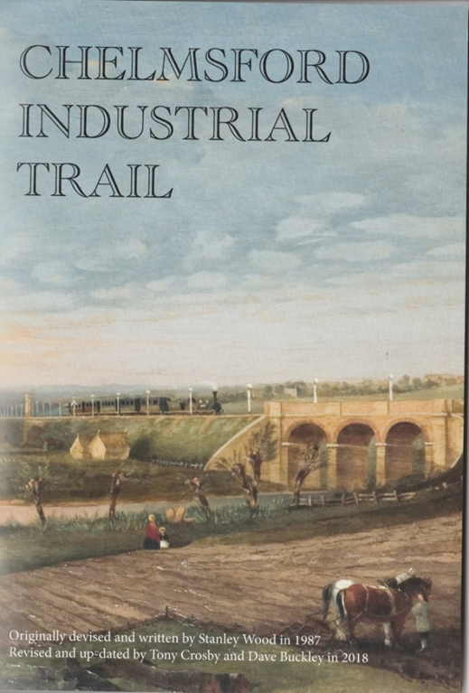
All ESAH/EIAG members will be receiving a copy with the next mail out of the ESAH Newsletter. Further copies are now available to buy at:

- Chelmsford Museum, Oaklands Park, Moulsham Street
- The Ideas Hub in Chelmsford Library, County Hall
- The Hop Beer Shop, 173 Moulsham Street.
Cost £4.00
Also available by emailing essexiag@gmail.com
Cost £4.00 plus P&P

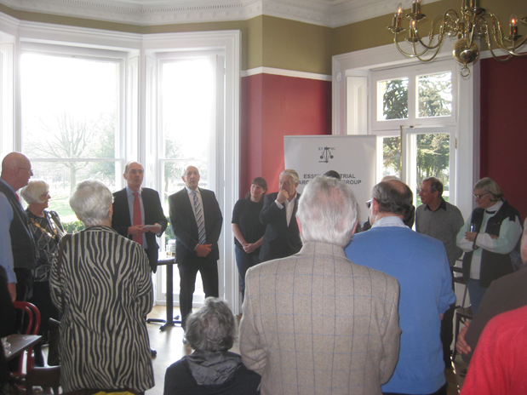
Speeches at the launch of the Chelmsford Industrial Trail

And don’t forget!

